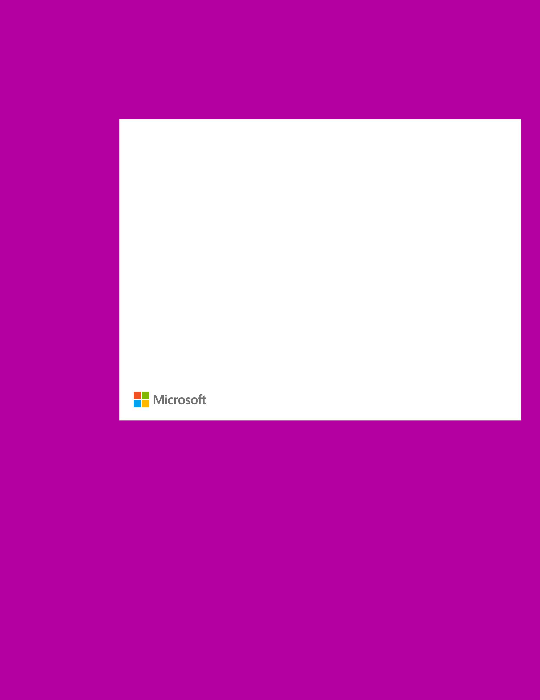Microsoft Volume Licensing

Microsoft Products and Services Agreement Licensing Manual

August 2016



Table of Contents

Document Purpose and Resources 1

Section 1 2

How the Microsoft Products and Services Agreement works 2

Transactional Purchasing 3

Section 2 5

Making copies of Products and re-imaging rights 5

License Transfer Process 6

Verifying Compliance Process and Limitations 6

Divestitures 6

Natural Disaster 6

Section 3 6

Licensing Manual changes over last 12 months 6

Appendix 7

Definition of Regions 7

Document Purpose and Resources

This Licensing Manual provides supporting information for customers with a Microsoft Products and Services Agreement (MPSA) about the account structure, ordering processes, pricing, and other terms. All capitalized terms used but not defined in this Licensing Manual will have the same meanings provided in the MPSA, including the Product Terms.

A general overview of the MPSA can be found at <http://www.microsoft.com/licensing/mpsa/>.

For the latest version of this document, details on use rights, and the Product Terms please see <http://www.microsoft.com/licensing/contracts>.

Section 1

How the Microsoft Products and Services Agreement works

**Account structure**

With the Microsoft Products and Services Agreement, you have the flexibility to set up the desired buying structure you want for Volume Licensing purchases with Purchasing Accounts. A Purchasing Account is defined as any unit within your organization that you want to enable to purchase both Software and Online Services. Your Purchasing Accounts are associated with your organization’s MPSA, through your defined legal entity on the Purchasing Account registration form.

There are three types of Purchasing Accounts supported for different Customer types: Commercial, Government, and Academic. To qualify for a Government or Academic Purchasing Account, an organization must meet the relevant eligibility requirements found at <http://www.microsoftvolumelicensing.com/contracts>.

The flexible Purchasing Account structure empowers you to define and redefine your organization’s purchasing configuration based on your business needs. These accounts can be established at the organization level, affiliate level, department level, or even for just a subset of personnel.

The first step is to decide how you want your organization to purchase Products. This will help guide the structure that is established for your Volume Licensing transaction purchases.

For instance, if you want to centrally manage purchases, you could register one Purchasing Account:

|  |
| --- |
| PURCHASING ACCOUNT |
| MPSA |

Alternatively, if you want to have a more decentralized approach, you can register multiple Purchasing Accounts and you can also have different Purchasing Account types through a single MPSA:

|  |  |  |
| --- | --- | --- |
| PURCHASING ACCOUNT 1  Academic | PURCHASING ACCOUNT 2  Commercial | PURCHASING ACCOUNT 3  Commercial |
| MPSA | | |

|  |  |  |
| --- | --- | --- |
| PURCHASING ACCOUNT 1  Commercial | PURCHASING ACCOUNT 2  Commercial | PURCHASING ACCOUNT 3  Commercial |
| MPSA | | |

**Purchasing Account anniversary month**

When registering each Purchasing Account, you may choose a specific month in which to align purchases that have subscription terms, in order to provide a single and consistent anniversary for renewals. For example, if one of your accounts were to choose January as its anniversary month, any Online Services purchase made under the account will align to that month, resulting in renewals for Online Services taking place in January of each year. You can change this designation as needed for your organization through the Microsoft Business Center. Any changes will only impact future orders.

For Government and Academic Purchasing Accounts, it is possible to specify an end date for purchases. When this option is selected, subscription terms will not extend beyond this date. It is possible to extend this date, if needed.

**The Agreement Administrator**

Each MPSA must be signed by a legal entity that is the “Customer.” The Customer will designate one Purchasing Account as an Agreement Administrator. Other Purchasing Accounts may be added and associated with the Agreement Administrator. This gives the Agreement Administrator a consolidated view across all assets within the organization and a convenient single source for managing all Purchasing Accounts. The Agreement Administrator account:

* Is provided a full asset view across all Purchasing Accounts.
* Is notified when a Purchasing Account is associated to your MPSA.
* Has the right to terminate the association of any Purchasing Accounts to the MPSA.
* Has the right to terminate the MPSA itself.
* Cannot order for other Purchasing Accounts or manage their assets.

The Customer (legal entity) of the Agreement Administrator is used for the Affiliate definition of the MPSA.

**Partners**

You may place orders under your MPSA Purchasing Account through a Licensing Solution Partner (LSP) authorized to resell Microsoft Products through the MPSA. Each Purchasing Account may choose a particular LSP who will work with you to register Purchasing Accounts and create the agreement electronically with electronic signing[1]. You can add LSPs to your account(s) over time as needed for transactional purchasing. For more information regarding worldwide Partners in your location, please refer to <http://pinpoint.microsoft.com>.

**Direct Sales**

Certain Microsoft sales professionals are authorized to offer Products through the MPSA and may work with you to register Purchasing Accounts.

Transactional Purchasing

**Products**

You can order most of Microsoft’s Volume Licensing Products through your MPSA. For a full list of Products available through the MPSA please refer to the Product Terms at <http://www.microsoft.com/licensing/contracts>.

**Access to downloads and account information**

You will have access to the Microsoft Business Center to download Software, access Product keys, view your licenses & services portfolio and provision Online Services. You can access the Microsoft Business Center at <https://licensing.microsoft.com/customer/>.

**Price levels**

You must achieve a minimum of 500 points per Product Pool annually to qualify for ordering Products in that Product Pool. Alternatively, you may qualify by ordering at least 250 points for Online Services in that Product Pool, or by associating an active qualifying contract (Enterprise Enrollment, Enterprise Subscription Enrollment, or Select Plus Agreement) with the MPSA. You may use a different qualifying contract for each Product Pool. However, you must (1) be an Affiliate of and (2) have approval from the Customer that entered into the qualifying contract to associate it with the MPSA. You may use Microsoft Azure Services without meeting the minimum point requirement.

Commercial Purchasing Accounts have four price levels available by Product Pool as defined below. For Commercial Purchasing Accounts the points for each price level are listed in the following table.

|  |  |
| --- | --- |
| **Price level – Commercial** | **Annual point minimum per Product Pool** |
| A | 500 or 250 for OLS Only |
| B | 4,000 |
| C | 10,000 |
| D | 25,000 |

By default, the initial price level upon signing is level A. Your organization will automatically move to a more favorable price level if one of these events occurs:

* You place an order that has enough points to qualify you for the next price level for a Product Pool.
* You associate an active qualifying contract that has a more favorable price level for a Product Pool than the corresponding Product Pool in the MPSA, in which case the more favorable price level will apply to future orders.

Government and Academic Purchasing Accounts each have a single price level reflecting the most beneficial pricing that Microsoft can offer to those Customer types through the MPSA. For Government, this is equivalent to level D commercial price level.

**Points**

Microsoft categorizes Products into three distinct Product Pools with tiered price levels: Applications, Systems, and Servers. The price level for each Product Pool is based on points that you earn against purchases in these Product Pools. Points are counted across all your Purchasing Accounts of the same type (*e.g.*, Commercial).

* Applications. Examples of application Products include Microsoft Office Professional, Microsoft Lync client, and Office 365.
* Systems. An example of a system Product is a Windows operating system upgrade such as Windows Enterprise.
* Servers. Examples of server Products include Windows Server, Microsoft Exchange Server, Microsoft SQL Server database Software, Intune and associated Client Access Licenses (CALs).

Examples:

|  |  |  |  |  |  |
| --- | --- | --- | --- | --- | --- |
| Applications | Points | Systems | Points | Servers | Points |
| Office Professional | 2 | Windows Enterprise LTSB Upgrade | 2 | Windows Server Standard | 15 |
| O365 K1/E1/E3/E5 | 1 |  |  | Intune | 1 |

For more information, see the Product Terms at <http://www.microsoft.com/licensing/contracts> or contact your Partner or Microsoft sales professional.

**Price level adjustments**

You will attain the next price level for a Product Pool as soon as your organization meets the corresponding annual minimum point count. The order that qualifies you for the next price level (e.g. level A to level B) will be priced at that level. Price levels for each Product Pool will be reviewed every year in the agreement compliance anniversary month established using the month your MPSA is activated. Any points that you have earned in a given year that are in excess of the current price level but below the next price level will be carried over to the next year to be counted toward that year’s compliance.

If at the agreement compliance anniversary month your accumulated points are below the minimum point count in a Product Pool, your organization’s price level will be reduced one level (*e.g.*, from level C to level B) for that Product Pool the following year and no points will be carried over to the next year. Your price level can only be reduced by a maximum of one level each year. If you are unable to meet the minimum to qualify for ordering Products in a Product Pool, you will be unable to place orders for Products in that Product Pool until a single order is placed which meets that minimum qualification.

If you have an active qualifying contract associated with your MPSA that has a more favorable Product Pool price level than the corresponding Product Pool in the MPSA, that more favorable Product Pool price level will be used for orders in the MPSA.

**Order Mechanics**

You may place orders for Products through the MPSA with your chosen Licensing Solution Partner(s) or Microsoft sales professional. The price and payment terms for all orders placed through a Partner will be determined by the agreement between you and your Partner. When placing orders, you must specify all countries in which your organization will use the Products.

At time of each order for Software Assurance or Software subscription licenses, you may choose if the term for these subscriptions expires on the day before your Purchasing Account’s third anniversary or on the last day of 36 full calendar months. You may pay for these subscriptions (1) in full at the time of the order, or (2) in advance annual installments, billed on either the Purchasing Account anniversary or order anniversary.

An order for an initial or a renewal term for Online Services or Package subscriptions, may expire (1) the day before your Purchasing Account’s next, second, or third Purchasing Account’s anniversary or (2) on the last day of the 12-, 24-, or 36-month term you selected during your order. Additional orders for a subscription of that Product during this term, on the same Purchasing Account, will automatically align to the same end date. Microsoft may make only some options for the initial or renewal length of a subscription term available, depending on the Product selected.

Billing for Online Services or Package subscriptions may be (1) in full at the time of the order or (2) in advance annual installments, billed on either the Purchasing Account anniversary or order anniversary. Pricing for additional orders of a subscription will be the same as the initial order of the subscription, unless there is a promotion available at time of ordering that is more favorable. If the subscription term was greater than one year, additional orders will receive the better of the current price at the time of the additional order or the price of the initial order, whichever is most favorable. Prices are reset upon renewal of the subscription term.

In addition to the options above, you may order some Online Services as a short-term subscription. Short-term subscriptions can be between one and eleven months with no automatic alignment to existing subscriptions for the same Product. Pricing for orders of short-term subscriptions is different from pricing for other term options and is set at time of ordering.

If you purchase Microsoft Azure Services through the MPSA, you will be billed in arrears based on your usage of services during that billing period. The billing period for Microsoft Azure Services is quarterly, aligned to the Purchasing Account anniversary when the Microsoft Azure Services subscription began.

You may also transition between types of licenses covered by Software Assurance or types of subscription licenses on the MPSA by ordering Step-Ups or changing from a device-based license to a user-based license or a user-based license to a device-based license. Some of these transitions may be made at renewal or during the term of your subscription or Software Assurance coverage period, such as Step-Ups, while others may only be made at renewal, such as device-to-user license model changes. For more information on transition options, please contact your Partner or Microsoft sales professional.

Other billing and alignment options for orders through your MPSA may be made available in the future.

After Microsoft has accepted your Purchasing Account’s registration, you may use any Product as if licensed under the terms of the MPSA, provided you submit an order in the same calendar month in which the Product is first used, for a sufficient number of licenses to cover your use of the Product. For additional quantities of a licensed Product, you must submit an order in the month those quantities are first used. For Online Services subscriptions that require a reconciliation order, you can find reporting about those quantities through the Microsoft Business Center or with help from your Partner or Microsoft sales professional.

Microsoft may change the Products available through the MPSA and may refuse to accept an order if it has a business reason to do so.

Information about orders received and processed by Microsoft are available from your Partner or in the Microsoft Business Center at <https://licensing.microsoft.com/customer>. Once registered, the Purchasing Account contact will be provided access to the Microsoft Business Center, and your designated Agreement Administrator account will have access to information across all Purchasing Account(s).

Section 2

Making copies of Products and re-imaging rights

Your registered Purchasing Accounts may make as many copies of Products as it needs to distribute them within your organization. Copies must be true and complete (including copyright and trademark notices), from master copies obtained from a Microsoft-approved fulfillment source. Purchasing Accounts may use a third party to make these copies; however, you and your accounts remain responsible for any third party’s actions.

In certain cases, re-imaging is permitted using the Product media. If a Product is licensed (1) from an original equipment manufacturer (OEM), (2) as a full packaged Product through a retail source, or (3) under another Microsoft program, then media provided through the MPSA may generally be used to create images for use in place of copies provided through that separate source. This right is conditional upon the following:

* Separate licenses must be acquired from the separate source for each Product that is re-imaged.
* The Product, language, version, and components of the copies made must be identical to the Product, language, version, and all components of the copies they replace, and the number of copies or instances of the re-imaged Product permitted remains the same.
* Except for copies of an operating system and copies of Products licensed under another Microsoft program, the Product type (*e.g.,* upgrade or full license) re-imaged must be identical to the Product type licensed from the separate source.
* Purchasing Account must adhere to any Product-specific processes or requirements for re-imaging identified in the Product Terms.
* Re-imaged Products remain subject to the terms and use rights of the license acquired from the separate source.

**Copies for training/evaluation and backup**

For all Products other than Online Services, each Purchasing Account may (1) use up to 20 complimentary copies of any licensed Product in a dedicated training facility on its premises for purposes of training on that particular Product, (2) use up to 10 complimentary copies of any Product for a 60-day evaluation period, and (3) use one complimentary copy of any licensed Product for backup or archival purposes for each of its distinct geographic locations.

License Transfer Process

You must notify Microsoft of a license transfer by completing a license transfer form, which can be obtained from <http://www.microsoft.com/licensing/contracts>, and sending the completed form to Microsoft before the license transfer. No license transfer will be valid unless you provide to the transferee, and the transferee accepts in writing, the applicable Product Use Rights, use restrictions, limitations of liability (including exclusions and warranty provisions), and the transfer restrictions described in this section.

Verifying Compliance Process and Limitations

Microsoft will notify you at least 30 days in advance of its intent to verify your compliance with the license terms for the Products you and your Affiliates use or distribute. Microsoft will engage an independent auditor, which will be subject to a confidentiality obligation. Any information collected in the self-audit will be used solely for purposes of determining compliance. This verification will take place during normal business hours and in a manner that does not unreasonably interfere with your operations.

Divestitures

If you intend to transfer more than ten percent of your licenses in connection with a divestiture of an Affiliate, an operating division, or any of your Affiliate’s operating divisions, Microsoft will work with you in good faith to enable the transfer.

Natural Disaster

In the event of a natural disaster, Microsoft may provide additional assistance or rights by posting them on <http://www.microsoft.com> at such time.

Section 3

Licensing Manual changes over last 12 months

* August 2016 updated to reflect the removal of Software Assurance content from the Licensing Manual, availability of the Microsoft Business Center (previously known as the Volume Licensing Center) for all customers, the ability to purchase Step-Ups and other transitions under the MPSA, and clarifications to language based on customer feedback. The terms that govern Software Assurance you purchase under the MPSA are found in the Product Terms.
* March 2016 updated to reflect new customer portal in some locations (“Microsoft Business Center”), the support of full year durations for subscriptions, the addition of short-term subscription option for some Products, and clarified language based on customer feedback.
* August 2015 updated to reflect additional Azure Services, Online Services, and Package purchasing options and to refer and align to the Product Terms document. Beginning July 1, 2015, the Product Terms replaced both the Product List and the Product Use Rights (PUR) documents.

Appendix

Definition of Regions

This list below presents the countries, regions or territories that are part of the Microsoft definition of the EMEA region (Europe, Middle East and Africa), which may be referenced in some Purchasing Account Type Country Terms. Please note, the MPSA may not be available in all countries.

Afghanistan, Albania, Algeria, Andorra, Angola, Armenia, Austria, Azerbaijan, Bahrain, Belarus, Belgium, Benin, Bosnia and Herzegovina, Botswana, Bulgaria, Burkina Faso, Burundi, Cameroon, Cape Verde, Central African Republic, Chad, Comoros, Congo, Congo (DRC), Côte d'Ivoire, Croatia, Cyprus, Czech Republic, Denmark, Djibouti, Egypt, Equatorial Guinea, Eritrea, Estonia, Ethiopia, Finland, France, French Polynesia, Gabon, Gambia, Georgia, Germany, Ghana, Greece, Guinea, Guinea-Bissau, Holy See (Vatican City), Hungary, Iceland, Iraq, Ireland, Israel, Italy, Jordan, Kazakhstan, Kenya, Kuwait, Kyrgyzstan, Latvia, Lebanon, Libya, Liechtenstein, Lithuania, Luxembourg, Macedonia, Madagascar, Malawi, Mali, Malta, Mauritania, Mauritius, Moldova, Monaco, Mongolia, Montenegro, Morocco, Mozambique, Namibia, Netherlands, New Caledonia, Niger, Nigeria, Norway, Oman, Pakistan, Poland, Portugal, Qatar, Romania, Russia, Rwanda, San Marino, Saudi Arabia, Senegal, Serbia, Seychelles, Sierra Leone, Slovakia, Slovenia, Somalia, South Africa, South Sudan, Spain, Sweden, Switzerland, Syria, Tajikistan, Tanzania, Togo, Tunisia, Turkey, Turkmenistan, Uganda, Ukraine, United Arab Emirates, United Kingdom, Uzbekistan, Yemen, Zambia, Zimbabwe.

1. Physical signature of electronically created agreements is supported as needed.