

**Instructional Guide**

Learning Agreement / Evaluation

Office of Field Education

Department of Social Work

**Field Education: Where *TRANSFORMATION* is Tradition!**

**Introduction**

This guide has been created to provide an explanation of how to use the GMU Learning Agreement/Evaluation form. This form combines both a learning agreement and mid-term and final evaluation in one document. When completed, the learning agreement provides an overview of the manner in which students will demonstrate the 10 core competencies during the practicum experience. When it is time for the mid-term evaluation and final evaluation, each field instructor will rate the performance of the student on the activities listed on this form( measurable learning activities). In addition, when the faculty liaison visits the agency that learning agreement will provide a clear assessment of where the student is in fulfilling the plan for the practicum.

Instructional Guide:

**A. Overview and Guide to the Learning Agreement**

The following information addresses three distinct components of the learning agreement as it applies to the field practicum experience and includes (1) an overview of the learning agreement, (2) a brief description of the development of the learning agreement as a guide to the learning experience and instrument for measuring progress, and (3) the logic that accompanies the evaluation/rating of student performance at the mid-term and end of the semester. The learning agreement is divided into 10 sections that reflect the 10 core competencies established by the Council on Social Work Education, Educational Policies and Accreditation Standards (EPAS). These are national standards of performance and every social work program in the U. S. must comply with them. Each competency is further defined by a number of practice behaviors. The practice behaviors are the focus of the learning agreement. ALL practice behaviors should be developed/adapted to each student’s internship experience EACH semester. The practice behaviors should be developed primarily by the student and adapted to her/his unique internship-learning environment with the oversight of the agency field instructor.

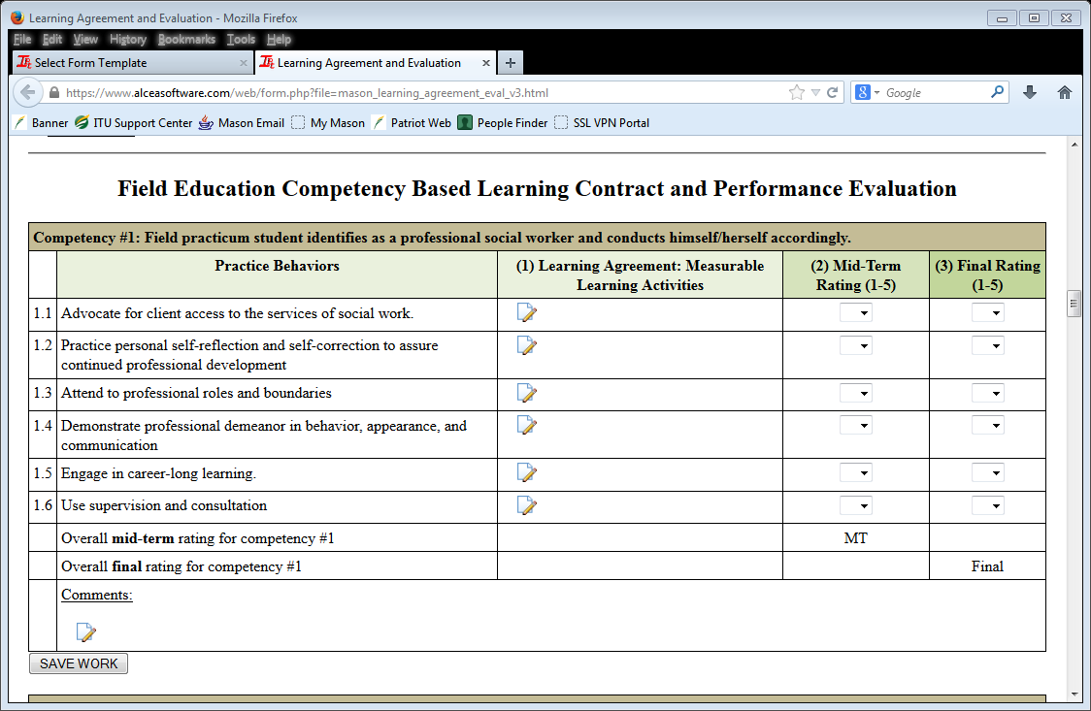

**Learning Agreement - Overview**

1. The learning agreement is a “contract.” It is an agreement between the student and the agency field instructor regarding practicum goals for this semester. It will reflect the kinds of learning experiences the student will have in the agency with respect to the required competencies and practice behaviors. The learning agreement is critical to establishing the expectations for the practicum and is to be created through a collaborative process between the student and agency field instructor as the first order of business each semester.

The learning agreement consists of several parts. First, it will list competencies that are identified by our accrediting organization. Secondly, it will identify practice behaviors, which are specific behaviors that help to build the competencies and finally it consists in of measurable learning activities that describe specific activities that students will engage in while your agency practicum setting.

When Faculty Liaisons from our program visit students in the agency practicum setting, the learning agreement will be an important focal point of discussion to determine how the student is progressing in the practicum. Discussions using this document provide an important blueprint for the design and implementation of the practicum experience.



**Mid-term Evaluation**  (Column ‘2’ on the learning agreement)

1. The Mid-Term Evaluation consists of ratings of the student’s performance approximately mid-way through the semester. The learning agreement is also the evaluation instrument that is used to gauge the student’s progress. It is good practice to set aside time during the weekly supervision meeting PRIOR to the mid-term due date to review the learning agreement goals and assess the degree of progress made toward achieving them. Mid-Term results should help to guide the remaining weeks of the practicum for the term and should indicate areas for improvement and growth. Students are not expected to have reached competence at mid-term and ratings of 3-4 are common. A rating of 5 at mid-term generally indicates either an over valuation of the student’s performance or the creation of a relatively unambitious practice behavior. In order to help students improve their performance, please develop a plan for improvement for areas where the student’s performance is assessed to fall below a competency rating of 3.

**Final Evaluation**  (Column ‘3’ on the learning agreement)

1. The Final Evaluation allows the agency field instructor to rate the student’s performance for the entire semester. Unlike the ratings for the mid-term, final evaluation ratings are factored into the student’s grade for the semester. The faculty field liaison/seminar instructor ultimately assigns the final grade. Agency field instructors are advised AGAINST “rating for a grade”. Rather, the focus in both the mid-term and final evaluations should be an ACCURATE record of the student’s performance of learning behaviors and achievement of learning outcomes.

**B. How to use this document to assess student performance of practice behaviors and achievement of competencies?**

Prior to its implementation as the contract for the field learning experience, the learning agreement will be submitted twice to the faculty field liaison in accordance with the dates contained within the field seminar syllabus. The first submission is a draft of the agreement for which the student will receive feedback from the faculty field liaison. The feedback will reflect the faculty member’s evaluation of the learning agreement and its agreement with the S.M.A.R.T. criteria. After revising the agreement, it will be submitted to the faculty field liaison a second time for grading purposes. After the agreement has been evaluated the final time, it will be used for guiding supervision and serve as the instrument that will be used by the field instructor to conduct the mid-term and final evaluation of the student’s progress toward achieving practice-based competence.

**Measureable Learning Activities**

Measureable learning activities should be constructed using the S.M.A.R.T. format. A rubric for this format will be included in the syllabus for each field seminar and provided to each faculty field liaison. Using the rubric as a guide, each measureable learning activity practice behavior should be worded using very specific, behavioral terms that can be easily measured. Additionally, the behavior must be achievable within the context of the internship experience, hold relevance with respect to the student’s experience, and be time-bound. In other words, it is like a field “treatment plan” and, like a treatment plan, should be reviewed frequently to guide the supervision process and ensure the development of practice competence. When you look at the list of well written measureable learning activities, it should provide a clear and specific overview of the kind of activities that students have been involved in during the semester.

**Developing Practice Behaviors using Measurable Learning Activities (MLAs)**

When developing the measurable learning activities (MLA), the student is expected to take the lead. Agency field instructors/supervisors should collaborate in discussion, review and final approval of the measurable learning activities, but the student is ultimately responsible for creating the learning activities.

In the column headed “Learning Agreement: Measurable Learning Activities” please identify measurable learning activities that correspond to the practice behavior listed using the S.M.A.R.T. criteria.

|  |  |
| --- | --- |
| **S** | **Specific** |
| **M** | **Measureable** |
| **A** | **Achievable** |
| **R** | **Relevant** |
| **T** | **Timely** |

* Question: Using the S. M. A. R. T. criteria, can you detect the difference between the two practice behaviors below?

Bad Example: “Student will become a better social worker”  
Good Example: “Student will co-facilitate 2 process groups per week by Nov. 1”

**Each semester, all of the practice behaviors** identified in the learning agreement template **should be accomplished through an MLA** that the student creates. Further, without exception, at least one practice behavior must be addressed for each competency every semester. In the event that a practice behavior does not fit the student’s plan of learning for the semester, it can be left blank, but must be addressed prior to the ending of the practicum experience. An explanation for omitting the practice behavior should appear in the comments section that accompanies the specific competency.

**Sample**

|  |  |  |  |
| --- | --- | --- | --- |
| **Practice Behaviors** | **Learning Agreement: Measurable Learning Activities** | **Mid Term Rating** | **Final Rating** |
| Demonstrates professional demeanor in communication | Writes weekly memos to the parent council  Writes a weekly supervision journal submitted to field instructor | 2  3 | 3  4 |

***Fall v. Spring Semester MLAs:***  
Although students are at sites for a full academic year, measurable learning activities (MLAs) should be designed to be completed within the semester time frame. For longer-term student projects, it is advisable to break the project into semester “phases” or “steps”. For example, even though an entire project may not be completed during the fall semester, MLAs should reflect that portion of the project (e.g. “research and write psychoeducational group curriculum”) that could be reasonably completed and evaluated within one semester. The spring learning agreement should then build on activities started in the fall (e.g. “implementation of psychoeducational group curriculum”) in addition to introducing new practice behaviors.

***Learning Agreement Submission:***

It is the STUDENT’S responsibility to assure all submission deadlines, per seminar syllabus dates, are met.

**C. Evaluation Rating Instructions:**

The standard by which a field practicum student is rated should reflect the student’s academic status. For example, a 1st semester BSW student’s performance or the Foundation level student’s performance should be measured within the context of what might be regarded as competent practice for a beginning level social work practitioner. Conversely, a 2nd semester, concentration year MSW student’s performance should be measured against the standard of practice for a beginning master’s level practitioner.

The primary goal of the evaluation process is to establish a measure, on a scale of 1-5, which reflects the location of the student on a continuum of competence when engaging in a specific practice behavior. Competence, a rating of “5,” simply means that the student has moved from the level of novice to that of competence. Competence does not mean that the student can be considered “experienced” or that the practice behavior has been “mastered.” Rather, a rating of 5 indicates that the student consistently demonstrates basic competence. Alternately, a rating of 1 is an indication that a student is not able to demonstrate any evidence of developing competence with respect to a practice behavior.

During the evaluation process, the student, agency field instructor and task supervisor (if applicable) should develop ratings of competence based on the specific and measurable practice behaviors contained within the learning agreement. The agency field instructor, however, determines the final ratings and should provide commentary for each competency especially when ratings are particularly low (e.g. ratings of 1-2).

Rating Criteria:

|  |  |
| --- | --- |
| **5** | The field practicum student consistently demonstrates basic competence when engaging in the practice behavior - suggesting no further development of this practice behavior is needed. |
| **4** | The field practicum student demonstrates basic competence when engaging in the practice behavior, but does not do so consistently. |
| **3** | The field practicum student is on track for developing basic competence when engaging in the practice behavior, but does not currently demonstrate basic competence. |
| **2** | The field practicum student has not met expectations in this area, but there are performance indicators that the student can meet the expectations in the near future with additional guidance and direction. |
| **1** | The field practicum student has not met the expectations in this area, and there are no performance indicators of the student’s ability to meet the expectations in this area in the near future even with added guidance and direction |
|  | Please leave the rating column blank if your student has not yet had the opportunity to engage in a practice behavior by the date of the final evaluation and be sure to provide a comment with respect to when the behavior will be developed. Never rate a student with a zero. |

***Comments Sections:***  
Comments may be made under any competency category to further clarify or explain numerical ratings. Again, please be sure to comment on those areas in which you think the field practicum student is in need of improvement (“1-2”ratings). Additional comments may be made at the end of the evaluation.

**NOTE: If the student is a second-year, Concentration MSW student in either the Clinical or Social Change track, a narrative for Competency #10 is REQUIRED.**



**Preparing to Use the Learning Agreement Form**

Students have the primary responsibility to write into the form. The form is located into IPT which is the field software. The following steps will launch you into the process of developing the learning agreement.



1. **Review the Form**

Both students and agency field instructors should review the form. There are 10 competencies and each competency includes a list of practice behaviors that are linked. During the time of the practicum students are expected to have the opportunity to demonstrate each of the competencies and practice behaviors.

2. **Field Instructor Student Discussion**

The field instructor and student should discuss during supervision the plan for the practicum. Since students are not always aware of planned learning activities over the time of the practicum, they will need to work collaboratively with the field instructor. Again, the student has the responsibility to write in the form. Using the learning agreement worksheet, and a copy of the learning agreement, have a discussion about planned activities.

Field Instructor Tasks

* The field instructor should share some of the learning activities that have been planned for the student.
* Review the form as the student is adding content making sure that the learning activities are achievable, relevant to the practicum experience, and specific in terms of time frame.

Student Tasks

* Review the list of activities identified through your discussion with the field instructor.
* Using the learning agreement worksheet, try to identify the broad competency that this activity is related to on the form.
* Identify what practice behavior is related to this activity
* Write a measureable learning activity that is specific and measureable. You can use the worksheet and transfer your measureable learning activities into the form or type directly into the form.
* You are expected to include a measureable learning activity for each practice behavior. When you have completed the form, you should submit the form to your field instructor for review and signature. The faculty liaison should next review the form and sign off.

**Example:**

|  |  |  |  |
| --- | --- | --- | --- |
| **Practicum Activities**  **Learning Plan** | **Competency** | **Practice Behavior** | **Measureable Learning Activity** |
| Complete client intakes | 10 Intervention | Use empathy and other interpersonal skills | Demonstrate appropriate empathy and interpersonal skills when completing client intakes weekly using the IHH intake form. |
| Attend training on crisis intervention |  |  |  |
| Orientation on universal precautions |  |  |  |
| Conduct psychosocial assessment on a minimum of 6 clients | 10 Intervention | Assess client strengths and limitations | Assess client strengths and limitations through completing psychosocial assessments for 6 clients over the Fall semester. |
| Write weekly case notes |  |  |  |
| Complete monthly home visits to homebound clients | 10 Intervention | Develop mutually-agreed upon intervention goals and objectives |  |
| Read and analyze ethics manual | 2 Ethics | Apply strategies of ethical reasoning to arrive at principled decisions |  |
| Participate on the evaluation team | 6 Research informed practice |  |  |
| Meet with supervisor weekly |  |  |  |
| Participate 0n the FAPT assessment team | 10 Intervention | Collect, organize, and interpret client data | Collect, organize and interpret client data by reviewing FAPT cases on a monthly basis. |

**LEARNING AGREEMENT WORKSHEET**

|  |  |  |  |
| --- | --- | --- | --- |
| Planned Practicum Activities | Practicum Behaviors | Competencies | Measureable learning activities |
|  |  |  |  |
|  |  |  |  |
|  |  |  |  |
|  |  |  |  |
|  |  |  |  |
|  |  |  |  |
|  |  |  |  |
|  |  |  |  |
|  |  |  |  |
|  |  |  |  |
|  |  |  |  |
|  |  |  |  |
|  |  |  |  |
|  |  |  |  |
|  |  |  |  |
|  |  |  |  |
|  |  |  |  |
|  |  |  |  |
|  |  |  |  |
|  |  |  |  |
|  |  |  |  |
|  |  |  |  |
|  |  |  |  |
|  |  |  |  |
|  |  |  |  |
|  |  |  |  |
|  |  |  |  |
|  |  |  |  |
|  |  |  |  |
|  |  |  |  |
|  |  |  |  |
|  |  |  |  |
|  |  |  |  |
|  |  |  |  |

**George Mason University**

**Department of Social Work**

**Department of Field Education**

**Rubric for S.M.A.R.T. Learning Agreements**

|  |  |  |  |  |
| --- | --- | --- | --- | --- |
|  | **Outstanding**  **Achieves Criteria Always or Almost Always** | **Good**  **Achieves Criteria Consistently, but not Always or Almost Always** | **Fair**  **Achieves Criteria Intermittently** | **Unacceptable**  **Randomly or Rarely Achieves** |
| **Goals are Specific**  **(20)**  **Points: _______** | **(10 pts. each)**  Goals are simplistically/clearly written in unambiguous terms  Goals clearly define what the student will do  - I.D.s who is involved  - I.D.s What will be accomplished  - I.D.s Where the goal will be accomplished  - I.D.s how the goal will be accomplished | **(8 pts. each)**  Goals are simplistically/clearly written in unambiguous terms  Goals clearly define what the student will do  - I.D.s who is involved  - I.D.s What will be accomplished  - I.D.s Where the goal will be accomplished  - I.D.s how the goal will be accomplished | **(7 pts. each)**  Goals are simplistically/clearly written in unambiguous terms  Goals clearly define what the student will do  - I.D.s who is involved  - I.D.s What will be accomplished  - I.D.s Where the goal will be accomplished  - I.D.s how the goal will be accomplished | **(6 pts. each)**  Goals are unclear and, in some cases, vague.  Goals clearly define what the student will do  - I.D.s who is involved  - I.D.s What will be accomplished  - I.D.s Where the goal will be accomplished  - I.D.s how the goal will be accomplished |
| **Goals are Measurable**  **(20)**  **Points: _______** | **(20 pts. each)**  Concrete Criteria for measuring progress have been included. Each goal clearly answers the questions:  -How much?  -How many?  -How will it be clear that the goal has been accomplished? | **(16 pts. each)**  Concrete Criteria for measuring progress have been included. Each goal clearly answers the questions:  -How much?  -How many?  -How will it be clear that the goal has been accomplished? | **(14 pts. each)**  Concrete Criteria for measuring progress have been included. Each goal clearly answers the questions:  -How much?  -How many?  -How will it be clear that the goal has been accomplished? | **(12 pts. each)**  Concrete Criteria for measuring progress have been included. Each goal clearly answers the questions:  -How much?  -How many?  -How will it be clear that the goal has been accomplished? |
| **Goals are Attainable**  **(20)**  **Points: _______** | **(5 pts. each)**  Goals realistically reflect student’s knowledge level  Goals realistically reflect student’s skill level  Goals realistically reflect student’s ability level  Goals are not too challenging/extreme or so unchallenging as to be meaningless | **(4 pts. each)**  Goals realistically reflect student’s knowledge level  Goals realistically reflect student’s skill level  Goals realistically reflect student’s ability level  Goals are not too challenging/extreme or so unchallenging as to be meaningless | **(3 pts. each)**  Goals realistically reflect student’s knowledge level  Goals realistically reflect student’s skill level  Goals realistically reflect student’s ability level  Goals are not too challenging/extreme or so unchallenging as to be meaningless | **(2 pts. each)**  Goals realistically reflect student’s knowledge level  Goals realistically reflect student’s skill level  Goals realistically reflect student’s ability level  Goals are not too challenging/extreme or so unchallenging as to be meaningless |
|  | **Outstanding**  **Achieves Criteria Always or Almost Always** | **Good**  **Achieves Criteria Consistently, but not Always or Almost Always** | **Fair**  **Achieves Criteria Intermittently** | **Unacceptable**  **Randomly or Rarely Achieves** |
| **Goals are Relevant**  **(20)**  **Points: _______** | **(5 pts each)**  Goals are consistent with one another  Goals reflect student’s willingness AND ability  Goals are congruent with practicum site’s mission  Goals reflect the need of the client population served | **(4 pts. each)**  Goals are consistent with one another  Goals reflect student’s willingness AND ability  Goals are congruent with practicum site’s mission  Goals reflect the need of the client population served | **(3 pts. each)**  Goals are consistent with one another  Goals reflect student’s willingness AND ability  Goals are congruent with practicum site’s mission  Goals reflect the need of the client population served | **(2 pts. each)**  Goals are consistent with one another  Goals reflect student’s willingness AND ability  Goals are congruent with practicum site’s mission  Goals reflect the need of the client population served |
| **Goals are Time-limited**  **(20)**  **Points: _______** | **(10 pts. each)**  Goals have time-specific end points (e.g. target dates)  The time-specific end points are realistic (not more/less time than is needed to accomplish the goal | **(8 pts. each)**  Goals have time-specific end points (e.g. target dates)  The time-specific end points are realistic (not more/less time than is needed to accomplish the goal | **(7 pts. each)**  Goals have time-specific end points (e.g. target dates)  The time-specific end points are realistic (not more/less time than is needed to accomplish the goal P | **(6 pts. each)**  Goals have time-specific end points (e.g. target dates)  The time-specific end points are realistic (not more/less time than is needed to accomplish the goal |
| **TOTAL: _____**  **GRADE: _____** | **COMMENTS:** | | | |

Created 10/27/12