2015-2016-1 B

选择：
1-5：BDBCD
6-10：BCBBC
11-15：ACADD
16-20：CCDDA
判断
1 F 不能全部检测出来
2 F slotted ALOHA 是 unslotted ALOHA的两倍
3 T
4 F RIP使用的是DV
5 T
6 T
7 T
8 F 在GBN中因为是直接丢弃失序的包，所以不要求窗口大小小于序列号的一般，在SR中才需要满足这样的条件。
9 F 毒性逆转可以避免只有3个节点的环存在的“count to infinity”问题。但是在节点更多的情况下，不能完全避免
10 F TCP提供可靠数据传输，而UDP提供不可靠数据传输。使用UDP可能会造成应用层数据丢失。但是UDP由于无需3次握手，速度更快。（我写的这个解释还不够全面）
简答题
- 由于第一次Alice访问www.gonzaga.edu时，local DNS需要访问edu的TLD DNS服务器，于是在local DNS就缓存了edu的TLD DNS服务器的ip地址。于是当Bob要访问www.seattleu.edu时，local DNS无需再去访问root DNS来得到TLD DNS服务器的ip地址.
- 从该学校到www.gonzaga.edu和到www.seattleu.edu的路径存在相同的一段，由于之前路由器已经通过ARP获取了需要的MAC地址，在Bob访问网站时，这段路径上便无需去获取MAC地址。
（我自己只想到了这两点，欢迎大家的答案！）

Suppose you were charged with putting together a LAN to support IP telephony (only) and that multiple users may want to carry on a phone call at the same time. Recall that IP telephony digitizes and packetizes voice at a constant bit rate when a user is making an IP phone call.
2(网上找到的答案，主观题，随意发挥）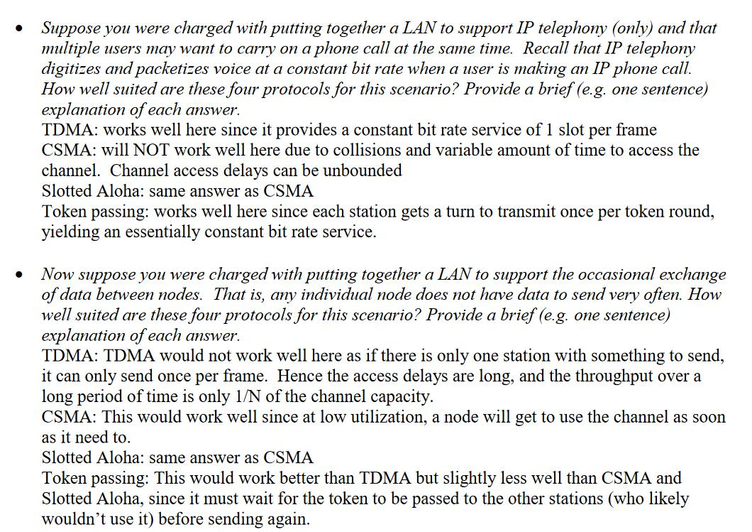

3（没有图,怎么做嘛）
4.Fill in the value of the congestion window size (number of segments) for each transmission round. Assume the threshold starts at 20 segments and the following events occur: (5 points)
- triple duplicate ACK during round 4
- timeout during round 9
- triple duplicate ACK during round 14
Round | Congestion Windows size | Round | Congestion Windows size
1 | 1 | 9 | 11
2 | 2 | 10 | 1 (threshold=5.5)
3 | 4 | 11 | 2
4 | 8 | 12 | 4
5 | 4+3=7 (threshold=4) | 13 | 5
6 | 8 | 14 | 6
7 | 9 | 15 | 3+3=6 (threshold=3)
8 | 10 | 16 | 7

四．
1.
- t+m(k+h)/R
- m(K+2h)/R
C.t+(K+h)/R
2.
A.3c:eBGP
3a:iBGP
1c:eBGP
1d:iBGP
B. It will be l1 because this interface begins the least cost path from ld towards the gateway router lc.
C. It will be l2 since both routes have equal AS-PATH length but l2 begins the path that has the closest NEXT-HOP router.
D.It will be l1 since l1 begins the path that has the shortest AS-PATH.
（大部分答案都是几个同学讨论出来的，可能有些会有问题，如果发现有错误的地方，大家要及时指出了哦！避免误导了其他同学）

