Gratitude Practice Lesson — Learning Materials
【Instructions for Use】
- This material is divided into three parts: 【Teachings】, 【Reflection】, and 【Practice】
- Self-study method:
1) 【Teachings】: Read the teaching content and outline the main points.
2) 【Reflection】: Write down your personal reflections in response to each reflection question.
3) 【Practice】: Before the group discussion, complete the following exercises: 2 Gratitude Journals, 2 Webs of Conditioned Arising.
- Group-study method: Discuss and share reflections on each question from the 【Reflection】 section (the group-study process is at the end of the material).
- Class-study method: The facilitator organizes discussion and sharing based on the PPT.
- Follow-up training method: After this lesson's discussion, all students practice according to the 'Follow-up Practice Plan' and share their experiences.
【Teachings】
I. Understanding Gratitude
Definition: To feel gratitude for everything one has, and to appreciate all those who have contributed.
In Buddhism, gratitude is not limited to any specific person or event. Buddhism teaches that all sentient beings are interdependent, and no one can survive without family, society, the masses, and nature. Therefore, we must face everything with a heart of gratitude.
— Excerpted from 'Interview: The Spirit of Gratitude in Chinese Culture'
Without a grateful heart, we tend to feel indifferent toward others, or even develop opposition, feeling that the world is full of enemies who are all plotting against us. When we look at people with such a mindset, we feel displeased with everyone, and others feel displeased with us too. If we recognize that every day we are enjoying what others provide—not only the care and help from parents, relatives, and friends, but also the services provided by people in all walks of society, and even the birds, fish, and insects that help build the ecological environment—we can look upon all sentient beings with gratitude, feeling joy at the sight of everything. When we view sentient beings in this way, we will develop a sense of affinity, bringing joy to others, being accepted by them. This harmony is a supporting condition for happiness.
— Excerpted from 'Enterprise and Life'
The 'field of gratitude' (恩田) means facing those who have been kind to you—such as parents and elders, siblings, relatives and friends, including all sentient beings, and even the mountains and rivers and the great earth—with a heart of gratitude and giving back. Because our lives cannot do without the help of others, nor without the sun, moon, sky and earth, mountains, rivers, plants, and trees. It is precisely because all these exist that we can live at ease and without worry. Therefore, we must face all of this with gratitude and do our best to give back to others, including caring for society and protecting the environment. When our heart is filled with gratitude, we will feel joy at the sight of everything. Gratitude is not only the source of merit and virtue; it is in itself a healthy, positive, and joyful state of mind. As we give back, we benefit immediately. On the contrary, if we know no gratitude and always look at things with a negative mindset, feeling that everyone owes us, the result can only be our own suffering.
— Excerpted from 'The Mind Creates Happiness'
II. Why Should We Cultivate a Grateful Heart? (Reflecting on the Benefits)
According to Robert Emmons, a leading figure in gratitude research (Robert Emmons & Mishra, 2012), practicing gratitude can bring eight different benefits, including:
1) Best Returns: Gratitude allows us to extract more from positive experiences. Better Relationships: Gratitude can strengthen our interpersonal relationships. When we truly recognize the value of friends and family, we are likely to treat them better. When we are kind to them, they are kind to us in return.
2) Fewer Negative Comparisons: Expressing gratitude reduces the likelihood of comparing ourselves with others. We become grateful and content with what we have (friends, family, home, health), and are less likely to feel bad about what we lack.
3) Fewer Negative Emotions: When we express gratitude, we may experience fewer negative emotions. For example, when we are grateful, we are less likely to feel guilt, greed, or anger.
4) Slow Adaptation: How long does the joy of having something new last? At first, we feel happy, but this happiness does not last long. By appreciating the meaning and value of things and experiences, we can slow down this adaptation process, allowing the experience of joy to last longer.
5) Achieve the best returns.
6) Self-worth and Self-esteem: Gratitude can enhance our self-worth and self-esteem, making us more confident and effective, and helping us avoid self-pity, a state of tending to feel like a victim.
7) Coping with Stress: Gratitude can help us cope with stress and adversity. After the initial shock, gratitude can help us evaluate what is most important in life.
8) Helping Others: Grateful people are more likely to help others. They become more aware of acts of kindness and caring, and feel the need to reciprocate. They are less likely to be materialistic, and more likely to cherish what they have.
Buddhism holds that a grateful heart can bring us the following benefits:
1) Gratitude is the source of merit and virtue
2) It makes the mind gentle and joyful
3) It generates affinity, brings joy to sentient beings, is accepted by sentient beings, and builds good connections with them
4) It contributes to social harmony
5) It is the foundation of love and compassion
III. Cultivating Gratitude
We do not live in isolation in this world. We need our parents to raise us and our teachers to instruct us. Even after we become adults, we still cannot do without the offerings of society. Otherwise, we would have to farm our own fields, weave our own cloth, and manufacture everything we need ourselves. Just considering our daily clothing, food, housing, and transportation, how much help and effort do we receive from sentient beings? Therefore, every sentient being is someone who has been kind to us and someone we need to repay with a grateful heart. Modern people tend to emphasize the feelings of the 'self,' but from the Buddhist perspective, this 'self' is nothing more than a thoroughgoing, superlative deception. Misled by this feeling, people easily set themselves in opposition to the world, even regarding each person as a potential enemy, leading to psychological illnesses such as loneliness, self-isolation, and even depression. If we change our perspective and think that everyone has been kind to us, and the whole world is serving us, then we will not find any stranger when we look at anyone.
【Reflection】
Based on the corresponding teaching content, think about and answer the following questions:
I. Understanding Gratitude
1. What kind of mind-state is gratitude? What is special about the gratitude spoken of in Buddhism?
2. What happens if one lacks a grateful heart?
3. How can one view all sentient beings with a grateful heart?
4. In the 【Practice】 section below, write a Gratitude Journal. During group discussion, share: 1) the content of my Gratitude Journal; 2) what effect does this simple practice have? Do I need to continue doing it? Why?
II. Why Should We Cultivate Gratitude
1. Buddhism teaches that a grateful heart can bring us which benefits? For each of these benefits mentioned by Buddhism, combine with observations from real life and share examples.
2. Reflect for yourself: Do I need to cultivate a grateful heart? Why? Write down the reasons why I want to cultivate gratitude.
III. Cultivating Gratitude
1. In daily life, whose efforts do I usually take for granted, rarely feeling gratitude toward them? Please list them.
2. In daily life, which people do I regard as completely unrelated strangers? What kind of attitude and behavior do I have when facing these 'strangers'?
3. In the 【Practice】 section below, draw a Web of Conditioned Arising. During group discussion, share: 1) Which Webs of Conditioned Arising did I draw? 2) What insights did I gain through the Web of Conditioned Arising practice?
4. During group discussion, all members together complete one 'Web of Conditioned Arising' exercise. Take 'our meeting here at this moment' as the event to be grateful for, and draw the 'Web of Conditioned Arising' for this event. Share: What conditions gave rise to 'our meeting here at this moment'? Which conditions particularly moved me? What thoughts and feelings did I have through this exercise? (Please prepare pens and paper in advance.)
【Practice】
Exercise 1: Gratitude Journal
Carefully observe the people, events, and things in life that are worthy of gratitude. Write them down using your phone or pen and paper—the more, the better. Then evaluate your 'level of gratitude' for each item (1–5 points, where 5 means extremely grateful). After finishing, review your list, experience the sense of gratitude arising in your mind, and rest in that feeling for 30 seconds.
Day 1
Gratitude Journal:
Today's reflection on gratitude practice:
Day 2
Gratitude Journal:
Today's reflection on gratitude practice:
Exercise 2: Web of Conditioned Arising
Modern society's 'atomized' way of life often gives people an illusion of isolation. In fact, all lives are closely connected and interdependent.
1) Please choose one thing you feel grateful for and write it in the center of the paper.
2) List the conditions (people, events, things) that gave rise to this thing one by one, and connect them with lines. Use squares to represent events and things, and circles to represent people.
3) Each person or event arises from conditions and does not exist independently. Next, list the conditions that gave rise to them in turn, forming a 'Web of Conditioned Arising.' Refer to the example below:
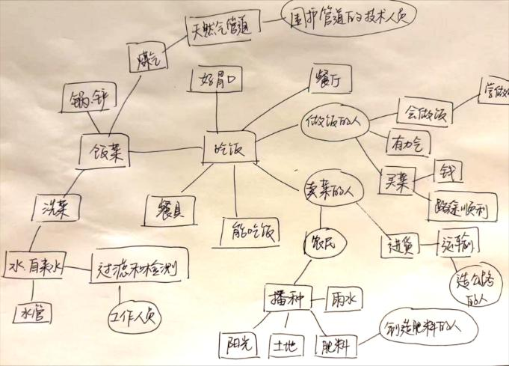
My Exercise 1:
My Exercise 2:
Group Discussion Process:
I. Preliminaries: Three Recitations of the Holy Name of the World-Honored One + Mahayana Verses of Homage
II. Reverently Listening to the Metta Sutta (Discourse on Loving-kindness)
III. Discussion and sharing based on the above reflection questions and exercises.
IV. Recite together: Gratitude Dedication Prayer
Grateful for the gifts of nature,
Grateful for the nurturing of parents,
Grateful for the instruction of teachers,
Grateful for the nourishment of our land,
Grateful for the support of all sentient beings,
Grateful for the protection of the Triple Gem.
May we feel gratitude for all that we have, and may we gladly give because of our gratitude.
May this gratitude bring comfort to sentient beings, awaken those sealed hearts, and dissolve all barriers between self and others.
May people open their hearts in gratitude and care for one another.
May the world be filled with warmth through gratitude, and may peace be everywhere.
V. Dedication of Merit
Follow-up Practice Plan:
Daily Formal Loving-Kindness Practice + Daily Gratitude Practice
Gratitude Journal / Web of Interdependent Origination — Week 2: Cultivate loving-kindness toward oneself — 15 min. 1. Practice requirement: Formal + informal practice at least 5 days per week. 2. Daily sharing: Share your daily practice and insights in the class group. 3. After each weekly class session, 2–3 students share their practice reflections from the week.

