星海实业财务风险分析综合实训分析报告
目录
一、相关的理论基础 2
二、总体分析思路与目标 2
1. 分析目标 2
2. 数据需求 2
3. 分析工具与方法 2
三、数据的获取与处理 3
1. 数据来源 3
2. 数据结构说明 3
3. 数据预处理步骤 3
1. 财务风险类别分布 4
2. 样本时序分布 5
3. 相关性分析 6
4. 财务风险预测模型训练 7
5. 特征重要性分析 8
五、分析结论 9
六、附录 9

一、相关的理论基础
财务风险是指企业在生产经营、投资融资等经济活动中，由于各种不确定因素的影响，导致企业无法如期偿付债务或产生经济损失的可能性。财务风险管理的核心在于及时识别、准确测量和有效控制企业的财务风险。
常用的财务风险评价方法包括：
- 财务比率分析法：通过企业资产负债表、利润表、现金流量表计算关键财务指标（如流动比率、资产负债率、利息保障倍数等）进行风险判断。
- 多元统计分析法：包括因子分析、判别分析、Logistic回归等，用于财务预警建模。
- 机器学习与数据挖掘方法：如决策树、随机森林、支持向量机（SVM）、XGBoost等，通过数据驱动方式建立财务风险预测模型。
- SMOTE过采样技术：用于解决企业财务风险样本不平衡问题，防止分类器偏向多数类。
本次分析重点采用机器学习中的XGBoost分类模型，结合SMOTE采样技术进行建模，同时通过相关性分析、特征重要性分析等方法进行财务风险的深入评价。

二、总体分析思路与目标

1. 分析目标
- 构建适用于星海实业有限公司的财务风险预测模型；
- 找出影响企业财务风险的核心特征指标；
- 通过可视化手段直观呈现财务风险特征与分布。

2. 数据需求
- 企业财务报表数据（如资产、负债、利润、现金流等财务指标）
- 企业标签数据（是否存在财务困境）

3. 分析工具与方法
- 数据分析工具：Python、pandas、matplotlib、seaborn
- 机器学习工具：SMOTE过采样、XGBoost分类器、标准化处理
- 可视化工具：相关性热力图、类别分布图、特征重要性条形图

三、数据的获取与处理

1. 数据来源
- 本数据集来自 Kaggle 平台，数据集名称为 Financial Distress Prediction。

2. 数据结构说明
列名 | 含义
Company | 企业不同时期编号
Time | 时间周期，数据为面板数据（时序长度1~14期）
Financial Distress | 财务困境标签，低于 -0.50 定义为高风险企业，标签为 1
x1 ~ x83 | 企业财务与非财务指标，其中 x80 为类别型变量，其他为数值型
数据特点：
- 数据属于时间序列样本不平衡数据。
- 总共 136 个企业存在财务困境，3546 个企业样本处于正常状态。

3. 数据预处理步骤
- 缺失值处理： 使用均值填补缺失数据。
- 去重处理： 删除重复企业记录，避免数据冗余。
- 类别特征处理： x80 特征使用标签编码进行转换。
- 标签定义： Financial Distress ≤ -0.5 标记为高风险企业，标签为 1；其余标记为 0。
- 样本划分： 按要求将数据随机划分为 70% 训练集，30% 测试集。
- 数据标准化： 使用 Z-score 标准化处理各特征，消除量纲影响。
- 样本平衡处理： 通过 SMOTE 合成少数类样本，防止模型偏向多数类。
四、财务风险评价与可视化

1. 财务风险类别分布
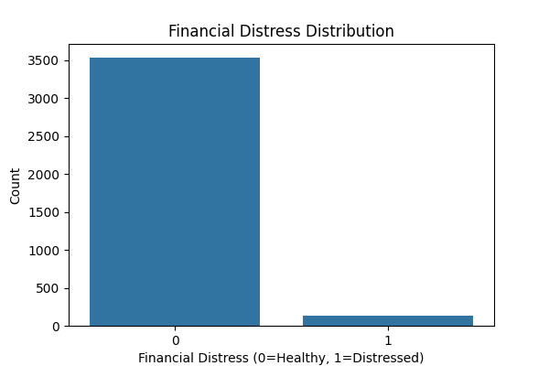
财务困境时期的企业样本在整个数据集中所占比例非常低，明显处于样本类别极度不平衡的状态。如果直接使用原始数据进行模型训练，模型很可能会偏向预测大多数类别（健康企业），从而忽视对财务困境企业的有效识别。这种情况下，模型虽然表面上准确率较高，但对高风险企业的预测效果会显著降低，实际应用价值不足。因此，必须通过如SMOTE（合成少数类过采样技术）等采样技术对数据进行平衡处理，增加少数类样本的比例，从而提升模型对财务困境企业的识别能力和分类性能。
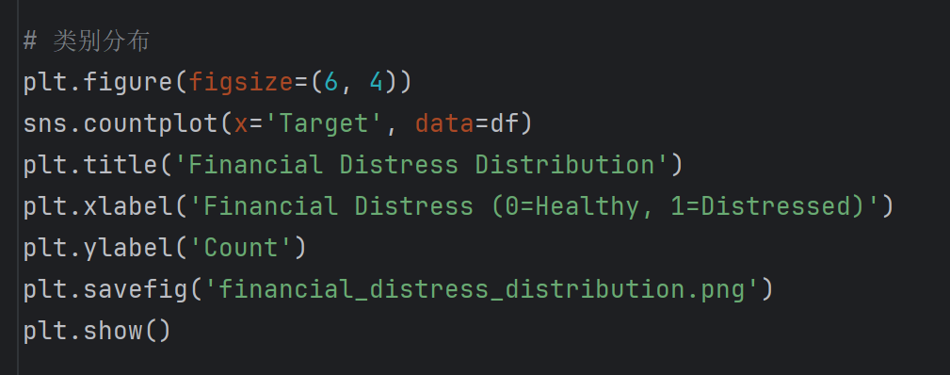

2. 样本时序分布
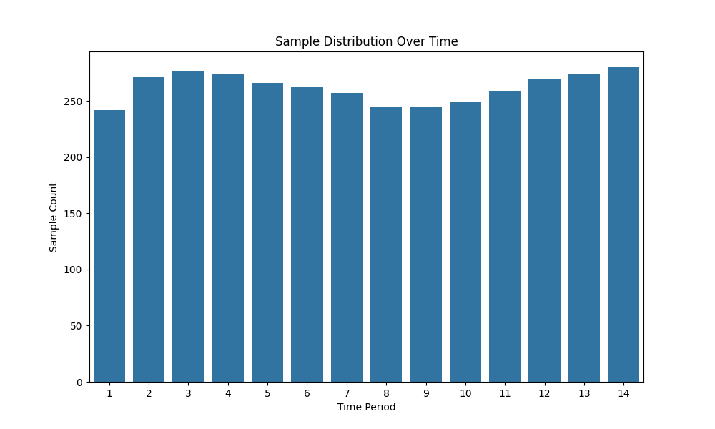
企业样本在各时间段的分布较为均匀，没有出现某一时间段样本数量异常集中的情况。具体来看，时间周期从1到14的样本数量大致在242到280之间，波动范围较小，说明数据集在时间维度上没有明显的偏差或异常。因此，时间序列模型能够较好地适应这种样本分布，进行趋势分析和预测。同时，由于各时间段数据量较为均匀，模型训练时不会受到某一时间段样本过多或过少的影响，从而确保了分析结果的稳定性和可靠性。
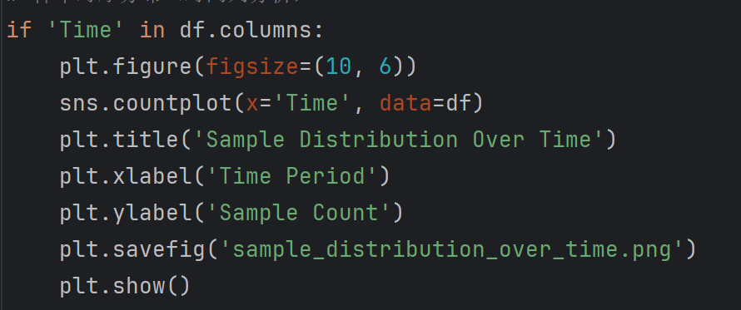

3. 相关性分析
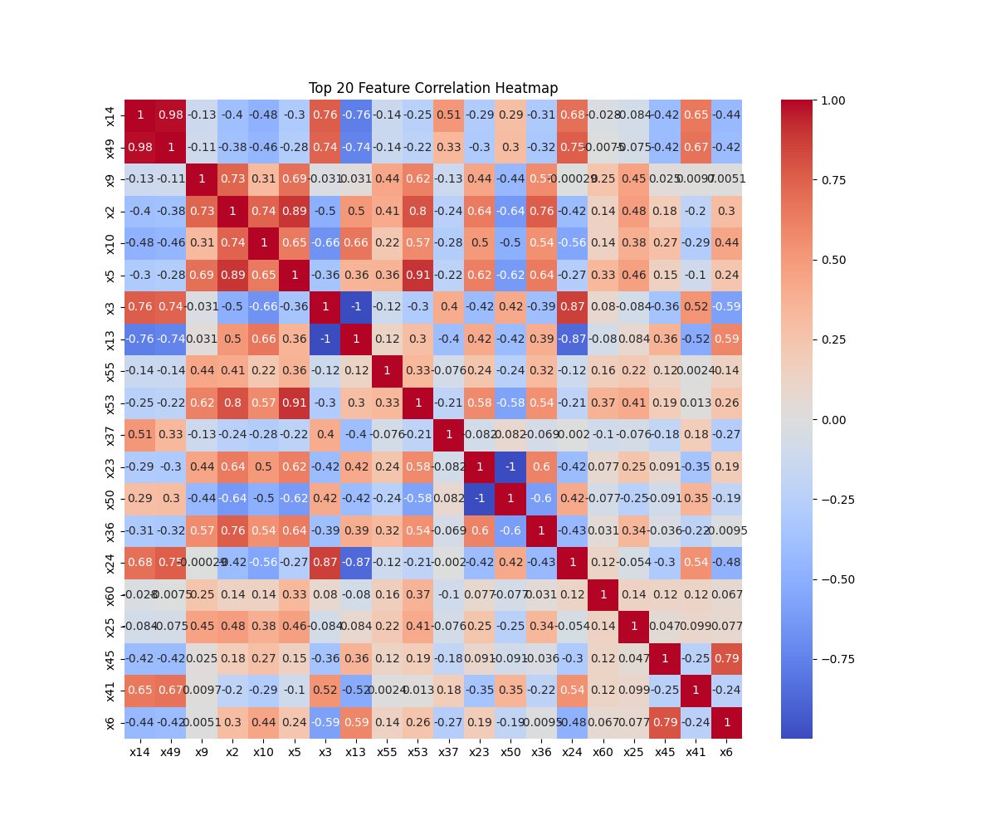
与企业财务风险高度相关的特征主要涉及流动性、资本结构、资产质量等核心财务指标，例如 x14（流动比率）、x49（负债率）、x9（总资产回报率）等。这些指标反映了企业的短期偿债能力、资本结构、盈利能力等关键财务状况，对于评估企业是否可能陷入财务困境起到了至关重要的作用。通过相关性分析可以发现，部分特征之间存在较强的相关性，如 x2（资产负债率）与 x10（负债总额）之间的高度相关性，以及 x5（存货周转率）与 x3（应收账款周转率）之间的相关性，这可能导致冗余信息的存在。因此，在实际建模过程中，为避免模型过拟合，可能需要对这些高度相关的特征进行适当的降维处理或特征选择，以提高模型的泛化能力和预测准确性。
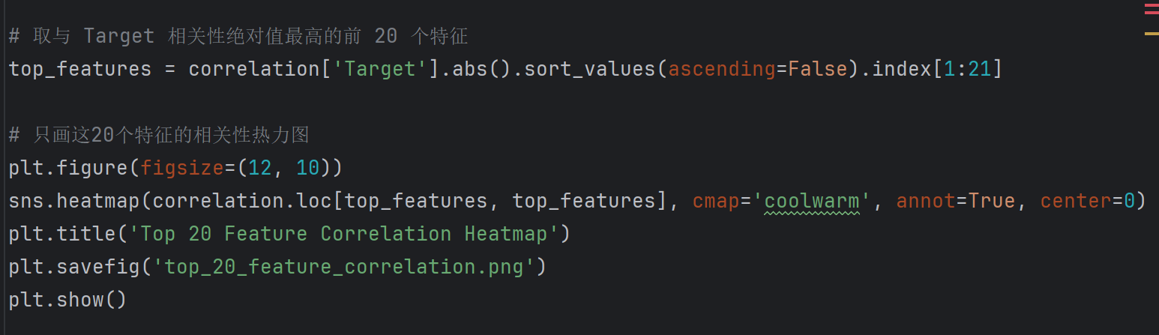

4. 财务风险预测模型训练
使用 XGBoost 分类器，训练并预测测试集结果，模型性能如下：
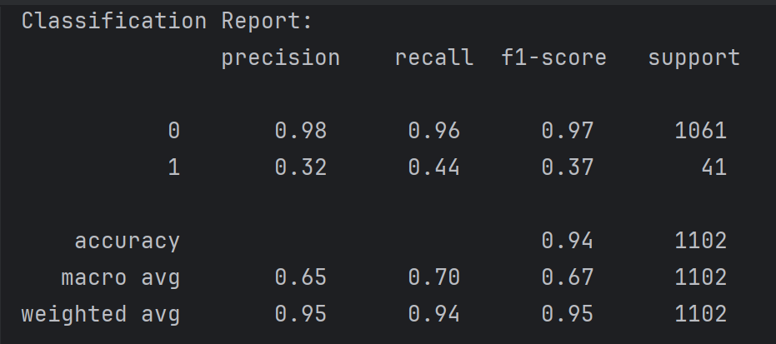
模型整体准确率达到了 94%，表明其在健康企业（标签为 0）的预测上具有较高的准确性。具体来看，模型在预测健康企业时，精确度（precision）为 98%，召回率（recall）为 96%，F1-Score 达到了 0.97，显示出模型能够准确识别大部分健康企业。然而，针对财务困境企业（标签为 1），由于数据集的不平衡性，模型在此类别的表现相对较差，精确度为 32%，召回率为 44%，F1-Score 仅为 0.37。这一结果表明，尽管模型总体准确率较高，但在财务困境企业的预测能力上仍有待提高。为此，未来可以尝试采用更多的采样方法（如 SMOTE）来改善对少数类的预测效果。整体而言，模型的加权平均 F1-Score 为 0.95，说明在处理整体数据集时，模型的表现依然优秀，具备较强的财务风险预测能力，但仍需要对少数类样本进行更细致的优化。
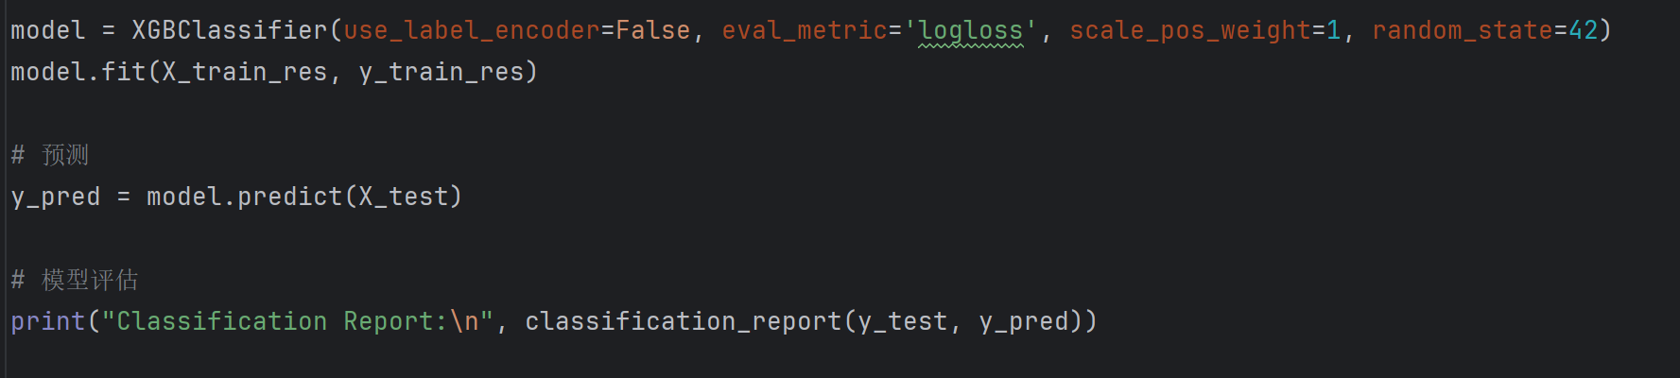

5. 特征重要性分析
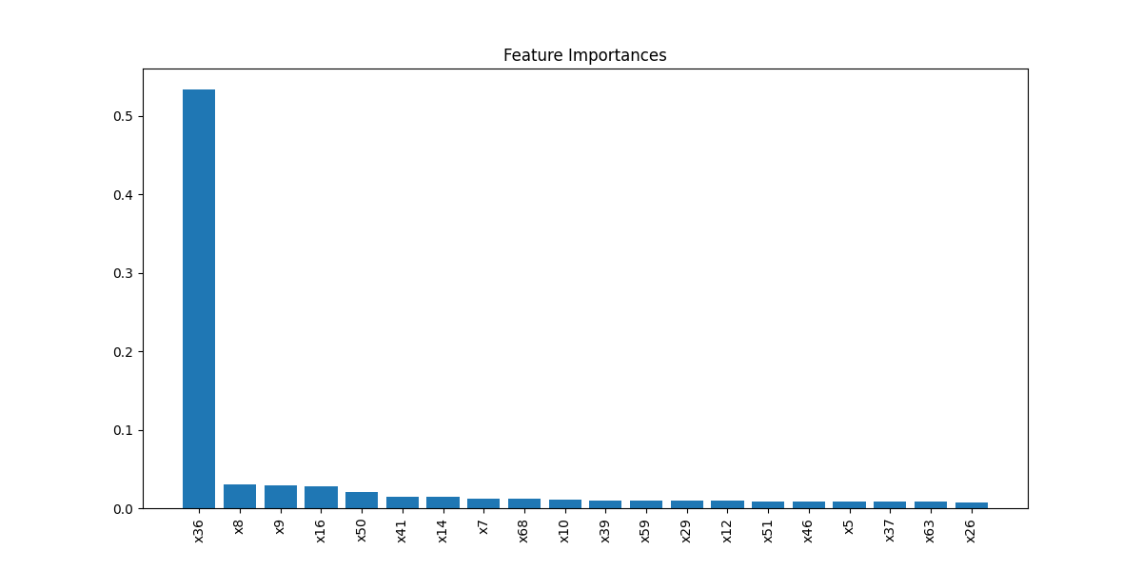
最重要的特征主要涉及与企业偿债能力、负债结构、现金流状况等财务健康指标密切相关的财务特征。例如，x36（可能与流动性或偿债能力相关）作为最重要的特征，具有 0.53 的重要性，反映了企业的短期偿债能力，突出了流动资金管理对财务风险评估的关键作用；同时，x8（可能与负债结构相关）、x9（可能涉及资产质量）、x16（可能与现金流状况相关）等特征，也在财务健康的评估中扮演重要角色。这些财务指标表明，企业的偿债能力、负债结构和现金流等核心财务因素，在风险识别中具有决定性作用。特别是 x36，其高重要性可能代表了企业的流动性状况或其他偿债能力指标，因此，它在预测企业是否可能陷入财务困境方面至关重要。整体来看，企业的短期和长期财务稳定性，对财务风险的评估与预测具有不可或缺的作用。
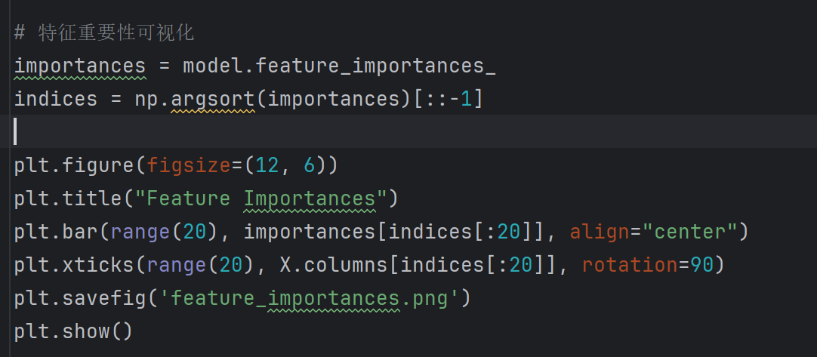

五、分析结论
主要结论
- 星海实业有限公司的企业财务风险受流动性、资产负债结构和盈利能力等财务指标显著影响；
- 样本类别极度不平衡，通过 SMOTE 技术调整后，模型预测效果良好；
- 构建的 XGBoost 模型能够高效、准确地识别企业财务风险。
风险管理建议
- 企业应密切关注流动资产与短期负债比例，优化资产结构，降低财务杠杆；
- 应加强现金流管理，确保日常偿债能力，防止出现短期资金断裂；
- 建议公司管理层建立财务风险动态预警机制，及时掌握风险企业的发展变化。
后续研究方向
- 后续可引入企业外部环境数据（如行业景气度、宏观经济指标）进一步完善风险预测模型；
- 可尝试时间序列深度学习模型（如LSTM）预测企业动态财务风险；
- 推荐扩展更多实际企业数据，提高模型的行业适配性和通用性。

六、附录
代码是：星海实业财务分析.py
数据来源：Kaggle
描述性统计数据：（data_description.csv）
,Company,Time,Financial Distress,x1,x2,x3,x4,x5,x6,x7,x8,x9,x10,x11,x12,x13,x14,x15,x16,x17,x18,x19,x20,x21,x22,x23,x24,x25,x26,x27,x28,x29,x30,x31,x32,x33,x34,x35,x36,x37,x38,x39,x40,x41,x42,x43,x44,x45,x46,x47,x48,x49,x50,x51,x52,x53,x54,x55,x56,x57,x58,x59,x60,x61,x62,x63,x64,x65,x66,x67,x68,x69,x70,x71,x72,x73,x74,x75,x76,x77,x78,x79,x80,x81,x82,x83
count,3672.0,3672.0,3672.0,3672.0,3672.0,3672.0,3672.0,3672.0,3672.0,3672.0,3672.0,3672.0,3672.0,3672.0,3672.0,3672.0,3672.0,3672.0,3672.0,3672.0,3672.0,3672.0,3672.0,3672.0,3672.0,3672.0,3672.0,3672.0,3672.0,3672.0,3672.0,3672.0,3672.0,3672.0,3672.0,3672.0,3672.0,3672.0,3672.0,3672.0,3672.0,3672.0,3672.0,3672.0,3672.0,3672.0,3672.0,3672.0,3672.0,3672.0,3672.0,3672.0,3672.0,3672.0,3672.0,3672.0,3672.0,3672.0,3672.0,3672.0,3672.0,3672.0,3672.0,3672.0,3672.0,3672.0,3672.0,3672.0,3672.0,3672.0,3672.0,3672.0,3672.0,3672.0,3672.0,3672.0,3672.0,3672.0,3672.0,3672.0,3672.0,3672.0,3672.0,3672.0,3672.0,3672.0
mean,182.08442265795208,7.528322440087146,1.040256690446623,1.3878197167755992,0.12970580785947713,0.6157691693899783,0.8681598652559913,0.15494915207788673,0.10671681176198257,0.7840311674836601,39.27436099800108,0.33261031173202615,0.13626256239379084,0.6388347690631807,125273.03225199725,0.38423050000000003,2.438321544117647,8185.968999468527,-25.039035735242376,2058.5771006311465,0.04137964879629629,77.54913726379901,0.10399870468137255,1.4496631433496732,14.19506476096269,0.273236058006536,0.5321178671023965,996.000715803377,13.28817873093682,-77.48266887161763,0.2025752829656863,0.08365133157679738,0.35482443311546846,358087.1342284101,379.8674631484204,0.8631409891067537,2859.2815645489027,68878.38610012579,0.24032409335784316,0.31206299507625274,15.149439680678107,120.23790107371185,0.2600970891285403,3.033581138496732,0.4272936422303922,11.526578881808279,3.3214081933823527,0.14924530368191719,0.298760697333878,1490.8902729621461,2484.105343137255,2.126259614106754,0.7267638899782135,12.929332298474945,-21.25244204390796,0.20730362121459697,3411.267857357298,0.007701808393246186,0.23741289894880177,1.027089601309913,-0.010017926574074073,-6.869395085909587,0.11380190128267974,2.6947383308551194,3.456374084422658,1.2992246023965142,-0.7038182900326799,31.677401805555554,28.245979030501086,11.459051470588236,15874.639433551198,21.47237655228758,17.863012799564274,23.301359547930286,1.9235013861655774,30.40716612200436,86.8398216230937,91.92050571895423,89.11590795206973,17.780855392156862,15.19870806100218,-2.6643045070806104,19.714596949891067,1.1004883722603485,13.122276688453159,33.044934640522875
std,117.02463592088273,4.064015619380814,2.652227144013065,1.4529259026155565,0.12001300488123953,0.17790418133928057,0.5719518614153843,0.12490402260343682,0.21055461701140718,1.0336061663073919,4305.68803876381,0.34613480151763903,0.1389782130204845,0.20198576720026928,1468207.1803030558,0.17790447703650478,2.377306587562073,108672.54852160395,1231.6236093377033,60229.264125467205,0.04537934410120116,3256.4691214371674,0.23102358265163447,0.9687047658625236,227.2613176328394,0.17117378491342883,0.18246924424657845,1822.605136832703,1.6140000908582233,4759.884901875533,0.28589771195429625,0.0929910026811374,0.17070293196416922,8275935.84585111,10444.296574642787,0.14075091085405692,76330.68499847372,2337750.506747631,0.2948399351636154,0.5043556218981825,420.1642664510686,5128.434480710312,0.18486620216499744,3.1870301903242915,14.291207569950874,136.30718091674092,58.38243815430787,0.7642872198290478,0.71208774055751,45586.374521854385,2927.820443934819,2.162011078958459,0.17117373569026703,1.7615269572440924,1209.4686753448852,0.13016498079823147,14441.801918201718,0.41661742187501244,0.1398990541055421,25.6367785123864,0.02656664847254006,290.2767316094344,0.08949362690313138,3.922625509698738,6.953459496523883,8.738036984804337,12.32198937064517,43.85258611218899,6.146999025030445,0.9528581594854935,10026.105023845097,97.19193833488472,7.119361093093161,17.834175467033614,1.469195613041633,3.7145116039182104,16.70620903287495,64.6565036378026,64.34938249883768,2.0401516114532767,2.828648181025506,8.192663334407209,7.5085876124203965,2.666732713508671,9.465907482033971,13.714562921095041
min,1.0,1.0,-8.6317,0.07517,-0.25808,0.016135,5.35e-07,-0.26979,-0.62775,0.03516,-145000.0,-3.6112,-0.31866,0.021491,-2620000.0,0.032101,0.0164,3.54e-06,-35758.0,0.0,0.0001016,0.0,0.00012744,2.72e-06,7.73e-07,-0.55385,0.016135,-3374.6,8.1951,-288000.0,-0.49944,0.0,0.0020823,0.0,0.01006,0.049372,4.56e-05,0.0,-4.8562,0.0,0.00024434,-1.0,0.00017019,2.3e-06,-414.71,0.089251,-56.719,-9.3769,-1.0749,0.016401,533.07,0.0164,0.0,0.0,-33563.0,-0.22522,0.010753,-1.0,0.0,-0.99871,-0.27926,-15649.0,-0.34906,-7.714,-11.824,-25.736,-21.411,-21.907,15.916,10.3,7941.8,-58.122,10.4,-10.665,0.0,22.0,54.806,24.318,23.776,15.25,12.0,-20.2,1.0,-0.49922,1.0,2.0
25%,80.0,4.0,0.17227499999999998,0.952145,0.04870075,0.5018875,0.5525575,0.07000125,-0.02775375,0.4360025,0.05618475,0.1576775,0.0338205,0.503125,1.882775,0.250575,1.0075500000000002,2.29475,0.08858425,1.6784750000000002,0.013266,0.013259,0.02480475,0.9042300000000001,1.925625,0.15648,0.40091,261.765,12.163,-2.066775,0.035210000000000005,0.0257465,0.2274925,4.687925,0.27027999999999996,0.8187500000000001,2.4429,42.169000000000004,0.07288325,0.06665625,0.01825475,-0.009910349999999998,0.114165,1.317525,-0.268475,0.9489475,0.18788,-0.0971935,0.06838475,1.01485,1418.925,0.82287,0.63129,11.844750000000001,0.112645,0.1167775,443.7025,-0.15414,0.13515,-0.04114975,-0.01261,-0.01671525,0.00591305,-0.075348,-0.71099,-0.53449,-9.302,2.6566,23.905,10.5,9042.5,-25.841,11.9,10.131,0.5,28.0,79.951,39.8,38.377,16.0,13.0,-7.0,14.0,0.18991249999999998,6.0,21.0
50%,168.0,7.0,0.583805,1.1836,0.10753,0.63869,0.775245,0.13183,0.104325,0.641875,0.135585,0.30261,0.10727,0.670855,4.5390999999999995,0.36131,1.7677,3.91715,0.1759,2.4614,0.0283745,0.0328805,0.0535685,1.2629,3.9661999999999997,0.24757,0.5425,605.1949999999999,13.139,2.94435,0.153235,0.052712,0.346125,9.417950000000001,0.42715000000000003,0.911095,3.66835,91.832,0.1646,0.15748,0.037151500000000004,0.15586499999999998,0.21753499999999998,2.1566,0.09980349999999999,1.5698500000000002,0.493065,0.28983000000000003,0.174985,1.7921,1917.6999999999998,1.4655,0.7524299999999999,12.797,0.20760499999999998,0.18669,962.645,0.04753,0.22259,0.071478,-0.00293885,-0.00407465,0.126035,3.6373,5.7874,1.8883,1.3445,28.286,28.184,11.3,9667.3,0.1896,15.6,22.571,2.0,30.0,90.0,66.12,59.471,17.0,14.5,0.2,20.0,0.594765,11.0,34.0
75%,264.25,11.0,1.35175,1.506475,0.188685,0.749425,1.039,0.21957,0.23123,0.8967725,0.2734225,0.484035,0.2100175,0.80492,15.070250000000001,0.49811249999999996,2.9908,8.497025,0.3003425,4.266325,0.0522655,0.06548825,0.1083325,1.741775,7.779825000000001,0.36871,0.67189,1260.25,14.152,6.90755,0.300755,0.10617750000000001,0.46914500000000003,23.264249999999997,0.6499874999999999,0.95702,5.7642750000000005,156.45000000000002,0.3365575,0.35431250000000003,0.0695385,0.3382175,0.3703675,3.66655,0.5572174999999999,2.94225,1.103175,0.5996325,0.3518825,3.0574250000000003,2812.5,2.610225,0.84352,13.8035,0.3459725,0.2833475,2176.0,0.219235,0.3198225,0.2734325,0.0,0.0,0.196305,5.7265,8.4799,7.1562,5.8267,57.368,30.245,12.2,26059.0,14.529,21.5,36.03,4.0,33.0,93.883,130.5,132.4,20.0,16.0,2.1,26.0,1.35505,17.0,44.0
max,422.0,14.0,128.4,51.954,0.74941,0.9679,6.8356,0.85854,0.92955,38.836,209000.0,3.8102,0.76962,0.99827,38300000.0,0.98386,30.152,3960000.0,42180.0,3540000.0,0.59655,140000.0,5.9646,13.398,10721.0,1.0,0.93563,79551.0,19.106,9327.4,4.6254,0.69046,0.948,361000000.0,312000.0,1.0,4350000.0,102000000.0,5.7661,10.536,15772.0,290000.0,0.97776,56.913,482.6,5731.7,3201.9,6.0524,34.063,1660000.0,136000.0,26.398,1.5538,19.809,46045.0,0.90456,342000.0,1.0,0.92653,1182.8,0.24727,1.4029,0.86332,7.4166,15.381,14.321,18.77,124.76,39.432,13.85,34501.0,364.95,34.7,61.476,4.0,36.75,120.87,227.5,214.5,22.0,22.0,8.6,37.0,128.4,49.0,74.0

