#author: a nan
#date: 2019-08-29

环境 
Server

去官网下载 https://www.packetix-download.com/cn.aspx

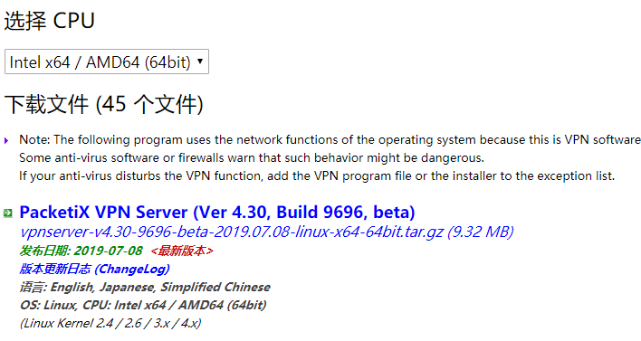
创建目录 mkdir /usr/local/vpnserver
上传server包
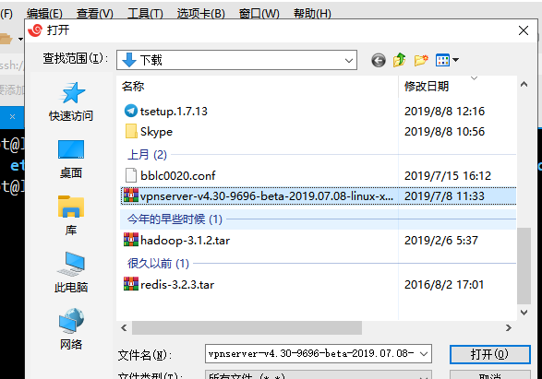

[root@localhost vpnserver]# ls
vpnserver-v4.30-9696-beta-2019.07.08-linux-x64-64bit.tar.gz
[root@localhost vpnserver]# pwd
/usr/local/vpnserver
[root@localhost vpnserver]#

[root@localhost vpnserver]# ls
vpnserver-v4.30-9696-beta-2019.07.08-linux-x64-64bit.tar.gz
[root@localhost vpnserver]# tar zxf vpnserver-v4.30-9696-beta-2019.07.08-linux-x64-64bit.tar.gz
[root@localhost vpnserver]# chmod 700 vpnserver
[root@localhost vpnserver]#

[root@localhost vpnserver]# cd vpnserver/
[root@localhost vpnserver]# make
Do you want to read the License Agreement for this software ?

1. Yes
2. No

Please choose one of above number:
1回车

Did you read and understand the License Agreement ?
(If you couldn't read above text, Please read 'ReadMeFirst_License.txt'
file with any text editor.)

1. Yes
2. No

Please choose one of above number:
1回车

Did you agree the License Agreement ?

1. Agree
2. Do Not Agree

Please choose one of above number:
1回车

如果报错就需要安装gcc

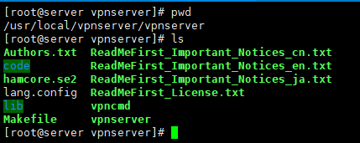
Make 后会多一个目录和一个文件lang.config 两个可执行文件，分别是vpncmd vpnserver

[root@localhost vpnserver]# pwd
/usr/local/vpnserver/vpnserver

[root@server vpnserver]# ./vpnserver start
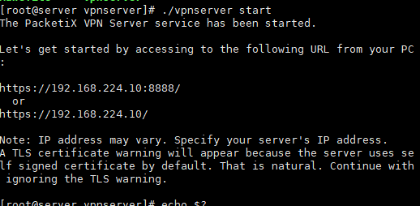
服务启动后，显示的是ip地址和端口号 端口已经被监听了；
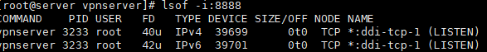

[root@localhost vpnserver]# ./vpncmd

By using vpncmd program, the following can be achieved.

1. Management of VPN Server or VPN Bridge
2. Management of VPN Client
3. Use of VPN Tools (certificate creation and Network Traffic Speed Test Tool)

Select 1, 2 or 3: 1
1回车

Specify the host name or IP address of the computer that the destination VPN Server or VPN Bridge is operating on.
By specifying according to the format 'host name:port number', you can also specify the port number.
(When the port number is unspecified, 443 is used.)
If nothing is input and the Enter key is pressed, the connection will be made to the port number 8888 of localhost (this computer).
Hostname of IP Address of Destination:

直接回车就好

If connecting to the server by Virtual Hub Admin Mode, please input the Virtual Hub name.
If connecting by server admin mode, please press Enter without inputting anything.
Specify Virtual Hub Name:
直接回车

VPN Server>
输入help查看帮助



VPN Server> ServerPasswordSet
设定服务器管理密码

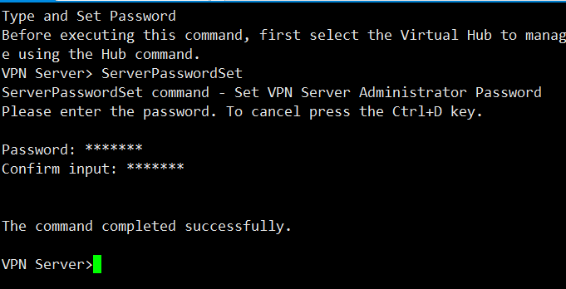

去packetix官网下载server管理工具和客户端 我这里已经下载好了，win7以上系统可以不用下载packetix ckient客户端软件

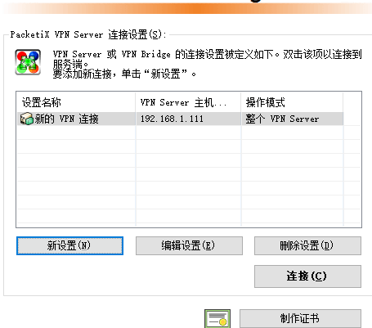
点击连接 如果连不上看下是不是防火墙没有设置好
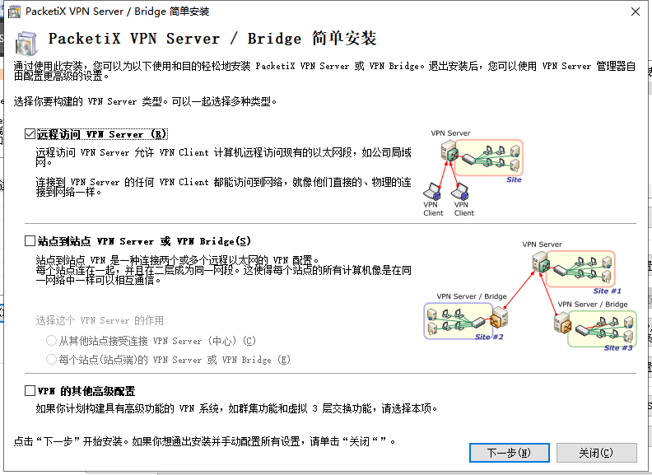
勾选远程访问vpn下一步
会弹出会话框，重新命名vpn就可以了
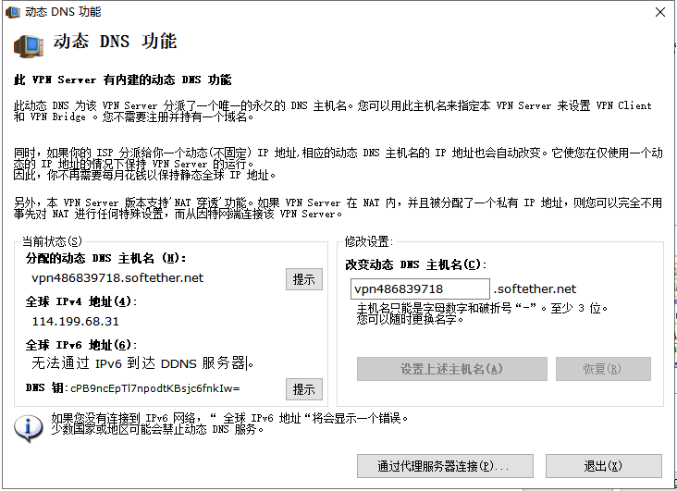
点击退出
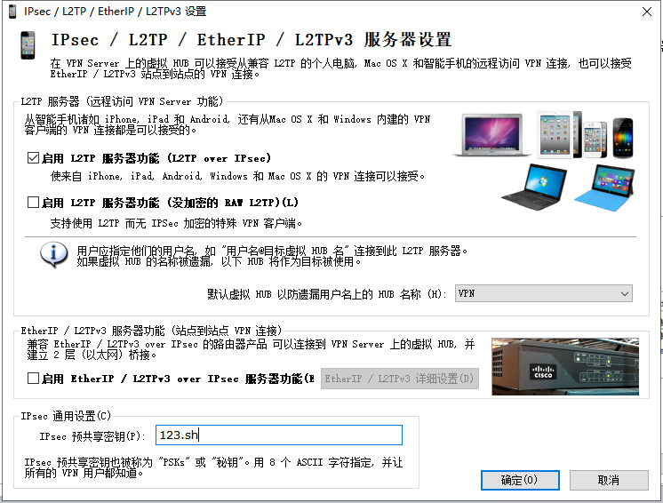启用L2TP 服务使可以接受来自手机的vpn 连接，设置预共享密钥123.sh
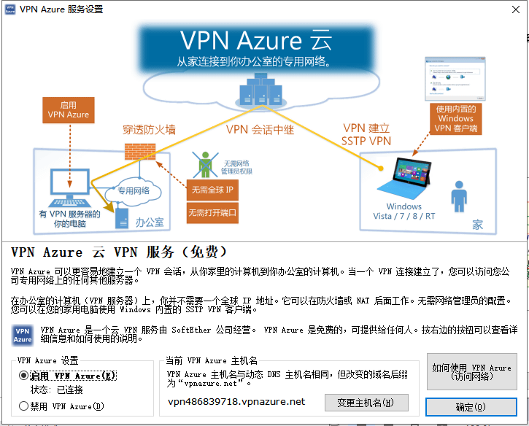
确定
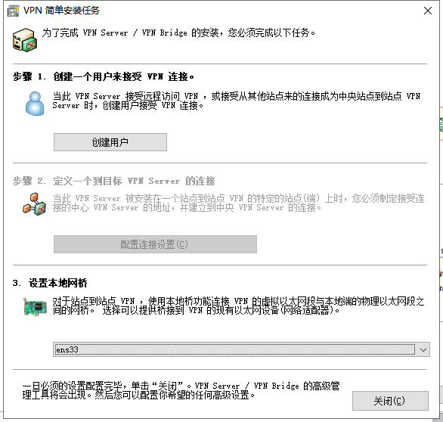
选择网卡 创建vpn client用户
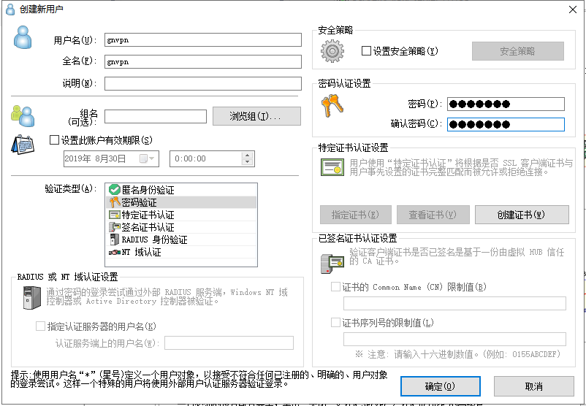
创建用户名gnvpn 密码123.shui 确定 如果连接的是虚拟机，会弹出以下界面。
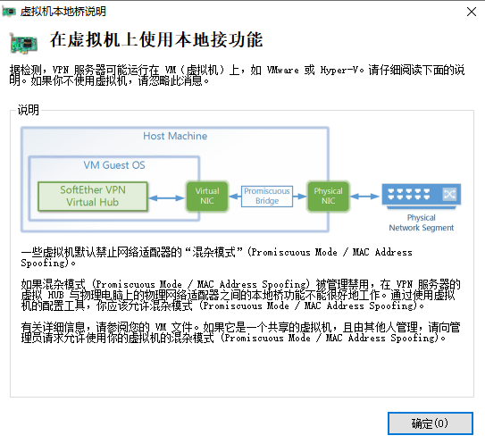
最后的页面
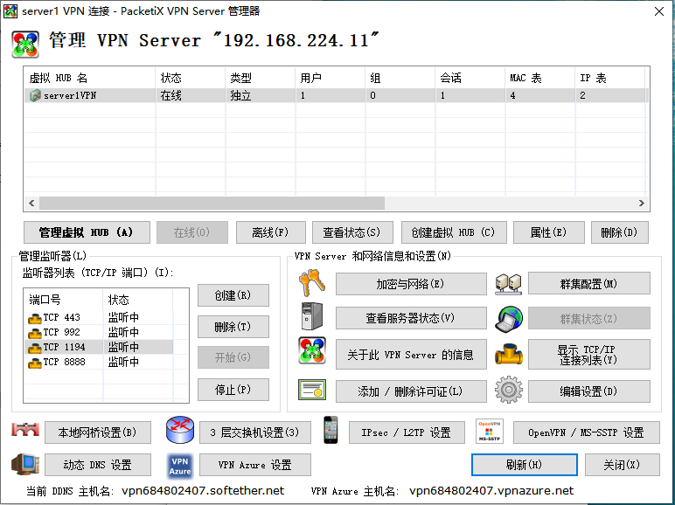

客户端开始连接 鼠标单击我的电脑右键，点属性按钮，弹出页面选择控制面板主页
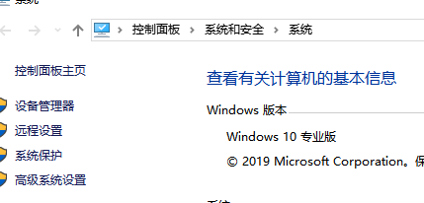

选择 网络和internet


然后点击网络共享中心

然后选择，设置新的连接或网络
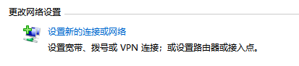

然后选择连接到工作区
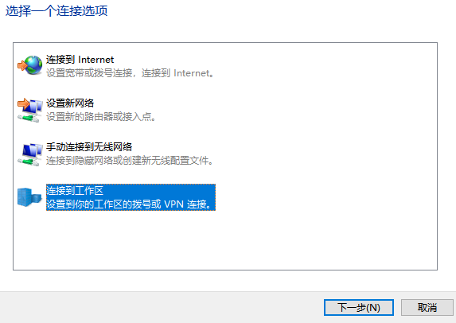

然后选择第一个
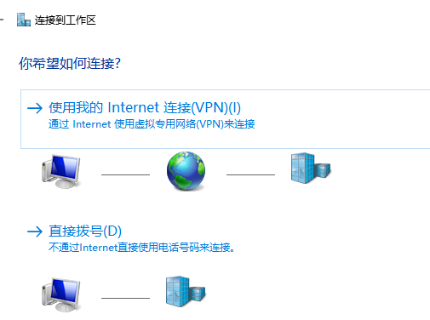

然后输入ip地址和用户名，ip 地址可以输入 VPN Azure 的主机名 ，最好输入主机名
