Docker部署zabbix+grafana 监控nginx并发

如在生产环境下运行请挂载volume 或者数据卷容器

环境 vm1 192.168.224.10 zabbix-server端 + grafana
vm2 192.168.224.11 zabbix-agent端 + nginx

以下操作在vm1
[root@localhost ~]# docker pull mysql:5.7
[root@localhost ~]# docker pull zabbix/zabbix-java-gateway:latest
[root@localhost ~]# docker pull zabbix/zabbix-server-mysql:latest
[root@localhost ~]# docker pull zabbix/zabbix-web-nginx-mysql:latest
[root@localhost ~]# docker pull grafana/grafana
[root@localhost ~]# docker run --name mysql-server -t -p 3306:3306\
-e MYSQL_DATABASE="zabbix" \
-e MYSQL_USER="zabbix" \
-e MYSQL_PASSWORD="zabbix" \
-e MYSQL_ROOT_PASSWORD="wwwwqqqq" \
-d mysql:5.7 \
--character-set-server=utf8 --collation-server=utf8_bin
docker run --name mysql-server -it -p 3306:3306 -e MYSQL_DATABASE="zabbix" -e MYSQL_USER="zabbix" -e MYSQL_PASSWORD="zabbix" -e MYSQL_ROOT_PASSWORD="wwwwqqqq" -d mysql:5.7 --character-set-server=utf8 --collation-server=utf8_bin

[root@localhost ~]# echo "net.ipv4.ip_forward = 1" >> /etc/sysctl.conf
[root@localhost ~]# sysctl -p --system
[root@localhost ~]# docker run --name zabbix-java-gateway -it -d zabbix/zabbix-java-gateway:latest

[root@localhost ~]# docker run --name zabbix-server-mysql -t \
-e DB_SERVER_HOST="mysql-server" \
-e MYSQL_DATABASE="zabbix" \
-e MYSQL_USER="zabbix" \
-e MYSQL_PASSWORD="zabbix" \
-e MYSQL_ROOT_PASSWORD="wwwwqqqq" \
-e ZBX_JAVAGATEWAY="zabbix-java-gateway" \
--link mysql-server:mysql \
--link zabbix-java-gateway:zabbix-java-gateway \
-p 10051:10051 \
-d zabbix/zabbix-server-mysql:latest
[root@localhost ~]#

现在应该可以直接访问 默认用户名Admin 密码zabbix 点击小人会出错
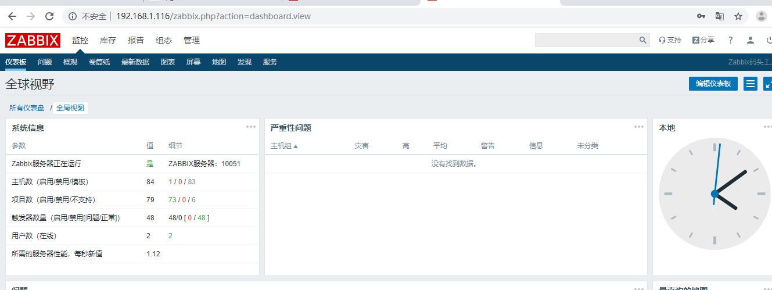

以下报错这样解决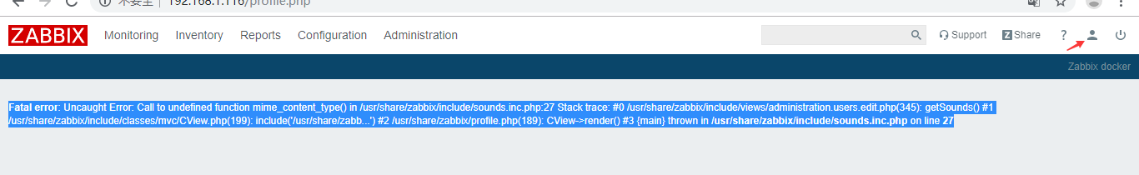
[root@localhost ~]# docker exec -it zabbix-web-nginx-mysql bash
bash-5.0# apk add php7-fileinfo
bash-5.0# exit
[root@localhost ~]# docker restart zabbix-web-nginx-mysql

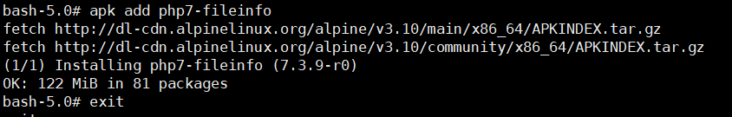
重启 容器
重新访问就好了 调成中文

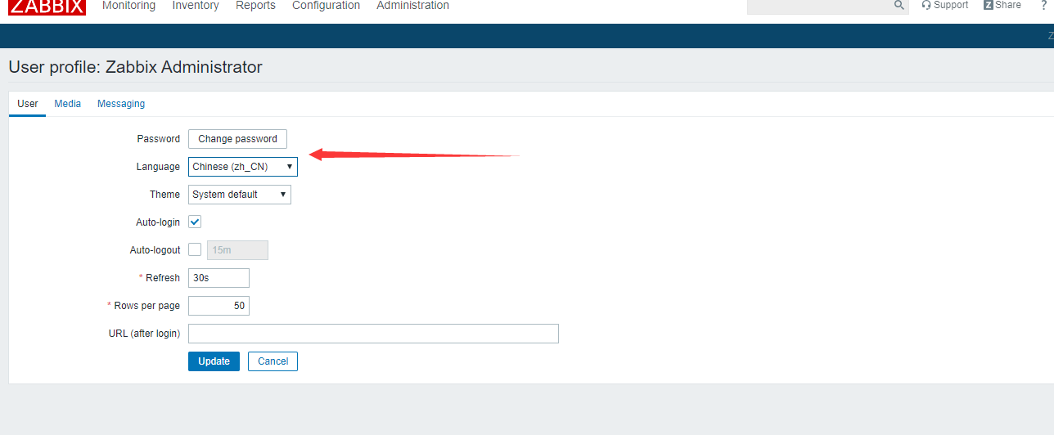

docker run \
-d \
-p 3000:3000 \
--name=grafana \
-e "GF_SERVER_ROOT_URL=http://grafana.server.name" \
-e "GF_SECURITY_ADMIN_PASSWORD=123456" \
grafana/grafana

此时 3000端口可以正常打开grafana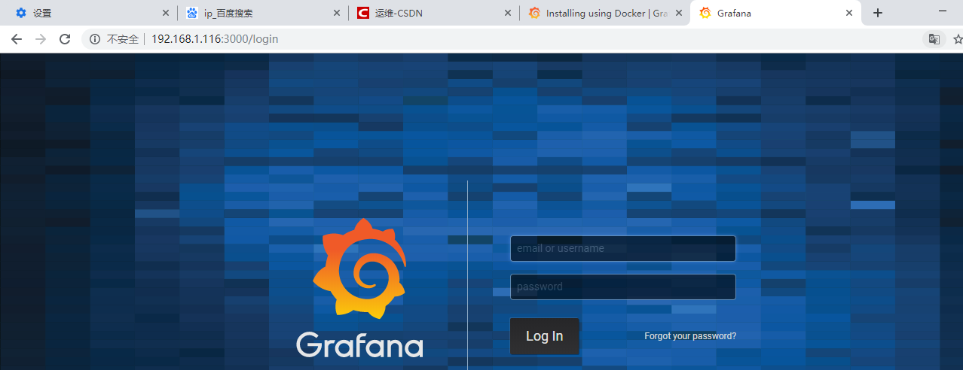

以下操作请在vm2进行
[root@localhost ~]# yum install -y epel-release
[root@localhost ~]# cd /etc/yum.repos.d/

[root@localhost yum.repos.d]# echo "
[zabbix]
name=Zabbix Official Repository - \$basearch
baseurl=http://repo.zabbix.com/zabbix/3.2/rhel/7/\$basearch/
enabled=1
gpgcheck=1
gpgkey=file:///etc/pki/rpm-gpg/RPM-GPG-KEY-ZABBIX-A14FE591

[zabbix-non-supported]
name=Zabbix Official Repository non-supported - \$basearch
baseurl=http://repo.zabbix.com/non-supported/rhel/7/\$basearch/
enabled=1
gpgkey=file:///etc/pki/rpm-gpg/RPM-GPG-KEY-ZABBIX
gpgcheck=1 " > zabbix.repo

[root@localhost yum.repos.d]# echo "-----BEGIN PGP PUBLIC KEY BLOCK-----
Version: GnuPG v1.4.10 (GNU/Linux)

mQENBFeIdv0BCADAzkjO9jHoDRfpJt8XgfsBS8FpANfHF2L29ntRwd8ocDwxXSbt
BuGIkUSkOPUTx6i/e9hd8vYh4mcX3yYpiW8Sui4aXbJu9uuSdU5KvPOaTsFeit9j
BDK4b0baFYBDpcBBrgQuyviMAVAczu5qlwolA/Vu6DWqah1X9p+4EFa1QitxkhYs
3br2ZGy7FZA3f2sZaVhHAPAOBSuQ1W6tiUfTIj/Oc7N+FBjmh3VNfIvMBa0E3rA2
JlObxUEywsgGo7FPWnwjZyv883slHp/I3H4Or9VBouTWA2yICeROmMwjr4mOZtJT
z9e4v/a2cG/mJXgxCe+FjBvTvrgOVHAXaNwLABEBAAG0IFphYmJpeCBMTEMgPHBh
Y2thZ2VyQHphYmJpeC5jb20+iQE4BBMBAgAiBQJXiHb9AhsDBgsJCAcDAgYVCAIJ
CgsEFgIDAQIeAQIXgAAKCRAIKrVroU/lkbO8B/4/MhxoUN2RPmH7BzFGIntKEWAw
bRkDzyQOk9TjXVegfsBnzmDSdowh7gyteVauvr62jiVtowlE/95vbXqbBCISLqKG
i9Wmbrj7lUXBd2sP7eApFzMUhb3G3GuV5pCnRBIzerDfhXiLE9EWRN89JYDxwCLY
ctQHieZtdmlnPyCbFF6wcXTHUEHBPqdTa6hvUqQL2lHLFoduqQz4Q47Cz7tZxnbr
akAewEToPcjMoteCSfXwF/BRxSUDlN7tKFfBpYQawS8ZtN09ImHOO6CZ/pA0qQim
iNiRUfA25onIDWLLY/NMWg+gK94NVVZ7KmFG3upDB5/uefK6Xwu2PsgiXSQguQEN
BFeIdv0BCACZgfqgz5YoX+ujVlw1gX1J+ygf10QsUM9GglLEuDiSS/Aa3C2UbgEa
+N7JuvzZigGFCvxtAzaerMMDzbliTqtMGJOTjWEVGxWQ3LiY6+NWgmV46AdXik7s
UXM155f1vhOzYp6EZj/xtGvyUzTLUkAlnZNrhEUbUmOhDLassVi32hIyMR5W7w6I
Ii0zIM1mSuLR0H6oDEpR3GzuGVHGj4/sLeAg7iY5MziGwySBQk0Dg0xH5YqHb+uK
zCTH/ILu3srPJq+237Px/PctAZCEA96ogc/DNF2XjdUpMSaEybR0LuHHstAqkrq8
AyRtDJNYE+09jDFdUIukhErLuo1YPWqFABEBAAGJAR8EGAECAAkFAleIdv0CGwwA
CgkQCCq1a6FP5ZH8+wf/erZneDXqM6xYT8qncFpc1GtOCeODNb19Ii22lDEXd9qN
UlAz2SB6zC5oywlnR0o1cglcrW96MD/uuCL/+tTczeB2C455ofs2mhpK7nKiA4FM
+JZZ6XSBnq7sfsYD6knbvS//SXQV/qYb4bKMvwYnyMz63escgQhOsTT20ptc/w7f
C+YPBR/rHImKspyIwxyqU8EXylFW8f3Ugi2+Fna3CAPR9yQIAChkCjUawUa2VFmm
5KP8DHg6oWM5mdqcpvU5DMqpi8SA26DEFvULs8bR+kgDd5AU3I4+ei71GslOdfk4
s1soKT4X2UK+dCCXui+/5ZJHakC67t5OgbMas3Hz4Q==
=5TOS
-----END PGP PUBLIC KEY BLOCK-----" >/etc/pki/rpm-gpg/RPM-GPG-KEY-ZABBIX-A14FE591
[root@localhost yum.repos.d]#
[root@localhost yum.repos.d]# echo "-----BEGIN PGP PUBLIC KEY BLOCK-----
Version: GnuPG v1.4.10 (GNU/Linux)

mQGiBFCNJaYRBAC4nIW8o2NyOIswb82Xn3AYSMUcNZuKB2fMtpu0WxSXIRiX2BwC
YXx8cIEQVYtLRBL5o0JdmoNCjW6jd5fOVem3EmOcPksvzzRWonIgFHf4EI2n1KJc
JXX/nDC+eoh5xW35mRNFN/BEJHxxiRGGbp2MCnApwgrZLhOujaCGAwavGwCgiG4D
wKMZ4xX6Y2Gv3MSuzMIT0bcEAKYn3WohS+udp0yC3FHDj+oxfuHpklu1xuI3y6ha
402aEFahNi3wr316ukgdPAYLbpz76ivoouTJ/U2MqbNLjAspDvlnHXXyqPM5GC6K
jtXPqNrRMUCrwisoAhorGUg/+S5pyXwsWcJ6EKmA80pR9HO+TbsELE5bGe/oc238
t/2oBAC3zcQ46wPvXpMCNFb+ED71qDOlnDYaaAPbjgkvnp+WN6nZFFyevjx180Kw
qWOLnlNP6JOuFW27MP75MDPDpbAAOVENp6qnuW9dxXTN80YpPLKUxrQS8vWPnzkY
WtUfF75pEOACFVTgXIqEgW0E6oww2HJi9zF5fS8IlFHJztNYtbQgWmFiYml4IFNJ
QSA8cGFja2FnZXJAemFiYml4LmNvbT6IYAQTEQIAIAUCUI0lpgIbAwYLCQgHAwIE
FQIIAwQWAgMBAh4BAheAAAoJENE9WOR56l7UhUwAmgIGZ39U6D2w2oIWDD8m7KV3
oI06AJ9EnOxMMlxEjTkt9lEvGhEX1bEh7bkBDQRQjSWmEAQAqx+ecOzBbhqMq5hU
l39cJ6l4aocz6EZ9mSSoF/g+HFz6WYnPAfRaYyfLmZdtF5rGBDD4ysalYG5yD59R
Mv5tNVf/CEx+JAPMhp6JCBkGRaH+xHws4eBPGkea4rGNVP3L3rA7g+c1YXZICGRI
OOH7CIzIZ/w6aFGsPp7xM35ogncAAwUD/3s8Nc1OLDy81DC6rGpxfEURd5pvd/j0
D5Di0WSBEcHXp5nThDz6ro/Vr0/FVIBtT97tmBHX27yBS3PqxxNRIjZ0GSWQqdws
Q8o3YT+RHjBugXn8CzTOvIn+2QNMA8EtGIZPpCblJv8q6MFPi9m7avQxguMqufgg
fAk7377Rt9RqiEkEGBECAAkFAlCNJaYCGwwACgkQ0T1Y5HnqXtQx4wCfcJZINKVq
kQIoV3KTQAIzr6IvbZoAn12XXt4GP89xHuzPDZ86YJVAgnfK
=+200
-----END PGP PUBLIC KEY BLOCK-----" >/etc/pki/rpm-gpg/RPM-GPG-KEY-ZABBIX

[root@localhost yum.repos.d]# yum -y install zabbix-agent nginx
[root@localhost ~]# nginx
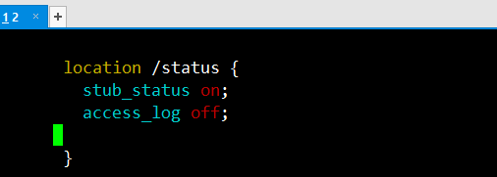

[root@localhost ~]# sed -i 's/Server=127.0.0.1/Server=192.168.224.10/g' /etc/zabbix/zabbix_agentd.conf
[root@localhost ~]# sed -i 's/ServerActive=127.0.0.1/ServerActive=192.168.224.10/g' /etc/zabbix/zabbix_agentd.conf
[root@localhost ~]# sed -i 's/Hostname=Zabbix server/Hostname='nginx-test' ----- '192.168.224.11'/g' /etc/zabbix/zabbix_agentd.conf
[root@localhost ~]# sed -i 's/# ListenPort=10050/ListenPort=10050/g' /etc/zabbix/zabbix_agentd.conf
[root@localhost ~]# sed -i 's/# HostMetadataItem=/HostMetadataItem=system.uname/g' /etc/zabbix/zabbix_agentd.conf
[root@localhost ~]# sed -i 's/# StartAgents=3/StartAgents=3/g' /etc/zabbix/zabbix_agentd.conf
[root@localhost ~]# sed -i 's/# Timeout=3/Timeout=10/g' /etc/zabbix/zabbix_agentd.conf
[root@localhost ~]# sed -i 's/# UnsafeUserParameters=0/UnsafeUserParameters=1/g' /etc/zabbix/zabbix_agentd.conf
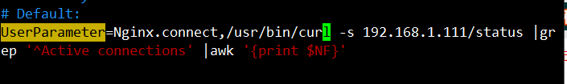

[root@localhost ~]# systemctl start zabbix-agent.service

以下操作在vm1的zabbix web页面
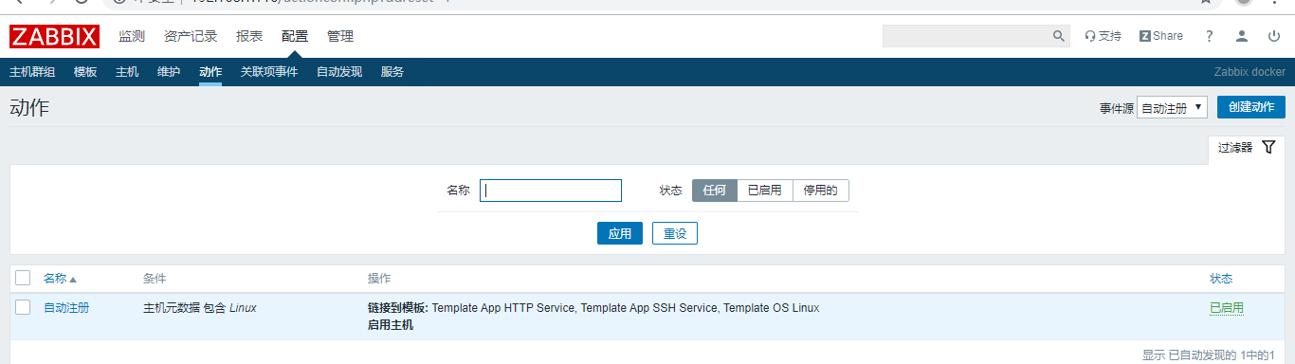

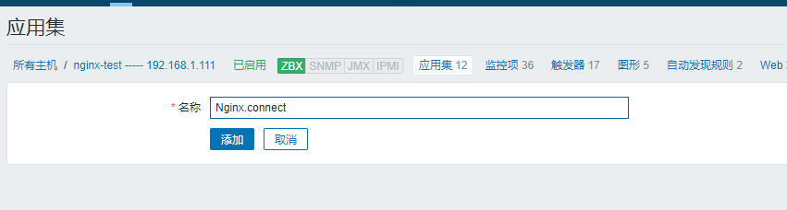
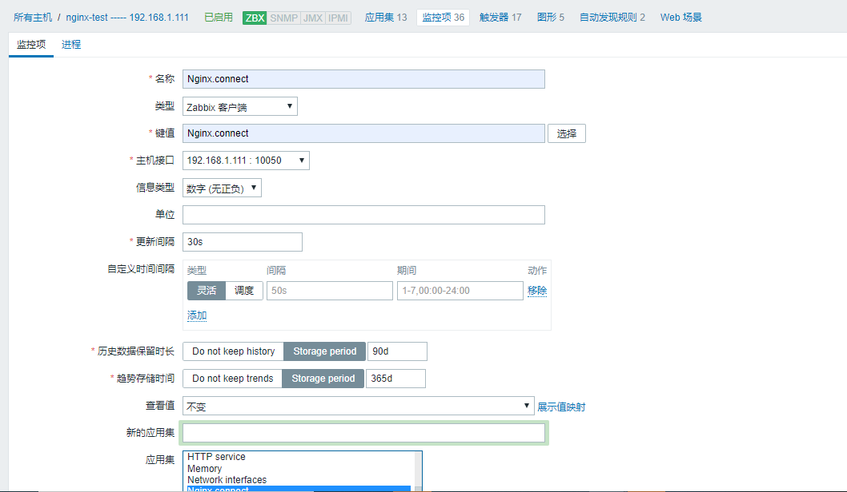

配置数据源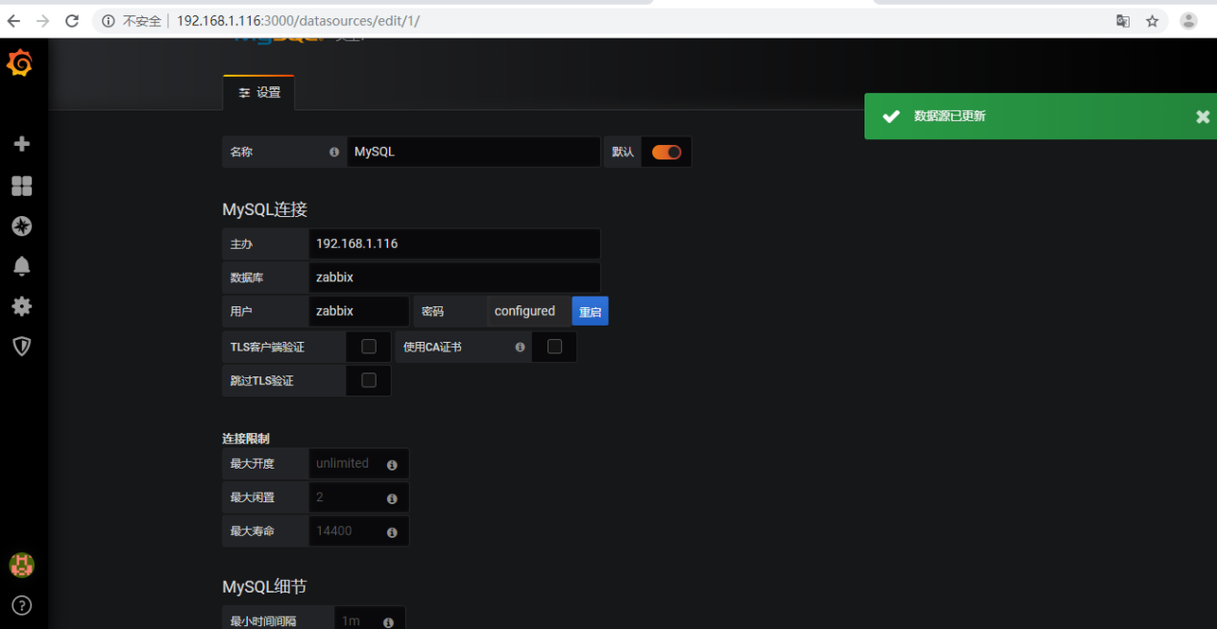

[root@localhost ~]# docker exec -it grafana bash
grafana@a7ae2cf148ba:/usr/share/grafana$ grafana-cli plugins install alexanderzobnin-zabbix-app
[root@localhost ~]# docker restart grafana

更新zabbix数据源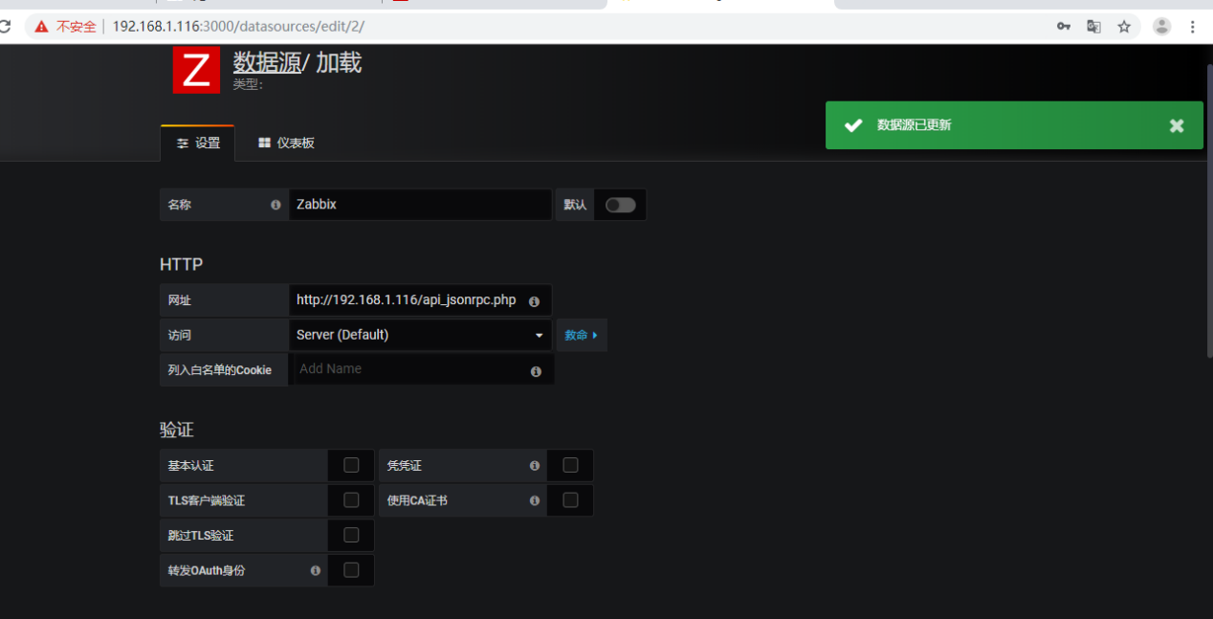

Vm2安装 yum -y install httpd-tools
vm2运行伪造并发
[root@localhost ~]# while true ;do ab -c 1000 -n 10000 http://192.168.224.11/status ;done
