需要用到的链接如下:

https://api.telegram.org/bot918525260:AAGpkBMJ1YuX0Qq3r8y0JOPXBDgNibJqoJ0/setwebhook?url= 用来关联群组 后面是编码了之后的 例如

https://api.telegram.org/bot918525260:AAGpkBMJ1YuX0Qq3r8y0JOPXBDgNibJqoJ0/setwebhook?url=https%3A%2F%2Fscript.google.com%2Fmacros%2Fs%2FAKfycbyeI5AOc42UjZRnLI-Nr_h2KKe0DWceLK2sSzL8JFKUXUnTV5s%2Fexec

https://www.url-encode-decode.com/ 用来编解码

https://script.google.com/home 放代码 发布用

首先需要打开https://script.google.com/home

代码如下

function doGet(e){

return HtmlService.createHtmlOutput("Hello World!! No, this link should be hidden!!!");

// return HtmlService.createHtmlOutputFromFile('Index');

}

function doPost(e){

var body = JSON.parse(e.postData.contents);

body.message.chat.id = body.message.chat.id + '';

var payload = preparePayload(body);

var data = {

"method": "post",

"contentType": 'application/json',

"payload": JSON.stringify(payload),

}

UrlFetchApp.fetch("https://api.telegram.org/bot682267360:AAHmjSil8oylavD2pENLLpcMU1svaD7mVeA/", data);

}

function getName(user) {

var name = user.first_name;

if (user.last_name) {

name += " " + user.last_name;

}

return name;

}

function escapeMarkDown(toEscapeMsg) {

var escapedMsg = toEscapeMsg

.replace(/_/g, "\\_")

.replace(/\*/g, "\\*")

.replace(/\[/g, "\\[")

.replace(/`/g, "\\`");

return escapedMsg;

}

function getMentionName(user) {

var username = user.username;

var mentionName = "";

var name = getName(user);

if (!name) {

name = "神秘人";

}

// if (!username) {

mentionName = getMarkDownUserUrl(escapeMarkDown(name), user.id);

// } else {

// mentionName = "[" + escapeMarkDown(name) + "](@" + escapeMarkDown(username) + ")";

// }

return mentionName;

}

function getMarkDownUserUrl(userName, userId) {

return "[" + userName + "](tg://user?id=" + userId + ")";

}

function preparePayload(body){

var payload;

if (body.message.new_chat_member) {

payload = {

"method": "sendMessage",

"chat_id": body.message.chat.id,

"text": "你好， 欢迎加入本群",

"parse_mode": "Markdown",

"disable_web_page_preview": true,

}

payload.text = "你好!" + getMentionName(body.message.new_chat_member) + " 欢迎加入本群";

return payload;

}

if (body.message.left_chat_member) {

payload = {

"method": "sendMessage",

"chat_id": body.message.chat.id,

"text": "你好， 欢迎加入本群",

"parse_mode": "Markdown",

"disable_web_page_preview": true,

}

payload.text = getMentionName(body.message.left_chat_member) + "君, 一路走好！";

return payload;

}

if (body.message.pinned_message) {

payload = {

"method": "sendMessage",

"chat_id": body.message.chat.id,

"text": "你好， 欢迎加入本群",

"parse_mode": "Markdown",

"disable_web_page_preview": true,

}

var whoPinned = getName(body.message.from);

var whoOwned = getName(body.message.pinned_message.from);

payload.text = whoPinned + "置顶了消息:\n\n" + body.message.pinned_message.text

+ "\n\n"

+ "本 BOT 代表" + whoOwned + "感谢您"

;

return payload;

}

body.message.text = body.message.text.toLowerCase();

body.message.text = body.message.text.replace(/@temptestbot2/g, '');

var paras = body.message.text.trim().split(" ");

// remove empty strings

paras = paras.filter(function(para){

if (para){

return true;

}

});

if (body.message.text){

payload = {

"method": "sendMessage",

"chat_id": body.message.chat.id,

"text": "你好， 欢迎使用本机器人， 本机器人现在只认识颜色。",

"parse_mode": "Markdown",

"disable_web_page_preview": true,

}

if(body.message.text.indexOf("/help") === 0){

payload.text = "你好， 欢迎使用本机器人， 本机器人现在只认识颜色。";

return payload;

}

if(body.message.text.indexOf("/colors") === 0){

payload.text = "红\n 黄\n 蓝";

return payload;

}

if(body.message.text.indexOf("/list") === 0){

if (paras[1]){

switch (paras[1].toLowerCase()){

case "people":

if (paras[2]){

if ("JS 神技能".toLowerCase().indexOf(paras[2]) >= 0){

payload.text = "JS 神技能 - https://www.youtube.com/channel/UC6tPP3jOTKgjqfDgqMsaG4g";

}

if ("悟空的日常".toLowerCase().indexOf(paras[2]) >= 0){

payload.text = "悟空的日常 - https://www.youtube.com/channel/UCii04BCvYIdQvshrdNDAcww";

}

if ("YuFeng Deng".toLowerCase().indexOf(paras[2]) >= 0){

payload.text = "YuFeng Deng - https://www.youtube.com/channel/UCG6xoef2xU86hnrCsS5m5Cw";

}

} else {

payload.text = "JS 神技能\n"

+ "悟空的日常\n"

+ "YuFeng Deng\n";

return payload;

}

break;

default:

payload.text = "红\n 黄\n 蓝";

break;

}

return payload;

} else {

payload.text = "*JS 神技能*\n"

+ "[悟空的日常](https://www.youtube.com/channel/UCii04BCvYIdQvshrdNDAcww)\n"

+ "[*YuFeng Deng*](https://www.youtube.com/channel/UCG6xoef2xU86hnrCsS5m5Cw)\n"

+ "_YuFeng Deng_\n"

+ "`01|" + "UCii04BCvYIdQvshrdNDAcww" + " | `\n"

+ "`02|" + "UCG6xoef2xU86hnrCsS5m5Cw" + " | `\n"

+ "```javascript\n"

+ 'payload = {\n'

+ ' "method": "sendMessage",\n'

+ ' "chat_id": body.message.chat.id,\n'

+ ' "text": body.message.text,\n'

+ '}'

+ "```"

;

var inlineKeyboardMarkup = {};

inlineKeyboardMarkup.inline_keyboard = [];

var keyboardRow = [];

var keyboardButton1 = {

text: "按钮 1",

url: "https://www.google.com"

};

var keyboardButton2 = {

text: "按钮 2",

url: "https://www.google.com"

};

var keyboardRow2 = [];

var keyboardButton3 = {

text: "按钮 3",

url: "https://www.google.com"

};

var keyboardButton4 = {

text: "按钮 4",

url: "https://www.google.com"

};

keyboardRow.push(keyboardButton1);

keyboardRow.push(keyboardButton2);

keyboardRow2.push(keyboardButton3);

keyboardRow2.push(keyboardButton4);

inlineKeyboardMarkup.inline_keyboard.push(keyboardRow);

inlineKeyboardMarkup.inline_keyboard.push(keyboardRow2);

payload.reply_markup = inlineKeyboardMarkup;

return payload;

}

}

payload = {

"method": "sendMessage",

"chat_id": body.message.chat.id,

"text": body.message.text,

}

}

else if (body.message.sticker){

payload = {

"method": "sendSticker",

"chat_id": body.message.chat.id,

"sticker": body.message.sticker.file_id

}

}

else if (body.message.photo){

array = body.message.photo;

text = array[1];

payload = {

"method": "sendPhoto",

"chat_id": body.message.chat.id,

"photo": text.file_id

}

}

else {

payload = {

"method": "sendMessage",

"chat_id": body.message.chat.id,

"text": "Try other stuff"

}

}

return payload

}

进入之后 放进去代码 改一下bot的token

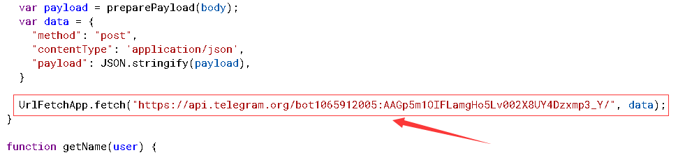

改一下 new_chat_member payload.text 内容就好 发布为网络应用 所有人匿名都可以访问。

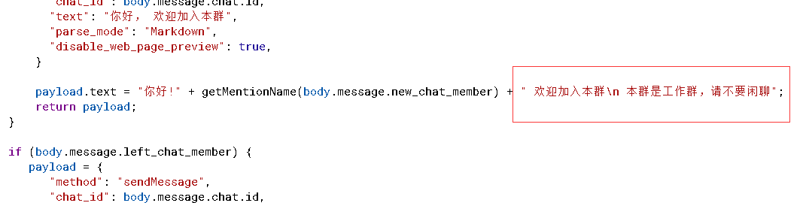

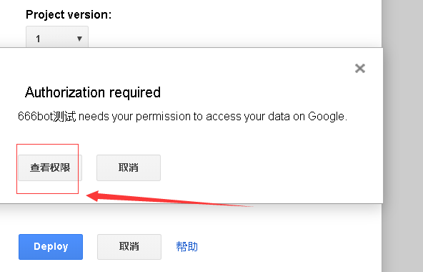

点击查看权限

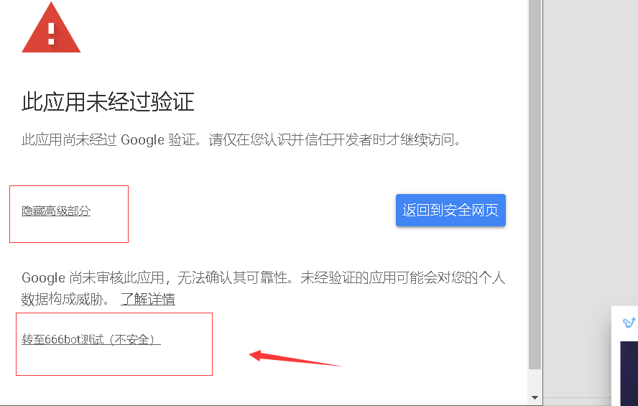

继续点击下一步，

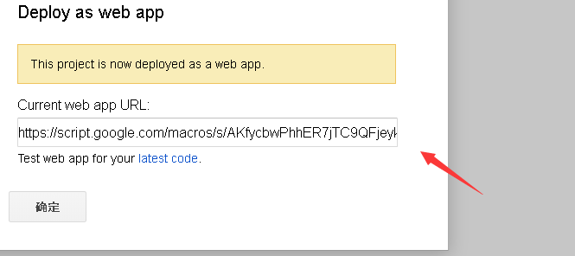

发布成功有一个url 谷歌浏览器打开 会有hello world等信息 就成功了。

https://script.google.com/macros/s/AKfycbwPhhER7jTC9QFjeyk1zhIY-piF0yWZNxXA8xiEER4aukRFJK2A/exec

然后继续复制exec结尾的这段url 去编解码 编码 encode

https://www.url-encode-decode.com/ 编码完成之后google浏览器访问 <https://api.telegram.org/bot964313453:AAEjCkJ72n-36i_emfl0a2UQ9Nw-kdQyLPo/setwebhook?url=>

完整的url

[https://api.telegram.org/bot806329752:AAGSkuBN_Q4gsfdGwfqzIpFLFLjHd4qbsS8/setwebhook?url=https%3A%2F%2Fscript.google.com%2Fmacros%2Fs%2FAKfycbwPhhER7jTC9QFjeyk1zhIY-piF0yWZNxXA8xiEER4aukRFJK2A%2Fexec](https://api.telegram.org/bot806329752:AAGSkuBN_Q4gsfdGwfqzIpFLFLjHd4qbsS8/setwebhook?url=https://script.google.com/macros/s/AKfycbwPhhER7jTC9QFjeyk1zhIY-piF0yWZNxXA8xiEER4aukRFJK2A/exec)

bot后面是机器人的toke

这个url=后面写你编码之后的地址 访问看到 ok true result 等信息就成功了 把机器人拉进群 他就会自动欢迎入群的人了

取消镜像功能版代码如下

function doGet(e){

return HtmlService.createHtmlOutput("Hello World!! No, this link should be hidden!!!");

// return HtmlService.createHtmlOutputFromFile('Index');

}

function doPost(e){

var body = JSON.parse(e.postData.contents);

body.message.chat.id = body.message.chat.id + '';

var payload = preparePayload(body);

var data = {

"method": "post",

"contentType": 'application/json',

"payload": JSON.stringify(payload),

}

UrlFetchApp.fetch("https://api.telegram.org/bot823364686:AAGZ7rfDbT6khbCqDCONMVoTXwHXaKn8TW0/", data);

}

function getName(user) {

var name = user.first_name;

if (user.last_name) {

name += " " + user.last_name;

}

return name;

}

function escapeMarkDown(toEscapeMsg) {

var escapedMsg = toEscapeMsg

.replace(/_/g, "\\_")

.replace(/\*/g, "\\*")

.replace(/\[/g, "\\[")

.replace(/`/g, "\\`");

return escapedMsg;

}

function getMentionName(user) {

var username = user.username;

var mentionName = "";

var name = getName(user);

if (!name) {

name = "神秘人";

}

// if (!username) {

mentionName = getMarkDownUserUrl(escapeMarkDown(name), user.id);

// } else {

// mentionName = "[" + escapeMarkDown(name) + "](@" + escapeMarkDown(username) + ")";

// }

return mentionName;

}

function getMarkDownUserUrl(userName, userId) {

return "[" + userName + "](tg://user?id=" + userId + ")";

}

function preparePayload(body){

var payload;

if (body.message.new_chat_member) {

payload = {

"method": "sendMessage",

"chat_id": body.message.chat.id,

"text": "你好， 欢迎加入本群",

"parse_mode": "Markdown",

"disable_web_page_preview": true,

}

payload.text = "你好!" + getMentionName(body.message.new_chat_member) + ", 11";

return payload;

}

if (body.message.left_chat_member) {

payload = {

"method": "sendMessage",

"chat_id": body.message.chat.id,

"text": "你好， 欢迎加入本群",

"parse_mode": "Markdown",

"disable_web_page_preview": true,

}

payload.text = getMentionName(body.message.left_chat_member) + "君, 一路走好！";

return payload;

}

if (body.message.pinned_message) {

payload = {

"method": "sendMessage",

"chat_id": body.message.chat.id,

"text": "你好， 欢迎加入本群",

"parse_mode": "Markdown",

"disable_web_page_preview": true,

}

var whoPinned = getName(body.message.from);

var whoOwned = getName(body.message.pinned_message.from);

payload.text = whoPinned + "置顶了消息:\n\n" + body.message.pinned_message.text

+ "\n\n"

+ "本 BOT 代表" + whoOwned + "感谢您"

;

return payload;

}

body.message.text = body.message.text.toLowerCase();

body.message.text = body.message.text.replace(/@temptestbot2/g, '');

var paras = body.message.text.trim().split(" ");

// remove empty strings

paras = paras.filter(function(para){

if (para){

return true;

}

});

if (body.message.text){

if(body.message.text.indexOf("/colors") === 0){

payload.text = "红\n 黄\n 蓝";

return payload;

}

if(body.message.text.indexOf("/list") === 0){

if (paras[1]){

switch (paras[1].toLowerCase()){

case "people":

if (paras[2]){

if ("JS 神技能".toLowerCase().indexOf(paras[2]) >= 0){

payload.text = "JS 神技能 - https://www.youtube.com/channel/UC6tPP3jOTKgjqfDgqMsaG4g";

}

if ("悟空的日常".toLowerCase().indexOf(paras[2]) >= 0){

payload.text = "悟空的日常 - https://www.youtube.com/channel/UCii04BCvYIdQvshrdNDAcww";

}

if ("YuFeng Deng".toLowerCase().indexOf(paras[2]) >= 0){

payload.text = "YuFeng Deng - https://www.youtube.com/channel/UCG6xoef2xU86hnrCsS5m5Cw";

}

} else {

payload.text = "JS 神技能\n"

+ "悟空的日常\n"

+ "YuFeng Deng\n";

return payload;

}

break;

default:

payload.text = "红\n 黄\n 蓝";

break;

}

return payload;

} else {

payload.text = "*JS 神技能*\n"

+ "[悟空的日常](https://www.youtube.com/channel/UCii04BCvYIdQvshrdNDAcww)\n"

+ "[*YuFeng Deng*](https://www.youtube.com/channel/UCG6xoef2xU86hnrCsS5m5Cw)\n"

+ "_YuFeng Deng_\n"

+ "`01|" + "UCii04BCvYIdQvshrdNDAcww" + " | `\n"

+ "`02|" + "UCG6xoef2xU86hnrCsS5m5Cw" + " | `\n"

+ "```javascript\n"

+ 'payload = {\n'

+ ' "method": "sendMessage",\n'

+ ' "chat_id": body.message.chat.id,\n'

+ ' "text": body.message.text,\n'

+ '}'

+ "```"

;

var inlineKeyboardMarkup = {};

inlineKeyboardMarkup.inline_keyboard = [];

var keyboardRow = [];

var keyboardButton1 = {

text: "按钮 1",

url: "https://www.google.com"

};

var keyboardButton2 = {

text: "按钮 2",

url: "https://www.google.com"

};

var keyboardRow2 = [];

var keyboardButton3 = {

text: "按钮 3",

url: "https://www.google.com"

};

var keyboardButton4 = {

text: "按钮 4",

url: "https://www.google.com"

};

keyboardRow.push(keyboardButton1);

keyboardRow.push(keyboardButton2);

keyboardRow2.push(keyboardButton3);

keyboardRow2.push(keyboardButton4);

inlineKeyboardMarkup.inline_keyboard.push(keyboardRow);

inlineKeyboardMarkup.inline_keyboard.push(keyboardRow2);

payload.reply_markup = inlineKeyboardMarkup;

return payload;

}

}

}

return payload

}