测网速 及其他

curl -Lso- -no-check-certificate https://raw.githubusercontent.com/oooldking/script/master/superbench.sh | bash

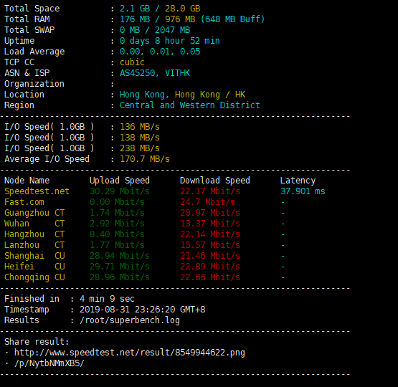

# **CentOS6-7手动安装BBR和魔改BBR教**

抓取 linux优化脚本

wget -N --no-check-certificate "https://raw.githubusercontent.com/chiakge/Linux-NetSpeed/master/tcp.sh"