2018-04-08 周日 晴

1、分页查询API中，联合查询（union）会出现垃圾数据行（原因是使用了左连接，但必须得使用），导致获取数据数量有误，查询条件加上某个字段（device_name）为非空，问题已解决。
问题现象：
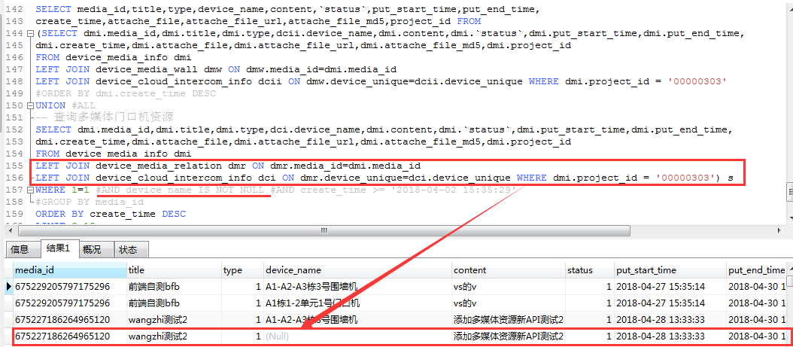
- 分页查询时，前端请求的分页参数的pageSize为实际media_id的去重后的count，而联合查询出的数据却是有多个相同media_id的（绑定了多个门口机或围墙机），如何正常分页？已解决，使用group by和group_concat。
问题详情：项目id下多媒体资源是11条，一条多媒体可绑定多个云对讲设备，故连接查询全部数据出来中条数是多余11条（17条），前端分页参数（1,15）请求过来后，实际查到15条，java代码以mediaId为单位封装过去是9条，数据不符，解决思路是查询出的数据中以去重后的mediaId分页，数据也不能少。
相关资料：https://www.cnblogs.com/snsdzjlz320/p/5738226.html[Mysql 查询语句]——分组查询group by
<select id="getDeviceMediaInfoByPage" parameterType="map" resultMap="DeviceMediaInfoByPageMap">
SELECT media_id,title,`type`,GROUP_CONCAT(device_name) device_name,content,`status`,put_start_time,put_end_time,
create_time,attache_file,attache_file_url,attache_file_md5,project_id FROM
(SELECT dmi.media_id,dmi.title,dmi.type,dcii.device_name,dmi.content,dmi.`status`,dmi.put_start_time,dmi.put_end_time,dmi.create_time,dmi.attache_file,dmi.attache_file_url,dmi.attache_file_md5,dmi.project_id
FROM device_media_info dmi
LEFT JOIN device_media_wall dmw ON dmw.media_id=dmi.media_id
LEFT JOIN device_cloud_intercom_info dcii ON dmw.device_unique=dcii.device_unique
WHERE 1=1 <if test="projectId != null">AND dmi.project_id = #{projectId}</if>
UNION
SELECT dmi.media_id,dmi.title,dmi.type,dci.device_name,dmi.content,dmi.`status`,dmi.put_start_time,dmi.put_end_time,dmi.create_time,dmi.attache_file,dmi.attache_file_url,dmi.attache_file_md5,dmi.project_id
FROM device_media_info dmi
LEFT JOIN device_media_relation dmr ON dmr.media_id=dmi.media_id
LEFT JOIN device_cloud_intercom_info dci ON dmr.device_unique=dci.device_unique
WHERE 1=1 <if test="projectId != null">AND dmi.project_id = #{projectId}</if>) s
WHERE 1=1 AND device_name IS NOT NULL <include refid="Like_Search_Param"/>
GROUP BY media_id
ORDER BY create_time DESC
limit #{startSlip},#{pageSize}
</select>

2018-04-09 周一 晴

1、目前”查看多媒体资源”即”精确查询单个多媒体资源API”中，查看该多媒体资源所绑定的云对讲设备是发送带mediaId参数请求到”获取门口机和围墙机设备API”上获取过滤后的数据，相当于查看一个多媒体资源要发两个请求，之后再要优化的话初步可以在查看多媒体资源API中直接分页查询出所绑定的设备。

2018-04-11 周三 晴

1、关于保存文件问题：
本机电脑中虚拟机CentOS6.0配置 Nginx监听ftp时，img.device-media.com映射的根目录是到/home/itlongftp/multimediaFile/18/04/11，故java代码中保存附件直接到根目录下，可是java代码中拼接保存图片的url是img.device-media.com/18/04/11/xxx.png，此时矛盾了，图片保存到/18/04/11中，而访问img.device-media.com/18/04/11/xxx.png相当于是访问img.device-media.com/18/04/11/18/04/11/xxx.png。
已解决：保存图片其实是根据IP地址+ftp端口号保存，意思其实是ftp协议保存，http协议获取，所以Nginx中配置好监听IP为虚拟机IP（192.168.13.36）端口为ftp端口（21）根目录为/home/itlongftp/multimediaFile/18/04/11，img.device-media.com监听目录为/home/itlongftp，即搞定，要注意的一点是，要先启动ftp，再启动nginx，否则算端口占用了。

2018-04-19 周四 晴

1、启动报错问题：
equip-service服务启动报错，无法创建bean
Error starting ApplicationContext. To display the auto-configuration report re-run your application with 'debug' enabled.
2018-04-19 17:25:16.696 [restartedMain] ERROR org.springframework.boot.SpringApplication - Application startup failed
org.springframework.beans.factory.UnsatisfiedDependencyException: Error creating bean with name 'appCloudElevatorCallStatusServiceResource': Unsatisfied dependency expressed through field 'iAppCloudElevatorCallStatusService'; nested exception is org.springframework.beans.factory.UnsatisfiedDependencyException: Error creating bean with name 'appCloudElevatorCallStatusServiceImpl': Unsatisfied dependency expressed through field 'iAppCloudElevatorCallStatusDao'; nested exception is org.springframework.beans.factory.BeanCreationException: Error creating bean with name 'IAppCloudElevatorCallStatusDao' defined in file [G:\itlong-cloud-trunk-JAVA\itlong-cloud-parent\service-equip\target\classes\com\itlong\cloud\app\dao\IAppCloudElevatorCallStatusDao.class]: Cannot resolve reference to bean 'masterSqlSessionFactory' while setting bean property 'sqlSessionFactory'; nested exception is org.springframework.beans.factory.BeanCreationException: Error creating bean with name 'masterSqlSessionFactory' defined in class path resource [com/itlong/cloud/datasource/config/DataSourceConfig.class]: Bean instantiation via factory method failed; nested exception is org.springframework.beans.BeanInstantiationException: Failed to instantiate [org.apache.ibatis.session.SqlSessionFactory]: Factory method 'masterSqlSessionFactory' threw exception; nested exception is java.lang.NoClassDefFoundError: com/itlong/cloud/dataSource/dao/ISubscriberDao (wrong name: com/itlong/cloud/datasource/dao/ISubscriberDao)

主要报错：java.lang.NoClassDefFoundError: com/itlong/cloud/dataSource/dao/ISubscriberD
关于这个异常的介绍：https://www.cnblogs.com/xyhz0310/p/6803950.html
已解决方法：尝试性地使用了maven项目clean再install。

