Required Screenshot Checklist
Screenshot 1 — Login Page
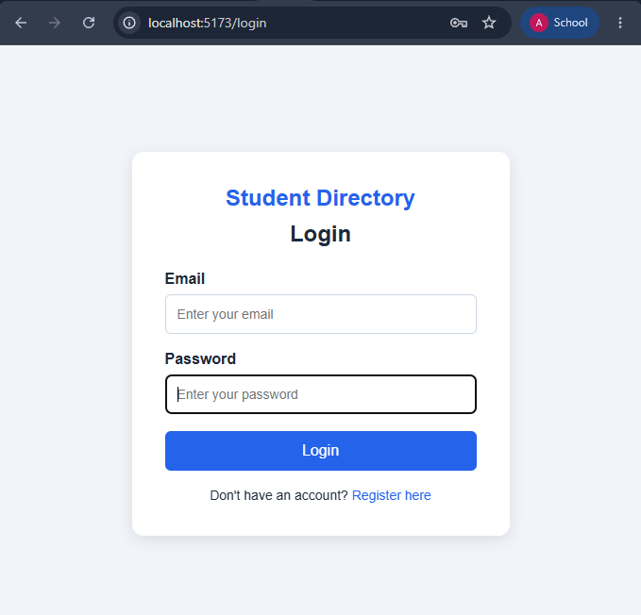

Screenshot 2 — Register Page
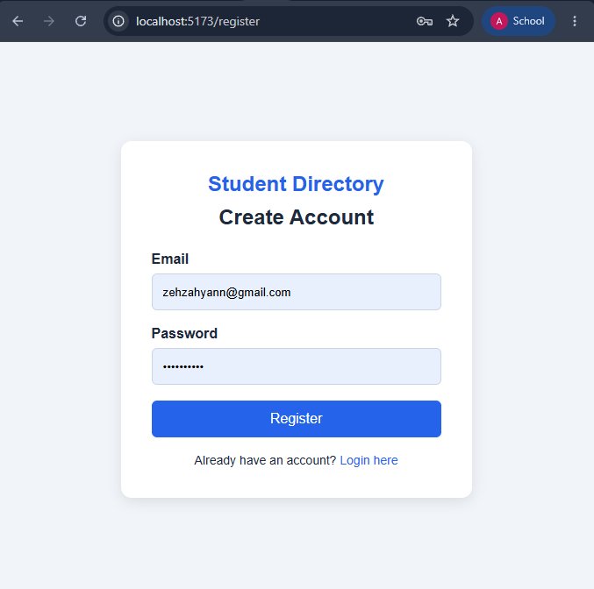

Screenshot 3 — Successful Login / Students Page
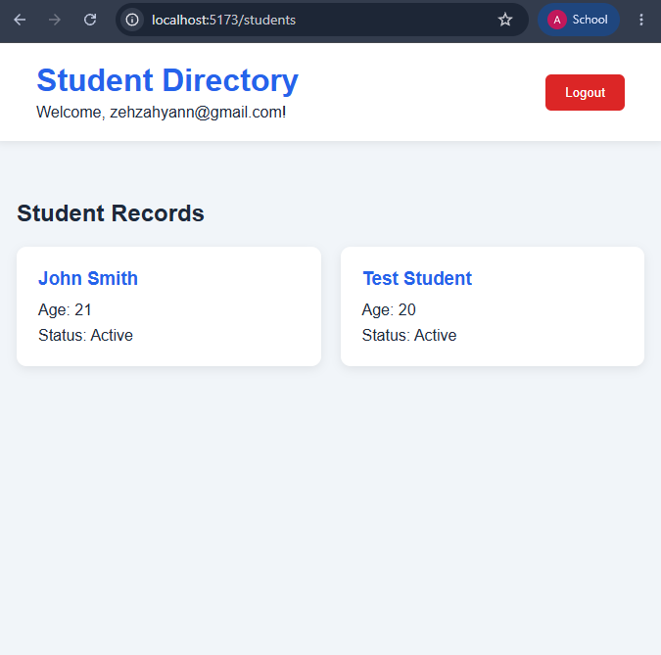

Screenshot 4 — Failed Login
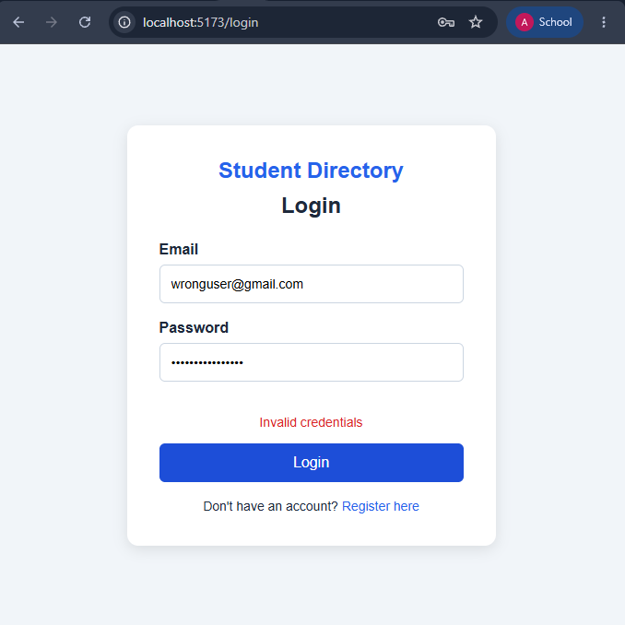

Screenshot 5 — Protected Route Redirect
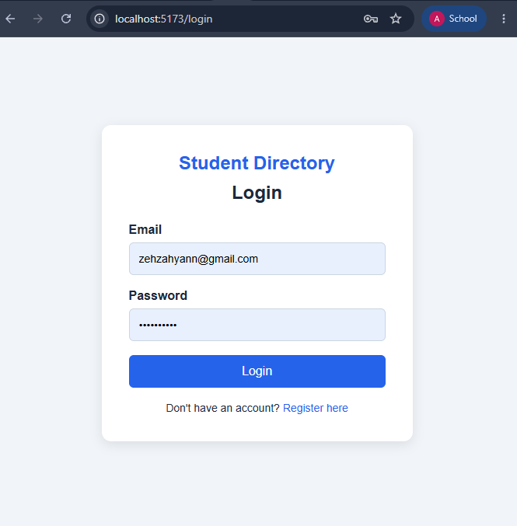

Screenshot 6 — DevTools Network Authorization Header


