Ambient-pressure superconductivity above 22 K in hole-doped YB₂

Xuejie Li,¹ Wenbo Zhao,² Yuzhou Hao,¹ XiaoyingWang,¹ Zhibin Gao^{1, †} and Xiangdong Ding¹
¹State Key Laboratory for Mechanical Behavior of Materials,
School of Materials Science and Engineering,
Xi’an Jiaotong University, Xi’an 710049, China
² Key Laboratory of Material Simulation Methods and Software of Ministry of Education, College of Physics, Jilin University, Changchun 130012, China
†Corresponding author: zhibin.gao@xjtu.edu.cn

I.The Sum of projected DOS for Selected Atoms and orbitals in YB₂

The orbital compositions of elements B and Y in YB₂, along with their projected DOS, are displayed in Fig. S1(a) and (b). In YB₂, the B-pz, Y-dxy and Y-dx2 orbitals dominate the total DOS at the Fermi energy level, with the remaining orbitals comprising a minor fraction.
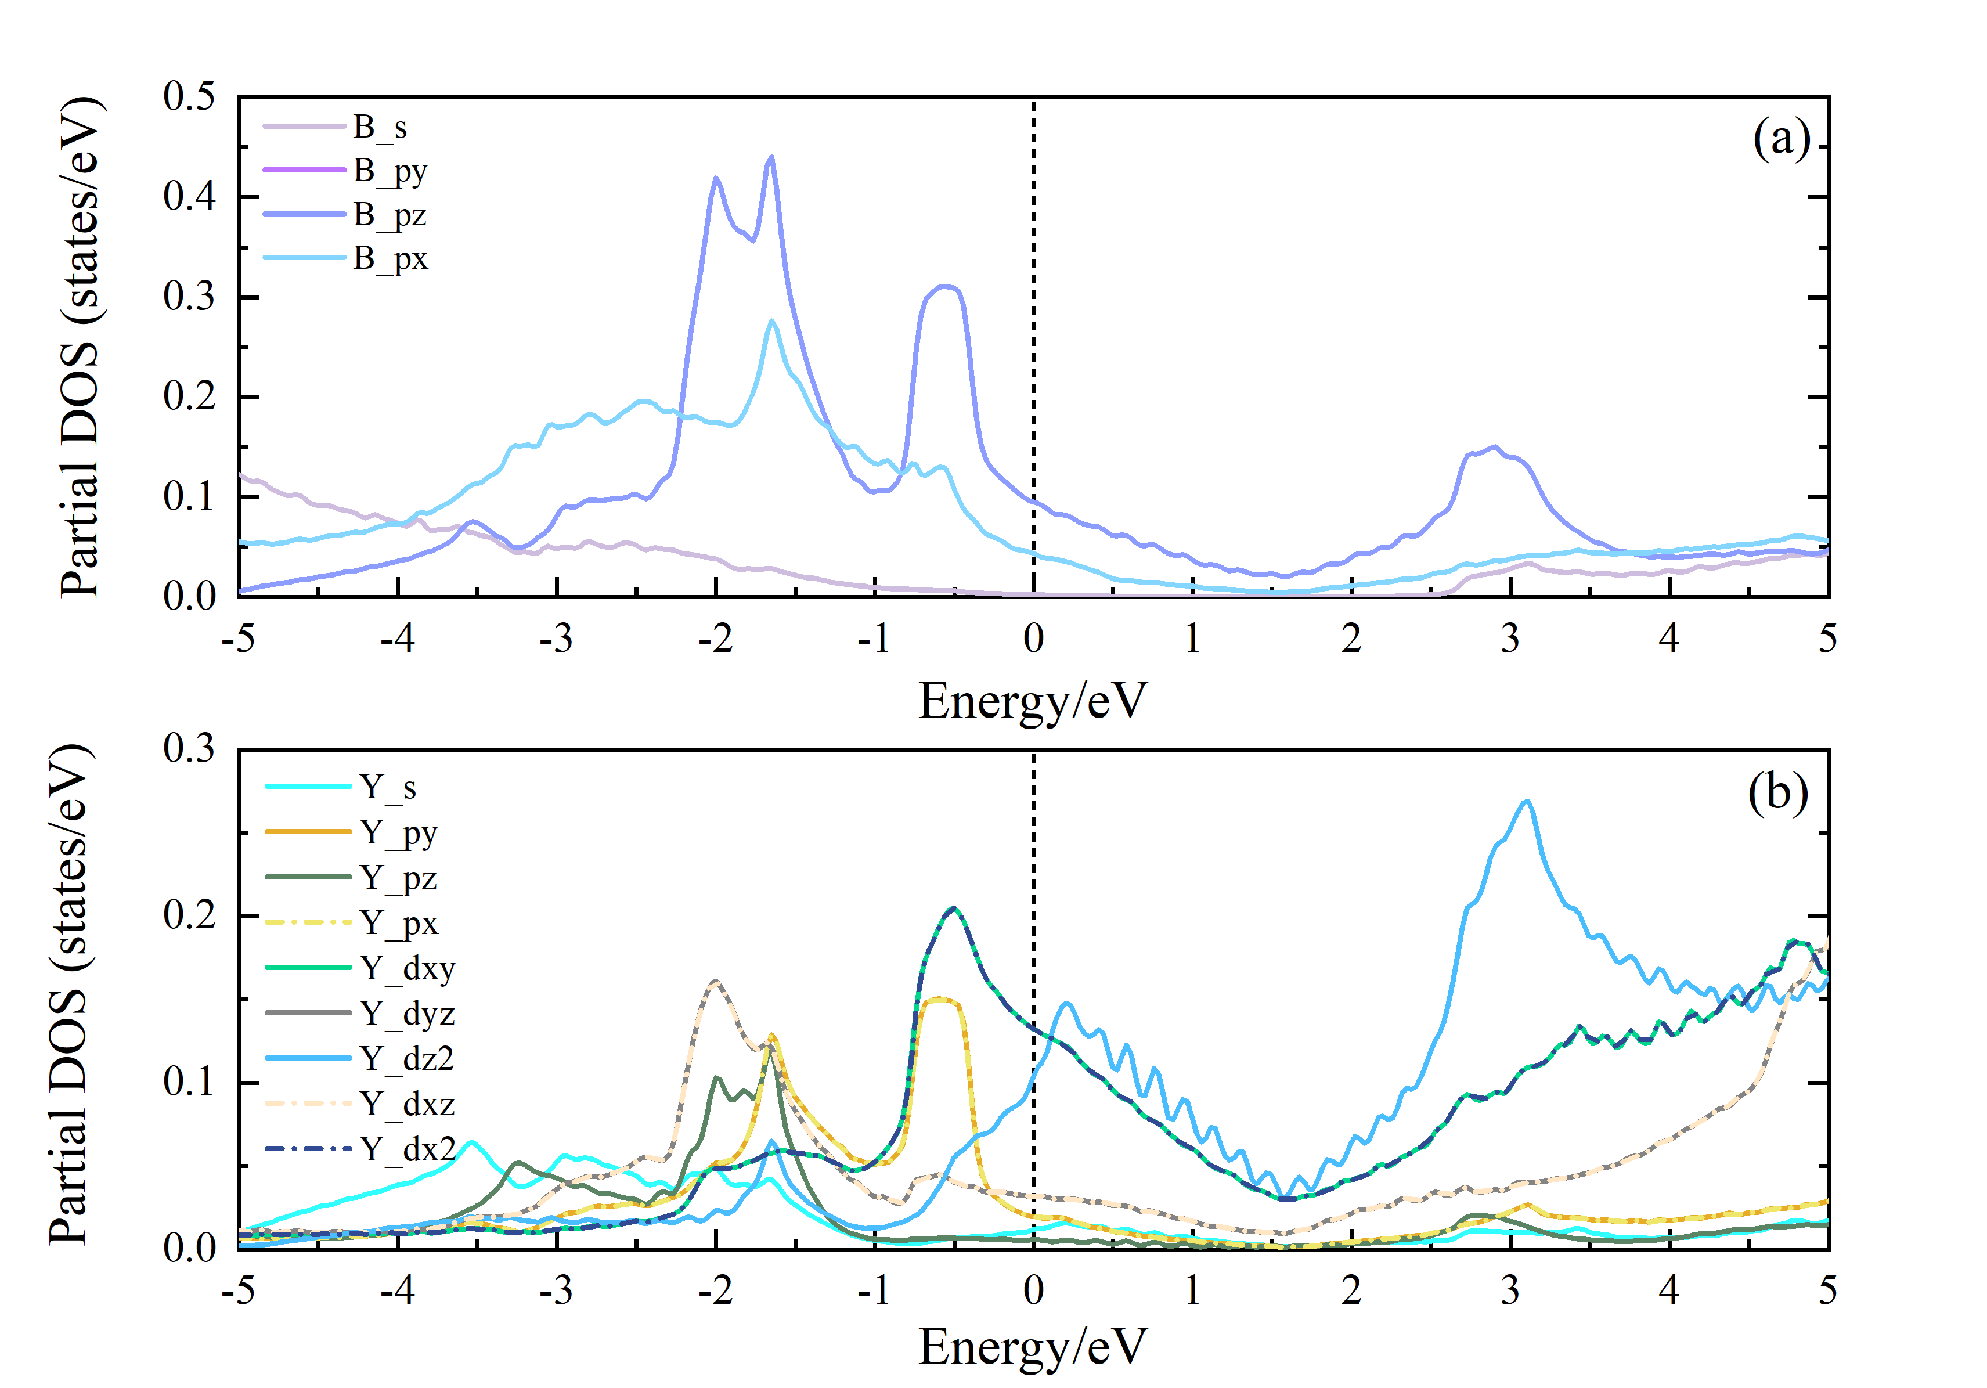
FIG.S1. The projected DOS consisting of individual orbitals of the elements in YB₂. (a) The projected DOS consisting of individual orbitals of the element B in YB₂ is near the E_{F}, where the dark purple, purple-blue, and blue lines stand in for the B-py, B-pz, and B-px orbitals, respectively, and the purple-grey line represents the s-orbital of element B. (b) In YB₂, the projected DOS of individual element Y orbitals is close to the E_{F}, where the lines colored bright blue, orange, dark green, and yellow represent the Y-s, Y-py, Y-pz, and Y-px orbits; and the other lines colored light green, gray, light blue, light flesh, and dark blue represent the Y-dxy, Y-dyz,Y-dz2, Y-dxz, and Y-dx2 orbits, respectively.

II.The Eliashberg spectral function in YB₂ with various additional electron or hole concentrations

The Eliashberg spectral function $α^{2}F\left(ω\right)$ of YB₂ with different concentrations of electrons and holes added are shown on Fig.S2, Fig. S3 and Fig. S4, respectively. When insertion electron concentration increases, the peak values of mid-frequency phonon and occupied areas of the Eliasberg spectral function increase slightly, but the high-frequency optical phonon and the peak values of low-frequency acoustic phonon and occupied areas decrease significantly. Furthermore, the peaks and occupied areas of the mid-frequency phonon bands decrease slightly as the concentration of additional holes in YB₂ rises, while the peaks and occupied areas of the Eliasberg spectral functions of the low-frequency acoustic and high-frequency optical phonons increase dramatically, particularly in the acoustic phonon portion. In contrast, the peaks and the area occupied by the Eliasberg spectral function of the acoustic phonon band considerably drop with the addition of hole concentration up to 0.8, and the associated T_{c} declines steeply.
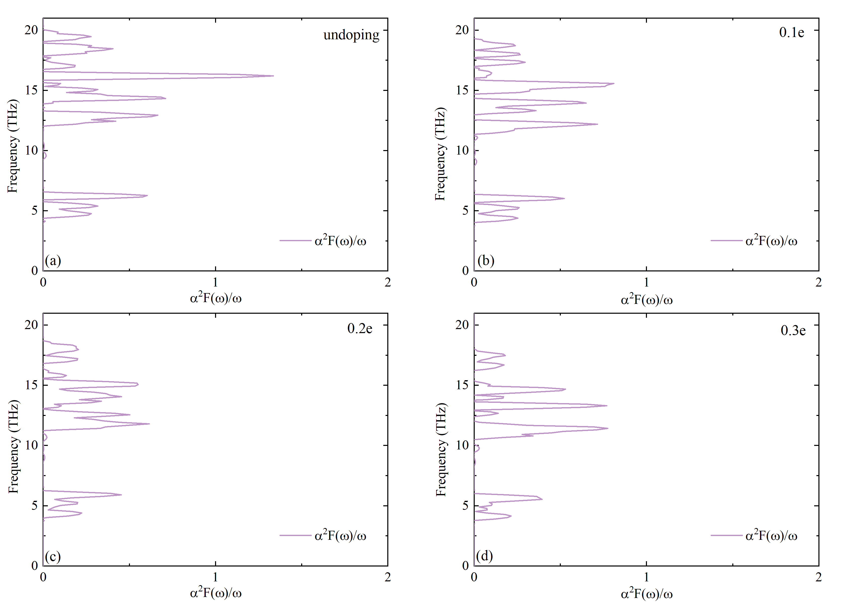
FIG.S2. The Eliashberg spectral function of YB₂ with the addition of different concentrations of electrons(0 ~ 0.3). The Eliashberg spectral function of (a) undoping YB₂, (b) 0.1 electrons added YB₂, (c) 0.2 electrons added YB₂ and (d) 0.3 electrons added YB₂.

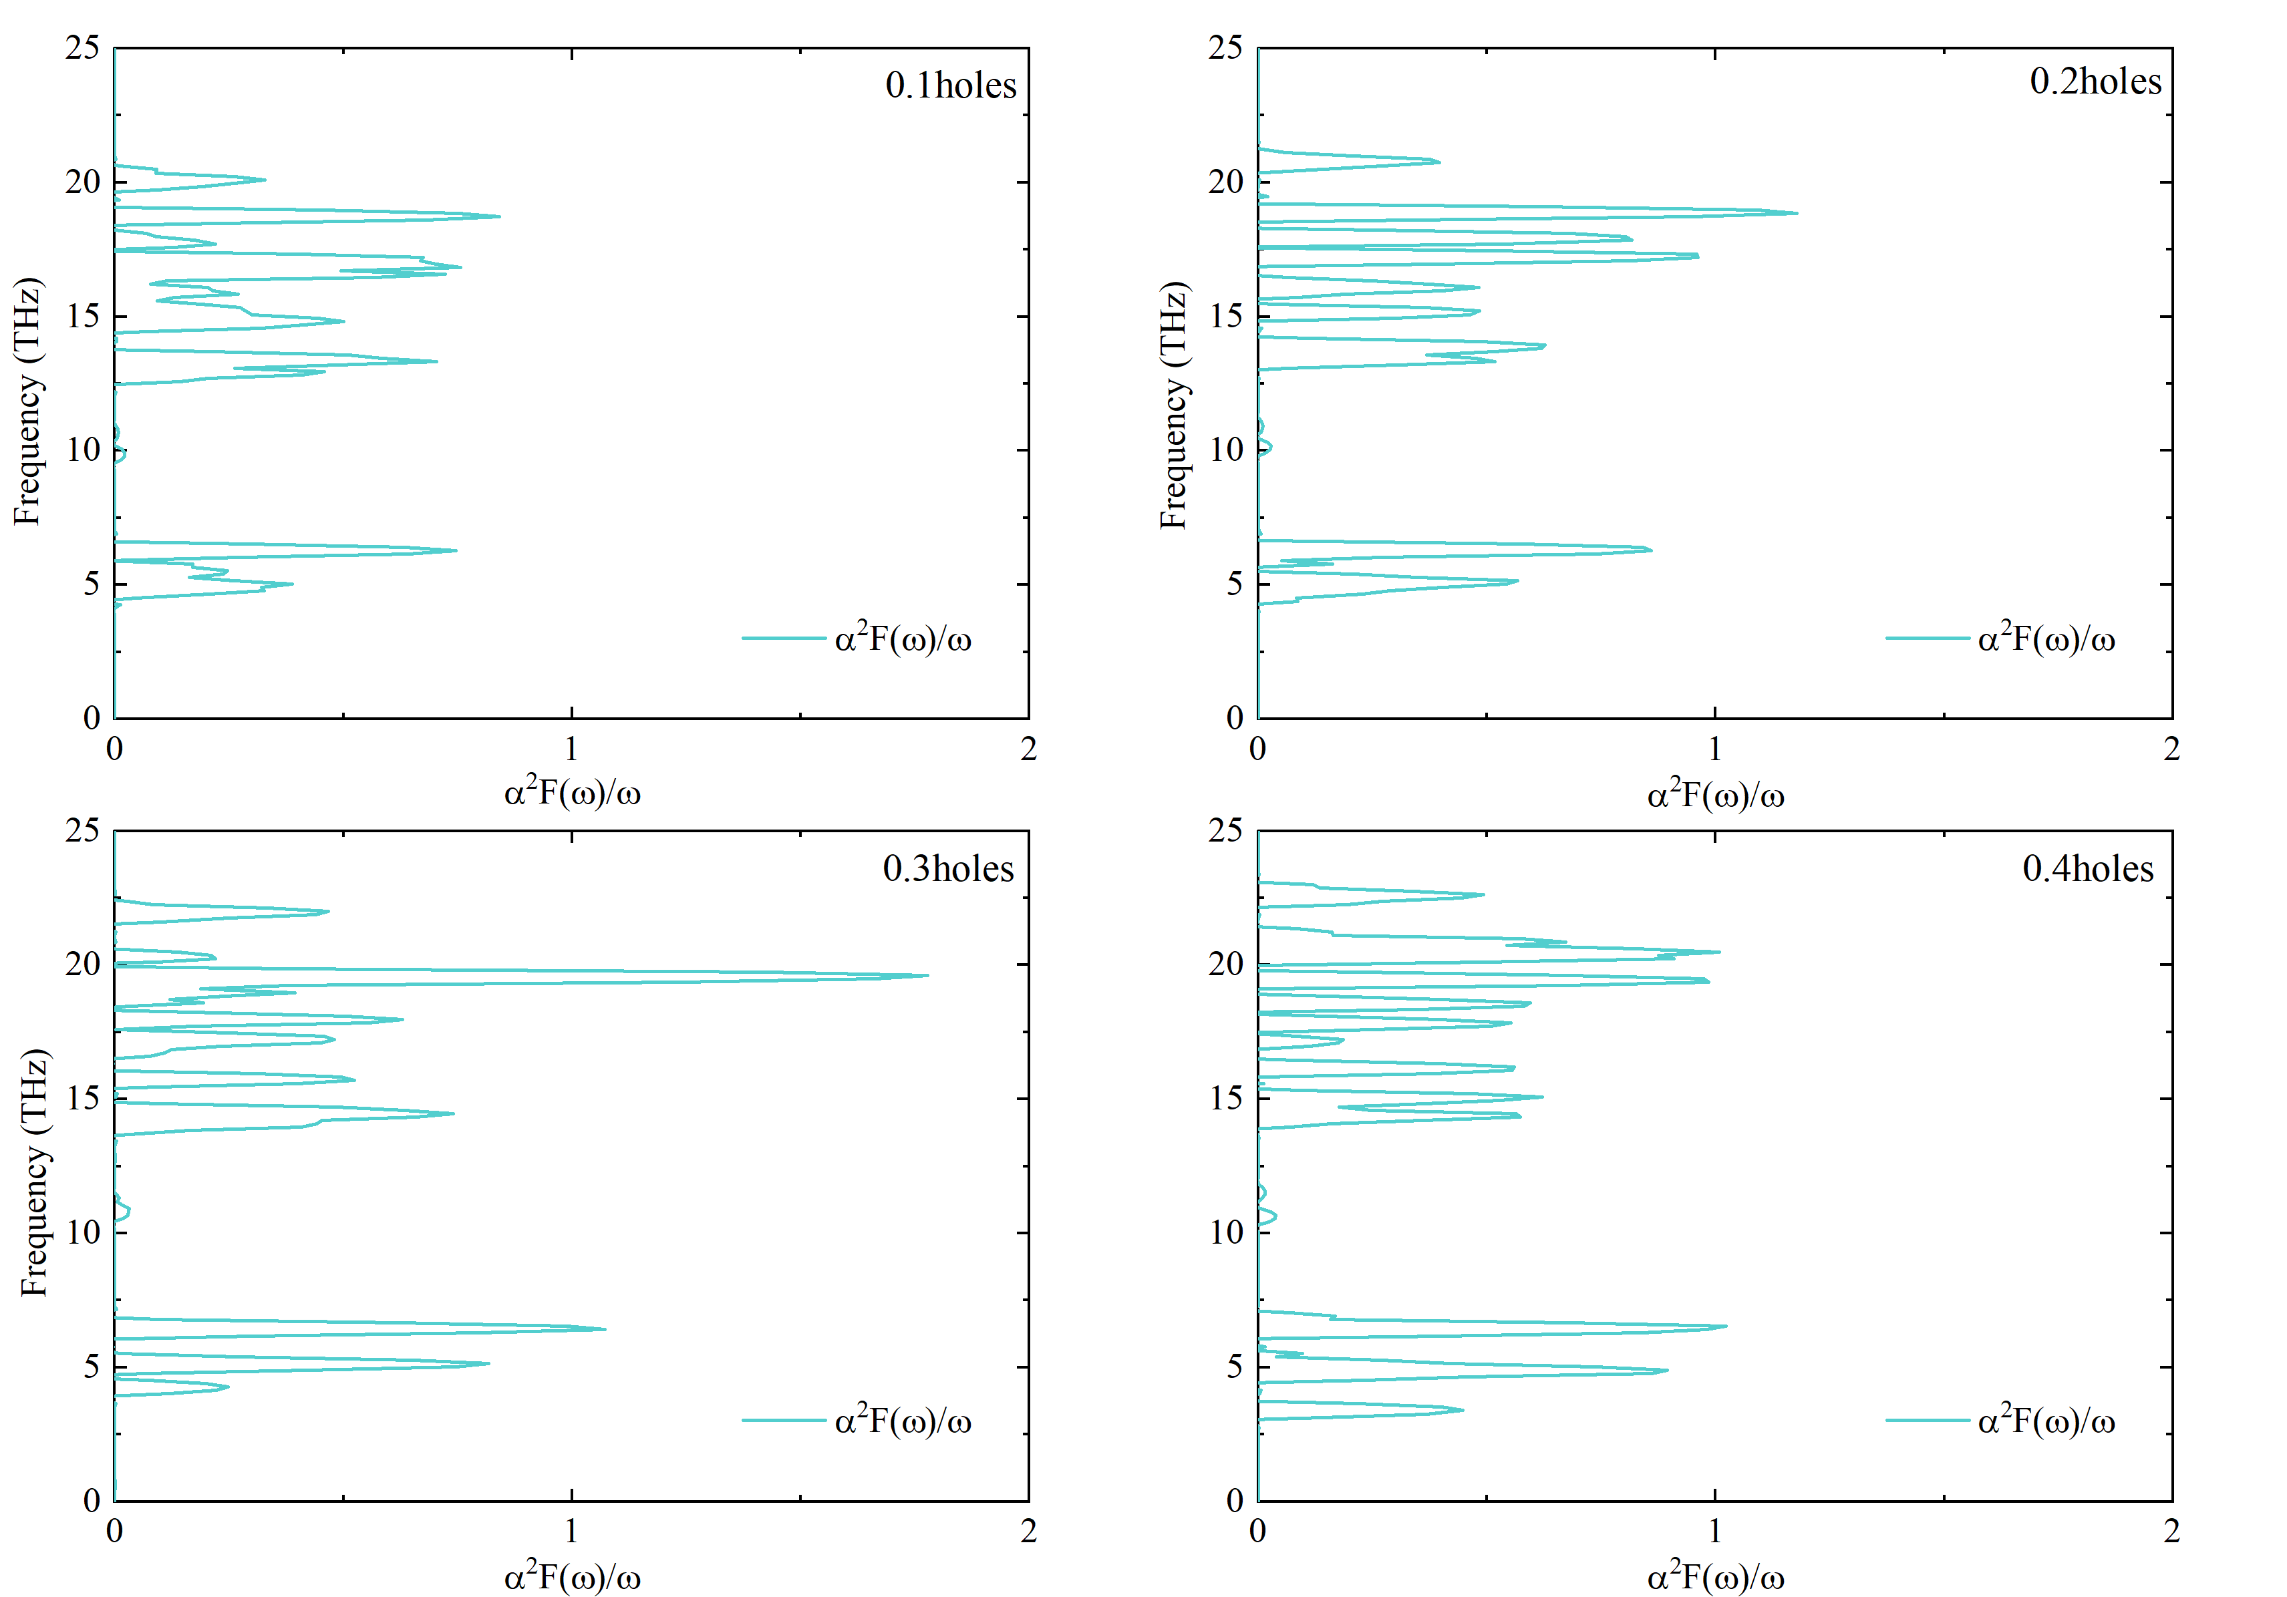
FIG.S3. The Eliashberg spectral function of YB₂ with additional holes at varying concentrations(0.1 ~ 0.4). The Eliashberg spectral function of (a) YB₂ with 0.1 holes added, (b) YB₂ with 0.2 holes added, (c) YB₂ with 0.3 electrons added and (d) YB₂ with 0.4 electrons added.

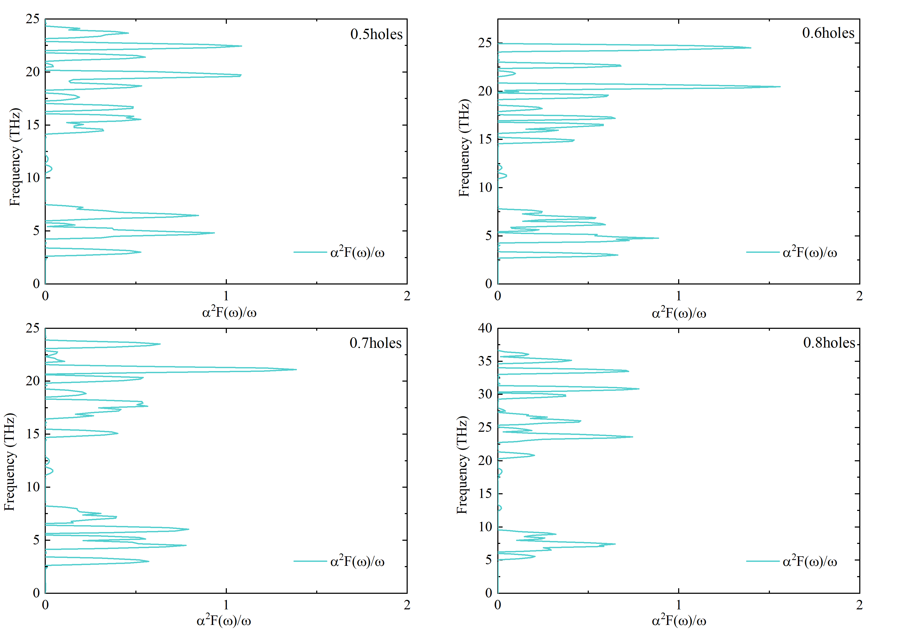
FIG.S4. The Eliashberg spectral function of YB₂ with additional holes at varying concentrations(0.5 ~0.8). The Eliashberg spectral function of (a) YB₂ adding 0.5 holes, (b) YB₂ adding 0.6 holes, (c) YB₂ adding 0.7 holes and (d) YB₂ adding 0.8 holes.

