Journal of the Geological Society, London, Vol. 165, 2008, pp. 423–433. Printed in Great Britain.

Detrital zircon U–Pb dating of low-grade metamorphic rocks in the Sulu UHP belt: evidence for overthrusting of the North China Craton onto the South China Craton during continental subduction

JIAN-BO ZHOU1,2, SIMON A. WILDE 1,2, GUO-CHUN ZHAO3, CHANG-QING ZHENG 1, WEI JIN 1,

XING-ZHOU ZHANG 1 & HONG CHENG 1

1College of Earth Sciences, Jilin University, Changchun 130061, China

2Department of Applied Geology, Curtin University of Technology, GPO Box U1987, Perth, WA 6845, Australia (e-mail: s.wilde@curtin.edu.au)

3Department of Earth Sciences, The University of Hong Kong, Pokfulam Road, Hong Kong, China

Abstract: The Shiqiao–Pingshang low-grade metasedimentary rocks sporadically crop out in the Sulu ultrahigh-pressure (UHP) belt in east–central China. Major and trace element data indicate that they were deposited in a passive margin basin, probably located at the southern margin of the North China Craton. Sensitive high-resolution ion microprobe (SHRIMP) U–Pb dating of detrital zircons from a quartzite (SD53) from Pingshang and a quartz schist (SD54) from Shiqiao records ages ranging from 2800 to 1900 Ma. Three age populations are defined: at 2660–2500, 2350–2150 and 2100–1900 Ma, with peak ages at 2522, 2212 and 2020 Ma, respectively. Muscovite Ar–Ar dating of the quartz schist (SD54) yields a plateau age of 265.9 1.2 Ma. These data support the view that the Shiqiao–Pingshang low-grade metasedimentary rocks originated from the North China Craton, and underwent deformation in the Permian during subduction of the South China Craton (Yangtze block) beneath the North China Craton. This requires that the low-grade metasedimentary rocks were overthrust for several tens of kilometres onto the South China Craton, explaining why source materials from the North China Craton are common in Triassic to Jurassic sedimentary basins

adjacent to the Dabie–Sulu orogenic belt.

The Sulu ultrahigh-pressure (UHP) metamorphic terrane is part of the Qinling–Dabie–Sulu orogenic belt in east–central China (Fig. 1a) and represents a continent–continent collisional orogen that evolved from the Permian to Triassic (Yin & Nie 1993; Hacker et al. 2000; Ratschbacher et al. 2003, 2006; Zheng et al. 2003, 2005; Xu et al. 2006). UHP metamorphic indicator minerals, such as coesite and micro-diamond in eclogites, gneisses and marbles (Wang et al. 1995; Liou et al. 1996), require that the South China Craton was subducted to at least 120–150 km depth beneath the North China Craton. However, greenschist-facies metamorphic rocks are also found in both the Dabie and Sulu UHP zones. Meta-volcanoclastic rocks occur at Ganghe in the interior of the UHP zone in Central Dabie (Fig. 1a) and these low-grade metamorphic rocks are interpreted to belong to the South China Craton (Zhou et al. 2001; Dong et al. 2002; Oberhaensli et al. 2002; Zheng et al. 2005) because zircon U–Pb protolith ages of 760 9 to 802 3 Ma and whole-rock Rb–Sr isochron ages of 232 8 Ma for metamorphism obtained from these rocks are equivalent to the Neoproterozoic protolith and Triassic metamorphic ages of the UHP rocks in the Dabie– Sulu belt (Dong et al. 1997; Schmid et al. 2003). Greenschistfacies metasedimentary rocks are also found at Shiqiao and Pingshang in the Sulu segment of the orogenic belt (Fig. 1b), and these are collectively referred to as the Shiqiao–Pingshang lowgrade metasedimentary rocks.

Several workers have studied the metamorphic conditions and tectonic relationship between the low-grade and UHP rocks (SBGMR 1987, 1997; Dong et al. 1996; Song & Song 1998; Zhou et al. 2001; Zheng et al. 2005), and have mostly suggested that the low-grade rocks at Sulu underwent the same events as at

423

Dabie, although there are still insufficient geochemical and geochronological data to establish this.

In this paper, we present sensitive high-resolution ion microprobe (SHRIMP) U–Pb detrital zircon and Ar–Ar geochronological data for the greenschist-facies metamorphic rocks in the Sulu segment of the Qingling–Dabie–Sulu orogenic belt. These allow us to re-evaluate the source areas of the Shiqiao– Pingshang low-grade metasedimentary rocks and ascertain their relationship to either the North China Craton or South China Craton. Ar–Ar geochronological data allow evaluation of the timing of metamorphism in the area.

# Geological setting

|  |
| --- |
| Fig. 1. (a) The location of the Dabie–Sulu orogenic belt in China (after Zhao et al. 2005); (b) geological sketch map of the Sulu orogenic belt of central–east China (after Faure et al. 2001; Zhou et al. 2001). The surface exposure of low-grade units is exaggerated to make them easily identifiable. NCC, North China Craton; SCC, South China Craton; SPLM, Shiqiao– Pingshang low-grade metasedimentary rocks; SGB, Songpan–Ganzi Basin; HB, Hefei Basin; QB, Qianshan Basin. |

The Sulu high-pressure–ultrahigh-pressure (HP–UHP) metamorphic terrane extends NE–SW for c. 750 km and is up to 180 km wide (Fig. 1a). Two main tectonic zones are identified, with a UHP eclogite-facies zone in the north and a high-pressure blueschist-facies zone in the south (e.g. Okay et al. 1993; Ernst & Liou 1995; Hacker et al. 1995, 2000; Wang et al. 1995; Liou et al. 1996; Zheng et al. 2005; Leech et al. 2006; Ratschbacher et al. 2006; Webb et al. 2006; Xu et al. 2006). The northern zone is composed of UHP eclogites, gneisses and marbles, with the occurrence of micro-diamond and coesite as inclusions in garnet and zircon indicating temperature–pressure conditions of 740– 840 8C and .2.8 GPa for the UHP metamorphism (Wang et al. 1995; Xu et al. 2006). Zircon cores and mantles preserve protolith ages between 640 and 780 Ma (Ames et al. 1996; Liu et al. 2004; Zheng et al. 2004), reflecting an affinity with the South China Craton. The UHP metamorphism at Sulu occurred in the middle Triassic at 240–220 Ma, based on Sm–Nd, U–Pb and Ar–Ar investigations (Li et al. 1993, 2000; Ames et al. 1996; Hacker et al. 1998, 2000; Liu et al. 2004, 2006; Xu et al. 2006). The high-pressure blueschist-facies zone to the south is separated from the UHP zone by the Haizhou–Siyang (Hai–Si) Fault (Fig. 1b). Recent SHRIMP U–Pb zircon and Ar–Ar dates show that the HP metamorphism at Sulu took place in the Late Permian at c. 253 Ma, reflecting the onset of subduction of the South China Craton beneath the North China Craton (Xu et al. 2006).

For this study, we have investigated the Shiqiao–Pingshang low-grade metasedimentary rocks from the Shiqiao and Pingshang areas in the central part of the Sulu UHP zone (Fig. 1b). These rocks at Pingshang extend in an east–west direction for 1.5 km in length and are 200–500 m wide. They consist of a sequence of schist, phyllite, slate, quartzite and meta-sandstone. Sample SD53 is a quartzite (about 1.5 m in thickness) and was collected from the central part of the sequence.

The Shiqiao–Pingshang low-grade metasedimentary rocks at Shiqiao are c. 100 m in length and 50 m wide. They are similar to those at Pingshang and include meta-sandstone, slate, phyllite and quartz schist. Sample SD54 is a quartz schist taken from the top of the sequence. According to graded bedding, the rocks at Shiqiao may have been inverted during tectonic emplacement (Song & Song 1998). Several reports also suggest there is a faulted relationship between the Shiqiao low-grade metasedimentary rocks and the UHP rocks (SBGMR 1987, 1997; Dong et al. 1996; Song & Song 1998).

Most Shiqiao–Pingshang low-grade metasedimentary rocks preserve sedimentary structures that include bedding in metasandstone and slate (Fig. 2a and b). Some of these rocks underwent folding and ductile shearing, transforming them into schists and mylonites. Typical mineral parageneses are chlorite + sericite + quartz for meta-sandstone; chlorite + biotite + sericite + quartz for slate; chlorite + sericite + quartz + albite for phyllite; and muscovite + quartz + albite for the quartzite and quartz schist (Fig. 2c and d), indicating greenschist-facies metamorphism (SBGMR 1987, 1997; Dong et al. 1996; Song & Song 1997; Zhou et al. 2001).

In summary, Shiqiao–Pingshang low-grade metasedimentary rocks show the following characteristics. (1) They occur within the Sulu UHP belt and have faulted contacts with the UHP country rocks (Dong et al. 1996; Song & Song 1998; Zhou et al. 2001; Zheng et al. 2005). (2) The rocks are typical of flysch clastic sequences and there is a lack of volcanic rocks. These features are similar to those of the Penglai Group in the Jiaobei terrane and the Wulian group at the northern margin of the Sulu belt (Fig. 1). (3) Late Neoproterozoic–Cambrian algal fossils have been found in the Shiqiao–Pingshang low-grade metasedimentary rocks (SBGMR 1987, 1997), and a Late Neoproterozoic (Sinian) age of 620 14 Ma was obtained from phyllite by the whole-rock Rb–Sr method (Song & Song 1997).

Analytical methods

# Major and trace elements

|  |
| --- |
| Fig. 2. Photographs of low-grade metamorphic rocks in the interior of the Sulu UHP metamorphic belt. (a) Thinly laminated slate at Shiqiao in SW Sulu (GPS: 358029320N, 1198109320E); lens cap is 4 cm in diameter; (b) photomicrograph of slate with original bedding (from outcrop shown in (a)); (c) photomicrograph of quartzite (sample SD53) with mineral paragenesis of muscovite + quartz + plagioclase + albite from Pingshang (358079330N, 1198039560E); (d) photomicrograph of quartz schist (sample SD54) with mineral paragenesis of muscovite + quartz + plagioclase from Shiqiao (358029320N, 1198109320E). Q, quartz; Mus, muscovite; Ab, albite; Pl, plagioclase. |

Analyses of major element oxides and trace elements were carried out at the Analytical Institute in the Hubei Bureau of Geology and Mineral Resources, Wuhan. Major elements were measured by XRF using a Regaku 3080E1 spectrometer. The analytical uncertainties are usually better than 0.3–0.9% for major elements. For REE and Nb, Ta, Zr, Hf, Th and Ba, the samples were digested by alkaline-fusion and analysed by inductively coupled plasma atomic emission spectrometry (ICP-AES) using a JY48/JY38P system at Wuhan. The analytical uncertainties are better than 5% (2) for REE, and ,10% for other trace elements.

Analyses of international standard reference samples from this laboratory have been reported by Gao et al. (1991).

# SHRIMP U–Pb

Two samples (SD53 and SD54) from the metasedimentary rocks at Shiqiao and Pingshang were selected for study. They were processed by crushing, initial heavy liquid and subsequent magnetic separation. Samples were divided into different size and magnetic fractions using a Frantz isodynamic separator. Zircons from the non-magnetic fractions were handpicked and mounted onto adhesive tape, along with pieces of the CZ3 zircon standard, enclosed in epoxy resin and then polished to about half their thickness. The mount was then cleaned and gold-coated and photographed in reflected and transmitted light. Cathodoluminescence (CL) imaging of zircon grains was carried out using a Philips XL30 SEM at Curtin University of Technology. U–Th–Pb analyses were conducted using the WA Consortium SHRIMP II ion microprobe housed at Curtin University of Technology. Detailed analytical procedures have been described by Nelson (1997) and Williams (1998). Isotopic ratios were monitored by reference to Sri Lankan gem zircon standard (CZ3) with a 206Pb/238U ratio of 0.0914 that is equivalent to an age of 564 Ma. Pb/U ratios in the unknown samples were corrected using the ln(Pb/U)/ ln(UO/U) relationship as measured on CZ3. All ages have been calculated from the U and Th decay constants recommended by Steiger & Ja¨ger (1977). Reported ages represent 207Pb/206Pb data that have been corrected for common lead using the measured 204Pb (Compston et al. 1984). The analytical data were reduced, calculated and plotted using the Squid (1.0) and IsoplotEx 2.46 programs (Ludwig 2001). Individual analyses in the data table and concordia plots are presented at 1 error and uncertainties in weighted mean ages are quoted at the 95% confidence level (2), unless otherwise indicated.

# Ar–Ar method

Muscovite selected from the quartz schist (SD54) was fresh and free of alteration. It was purified using a magnetic separator and then cleaned by ultrasonic treatment under ethanol. The purity of the mineral separates (0.08–0.15 mm in size) exceeds 99%. Samples were wrapped in aluminium foil and loaded into an aluminium tube, together with two or three monitor samples. The tubes were sealed into a quartz bottle (40 mm high; 50 mm in diameter) and irradiated for 51 h 46 min in a nuclear reactor (The Swimming Pool Reactor, Chinese Institute of Atomic Energy, Beijing). The reactor delivers a neutron flux of 6.4 3 1012 n cm2 s1; the integrated neutron flux is about 1.21 3 1018 n cm2. After irradiation and a delay of 3 months, the samples and monitors were removed from the quartz bottle and then loaded into the vacuum extraction system at the Isotopic Laboratory of the Institute of Geology and Geophysics, Chinese Academy of Sciences (CAS). They were baked for 48 h at 120– 150 8C. The Ar extraction system comprises an electron bombardment heated furnace in which the samples are heated under a vacuum. A thermocouple was used to monitor and automatically control the temperature of the furnace. The released gases were then passed through a purification system. The heating–extraction step for each temperature increment was 30 min, with 30 min for purification. The purification system uses a U-tube cooled with a mixture of acetone and dry ice, with the titanium sublimation pump at 38 A filament current and a titanium sponge furnace at 800 8C. Finally, the gases were purified by two SorbAC pumps at room temperature. The purified argon was trapped in an activated charcoal finger at liquid nitrogen temperature, and then released into the MM-1200B mass spectrometer for Ar isotope analysis.

The measured isotopic ratios were corrected for mass discrimination, atmospheric Ar contamination, blanks and irradiation-induced mass interference. The correction factors of interfering isotopes produced during irradiation were determined by analysis of irradiated pure K2SO4 and CaF2. Their values are: (36Ar=37Ar)Ca ¼ 0:000240; (40Ar=39Ar)K ¼ 0:004782; (39Ar=37Ar)Ca ¼ 0:000806. The blanks of m=e ¼ 40, m=e ¼ 39, m=e ¼ 37 and m=e ¼ 36 are less than 2 3 1014 mol,

4 3 1016 mol, 8 3 1017 mol and 6 3 1017 mol, respectively. All 37Ar abundances were corrected for radiogenic decay (half-life 35.1 days). The errors are given as one standard deviation. The monitor used in this work is an internal standard: Fangshan biotite (ZBH-25) with an age of 132.7 1.2 Ma and potassium content is 7.579 0.030 wt.% (Wang 1983). The 40Ar/36Ar v. 39Ar/36Ar isochron diagram was defined by using the regression of York (1968).

Results

# Major and trace elements

The major and trace element data, for meta-sandstone, phyllite, slate and quartz schist are available online at http://www.geolsoc. org.uk/SUP18293. The phyllite and slate are similar to PostArchaean Australian Shale (PAAS) (Taylor & McLennan 1985). Most of the samples have high SiO2 (60.49–75.50%) and K2O (3.87–10.79%), with the high K content almost certainly caused by the original presence of large quantities of illite (McLennan et al. 1983). The quartz schist, quartzite and meta-sandstone are also high in SiO2 (85.50–95.11%), but low in MgO (0.14–

0.85%), CaO (0.05–0.71%), Al2O3 (1.96–5.43%), Fe2O3 (0.01–

0.16%), Na2O (0.11–0.58%), K2O (1.29–3.60%), TiO2 (0.1– 0.57%) and P2O5 (0.02–0.52%). Samples of meta-sandstone, phyllite and slate are all similar to upper continental crust (Figs

P P

3 and 4) (REE ¼ 118:5–297:3 ppm, REE= HREE ¼ 7–16, (La=Yb)N ¼ 7:02–18.42 and Eu=Eu¼ 0:61–0:92). The samples of quartzite and quartz schist (SD52, SD53, SD54) are likewise similar to upper continental crust (Fig. 3), but are low in PREE (45.41–7.62), and have a positive Eu anomaly (1.30–1.19). The trace element values in phyllite and slate (SD40, SD48, SD49) are similar to upper continental crust (Fig. 4), but are lower in Sr (128–204 ppm). The samples of meta-sandstone and quartzite are also low in Sr (20–149 ppm), Y (2.55–31.48 ppm) and Yb (0.34–2.51 ppm). In general, the analytical results for all samples are not significantly different from the upper continental crust or PAAS (Taylor & McLennan 1985; McLennan 1989).

Overall, the analytical results for all samples are not significantly different from the upper continental crust, but are distinctly different from the UHP country rocks (Figs 3 and 4). Major and trace element discrimination diagrams indicate that most of the Shiqiao–Pingshang low-grade metasedimentary rocks belong to the Quartzose sedimentary provenance (Fig. 5a), and appear to have been deposited at a passive continental margin (Figs 5b and 6).

# SHRIMP zircon ages

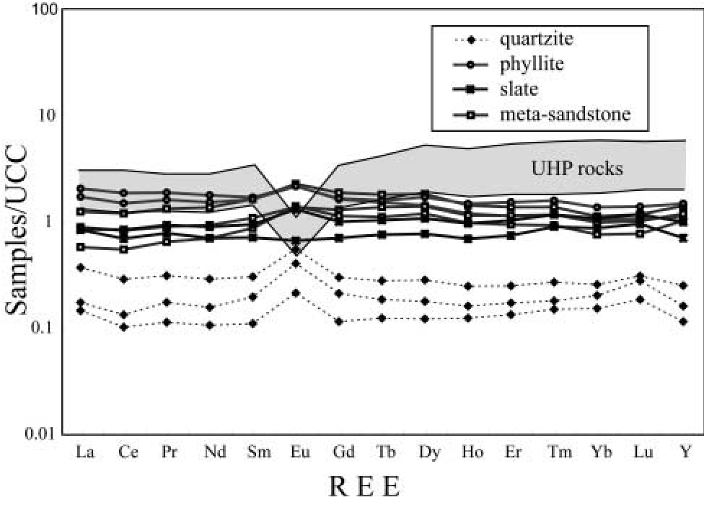

Fig. 3. Diagram of upper continental crust (UCC)-normalized REE for

Shiqiao–Pingshang low-grade metasedimentary rocks from Shiqiao and Pingshang in the Sulu orogen (the values of UHP rocks in the Sulu belt are from Liu et al. 2004). UCC values are after McLennan et al. (2006).

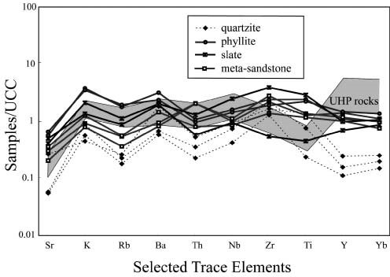

Fig. 4. Diagram of UCC-normalized trace elements for Shiqiao– Pingshang low-grade metasedimentary rocks in the Sulu orogen (the values for UHP rocks in the Sulu belt are from Liu et al. 2004). UCC values are after McLennan et al. (2006).

Samples SD53 and SD54 are both high in SiO2 (90–95%) and their constituents may have travelled considerable distances from the source. Consequently, we chose these samples for U–Pb zircon analysis, as they can provide key evidence on the provenance of the source regions.

# Sample SD53: quartzite

Sample SD53 was collected in the Wangjia valley in Pingshang townsite (Fig. 1b). The quartzite is interlayered with phyllite and slate and consists mostly of recrystallized quartz grains (.80%) with serrated margins, feldspar (,8%) and muscovite (,10%) (Fig. 2c). Accessory tourmaline and zircon are also present. The sample yielded abundant small zircon grains, ranging from 50 to 200 m in size, most of which are rounded to subhedral and isometric in form. CL imaging reveals that most grains contain oscillatory zoned portions, although both marginal and internal recrystallization has taken place (Fig. 7a). Some show dark cores that contain higher U concentrations than the relatively lighter grey rims and a small number are homogeneous in CL. A total of 58 analyses were made on 54 rounded grains and 37 analyses show discordance less than 5% (Fig. 8). Data are available online as a Supplementary Publication (see above). The grains show great variation in U and Th contents and Th/U ratios, with respective ranges of 12–395 ppm, 2–441 ppm and 0.04–1.93. Broadly, the grains fall into two age populations with 207Pb/206Pb ages ranging from 2800–2400 and 2150–1900 Ma, with peaks at 2524 and 2026 Ma, respectively (Fig. 8). The 37 concordant analyses yield 207Pb/206Pb ages ranging from 2800 to 1900 Ma and are thus representative of the entire population.

# Sample SD54: quartz schist

Sample SD54 was collected from the top of the metasedimentary sequence in Shiqiao valley (Fig. 1b) and consists of recrystallized quartz grains (.75%) with serrated margins, plagioclase (,10%), muscovite (,15%) and trace amounts of opaque minerals (Fig. 2d). The rock is foliated, defined by aligned plagioclase and muscovite grains. Muscovite flakes are poikiloblastic, with inclusions of quartz and plagioclase. Accessory tourmaline and zircon are also present. The sample yielded abundant small zircon grains, most of which are rounded. A total

|  |
| --- |
| Fig. 5. (a) Discrimination function analysis classification plot of function F1 and function F2 scores for Shiqiao–Pingshang low-grade metasedimentary rocks in the Sulu orogen (after Roser & Korsch 1988). (b) Discrimination function analysis (K2O/Na2O) v. SiO2 binary diagram after Bhatia & Crook  1986) for Shiqiao–Pingshang low-grade metasedimentary rocks in the Sulu orogen. F1 ¼1:773TiO2 þ 0:607Al2O3þ 0:76Fe2O3 1:5MgOþ 0:616CaO þ 0:509Na2O 1:224K2O 9:09; F2 ¼ 0:445TiO2þ 0:07Al2O3 0:25Fe2O3 1:142MgO þ 0:438CaO þ1:475Na2Oþ 1:426K2O 6:861. It should be noted that (a) shows most of the samples belong to the quartzose sedimentary provenance and two samples belong to the felsic igneous |

provenance; and (b) shows all the samples plot in the passive margin field.

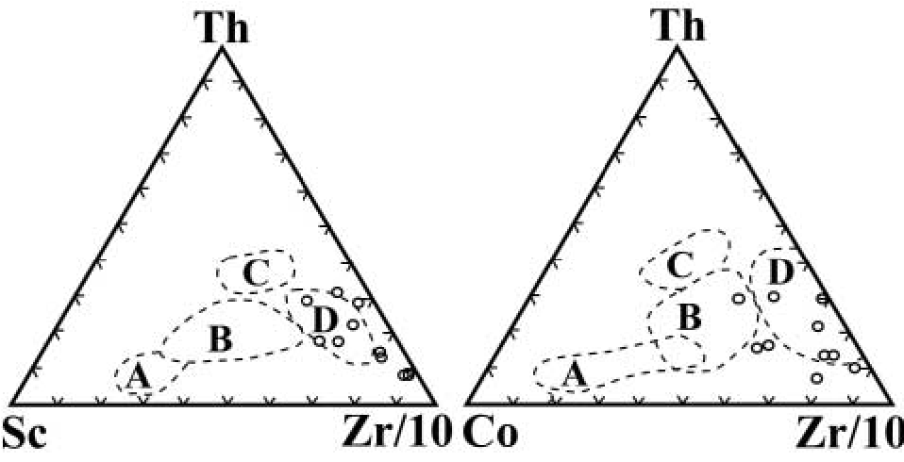

Fig. 6. Th–Sc–Zr/10 and Th–Co–Zr/10 plots (after Bhatia & Crook 1986) of the sandstone–mudstone suites from the low-grade metamorphic rocks in the Sulu orogen. The fields are: A, oceanic island arc; B, continental island arc; C, active continental margin; D, passive margin. Most samples plot in the passive margin fields.

of 55 analyses were made of 54 grains, and they show great variation in U and Th contents and Th/U ratios, with respective ranges of 20–236 ppm, 5–225 ppm and 0.10–1.47. All grains show weak to prominent oscillatory zoning in CL images and compositional features consistent with magmatic zircon (Fig. 7b). The 50 analyses with discordance less than 5% yield 207Pb/ 206Pb ages ranging from 2650 to 1950 Ma. Broadly, the grains fall into three age populations: at 2700–2500, 2350–2200 and 2100–1950 Ma, with peaks at 2520, 2212 and 2018 Ma (Fig. 9).

|  |
| --- |
| Fig. 7. Representative CL images of zircons from (a) sample SD53 and (b) sample SD54 in the Sulu orogen. Circles mark SHRIMP analysis sites. The notation for each spot consists of spot number, and in parentheses, the 207Pb/206Pb age and Th/U ratio. Light area around the analysis spots is the result of rastering the site prior to analysis. |

When the data for samples SD53 and SD54 are combined, they indicate three main age populations (Fig. 10): 2700–2500, 2400–2200 and 2100–1900 Ma, with peaks at 2522, 2212 and 2020 Ma. Detrital zircon grains with ages .2600 Ma are small in number and there are none with ages ,1800 Ma. Importantly, no Neoproterozoic ages were identified in the zircon populations of either sample, even though the metasedimentary rocks were deposited during the Sinian (Late Neoproterozoic) and in the Sulu area at the northern margin of the South China Craton.

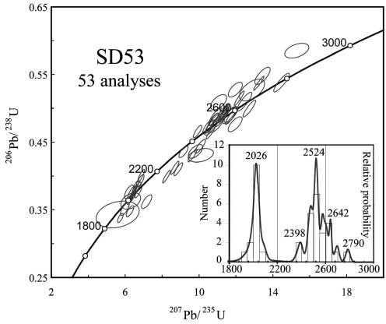

Fig. 8. U–Pb concordia diagram of detrital zircons from quartzite sample SD53 from Pingshang in the Sulu belt. Inset shows a relative probability plot for SD53; ages with discordance greater than 5% are not included here.

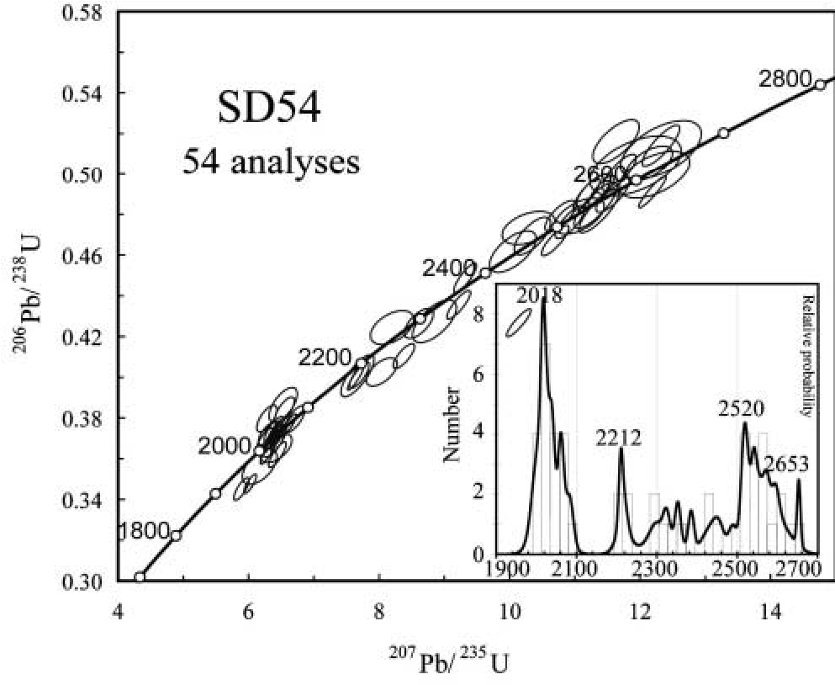

Fig. 9. U–Pb concordia diagram for detrital zircons from quartz schist sample SD54 from Shiqiao in the Sulu belt. Inset shows a relative probability plot for SD54: ages with discordance greater than 5% are not included.

# Ar–Ar data

To constrain the timing of deformation of the Shiqiao–Pingshang low-grade metasedimentary rocks, muscovite from quartz schist sample SD54 was selected for study using the 40Ar/39Ar stepwise heating method (Dalrymple & Lanphere 1971). Step heating resulted in a younger apparent age for the first step (Fig. 11), which accounts for 1.05% of the cumulative 39Ar released. The muscovite inverse isochron age for steps 1–9 is 271.1 9.3 Ma, and the plateau age of 265.9 1.2 Ma includes 72% of 39Ar released (Fig. 11), which is within error of the inverse isochron age. The inverse isochron defines an intercept within error of a trapped atmospheric component. Data are available online (see Supplementary Publication, see p. 426).

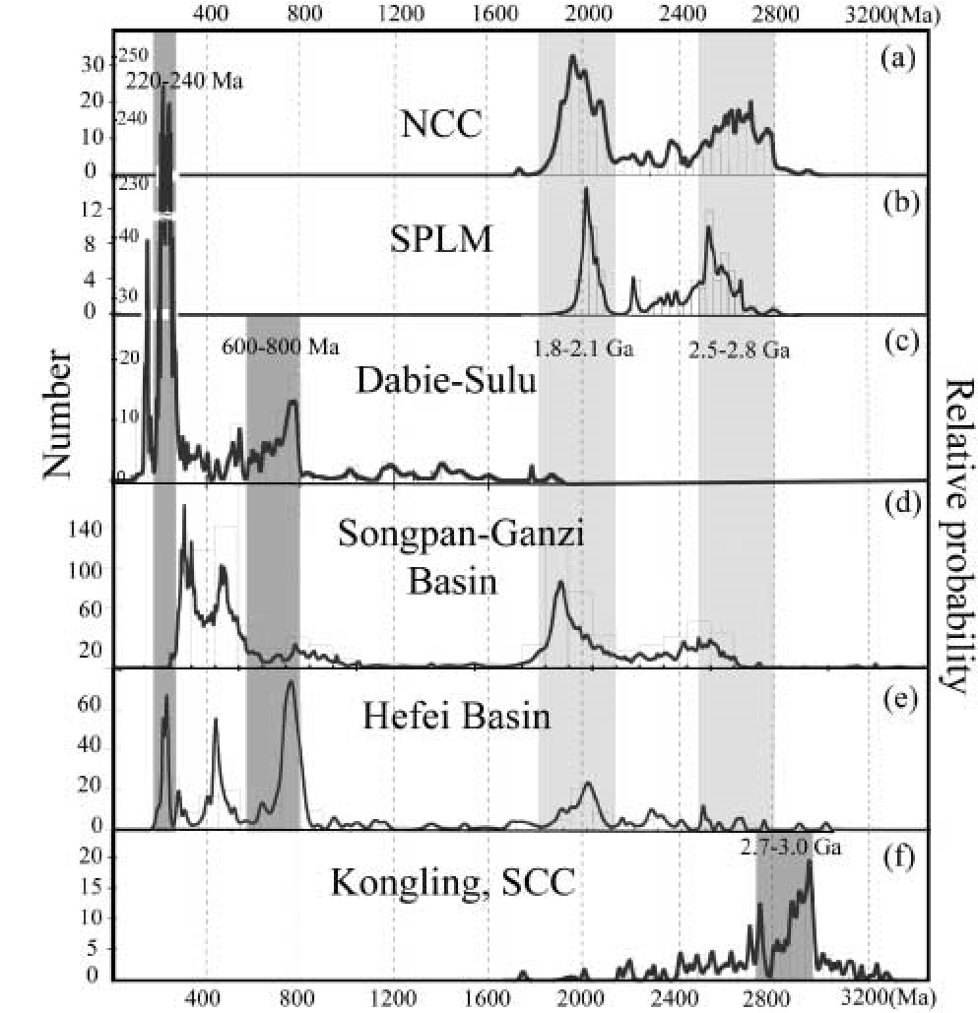

Fig. 10. Relative probability plot of Shiqiao–Pingshang low-grade metasedimentary rocks, compared with zircon ages from the neighbouring North China Craton, South China Craton and Mesozoic basins. (a) North China Craton, data from Darby et al. (2006); (b) Shiqiao–Pingshang low-grade metasedimentary rocks, this study, data from samples SD53 and SD54; (c) Dabie–Sulu orogenic belt, data from Leech et al. (2006) and Liu, R.W. et al. (2006), (d) Middle–Late Triassic

Songpan–Ganzi basin, data from Weislogel et al. (2006); (e) Jurassic–

Cretaceous Hefei basin, data from Li, R.W. et al. (2004); (f) Kongling Archaean metamorphic complex in the South China Craton, data from Qiu et al. (2000) and Zhang et al. (2006).

40Ar/39Ar dates generally represent mineral cooling ages. However, if the deformation temperature is near the closure temperature of the 40Ar/39Ar isotopic system, the plateau ages may record the timing of synkinematic mineral crystallization (Kirschner et al. 1996). Accepting that the argon closure temperature of muscovite is 350 50 8C (Dodson 1973; Hames & Bowring 1994), and taking into account the aforementioned deformation fabrics, the 40Ar/39Ar plateau age of c. 265 Ma for muscovite separates probably dates the regional metamorphism. The age of 265 Ma is in contrast to the 40Ar/39Ar ages previously obtained for HP–UHP rocks in the Sulu UHP belt (250–200 Ma), and taken to bracket the time of metamorphism and exhumation (Webb et al. 2006; Xu et al. 2006). However, ages similar to that reported here have been recognized from the Xinyang–Beihuaiyang low-grade rock unit at the northern margin of the Qinling–Dabie belt (Fig. 1a) (Hacker et al. 2000; Ratschbacher et al. 2003, 2006). These ages are 10–20 Ma older than the UHP metamorphism and may therefore record initial subduction between the North China Craton and South China Craton.

Discussion

# Tectonic affinity of the Shiqiao–Pingshang low-grade metasedimentary rocks in the Sulu Orogen

The basement rocks of the North China Craton and South China Craton record very different thermal–magmatic histories prior to amalgamation in the Early Mesozoic (Bruguier et al. 1997; Hacker et al. 1998, 2000; Chen et al. 2003; Li, R. W., et al. 2005; Zheng, Y. F., et al. 2005, 2006; Ratschbacher et al. 2006; Weislogel et al. 2006; Tang et al. 2007). Detrital zircon data presented in this study were collected from low-grade metamorphic rocks of the Sulu UHP belt, which marks the boundary between the North and South China cratons. Detrital zircon analysis can be important in identifying the provenance. The new zircon data from this study not only characterize the source regions, but also have the potential to provide important information about the continental collision. The data establish three populations in the Shiqiao–Pingshang low-grade metasedimentary rocks, with age groups at 2700–2500, 2400–2200 and 2100–1900 Ma, and peaks at 2522, 2212 and 2020 Ma, respectively, which can be compared with previous results obtained from both the North and South China cratons.

In the North China Craton, Precambrian basement rocks are dominated by Neoarchaean granitoids and orthogneisses (mostly tonalite–trondhjemite–granodiorite) and Palaeoproterozoic metasedimentary sequences (Jahn & Zhang 1984; Jahn & Ernst 1990; Zhao et al. 2000, 2002, 2005; Kusky & Li 2003; Zhai & Liu 2003; Wilde & Zhao 2005; Wilde et al. 2005; Zhai et al. 2005). Protolith ages for the North China Craton orthogneisses and the granitoids are mostly in the range of 2900–2500 Ma, with distinct populations at 2900–2700 and 2600–2500 Ma (Zhai & Liu 2003; Wilde & Zhao 2005; Wilde et al. 2005; Zhai et al. 2005; Zhao et al. 2005). In addition, the basement rocks in the North China Craton underwent 1900–1800 Ma regional amphibolite- to granulite-facies metamorphism (Zhai & Liu 2003; Zhai et al. 2005; Santosh et al. 2007). Ages between 2400 and 2100 Ma have only recently been recognized in the North China Craton (Lu et al. 2004; Li, S. Z., et al. 2005; Wan et al. 2006). These are mostly restricted to the Trans-North China Orogen and the Jiao–Liao–Ji Belt (Fig. 1a), where metasedimentary and metavolcanic rocks of this age are locally abundant. Importantly, they include SHRIMP U–Pb detrital zircon ages of 2200– 2000 Ma from the Liaohe group (Li, S. Z., et al. 2005; Wan et al. 2006) at Dashiqiao in eastern Liaoning Province; 2300– 2200 Ma detrital zircons from the Jingshan Group and c. 2200 Ma detrital zircons ages from the Fenzishan Group in the Jiaobei Terrane (Wan et al. 2006), all in close proximity to the study area (Fig. 1a).

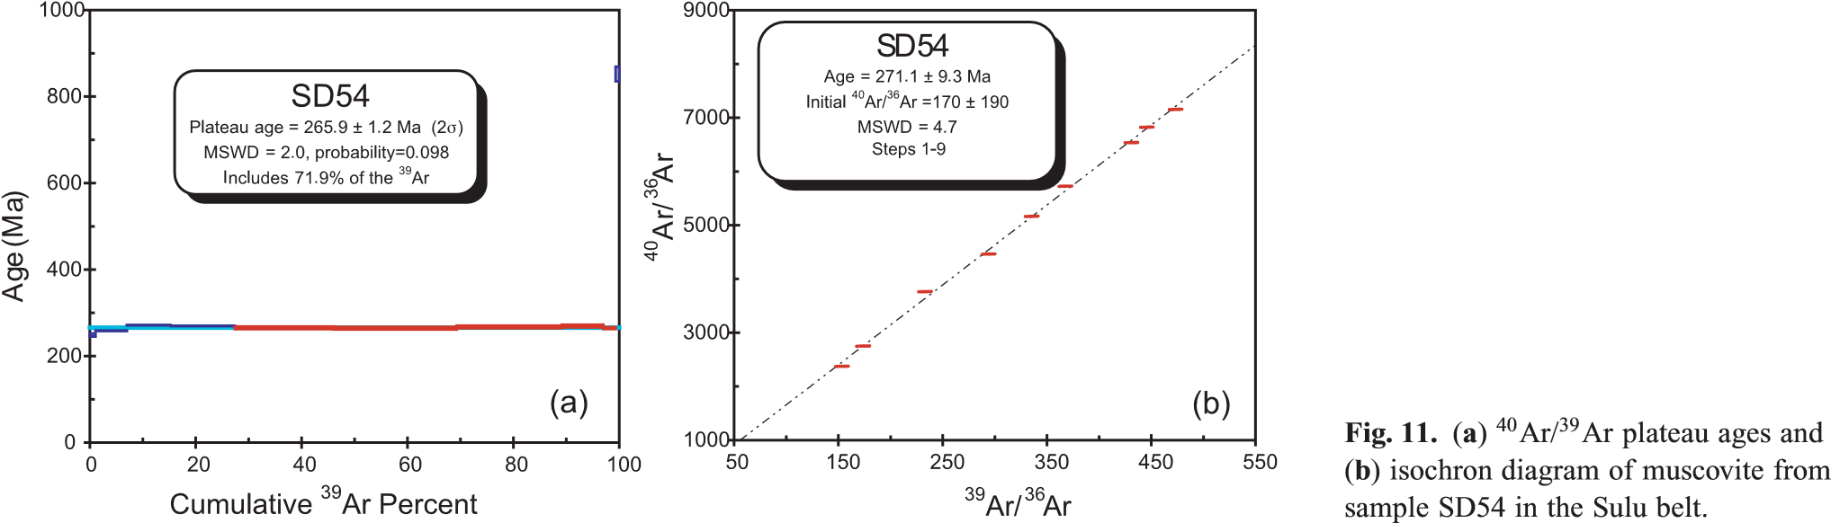The South China Craton, especially the Yangtze block, is characterized by young basement with Meso- to Neoproterozoic ages. This was subjected to major thermal events at 1100–1000 and 850–700 Ma (Li, Z. X., et al. 2002, 2003; Li, X. H., et al. 2003; Zheng, Y. F., et al. 2004, 2006). Although Palaeoproterozoic to Archaean rocks are also present at Kongling (Fig. 10f) in the northern South China Craton (Gao et al. 1999; Qiu et al. 2000; Zhang et al. 2006; Zheng et al. 2006), the age populations are none the less distinct from the age populations in the North China Craton. Precambrian basement in the South China Craton is characterized by the widespread occurrence of 820–740 Ma bimodal igneous rocks that evolved in a rift setting (Hacker et al. 1998, 2000; Li, Z. X., et al. 2002, 2003; Li, X. H., et al. 2003; Zheng, Y. F., et al. 2004, 2006; Leech et al. 2006). Therefore, Neoproterozoic rift magmatism is regarded as an important signature in distinguishing the South China Craton from the North China Craton (Hacker et al. 1998, 2000; Ratschbacher et al. 2003, 2006; Zheng et al. 2005; Wu et al. 2006).

The new zircon data from this study establish three populations in the Shiqiao–Pingshang low-grade metasedimentary rocks, with age groupings at 2700–2500, 2400–2200 and 2100– 1900 Ma (Fig. 10b). These are similar to those recorded in the North China Craton (Fig. 10a), but are different from those of the South China Craton (Fig. 10f) and the UHP rocks (Fig. 10c). Based on this and the fact that Neoproterozoic magmatic ages are absent in the Shiqiao–Pingshang low-grade metasedimentary rocks, although they are located in the Sulu UHP belt, we conclude that the most likely source for the Shiqiao–Pingshang low-grade metasedimentary rocks is from the southern edge of North China Craton, rather than the northern edge of the South China Craton.

# Relationship between low-grade metamorphic and UHP rocks

Although located in the Sulu UHP belt, the Shiqiao–Pingshang low-grade metasedimentary rocks are different from the UHP rocks in several distinct features. (1) The Shiqiao–Pingshang low-grade metasedimentary rocks are metasedimentary in origin whereas the rocks that underwent UHP metamorphism are dominantly of igneous protolith (Hacker et al. 1998, 2000; Zheng et al. 2005; Leech et al. 2006). (2) The Shiqiao–Pingshang lowgrade metasedimentary rocks are at greenschist-facies whereas the UHP rocks are at eclogite-facies. (3) Geochemical data show that the Shiqiao–Pingshang low-grade metasedimentary rocks are similar to upper continental crust or PAAS and indicate deposition in a passive margin setting, whereas the UHP rocks are igneous and evolved in a rift setting at the northern margin of the South China Craton (Ames et al. 1996; Hacker et al. 1998, 2000; Zheng, Y. F., et al. 2004, 2006; Leech et al. 2006). (4) SHRIMP detrital zircon data from the Shiqiao–Pingshang low-grade metasedimentary rocks establish three age populations: 2700–2500, 2400–2200 and 2100–1900 Ma, with peaks at 2522, 2212 and 2120 Ma, respectively; such ages are absent in the UHP rocks. On the other hand, Neoproterozoic ages between 650 and 850 Ma are common in the UHP rocks, but are absent in the Shiqiao–Pingshang low-grade metasedimentary rocks. (5) New SHRIMP zircon U–Pb dates show that the peak of UHP metamorphism was between 240 and 220 Ma (Leech et al. 2006; Liu et al. 2006; Wu et al. 2006; Xu et al. 2006). The Ar–Ar dating of muscovite from the Shiqiao–Pingshang low-grade metasedimentary rocks indicates metamorphism at c. 265 Ma. If these rocks underwent similar tectonic events to the UHP rocks, they would be expected to show similar metamorphic ages. However, there is no evidence to show that they underwent Triassic UHP metamorphism from either SHRIMP zircon or Ar– Ar muscovite dating.

The age of 265 Ma for muscovite from the quartz schist at Shiqiao has not previously been recorded from the Sulu UHP belt. However, similar ages have recently been reported in the Xinyang–Foziling unit, at the northern margin of the Dabie belt (Fig. 1a). The new evidence includes muscovite Ar–Ar ages of 271–261 Ma at Foziling (Ratschbacher et al. 2003, 2006) and 275–254 Ma at Xinxian (Xu et al. 2000; Ratschbacher et al. 2003, 2006). There is also a biotite Ar–Ar age of c. 253 Ma from Lianyunguang in the HP segment of the Sulu belt (Xu et al. 2006) (Fig. 1a). These ages are older by 10–20 Ma than the UHP metamorphism in the Dabie–Sulu belt, and Ratschbacher et al. (2003, 2006) suggested that they may record the time of initial subduction between the Xinyang–Foziling unit and North China Craton, and that this was earlier than the main subduction events between the North China Craton and South China Craton. Xu et al. (2006) have also suggested that the age of c. 253 Ma is the time of peak HP metamorphism in the Sulu belt, and that subduction between the North China Craton and South China Craton may have commenced prior to c. 253 Ma. Taken together, these data indicate that ages of 270–250 Ma may reflect the earliest deformation events during subduction of the South China Craton beneath the North China Craton.

# Tectonic implications

Was the North China Craton overthrust onto the South China Craton during continental subduction?

Shiqiao–Pingshang low-grade metasedimentary rocks with North China Craton affinity are now tectonically interleaved with UHP rocks in the Sulu belt. The simplest way to explain this is to invoke a model whereby the basement rocks of the North China Craton, together with the original marginal sedimentary basin (now represented by the Shiqiao–Pingshang low-grade metasedimentary rocks) overrode the South China Craton during continental subduction.

To test this hypothesis, it is necessary to examine data from the various Triassic to Jurassic sedimentary basins that developed around the Dabie–Sulu belt. The presence of coesite- and diamond-bearing UHP metamorphic rocks in the Dabie–Sulu belt suggests that a huge crustal section was buried, uplifted and then denuded (Nie et al. 1994). Most material eroded from the Dabie–Sulu belt appears to have accumulated in the Triassic Songpan–Ganzi Basin (Nie et al. 1994, 1995; Bruguier et al. 1997; Weislogel et al. 2006) (Fig. 1a), although some material also accumulated in several Jurassic–Cretaceous sedimentary basins that evolved around the Dabie–Sulu belt during postcollisional exhumation (Grimmer et al. 2003; Li, R. W., et al. 2005).

For the middle to late Triassic Songpan–Ganzi Basin (Fig. 1a), volumetric comparisons between the basin fill and the amount of material removed to exhume the UHP rocks (Nie et al. 1994, 1995) suggest that it was eroded during exhumation of the Dabie–Sulu belt. Weislogel et al. (2006) reported five major age populations in the detrital zircon suite obtained from the Songpan–Ganzi Basin by SHRIMP dating (Fig. 10d): 2500– 2400, 2050–1850, 900–800, 500–400 and 350–250 Ma. Most detrital zircon ages belong to the two oldest age populations (2500–2400 and 2050–1850 Ma), suggesting an affinity to the North China Craton (Fig. 10d). Bruguier et al. (1997) also reported detrital zircon ages from the Songpan–Ganzi Basin, recording age populations at 2600–2500 and 2000–1800 Ma, suggesting most of the detrital material was of North China Craton affinity (Bruguier et al. 1997). They also reported zircon ages of 760 and 230 Ma, correlating with the protolith and metamorphic ages, respectively, of the UHP rocks in the Dabie– Sulu belt (Bruguier et al. 1997; Hacker et al. 1998, 2000, 2006).

In the Jurassic to Cretaceous Hefei Basin and the Jurassic foreland Qianshan Basin (Fig. 1a), adjacent to the Dabie–Sulu belt, most sediments were also derived from the UHP orogen (Grimmer et al. 2003; Li, R. W., et al. 2005; Wan et al. 2005). The provenance of the Jurassic sediments is also a key issue in constraining the evolution and palaeogeographical reconstruction of HP–UHP rocks. In the Hefei Basin, Li, R. W., et al. (2005) reported that the major component in the Jurassic sediments was derived from the exhumed Dabie belt. Zircon ages from 2700– 1890 Ma were present though not abundant (Fig. 10e), suggesting material of North China Craton affinity, but probably derived from the erosion of the Dabie belt (Li, R. W., et al. 2005; Wan et al. 2005). These ages are also found in the Qianshan Foreland Basin at the southern margin of the Dabie orogen (Grimmer et al. 2003).

One problem is to explain why so much North China Craton source material is found in these basins and why so few materials are from the UHP rocks, especially in the Triassic Songpan– Ganzi Basin. Material from the Dabie–Sulu orogenic belt, involving erosion of the UHP rocks, would be expected to mainly provide 740–780 and 220–240 Ma detrital zircons, but this is not the case. We suggest that most of the eroded material did, indeed, come from the Dabie–Sulu belt, but that it not only involved removal of UHP rocks, but also rocks of North China Craton affinity that were thrust several tens of kilometres onto the South China Craton (Fig. 12). The rocks of North China Craton affinity would thus overlie the orogen and these were the first materials to be eroded during Triassic to Jurassic time and therefore provided most of the material fill in the Triassic to Jurassic basins.

# A tectonic model of continental subduction in the Dabie– Sulu belt

A number of tectonic models have been advanced for the formation and exhumation of the HP and UHP metamorphic rocks in the Dabie–Sulu orogenic belt (Okay et al. 1993; Hacker et al. 1995, 2000; Liou et al. 1996; Faure et al. 2001; Ratschbacher et al. 2003, 2006; Zheng et al. 2005), and for the collision and suturing between the South China Craton and the North China Craton (Yin & Nie 1993; Gilder et al. 1999; Faure et al. 2001). Combining our new data for the Shiqiao–Pingshang low-grade metasedimentary rocks with those recently obtained from the UHP rocks (Leech et al. 2006; Ratschbacher et al. 2006; Wan et al. 2006; Webb et al. 2006; Wu et al. 2006; Xu et al. 2006), together with detrital zircon ages from the Songpan– Ganzi Basin (Weislogel et al. 2006; Bruguier et al. 1997), Heifei Basin (Li, R. W., et al. 2005) and Qianshan Basin (Grimmer et al. 2003), we propose an overthrust model to explain the

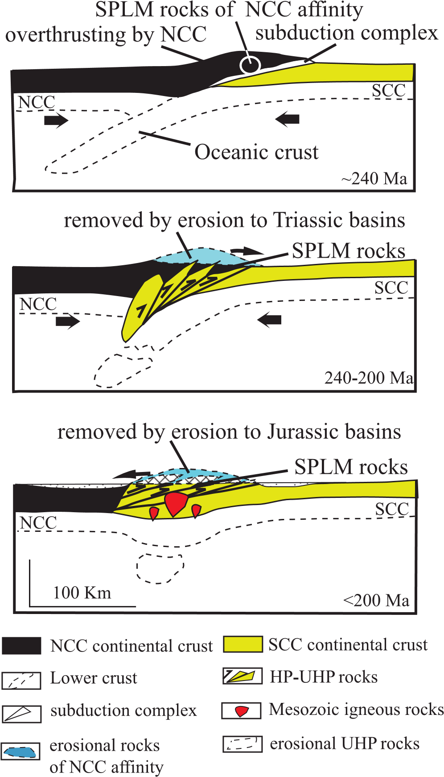

Fig. 12. Tectonic model for the evolution of the Shiqiao–Pingshang lowgrade metasedimentary rocks during subduction and exhumation between the North China Craton and South China Craton.

geodynamic setting at the time of collision of the South China Craton with the North China Craton.

Before c. 270 Ma, the South China Craton, together with oceanic crust to the north, started to subduct beneath the North China Craton. The North China Craton rocks, including the marginal basin cover at the southern boundary (e.g. the Shiqiao– Pingshang low-grade metasedimentary rocks) and other rocks of North China Craton affinity (now eroded and deposited in the Triassic–Jurassic basins; Nie et al. 1994, 1995; Bruguier et al. 1997; Grimmer et al. 2003; Li, R. W., et al. 2005; Weislogel et al. 2006), were overthrust onto the northern edge of the South China Craton (Fig. 12a). Ar–Ar muscovite data from the Shiqiao–Pingshang low-grade metasedimentary rocks suggest that they were metamorphosed to greenschist facies at 265 Ma, probably through initial tectonic stacking.

At 240–220 Ma, ultrahigh-pressure rocks were formed at c. 150 km depth (e.g. Hacker et al. 2000; Leech et al. 2006; Xu et al. 2006). The HP and UHP slabs were then exhumed between 220 and 200 Ma (e.g. Ratschbacher et al. 2006; Webb et al. 2006; Xu et al. 2006). The overthrust rocks of the North China Craton were then subject to erosion and removal (Figs 10d and 12b). Most became detritus that was transported into the Middle–Late Triassic Songpan–Ganzi Basin (Nie et al. 1994; Bruguier et al. 1997; Weislogel et al. 2006). Additional material was transported into the Qianshan foreland basin at the southern margin of the Dabie–Sulu belt (Grimmer et al. 2003). Thus, detrital zircons with ages of 2700–1900 Ma are of North China Craton affinity and are now found in these Mesozoic basins.

Post-collisional denudation (,200 Ma) (Webb et al. 2006; Xu et al. 2006) exhumed the UHP rocks, during which tectonic interleaving with any remaining rocks of North China Craton affinity took place. Erosion continued and the detritus was transported into the evolving Jurassic basins adjacent to the Dabie–Sulu belt (Fig. 1a) (Grimmer et al. 2003; Li, R. W., et al. 2005). As a result, detrital zircons recording the age of both UHP metamorphism and the North China Craton source can be found in the Jurassic Qianshan and Hefei basins (Fig. 10e). Most overthrust North China Craton rocks were denuded between the Triassic and the present day, and only a small portion was preserved owing to their being tectonically interleaved with the UHP rocks. As a result, the remaining rocks of North China Craton affinity occur as the Shiqiao–Pingshang low-grade metasedimentary unit in the Dabie–Sulu UHP belt, in tectonic contact with the UHP rocks (Fig. 12c).

# Conclusions

Neoproterozoic (Sinian) low-grade metamorphic rocks (Shiqiao– Pingshang low-grade metasedimentary rocks) occur at Shiqiao and Pingshang, in the Sulu UHP belt, and consist of metasandstone, phyllite, slate, quartzite and quartz schist. The major and trace element data indicate deposition in a passive margin basin at the southern edge of the North China Craton. SHRIMP zircon U–Pb dating of both quartzite and quartz schist records ages between 2700 and 1800 Ma, with three discrete populations at 2700–2500, 2400–2200 and 2100–1900 Ma. These data support the view that the Shiqiao–Pingshang low-grade metasedimentary rocks are of North China Craton affinity. Ar–Ar dating of muscovite from the quartz schist defines a plateau age of 265 Ma, possibly recording the onset of subduction of the South China Craton beneath the North China Craton. We propose that the North China Craton was overthrust for several tens of kilometres onto the South China Craton during early continental subduction and tectonically interleaved with the UHP rocks during subsequent exhumation. This explains why the Shiqiao– Pingshang low-grade metasedimentary rocks are interleaved with UHP rocks and why North China Craton source materials are common in the Triassic to Jurassic basins adjacent to the Dabie– Sulu belt, especially in the Songpan–Ganzi Basin.

This study was funded by grants from the Natural Science Foundation of China (40272100, 40672148 and 40739905). We thank A. Frew for assistance with SHRIMP analysis. The final version of the paper has greatly benefited from the perceptive comments of M. Whitehouse (editor), N. Kelly and an anonymous reviewer. The Western Australia SHRIMP Facility is jointly run by Curtin University of Technology, the University of Western Australia and the Geological Survey of Western Australia. This is The Institute for Geoscience Research (TIGeR) Publication 66.

# References

Ames, L., Zhou, G. & Xiong, B. 1996. Geochronology and geochemistry of ultrahigh-pressure metamorphism with implications for collision of the North

China and Yangtze cratons, central China. Tectonics, 15, 472–489.

Bhatia, M.R. & Crook, K.A. 1986. Trace element characteristics of graywackes and tectonic setting discrimination of sedimentary basins. Contributions to Mineralogy and Petrology, 92, 181–193.

Bruguier, O., Lancelot, J.R. & Malavieille, J. 1997. U–Pb dating on single detrital zircon grains from the Triassic Songpan–Ganze flysch (Central China): provenance and tectonic correlations. Earth and Planetary Science Letters, 152, 217–231.

Chen, F.K., Guo, J.H., Jiang, L.L., Siebel, W., Cong, B.L. & Satir, M. 2003. Provenance of the Beihuaiyang lower-grade metamorphic zone of the Dabie ultrahigh-pressure collisional orogen, China: Evidence from zircon ages. Journal of Asian Earth Sciences, 22, 343–352.

Compston, W., Williams, I.S. & Meyer, C. 1984. U–Pb geochronology of zircons from lunar breccia 73217 using a sensitive high mass-resolution ion microprobe. Journal of Geophysical Research, 89B, 525–534.

Dalrymple, G.B. & Lanphere, M.A. 1971. 40Ar/39Ar Ar technique of K/Ar dating: a comparison with the conventional technique. Earth and Planetary Science Letters, 12, 300–308.

Darby, B.J. & Gehrels, G. 2006. Detrital zircon reference for the North China block. Journal of Asian Earth Sciences, 26, 637–648.

Dodson, M.H. 1973. Closure temperature in cooling geochronological and petrological systems. Contributions to Mineralogy and Petrology, 40, 259–274.

Dong, S.W., Zhang, Y. & Huang, D.Z. 1996. Geological feature of a tectonic window at Shiqiao within ultrahigh pressure metamorphic belt in North Jiangsu. Anhui Geology, 6, 9–13 [in Chinese with English abstract].

Dong, S.W., Wang, X.F. & Huang, D.Z. 1997. Discovery of low-grade metavolcanic rock sheets within UHP belt in Dabieshan and its implications. Chinese Science Bulletin, 42, 1199–1203.

Dong, S.W., Oberhaensli, R., Schmidt, R., Liu, X.C., Tang, J.F. & Xue, H.M. 2002. Occurrence of metastable rocks in deeply subducted continental crust from the Dabie Mountains, central China. Episodes, 25, 84–89.

Ernst, W.G. & Liou, J.G. 1995. Contrasting plate-tectonic styles of the Qinling– Dabie–Sulu and Franciscan metamorphic belts. Geology, 23, 253–256.

Faure, M., Lin, W. & Le Breton, N. 2001. Where is the North China–South China block boundary in eastern China? Geology, 29, 119–122.

Gao, S., Zhang, B., Xie, Q., Gu, X., Ouyamg, J., Wang, D. & Gao, C. 1991. Average chemical compositions of post-Archean sedimentary and volcanic rocks from the Qinling Orogenic Belt and its adjacent North China and Yangtze Cratons. Chemical Geology, 92, 261–282.

Gao, S., Ling, W.L., Qiu, Y.M., Lian, Z., Hartmann, G. & Simon, K. 1999. Contrasting geochemical and Sm–Nd isotopic compositions of Archean metasediments from the Kongling high-grade terrain of the Yangtze Craton: evidence for cratonic evolution and redistribution of REE during crustal anatexis. Geochimica et Cosmochimica Acta, 63, 2071–2088.

Gilder, S.A., Leloup, P.H. & Courtillot, V. et al. 1999. Tectonic evolution of the Tancheng–Lujiang (Tan–Lu) fault via Middle Triassic to Early Cenozoic paleomagnetic data. Journal of Geophysical Research, 104B, 15365–15390.

Grimmer, J.C., Ratschbacher, L. & McWilliams, M. etal. 2003. When did the ultrahigh-pressure rocks reach the surface? A 207Pb/206Pb zircon, 40Ar/39Ar white mica, Si-in-white mica, single-grain provenance study of Dabie Shan synorogenic foreland sediments. Chemical Geology, 197, 87–110.

Hacker, B.R., Ratschbacher, L., Webb, L. & Dong, S. 1995. What brought them up? Exhumation of the Dabie Shan ultrahigh-pressure rocks. Geology, 23, 743–746.

Hacker, B.R., Ratschbacher, L., Webb, L., Ireland, T., Walker, D. & Dong, S. 1998. U/Pb zircon ages constrain the architecture of the ultrahigh-pressure Qinling–Dabie Orogen, China. Earth and Planetary Science Letters, 161, 215–230.

Hacker, B.R., Ratschbacher, L. & Webb, L. et al. 2000. Exhumation of ultrahigh-pressure continental crust in east central China: Late Triassic–Early Jurassic tectonic unroofing. Journal of Geophysical Research, 105B, 13339– 13364.

Hacker, B.R., McClelland, W.C. & Liu, J.G. (eds) 2006. Ultrahigh-pressure metamorphism: Deep Continental Subduction. Geological Society of America, Special Papers, 403.

Hames, W.E. & Bowring, S.A. 1994. An empirical evaluation of the argon diffusion geometry in muscovite. Earth and Planetary Science Letters, 124, 161–167.

Jahn, B.M. & Ernst, W.G. 1990. Late Archean Sm–Nd isochron age for mafic– ultramafic supracrustal amphibolites from the northeastern Sino-Korean Craton, China. Precambrian Research, 46, 295–306.

Jahn, B.M. & Zhang, Z.Q. 1984. Radiometric ages (Rb–Sr, Sm–Nd, U–Pb) and REE geochemistry of Archean granulite gneisses from eastern Hebei

Province, China. In: Kroner, A. (ed.) Archean Geochemistry. Springer, Berlin, 204–234.

Kirschner, L., Cosca, M.A., Masson, H. & Hunziker, J.C. 1996. Staircase 40Ar/ 39Ar spectra of fine-grained white mica: timing and duration of deformation

and empirical constraints on argon diffusion. Geology, 24, 747–750.

Kusky, T.M. & Li, J. 2003. Paleoproterozoic tectonic evolution of the North China Craton. Journal of Asian Earth Sciences, 22, 383–397.

Leech, M.L., Webb, L.E. & Yang, T.N. 2006. Diachronous histories for the Dabie–Sulu orogen from high-temperature geochronology. In: Hacker, B.R.,

McClelland, W.C. & Liou, J.G. (eds) Ultrahigh-pressure Metamorphism: Deep Continental Subduction. Geological Society of America, Special Papers, 403, 1–22.

Li, R.W., Wan, Y.S. & Cheng, Z.Y. et al. 2005. Provenance of Jurassic sediments in the Hefei Basin, east–central China and the contribution of high-pressure and ultrahigh-pressure metamorphic rocks from the Dabie Shan. Earth and Planetary Science Letters, 231, 279–294.

Li, S.G., Xiao, Y.L. & Liou, D.L. et al. 1993. Collision of the North China and Yangtse blocks and formation of coesite-bearing eclogites: Timing and processes. Chemical Geology, 109, 89–111.

Li, S.G., Jagoutz, E., Chen, Y.Z. & Li, Q.L. 2000. Sm–Nd and Rb–Sr isotopic chronology and cooling history of ultrahigh pressure metamorphic rocks and their country rocks at Shuanghe in the Dabie Mountains, Central China. Geochimica et Cosmochimica Acta, 64, 1077–1093.

Li, S.Z., Zhao, G.C., Sun, M., Han, Z.Z., Luo, Y., Hao, D.F. & Xia, X.P. 2005. Deformation history of the Paleoproterozoic Liaohe assemblage in the Eastern Block of the North China Craton. Journal of Asian Earth Sciences, 24, 659–674.

Li, X.H., Li, Z., Ge, W., Zhou, H., Li, W., Liu, Y. & Wingate, T.D. 2003. Neoproterozoic granitoids in South China: crustal melting above a mantle plume at ca. 825 Ma? Precambrian Research, 122, 45–83.

Li, Z.X., Li, X.H., Zhou, H. & Kinny, P.D. 2002. Grenvillian continental collision in south China: new SHRIMP U–Pb zircon results and implications for the configuration of Rodinia. Geology, 30, 163–166.

Li, Z.X., Li, X.H., Kinny, P.D., Wang, J., Zhang, S. & Zhou, H. 2003.

Geochronology of Neoproterozoic syn-rift magmatism in the Yangtze Craton, South China and correlations with other continents: evidence for a mantle superplume that broke up Rodinia. Precambrian Research, 122, 85–109.

Liou, J.G., Zhang, R.Y., Eide, E.A., Wang, X.M., Ernst, W.G. & Maruyama, S. 1996. Metamorphism and tectonics of high-pressure and ultra-highpressure belts in the Dabie–Sulu region, China. In: Harrison, T.M. & Yin, A. (eds) The Tectonics of Asia. Cambridge University Press, Cambridge, 300– 344.

Liu, D.Y., Jian, P., Kro¨ner, A. & Xu, S.T. 2006. Dating of prograde metamorphic events deciphered from episodic zircon growth in rocks of the Dabie–Sulu UHP complex, China. Earth and Planetary Science Letters, 250, 650–666.

Liu, F.L., Xu, Z.Q. & Xue, H.M. 2004. Tracing the protolith, UHP metamorphism, and exhumation ages of orthogneiss from the SW Sulu terrane (eastern China): SHRIMP U–Pb dating of mineral inclusion-bearing zircons. Lithos, 78, 411–429.

Lu, X.P., Wu, F.Y., Zhang, Y.B., Zhao, C.B. & Guo, C.L. 2004. Emplacement age and tectonic setting of the Paleoproterozoic Liaoji granites in Tonghua area, Southern Jilin Province. Acta Petrologica Sinica, 20, 381–392 (in Chinese with English abstract).

Ludwig, K.R. 2001. Users Manual for Isoplot/Ex (rev. 2.49): A Geochronological Toolkit for Microsoft Excel. Berkeley Geochronology Center, Special Publications, 1a.

McLennan, S.M. 1989. Rare earth elements in sedimentary rocks: influence of provenance and sedimentary processes. In: Lipin, B.R. & McKay, G.A. (eds) Geochemistry and Mineralogy of Rare Earth Elements. Mineralogical Society of America, Reviews in Mineralogy, 21, 169–200.

McLennan, S.M., Taylor, S.R. & Eriksson, K.A. 1983. Geochemistry of Archean shales from the Pilbara Supergroup, Western Australia. Geochimica et Cosmochimica Acta, 47, 1211–1222.

McLennan, S.M., Taylor, S.R. & Hemming, S.R. 2006. Composition, differentiation, and evolution of continental crust: constraints from sedimentary rocks and heat flow. In: Brown, M. & Rushmer, T. (eds) Evolution and Differentiation of the Continental Crust. Cambridge University Press, Cambridge, 92–134.

Nelson, D.R. 1997. Compilation of SHRIMP U–Pb zircon geochronology data, 1996. Geological Survey of Western Australia. Record, 1997/2, 1–189.

Nie, S., Yin, A., Rowley, D.B. & Jin, Y. 1994. Exhumation of the Dabie Shan ultra-high-pressure rocks and accumulation of the Songpan–Ganzi flysch sequence, central China. Geology, 22, 999–1002.

Nie, S., Yin, A., Rowley, D.B. & Jin, Y. 1995. Exhumation of the Dabie Shan ultra-high-pressure rocks and accumulation of the Songpan–Ganze flysch sequence, central China: reply. Geology, 23, 765–766.

Oberhaensli, R., Martinotti, G., Schmid, R. & Liu, X. 2002. Preservation of primary volcanic textures in the ultrahigh-pressure terrain of Dabie Shan. Geology, 30, 699–702.

Okay, A.I., Sengor, A.M.C. & Satir, M. 1993. Tectonics of an ultrahigh-pressure metamorphic terrane: The Dabie Shan/Tongbai Shan orogen, China. Tectonics, 12, 1320–1334.

Qiu, Y.H., Gao, S. McNaughton, N.J., Groves, D.I. & Ling, W.L. 2000. First evidence of .3.2 Ga continental crust in the Yangtze Craton of South China and its implications for Archean crustal evolution and Phanerozoic tectonics. Geology, 28, 11–14.

Ratschbacher, L., Hacker, B.R. & Calvert, A. et al. 2003. Tectonics of the Qinling (Central China): Tectonostratigraphy, geochronology, and deformation history. Tectonophysics, 366, 1–53.

Ratschbacher, L., Franz, L. & Enkelmann, E. et al. 2006. The Sino-Korean– Yangtze suture, the Huwan detachment, and the Palaeozoic–Tertiary exhumation of (ultra) high-pressure rocks along the Tongbai–Xinxian–Dabie

Mountains. In: Hacker, B.R., McClelland, W.C. & Liou, J.G.etal. (eds) Ultrahigh-pressure Metamorphism: Deep Continental Subduction. Geological Society of America, Special Papers, 403, 45–77.

Roser, B.P. & Korsch, R.J. 1988. Provenance signatures of sandstone–mudstone suites determined using discriminant function analysis of major element data. Chemical Geology, 67, 119–139.

Santosh, M., Wilde, S.A. & Li, J.H. 2007. Timing of Paleoproterozoic ultrahightemperature metamorphism in the North China Craton: evidence from SHRIMP U–Pb zircon geochronology. Precambrian Research, 159, 178–196.

SBGMR (Shandong Bureau of Geology and Mineral Resources) 1987. Regional Geology of Shandong Province. Geological Publishing House, Beijing (in Chinese).

SBGMR (Shandong Bureau of Geology and Mineral Resources) 1997. Stratigraphy of Shandong Province. China University of Geosciences Press, Wuhan (in Chinese).

Schmid, R., Romer, R.L., Franz, L., Oberhaensli, R. & Martinotti, G. 2003. Basement–cover sequences within the UHP unit of the Dabie Shan. Journal of Metamorphic Geology, 21, 531–538.

Song, M.C. & Song, Z.Y. 1998. Some new viewpoints on Pengheshi Group in Jiaonan orogen. Shandong Geology, 14, 24–25 (in Chinese).

Steiger, R.H. & Ja¨ger, E. 1977. Subcommission on geochronology: convention on the use of decay constants in geo- and cosmochronology. Earth and Planetary Science Letters, 36, 359–362.

Tang, J., Zheng, Y.F., Wu, Y.B., Gong, B. & Liu, X.M. 2007. Geochronology and geochemistry of metamorphic rocks in the Jiaobei terrane: Constraints on its tectonic affinity in the Sulu orogen. Precambrian Research, 152, 48–82.

Taylor, S.R. & McLennan, S.M. 1985. The Continental Crust: its Composition and Evolution. Blackwell, Oxford.

Wan, Y.S., Li, R.W. & Wilde, S.A. et al. 2005. UHP metamorphism and exhumation of the Dabie Orogen: evidence from SHRIMP dating of zircon and monazite from a UHP granitic gneiss cobble from the Hefei Basin, China. Geochimica et Cosmochimica Acta, 69, 4333–4348.

Wan, Y.S., Song, B. & Liu, D.Y. et al. 2006. SHRIMP U–Pb zircon geochronology of Palaeoproterozoic metasedimentary rocks in the North China Craton: Evidence for a major Late Palaeoproterozoic tectonothermal event. Precambrian Research, 149, 249–271.

Wang, S.S. 1983. Dating of the Chinese K–Ar standard sample (Fangshan biotite, ZBH-25) by using the 40Ar/39Ar method. Scientia Geologica Sinica, 4, 315– 321 (in Chinese with English abstract).

Wang, X.M., Zhang, R.Y. & Liou, J.G. 1995. UHPM terrane in east central

China. In: Coleman, R. & Wang, X.-M. (eds) Ultrahigh Pressure

Metamorphism. Cambridge University Press, Cambridge, 356–390.

Webb, L.E., Leech, M.L. & Yang, T.N. 2006. 40Ar/39Ar thermochronology of the Sulu terrane: Late Triassic exhumation of highland ultrahigh-pressure rocks and implications for Mesozoic tectonics in East Asia. In: Hacker, B.R.,

McClelland, W.C. & Liou, J.G. (eds) Ultrahigh-pressure Metamorphism: Deep Continental Subduction. Geological Society of America, Special Papers, 403, 77–93.

Weislogel, A.L., Graham, S.A., Chang, E.Z., Wooden, J.L., Gehrels, G.E. &

Yang, H. 2006. Detrital zircon provenance of the Late Triassic Songpan– Ganzi complex: Sedimentary record of collision of the North and South China blocks. Geology, 34, 97–100.

Wilde, S.A. & Zhao, G.C. 2005. Archean to Paleoproterozoic evolution of the North China Craton. Journal of Asian Earth Sciences, 24, 519–522.

Wilde, S.A., Cawood, P.A., Wang, K.Y. & Nemchin, A.A. 2005. Granitoid evolution in the Late Archean Wutai Complex. Journal of Asian Earth Sciences, 24, 597–613.

Williams, I.S. 1998. U–Th–Pb geochronology by ion microprobe. In: McKibben,

M.A., Shanks, W.C. III & Ridley, W.I. (eds) Applications of Microanalytical Techniques to Understanding Mineralizing Processes. Reviews in Economic Geology, 7, 1–35.

Wu, Y.B., Zheng, Y.F., Zhao, Z.F., Gong, B., Liu, X.M. & Wu, F.Y. 2006. U–Pb, Hf and O isotope evidence for two episodes of fluid-assisted zircon growth in marble-hosted eclogites from the Dabie orogen. Geochimica et Cosmochimica Acta, 70, 3743–3761.

Xu, B., Grove, M., Wang, C.H., Zhang, L. & Liu, S. 2000. 40Ar/39Ar thermochronology from the northwestern Dabie orogenic belt, east–central China. Tectonophysics, 322, 279–301.

Xu, Z., Zeng, L., Liu, F., Yang, J., Zhang, Z., McWilliams, M. & Liu, J.G. 2006. Polyphase subduction and exhumation of the Sulu high-pressure– ultrahigh-pressure metamorphic terrane. In: Hacker, B.R., McClelland, W.C. & Liou, J.G. (eds) Ultrahigh-pressure Metamorphism: Deep Continental Subduction. Geological Society of America, Special Papers, 403, 93–114.

Yin, A. & Nie, S. 1993. An indentation model for the north and south China collision and the development of the Tan–Lu and Honam fault system, east China. Tectonics, 12, 801–813.

York, D. 1968. Least squares fitting of a straight line with correlated errors. Earth and Planetary Science Letters, 5, 320–324.

Zhai, M.G. & Liu, W.J. 2003. Palaeoproterozoic tectonic history of the North China craton: a review. Precambrian Research, 122, 183–199.

Zhai, M.G., Guo, J.H. & Liu, W.J. 2005. Neoarchean to Paleoproterozoic continental evolution and tectonic history of the North China Craton: a review. Journal of Asian Earth Sciences, 24, 547–561.

Zhang, S.B., Zheng, Y.F., Wu, Y.B., Zhao, Z.F., Gao, S. & Wu, F.Y. 2006. Zircon isotope evidence for >3.5 Ga continental crust in the Yangtze craton of China. Precambrian Research, 146, 16–34.

Zhao, G.C., Cawood, P.A., Wilde, S.A., Sun, M. & Lu, L.Z. 2000. Metamorphism of basement rocks in the Central Zone of the North China Craton: implications for Paleoproterozoic tectonic evolution. Precambrian Research, 103, 55–88.

Zhao, G.C., Cawood, P.A., Wilde, S.A. & Sun, M. 2002. Review of global 2.1– 1.8 Ga orogens: implications for a pre-Rodinia supercontinent. Earth-Science Reviews, 59, 125–162.

Zhao, G.C., Sun, M., Wilde, S.M. & Li, S.Z. 2005. Late Archean to Paleoproterozoic evolution of the North China Craton: key issues revisited. Precambrian Research, 136, 177–202.

Zheng, J.P., Griffin, W.L., O’Reilly, S.Y., Zhang, M., Pearson, N. & Pan, Y.M. 2006. Widespread Archean basement beneath the Yangtze craton. Geology, 34, 417–420.

Zheng, Y.-F., Fu, B., Gong, B. & Li, L. 2003. Stable isotope geochemistry of ultrahigh pressure metamorphic rocks from the Dabie–Sulu orogen in China: Implications for geodynamics and fluid regime. Earth-Science Reviews, 62, 105–161.

Zheng, Y.F., Wu, Y.B., Chen, F.K., Gong, B., Li, L. & Zhao, Z.F. 2004. Zircon U–Pb and oxygen isotope evidence for a large-scale 18O depletion event in igneous rocks during the Neoproterozoic. Geochimica et Cosmochimica Acta, 68, 4145–4165.

Zheng, Y.F., Zhou, J.B., Wu, Y.B. & Xie, Z. 2005. Low-grade metamorphic rocks in the Dabie–Sulu orogenic belt: a passive-margin accretionary wedge deformed during continent subduction. International Geology Review, 47, 851–871.

Zheng, Y.F., Zhao, Z.F., Wu, Y.B., Zhang, S.B., Liu, X.M. & Wu, F.Y. 2006. Zircon U–Pb age, Hf and O isotope constraints on protolith origin of ultrahigh-pressure eclogite and gneiss in the Dabie orogen. Chemical Geology, 231, 135–158.

Zhou, J.B., Zheng, Y.F., Li, L. & Xie, Z. 2001. On low-grade metamorphic rocks within Dabie–Sulu ultrahigh pressure metamorphic belt. Acta Petrologica Sinica, 17, 39–48.

Received 7 April 2007; revised typescript accepted 9 August 2007.

Scientific editing by Martin Whitehouse