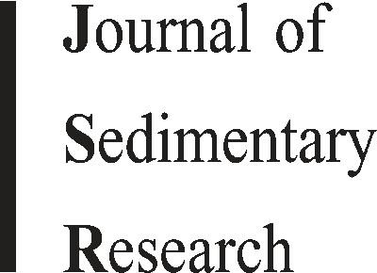Sedimentary Research, 2006, v. 76, 444–459

Research Article

DOI: 10.2110/jsr.2006.040

LOW-POROSITY HALOES AT STYLOLITES IN THE FELDSPATHIC UPPER JURASSIC ULA

SANDSTONE, NORWEGIAN NORTH SEA: AN INTEGRATED PETROGRAPHIC AND CHEMICAL MASS-BALANCE APPROACH

NICHOLAS B. HARRIS*

Department of Geoscience, 503 Deike Building, The Pennsylvania State University, University Park, Pennsylvania 16802, U.S.A. e-mail: nbharris@mines.edu

ABSTRACT: Although stylolites in quartz-rich sandstones have been described and modeled, more feldspathic sandstones have not been similarly investigated. The Upper Jurassic Ula sandstone, Norwegian North Sea, a subarkose with 15 to 25% feldspar, displays stylolites with prominent low-porosity haloes up to 10 cm wide. Detailed mineralogical and chemical profiles across several stylolites and haloes are used to investigate the role of feldspar in mineral reactions at stylolites and to constrain the transport of chemical components.

Quartz and feldspar are intensely dissolved at the margins of stylolites. The surrounding haloes are characterized by: dissolution of quartz and feldspar, intense compaction, anomalously high feldspar content, high concentrations of clay, and oxide cement volumes that increase away from the stylolite. Chemical mass-balance calculations demonstrate that silica and elements associated with feldspar (Al2O3, Na2O, K2O) were exported from the haloes. Grain-size data and evidence for aluminum loss from the halo indicate that primary concentrations of clay and mica were not higher near the stylolites and that the petrographic and geochemical patterns reflect the diagenetic concentration of clay. The analysis suggests that K-feldspar dissolution at and near the stylolite resulted in precipitation of authigenic illite near the site of K-feldspar dissolution, due to the low solubility of Al3+. This in turn catalyzed chemical dissolution of quartz in the low-porosity halo.

Transport of CaO, MgO, and MnO into the haloes suggests that the haloes were zones of higher pH. The increased pH, perhaps due to the presence of clays, would have also increased quartz solubility, consistent with evidence for silica export from the halo. The dissolution of K-feldspar in the absence of kaolinite would also have raised pH around the site of K-feldspar dissolution and illite precipitation, favoring carbonate precipitation.

This interpretation of stylolite diagenesis differs from conventional models based on quartz-rich sandstones, in which quartz cement volumes decrease away from stylolites. Models for compaction in arkosic sandstones need to account for the enhanced dissolution of quartz that is driven by K-feldspar dissolution and for catalysis by the resulting illite.

# INTRODUCTION

Stylolites are thin, crenulated sheets in rocks, most notably carbonates and sandstones, against which the rock constituents dissolve (Heald 1959). Stylolites consist of material such as mica, clay, and opaque minerals, sedimentary and authigenic components that are dispersed in low abundance in unaltered sandstone but are concentrated by dissolution of the soluble phases in the stylolites.

Dissolution of silicate grains along stylolite surfaces may provide a significant source of silica cement in sandstones (Walderhaug and Bjørkum 2003). In the Middle Jurassic Brent sandstones of the North Sea, for example, stylolites first appear at a depth of approximately 3000 meters and a temperature of approximately 100uC. The volume of quartz cement begins to increase dramatically at that depth, such that at a depth only 400 meters deeper, the volume has effectively increased 3 to 4 fold, from 1–2% to 1–12% (Harris 1992 and references therein). Such observations have led to formulation of models in which dissolution of quartz grains at stylolites provides a primary source of dissolved silica (Oelkers et al. 1996; Walderhaug 1996; Lander and Walderhaug 1999; Oelkers et al. 2000). The silica diffuses away from the stylolite, where it precipitates as cement on quartz grains.

|  |  |
| --- | --- |
| |  | | --- | | * Present address: Department of Geology and Geological Engineering, Colorado School of Mines, 1516 Illinois Street, Golden, Colorado 80401, U.S.A. |   turn on grain size, the presence of clay and microcrystalline quartz coatings (Ramm et al. 1997).  Theoretical analyses of stylolites (Oelkers et al. 1996; Walderhaug and  Bjørkum 2003) generally treat sandstones as consisting entirely of quartz  Copyright E 2006, SEPM (Society for Sedimentary Geology) 1527-1404/06/076-444/$03.00 |

The mechanism responsible for quartz dissolution at the stylolite is somewhat controversial, with much discussion focused on the relative importance of effective stress, emphasized by Sheldon et al. (2003), versus clay- or mica-catalyzed quartz dissolution, advocated by Bjørkum (1996), Oelkers et al (1996), and Walderhaug (2000). Regardless of the mechanism, however, such models suggest that stylolites should be surrounded by bands of highly cemented, low-porosity sandstone, which is consistent with descriptions of natural sandstones by Fu¨chtbauer (1983) and Walderhaug and Bjørkum (2003). The distribution of cements may also depend on the timing of oil emplacement relative to stylolite development and quartz cementation (Gluyas 1997), on the surface area of quartz grains available for cement growth (Walderhaug 2000), and in

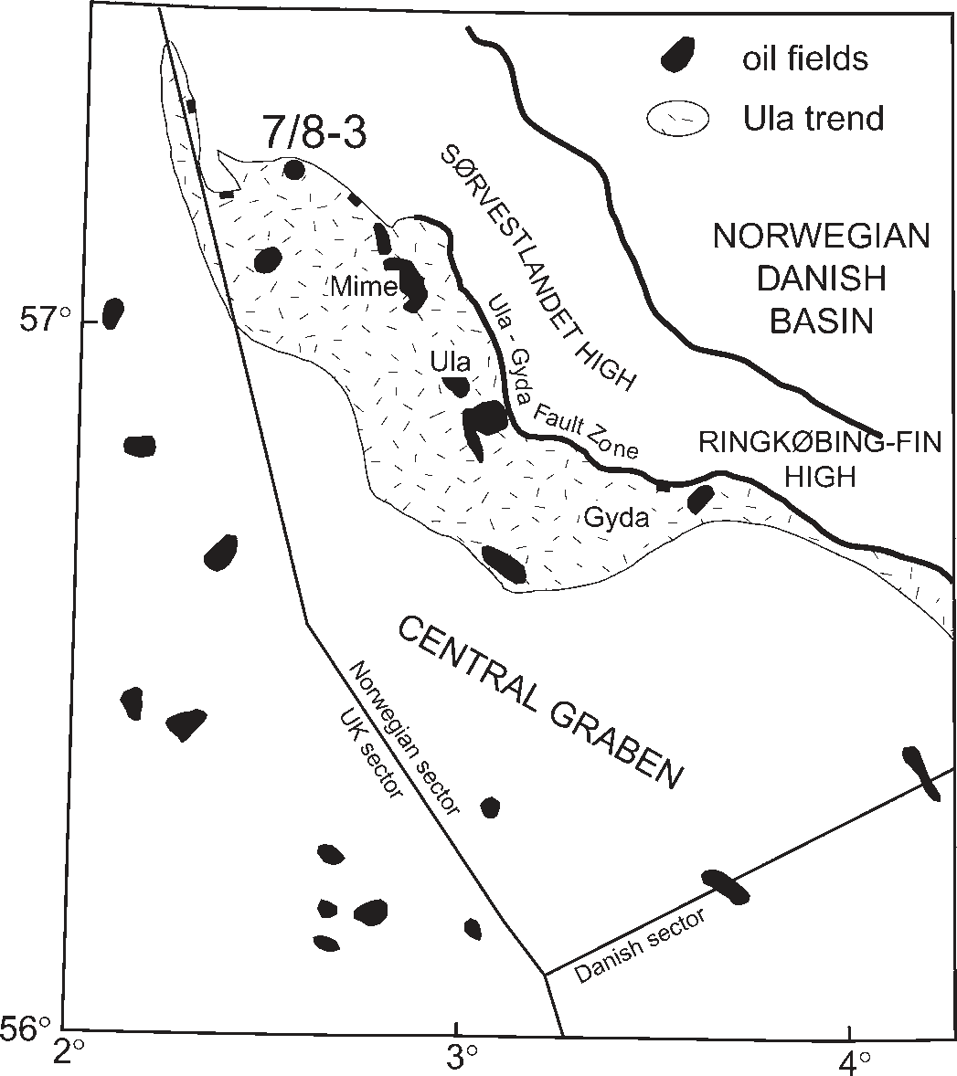

FIG. 1.— Map of Ula trend. Upper Jurassic Ula sands were deposited on a shallow-water platform on the hanging wall of the Hidra fault system, which separates the Sydvestlandet Platform from the Central Graben.

grains and mica or clay. While these models effectively describe many sandstones, they may not apply to feldspathic sandstones. The solubility of feldspars differs from that of quartz; hence conditions that promote rapid dissolution of quartz grains may be less effective at promoting feldspar dissolution. The chemical components released by feldspar dissolution obviously differ from those released by quartz dissolution. This difference has practical applications as well as scientific significance; the current generation of forward models for predicting porosity such as Touchstone and Exemplar (Lander and Walderhaug 1999; Walderhaug 2000) assume a very quartz-rich sandstone; aspects of these models may not apply if the sandstones contain significant quantities of feldspar.

This paper reports on stylolites in sandstones from the feldspathic Upper Jurassic marine Ula Formation, offshore Norway. The stylolites are distinctive for the presence of low-porosity haloes that surround the actual stylolite seam. The purpose of the study was to test whether models developed for quartz-arenite sandstones apply to more feldspathic rocks and, if not, to identify the different processes that arise in the latter. The investigation utilizes sequences of contiguous samples from stylolite to host sandstone in order to identify and quantify dissolution, compaction, and cementation processes associated with stylolites, relying on detailed petrographic data from thin-section analysis and whole-rock geochemical data on sandstones. These data are supplemented by XRD and SEM analysis.

# BACKGROUND

The Conoco Norway 7/8-3 well is located in the southern part of block 7/8 in the Norwegian sector of the North Sea (Fig. 1). The 7/8-3 well, drilled in 1984–1985, discovered a subcommercial oil pool at 3700 m depth in the northern part of the Ula trend, a belt of oil accumulations in Middle and Upper Jurassic sandstones on the southwestern margin of the

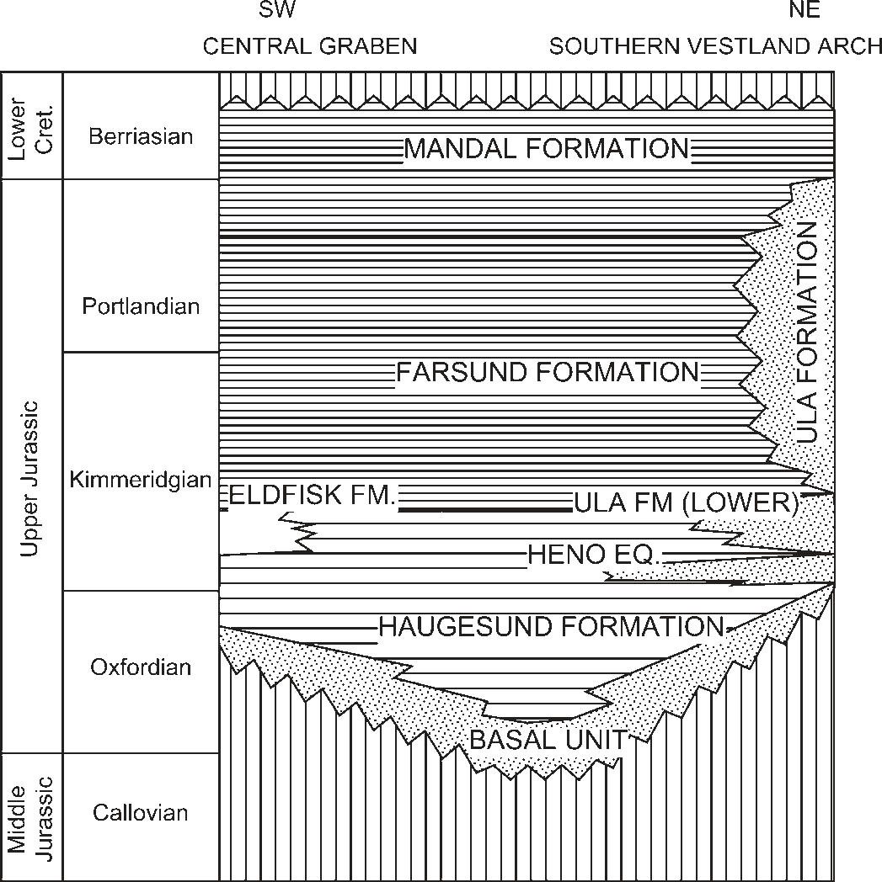

FIG. 2.—Upper Jurassic stratigraphy in the Central Graben–Southern Vestland Arch area. Modified from Underhill (1998) and Bergan et al. (1989).

Southern Vestland Arch (Spencer et al. 1986). The Ula and Gyda oil fields, both currently in production from the same formation, lie along trend a short distance to the southeast. The Ula trend occurs on the northeast shoulder of the Central Graben, a major structure that was active from the Middle Jurassic through the Late Cretaceous. Oil was generated from the Upper Jurassic Mandal Formation beginning in the Late Cretaceous from the deeper parts of the Central Graben and currently is being generated in the Ula trend (Taylor et al. 1999).

Oil accumulations in the Ula trend occur in the Upper Jurassic (Kimmeridgian) Ula Formation (Fig. 2; Bergan et al. 1989; Partington et al. 1993; Underhill 1998). This unit is a shallow marine sandstone up to 200 m thick that prograded across outer-shelf mudstones, following a sealevel drop in the early Kimmeridgian. The thickest accumulations of sand occur on the downthrown side of basin-bounding faults. It is typically fine grained, well sorted, and highly bioturbated and contains glauconite and beds rich in shell fragments. Ramm et al. (1997) and Forsberg et al. (1994) have identified five Upper Jurassic sequences in the Ula Trend and suggested that the name Ula Formation be discarded.

Gluyas (1997) described Ula Formation sandstones at Ula field as arkosic and interpreted them as having been derived from nearby Triassic sandstones. He notes that they are significantly affected by quartz cementation, with quartz cement volume ranging from as little as 3% to as much as 19%. He attributed the variation in volume, which occurs over a very narrow range of burial depth, to control principally by the timing of cementation relative to oil emplacement. Where oil was emplaced relatively early, formation of quartz cement was inhibited, and cement volumes are low; in rocks where oil was emplaced late or not at all (i.e., in water-leg samples), cement volume is relatively high.

Aase et al. (1996) also analyzed Upper Jurassic sandstone reservoirs from the Gyda and Ula fields at depths from 3970 to 4320 meters but arrived at a different conclusion regarding controls on porosity. They described a population of high-porosity sandstones that they related to the presence of microcrystalline quartz coatings, visible on SEM examination, and in turn to the original presence of sponge spicules.

Other key observations in their analysis were the presence of two distinct porosity populations and an association of high porosities with low volumes of quartz cement.

In the 7/8-3 well, the Ula sandstone occurs at a sub-sea-level depth of 3698.5 meters and a temperature of 132uC, based on corrected bottomhole measurements. The Ula sandstone underwent more than 2000 meters of subsidence since the early Oligocene. Possibly as a consequence of the rapid Late Tertiary subsidence, the Ula sandstone is significantly overpressured. Multiple pressure measurements by repeat formation tester are equivalent to an average gradient of 0.703 psi/foot (15.9 MPa/ km), equivalent to an excess over normal pressure of 22.2 MPa. Holm (1998) relates the development of overpressure in Jurassic sandstones of the Central Graben to hydrocarbon generation in the overlying Farsund Formation.

The Ula sandstone is 43.5 meters thick in the 7/8-3 well and unconformably overlies metamorphic basement (Fig. 3). It is fine to medium grained, with rare thin intervals of muddy sandstone or siltstone; average grain sizes range from 0.16 to 0.29 mm. It has been intensely burrowed, and even where no burrows are evident, physical sedimentary structures are nonetheless absent, suggesting that the unit has been completely bioturbated. Identifiable trace fossils are limited to Ophiomorpha, suggesting a shallow marine origin for the sandstone. A few intervals of sandstone, from a few centimeters to a meter thick, have been completely cemented by calcite; these commonly contain large bivalve shells.

# METHODS

Eight stylolites and surrounding sandstone were analyzed in detail. Each of these stylolites is surrounded by a low-porosity halo, clearly identifiable in UV core photos (Fig. 4), the nature of which is described below. One thin-section-size plug (21 mm 3 42 mm) included the stylolite itself; several contiguous plug samples were taken on one or both sides of the stylolite (Fig. 4), extending beyond the low-porosity halo in at least one direction. In several cases, from two to four contiguous plugs were analyzed away from the stylolite; the plug most distant was 8 cm from the stylolite. Two samples, taken more than 20 cm from the nearest stylolite, were also analyzed; in this paper, these are termed remote samples. In the sequences of samples, the stylolite or stylolites were concentrated in one plug, with no visible evidence in hand specimen for stylolites in adjacent plugs. All data tabulations and presentations are shown with respect to the individual stylolite, where the plug at zero distance contains the stylolite.

Thin sections were stained for potassium and plagioclase feldspar and analyzed using standard petrographic techniques, counting a minimum of 500 points per thin section. Tabulated petrographic data are not included in this paper but are available as supplementary material from SEPM. Sandstone compositions are classified according to the modified Folk system (Stanton and Wilson 1994). In data tabulations and graphs, quartz includes monocrystalline and polycrystalline quartz; virtually no chert is present. Mica and lithics are dominated by muscovite, with only minor biotite and rare lithic and other grains such as hornblende present. Pores within dissolved feldspar were treated as porosity and therefore not included in presentations of rock composition. However, the type of dissolved feldspar was recorded for purposes of reconstructing sandstone composition prior to feldspar dissolution. Matrix material is not represented in compositional diagrams; however, the data set averaged only 4.9% detrital clay.

Quartz overgrowths were readily distinguished from the detrital grains in petrographic examination by the presence of dust rims and trains of fluid inclusions at the grain-cement boundary.

Data on the clay-mineral component of the sandstones were obtained from SEM and clay XRD analysis of the , 2 mm fraction. In general, the

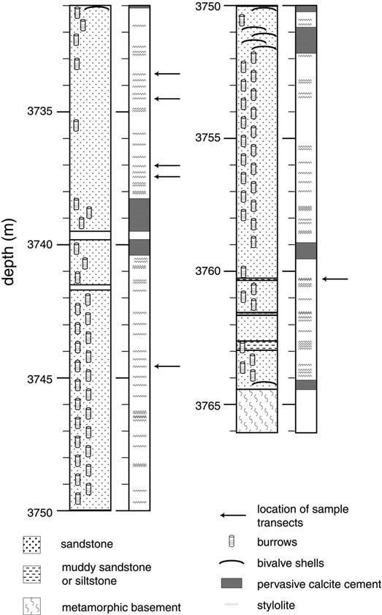

FIG. 3.—Description of Ula Formation core from the 7/8-3 well.

sandstones are relatively clay-poor in this fraction, yielding little clay even after repeated treatments of peroxide, heating, and ultrasonic baths.

Whole-rock chemical compositions of the sandstones were obtained by X-ray fluorescence (XRF) analysis of pressed powder samples, following a peroxide wash to remove residual oil. Several U.S. Geological Survey, National Bureau of Standards, and Conoco rock standards were used, including sandstone, limestone, dolomitic limestone, granite, granodiorite, and pure quartz. Matrix corrections were not used because standards of composition similar to that of the unknowns were used. The tabulated geochemical data are also available as supplementary material from the JSR data archive (see Acknowledgments section). Chemical data are cast in terms of fluxes of elements to and from a parent sandstone; the details of this approach are discussed in a later section.

PETROGRAPHY OF 7/8-3 SANDSTONES

# General Characteristics

Sandstones from the 7/8-3 well are dominantly subarkoses, with a subordinate number of arkoses (Fig. 5). All but one sample contain from 14 to 25% detrital feldspar (average 21.7%), 70 to 83% detrital quartz (average 76.8%), and from 0 to 6% detrital mica and lithics

|  |
| --- |
| FIG. 4.—A) Core photograph, showing sampling scheme. Stylolite is present in plug #3. B) Core photographs in white light (left) and UV light (right). Brightness of core in UV light is a function of oil saturation. Note the lower oil saturations surrounding the stylolites at 3737.1 meters. This is a result of lower porosities in sandstone |

adjacent to the stylolites.

(average 1.5%). The similarity in sandstone composition in samples over a span of 15 m can probably be attributed to a constant depositional environment and source terrane. The feldspar component is dominantly K-feldspar, typically 65 to 80% of the total feldspar. The micas consist almost entirely of muscovite. Detrital clay amounts to 3 to 7% of the rock volume (average 4.9%).

The dominant cement in the sandstones is quartz, which forms syntaxial overgrowths (Fig. 6A). These overgrowths are readily distinguished by their euhedral morphology and trails of fluid and mineral inclusions at the edge of the detrital core. The abundance of quartz cement ranges from 2% to 13% of the rock volume. Dolomite cement is also a significant component, constituting up to 5% of the rock volume. The dolomite cement both interferes with and overlies quartz overgrowths and generally appears to have formed contemporaneously with or to postdate quartz.

Other diagenetic components are typically minor. The only other carbonate present is siderite; authigenic calcite is entirely absent, except in intensely cemented calcite zones noted above and in Figure 3. High intergranular volume and the absence of quartz cement in the calcitecemented zones indicate that this cement formed earlier, predating formation of stylolites and deposition of most of the quartz cement. Traces of K-feldspar overgrowth are present. As in other Jurassic sandstones on the northwest European continental margin, these Kfeldspar cements formed early and are now partially dissolved.

Authigenic clay constitutes a small proportion of the rock volume, amounting to less than 1%. Of this fraction, illite, and rarely chlorite, are the only clearly authigenic clays present; though kaolinite was determined by XRD, none was apparent in SEM examination, which suggests that the kaolinite is detrital.

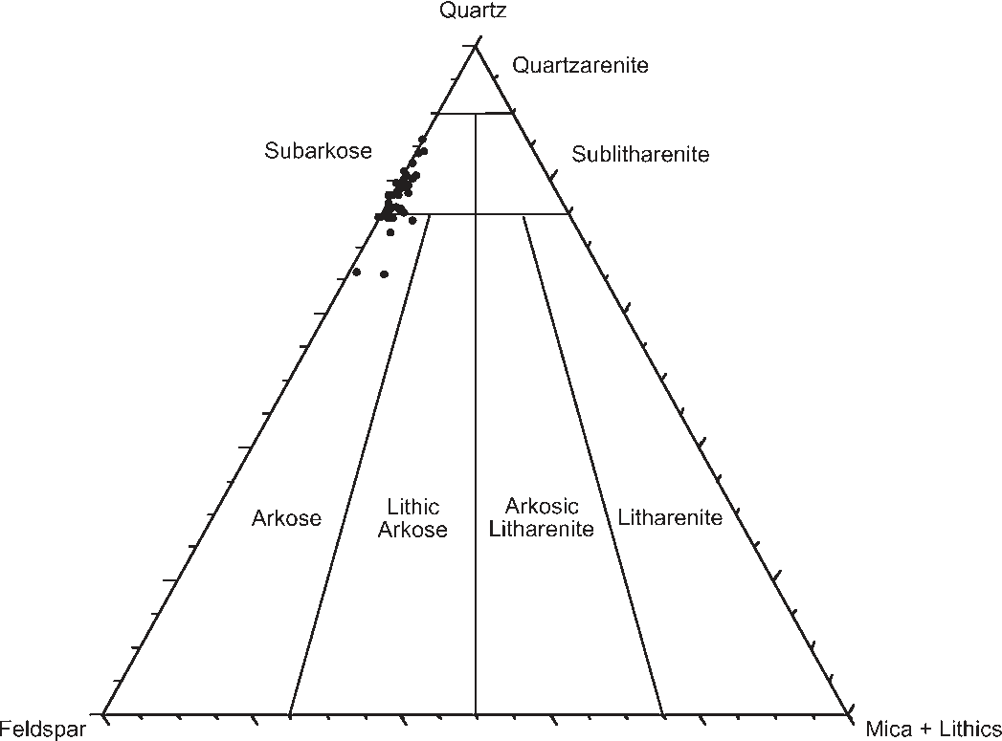

FIG. 5.— Composition of Ula Formation sandstones, portrayed on a quartz– feldspar–mica + lithics diagram. Modified Folk sandstone classification system is used (Stanton and Wilson 1994). Sandstones are dominantly sub-arkoses, with a subordinate number of arkoses.

|  |
| --- |
| FIG. 6.—Petrographic photos. A) Quartz cement. B) Stylolite, with concentration of feldspar (gray-colored grains) adjacent to the stylolite (black). C) Interpenetrating quartz grains due to chemical dissolution in halo surrounding stylolite. D) Feldspar and quartz in stylolite seam. Note the quartz grains (white) in center of photo that have been almost completely dissolved. E) Interpenetrating contact between feldspar and quartz grains, indicating that both have been dissolved. F) Quartz and Kfeldspar grains in a stylolite. Quartz grains are highly dissolved (for example, lower left). The contact between quartz and K-feldspar grains is interpenetrating, indicating |

that significant dissolution of K-feldspar has occurred.

Intergranular porosity typically ranges from 7 to 13%. Secondary porosity, due almost entirely to feldspar dissolution, ranges from approximately 1.5 to 5% of the rock volume and averages 2.56%. This is much less than the overall feldspar content, so that reconstructed sandstone compositions are only slightly more feldspathic than the present composition. Trace amounts of secondary porosity are also present in dissolved dolomite, detrital calcite fossil material, and Kfeldspar overgrowths. Intergranular volumes (IGV; also termed minuscement porosity), which provide a measure of sandstone compaction, range from 19.3% to 34.0%, averaging 25.9%. These values indicate that compaction has been enhanced by chemical dissolution of sand grains, because the minimum porosity possible in a well-sorted sandstone affected only by physical compaction is 26% (Paxton et al. 1990; Ajdukiewicz et al. 1991; Szabo and Paxton 1991).

Stylolites are common; 111 individual stylolites were counted in the 33.4 meter core, although distinguishing individual stylolites is highly interpretive in intervals with dense burrowing, particularly in muddy intervals. They are irregular in form and do not obviously conform to a physical sedimentary structure; it may be that they formed along original sedimentary laminae that have been distorted by bioturbation. Stylolites commonly occur in clusters, particularly in the silty zones, spaced at 2 cm or less. Average stylolite spacing is 25.9 cm with a median spacing of 16.0 cm. If spacing of the nested stylolites are disregarded (spacing # 5 cm), the average spacing is 36.1 cm, with a median spacing of 31.0 cm.

Petrographic evidence for chemically enhanced compaction within and adjacent to stylolites is abundant (Fig. 6B). Quartz grains are commonly extremely thin (disk-like) with irregular surfaces (Fig. 6D). Such grain shapes are clearly diagenetic in origin, because they could not have survived sedimentary transport and deposition without breaking. In the halo surrounding the stylolites, chemical compaction, indicated by highly interpenetrating contacts between quartz grains, is relatively common (Fig. 6C). Such textures are similar to those described by Oelkers et al. (1996) and Bjørkum (1996). Quartz grain contacts in the halo showing pressure solution typically contain fine-grained material and, locally, brightly birefringent grains similar to muscovite.

Dissolution of feldspar at grain contacts is also evident, indicated by the presence of crenellations and embayments in the feldspar (Fig. 6E, F). Feldspar dissolution is volumetrically minor in comparison to quartz dissolution but may be significant as a source for dissolved potassium and aluminum.

# Spatial Variation in Compaction and Porosity

Intergranular porosities are reduced around stylolites in zones typically up to 10 centimeters wide (Fig. 7). These zones are evident in core photographs taken in UV light, where lower oil saturations associated with lower porosity result in dark haloes surrounding the stylolites (Fig. 4B). The difference in sandstone samples adjacent to the stylolite and at some distance away ranges from 2 to 6 percent porosity. Although the absolute magnitude of intergranular porosity varies significantly between sample sets, the variation in intergranular porosity from stylolite seam to the halo is reasonably constant. Thus, for example, the sample containing the stylolite at 3746.35 m has very low intergranular porosity (Fig. 7H), less than 1%, and samples adjacent to the stylolite are also relatively low at 5 and 7%. The sample including the stylolite at 3732.15 m is high at 11% (Fig. 7A); the sample adjacent to the stylolite is likewise relatively high at 16%.

Most of the Ula samples at or close to stylolites have low IGV values (Fig. 7). Sandstone at and within 3 cm of the stylolites (totals of 9 and 13 samples, respectively) have IGV values reduced some 6 to 8% relative to the IGV of samples at 6 to 10 cm from the stylolite. For example, in the suite of samples from 3744.6 (Fig. 7), the sample containing the stylolite has an IGV of 26.48% and the samples immediately surrounding the stylolite have IGVs of 23.47% and 24.42%. By comparison, samples in this profile at a distance of 7 cm from the stylolite have IGVs of 28.13% and 28.30%. Samples at distances of 6 cm or more from the stylolites (4 samples) and the two remote samples have similar IGVs, averaging 27.65 and 27.13% respectively, suggesting that samples at this distance from the stylolite are fairly representative of the background sandstone. The width of the low IGV zones is clearly shown in transects from sample sets 3733.35 m, 3733.7 m, 3737.1 m, 3737.5 m, and 3744.6 m.

The reduction in IGV surrounding the stylolites is comparable to the reduction in intergranular porosity, suggesting that the low-porosity halo is chiefly associated with more intense compaction. If the low porosities in samples surrounding the stylolite were due to more intense quartz cementation, IGV values should be similar to more distant samples or possibly higher, because of the strengthening effect of quartz cement in resisting effective stress.

# Spatial Variation in Sandstone Mineral Composition

In several sample sets, the samples that include the stylolite have elevated feldspar content (Fig. 8). The absolute difference in total feldspar between the stylolite samples and the surrounding rock varies from 1.5% to 11.5%. The variation in feldspar content probably represents the higher resistance of feldspar to pressure or chemical solution in comparison to quartz. In other words, a high rate of quartz dissolution relative to feldspar tends to elevate the concentration of feldspar. Alternatively, it may represent variation in the primary composition of the sandstone; this possibility is assessed with geochemical data (see below). However, the consistent grain size in these samples suggests that the primary composition was also consistent.

Both detrital clay and mica are concentrated within the stylolite seams (Fig. 9). For example, sample set from 3734.5 meters contains 5% mica and 10% clay in the sample containing the stylolite, compared to approximately 1.5% mica and 5% clay in adjacent plugs. The petrographic data do not indicate that the low-porosity halo surrounding the stylolites is enriched in clay and mica. However, geochemical data, specifically SiO2/Al2O3 and K2O/Al2O3 ratios (Fig. 10) suggest that mica and/or clay are also concentrated in the halo. Low values of the SiO2/ Al2O3 ratio in samples surrounding the stylolite reflect higher concentrations of feldspar, mica, or clay, all of which contain lower SiO2/Al2O3 ratios than quartz. K2O/Al2O3 ratios can be used to identify trends in the relative proportions of feldspar and mica. A value of 0.31 is characteristic of muscovite, 0.92 of K-feldspar, and 0.00 of plagioclase. K2O/Al2O3 ratios decrease systematically toward the stylolites in all sample sets to values generally between 0.40 and 0.35 from background levels of typically 0.45 to 0.50 (Fig. 10), suggesting that the feldspar halo is wider than the clay/mica halo. This is consistent with the petrographic data that show no enrichment in clay and mica outside the immediate sample containing the stylolite. Because Na2O/K2O ratios display no systematic trend (not shown), the variation in K2O/Al2O3 ratios reflects the concentration of clay or mica rather than plagioclase.

# Variation in Quartz Cement

The volume of quartz cement varies systematically in almost all sample sets relative to the stylolite (Fig. 8). The concentration of quartz cement is relatively low both in samples containing the stylolite (typically about 8%) and in the immediately adjacent samples. This is particularly evident in sample sets from 3733.7, 3737.5, and 3744.6 m. Quartz cement volumes increase away from the stylolite, thus the low-porosity haloes that surround the stylolites cannot be attributed to quartz cement.

MASS-BALANCE RELATIONSHIPS AND CHEMICAL TRANSPORT RELATIVE TO STYLOLITES

# Mass-Balance Approach

Mass-balance calculations are applied here to the diagenetic transport of chemical components relative to stylolites in Ula sandstone, following an approach first used to quantify mass transport in supergene enrichment in porphyry copper deposits (Brimhall et al. 1985) and subsequently in chemical weathering (Brimhall et al. 1991; Heimsath et al. 1997; Anderson et al. 2002; Stiles et al. 2003), The approach requires: (1) characterizing parent (pre-alteration) material in terms of chemical composition and density; and (2) selection of a conservative element (or oxide) that is neither removed nor added to altered rock through dissolution or precipitation reactions. Dissolution of a nonconservative element effectively increases the concentration of the conservative element, while precipitation decreases that concentration. The mass of

|  |
| --- |
| FIG. 7.—Estimates of primary porosity and intergranular volume (IGV) from point-count data, plotted as a function of distance from the stylolite seam. The low-porosity haloes around the stylolites are well defined by the primaryporosity data. The haloes are also characterized by zones of relatively intense compaction, defined by low IGV, with the exception of stylolites at 3732.15 and 3746.35 m. Error bars in this and the following two figures represent 6 1 standard deviation, calculated following the method of Chayes (1956). |

an element added to or lost from a rock dj,w can be calculated by the following equation:

1 ci,p

dj,w ~ cj,wrp {rpcj,p

100 ci,w

where c and r refer to the element concentration and density in the altered and parent rock; the subscripts j , i , w, and p refer to the element of interest, the immobile element, the altered rock, and the parent rock, respectively.

Assumptions include estimates of the density and composition of the parent material and the choice of an inert (conservative) element or oxide. In this case, rock densities were calculated from the mineral composition of five sandstone samples from petrographic analysis, including the two remote samples not associated with stylolites and three samples at the end

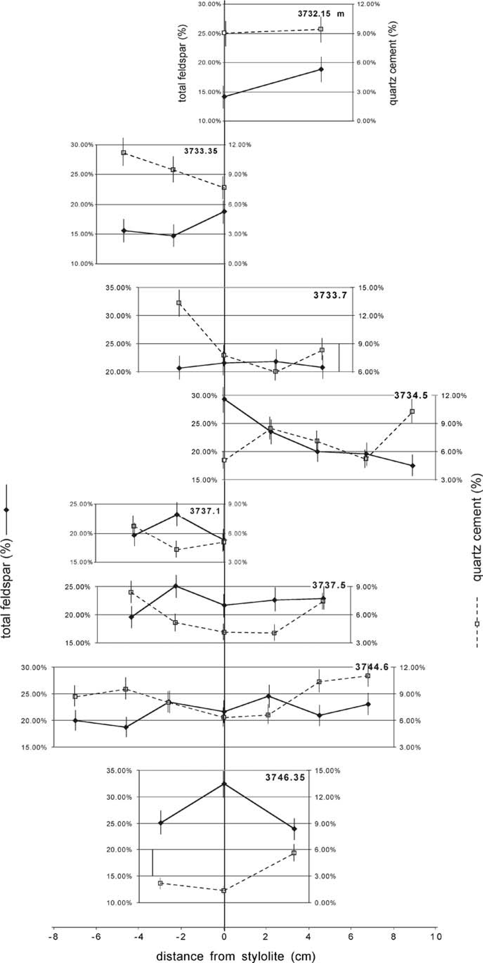FIG. 8.—Feldspar and quartz cement estimates from point-count data. Quartz cement content is relatively low at the stylolite and increases away from the stylolite. The feldspar content is generally greatest in samples near the stylolite, interpreted to be the result of preferential dissolution of quartz.

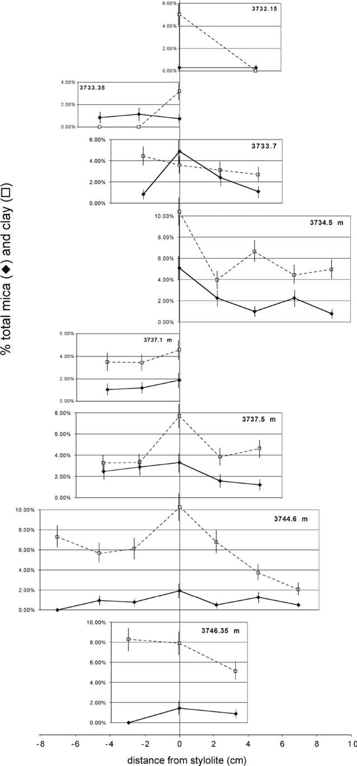FIG. 9.—Detrital clay and mica estimates from point-count data. Content of clay and mica increases systematically toward the stylolites in most sample sets.

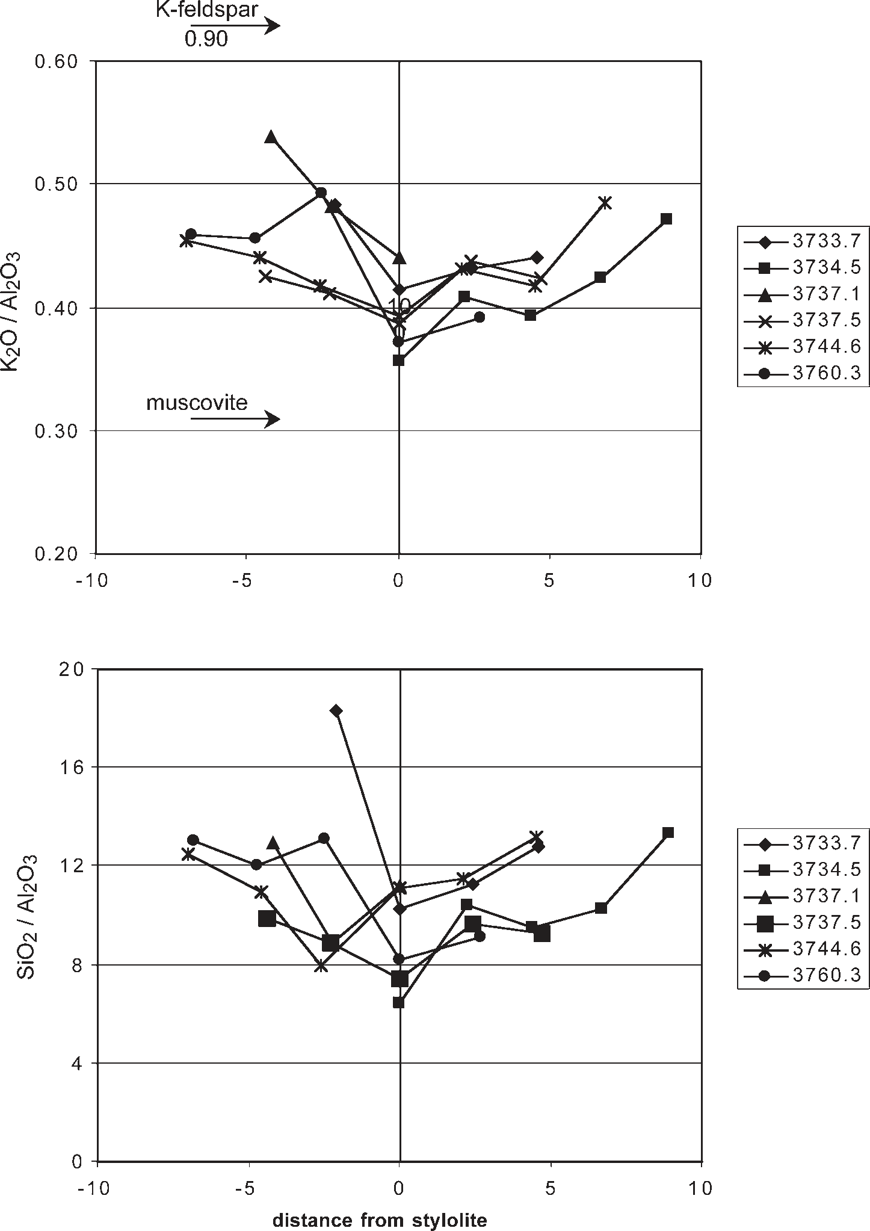FIG. 10.—SiO2/Al2O3 and K2O/Al2O3 ratios in sample transects. SiO2/Al2O3 ratios increase systematically away from the stylolite, a function of decreasing feldspar, mica, and clay content. K2O/Al2O3 ratios decrease toward the stylolites, indicating that the feldspar-rich halo is wider than the mica–clay halo.

of sample transects. The chemical composition of the parent material was calculated from the average of four samples at the ends of sample transects. Because the intent here was to estimate the flux of components associated with stylolite development, the composition and density of the parent material were corrected for the presence of quartz overgrowths, which were assumed to have formed as a consequence of the stylolites, by subtracting the SiO2 in the quartz cement from parental rock composition on the basis of petrographic estimates of the quartz overgrowth abundance in the remote samples. Thus samples that exhibit quartz overgrowths and no dissolution should show a net addition of silica, and rocks that show dissolution and no cement should show a net loss. The concentration of other oxides in the remote samples was assumed to represent the parent material; thus the average of the remote samples is constrained to represent no net loss or addition of mass. TiO2 was selected as the conservative oxide. The range of possible errors induced by these assumptions is discussed later.

# Estimates of Mass Flux

Profiles of SiO2 flux through six stylolites are shown in Figures 11 and 12. With one exception, individual stylolite profiles show loss of silica (negative values) within 1 to 2 cm of the stylolite, amounting to 0.015 to 0.095 g/cm3 of SiO2. The zone of depletion at most stylolites ranges from 2 to 5 cm wide, although silica depletion is substantially less in the halo than in the immediate vicinity of the stylolite. Outside this zone, there is generally a net accumulation of silica, ranging from zero to 0.10 g/cm3 SiO2.

|  |
| --- |
| FIG. 11.—Silica flux, dSiO2 (g/cm3), in individual sample transects from stylolite to halo. The error bar indicated by the gray pattern refers to the variation in calculated SiO2 flux introduced by a 6 1 standard deviation variation in the TiO2 content of the parent material. |

The single largest source of potential error in these calculations is the assumption of a uniform starting composition for TiO2. Errors introduced by other assumptions, such as variation in parent-rock density or silica content, are an order of magnitude less than the effect of TiO2 variation. Error bars (Figs. 11, 12) were constructed for silica flux in each sample by assuming a 6 1 standard deviation variation in the TiO2 content of the parent material, based on the far (remote) rock samples. From this analysis, it is clear that in most cases, the range of possible error induced by variation in TiO2 of the parent material is less than the degree of depletion of silica at the stylolite. Values in the low-porosity halo are generally negative, indicating silica loss, but close enough to zero to allow for the possibility of no net transfer of silica in individual samples. Evidently, while petrographic data indicate the occurrence of significant pressure solution in the halo, the loss of silica was partially balanced by the precipitation of quartz cement. The average of samples at $ 6 cm from the stylolite is positive, consistent with observations of quartz cementation and relatively little pressure solution, but again generally individual values do not exceed the range of possible error introduced by TiO2 variation.

The transport of major and minor components is summarized in Figure 12, which superimposes results from all sample sets as a function of distance from the respective stylolite. Error bars reflect variation in calculated flux introduced by a 6 one standard deviation shift in the assumed TiO2 composition of the parent material, as discussed above. Al2O3, K2O, and Na2O show trends similar to SiO2. These elements are substantially depleted in the immediate vicinity of the stylolite. They also show a consistent but lesser degree of depletion from 2 to 5 cm. Note that because all elements, with the exception of SiO2, were assumed to be at original (parent) concentrations in samples at the ends of the transects, the average of these far samples is necessarily zero. If there were net addition or loss of Al2O3, K2O, or Na2O in the far samples, this would have the effect of uniformly shifting all individual analyses in a positive or negative direction, respectively.

Components associated with carbonate minerals (CaO, MgO, MnO) behave quite differently from SiO2, Al2O3, Na2O, and K2O. These

|  |
| --- |
| FIG. 12.— Flux, (g/cm3), of major and minor components in relationship to distance from stylolite. Lines through each data point indicate range of variation in calculated SiO2 flux introduced by a 6 1 standard deviation variation in the TiO2 content of the parent material. Gray square indicates the mean flux of the component at that distance from the stylolite seam. Points from samples that include the stylolite (zero distance) have been spread apart in order to make the individual points and error |

bars distinguishable.

carbonate-associated components show substantial enrichment in a broad halo around the stylolite. The trend in F2O3 is relatively flat, showing depletion in samples at the stylolite and similar levels of depletion in most samples from 2 to 5 cm away, although a few samples with much higher iron content pull the averages at 2 and 5 cm to positive values.

DISCUSSION

# Characteristics of the Halo

Petrographic data from the Ula sandstone in the 7/8-3 well show that stylolites and surrounding rock have the following characteristics:

1. The central stylolite consists of a seam or seams of mica, clay, and opaque minerals. Quartz grains contacting this seam show indications of intense chemical dissolution. Feldspar grains also appear to have been dissolved where they contact the stylolite seam.
2. A low-porosity halo of 4 to 10 cm width surrounding the stylolite is characterized by: a) dissolved quartz grains; b) minor dissolution of K-feldspar; c) high concentration of feldspar relative to quartz; d) low IGV; and e) low amounts of quartz cement.
3. Background or ‘‘normal’’ sandstones, outside the halo, contain minor quartz-grain dissolution and higher IGVs, lower ratios of feldspar to quartz, and higher amounts of quartz cement.

Geochemical mass-balance calculations largely substantiate these findings. Silica shows intense depletion at the stylolite and lesser depletion across a relatively broad zone extending a few centimeters from the stylolite seam. Components in detrital feldspar (Al2O3, Na2O, K2O) are also clearly depleted, both at the stylolite and to a lesser extent in the halo.

The difference in the degree of silica depletion between stylolite and halo, evident in the mass-balance calculations, may result from more effective dissolution at the stylolite as compared to the intergranular dissolution in the halo. The long grain contacts in and adjacent to the stylolite provide more extensive surface area for dissolution. In addition, silica depletion in the halo due to quartz and feldspar dissolution is partially offset by quartz cementation, albeit minor in comparison to the amount of cementation in the background samples. Similarly, it can be argued that loss of Al2O3, Na2O, and K2O in the halo due to feldspar dissolution is also probably partially offset by precipitation of clays.

|  |
| --- |
| FIG. 13.—Model for development of lowporosity haloes. Stylolites nucleate around seams of detrital clay or mica. Dissolution initially takes place in quartz and feldspar grains contacting the stylolite. Aluminum and potassium released by dissolution of feldspar precipitates near the stylolite as illite, while dissolved silica generally diffuses a greater distance and largely precipitates as quartz cement. The newly formed illite serves to catalyze the further dissolution of quartz and feldspar in a halo around the stylolite. |

These features differ from those found in more quartz-rich sandstones, where dissolution occurs almost exclusively at the stylolite margin, cementation occurs in a wide zone around the stylolite (Oelkers et al. 1996; Walderhaug and Bjørkum 2003), and compaction of grains is retarded, even close to the stylolite, as the quartz cement forms a rigid framework.

Observations in the Ula sandstone suggest that an alternative to the standard model may be appropriate for stylolites in sandstones with a significant feldspar concentration (Fig. 13). The dissolution of Kfeldspar, coupled with the relative mobility of silica versus aluminum, are probably key factors. Aluminum mobility is generally regarded as limited; in a simulation of illite formation in the Statfjord Formation, North Sea, under similar diagenetic conditions, Thyne et al. (2001) assumed that Al mobility was restricted to less than 5 cm. This is consistent both with petrographic observations (Ehrenberg 1991; Hayes and Boles 1992) and with low solubilities of aluminosilicates (assuming a first-order precipitation reaction). Petrographic observations suggest that silica is significantly more mobile. Walderhaug (1996) demonstrated that distributions of quartz cement are relatively uniform surrounding stylolites until their spacing approaches 50 cm, while his later study of the Brent Group (Walderhaug 2000) demonstrates no significant correlation between quartz cement volume and distance to the nearest stylolite. Quartz cement abundance is controlled by stylolite frequency only at a scale of tens of meters, for example in Upper Jurassic sandstones at the East Brae field, North Sea (Grau 2000).

Because aluminum is relatively immobile, dissolution of K-feldspar at the edge of a stylolite produces a halo of illite in the sandstone adjacent to the stylolite. The catalytic effect of illite on quartz grain dissolution should be similar to that of muscovite; therefore an illite halo surrounding the stylolite results in enhanced chemical dissolution of quartz within the halo. Illite coats also tend to inhibit nucleation of quartz cement, and the relatively low concentration of quartz in the haloes provides fewer nucleation surfaces for quartz cement. Consequently, the net concentration of quartz cement is ultimately highest in parts of the sandstone relatively distant from the stylolite, away from the compacted, feldsparrich halo.

It is unlikely that microcrystalline quartz coats, described by Aase et al. (1996) in the nearby Ula and Gyda fields, play a significant role in controlling quartz cementation and porosity. In those fields, the presence of microcrystalline quartz coats retarded formation of syntaxial quartz cements and preserved porosity, locally in excess of 20%. In the 7/8-3 well, however, maximum porosities are much less, and the highest porosities occur in the sandstones with the most quartz cement, the inverse of the relationship at Ula and Gyda fields (Aase et al. 1996).

Differences in the precipitation rates of chemical components may result in the transformation of a sandstone that was nearly homogeneous (Fig. 13), containing a mixture of quartz, feldspar, mica, and clay, into a banded rock with pronounced mineral segregations. In effect, the sandstone records a chromatographic process, because aqueous silica diffuses farther than aluminum. In this case, however, it is likely that this effect arises from differences in solubility and precipitation kinetics rather than from differences in diffusion rates.

# Precipitation of Carbonate

The difference in the behavior of elements important in carbonate minerals (CaO, MgO, MnO) as compared to elements in silicate minerals (SiO2, Al2O3, Na2O, and K2O) is striking. Most of the samples from the stylolite and the low-porosity halo demonstrate addition of CaO, MgO, and MnO. In fact, given petrographic evidence from samples outside the haloes for the coeval precipitation of carbonate and quartz cement, this analysis may underestimate the flux of CaO, MgO, and MnO to the stylolite halo, because the calculations constrain the flux of these components in the remote samples to average zero.

One explanation for the flux of carbonate components into the stylolite haloes is that the presence of newly precipitated clay minerals increases pH in the halo. The stylolite model proposed by Oelkers et al. (1992, 1996) relies on the presence of clay and mica grains to increase pH in the microenvironment surrounding the grains. This occurs through the attraction of OH2 ions in the water phase to surface charge on the mineral and has the effect of increasing quartz solubility, as initially proposed by Boles and Johnson (1983). The results presented here, however, suggest that the effect may extend beyond the microenvironment surrounding the clay or mica surface and that the entire halo is characterized by higher pH. This decreases the chemical potential of dissolved Ca, Mg, and Mn in the halo relative to the rest of the sandstone, favoring the influx of these components into the halo.

A second explanation relates to the presence or absence of preexisting kaolinite. Bjørkum et al. (1993) demonstrated that where kaolinite exists in a sandstone, potassium released by dissolution of K-feldspar reacts with that kaolinite to form illite:

3Al2Si2O5 ðOHÞ4 z 3KalSi3O8 ~ 3Kal3Si3O10 ðOH4Þ kaolinite K-feldspar illite

ð1Þ

z 6SiO2 ð Þaq z 3H2O

silica

This reaction neither produces nor consumes hydrogen ion.

However in the absence of preexisting kaolinite, dissolution of Kfeldspar proceeds through the following reaction:

3KalSi3O8 z 2Hz~ Kal3Si3O10 ðOH4Þ z 6SiO2 ð Þaq z 2Kz ð2Þ Kfeldspar kaolinite

Reaction (2), unlike reaction (1), consumes hydrogen ion and raises pH. The absence of preexisting kaolinite in the Ula sandstone would favor reaction (2), raising pH around the site of K-feldspar dissolution and illite precipitation, favoring precipitation of carbonate phases.

# Significance for Porosity Modeling

Recent porosity models such as Exemplar (Lander and Walderhaug 1999; Walderhaug 2000), and related schemes (Bjørkum et al. 1998) combine algorithms for compaction with those for quartz cementation. The compaction part of these models demands an accounting of the texture of the sandstone grains and the proportions of hard and soft grains. The cementation part of the models relies on dissolution of quartz grains at stylolites as a source of silica, with the rate-determining step being precipitation of the quartz cement (Oelkers et al. 1992). The assumption of an internal source of quartz cement has been validated in a study of the East Brae field (Grau 2000).

Such models assume that the sandstone in question consists of quartz grains with stylolitic seams of clay or mica (for example, see fig. 1 in Bjørkum et al. 1998); feldspar grains play no role in the chemical part of this model. Yet the petrographic and chemical data presented here suggest that even moderate amounts of K-feldspar can significantly alter dissolution at stylolites. The presence of feldspar may enhance porosity loss beyond that caused by quartz dissolution and reprecipitation as cement, for two reasons. First, there is a greater degree of compaction of sand grains in the haloes surrounding the stylolite due to the presence of precipitated illite. Second, the enhanced chemical compaction in turn yields additional aqueous silica to form cement in sandstone outside the haloes.

The relative impact of stylolites in quartzose versus more feldspathic sandstones can be argued from the opposite standpoint, however. Although K-feldspar grains do dissolve at stylolites, they clearly dissolve at a slower rate, as is indicated by the accumulation of feldspar in the lowporosity haloes. It may be that when the concentration of feldspar in the haloes reaches a certain level, the overall rate of grain dissolution becomes significantly slower than would occur in a quartzose sandstone, decreasing the flux of silica cement to the sandstone. Assessing the relative balance between these two effects will probably require chemical models that incorporate feldspar dissolution and illite precipitation into algorithms for chemical compaction.

Itispossiblethatthismodelwillnotapplytokaolinite-bearingfeldspathic sandstones. Considerationofillite-formingreactionsabovesuggeststhat the absenceofpreexistingkaoliniteintheUlasandstonefavoredprecipitationof neoformedillite.Itmaybethatillitizedkaoliniteislesseffectiveatpromoting pressuresolutionthanneoformedillite,inwhichcaseafeldspathicsandstone might not have the highly compacted, low-porosity haloes surrounding stylolites that are so evident in the Ula sandstone.

# Distinguishing Sedimentary from Diagenetic Origins

Interpretations of porosity, compaction, minerals and cement are often complicated by the difficulty in distinguishing primary depositional features from diagenetic ones. One challenge in this study lies in identifying whether the haloes surrounding the stylolites resulted from relatively high detrital concentrations of clay or mica present in the halo at the time of sediment deposition or whether the concentrations were diagenetic in origin. It is clear that clay-rich laminae commonly evolve into stylolites. There is no hand-specimen evidence of sedimentary features that would cause high concentrations of primary clay or mica. There is a weak negative correlation between grain size and IGV, so that samples in which compaction is most intense are somewhat coarser grained. If grain size serves as a proxy for detrital clay content, then clay content was not a factor in formation of the haloes.

The mass-balance calculations, in conjunction with the mineral pointcount data, provide the strongest evidence for a diagenetic origin of the low-porosity haloes. Despite the high concentrations of Al2O3 and relatively high proportion of feldspar in the halo, the data sets show fairly consistent evidence for aluminum loss in the entire halo. It is evident that feldspar underwent a significant degree of dissolution. If the halo had a high primary concentration of detrital clay, estimates of Al2O3 flux should have indicated an apparent addition of aluminum relative to background rock composition. If this clay had been illite, there would also have been an apparent addition of potassium. Instead, both elements show depletion from the halo, interpreted here as evidence for a diagenetic origin to the haloes.

## SUMMARY

Detailed petrographic analysis of contiguous thin-section plugs that contain and surround stylolites in the feldspathic Ula sandstone are used to document the characteristics of low-porosity haloes up to 10 cm wide surrounding the stylolites. These haloes do not result from high concentrations of quartz cement, as predicted in some models for stylolite evolution, but rather from enhanced grain dissolution, particularly of quartz. Quartz cement concentrations are relatively low in the halo and increase away from the stylolite.

Two mechanisms may lead to formation of the haloes. First, primary concentrations of mica and clay may be slightly higher in plugs adjacent to the stylolite; this would lead to enhanced grain dissolution and compaction. Alternatively, dissolution of K-feldspar at the stylolite contact, although relatively subtle in comparison to that of quartz, provides a source of potassium and aluminum. The K+ and Al3+ then diffuse a short distance and precipitate as illite. Because Al3+ is much less soluble than aqueous silica, illite tends to be concentrated near the stylolite, while quartz cement is more evenly distributed. The newly formed illite, concentrated near the stylolite seam, promotes dissolution of quartz grains, leading to enhanced compaction and low porosity in a halo surrounding the stylolite.

## ACKNOWLEGEMENTS

I thank David Houseknecht, Salman Bloch, and Susan Brantley for their helpful, constructive comments on an early draft of this paper. Reviews by Rick Tobin, Earle McBride, Rob Lander, and associate editor Stan Paxton were enormously helpful in refining and clarifying the ideas presented here. I also thank Henning Dypvik for arranging to have core photos made available to me. The data described in this article are available from the JSR data archive, URL: http://www.sepm.org/archive/index.html.

## REFERENCES

AASE, N.E., BJØRKUM, P.A., AND NADEAU, P.H., 1996, The effect of grain-coating microquartz on preservation of reservoir porosity: American Association of Petroleum Geologists, Bulletin, v. 80, p. 1654–1673.

AJDUKIEWICZ, J.M., PAXTON, S.T., AND SZABO, J.O., 1991, Deep porosity preservation in the Norphlet Formation, Mobile Bay, Alabama (abstract): American Association of Petroleum Geologists, Bulletin, v. 75, 533 p.

ANDERSON, S.P., DIETRICH, W.E., AND BRIMHALL, G.H, JR, 2002, Weathering profiles, mass-balance analysis, and rates of solute loss: Linkages between weathering and erosion in a small, steep catchment: Geological Society of America, Bulletin, v. 114, p. 1143–1158.

BERGAN, M., TORUDBAKKEN, B., AND WANDAS, B., 1989, Lithostratigraphic correlation of Upper Jurassic sandstones within the Norwegian Central Graben: sedimentology and tectonic implications, in Collinson, J.D., ed., Correlation in Hydrocarbon Exploration: London, Graham & Trotman, p. 243–251.

BJØRKUM, P.A., 1996, How important is pressure in causing dissolution of quartz in sandstones?: Journal of Sedimentary Research, v. 66, p. 147–154.

BJØRKUM, P.A., WALDERHAUG, O., AND AASE, N.E., 1993, A model for the effect of illitization on porosity and quartz cementation of sandstones: Journal of Sedimentary Petrology, v. 63, p. 1089–1091.

BJØRKUM, P.A., OELKERS, E.H., NADEAU, P.H., WALDERHAUG, O., AND MURPHY, W.M., 1998, Porosity prediction in quartzose sandstones as a function of time, temperature, depth, stylolite frequency, and hydrocarbon saturation: Association of Petroleum Geologists, Bulletin, v. 82, p. 637–648.

BOLES, J.R., AND JOHNSON, K.S., 1983, Influence of mica surfaces on pore-water pH: Chemical Geology, v. 43, p. 303–317.

BRIMHALL, G.H., ALPERS, C.N., AND CUMMINGHAM, A.B., 1985, Analysis of supergene ore-forming processes and ground-water solute transport using mass balance principles: Economic Geology, v. 80, p. 1227–1256.

BRIMHALL, G.H., CHADWICK, O.A., LEWIS, C.J., COMPSTON, W., WILLIAMS, I.S.,

DANTI, K.J., DIETRICH, W.E., POWER, M.E., HENDRICKS, D., AND BRATT, J., 1991, Deformational mass transport andinvasive processes in soil evolution: Science, v. 255, p. 695–702.

CHAYES, F., 1956. Petrographic Modal Analysis; An Elementary Statistical Appraisal: New York, John Wiley, 113 p.

EHRENBERG, S.N., 1991, Kaolinized, potassium-leached zones at the contacts of the Garn Formation, Haltenbanken, mid-Norwegian continental shelf: Marine and Petroleum Geology, v. 8, p. 250–269.

FORSBERG, A.W., GOWERS, M.B., AND HOLTAR, E., 1994, Multidiscipline stratigraphic analysis of the Upper Jurassic strata of the Norwegian Central Trough, in Spencer, A.M., ed., Generation, Accumulation and Production of Europe’s Hydrocarbons III: Proceedings of the European Association of Petroleum Geologists, Special Publication, New York, Springer-Verlag, v. 3, p. 43–58.

FU¨ CHTBAUER, H., 1983, Facies controls on sandstone diagenesis, in Parker, A., and Sellwood, B., eds., Sediment Diagenesis: Proceedings, NATO Advanced Study Institute, Series C, Mathematical and Physical Sciences, v. 115, p. 269–288.

GLUYAS, J.G., 1997, Poroperm prediction for reserves growth exploration: Ula Trend, Norwegian North Sea, in Kupecz, J.A., Gluyas, J.G., and Bloch, S., eds., Reservoir Quality Prediction in Sandstones and Carbonates: American Association of Petroleum Geologists, Memoir, v. 69, p. 201–210.

GRAU, A., 2000. Material balance: Quartz cement vs. internal sources of silica, East Brae Field, offshore United Kingdom [Unpublished Ph.D. dissertation]: Colorado School of Mines, Golden, 380 p.

HARRIS, N.B., 1992, Burial diagenesis of Brent sandstones: A study of Statfjord, Hutton and Lyell fields, in Morton, A.C., Haszeldine, R.S., Giles, M.R., and Brown, S., eds., Geology of the Brent Group: Geological Society of London, Special Publication 61, p. 351–375.

HAYES, M.J., AND BOLES, J.R., 1992, Volumetric relations between dissolved plagioclase and kaolinite in sandstones: implications for aluminum mass transfer in San Joaquin basin, California, in Houseknecht, D.W., and Pitman, E.D., eds., Origin, Diagenesis and Petrophysics of Clay Minerals in Sandstones: SEPM, Special Publication 37, p. 111–123.

HEALD, M.T., 1959, Significance of stylolites in permeable sandstones: Journal of Sedimentary Petrology, v. 29, p. 251–253.

HEIMSATH, A.M., DIETRICH, W.E., NISHIIZUMI, K., AND FINKEL, R.C., 1997, The soil production function and landscape equilibrium: Nature, v. 388, p. 358–361.

HOLM, G.M., 1998, Distribution and origin of overpressure in the Central Graben of the North Sea, in Law, B.E., Ulmishek, G.F., and Slavin, V., eds., Abnormal Pressures in Hydrocarbon Environments: American Association of Petroleum Geologists, Memoir 70, p. 123–144.

LANDER, R.H., AND WALDERHAUG, O., 1999, Predicting porosity through simulating sandstone compaction and quartz cementation: American Association of Petroleum Geologists, Bulletin, v. 83, p. 433–449.

OELKERS, E.H., BJØRKUM, P.A., AND MURPHY, W.M., 1992, The mechanism of porosity reduction, stylolite development and quartz cementation in North Sea sandstones, in Kharaka, Y.K., and Maest, A.S., eds., Proceedings of the 7th International Symposium on Water–Rock InteractionVolume 2, Moderate and High Temperature Environments: Rotterdam, Balkema, p. 1183–1186.

OELKERS, E.H., BJØRKUM, P.A., AND MURPHY, W., 1996, A petrographic and computational investigation of quartz cementation and porosity reduction in North Sea sandstones: American Journal of Science, v. 296, p. 420–452.

OELKERS, E.H., BJØRKUM, P.A., WALDERHAUG, O., NADEAU, P.H., AND MURPHY, W., 2000, Making diagenesis obey thermodynamics and kinetics; the case of quartz cementation in sandstones from offshore mid-Norway: Applied Geochemistry, v. 15, p. 295–309.

PARTINGTON, M.A., MITCHENER, B.C., MILTON, N.J., AND FRASER, A.J., 1993, Genetic sequence stratigraphy for the North Sea Late Jurassic and Early Cretaceous; distribution and prediction of Kimmeridgian–late Ryazanian reservoirs in the North Sea and adjacent areas, in Parker, J.R., ed., Petroleum Geology of Northwest Europe; Proceedings of the 4th Conference: London, Geological Society of London, p. 347–370.

PAXTON, S.T., SZABO, J.O., CALVERT, C.S., AND AJDUKIEWICZ, J.M., 1990, Preservation of primary porosity in deeply buried sandstones: a new play concept from the Cretaceous Tuscaloosa Sandstone of Louisiana (abstract): American Association of Petroleum Geologists, Bulletin, v. 74, p. 737.

RAMM, M., FORSBERG, A.W., AND JAHREN, J.S., 1997, Porosity-depth trends in deeply buried Upper Jurassic reservoirs in the Norwegian Central Graben: an example of porosity preservation beneath the normal economic basement by grain-coating microquartz, in Kupecz, J.A., Gluyas, J.G., and Bloch, S., eds., Reservoir Quality Prediction in Sandstones and Carbonates: American Association of Petroleum Geologists, Memoir 69, p. 177–199.

SHELDON, H.A., WHEELER, J., WORDEN, R.H., AND CHEADLE, M.J., 2003, An analysis of the roles of stress, temperature, and pH in chemical compaction of sandstones: Journal of Sedimentary Research, v. 73, p. 64–71.

SPENCER, A.M., HOME, P.C., AND WIIK, V., 1986, Habitat of hydrocarbons in the Jurassic Ula Trend, Central Graben, Norway, in Spencer, A.M., ed., Habitat of Hydrocarbons on the Norwegian Continental Shelf: Proceedings of an International Conference: London, Graham & Trotman, p. 111–127.

STANTON, P.D., AND WILSON, M.D., 1994, Measurement of independent variables— composition, in Wilson, M.D., ed., Reservoir Quality Assessment and Prediction in Clastic Rocks: SEPM, Short Course 30, p. 277–291.

STILES, C.A., MORA, C.I., DRIESE, S.G., AND ROBINSON, A.C., 2003, Distinguishing climate and time in the soil record: mass-balance trends in vertisols from the Texas coastal prairie: Geology, v. 31, p. 331–334.

SZABO, J.O., AND PAXTON, S.T., 1991, Intergranular volume (IGV) decline curves for evaluating and predicting compaction and porosity loss in sandstones (abstract): American Association of Petroleum Geologists, Bulletin, v. 75, p. 678.

TAYLOR, M.S.G., LEROY, A., AND FORLAND, M., 1999, Hydrocarbon systems modelling of the Norwegian Central Graben fairway trend, in Fleet, A.J., and Boldy, S.A.R., eds., Petroleum geology of Northwest Europe; Proceedings of the 5th Conference: London, Geological Society of London, p. 1325–1338.

THYNE, G., BOUDREAU, B.P., RAMM, M., AND MITBØ, R.E., 2001, Simulation of potassium feldspar dissolution and illitization in the Statfjord Formation, North Sea: American Association of Petroleum Geologists, Bulletin, v. 85, p. 621–635.

UNDERHILL, J.R., 1998, Jurassic, in Glennie, K.W., ed., Petroleum Geology of the North Sea; Basic Concepts and Recent Advances: Oxford, U.K., Blackwell Science, Geology and Petroleum Geology, p. 245–293.

WALDERHAUG, O., 1996, Kinetic modelling of quartz cementation and porosity loss in deeply buried sandstone reservoirs: American Association of Petroleum Geologists, Bulletin, v. 80, p. 731–745.

WALDERHAUG, O., 2000, Modeling quartz cementation and porosity in Middle Jurassic Brent Group sandstones of the Kvitebjørn Field, northern North Sea: American Association of Petroleum Geologists, Bulletin, v. 84, p. 1325–1339.

WALDERHAUG, O., AND BJØRKUM, P.A., 2003, The effect of stylolite spacing on quartz cementation in the Lower Jurassic Stø Formation, southern Barents Sea: Journal of Sedimentary Research, v. 73, p. 145–156.

Received 2 October 2001; accepted 8 May 2005.