**Detrital zircon ages indicate an Early Cretaceous episode of blueschist-facies metamorphism in southern Alaska: Implications for the Mesozoic paleogeography of the northern Cordillera**

**Erik M. Day1, Terry L. Pavlis1, and Jeffrey M. Amato2**

1DEPARTMENT OF GEOLOGICAL SCIENCES, UNIVERSITY OF TEXAS, EL PASO, TEXAS 79968, USA

2DEPARTMENT OF GEOLOGICAL SCIENCES, NEW MEXICO STATE UNIVERSITY, LAS CRUCES, NEW MEXICO 88003, USA

# ABSTRACT

Detrital zircon U-Pb ages are presented from the Liberty Creek schist in the central Chugach Mountains that indicate two distinct periods of preservation of blueschist-facies metamorphism along the southern Alaskan margin. A maximum depositional age (MDA) of 136 Ma demonstrates that the Liberty Creek schist was deposited long after the Early Jurassic cooling ages (196–185 Ma) recorded in other western Alaskan schist bodies containing blueschist-facies rocks, thus revealing two distinct blueschist-facies preservation events: an Early Jurassic event and a post–Early Cretaceous event. This Early Cretaceous depositional age also indicates that there have been major reorganizations within this subduction complex because the Potter Creek assemblage (MDA of 169–156 Ma), directly south of the Liberty Creek schist, is an older but more shallowly exhumed assemblage. Strike-slip faulting has rearranged the accretionary complex by carrying the Potter Creek assemblage outboard and south of the Liberty Creek schist. The predominance of 140–130 Ma zircons in the Liberty Creek schist sample and a population of detrital zircons that is distinct from nearby terranes suggest a sedimentary source different from other related accretionary assemblages. Three suggested Cordilleran source terranes are the Chitina Valley batholith immediately to the east; the Firvale suite of the Coast plutonic complex, ~1500 km to the southeast near Vancouver, British Columbia; or our preferred source, the southern Mexican Guerrero terrane, ~3000 km to the southeast. The detrital zircon signature of the Liberty Creek schist and these distances to potential sources support models suggesting thousands of kilometers of strike-slip movement along the western Cordillera since Cretaceous time, consistent with the Baja–British Columbia hypothesis.

|  |  |
| --- | --- |
| LITHOSPHERE; v. 8; no. 5; p. 451–462; GSA Data Repository Item 2016224 | Published online 28 July 2016 | doi: 10.1130/L525.1 |

# INTRODUCTION

Blueschist-facies rocks are among the most difficult rocks to date accurately. Estimation of the depositional age of protoliths has traditionally been complicated because of mixed source terranes with little or no fossil age control (e.g., Dumitru et al., 2010; Amato et al., 2013), and minimum ages are complicated by difficulties in the K-Ar system within blueschist-facies minerals (e.g., Sisson and Onstott, 1986; Baldwin and Harrison, 1989). Increased precision of laser-ablation inductively coupled plasma–mass spectrometry (ICP-MS) U-Pb zircon analyses (Gehrels et al., 2008) has led to faster and cheaper dating of single zircon grains. This has led to new insights on forearc assemblages through assessment of detrital zircon ages (e.g., Brown and Gehrels, 2007; Amato and Pavlis,

2010; Snow et al., 2010; Amato et al., 2013), ages of intrusive terranes (e.g., Gehrels et al., 2009; Rusmore et al., 2013), or combinations of both types of analyses (e.g., Willner and Massone, 2008; Zhu et al., 2011). Less studied in this context are terranes containing blueschist-facies rocks, where zircon-poor pelagic and/or basaltic protoliths handicap detrital zircon studies, and thermochronologic data are often complicated (e.g., Roeske, 1986; Sisson and Onstott, 1986). Nonetheless, some studies have successfully characterized detrital ages in blueschist-facies rocks and have provided insight into the complexities occurring along subduction margins (e.g., Kapp et al., 2003; Brown and Gehrels, 2007; Snow et al., 2010; Zhu et al., 2011). Amato and Pavlis (2010) emphasized that detrital zircon ages in sandstones from forearc accretionary complexes can be used to approximate the time of accretion because of the short deposition-toaccretion pathway in subduction zones. Here, we apply this relationship to southern Alaskan blueschist-facies rocks.

The southern Alaskan, 2000-km-long, Jurassic–Cretaceous paleo–convergent margin contains a series of fault-bounded schist bodies, all containing blueschist-facies rocks, that are located either against or in close proximity to the Border Ranges fault (Sisson and Onstott, 1986), which is the crystalline backstop to the accretionary complex (Plafker et al.,

1994; Pavlis and Roeske, 2007; Fig. 1A). Previous studies have applied K/Ar, 40Ar/39Ar, and Rb/Sr analysis and a pressure-temperature (*P*-*T*) pseudosection approach to these rocks and have provided a reasonable description of peak blueschist-facies metamorphism for southern Alaskan terranes containing blueschist-facies rocks (e.g., Decker, 1980; Sisson and Onstott, 1986; Roeske et al., 1989; Plafker et al., 1994; Bradley et al., 1999; López-Carmona et al., 2011; Fig. 1A). Thermochronologic

LITHOSPHERE © 2016 Geological Society of America | | Number 5| |For permission to copy, contact editing@geosociety.org

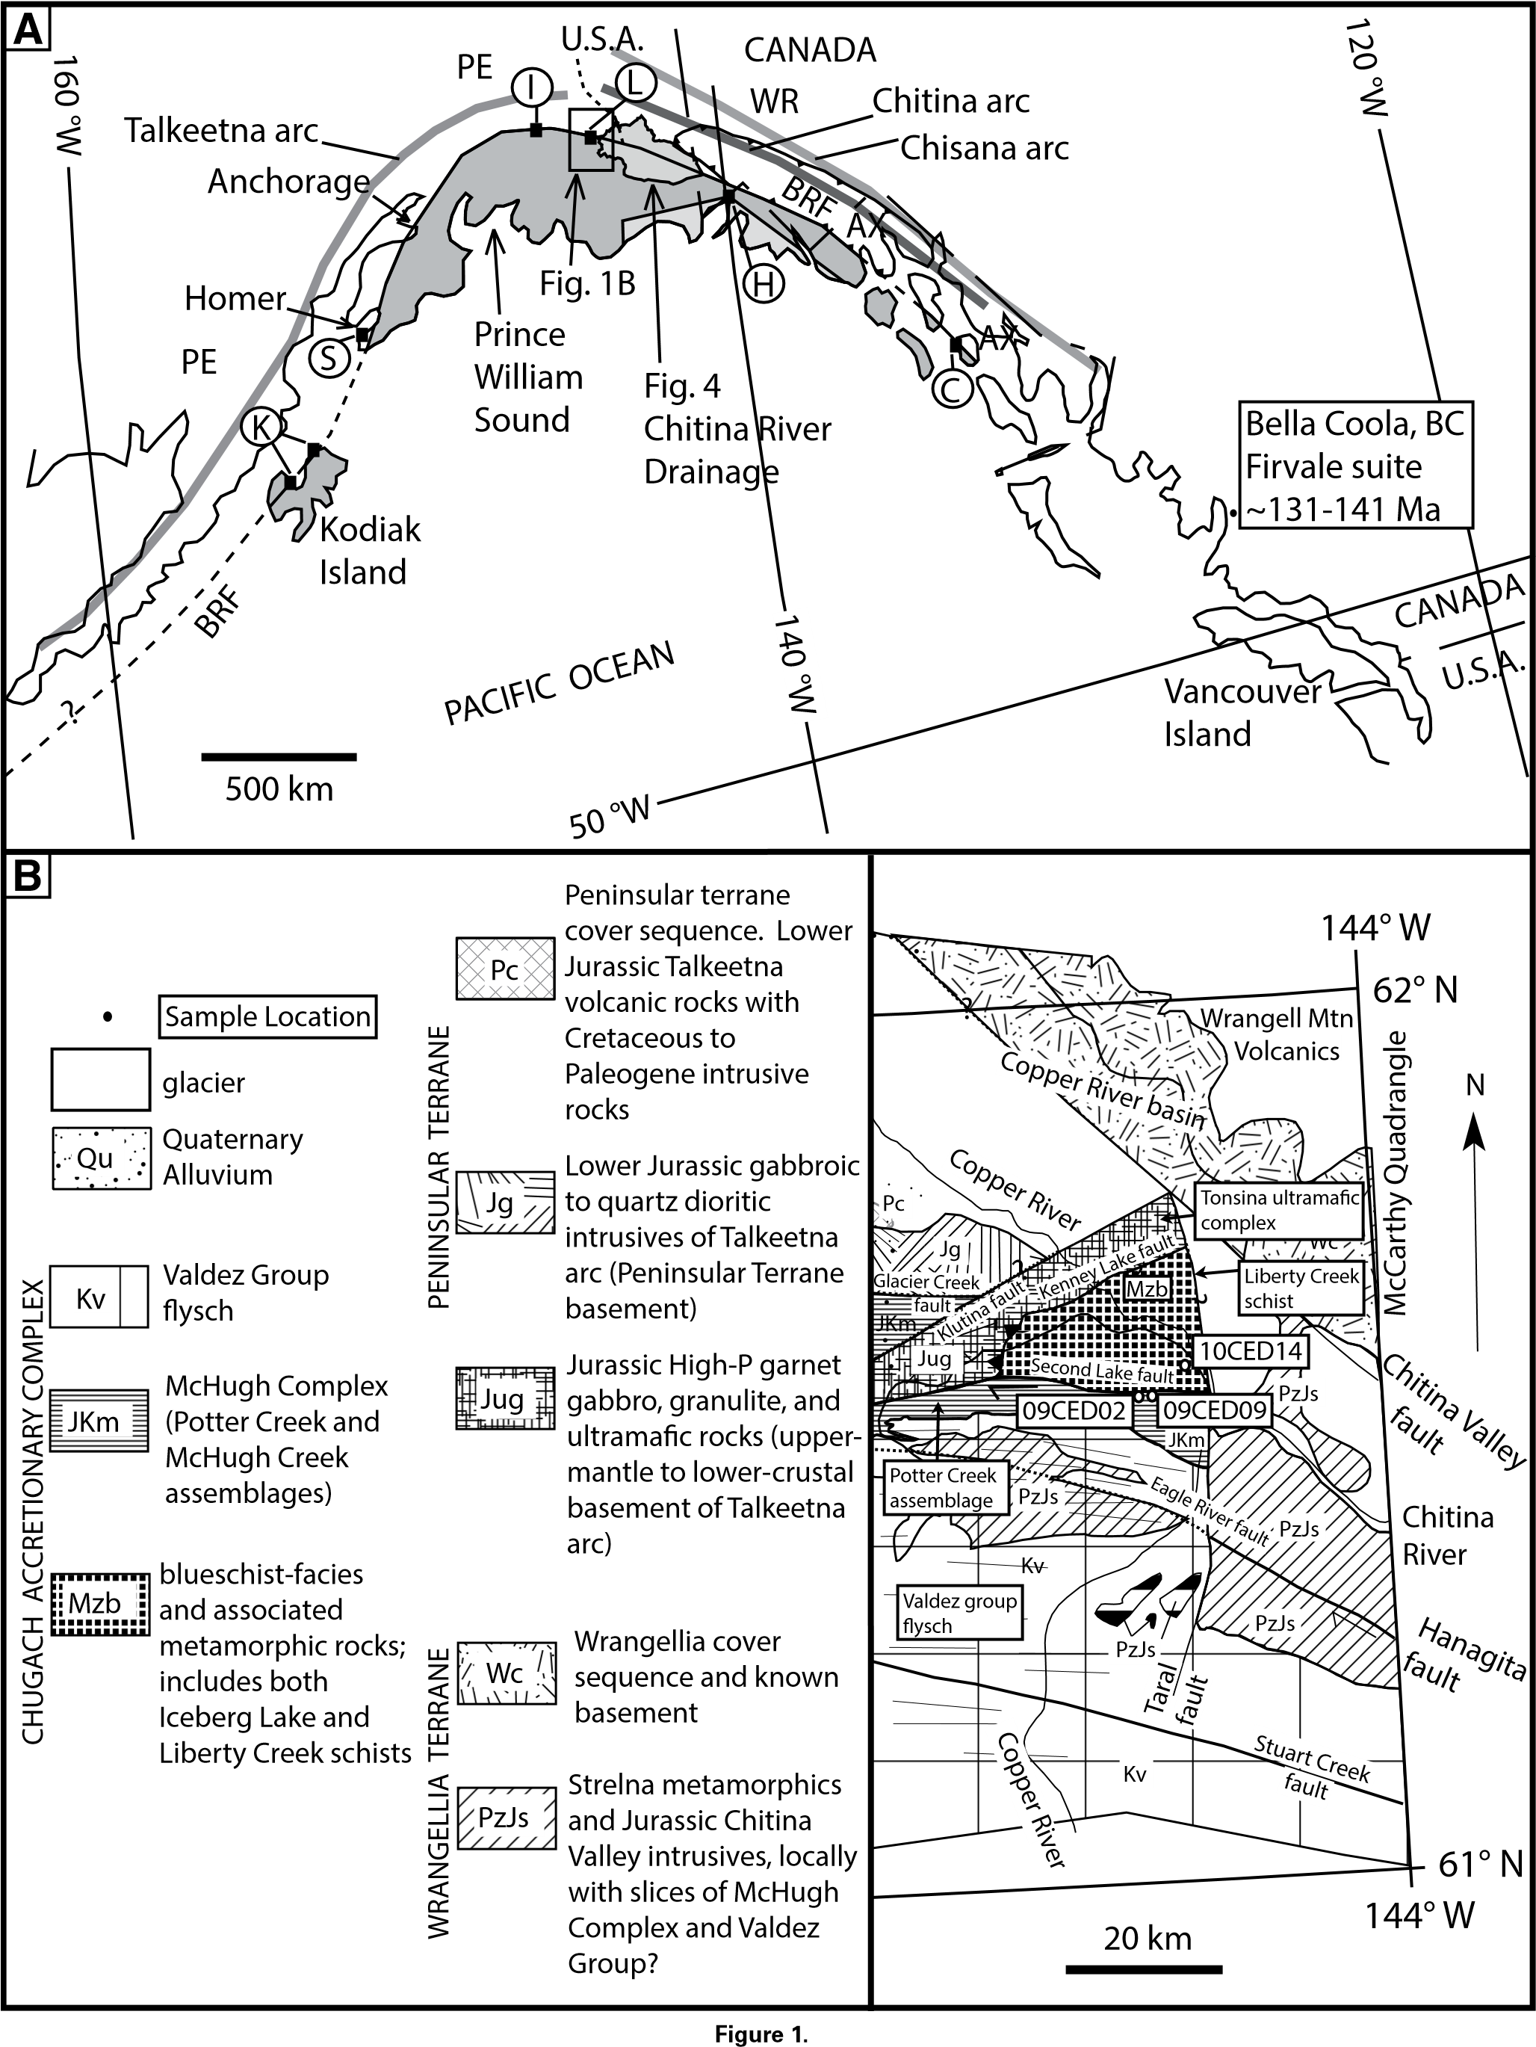

**Figure 1. (A) Map of southern Alaska showing the Wrangellia composite terrane, Chugach accretionary complex, the Border Ranges fault (BRF), the relative locations of ancient arcs, the Firvale suite, and the extent of the Chitina River drainage basin. The Wrangellia composite terrane is composed of Peninsular terrane (PE), Wrangellia terrane (WR), and Alexander terrane (AX). Dark-gray shading is the Chugach accretionary complex, and the light shading shows the position of the Neogene Yakutat terrane. Black squares with letters are the locations of blueschist bodies along the Border Ranges fault. K—Afognak and Raspberry schist (196 Ma, Rb-Sr), Kodiak Island; S—Seldovia schist (191 Ma, 40Ar/39Ar), Kenai Peninsula; I—Iceberg Lake schist (185 Ma, 40Ar/39Ar); L—Liberty Creek schist (123–107 Ma, K-Ar), Chitina, Alaska; H—Hubbard Glacier schist; C—Chichagof Island schist (91–106 Ma, K/Ar), Chichagof Island. Map is after Sisson and Onstott (1986), Plafker et al. (1989), and Pavlis and Roeske (2007). BC—British Columbia. (B) Geologic map of the central Chugach Mountains showing the Liberty Creek schist and associated Chugach accretionary complex assemblages. Also shown are locations of detrital zircon samples. Figure is modified from Pavlis and Roeske (2007).**

data from these assemblages reveal a ca. 196–91 Ma range of cooling ages for these blueschist-facies terranes, with ages decreasing from west to east along the margin (e.g., Decker, 1980; Sisson and Onstott, 1986; Roeske et al., 1989; Plafker et al., 1994; Bradley et al., 1999; Fig. 1A).

These data have led to three hypotheses regarding the timing of southern

Alaskan blueschist-facies metamorphism: (1) The variation in metamorphic cooling ages results from different times of subduction, exhumation, or movement along the subduction interface (Sisson and Onstott, 1986); (2) the varied cooling ages are a result of progressively younger cooling from west to east following a ca. 210 Ma blueschist-facies metamorphism event (Sisson and Onstott, 1986); or (3) there were two blueschist-facies metamorphism events, one event at ca. 200 Ma represented by the western and central Alaskan blueschist-facies terranes (K, S, I, L in Fig. 1A), and a second blueschist-facies metamorphism event at ca. 110 Ma represented by the easternmost south Alaskan blueschist-facies terranes (Plafker et al., 1989; C in Fig. 1A). The goal of this study was to use a detrital zircon approach to test these alternative hypotheses and add detail to the earliest histories of the southern Alaskan blueschist-facies terranes.

Here, we report on detrital zircon analyses from the Liberty Creek schist and other nearby rocks of the Chugach accretionary complex in the central Chugach Mountains (Figs. 1B and 2). These data show that the Liberty Creek schist (L in Fig. 1A) cannot be related to the Early Jurassic blueschist-facies assemblages of southern Alaska (K, S, and I in Fig. 1A), and it represents a distinctly younger, Early Cretaceous blueschist-facies assemblage. We show that the detrital zircon signature of the Liberty Creek schist is distinct from other detrital signatures heretofore seen in this accretionary complex, and it may be representative of a missing part of the accretionary complex. Based on this detrital signature and similar conclusions from other authors (e.g., Umhoefer, 2003; Garver and Davidson, 2015; Hildebrand, 2015; Shaw and Johnston, 2016), we speculate that long-distance northward transport of terranes in the North American Cordillera during Late Cretaceous to Paleogene time was responsible for the current geographic location of the Liberty Creek schist, both along the paleomargin and among other terranes of this accretionary complex.

# TECTONIC SETTING

Blueschist-facies rocks along the northernmost Cordilleran margin have been interpreted as exhumed products of a subduction zone with a similar polarity to the present-day margin (e.g., Carden et al., 1977; Forbes et. al., 1979; Plafker et al., 1994). Structures indicate that both the past and current subduction zones are directed to the north (e.g., Carden et al., 1977; Forbes et al., 1979; Nokleberg et al., 1989; Plafker et al., 1994). Nonetheless, interpretations of the tectonic affinities through time and the subduction histories of these southern Alaskan blueschist-facies rocks remain controversial. Throughout the Mesozoic, the northern Cordillera was characterized by the accretion of arc systems and subsequent strike-slip dispersal of elements of these arc-trench systems, leading to the observed terrane mosaic of the modern margin (Plafker et al., 1994).

The outer Cordilleran assemblage is composed of an accreted arc–trench system, with the Wrangellia composite terrane representing the arc assemblage and the “Chugach terrane” representing the subduction complex (Fig. 1B; Plafker et al., 1994; Pavlis and Roeske, 2007). The Wrangellia composite terrane was assembled from three late Paleozoic to early Mesozoic terranes that may represent as many as three distinct oceanic arcs (Israel et al., 2014; Beranek et al., 2014). Overlap assemblages and plutonic ties establish that the Wrangellia composite terrane was partially assembled during the late Paleozoic (Israel et al., 2014; Beranek et al., 2014). The Peninsular terrane is the part of the Wrangellia composite terrane underlying most of southern Alaska (Plafker et al., 1994). This arc terrane is either a younger separate oceanic arc that was amalgamated with Wrangellia as recently as Late Jurassic time (Clift et al., 2005), or it was constructed upon the combined Wrangellia-Alexander terrane by Late Jurassic time, when a cover sequence firmly establishes connections between these terranes (e.g., Coney et al., 1980; Plafker et al., 1994; Trop et al., 2002, 2005). The backstop to the subduction complex is the

Border Ranges fault, which extends along the entire length of the southern Alaskan margin (MacKevett and Plafker, 1974; Pavlis and Roeske, 2007; Fig. 1A).

The southern Alaskan blueschist-facies terranes are all located south of the Border Ranges fault (Sisson and Onstott, 1986; Plafker et al., 1994; Pavlis and Roeske, 2007; Fig. 1A). The blueschist-facies terranes occur as fault-bounded bodies, but juxtapositions with other rocks vary among the isolated bodies. Most lie directly south of the Border Ranges fault and north of what has traditionally been called the mélange subterrane of the Chugach terrane (e.g., Coney et al., 1980; Plafker et al., 1994). Some of the blueschist-facies terranes, however, are exposed as large isolated bodies within the Chugach mélange (Sisson and Onstott, 1986); because of this structural relationship, the blueschist-facies terranes have loosely been associated with the mélange subterrane of the Chugach terrane.

Detrital zircon studies indicate that the mélange subterrane of the

Chugach terrane is composed of at least two elements: a Late Jurassic mélange dominated by pelagic to hemipelagic protoliths, and a middle Cretaceous clastic-dominated stratally disrupted assemblage (Amato and

Pavlis, 2010; Amato et al., 2013). These data and related studies led

Amato et al. (2013) to propose a new nomenclature for these subduction assemblages: the term Chugach accretionary complex for the Chugach and Prince William terranes, and the terms Potter Creek assemblage and McHugh Creek assemblage for the Late Jurassic and Early Cretaceous parts of the Chugach accretionary complex, respectively. The blueschistfacies terranes do not directly fit into this terminology aside from local names for these units. The known cooling ages indicate they may represent the oldest parts of the Potter Creek assemblage or they may be an older assemblage.

The blueschist-facies terranes are located north of, or sliced into, the

Potter Creek assemblage (e.g., Amato et al., 2013), and, where undisturbed by younger strike-slip movement, the McHugh Creek assemblage lies structurally beneath the Potter Creek assemblage. The McHugh Creek assemblage, in turn, lies structurally above, and is gradational in age to, the Late Cretaceous coherent turbidite assemblage known in the Chugach

|  |
| --- |
| **Figure 2. Normalized probability plot of detrital zircon populations from this study. 10CED14—Liberty Creek schist; 09CED02 and 09DED09—greenschist from the Second Lake shear zone south of the Liberty Creek schist; 10CHITINA-1—sands from the Chitina River valley. Valdez group flysch, McHugh Creek assemblage, and Potter Creek assemblage detrital zircon populations are from the Chugach accretionary complex assemblages of Amato et al. (2013), provided for comparison. Shaded area signifies ca. 140–110 Ma magmatic lull experienced in the northern Cordillera. MDA—maximum depositional age.** |

Mountains as the Valdez group or Chugach flysch (Plafker et al., 1994; Kochelek et al., 2011) and elsewhere termed the Valdez group flysch by Amato et al., (2013). The Chugach flysch constitutes the bulk of the “Chugach terrane” of Plafker et al. (1994).

The depositional ages of protoliths to the southern Alaskan blueschistfacies terranes were previously unknown other than minimum ages provided by cooling dates. Based on cooling ages as old as the earliest Jurassic and structural position, these blueschist-facies rocks are widely cited as evidence for the initiation of subduction and the earliest accretion of the Chugach accretionary complex (e.g., Plafker et al., 1994; Pavlis and Roeske, 2007). Detrital zircons from the other members of the Chugach accretionary complex, however, are much younger than the available blueschist-facies cooling ages (Amato et al., 2013). This observation, together with relationships in the adjacent arc on the Wrangellia composite terrane, is the principal evidence that a prolonged period of subduction erosion followed Early Jurassic accretion of the blueschist-facies rocks (Clift et al., 2005; Amato and Pavlis, 2010).

The source of the clastic rocks that formed the protolith to the Potter Creek assemblage was the Early to Middle Jurassic Talkeetna-Bonanza arc or another coeval mid-Jurassic arc on the Wrangellia composite terrane, but the Potter Creek clastic rocks are mixed with pelagic to hemipelagic rocks that include radiolarian cherts with a wide range of depositional ages (e.g., Plafker et al., 1994; Amato et al., 2013). In contrast, the younger McHugh Creek assemblage and the Valdez group indicate a source primarily from the Coast Mountains batholith near SE Alaska and British Columbia, which is consistent with younger dextral strike-slip transport of these rocks to their present position in southern Alaska (Kochelek et al., 2011; Amato et al., 2013). These source terranes are important for this study because they provide tectonic context for time windows that surround the accretion of blueschist-facies rocks.

# Geology of the Central Chugach Mountains Blueschist-Facies Terranes

The southern Alaska blueschist-facies terranes are scattered along the margin from Kodiak Island in the west to Chichagof Island in the east

(Fig. 1A). The rocks have been most extensively studied in the far west on Kodiak Island (K in Fig. 1A), including the Raspberry schist of Raspberry

Island (Roeske, 1986; Roeske et al., 1989) and Afognak Island schist of

Carden et al. (1977), and the southwestern tip of the Kenai Peninsula

(Seldovia schist; S in Fig. 1A). Less well known are the blueschist-facies terranes of the central Chugach Mountains, which include the Iceberg Lake (I in Fig. 1A) and the Liberty Creek schists (L in Fig. 1A), as well as southeastern Alaskan blueschist-facies terranes (Hubbard Glacier locality [H in Fig. 1A] and Chichagof Island [C in Fig. 1A]). In this study, we concentrated on the two central Chugach Mountains localities (Fig. 1B).

The Iceberg Lake schist was first recognized by Winkler et al. (1981a, 1981b) during reconnaissance mapping but has received little attention because of its remote setting. They recognized that the assemblage was surrounded by lower-grade mélange rocks of the McHugh complex, and they mapped the assemblage as a large, elongate slab bounded by highangle faults. Pavlis and Roeske (2007) and Day (2014) showed that the structure of the Iceberg Lake schist is more complex, with the assemblage composed of multiple faulted slices of rock of varying scale. The structural history of the faulting is poorly understood, but it clearly included Cenozoic faulting (Pavlis and Roeske, 2007), suggesting a protracted structural history. The Iceberg Lake schist is lithologically diverse and composed of rocks with variably developed metamorphic fabrics (Winkler et al., 1981b; Pavlis and Roeske, 2007). The most abundant rocks are mafic glaucophane ± lawsonite schists derived from both volcanic and plutonic protoliths with highly variable fabric development (Winkler et al., 1981b; Pavlis and Roeske, 2007). Other rock types are diverse metasedimentary rocks, including dark phyllites and fine- to medium-grained micaceous schists associated with quartzites and minor amounts of marble (Winkler et al., 1981b; Pavlis and Roeske, 2007).

Sisson and Onstott (1986) dated the Iceberg Lake schist with 40Ar/39Ar techniques applied to blue amphibole and white mica separates and recognized that the dates from blue amphibole were from fine-grained white mica inclusions in the amphibole. Their study provides the only age constraint on the Iceberg Lake schist—a clear Early Jurassic cooling date of 186 Ma, indicating a likely correlation to the Kodiak and Seldovia blueschist-facies terranes, which have similar Early Jurassic (ca. 190 Ma) cooling dates (Roeske, 1986; Bradley et al., 1999).

The second blueschist assemblage of the central Chugach Mountains is the Liberty Creek schist (L in Fig. 1A; detail in Fig. 1B), first recognized by Metz (1976). Early studies (e.g., Metz, 1976; Winkler et al., 1981b) concentrated on the petrology of the assemblage. Later studies (e.g., Nokleberg et al., 1989) described the structure, which was further refined by Pavlis and Roeske (2007). Lopez-Carmona et al. (2011) analyzed samples for thermobarometry and estimated peak pressures of 15 kbar or a depth of ~50 km for the Liberty Creek schist.

The Liberty Creek schist is distinct from the Iceberg Lake schist, both in lithology and mineralogy. The Liberty Creek schist is composed predominantly of metasedimentary rocks with a prominent, relatively uniform continuous cleavage defined by a pronounced mica foliation (Forbes et al., 1979; Plafker et al., 1989). In outcrop, the Liberty Creek schist appears superficially similar to the Potter Creek assemblage in that it is typically composed of thin laminae of mafic greenschist interleaved with dark phyllite and minor quartzite (Day, 2014)—compositions suggestive of the green tuff, black argillite, chert association characteristic of the Potter Creek assemblage (Amato and Pavlis, 2010; Amato et al., 2013). The Liberty Creek schist is different, however; it has a characteristic penetrative, continuous cleavage suggesting a more pronounced ductile finite strain than other parts of the Chugach mélange (Day, 2014). Nokleberg et al. (1989) noted this fabric and its parallelism with fabrics in adjacent rocks, although Pavlis and Roeske (2007) considered it a distinctly different fabric. The Liberty Creek schist is also structurally distinct on a large scale, bounded by two prominent, but distinctly different fault systems

(Plafker et al., 1989; Pavlis and Roeske, 2007). To the north and west, the Liberty Creek schist is in low-angle fault contact with the Tonsina ultramafic complex (Pavlis and Roeske, 2007; Fig. 1B). The Tonsina ultramafic complex is widely recognized as the upper-mantle basement to the Early Jurassic Talkeetna arc of the Peninsular terrane (Burns, 1985; DeBari and

Coleman, 1989; Rioux et al., 2007, 2010; Hacker et al., 2008). To the south of the Liberty Creek schist, the Second Lake fault is a high-angle strike-slip shear zone that is clearly a younger strike-slip structure (Pavlis and Roeske, 2007). Rocks south of the Second Lake fault were originally mapped as a different assemblage (Winkler et al., 1981b). Plafker et al. (1994) correlated these rocks to the McHugh complex, and our work reported here supports this conclusion.

The age of the Liberty Creek schist has been debated since its discovery. Winkler et al. (1981b) attempted to date the complex using conventional K-Ar dating, and Plafker et al. (1989) produced additional conventional

K-Ar dates. All of these dates were on whole rocks and scatter from 123 to 107 Ma, suggesting a mid-Cretaceous minimum age. Nonetheless, these ages are difficult to interpret because with conventional K-Ar, particularly whole-rock ages, these dates could be too old from extraneous Ar or excessively young due to partial Ar loss during later events. For example, the region experienced a Paleogene thermal event (e.g., Sisson et al., 1989) that could have produced partial Ar loss from rocks that cooled originally in the Jurassic. Although we had similar problems producing clean mineral separations in these fine-grained rocks, the detrital signature of these rocks confirms they are distinct from the blueschist-facies rocks exposed to the west.

# METHODS

The purpose of this work was to obtain a maximum age of deposition for the Liberty Creek schist. Samples were collected with the goal of covering as much area of the Liberty Creek schist as possible. Ten days were spent mapping and sampling along the Second Lake shear zone during the summer of 2009. A helicopter camp was set up near the location of 09CED02 on Figure 1B, and sampling was undertaken by hiking in all compass directions with the added goal of finding a detailed location of the Second Lake shear zone, the boundary between the Liberty Creek schist and the McHugh complex rocks to the south. Over the summer of 2010, another 10 days were spent along the Edgerton Highway, which parallels the Copper River through the northern Liberty Creek schist (Fig. 1B). Mapping and sampling were carried out between the intersection of the Tonsina River near the Edgerton Highway (base of the “y” in “Kenney Lake fault” label Fig. 1B) and the town of Chitina (top of the “E” in “09CED09” label in Fig. 1B).

Geologic mapping of structure and metamorphic fabrics was carried out using handheld computers and ESRI ArcPad™ software. Thin sections were prepared for each sample, with the intention of identifying the presence of detrital zircons and blueschist-facies metamorphism. Samples were taken primarily from outcrops that had a “blue” coloration upon visual inspection and a schistose texture, with the notion that these would be blueschist-facies rocks. Non-blue-schistose outcrops were also sampled with the goal of complete spatial coverage of samples when no blue outcrop was available. Twenty samples were collected from the Liberty Creek schist. Each sample contained ~3.5 L of material from which detrital zircons were separated following the methods described by Amato and Pavlis (2010). Analyzed zircons were euhedral, with an average size of

100 × 30 μm. Analyses were carried out with a 35 μm beam, essentially obliterating most zircons after laser ablation. Three samples from the Liberty Creek schist area, 09CED02, 09CED09, and 10CED14, were found to contain detrital zircons, and of these, only sample 10CED14 contained blueschist-facies minerals.

U-Pb ages of detrital zircons were analyzed using the Nu Plasma high-resolution (HR) laser ablation–multicollector–inductively coupled plasma–mass spectrometer (LA-MC-ICP-MS) at the University of Arizona (for details of the methods, see Gehrels et al., 2008). Beam diameter was generally 35 μm. Errors on spot ages of individual zircon grains are reported in the text and tables at 1s, and weighted mean ages are reported in the text and figures at the 2s level. Data are presented on concordia diagrams and relative probability distribution diagrams created using Isoplot (Ludwig, 2003). We do not report the 207Pb/206Pb ages unless the 206Pb/238U age is older than 350 Ma because of low precision. Because the uncertainty on the 207Pb measurement for these young grains (with relatively low U concentrations) is high, we did not apply any discordance filter to the data. Note that the high uncertainties in general result in concordant data owing to the size of the error ellipse. None of the samples had zircon ages significantly younger than the main population, suggesting Pb loss

was not an issue. We did apply an uncertainty filter to exclude 206Pb/238U ages with a 1s uncertainty of >10%.

Maximum depositional ages (MDAs) were determined from the weighted mean of the youngest population of grains with overlapping uncertainties and a mean square of weighted deviates (MSWD) as close to 1 as possible (Fig. 2; Figs. DR1, DR2, DR3, and DR4[1]). This procedure produces a maximum age at which this population of zircons could have been derived from a common source. Relative probability plots in Figure 2 have been normalized; the relative sizes of population peaks in the probability plots are placed on an equal scale relative to the number of grains of each age. This allows for comparison of one sample to another despite varying numbers of zircons analyzed in different sample sets. See Table DR1 for the full U-Pb data set.

**RESULTS**

# Central Chugach Mountains Blueschist-Facies Terranes

We sampled the Iceberg Lake schist for detrital zircons, and none of the 11 samples we processed yielded zircons. Amato et al. (2013) reported a similar paucity of zircon from the Seldovia schist. The absence of zircons from both assemblages is consistent with the hypothesis that these blueschist-facies rocks were formed from a pelagic sediment and mid-ocean-ridge basalt assemblage.

Of 20 samples we examined for detrital zircons in the Liberty Creek schist, three samples yielded detrital zircons (Figs. 1B and 2). In hand sample, 10CED14 is a fine-grained, medium–dark-green color with a phyllitic texture and ferruginous chert layers. In thin section (Fig. 3), this sample has blue Na-amphibole, confirming that 10CED14 is part of the southern Alaskan blueschist-facies assemblages as described by Forbes et al. (1979). López-Carmona et al. (2011) analyzed similar Naamphiboles from a nearby locality and showed a variety of Na-amphibole compositions ranging from glaucophane to magnesio-riebeckite for this

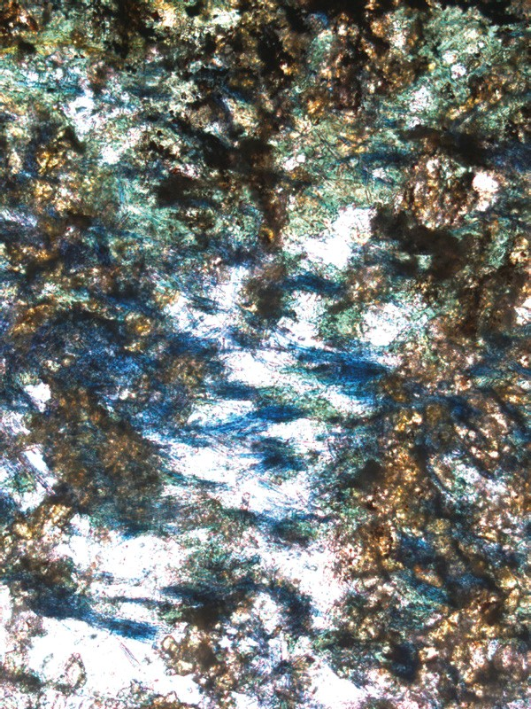

100

μm

**Figure 3. Photomicrograph from 10CED14, showing Na-amphibole. Plane light, 10× magnification.**

assemblage. The matrix of the sample is a mix of fine-grained chlorite and white mica. Na-amphibole is partially replaced by chlorite, and the presence of multiple crosscutting generations of prehnite, stilpnomelane, laumontite, and calcite veins indicates low-temperature retrograde conditions after blueschist-facies metamorphism. The MDA of sample 10CED14 is 136 ± 2 Ma, with a MSWD of 0.99 (Fig. 2; Fig. DR1), and half of the zircon ages are between 130 and 140 Ma (Fig. 2; Table DR1). Multiple peaks are visible in the probability plot of 10CED14, with peak ages at 137 Ma, 159 Ma, 170 Ma, and 173 Ma (Fig. 2).

Samples 09CED02 and 09CED09 were collected in rocks mapped along the southern border of the Liberty Creek schist (Plafker et al., 1989); however, these samples are from rocks that are lithologically distinct from the bulk of the Liberty Creek schist. The samples were collected within the Second Lake shear zone, just north of the southern boundary of the Second

Lake fault separating the Liberty Creek schist from the McHugh complex (Fig. 1B). Our work (Day, 2014) indicates that the Second Lake fault is a complex, ~600-m-wide shear zone where rock units are shuffled and difficult to recognize because of lithologic similarities between the McHugh complex and Liberty Creek schist (e.g., Pavlis and Roeske, 2007). In hand sample, 09CED02 is a light-green to gray meta-graywacke with minor visible sand-sized grains and clear evidence of cleavage development similar to cleavage in the Liberty Creek schist. Petrographic observations confirm the sand-sized grains as quartz and cryptocrystalline quartz (chert) in a

very fine-grained matrix of cryptocrystalline quartz, and recrystallized, very fine-grained micaceous matrix (chlorite and white mica). Sample 09CED09 is a gray, coarse-grained meta-graywacke; petrographic observations reveal the presence of mud rip-up clasts and deformed quartz grains in a very fine-grained micaceous matrix (chlorite and white mica) and cryptocrystalline quartz. The MDA of 09CED02 is 149 ± 2 Ma, with a MSWD of 1.11 (Fig. 2; Fig. DR2), and zircon population peaks at 153 Ma and 203 Ma (Fig. 2). Sample 09CED09 has an MDA of 159 ± 2 Ma, with a MSWD of 1.05 (Fig. 2; Fig. DR3), and zircon population peaks at 159 Ma, 190 Ma, and 208 Ma (Fig. 2).

# Chitina River Valley Sediment

Sample 10Chitina-1 was collected from modern sediment of the Chitina River near the Ultima Thule Lodge (Fig. 4). This sample was collected because a potential source for the Liberty Creek schist and McHugh complex is the Jurassic Chitina arc, exposed for more than 400 km along the Border Ranges fault from the Copper River into SE Alaska (Plafker et al., 1989; Roeske et al., 2003; Fig. 1A). However, the Chitina arc is not well dated, with the bulk of the geochronology from conventional K-Ar dates (Hudson, 1983; Dodds and Campbell, 1988; Plafker et al., 1989) and a few modern 40Ar/39Ar cooling ages (Roeske et al., 2003), all of which scatter from 171 to 130 Ma. Thus, the modern sediment sample was collected as a proxy for the age of the Chitina Valley batholith, which makes up a significant part of the Chitina arc (Plafker et al., 1994). Figure 4 shows the drainage basin of the Chitina River and the sample locality, indicating this sample should be sampling ~150 km of the strike length of the Chitina Valley batholith (Jc and PzJs of Fig. 4) plus rocks of Wrangellia

(Wc of Fig. 4). Zircon separates from sample 10Chitina-1 were analyzed following the same procedures as the other samples from the Chugach accretionary complex. Treating the Chitina sand like the metasedimentary samples, the zircon population shows the equivalent of an “MDA” of 143 ± 2 Ma, with a MSWD of 1.03 (Fig. 2; Fig. DR4), and observable peaks at 146 Ma, 156 Ma, and 305 Ma (Fig. 2).

**DISCUSSION**

# Two Distinct Blueschist-Facies Assemblages in Southern Alaska

The MDA of 136 Ma from the Liberty Creek schist confirms the hypothesis of Plafker et al. (1989) that there are two distinct blueschistfacies assemblages along the southern Alaskan margin, one in the Early Jurassic and another after the Early Cretaceous. Prior to this study, robust geochronologic data only existed for the three western blueschist-facies terranes (K, S, and I in Fig. 1A), and these cooling ages indicate these three blueschist-facies terranes represent an Early Jurassic blueschistfacies assemblage. Our 136 Ma MDA (Fig. 2; Fig. DR1) for the Liberty Creek schist unequivocally shows that it cannot be a part of this Early

Jurassic blueschist-facies assemblage because the protolith for the Liberty Creek schist was deposited at least 50 m.y. after the Early Jurassic blueschist-facies terranes had cooled through their 40Ar/39Ar and Rb-Sr (white mica) closure temperatures. Thus, the Liberty Creek schist must represent a distinctly younger blueschist-facies metamorphism event.

|  |
| --- |
| **Figure 4. Geologic map showing the extent of the Chitina River drainage basin. The location of sample 10Chitina-1 shows that the sands of this part of the Chitina River mostly sample rocks related to the Wrangellia terrane or the Chitina Valley intrusive rocks (batholith).** |

Possible correlations for the Liberty Creek schist are blueschist-facies rocks from the Hubbard Glacier (H in Fig. 1A) and Chichagof Island (C in Fig. 1A) locations. There are few geologic and thermochronologic data available for the Chichagof Island schist (e.g., Decker, 1980) and even fewer for the Hubbard Glacier schist (C and H in Fig. 1A). The latter is known only from glacial float (Forbes et al., 1979; T. Pavlis, 1992, field observations). As Decker (1980) noted, the Chichagof schists have lithologic similarities with the Liberty Creek schist, but he also observed that the Chichagof schists occur as blocks in a mélange, suggesting structural affinities with other southern Alaskan blueschist-facies terranes. Decker (1980) considered the associated mélange, the Kelp Bay group, as an

equivalent of the McHugh complex, which led to widespread correlation of the Chichagof schists with the Kodiak Island blueschist-facies rocks. Nonetheless, Decker (1980) reported conventional K-Ar cooling ages from actinolite and white mica separates collected from greenschist-facies and blueschist-facies rocks at Chichagof Island that range from 109 Ma to 91 Ma; three of the white mica cooling ages from blueschist-facies rocks ranged from 98 Ma to 95 Ma. These cooling ages are similar to the con-

ventional whole-rock K-Ar ages reported from the Liberty Creek schist, which scatter from 123 to 107 Ma (Plafker et al., 1994). We recognize that comparison of whole-rock and mineral separate analyses is prone to error, particularly in systems with known complex Ar systematics (e.g., Sisson and Onstott, 1986), yet these data collectively suggest the Liberty

Creek schist, Hubbard Glacier schist, and Chichagof Island schist are the result of a second mid-Cretaceous blueschist-facies event. Nonetheless, until more reliable cooling ages from all assemblages are available, this correlation should be considered tentative.

# Paleogeographic Implications of the Liberty Creek Schist within the Central Chugach Mountains

The location of the Liberty Creek schist within the complex geology of the central Chugach Mountains has implications for subduction zone processes that produced this system, particularly the role of strike-slip overprinting during oblique subduction. The Liberty Creek schist now lies to the south of, and structurally beneath, the Tonsina ultramafic complex, but it is north of a dextral strike-slip fault system that transported these rocks at least 130 km along strike in the latest Cretaceous–Paleogene (Pavlis and Roeske, 2007; Fig. 1B). The mantle rocks of the Tonsina complex in juxtaposition with blueschist-facies rocks formed at pressures comparable to mantle depths (López-Carmona et al., 2011), suggest the Liberty Creek schist preserves a vestige of the mantle-level megathrust. Younger events both to the north and south have isolated this deeply exhumed fragment relative to adjacent areas. The northern limits of both the Tonsina complex and the Liberty Creek schist are not exposed (Fig. 1B). Thus, the structures responsible for the exhumation of these assemblages are poorly constrained. The northwest-dipping thrust contact between the Tonsina complex and the Liberty Creek schist, the Kenney Lake fault, is truncated by the Second

Lake shear zone, a major strike-slip fault system that forms the southern contact of these assemblages (Pavlis and Roeske, 2007; Fig. 1B). This pattern suggests that strike-slip faulting along the Second Lake fault occurred after the thrusting of the Kenney Lake fault. However, the geometry of these and other nearby structures strongly suggests that the deep exhumation of the assemblages in this area was at least in part related to strike-slip and or oblique motions (e.g., fig. 7 *in* Pavlis and Roeske, 2007).

This interpretation may explain the location of the Liberty Creek schist along this segment of the Border Ranges fault. The classic two-dimensional, north-directed, trench-perpendicular subduction model creates an age progression from older to younger accreted rocks as one moves from the backstop south toward the trench. Samples 09CED02 and 09CED09 (Fig. 1B) have MDA of ca. 149 Ma and ca. 159 Ma, respectively, and probability plots that are most consistent with the robust example of the Potter Creek assemblage from Amato et al. (2013) (see also Fig. 2; Figs. DR2 and DR3). The location of these samples within the Second Lake shear zone indicates that samples 09CED02 and 09CED09 may be slices of the Potter Creek assemblage worked into the Second Lake shear zone during the aforementioned strike-slip motions. The ideal south-directed age progression within an accretionary complex is clearly violated in this area, with the Cretaceous Liberty Creek schist (MDA ca. 136 Ma; Figs. 1B and 2; Fig. DR1) located inboard of the Jurassic Potter Creek assemblage (Fig. 1B), represented by samples 09CED02 and 09CED09 (Fig. 2; Figs. DR2 and DR3). This progression is consistent with a threedimensional view of the system. That is, the Liberty Creek schist and Tonsina assemblage presumably were both at upper-mantle depths in the

Early Cretaceous, but later strike-slip systems juxtaposed these rocks with younger and older rocks that had been accreted at shallower depths and hundreds of kilometers along strike. Thus, strike-slip motions have rearranged the accretionary complex by carrying the Potter Creek assemblage laterally along strike, outboard and south of the Tonsina complex and the Liberty Creek schist. The missing McHugh Creek assemblage rocks and the presence of the much younger Valdez group flysch structurally below and south of the Potter Creek assemblage strengthen the argument for strike-slip motions reorganizing the Chugach accretionary complex during Late Cretaceous dextral oblique subduction (Pavlis and Roeske, 2007).

# Paleogeographic Implications of the Liberty Creek Schist in the Cordillera

Our initial hypothesis based on the detrital zircon analysis of the Liberty Creek schist was that the nearby Chitina Valley batholith, part of the Chitina arc, was the source for the assemblage because cooling ages as young as 130 Ma have been reported from this belt (Hudson, 1983; Dodds and Campbell, 1988). Pavlis and Roeske (2007) showed that clasts in sedimentary cover deposited unconformably on the Chugach accretionary complex were derived from Chitina Valley metamorphic rocks now lying 150 km to the east, indicating at least 150 km of dextral slip and a paleogeography adjacent to the Chitina Valley batholith.

Our sample from the Chitina River sands (10Chitina-1) shows, however, that the Chitina Valley batholith is an unlikely source for the Liberty Creek schist. Assuming these modern sands are a good proxy for the age of the batholith, the equivalent of an “MDA” by process (143 Ma) and the main peak on the probability distribution curve for the Chitina Valley batholith (146 Ma) are ~10 m.y. older than the main peak (137 Ma) and the calculated 136 Ma MDA of the Liberty Creek schist (Fig. 2; Fig. DR1). Further, 50 out of 96 zircons (52%) of analyzed grains from the

Liberty Creek schist (10CED14) have an age (±1s uncertainty) between

140 Ma and 130 Ma (Table DR1), indicating the Liberty Creek schist was sourced from an area dominated by Early Cretaceous rocks with zircon ages primarily in the 140–130 Ma range. In contrast, for the Chitina River sands, only 25 out of 83 zircons (30%) have ages within this range, and only one of these zircons is as young as the youngest ages in the Liberty Creek sample (Table DR1). Figure 4 shows the location of sample 10Chitina-1 within the drainage of the Chitina River and the rocks that should contribute zircons to sample 10Chitina-1. Admittedly, this sample (10Chitina-1) was collected from a drainage dominated by glacial erosion, which is known to preferentially sample restricted valley segments and valley walls (Enkelmann et al., 2010). Nonetheless, we note that the dominant glacial source upriver from the sampling site (Fig. 4) is the Logan glacier and its southern tributaries from the high St. Elias range, both of which carve valleys through predominantly Chitina Valley batholith and related metamorphic rocks. Further evidence for a dominance of Chitina Valley batholith sources is the scarcity of Paleozoic zircons in the sample (Fig. 2), which would be expected if a Wrangellian source were dominant (Fig.

4). Thus, in the absence of better geochronologic control from the Chitina Valley batholith, the available data suggest the Chitina Valley batholith is an unlikely source for metasedimentary rocks of Liberty Creek schist. With these caveats, we suggest that the population of detrital zircons in the Liberty Creek schist sample is sufficiently distinct from the population of zircons collected from the Chitina River sands and the populations of zircons representing the Chugach accretionary complex presented by Amato et al. (2013) that alternative sources must be considered.

The time interval between 140 and 110 Ma lies within a well-known magmatic gap in the northern Cordillera (e.g., Armstrong, 1988; Gehrels et al., 2009; Fig. 2). This gap has been confirmed in the Canadian Cordillera (Gehrels et al., 2009) as well as within the Wrangellia composite terrane (Hudson, 1983; Rioux et al., 2007) and sedimentary debris derived from it (Hampton et al., 2007; Amato et al., 2013). Thus, the predominance of 140–130 Ma zircons in the Liberty Creek schist raises the question of

what was the source for these zircons.

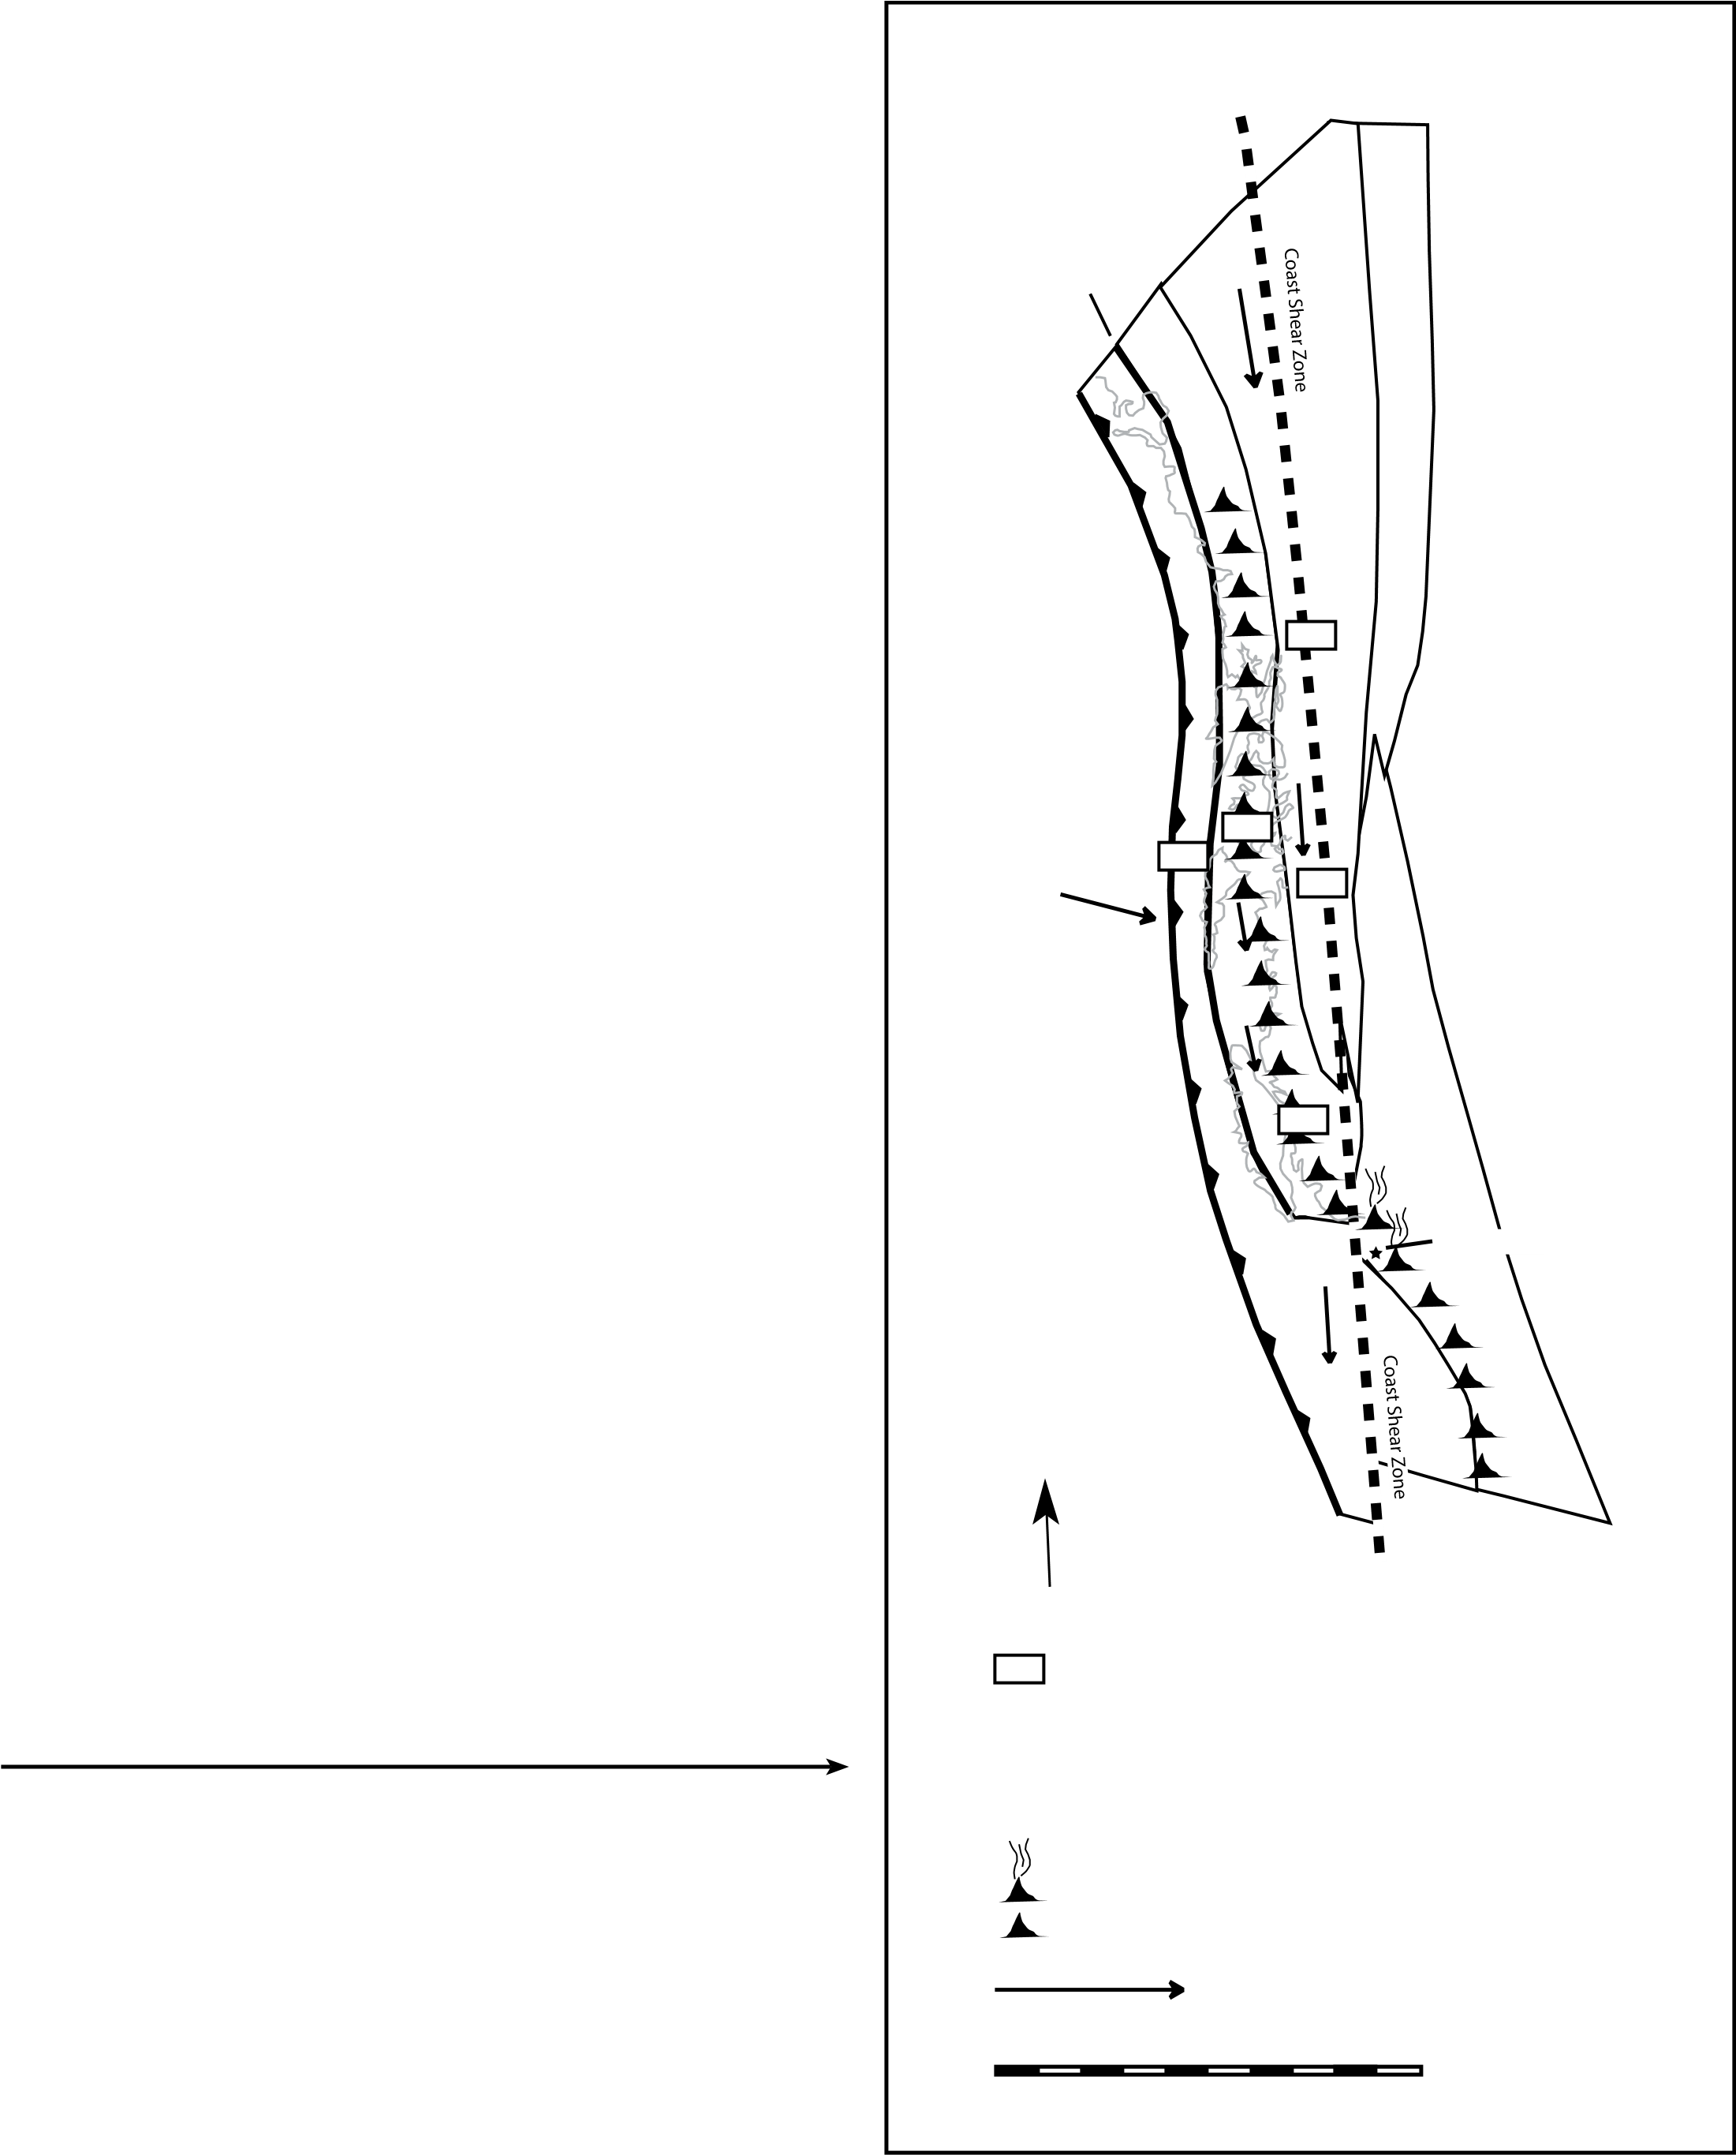Because igneous rocks of these ages in the northern Cordillera are rare, the simplest assumption is to use reasonable post–mid-Cretaceous right-lateral motions along the margin to infer a paleogeography. Estimates are variable for different structures, but if the Liberty Creek schist was transported as much as 600 km along the Border Ranges fault system (e.g., Pavlis and Roeske, 2007) as well as ~350 km along the Denali system (e.g., Lanphere, 1978; Lowey, 1998), then offsets on the order of 1000 km are reasonable. This translation distance would point to a source in western Canada or southeast Alaska adjacent to the Coast plutonic complex, a reasonable source location for the Liberty Creek schist given evidence that the Coast plutonic complex was likely the source of the McHugh Creek assemblage a few million years later (e.g., Amato et al., 2013; Garver and Davidson, 2015).

Like most of the northern Cordillera, the Coast plutonic complex experienced a magmatic lull from Late Jurassic to Early Cretaceous time (ca. 140–110 Ma), but that lull varied spatially (e.g., Armstrong, 1988; Gehrels et al., 2009). In particular, the lull is prominent to the west of the Coast shear zone in rocks of the western magmatic belt of the Coast plutonic complex. Intrusive rocks to the east of the Coast shear zone, the eastern magmatic belt, are known to have been active during this magmatic lull

(Gehrels et al., 2009; Mahoney et al., 2009). Particularly notable is the Firvale suite near Bella Coola, British Columbia (Fig. 1A), which was an active magmatic belt from 140 to 130 Ma (Gehrels et al., 2009; Mahoney et al., 2009). Nonetheless, although this belt is the right age to source the Liberty Creek schist, the plutons in this region were emplaced into Stikine and Yukon-Tanana basement, which not only contains older rocks than we see in the detrital zircons of the Liberty Creek schist, but also lies on the wrong side of the Coast shear zone, which is widely recognized as a mid-Cretaceous suture (Rubin and Saleeby, 1992). That is, an ocean basin separated these rocks in the Early Cretaceous, prior to mid-Cretaceous closure of the suture.

One solution to this issue is the tectonic model of Gehrels et al. (2009), which is a modern version of the northern option in the Baja–British Columbia controversy (Cowan et al., 1997). In this model, prior to ca. 140 Ma, the eastern magmatic belt of the Coast plutonic complex was actually part of the active subduction arc, and sediments of this arc would have had access to the forearc. Figure 5 shows a time in the model from Gehrels et al. (2009) when the Firvale suite, currently located by Bella Coola, British Columbia, could have made its way to the paleotrench.

**Figure 5. Schematic model of the northern Cordillera in the Late Cretaceous. This model illustrates one hypothesis of how the eastern magmatic belt of the Coast plutonic complex could have supplied sediments to the Chugach accretionary complex. The active and inactive volcanoes in this figure are representative of the emplacement of Coast plutonic complex intrusives and volcanics; at 130 Ma, most of the Coast plutonic complex was inactive except for the Firvale suite part of the eastern magmatic belt. After continued sinistral motion along the Coast shear zone, the Firvale suite and eastern magmatic belt of the Coast plutonic complex are located inland, as they are observed today. See Gehrels et al. (2009) for more detailed discussion of the evolution of the Coast plutonic complex. Figure is modified from Gehrels et al. (2009).**

130 Ma (Early Cretaceous)

Y-T

Border

Ranges

Fault G-N

G-N

A-W

Ch

Y-T

G-N

A-W

Ch G-N

St

A-W

St

Bella Coola

Ch

St

N

Possible large-scale southward motion

St Stikine and related inboard terranes Y-T Yukon-Tanana and related terranes G-N Gravina-Nutzotin belt

A-W Alexander-Wrangellia terrane

Ch Chugach terrane subduction zone assemblages

140-130 Ma magmatism (Firvale suite)

Inactive arc (topographic high)

Plate motion

200 km/Ma

0 500 1000

(km)

UNITED STATES **A**

Anchorage

Arctic Circle

Kodiak Liberty Creek schist

Island

CANADA 60° W 120° W

Bella Coola, BC

Firvale suite

100° W

UNITED

STATES

San Francisco 40° W

San Diego

MEXICO Guerrero terrane

120° W

20° W

Guadalajara

0 500 1000

(km)

Guerrero terrane Latitude and Longitude lines

International Border 100° W

Coastline

Point of Interest or City

Valanginian-Barremian (137-121 Ma) **B**

Al ? North Zi ? America

LCs?

Ar Te Tx

?

LCs? Ac

Taxco arc Ox

Guerrero terrane

Coastline N Ch

Subduction zone Shear zone

At this time in the model, the Coast plutonic complex was incurring a diachronous closure of the basin associated with a left-lateral strike-slip system along what is now the Coast shear zone (Fig. 5). This sinistral motion continued until ca. 100 Ma, when dextral transpressive subduction resumed outboard of the western Coast plutonic complex (Gehrels et al., 2009). This model allows for open ocean basins at the same time the Bella Coola area, the 140–130 Ma Firvale suite, was a magmatic arc source to the Early Cretaceous trench (Fig. 5; for a full explanation of this reorganization of the Coast plutonic complex, see Gehrels et al., 2009).

This model may be too straightforward, however, to accommodate these new data. Figure 2 shows that 10CED14, as with most Chugach accretionary complex samples, contains a minimal amount of Paleozoic zircons. This lack of Paleozoic material is the basis of the “direct arc to trench” assumption we make, allowing us to assume our MDA is representative of the age of accretion for the Chugach accretionary complex. The minimal amount of Paleozoic zircons in sample 10CED14 suggests the Firvale suite was not the source for the Liberty Creek schist.

An alternative source for 140–130 Ma rocks within the North American Cordillera is the Guerrero superterrane of central Mexico (Fig. 6B). The Guerrero terrane was a complex Jurassic–Cretaceous arc system that was active during this interval (Umhoefer, 2003; Fig. 6A) and eventually accreted to the Mexican margin in the Late Cretaceous (TalaveraMendoza et al., 2007; Fig. 6B). If the Liberty Creek schist protoliths were derived from the Guerrero arc before it collided (Fig. 6B), there might not be evidence of an older cratonal sediment source. This is consistent with the lack of Precambrian zircon in the Liberty Creek schist and the older constituents of the Chugach terrane (Amato et al., 2013; Fig. 6B).

The Wrangellia composite terrane likely was an offshore arc system in Late Jurassic–earliest Cretaceous time, and paleomagnetic data have consistently shown that it was at low paleolatitudes at this time, consistent

with a location in southwestern North America (Coney et al., 1980; Oldow et al., 1989; Irving et al., 1996; Johnston, 2001; Stamatakos et al., 2001; Shaw and Johnston, 2016). These conclusions are at the heart of the Baja–

British Columbia controversy and form the basis for the southern option for Wrangellia (e.g., Cowan et al., 1997). A Guerrero terrane source for the Liberty Creek schist is consistent with the southern option for Baja–British Columbia and the Early Cretaceous paleogeographic model of Umhoefer (2003). Results by Garver and Davidson (2015) and this study therefore provide evidence that complements paleomagnetic data for large-scale, post–Early Cretaceous northward transport of the Wrangellia composite terrane and the southern option for Baja–British Columbia.

# CONCLUSIONS

At least two examples of blueschist-facies preservation events are visible along the south Alaskan margin. The first blueschist-facies preservation event was in the Early Jurassic and produced the blueschist-facies

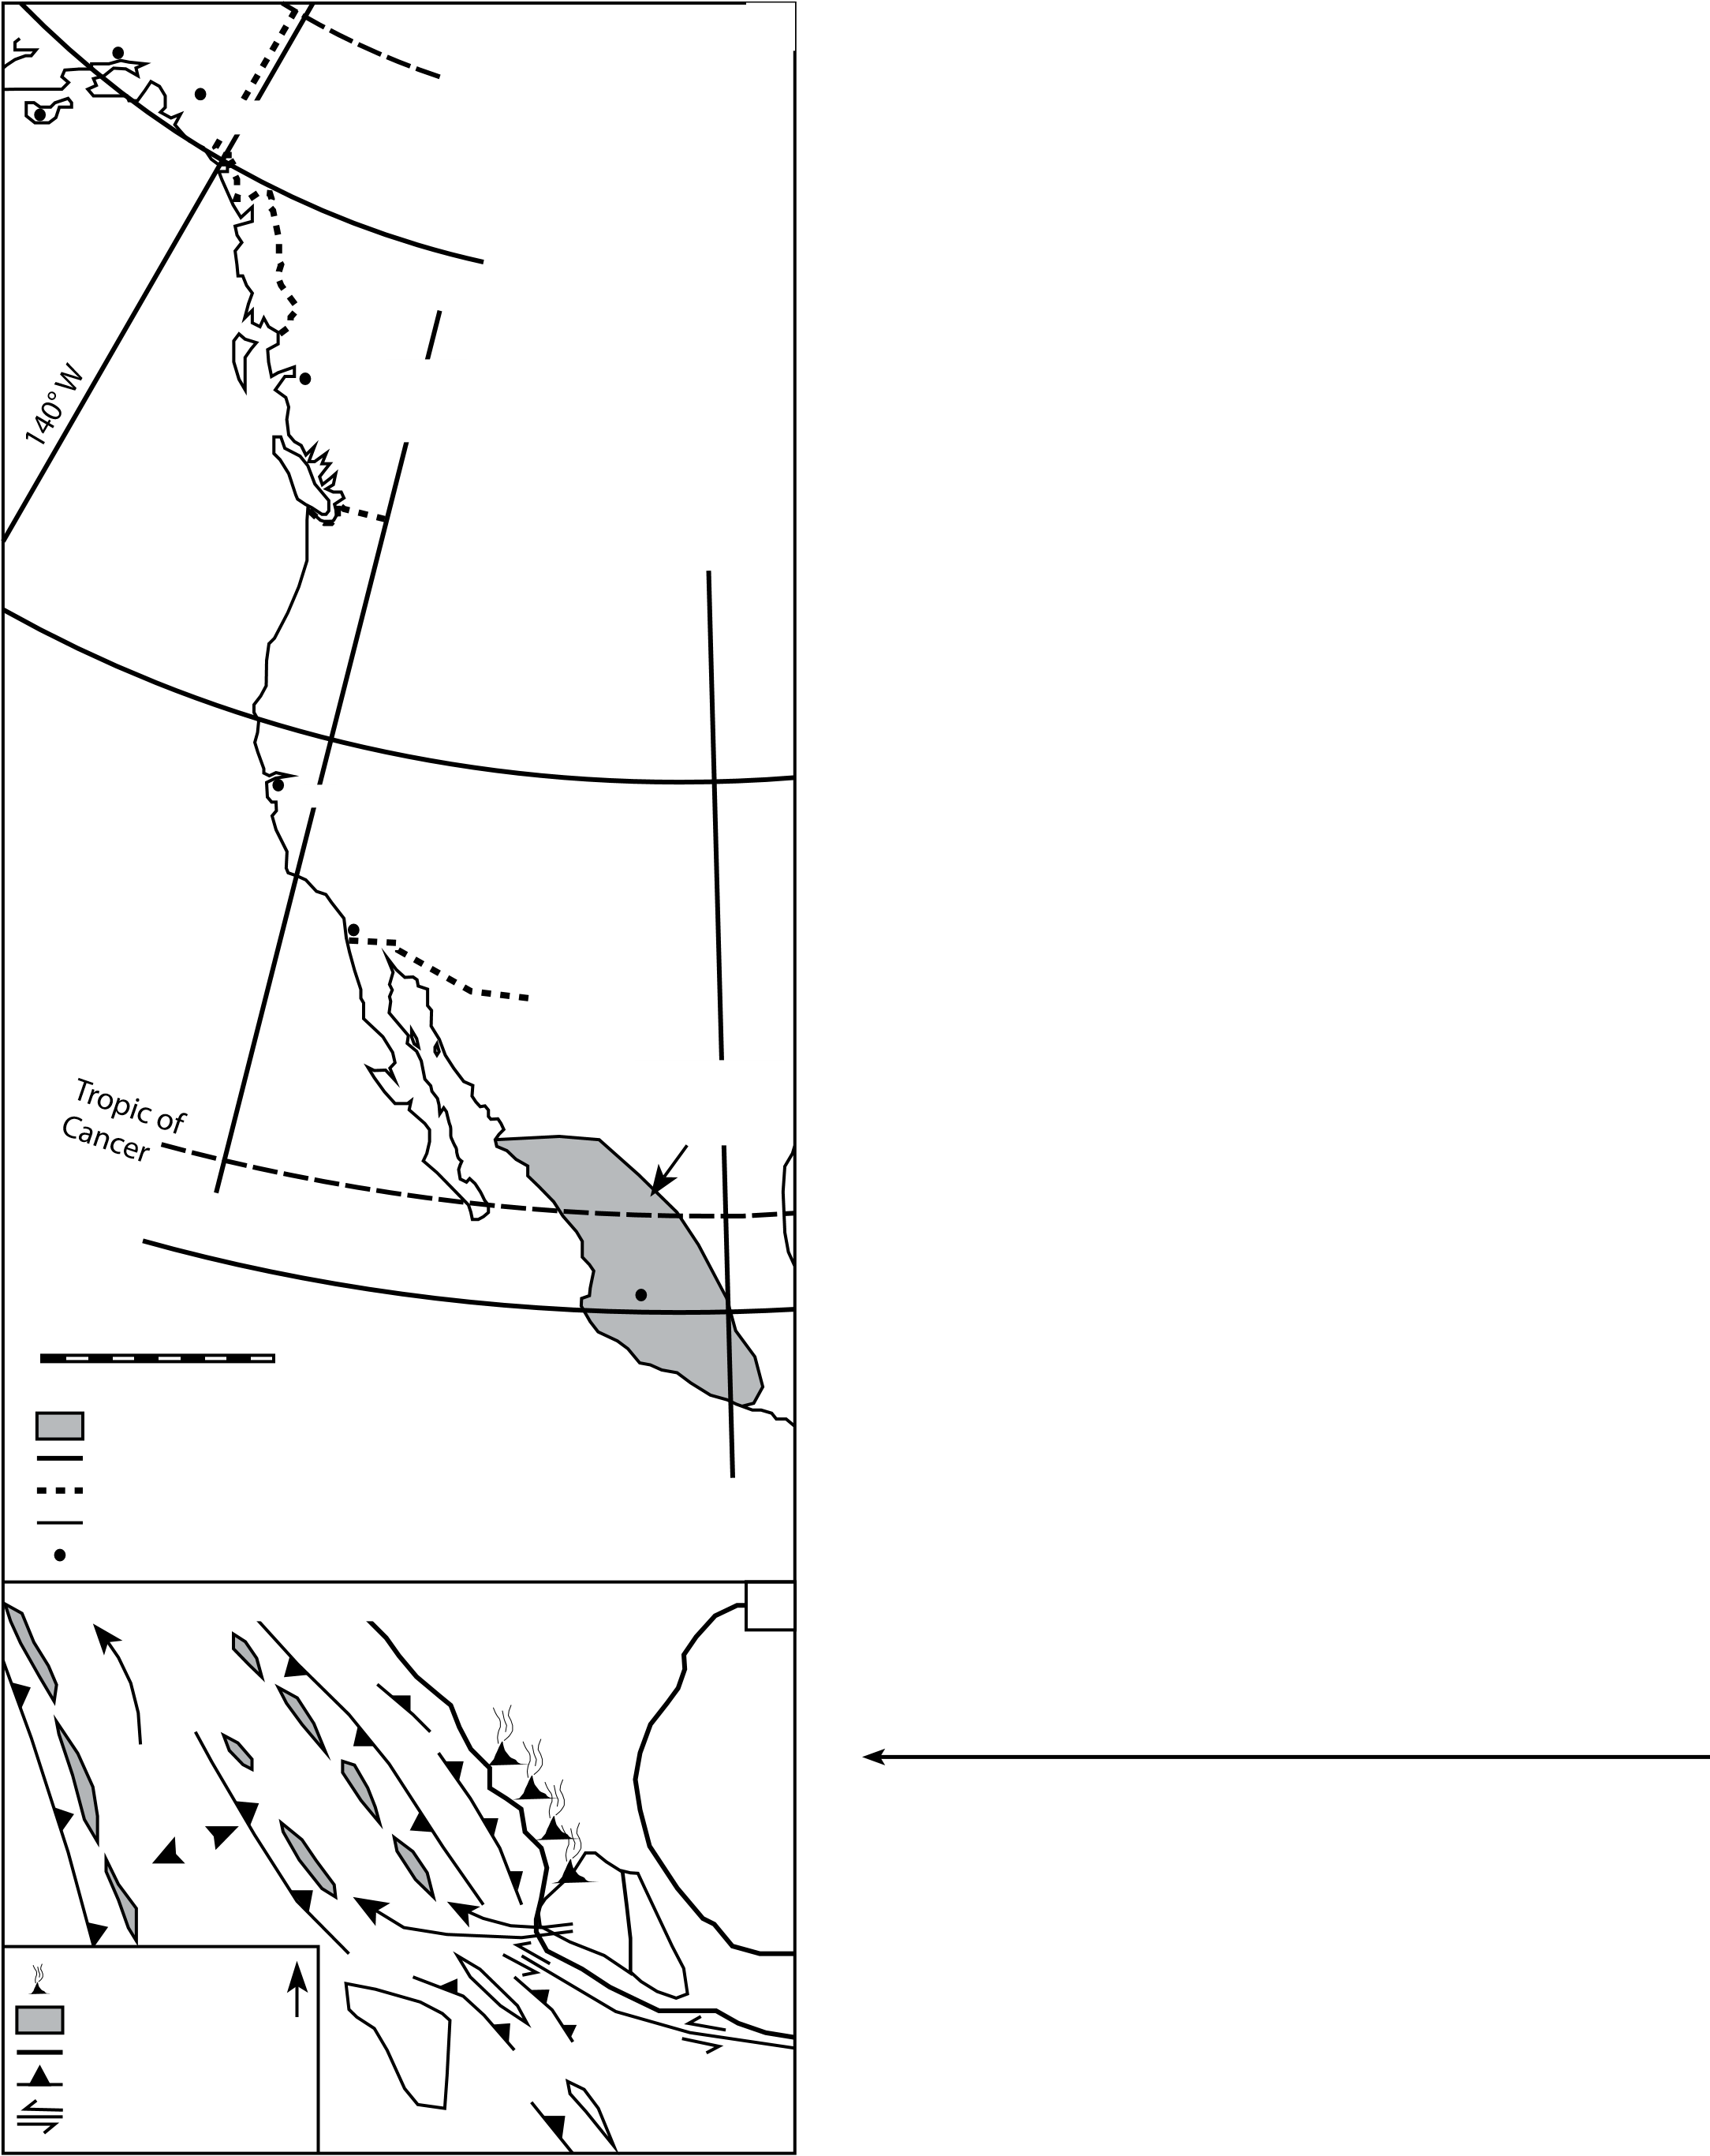**Figure 6. (A) Illustration of the modern coastline of the northern Cordillera presented to show the relative locations of the Liberty Creek schist, Firvale suite of Bella Coola, British Columbia (BC), and the Guerrero terrane of central Mexico. Landmarks and major cities are provided for reference. (B) Early Cretaceous paleogeographic model of the arc successions of the Guerrero and western Mixteca terranes of western Mexico. This model illustrates how the arcs that make up the Guerrero terrane could have deposited zircons to a trench, which became the source of the Liberty Creek schist, with minimal input of detrital zircons from the craton. Ac—Acatlán; Al—Alisitos; Ar—Arcelia; Ch—Chortis block; LCs—Liberty Creek schist; Ox—Oaxaca; Te— Teloloapan; Tx—Taxco–Taxco Viejo; Zi—Zihuatanejo. Gray pattern indicates Guerrero terrane arcs. Figure is modified from Talavera-Mendoza et al. (2007).**

rocks on the Kodiak Islands, the Seldovia schist, and the Iceberg Lake schist (Fig. 1A). The second blueschist-facies preservation event produced the Liberty Creek schist after ca. 136 Ma and probably before the

123–107 Ma K/Ar whole-rock ages from the Liberty Creek schist. The Hubbard Glacier schist and Chichagof Island schist were probably produced during this second blueschist-facies preservation event, but further

work is needed on all of the eastern blueschist-facies terranes (Fig. 1A). A two-dimensional perpendicular subduction margin accretionary model cannot account for the present distribution of subduction assemblages in the central Chugach Mountains. The presence of a younger accretionary assemblage, the Liberty Creek schist, inboard of an older assemblage, the Potter Creek assemblage, points to a three-dimensional process including the well-known record of forearc strike-slip within the system (Fig. 1B). The unusual detrital zircon signature of the Liberty Creek schist with a predominance of 140–130 Ma zircons points to a sedimentary source that is atypical of the northern Cordillera but consistent with a more southerly Cordilleran source, particularly the Guerrero terrane of

western Mexico (Figs. 2, 6A, and 6B). Thus, future work should address far-traveled scenarios for the Wrangellia composite terrane and other southern Alaskan terranes.

**ACKNOWLEDGMENTS**

This work was funded by National Science Foundation grants EAR-0809608 to Amato and

EAR-0809609 to Pavlis. G. Gehrels and M. Pecha helped acquire detrital zircon data at the

Arizona LaserChron Center supported by grant EAR-0443387. C. Worthman and A. Labrado assisted with sample collection, preparation, and analysis.

**REFERENCES CITED**

Amato, J.M., and Pavlis, T.L., 2010, Detrital zircon ages from the Chugach terrane, southern

Alaska, reveal multiple episodes of accretion and erosion in a subduction complex: Geology, v. 38, p. 459–462, doi:1 0.1130 / G30719.1.

Amato, J.M., Pavlis, T.L., Clift, P.D., Kochelek, E.J., Hecker, J.P., Worthman, C.M., and Day, E.M., 2013, Architecture of the Chugach accretionary complex as revealed by detrital zircon ages and lithologic variations: Evidence for Mesozoic subduction erosion in south-central Alaska: Geological Society of America Bulletin, v. 125, p. 1891–1911, doi:1 0.1130 / B30818.1.

Armstrong, R.L., 1988, Mesozoic and early Cenozoic magmatic evolution of the Canadian Cordillera, *in* Clark, S.P., et al., eds., Processes in Continental Lithospheric Deformation: Geological Society of America Special Paper 218, p. 55–91.

Baldwin, S.L., and Harrison, M.T., 1989, Geochronology of blueschists from west-central Baja California and the timing of uplift in subduction complexes: The Journal of Geology, v. 97, p. 149–163, doi: 10 .1086 /629291.

Beranek, L.P., van Staal, C.R., McClelland, W.C., Joyce, N., and Israel, S., 2014, Late Paleozoic assembly of the Alexander-Wrangellia-Peninsular composite terrane, Canadian and Alaskan Cordillera: Geological Society of America Bulletin, v. 126, p. 1531–1550, doi:1 0.1130 / 31066.1.

Bradley, D.C., Kusky, T.M., Haeussler, P.J., Karl, S.M., and Donley, D.T., 1999, Geologic Map of the Seldovia Quadrangle, South-Central Alaska: U.S. Geological Survey Open-File Report 99–18, scale 1:250,000, 1 sheet.

Brown, E.H., and Gehrels, G.E., 2007, Detrital zircon constraints on terrane ages and affinities and timing of orogenic events in the San Juan Islands and North Cascades, Washington: Canadian Journal of Earth Sciences, v. 44, p. 1375–1396, doi: 10. 1139/E07 -040.

Burns, L.E., 1985, The Border Ranges ultramafic and mafic complex, south-central Alaska: Cumulate fractionates of island-arc volcanics: Canadian Journal of Earth Sciences, v. 22, p. 1020–1038, doi: 10 .1139 /e85 -106.

Carden, J.R., Connelly, W., Forbes, R.B., and Turner, D.L., 1977, Blueschists of the Kodiak Islands, Alaska: An extension of the Seldovia schist terrane: Geology, v. 5, p. 529–533, doi: 10 .1130 /0091 -7613 (1977)5 <529: BOTKIA>2 .0 .CO;2.

Clift, P.D., Pavlis, T., DeBari, S.M., Draut, A.E., Rioux, M., and Kelemen, P.B., 2005, Subduction erosion of the Jurassic Talkeetna-Bonanza arc and the Mesozoic accretionary tectonics of western North America: Geology, v. 33, p. 881–884, doi:1 0.1130 / G21822.1.

Coney, P.J., Jones, D.L., and Monger, J.W.H., 1980, Cordilleran suspect terranes: Nature, v. 288,

p. 329–333, doi: 10 .1038 /288329a0.

Cowan, D.S., Brandon, M.T., and Garver, J.I., 1997, Geologic tests of hypotheses for large coastwise displacements—A critique illustrated by the Baja British Columbia controversy: American Journal of Science, v. 297, p. 117–173, doi: 10. 2475 /ajs .297 .2 .117.

Day, E.M., 2014, Structural and Geochronologic History of Southern Alaskan Blueschists [Ph.D. thesis]: El Paso, Texas, The University of Texas at El Paso, 90 p.

DeBari, S.M., and Coleman, R.G., 1989, Examination of the deep levels of an island arc; evidence from the Tonsina ultramafic-mafic assemblage, Tonsina, Alaska: Journal of Geophysical Research, v. 94, p. 4373–4391, doi: 10. 1029/JB094iB04p04373.

Decker, J., 1980, Geology of a Cretaceous Subduction Complex, Western Chichagof Island, Southeastern Alaska [Ph.D. thesis]: Stanford, California, Stanford University, 135 p.

Dodds, C.J., and Campbell, R.B., 1988, Potassium-Argon Ages of Mainly Intrusive Rocks in the Saint Elias Mountains, Yukon and British Columbia: Geological Survey of Canada Paper 87–16, 43 p.

Dumitru, T.A., Wakabayashi, J., Wright, J.E., and Wooden, J.L., 2010, Early Cretaceous transition from nonaccretionary behavior to strongly accretionary behavior within the Franciscan subduction complex: Tectonics, v. 29, p. TC5001, doi:1 0.1029 / 2009TC002542.

Enkelmann, E., Zeitler, P.K., Garver, J.I., Pavlis, T.L., and Hooks, B.P., 2010, The thermochronological record of tectonic and surface process interaction at the Yakutat–North American collision zone in southeast Alaska: American Journal of Science, v. 310, p. 231–260, doi: 10 .2475 /04 .2010 .01.

Forbes, R.B., Carden, J.R., Turner, D.C., and Connelly, W., 1979, Regional tectonic implications of Alaskan blueschist terranes, *in* Sisson, A., ed., The Relationship of Plate Tectonics to Alaskan Geology and Resources: Anchorage, Alaska Geological Society, p. L1–L28.

Garver, J.I., and Davidson, C.M., 2015, Southwestern Laurentian zircons in Upper Cretaceous flysch of the Chugach–Prince William terrane in Alaska: American Journal of Science, v. 315, p. 537–556, doi: 10 .2475 /06 .2015 .02.

Gehrels, G.E., Valencia, V., and Ruiz, J., 2008, Enhanced precision, accuracy, efficiency, and spatial resolution of U-Pb ages by laser ablation–multicollector–inductively coupled Plasma–mass spectrometry: Geochemistry, Geophysics, Geosystems (Gcubed), v. 9, p.Q03017, doi: 10 .1029 /2007GC001805.

Gehrels, G., Rusmore, M., Woodsworth, G., Crawford, M., Andronicos, C., Hollister, L., Patchett, J., Ducea, M., Butler, R., Klepeis, K., and Davidson, C., 2009, U-Th-Pb geochronology of the Coast Mountains batholith in north-coastal British Columbia: Constraints on age and tectonic evolution. Geological Society of America Bulletin, v. 121, p. 1341–1361, doi: 10 .1130 /B26404 .1.

Hacker, B.R., Mehl, L., Kelemen, P.B., Rioux, M., Behn, M.D., and Luffi, P., 2008, Reconstruction of the Talkeetna intraoceanic arc of Alaska through thermobarometry: Journal of Geophysical Research, v. 113, p. B03204, doi:1 0.1029 / 2007JB005208.

Hampton, B.A., Ridgway, K.D., O’Neill, J.M., Gehrels, G.E., Schmidt, J., and Blodgett, R.B.,

2007, Pre-, syn-, and postcollisional stratigraphic framework and provenance of Upper

Triassic–Upper Cretaceous strata in the northwestern Talkeetna Mountains, Alaska, *in*

Ridgway, K.D., Trop, J.M., Glen, J.M.G., and O’Neill, J.M., eds., Tectonic Growth of a Collisional Continental Margin: Crustal Evolution of Southern Alaska: Geological Society of America Special Paper 431, p. 401–438.

Hildebrand, Robert S., 2015, Dismemberment and northward migration of the Cordilleran orogen: Baja-BC resolved: GSA Today, v. 25, doi: 10.1130 / GSATG255A.1.

Hudson, T., 1983, Calc-alkaline plutonism along the Pacific rim of southern Alaska, *in* Roddick, J.A., ed., Circum-Pacific Plutonic Terranes: Geological Society of America Memoir 159, p. 159–169.

Irving, E., Wynne, P.J., Thorkelson, D.J., and Schiarizza, P., 1996, Large (1000 to 4000 km) northward movements of tectonic domains in the northern Cordillera, 83 to 45 Ma: Journal of Geophysical Research–Solid Earth, v. 101, p. 17,901–17,916, doi:1 0 .1029 /96JB01181.

Israel, S., Beranek, L., Friedman, R.M., and Crowley, J.L., 2014, New ties between the Alexander terrane and Wrangellia and implications for North America Cordilleran evolution: Lithosphere, v. 6, p. 270–276, doi:1 0.1130 / L364 .1.

Johnston, S.T., 2001, The Great Alaskan terrane wreck: Reconciliation of paleomagnetic and geological data in the northern Cordillera: Earth and Planetary Science Letters, v. 193, p. 259–272, doi: 10 .1016 /S0012 -821X (01)00516 -7.

Kapp, P., Yin, A., Manning, C.E., Harrison, T.M., and Taylor, M.H., 2003, Tectonic evolution of the early Mesozoic blueschist-bearing Qiangtang metamorphic belt, central Tibet: Tectonics, v. 22, p. 1043–1068, doi:1 0.1029 / 2002TC001383.

Kochelek, E.J., Amato, J.M., Pavlis, T.L., and Clift, P.D., 2011, Flysch deposition and preservation of coherent bedding in an accretionary complex; detrital zircon ages from the Upper Cretaceous Valdez Group, Chugach terrane, Alaska: Lithosphere, v. 3, p. 265–274, doi: 10 .1130 /L131 .1.

Lanphere, M.A., 1978, Displacement history of the Denali fault system, Alaska and Canada: Canadian Journal of Earth Sciences, v. 15, p. 817–822, doi: 10. 1139/e78 -086.

López-Carmona, A., Kusky, T.M., Santosh, M., and Abati, J., 2011, *P*-*T* and structural constraints of lawsonite and epidote blueschists from Liberty Creek and Seldovia: Tectonic implications for early stages of subduction along the southern Alaska convergent margin: Lithos, v. 121, p. 100–116, doi: 10 .1016 /j .lithos .2010 .10 .007.

Lowey, G.W., 1998, A new estimate of the amount of displacement on the Denali fault system based on the occurrence of carbonate megaboulders in the Dezadeash Formation (JuraCretaceous), Yukon, and the Nutzotin Mountains sequence (Jura-Cretaceous), Alaska: Bulletin of Canadian Petroleum Geology, v. 46, p. 379–386.

Ludwig, K. R., 2003, User’s manual for Isoplot 3.00: A geochronological toolkit for Microsoft Excel (No. 4).

MacKevett, E.M., and Plafker, G., 1974, The Border Ranges fault in south-central Alaska: Journal of Research of the U.S. Geological Survey, v. 2, no. 3, p. 323–329.

Mahoney, J.B., Gordee, S.M., Haggart, J.W., Friedman, R.M., Diakow, L.J., and Woodsworth,

G.J., 2009, Magmatic evolution of the eastern Coast Plutonic Complex, Bella Coola region, west-central British Columbia: Geological Society of America Bulletin, v. 121, p. 1362– 1380, doi: 10 .1130 /B26325 .1.

Metz, P.A., 1976, Occurrences of sodic amphibole-bearing rocks in the Valdez C-2 quadrangle, *in* Short notes on Alaskan geology - 1976: Alaska Division of Geological & Geophysical Surveys Geologic Report 51G, p. 27–29, doi:1 0.14509/ 386.

Nokleberg, W.J., Plafker, G., Lull, J.S., Wallace, W.K., and Winkler, G.R., 1989, Structural analysis of the Southern Peninsular, Southern Wrangellia, and Northern Chugach Terranes Along the Trans-Alaska Crustal Transect, Northern Chugach Mountains, Alaska: Journal of Geophysical Research: Solid Earth, v. 94, p. 4297–4320.

Oldow, J.S., Bally, A.W., Avé Lallemant, H.G., and Leeman, W.P., 1989, Phanerozoic evolution of the North American Cordillera; United States and Canada, *in* The Geology of North America: An Overview: Boulder, Colorado, Geological Society of America, Geology of North America, v. A, p. 139–232.

Pavlis, T.L., and Roeske, S.M., 2007, The Border Ranges fault system, southern Alaska, *in*

Ridgway, K.D., et al., eds., Tectonic Growth of a Collisional Continental Margin: Crustal Evolution of Southern Alaska: Geological Society of America Special Paper 431, p. 95–127.

Plafker, G., Nokleberg, W.J., and Lull, J.S., 1989, Bedrock geology and tectonic evolution of the Wrangellia, Peninsular, and Chugach terranes along the Trans-Alaska crustal transect in the Chugach Mountains and southern Copper River basin, Alaska: Journal of Geophysical Research, v. 94, p. 4255–4295, doi: 10. 1029/JB094iB04p04255.

Plafker, G., Moore, J.C., and Winkler, G.R., 1994, Geology of the southern Alaska margin, *in*

Plafker, G., and Berg, H.C., eds., The Geology of Alaska: Boulder, Colorado, Geological Society of America, Geology of North America, v. G-1, p. 389–449.

Rioux, M., Hacker, B., Mattinson, J., Kelemen, P., Blusztajn, J., and Gehrels, G., 2007, Magmatic development of an intra-oceanic arc: High-precision U-Pb zircon and whole-rock isotopic analyses from the accreted Talkeetna arc, south-central Alaska: Geological Society of America Bulletin, v. 119, p. 1168–1184, doi:1 0.1130 / B25964 .1.

Rioux, M., Mattinson, J., Hacker, B., Kelemen, P., Blusztajn, J., Hanghøj, K., and Gehrels, G., 2010, Intermediate to felsic middle crust in the accreted Talkeetna arc, the Alaska Peninsula and Kodiak Island, Alaska: An analogue for low-velocity middle crust in modern arcs: Tectonics, v. 29, TC3001, doi: 10 .1029 /2009TC002541.

Roeske, S.M., 1986, Field relations and metamorphism of the Raspberry Schist, Kodiak Islands, Alaska, *in* Evans, B.W., and Brown, E.H., eds., Blueschists and Eclogites: Geological Society of America Memoir 164, p. 169–184, doi:1 0.1130 / MEM164-p169.

Roeske, S.M., Mattinson, J.M., and Armstrong, R.L., 1989, Isotopic ages of glaucophane schists on the Kodiak Islands, southern Alaska, and their implications for the Mesozoic tectonic history of the Border Ranges fault system: Geological Society of America Bulletin, v. 101, p. 1021–1037, doi: 10. 1130 /0016 -7606 (1989)101 <1021: IAOGSO>2 .3 .CO;2.

Roeske, S.M., Snee, L.W., and Pavlis, T.L., 2003, Dextral-slip reactivation of an arc-forearc boundary during Late Cretaceous–early Eocene oblique convergence in the northern Cordillera, *in* Sisson, V.B., et al., eds., Geology of a Transpressional Orogen Developed during Ridge-Trench Interaction along the North Pacific Margin: Geological Society of America Special Paper 371, p. 141–169.

Rubin, C.M., and Saleeby, J.B., 1992, Tectonic history of the eastern edge of the Alexander terrane, southeast Alaska: Tectonics, v. 11, p. 586–602, doi:1 0.1029 / 91TC02182.

Rusmore, M.E., Bogue, S.W., and Woodsworth, G.J., 2013, Paleogeography of the Insular and Intermontane terranes reconsidered: Evidence from the southern Coast Mountains Batholith, British Columbia: Lithosphere, v. 5, p. 521–536, doi: 10. 1130/L288 .1.

Shaw, J., and Johnston, T.J., 2016, Terrane wrecks (coupled oroclines) and paleomagnetic inclination anomalies: Earth-Science Reviews, v. 154, p. 191–209, doi:1 0.1016 / j.earscirev. 2016 .01. 003.

Sisson, V.B., and Onstott, T.C., 1986, Dating blueschist metamorphism: A combined 40Ar/39Ar and electron microprobe approach: Geochimica et Cosmochimica Acta, v. 50, p. 2111–2117, doi: 10 .1016 /0016 -7037 (86)90264 -4.

Sisson, V.B., Hollister, L.S., and Onstott, T.C., 1989, Petrologic and age constraints on the origin of a low-pressure/high-temperature metamorphic complex, southern Alaska: Journal of Geophysical Research–Solid Earth, v. 94, p. 4392–4410, doi: 10. 1029/JB094iB04p04392.

Snow, C.A., Wakabayashi, J., Ernst, W.G., and Wooden, J.L., 2010, Detrital zircon evidence for progressive underthrusting in Franciscan metagraywackes, west-central California:

Geological Society of America Bulletin, v. 122, p. 282–291.

Stamatakos, J.A., Trop, J.M., and Ridgway, K.D., 2001, Late Cretaceous paleogeography of Wrangellia: Paleomagnetism of the MacColl Ridge Formation, southern Alaska, revisited: Geology, v. 29, p. 947–950, doi:10. 1130 /0091- 7613 (2001)029< 0947: LCPOWP>2. 0 .CO;2.

Talavera-Mendoza, O., Ruiz, J., Gehrels, G.E., Valencia, V.A., and Centeno-García, E., 2007, Detrital zircon U/Pb geochronology of southern Guerrero and western Mixteca arc successions (southern Mexico): New insights for the tectonic evolution of southwestern North America during the late Mesozoic: Geological Society of America Bulletin, v. 119, p. 1052–1065, doi: 10 .1130 /B26016 .1.

Trop, J.M., Ridgway, K.D., Manuszak, J.D., and Layer, P., 2002, Mesozoic sedimentary-basin development on the allochthonous Wrangellia composite terrane, Wrangell Mountains basin, Alaska: A long-term record of terrane migration and arc construction: Geological Society of America Bulletin, v. 114, p. 693–717, doi: 10. 1130/0016 -7606( 2002)114 <0693: MSBDOT>2 .0 .CO;2.

Trop, J.M., Szuch, D.A., Rioux, M., and Blodgett, R.B., 2005, Sedimentology and provenance of the Upper Jurassic Naknek Formation, Talkeetna Mountains, Alaska: Bearings on the accretionary tectonic history of the Wrangellia composite terrane: Geological Society of America Bulletin, v. 117, p. 570–588, doi:1 0.1130 / B25575.1.

Umhoefer, P.J., 2003, A model for the North America Cordillera in the Early Cretaceous:

Tectonic escape related to arc collision of the Guerrero terrane and a change in North

America plate motion, *in* Johnson, S.E., Paterson, S.R., Fletcher, J.M., Girty, G.H., Kimbrough, D.L., and Martin-Barajas, A., eds., Tectonic Evolution of Northwestern Mexico and the Southwestern USA: Geological Society of America Special Paper 374, p. 117–134.

Willner, G.A., and Massonne, H.J., 2008, History of crustal growth and recycling at the Pacific convergent margin of South America at latitudes 29°-36°S revealed by a U-Pb and Lu-Hf isotope study of detrital zircon from late Paleozoic accretionary systems: Chemical Geology, v. 253, p. 114–129, doi: 10 .1016 /j .chemgeo .2008 .04 .016.

Winkler, G.R., Silberman, M.L., Grantz, A., Miller, R.J., and MacKevett, E.M., Jr., 1981a, Geologic Map and Summary Geochronology of the Valdez Quadrangle, Southern Alaska, U.S. Geological Survey Open-File Report 80–892-A, scale 1:250,000, 1 sheet.

Winkler, G.R., Miller, R.J., and Case, J.E., 1981b, Blocks and belts of blueschist and greenschist in the northwestern Valdez quadrangle, *in* Albert, N.R.D., and Hudson, Travis, eds., The United States Geological Survey in Alaska: Accomplishments during 1979: U.S. Geological Survey Circular 823-B, p. B72–B73.

Zhu, W., Zheng, B., Shu, L., Ma, D., Wu, H., Li, Y., Huang, W., and Yu, J., 2011, Neoproterozoic tectonic evolution of the Precambrian Aksu blueschist terrane northwestern Tarim, China: Insights from LA-ICP-MS zircon U-Pb ages and geochemical data: Precambrian Research, v. 185, p. 215–230, doi: 10 .1016 /j .precamres .2011 .01 .012.

MANUSCRIPT RECEIVED 8 FEBRUARY 2016

REVISED MANUSCRIPT RECEIVED 8 JUNE 2016 MANUSCRIPT ACCEPTED 30 JUNE 2016

Printed in the USA

1. [GSA Data Repository Item 2016224, full U-Pb data set, Tera-Wasserburg concordia plots for each sample, and weighted mean age plots for each sample, is available at www.geosociety.org/pubs/ft2016.htm, or on request from editing@geosociety.org.](ftp://rock.geosociety.org/pub/reposit/2016/2016224.pdf)