Journal of the Geological Society, London, Vol. 161, 2004, pp. 463–476. Printed in Great Britain.

Provenance constraints from detrital zircon U–Pb ages in the NW Iberian Massif:

implications for Palaeozoic plate configuration and Variscan evolution

JOSE´ R. MARTI´NEZ CATALA´ N1, JAVIER FERNA´ NDEZ-SUA´ REZ2, GEORGE A. JENNER3,

ELENA BELOUSOVA4 & ALEJANDRO DI´EZ MONTES5

1Departamento de Geologı´a, Universidad de Salamanca, 37008 Salamanca, Spain (e-mail: jrmc@usal.es)

2Departamento de Petrologı´a y Geoquı´mica, Universidad Complutense, 28040 Madrid, Spain

3Department of Earth Sciences, Memorial University of Newfoundland, St. John’s NF, A1B 3X5, Canada

4GEMOC, Department of Earth and Planetary Sciences, Macquarie University, Sydney, N.S.W. 2109 Australia

5Instituto Geolo´gico y Minero de Espan˜a, Parque Cientı´fico de Leo´n, Av. Real 1, Edificio 1, 24006 Leo´n, Spain

Abstract: Detrital zircons from pre-orogenic Upper Ordovician to Devonian low-grade metasedimentary rocks have been dated by laser ablation–inductively coupled plasma mass spectrometry (LA–ICP-MS) to: (1) constrain the variations of zircon age populations within the autochthonous sequences of NW Iberia; (2) compare U–Pb detrital zircon ages with previous data; (3) test the hypothesis of the Armorica microplate as a peri-Gondwanan terrane separated from Gondwana. The similarity in the ages of detrital zircons found in the Palaeozoic samples studied here to those published for the Upper Proterozoic, Lower Cambrian and Lower Ordovician sediments of NW Iberia argues against the separation of Armorica, and points to a common source area for all of the Palaeozoic detrital formations of NW Iberia, the West African craton and the surrounding Pan-African belts. LA–ICP-MS U–Pb dating of zircons from a synorogenic flysch preserved in klippen in the core of a syncline establishes a maximum depositional age for this deposit as Early Namurian. This age is also a maximum age limit for thrusting and refolding in this part of the Iberian Massif. Correlation of the zircon age populations with published ages confirms the link between the emplacement of the allochthonous complexes of NW Iberia and synorogenic sedimentation.

Keywords: Armorica, Iberian Massif, U–Pb, flysch, zircons.

Palaeomagnetic investigations on the position of the Variscan belt of central and western Europe during the Palaeozoic led to the formulation of the Armorica microplate hypothesis in the early 1980s. The existence of Armorica as a separate microplate was proposed by Van der Voo (1982, 1988) to account for the similar apparent polar wander paths for the Armorican Massif and Gondwana until the Cambrian, but a difference in latitude of 30–408 during the Devonian (Van der Voo 1979, 1982, 1988; Perroud et al. 1984). Armorica (Fig. 1) would have been composed of the Armorican and Iberian Massifs with (according to Van der Voo 1988, 1993) or without (according to Perroud et al. 1984; Cocks, 2000) the Bohemian Massif and, according to these workers, it would have drifted away from Gondwana during the Ordovician, colliding with Laurentia in the Mid-Devonian, before the large continental masses did so to form Pangaea.

The palaeomagnetic data on which this hypothesis relies were questioned by Kent et al. (1984), Scotese (1984) and Hargraves et al. (1987), who reported a much higher latitude for Gondwana during the Devonian. Although new data were used to support the existence of an Armorica microplate (Tait et al. 1997; Tait 1999), these data constrain the relative position of the Bohemian and Armorican Massifs relative to Baltica, not to Gondwana. Recent reconstructions by Scotese & McKerrow (1990) and Scotese (2002) place Gondwana close to Laurentia and Baltica by the Early Devonian (Fig. 1a).

Bonhommet & Perroud (1986), Paris & Robardet (1990) and Robardet et al. (1990) presented arguments against a significant separation of Armorica from Gondwana, based on sedimentary and faunal evidence indicating that the palaeogeographical affinities between southern Europe and northern Africa persisted

463

during the Silurian and Devonian. Furthermore, the suture between the hypothetical Armorica plate and Gondwana has not been found, putting in doubt the existence of a Proto-Tethys Ocean (Fig. 1b). Robardet (2002, 2003) reviewed the existing models for the Variscan belt in SW Europe and concluded that only those involving a single Rheic Ocean between Gondwana and Laurentia are realistic on the basis of palaeogeographical analysis (Fig. 1a). The closure of this ocean and the subsequent collision between both continental masses has been registered in the structures, metamorphism and synorogenic sedimentation of the Variscan belt.

In addition to palaeomagnetism, stratigraphic correlation and faunal studies, U–Pb dating of detrital zircons in unmetamorphosed or low-grade metasedimentary rocks offers tight constraints on source areas of detrital deposits, and is now firmly established as a powerful tectonic tracer in palaeogeographical reconstructions. This approach has been applied by Ferna´ndezSua´rez and coworkers in the Ibero-Armorican arc, to constrain the palaeoposition of Iberia and Brittany in the Neoproterozoic; those workers found that different zones within those Variscan realms occupied different positions at that time (Ferna´ndezSua´rez et al. 2000b, 2002c; Gutie´rrez-Alonso et al. 2003). Early Palaeozoic sediments and volcanic rocks have also been investigated in NW Iberia; namely, the Lower Cambrian and Lower Ordovician quartzites, and the volcaniclastic part of the Ollo de Sapo Formation (Ferna´ndez-Sua´rez et al. 1999, 2000b, 2002b). These data have helped to constrain the time of amalgamation of the Neoproterozoic terranes to Gondwana, and the source areas of the lower part of the Palaeozoic sedimentary pile, and have confirmed the Early Ordovician age of the Ollo

|  |
| --- |
| Fig. 1. (a) Reconstruction of the continental masses (light grey) at the limit between Early and Mid-Devonian, after Scotese (2002), showing the possible position of Iberia and the Armorican and Bohemian Massifs (AM and BM) in northern Gondwana, the Rheic Ocean separating them from Laurentia– Baltica, and the outcropping basement of the West African craton (area with crosses), supposed to have been, together with the surrounding Pan-African belts, the main supply area of detritus for the pre-orogenic autochthonous sequences. (b) Same as (a), but with Gondwana in the position preferred by Tait  (1999) and based on the apparent polar wander path of Bachtadse & Briden (1991). It should be noted that this reconstruction implies the existence of a Proto-Tethys ocean between Armorica and Gondwana. Only this and similar reconstructions, with Gondwana at a high southern latitude during the |

Devonian, support the Armorica microplate hypothesis.

de Sapo Formation (Gebauer 1993; Valverde Vaquero &

Dunning, 2000).

This study focuses on the use of U–Pb ages of detrital zircons to test and constrain the existing palaeotectonic models for the Variscan belt. Ferna´ndez-Sua´rez et al. (1999, 2000b, 2002b) have shown that the zircon age populations of Lower Cambrian and Lower Ordovician sedimentary rocks in Iberia are similar to those of Neoproterozoic sedimentary rocks, which suggest the same source area, the West African craton and the surrounding Pan-African belts (Ferna´ndez-Sua´rez et al. 2002c). This is consistent with the assertion of Noblet & Lefort (1990) that, although accepting the Armorica microplate hypothesis, pointed out that the time of the alleged drift of Armorica was unconstrained by palaeomagnetism. They suggested that this drift did not take place until after the Arenig, the time of deposition of the Armorican Quartzite. Their assertion was based on the large volume of clastic material transported and the consistent current directions, indicating that the sediment source was to the south of the present-day Sahara.

If the drift of Armorica took place either later in the Ordovician or during the Silurian, the source area could no longer have been the West African craton and surrounding areas, and different age clustering should be expected for detrital zircon ages. Extending the investigation of zircon age populations to Upper Ordovician, Silurian and Devonian (pre-orogenic) metasedimentary rocks may shed new light on whether or not of Armorica existed as a microplate at any time in the early to midPalaeozoic.

Continental collision of Laurentia and Baltica with Gondwana started in NW Iberia probably during the Late Devonian (Dallmeyer et al. 1997; Mart´ınez Catala´n et al. 1997). Carboniferous sedimentation was essentially synorogenic and the source areas changed drastically from the emerged areas of the foreland to the relief created in the hinterland by the continuing orogenic shortening (Marcos & Pulgar 1982; Pe´rez-Estau´n et al. 1988; Rodr´ıguez Ferna´ndez 1993). U–Pb dating of detrital zircons in the synorogenic deposits may help to constrain the time of deformation by establishing maximum age limits for these deposits, which are poorly constrained in the internal zones of the Iberian Massif. Furthermore, the age populations can be compared with those of the pre-orogenic sequence to establish which units supplied the detritus, thus providing valuable information on the orogenic evolution.

# Geological setting

The Variscan belt of NW Iberia is characterized by four main groups of rocks: the autochthonous sequences, the allochthonous complexes, the Variscan granites and the synorogenic sediments preserved in the internal zones of the belt (Fig. 2). Brief descriptions and key references for the four groups are given below. together with relevant geochronological information for comparison with the U–Pb ages of detrital zircons reported in this paper.

# Autochthonous sequences

They are essentially metasedimentary, and consist of thick and monotonous Upper Proterozoic siliciclastic rocks (cut by a few intrusions), and of Palaeozoic clastic rocks, carbonates, and volcanic and intrusive rocks. It is generally agreed that the autochthonous sedimentary sequences were deposited in the northern margin of Gondwana.

During the Late Proterozoic, this area was an active continental margin (Murphy & Nance 1991; Ochsner 1993) involved in the Cadomian–Avalonian–Pan-African orogeny. Cadomian arc

|  |
| --- |
| Fig. 2. Geological sketch map and composite cross-section of the NW Iberian Massif showing the main groups of rocks and the overall structure. |

Location of Figure 3 is outlined.

construction activity was followed by continental rifting in Cambro-Ordovician times, which resulted in the drift of the Avalon microcontinent and other peri-Gondwanan terranes and the opening of the Rheic oceanic domain (Fortey & Cocks 1988; Soper 1988). Some palaeomagnetic data suggest that Iberia, together with the French Armorican Massif, also drifted away from Gondwana during the Ordovician and collided with Laurentia in the Early or Mid-Devonian, prior to the Laurentia– Gondwana collision. Nevertheless, stratigraphic and palaeogeographical data suggest a continuity between Iberia and Gondwana throughout the Palaeozoic and deposition of the autochthonous sequences on the Gondwanan continental margin (Paris & Robardet 1990; Ribeiro et al. 1990; Mart´ınez Catala´n et al. 1997). This margin seems to have been passive from the Cambrian to the Early Devonian, as suggested by the shallowwater platform character of most stratigraphic units, and also by the continuity in the sedimentation.

As regards geochronological constraints, the oldest ages obtained from upper intercepts and inherited zircons from Iberian orthogneisses of the autochthon range between 2.7 and 1.8 Ga (Lancelot et al. 1985; Gebauer 1993) and are similar to those of the West African craton (Bessoles 1977; Caby 1989), suggesting a link between the two areas. The crystallization ages of these orthogneisses range from 620 to 470 Ma (Lancelot et al. 1985; Allegret & Iglesias Ponce de Leo´n 1987; Vialette et al. 1987;

Gebauer 1993; Ochsner 1993; Ferna´ndez-Sua´rez et al. 1998; Valverde Vaquero & Dunning, 2000), and record the Cadomian orogeny and the Cambro-Ordovician continental rifting. U–Pb dating of detrital zircons from Upper Proterozoic sedimentary rocks in NW Iberia (Ferna´ndez-Sua´rez et al. 2000b) yielded four main age clusters: Archaean (2.8–2.5 Ga), Palaeoproterozoic (2– 1.8 Ga), Mesoproterozoic (1.2–0.9 Ga) and Neoproterozoic (800–640 Ma). U–Pb dating of detrital zircons from Lower Palaeozoic sequences gave roughly the same populations, plus a younger Neoproterozoic (620–550 Ma) population (Ferna´ndezSua´rez et al. 1999, 2000b, 2002b).

As regards the Variscan deformation, several 40Ar/39Ar wholerock and muscovite ages were obtained by Dallmeyer et al. (1997) in low-grade regional cleavages and thrust-related phyllonites of NW Spain. The first cleavage, associated with recumbent folding (D1), was dated between 360 and 335 Ma, whereas several ages for the subsequent thrusting (D2) range between 345 and 315 Ma.

# Allochthonous complexes

Five complexes crop out in synforms as megaklippen (Fig. 2). They consist of a stack of allochthonous units comprising fragments of a peri-Gondwanan terrane on top (upper units), several ophiolitic units in the middle, and pieces of the subducted and exhumed outermost margin of Gondwana at the base (basal units). The units were stacked in Early and Mid-Devonian time, during the first stages of the Variscan orogeny, and subsequently thrust over the autochthonous sequences during the Late Devonian–Carboniferous (Mart´ınez Catala´n et al. 1996; Dallmeyer et al. 1997), with an intervening thrust system, the parautochthon, which involves metasediments and volcanic rocks of Gondwanan affinity (Farias et al. 1987).

In the upper units, early Palaeozoic (500–480 Ma) U–Pb zircon ages obtained in metabasic rocks, orthogneisses and migmatites are interpreted as dating the igneous protoliths and related partial melting (Kuijper 1980; Peucat et al. 1990; Dallmeyer & Tucker 1993; Abati et al. 1999). Greywackes from low-grade metasediments of the uppermost unit in the Ordenes Complex have been investigated for detrital zircon ages, yielding three age populations of 2.5–2.4 Ga, 2.1–1.9 Ga and 610– 480 Ma (Ferna´ndez-Sua´rez et al. 2003). They record the major events in the African section of northern Gondwana, where no Mesoproterozoic events have been identified, and provide a maximum depositional age for this uppermost sedimentary unit at c. 480 Ma. The age of metamorphism is constrained in the upper units by U–Pb ages between 405 and 390 Ma, obtained on zircons, monazites, titanites and rutile of high-pressure and hightemperature units (Scha¨fer et al. 1993; Santos Zalduegui et al. 1996; Ordo´n˜ez Casado et al. 2001; Ferna´ndez-Sua´rez et al. 2002a). This Early Devonian metamorphic event was followed by a subsequent retrograde amphibolite-facies metamorphism at 390–380 Ma (Dallmeyer et al. 1991, 1997; Valverde Vaquero & Ferna´ndez 1996).

One of the ophiolitic units, dated by U–Pb on zircons, yielded an age of 395 Ma (D´ıaz Garcı´a et al. 1999; Pin et al. 2002), whereas amphibolite-facies metamorphism affected the ophiolites at 390–380 Ma (Dallmeyer et al. 1991, 1997; 40Ar/39Ar on hornblende concentrates), closely following oceanic crust generation. This age is that of the foliation related to ophiolite imbrication, and represents the closure of the Rheic Ocean or a marginal oceanic basin (D´ıaz Garcı´a et al. 1999; Pin et al. 2002).

In the basal units, granitic and peralkaline orthogneisses have yielded Rb–Sr whole-rock (Van Calsteren et al. 1979; Garc´ıa Garzo´n et al. 1981) and U–Pb zircon (Santos Zalduegui et al. 1995) ages of 480–460 Ma, the latter with an inherited component of 1.8 Ga. This magmatism reflects the Ordovician rifting (Ribeiro & Floor 1987; Pin et al. 1992), and is coeval with that found in the autochthon, suggesting that the basal units formed part of the northern Gondwana platform. These units represent the external edge of the continental margin that underwent subduction followed by thrusting and exhumation during the Variscan collision (Gil Ibarguchi & Ortega Girone´s 1985; Arenas et al. 1995; Mart´ınez Catala´n et al. 1996, 1997; Rubio Pascual et al. 2002). The age of subduction is constrained between the 390–380 Ma age of oceanic closure and the 374–365 Ma Rb–Sr ages of posteclogitic white micas (Van Calsteren et al. 1979; Santos Zalduegui et al. 1995). Subsequent high-temperature metamorphism, previous to thrusting, has been dated at c. 346 Ma by Abati & Dunning (2002; U–Pb in monazite and rutile).

The parautochthon (Ribeiro et al. 1990) or schistose domain (Farias et al. 1987) represents a relatively distal part of the Gondwanan continental margin, and consists of Ordovician to Devonian sedimentary sequences similar to those of the autochthon, and younger synorogenic flysch deposits (Pereira et al. 1999; Gonza´lez Clavijo & Mart´ınez Catala´n, 2002). Its has an imbricate structure, 3–7 km thick, formed during the D2 deformational event and the basal thrust truncates earlier recumbent D1 folds in the autochthon (Gonza´lez Clavijo 1997). Subsequently, open D3 antiforms and synforms affected the allochthonous complexes and the parautochthon, whereas tight folds developed in the autochthon together with a pervasive tectonic fabric (Alonso & Rodr´ıguez Ferna´ndez 1981). Dallmeyer et al. (1997) obtained an 40Ar/39Ar age of 340 Ma for the regional cleavage related to thrusting (Marqu´ınez Garcı´a 1984) in the parautochthon, and 316 and 313 Ma in greenschist-facies mylonites associated with the lower imbricates east of the Cabo Ortegal Complex and in the Ver´ın syncline, respectively (Fig. 2).

# Variscan granitoids

Granitoids are abundant in the Iberian Massif (Fig. 2), and result from melting of the continental crust thickened during the Variscan orogeny. Capdevila (1969), Capdevila & Floor (1970) and Capdevila et al. (1973) established the main types, which include a syntectonic biotite- (and hornblende-) rich metaluminous type, formed by melting of the lower crust with variable mantle participation, a two-mica, peraluminous type, also syntectonic and derived from melting of mid-crustal metasediments rich in hydrous phases, and a wide group of post-tectonic granitoids with compositions similar to those of the syntectonic groups. Scarce U–Pb ages of the syntectonic granitoids range between 350 and 310 Ma (Gallastegui 1993; Ferna´ndez-Sua´rez et al. 2000a), with the metaluminous massifs (tonalites, granodiorites and monzogranites) being generally older than the peraluminous granites. The post-tectonic intrusions range between 295 and 285 Ma (Ferna´ndez-Sua´rez et al. 2000a).

# Synorogenic sediments in the internal zones

Synorogenic sedimentation is well preserved in the two external zones of the Iberian Variscan belt, the South Portuguese and Cantabrian Zones, with ages ranging from Late Vise´an to Early Westphalian in the former (Oliveira 1990), and Namurian to Westphalian in the latter (Marcos & Pulgar 1982; Pe´rez-Estau´n et al. 1988).

In the internal zones, synorogenic flysch deposits are much less abundant and have been preserved in the Terena and Los Pedroches basins, in southern Iberia, and close to the Portuguese allochthonous complex of Braganc¸a, and in the core of the Sil syncline in the north. In all these occurrences, the deposits show a flyschoid and turbiditic character and include metamorphic pebbles of soft rocks, such as slates and schists, as well as plant debris. In Terena, their age is Early Carboniferous (Schermerhorn 1971) and includes Tournaisian–Vise´an fauna (Giese et al. 1994), although Early Devonian fauna and flora have been reported in Portugal (Pereira et al. 1998; Pic¸arra et al. 1998). In Los Pedroches, their age ranges from Late Tournaisian to Early Namurian (Mart´ınez Poyatos 2002).

To the east of the Braganc¸a complex (Fig. 2), the synorogenic flysch deposits are called the San Vitero Formation in the Alcan˜ices synform, in Spain (Mart´ınez Garcı´a 1972, 1973) and Gimonde Formation in Portugal (Meireles 2000a, b), and have been dated as Late Devonian by plant debris (Teixeira & Pais 1973) and palynomorphs (Pereira et al. 1999). They disconformably overlie the Silurian succession and are involved in the D2 imbricated thrust system separating the allochthonous complexes from the autochthon (Ribeiro & Ribeiro 1974; Antona &

Mart´ınez Catala´n 1990; Gonza´lez Clavijo 1997; Meireles 2000a, b; Gonza´lez Clavijo & Mart´ınez Catala´n, 2002). The last group of synorogenic outcrops, in the Sil syncline, forms part of the study area, and their characteristics are described in the next section.

# Geology of the Courel, Truchas and Sil synclines

The sampling area was chosen based on the presence of a continuous stratigraphic sequence from the Lower Ordovician to the Lower Devonian, the low-grade Variscan metamorphic overprint, the existence of synorogenic deposits and the relative proximity to the allochthonous complexes. The Courel, Truchas and Sil synclines (Fig. 3) are Variscan structures close to each other, but of different tectonic significance. The first is a D1 isoclinal recumbent fold delineated by the Armorican Quartzite, whose core is occupied by Silurian carbonaceous slates and Lower Devonian detrital sedimentary rocks and limestones (Drot & Matte 1967; Matte 1968). The Truchas syncline, to the SE, is a broad (.20 km) D1 synclinorium formed by many individual recumbent folds. It is also outlined by the Armorican Quartzite, and cored by Middle–Upper Ordovician and Silurian pre-orogenic deposits. The Courel and Truchas synclines are separated from each other by a D1 anticline, which is recumbent in the west (Piornal anticline) and becomes steep to the east (Teleno anticline). The Sil syncline occurs in the NW continuation of the Truchas syncline, but this is a narrower (6 km) D3 structure at whose core a synorogenic Carboniferous flysch, the San Clodio Formation, occurs. Figure 4 illustrates key stratigraphic columns, showing correlations among the synclines.

# Lower Ordovician–Lower Devonian stratigraphy

The succession starts with the Ollo de Sapo Formation, a Lower Ordovician thick volcanic and volcaniclastic sequence (Parga Pondal et al. 1964), and is followed by an alternation of pelites, sandstones and quartzites known as the Montes Slates (Riemer 1963), culminating in the Armorican Quartzite. This sequence, of Tremadoc–Arenig age (Matte 1968; Pe´rez-Estau´n 1978) is conformably overlain by dark grey to black metapelites of Llanvirn age (Gutie´rrez Marco et al. 1988), known as the Luarca Slates and, in the Truchas syncline, by the Casaio, Rozada´is and Losadilla Formations (Barros Lorenzo 1989), of Late Ordovician age (Caradoc–Ashgill; Pe´rez-Estau´n et al. 1990; Sarmiento et al. 1999) and consisting of slates, sandstones and quartzites. To the north, facies changes result in the three formations being replaced by the Aquiana Limestone, of Ashgill age (Sarmiento et al. 1999).

The Silurian succession begins locally with a quartzite, and mostly consists of grey and black carbonaceous slates and carbonaceous cherts (lydites). It rest comformably on the Ordovician sequence in the eastern part of the Truchas syncline and slightly unconformably elsewhere (Gutie´rrez Marco et al. 1988). The unconformity has been related to block faulting, related palaeorelief, and a south-to-north transgression (Mart´ınez Catala´n et al. 1992; Ra´bano et al. 1993; Sarmiento et al. 1999). In the Courel and Pen˜alba synclines, the Silurian sequence is conformably overlain by a Lower Devonian succession, the Seceda Formation, beginning with a thin quartzite layer followed by arenaceous slates containing brachiopods, grey crinoidal limestones and grey slates (Drot & Matte 1967).

# The synorogenic San Clodio Formation

Synorogenic turbidites consisting of pelites and greywackes, the San Clodio Formation, crop out along a NW–SE synformal structure in the Sil syncline (Fig. 3), a D3 structure refolding earlier folds (Matte 1968). Riemer (1966) decribed carbonaceous cherts at the base of the formation, reported thin coal veins, poorly preserved plant debris, and pebbles of quartzite, slate, gneiss and granite, and suggested a pre-Stephanian Carboniferous age, based on the fact that they were folded, but remarking that deformation is weaker here than in the underlying Ordovician slates. Matte (1968) discussed the deformation, and found no appreciable differences in metamorphism and cleavage development between the San Clodio Formation and older strata. He did not conclude whether or not the turbidites post-dated the first Variscan recumbent folds and cleavage. Pe´rez-Estau´n (1974) described typical turbiditic sedimentary structures such as groove and flute casts and prod marks, as well as trace fossils in the pelites. According to him, the greywackes are not older than Late Devonian on the basis of the plant debris found.

The San Clodio Formation rests usually on Middle to Upper Ordovician slates but often a few metres of Silurian carbonaceous slates and cherts occur between the turbidites and the underlying Ordovician units, and these rocks are commonly sheared and phyllonitized, indicating that they mark a detachment, which may be either a thrust fault or a gravity-driven structure (Barrera Morate et al. 1989). An underlying allochthonous sheet including the reverse limb of a recumbent anticline supports the presence of D2 thrusts in the Sil syncline (Fig. 3b, Section I). Furthermore, the lithologies of the San Clodio Formation are very similar to that of the San Vitero Formation in the Alcan˜ices synform, described in the previous section and which crops out on top of Silurian carbonaceous slates and cherts in thrust sheets subsequently folded and preserved in the core of a D3 syncline (Gonza´lez Clavijo & Mart´ınez Catala´n, 2002). It is worth noting that the presence of synorogenic sedimentary rocks in thrust sheets derived from more internal parts of the orogen seems to be a common feature in other parts of the Variscan Belt (Franke & Engel 1986).

# Sample description

Three pre-orogenic quartzites (PO-1, 2, 3) and two synorogenic samples (SO-1, 2), a greywacke and a conglomerate, were collected from the Upper Ordovician–Lower Devonian succession and in the San Clodio Formation, respectively. The sampling locations and stratigraphic and structural positions are shown in Figures 3 and 4.

|  |
| --- |
| Fig. 3. (a) Geological map of the Courel, Truchas and Sil synclines and surrounding areas, showing the sampling localities. (b) Geological sections. Fine dashed lines represent axial surfaces of D1 recumbent folds and associated cleavage. It should be noted that D1 folds are cut by thrusts (D2) and both are overprinted by later upright folds (D3). Sampling localities have been projected into the closest section to show their structural position. |

PO-1 was sampled in a quartzite horizon at top of the Casaio Formation, in the Truchas syncline. It is a reddish brown sandstone formed by detrital quartz, plagioclase, feldspar and muscovite, with subordinate apatite, zircon and opaque minerals. The rock is equigranular and fine grained, rich in Fe-oxides, and has a weak tectonic foliation showing evidence of white mica recrystallization. According to its stratigraphic position, its age is Late Ordovician, most probably Ashgill (Sarmiento et al. 1999).

PO-2 is a quartzite at the base of the Silurian succession, also in the Truchas syncline. It is a medium-grained quartzite consisting of quartz, plagioclase, carbonate and subordinate tourmaline, zircon and opaque minerals. A weak foliation is marked by the preferred orientation of quartz grains.

|  |
| --- |
| Fig. 4. Stratigraphic columns of the study area showing the sampled units. The left parts of the columns depict the stratigraphic subdivisions mapped in |

PO-3 is a quartzite at the base of the Devonian succession sampled to the north of Folgoso, in the Courel syncline. It is the most mature of the three pre-orogenic quartzites sampled, and consists of quartz and very Figure 3.

little muscovite, with minor tourmaline and zircon. Chloritoid is also present as a metamorphic phase. It is the most strongly foliated of the three quartzites, with the quartz grains showing preferred shape fabric and internal deformation.

SO-1 is a coarse-grained greywacke from Pobra de Brollo´n. It consists of clasts of angular to rounded quartz, plagioclase, tourmaline and rock fragments, up to 3 mm in diameter. The rock fragments are the most abundant and include very low-grade to greenschist-facies metapelites, polycrystalline quartz or quartzites, and gneisses. All the fragments derive from strongly deformed rocks. The metapelite clasts show at least one cleavage and commonly a second crenulation cleavage previous to the greywacke cleavage. The individual quartz grains, the quartz aggregates and the gneisses show intense ductile deformation under lowtemperature conditions. A rough cleavage, mainly formed by pressure solution, affects the whole rock. In the outcrop, this is a low-dipping cleavage folded by open steep folds. Chlorite and white mica are recrystallized in the matrix.

SO-2 is a conglomerate from Rubia´n, similar in composition to the previous sample and with a comparable rough cleavage. The pebbles are usually 1–3 cm in diameter with occasional larger clasts. A large pebble (10 cm) with a gneissose appearance is a retrograded orthogneiss, consisting of quartz, plagioclase, feldspar and muscovite, with relics of biotite, mostly chloritized, and a weakly folded tectonic foliation. The feldspar in this large pebble occurs in large phenocrysts, similar to some large individual feldspars found in the matrix.

# Analytical methods: U–Pb zircon dating

Mineral separation was carried out at the Universidad Complutense (Madrid) following conventional techniques. Zircons were hand-picked in alcohol under a binocular microscope and chosen to represent all types found in the samples in terms of size, length to breadth ratio, roundness, colour and other salient morphological features.

The zircon grains were mounted in epoxy discs and polished. Backscattered electron images were obtained for all grains selected for laser ablation–inductively coupled plasma mass spectrometry (LA–ICP-MS) analysis to ensure ablation of homogeneous zircon domains. Grain mounts containing the samples and zircon standards were cleaned in 2N nitric acid for c. 1 h before analysis. Analyses were performed using a custom-built UV laser ablation microprobe (LAM; Norman et al. 1996) coupled to an Agilent 4500, Series 300 ICP-MS system at the GEMOC Key Centre, Macquarie University. ICP-MS operating conditions and data acquisition parameters are listed in Table 1.

Samples and standard were ablated in a custom-built sample chamber using He to carry ablated material out of the sample cell and into the ICP-MS system. Identical laser operating conditions (laser energy and degree of defocusing) were rigorously maintained throughout each run of 20 analyses to ensure constant U–Pb fractionation. It should be noted that the effect of any uncorrected U–Pb fractionation is to move data points along a chord corresponding to zero-age Pb loss or gain in the concordia plot, without affecting the 207Pb/206Pb ratios. Ablation pit diameter was generally 40–50 m.

Samples were analysed in separate ‘runs’ of 20 analyses comprising 12 analyses of unknowns bracketed, before and after, by four analyses of the GEMOC GJ-1 zircon standard. This zircon contains c. 230 ppm U and

Table 1. Operating conditions and data acquisition parameters for LA–

ICP-MS U–Pb analyses

|  |  |
| --- | --- |
| ICP-MS |  |
| Model | HP 4500 (Series 300) |
| Forward power Gas flows | 1350 kW |
| Plasma | Ar 13 l min1 |
| Auxiliary | Ar 0.8 l min1 |
| Carrier  LAM | He c. 1 l min1, Ar c. 0.9 l min1 |
| Wavelength | 266 nm |
| Repetition rate | 10 Hz |
| Pulse duration (FWHM) | 6 ns |
| Focusing objective | 103, UV laser achromat, f.l. ¼ 20 mm |
| Degree of defocusing | 200 m (above sample) |
| Measured pulse energy | 0.2–0.4 mJ |

Data acquisition parameters

Data acquisition protocol Time-resolved analysis

|  |  |
| --- | --- |
| Scanning mode Dwell times | Peak hopping, 1 point per peak |
| 206Pb, 238U | 15 ms |
| 207Pb | 30 ms |
| 208Pb, 232Th | 10 ms |

multiple thermal ionization mass spectrometry (TIMS) analyses show it to be 608.5 0.4 Ma old (207Pb/206Pb age) and very slightly discordant (F. Corfu, pers. comm.).

Each analysis took c. 180 s, with gas background measurements being taken over the first c. 60 s, prior to initiation of ablation. Data were acquired on five isotopes using the instrument’s time-resolved analysis data acquisition software with short dwell times to provide quasisimultaneous measurement of the five masses and optimum precision. 204Pb was not determined because of low count rates and the isobaric interference from Hg, which is a significant contaminant in the Ar supply gas. The time-resolved analysis software determines signal intensity data for each mass sweep performed by the mass spectrometer. Time-resolved signals (i.e. signals as a function of time, which is a proxy for ablation depth) generally allow isotopic heterogeneity within the ablation volume to be clearly identified (e.g. zones of Pb loss or common Pb related to fractures or areas of radiation damage; also inclusions, inherited cores, etc.).

Raw data were processed using glitter, an in-house on-line data reduction program. 208Pb/232Th, 207Pb/206Pb, 206Pb/238U and 207Pb/235U (235U ¼ 238U=137:88) ratios were calculated for each mass sweep and the time-resolved ratios for each analysis were then carefully examined. Optimal signal intervals for the background and ablation data were selected for each sample and automatically matched with identical time intervals for the standard zircon analyses, thus correcting for the effects of ablation- or transport-related U/Pb fractionation and mass bias of the mass spectrometer. Net background-corrected count rates for each isotope were used for calculation of sample ages. The data in the tables show internal precision (1) based on counting statistics on standards and sample. Concordia and intercept ages were calculated using isoplot 2.49 (Ludwig 2001).

To monitor the quality of the data, analyses of well-characterized zircons such as the Mud Tank zircon (732 5 Ma; Black & Gulson 1978) and 91500 (1064 Ma; Wiedenbeck et al. 1995), have been performed within each separate run of 20 analyses. The U–Pb age data obtained for Mud Tank and 91500 zircons during analytical sessions are given in comparison with isotope dilution (ID)-TIMS data for those zircons in Table 2.

Common-lead correction. In ID-TIMS U–Pb analyses, common lead is measured by analysis of 204Pb, and the isotopic composition of lead is corrected accordingly. However, LA–ICP-MS U–Pb analyses do not report 204Pb, because of the low peak/background ratio of the 204Pb peak owing to the presence of Hg in the argon nebulizer gas. An alternative approach to common-lead correction of U–Pb data proposed by Andersen (2002) has been applied to the U–Th–Pb isotope data collected in this study, except when the data were initially concordant or in cases where the detected common lead is below error and therefore not significant for the age reported.

# Results General

A total of 240 analyses were performed on single grains from the five samples. Of these, 68 were rejected based on the criteria reported below. The results are shown as concordia diagrams (Fig. 5) and histograms (Fig. 6). A table of LA–ICP-MS U–Th– Pb results is available as a Supplementary Publication, which can be obtained from the Society Library or the British Library Document Supply Centre, Boston Spa, Wetherby, West Yorkshire LS23 7BQ, UK as Supplementary Publication No. SUP18197 (6 pages). It is also available online at <http://www.geolsoc.org.uk/>SUP18197, or from the corresponding author on request.

Although the analytical methods and BSE imaging (see above) ensure ablation of homogeneous zircon domains, analyses with .20% discordancy (calculated from [206Pb/238U]/[207Pb/206Pb] age) after common-lead correction were rejected. Using the analytical approach described above, it can be assumed confidently that discordance in the selected analyses did not originate by mixing of differently aged zircon domains but by lead loss and/or U–Pb elemental fractionation.

As a routine further precaution, those discordant analyses whose 207Pb/206Pb ages have no concordant counterparts are not used to derive geological conclusions. In other words, we consider only the conclusions that would not be affected if solely 207Pb/206Pb or 206Pb/238U ages were used. Another useful criterion in evaluating detrital zircon U–Pb data is the reproducibility of age patterns in samples that are considered equivalent on the basis of independent geological criteria (e.g. Ferna´ndezSua´rez et al. 2002c) as is the case of some of the samples studied here.

The ages reported in the histograms of Figure 6 are obtained as follows: (1) for concordant analyses (ages whose corresponding isotope ratios have a 2 error ellipse that overlaps the concordia curve) we use concordia ages and errors as defined by Ludwig (1998); (2) for normally discordant analyses we report the upper intercept age and 2 error of a discordia forced through 0 5 Ma, which gives a more realistic estimation of errors, particularly in zircons with low 207Pb; (3) for reversely discordant zircons younger than c. 1000 Ma and whose 207Pb/ 206Pb ages have large errors owing to small amounts of 207Pb we use the more precise 206Pb/238U age.

If we assume that discordant analyses are caused mainly by Pb loss and, as the effect of possible episodic Pb loss at intermediate ages cannot be confidently evaluated, then individual 207Pb/206Pb dates represent minimum ages of growth for a given zircon. However, in this type of study, the clustering of grain ages is the key indicator of zircon-forming events. As the effect of Pb loss is to disperse zircon ages (i.e. broadening the spectra), the presence of well-defined clusters must be considered geologically significant (e.g. Ireland et al. 1998; Ferna´ndez-Sua´rez et al. 2002c).

# Age populations in pre-orogenic samples

The three pre-orogenic quartzites have yielded the same five age populations: Archaean (2.7–2.5 Ga), Palaeoproterozoic (2.2– 1.8 Ga), Mesoproterozoic (1.1–1 Ga), Neoproterozoic (990– 555 Ma), and three zircons with Palaeozoic ages of 537, 516 and 499 Ma (Fig. 6).

The Precambrian age clusters are roughly the same as those found in the Upper Proterozoic, Lower Cambrian and Lower Ordovician sedimentary rocks of NW Iberia (Ferna´ndez-Sua´rez

Table 2. U–Pb data for the Mud Tank and 91500 zircons compared with ID-TIMS data

|  |  |  |  |  |  |  |
| --- | --- | --- | --- | --- | --- | --- |
|  | TIMS 207Pb/206Pb | 206Pb/238U MSWD | 207Pb/235U | MSWD | 207Pb/206Pb | MSWD |
| 91500 | 1065.4 | (Wiedenbeck et al. 1995; n ¼ 11) |  |  |  |  |
| (n ¼ 53) |  | 1051 5 4.5 | 1055 3 | 1.6 | 1064 6 | 0.15 |
| Mud Tank | 734 32 | (Black & Gulson 1978; n ¼ 5) |  |  |  |  |
| (n ¼ 51) |  | 736 3 2.3 | 735 3 | 0.12 | 737 7 | 0.98 |

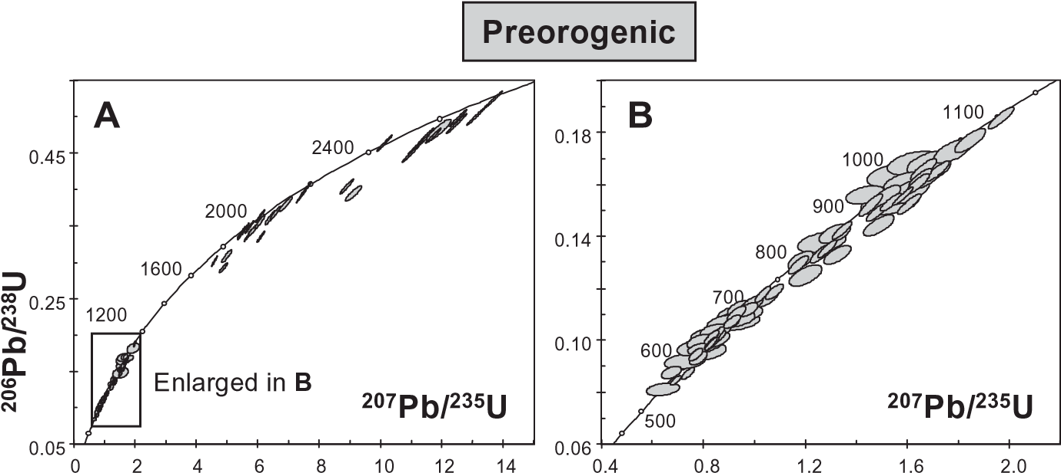

|  |  |  |
| --- | --- | --- |
| 0.072  0.54 | 0.62 0.70  **207Pb/235U** | samples, and from a pebble of orthogneiss in the synorogenic conglomerate. Ellipses represent 2 uncertainties. |

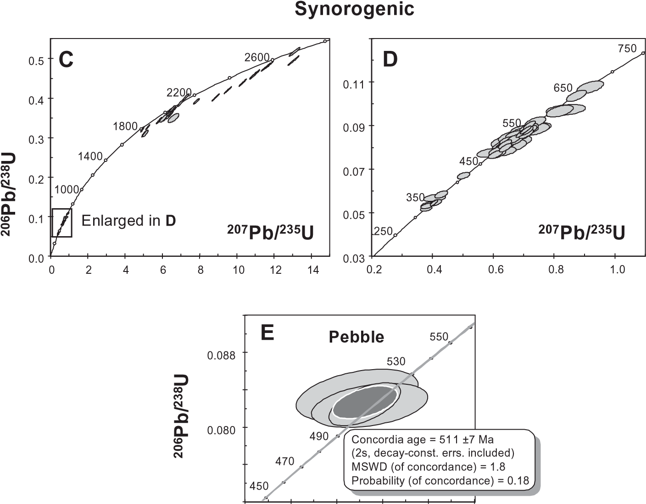Fig. 5. Concordia plots of U–Pb analytical data from the pre-orogenic and synorogenic

et al. 2000b, 2002c). The transition from the Cadomian orogeny, recorded by the Neoproterozoic population, to the CambroOrdovician rifting, is mainly marked by the scarce 535–500 Ma population, which had not been previously detected in the Lower Cambrian arkoses, the Ollo de Sapo Formation (Ferna´ndezSua´rez et al. 2000b) or the Armorican Quartzite (Ferna´ndezSua´rez et al. 2002b) of NW Iberia.

# Age populations in synorogenic samples

The greywacke and the conglomerate from the San Clodio Formation have both yielded four zircon age populations: Archaean (2.9–2.5 Ga), Palaeoproterozoic (2.3–1.8 Ga), Neoproterozoic–Ordovician (660–470 Ma), and latest Silurian–Carboniferous (417–324 Ma). The main differences from the preorogenic samples are: (1) the absence of a Mesoproterozoic population; (2) the absence of an older Neoproterozoic population; (3) the continuity between the Neoproterozoic and Early Palaeozoic ages; (4) the younger Early Palaeozoic ages; (5) the presence of a Late Palaeozoic population recording Variscan events.

In the conglomerate, which has a larger Late Palaeozoic population, the youngest zircon dated is concordant with a 324 7 Ma age. This datum establishes a maximum Late Vise´an–Early Namurian depositional age for the San Clodio Formation according to the geological timetables of Cowie & Bassett (1989) and Haq & Van Eysinga (1998). Moreover, the apparent absence of younger zircons in an area of active tectonism and abundant syntectonic magmatism, ranging between 350 and 310 Ma (Gallastegui 1993; Ferna´ndez-Sua´rez et al. 2000a), suggests that the Early Namurian is probably the actual age of sedimentation.

Three zircons extracted from the large pebble of orthogneiss yield a concordia age of 511 7 Ma (Fig. 5e) in agreement with similar ages for the matrix zircons. An older core yielded a discordant Palaeoproterozoic 207Pb/206Pb age of 1769 Ma.

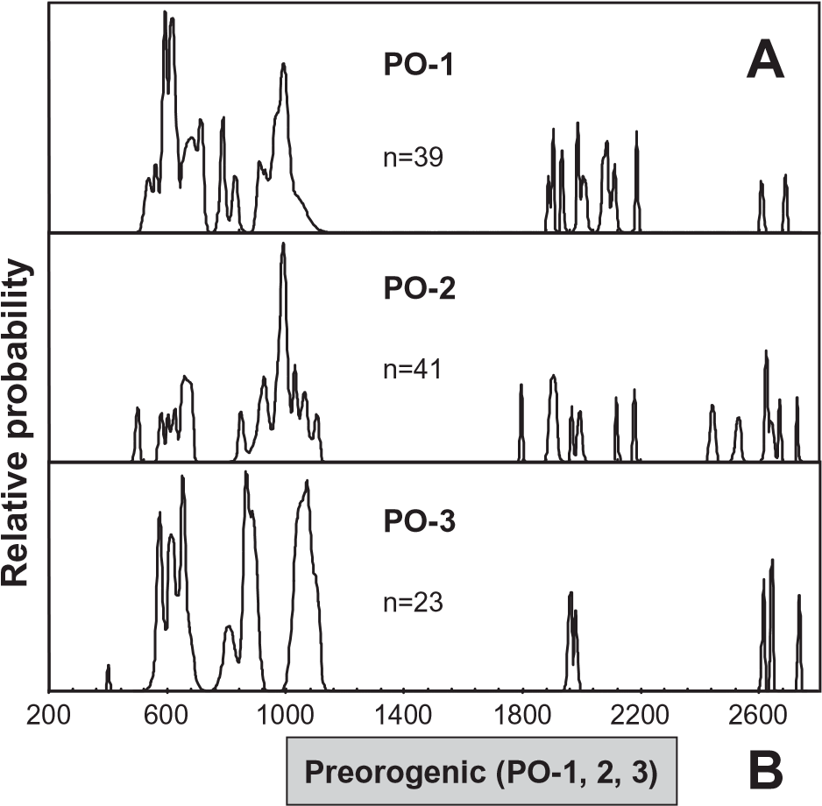

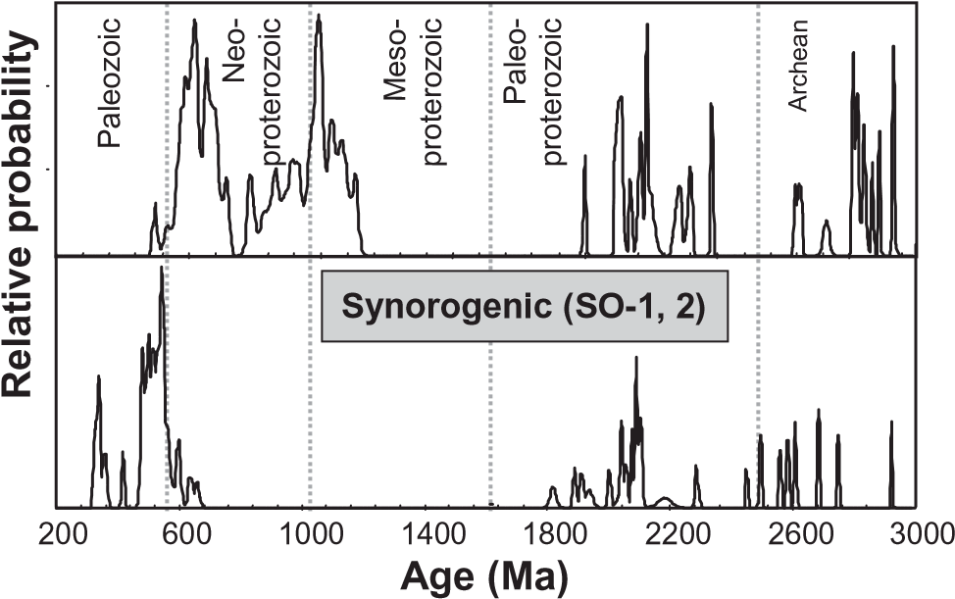

Fig. 6. Relative probability plots of U–Pb ages. (a) Separate plots for each of the three pre-orogenic samples showing the similarity in age clustering. (b) Composite plots showing the difference in age populations between the pre-orogenic and synorogenic samples.

# Discussion and geological significance The Armorica hypothesis

The Armorica plate, as it is usually conceived, was composed of the Iberian, Armorican and Bohemian Massifs (Van der Voo 1993; Tait et al. 1997; Tait 1999). All massifs were covered by a fairly continuous Palaeozoic detrital succession, ranging in age from the Cambrian or Early Ordovician to the Devonian, whereas large outcrops of basement older than the Neoproterozoic, which could have acted as supply areas, are absent.

A salient feature of the data set is that the Precambrian age clusters of our samples are identical to those reported for the Neoproterozoic sedimentary rocks underlying these Palaeozoic sequences. This implies either the same source area, or a recycling of previous deposits. Some recycling was probably related to normal faulting and erosion of the elevated blocks, as has been proposed for the Upper Ordovician sequence in the study area (Marcos 1973; Pe´rez-Estau´n & Marcos 1981; Pe´rezEstau´n et al. 1990; Mart´ınez Catala´n et al. 1992). However, this erosion and recycling must have been of limited extent, as only small portions of the sequence are omitted, and cannot account for the voluminous pre-orogenic detrital deposits.

The marked scarcity of recycled Cambro-Ordovician zircons (representing granitoids and coeval volcanic rocks) and, in particular, the absence of 490–460 Ma ages that could represent the erosion of the Ollo de Sapo volcanic rocks argues against the reworking of older deposits. The fact that these rocks were not supplying detritus to the sedimentary basin is consistent with the geological observation that they always appear covered by the younger deposits, with little or no discontinuity until the Devonian.

Our data suggest a common source area for the Neoproterozoic and the pre-orogenic Palaeozoic sediments, deposited before the start of the Variscan orogeny. This area would have included the West African craton and the surrounding PanAfrican belts, with the addition of a terrane with Mesoproterozoic rocks or its erosion products, possibly an Amazonian or Oaxacan terrane, as suggested by Ferna´ndez-Sua´rez et al. (2002c). These data are consistent with the permanence of Iberia in the northern margin of Gondwana (Fig. 1a) throughout the Palaeozoic, as is also suggested by faunal studies (Cocks & Fortey 1988; Paris & Robardet 1990; Robardet et al. 1990; Robardet 2002, 2003), and do not support the existence of an independent Armorica microplate (Fig. 1b).

# Provenance and tectonic significance of the San Clodio Formation

The absence of a Mesoproterozoic population in the synorogenic samples indicates that the underlying Palaeozoic and Upper Proterozoic sediments did not supply significant detritus to the San Clodio Formation. Furthermore, although the Ordovician population matches that found in the Ollo de Sapo Formation (490–460 Ma; Ferna´ndez-Sua´rez et al. 2000b), the lack of 1.1– 0.9 Ga zircons also indicates that this formation did not feed the synorogenic deposits.

The only known potential source whose age spectrum fits the zircon ages of the San Clodio Formation is the allochthonous complexes, where the uppermost low-grade metasedimentary succession of the Ordenes Complex includes 2.5–2.4, 2.1– 1.9 Ga and 610–480 Ma age clusters and lacks the Mesoproterozoic and the Early Neoproterozoic populations (Ferna´ndezSua´rez et al. 2003). The low-grade pelitic clasts found in the greywackes and conglomerates could be derived from the uppermost unit of the allochthonous complexes, although such rock types are also common in the basal units, and can be found in two of the ophiolitic units.

The age of the orthogneiss pebble, 511 7 Ma, fits that of the same type of rocks in the upper units (Dallmeyer & Tucker 1993; Abati et al. 1999), whereas younger Ordovician ages fit those of granitic and peralkaline orthogneisses of the basal units (Van Calsteren et al. 1979; Garc´ıa Garzo´n et al. 1981; Santos Zalduegui et al. 1995).

Late Silurian and Devonian ages between 417 and 360 Ma may reflect the exhumation of medium- to high-grade rocks of many of the allochthonous units (Van Calsteren et al. 1979; Dallmeyer et al. 1991, 1997; Scha¨fer et al. 1993; Santos Zalduegui et al. 1996; Ordo´n˜ez Casado et al. 2001; Ferna´ndezSua´rez et al. 2002a) and, to a limited extent, the local generation of oceanic crust (D´ıaz Garcı´a et al. 1999; Pin et al. 2002).

Finally, Early to Mid-Carboniferous zircons (355–324 Ma) may be derived from rocks with high-temperature metamorphism and migmatization of comparable age found in some basal units (346 Ma; Abati & Dunning, 2002) and possibly also from

Variscan granites intruded in the complexes.

The relationship between synorogenic sedimentation and thrusting of the allochthonous complexes was described by Gonza´lez Clavijo & Mart´ınez Catala´n (2002), and is sketched in Figure 7. The complexes were stacked during the Devonian in an accretionary wedge to the west or NW of the Rheic oceanic basin (Mart´ınez Catala´n et al. 1997). After oceanic closure, continental collision of Laurentia and Baltica with Gondwana gave rise to a first deformational event characterized by partial underthrusting of the Gondwanan crust and the development of recumbent folds. Synorogenic flysch deposits were laid down in front of the advancing allochthonous complexes, and were overridden by them. If the Gimonde Formation has a Late Devonian age (Pereira et al. 1999), the Late Vise´an–Early Namurian age of the San Clodio Formation would confirm the progradation of the deformation to the east, with the youngest deposits cropping out far from the allochthonous complexes and forming part of the lowermost imbricates.

# Conclusions

Five zircon age populations have been found in Upper Ordovician to Lower Devonian quartzites of the autochthonous pre-orogenic sequences of NW Iberian Massif: Archaean (2.8–2.5 Ga), Palaeoproterozoic (2.3–1.8 Ga), Mesoproterozoic (1.1–1 Ga), Neoproterozoic (990–555 Ma) and Palaeozoic (535–500 Ma). All but the last age cluster had been previously reported in Neoproterozoic, Lower Cambrian and Lower Ordovician sedimentary rocks in the same area of NW Spain

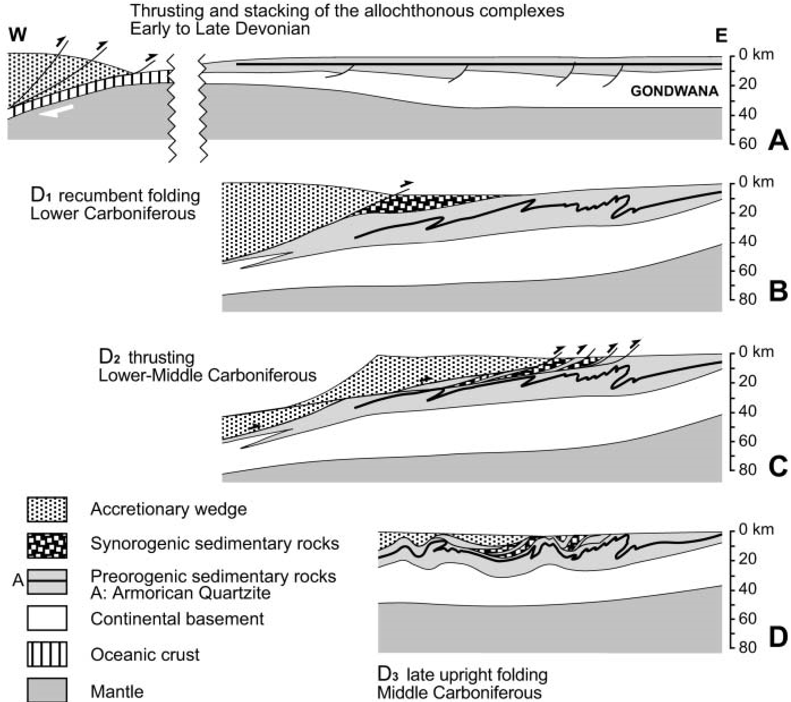(Ferna´ndez-Sua´rez et al. 2000b, 2002b), and the similarity of detrital zircon ages throughout the pre-orogenic sequences suggests a common source area from Neoproterozoic to Early Devonian time. Our data do not favour the existence of Armorica as a separate microplate. Instead, they indicate that the Iberian Massif remained attached to the northern margin of Gondwana until the Early Devonian and support the palaeomagnetic data yielding a relatively low palaeolatitude for Gondwana in the Devonian (Fig. 1a).

Synorogenic greywackes and conglomerates have yielded four zircon age populations: Archaean (2.9–2.5 Ga), Palaeoproterozoic (2.3–1.8 Ga), Neoproterozoic–Ordovician (660–470 Ma) and latest Silurian–Carboniferous (417–324 Ma). The youngest concordant zircon (324 Ma) establishes a maximum limit for the depositional age of the San Clodio Formation but, taking into account its synorogenic character, this age probably reflects very closely the time of sedimentation. Correlation with published detrital zircon ages points to the allochthonous complexes of NW Iberia as the source area, confirming the close link between their emplacement and synorogenic sedimentation (Gonza´lez Clavijo & Mart´ınez Catala´n, 2002).

These results are a further proof of the value of detrital zircon studies in palaeotectonic reconstructions, and such studies, when used in conjunction with structural work, can help to refine structural models and better constrain collisional processes.

This work forms part of the research carried out in project 1FD19970959-C03-03 of the Direccio´n General de Ensen˜anza Superior e Investigacio´n Cient´ıfica, of the Spanish Ministerio de Educacio´n y Cultura. M. Lombardero is acknowledged for help with the sampling of two quartzites and their precise location in the stratigraphic columns. T. Andersen and B. Murphy are thanked for their critical reviews and correction of the manuscript.

# References

Abati, J. & Dunning, G.R. 2002. Edad U–Pb en monacitas y rutilos de los paragneises de la Unidad de Agualada (Complejo de O´ rdenes, NW del Macizo Ibe´rico). Geogaceta, 32, 95–98.

Fig. 7. Sketch showing the relationship between thrusting of the allochthonous complexes and synorogenic sedimentation, based on Gonza´lez Clavijo & Mart´ınez Catala´n (2002).

Abati, J., Dunning, G.R., Arenas, R., Dı´az Garcı´a, F., Gonza´lez Cuadra, P., Martı´nez Catala´n, J.R. & Andonaegui, P. 1999. Early Ordovician orogenic event in Galicia (NW Spain): evidence from U–Pb ages in the uppermost unit of the Ordenes Complex. Earth and Planetary Science Letters, 165, 213–228.

Allegret, A. & Iglesias Ponce de Leo´n, M. 1987. U–Pb dating of Sisargas orthogneisses (Galicia, NW-Spain): new evidence of a Precambrian basement in the northwestern part of the Iberian Peninsula. Neues Jahrbuch fu¨r Mineralogie, 8, 355–368.

Alonso, J.L. & Rodrı´guez Ferna´ndez, L.R. 1981. Aportaciones al conocimiento de la estructura del Sinclinorio de Ver´ın. Cuadernos do Laboratorio Xeolo´xico de Laxe, 3, 93–122.

Andersen, T. 2002. Correction of common-lead in U–Pb analyses that do not report 204Pb. Chemical Geology, 192, 59–79.

Antona, J.F. & Martı´nez Catala´n, J.R. 1990. Interpretacio´n de la Formacio´n San Vitero en relacio´n con la Orogenia Herc´ınica. Cuadernos do Laboratorio Xeolo´xico de Laxe, 15, 257–269.

Arenas, R., Rubio Pascual, F.J., Dı´az Garcı´a, F. & Martı´nez Catala´n, J.R. 1995. High-pressure micro-inclusions and development of an inverted metamorphic gradient in the Santiago Schists (Ordenes Complex, NW Iberian Massif, Spain): evidence of subduction and syn-collisional decompression. Journal of Metamorphic Geology, 13, 141–164.

Bachtadse, V. & Briden, J.C. 1991. Palaeomagnetism of Devonian ring complexes from the Bayuda Desert, Sudan—new constraints on Gondwana’s apparent polar wander path. Geophysical Journal International, 104, 635–646.

Barrera Morate, J.L., Farias Arquer, P. & Gonza´lez Lodeiro, F. et al.

1989. Mapa Geolo´gico Nacional E. 1:200 000, 17-27, Orense–Verı´n. Instituto Geolo´gico y Minero de Espan˜a, Madrid.

Barros Lorenzo, J.C. 1989. Nuevos datos geolo´gicos y cartogra´ficos sobre el flanco Sur del Sinclinorio de Truchas (Ourense–Leo´n, NW de Espan˜a). Cuadernos do Laboratorio Xeolo´xico de Laxe, 14, 93–116.

Bessoles, B. 1977. Ge´ologie de l’Afrique: Le Craton Ouest-Africain. Bureau des Recherches Ge´ologiques et Minie`res, Me´moires, 88.

Black, L.P. & Gulson, B.L. 1978. The age of the Mud Tank carbonatite, Strangways Range, Northern Territory. BMR Journal of Australian Geology and Geophysics, 3, 227–232.

Bonhommet, N. & Perroud, H. 1986. Apport du pale´omagnetisme a` la compre´hension de l’orogene`se hercynienne en Europe occidentale. Bulletin de la Societe´ Ge´ologique de France, 8, 35–42.

Caby, R. 1989. Precambrian terranes of Benin–Nigeria and northeast Brazil and the Late Proterozoic South Atlantic fit. In: Dallmeyer, R.D. (ed.) Terranes in the Circum-Atlantic Paleozoic Orogens. Geological Society of America, Special Papers, 230, 145–158.

Capdevila, R. 1969. Le me´tamorphisme re´gional progressif et les granites dans le segment hercynien de Galice nord oriental (NW de l’Espagne). PhD thesis, University of Montpellier.

Capdevila, R. & Floor, P. 1970. Les differents types de granites hercyniens et leur distribution dans le Nord-Ouest de l’Espagne. Boletı´n Geolo´gico y Minero, 81, 215–225.

Capdevila, R., Corretge´, L.G. & Floor, P. 1973. Les granito¨ıdes varisques de la Meseta Ibe´rique. Bulletin de la Societe´ Ge´ologique de France, 15, 209–228.

Cocks, L.R.M. 2000. The Early Palaeozoic geography of Europe. Journal of the Geological Society, London, 157, 1–10.

Cocks, L.R.M. & Fortey, R.A. 1988. Lower Palaeozoic facies and faunas around

Gondwana. In: Audley-Charles, M.G. & Hallam, A. (eds) Gondwana and the Tethys. Geological Society, London, Special Publications, 37, 183–200.

Cowie, J.W. & Bassett, M.G. 1989. IUGS 1989 Global Stratigraphic Chart. Episodes, 12(2), Supplement.

Dallmeyer, R.D. & Tucker, R.D. 1993. U–Pb zircon age for the Lagoa augen gneiss, Morais Complex, Portugal: tectonic implications. Journal of the Geological Society, London, 150, 405–410.

Dallmeyer, R.D., Ribeiro, A. & Marques, F. 1991. Polyphase Variscan emplacement of exotic terranes (Morais and Braganc¸a Massifs) onto Iberian successions: evidence from 40Ar/39Ar mineral ages. Lithos, 27, 133–144.

Dallmeyer, R.D., Martı´nez Catala´n, J.R. & Arenas, R. et al. 1997. Diachronous Variscan tectonothermal activity in the NW Iberian Massif: evidence from 40Ar/39Ar dating of regional fabrics. Tectonophysics, 277, 307–337.

Dı´az Garcı´a, F., Arenas, R., Martı´nez Catala´n, J.R., Gonza´lez del Ta´nago, J. & Dunning, G. 1999. Tectonic evolution of the Careo´n ophiolite (Northwest Spain): a remnant of oceanic lithosphere in the Variscan belt. Journal of Geology, 107, 587–605.

Drot, J. & Matte, Ph. 1967. Sobre la presencia de capas del Devoniano en el l´ımite de Galicia y Leo´n (NW de Espan˜a). Notas y Comunicaciones del Instituto Geolo´gico y Minero de Espan˜a, 93, 87–92.

Farias, P., Gallastegui, G. & Gonza´lez-Lodeiro, F. etal. 1987. Aportaciones al conocimiento de la litoestratigraf´ıa y estructura de Galicia Central.

Memo´rias da Faculdade de Cieˆncias, Universidade do Porto, 1, 411–431.

Ferna´ndez-Sua´rez, J., Gutie´rrez-Alonso, G., Jenner, G.A. & Jackson, S.E. 1998. Geochronology and geochemistry of the Pola de Allande granitoids (northern Spain). Their bearing on the Cadomian/Avalonian evolution of NW Iberia. Canadian Journal of Earth Sciences, 35, 1439–1453.

Ferna´ndez-Sua´rez, J., Gutie´rrez-Alonso, G., Jenner, G.A. & Tubrett, M.N. 1999. Crustal sources in Lower Paleozoic rocks from NW Iberia: insights from laser ablation U–Pb ages of detrital zircons. Journal of the Geological Society, London, 156, 1065–1068.

Ferna´ndez-Sua´rez, J., Dunning, G.R., Jenner, G.A. & Gutie´rrez-Alonso, G. 2000a. Variscan collisional magmatism and deformation in NW Iberia: constraints from U–Pb geochronology of granitoids. Journal of the Geological Society, London, 157, 565–576.

Ferna´ndez-Sua´rez, J., Gutie´rrez-Alonso, G., Jenner, G.A. & Tubrett, M.N. 2000b. New ideas on the Proterozoic–Early Paleozoic evolution of NW Iberia: insights from U–Pb detrital zircon ages. Precambrian Research, 102, 185–206.

Ferna´ndez-Sua´rez, J., Corfu, F. & Arenas, R. et al. 2002a. U–Pb evidence for a polyorogenic evolution of the HP–HT units of the NW Iberian Massif. Contributions to Mineralogy and Petrology, 143, 236–253.

Ferna´ndez-Sua´rez, J., Gutie´rrez-Alonso, G., Cox, R. & Jenner, G.A. 2002b. Assembly of the Armorica microplate: a strike-slip terrane delivery? Evidence from U–Pb ages of detrital zircons. Journal of Geology, 110, 619–626.

Ferna´ndez-Sua´rez, J., Gutie´rrez Alonso, G. & Jeffries, T.E. 2002c. The importance of along-margin terrane transport in northern Gondwana: insights from detrital zircon parentage in Neoproterozoic rocks from Iberia and Brittany. Earth and Planetary Science Letters, 204, 75–88.

Ferna´ndez-Sua´rez, J., Dı´az Garcı´a, F., Jeffries, T.E., Arenas, R. & Abati, J. 2003. Constraints on the provenance of the uppermost allochthonous terrane of the NW Iberian Massif: inferences from detrital zircon U–Pb ages. Terra Nova, 15, 138–144.

Fortey, R.A. & Cocks, L.R.M. 1988. Arenig to Llandovery faunal distributions in the Caledonides. In: Harris, A.L. & Fettes, D.J. (eds) The Caledonian– Appalachian Orogen. Geological Society, London, Special Publications, 38, 233–246.

Franke, W. & Engel, W. 1986. Synorogenic sedimentation in the Variscan Belt of Europe. Bulletin de la Societe´ Ge´ologique de France, 8(2), 25–33.

Gallastegui, G. 1993. Petrologı´a del macizo granodiorı´tico de Bayo-Vigo (Provincia de Pontevedra, Espan˜a). PhD thesis, University of Oviedo.

Garcı´a Garzo´n, J., de Pablo Macia´, J.G. & Llamas Borrajo, J.F. 1981. Edades absolutas obtenidas mediante el me´todo Rb/Sr en dos cuerpos de ortoneises en Galicia Occidental. Boletı´n Geolo´gico y Minero, 92, 463–466.

Gebauer, D. 1993. Intra-grain zircon dating within the Iberian Massif: Ollo de Sapo augengneisses, bimodal gneisses from the Massif de Guilleries (Girona), graywacke of the Tentud´ıa Group (Serie Negra, SW Spain) and the HP/HTrock association at Cabo Ortegal (Galicia). Comunicac¸o˜es da XII Reunia˜o de Geologia do Oeste Peninsular, Universidade de Evora, 2, 41–46.

Giese, W., Hoegen, R.V., Hollmann, G. & Walter, R. 1994. Geology of the southwestern Iberian Meseta I. The Palaeozoic of the Ossa Morena Zone north and south of the Olivenza–Monesterio Anticline (Huelva province, SW Spain). Neues Jahrbuch fu¨r Geologie und Pala¨ontologie, Abhandlungen, 192, 293–331.

Gil Ibarguchi, I. & Ortega Girone´s, E. 1985. Petrology, structure and geotectonic implications of glaucophane-bearing eclogites and related rocks from the Malpica–Tuy (MT) Unit, Galicia, Northwest Spain. Chemical Geology, 50, 145–162.

Gonza´lez Clavijo, E.J. 1997. La geologı´a del Sinforme de Alcan˜ices, oeste de Zamora. Ph.D. Thesis, University of Salamanca.

Gonza´lez Clavijo, E. & Martı´nez Catala´n, J.R. 2002. Stratigraphic record of preorogenic to synorogenic sedimentation, and tectonic evolution of imbricate units in the Alcan˜ices synform (northwestern Iberian Massif). In: Martı´nez

Catala´n, J.R., Hatcher, R.D., Arenas, R. & Dı´az Garcı´a, F. (eds) Variscan–Appalachian Dynamics: the Building of the Late Paleozoic Basement. Geological Society of America, Special Papers, 364, 17–35.

Gutie´rrez-Alonso, G., Ferna´ndez-Sua´rez, J., Jeffries, T.E., Jenner, G.A., Tubrett, M.N., Cox, R. & Jackson, S.E. 2003. Terrane accretion and dispersal in the northern Gondwana margin. An Early Paleozoic analogue of a long-lived active margin. Tectonophysics, 365, 221–232.

Gutie´rrez Marco, J.C., Ra´bano, I., Go´mez Moreno, G. & Hacar Rodrı´guez, M. 1988. Revisio´n bioestratigra´fica de la sucesio´n ordov´ıcico-silu´rica del sector meridional de la zona asturoccidental-leonesa (prov. de Orense y Leo´n, NO de Espan˜a). X Reunio´n de Xeoloxı´a e Minerı´a do NO Peninsuar,

Laboratorio Xeolo´xico de Laxe, Abstracts, 36.

Haq, B.U. & Van Eysinga, F.W.B. 1998. Geological Time Table, 5th. Elsevier, Amsterdam.

Hargraves, R.B., Dawson, E.M. & Van Houten, F.B. 1987. Palaeomagnetism and age of mid Palaeozoic ring complexes in Niger, West Africa, and tectonic implications. Geophysical Journal of the Royal Astronomical Society, 90, 705–729.

Ireland, T.R., Flo¨ttman, T., Fanning, C.M., Gibson, G.M. & Preiss, W.V. 1998. Development of the early Paleozoic Pacific margin of Gondwana from detrital-zircon ages across the Delamerian orogen. Geology, 26, 243–246.

Kent, D.V., Dia, O. & Sougy, J.M.A. 1984. Paleomagnetism of Lower–Middle Devonian and Upper Proterozoic–Cambrian(?) rocks from Mejeria (Mauritania, West Africa). In: Van der Voo, R., Scotese, C.R. & Bonhommet, N. (eds) Plate Reconstruction from Paleozoic Paleomagnetism. American Geophysical Union, Geodynamics Series, 12, 99–115.

Kuijper, R.P. 1980. Precambrian U–Pb zircon ages from Western Galicia (NW Spain). Earth-Science Reviews, 16, 313–316.

Lancelot, J.R., Allegret, A. & Iglesias-Ponce de Leo´n, M. 1985. Outline of Upper Precambrian and Lower Paleozoic evolution of the Iberian Peninsula according to U–Pb dating of zircons. Earth and Planetary Science Letters, 74, 325–337.

Ludwig, K.R. 1998. On the treatment of concordant uranium–lead ages. Geochimica et Cosmochimica Acta, 62, 665–676.

Ludwig, K.R. 2001. Isoplot/Ex Rev. 2.49—a Geochronological Toolkit for Microsoft Excel. Berkeley Geochronology Center, Special Publication, 1a.

Marcos, A. 1973. Las Series del Paleozoico Inferior y la estructura herciniana del occidente de Asturias (NW de Espan˜a). Trabajos de Geolog´ıa de la Universidad de Oviedo, 6.

Marcos, A. & Pulgar, J.A. 1982. An approach to the tectonostratigraphic evolution of the Cantabrian Foreland thrust and fold belt, Hercynian Cordillera of NW Spain. Neues Jahrbuch fu¨r Geologie und Pala¨ontologie, Abhandlungen, 163, 256–260.

Marquı´nez Garcı´a, J.L. 1984. La geologı´a del a´rea esquistosa de Galicia Central (Cordillera Herciniana, NW de Espan˜a). Memorias del Instituto Geolo´gico y Minero de Espan˜a, 100.

Martı´nez Catala´n, J.R., Hacar Rodrı´guez, M.P., Villar Alonso, P., Pe´rezEstau´n, A. & Gonza´lez Lodeiro, F. 1992. Lower Paleozoic extensional tectonics in the limit between the West Asturian–Leonese and Central Iberian Zones of the Variscan Fold-Belt in NW Spain. Geologische Rundschau, 81, 545–560.

Martı´nez Catala´n, J.R., Arenas, R., Dı´az Garcı´a, F., Rubio Pascual, F.J., Abati, J. & Marquı´nez, J. 1996. Variscan exhumation of a subducted Paleozoic continental margin: the basal units of the Ordenes Complex, Galicia, NW Spain. Tectonics, 15, 106–121.

Martı´nez Catala´n, J.R., Arenas, R., Dı´az Garcı´a, F. & Abati, J. 1997. Variscan accretionary complex of northwest Iberia: terrane correlation and succession of tectonothermal events. Geology, 25, 1103–1106.

Martı´nez Garcı´a, E. 1972. El Silu´rico de San Vitero (Zamora). Comparacio´n con las series vecinas e importancia oroge´nica. Acta Geolo´gica Hispa´nica, 7, 104–108.

Martı´nez Garcı´a, E. 1973. Deformacio´n y metamorfismo en la zona de Sanabria. Studia Geologica Salmanticensia, 5, 7–106.

Martı´nez Poyatos, D.J. 2002. Estructura del borde meridional de la Zona Centroibe´rica y su relacio´n con el contacto entre las Zonas Centroibe´rica y de Ossa–Morena. Nova Terra, 18.

Matte, Ph. 1968. La structure de la virgation hercynienne de Galice (Espagne). Revue de Ge´ologie Alpine, 44, 1–128.

Meireles, C.A.P. 2000a. Carta Geolo´gica de Portugal, Folha 3-D, Espinhosela. Instituto Geolo´gico e Mineiro, Lisboa.

Meireles, C.A.P. 2000b. Carta Geolo´gica de Portugal, Folha 4-C, Deila˜o. Instituto Geolo´gico e Mineiro, Lisboa.

Murphy, J.B. & Nance, R.D. 1991. Supercontinent model for the contrasting character of Late Proterozoic orogenic belts. Geology, 19, 469–472.

Noblet, Ch. & Lefort, J.P. 1990. Sedimentological evidence for a limited separation between Armorica and Gondwana during the Early Ordovician. Geology, 18, 303–306.

Norman, M.D., Pearson, N.J., Sharma, A. & Griffin, W.L. 1996. Quantitative analysis of trace elements in geological materials by laser ablation ICPMS: instrumental operating conditions and calibration values of NIST glasses. Geostandards Newsletter, 20, 247–261.

Ochsner, A. 1993. U–Pb geochronology of the Upper Proterozoic–Lower Paleozoic geodynamic evolution in the Ossa–Morena Zone (SW Iberia): constraints on the timing of the Cadomian orogeny. PhD thesis, University of Zurich.

Oliveira, J.T. 1990. South Portuguese Zone. Stratigraphy and synsedimentary tectonism. In: Dallmeyer, R.D. & Martı´nez Garcı´a, E. (eds) PreMesozoic Geology of Iberia. Springer, Berlin, 334–347.

Ordo´n˜ez Casado, B., Gebauer, D., Scha¨fer, H.J., Gil Ibarguchi, J.I. & Peucat, J.J. 2001. A single Devonian subduction event for the HP/HT metamorphism of the Cabo Ortegal complex within the Iberian Massif. Tectonophysics, 332, 359–385.

Parga Pondal, I., Matte, P. & Capdevila, R. 1964. Introduction a` la ge´ologie de l’‘Ollo de Sapo’, Formation porphyroide antesilurienne du Nord Ouest de l’Espagne. Notas y Comunicaciones del Instituto Geolo´gico y Minero de Espan˜a, 76, 119–153.

Paris, F. & Robardet, M. 1990. Early Paleozoic paleobiogeography of the Variscan regions. Tectonophysics, 11, 193–213.

Pereira, Z., Pic¸arra, J.M. & Oliveira, J.T. 1998. Palinomorfos do Devo´nico Inferior da regia˜o de Barrancos (Zona de Ossa Morena). Actas do V Congresso Nacional de Geologia, Instituto Geolo´gico e Mineiro, 84, A-18–A-21.

Pereira, Z., Meireles, C. & Pereira, E. 1999. Upper Devonian palynomorphs of the NE sector of Tra´s-os-Montes (Central Iberian Zone). XV Reunio´n de Geologı´a del Oeste Peninsular–International Meeting on Cadomian Orogens, Badajoz, Spain, Extended Abstracts, 201–206.

Pe´rez-Estau´n, A. 1974. Aportaciones al conocimiento del Carbon´ıfero de San Clodio (Prov. de Lugo). Breviora Geologica Asturica, 18, 3–8.

Pe´rez-Estau´n, A. 1978. Estratigraf´ıa y estructura de la rama Sur de la Zona Asturoccidental-Leonesa. Memorias del Instituto Geolo´gico y Minero de Espan˜a, 92, 1–151.

Pe´rez-Estau´n, A. & Marcos, A. 1981. La Formacio´n Agu¨eira en el sinclinorio de Vega de Espinareda: aproximacio´n al modelo de sedimentacio´n durante el Ordov´ıcico Superior en la Zona Asturoccidental-Leonesa (NW de Espan˜a). Trabajos de Geologı´a de la Universidad de Oviedo, 11, 135–145.

Pe´rez-Estau´n, A., Bastida, F. & Alonso, J.L. et al. 1988. A thin-skinned tectonics model for an arcuate fold and thrust belt: the Cantabrian Zone (Variscan Ibero-Armorican Arc). Tectonics, 7, 517–537.

Pe´rez-Estau´n, A., Bastida, F., Martı´nez Catala´n, J.R., Gutierrez Marco, J.C., Marcos, A. & Pulgar, J.A. 1990. West Asturian–Leonese Zone.

Stratigraphy. In: Dallmeyer, R.D. & Martı´nez Garcı´a, E. (eds) PreMesozoic Geology of Iberia. Springer, Berlin.

Perroud, H., Van der Voo, R. & Bonhommet, N. 1984. Paleozoic evolution of the Armorica plate on the basis of paleomagnetic data. Geology, 12, 579–582.

Peucat, J.J., Bernard-Griffiths, J., Gil Ibarguchi, J.I., Dallmeyer, R.D.,

Menot, R.P., Cornichet, J. & Iglesias Ponce de Leo´n, M. 1990.

Geochemical and geochronological cross section of the deep Variscan crust: the Cabo Ortegal high-pressure nappe (northwestern Spain). Tectonophysics, 177, 263–292.

Pic¸arra, J.M., Pereira, Z. & Oliveira, J.T. 1998. Novos dados sobre a idade da sucessao˜ Silu´rico-Devo´nica do Sinclinal de Terena, na regia˜o de Barrancos. Implicac¸o˜es geodinaˆmicas. Actas do V Congresso Nacional de Geologia. Instituto Geolo´gico e Mineiro, 84, A-15–A-17.

Pin, C., Ortega Cuesta, L.A. & Gil Ibarguchi, J.I. 1992. Mantle-derived, early Paleozoic A-type metagranitoids from the NW Iberian Massif: Nd isotope and trace-element constraints. Bulletin de la Societe´ Ge´ologique de France, 163, 483–494.

Pin, C., Paquette, J.L., Santos Zalduegui, J.F. & Gil Ibarguchi, J.I. 2002. Early Devonian supra-subduction zone ophiolite related to incipient collisional processes in the Western Variscan Belt: the Sierra de Careo´n unit,

Ordenes Complex, Galicia. In: Martı´nez Catala´n, J.R., Hatcher, R.D., Arenas, R. & Dı´az Garcı´a, F. (eds) Variscan–Appalachian Dynamics: the Building of the Late Paleozoic Basement. Geological Society of America, Special Papers, 364, 57–72.

Ra´bano, I., Gutie´rrez Marco, J.C. & Robardet, M. 1993. Upper Silurian trilobites of Bohemian affinities from the West Asturian–Leonese Zone (NW Spain). Geobios, 26, 361–376.

Ribeiro, A., Quesada, C. & Dallmeyer, R.D. 1990. Geodynamic evolution of the Iberian Massif. In: Dallmeyer, R.D. & Martı´nez Garcı´a, E. (eds) PreMesozoic Geology of Iberia. Springer, Berlin, 399–409.

Ribeiro, M.L. & Floor, P. 1987. Magmatismo peralcalino no Macic¸o Hespe´rico: sua distribuc¸a˜o e significado geodina´mico. In: Bea, F., Carnicero, A.,

Gonzalo, J.C., Lo´pez-Plaza, M. & Rodrı´guez Alonso, M.D. (eds) Geologı´a de los granitoides y rocas asociadas del Macizo Hespe´rico. Rueda, Madrid, 211–221.

Ribeiro, M.L. & Ribeiro, A. 1974. Signification pale´oge´ographique et tectonique de la pre´sence de galets de roches metamorphiques dans un flysch d’aˆge de´vonien supe´rieur du Tras-os-Montes oriental (Nord-Est du Portugal). Comptes Rendus de l’Acade´mie des Sciences, 278, 3161–3163.

Riemer, W. 1963. Entwicklung des Pala¨ozoikums in der Su¨dlichen Provinz Lugo (Spanien). Neues Jahrbuch fu¨r Geologie und Pala¨ontologie, Abhandlungen, 117, 273–285.

Riemer, W. 1966. Datos para el conocimiento de la estratigraf´ıa de Galicia. Notas y Comunicaciones del Instituto Geolo´gico y Minero de Espan˜a, 81, 7–20.

Robardet, M. 2002. Alternative approach to the Variscan Belt of southwestern Europe: preorogenic paleobiogeographical constraints. In: Martı´nez Cata-

la´n, J.R., Hatcher, R.D., Arenas, R. & Dı´az Garcı´a, F. (eds) Variscan– Appalachian Dynamics: the Building of the Late Paleozoic Basement. Geological Society of America, Special Papers, 364, 1–15.

Robardet, M. 2003. The Armorica ‘microplate’: fact or fiction? Critical review of the concept and contradictory paleobiogeographical data. Palaeogeography, Palaeoclimatology, Palaeoecology, 195, 125–148.

Robardet, M., Paris, F. & Racheboeuf, P.R. 1990. Paleogeographic evolution of southwestern Europe during Early Paleozoic times. In: McKerrow, W.S. & Scotese, C.R. (eds) Palaeozoic Palaeogeography and Biogeography. Geological Society, London, Memoirs, 12, 411–419.

Rodrı´guez Ferna´ndez, L.R. 1993. Tectonosedimentary evolution of a Carboniferous foreland basin related with arcuated fold–thrust belt. The example of NW Iberian Variscan Belt. Comptes Rendus XII International Congress on Carboniferous–Permian, Buenos Aires, 1, 435–445.

Rubio Pascual, F.J., Arenas, R., Dı´az Garcı´a, F., Martı´nez Catala´n, J.R. & Abati, J. 2002. Eclogites and eclogite–amphibolites from the Santiago Unit (Ordenes Complex, NW Iberian Massif, Spain): a case study of contrasting high-pressure metabasites in a context of crustal subduction. In: Martı´nez

Catala´n, J.R., Hatcher, R.D., Arenas, R. & Dı´az Garcı´a, F. (eds) Variscan–Appalachian Dynamics: the Building of the Late Paleozoic Basement. Geological Society of America, Special Papers, 364, 105–124.

Santos Zalduegui, J.F., Scha¨rer, U. & Gil Ibarguchi, J.I. 1995. Isotope constraints on the age and origin of magmatism and metamorphism in the Malpica–Tuy allochthon, Galicia, NW-Spain. Chemical Geology, 1221, 91–103.

Santos Zalduegui, J.F., Scha¨rer, U., Gil Ibarguchi, J.I. & Girardeau, J. 1996. Origin and evolution of the Paleozoic Cabo Ortegal ultramafic–mafic complex (NW Spain): U–Pb, Rb–Sr and Pb–Pb isotope data. Chemical Geology, 129, 281–304.

Sarmiento, G.N., Gutie´rrez Marco, J.C. & Robardet, M. 1999. Conodontos ordov´ıcicos del Noroeste de Espan˜a. Aplicacio´n al modelo de sedimentacio´n de la regio´n lim´ıtrofe entre las Zonas Asturoccidental-leonesa y Centroibe´rica durante el Ordov´ıcico Superior. Revista de la Sociedad Geolo´gica de Espan˜a, 12, 477–500.

Scha¨fer, H.J., Gebauer, D., Gil Ibarguchi, J.I. & Peucat, J.J. 1993. Ionmicroprobe U–Pb zircon dating on the HP/HT Cabo Ortegal Complex

(Galicia, NW Spain): preliminary results. Terra Abstracts, 5(4), 22.

Schermerhorn, L.J.G. 1971. An outline of the stratigraphy of the Iberian pyrite belt. Boletı´n Geolo´gico y Minero, 82, 239–268.

Scotese, C.R. 1984. Paleozoic paleomagnetism and the assembly of Pangea. In:

Van der Voo, R., Scotese, C.R. & Bonhommet, N. (eds) Plate Reconstruction from Paleozoic Paleomagnetism. American Geophysical Union, Geodynamic Series, 12, 1–10.

Scotese, C.R. 2002. Paleomap Project. Available at [http://www.scotese.com/.](http://www.scotese.com/)

Scotese, C.R. & McKerrow, W.S. 1990. Revised world maps and introduction.

In: McKerrow, W.S. & Scotese, C.R. (eds) Palaeozoic Paleogeography and Biogeography. Geological Society, London, Memoirs, 12, 1–22.

Soper, N.J. 1988. Timing and geometry of collision, terrane accretion and sinistral strike-slip events in the British Caledonides. In: Harris, A.L. & Fettes, D.J.

(eds) The Caledonian–Appalachian Orogen. Geological Society, London, Special Publications, 38, 481–492.

Tait, J. 1999. New Early Devonian paleomagnetic data from NW France: paleogeography and implications for the Armorican microplate hypothesis. Journal of Geophysical Research, 104, 2831–2839.

Tait, J.A., Bachtadse, V., Franke, W. & Soffel, H.C. 1997. Geodynamic evolution of the European Variscan fold belt: paleomagnetic and geological constraints. Geologische Rundschau, 86, 585–598.

Teixeira, C. & Pais, J. 1973. Sobre a presenc¸a de Devo´nico na regia˜o da Braganc¸a (Guadramil e Mofreita) e de Alcan˜ices (Zamora). Boletim da Sociedade Geolo´gica de Portugal, 18, 199–202.

Valverde Vaquero, P. & Ferna´ndez, F.J. 1996. Edad de enframiento U/Pb en rutilos del Gneis de Ch´ımparra (Cabo Ortegal, Node Espan˜a). Geogaceta, 20, 475–478.

Valverde Vaquero, P. & Dunning, G.R. 2000. New U–Pb ages for Early Ordovician magmatism in Central Spain. Journal of the Geological Society, London, 157, 15–26.

Van Calsteren, P.W.C., Boelrijk, N.A.I.M., Hebeda, E.H., Priem, H.N.A., Tex, E., Den Verdurmen, E.A.T.H. & Verschure, R.H. 1979. Isotopic dating of older elements (including the Cabo Ortegal mafic–ultramafic complex) in the Hercynian Orogen of NW Spain: manifestations of a presumed Early Paleozoic mantle-plume. Chemical Geology, 24, 35–56.

Van der Voo, R. 1979. Paleozoic assembly of Pangea: a new plate tectonic model for the Taconic, Caledonian and Hercynian orogenies (abstract). EOS Transactions, American Geophysical Union, 60, 241.

Van der Voo, R. 1982. Pre-Mesozoic paleomagnetism and plate tectonics. Annual Review of Earth and Planetary Sciences, 10, 191–220.

Van der Voo, R. 1988. Paleozoic paleogeography of North America, Gondwana, and intervening displaced terranes: comparisons of paleomagnetism with paleoclimatology and biogeographical patterns. Geological Society of America Bulletin, 100, 311–324.

Van der Voo, R. 1993. Paleomagnetism of the Atlantic, Tethys and Iapetus Ocean. Cambridge University Press, Cambridge.

Vialette, Y., Casquet, C., Fu´ster, J.M., Ibarrola, E., Navidad, M., Peinado, M. & Villaseca, C. 1987. Geochronological study of orthogneisses from the Sierra de Guadarrama (Spanish Central System). Neues Jahrbuch fu¨r Mineralogie, Monatshefte, 10, 465–479.

Wiedenbeck, M., Alle, P. & Corfu, F. et al. 1995. Three natural zircon standards for U–Th–Ph, Lu–Th, trace element and REE analyses. Geostandards Newsletter, 19, 1–23.

Received 14 April 2003; revised typescript accepted 12 November 2003.

Scientific editing by Martin Whitehouse