Detrital zircon record of thrust belt unroofi ng in Lower Cretaceous synorogenic conglomerates, central Utah

Timothy F. Lawton[1]*, Gary J. Hunt1*, and George E. Gehrels2

1Department of Geological Sciences, New Mexico State University, Las Cruces, New Mexico 88003, USA

2Department of Geosciences, University of Arizona, Tucson, Arizona 85721, USA

# ABSTRACT

**U-Pb detrital zircon (DZ) ages (n = 807) from Lower Cretaceous and lowermost Upper Cretaceous synorogenic conglomerate and interbedded sandstone deposited in and near the foredeep of the Cordilleran foreland basin in central Utah indicate stratigraphic compositional variation among the deposits. Eight DZ age populations, ranging from Archean through Mesozoic, are present in the synorogenic foredeep deposits in varying proportions and permit defi nition of three compositional suites, termed here chronofacies. Chronofacies A, present in uppermost Neocomian–lowermost Aptian foredeep deposits, contains Archean through early Paleozoic DZ grains derived from Jurassic–Pennsylvanian strata of the thrust belt. Chronofacies B, in Aptian–Albian foredeep deposits, contains Archean and Paleoproterozoic grains with an age peak near 1850 Ma, a population distribution similar to that of lower Paleozoic quartzites of the thrust belt. Chronofacies C, in Albian–lower Cenomanian foredeep deposits, contains a trimodal population distribution of Paleoproterozoic and Mesoproterozoic grains similar to that of Cambrian–Neoproterozoic quartzite strata of the thrust belt. The chronofacies of the foredeep deposits thus record systematic erosional unroofi ng of the thrust belt during Early Cretaceous time.**

|  |  |
| --- | --- |
| **INTRODUCTION**  Provenance modeling of foreland-basin deposits employs identifi cation of clasts in synorogenic conglomerate to infer what formations, termed “source units,” were exposed in an adjoining thrust belt during conglomerate deposition (e.g., Graham et al., 1986; DeCelles, 1988). The technique is useful in determining the history of thrust sheet emplacement and erosion during deposition of particular formations in the basin. An existing shortcoming of lithology-based provenance modeling is that some types of source units in a thrust orogen may be particularly useful in the analysis because they are readily identifi able, whereas others are diffi cult to distinguish from one another. Quartzite units fall into the latter category. For example, in central Utah, specifi c carbonate formations in the Sevier orogenic belt can usually be recognized as clasts in conglomerates of the Cretaceous foredeep (DeCelles et al., 1995; DeCelles and Coogan, 2006; Lawton et al., 2007), and thus serve as a useful record of thrust sheet exposure. But quartzite clasts are more diffi cult to confi dently attribute to their original sources because individual source units typically vary in color and texture, and because different source units locally have similar characteristics. To some extent, the identity of quartzite clasts can be inferred on the basis of associated clasts; for example, quartzite clasts are commonly identifi ed as Ordovician and Devonian in conglom- | erates having abundant lower Paleozoic carbonate clasts (DeCelles et al., 1995; Lawton et al., 2007). Nevertheless, it is likely that erroneous identifi cation of quartzite clasts in some key foreland-basin conglomerates has led to incorrect interpretation of thrust belt unroofi ng history and structural development.  An improved means of identifying quartzite clast sources in foreland-basin conglomerates is desirable for several reasons: (1) Confi dent quartzite clast identifi cation would improve the defi nition of conglomerate exposure gates, or those source units exposed in the thrust belt during deposition of a particular synorogenic conglomerate; (2) some foreland-basin conglomerates contain no carbonate clasts, due either to distance of transport, source area weathering conditions, or absence of exposed carbonate units; (3) compositional differentiation might provide a useful means of correlating quartzite clast conglomerates, which typically lack useful biostratigraphic information.  To test the hypothesis that quartzite clast conglomerates can be attributed to potential source formations in the thrust belt on the basis of their detrital zircon (DZ) age distributions, and to determine if different quartzite clast conglomerates have different provenance signatures, we compare the DZ populations of eight samples from Neocomian through lowermost Cenomanian conglomeratic units in the foredeep of the Cordilleran foreland basin and seven potential source formations in the |
|  | adjacent Sevier orogen of central Utah. Our |
| *E-mails: tlawton@nmsu.edu; hunt.gary@gmail .com. | small sample set demonstrates that Mesozoic, Paleozoic, and Proterozoic source units can be |

inferred for different conglomeratic deposits in the foredeep.

# METHODS

Conglomerate and sandstone samples were collected from several locations and stratigraphic intervals in the foredeep and from several postulated source units in the thrust belt (Fig. 1). Pebbles and cobbles of quartzite and quartzose sandstone were extracted from conglomerate outcrops without regard to color, texture, or inferred source unit and were carefully cleaned of sandstone matrix. The clasts from each site, which likely represent fragments of different source formations, were crushed together to create a single sample. A sandstone bed in the type Buckhorn Conglomerate (UT6-8B) was collected for comparison with clast data (UT06-8A) from the same locality and with a published Buckhorn sandstone analysis (CP32; Dickinson and Gehrels, 2008). We include in our source unit data published analyses from the Ordovician Eureka and Valmy Formations of central Nevada (Gehrels and Dickinson, 1995) and the Jurassic Nugget Sandstone in the Nebo thrust sheet (CP3; Dickinson and Gehrels, 2009).

Zircon grain separation employed standard magnetic and dense-liquid techniques. Detrital zircon ages of sandstone samples (84–139 grain analyses per sample; Table DR1 in the GSA Data Repository1) were obtained using a laser-ablation multicollector–inductively coupled plasma–mass spectrometer (LA-MC-ICPMS) at the University of Arizona LaserChron facility. Procedures and errors associated with the laser facility are detailed elsewhere (Gehrels et al., 2008). Histograms and relative probability curves of zircon U-Pb ages were calculated using Isoplot 3.0 (Ludwig, 2005). We employ the geologic time scale of Walker and Geissman (2009).

# RESULTS

|  |
| --- |
| © 2010 Geological Society of America. For permission to copy, contact Copyright Permissions, GSA, or editing@geosociety.org.  *Geology*EOLOGY, May 2010 , May 2010; v. 38; no. 5; p. 463–466; doi: 10.1130/G30684.1; 4 fi gures; Data Repository item 2010125. 463 |

We defi ne eight separate zircon age populations in the synorogenic foredeep deposits

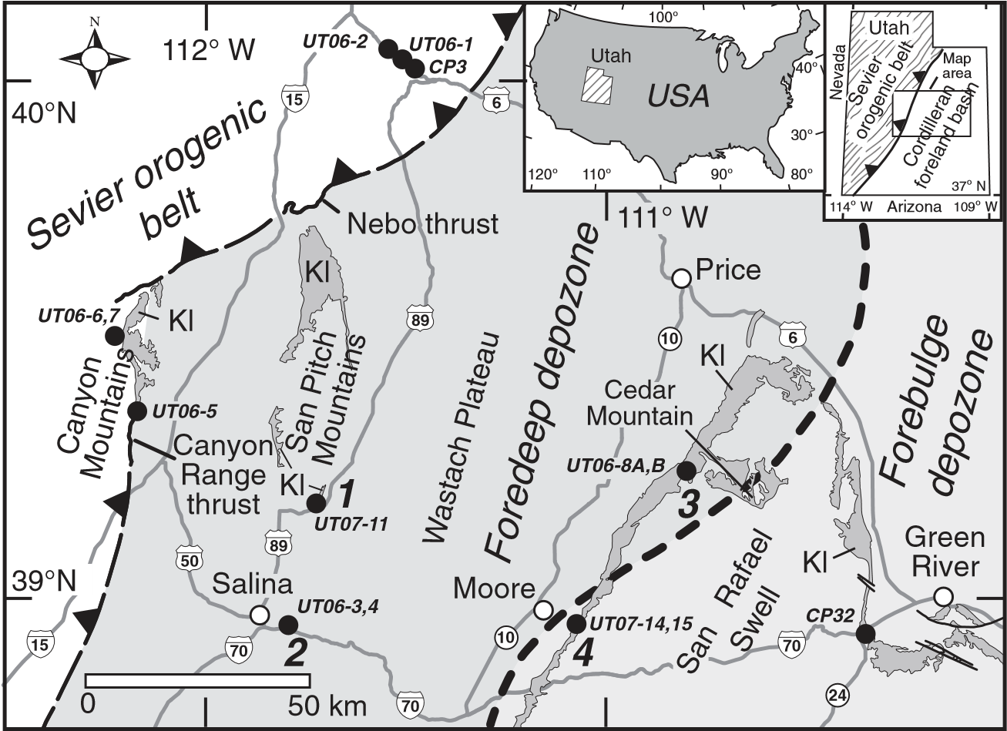

**Figure 1. Location map of central Utah, indicating distribution of Lower Cretaceous strata (Kl, which includes some Upper Cretaceous rocks in San Pitch Mountains), detrital zircon sample locations (black dots), and stratigraphic sections of Figure 4 (bold numerals). Adapted from Hintze et al. (2000). Early Cretaceous foredeep/forebulge depozones after Currie (2002); boundary indicated by dashed bold line.**

|  |  |
| --- | --- |
| (Fig. 2). These populations consist of grain age groups present in a merged data set of individual DZ analyses (n = 807) from eight separate synorogenic conglomerate samples (Figs. 3 and 4). The populations are (1) Archean grains | (ca. 3400–2500 Ma) with age peaks near 2773 and 2728 Ma, (2) older Paleoproterozoic grains (ca. 2124–1750 Ma) with a minor peak near 2092 Ma and a dominant peak near 1850 Ma, (3) younger Paleoproterozoic grains (ca. 1745– 1600 Ma) with a peak near 1707 Ma, (4) older |

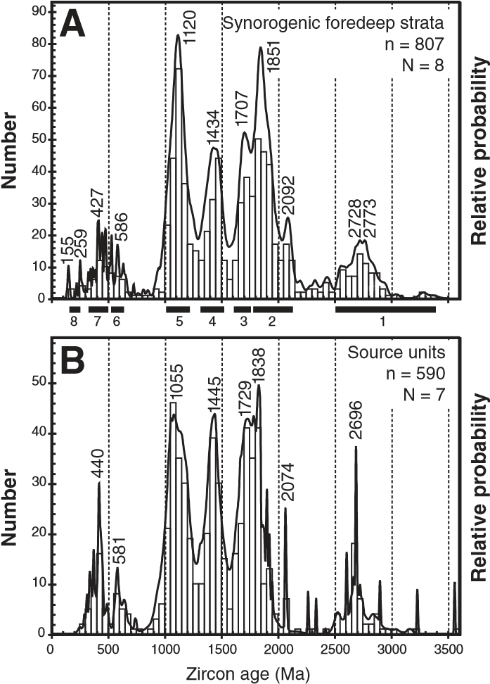Mesoproterozoic grains (ca. 1510–1320 Ma) with a peak near 1434 Ma, (5) younger Mesoproterozoic grains (ca. 1265–1000 Ma) with a peak near 1120 Ma (informally abbreviated as Grenville grains for their dominant ultimate source in the Grenville orogen and their near omnipresence in North American DZ data sets; e.g., Dickinson and Gehrels, 2003; Moecher and Samson, 2006), (6) Neoproterozoic–Early Cambrian grains (ca. 643–517 Ma) grains with peaks near 642, 586 and 536 Ma, (7) early Paleozoic grains (ca. 500–330 Ma) with multiple peaks, and (8) a small population of latest Paleozoic to Mesozoic grains (ca. 265–154 Ma) with a

peak near 155 Ma. Broad age spans in Archean, Paleoproterozoic, and Mesoproterozoic populations result from generally large analytical errors for grains older than 1000 Ma relative to grains younger than 1000 Ma (e.g., Gehrels, 2000) (Table DR1).

Signifi cantly, not all eight grain age populations are present in each foredeep sample; more-

**Figure 2. U-Pb relative probability age dis-** over, the age populations that are present vary

**tributions and histograms of synorogenic** among samples and serve to differentiate sets of

**foredeep strata (A) and thrust belt source** samples (Fig. 3). Accordingly, we herein defi ne

**units (B). Numbered age populations il-**

the term *chronofacies* as a group of sedimentary

**lustrated by bars, discussed in text, were**

**derived from analyses in A. N—number of** rocks that contains a specifi ed suite of DZ age

**samples; n—number of U-Pb analyses.** populations. The synorogenic samples contain

464

three such population suites, termed chronofacies A–C: (1) Chronofacies A contains a spread of Paleoproterozoic grains, some Archean grains, and groups of grains in the Neoproterozoic and early Paleozoic (samples UT06-8A and -8B, UT07-10 and -16); (2) chronofacies B contains rare Grenville grains, a prominent group of Paleoproterozoic grains with a peak near 1850 Ma, and Archean grains (samples UT06-4, UT07-9 and -15); (3) chronofacies C contains three prominent Proterozoic grain populations with peaks near 1750 Ma, 1450 Ma, and 1140 Ma (samples UT06-3, UT07-11 and -14). Some samples in chronofacies A also contain

Mesozoic grains (samples UT06-8B and UT0716). Most samples have prominent populations of Grenville grains, which are present in almost all Proterozoic quartzite formations of western North America (e.g., Stewart et al., 2001) (Fig. 3); therefore it is noteworthy that Grenville grains are rare in Cedar Mountain samples (UT06-4 and UT07-15, Fig. 3).

Proterozoic through Mesozoic strata in the thrust belt can be divided into three distinctive provenance intervals with DZ age populations that generally correspond to those of the synorogenic units. Three samples, representing Pennsylvanian–Jurassic sandstones of the thrust belt, strongly resemble the DZ age distribution of chronofacies A (Fig. 3; Table DR2). Analyses of Ordovician sandstones from central Nevada (Gehrels and Dickinson, 1995) contain Archean grains and a prominent Paleoproterozoic group with an age peak near 1850 Ma, similar to the grain age distributions observed in the synorogenic Cedar Mountain samples. The Proterozoic Caddy Canyon Quartzite and Lower Cambrian Prospect Mountain Quartzite have a distinctive trimodal Proterozoic DZ age distribution matching that of chronofacies C in the two youngest synorogenic conglomerate samples. Our Devonian quartzite sample (UT06-5) does not conform well to the composition of chronofacies B, resembling instead the trimodal grain age distribution of chronofacies C, and may explain the grain age distribution in our basal Cedar Mountain sample (UT06-4, Fig. 3), which contains an age peak near 1400 Ma and age populations around 2950 and 1850 Ma.

# DISCUSSION

Our data indicate that the three DZ chronofacies of the synorogenic foredeep deposits contain zircon grains derived from different combinations of source units, termed provenance intervals A–C, in the Sevier orogenic belt (Fig. 4). Provenance interval A, with Neoproterozoic and Paleozoic grains and a diverse population of older Proterozoic grains, spans Pennsylvanian, Permian, and Jurassic sandstones, which contain a similar spectrum of grain ages. The type Buckhorn Conglomerate

GEOLOGY, May 2010

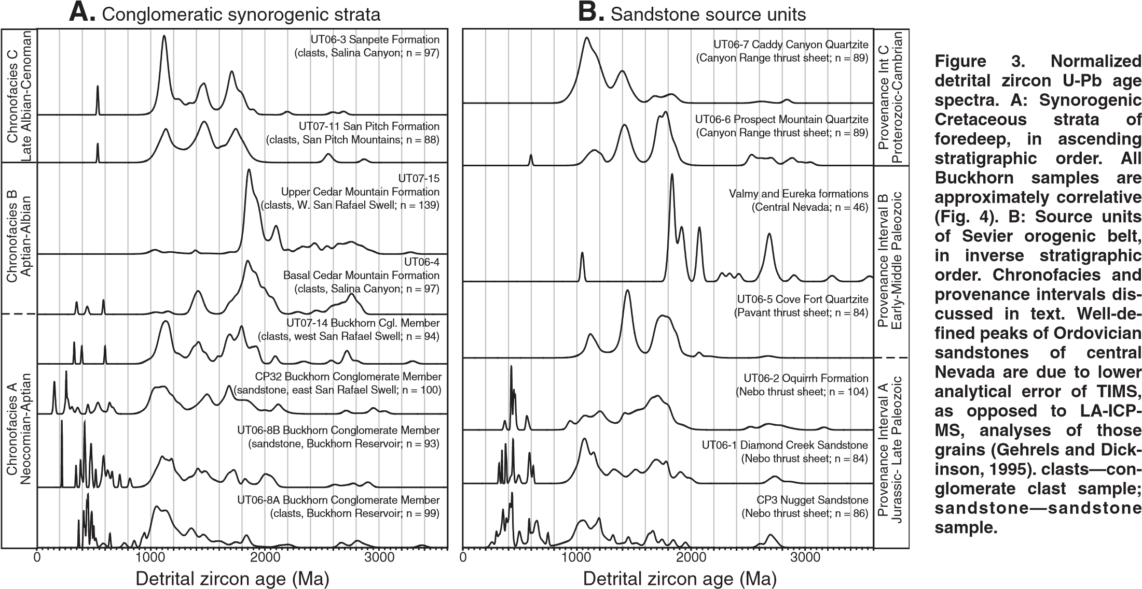

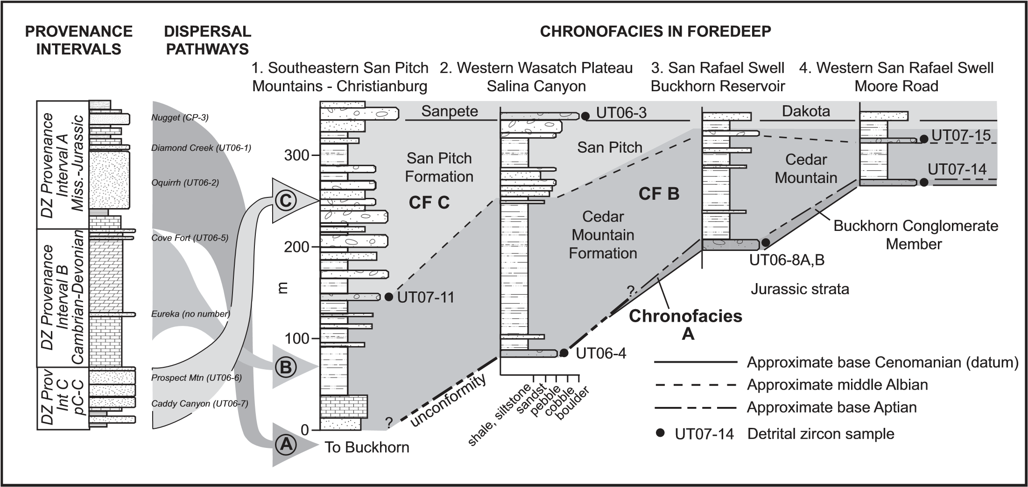

**Figure 4. Model for detrital zircon (DZ) provenance intervals in source units of thrust belt (left column), dispersal pathways (arrows), and stratigraphic distribution of chronofacies (CF) in foredeep of Cordilleran foreland basin. Source unit samples indicated adjacent to source unit column. Proterozoic–Devonian of Canyon Range thrust plate and localities to west adapted from Hintze and Davis (2003); Mississippian–Jurassic of Nebo thrust plate adapted from Hintze (1988). Age boundaries of synorogenic strata adapted from Sprinkel et al. (1999) and Greenhalgh and Britt (2007). Section locations in Figure 1. Sections 1 and 2 from Sprinkel et al. (1999); section 3 from Stokes (1952). Sample CP32, collected southeast of Cedar Mountain (Fig. 1) correlates with UT06-8A, UT06-8B, and UT07-14.**

|  |  |  |
| --- | --- | --- |
| contains these grain ages in both sandstone interbeds (UT06-8B, CP32) and conglomerate clasts (UT06-8A), indicating that the Permian or Jurassic eolianites were locally suffi ciently indurated to yield clasts. Thus, chronofacies A | contains detritus derived from provenance interval A of an incipiently eroded thrust belt.  Provenance interval B, containing two populations of Paleoproterozoic grains and common Archean grains, is defi ned to include | lower Paleozoic quartzite units, particularly the Eureka Quartzite in Nevada and Utah, and the Valmy Formation, a deepwater equivalent of the Eureka, in Nevada. The corresponding chronofacies B was deposited in the foredeep |
| GEOLOGY, May 2010 |  | 465 |

prior to widespread exposure of Proterozoic and lowermost Paleozoic strata in the thrust belt, because those source units contain abundant Grenville grains, which are scarce in chronofacies B. Chronofacies B deposits in the foreland therefore record intermediate erosion of the thrust belt down to strata of the lower to middle Paleozoic.

Provenance interval C includes Neoproterozoic and lowermost Paleozoic quartzites in the thrust belt, with a prominent trimodal population of Paleoproterozoic and Mesoproterozoic grain ages. Chronofacies C deposits in the foredeep, with a similar age distribution and typically composed exclusively of quartzite clasts, thus indicate widespread exposure of Proterozoic quartzite strata in the thrust belt.

The use of DZ chronofacies has the potential to better defi ne exposure gates in thrust sheets and document their along-strike variability in thrust orogens. For example, Proterozoic quartzite clasts have been reported from the basal Cedar Mountain Conglomerate, a representative of chronofacies B in Salina Canyon (section 2, Fig. 4) (Currie, 2002). The conglomerate also contains upper Paleozoic chert clasts and clasts of silicifi ed wood likely derived from Triassic strata. The absence of Grenville zircons in this conglomerate indicates that Proterozoic or Lower Cambrian strata were not yet unroofed in the Sevier orogenic belt and precludes the scenario that the whole preorogenic section, roughly 16,000 m of strata, was exposed when the lowermost preserved synorogenic conglomerate was deposited.

Whether these geochronologic provenance distinctions can improve conglomerate correlations remains to be determined. The boundary between chronofacies B and C crosses a correlation line between sites in the San Rafael Swell (sections 3 and 4, Fig. 4), indicating possible miscorrelation and a need for more detailed sampling. In addition, chronofacies A remains undetected in thick western sections of the foredeep (Fig. 4). This may have resulted from sediment bypass at the base of the section (indicated by an unconformity in the western section of Fig. 4), or from along-strike variation in structure and stratigraphic exposure in the thrust belt.

# CONCLUSIONS

Synorogenic conglomerates in the foredeep of the Cordilleran foreland basin in central Utah composed of quartzite clasts and mixed populations of chert, carbonate, and quartzite clasts contain different DZ U-Pb age distributions. The synorogenic deposits have eight discrete DZ age populations ranging in age from Archean through Mesozoic. These grain age populations

466

are also present in the formations that provided sediment to the foreland basin. The individual grain age populations combine with one another to form distinctive groups, termed chronofacies, that record systematic progressive erosion through three corresponding provenance intervals in the adjacent Sevier orogenic belt.

## ACKNOWLEDGMENTS

DZ analyses funded by the Institute of Tectonic Studies and Manasse Endowed Chair, New Mexico State University, and the Utah Geological Survey. National Science Foundation grant EAR-0443387 supported the Arizona LaserChron Center. We thank J.M. Amato, W.R. Dickinson, K.A. Giles, T.C. Peryam, M.C. Pope, and V.A. Valencia for discussions and assistance. Reviews by D.L. Barbeau, A.D. Hanson, and an anonymous reviewer substantially improved the manuscript.

## REFERENCES CITED

Currie, B.S., 2002, Structural confi guration of the Early Cretaceous Cordilleran foreland-basin system and Sevier thrust belt, Utah and Colorado: Journal of Geology, v. 110, p. 697–718, doi: 10.1086/342626.

DeCelles, P.G., 1988, Lithologic provenance modeling applied to the Late Cretaceous synorogenic Echo Canyon Conglomerate, Utah: A case of multiple source areas: Geology, v. 16, p. 1039–1043, doi: 10.1130/0091-7613(1988)016<1039:LPMATT >2.3.CO;2.

DeCelles, P.G., and Coogan, J.C., 2006, Regional structure and kinematic history of the Sevier fold-and-thrust belt, central Utah: Geological Society of America Bulletin, v. 118, p. 841– 864, doi: 10.1130/B25759.1.

DeCelles, P.G., Lawton, T.F., and Mitra, G., 1995, Thrust timing, growth of structural culminations, and synorogenic sedimentation in the type Sevier orogenic belt, western United States:

Geology, v. 23, p. 699–702, doi: 10.1130/0091 -7613(1995)023<0699:TTGOSC>2.3.CO;2.

Dickinson, W.R., and Gehrels, G.E., 2003, U-Pb ages of detrital zircons from Permian and Jurassic eolian sandstones of the Colorado Plateau, USA: Paleogeographic implications: Sedimentary Geology, v. 163, p. 29–66, doi: 10.1016/S0037 -0738(03)00158-1.

Dickinson, W.R., and Gehrels, G.E., 2008, Sediment delivery to the Cordilleran foreland basin: Insights from U-Pb ages of detrital zircons in Upper Jurassic and Cretaceous strata of the Colorado Plateau: American Journal of Science, v. 308, p. 1041–1082, doi: 10.2475/10.2008.10.

Dickinson, W.R., and Gehrels, G.E., 2009, U-Pb ages of detrital zircons in Jurassic eolian and associated sandstones of the Colorado Plateau: Evidence for transcontinental dispersal and intraregional recycling of sediment: Geological Society of America Bulletin, v. 121, p. 408– 433, doi: 10.1130/B26406.

Gehrels, G.E., 2000, Introduction to detrital zircon studies of Paleozoic and Triassic strata in western Nevada and northern California, *in* Soreghan, M.J., and Gehrels, G.E., eds., Paleozoic and Triassic paleogeography and tectonics of western Nevada and northern California: Geological Society of America Special Paper 347, p. 1–17.

Gehrels, G.E., and Dickinson, W.R., 1995, Detrital zircon provenance of Cambrian to Triassic miogeoclinal and eugeoclinal strata in Nevada: American Journal of Science, v. 295, p. 18–48.

Gehrels, G.E., Valencia, V.A., and Ruiz, J., 2008, Enhanced precision, accuracy, effi ciency, and spatial resolution of U-Pb ages by laser ablation–multicollector–inductively coupled plasma–mass spectrometry: Geochemistry, Geophysics, Geosystems, v. 9, Q03017, 13 p., doi: 10.1029/2007GC001805.

Graham, S.A., and 14 others, 1986, Provenance modelling as a technique for analysing source terrane evolution and controls on foreland sedimentation, *in* Allen, P.A., and Homewood, P., eds., Foreland basins: International Association of Sedimentologists Special Publication 8, p. 425–436.

Greenhalgh, B.W., and Britt, B.B., 2007, Stratigraphy and sedimentology of the Morrison–Cedar Mountain formation boundary, east-central Utah: Utah Geological Association Publication, v. 36, p. 81–100.

Hintze, L.F., 1988, Geologic history of Utah: Brigham Young University Geology Studies Special Publication 7, 202 p.

Hintze, L.F., and Davis, F.D., 2003, Geology of Millard County, Utah: Utah Geological Survey Bulletin 133, 305 p.

Hintze, L.F., Willis, G.C., Laes, D.Y.M., Sprinkel, D.A., and Brown, K.D., 2000, Digital geologic map of Utah: Utah Geological Survey, scale 1:500,000, http://geology.utah.gov/maps/ geomap/statemap/pdf/digitalgeoutah.pdf (December 2009).

Lawton, T.F., Sprinkel, D.A., and Waanders, G.L., 2007, The Cretaceous Canyon Range Conglomerate, central Utah: Stratigraphy, structure and signifi cance: Utah Geological Association Publication, v. 36, p. 101–122.

Ludwig, K.R., 2005, Isoplot© 3.0 software: http:// www.bgc.org/isoplot_etc/software.html (December 2009).

Moecher, D.P., and Samson, S.D., 2006, Differential zircon fertility of source terranes and natural bias in the detrital zircon record: Implications for sedimentary provenance analysis: Earth and Planetary Science Letters, v. 247, p. 252–266.

Sprinkel, D.A., Weiss, M.P., Fleming, R.W., and Waanders, G.L., 1999, Redefi ning the Lower Cretaceous stratigraphy within the central Utah foreland basin: Utah Geological Survey Special Study 97, 21 p.

Stewart, J.H., Gehrels, G.E., Barth, A.P., Link, P.K., Christie-Blick, N., and Wrucke, C.T., 2001, Detrital zircon provenance of Mesoproterozoic to Cambrian arenites in the western United States and northwestern Mexico: Geological Society of America Bulletin, v. 113, p. 1343–1356, doi: 10.1130/0016-7606(2001)113<1343:DZPOMT >2.0.CO;2.

Stokes, W.L., 1952, Lower Cretaceous of Colorado Plateau: American Association of Petroleum Geologists Bulletin, v. 36, p. 1766–1776.

Walker, J.D., and Geissman, J.W., 2009, Commentary: 2009 GSA Geologic Time Scale: GSA Today, v. 19, no. 4, p. 60–61, doi: 10.1130/1052 -5173-19.4-5.60.

Manuscript received 11 September 2009

Revised manuscript received 4 December 2009

Manuscript accepted 13 December 2009

Printed in USA

GEOLOGY, May 2010

1. GSA Data Repository item 2010125, supplemental text, Table DR1 (U-Pb detrital zircon geochronologic analyses), and Table DR2 (KolomogorovSchmirnov P-values for compared pairs of detrital zircon probability spectra), is available online at www.geosociety.org/pubs/ft2010.htm, or on request from editing@geosociety.org or Documents Secretary, GSA, P.O. Box 9140, Boulder, CO 80301, USA.