**DEVELOPMENT OF TIGHTLY CEMENTED SANDSTONE LENSES IN UNCEMENTED SAND: EXAMPLE OF**

**THE FONTAINEBLEAU SAND (OLIGOCENE) IN THE PARIS BASIN**

ME´DARD THIRY AND BENOIˆT MARE´CHAL*

*Centre Informatique Ge´ologique, E´cole des Mines de Paris, 35 rue St. Honore´, 77305 Fontainebleau Cedex, France and CNRS-UMR 7619 Sisyphe ‘‘Structure et*

*fonctionnement des syste`mes hydriques continentaux’’*

*e-mail: thiry@cig.ensmp.fr*

**ABSTRACT: In the Fontainebleau Sand (Oligocene), superposed lenses of sandstone result from a silicification process controlled by the watertable during the recent geomorphologic evolution of the landscape. The most outstanding feature of these silicified bodies is the contrast they show between the very hard, tightly cemented sandstone and the loose and permeable embedding sand. This pattern raises the question of the growth mechanism of the lenses.**

**The lenses are composed of tightly quartz-cemented sandstone with well-developed quartz overgrowths. Cathodoluminescence of the sandstones shows detrital grains with subeuhedral quartz overgrowths and isopachous quartz rims surrounding the detrital grains or the overgrowths. The isopachous rims suggest amorphous or poorly ordered silica deposits that later recrystallized into quartz. The syntaxial overgrowths and the silica deposits alternate in a sequential way on a centimeter scale and reflect variations in the physicochemical characteristics of the feeding groundwater. The mechanism of the silica deposition is probably complex and can only be hypothesized. Whatever the mechanism, it appears from the arrangement of the sandstone layers that silica precipitation occurred near the watertable and at the interface between regional groundwater and local recharge water. Silica precipitation along an interface may explain the sharp boundary between cemented sandstone and loose sand.**

**The cementation was modeled with the coupled reaction-transport code METIS. The model was constrained with permeability values, hydraulic gradient, and dissolved silica contents measured in the Fontainebleau Sand. The simulation reproduced the characteristics and morphologies shown by the sandstone lenses in the field. It shows the importance of a high groundwater flow rate to provide the silica necessary for cementation of the sandstones in a time span compatible with the geological constraints. The conventionally accepted kinetics of quartz precipitation did not result in simulating cementation of the sandstone lenses in a geologically reasonable time frame. To overcome this constraint, it was necessary to increase the kinetic reaction rate about 1,000 times, which agrees with the amorphous silica deposits observed in the Fontainebleau Sandstones.**

# INTRODUCTION

Highly contrasting silicified patterns are not common diagenetic features in sandstones. Most commonly, sandstone silicification develops in subsurface realms in response to temperature and pressure elevation, or to pressure, gravitational, or convective fluid flow (McBride 1989; Bjørkum 1993; Bjørlykke 1994). Under these conditions, cementation is rather homogeneous, generally altering the whole sand unit on a regional scale. Cementation heterogeneities may result from heterogeneities in the primary sand (for example grain size or clay-mineral content), which cause relatively low porosity variation. Highly contrasting silicified patterns in sandstones are mainly restricted to surficial silicification, specifically groundwater and pedogenic silcretes (Millot et al. 1959; Macpherson 1986; Go¨tze and Walther 1995; Thiry and Milnes 1991; Thiry 1997).

|  |
| --- |
| * Present address: Ecole des Mines de St-Etienne, 158 Cours Fauriel, 42023 Saint-  Etienne Cedex 2, France  JOURNAL OF SEDIMENTARY RESEARCH, VOL. 71, NO. 3, MAY, 2001, P. 473–483 |

The Fontainebleau Sandstones are a simple and extreme example of such porosity variations: the sandstones form silica-cemented lenses of low permeability that are embedded in a loose uncemented permeable sand. The fabric and the geometry of these sandstone lenses can be studied in many quarries, allowing precise positioning of features with respect to the hydrological systems that governed the cementation of the sands.

The goal of this paper is to consider the mechanisms by which tightly silicified and impermeable sandstone lenses develop in uncemented and porous sand. Three particular aspects are examined here: (1) the petrography of the sandstone and its spatial development, (2) the mechanisms that prevail in this silicification and (3) modeling of the silicification to determine the constraints on fluid flow and silica deposition to achieve such cementation.

**THE FONTAINEBLEAU SAND AND SANDSTONES**

# Geological Setting

The Fontainebleau Sand is of Stampian (Oligocene) age and forms an unit 50 to 80 m thick. It overlies the Argiles Vertes and the Marnes a` Huitres and is overlain by the Calcaire d’Etampes and the Calcaire de Beauce (*s.l.*). The Calcaire de Beauce (*s.l.*) and the Fontainebleau Sand are deeply eroded by the hydrographic network (Fig. 1). On the northern edge of the Beauce Plateau, sands form steep slopes at least 50 m high; towards the south, beneath the Beauce Plateau, they thin and disappear. Burial of the Fontainebleau Sand never exceeded 100 m and, in many areas, was limited to a few tens of meters. This rules out the possibility of pressure and temperature elevation to explain diagenetic features (Thiry et al. 1988a).

The sands are composed almost exclusively of detrital quartz, deposited mainly in a marine environment; however, the top of the formation consists of eolian sands arranged in long parallel ridges (Dollfus 1911). Three distinct diagenetic facies occur, each directly related to their geomorphological position (Thiry et al. 1989).

* Near the outcrops, at the edge of the valleys and plateaus, sands are generally white and almost exclusively made of quartz.
* Beneath the plateaus, sands are most often beige, sometimes greenish or ochre; they contain clays (smectite and illite) and traces of feldspars and glauconite as well as quartz.
* Locally, beneath the plateaus and always below the watertable, sands are black or gray. In addition to quartz, these black facies contain feldspars, glauconite, carbonates, pyrite, and organic matter.

The dark sands correspond to the primary sedimentary facies. The white and beige facies result from oxidation and alteration of the dark facies by groundwaters and recharge waters (in this paper, recharge water refers to water that is moving downwards through the vadose zone to the watertable). The alteration is most intense in zones of groundwater discharge, near the outcrop where sands are strongly leached, resulting in sands composed exclusively of quartz (Thiry et al. 1989; Bariteau 1996).

# Regional Distribution of the Sandstones

Silicification in the Fontainebleau Sand has produced flat-lying and very tightly cemented sandstones. The silicified sandstones are contained in white sands, towards the top of the formation. The sandstones often form

Copyright q 2001, SEPM (Society for Sedimentary Geology) 1073-130X/01/071-473/$03.00

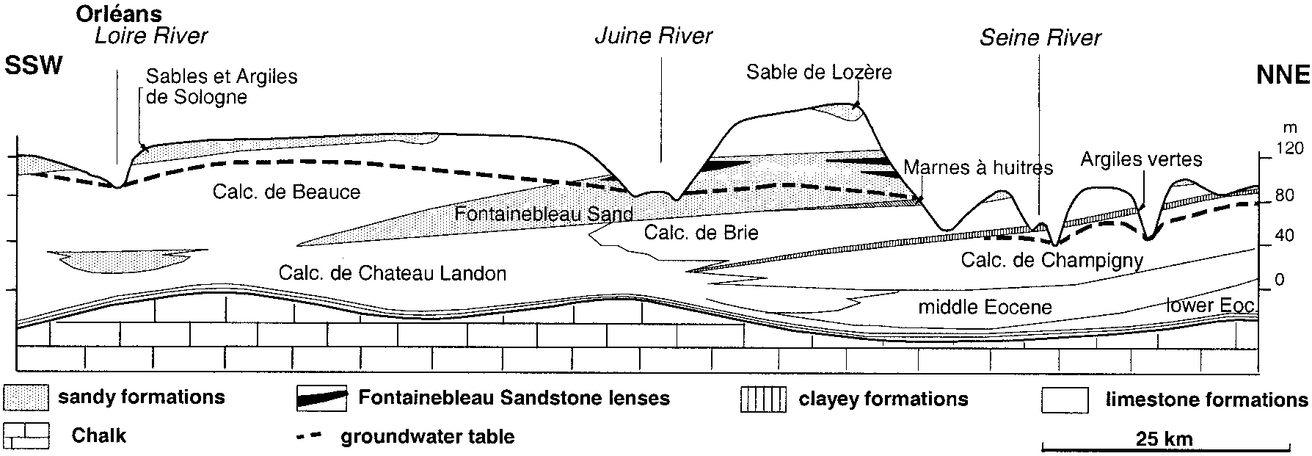

FIG. 1.—Hydrogeologic section of the Beauce Plateau. The Fontainebleau Sand forms a beveled layer between the Calcaire de Brie and the Calcaire de Beauce; the

Marnes Vertes, which form the impermeable footwall of the aquifer, have a more limited extension (according to Me´gnien 1979). The sandstone lenses are restricted to

the edges of the valleys.

superimposed subhorizontal lenses, ranging from 0.5 to 8 m in thickness and decameters to hectometers in length. Drill-hole data indicate that the sandstone lenses that crop out on the edges of the plateau and in the valleys do not extend beneath the calcareous cover of the plateau, where the sands are devoid of silicified bodies (Fig. 2). The thickest and most abundant sandstone lenses are found in secondary drainage incisions (Thiry et al. 1988b). The strong correlation between the localization of the silicified sandstone and the current geomorphology suggests a relatively recent (Plio–Quaternary) silicification, near the outcrop zones. The general arrangement of the sandstone in subhorizontal layers also suggests a control on their genesis by groundwater levels (Thiry et al. 1988a). Each sandstone level would correspond to an old groundwater level.

According to this model (Fig. 3), erosion removes the limestone cover along the valleys and brings the sands to outcrop. A first sandstone level can then be formed at the groundwater discharge zone. The incision of the landscapes continues and the watertable sinks in the sand formation, allowing the development of a second silicified level. In this model, the deepest sandstone lenses are thus the most recent. The fall of the watertable is responsible for the development of a bleached and leached zone and for the superposition of impermeable sandstone levels, embedded in loose sands.

# Arrangement and Morphologies of the Sandstone Lenses

Superposition of several silicified lenses is characteristic of the Fontainebleau Sand. Up to four principal levels can be present in the bleached sands above the watertable. The sandstone lenses are discontinuous and of variable size. The sandstone bodies can thus represent very different volumes, from some cubic decimeters to several thousands cubic meters. It is possible to distinguish relatively even layers, up to a few hundred meters long and approximately 2 m thick, as well as silicified masses less than one meter long. In detail, the cemented zones are often discontinuous and the silicified bodies arranged en echelon (Fig. 4).

The sandstone lenses have elongated, contorted morphologies with often asymmetrical profiles of airfoil-like shapes (one edge rounded, the other one thinning out), which clearly suggest horizontal fluid flow (Fig. 5). These structures are mainly elongated towards valleys, i.e. according to the direction of flow of the groundwater, suggesting that silicification is linked to paleohydrological flows. The sandstones are comparable to oriented carbonate concretions described in alluvial and sandstone formations and interpreted as evidence of the paleo-groundwater flow direction (Jacob 1973; Johnson 1989; McBride et al. 1994; Mozley and Davis 1996).

The sandstone lenses show botryoidal structures on their surfaces (Fig. 6A). These structures are formed of silicified ‘‘layers’’ that overlap each other (Mare´chal 1995). In some cases these outer layers are visible inside the sandstone, underlined by more strongly silicified fringes (Figs. 6B, 6C, 7). Generally, the continuity of these structures is not visible in the sandstone. The successive layers are highlighted at the edges of the sandstone bodies because of variations in the hardness of the silica cement (Fig. 8). They correspond to successive layers of silicification which enlarge or ‘‘aggrade’’ a silicified core.

# Petrography of the Sandstones

The sandstone lenses are made of quartz grains with well-developed overgrowths and a low residual porosity. The sandstone is very pure, without clay minerals and micas. The detrital grains are very clean and generally do not show impurities underlining the overgrowths. This makes it very difficult to estimate the volume of cement in the sandstones (Fig. 9A). The overgrowths are subhedral or sutured and have polygonal contacts. In places, mainly in the uppermost sandstone layer below the limestone cover, the overgrowths display very thin rims, which are distinguished only by slight

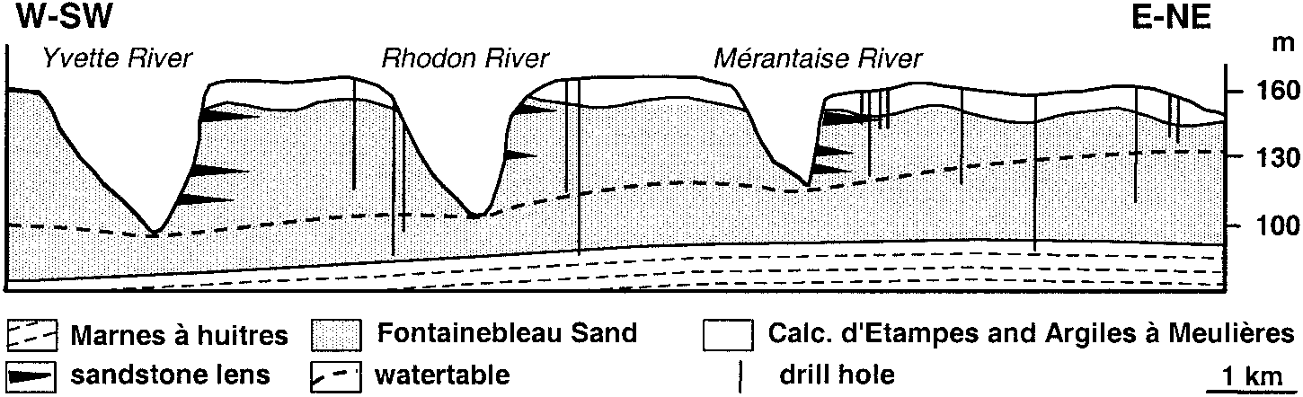FIG. 2.—Arrangement of the sandstone lenses in the Fontainebleau Sand on the dissected Beauce Plateau south of Paris. The sandstone lenses, which crop out on the edges of the plateaus and in the valleys, do not extend beneath the limestone-covered plateaus. Corehole data define both the extent of the sandstone lenses and the modern groundwater level.

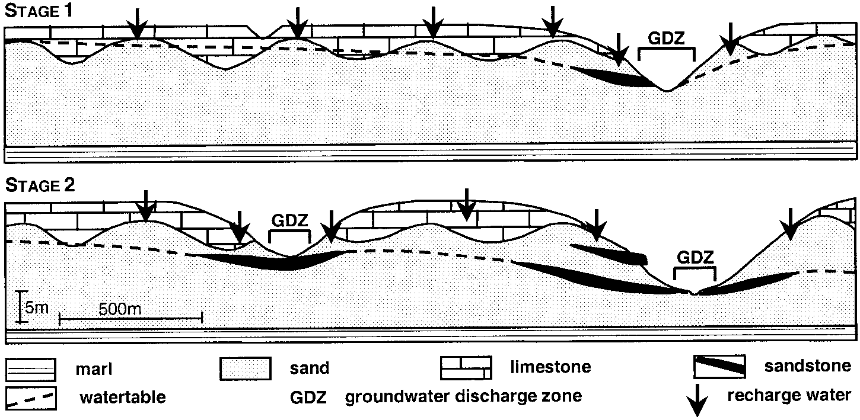FIG. 3.—Diagrammatic scheme of the successive stages of sandstone development in the Fontainebleau Sand related to the watertable levels during the downcutting of the valleys. The uppermost sandstone is the oldest, and the deeper lens the youngest (from Thiry et al. 1988a).

refringence variations under plane-polarized light (Fig. 9B). These rims are isopachous, of constant thickness, and develop either directly on the detrital grain or on the euhedral overgrowths. They often develop in a sequential way, with successive thinner and thicker rims, which occur throughout the whole thin section. These isopachous rims could not have formed as quartz overgrowths, which would have developed euhedral shapes. They probably are related to amorphous or poorly ordered silica deposits like opal, which later recrystallized syntaxially from the detrital grain. The development of euhedral quartz overgrowths following the deposition of the isopachous silica layers indicates that these layers were recrystallized early into quartz and before the development of the following quartz overgrowths, which precipitated in optical continuity with the detrital grains.

Cathodoluminescence highlights the detrital grains and allows quantification of overgrowths. Image analyses of cathodoluminescence pictures show that secondary quartz cement varies between 30 and 35% and that the residual porosity of the sandstones is often reduced to 2% (Mare´chal 1995; Mare´chal et al. 1996; Cooper et al. 2000). Three petrographic facies are distinguished in the silica cement.

* Subhedral overgrowths with successively luminescent (clear) and nonluminescent (dark) zones (Fig. 10A). The contacts between the neighboring overgrowths are rectilinear and convergent to triple junctions, shaping polygonal contacts between the overgrowths. These overgrowths are syntaxial around the detrital grains.
* Concentric rims of constant thickness, alternately clear or nonluminescent, wrap the detrital grains (Fig. 10B).They originally precipitated as amorphous or poorly crystallized silica deposits and later recrystallized to quartz.
* Some overgrowths show clear and dark radial zones along the overgrowths. These structures also are probably linked to recrystallization of a primary silica deposit, which would have developed in a centrifugal way starting from the detrital grain.

These various types of silica cement can coexist in a single silicified lens. In some cases, they follow each other in a sequential way. The subhedral overgrowths may be covered by silica deposits, which may be succeeded again by euhedral overgrowths. Dissolution features are also visible in some places between the successive silica deposits. Where developed, these microscopic sequences correspond to the macroscopic ‘‘layers’’ or fringes observed in some sandstones (Figs. 6, 7). They show the alternation of periods of cementation by quartz overgrowths, periods of amorphous silica deposits and, occasionally, periods of silica dissolution (Fig. 11).

The succession of these petrographic facies points to variable physicochemical conditions during the cementation of the sandstones, particularly the variation of the silica concentration in solution and the degree of supersaturation with respect to quartz.

# Chemistry of the Quartz Overgrowths

|  |
| --- |
| FIG. 4.—Arrangement of silicification in the quarry of Bonnevault, Larchant (77). The sandstone lenses are superposed and of very variable size. At least three sandstone levels are distinguished. In detail, the various lenses are at slightly different levels, like stairs. Digging out of the sandstone by sand quarrying reveals a preferential lengthening of the silicifications in the direction of the valley, which is NNE (arrow). |

Bruhn et al. (1996) and Pagel et al. (1996) determined the chemistry of the Fontainebleau Sandstones quartz overgrowths by SIMS (secondary ion mass spectrometry) and showed that they differ from those developed during burial diagenesis. The Al content of overgrowths in the Fontainebleau Sandstone lenses is lower than 30 ppm and well below Al content in burial quartz overgrowths (Pagel et al. 1996; Kraishan et al. 2000). On the other hand, the Fe contents of the overgrowths in the Fontainebleau Sandstone

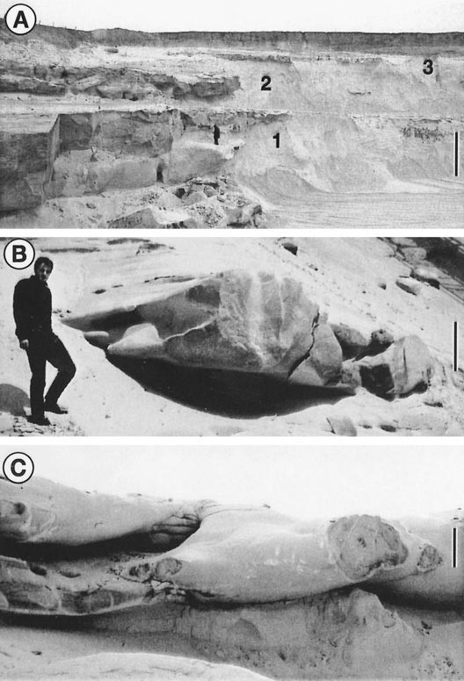

FIG. 5.—Silicification in the Fontainebleau Sand. **A)** Silicified zones in the Fontainebleau Sand occur as superposed sandstone lenses (labeled 1–3). Scale bar is about 5 m. **B, C)** Sandstone lens with typical airfoil-like shaped morphologies suggesting the paleohydrological flow direction towards the camera. Scale bar is about 0.50 m.

lenses are high. The clear overgrowths yield relatively high Fe concentrations of 98 to 192 ppm whereas the dark overgrowths have significantly lower Fe content, ranging between 12 and 59 ppm (Bruhn et al. 1996). Bruhn et al. (1996) suggest that the luminescent generation with high Fe contents may relate to precipitation in low pH and oxidized pore-waters owing to the presence of humic acids with considerable quantities of Fe31 available for substitution. The precipitation of the non-luminescent generation, on the other hand, may be the consequence of lower concentrations of Fe31 in the pore water, owing to enhanced decomposition of organic material, causing the decline in the Eh of the diagenetic milieu.

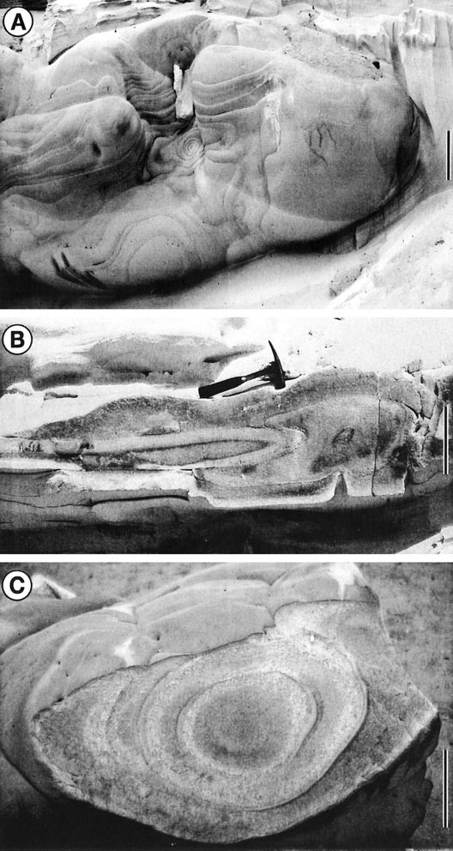

FIG. 6.—Internal structures of the silicified lenses. **A)** Botryoidal or ‘‘custardlike’’ shapes of silicified lenses. These features result from successive silicified layers that point to a centrifugal growth of the silicification. **B)** Silicified lens displaying zones fitting into each other that point to two successive silicification stages. **C)** Silicified lens with zones underlined by tightly cemented fringes that indicate a growth of the pan by successive silicified layers. The outer surface of the lens displays ‘‘custard-like’’ features related to these silicified layers. Scale bars are 0.20 m.

**MECHANISMS OF SILICIFICATION**

# Groundwater Chemistry

The current hydrochemistry of the Beauce groundwater basin is homogeneous, with a regional variation from the south towards the north (Table 1). This variation results from regional differences in groundwater pathways (Fig. 1; Bariteau 1996).

In the south, the groundwater is entirely contained in the Calcaire de Beauce and is a Ca-HCO3 water, with a pH of about 6.5. Its SiO2 content results from the alteration of the clay minerals contained in the Calcaire de Beauce and averages 14–17 ppm SiO2, and is thus supersaturated with respect to quartz and cristobalite.

In the north, where the calcareous cover is reduced, the groundwater is contained in sands. The recharge waters are less mineralized and gradually dilute the groundwater towards the discharge zones. The dissolved silica content of the groundwater decreases to 10–12 ppm SiO2 towards the outcrop zones. Near the groundwater discharge zones, the sands are outcropping and the recharge waters are more acidic and contain organic acids.

Thus, paradoxically, sands are cemented near the valleys where the

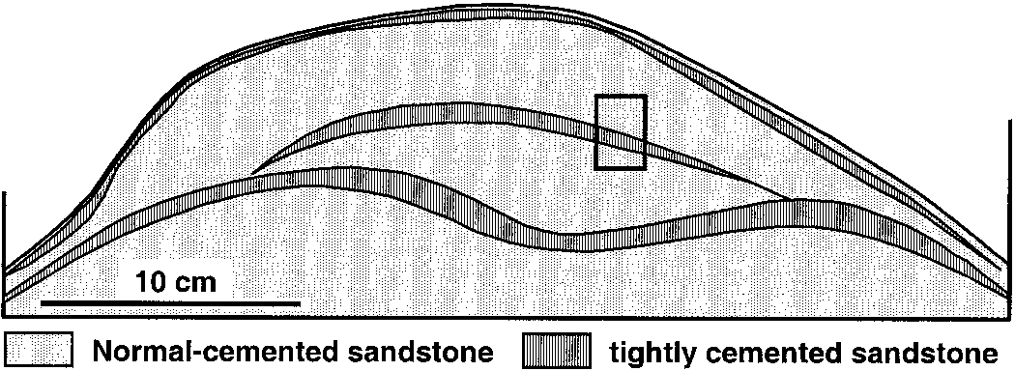

FIG. 7.—Successive zones of normal cemented sandstone emphasized by tightly silicified fringes of glassy aspect and devoid of porosity. The zonation reflects growth through the addition of successive silicified layers. The insert shows the position of the petrographic sequence illustrated by Figure 11.

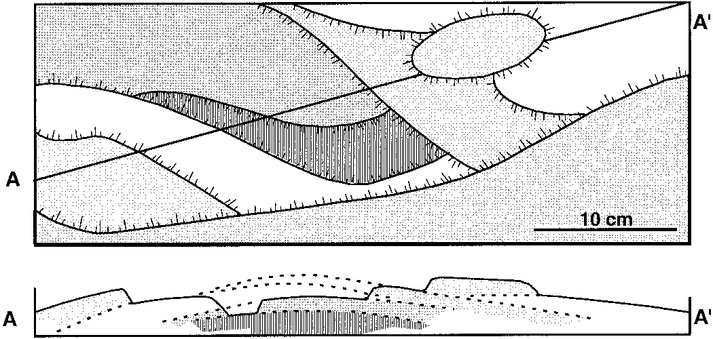

FIG. 8.—Schematic of botryoidal structures on the surface of a sandstone lens

groundwaters have the lowest silica content and neither silicification nor quartz overgrowth precipitation occurs beneath the limestone plateaus, where the silica content is the highest (well above quartz supersaturation). Mechanisms of silica deposition are probably complex, related to physicochemical variations within the groundwater near the discharge zones, possibly induced by mixing of recharge water and discharging groundwater. Two factors are likely to control silica precipitation: (1) the geochemical behavior of silica in solution and (2) physicochemical factors that influence the quartz growth.

# Solubility of Silica and Organic Complexes

Variations of the pH or temperature cannot explain silicification related to the Beauce groundwater; those are too weak to affect silica precipitation to a significant degree. It is necessary to consider a possible role of the organic matter. Indeed, some dissolved organic compounds can form complexes with silica and thus increase its solubility, like those that have been highlighted in the natural environment and reproduced in laboratory experiments (Bennett et al. 1988; Bennett and Siegel 1989; Fein 2000).

If such a mechanism is involved in the cementation of the Fontainebleau Sandstones, it is necessary to consider that these silico-organic complexes exist in the groundwater, then are altered (oxidized?) by mixing with downward-percolating recharge waters near the discharge zone. Indeed, the recharge waters always contain more dissolved oxygen than groundwater, but, at the same time, they are also slightly more acid and richer in organic compounds, mainly humic acids (Bariteau 1996). It can be hypothesized that the rapid breakup of such silico-organic complexes near the discharge zones may lead to strong silica supersaturation in the groundwater contained in the Fontainebleau Sand. This is the scenario hypothesized by Bruhn et al. (1996) for the control on Fe content of quartz overgrowths.

# Quartz Precipitation

Precipitation of siliceous mineral phases has been little studied, especially at low temperatures, because the development of quartz is very slow and difficult to achieve experimentally under surficial conditions. The precipitation of quartz, like that of other minerals, can be divided into three main stages (Baronnet 1988):

* aggregation of molecules in solution, forming a ‘‘cluster’’;
* increase in size of the cluster, which reaches a critical size, forming a nucleus or a germ;
* crystal growth starting from this germ.

The nucleation of quartz or other siliceous phases can be homogeneous (occurring within the solution) or heterogeneous (developing from the surface of a crystal). The formation of nuclei requires the overstepping of an energy barrier (Steefel and Van Cappelen 1990). This barrier is generally much higher for homogeneous nucleation than for heterogeneous nucleation. The relatively easier heterogeneous nucleation results in abundant

(upper diagram). These structures are due to successive silicified layers reflecting centrifugal ‘‘growth’’ of the silicification (lower diagram). Generally, the lenses show no internal structure.

development of overgrowths during sandstone cementation (McBride 1989; Steefel and Van Cappelen 1990).

The surface properties of the grains acting as nucleation sites are important in these nucleation problems. Some elements can inhibit or, on the contrary, improve precipitation on the grains. Laboratory and field observations suggest that equilibrium crystallization processes in nature are often modified by the presence of impurities in the solution, which act as crystallization inhibitors (Berner et al. 1978; Inskeep and Silvertooth 1988; Mucci et al. 1989; Cody 1991). Such inhibitors may prevent or reduce precipitation and crystal growth by very small concentrations of inhibitor molecules and/or alter the relative precipitation kinetics from a solution. Because inhibition affects crystallization processes by acting on solid-phase precipitates, it is responsible for the large degrees of supersaturation that

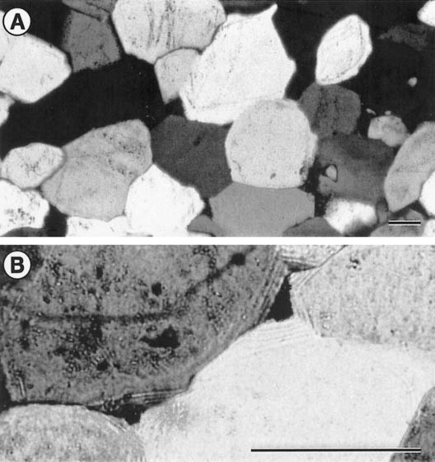

FIG. 9.—**A)** Sandstone fabrics show subhedral overgrowths sutured with polygonal contacts. The sandstone is very pure: only a few detrital grains are underlined with dust rims, and there are no clay minerals or micas. **B)** Isopachous rims, shown only when the light is slightly out of focus, are present within the quartz overgrowths. They suggest a primary noncrystalline silica deposit. Polars crossed. Scale bars are 500 mm in length.

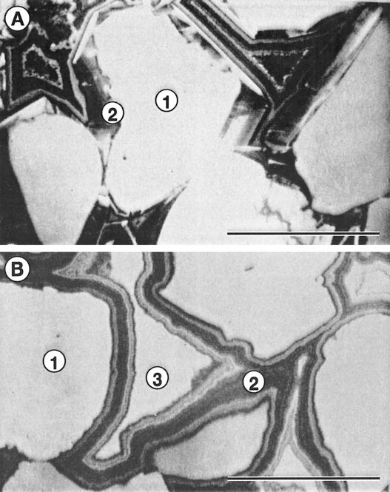

FIG. 10.—Cathodoluminescence of the silica cement. **A)** Subhedral overgrowths with successively luminescent (clear) and nonluminescent (dark) zones. These overgrowths are syntaxial overgrowths (2) around the detrital grains (1). **B)** Concentric isopachous overgrowths wrap the detrital grains. They formed as amorphous or poorly crystallized silica deposits. (1) detrital grain, (2) isopachous rims that have recrystallized into quartz, (3) final quartz cement occluding porosity. Scale bars are 100 mm in length.

exist in many sedimentary systems (Schneider and Herrmann 1980; Inskeep and Bloom, 1986). Crystallization inhibition, also referred to as adsorption poisoning, may be related to extremely small, substoichiometric concentrations (, 1 mg/l) of soluble organic substances, polyphosphates, and other compounds (Cody 1991). Such inhibition is a fundamentally different process from that of stochiometric complexation.

Thus, coatings on the surfaces of the quartz grains can prevent silica cementation: this is the case for chlorites, illite, carbonates, or iron oxides, which coat quartz grains (Heald and Larese 1974; McBride 1989; Ehrenberg 1993). Metallic ions such as Al31, adsorbed on the surface of the quartz grains, can also inhibit the crystal growth (Garcia-Hernandez 1981; Delmas et al. 1982; Merino et al. 1994). The ions adsorbed on the surface of the mineral, quartz in our case, may form a ‘‘barrier’’ that prevents the H4SiO4 molecules from ‘‘being grafted’’ on the existing crystal network. On the other hand, some ions may improve the mineral crystallization and act as catalysts for the crystalline growth.

# Precipitation of Amorphous Silica

Silica can precipitate in an amorphous form, obtained from the polymerization of H4SiO4, followed by aggregation of polymers to form colloids, and finally precipitation of colloids to form opal-A (Iler 1979; Williams et al. 1985; Chan et al. 1995). Polymer aggregation can be improved by the presence of some ions in solution and by the flocculation of colloids.

The distribution of the various silica cements in the Fontainebleau Sandstones probably relates to such quartz crystallization and silica flocculation phenomena. The relatively high supersaturation of silica with respect to quartz in the Beauce groundwater basin, where neither silicification nor quartz overgrowth are perceptible, has to be related to the properties of quartz grain surfaces and/or to the presence of ‘‘inhibiting’’ cations that prevent crystal growth on the detrital grains. In the nearby groundwater discharge zones, inflow of more diluted recharge waters with different geochemical properties (more acidic pH, presence of organic compounds, etc. . .) may modify the surface properties of the quartz grains and thus allow silica precipitation.

Speciation of silica in solution can occur in a similar way. Silica may be complexed within the groundwater, and observed silica supersaturation may be only ‘‘apparent’’. The recharge water may destroy these complexes and thus allow crystallization of quartz if silica is gradually ‘‘released’’

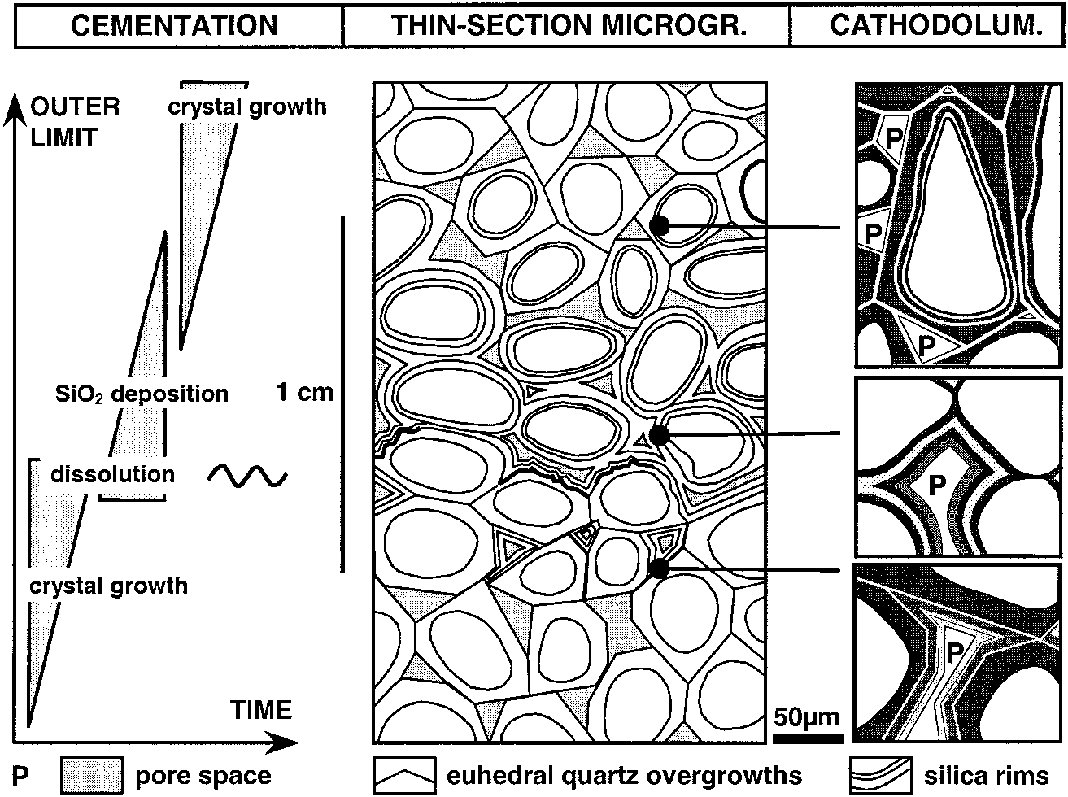FIG. 11.—Diagrammatic scheme of the succession of quartz overgrowths and silica deposits during cementation of the sandstones. The succession illustrates the growth of the silicified lens by centrifugal aggradation. See the position of the sequence in Figure 7.

without strong supersaturation or lead to the formation of colloids if the existing complexes are quickly destroyed, causing high supersaturations.

# Processes Considered

Only hypothetical and speculative processes, referring to quartz surface properties or complexation–decomplexation of silica in solution, can be made to explain silica precipitation in the Fontainebleau Sandstones near the groundwater discharge zones, even though water is relatively dilute there (Fig. 12). Whatever the mechanism considered, it appears that *silica precipitation occurs at the interface between groundwater and downwardpercolating recharge water* that flowed only through a thin limestone cover. Silica precipitation along this interface would also explain the straight edges of the silicified bodies, crossing, on a centimeter scale, from an unconsolidated sand to a tight, completely impermeable sandstone. In the same way, the successive envelopes that form the silicified bodies may be the expression of this interface where silica precipitates.

# Cementation and Fluid Flow

It is not conceivable that an impermeable sandstone lens of a few tens of centimeters (or even of several meters) thickness could develop in a single event, in a homogeneous and isotropic way. Indeed, from the very beginning of the cementation, the porosity and permeability of the sandstone are reduced and the groundwater flow is diverted around the incipient silicified core. Thus, it is difficult to imagine the transport to the silicified core of all the silica necessary to carry out cementation until its completion. As cementation begins, the zones of silicification are shifted and the final silicification leads to either weak cementation of the whole formation or to sandstone lenses with a weakly cemented core and a tightly cemented outer rim.

To obtain completely impermeable bodies silicified within a loose uncemented sand, it is thus necessary to imagine silicification, i.e., growth of the silica cement around a core. The sandstone lenses would thus develop in a centrifugal way. The structure of successive centimeter-scale layers observed in the sandstones and the cement sequences observed by cathodoluminescence would correspond to such a process of silica cementation by successive outer layers around a silicified core.

T

ABLE

.—

1

*MeanphysicochemicalcharacteristicsandchemicalcompositionsofthegroundwaterrelatedtotheBeauceaquiferfacies(fromBariteau1996).*

AquiferpHEhmV

mg/l

O

2(

aq

)

CaMgNaKHCO

3

ClSO

4

SiO

2

Al

BeaucelimestoneFormation6.7

6

0.4422

6

205.33

6

1.66115.83

6

12.423.889

6

0.4867.678

6

0.5283.597

6

1.486259.93

6

22.5719.39

6

3.0812.39

6

11.0514.18

6

1.925.23e-3

6

2.7e-3

FontainebleauSandFormation7.0

6

0.7388

6

525.63

6

1.4187.77

6

8.423.160

6

0.2436.437

6

0.9190.274

6

1.955244.06

6

21.9513.47

6

2.485.764

6

4.80310.21

6

0.36

.

## MODELING OF THE FOUNTAINEBLEAU SAND CEMENTATION

A coupled mathematical reaction-transport model was developed to simulate this kind of silicification, in order to clarify the influence of the various interrelated factors, especially flow rate, porosity, and kinetics, and to attempt a quantitative approach to the phenomenon.

# Formalization of the Modeling Procedures

The formation of the sandstone lenses is caused by a combination of groundwater flow (silicification in the discharge zones), transport of solutes (mixing of waters), and water–rock interactions. Fluid flow is governed by the diffusivity equation, transport of solutes by the dispersivity equation, and the water–rock interactions by thermodynamics and kinetics laws. Considering the small degree of knowledge of the real mechanisms of silica precipitation, and the need to generate silica cementation along an interface between two solutions, we chose to represent this interface by introducing an unspecified catalyst species. This catalyst, under particular conditions (i.e., a concentration higher than a given threshold), would make silica deposition possible if the water is supersaturated with respect to the silica phase. This approach, based on the concept of catalysis and inhibitor, is a simple way to account for the interactions between silica and other species in solution or onto quartz grains.

Precipitation, if sufficiently extensive, induces variations of porosity and permeability and has an influence on the subsequent flow and dispersion

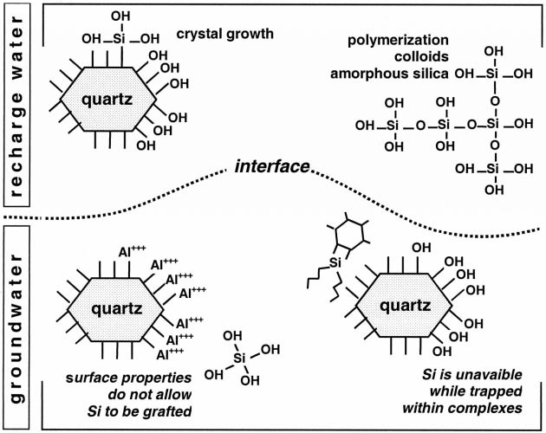FIG. 12.—Conceptual scheme illustrating the hypothesized mechanisms to explain changes in silica solubility and precipitation behavior with respect to quartz at the mixing interface of groundwater and recharge water in the discharge areas where sandstones develop.

of solutes. This feedback is taken into account by dividing simulations into successive cycles with constant porosity and permeability, including calculation of the flow, the dispersion of aqueous species, and the precipitation of silica. At the end of each cycle, a new porosity and permeability are established from assessment of the quantity of precipitated silica and the Kozeny-Carman law (Carman 1937), which is appropriate for pure quartz sands and sandstones. The duration of the calculation cycles was chosen in such a way that the variations in porosity and permeability cause only small disturbances of flow and dispersion during each cycle. Simulations were computed with the METIS code (Goblet 1989; Cordier and Goblet

1996).

The data used are from various studies on the Fontainebleau Sandstones and the Beauce groundwater (Fig. 13).

* Permeability, 1024 m/s (10,000 millidarcies); porosity 30%; lateral and vertical dispersivity 3 m and 0.3 m, respectively, according to the known orders of magnitude (Me´gnien 1979; Vinsot 1995).
* Groundwater flow rate 10 m/year at the upstream boundary; infiltration rate 100 mm/year (Me´gnien 1979).
* Chemistry of water: only two reactive species are considered: silica and catalyst. Silica was set to 20 ppm in the groundwater and decreasing in the recharge water from 20 ppm upstream to 6 ppm downstream, according to the thinning of the limestone cover towards the discharge zone (Bariteau 1996). Catalyst is absent in the groundwater and increases from 0 upstream to 1 arbitrary unit downstream in the recharge water, to reflect the increasing influence of organic and other compounds related to the sandy soils near the discharge zones.
* Kinetic and thermodynamic data from the literature were used (Lasaga 1984; Made´ et al. 1994).

These data have been applied to an aquifer 1000 m long and 20 m thick, corresponding to the bleached sands near the valleys (Mare´chal 1996).

# Results of the Simulations

A first set of simulations was computed considering a planar section. In this case, the calculated hydraulic gradient is quasi-linear from upstream to downstream and close to 0.5%, in conformity with the mean gradient known for Beauce groundwater. The dispersion of the two aqueous species implies opposite distributions: an increase of the catalyst concentration and a decrease of silica from upstream to downstream and from the bottom to the top of the aquifer. This reflects dilution of the groundwater by recharge waters. According to the simulated dispersion profiles, the threshold for the catalyst is chosen in order to allow precipitation of silica in the downstream part of the sandy layer (over 200 m long and 5 m high). The planar simulations show almost negligible porosity reduction (0.2%) over a long time (500,000 years) (Fig. 14A).

A second set of simulations was computed considering a cylindrical symmetry (radial simulations) (Fig. 14B). In this case, all the flow lines converge towards the center of the model, which could represent a spring or a well. The calculated piezometric surface is characteristic of a spring in a deeply incised valley. Downgradient, there is a strong discharge and the hydraulic gradient is locally very high, leading to higher flow velocity at the discharge area than in the planar case. However, the dispersion of catalyst and silica is not modified. The radial simulations of the flow for durations of 50,000 to 500,000 years show that the quantities of silica deposited are sufficient to induce a remarkable reduction of porosity and permeability in the zone of precipitation. Nevertheless, to reduce porosity below 10% in some cells of the model, it is necessary to use kinetic coefficients 100 or 1000 times greater than the published values. Such values are compatible with opal precipitation or silica flocculation processes. These results illustrate the importance of the lateral flow contributions (zone of convergence) in the cementation process.

Morphologies of the silicified zones obtained by the radial simulations show similarities with the sandstone bodies at the outcrop. The silicification develops around a core by successive layers. Moreover, the layers of equal porosity are slightly tilted upstream to downstream and follow roughly the curves of isoconcentration of solutes (Fig. 14B). However, simulations created only one continuous layer, whose texture is variable, whereas the Fontainebleau Sandstones are heterogeneous in size. To simulate this heterogeneity, the distribution of the catalyst was made more complicated and highly reduced in some cells (Fig. 14C). This prevents silica precipitation in the underlying cells. The absence of silica formation in some zones leads to the concentration of silica cement in a more limited part of the model: the mass of precipitated silica remains broadly the same but the reduction

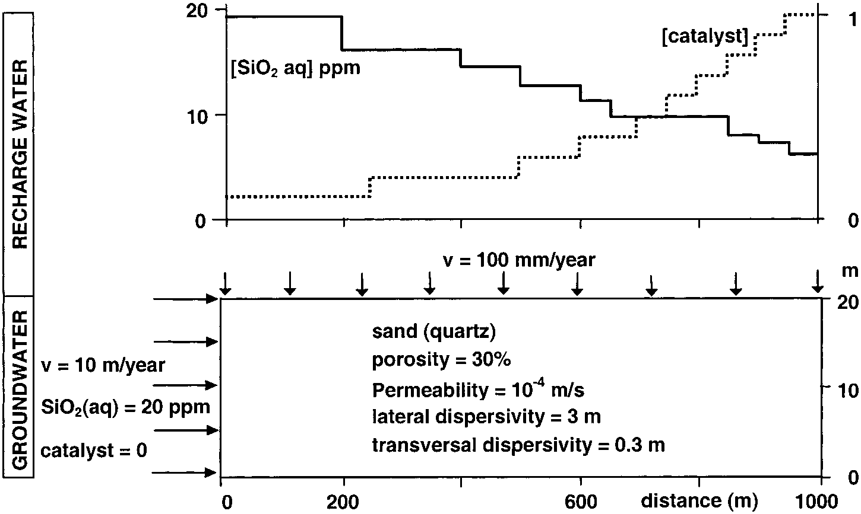FIG. 13.—Characteristics of the model and boundary conditions used for METIS simulation.

Note that the chemistry of the recharge water (upper diagram) changes from upstream to downstream according to thinning of the limestone cover and development of sandy soils near the discharge zone. See text for further explanation.

of porosity is greater (porosity , 2% in some cells). Moreover, the for- **DISCUSSION** mation of lenses from 40 to 100 m long and 5 m thick agrees better with the natural occurrence. The subhorizontal cemented bodies are lengthened The METIS code, updated with procedures of precipitation and texture in the direction of the flow and the tightly cemented cores deepen pro- (porosity and permeability) evolution, gives valuable results on the selected gressively downstream. Simulations thus carried out provide cemented mechanism of precipitation. Even if this mechanism is poorly understood, structures comparable to those within the Fontainebleau Sand. it is possible to reproduce some characteristics of the silicification in the

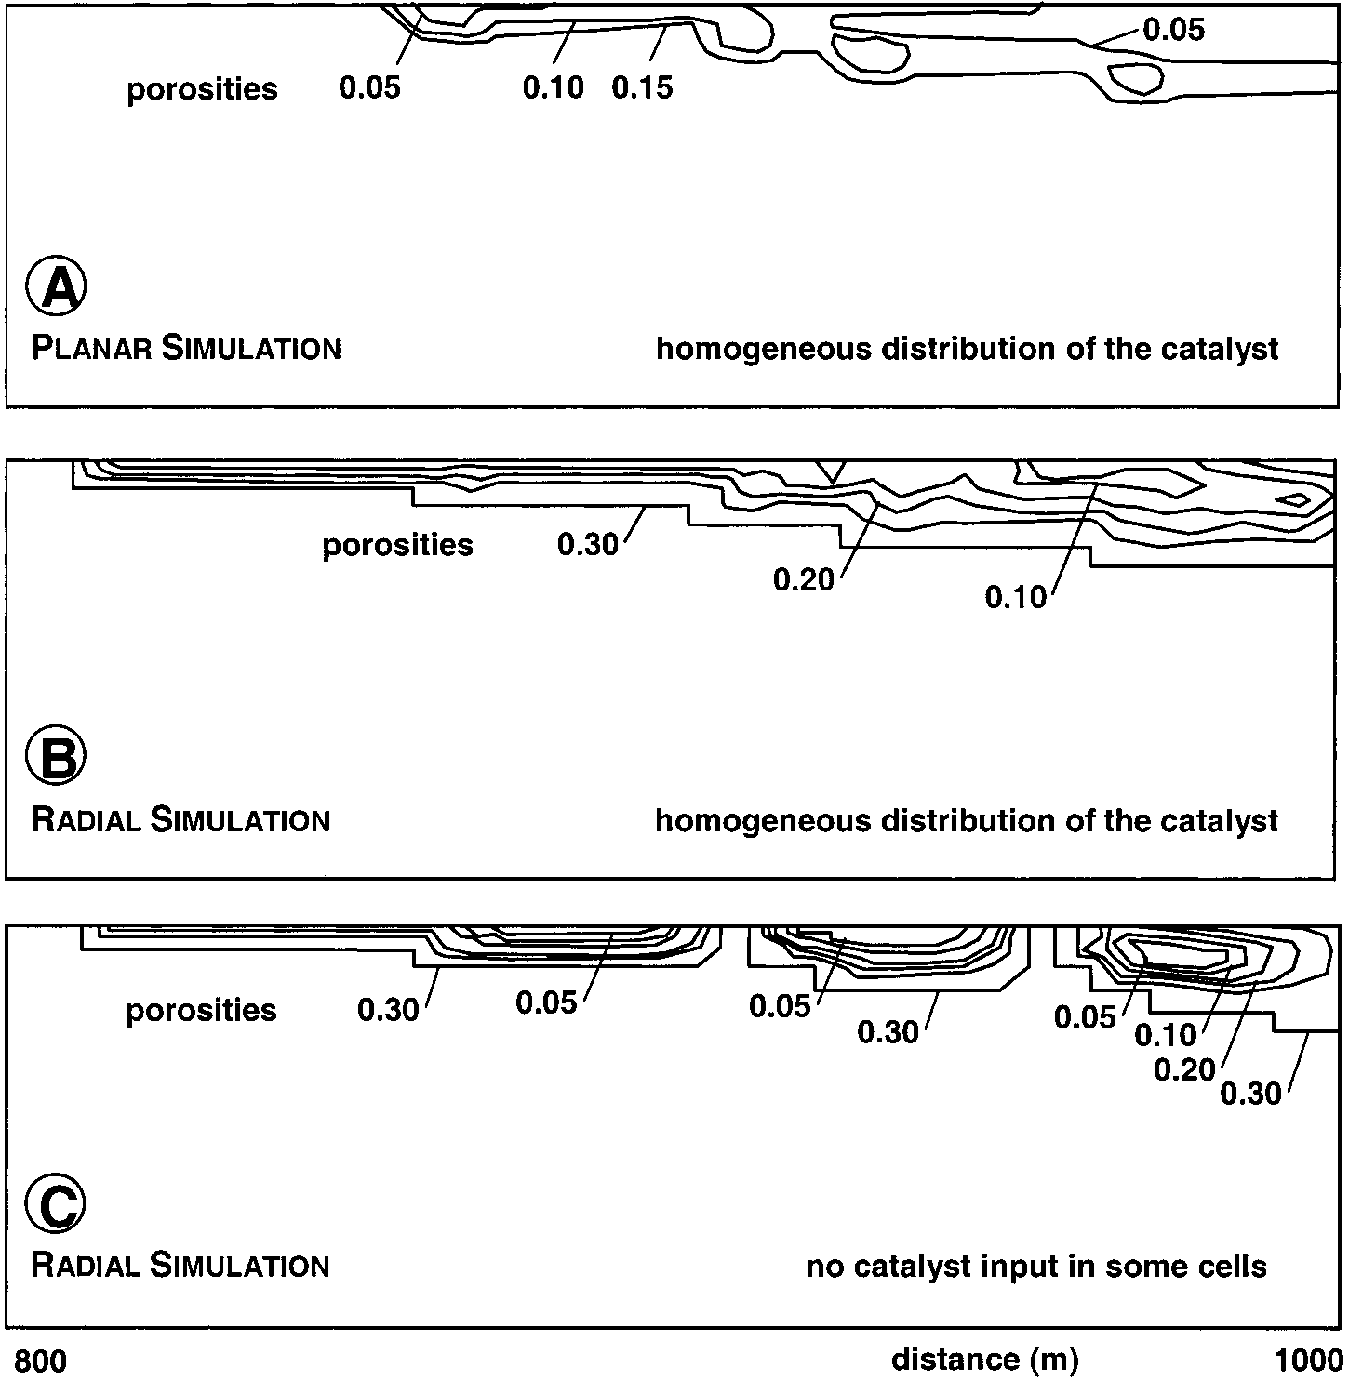FIG. 14.—Simulation of silica cementation at the groundwater/recharge water interface throughout 500,000 years. The planar simulation (A) shows only small porosity reduction whereas the radial simulation (B), with higher flow velocity at the discharge area, induces high reduction of porosity. The radial simulation provides cemented structures comparable to those observed at the outcrop. Uneven distribution of the catalyst (C) leads to formation of separate and more tightly cemented lenses, rather comparable to those of the Fontainebleau Sandstones.

Fontainebleau Sand: the location of the sandstone lenses in zones of strong groundwater discharge, their distribution, and their morphologies. Modeling thus consolidates the outline of formation of the sandstone lenses proposed by Thiry et al. (1988a).

Some questions remain. The precipitation mechanisms are not understood. Moreover, the modeled cementation of the sand does not match with field observations. The core of the simulated sandstone bodies is often tightly cemented, with porosities comparable with those in the natural occurrences, but the calculated external layers are not affected enough by precipitation. It is probable that a reduction of the size of the cells would create more abrupt silicification boundaries.

The simulation durations are relatively long but acceptable for the assumption of formation of silicified lenses associated with the downcutting of the valleys during the Plio–Quaternary. Water flow rate is the most critical parameter to fulfil mass balance and duration constraints, as has been shown previously by Canals and Meunier (1995).

## CONCLUSIONS

Fontainebleau Sandstones show that development of tightly cemented sandstone lenses, with very low residual porosity, within loose porous sands is achieved by centrifugal growth of the lenses. Cementation develops by cementing successive centimeter-scale layers that are superimposed on each other, with sharp boundaries between unconsolidated sand and tight sandstone. Because of this centrifugal development, silica intake is possible until complete occlusion of the porosity. This implies that the conditions of silica precipitation are fulfilled in a restricted zone, along a surface, i.e., at the interface between two solutions or possibly between a solid surface and a solution.

The conditions of silica precipitation vary during cementation, with alternating precipitation of amorphous silica and quartz growth, and even episodes of silica dissolution. These variations probably are related to fluctuations of the physicochemical conditions in the groundwater. The mechanisms of silica precipitation remain unsolved. Only processes involving surface properties of the quartz or complexation–decomplexation of silica in solution appear likely to explain silica precipitation in the Fontainebleau Sandstones.

A simplified simulation of the cementation, with a reaction-transport model, reproduced reasonably well the characteristics and morphologies shown by the sandstone lenses in the field: lengthened shapes, development around a tightly cemented core, and appropriate size and spatial distribution of the sandstone lenses. However, the generally accepted kinetic rates of quartz precipitation do not result in cementation of the sandstone lenses in a time period compatible with the geological constraints. To simulate the cementation in the assigned time, it was necessary to apply kinetics of silica precipitation approximately 1000 times higher than the kinetics of quartz precipitation. This agrees with the observed amorphous silica deposits in the Fontainebleau Sandstones. On the other hand, the simulations clearly show the necessity to have high groundwater flow rates in order to accumulate the reactive silica needed for cementation of the sandstones in a time span compatible with the geological constraints. This explains why the thickest and most numerous sandstone lenses are found in secondary drainage incisions where groundwater discharge flow lines converge.

## ACKNOWLEDGMENTS

This study has been supported by grants from the Centre National de la Recherche Scientifique (CNRS), Transfert dans les Bassins Se´dimentaires (TRABAS) Research Group, and TOTAL Expl.-Production Company. Discussions with the member of the TRABAS Group and especially with Ghislain de Marsily from Universite´ Paris VI and Fre´de´ric Sommer from TOTAL helped in emergence and maturation of numerous ideas developed in this review. The modeling benefited from advice and comments by Emmanuel Ledoux from the Ecole des Mines de Paris. The author thanks R.P. Major from University of Mississippi and R.H Worden from University of Liverpool for critical comments and thoughtful reviews, which improved and strengthened the manuscript. They also wish to thank Associate Editor P. Dutton and Editors D.A. Budd and J.B. Southard for their advice and language editing.

## REFERENCES

BARITEAU, A., 1996, Mode´lisation ge´ochimique d’un aquife`re: la nappe de l’Oligoce`ne en Beauce et l’alte´ration des Sables de Fontainebleau: Ecole Nationale Supe´rieure des Mines de Paris, Me´moires des Sciences de la Terre, Paris, v. 28, 178 p.

BARONNET, A., 1988, Mine´ralogie: Ed. Dunod, coll. Ge´osciences, 184 p.

BENNETT, P.C., MELCER, M.E., SIEGEL, D.I., AND HASSETT, J.P., 1988, The dissolution of quartz in dilute aqueous solutions of organic acids at 258C: Geochimica et Cosmochimica Acta, v. 52, p. 1521–1530.

BENNETT, P.C., AND SIEGEL, D.I., 1989, Silica-organic complexes and enhanced quartz dissolution in nature by organic acids, *in* Miles, R., ed., Water–Rock Interactions: Rotterdam, Balkema, p. 69–72.

BERNER, R.A., WESTRICH, J.T., GRABER, R., SMITH, J., AND MARTINS, C.S., 1978, Inhibition of aragonite precipitation from supersaturated seawater, a laboratory and field study: American Journal of Science, v. 278, p. 816–837.

BJøRLYKKE, K., 1994, Fluid-flow processes and diagenesis in sedimentary basins, *in* Parnell, J., ed., Geofluids; Origin, Migration and Evolution of Fluids in Sedimentary Basins: Geological Society of London, Special Publication 78, p. 127–140.

BJøRKUM, P.A., 1993, How important is pressure in causing dissolution of quartz in sandstones?: Journal of Sedimentary Petrology, v. 66, p. 147–154.

BRUHN, F., BRUCKSCHEN, P., MEIJER, J., STEPHAN, A., RICHTER D.K., AND VEIZER, J., 1996, Cathodoluminescence investigations and trace-element analysis of quartz by micro-PIXE: implications for diagenetic and provenance studies in sandstone: Canadian Mineralogist, v. 34, p. 1223–1232.

CANALS, M., AND MEUNIER, J.D., 1995, A model for porosity reduction in quartzite reservoirs by quartz cementation: Geochimica et Cosmochimica Acta, v. 59, p. 699–709. CARMAN, P.C., 1937, Fluid flow through granular beds: Institution of Chemical Engineers, Transactions, v. 15, p. 150–166.

CHAN, S.P., FRASER, D.S., CHENG, S.Y.S., XU, Y., AND KOGA, Y., 1995, Instability of SiO2 colloids and sorption of Ca21 ions: Clays and Clay Minerals, v. 43, p. 478–481.

CODY, R.D., 1991, Organo-crystalline interactions in evaporite systems: the effects of crystallization inhibition: Journal of Sedimentary Petrology, v. 61, p. 704–718.

COOPER, M.R., EVANS, J., FLINT, S.S., HOGG, A.J.C., AND HUNTER, R.H., 2000, Quantification of detrital, authigenic and porosity components of the Fontainebleau Sandstone: a comparison of conventional optical and combined scanning electron microscope-based methods of modal analyses, *in* Worden, R.H., and Morad, S., eds., Quartz Cementation in Sandstones: International Association of Sedimentologists, Special Publication 29, p. 89–101.

CORDIER, E., AND GOBLET, P., 1996, Programme METIS, simulation d’e´coulement et de transport miscible en milieu poreux et fracture, Version 2.0. Notice d’emploi: Ecole des Mines de Paris, Rapport, LHM/RD/96/08, 141 p.

DELMAS, A.B., GARCIA-HERNANDEZ, J.E., AND PE´DRO, G., 1982, Discussion sur les conditions et les me´canismes de formation du quartz a` 258C en milieu ouvert. Analyse re´actionnelle par voie cine´tique: Sciences Ge´oliques, Bulletin, v. 35, p. 81–91.

DOLLFUS, G.F., 1911, Feuilles de Fontainebleau et de Chateaudun au 80 000: Bulletin du Service de la Carte ge´ologique de France, 128, v. 21, p. 8–31.

EHRENBERG, S.N., 1993, Preservation of anomalously high porosity in deeply buried sandstones by grain-coating chlorite: examples from the Norwegian continental shelf: Association of American Petroleum Geologists, Bulletin, v. 77, p. 1260–1286.

FEIN, J.B., 2000, Experimental and field constraints on the role of silica-organic complexation and silica-microbial interactions during sediment diagenesis, *in* Worden, R.H., and Morad, S., eds., Quartz Cementation in Sandstones: International Association of Sedimentologists, Special Publication 29, p. 119–127.

GARCIA-HERNANDEZ, J.E., 1981, Interpre´tation cine´tique de la ge´ochimie de la silice a` basse tempe´rature (258C): Institut National de la Recherche Agronomique, Versailles, 213 p.

GOBLET, P., 1989, Programme METIS, simulation d’e´coulement et de transport miscible en milieu poreux et fracture´, Notice de conception: Ecole des Mines de Paris, Rapport, LHM/ RD/89/23, 124 p.

GO¨TZE, J., AND WALTHER, H., 1995, An integrated mineralogical and geochemical study on a silicified Miocene quartz sand: Zentralblatt fur Geologie und Pala¨ontologie, Teil 1, 1/2, p. 119–129.

HEALD, M.T., AND LARESE, R.E., 1974, Influence of coatings on quartz cementation: Journal of Sedimentary Petrology, v. 44, p. 1269–1274.

ILER, R.K., 1979, Chemistry of Silica: Solubility, Polymerization, Colloid and Surface Properties, and Biochemistry: New York, Wiley Interscience, 866 p.

INSKEEP, W.P., AND BLOOM, P.R., 1986, kinetics of calcite precipitation in the presence of watersoluble organic ligands: Soil Science Society of America, Journal, v. 50, p. 1167–1172.

INSKEEP W.P., AND SILVERTOOTH, J.C., 1988, Inhibition of hydroxyapatite precipitation in the presence of fulvic, humic, and tannic acids: Soil Science Society of America, Journal, v. 52, p. 941–946.

JACOB, A.F., 1973, Elongate concretions as paleochannel indicators, Tongue River Formation (Paleocene), North Dakota: Geological Society of America, Bulletin, v. 84, p. 2127–2132.

JOHNSON, M.R., 1989, Paleogeographic significance of oriented calcareous concretions in the Triassic Katberg Formation, South Africa: Journal of Sedimentary Petrology, v. 59, p. 1008– 1010.

KRAISHAN, G.M., REZAEE, M.R., AND WORDEN, R.H., 2000, Significance of trace elements composition of quartz cement as a key to reveal the origin of silica in sandstones: an example from the Cretaceous of the Barrow sub-basin, Western Australia, *in* Worden, R.H., and Morad, S., eds., Quartz Cemenation in Sandstones, International Association of Sedimentologists, Special Publication 29, p. 317–331.

LASAGA, A.C., 1984, Chemical kinetics of water–rock interactions: Journal of Geophysical Research, 89, p. 4009–4025.

MACPHERSON, G.L., 1986, Hydrochemistry of the Carrizo sand and the Wilcox Group in eastcentral Texas, *in* Kaiser, W.R., et al., eds., Geology and Ground-Water Hydrology of DeepBasin Lignite in the Wilcox Group of East Texas: University of Texas at Austin, Bureau of Economic Geology, p. 100–114.

MADE´, B., CLE´MENT, A., AND FRITZ, B., 1994, Mode´lisation thermodynamique et cine´tique des re´actions diage´ne´tiques dans les bassins se´dimentaires, Pre´sentation du mode`le KINDISP: Revue Institut Franc¸ais du Pe´trole, v. 49/6, p. 569–602.

MARE´CHAL, B., 1995, Etude de la cimentation des gre`s de Fontainebleau par cathodoluminescence et analyse d’image: Ecole des Mines de Paris, Rapport, LHM/RD/95/17, 52 p. MARE´CHAL, B., 1996, Mode´lisation de la cimentation des Sables de Fontainebleau: Ecole des Mines de Paris, Rapport, LHM/RD/96/40, 58 p.

MARE´CHAL, B., BLANC, P., DELOULE, E., PAGEL, M. AND THIRY, M., 1996, Quartz overgrowths in surficial groundwater silicification: the Fontainebleau Sandstone (Paris basin) (abstract): International Conference of Cathodoluminescence and Related Techniques in Geosiences and Geomaterials, Sept. 2–4, Nancy, Abstracts, p. 93–94.

MCBRIDE, E.F., 1989, Quartz cement in sandstones: a review: Earth-Science Reviews, v. 26,

p. 69–112.

MCBRIDE, E.F., PICARD, M.D., AND FOLK, R.L., 1994, Oriented concretions, Ionian Coast, Italy: evidence of groundwater flow direction: Journal of Sedimentary Research, v. A64, p. 535– 540.

ME´GNIEN, C., 1979, Hydroge´ologie du centre du bassin de Paris: Bureau de Recherche Ge´ologique et Minie`re, Paris, Me´moires, v. 98, 532 p.

MERINO, E., WANG, Y., AND DELOULE, E., 1994, Genesis of banded, fibrous, and twisted quartz by ‘‘catalysis’’, unstable crystallization fronts, and substitution: self-organization in agates: Mineralogical Magazine, v. 58A, p. 597–598.

MILLOT, G., RADIER, H., MULLER-FEUGA, R., DEFOSSEZ, M., AND WEY, R., 1959, Sur la ge´ochimie de la silice et les silicifications sahariennes: Bulletin du Service de la Carte ge´ologique d’Alsace-Lorraine, v. 12, p. 3–15.

MOZLEY, P.S., AND DAVIS, J. M., 1996, Relationship between oriented calcite concretions and permeability correlation structure in an alluvial aquifer, Sierra Ladrones Formation, New Mexico: Journal of Sedimentary Research, v. 66, p. 11–16.

MUCCI, A, CANUEL, R., AND ZHONG, S., 1989, The solubility of calcite and aragonite in sulfatefree seawater and the seeded growth kinetics and composition of the precipitates at 258C: Chemical Geology, v. 74, p. 309–320.

PAGEL, M., DEMARS, C., DELOULE, E., BLANC, P., AND BARBARAND, J., 1996, Cathodoluminescence and trace element distribution in authigenic quartz in sandstones: 1996 International Symposium of the Society of Core Analysts, Improving Reservoir Management, Proceedings, Montpellier, 8–10 September, 9613, 2 p.

SCHNEIDER, J., AND HERRMANN, A.G., 1980, Saltworks: natural laboratories for microbiological and geochemical investigations during the evaporation of seawater: Northern Ohio Geological Society, 5th Symposium on Salt, v. 2, p. 371–381.

STEEFEL, C.I., AND VAN CAPPELLEN, P., 1990, A new kinetic approach to modeling water–rock interaction: the role of nucleation, precursors, and Ostwald ripening: Geochimica and Cosmochimica Acta, v. 54, p. 2657–2677.

THIRY, M., 1997, Continental silicification: a review, *in* Paquet, H., and Clauer, N., eds., Soils and Sediments: Mineralogy et Geochemistry: Berlin, Springer, p. 191–221.

THIRY, M., BERTRAND AYRAULT, M., AND GRISONI, J.C., 1988a, Ground-water silicification and leaching in sands: Example of the Fontainebleau Sand (Oligocene) in the Paris Bbasin: Geological Society of America, Bulletin, v. 100, p. 1283–1290.

THIRY, M., BERTRAND AYRAULT, M., GRISONI, J.C., ME´NILLET, F., AND SCHMITT, J.M., 1988b, Les Gre`s de Fontainebleau: silicifications de nappes lie´es a` l’e´volution ge´omorphologique du bassin de Paris durant le Plio–Quaternaire: Bulletin de la Socie´te´ ge´ologique de France, se´rie 8, v. 4, p. 419–430.

THIRY, M., AND MILNES, A.R., 1991, Pedogenic and groundwater silcretes at Stuart Creek Opal Field, South Australia: Journal of Sedimentary Petrology, v. 61, p. 111–127.

THIRY, M., VINSOT, A., AND BERTRAND AYRAULT, M., 1989, Facie`s blancs et facie`s glauconieux sombres dans les Sables de Fontainebleau (Stampien, Bassin de Paris). Milieux de de´poˆt et pale´oalte´rations: 2e´me Congre`s Franc¸ais de Se´dimentologie, Paris, p. 279–280.

VINSOT, A., 1995, Analyse du fonctionnement ge´ochimique d’un aquife`re: e´tude de stockage de chaleur dans les Sables de Fontainebleau a` Trappes et dans les sables alluviaux re´cents (Lausanne): Ecole Nationale Supe´rieure des Mines de Paris, Me´moires des Sciences de la Terre, v. 24, 219 p.

WILLIAMS, L.A., ARKS, G.A., AND CRERAR, D.A., 1985, Silica diagenesis, I. Solubility controls: Journal of Sedimentary Petrology, v. 55, p. 301–311.

Received 7 April 2000; accepted 20 September 2000.