**CONTACT DIAGENESIS: THE EFFECT OF AN INTRUSION ON RESERVOIR QUALITY IN THE TRIASSIC SHERWOOD SANDSTONE GROUP, NORTHERN IRELAND**

JENNIFER M. McKINLEY1, RICHARD H. WORDEN2, AND ALASTAIR H. RUFFELL1

1. *School of Geography, Queen’s University, Belfast, BT7 1NN, U.K.*
2. *Department of Earth Sciences, The University of Liverpool, Brownlow Street, Liverpool, L69 3BX, U.K.*

**ABSTRACT: Intrusion of a dolerite sill into clay-bearing, arkosic Triassic Sherwood Group sandstones with moderate porosity (22%) and high but anisotropic permeability (mode 500 md) led to the progressive transformation of precursor diagenetic minerals. In the host rock, locally pore-filling Mg-rich smectite (saponite), quartz, and dolomite, existing in the rock following earlier burial diagenesis, reacted to produce grain-coating flakes of talc at the lowest contact temperatures (130– 180**8**C; based on equilibrium reaction-path and thermal-history calculations). At higher temperatures (200–230**8**C), talc reacted with calcite to produce an actinolitic amphibole. Close to the intrusion, at temperatures of** . **250**8**C, bundles of acicular needles of actinolite protruding into open pores were produced by a second reaction involving saponite, hematite, and calcite. Framework feldspar minerals (mainly K-feldspars) played little or no part in the reactions because there were no K-Al rich minerals produced by contact diagenesis and because the detrital feldspar grains are essentially unaltered. Thus while equilibrium may have been approached on the intrapore scale (**; **10** m**m), it was not achieved between grains (e.g., detrital feldspars), pore water, and clays in the pores. Total porosity has been unaffected by the intrusion and consequent mineral reactions, because reactions involved recrystallization of original pore-filling minerals. Despite the contact diagenetic changes in the rock, the permeability of the sandstone remained largely unaffected by intrusion.**

# INTRODUCTION

Porosity and permeability are key properties for any reservoir sandstone. Accurate measurement and prediction of these properties is important during exploration and appraisal of petroleum reservoirs because they profoundly influence the amount of petroleum in place and the rate at which it can be extracted. While it may be possible to broadly predict porosity and permeability (e.g., they tend to decrease with increasing burial), it is often important to predict both positive and negative anomalies. In many sedimentary basins, igneous intrusions are common (e.g., Manspeizer 1988, Triassic synrift igneous and volcanics; Darros de Matos 1992, Cretaceous fluvial redbeds with intrusives). The effects of intrusions on host sedimentary rocks fall outside the realm of normal burial diagenetic processes, although the maximum temperatures attained in the host rock may not be much greater than the temperatures of advanced burial diagenesis. The scale of thermodynamic equilibrium is at best severely limited in the host rock units, because the heating event may be very short-lived. This suite of processes in the host rock resulting from the intrusion of sills and dikes into sedimentary rock is referred to as ‘‘contact diagenesis,’’ which verges on contact metamorphism. Contact diagenesis occurs when small igneous bodies intrude sedimentary rocks, which promotes mineral alteration at temperatures below about 3008C. The effects fall into the realm of diagenesis because at the thin-section scale and larger the rocks may be far from thermodynamic equilibrium but retain well-preserved pore fabrics.

This paper discusses the effect of the intrusion of a 2-m-thick sill on sandstone reservoir properties and mineralogy. The key issues addressed concern the mineral reactions that occur in the sandstone, the involvement of both framework-forming mineral grains and pore-filling minerals in mineral reactions (e.g., scale of thermodynamic equilibrium), and the effects of mineral reactions on porosity and permeability of the host sandstone.

JOURNAL OF SEDIMENTARY RESEARCH, VOL. 71, NO. 3, MAY, 2001, P. 484–495

# BACKGROUND GEOLOGY

The Triassic Sherwood Sandstone Group (SSG, 220 Ma) comprises a series of continental red beds in the United Kingdom and Irish Continental Shelf. They were deposited in several discrete, rapidly subsiding, faultbounded basins that have maximum burial depths from , 1 km in basin margins to . 4 km in basin centers (Burley 1984). In Northern Ireland, (Fig. 1) the SSG is locally underlain by Lower Permian sediments and capped by the Upper Triassic Mercia Mudstone Group. It crops out locally but is presently most deeply buried in a basin centered on Lough Neagh (where it is up to 800 m thick) and underlies the Antrim coast (Parnell 1991). A maximum burial depth of about 2000 m was achieved for the SSG in later Mesozoic times (Shelton 1997). Maximum paleotemperatures may have reached 75–858C assuming a geothermal gradient of about 308C/ km (typical of many rift-related sedimentary basins in the late thermal subsidence stage; North 1985) and a surface temperature of about 18–308C (reasonable for subaerial temperatures in the early Tertiary; Frakes et al. 1992).

The study is concentrated on the SSG exposed at Scrabo Quarry in County Down, Northern Ireland (Fig. 1). Approximately 37 m thickness of nearly flat-lying sediments is exposed in the quarry. The SSG mainly comprises a succession of red or white, fine- to medium-grained arkosic sandstones with subordinate dark red-brown mudstones and siltstones. The sandstones exhibit medium- to large-scale planar and trough cross bedding, thought to represent dune forms in river channels (Buckman et al. 1998). In the finegrained sandstones and siltstones, ripples are preserved, some draped with mud, suggesting a shallow-water depositional environment with variable energy levels (e.g., Buckman et al. 1998; Wilson and Montgomery 1979). Some of the interbedded mudstones have polygonal mudcracks suggesting subaerial desiccation. Deposition occurred in a predominantly hot, seasonally arid, fluviatile environment. The SSG is an arkosic sandstone, dominated by detrital quartz and K-feldspar with trace amounts of muscovite mica, zircon, and tourmaline (Preston 1962).

Widespread igneous activity in the northeast of Ireland during the early Tertiary resulted in an intrusive complex of dikes and sills. A major early Tertiary (approx. 65 Ma) sill is well exposed in a sandstone quarry at Scrabo, from which a vertical traverse could be made and samples collected at progressively greater distances from the contact. The intrusion is composed of olivine dolerite (Bazley 1975), which suggests intrusion temperatures in excess of 11008C (Cox et al. 1979). The pressure at the time of contact diagenesis would have been about 180–210 bars assuming a hydrostatic pressure in these highly porous rocks.

**METHODOLOGY AND SAMPLE COLLECTION**

# Sampling

|  |
| --- |
| Copyright q 2001, SEPM (Society for Sedimentary Geology) 1073-130X/01/071-484/$03.00 |

Samples were collected from the abandoned quarry at Scrabo to provide information about the spatial variability of the effects of the intrusion on the sandstone. Initial field examination comprised visual inspection of all quarry faces, sedimentary logging and hand-specimen textural description, and measurement of sample sites from the intrusion. Samples for analysis were collected from a few centimeters below the intrusion and then at 1 m intervals out to 10 m along a vertical transect (lack of exposure limited sampling at 8 m and 7 m distances from the intrusion). The designation of Scrabo quarry as a SSSI (Site of Special Scientific Interest) meant that only

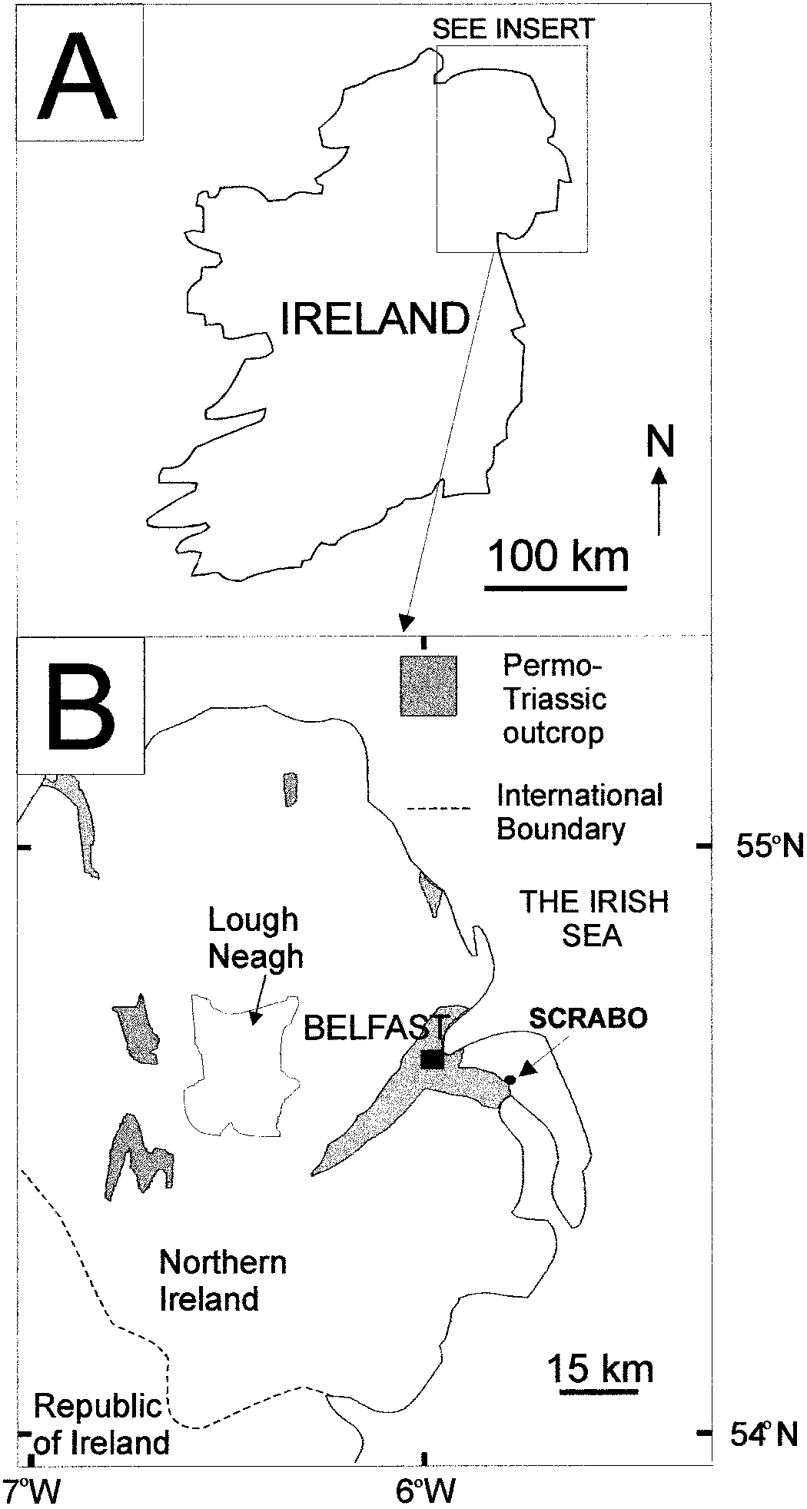

FIG. 1.—Location map: **A)** Map of Ireland with approximate location of the study area; **B)** map of Northern Ireland showing location of Scrabo and outcrop of Permo– Triassic sediments. Modified after Buckman et al. (1998).

1–2 samples could be taken at each sampling site. Lithofacies were characterized by grain size, sorting, and roundness, by sedimentary logs, and by bedform description of outcrop sketches. While these analyses revealed highly variable lithofacies associations at each sample site, no major systematic shift in facies was detected between positions adjacent to the intrusions and those up to 10 m away. A geochemical and petrographic comparison could be made between the samples at different distances from the sill because of the similarity in bulk mineralogy and characteristics.

# Petrographic Analysis

Thin sections (one per sample site, with the exception of one site where two samples were taken), impregnated with blue-dye resin to highlight porosity and stained for simple recognition of carbonate minerals (Dickson 1965), were studied by optical microscopy. Thin sections were point-counted to quantify detrital components, authigenic phases, and porosity. Mineral quantities and porosity derived from modal analyses were based on 400 point counts per section. The counting error for each grain, cement, or porosity type varies with the total number of points counted and the percentage of the constituent. At 95% confidence limits, a constituent that is 50% of the sample has an absolute error of up to 6 5%, whereas constituents that constitute 10% and 2% of the sample have absolute errors of 6 3% and 6 1.4% respectively (Van Der Plas and Tobi 1965). Broken rock surfaces were studied by scanning electron microscopy using a Joel Winsem JSM 6400 scanning microscope to determine mineral identification by mineral morphology. X-ray analysis, using an energy dispersive analyzer (EDS) attached to the SEM, permitted mineral identification. Back-scatter electron imaging of polished thin sections enabled further assessment of the occurrence and spatial distribution of minerals in the sandstone samples.

# Mineral Identification

X-ray diffraction (XRD) analyses were performed on all the samples with the use of a Siemens D5000 diffractometer using monochromatic Cu Karadiation (1.5418 A˚ ), with the X-ray tube voltage and current set at 40 kV and 40 mA respectively. The detector used was a scintillation counter. A 1 mm divergent slit, 0.6 mm detector slit, 1 mm anti-scatter slit and a graphite monochromator were used. Each bulk sample was scanned between 38 and 638 2 uwith a step size of 0.048 and a count time of 1 second per step, and rotated during the scan to ensure random sample orientation. Qualitative analysis of the data was performed using Diffrac-AT (v.3.0) software provided by Scobain Siemens and JCPDS data files on CD-ROM.

A simple separation method was used to concentrate the finer-grained fraction in order to better define the nature and relative quantities of ferromagnesian minerals (i.e., clay minerals and intra-pore plates and needles, discussed later). Pre-concentration involved chipping the sample into approximately 5 cm pieces, followed by gentle disaggregation of the sample with a mortar and pestle (intended to minimize crushing the framework grains). A sonic probe was used in an aqueous suspension of the disaggregated sample to help gently dislodge the fine mineral fraction from framework grains. The suspension of fine particles was decanted and then centrifuged to separate the solids from the de-ionized water. The mass of the fine material was measured by the difference between the original sample and the remainder (coarse fraction) of the disaggregated sample (after separation). XRD semiquantification was performed on the separated fines and compared with the bulk sample. The percentage amounts of the fine-fraction minerals were recalculated by reference to the fractional amount of the fine material. Amounts of carbonate minerals were calculated by selective dissolution of a weighed, crushed rock sample in dilute HCl for calcite and at 408C for dolomite followed by washing, drying, and reweighing.

# Electron Microprobe Analysis

Quantitative chemical analyses of individual minerals were generated using a Jeol 733 electron microprobe (EMP) fitted with a Link energy dispersion (EDS) system. Spectra obtained from samples, analyzed using EDS, were processed and corrected for ZAF factors (an iterative procedure correcting for the effects of atomic number, or Z, absorbance factors, or A, and fluorescence, or F) by a Link Analytical Systems AN1000 computer.

Polished, carbon-coated thin sections were analyzed using a 1 mm diameter electron beam at an accelerating voltage of 15 kV and a beam current of 15 nA. Grains were analyzed for 50 seconds (at a count rate of up to 2000 counts per second). A series of standards were used to check the precision and accuracy of the machine. Standards used in the study were: albite for Na and Al; wollastonite for Si and Ca; periclase for Mg; rutile for Ti; orthoclase for K; metallic iron and manganese for Fe and Mn,

|  |  |  |  |  |  |  |  |  |  |  |  |  |  |  |  |  |  |  |  |  |  |  |  |  |  |  |  |  |  |  |  |  |  |  |  |  |  |  |  |  |  |  |  |  |  |  |  |
| --- | --- | --- | --- | --- | --- | --- | --- | --- | --- | --- | --- | --- | --- | --- | --- | --- | --- | --- | --- | --- | --- | --- | --- | --- | --- | --- | --- | --- | --- | --- | --- | --- | --- | --- | --- | --- | --- | --- | --- | --- | --- | --- | --- | --- | --- | --- | --- |
| TABLE 1.—*Point-counting data based on 400 point counts per section.*   |  |  |  |  |  |  |  |  | | --- | --- | --- | --- | --- | --- | --- | --- | |  |  |  |  | Distance from Intrusion |  |  |  | | 10 m | 9 m | 6 m | 5 m | 4 m | 3 m | ,1 m | | monocrystalline quartz polycrystalline quartz microcline plagioclase perthite | 37.50 6 4.84  3.00 6 1.71  11.75 6 3.22  3.00 6 1.71  1.00 6 0.99 | 33.75 6 4.73  2.00 6 1.40  11.75 6 3.22  2.75 6 1.64  1.00 6 0.99 | 35.75 6 4.79  3.50 6 1.84  13.75 6 3.44  1.75 6 1.31  1.75 6 1.31 | 42.75 6 4.94  3.25 6 1.77  16.75 6 3.73  1.50 6 1.22  1.00 6 0.99 | 45.00 6 4.97  4.00 6 1.96  12.50 6 3.31  1.75 6 1.31  0.50 6 0.71 | 39.50 6 4.89  4.50 6 2.07  13.00 6 3.36  3.00 6 1.71  1.50 6 1.22 | 42.00 6 4.94  3.75 6 1.90  12.25 6 3.28  1.00 6 0.99  0.00 | | authigenic quartz authigenic feldspar  opaques hematite muscovite mica | 0.50 6 0.71  0.25 6 0.50 2.75 6 1.64 7.50 6 2.63  1.50 6 1.22 | 0.50 6 0.71  0.00  2.75 6 1.64 9.00 6 2.86  0.25 6 0.50 | 1.00 6 0.99  0.25 6 0.50 4.00 6 1.96 6.50 6 2.47  1.00 6 0.99 | 1.25 6 1.11  0.00  5.00 6 2.18 6.25 6 2.42  0.75 6 0.86 | 1.25 6 1.11  0.75 6 0.86 4.50 6 2.07 0.75 6 0.86  0.75 6 0.86 | 0.50 6 0.71  0.00  2.25 6 1.48 2.00 6 1.40  0.75 6 0.86 | 0.25 6 0.50  0.50 6 0.71  1.00 6 0.99  0.00  0.00 | | saponite talc actinolite calcite dolomite | 7.00 6 2.55  0.00 0.00 0.00  0.00 | 10.00 6 3.00  0.00 0.00 0.00  0.00 | 1.25 6 1.11  3.00 6 1.71  0.00 0.00  0.00 | 0.75 6 0.86  2.00 6 1.40  2.00 6 1.40  0.00  0.25 6 0.50 | 0.25 6 0.50  4.50 6 2.07  2.00 6 1.40  0.00  0.00 | 0.25 6 0.50  2.25 6 1.48  4.00 6 1.96  0.00  0.00 | 0.00  0.00  15.5 6 3.62  0.00  0.00 | | RF quartz feldspar RF clay  primary macro porosity primary micro porosity secondary macro porosity secondary micro porosity  Total | 2.00 6 1.40  0.00  11.00 6 3.13  4.00 6 1.96  4.75 6 2.13  2.50 6 1.56  100.00 | 1.50 6 1.22  0.00  12.75 6 3.34  4.50 6 2.07  4.75 6 2.13  2.75 6 1.64  100.00 | 2.25 6 1.48  0.00  8.00 6 2.71 7.50 6 2.63 3.00 6 1.71  5.00 6 2.18  100.00 | 2.25 6 1.48  0.00  7.75 6 2.67 3.00 6 1.71 3.00 6 1.71  1.25 6 1.11  100.00 | 4.00 6 1.96  0.00  9.50 6 2.93 1.75 6 1.31 6.00 6 2.37  0.25 6 0.50  100.00 | 3.00 6 1.71  0.00  7.50 6 2.63  10.50 6 3.07  3.00 6 1.71  2.50 6 1.56  100.00 | 1.50 6 1.22  0.00  4.00 6 1.96  14.75 6 3.55  2.50 6 1.56  1.00 6 0.99  100.00 |   One sample was counted per site with the exception of 10 m from the intrusion where two samples were averaged. Errors are shown for 95% confidence limits. Constituents constituting 50% of sample have an absolute error of 6 5%, whereas constituents constituting 10% and 2% of the sample have absolute errors of 6 3% and 6 1.4%, respectively (Van der Plas and Tobi 1965).  Dolomite and calcite were predominantly identified using chemical dissolution methods, and those results were not integrated with the point-count data. Dolomite was most abundant distant from the intrusion and was absent within 4 m of the intrusion. Calcite was found 3 m from the intrusion. Carbonate minerals were absent close to the intrusion. |

respectively. The resolution of the standards is 6 1% accuracy at 15 kV. The resolution of the detector is 158 eV at 5.9 keV. The oxide data for the minerals saponite and talc were recalculated as stoichiometric formulae on the basis of 22 oxygen atoms per formula unit. Actinolite data were recalculated on the basis of 23 oxygen atoms per formula unit.

# Field Probe Permeametry

In order to compare the permeability of the sandstone at close proximity to the intrusion to that 10 m away, a FPP300 field probe permeameter was used which enabled measurements to be taken on outcrop faces. Measurement of permeability was performed on a defined grid to avoid sampling bias. At the 9–10 m and 2–3 m sampling sites readings were taken every 15 cm over a 1.05 m2 grid. Flow response in minipermeameters consists of steady-state measurements of gas flow rate and injected pressure at the point of injection (Goggin 1993). The flow rate at a given injection pressure was calibrated against measurements of core plugs (standards) of known permeability, according to manufacturer’s instructions. A good instrumental correlation was obtained during calibration between core permeabilities and minipermeameter permeabilities in the 100–2000 md range (200 and 2000 flow tubes). The FPP300 automatically records a measurement when 10 consecutive readings are within 5%. Measurement is nondestructive and is readily repeatable (Hurst and Goggin 1995). Weathered or lichen-covered quarry faces were avoided (Sutherland et al. 1993).

**RESULTS**

# Detrital Mineralogy and Fabric

The host Triassic Sherwood Sandstone Group is predominantly red colored in hand specimen at distances unaffected by the thermal pulse. The reddening is presumably due to Fe-oxide although the mineral surface coating in red beds is often thought to be contain Al minerals as well as Fe minerals (e.g., Nagy et al. 1991). Petrographic analysis confirmed that the sandstones are well bedded and laminated on the millimeter scale. The sand- and silt-grade fraction is moderately to poorly sorted with subrounded grains. XRD analyses and thin-section petrography showed that the detrital mineralogy is dominated by quartz and feldspar. Quartz grains are dominated by monocrystalline quartz (33–38%), with subordinate polycrystalline quartz (2–3%). The dominant feldspar is K-feldspar (13%), including perthites, microcline, and orthoclase, with plagioclase feldspars as a minor component (3%). Most framework feldspar grains are fresh, although (perthitic and orthoclase) grains locally display selective dissolution fabrics. Porosity is highly heterogeneous on a millimeter to centimeter scale. This is caused by bedding, with the coarsest-grained sand layers having good primary porosity and the finest-grained sand layers having their intergranular porosity occluded predominantly by clay matrix. Total primary porosity amounts to 17%, whereas secondary porosity is less significant (6%). Detrital muscovite constitutes , 2% of the rock. Rock fragments and opaques (typically iron-rich minerals) are quantitatively minor, constituting 2% and 3%, respectively. The observation of mud drapes in the studied exposure suggests that detrital clay was an important part of the detrital mineralogy prior to burial or contact diagenesis.

# Burial Diagenetic Mineralogy and Fabric

The sandstones contain a variety of minor cements in the unaltered samples away from the intrusion, including quartz, K-feldspar, dolomite, iron oxides and clay minerals. Quartz overgrowths are minor in volume (, 2%, Table 1), occurring mainly in the coarser-grained sand layers where the clay matrix is absent. Albite overgrowths on detrital plagioclase and Kfeldspar overgrowths on detrital K-feldspar are also minor (; 1%). Most detrital grains exhibit Fe oxide coatings, presumably a result of deposition and surface diagenesis in a predominantly arid environment. Clay minerals with a pore-bridging honeycomb texture characteristic of the smectite group (Fig. 2) form the most abundant cement throughout the unaltered part of the SSG. Electron microprobe analyses of the abundant honeycomb clay mineral revealed that it is dominated by Mg and Si and has the approximate formula (Na0.10Ca0.08)(Mg5.03Fe0.50)(Al0.95Si7.44)O20(OH)4. XRD data revealed a 001 spacing of 14.63 A˚ (Table 2; Fig. 3). The 001 spacing proved to be expandable upon glycolation. The chemistry, *d*-spacing, and expandability most closely conform to saponite, a trioctahedral member of the smectite group (e.g., Brindley and Brown 1980; Newman 1987; Deer et al. 1998). Electron microprobe analyses revealed minor variation in the Al and Fe contents of saponite (Table 2; Fig. 4). Thin-section petrography showed that saponite constitutes up to about 10% of the volume of the rock, with Fe-oxide constituting 8% (Table 1). Dolomite cement is present in small

|  |
| --- |
| FIG. 2.—SEM micrographs of samples. Part A is of unaltered SSG sample collected 10 m from the dolerite intrusion. s 5 saponite; dq 5 detrital quartz; bq 5 burial diagenetic quartz. Part B and C are from 6 m and 3 m below the intrusion, respectively. t 5 talc; a 5 actinolite. Part D is from very close to the intrusion (a few |

centimeters).

quantities (2 wt % identified using chemical dissolution methods) in the unaltered sandstones, typically within the pore-filling clay. Note that point counting cannot discern microporosity within clay masses and Fe-oxide coatings: the point-counted figure is likely to be an overestimate of the actual amount of these minerals present in the rock.

# Contact Diagenetic Mineralogy and Fabric

The observed macroscopic effects of the Tertiary intrusive activity are the (1) bleaching of the formerly red sandstone to a pale pink or buff color and (2) hardening of the rock. Detrital quartz, plagioclase, and K-feldspar remain the most abundant minerals. The implication is that the framework grains appear to be generally unaffected by igneous activity.

**Mineralogy and Fabric 10 m from the Intrusive Contact.**—Samples 10 m from the sill contact are apparently unaffected by the intrusion and contain the pre-intrusion mineralogy, including a small quantity of dolomite (up to 2 wt %, identified using chemical dissolution methods). Detrital quartz is the major component (40%). Detrital K-feldspar is present up to 13%, with lesser amounts of detrital plagioclase (3%). Under low-magnification optical microscopy, the pore system of the sandstone appears unaffected by the intrusion. Total porosity is about 22% (Table 1; Fig. 5). The clay mineral saponite is the most prevalent cement (7%) and exhibits a pore-bridging, honeycomb texture (Fig. 2).

**Mineralogy and Fabric 6 m from the Intrusive Contact.**—Thin-section petrography and electron microscopy of these samples indicate that quartz (39%) and K-feldspar (15.5%) remain the dominant framework grains 6 m from the contact with the intrusion. A small quantity of dolomite (0.25%) was identified during point counting of a sample at 5 meters from the intrusion, although a chemical dissolution analysis of carbonate cement quantities was not performed on this sample. SEM analyses of these sandstones revealed an abundance of thin plates of a diagenetic mineral that dominates the pore space. Electron microprobe analysis of the thin plates showed them to be an Mg-Si dominated mineral with minor Fe and Al and very low concentrations of Na, Ca, and K (just above the detection limit). XRD analyses of this mineral revealed high-intensity reflections equivalent to a *d*-spacing of 9.41 A˚ (Fig. 3). From consideration of the microprobe and the XRD data, the thin plates are most likely to be talc with a typical formula (Na0.14Ca0.03K0.02)(Mg5.62Fe0.28)(Al0.20Si7.84)O20(OH)4. The pres-

TABLE 2.—*Electron microprobe analytical data for saponite, talc and actinolite.*

Saponite

Talc

Actinolite

|  |  |  |  |  |  |  |  |  |  |  |  |  |  |  |  |
| --- | --- | --- | --- | --- | --- | --- | --- | --- | --- | --- | --- | --- | --- | --- | --- |
| SiO2  Al2O3  TiO2  FeO  MnO | 56.48  5.98 0.00 4.04  0.02 | 55.39  6.44 0.17 3.85  0.07 | 56.04  5.54 0.08 4.99  0.03 | 53.84  5.94 0.04 6.15  0.22 | 56.73  6.15 0.10 4.21  0.15 | 55.10  6.10 0.00 3.74  0.01 | 62.37  1.61 0.03 2.81  0.00 | 61.05  1.45 0.00 2.88  0.01 | 58.49  2.22 0.00 3.43  0.05 | 61.58  0.61 0.00 2.15  0.10 | 61.07  0.70 0.09 1.92  0.06 | 55.67  0.51  0.28  10.22  0.62 | 56.32  0.37 0.08 9.93  0.57 | 56.45  0.22  0.06  12.50  0.85 | 55.93  0.50  0.21  10.29  0.59 |
| MgO  CaO  Na2O  K2O  Total | 25.40  0.39 0.32  0.04  92.66 | 24.89  0.76 0.39  0.09  92.05 | 25.13  0.58 0.12  0.07  92.59 | 24.54  0.60 0.15  0.06  91.54 | 25.58  0.56 0.46  0.10  94.03 | 25.73  0.44 0.94  0.09  92.15 | 29.51  0.04 0.28  0.11  96.76 | 29.27  0.27 0.73  0.25  95.91 | 28.56  0.38 0.67  0.05  93.86 | 29.18  0.21 0.50  0.10  94.43 | 29.83  0.17 0.61  0.10  94.54 | 17.10  11.79  0.51  0.19  96.90 | 17.82  12.19  0.35  0.05  97.67 | 16.42  11.38  0.66  0.28  98.81 | 17.64  12.33  0.85  0.33  98.66 |
| Si  Al (total)  Al-IV  Al-VI  TI | 7.51 0.94 0.49 0.44  0.00 | 7.43 1.02 0.57 0.45  0.02 | 7.50 0.87 0.50 0.37  0.01 | 7.36 0.96 0.64 0.32  0.00 | 7.46 0.95 0.54 0.41  0.01 | 7.40 0.97 0.60 0.36  0.00 | 7.87 0.24 0.13 0.11  0.00 | 7.82 0.22 0.18 0.03  0.00 | 7.68 0.34 0.32 0.03  0.00 | 7.95 0.09 0.05 0.04  0.00 | 7.88 0.11 0.11 0.00  0.01 | 7.98 0.09 0.02 0.06  0.03 | 7.99 0.06 0.01 0.05  0.01 | 8.01 0.04 0.00 0.04  0.01 | 7.91 0.08 0.08 0.00  0.02 |
| Fe21  Mn  Mg  Ca  Na  K | 0.45 0.00 5.03 0.06 0.08  0.01 | 0.43 0.01 4.97 0.11 0.10  0.02 | 0.58 0.00 5.01 0.08 0.03  0.01 | 0.70 0.03 5.00 0.09 0.04  0.01 | 0.46 0.02 5.01 0.08 0.12  0.02 | 0.42 0.00 5.15 0.06 0.25  0.02 | 0.30 0.00 5.55 0.01 0.07  0.02 | 0.31 0.00 5.58 0.04 0.18  0.04 | 0.38 0.01 5.59 0.05 0.17  0.01 | 0.23 0.01 5.62 0.03 0.13  0.02 | 0.21 0.01 5.74 0.02 0.15  0.02 | 1.22 0.08 3.65 1.81 0.14  0.04 | 1.18 0.07 3.77 1.85 0.10  0.01 | 1.48 0.10 3.47 1.73 0.18  0.05 | 1.22 0.07 3.72 1.87 0.23  0.06 |
| tetrahedral octahedral  interlayer ions (saponite/talc)  Fe/(Mg1Fe)  Al/(Al1Si) | 8.00 5.03 0.14 0.08  0.12 | 8.00 4.97 0.23 0.08  0.13 | 8.00 5.01 0.13 0.10  0.11 | 8.00 5.00 0.14 0.12  0.12 | 8.00 5.01 0.21 0.08  0.12 | 8.00 5.15 0.32 0.08  0.12 | 8.00 5.96 0.09 0.03  0.05 | 8.00 5.93 0.26 0.03  0.05 | 8.00 6.00 0.23 0.04  0.06 | 8.00 5.90 0.17 0.01  0.04 | 8.00 5.95 0.19 0.01  0.03 | 8.00 5.05 1.99 0.01  0.25 | 8.00 5.07 1.96 0.01  0.24 | 8.00 5.12 1.96 0.00  0.30 | 8.00 5.02 2.16 0.01  0.25 |

Normalization procedures adopted following Deer et al. (1998) using 22 oxygens per formula unit for talc and saponite and 23 oxygen atoms per formula unit for actinolite.

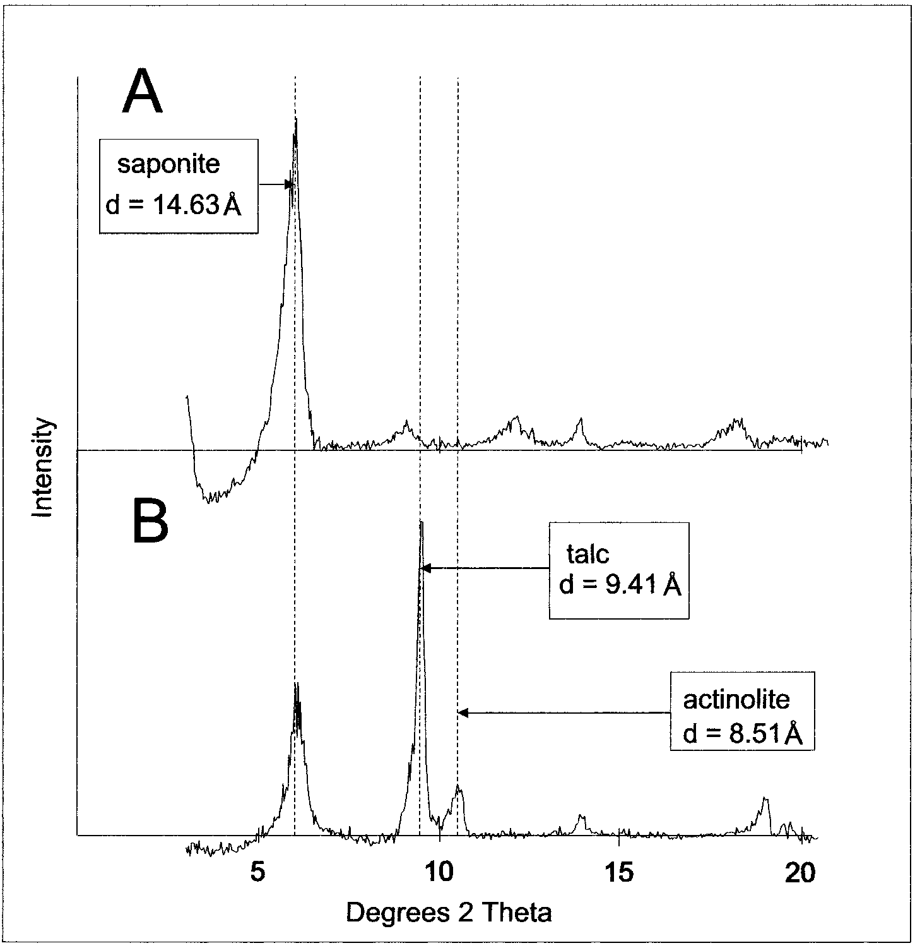FIG. 3.—XRD scans of two samples. **A)** An unaltered Sherwood Sandstone Group sample collected at c. 10 m from sill, displaying abundant saponite with no talc or actinolite. **B)** A sample collected at c. 3 m from the sill showing less saponite and significant amounts of talc and actinolite.

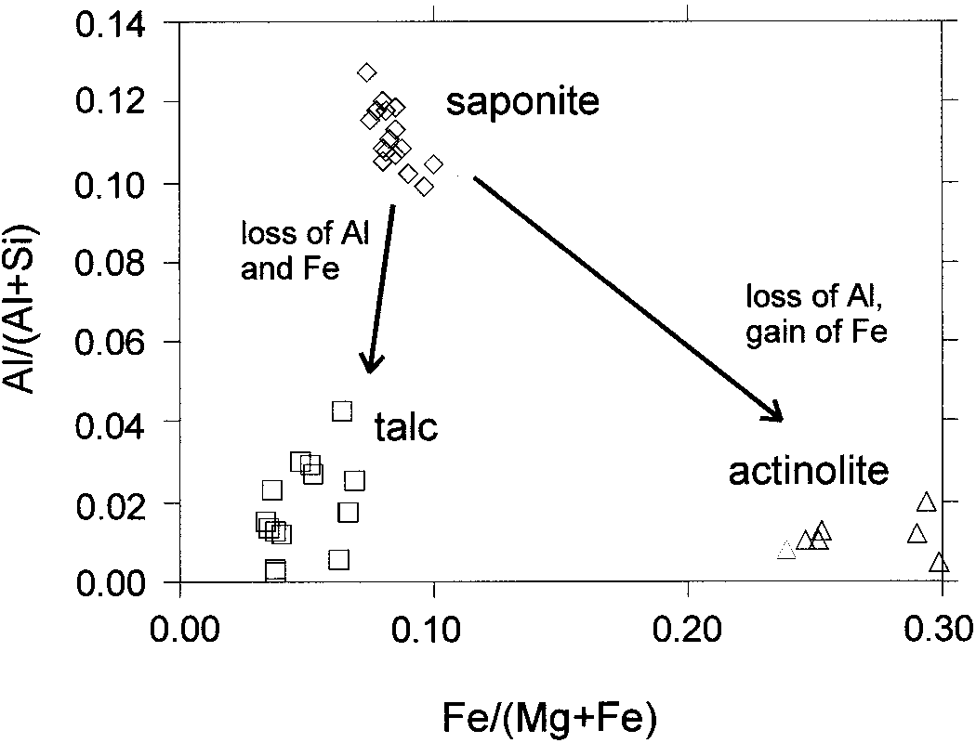

FIG. 4.—Mineral chemistry data (Fe/[Fe 1 Mg] and Al/[Al 1 Si]) for saponite, talc, and actinolite.

ence of alkali elements and Ca is not typical of talc (Deer et al. 1998), although sodian talc has been found in diagenetic and metamorphosed evaporites (Warren 1999). The presence of these unusual elements in talc could be due to the growth of talc in Na-rich waters (mimicking an evaporite; see later) or due to an intergrowth of a very small quantity of another mineral. The XRD data do not seem to support a mixed-layer talc. Electron microprobe analyses revealed minor variation in the Al and Fe contents of talc (Table 2; Fig. 4). Total porosity is similar to the sample at 10 m from the sill contact (23%, Fig. 5).

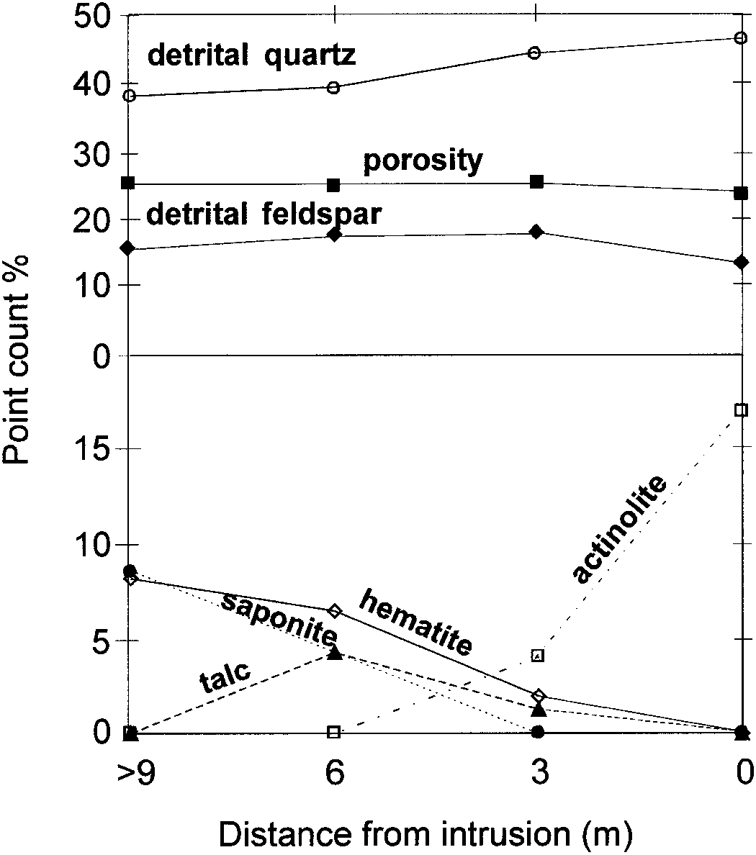

FIG. 5.—A comparison of the petrographic (point-counted) abundance of **A)** detrital components (quartz, K-feldspar) and **B)** pore-filling minerals (saponite, talc, and actinolite) versus distance to the intrusion. Point-counted porosity data are also given for distance from the intrusion.

**Mineralogy and Fabric 3 m from the Intrusive Contact.**—Detrital quartz remains the most important framework mineral (44%). Detrital Kfeldspar and plagioclase are present up to 14% and 3% respectively. SEM examination of these samples revealed a pore fabric dominated by the thin plates, similar to the sample at 6 m from the igneous contact, but with the notable addition of radiating needles (Fig. 2). Mg and Si with significant Ca and Fe and minor Na and Al (Table 2) dominate the needle-like crystals. XRD analyses of the samples showed the presence of minerals with highintensity reflections equivalent to a *d*-spacing of 8.51A˚ (Fig. 3). Combining the microprobe and XRD data, it is likely that the radiating needles are an amphibole of the actinolite series with an average formula (Ca1.82Na0.16K0.04)(Mg3.65Fe1.28)(Al0.07Si7.97)O22(OH)2. Electron microprobe analyses revealed minor variation in the Al and Fe contents of the actinolite (Table 2; Fig. 4). Calcite is present in the samples 3 m from the intrusion but in reduced quantities (0.4 wt %) relative to the dolomite in the unaltered sandstone (identified using chemical dissolution methods). Fe-oxide is present in these samples but at about 2% by volume it is less abundant than in samples at 6 m and 10 m away from the sill. With growth of talc and actinolite, the saponite content has been reduced to negligible quantities. The total porosity visible in thin section, however, is about 23%, i.e., similar to samples at greater distances from the sill (Fig. 5).

**Mineralogy and Fabric in the Sandstone Adjacent to the Intrusion.**— Samples taken a few centimeters from the igneous contact show an increase in the amount of actinolite and the absence of talc and saponite (Fig. 5). Whereas the micrographs (Fig. 2) illustrate the presence of talc in the sample 3 m from the intrusion, at the contact the pore fabric is dominated by fibrous actinolite. Carbonate minerals could not be detected in samples very close to the igneous contact using chemical dissolution or optical techniques. Point-count analyses reveal that the proportion of detrital quartz (46%), K-feldspar (12%), and plagioclase (1%) remain very similar to samples distant from the sill (and all within point-count errors). However, the samples exhibit a small but significant amount of authigenic pore-occupying albite rhombs.

**Permeability Data.**—The sandstones distant from the intrusion have a wide range of permeability values (250 to 1750 md with a mode of about 500 md), typical of poorly sorted, heterolithic fluvial sandstones that have undergone mild burial diagenesis (e.g., Strong and Milodowski 1987). The sandstones closer to the intrusion also have high permeability and also have a mode of about 500 md. However, the upper range of permeability values found in the unaltered sandstones were not found close to the intrusion (Fig. 6).

**DISCUSSION**

# Paragenetic Sequence for Burial-Related Diagenesis

Before the heating effects on the sandstones can be assessed it is essential to understand the ‘‘normal’’ burial diagenetic mineralogy and sequence. The diagenetic minerals present in the pore network prior to intrusion are likely to be an important control on subsequent contact diagenetic processes.

Fe-oxide coatings on quartz grains are ubiquitous in the SSG and appear either as a rim directly on each grain or as an outline of an original grain before embayment and corrosion resulting from partial dissolution. This observation supports that the iron oxide coating is the earliest diagenetic material. Dolomite is present in minor quantities and is thought to typify early diagenesis (pedogenesis) in Triassic sandstones across northwest Europe (Burley 1984; Strong and Milodowski 1987; Worden et al. 1999), and there is no evidence to suggest otherwise for the SSG at Scrabo. Other authigenic minerals consist of quartz, K-feldspar, and saponite. Feldspar and quartz cements are volumetrically minor compared to saponite. The origin of saponite may be related to the weathering of detrital basaltic rock

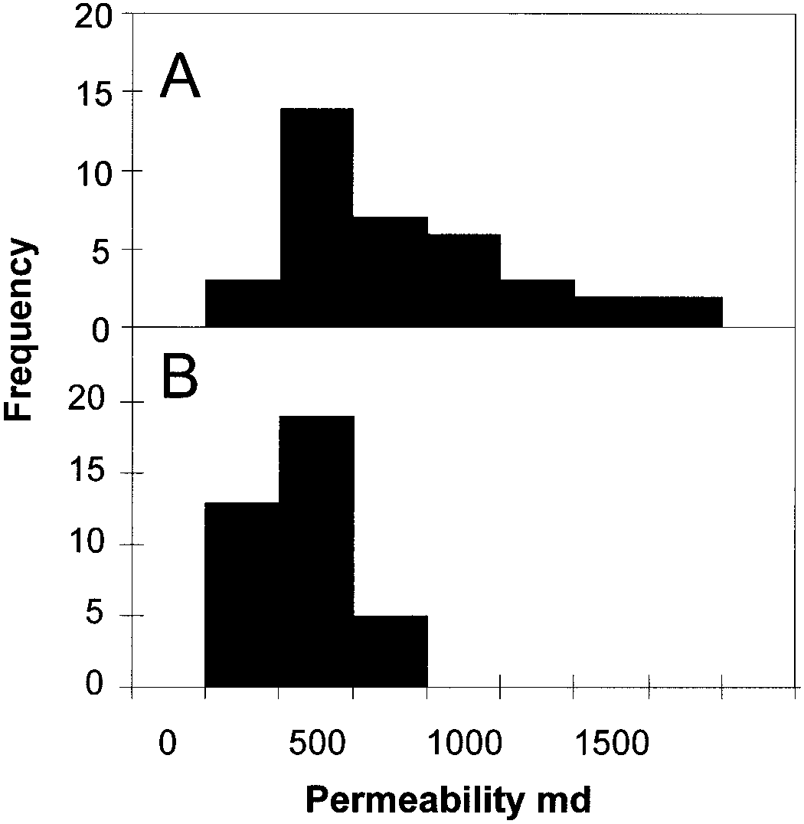

FIG. 6.—Permeability data: **A)** a face unaffected by the intrusion (9–10 m from contact), **B)** one within 2 to 3 m of the igneous sill. Both the distant and proximal faces have a mode of about 500 md although the proximal face (B) does not have the high-permeability ‘‘tail’’ found in the sandstones distant from the intrusion.

fragments, usually under hydrothermal conditions (April and Keller 1992; Shau and Peacor 1992) or during intense weathering (Ibrahim and Hall 1996). In studies of saponite in sandstones, both Tanner (1994) and Buch and Rose (1996) invoked alteration of basaltic or feldspathic rock fragments as the source of the components required to form saponite. However, Nadeau (1998) considered that the reaction of dolomite, Al-silicate clay, and quartz would produce saponite from the following general reaction: dolomite 1 kaolinite 1 quartz → saponite 1 calcite 1 CO2 [R1]

The origin of the saponite observed in the SSG at Scrabo is uncertain, but even if it is detrital in origin, it must have recrystallized *in situ* for it to have produced and preserved the delicate honeycomb texture (Fig 2). From our observations, we favor Nadeau’s (1998) model for saponite formation, because this may explain the absence of kaolinite in the claymineral assemblage (since kaolinite might have been anticipated in such arkosic sandstones). Overgrowths of authigenic quartz occurred during burial diagenesis (Fig. 7) and indicate that the temperature reached (at least) about 80 to 908C (e.g., Worden and Morad 2000). The diagenetic pattern observed here (iron oxides, minor quartz and feldspar, abundant clay, and localized carbonate cements with variable amounts of feldspar dissolution) is comparable to other studies of the diagenesis of the Triassic sandstones in the U.K. (e.g., Burley 1984; Strong and Milodowski 1987).

# Paragenetic Sequence for Contact Diagenesis

The occurrence of actinolite in the Scrabo sandstones was first recorded by Preston (1962) and later by Parnell (1992). There have been no previous attempts to deduce the series of diagenetic processes that produced the actinolite at Scrabo. Talc has not been published previously as a product of intrusion-related heating in the Scrabo sandstone. Moreover, there are very few reports in the literature of diagenetic talc (Bailey 1949; Evans 1970; Schreyer and Abraham 1976; Scrivener and Sanderson 1982) or dia-

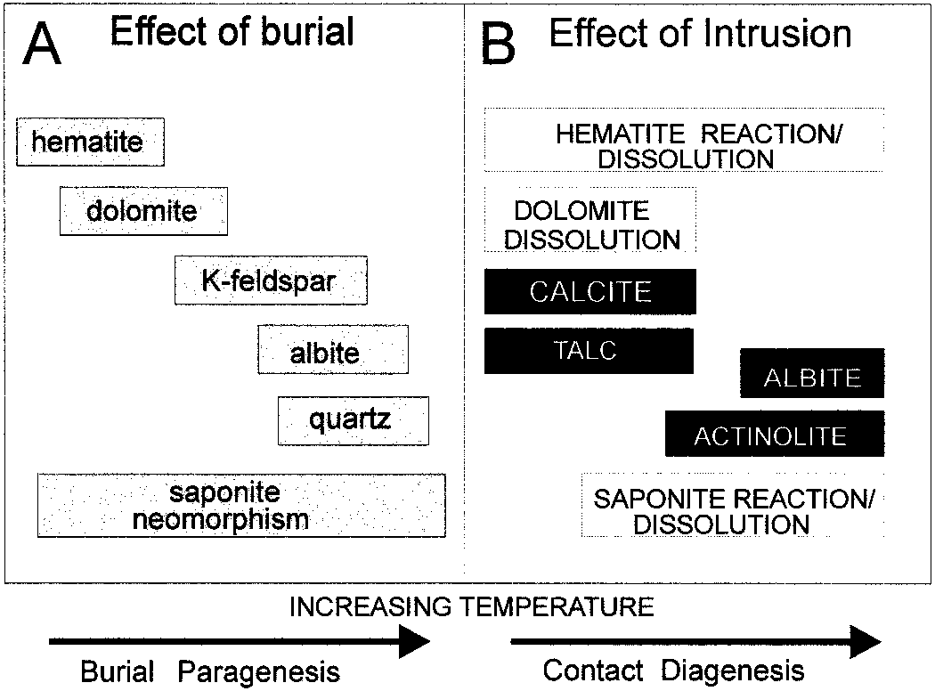

FIG. 7.—Summary of the paragenetic sequence of sandstones during **A)** normal burial heating and **B)** during contact diagenesis heating. All phases are precipitates unless noted otherwise.

genetic amphibole (DeRos et al. 1994). The literature suggests that diagenetic talc seems to form during authigenesis of evaporite-siliciclastic se-

quences where there is an association of elevated Mg21aq and depleted

K1aq.

Talc apparently grew at the lowest temperature of contact diagenetic heating, in as much as it occurs farther from the contact than actinolite (Fig. 5). The intergrowth of talc and actinolite at 3 m from the intrusion and the absence of talc and dominance of actinolite adjacent to the intrusion suggest that talc was a product of lower-temperature contact diagenesis whereas amphibole seems to have grown at the expense of talc at higher contact diagenetic temperatures. Saponite is found in small amounts in the mineral assemblage at about 6 m from the intrusion. Fe-oxide occurs in the presence of talc and actinolite 6 m and 3 m from the intrusion but in reduced amounts relative to rocks remote from the intrusion. Grain-coating Fe-oxide is absent from sandstones directly adjacent to the intrusion. This pattern suggests that saponite and Fe-oxide could have been used as reactants during the sequential growth of talc and actinolite. Given their porefilling textures and Fe–Mg-dominated mineralogy, it suggests that the disappearance of one pair of minerals results in the growth of another pair of minerals.

Carbonate minerals, with the type and abundance determined by both optical and selective dissolution techniques, are absent close to the intrusion but present in trace amounts 3 m from the intrusion. Carbonate minerals apparently also underwent progressive reaction. The prevalence of minor dolomite in unaltered rocks and transiently increasing calcite in rocks at 6 m and 3 m from the intrusion suggests that dolomite reacted to form calcite. The absence of any carbonate mineral very close to the contact suggests that they were consumed during the highest-temperature contact diagenesis. The conversion of dolomite to calcite suggests that at least some of the Mg in talc and/or actinolite may have been derived from a carbonate precursor.

The overall paragenetic sequence during contact diagenesis probably involved dissolution and reprecipitation (because the high-surface-area clays would have been immersed in water in the pores), although solid-state recrystallization cannot be ruled out because it is routinely observed in high-temperature contact metamorphism (e.g., Worden et al. 1992). In the following section, we will show that heating and reaction occurred over a very short time interval such that reactions were unlikely to have been progressive. Thus the highest-temperature assemblage close to the intrusion

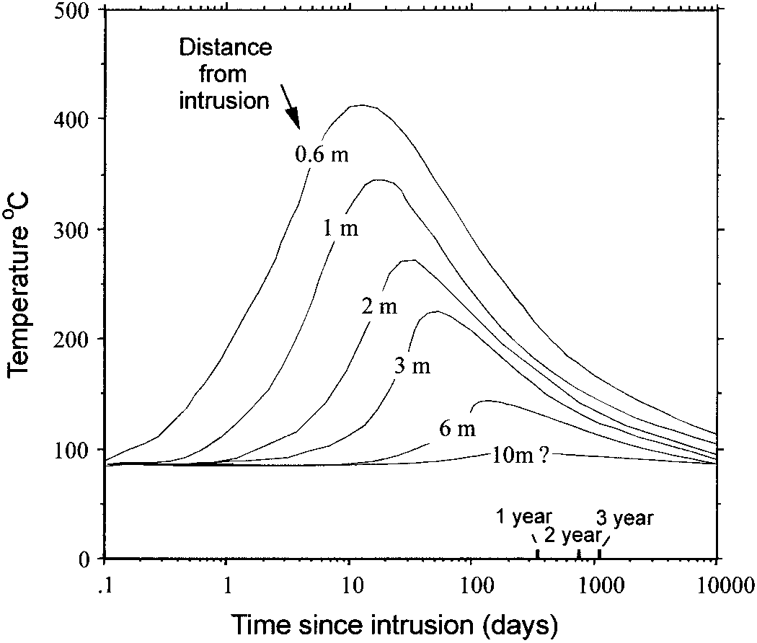

FIG. 8.—Thermal-history plot showing the effect of a 2-m-thick sill intruded at 11008C into a sandstone at an ambient temperature of 70–808C. The model is based upon simple equations presented by Carslaw and Jaeger (1959) and employs an assumption that all heat transfer is by conduction (and other assumptions listed in the text).

probably did not go through a transient intermediate-temperature assemblage (representative of rocks a few meters from the intrusion.

# Thermal-History Modeling of Contact Diagenesis

In order to deduce the maximum temperature and thermal history of rocks adjacent to the intrusion, we have used the one-dimensional conductive heat transport models of Carslaw and Jaeger (1959). This modeling approach involves assumptions that: (1) heat was transported predominantly by conduction and that there was negligible thermal convection, (2) there was only a single sill that affected the rocks that were examined, (3) intrusion happened instantly, (4) thermal equilibrium was rapidly achieved,

(5) the sill was uniformly 2 m thick and of effectively infinite lateral extent, (6) the dolerite was at 11008C when intruded into the country rock, (7) the country rock (sandstone) was at a pre-intrusion (ambient) temperature of about 808C (as indicated by the incipient growth of diagenetic quartz; see earlier), and (8) the thermal diffusivity of the rocks was 0.01 cm2/s. The absence of convective cooling in the aureole is reasonable despite the high permeability values (Fig. 6) because the mud drapes and cross stratification serve to compartmentalize the sandstone in sub-meter scale units with minimal fluid communication.

The thermal evolution of the country rock is illustrated in Figure 8. The timing of the thermal maximum is variable as heat moves out in a front. Progressively lower maximum temperatures are achieved at progressively later times and distances as heat dissipates. Note that, even close to the igneous contact (60 cm distant), the maximum temperature of about 4108C is much less than the temperature of the intrusion (11008C). The thermal impact of the intrusion on the country rock is very muted beyond a distance of 5 m. The heating event in the country rock can be measured in terms of tens to thousands of days compared to tens to hundreds of million years for the burial diagenesis of this Triassic sandstone.

The rock samples at about 3 m distance from the intrusion achieved a maximum temperature of about 2308C at a time of 20 to 30 days after the intrusion occurred. The sample at 6 m from the contact should have reached a maximum temperature of slightly less than 1508C about 130 to 200 days after the intrusion. The sample at 10 m distance from the intrusion will have suffered a negligible thermal effect. Note that the exact times and temperatures from the model (Fig. 8) are not absolute because of uncertainties implicit in the original assumptions and in model conditions. The model is a useful first approximation to obtain maximum temperatures as a function of distance for the different samples analyzed.

# Thermodynamic Modeling of Potential Reactions

Mineral assemblages in sedimentary rocks do not necessarily conform to thermodynamic equilibrium because the rates of reaction required to achieve equilibrium at low temperatures are typically slow (especially for Al and Si minerals). Even rocks affected by igneous intrusions do not necessarily achieve thermodynamic equilibrium because the time at the elevated temperature is limited (e.g., see Fig. 8). However, it is worthwhile addressing the mineral assemblage representative of thermodynamic equilibrium at any temperature, because this indicates what reactions should happen en route to equilibrium.

The stability of dolomite, saponite (with the model formula

Na0.66Mg6.00Al0.66Si7.34O20(OH)4), and quartz during contact diagenesis has been modeled as a function of temperature to address the thermal conditions and reactions that occurred in the sandstone during contact diagenesis. The absolute volumes of these minerals are not particularly important, but quartz was assumed to be predominant (85% of the solid rock) with lesser quantities of saponite (10%) and dolomite (5%). Equilibrium phase relations were initially defined for the system: quartz–saponite–dolomite in the presence of mildly saline formation water dominated by Na1 and Cl2 (0.5 molar each) with lesser amounts of Mg21 and HCO32 in solution (0.05 molar each). Because the water was modeled to be in equilibrium with dolomite, Ca21aq was automatically defined. The initial minerals were chosen because they represent . 80% of the mineralogy of the unaltered sandstone. The modeled effect of the involvement of K-feldspar in the reaction will be discussed. Mineral assembly-temperature diagrams were produced using the computer program Reacty (Bethke 1994) and a set of thermodynamic data compiled and distributed by Lawrence Livermore National Laboratory (Delany and Lundeen 1990). Equilibrium phase relations were defined for progressive temperature increase and involved the consumption of a relatively small quantity of quartz, plus dolomite and saponite with the production of transient talc, tremolite and albite. There are insufficient thermodynamic data to model the impact of solid solutions on these minerals at low temperatures (i.e., no opportunity to use Margules parameters to model Fe–Mg activity models of solid solutions in saponite, talc, or tremolite). Because the clay (saponite), talc, and amphibole are all Mg-dominated (relative to Fe), the Mg end members have been modeled and the potentially important contribution of Fe-oxide and Fe–Mg solid solutions cannot be accounted for. The reactions were defined for idealized Mg end members of the solid-solution series for the clay, talc, and actinolite. In discussing the model output, the amphibole is tremolite, although actinolite (with its significant Fe content) will be the natural equivalent. Thus, in the following sections, for tremolite read actinolite in the actual rock.

The evolution of the initial mineral assemblage during contact diagenesis is illustrated in a temperature-mineralogy diagram (Fig. 9). In the model, at low temperatures, dolomite reacts with the water–mineral assemblage to produce calcite. At about 1308C, dolomite should begin to react with quartz (and water) to produce talc, the reaction being complete by about 1808C. At about 200–2308C, talc then reacts with calcite and quartz to produce tremolite. There is then a second tremolite-forming reaction in which saponite reacts with calcite and quartz. This reaction starts at about 2508C and is complete by about 3008C (for the model conditions). These Mg endmember model reactions take the form:

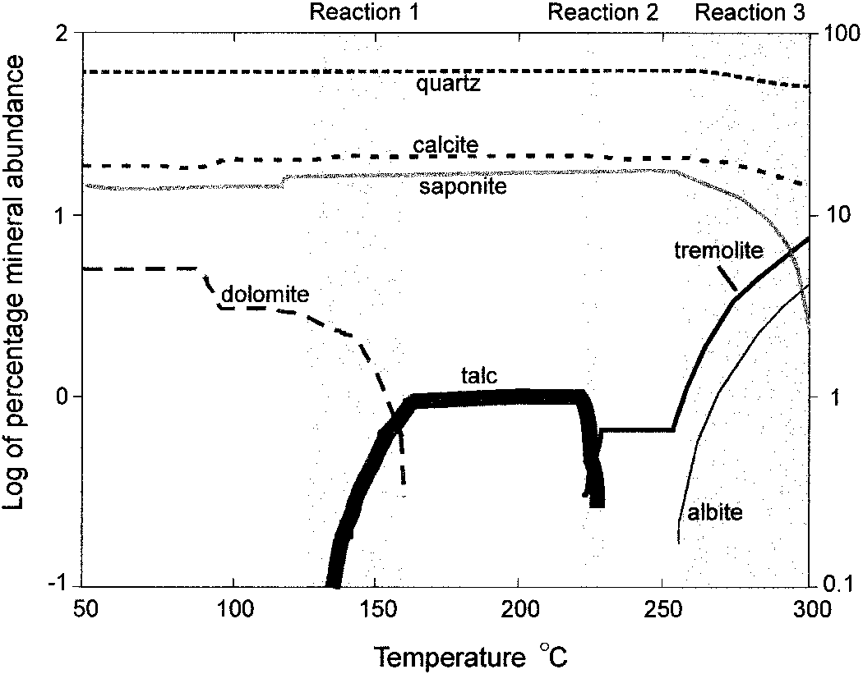

FIG. 9.—Geochemical model of the evolution of the unaltered SSG during isochemical heating due to the intrusion of the sill. The model was constructed using Geochemist’s Workbench, an initial reacted mineralogy of quartz, calcite, and saponite, and a moderately saline NaCl-dominated formation water. The model predicts at what temperature equilibrium reaction should happen; however the actual temperature of reactions will be influenced by the involvement of iron (derived from reduced hematite).

6CaMg(CO3 2) +8SiO2 1 2H O2 dolomite 1 quartz

|  |  |
| --- | --- |
| → Mg Si O6 8 20(OH)4 1 6CaCO3 1 6HCO2 (130–1808C)  → talc 1 calcite  5Mg Si O6 8 20(OH)4 1 12CaCO3 1 8SiO2 talc 1 calcite 1 quartz | [R2] |
| → 6Ca Mg Si O2 5 8 22(OH)2 1 4H O2 1 12CO2 (220–2308C)  → tremolite  12CaCO3 1 21.2SiO2 1 5Na0.66Mg6.00Al0.66Si7.34O20(OH)4  calcite 1 quartz 1 saponite  → 6Ca Mg Si O2 5 8 22(OH)2 1 3.3NaAlSi O5 8 1 4H O2 1 12CO2  → tremolite 1 albite | [R3] |
| (.2508C) | [R4] |

In nature, the growth of the amphibole (by reactions 2 and 3) probably also involved reaction and reduction of Fe-oxide, because the Fe/Mg ratio of the amphibole is significantly higher than that of either saponite or talc (Fig. 4). The reduction of Fe-oxide and incorporation into actinolite is likely to be the cause of the bleaching of the rock in the vicinity of the intrusion. The silicate minerals also contain minor quantities of Al (Fig. 4; Table 2). Saponite has a significantly higher Al/Al1Si ratio than either of the resulting silicate minerals (talc or actinolite). The likely result of the relatively elevated Al content of the reactant saponite is the small quantity of finely crystalline, euhedral albite, presumably resulting from contact diagenesis and modeled as a result of saponite breakdown (Fig. 9).

The exact temperatures of modeled reactions listed above are somewhat sensitive to the initial pore-water composition (e.g., 108C lower temperature for R4 when the formation water is modeled to be halite saturated), thus the temperature should be taken as a broad indicator only. The relatively minor amounts of Fe and Al in saponite and talc and the greater amount of Fe in the amphibole also add extra degrees of freedom to the system. These tend to broaden the range of temperatures over which the reactions (R2–R4) can occur. The presence of reduced iron in the actinolite increases the stability field of the amphibole and may allow growth at lower temperatures.

Following the petrographic observations and geochemical modeling described above, balanced stoichiometric reactions including real mineral chemistry and the solid solutions reported in Table 2 can be written:

5.64CaMg(CO3 2) 1 7.86SiO2 1 2.59H O2 1 0.27Feaq21 dolomite quartz

1 0.14Naaq1 1 0.17Alaq31

→ (Na0.14)(Mg5.64Fe0.27)(Al0.17Si7.86)O20(OH)4

talc

1 5.64CaCO3 1 5.64CO2 1 1.19Haq1 [R5]

calcite

3.64(Na0.14)(Mg5.64Fe0.27)(Al0.17Si7.86)O20(OH)4 1 16.9SiO2

talc quartz

1 10.26CaCO3 1 6.07H O2 1 0.84Naaq1 1 6.293Feaq21

calcite

→ 0.22NaAlSi O3 8

albite

1 5.64(Ca1.82Na0.20)(Mg3.64Fe1.29)(Al0.07Si7.95)O22(OH)2

actinolite

1 10.26CO2 1 13.42Haq1 [R6]

3.64(Na0.10Ca0.08)(Mg4.80Fe0.48)(Al0.91Si7.11)O20(OH) H O4• 2

saponite

1 21.16SiO2 1 8.44CaCO3 1 0.14H O2 1 3.56Naaq11 4.48Feaq21 quartz calcite

→ 4.80(Ca1.82Na0.20)(Mg3.64Fe1.29)(Al0.07Si7.95)O22(OH)2

actinolite

1 2.96NaAlSi O3 8 1 8.44CO2 1 12.52Haq1 [R7]

albite

The stoichiometric reactions above (R5–R7) bear strong similarities to the modeled reactions (R2–R4) although other components are introduced in the realistic cases. Fe was introduced and probably was derived from reduction of Fe-oxide in the red mineral coatings. Al was required in R5 and may also have been derived from the mineral coatings, because these often contain small amounts of this element (e.g., Nagy et al. 1991). Extra sodium was involved in all of the reactions and may have been derived from the paleo-formation water. Present-day Triassic sandstone formation waters in Northern Ireland are highly saline (200 g/l) with cations dominated by Na (Bennett 1983). The Triassic sandstones in this area are associated with bedded halite, and it is reasonable to assume that pre-intrusion pore waters were highly enriched in aqueous sodium. Note that the few other reports of high-temperature diagenetic talc involve silicate diagenesis in the presence of halite-rich evaporites (Bailey 1949; Evans 1970; Schreyer and Abraham 1976; Scrivener and Sanderson 1982), reaffirming the importance of saline formation waters at the time of contact diagenesis at Scrabo Quarry. Involvement of other cations suggests that the reactions are not pH-neutral; acidity was generated for the reactions as written.

Description of the stoichiometry of the possible reactions permits assessment of the relative volumes of reactants and products. For the reaction between dolomite and quartz (R5), 4 volumes of dolomite should react with 2 volumes of quartz to produce 2 volumes of calcite and 3 volumes of talc. For the reaction between talc, calcite and quartz (R6), 11 volumes of talc should react with 4 volumes of both calcite and quartz to produce 16 volumes of actinolite and 0.2 volumes of albite. For the reaction between saponite, calcite and quartz (R7), 11 volumes of saponite should react with 5 volumes of quartz and 3 volumes of calcite to produce 16 volumes of actinolite and 3 volumes of albite. These volumes form a reasonable correspondence to the rocks observed in this study, thus supporting the inferred reactions. All the reactions lead to a volume loss of between 13 and 17%, largely due to the formation of higher-density minerals and the loss of volatiles (CO2).

Thermodynamic modeling and the location of minerals relative to the intrusion reveal that talc grew at moderately elevated temperature. This model also shows that (1) there are two amphibole-forming reactions, (2) saponite should break down only after talc has reacted, and (3) talc did not grow from saponite (at least for Mg-end-member minerals). However, the model does not take into account the reaction kinetics. Thus it is possible that the first actinolite-forming reaction was not complete before the second actinolite formation, allowing both reactions to proceed at the same time. The (spatially) close coexistence of talc and actinolite in contact diagenetic rocks (Fig. 2) suggests the temperature was not much more than about 200–2508C (assuming attainment of equilibrium; see below). Samples with actinolite but no talc close to the contact achieved greater temperatures but not necessarily much higher than about 300–4008C and for a very short time period at that (Fig. 8). This reaction scheme is very similar to that proposed for the regional and contact metamorphism of siliceous limestones (e.g., Miyashiro 1973; Yardley 1989).

When other minerals such as K-feldspar and montmorillonite were introduced into the model reaction scheme, the mineral reactions and products were entirely different. The main differences were K-bearing mineral products: (1) illite–muscovite became a significant reaction product, (2) various zeolites were produced, (3) talc was not produced, and (4) amphibole either did not grow or grew only at temperatures very close to 3008C. The inability to reproduce the observed mineral assemblages for expanded initial mineralogies (especially K-feldspar) suggests that the additional minerals did not partake in the contact diagenetic reactions. Even though Kfeldspar was present up to about 14% by volume, it apparently was not involved in reactions. This was probably a kinetic effect because the Kfeldspar was in sand grains and had a low ratio of surface area to volume (in contrast to pore-filling, fine-grained clays and carbonates). Thus although equilibrium may have been approached on the intrapore scale (; 10 mm), it was not achieved between grains (e.g., detrital feldspars), pore fluids, and fine-grained minerals in the pores. It is apparently valid to use equilibrium modeling as long as the scale of the equilibrium (i.e., very limited in this case) is taken into account.

The overall conclusions from the equilibrium thermodynamic modeling (Fig. 9) and the observed changes in mineralogy in the proximity of the intrusion (Fig. 5) are:

1. Talc was probably generated from reaction between quartz and dolomite at moderate temperatures (130–1808C).
2. Actinolite may have been generated from reaction of the lower-temperature products, talc, quartz, Fe21 resulting from reduction of Fe-oxide, and calcite, at about 200–2308C.
3. Actinolite was also probably generated from a second reaction involving saponite, calcite, Fe-oxide, and quartz at temperatures greater than about 2508C.
4. Talc and actinolite coexist over a limited thermal range.
5. The only minerals involved in the reaction were those in contact with the pore fluid: intergranular saponite and pore-occupying carbonate minerals (6 minor quartz).
6. K-feldspar (whether detrital and burial diagenetic) was not significantly involved in the contact diagenesis (possibly because of its limited exposed surface area) despite its abundance in these arkosic rocks.

# Conditions During Contact Diagenesis

Although there are no direct geochemical (e.g., fluid inclusion) or mineral–chemical (e.g., Fe–Mg mineral partitioning) indicators of temperature that can be used to define the maximum temperatures experienced during contact diagenesis, the modeling approaches outlined above are broadly consistent. Geochemical modeling of the coexistence of talc and tremolite (actinolite) at 3 m from the intrusion suggests a maximum temperature of # 240–2508C (Fig. 9). Thermal-history modeling of the system shows that the maximum temperature at 3 m should have been about 2208C (Fig. 8). Given the diverse assumptions made in each model and the attendant uncertainties, the outputs from each approach are similar. The broad agreement of the two independent techniques can be taken to suggest that the overall thermal model (Fig. 8) and the overall geochemical reaction scheme (Fig. 9; Reactions 2, 3, and 4) are possibly a fair representation of the actual conditions and reactions.

# Effect of the Intrusion on Reservoir Properties

The geochemical and mineralogical data presented here suggest strongly that contact diagenesis was largely isochemical (in terms of rock-forming mineral components). There was apparently minimal effect upon the matrix of the sandstone even during heating to about 3008C.

The observed total porosity of samples as close as a few centimeters from the intrusion is essentially unaffected by the contact diagenesis (Fig. 5). Pore-filling clay and carbonate minerals have reacted to produce talc and actinolite (at approximately constant solid mineral volume). There has not been a major recrystallization of framework-forming grains. Thus the observed porosity (from petrography) has remained essentially unchanged. It is not clear that sills and dikes have a highly detrimental effect on reservoir porosity except in their immediate vicinity. However, even if they did have a porosity-reducing effect, the thermal modeling (Fig. 8) suggests that the thermal (and thus reservoir quality) effect of the intrusion would not be much more than one or two times the thickness of the igneous intrusion itself.

Permeability in clay-bearing sandstones can be low because pore-bridging clay flakes, and sheets block pore throats very efficiently. Contact diagenesis transformed the open and dispersed honeycomb fabric of the saponite (Fig. 2) into tightly bundled collections of needles (actinolite) and grain-coating flakes (talc; Fig. 2). The heating event retained the mode of the permeability at about 500 mD (Fig. 6) although the highest permeability values of the unaltered sandstones are not present in rocks 2–3 m from the contact. The loss of high permeability values is unlikely to be an effect of depositional facies, in as much as the rocks at 9–10 m and 2–3 m from the intrusion are the same primary depositional facies. Thus contact diagenesis may have reduced the heterogeneity of permeability values. A key conclusion from the minipermeametry data is that permeability has *not* been destroyed by intrusion into the sandstone as close as 2 m from the contact with a 2-m-thick igneous body.

Rift-related basinal sedimentary rocks intruded by igneous sills and dykes are not actively sought during petroleum exploration. However, this study has shown that the effects of intrusions may be relatively minor in terms of porosity and permeability for small intrusions. The contact-diagenetic processes observed here include the fine-grained, pore-filling minerals (which necessarily have high ratios of surface area to volume and easy access to the reactive medium) and the isovolumetric reaction. Clearly other sandstone lithologies, other clay minerals, and other thermal regimes need to be assessed before the effects of intrusions can be discounted as a reservoir-quality problem, but the indications from this study are positive in terms of reservoir quality.

# Implications for Similar Reservoir Successions

Rift basins display similar features that control sediment supply and to a lesser extent sediment type. These features include thinned crust/mantle lithosphere and a very high heat flow. Thinning in brittle crust causes faulting, which in turn creates (simultaneously) actively eroding footwalls and accommodation space in adjacent hanging wall grabens and half grabens. The regionally high heat flow also results in partial melting and igneous activity. Thus, many ancient and modern rift basins are intruded by igneous rocks (Tian et al. 1992, nonmarine rift and intrusives; Naylor et al. 1999). In the study location (Fig. 1), the early Tertiary igneous intrusives that caused contact diagenesis are about 170 My younger than the host nonmarine Triassic sandstones. In contrast, many rift successions display intrusive rocks that are fractionally younger than their host sediments, sometimes by as little as tens to hundreds of thousands of years (e.g., Lake Turkana, Lake Natron, East African Rift). The succession studied here provides a suitable analogy for such rift basins, because both have experienced significant burial diagenesis prior to intrusion: in modern rifts through rapid sedimentation and in the present study through prolonged burial. Extensional basins often display the essential mix of sediment and igneous rock required for the high-temperature diagenetic reactions that we have presented here.

The implications of this study are that similar mineralogical reactions and reservoir properties can be expected in other petroleum-bearing basins. Direct analogues include the Triassic sandstones of the eastern seaboard of North America, where basic intrusions were formed during early rifting and continental breakup (Veevers 1989). The common association of redbeds with igneous intrusions is also apparent in many Phanerozoic successions of the South Atlantic (Cameron et al. 1999). These include both the Gondwanan rift successions of the Karoo and equivalents in South Africa and the Falkland Islands as well as subsequent Cretaceous rift-basin sediments offshore west Africa and Brazil.

## CONCLUSIONS

1. The study of contact diagenesis of Triassic Sherwood Sandstone Group sandstones from Scrabo, Northern Ireland, has revealed a series of mineral reactions and textural changes that resulted from the intrusion of a dolerite sill.
2. Contact diagenesis apparently had little or no effect on the framework grains (quartz and feldspars) of the sandstone.
3. Contact diagenesis of the carbonate–saponite matrix of the sandstone revealed a pore-filling mineral assemblage of talc and actinolite at 3 m from the intrusion whereas only the amphibole was found in pores closer to (within centimeters) the intrusion.
4. The original saponite was present as a permeability-diminishing open-honeycomb fabric. Talc grew as framework grain-hugging flakes. Actinolite grew as tightly bundled collections of needles projecting into pores.
5. Equilibrium thermodynamic modeling suggests that talc formed from reaction between dolomite and quartz at relatively low temperature (130– 1608C); actinolite grew first from reaction between talc and calcite at 220– 2308C and then from reaction between quartz, saponite, and calcite at temperatures greater than 2508C.
6. Thermal history modeling and geochemical modeling suggest that the maximum temperature was between 2008C and 2508C at 3 m from the intrusion.
7. Detrital feldspar minerals (principally K-feldspar) were not involved in contact diagenesis even though they are thermodynamically unstable in the presence of the other minerals listed. Contact diagenetic reactions involved only minerals present within the pore system and largely ignored framework minerals with low specific surface area.
8. Contact diagenesis conserved porosity and had little effect on permeability.

## ACKNOWLEDGMENTS

We are very grateful for the assistance received in the field from Paul Carey, Joanne Curran, John Meneely, Mark Russell (for help with minipermeametry analyses), Paddy Gaffikin (for XRD analyses), Stephen McFarland, and Jackie Patrick (for help with electron microprobe analyses). David Doff and Rob Shelton provided useful advice and encouragement. We acknowledge the assistance of Queen’s University Belfast with the funding of this work. Constructive and very helpful comments on an early and then modified version of this paper by Barbara Dutrow, David Awwiller, and Kitty Lou Milliken have improved this paper beyond all recognition. Chris Cornford is thanked for helpful suggestions about the thermal history modeling.

## REFERENCES

APRIL, R.H., AND KELLER, D.M., 1992, Saponite and vermiculite in amygdales of the Granby Basaltic Tuff, Connecticut Valley: Clay and Clay Minerals, v. 40, p. 22–31. BAILEY, R.K., 1949, Talc in the salines of the potash field near Carlsbad, Eddy County, New Mexico: American Mineralogist, p. 9–10.

BAZLEY, R.A.B., 1975, The Tertiary igneous and Permo–Triassic Rocks of the Ballyalton Borehole, Co. Down: Geological Survey of Great Britain, Bulletin, v. 50, p. 71–101.

BENNETT, J.R.P., 1983, Investigation of the geothermal potential of the U.K.: The sedimentary basins in Northern Ireland. United Kingdom, Institute of Geological Sciences Report. BETHKE, C.M., 1994, The Geochemist’s Workbench, version 2.4, A Users Guide to Rxn, Act2, Tact, React and Gtplot: Hydrology Program, University of Illinois, U.S.A., 213 p.

BRINDLEY, G.W., AND BROWN, G., 1980, Crystal Structures of Clay Minerals and Their X-ray Identification: Mineralogical Society, Monograph 5, 495 p.

BUCH, M.W., AND ROSE, D., 1996, Mineralogy and geochemistry of the sediments of the Etosha Pan region in northern Namibia: A reconstruction of the depositional environment: Journal of African Earth Sciences, v. 3, p. 355–378.

BUCKMAN, J.O., DOUGHTY, P.S., BENTON, M.J., AND JERAM, A.J., 1998, Palaeoenvironmental interpretation of the Triassic sandstones at Scrabo, County Down, Northern Ireland: ichnological and sedimentological studies indicating a mixed fluviatile–aeolian succession: Irish Journal of Earth Sciences, v. 16, p. 85–102.

BURLEY, S.D., 1984, Patterns of diagenesis in the Sherwood Sandstone Group (Triassic), United Kingdom: Clay Minerals, v. 19, p. 403–440.

CAMERON, N., BATE, R., CLURE, V., AND SMITH, D., 1999, The Oil and Gas of the South Atlantic: Geological Society of London, Special Publication 153, 474p.

CARSLAW, H.S., AND JAEGER J.G., 1959, Conduction of Heat in Solids: Oxford, Clarendon Press, U.K., 510 p.

COX, K.G., BELL J.D., AND PANKHURST, R.J., 1979, The interpretation of igneous rocks: London, George, Allen & Unwin, 450 p.

DARROS DE MATOS, R., 1992, The northeast Brazilian Rift system: Tectonics, v. 11, p. 766– 791.

DEER, W.A., HOWIE, R.A., AND ZUSSMAN, J., 1998, An Introduction to the Rock-Forming Minerals: Essex, England, Longman, 528 p.

DELANY, J.M., AND LUNDEEN, S.R., 1990, The LLNL thermochemical database: Lawrence Livermore National Laboratory, Report UCRL-21658, 150 p.

DEROS, L.F., ANJOS, S.M.C., AND MORAD, S., 1994, Authigenesis of amphibole and its relationship to the diagenetic evolution of Lower Cretaceous sandstones of the Potiguar Rift Basin, Northeastern Brazil: Sedimentary Geology, v. 88, p. 253–266.

DICKSON, J.A.D., 1965, A modified staining technique for carbonates in thin section: Nature,

v. 205, p. 587.

EVANS, R., 1970, Genesis of sylvite and carnallite bearing rocks from Wallace, Nova Scotia: Third Symposium on Salt, v.1, p. 239–245.

FRAKES, L.A., FRANCIS, J.E., AND SYKTUS, J.I., 1992, Climate modes of the Phanerozoic: Cambridge, U.K., Cambridge University Press, 274 p.

GOGGIN, D.J., 1993, Probe permeametry: is it worth the effort?: Marine and Petroleum Geology,

v. 10, p. 299–308.

HURST, A., AND GOGGIN, D.J., 1995, Probe permeametry: an overview and bibliography: American Association of Petroleum Geologists, Bulletin, v. 79, p. 463–473.

IBRAHIM, K., AND HALL, A., 1996, The authigenic zeolites of the Aritayn Volcaniclastic Formation, north-east Jordan: Mineralium Deposita, v. 31, p. 514–522.

MANSPEIZER, W., 1988, Triassic–Jurassic rifting and opening of the Atlantic: an overview, *in* Manspeizer, W., ed., Triassic–Jurassic Rifting: Continental Breakup and the Origin of the Atlantic Ocean and Passive Margins: Amsterdam, Elsevier, p. 41–79.

MIYASHIRO, A., 1973, Metamorphism and Metamorphic Belts: London, Allen and Unwin, 492 p.

NADEAU, P.H., 1998, An experimental study of the effects of diagenetic clay minerals on reservoir sands: Clays and Clay Minerals, v. 46, p. 18–26.

NAGY, B., NAGY, L.A., RIGALI, M.J., AND JONES, W.D., 1991, Rock varnish in the Sonoran Desert: microbiologically mediated accumulation of manganiferous sediments. Sedimentology, v. 38, p. 1153–1171.

NAYLOR, P.H., BELL, B.R., JOLLEY, D.W., DURNALL, P., AND FREDSTED, R., 1999, Palaeogene Magmatism in the Faeroe-Shetland Basin: influences on uplift history and sedimentation, *in* Fleet, A.J., and Boldy, S.A.R., eds., Petroleum Geology of Northwest Europe: Proceedings of the 5th Conference, Geological Society of London, p. 545–558.

NEWMAN, A.C.D., 1987, Chemistry of Clays and Clay Minerals: Mineralogical Society, Monograph 6, London, U.K., Longman, 480 p.

NORTH, F.K., 1985, Petroleum Geology: Boston-London, Allen & Unwin, 607 p.

PARNELL, J., 1991, Hydrocarbon potential of Northern Ireland: Journal of Petroleum Geology,

v. 14, p. 65–78.

PARNELL, J., 1992, Hydrocarbon potential of Northern Ireland: Journal of Petroleum Geology,

v. 15, p. 51–70.

PRESTON, J., 1962, Explosive volcanic activity in the Triassic sandstone of Scrabo Hill, Co. Down: The Irish Naturalists Journal, v. 14, p. 45–51.

SCHREYER, W., AND ABRAHAM, K., 1976, Three stage metamorphic history of a whiteschist from Sar e Sang, Afghanistan, as part of a former evaporite complex: Contributions to Mineralogy and Petrology, v. 59, p. 111–130.

SCRIVENER, R.C., AND SANDERSON R.W., 1982, Talc and aragonite from the Triassic halite deposit of the Burton Row Borehole, Brent Knoll, Somerset: United Kingdom, Institute of Geological Sciences Report v82/1, v 1, p. 58–60.

SHAU, Y.H., AND PEACOR, D.R., 1992, Phyllosilicates in hydrothermally altered basalts from DSDP Hole 504B, Leg-83-A TEM and AEM study: Contributions to Mineralogy and Petrology, v. 112, p. 119–133.

SHELTON, R., 1997, Tectonic evolution of the Larne Basin, *in* Meadows, N.S., Hardman, M., and Cowan, G., eds., Petroleum Geology of the Irish Sea and Adjacent Areas: Geological Society, London, Special Publication 124, p. 109–129.

STRONG, G.E., AND MILODOWSKI, A.E., 1987, Aspects of diagenesis of the Sherwood Sandstones of the Wessex Basin and their influence on reservoir characteristics: Geological Society of London, Special Publication 36, p. 325–337.

SUTHERLAND, W.J.C., HALVORSEN, A., HURST, A., MCPHEE, G., AND WORTHINGTON, P.F., 1993, Recommended practice for probe permeametry: Marine and Petroleum Geology, v. 10, p. 309–317.

TANNER, L.H., 1994, Distribution and origin of clay minerals in the Lower Jurassic McCoy Brook Formation, Minas Basin, Nova-Scotia: Sedimentary Geology, v. 92, p. 229–239.

TIAN, Z.-Y., HAN, P., AND XU, K.-D., 1992, The Mesozoic–Cenozoic East China rift system:

Tectonophysics, v. 208, p. 341–363.

VAN DER PLAS, L., AND TOBI, A.C., 1965, A chart for judging the reliability of point counting results: American Journal of Science, v. 263, p. 87–90.

VEEVERS, J.J., 1989, Middle/Late Triassic (230 6 5 Ma) singularity in the stratigraphic and magmatic history of the Pangaean heat anomaly: Geology, v. 17, p. 784–787.

WARREN, J, 1999, Evaporites; Their Evolution and Economics: Oxford, U.K., Blackwell Science, 438 p.

WILSON, N.P., AND MONTGOMERY, G., 1979, Metasomatized Triassic sandstone from Scrabo, Co. Down: Irish Naturalists Journal, v. 19, p. 358–359.

WORDEN R.H., COLEMAN M.L., AND MATRAY J.-M., 1999, Basin scale evolution of formation waters: a diagenetic and formation water study of the Triassic Chaunoy Formation, Paris basin: Geochimica et Cosmochimica Acta, v. 63, p. 2513–2528.

WORDEN R.H., DROOP G.T., AND CHAMPNESS, P.E., 1992, The roles of crystallography and kinetics on phengite breakdown reactions in a low pressure metamorphic aureole: Contributions to Mineralogy and Petrology, v. 110, p. 329–345.

WORDEN, R.H., AND MORAD S., 2000, Quartz cementation in sandstones: International Association of Sedimentologists, 29, Special Publication 373 p.

YARDLEY, B.W.D., 1989, An Introduction to Metamorphic Petrology: New York, Longman, 248 p.

Received 12 October 1999; accepted 26 September 2000.