*The Canadian Mineralogist* Vol. 49, pp. 487-501 (2011)

DOI : 10.3749/canmin.49.2.487

# DETRITAL MONAZITE IN THE TIM MERSOI BASIN, NIGER: PROVENANCE

**AND CONTRIBUTION TO THE URANIUM BUDGET IN SILICICLASTIC SEDIMENTS**

IbrahIm WaGaNI aNd maurIce PaGeL[1]

*Université de Paris-Sud, Faculté des Sciences, UMR CNRS–UPS IDES 8148, Boîte 504, F–91405 Orsay Cedex, France*

ÉmILIe JaNOTS aNd edWIN GNOS

*Institute of Geological Sciences, University of Bern, Baltzerstrasse 3, CH–3012 Bern, Switzerland*

abSTracT

A detailed study using back-scattered electron imaging and electron-microprobe analysis shows that grains of detrital monazite are present in the Carboniferous, Permian, Triassic and Jurassic sediments of the Tim Mersoï basin, Niger. Despite variations in the size and shape of monazite grains, the U–Th–Pb chemical ages obtained by electron microprobe fall in a narrow range, 425 to 650 Ma. These ages indicate that the monazite grains are issued from the erosion of Pan-African granites and metamorphic rocks from the Aïr Mountains, and probably also from the basement near Zinder and in Nigeria, a hypothesis in good agreement with paleocurrent reconstruction. The uranium content of monazite from sediments is high (up to 1.7 wt% UO2), but low in adjacent rhyolite. Some monazite grains from the sandstone show evidence of alteration, especially to florencite. We conclude that detrital monazite is a major reservoir of uranium in some sandstones from the Tim Mersoï Basin.

*Keywords*: monazite, electron-microprobe dating, Tim Mersoï Basin, Aïr Massif, Niger.

SOmmaIre

Une cartographie détaillée et des analyses à la microsonde électronique montrent que des grains détritiques de monazite sont présents dans les sédiments carbonifères, permiens, triassiques et jurassiques dans le bassin de Tim Mersoï. Les âges U–Th–Pb obtenus par microsonde électronique sur les grains de monazite sont peu variables, compris entre 425 et 650 Ma en dépit de leur variation en taille et en morphologie. Ces âges indiquent que les grains de monazite proviennent de l’érosion de granites panafricains et de roches métamorphiques du massif de l’Aïr à l’Est, mais également de la région de Zinder, Niger et du Nigeria au sud. Cette hypothèse est en bon accord avec la reconstruction des paléocourants. La teneur en uranium des grains de monazite est élevée dans les formations sédimentaires, jusqu’à 1.7 % UO2 poids, mais étonnament faible dans les rhyolites adjacentes. Quelques grains de monazite montrent des évidences d’altération, en particulier en florencite. La monazite est un réservoir important d’uranium dans les grès du bassin de Tïm Mersoï.

*Mots-clés*: monazite, datation, microsonde électronique, bassin de Tim Mersoï, massif de l’Aïr, Niger.

INTrOducTION

The Tim Mersoï basin is located north of Agadès, west of the Aïr Moutains in Niger (Fig. 1). It contains medium- to fine-grained siliciclastic sedimentary rocks of Devonian to Cretaceous age. The sedimentary sequence has a total thickness of about 1200 m and hosts several world-class deposits of uranium. They are located in the Visean Guezouman Formation for the deposits mined underground by Cominak near Arlit (44 000 tonnes U), and in the Namurian Tarat Formation, mined by open pit by Somaïr near Akokan (50 000 tonnes U), 50 km to the west of the Aïr basement. The grade ranges from 0.2 to 0.5%. The Imouraren deposit, of lower grade (0.12%), is located 80 km south (Fig. 1), in the Tchirezrine 2 sandstones. Its tonnage was evaluated at 66 000 tonnes U (Pagel *et al.* 2005). The Akouta deposit, in the Akokan disctrict, was dated by the U–Pb method on uraninite and by K–Ar on corrensite-rich clay fractions. The age of the mineralization is estimated at 197 ± 60 Ma and rules out a synsedimentary origin of the U ore (Turpin *et al.* 1991). One important question

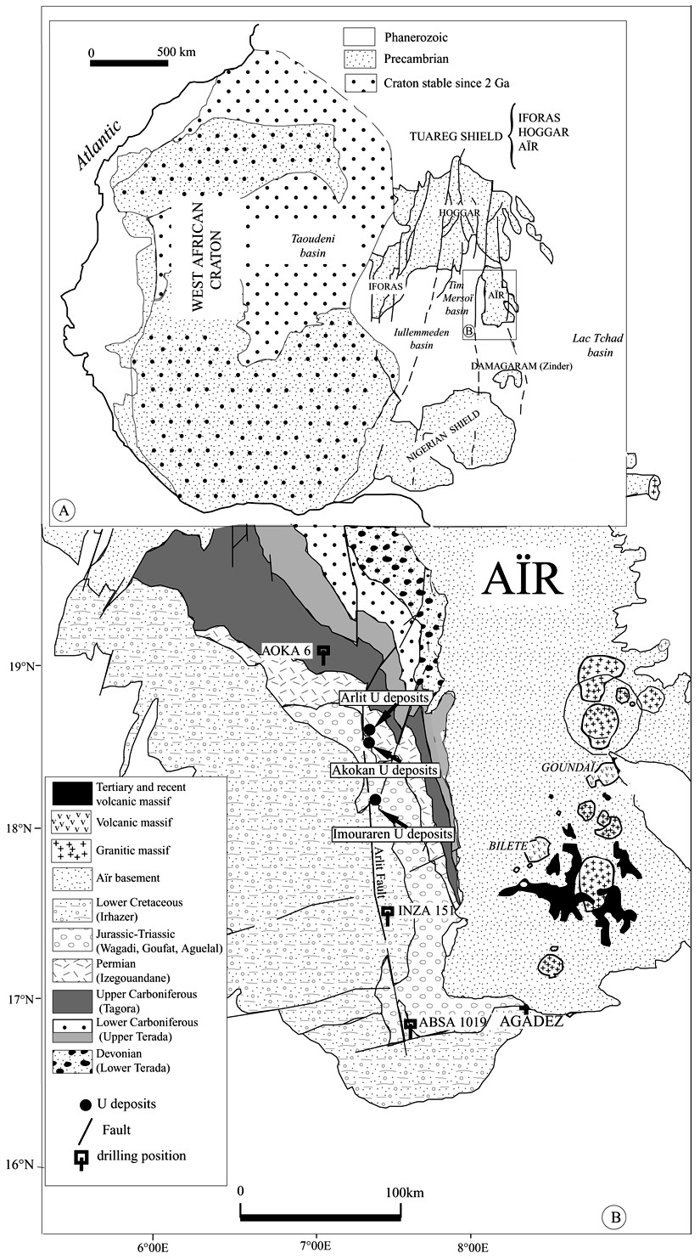

FIG. 1. (A) Geological overview map of West Africa based on Black & Liégeois (1991). (B) Geological map of the Tim Mersoï basin (Joulia 1963), showing sample localities.

about the genesis of the uranium deposits is the source of the uranium. The siliciclastic sediments contain:

(1) detrital granitic and metamorphic components, (2) detrital quartz grains containing glass inclusions derived from the volcanic complexes, (3) analcime-rich sandstones resulting from the diagenetic alteration of volcanic glass, and (4) synsedimentary volcanic material represented by quartz shards. The Arlit and Akokan deposits contain mainly uraninite (U in the tetravalent state), whereas the Imouraren deposit contains mainly U6+ minerals. In the Arlit district, the uranium deposits show a typical U–Zr–Zn–Mo–V geochemical association, and their formation was attributed to alteration of volcanic material (Forbes *et al.* 1984). However, these elements are not necessarily related to a single source and could also result from alteration of detrital material present in the basin (*e.g.*, Turpin *et al.* 1991). The aim of this study is twofold: (1) to determine the source of the monazite grains by determining their age and comparing them with published ages of basement and volcanic rocks, and with the age of diagenesis if they derive from the devitrification of volcanic glasses and, (2) to evaluate the contribution of monazite in the uranium budget of siliciclastic rocks of the Tim Mersoï basin, by considering the U content of monazite and using a mass-balance calculation. Therefore, sampling was done at a regional scale; samples were not taken close to active deposits.

backGrOuNd INFOrmaTION

Forbes *et al.* (1984), Forbes (1989) and Turpin *et al.* (1991) have proposed that a large part of the uranium was derived by the alteration of volcanic material. However, other sources cannot be excluded. Forbes (1989) noted that monazite grains are less abundant in the mineralized formations than in the rest of the basin. Unfortunately, there are not enough drill-core samples available to do a quantitative mass-balance assessment. Cuney & Mathieu (2000), Hecht & Cuney (2000) and Mathieu *et al.* (2001) have proposed that in siliciclastic formations, uranium can be leached from monazite during diagenesis. Therefore, it seems important to characterize the composition and the provenance of the monazite grains in the Tim Mersoï basin to determine their origin. González-Álvarez *et al.* (2006), Kusiak *et al.* (2006) and Yang *et al.* (2006) showed that characterization with an electron microprobe (EMP) can shed light on the provenance of detrital material and the history of the basins.

GeOLOGIcaL SeTTING

West Africa can be subdivided into three major geological areas: (1) the West African craton, (2) the Pan-African mobile zone, including the Tuareg

Shield, and (3) large sedimentary basins (Taoudeni, Iullemmeden, and Lac Tchad). The Aïr massif is the southeastern extension of the Tuareg Shield, which also includes the Hoggar and Iforas Mountains (Fig. 1A). This Trans-Saharan segment of the Pan-African belt (Cahen *et al.* 1984) displays many elongate N–S blocks separated by strike-slip zones, resulting from the Pan-African collision of the West African Craton with an eastern mobile belt (Bertrand & Caby 1978, Black & Liégeois 1993). The Tuareg Shield is composed of 23 displaced terranes (Liégeois *et al.* 1994). Some of the basement faults extend into the sedimentary cover. An example is the Arlit fault (Fig. 1B). The Aïr Mountains (Fig. 1B) consist of Cambrian and Proterozoic gneisses and granites, Devonian plutonic rocks and annular volcanic complexes (Moreau *et al.* 1994), like the Goundaï rhyolitic massif (Fig. 1B). Plutonic and volcanic ring complexes are geochemically similar to the so-called Younger Granites found in the Damagaram Mounio Mountains, Zinder area, Niger, and on the Jos Plateau in Nigeria (Moreau 1982). A compilation of isotopic ages from numerous references is presented in Table 1. The Tim Mersoï basin, located to the west of the Aïr Mountains, forms part of the vast Iullemmeden Basin (Fig. 1A). The detrital material in the Mersoï basin was supplied from various sources, according to Valsardieu (1971). During the Carboniferous, the direction of sediment transport indicates erosion of the Hoggar and Aïr Mountains. During the Permian to Cretaceous, sediments were transported from south to north and northwest. During this stage, detrital material was derived from the Aïr and Zinder areas of Niger and from Nigeria. From the Visean to the Upper Jurassic, four groups can be distinguished (Fig. 2): (1) the Terada Group (Lower Visean to Upper Visean) includes mudstones, sandstones, and siltstones, (2) the Tagora Group (higher Visean to Namurian–Westphalian) contains continental sandstones, marine sandstones, arkoses and mudstones, (3) the Izegouandan Group (Permian) consists of arkoses, mudstones and analcimolite, and (4) the Agadès Group (Triassic – Jurassic – Lower Cretaceous) consists of sandstones, arkoses and important amounts of volcanic material.

The uranium deposits in the Tim Mersoï basin are located in the sedimentary formations of the Tagora and the Agadès groups (Fig. 2). In the Tagora Group, the uranium deposits in the Akokan district are located in the organic-matter-rich Guezouman sandstones, and the uranium deposits in the Arlit district occur in the Tarat Formation (Fig. 2). Only the Imouraren U deposit was discovered in the younger (Triassic – Jurassic) Aguelal, Goufat, and Wagadi groups (Fig. 2). It is located in continental arkoses in the Tchirezerine 2 Formation. Uranium deposits are mainly located on the eastern side of the Arlit fault (Fig. 1).

In this study, seven sandstones from different formations were sampled from core material; the location of the three drill cores studied is indicated in Figure 1. One

|  |  |  |  |  |  |  |  |  |  |  |  |  |  |  |  |  |  |  |  |  |  |  |  |  |  |  |  |  |  |  |  |  |  |  |  |  |  |  |  |  |  |  |  |  |  |  |  |  |  |  |  |  |  |  |  |  |  |  |  |  |  |  |  |  |  |  |  |  |  |  |  |  |  |  |  |  |  |  |  |  |  |  |  |  |  |  |  |  |  |  |  |  |  |  |  |  |  |  |  |  |  |  |  |  |  |  |  |  |  |  |  |  |  |  |  |  |  |  |  |  |  |  |  |  |  |  |  |  |  |  |  |  |  |  |  |  |  |  |  |  |  |  |  |  |  |  |  |  |  |  |  |  |  |  |  |  |  |  |  |  |  |  |  |  |  |  |  |  |  |  |  |  |  |  |  |  |  |  |  |  |  |  |  |  |  |  |  |  |  |  |
| --- | --- | --- | --- | --- | --- | --- | --- | --- | --- | --- | --- | --- | --- | --- | --- | --- | --- | --- | --- | --- | --- | --- | --- | --- | --- | --- | --- | --- | --- | --- | --- | --- | --- | --- | --- | --- | --- | --- | --- | --- | --- | --- | --- | --- | --- | --- | --- | --- | --- | --- | --- | --- | --- | --- | --- | --- | --- | --- | --- | --- | --- | --- | --- | --- | --- | --- | --- | --- | --- | --- | --- | --- | --- | --- | --- | --- | --- | --- | --- | --- | --- | --- | --- | --- | --- | --- | --- | --- | --- | --- | --- | --- | --- | --- | --- | --- | --- | --- | --- | --- | --- | --- | --- | --- | --- | --- | --- | --- | --- | --- | --- | --- | --- | --- | --- | --- | --- | --- | --- | --- | --- | --- | --- | --- | --- | --- | --- | --- | --- | --- | --- | --- | --- | --- | --- | --- | --- | --- | --- | --- | --- | --- | --- | --- | --- | --- | --- | --- | --- | --- | --- | --- | --- | --- | --- | --- | --- | --- | --- | --- | --- | --- | --- | --- | --- | --- | --- | --- | --- | --- | --- | --- | --- | --- | --- | --- | --- | --- | --- | --- | --- | --- | --- | --- | --- | --- | --- | --- | --- | --- |
| TABLE 1. SUMMARY AND REFERENCES OF AGES  OF THE MAGMATIC ROCKS FROM DIFFERENT BASEMENTS  AROUND THE IULLEMMEDEN BASIN  ___________________________________________________________________________________  Locality Rock Method Age, error (Ma) References  ___________________________________________________________________________________   |  |  |  |  |  | | --- | --- | --- | --- | --- | |  | **Aïr Mountains** (**Niger**) | | |  | | Bous | granite | Rb–Sr 406 ± 11 | | Moreau *et al.* (1994) | | Tamgak | granite | Rb–Sr 414 ± 9 | | “ | | Ofoud | granite | Rb–Sr 409 ± 12 | | “ | | Abontorok | granite | Rb–Sr 399 ± 10 | | Brown *et al.* (1989) | | Renatt | granite | Rb–Sr 666 ± 11 | | Liégeois *et al.* (1994) | | Iferouane | monzogranite | Rb–Sr 602 ± 14 | | “ | | Teggar | monzogranite | Rb–Sr 586 ± 93 | | “ | | Azan | gneiss | U–Pb 524 ± 7 | | “ | | Dabaga | monzogranite | U–Pb 643 ± 11  **Zinder** (**Niger**) | | “ | | Gouré | granite | Rb–Sr | 296 ± 5 | Bowden *et al.* (1976) | | Zarniski | granite | Rb–Sr | 302 ± 9 | “ | | Zinder | granite | Rb–Sr | 323 | “ | | Adoumchi | granite | Rb–Sr | 289 | “ | | Kazoe | granite | Rb–Sr | 580 ± 69 | Black & Liégeois (1991) | | Moha | granite | Rb–Sr | 530 ± 44 | “ | | Tyanza | granite | Rb–Sr | 556 ± 63 | “ | | Dakousa | granite | Rb–Sr **Nigeria** | 579 ± 14 | “ | | Jos | granite | Rb–Sr | 161 ± 4 | Van Breemen *et al.* (1975) | | Afu | granite | Rb–Sr | 141 | Bowden *et al.* (1976) | | Mika | rhyolite | Rb–Sr | 147 ± 7 | Popoff *et al.* (1982) | | Ririwai | granite | Rb–Sr | 170 ± 5 | Bonin *et al.* (1979) | | Rubuku | granite | K–Ar | 510 ± 20 | Tougarinov *et al.* (1968) | | Solli Hills | granite | Ar–Ar | 560 ± 5 | Ferré *et al.* (2002) | | Panyam | granite | U–Pb | 605 ± 10 | Van Breemen *et al.* (1977) | | Jalingo | granite | U–Pb | 656 ± 5 | Tubosun *et al.* (1984) | | Toro | granite | U–Pb **Hoggar** | 589 ± 11 | Dada *et al.* (1989) | | Immezzarene | batholith | U–Pb | 583 ± 7 | Bertrand *et al.* (1986) | | Taourirts | granite | Rb–Sr | 560 ± 40 | Boissonnas *et al.* (1969) | | " | " | K–Ar | 539 | Cheilletz *et al.* (1992) | | Tioueine | syenite | U–Pb | 523 ± 1 | Paquette *et al.* (1998) | | Tin Zebane | granite | Rb–Sr  **Iforas** (**Mali**) | 592 ± 5 | Hadj-Kaddour *et al.* (1998) | | Adrar Tadhak | nepheline syenite | Rb–Sr | 262 ± 7 | Liégeois *et al.* (1983) | | " | " | U–Pb | 254 ± 18 | Weis *et al.* (1987) | | " | " | U–Pb | 271 ± 32 | " | | Kidal | granite | Rb–Sr | 561 ± 7 | Liégeois & Black (1984) | | " | " | U–Pb | 596 ± 6 | Ducrot *et al.* (1979) | | Adma granite Rb–Sr 595 ± 24 Liégeois & Black (1984) | | | | |   ___________________________________________________________________________________ |

drill core (AOKA 6) is located to the north, west of the Arlit fault. The other two (INZA 151 and ABSA 1019) are located to the southeast of the Arlit fault (Fig. 1).

aNaLyTIcaL TechNIqueS

Whole-rock samples of sandstone have been analyzed by ICP–AES (inductively coupled plasma – atomic emission spectrometry) for major elements including phosphorus and by ICP–MS (inductively coupled plasma – mass spectrometry) for the trace elements including U, Th and La at the Centre de Recherches Pétrographiques et Géochimiques, Nancy. The sandstones were fused with LiBO2, dissolved in

HNO3, and analyzed with a Jobin–Yvon JY 70 ICP– AES and a Perkin Elmer ELAN500 ICP–MS instrument. The amount of soluble uranium (mainly U6+) was established by the SRC Geoanalytical Laboratories in Saskatoon, Canada. One g pulp was digested with 2.25 mL of a 9:1 HNO3:HCl mix for 1 hour at 95°C. Monazite is not dissolved at these conditions. The amount of uranium was measured by fluorimetry.

Monazite grains located by scanning electron microscopy (SEM) were analyzed with a JEOL JXA 8200 electron microprobe (EMP) at the University of Bern following the procedure described in Scherrer *et al.* (2000) and Janots *et al.* (2008). Beam conditions used were 25 kV and 50 nA, with counting times (peak plus background) of 300 s for Pb, 225 s for U and 150 s for Th. We used the *K*a X-ray lines for Si, Fe, Ca, P and Al, *L*a lines for Y, Ce, Yb, La, Nd and Er, *L*b lines for Pr, Dy, Sm, Ho, Gd and Tb, *M*a lines for Th, and the *L*b and *M*b lines for U and Pb. For standards, we used synthetic REE phosphates, Y2O3 (Y), PbCrO4 (Pb), anorthite (Al, Ca), almandine (Si, Fe) and natural monazite (Ce and P). With this standardization, the analyses on standard monazite (pegmatite, cabochon, Sri Lanka) yielded reproducible and satisfactory results for all the elements, with the exception of phosphorus, which generally seems to be in excess. Chemical ages were obtained from U–Th–Pb concentrations assuming no initial common lead in the monazite grains (Montel *et al.* 1996). Errors on single ages (2s) are obtained using propagation of the average errors on U, Th and Pb. Ages were considered erroneous in cases where U, Th and Pb values were found to be below detection limits, typically around 100 ppm, or in the range of analytical uncertainties.

WhOLe-rOck cOmPOSITIONS

|  |
| --- |
| FIG. 2. Stratigraphic column of the Tim Mersoï basin displaying sample positions and U ore deposits. |

The Th, U, La and P2O5 contents of the six sandstone samples in which monazite grains were studied vary from 8.3 to 20.6 ppm Th, 1.9–7.6 ppm U, 18.2–64.4 ppm La, and 0.04–1.7 wt% P2O5 (Table 2). The rhyolite sample from the Goundaï massif contains 2.6 ppm U

and 21 ppm Th. The soluble uranium in all samples varies between <0.02 and 1.32 ppm and corresponds to <1.5 to 35.2% of the total uranium of the samples. The total U and soluble U contents of 32 samples of sandstone of variable age are more variable (Table 3), and the percentage of soluble U content could be much higher.

TexTure aNd cOmPOSITION OF mONazITe

Monazite grains were identified by SEM using back-scattered electron imaging in combination with energy-dispersion (EDS) analysis. In the Carboniferous beds located west of the Arlit fault (AOKA 6 drill-hole, Fig. 1), the monazite grains are rounded and chemically

TABLE 2. CHEMICAL COMPOSITION OF THE SIX SANDSTONES

FROM THE TIM MERSOÏ BASIN

IN WHICH MONAZITE GRAINS WERE STUDIED

____________________________________________________________

Sample AK22 AK9 28 78 76 69 Akokan Tarat Moradi Teloua 3 Mousse- Abinky

Unit den

____________________________________________________________

|  |  |  |  |  |  |  |
| --- | --- | --- | --- | --- | --- | --- |
| SiO2 wt.% | 83.07 | 79.93 | 70.3 | 68.09 | 77.59 | 75.48 |
| Al2 3O | 8.36 | 8.08 | 11.46 | 14.20 | 10.48 | 9.45 |
| Fe2 3O | 1.66 | 0.82 | 2.57 | 3.42 | 1.72 | 4.54 |
| MnO | 0.04 | 0.01 | 0.03 | 0.04 | <d.l. | <d.l. |
| MgO | 0.43 | 0.29 | 0.83 | 0.66 | <d.l. | 0.38 |
| CaO | 1.04 | 2.87 | 1.64 | 0.20 | <d.l. | 0.23 |
| Na2O | 0.92 | 1.46 | 3.35 | 4.40 | 3.60 | 3.92 |
| K2O | 2.35 | 2.17 | 3.26 | 3.09 | 3.08 | 1.38 |
| TiO2 | 0.68 | 0.53 | 0.60 | 0.72 | 0.29 | 0.78 |
| P2 5O | 0.04 | 1.73 | 0.08 | 0.08 | 0.05 | 0.08 |
| LOI | 2.14 | 1.59 | 4.55 | 4.90 | 2.74 | 3.41 |
| Total | 100.73 | 99.48 | 98.67 | 99.80 | 99.55 | 99.65 |
| La ppm | 35.84 | 64.43 | 23.5 | 57.0 | 51.3 | 18.3 |
| Ce | 73.19 | 235.2 | 43.0 | 115.0 | 101.0 | 36.5 |
| Pr | 8.64 | 46.44 | 5.39 | 12.8 | 10.3 | 4.08 |
| Nd | 31.58 | 225.6 | 19.7 | 45.6 | 36.9 | 15.5 |
| Sm | 5.63 | 65.73 | 3.71 | 8.36 | 7.52 | 3.64 |
| Eu | 0.97 | 17.21 | 0.634 | 1.4 | 1.29 | 0.55 |
| Gd | 4.11 | 65.09 | 2.9 | 6.26 | 6.47 | 4.05 |
| Tb | 0.59 | 8.81 | 0.45 | 1.94 | 0.98 | 0.89 |
| Dy | 3.32 | 40.47 | 2.74 | 5.43 | 5.45 | 6.75 |
| Ho | 0.63 | 5.71 | 0.56 | 1.05 | 1.01 | 1.57 |
| Er | 1.92 | 10.31 | 1.86 | 3.07 | 2.86 | 5.25 |
| Tm | 0.31 | 0.98 | 0.33 | 0.46 | 0.42 | 0.89 |
| Yb | 2.22 | 4.82 | 2.46 | 3.12 | 2.78 | 6.46 |
| Lu | 0.37 | 0.69 | 0.44 | 0.49 | 0.42 | 1.01 |
| Y | 19.13 | 157.0 | 16.8 | 30.8 | 29.2 | 45.9 |
| Ba ppm | 776 | 462 | 775 | 503 | 1142 | 542 |
| Rb | 65.5 | 64.1 | 112.0 | 208.0 | 95.0 | 49.5 |
| Sr | 102.0 | 163.0 | 98.7 | 95.2 | 143.0 | 78.6 |
| Ni | 8.7 | 8.8 | 11.9 | 22.6 | 4.2 | 13.0 |
| Co | 3.5 | 2.9 | 4.9 | 9.1 | 1.7 | 7.7 |
| Cr | 35.5 | 37.1 | 28.0 | 37.4 | 9.7 | 48.1 |
| Cu | 3.7 | <d.l. | 17.1 | 12.1 | 3.2 | 5.5 |
| V | 29.7 | 25.5 | 24.5 | 55.5 | 26.9 | 294 |
| Zn | 18.6 | 18.1 | 48.2 | 69.2 | 13.9 | 60.6 |
| Pb | 15.3 | 14 | 26.9 | 23.8 | 25.4 | 40.5 |
| Nb | 31.6 | 226.0 | 21.8 | 30.1 | 16.8 | 59.5 |
| Th | 12.32 | 10.67 | 8.33 | 20.64 | 9.46 | 11.26 |
| U | 2.58 | 7.56 | 2.26 | 2.08 | 1.95 | 6.77 |
| Zr | 926 | 1014 | 1035 | 420 | 465 | 1511 |

____________________________________________________________

LOI: Loss of ignition, <d.l. below the detection limit. Samples: 22: Grey fine-grained sandstone cemented by kaolinite, organic matter and pyrite. 9: Pink to beige fine-grained sandstone cemented by calcite. Heavy minerals layers are present. 28: Brown dark to clear fine-grained sandstone with analcime spots and small veins. 78: Brown sandstone to siltstone layers rich in analcime spots. 76: Medium-grained sandstone, purple to yellow with analcime spots. 69: Muticolored fine-grained sandstone to siltstone with layers of massive analcime. For samples locations, see Figure 1.

homogeneous, with a diameter greater than 40 mm (Fig. 3A). In the Carboniferous beds east of the Arlit fault, monazite grains are rare. In the post-Carboniferous formations (Moradi, Teloua 3, Mousseden and Abinky), monazite grains are generally less abundant. They occur as chemically homogeneous and euhedral grains <20 mm across in the matrix or as inclusions in analcime. In these formations, a few large heterogeneous grains

(>40 mm) show cuspate shapes, suggesting dissolution (Fig. 3B). Result of SEM–EDS analyses show that these grains are partly replaced by newly formed florencite [LREEAl3(PO4)2(OH)6] (Fig. 3B). Monazite has been observed as an overgrowth on a detrital quartz grain in the Mousseden Formation.

A total of 54 monazite grains were analyzed with an electron microprobe. Mean values and characteristic compositional ranges are listed in Table 4. The REE distribution in the monazite grains of the different formations in the Tim Mersoï basin is presented as chondrite-normalized REE patterns in Figure 4. The REE patterns show a regular decrease from La to Gd and a strong decrease from Gd to Dy. The REE patterns are very homogeneous in all the sedimentary formations except in the Teloua 3 Formation, in which some monazite grains have a higher La content and lower Nd, Sm, Gd contents. The U and Th contents of the monazite grains in the Tim Mersoï basin vary from 0.04 to 1.75 wt% UO2, and from 2.0 to 13.1 wt% ThO2, and the Th/U values range from 3 to 30 (Fig. 5). Whereas the highest uranium contents are found in monazite grains from the Mousseden and Tarat Formations and the Akokan Unit, lower concentrations were found in the grains from Moradi, Teloua 3 and Abinki formations. The Th content of monazite grains of the Goundaï massif rhyolite ranges from 1300 to 7400 ppm, and uranium contents are generally below the detection limit of the electron microprobe.

The mode of incorporation of U and Th in monazite has been tested following Van Emden *et al.* (1997). Plots of the proportion of Ca *versus* Th + U + Pb, Si *versus* Th + U + Pb and Ca + Si *versus* Th + U + Pb are presented in Figure 6. They show that for a significant proportion of the monazite population, the substitution mechanism is (Th + U)4+ + Ca2+ = 2 REE3+ (cheralite substitution). The data (Fig. 6D) plot between two lines with a slope of –1, which accounts for the huttonite substitution, considering the excess of phosphorus oxide (due to calibration, see Analytical Techniques). This negative correlation of P and Si shows that Si is mainly incorporated according to the huttonite substitution:

REE3+ + PO43– ←→ Th4+ + SiO44–.

However, some grains show an excess of Si that can be related to inclusions or contamination by the surrounding silicates. However, those contaminations have no serious impact on the REE + Th + U + Pb distribution, as they are diluted by the excess of Si + P (Fig. 6E).

mONazITe daTeS

The monazite grains were analyzed following a topdown approach (Williams *et al.* 2006). The U–Th–Pb data with their calculated ages are compiled in Table 5. With the exception of a 2500 Ma monazite grain (Akokan Unit), all monazite ages are in the range of 425–650 Ma (Figs. 7, 8) with two sigma standard errors usually in the range ±10–20 Ma. In the Carboniferous formations, the grains show a larger spread in age than in the post-Carboniferous formations (Fig. 7). Ages in the Akokan Unit are linearly distributed between 425 and 650 Ma, with a small gap around 600 Ma. Lead concentrations in monazite of the Goundaï rhyolite are at the detection limit, unlike the grains measured in the Mersoï basin.

We find it surprising that there is only one grain of monazite from older basement units (>650 Ma), as the Aïr basement contains much older Proterozoic units (Liégeois *et al.* 1994, Navez *et al.* 1999). This may be related to the fact that: (i) monazite is not present in all rock types, contrary to the case of zircon, usually considered in such provenance studies in sedimentary basins, (ii) U–Pb ages of monazite from older formations have been reset during the Pan-African metamorphism.

maSS-baLaNce caLcuLaTION OF u SuPPLIed by mONazITe

Results of BSE–SEM and EMP analyses show that monazite is present in all formations studied in the Tim Mersoï basin. The analyzed grains of monazite are rich in uranium (Table 4) and can therefore be a potential source for the uranium of the ore deposits. The contribution of monazite to the whole-rock uranium content has been evaluated by mass-balance calculation. For this calculation, we assumed that the lanthanum content of the whole rock (Table 2) is entirely contained in monazite. A detailed mineralogical study of accessory minerals in the different formations from the Tim Mersoï basin shows that monazite is the main LREEbearing mineral; apatite also is present in some cases. Two HREE-bearing minerals, zircon and xenotime, also are present in the sandstone. The lanthanum and uranium contents of the monazite listed in Table 6 correspond to the average result of the EMP analyses for each formation. The amount of U bound in monazite is obtained from the whole-rock data using the simple proportionality coefficient:

CU = CU (m) 3 CLa (WR) / CLa (m),

|  |
| --- |
| FIG. 3. Back-scattered electron images of monazite from the Tim Mersoï basin. (A) Detrital rounded grain of monazite in the Tarat Formation. (B) Altered monazite grain in the Moradi Formation. The alteration product is florencite [grey areas in the monazite grain], (Mnz) monazite, (Qtz) quartz, (K–Fsp) K-rich feldspar, and (Anl) analcime. |

where CU is the U content in the whole rock supplied by monazite, CLa (WR) is the La content in the whole rock (results of the ICP–MS analyses), CU (m) is the average content of U in the monazite grains (results of

the EMP analyses), and CLa (m) represents the average content of La in the monazite grains (results of the EMP analyses). The calculated contribution of monazite to the whole-rock uranium (CU) content is listed for the six samples in Table 6. In the Carboniferous formations, the contribution of these grains is very large: 34% in the Tarat Formation, and 63% in the Akokan Unit Formation.

In these formations, the content of soluble uranium is less than 10%. In the post-Carboniferous formations (Abinky, Mousseden, Teloua 3 and Moradi), the amount of soluble uranium is greater, and ranges from 18.3 to 35.2%, but the contribution of the monazite to the bulk-rock U content may be as low as 4.9% (Table 6). The amount of U held in monazite in each rock sample is variable. It must be stressed here that the sediment components are extremely variable within one formation, and the amount of soluble U varies as a result (Table 3).

SOurce OF The mONazITe GraINS

Owing to the presence of a basement in the vicinity of the Tim Mersoï basin, possible origins for detrital monazite are attributed to the basement, composed of metamorphic or granitic rocks, or to the synsedimentary volcanic rocks (Pacquet 1968, El Hamet 1983, Forbes 1989). In order to discriminate between these options, U–Th–Pb chemical ages have been retrieved for monazite from i) sandstones of different formations of the basin, and ii) the Goundaï rhyolite from the Aïr Mountain. In these two lithologies, monazite grains have distinct chemical compositions (Table 4). As an example, two populations of U and Th contents illus-

TABLE 3. SOLUBLE U AND WHOLE-ROCK U IN SANDSTONES

FROM THE TIM MERSOÏ BASIN

____________________________________________________________

Formation Sample Soluble U Whole-rock U soluble U ppm ppm %

____________________________________________________________

|  |  |  |  |  |
| --- | --- | --- | --- | --- |
|  |  | **Jurassic** |  |  |
| Tchinezogue 2 | 11 | 6.36 | 9.24 | 69 |
| Tchinezogue 2 | 64 | 0.86 | 2.13 | 40 |
| Abinky | 16 | 3.69 | 7.97 | 46 |
| Abinky | 38 | 0.64 | 1.46 | 44 |
| Abinky | 49 | 0.46 | 1.68 | 27 |
| **Abinky** | **69** | **1.32** | **6.77** | **19** |
| Tchinezogue 1 | 72 | 1.40 | 4.00 | 35 |
| Tchinezogue 1 | 73 | 1.27  **Triassic** | 1.28 | 99 |
| Mousseden | 75 | 0.20 | 1.59 | 13 |
| **Mousseden** | **76** | **0.56** | **1.95** | **29** |
| **Teloua 3** | **78** | **0.74** | **2.08** | **36** |
| Teloua 3 | 42 | 0.34 | 0.80 | 43 |
| Teloua 3 | 24 | 1.89 | 5.25 | 36 |
| Teloua 1 | 25 | 2.49 | 4.13 | 60 |
| Teloua 1 | 47 | 0.05 **Permian** | 0.54 | 9 |
| **Moradi** | **28** | **0.42** | **2.26** | **19** |
| Moradi | 31 | 0.12 | 1.66 | 7 |
| Moradi | 79 | 0.23 | 1.63 | 14 |
| Izegouande | 85 | 0.34  **Carboniferous** | 1.34 | 25 |
| Madaouela | 84 | 0.61 | 3.36 | 18 |
| Arlit | 86 | 0.13 | 0.95 | 14 |
| Arlit | 95 | 0.25 | 0.72 | 35 |
| Arlit | AK26 | 0.83 | 2.90 | 29 |
| Tarat | 97 | 54.4 | 70.8 | 77 |
| Tarat | 98 | 0.35 | 1.04 | 34 |
| **Tarat** | **AK9** | **0.39** | **7.56** | **5** |
| Guezouman | 104 | 5.43 | 7.98 | 68 |
| Guezouman | 105 | 1.34 | 5.76 | 23 |
| Guezouman | 167 | 12.1 | 16.4 | 74 |
| Guezouman | 170 | 11.1 | 13.9 | 80 |
| Guezouman | AK19 | 0.24 | 2.78 | 9 |
| **Akokan Unit AK22 <0.02 2.58 <0.8** | | | | |

____________________________________________________________

Monazite grains in samples indicated in bold were analyzed with an electron microprobe.

trate this difference in Figure 5. Only one analysis for U and Th was made of the Goundaï monazite (Table 4) because U is below the detection limit, 100 ppm, for 28 analyses. Higher concentrations were measured in monazite from the sandstones (Fig. 5). Electron-microprobe analyses of monazite from the Tim Mersoï basin yield ages mainly between 425 to 650 Ma. Although it was not possible to obtain an age for the monazite from the Goundaï rhyolite (Pb is near or below detection limit), the volcanic rocks are Devonian in age (Moreau *et al.* 1994). Considering the composition and ages of monazite, Pan-African granites and metamorphic rocks rather than the anorogenic Devonian volcanic rocks are assumed to be the main source for the monazite in the Tim Mersoï basin. According to the paleodirections obtained by Valsardieu (1971), these detrital products could be issued from the Aïr Mountains during the Carboniferous and from the Zinder and Nigeria basements during the Permian – Triassic – Jurassic. The Aïr Mountains do host rocks with ages in the 400–420 Ma range (Table 1), ages not known in Nigeria and in the Zinder Mountains. This explains why the age range of monazite is more restricted in the post-Carboniferous sandstones than in the Carboniferous formations

(Fig. 7).

*Monazite as a potential source of uranium*

Forbes *et al.* (1984) proposed that U and Zr were leached from detrital and synsedimentary volcanic material. In the Aïr Mountains, the Devonian Goundaï and Bilete complexes represent the type of volcanic material that could have been eroded. These complexes are rich in U and Zr (Bowden *et al.* 1976, Forbes 1989). From a Nd isotopic study of uraninite, Turpin *et al.* (1991) concluded that a large part of the Nd present could originate from these alkaline complexes. However, a second component was also detected and attributed to the crust. This contribution is a minor one. By analogy, a portion of uranium could also be due to the leaching of other material. A contribution from monazite can be

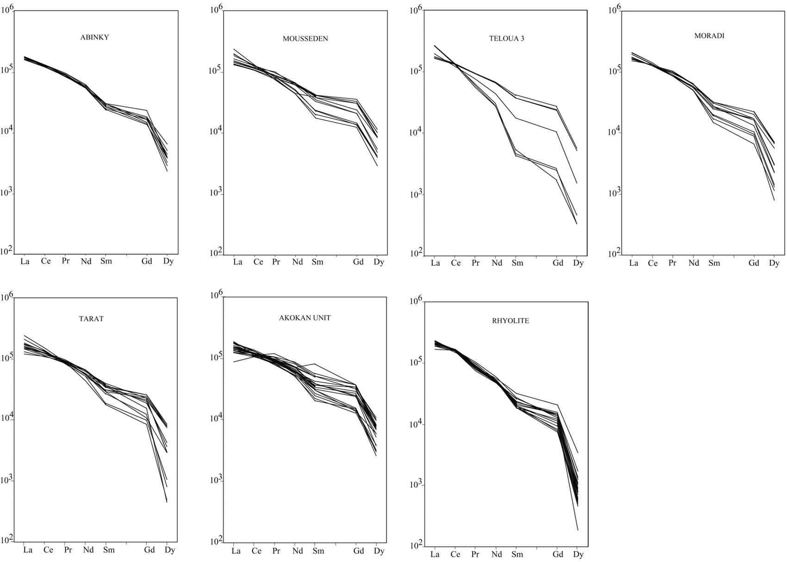

F

IG

.

4.

Chondrite-normal ized

REE patterns of monazite

grains from the Tim Mersoï

basin and from the Goundaï

rhyolite, Aïr Mountains.

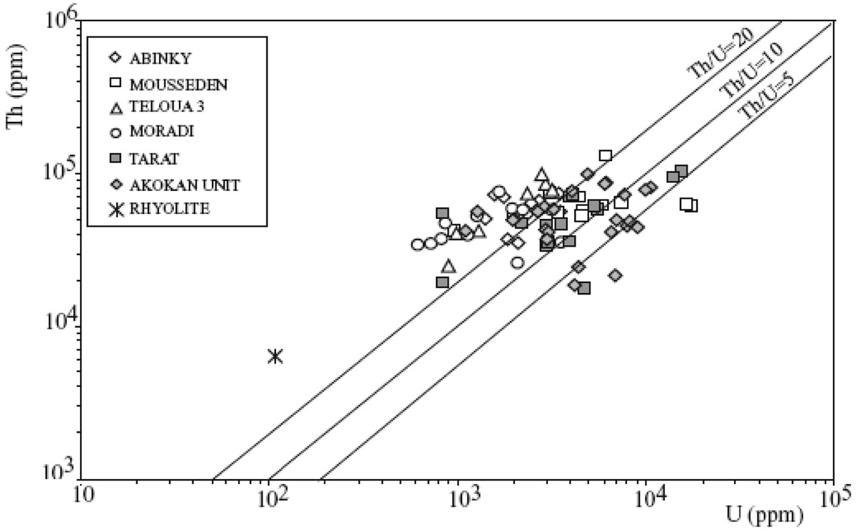

FIG. 5. Thorium and U concentrations in monazite grains of the Tim Mersoï basin and in a rhyolite of the Goundaï massif, Aïr Mountains.

TABLE 4. MEAN CHEMICAL COMPOSITION AND COMPOSITIONAL RANGE OF MONAZITE

___________________________________________________________________________________

d.l. Akokan Unit Tarat Moradi

Range Mean Range Mean Range Mean

___________________________________________________________________________________

|  |  |  |  |  |  |  |  |
| --- | --- | --- | --- | --- | --- | --- | --- |
| Y2 3O wt% | 0.01 | 0.15 – 3.57 | 2.33 | 0.00 – 3.25 | 1.77 | 0.36 – 2.48 | 1.27 |
| La2 3O | 0.04 | 7.57 – 16.13 | 12.82 | 11.24 – 20.64 | 14.26 | 14.08 – 17.61 | 15.67 |
| Ce2 3O | 0.04 | 24.08 – 29.91 | 27.03 | 24.51 – 33.96 | 28.26 | 28.51 – 32.38 | 29.94 |
| Pr2 3O | 0.06 | 2.44 – 3.27 | 2.91 | 2.56 – 3.03 | 2.79 | 2.65 – 3.24 | 2.83 |
| Nd2 3O | 0.06 | 8.63 – 14.92 | 11.12 | 7.37 – 11.24 | 9.85 | 8.7 – 11.00 | 9.67 |
| Sm2 3O | 0.06 | 1.22 – 4.46 | 2.10 | 0.97 – 2.16 | 1.70 | 0.81 – 1.76 | 1.31 |
| Gd2 3O | 0.06 | 0.93 – 2.68 | 1.85 | 0.00 – 0.77 | 1.35 | 0.47 – 1.44 | 0.98 |
| Dy2 3O | 0.02 | 0.008 – 0.97 | 0.58 | 0.04 – 0.77 | 0.40 | 0.07 – 0.62 | 0.27 |
| ThO2 | 0.006 | 2.11 – 11.34 | 6.23 | 2.00 – 11.64 | 6.01 | 2.32 – 8.57 | 5.11 |
| UO2 | 0.008 | 0.12 – 1.17 | 0.56 | 0.09 – 1.74 | 0.55 | 0.07 – 0.39 | 0.18 |
| PbO | 0.02 | 0.08 – 1.15 | 0.22 | 0.04 – 0.41 | 0.18 | 0.02 – 0.17 | 0.12 |
| CaO | 0.008 | 0.28 – 2.25 | 1.14 | 0.45 – 2.79 | 1.52 | 0.18 – 1.30 | 0.76 |
| SiO2 | 0.01 | 0.09 – 2.00 | 0.88 | 0.17 – 1.46 | 0.53 | 0.29 – 2.40 | 1.13 |
| P2 5O | 0.02 | 28.70 – 32.58 | 30.55 | 28.95 – 31.96 | 30.76 | 26.42 – 35.24 | 30.55 |
| Total 97.17 – 103.11 100.32 98.43 – 102.30 99.86 97.28 – 102.83 99.79 | | | | | | | |

___________________________________________________________________________________

TABLE 4 (cont’d). MEAN CHEMICAL COMPOSITION AND COMPOSITIONAL RANGE OF MONAZITE

_______________________________________________________________________________________________________________

Teloua 3 Mousseden Abinky Rhyolite

Range Mean Range Mean Range Mean Range Mean

_______________________________________________________________________________________________________________

|  |  |  |  |  |  |  |  |  |
| --- | --- | --- | --- | --- | --- | --- | --- | --- |
| Y2 3O wt% | 0.03 – 1.05 | 0.55 | 1.15 – 3.59 | 2.21 | 0.73 – 2.79 | 1.58 | 0.22 – 0.96 | 0.42 |
| La2 3O | 14.02 – 23.00 | 18.30 | 11.13 – 20.13 | 14.04 | 13.90 – 15.60 | 14.69 | 14.35 – 19.37 | 17.07 |
| Ce2 3O | 27.83 – 30.61 | 29.74 | 24.10 – 29.78 | 26.70 | 27.69 – 30.20 | 28.92 | 33.55 – 37.58 | 36.32 |
| Pr2 3O | 1.73 – 2.92 | 2.36 | 2.31 – 3.04 | 2.63 | 2.64 – 3.04 | 2.82 | 2.57 – 3.17 | 2.80 |
| Nd2 3O | 4.67 – 11.39 | 7.93 | 7.35 – 11.31 | 9.54 | 9.25 – 10.65 | 9.75 | 8.33 – 9.93 | 8.86 |
| Sm2 3O | 0.23 – 2.29 | 1.15 | 0.96 – 2.31 | 1.79 | 1.30 – 1.67 | 1.48 | 1.01 – 1.73 | 1.19 |
| Gd2 3O | 0.12 – 1.92 | 0.94 | 0.87 – 2.52 | 1.67 | 0.99 – 1.67 | 1.23 | 0.56 – 1.50 | 0.84 |
| Dy2 3O | 0.04 – 0.50 | 0.23 | 0.26 – 1.03 | 0.62 | 0.21 – 0.59 | 0.37 | 0.04 – 0.31 | 0.09 |
| ThO2 | 2.81 – 11.37 | 7.22 | 4.76 – 14.95 | 7.45 | 3.96 – 8.50 | 6.61 | 0.15 – 0.73 | 0.39 |
| UO2 | 0.09 – 0.35 | 0.22 | 0.10 – 1.93 | 0.71 | 0.15 – 0.39 | 0.25 | <d.l. | <d.l. |
| PbO | 0.07 – 0.28 | 0.18 | 0.12 – 0.34 | 0.22 | 0.10 – 0.20 | 0.16 | <d.l | <d.l. |
| CaO | 0.38 – 1.55 | 0.92 | 0.58 – 2.17 | 1.30 | 0.72 – 1.56 | 1.20 | 0.04 – 0.21 | 0.10 |
| SiO2 | 0.55 – 3.68 | 1.76 | 0.20 – 1.84 | 1.13 | 0.43 – 1.58 | 0.85 | 0.12 – 0.50 | 0.32 |
| P2 5O | 27.29 – 31.15 | 28.92 | 29.16 – 34.70 | 31.11 | 26.13 – 34.86 | 30.48 | 30.63 – 35.67 | 32.27 |

Total 100.40 – 101.93 100.42 98.52 – 102.81 101.12 96.18 – 102.78 100.31 99.04 – 103.03 100.67

_______________________________________________________________________________________________________________

d.l.: detection limit.

envisaged because (1) Forbes (1989) showed that monazite grains are less abundant in the uranium-mineralized zones, (2) phosphorus and Th contents in sandstones are lower in mineralized areas than in other portions of the sandstone, and (3) BSE–SEM observations show that the monazite grains show signs of alteration (Fig. 4). Concerning the second point, note that P and the REE can be relatively mobile during diagenesis (Mathieu *et al.* 2001), but the same cannot be said for Th, which is weakly soluble at low temperature. For example, no Th is present in the uranium oxides from the deposits, but they contain more than 1000 ppm REE. The low Th content of the sandstone in the mineralized areas may be an original feature. This interpretation has been discarded because it does not apply to the sediments from the East, and they belong to the same system of fluvial transport. It will thus be very interesting in the future to study in detail the corrosion of monazite grains (Berger *et al.* 2008) to show its importance in the Tim Mersoï Basin and to evaluate the potential tonnage that could result from the leaching of monazite.

ackNOWLedGemeNTS

We thank COMINAK, SOMAIR and COGEMA

Niger for access to the facilities. We thank Claude Caillat, Michel Cuney, Régis Mathieu and Bernard Bonin for fruitful discussions. The study was supported

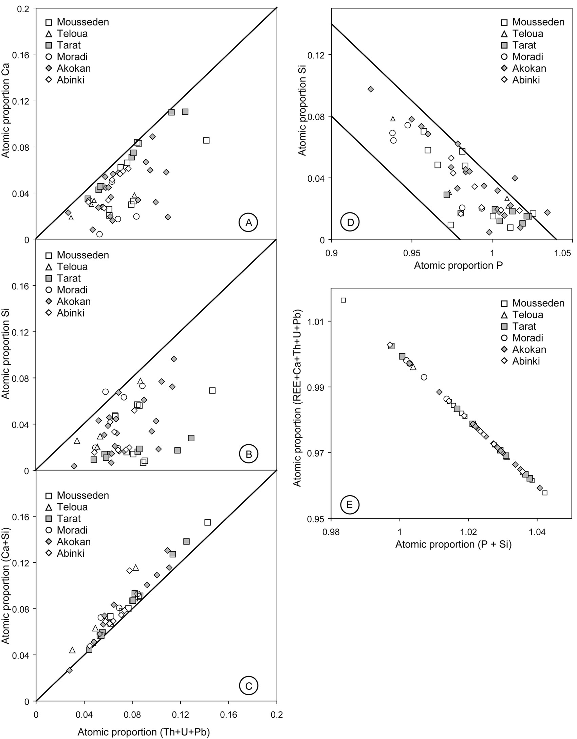

F

IG

.

6.

Proportion of Ca (A), Si (B), Ca + Si (C)

*versus*

Th

+

U. Plot (D) shows the atomic proportion of Si

*versus*

P in monazite grains from the Tim Mersoï basin; plot E

shows the atomic proportion (P = Si) against the atomic

proportion (REE + Ca + Th + U + Pb).

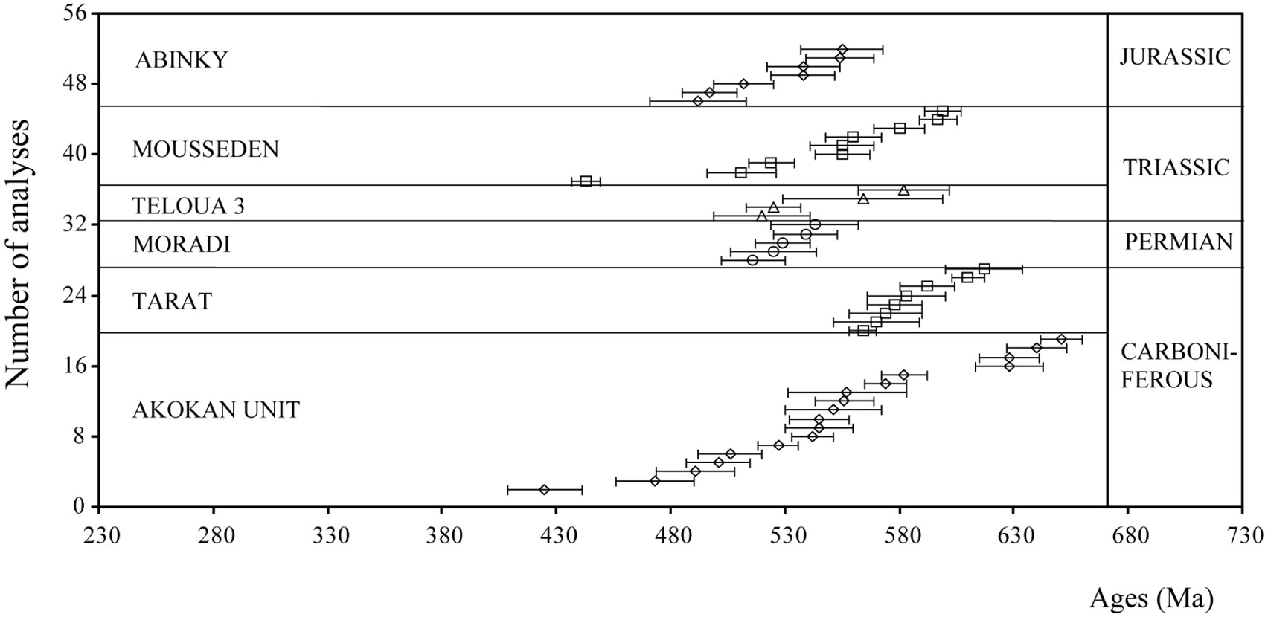FIG. 7. Chemical age range of monazite grains in different stratigraphic units of the Tim Mersoï basin.

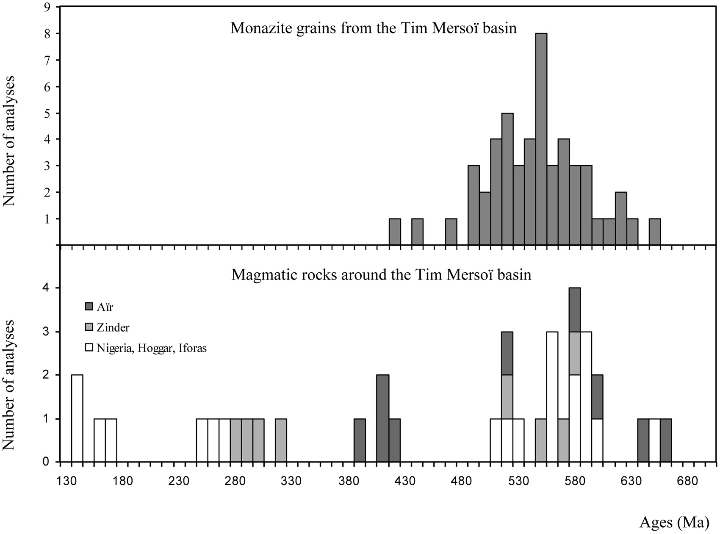

FIG. 8. (A) Histogram of the chemical ages of the monazite grains from Tim Mersoï basin obtained by electron-microprobe analyses (Table 5). (B) Histogram of the ages of the granites around the Tim Mersoï basin obtained from data in the literature (Table 1).

TABLE 5. ELECTRON-MICROPROBE U–Th–Pb DATA

AND CALCULATED CHEMICAL AGES OF MONAZITE GRAINS

FROM TIM MERSOÏ BASIN AND RHYOLITE OF THE GOUNDAÏ MASSIF

____________________________________________________________

Sample Anal- U ó Th ó Pb ó Age ó ysis ppm ppm ppm ppm ppm ppm Ma Ma

|  |  |  |  |  |  |  |  |  |
| --- | --- | --- | --- | --- | --- | --- | --- | --- |
|  |  |  |  | **Abinky** |  |  |  |  |
| 69 | 1 | 1811 | 53 | 37174 100 | 932 | 41 | 492 | 21 |
| 69 | 3a | 1383 | 52 | 50532 116 | 1349 | 45 | 555 | 18 |
| 69 | 3b | 2292 | 54 | 54047 119 | 1460 | 44 | 538 | 16 |
| 69 | 4 | 1731 | 53 | 70305 134 | 1800 | 47 | 538 | 14 |
| 69 | 5 | 2689 | 54 | 66438 126 | 1646 | 42 | 497 | 12 |
| 69 | 6 | 2422 | 54 | 63450 127 | 1610 | 42 | 512 | 13 |
| 69 | 7 | 3453 | 56 | 56244 118  **Mousseden** | 1653 | 44 | 554 | 15 |
| 76 | 1 | 1955 | 53 | 54398 120 | 1370 | 40 | 511 | 15 |
| 76 | 2 | 6061 | 60 | 131382 171 | 2949 | 46 | 443 | 6 |
| 76 | 3a | 17101 | 75 | 60726 121 | 3120 | 45 | 599 | 8 |
| 76 | 3b | 16220 | 73 | 63274 127 | 3096 | 45 | 597 | 8 |
| 76 | 5 | 7298 | 61 | 63802 128 | 2256 | 45 | 580 | 11 |
| 76 | 6 | 5858 | 59 | 61253 123 | 1993 | 43 | 560 | 12 |
| 76 | 7 | 4393 | 56 | 69602 132 | 1942 | 42 | 524 | 10 |
| 76 | 8a | 4506 | 56 | 52641 116 | 1655 | 43 | 555 | 14 |
| 76 | 8b | 3031 | 54 | 74259 134  **Taloua 3** | 2063 | 45 | 555 | 12 |
| 78 | 1 | 2299 | 53 | 74172 134 | 1890 | 44 | 525 | 12 |
| 78 | 3 | 977 | 51 | 40689 102 | 1007 | 40 | 520 | 21 |
| 78 | 4a | 1283 | 51 | 42183 105 | 1193 | 42 | 582 | 20 |
| 78 | 4b | 886 | 50 | 24695 84  **Moradi** | 687 | 43 | 564 | 35 |
| 28 | 1 | 1658 | 53 | 75314 136 | 1879 | 43 | 529 | 12 |
| 28 | 3 | 3115 | 55 | 57562 121 | 1542 | 42 | 516 | 14 |
| 28 | 5 | 852 | 52 | 46928 113 | 1149 | 42 | 525 | 19 |
| 28 | 7 | 2184 | 53 | 57123 120 | 1530 | 42 | 539 | 14 |
| 28 | 8 | 3520 | 56 | 35328 99  **Tarat** | 1125 | 41 | 543 | 19 |
| AK9 | 3a | 2154 | 53 | 46665 112 | 1386 | 42 | 583 | 17 |
| AK9 | 3b | 2973 | 55 | 34977 98 | 1129 | 40 | 570 | 19 |
| AK9 | 7a | 3890 | 56 | 69953 133 | 2113 | 45 | 578 | 12 |
| AK9 | 7b | 4030 | 56 | 72765 131 | 2248 | 47 | 592 | 12 |
| AK9 | 8a | 15426 | 73 | 102293 153 | 3827 | 48 | 564 | 6 |
| AK9 | 8b | 14016 | 70 | 94296 151 | 3804 | 47 | 610 | 7 |
| AK9 | 9a | 2957 | 54 | 45698 110 | 1514 | 42 | 617 | 17 |

____________________________________________________________

by the Swiss National Fund, microprobe credit 200021– 103479/1. We also thank reviewers Paul Tomascak and Lutz Hecht, Associate Editor Louis Raimbault et Robert F. Martin for helpful suggestions on how to improve this contribution.

reFereNceS

berGer, a., GNOS, e., JaNOTS, e., FerNaNdez, a. & GIeSe, J. (2008): Formation and composition of rhabdophane, bastnäsite and hydrated thorium minerals during alteration: implications for geochronology and low-temperature processes. *Chem. Geol.* **254**, 238-248.

berTraNd, J.-m. & caby, r. (1978): Geodynamic evolution of the Pan-African orogenic belt: a new interpretation of the Hoggar shield (Algerian Sahara). *Geol. Rundschau* **67**, 357-388.

berTraNd, J.-m., mIchard, a., bOuLLIer, a.-m. & dauTeL, d. (1986): Structure and U–Pb geochronology of the Central Hoggar (Algeria): a reappraisal of its Pan-African evolution. *Tectonics* **5**, 955-972.

bLack, r. & LIÉGeOIS, J.-P. (1991): Pan-African plutonism of the Damagaram inlier, Niger Republic. *J. Afr. Earth Sci.* **13**, 471-482.

bLack, r. & LIÉGeOIS, J.-P. (1993): Cratons, mobile belts, alkaline rocks and continental lithospheric mantle: the Pan-African testimony. *J. Geol. Soc. London* **150**, 89-98.

bOISSONNaS, J., bOrSI, S., Ferrara, G., Fabre, J. & GraveLLe, m. (1969): On the Early Cambrian age of two late orogenic granites from west-central Ahaggar (Algerian Sahara). *Can. J. Earth Sci*. **6**, 25-37.

|  |  |  |  |  |  |  |  |  |
| --- | --- | --- | --- | --- | --- | --- | --- | --- |
| AK9 9b | 3527 | 55 | 45786 110  **Akokan Unit** | | 1456 | 44 | 574 | 16 |
| AK22 1 | 7838 | 63 | 45083 | 108 | 2018 | 44 | 640 | 13 |
| AK22 2 | 3997 | 56 | 76632 | 138 | 10700 | 59 | 2500 | 12 |
| AK22 3 | 6891 | 61 | 49301 | 113 | 1771 | 43 | 556 | 13 |
| AK22 4a | 1253 | 52 | 56156 | 118 | 1125 | 42 | 425 | 16 |
| AK22 4b | 7613 | 62 | 72238 | 130 | 2506 | 45 | 582 | 10 |
| AK22 5 | 10490 | 66 | 81817 | 139 | 2714 | 46 | 527 | 9 |
| AK22 6 | 8838 | 64 | 44556 | 107 | 1779 | 42 | 545 | 13 |
| AK22 7 | 2835 | 54 | 61165 | 122 | 1555 | 44 | 501 | 14 |
| AK22 8 | 3162 | 55 | 58265 | 122 | 1531 | 42 | 506 | 14 |
| AK22 10 | 6018 | 60 | 87002 | 139 | 2556 | 44 | 542 | 9 |
| AK22 11 | 4120 | 57 | 18543 | 80 | 804 | 39 | 557 | 26 |
| AK22 13a | 1952 | 52 | 50268 | 116 | 1225 | 42 | 491 | 17 |
| AK22 13b | 1930 | 53 | 49565 | 114 | 1164 | 42 | 473 | 17 |
| AK22 14a | 8102 | 62 | 48950 | 113 | 2111 | 46 | 628 | 13 |
| AK22 14b | 6496 | 60 | 41216 | 103 | 1746 | 43 | 628 | 15 |
| AK22 15a | 1094 | 51 | 41831 | 105 | 1104 | 43 | 551 | 21 |
| AK22 15b | 2638 | 54 | 56156 | 118 | 1559 | 43 | 545 | 15 |
| AK22 16a | 9825 | 66 | 77687 | 140 | 3183 | 47 | 651 | 9 |
| AK22 16b | 4801 | 58 | 99657 | 149 | 2929 | 47 | 574 | 9 |
| **Goundaï rhyolite** | | |
| 1 107 6374 120 | | | | | | | | |

bONIN, b., bOWdeN, P. & vIaLeTTe, y. (1979): Le comportement des éléments Rb et Sr au cours des phases de minéralisation: l’exemple de Ririwai (Liruei), Nigeria. *C.R. Acad. Sci. Paris* **289**, 707-710.

____________________________________________________________

TABLE 6. ESTIMATED CONTRIBUTION OF MONAZITE GRAINS

TO THE TOTAL U CONTENT IN THE SEDIMENTS

FROM THE TIM MERSOÏ BASIN

____________________________________________________________

1 2 3 4 5 6 7 8

____________________________________________________________

Abinky 69 2300 6.77 18.3 125300 0.34 5 Mousseden 76 4200* 1.95 51.3 119700 1.80 92 Teloua 3 78 2000 2.08 57.0 156000 0.73 35 Moradi 28 1600 2.26 23.5 133600 0.28 12 Tarat AK9 4900 7.56 64.4 121600 2.60 34 Akokan AK22 5000 2.58 35.8 109300 1.64 63

____________________________________________________________

Column headings: 1 Formations, 2 sample number, 3 average U content in monazite in ppm, 4 U content in sediments in ppm, 5 La content in sediments in ppm, 6 average La content in monazite in ppm, 7 U content in monazite in ppm, 8 100 U in monazite / U in sediments, in %. * Results of two analyses on grain 3 were not taken into account because the uranium content is very high compared to the other results.

bOWdeN, P., vaN breemeN, O., huTchISON, J. & TurNer, d.c. (1976): Palaeozoic and Mesozoic age trends for some ring complexes in Niger and Nigeria. *Nature* **259**, 297-299.

brOWN, W.L., mOreau, c. & demaIFFe, d. (1989): An anorthosite suite in a ring-complex: crystallization and emplacement of an anorogenic type from Abontorok, Aïr, Niger. *J. Petrol.* **30**, 1501-1540.

caheN, L., SNeLLING, N.J., deLhaL, J., vaIL, J.r., bONhOmme,

m. & LedeNT, d. (1984): *The Geochronology and Evolution of Africa*. Clarendon Press, Oxford, U.K.

cheILLeTz, a., berTraNd, J.m., charOy, b., mOuLahOum,

O., bOuabSa, L., Farrar, e., zImmermaNN, J.L., dauTeL,

d., archIbaLd, d.a. & bOuLLIer, a.-m. (1992): Géochimie et géochronologie Rb–Sr, K–Ar et 40Ar–39Ar des complexes granitiques panafricains de la région de Tamanrasset (Algérie): relations avec les minéralisations Sn–W associées et l’évolution tectonique du Hoggar central. *Bull. Soc. Géol. France* **163**, 733-750.

cuNey, m. & maThIeu, r. (2000): Extreme light rare earth element mobilization by diagenetic fluids in the geological environment of the Oklo natural reactor zones, Franceville basin, Gabon. *Geology* **28**, 743-746.

dada, S.S., LaNceLOT, J.r. & brIqueu, L. (1989): Age and origin of the annular charnockitic complex at Toro, northern Nigeria: U–Pb and Rb–Sr evidence. *J. Afr. Earth Sci.* **9**, 227-234.

ducrOT, J., de La bOISSe, h., reNaud, u. & LaNceLOT, J.r. (1979): Synthèse géochronologique sur la succession des événements magmatiques panafricains au Maroc, dans l’Adrar des Iforas et dans l’Est Hoggar. *Dixième Coll. Géologie Africaine* (*Montpellier*), *Résumés*, 40-42.

eL hameT, m.O. (1983): *Analyse géologique et pétrographique de la formation de Tarat dans les carrières* (*Paléozoïque supérieur*). *Essai d’interprétation paléoclimatique à la lumière de l’épisode glaciaire dévono-carbonifère, région d’Arlit, Niger septentrional*. Thèse de Doctorat de troisième cycle, Université de Bourgogne, Dijon, France.

FerrÉ, e., GLeIzeS, G. & caby, r. (2002): Obliquely convergent tectonics and granite emplacement in the TransSaharan belt of eastern Nigeria: a synthesis. *Precamb. Res.* **114**, 199-219.

FOrbeS, P. (1989): *Rôles des structures sédimentaires et tectoniques, du volcanisme alcalin régional et des fluides diagénétiques-hydrothermaux pour la formation des minéralisations à U–Zr–Zn–V–Mo d’Akouta* (*Niger*). Thèse, Université de Bourgogne, Dijon, France.

FOrbeS, P., PacqueT, a., chaNTreT, F., OumarOu, J. & PaGeL, m. (1984): Marqueurs du volcanisme dans le gisement d’uranium d’Akouta (République du Niger). *C.R. Acad. Sci. Paris, sér.* II, **298**, 647-650.

GONzáLez-áLvarez, I., kuSIak, m.a. & kerrIch, r. (2006): A trace element and chemical Th–U total Pb dating study

in the lower Belt–Purcell Supergroup, western North America: provenance and diagenetic implications. *Chem. Geol.* **230**, 140-160.

hadJ-kaddOur, z., LIÉGeOIS, J.-P., demaIFFe, d. & caby, r. (1998): The alkaline–peralkaline granitic postcollisional Tin Zebane dyke swarm (Pan-African Tuareg Shield, Algeria): prevalent mantle signature and late agpaitic differentiation. *Lithos* **45**, 223-243.

hechT, L. & cuNey, m. (2000): Hydrothermal alteration of monazite in the Precambrian basement of the Athabasca Basin (Saskatchewan, Canada): implications for the genesis of unconformity-related uranium deposits. *Mineral. Deposita* **35**, 791-795.

JaNOTS, e., eNGI, m., berGer, a., aLLaz, J., SchWarz, J.-O. & SPaNdLer, c. (2008): Prograde metamorphic sequence of REE minerals in pelitic rocks of the Central Alps: implications for allanite – monazite – xenotime phase relations from 250 to 610°C. *J. Metam. Geol.* **26**, 509-526.

JOuLIa, F. (1963): Carte géologique de reconnaissance de la bordure sédimentaire occidentale de l’Aïr, échelle 1/500 000. Ed. BRGM, Orléans. France.

kuSIak, m.a., kedzIOr, a., PaSzkOWSkI, m., SuzukI, k., GONzáLez-áLvarez, I., WaJSPrych, b. & dOkTOr, m. (2006): Provenance implications of Th–U–Pb electron microprobe ages from detrital monazite in the Carboniferous Upper Silesia Coal Basin, Poland. *Lithos* **88**, 56-71.

LIÉGeOIS, J.-P., berTraNd, h., bLack, r., caby, r. & Fabre, J. (1983): Permian alkaline undersaturated and carbonatite province, and rifting along the West African craton. *Nature* **305**, 42-43.

LIÉGeOIS, J.-P. & bLack, r. (1984): Pétrographie et géochronologie Rb–Sr de la transition calco-alcaline – alcaline fini-Pan-Africaine dans l’Adrar des Iforas (Mali): accrétion crustale au Précambrien supérieur. *In* Géologie Africaine – African Geology (J. Klerkx & J. Michot, eds.). Musée Royal de l’Afrique centrale, Tervuren, Belgium (115-145).

LIÉGeOIS, J.-P., bLack, r., Navez, J. & LaTOuche, L. (1994): Early and late Pan-African orogenies in the Aïr assembly of terranes (Touareg Shield, Niger). *Precamb. Res.* **67**, 59-88.

maThIeu, r., zeTTerSTröm, L., cuNey, m., GauThIerLaFaye, F. & hIdakI, h. (2001): Alteration of monazite and zircon and lead migration as geochemical traces of fluid paleocirculations around the Oklo–Okélobondo and Bangombé natural nuclear reaction zones (Franceville basin, Gabon). *Chem. Geol.* **171**, 147-171.

mONTeL, J.-m., FOreT, S., veSchambre, m., NIcOLLeT, c. & PrOvOST, a. (1996). Electron microprobe dating of monazite. *Chem. Geol.* **131**, 37-53.

mOreau, c. (1982): *Les complexes annulaires anorogéniques à suites anorthositiques de l’Aïr central et septentrional* (*Niger*). Thèse d’Etat, Univ. Nancy I, Nancy, France.

mOreau, c., demaIFFe, d., beLLION, y. & bOuLLIer, a-m. (1994): A tectonic model for the location of Palaeozoic ring complexes in Aïr (Niger, West Africa). *Tectonophysics* **234**, 129-146.

Navez, J., LIÉGeOIS, J.-P., LaTOuche, L., bOveN, a. & bLack, r. (1999): The Palaeoproterozoic Tchilit exotic terrane (Aïr, Niger) within the Pan-African collage of the Tuareg Shield. *J. Geol. Soc.* **156**, 247-259.

PacqueT, a. (1968): Analcimes et argiles diagénétiques dans les formations sédimentaires de la region d’Agadès (République du Niger). *Mém. Serv. Carte Géol. AlsaceLorraine* **27**.

PaGeL, m., caveLLec, S., FOrbeS, P., Gerbaud, O., verGeLy, P., WaGaNI, I. & maThIeu, R. (2005): Uranium deposits in the Arlit area (Niger). *In* Mineral Deposit Research: Meeting the Global Challenge 1 (Jingwen Mao & F.P. Bierlen, eds.). Springer, New York, N.Y. (303-305).

PaqueTTe, J.L., caby, r., dJOuadI, m.T. & bOuchez, J.-L. (1998): U–Pb dating of the end of the Pan-African orogeny in the Tuareg shield: the post-collisional syn-shear Tioueine pluton (western Hoggar, Algeria). *Lithos* **45**, 245-253.

POPOFF, m., kamPuNzu, a.b., cOuLON, c. & eSquevIN, J.

(1982): Découverte d’un volcanisme mésozoïque dans le NE du Nigeria. *Travaux de Laboratoire de Sciences de la Terre, St Jérôme, Marseille* **19**, 47-49.

Scherrer, N.c., eNGI, m., GNOS, e., JakOb, v. & LIechTI, a. (2000): Monazite analysis: from sample preparation to microprobe age dating and REE quantification. *Schweiz. Mineral. Petrogr. Mitt.* **80**, 93-105.

TOuGarINOv, a.I., kNOrre, k.G., ShaNIN, L.L. & PrOkOFIeva, L.N. (1968): The geochronology of some Precambrian rocks of southern West Africa. *Can. J. Earth Sci*. **5**, 639-642.

TubOSuN, I.a., LaNceLOT, J.r., rahamaN, m.a. & OcaN, O. (1984): U–Pb Pan-African ages of two charnockite–granite associations from SW Nigeria. *Contrib. Mineral. Petrol.* **88**, 188-195.

TurPIN, L., cLauer, N., FOrbeS, P. & PaGeL, m. (1991): U– Pb, Sm–Nd and K–Ar systematic of the Akouta uranium deposit, Niger. *Chem. Geol.* **87**, 217-230.

vaLSardIeu, c. (1971): *Cadre géologique et paléogéographique des minéralisations de charbon, de cuivre et d’uranium de la région d’Agadès* (*République du Niger*). Thèse Doctorat d’Etat, Université de Nice, Nice, France.

vaN breemeN, O., huTchINSON, J. & bOWdeN, P. (1975): Age and origin of the Nigerian Mesozoic granites: a Rb–Sr isotopic study. *Contrib. Mineral. Petrol.* **50**, 157-172.

vaN breemeN, O., PIdGeON, r.T. & bOWdeN, P. (1977): Age and isotopic studies of some Pan-African granites from north-central Nigeria. *Precamb. Res.* **4**, 307-319.

vaN emdeN, b., ThOrNber, m.r., Graham, J. & LINcOLN, F.J. (1997): The incorporation of actinides in monazite and xenotime from placer deposits in Western Australia. *Can. Mineral.* **35**, 95-104.

WeIS, d., LIÉGeOIS, J.-P. & bLack, r. (1987): Tadhak alkaline ring-complex (Mali): existence of U–Pb isochrons and “Dupal” signature 270 Ma ago. *Earth Planet. Sci. Lett.* **82**, 316-322.

WILLIamS, m.L., JercINOvIc, m.J., GONcaLveS, P. & mahaN,

k. (2006): Format and philosophy for collecting, compiling, and reporting microprobe monazite ages. *Chem. Geol*. **225**, 1-15.

yaNG, ShOuye, LI, cONGxIaN & yOkOyama, k. (2006): Elemental compositions and monazite age patterns of core sediments in the Changjiang Delta: implications for sediment provenance and development history of the Changjiang River. *Earth Planet. Sci. Lett.* **245**, 762-776.

*Received October 23,2009, revised manuscript accepted April 21, 2011.*

Downloaded from http://pubs.geoscienceworld.org/canmin/article-pdf/49/2/487/3455743/487_vol_49-2_art_04.pdf by Nanjing University user

1. *E-mail address*: maurice.pagel@u-psud.fr