Journal of the Geological Society, London, Vol. 166, 2009, pp. 501–515. doi: 10.1144/0016-76492008-088.

Early Ordovician rifting of Avalonia and birth of the Rheic Ocean: U–Pb detrital zircon constraints from Newfoundland

JEFFREY C. POLLOCK1,2*, JAMES P. HIBBARD1 & PAUL J. SYLVESTER3

1Department of Marine, Earth and Atmospheric Sciences, North Carolina State University, Raleigh, NC 27695, USA 2Present address: School of GeoSciences, University of Edinburgh, Edinburgh EH9 3JW, UK

3Department of Earth Sciences, Memorial University of Newfoundland, St. John’s, Newfoundland, A1B 3X5, Canada

*Corresponding author (e-mail: jpollock@mun.ca)

Abstract: Avalonia is the largest accreted crustal block in the Appalachian orogen and comprises a collection of late Neoproterozoic volcano-sedimentary sequences that are overlain by a Palaeozoic platformal sedimentary succession. Detrital zircons from the Conception Group are dominated by 570–620 Ma ages and contain a significant component generated by erosion of coeval igneous arc-volcanic rocks. Overlying samples from the Cuckold and Crown Hill formations are dominated by Neoproterozoic populations with ages between 600 and 650 Ma and are interpreted to be derived from the underlying calc-alkaline arc-plutonic rocks. Early Palaeozoic platform units are dominated by c. 620 Ma zircons with lesser Mesoproterozoic and Palaeoproterozoic zircons. The range of detrital zircon ages is inconsistent with a West African provenance and suggests that Avalonia originated along the Gondwanan margin of the Amazon craton. The influx of Mesoproterozoic and Palaeoproterozoic detritus in the Avalonian platform suggests a major change in tectonic regime. The prominent change in provenance is interpreted to be related to separation of Avalonia from Gondwana during the Early Ordovician opening of the Rheic Ocean. The Redmans Formation is interpreted to represent the rift–drift transition of the Rheic Ocean, which imposes important constraints on the palaeotectonic evolution of Avalonia.

Supplementary material: U–Pb isotopic data of LA-ICP-MS analysis of detrital zircons are available at

http://www.geolsoc.org.uk/SUP18346.

Avalonia is the largest accreted crustal block in the Appalachian–Caledonian orogen and comprises Neoproterozoic–early Palaeozoic magmatic arc and sedimentary cover sequences that can be traced from the British Caledonides in England SW to Rhode Island (Fig. 1). Lithostratigraphic, isotopic, faunal, and palaeomagnetic data indicate that Avalonia records a Neoproterozoic tectonomagmatic history that predates opening of the Iapetus Ocean and is considered to have formed as a Neoproterozoic arc-related terrane along an active margin of Gondwana (O’Brien et al. 1996; Murphy et al. 1999; Nance et al. 2002). Sometime between the latest Neoproterozoic and Early Silurian Avalonia rifted and separated from Gondwana as a microcontinent where it constituted the boundary between the expanding Rheic Ocean to the south and the contracting Iapetus Ocean to the north (van Staal et al. 1998; Murphy et al. 2006). Despite its prominence in Palaeozoic palaeogeography, our understanding of such fundamental aspects of Avalonia such as the precise timing of rifting and separation, its source area(s) in Gondwana, and its geometry and relationship to other peri-Gondwanan terranes are poorly constrained. The resolution of these uncertainties bears directly upon our understanding of the timing and nature of opening and the geometry of the Rheic Ocean. To address these problems, a U–Pb geochronological study was conducted on detrital zircon grains in clastic sedimentary rocks from the major lithotectonic units of the type area of Avalonia, the Avalon Peninsula of eastern Newfoundland. New technical developments in high-frequency sampling (e.g. Kosˇler & Sylvester 2003) have led to improved precision and accuracy of zircon geochronology, which is critical to understanding the

501

palaeotectonic evolution of the major Neoproterozoic–early Palaeozoic continents.

Despite its low abundance in sediments and sedimentary rocks, zircon is a common detrital constituent in many sedimentary rocks because it occurs in a wide spectrum of igneous rock types and is one of the few primary igneous minerals that can survive the highest grades of metamorphism and partial melting, as well as erosion, transportation, deposition and diagenesis, and thus can survive in the crust almost indefinitely (Mezger & Kro¨gstad 1997).

Previous studies have shown that single-grain detrital zircon geochronology is a useful method of dating and tracing crustal processes because it can provide information that can be used to: (1) assist stratigraphic correlation of monotonous sedimentary sequences that lack distinctive marker units (Samson et al. 2005); (2) determine a maximum limit for the age of deposition of a stratigraphic succession (Barr et al. 2003); (3) determine time Gaps in the geological record (Davis 2002); (4) fingerprint source areas with distinct zircon age populations (Cawood et al. 2003); (5) constrain the timing of tectonic processes on an orogenic scale (Pollock et al. 2007). The ability to utilize zircon to interpret the provenance history of a sedimentary sequence requires that the depositional age of the sequence to be analysed be constrained by either faunal and/or high-precision isotope dilution thermal ionization mass spectrometry (ID-TIMS) data and that the source area(s) of this sequence have a well-defined and distinct U–Pb age signature.

|  |
| --- |
| Fig. 1. Early Mesozoic restoration of the North Atlantic region and Appalachian–Caledonian orogen (modified after Williams 1984; Hibbard et al. 2007). |

This study is the first zircon provenance analysis of Neoproterozoic–early Palaeozoic rocks from the type area of Avalonia in Newfoundland. We herein demonstrate the ability of U–Pb detrital zircon geochronology to address two critical problems in Avalonia: (1) the timing of rifting of Avalonia from Gondwana; (2) the provenance and ultimate source craton in Gondwana of Avalonian sedimentary sequences.

# Regional geological setting

On the island of Newfoundland the type area of Avalonia (Fig. 2) comprises Neoproterozoic (c. 760–540 Ma), largely juvenile, low-grade arc-related volcano-sedimentary sequences and associated plutonic rocks that experienced a prolonged tectonic history before deposition of a terminal Neoproterozoic–early Palaeozoic cover of fine-grained platformal sedimentary rocks that contain Acado-Baltic faunas (Landing 1996; O’Brien et al. 1996). The general evolution of Avalonia indicates a protracted and episodic geological history of tectonomagmatic and depositional events that define a four-phase succession comprising: (1) early phases of arc- and rift-related magmatism between 760 and 670 Ma; (2) a main phase (635–570 Ma) of arc volcanism with coeval sedimentary succession dominated by volcanogenic turbidites and cogenetic plutons; (3) rift-related intracontinental volcanism and interlayered clastic sedimentation that records the transition from an arc to a platform without collision between 570 and 545 Ma; (4) deposition of a Cambrian–Ordovician shale-rich platformal sedimentary succession (Nance et al. 2002).

Remnants of early arc-related magmatic activity are preserved in three distinct intervals at c. 760, 730 and 685–670 Ma. On the Burin Peninsula, a fault-bounded, mixed assemblage of sedimentary and rift-related volcanic rocks and Gabbro of the Burin Group is analogous to basalts and mafic intrusive complexes in modern ocean basins and immature island arcs, and is interpreted to represent an incomplete ophiolite sequence (Strong & Dostal 1980). ID-TIMS ages of 763 2 Ma and 764.5 2.1 Ma from zircon date this Gabbroic succession (Krogh et al. 1988; Murphy et al. 2008). Vestiges of the c. 730 Ma arc are preserved along the southern shore of Conception Bay at Chapel Cove. The Hawke Hills tuff (O’Brien et al. 2001) comprises a subaerial felsic to mafic volcanic sequence that is intruded by 630– 640 Ma plutonic rocks and unconformably overlain by Neoproterozoic marine siliciclastic rocks of the Conception Group. The Hawk Hills tuff has traditionally been included with the younger Harbour Main Group; however, a U–Pb age from a felsic volcanic tuff sampled immediately below the sub-Conception Group unconformity yields a date of 729 7 Ma (Israel 1998), thereby negating any correlation with the younger volcanic arc sequences. On the Connaigre Peninsula, early arc rocks are represented by low-grade calc-alkaline rhyolite flows and pyroclastic rocks of the Tickle Point Formation that yielded a 682.8 1.6 Ma U–Pb zircon age (Swinden & Hunt 1991). Prior to the deposition of younger Neoproterozoic rocks, the Tickle Point Formation was intruded by granite and Gabbro of the 673 3 Ma Furby’s Cove Intrusive Suite (O’Brien et al. 1996).

The main phase of Avalonian magmatism records volcanism and plutonism, and coeval sedimentation in arc-related and arcadjacent basins following an apparent hiatus of c. 40 Ma between deposition of the youngest early arc sequences and the main arc phase. Main phase volcanic successions are defined by the widespread occurrence of low metamorphic grade felsic to mafic submarine to subaerial volcanic rocks that are several kilometres thick and formed between 635 and 570 Ma. West to east, these rocks include the Marystown, Love Cove and Harbour Main groups, which have calk-alkaline to transitional and island arc (arc-rift) tholeiitic affinities. Radiogenic isotopic analysis of these rocks yield the following U–Pb ages: 631 2 Ma, 606 + 3.7/ 2.9 Ma and 589.5 3 Ma for the Harbour Main Group, and 608 +20/7 Ma for the Marystown Group (Krogh et al. 1988; O’Brien et al. 1996). Shortly after their eruption, these sequences were intruded by calk-alkaline plutonic complexes, of which the Holyrood and Simmonds Brook intrusive suites have both been dated at 620 2 Ma (Krogh et al. 1988; O’Brien et al. 1995). Sm–Nd and Pb isotopic characteristics and ages of xenocrystic zircons indicate that this main phase is juvenile, but erupted on some form of c. 1.0–1.2 Ga continental crust (Kerr et al. 1995).

|  |
| --- |
| Fig. 2. Regional distribution of late  Neoproterozoic sedimentary rocks of  Avalonia in eastern Newfoundland (modified after O’Brien & King 2005). |

These arc-related magmatic rocks are spatially associated with thick successions of consanguineous marine siliciclastic rocks dominated by volcanogenic turbidites that were deposited in intra-arc, inter-arc, and back-arc basins proximal to active volcanic arcs. The Conception, Connaigre Bay and Connecting Point groups are 4–5 km thick sedimentary sequences that are dominated by low-grade, fine-grained siliceous volcaniclastic and epiclastic sedimentary rocks. Field relationships and geochronology (O’Brien et al. 1995) demonstrate that deposition of these sequences commenced c. 630–620 Ma, locally upon a substrate of 685–670 Ma plutonic and volcanic rocks. Basal interfingering of the Conception Group with the Harbour Main Group, coupled with the occurrence of the Ediacaran index fossil Charnia in the top of the Conception Group, implies a depositional span of c. 50 Ma. In the SW Avalon Peninsula, a bimodal volcanic succession, the c. 575 Ma Bull Arm Formation and 580–565 Ma calcalkaline volcanic (Long Harbour Group) and intrusive (Louil Hills granite) complexes, occur stratigraphically above the Connecting Point and Connaigre Bay groups (O’Brien et al. 1996).

The c. 570 Ma change to bimodal igneous activity is coeval with the cessation of arc-related magmatism and is interpreted to be related to the termination of subduction and the transition to an extensional or transtensional regime (Murphy & Nance 1989). This transition is accompanied by clastic sedimentation in pullapart basins that first produced thin-bedded, deltaic sandstones and shales (St. John’s Group) that pass upwards to fluvial- and alluvial-facies sedimentary rocks (Signal Hill Group) without significant disconformity. Although sedimentation, which continued until the terminal Neoproterozoic, was accompanied by deformation and metamorphism expressed as local thrust faulting, gentle folding and low-grade (prehnite–pumpellyite) regional metamorphism (Calon 2001), there is no evidence for major regional orogenesis and crustal shortening.

The arc–platform transition rocks are overlain by an undeformed, siliciclastic-dominated late Neoproterozoic–early Palaeozoic platform sequence. In the latest Neoproterozoic– Early Cambrian, deposition was dominated by quartz arenite transgressive successions (Chapel Island and Random formations), which pass conformably upward into Middle to Late Cambrian shale and limestone sequences (Adeyton and Harcourt groups) locally accompanied by eruption of alkalic mafic volcanic rocks (Greenough & Papezik 1986). The top of the Avalonian platform is represented by the Early Ordovician Bell Island and Wabana groups, which record tidal-dominated sedimentation of micaceous sandstone, siltstone, oolitic hematite and quartz arenite (Ranger et al. 1984).

# Sample description

|  |
| --- |
| Fig. 3. Composite stratigraphic section of Neoproterozoic–early Palaeozoic sedimentary sequences of Avalonia (modified after O’Brien & King 2005). |

U–Pb ages were obtained from single detrital zircon grains from six samples of Neoproterozoic–early Palaeozoic rocks from eastern Newfoundland in an attempt to constrain the tectonic evolution of Avalonia (Fig. 3). Two samples were collected from the main phase of arc volcanism (635–570 Ma), two samples from the arc–platform transition (590–545 Ma), and two samples from the Palaeozoic platform sequence (Fig. 4). Each sample consisted of c. 40 kg of rock that comprised several subsamples collected at varying stratigraphic locations from a single continuous outcrop. This method greatly reduces any potential natural bias that may result from variations in physical sorting and mechanical abrasion that are the result of the hydrodynamic conditions operative during sediment transport and deposition. Previous studies have shown that a single lithostratigraphic unit may contain a diverse zircon population, as significant variations can exist in zircon age distributions at different geographical locations at the same stratigraphic level from the same formation (DeGraaff-Surpless et al. 2003), and other workers have shown that mixed detrital zircon populations may occur throughout the vertical section (Sircombe et al. 2001).

# Main arc phase

Conception Group, Mall Bay Formation. A sample of a thicklaminated, grey to green siltstone argillite was collected from the lower Conception Group along the eastern shore of Holyrood Bay. At this location the Conception Group comprises c. 700 m of rhythmically interbedded fine-grained siliceous sandstone, siltstone and mudstone that show typical Bouma sequence features such as sole marks, rip-up clasts, grading, parallel and cross laminations and structureless mudstone. These features and overall lithology suggest that deposition was controlled by turbidity currents in a deep marine environment (O’Brien et al. 1996). The consistency of Conception Group stratigraphy over the entire Avalon Peninsula (Williams et al. 1995) invites correlation of the sampled unit with the Mall Bay Formation (Williams & King 1979), which therefore provides an age constraint on the timing of deposition. A maximum age is provided by a U–Pb date of 606 + 3.7/2.9 Ma from the Harbour Main Group, which unconformably underlies the Conception Group below the basal Mall Bay Formation (Krogh et al. 1988). On the southern Avalon Peninsula, the Mall Bay Formation is conformably overlain by glaciogenic rocks of the Gaskiers Formation (Williams & King 1979; Myrow & Kaufman 1999). Lithostratigraphic correlation of the Avalonian successions of Boston Bay and Newfoundland (Narbonne & Gehling 2003) provides an upper limit on the deposition of the Mall Bay Formation, as the correlative of the Gaskiers Formation in the Boston basin, the Squantum Member diamictite of the Roxbury Formation, is dated at 595.5 2 Ma (Thompson & Bowring

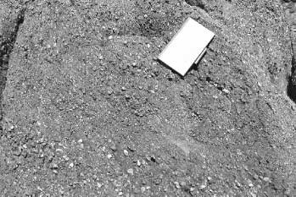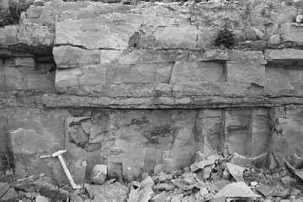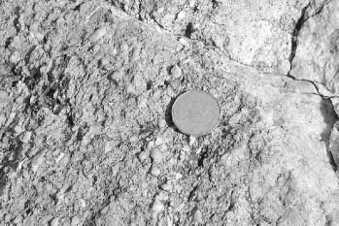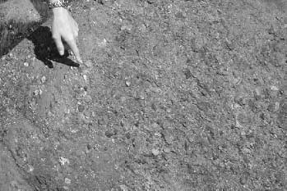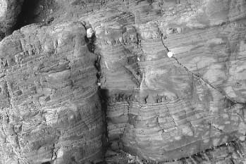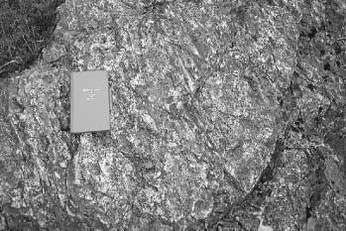

Fig. 4.

Representative outcrops for detrital

zircon analysis: (

a

)

Mall Bay Formation;

(

b

)

Briscal Formation;

(

c

)

Cuckold

Formation; (

d

)

Crown Hill Formation;

(

e

)

Random Formation;

(

f

)

Redmans

Formation.

2000).

Conception Group, Briscal Formation. The Briscal Formation was sampled on the southern Avalon Peninsula from wellexposed outcrops on Portugal Cove Brook. At this location the formation consists of 1200 m of coarse-grained, thick-bedded (1–2 m) grey–green sandstone turbidites containing pyroclastic and epiclastic detritus interpreted to have been deposited in a deep marine environment (Williams & King 1979). The Briscal Formation conformably overlies the Drook Formation and is in turn conformably overlain by the Mistaken Point Formation. A late Neoproterozoic age of deposition is suggested for the sequence as all three formations contain the Ediacaran fauna Charnia masoni (Narbonne & Gehling 2003) and a minimum age of deposition is constrained by a date of 565 3 Ma from a volcanic tuff in the Mistaken Point Formation (G. Dunning, cited by Benus 1988).

# Arc–platform transition

Signal Hill Group, Cuckold Formation (Cape Spear Member). The Cuckold Formation was collected from the type section of the Cape Spear Member at Cape Spear National Park and represents the most easterly onshore formation on the North American continent. The unit comprises c. 250 m of gently westward dipping, matrix-supported, pebble to cobble conglomerates that contain predominantly sub-angular red to purple clasts of rhyolite, rhyolite porphyry, ignimbrite and coarse-grained granitoid. Beds in the middle of the formation contain distinctive exotic clasts of quartz–sericite schist, quartzite, vein-quartz and other low-grade metamorphic rocks that locally form less than 25% of the coarse fraction and have been interpreted by King (1990) to indicate a sialic basement source. Diffuse interbeds of pebbly sandstone show large-scale trough crossbeds with a unimodal palaeoflow to the SSW (King 1990).

At Flatrock the Cape Spear Member is disconformably overlain by grey conglomerate of the Flat Rock Cove Formation, which was deposited in response to east-vergent thrusting (Rice 1996). The recognition of this contact as a composite progressive unconformity related to faulting (Calon 2001) indicates that the Cuckold Formation represents a sedimentary succession deposited syntectonically during the earliest phase of deformation. The youngest rocks of the Flat Rock Cove Formation overlie Conception Group strata with angular unconformity and constrain the age of faulting and deposition of the Signal Hill Group to the latest Neoproterozoic (Anderson et al. 1975).

Musgravetown Group, Crown Hill Formation. The Crown Hill Formation was sampled from the community of Tickle Cove on the Bonavista Peninsula and comprises a red to maroon pebble to cobble conglomerate that commonly shows medium- to largescale trough crossbeds. On the basis of similar facies and overall stratigraphy, O’Brien & King (2005) have correlated this unit with the Cuckold Formation of the Signal Hill Group on the Avalon Peninsula. On the Bonavista Peninsula the Crown Hill Formation is conformably overlain by the earliest Cambrian Random Formation. Fluvial and alluvial facies developed within molasse-like rocks of the Cuckold and Crown Hill formations are characteristic of braided river deposits interpreted to have developed in response to major uplift of Avalonia related to the Avalonian orogeny (King 1990).

# Platform

Random Formation. The Random Formation is a distinctive grey clastic sequence characterized by white weathering crossbedded orthoquartzite, sandstone and shale that locally attains thicknesses of up to 400 m and is exposed across the entire western half of Avalonia in Newfoundland (Walcott 1900; Landing 1996). A sample of two interbedded rock types of the Random Formation was collected from a 90 m thick section at Keels on the Bonavista Peninsula; a thick- to very thick-bedded, white coarse-grained crossbedded quartzarenite with lenses and thin beds of quartz granule conglomerate from the base of the formation and a dark grey micaceous siltstone that occurs c. 30 m higher in the stratigraphic sequence. Facies analysis suggests deposition under macrotidal conditions in an open marine environment (Hiscott 1982). The age of the Random Formation is earliest Cambrian. On the Burin Peninsula the Random Formation conformably overlies the Chapel Island Formation, which contains the Global Stratotype Section and Point for the Neoproterozoic–Cambrian boundary at Fortune Head (Brasier et al. 1994); elsewhere in eastern Newfoundland, the Random Formation underlies all exposed fossiliferous Cambrian strata in Avalonia.

Bell Island Group, Redmans Formation. This sample was collected from the type section of the Redmans Formation at Redmans Head on the NE shore of Bell Island. The rock is a medium-grained, white to grey thin- to medium-bedded quartzarenite with minor thin silty interbeds. Most of the sandstones display trough and herringbone cross-bedding, mega-ripple marks and channel and scour surfaces; all features associated with tidal sand wave or barrier island deposits generated by transgression and regression (Brenchley et al. 1993). The Redmans Formation conformably overlies the Beach Formation and is in turn conformably overlain by the Ochre Cove Formation. Rare inarticulate brachiopods (van Ingen 1914) and abundant trace fossils in all formations of the Bell Island Group indicate deposition of the Redmans Formation during the Arenig (Ranger et al. 1984).

# Analytical methods

Detrital zircons were isolated from c. 25 kg of unweathered rock using a jaw crusher–Bico disc mill and concentrated using a Wilfley table, diiodomethane (CH2I2), and a Frantz isodynamic separator at the Mineral Processing Facility at Memorial University of Newfoundland (MUN). For each of the six samples c. 150 zircon grains were selected from a range of non- and paramagnetic fractions to reduce any artificial biasing caused by variations in magnetic susceptibility (Sircombe & Stern 2002). The crystals were mounted with epoxy in 25 mm diameter grain mounts and after curing were ground to a flat surface and polished to expose even surfaces at the cores of the grains so as to remove the outer section of the crystal, which is the principal region where Pb loss occurs in zircon (Krogh 1982). All zircons were imaged with transmitted and reflected light and an SEM to characterize the internal structures of the grains. The data were acquired in back-scattered electron (BSE) mode to illuminate oscillatory zoning and inherited crystals using an FEI Quanta 400 SEM equipped with a solid-state, twin-segment BSE detector. The SEM was operated under high vacuum of ,6 3 104 Pa with an accelerating potential of 25 keV and a beam current of 10 nA. To minimize potential common Pb surface contamination from the ambient environment, each sample mount was bathed in ultrasonic deionized water and then cleaned with double-distilled HNO3 followed by a purified Milli-Q H2O rinse.

Isotopic data were obtained by laser ablation-inductively coupled plasma-mass spectrometry (LA-ICP-MS) at the MUNInco Innovation Centre. Zircons were ablated in situ using a Lambda Physik COMPexPro 110 ArF excimer laser operating at a deep UV wavelength of 193 nm and a pulse width of 20 ns. The 10 m laser beam was delivered to the sample surface by an automated GeoLas Pro optical beam delivery system and fired at a 10 Hz repetition rate using an energy density of 3 Jcm2. During ablation the sample was mounted in a sealed sample chamber and moved beneath the laser to produce a square 40 m 3 40 m pit, to minimize the depth of ablation and reduce laserinduced elemental fractionation at the ablation site. Spot analyses were performed on homogeneous BSE domains to ensure that the measured U/Pb ratios did not represent mixtures of two or more age components. A reference grid network for each mount in the SEM was aligned with the grid network in the LA-ICPMS system and used with the BSE images of each grain to position spots for ablation. The ablated sample was flushed from the sample cell and transported to the ICP-MS system using a helium carrier Gas (Q ¼ 1.3 l min1), which reduces sample redeposition and elemental fractionation while increasing sensitivity for deep UV ablation. Mercury was filtered from the helium using gold-coated glass wool placed in the carrier Gas line feeding the ablation cell.

All analyses were performed by high-resolution (HR)-ICP-MS on a Finnigan Element XR system equipped with a dual-mode secondary electron multiplier operating in both counting and analogue modes. The operating ranges of these two modes allow for a large crossover range where both modes are simultaneously valid; in this range a cross-calibration is automatically performed for every spectrum acquired, thereby ensuring accurate analysis. Data were collected using a 30 s measurement of the Gas background before activation of the laser followed by 180 s of measurement with the laser on and zircon being ablated. The U and Pb isotopic ratios from the zircon were acquired along with a mixed 203Tl–205Tl–209Bi– 233U–237Np tracer solution (concentration of 10 ppb each) that was nebulized simultaneously with the ablated solid sample. Aspiration of the tracer solution allowed for a real-time instrument mass bias correction using the known isotopic ratios of the tracer solution measured while the sample was ablated; this technique is largely independent of matrix effects that can variably influence measured isotopic ratios and hence the resulting ages (Kosˇler & Sylvester 2003).

Raw data for 207Pb, 206Pb, 204Pb and 238U were reduced using the macro-based spreadsheet program LAMDATE (Kosˇler et al. 2008). The 207Pb/206Pb, 206Pb/238U and 207Pb/235U ratios were calculated and blank corrected for each analysis. Laser-induced U/Pb fractionation was typically less than 0.05% per a.m.u. based on repeat measurements of the 206Pb/238U ratio of the reference standards. This fractionation was corrected using the intercept method of Sylvester & Ghaderi (1997). For each analysis, time-resolved signals were inspected to ensure that only stable flat signal intervals were used in the age calculation. Measured 207Pb/206Pb ratios were not intercept-corrected; instead the average ratio of the ablation interval selected for the age calculation was used. Analyses were rejected from the final dataset where the 207Pb/206Pb ratio calculated from the interceptcorrected 206Pb/238U and 207Pb/235U ratios did not fall within the 1 uncertainty of the measured average 206Pb/207Pb ratio. Analyses that fell more than 5% above the 206Pb/238U–207Pb/ 235U concordia were also rejected. These two conservative filters ensured that any analyses that may have not been corrected for laser-induced U/Pb fractionation properly were eliminated from further consideration.

High instrumental Hg backgrounds prohibited accurate measurement of 204Pb. Thus, in the few analyses where 204Pb was detected above background, the analysis was simply rejected from the dataset rather than to attempt common Pb corrections. In the other analyses of this study, the amount of common Pb present in the zircon represents an insignificant amount relative to the content of radiogenic Pb; as a result, no common Pb correction was applied to the data.

Accuracy and reproducibility of U–Pb analysis in the MUN laboratory are routinely monitored by measurements of natural zircon standards of known ID-TIMS U–Pb age. To monitor the efficiency of mass bias and laser-induced fractionation corrections, standard reference materials 91500 zircon (1065 3 Ma; Wiedenbeck et al. 1995) and Plesˇovice zircon (337.13 0.37 Ma; Sla´ma et al. 2008) were analysed in this study before and after every eight unknowns. Age determinations were calculated using the 238U (1.55125 3 1010 a1) and 235U (9.8485 3 1010 a1) decay constants and the present-day 238U/ 235U ratio of 137.88 (Jaffey et al. 1971). Final ages and concordia diagrams were produced using the Isoplot/Ex macro (Ludwig 2003). The concordia ages for all analyses of 91500 and Plesˇovice zircon performed over the course of this study were 1064.2 3.1 Ma (n ¼ 77) and 337.61 1.1 Ma (n ¼ 75), respectively (95% confidence interval, with decay-constant errors included).

# U–Pb results

A total of 398 detrital zircon grains analysed in the six sedimentary rocks Gave results that passed all the analytical data quality screens and were used in the final age compilation. Ages for c. 40–80 grains are reported for each of the six analysed samples (40 from the Briscal Formation; 64 each from the Cuckold and Random formations; 68 from the Crown Hill Formation; 81 each from the Mall Bay and Redmans formations). There is some question about the minimum number of zircons that need to be analysed to adequately identify all of the age populations present in a sedimentary rock sample (e.g. Fedo et al. 2003; Vermeesch 2004; Andersen 2005). Fedo et al. (2003) argued that the analysis of 59 randomly selected zircon grains from a sedimentary rock that has a typical abundance of zircon (given as 5% of the total) reduces the possibility of missing an age population of zircon to 5%. Andersen (2005) suggested, however, that several hundred randomly selected zircon grains would be necessary to give adequate control on the total age probability density pattern, which is impractical for most studies. As a practical alternative he suggested that 35–70 grains be analysed randomly, and a complementary set of non-randomly selected analyses should be added to capture any minor age population too small to be identified by the random data. In this study we have analysed more than the 59 grains suggested by Fedo et al. (2003) in all but one sample, and included both random and non-random (targeted for unusual shape and size) analyses as suggested by Andersen (2005).

Age data are displayed in Figure 5 as U–Pb concordia plots, in Figure 6 as age histograms and Gaussian probability density plots, and in Figure 7 as cumulative probability plots. Concordia ages (Ludwig 2003) with 2 uncertainties are plotted in Figure 6 (rather than 206Pb/238U or 207Pb/206Pb ages as are commonly used) because they make optimal use of all radiogenic U/Pb and Pb/Pb ratios and their uncertainties simultaneously and therefore are more precise than any single U–Pb or Pb–Pb age. The Isoplot/Ex macro estimates the probability of concordance for each calculated concordia age and does not return a result if this probability is less than 1%. An analysis is regarded as discordant when the probability of concordance is less than 5%, and is excluded from the probability density plots in Figure 6. All of the analyses are thus concordant within their stated uncertainties. The use of concordia ages in cumulative probability plots avoids the need to compare 207Pb/206Pb ages, which are most precise for older grains (.1 Ga), with 206Pb/238U ages, which are more precise for younger grains (,1 Ga), on the same plot.

# Main arc phase

The Mall Bay Formation is characterized by Neoproterozoic zircons that show one major cluster between 686 22 Ma and 581 14 Ma. Four older Meso- and Palaeoproterozoic components are present as single analyses of 1239 25, 1435 24, 1651 22, and 1823 36 Ma. The detrital zircon age distribution of the Briscal Formation of the Conception Group is similar to that of the Mall Bay Formation and is dominated by a zircon population that constitutes .90% of analyses and comprises Ediacaran zircons that range in age from 562 to 641 Ma. However, in the Briscal Formation this main group is separated by a Gap of 100 Ma from an older (c. 730 Ma) Neoproterozoic component. A single zircon grain yielded a Mesoproterozoic age of 1414 47 Ma. The cumulative probability curves for both Conception Group samples have a similar shape (Fig. 7), indicating derivation from a common protosource; probability density plots show a single distinct peak at c. 590 Ma.

# Arc–platform transition

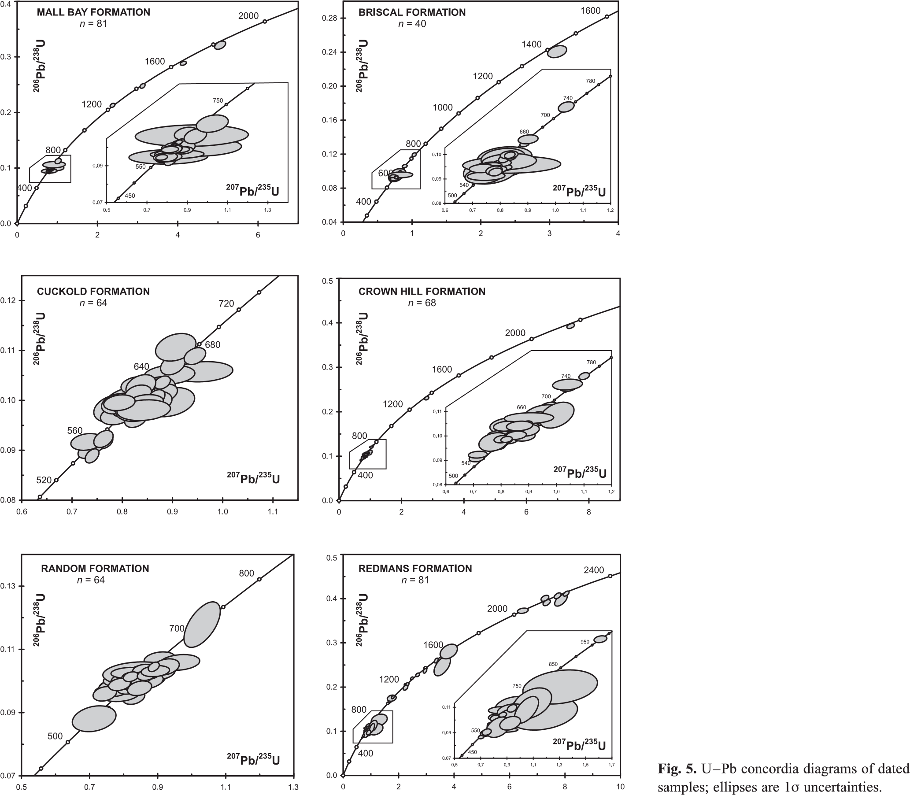The Cuckold Formation is dominated (82%) by zircons that fall within one broad nearly unimodal peak at c. 620 Ma that spans 60 Ma between 590 and 650 Ma. On the probability density plot, there is a minor peak at 565 Ma that consists of six zircons that range from 555 to 572 Ma; the two remaining analyses make up 3% of the total population and yielded older ages of 670 Ma. The zircon signature of the Cuckold Formation is almost identical to the Crown Hill Formation; the latter is characterized by a continuous cluster of zircons (84%) between 590 and 660 Ma and minor components between 557 and 566 Ma (two analyses) and 665 and 682 Ma (four analyses). These components are separated by a Gap of c. 60 Ma from older Neoproterozoic zircons of three concordant analyses at 731 20, 734 20, and 755 12 Ma. Although making up less than 2% of the total, two analyses indicate the presence of Mesoproterozoic (1349 27 Ma) and Palaeoproterozoic (2160 24 Ma) components.

# Platform

Detrital zircons analysis of the Random Formation yielded ages from 64 zircons, of which 85% cluster in the range from 580 to 655 Ma. A slightly younger grouping of three analyses is separated by a c. 20 Ma Gap from the dominant group and contains latest Neoproterozoic to early Palaeozoic zircons between 562 and 542 Ma. The remaining analysis comprises one concordant Neoproterozoic age of 719 44 Ma. The probability density plot of the Random Formation is characterized by a nearunimodal population that has a discrete relative peak at c. 620 Ma.

Zircons from the Redmans Formation consist mainly of colourless and brown prismatic grains of variable size. Both colour types range from pristine to strongly pitted, and several

Fig. 7. Detrital zircon cumulative probability distributions for all dated samples.

grains have visible core and overgrowth components. A total of 81 grains representing the entire range of zircon morphologies in the sample were analysed. The data show one major cluster (35%) from 550 to 685 Ma that peaks on the probability density

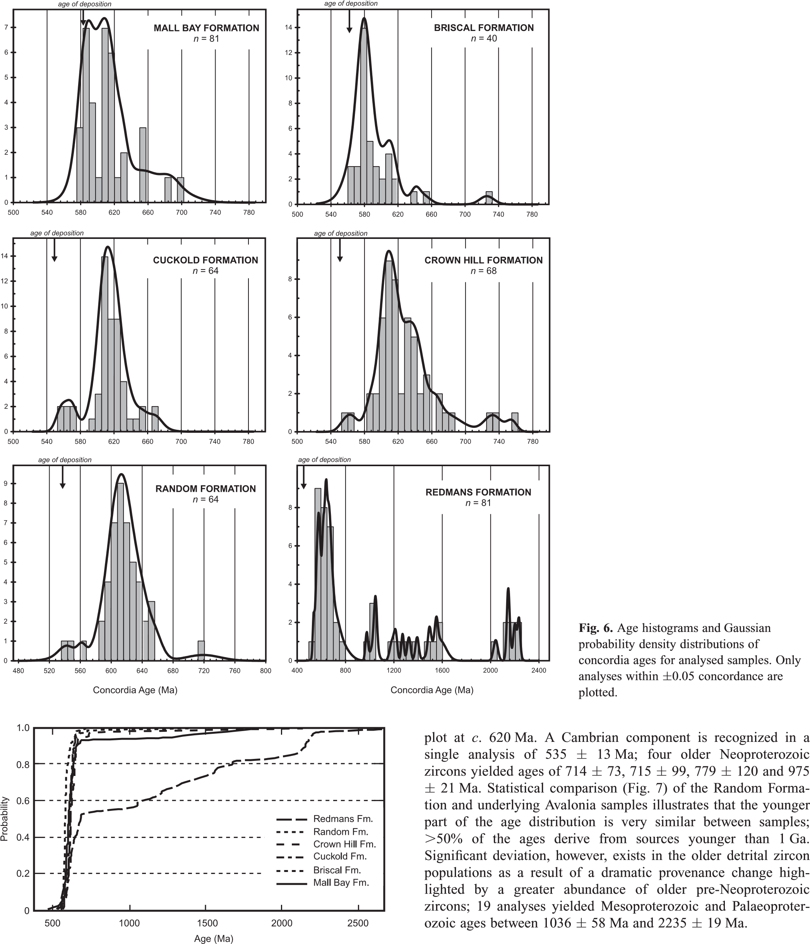Discussion

# Provenance

The new detrital zircon data from Neoproterozoic–early Palaeozoic rocks of Avalonia in Newfoundland demonstrate the temporal controls on zircon heterogeneity in the various sampled stratigraphic successions. The data allow for the deduction of the changing tectonic regimes as the varied provenance can be correlated with discrete sources including contemporaneously generated Avalonian crust and older Gondwanan cratonic crustal sources.

The sedimentary rocks from the main arc phase contain a preponderance of zircons that fall in the c. 570–620 Ma range, which corresponds to the period of main phase of magmatic activity in the adjacent Neoproterozoic Avalonian arc. The Conception Group is therefore interpreted to contain a significant detrital component generated by erosion of coeval igneous rocks formed in these arc sequences, which include the Harbour Main and Marystown groups. The lack of zircons in the range c. 650– 660 Ma and 700–720 Ma in both samples reflects relative periods of little magmatic activity in the early phase of Avalonian arc volcanism; the minor occurrence of c. 730 Ma zircons in the Briscal Formation, however, indicates that parts of the early arc were sourced, as these ages correspond to volcanism in the Chapel Cove arc (Israel 1998).

These data indicate that the Conception Group was principally derived from the underlying volcanic main phase arc. The detrital zircon ages are consistent with petrography and chemical composition of the detrital phases that indicate turbidite deposition in submarine fans adjacent to an active evolved magmatic arc (Dec et al. 1992). The zircons are probably first-cycle detritus because of the relatively short amount of time between their igneous crystallization and time of deposition. The very high rate of sedimentation, abundant pyroclastic and epiclastic detritus, deep-water environment (Williams & King 1979; O’Brien et al. 1996), sedimentation coeval with arc magmatism and detrital zircon ages that are roughly synchronous with the age of deposition all suggest that deposition of these main arc sequences occurred in a tectonically active environment.

The detrital zircon populations in the arc–platform transition (Cuckold and Crown Hill formations) yielded fewer zircons in the 570–600 Ma range and instead are dominated by a group of older zircons between 600 and 650 Ma. Vestiges of 600–650 Ma rocks are exposed throughout Avalonia in Newfoundland and include the Holyrood and Simmons Brook intrusive suites and Connaigre Bay and Love Cove groups. A minor cluster of older Neoproterozoic zircons between 660–680 Ma and c. 730 Ma can be attributed to erosion of the underlying early arc sequences (Furby’s Cove intrusive suite, Tickle Point Formation, and Hawke Hill tuff) of Avalonia. Such derivation is consistent with facies trends and palaeocurrents (O’Brien et al. 1995). The change from siliceous volcaniclastic rocks of the Conception Group to overlying molasse-like red beds of the Signal Hill and Musgravetown groups represents a transition from deep-water turbidite deposition to subaerial fluvial and alluvial plain conditions. The overall coarsening- and thickening-upwards sequences of the Cuckold and Crown Hill formations (King 1990) indicate that deposition occurred in tectonically active fault-bounded basins controlled by major uplift of the underlying arc sequences during the latest Neoproterozoic Avalonian orogeny (Hughes 1970).

The detrital zircon populations in the Random Formation are markedly similar to those in the underlying Crown Hill Formation (600–650 Ma) as both contain Palaeoproterozoic zircons. These data may indicate either a shared protolith and/or the presence of recycled components of the Crown Hill Formation in the Random Formation. The mineralogical and texturally mature quartzarenites, relatively high (up to 25%) plagioclase content and abundance of detrital muscovite argue against significant sediment recycling and suggest derivation from a proximal orogenic source area where detritus was not transported long distances prior to deposition (Jenness 1963). The most likely provenance for the zircons in the Random Formation is the same Avalonian arc-related calc-alkaline plutonic suites as the underlying arc-transition sequences. Stratigraphic variations, however, suggest a change in the depositional environment of the Random Formation. The quartzarenites and interbedded fine-grained siltstones are interpreted to be subtidal sand shoals and intertidal mud flats formed on a macrotidal coastline adjacent to a broad continental shelf or in a large coastal embayment during marine transgression (Hiscott 1982). Early Cambrian transgressive quartz-rich sandstone sequences are present throughout Avalonia in Massachusetts, Maritime Canada, Wales and England (Landing 1996) and were deposited on shallow, wide, shelf platforms during eustatic sea-level rise (Sloss 1963).

Similar to the Random Formation, quartzarenites of the Redmans Formation contain a dominant late Neoproterozoic population (c. 620 Ma) and suggest direct derivation from the main arc plutonic suites. Less prominent groupings of zircons between 665 and 685 Ma and 700 and 760 Ma are interpreted to have been derived from the early arc sequences, the Furby’s Cove intrusive suite, Tickle Point Formation and Burin Group, respectively. In contrast to other sequences in Avalonia, the Redmans Formation, however, also contains a much wider range of significantly older detrital zircon populations. The pronounced cluster of continuous ages between 1.0 and 1.6 Ga, together with a Palaeoproterozoic component, suggests a significant difference in provenance from all other Avalonian rocks analysed in this study.

The presence of Mesoproterozoic zircons, mainly in the Redmans Formation (but an accessory component in other units) is consistent with the existence of a Mesoproterozoic (c. 1.0– 1.6 Ga) crustal component in the basement of Avalonia.

Although no exposed basement is present anywhere in Avalonia, Sm–Nd (Kerr et al. 1995; Murphy et al. 1996) and U–Pb (Ayuso et al. 1996) isotopic data indicate that the Avalonian magmatic arcs formed upon a dominantly c. 1.0–1.2 Ga basement with a minor component of older c. 1.6 Ga crust. Palaeoproterozoic grains in the Redmans Formation could also be derived from a local Avalonian basement source, as rare c. 2.0 and 2.4 Ga xenocrystic zircons are reported from Avalonian plutonic rocks in the Mira terrane (Bevier & Barr 1990) and New England (Zartman & Hermes 1987).

# Source craton

Zircons from sedimentary units in Avalonia show a wide age spectrum with well-defined Palaeoproterozoic, Mesoproterozoic and late Neoproterozoic (Ediacaran) ages. Age patterns of detrital zircon data from main arc and transition samples in Avalonia are dominated by a unimodal population of Neoproterozoic zircons that almost certainly were locally derived from the underlying or adjacent arc sequences of Avalonia and deposited as first-cycle sediments. In contrast, the sequences from the platform contain significant quantities of Mesoproterozoic (1.0–1.6 Ga) and Palaeoproterozoic (1.6–2.3 Ga) components. Although some of these zircons could have been derived from the underlying sequences as second-generation recycled zircons, the large population of zircons and absence of isotopic and geological data for an older basement component in the underlying units, however, suggest that the Meso- and Palaeoproterozoic zircons in the platform sequences were probably derived as first-cycle detritus from basement or from a crustal source that was external to Avalonia.

The Ediacaran zircons provide no palaeogeographical information as they overlap the known age range of underlying Avalonian igneous rocks. The older U–Pb detrital zircon ages, however, can be compared with potential source cratons that are characterized by Archaean to early Neoproterozoic tectonothermal activity. The detrital zircon population data presented herein to some extent match the age of tectonothermal events in Laurentia, Baltica and Gondwana; hence these cratons are potential sources for the zircons in the rocks of Avalonia.

Although Laurentia and Baltica have comparable geological histories during the Proterozoic, which suggest evolution as a single cratonic nucleus following the amalgamation of Archaean cratons between 1.8 and 1.9 Ga (Hoffman 1988; Gower et al. 1990), geological, lithological, faunal, palaeomagnetic and isotopic evidence indicates that Avalonia is a distinct terrane exotic to Laurentia (Williams 1964; Murphy & Nance 1989; Hibbard et al. 2007). The detrital zircon data also refute an eastern Laurentian–Baltica source because the analysed rocks in Avalonia contain zircons with ages of 2.0–2.4 Ga and 620–750 Ma, which correspond to major Palaeoproterozoic (2.0–2.4 Ga) and Neoproterozoic tectonic and crust-forming events that are noticeably absent from the geological record of eastern Laurentian and Baltica (Gower et al. 1990; Wardle et al. 2002). These ages are, however, compatible with a Gondwanan provenance.

The Proterozoic detrital zircons match the age signatures of rocks found along the Neoproterozoic–early Palaeozoic West African and Amazonian margins of Gondwana. The presence of Meosproterozoic–early Neoproterozoic grains in Avalonia is, however, incompatible with a West African source, as the latter contains only minor occurrences of Mesoproterozoic (c. 1000 Ma) magmatism (de Wit et al. 2005) and no record of any tectonothermal events between 1.1 and 2.0 Ga (Rocci et al. 1991). The data are compatible with an Amazonian provenance. Mesoproterozoic and Palaeoproterozoic rocks are present along the Amazonian margin of Gondwana (Fig. 8) and correlate with the Sunsa´s–Aguape´ı (0.9–1.2 Ga), Rondoˆnia–San Ignacio (1.2– 1.4 Ga), Rio Negro–Jurena (1.5–1.75 Ga), and Trans-Amazonian (1.9–2.2 Ga) orogenic belts located along the periphery of the Archaean Amazon craton (Sadowski & Bettencourt 1996; Bettencourt et al. 1999; Dall’Agnol et al. 1999). An Avalonia– Amazonia link is also consistent with Sm–Nd isotope (Murphy et al. 1996), xenocrystic and detrital zircon (Zartman & Hermes 1987; Bevier & Barr 1990; Murphy et al. 2004), faunal and stratigraphic (Hiscott 1982; Landing 1996) data that are incompatible with a West African provenance for Avalonia.

# Timing of rifting

|  |
| --- |
| Fig. 8. Late Neoproterozoic–early Palaeozoic palaeomagnetically controlled palaeogeographical continental reconstructions of the southern hemisphere of Torsvik et al. (1996). Position of Avalonia, Ganderia, Cadomia and Carolinia from detrital zircon and isotopic data (Samson et al. 2005; Hibbard et al.  2007; Pollock 2007). Relative position of Gondwana and Laurentia and age provinces from Hoffman (1991) and Murphy et al. (2004). |

Current palaeotectonic models suggest that Avalonia formed along the Neoproterozoic margin of Gondwana and accreted to Ganderia (the leading edge of composite Laurentia) in the Late Silurian–Early Devonian during the Acadian orogeny (van Staal 2007). Opening of the Rheic Ocean separating Avalonia from Gondwana is therefore constrained to a period between the Neoproterozoic and Silurian. However, there is considerable debate regarding the timing and extent of rifting of Avalonia within this interval. A Neoproterozoic age of separation was proposed by Landing (1996, 2005) based on contrasting Cambrian faunal assemblages and platform sequences between Newfoundland and Morocco, and interpretation of the Cambrian–Ordovician Gander Group as a slope and rise prism of the Avalonia microcontinent. A Neoproterozoic separation of Avalo-

nia from Gondwana is, however, inconsistent with a wide range of palaeomagnetic, faunal, isotopic and geological arguments (O’Brien et al. 1996; van Staal et al. 1998), as it relies on a prerifting connection to West Africa and interpretation of Avalonia and Ganderia as a single tectonic entity. Avalonia is interpreted to have formed along the Amazonian margin of Gondwana and an Avalonia–Ganderia connection is unlikely because even though Ganderia and Avalonia have similar arc-dominated Neoproterozoic basement rocks, they have very distinct magmatic, depositional and tectonothermal histories (O’Brien et al. 1996; Hibbard et al. 2007; Potter et al. 2008) and were therefore almost certainly tectonically decoupled and separated in the early Palaeozoic.

Separation during the Early Ordovician is supported by subsidence analysis (Prigmore et al. 1997), comparable faunal assemblages until the Tremadoc (Cocks et al. 1997; Fortey & Cocks 2003) and palaeomagnetic data that indicate that Avalonia resided at high southerly latitude near Gondwana from the Middle Cambrian to the end of the Early Ordovician (van der Voo & Johnson 1985; Hodych & Buchan 1998; MacNiocaill, 2000; Hamilton & Murphy 2004). The zircon data presented herein are compatible with a younger timing of separation of Avalonia from Gondwana that occurred in the Early Ordovician (Fig. 9). The absence of significant quantities of Mesoproterozoic and Palaeoproterozoic zircons in Ediacaran–Early Cambrian sequences of Avalonia suggest that zircons of these ages found in Ordovician rocks of the platform represent first-cycle detritus derived directly from Amazonia rather than second-generation recycled zircons from underlying sequences. This interpretation requires that Avalonia lay adjacent to Gondwana throughout the Cambrian until deposition of the Redmans Formation in the Early Ordovician.

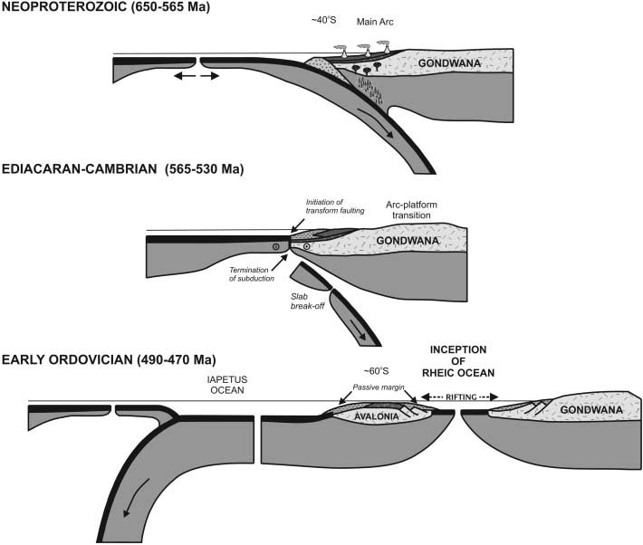Middle Cambrian to Middle Ordovician arc rift-related volcanic rocks in Newfoundland (Spread Eagle Gabbro), Wales (Rhobell volcanic complex), and England (Lake District arc) are generally considered to be related to Avalonia’s rifting and departure from Gondwana (Kokelaar 1988; van Staal et al. 1998). The separation of Avalonia was followed by widespread Arenig subsidence recorded in the Stiperstone Quartzite of Avalonia in England and the Armorican Quartzite of Cadomia in Brittany, interpreted to reflect the rift–drift transition of the Rheic Ocean (van Staal et al. 1998; Nance et al. 2002; Murphy et al. 2006). The Rheic Ocean may have opened in a manner analogous to the opening of the Iapetus Ocean, where protracted, multiple phases of Neoproterozoic rift-related magmatism were followed by later development of a Palaeozoic rift–drift transition (Williams & Hiscott 1987; Cawood et al. 2001; Waldron & van Staal 2001).

The tectonic controls on the mechanisms responsible for separation are uncertain and have been proposed as being related to subduction along an active plate margin with slab roll-back leading to the opening of a back-arc basin in Avalonia (van Staal et al. 1998), in a manner analogous to the present-day Okinawa Trough. The Okinawa Trough is a back-arc basin in a prolonged early stage of rifting that formed in the Miocene by NW subduction of the Philippine sea plate causing extension of the Asian continental lithosphere behind the Ryukyu arc system (Shinjo et al. 1999).

Alternatively, because most palaeogeographical reconstructions assume that the Palaeozoic proto-Avalonian margin of Gondwana extended into the Iapetus Ocean, the simultaneous subduction on both margins of Iapetus resulted in a major plate boundary reorganization, which may have contributed to the partial breakup and lateral displacement of Gondwanan terranes. Hence, the intra-Iapetus subduction and arc–rifted margin collision on the Laurentian margin (Taconic orogeny) coupled with arc polarity reversal, rapid roll-back, extension and arc-rifting on the Ganderian margin (Penobscot orogeny) may have detached Avalonia

Fig. 9. Late Neoproterozoic–early Palaeozoic tectonic evolution of Avalonia and the west Gondwanan margin.

from Gondwana as a result of increasing slab-pull forces similar to the Permian opening of NeoTethys and separation of Cimmerian terranes from the Eurasian margin by subduction and slab roll-back in PalaeoTethys (Stampfli & Borel 2002; Murphy et al. 2006). However, the absence of significant volumes of Early Ordovician volcanic rocks in Avalonia suggests that rifting may have resulted from the propagation of an active, intraoceanic spreading ridge inboard to the edge of the Gondwanan margin in a manner analogous to the rifting of the Jan Mayen and

Seychelles microcontinents (Mu¨ller et al. 2001).

# Summary and conclusions

Avalonia comprises a sequence of late Neoproterozoic volcanosedimentary sequences that are overlain by a Cambrian–Ordovician shale-rich platformal sedimentary succession. U–Pb ages of detrital zircons from Neoproterozoic rocks of the type area of Avalonia in eastern Newfoundland are dominated by Ediacaran populations with ages between 620 and 580 Ma that are interpreted to be derived from the underlying volcanic–plutonic rocks of the main Avalonian arc. These rocks are inferred to have accumulated as a series of submarine fans in restricted faultbounded, arc-adjacent basins that grade upwards into terrestrial siliciclastic rocks deposited under subaerial fluviatile conditions without a significant change in provenance. Early Palaeozoic platform units show an overall up-section increase in Mesoproterozoic and Palaeoproterozoic zircons that are inconsistent with recycling from underlying Neoproterozoic rocks. The range of detrital zircon ages, combined with isotopic and sedimentological data, argues against Avalonia being proximal to West Africa and suggests that the former originated along the periphery of Amazonia. The rapid influx of Mesoproterozoic and older detritus in the upper sequences of the Avalonian platform suggests a major change in tectonic regime to expose older material that is temporally consistent with Avalonian basement. We conclude from the detrital zircon analysis that, if the rifting of Avalonia was marked by a change in provenance and the rapid influx of Palaeoproterozoic detritus in the upper sequences of the Avalonian platform, then separation of Avalonia from Gondwana and opening of the Rheic Ocean occurred during the Arenig. An Early Ordovician time of separation is also supported by stratigraphic, faunal, palaeomagnetic and tectonic data.

There is close correspondence between lithology, depositional age and detrital zircon signatures of the Redmans Formation and Armorican Quartzite (Ranger et al. 1984; Ferna´ndez-Sua´rez et al. 2002) and therefore we propose that the Redmans Formation represents the rift–drift transition of the Rheic Ocean. Interpretation of the Redmans Formation as the Rheic rift–drift transition imposes important constraints on the palaeotectonic evolution of Avalonia and opening of the Rheic Ocean. The most significant implication of this observation is the connection between Avalonia and the peri-Gondwanan block of Cadomia in the early Palaeozoic. In this model Avalonia and Cadomia represent two different terranes with distinct basement rocks and contrasting Neoproterozoic histories (Samson & D’Lemos 1998; Samson et al. 2005; Murphy et al. 2006). The two terranes formed independent of one another on the Gondwanan margin but were juxtaposed along a Neoproterozoic suture prior to the Early Ordovician opening of the Rheic Ocean (Murphy et al. 2006; Linnemann et al. 2007). Available data suggest that assembly of the Avalonian and Cadomian microplates was accomplished by margin-parallel strike-slip activity caused by the complex interaction of a continental margin transform system with a subduction zone as a result of ridge–trench collision (Keppie et al. 2002; Nance et al. 2002).

The separation of Avalonia (and Cadomia) and opening of the Rheic Ocean is contemporaneous with, and may be related to closure of the larger Iapetus Ocean. This scenario is similar to the opening of young rifted margins formed behind volcanic arcs that span the closing ages of larger oceans, such as the modern Japan Sea, Okinawa Trough and Tasman Sea, which formed behind arcs of the western Pacific Ocean. Rifting may have initiated as the result of subduction and slab roll-back, slab pull by subduction and ridge–trench collision, or an inboard ridge jump. However, regardless of the actual mechanism of rifting, the timing of rifting and separation is recorded in the changing detrital zircon provenance in the sedimentary record.

We are indebted to S. O’Brien and A. King for sharing their knowledge of Avalonia and for great field excursions on the Bonavista Peninsula. As always, M. Tubrett provided timely analyses and always made sure that the laser and ICP-MS system ran smoothly. The exceptional assistance of A. Paveley in the mineral separation laboratory was vital, as were the SEM images provided by M. Shaffer. We acknowledge the financial support of the US National Science Foundation (EAR-0439072) and inkind support from the Geological Survey of Newfoundland. Figures 2 and 3 were produced with the assistance of D. Leonard and

A. Paltanavage. J.C.P. is grateful to B. Miller and K. Stewart for helpful criticism of an earlier version of the manuscript. Thanks go to P. Cawood and J. Kosˇler for their thorough and thoughtful reviews.

# References

Andersen, T. 2005. Detrital zircons as tracers of sedimentary provenance: limiting conditions from statistics and numerical simulation. Chemical Geology, 216, 249–270.

Anderson, M.M., Bruckner, W.D., King, A.F. & Maher, J.B. 1975. The late Proterozoic ‘H.D. Lilly Unconformity’ at Red Head, northeastern Avalon Peninsula, Newfoundland. American Journal of Science, 275, 1012–1027.

Ayuso, R.A., Barr, S.M. & Longstaffe, F.J. 1996. Pb and O isotopic constraints on the source of granitic rocks from Cape Breton Island, Nova Scotia, Canada. American Journal of Science, 296, 789–817.

Barr, S.M., Davis, D.W., Kamo, S. & White, C.E. 2003. Significance of U–Pb detrital zircon ages in quartzite from peri-Gondwanan terranes, New Brunswick and Nova Scotia, Canada. Precambrian Research, 126, 123–145.

Benus, A.P. 1988. Sedimentological context of a deep-water Ediacaran fauna (Mistaken Point, Avalon Zone, eastern Newfoundland). In: Landing, E.,

Myrow, P. & Narbonne, G. (eds) Trace Fossils, Small Shelly Fossils and the Precambrian–Cambrian Boundary. New York State Museum and

Geological Survey Bulletin, 463, 8–9.

Bettencourt, J.S., Tosdal, R.M., Leite, W.B. & Payolla, B.L. 1999. Mesoproterozoic rapakivi granites of the Rondoˆnia Tin Province, southwestern border of the Amazon Craton, Brazil. Reconnaissance U–Pb geochronology and regional implications. Precambrian Research, 95, 41–67.

Bevier, M.L. & Barr, S.M. 1990. U–Pb age constraints on the stratigraphy and tectonic history of the Avalon terrane, New Brunswick, Canada. Journal of Geology, 58, 53–63.

Brasier, M., Cowie, J. & Taylor, M. 1994. Decision on the Precambrian– Cambrian boundary stratotype. Episodes, 17, 3–8.

Brenchley, P.J., Pickerill, R.K. & Stromberg, S.G. 1993. The role of wave reworking on the architecture of storm sandstone facies, Bell Island Group (Lower Ordovician), eastern Newfoundland. Sedimentology, 40, 359–382.

Calon, T. 2001. Late Precambrian sedimentation and related orogenesis of the Avalon Peninsula, eastern Avalon Zone, Newfoundland. Geological Association of Canada, St. John’s 2001 Field Trip Guidebook, A9/B8, 1–32.

Cawood, P.A., McCausland, P.J.A. & Dunning, G.R. 2001. Opening Iapetus: Constraints from the Laurentian margin in Newfoundland. Geological Society of America Bulletin, 113, 443–453.

Cawood, P.A., Nemchin, A.A., Smith, M. & Loewy, S. 2003. Source of the Dalradian Supergroup constrained by U–Pb dating of detrital zircon and implications for the East Laurentian margin. Journal of the Geological Society, London, 160, 231–246.

Cocks, L.R.M., McKerrow, W.S. & van Staal, C.R. 1997. The margins of

Avalonia. Geological Magazine, 134, 627–636.

Dall’Agnol, R., Costi, H.T., Leite, A.A., Magalhaes, M.S. & Teixeira, N.P. 1999. Rapakivi granites from Brazil and adjacent areas. Precambrian Research, 95, 9–39.

Davis, D.W. 2002. U–Pb geochronology of Archean metasediments in the Pontiac and Abitibi subprovinces, Quebec, constraints on timing, provenance and regional tectonics. Precambrian Research, 115, 97–117.

Dec, T., O’Brien, S.J. & Knight, I. 1992. Late Precambrian volcaniclastic deposits of the Avalonian Eastport basin (Newfoundland Appalachians): petrofacies, detrital clinopyroxene geochemistry and palaeotectonic implications. Precambrian Research, 59, 243–262.

DeGraaff-Surpless, K., Mahoney, J.B., Wooden, J.L. & McWilliams, M.O. 2003. Lithofacies control in detrital zircon provenance studies: Insights from the Cretaceous Methow basin, southern Canadian Cordillera. Geological Society of America Bulletin, 115, 899–915.

de Wit, M.J., Bowring, S., Dudas, F. & Kamga, G. 2005. The great Neoproterozoic central Saharan Arc and the amalgamation of the North African Shield. Geological Association of Canada, Annual Meeting, Abstracts with Programs, 30, 42–43.

Fedo, C.M., Sircombe, K.N. & Rainbird, R.H. 2003. Detrital zircon analysis of the sedimentary record. In: Hanchar, J.M. & Hoskin, P. (eds) Zircon: Experiments, Isotopes, and Trace Element Investigations. Mineralogical Society of America, Reviews in Mineralogy, 53, 277–303.

Ferna´ndez-Sua´rez, J., Gutie´rrez-Alonso, G. & Jeffries, T.E. 2002. The importance of along-margin terrane transport in northern Gondwana: Insights from detrital zircon parentage in Neoproterozoic rocks from Iberia and Brittany. Earth and Planetary Science Letters, 204, 75–88.

Fortey, R.A. & Cocks, L.R.M. 2003. Palaeontological evidence bearing on global Ordovician–Silurian continental reconstructions. Earth-Science Reviews, 61, 245–307.

Gower, C.F., Ryan, A.B. & Rivers, T. 1990. Mid-Proterozoic Laurentia–Baltica: an overview of its geological evolution and a summary of the contributions made by this volume. In: Gower, C.F., Rivers, T. & Ryan, A.B. (eds) MidProterozoic Laurentia–Baltica. Geological Association of Canada, Special Papers, 38, 1–20.

Greenough, J.G. & Papezik, V.S. 1986. Acado-Baltic volcanism in eastern North America and western Europe: Implications for Cambrian tectonism. Maritime Sediments and Atlantic Geology, 22, 240–251.

Hamilton, M.A. & Murphy, J.B. 2004. Tectonic significance of a Llanvirn age for the Dunn Point volcanic rocks, Avalon terrane, Nova Scotia, Canada: implications for the evolution of the Iapetus and Rheic Oceans. Tectonophysics, 379, 199–209.

Hibbard, J.P., van Staal, C.R. & Miller, B.V. 2007. Links between Carolinia, Avalonia, and Ganderia in the Appalachian peri-Gondwanan Realm. In:

Sears, J.W., Harms, T.A. & Evenchick, C.A. (eds) Whence the Mountains? Inquiries into the Evolution of Orogenic Systems: A Volume in Honor of

Raymond A. Price. Geological Society of America, Special Papers, 433, 291– 311.

Hiscott, R.N. 1982. Tidal deposits of the Lower Cambrian Random Formation, eastern Newfoundland: facies and paleoenvironments. Canadian Journal of Earth Sciences, 19, 2028–2042.

Hodych, J.P. & Buchan, K.L. 1998. Palaeomagnetism of the c. 440 Ma Cape St Mary’s sills of the Avalon Peninsula of Newfoundland: implications for Iapetus Ocean closure. Geophysical Journal International, 135, 155–164.

Hoffman, P.F. 1988. United Plates of America, the birth of a craton—Early Proterozoic assembly and growth of Laurentia. Annual Review of Earth and Planetary Sciences, 16, 543–603.

Hoffman, P.F. 1991. Did the breakout of Laurentia turn Gondwanaland inside out? Science, 252, 1409–1412.

Hughes, C.J. 1970. The Late Precambrian Avalonian Orogeny in Avalon, southeast Newfoundland. American Journal of Science, 269, 183–190.

Israel, S.A. 1998. Geochronological, structural and stratigraphic investigation of a Precambrian unconformity between the Harbour Main Group and Conception Group, east coast Holyrood Bay, Avalon Peninsula, Newfoundland. BSc(Hons) thesis, Memorial University of Newfoundland, St. John’s.

Jaffey, A.H., Flynn, K.F., Glendenin, L.E., Bentley, W.C. & Essling, A.M. 1971. Precision measurement of half-lives and specific activities of 235U and 238U. Physical Review, C4, 1889–1906.

Jenness, S.E. 1963. Terra Nova and Bonavista map-areas, Newfoundland. Geological Survey of Canada Memoir, 327, 184.

Keppie, J.D., Nance, R.D., Murphy, J.B. & Dostal, J. 2002. Tethyan,

Mediterranean, and Pacific analogues for the Neoproterozoic–Paleozoic birth and development of peri-Gondwanan terranes and their transfer to Laurentia and Laurussia. Tectonophysics, 365, 195–219.

Kerr, A., Jenner, G.A. & Fryer, B.J. 1995. Sm–Nd isotopic geochemistry of Precambrian to Paleozoic granitoid suites and the deep-crustal structure of the southeast margin of the Newfoundland Appalachians. Canadian Journal of Earth Sciences, 32, 224–245.

King, A.F. 1990. Geology of the St. John’s area. Geological Survey Branch, Government of Newfoundland and Labrador, 90-2.

Kokelaar, P. 1988. Tectonic controls of Ordovician arc and marginal basin volcanism in Wales. Journal of the Geological Society, London, 145, 759– 775.

Kosˇler, J. & Sylvester, P. 2003. Present trends and the future of zircon in geochronology: laser ablation ICPMS. In: Hanchar, J.M. & Hoskin, P. (eds) Zircon: Experiments, Isotopes, and Trace Element Investigations. Mineralogical Society of America, Reviews in Mineralogy, 53, 243–275.

Kosˇler, J., Forst, L. & Sla´ma, J. 2008. LamDate and LamTool: spreadsheetbased data reduction for laser ablation ICP–MS. In: Sylvester, P.J. (ed.) Laser Ablation ICP–MS in the Earth Sciences: Current Practices and Outstanding Issues. Mineralogical Association of Canada, Short Courses, 40, 315–317.

Krogh, T.E. 1982. Improved accuracy of U–Pb zircon ages by the creation of a more concordant system using an air abrasion technique. Geochimica et Cosmochimica Acta, 46, 637–649.

Krogh, T.E., Strong, D.F., O’Brien, S.J. & Papezik, V. 1988. Precise U–Pb dates from zircons in the Avalon terrane of Newfoundland. Canadian Journal of Earth Sciences, 25, 442–453.

Landing, E. 1996. Avalon: Insular continent by the latest Precambrian. In: Nance, R.D. & Thompson, M.D. (eds) Avalonian and Related Peri-Gondwanan Terranes of the Circum-North Atlantic. Geological Society of America, Special Papers, 304, 29–63.

Landing, E. 2005. Early Paleozoic Avalon–Gondwana unity: an obituary— response to ‘Palaeontological evidence bearing on global Ordovician–Silurian continental reconstructions’ by R.A. Fortey and L.R.M. Cocks. Earth-Science Reviews, 69, 169–175.

Linnemann, U., Gerdes, A., Drost, K. & Buschmann, B. 2007. The continuum between Cadomian orogenesis and opening of the Rheic Ocean: Constraints from LA-ICP-MS U–Pb zircon dating and analysis of plate-tectonic setting (Saxo-Thuringian zone, northeastern Bohemian Massif, Germany). In:

Linnemann, U., Nance, R.D., Kraft, P. & Zulauf, G. (eds) The Evolution of the Rheic Ocean: From Avalonian–Cadomian Active Margin to Alleghenian–Variscan Collision. Geological Society of America, Special Papers, 423, 61–96.

Ludwig, K.R. 2003. Isoplot/Ex 3: a Geochronological Toolkit for Microsoft Excel. Berkeley Geochronology Center Special Publication, 1a.

MacNiocaill, C. 2000. A new Silurian paleolatitude for eastern Avalonia and evidence for crustal rotations in the Avalonian margin of southwestern Ireland. Geophysical Journal International, 141, 661–671.

Mezger, K. & Kro¨gstad, E.J. 1997. Interpretation of discordant U–Pb zircon ages, an evaluation. Journal of Metamorphic Geology, 15, 127–140.

Mu¨ller, R.D., Gaina, C., Roest, W.R. & Hansen, D.L. 2001. A recipe for microcontinent formation. Geology, 29, 203–206.

Murphy, J.B. & Nance R.D. 1989. A model for the evolution of the AvalonianCadomian belt. Geology, 17, 735–738.

Murphy, J.B., Keppie, J.D., Dostal, J. & Cousins, B.L. 1996. Repeated late Neoproterozoic–Silurian lower crustal melting beneath the Antigonish Highlands, Nova Scotia: Nd isotopic evidence and tectonic interpretations. In:

Nance, R.D. & Thompson, M.D. (eds) Avalonian and Related PeriGondwanan Terranes of the Circum-North Atlantic. Geological Society of America, Special Papers, 304, 109–120.

Murphy, J.B., Keppie, J.D., Dostal, J. & Nance, R.D. 1999. Neoproterozoic– early Paleozoic evolution of Avalonia. In: Ramos, V.A. & Keppie, J.D. (eds) Laurentia–Gondwana Connections Before Pangea. Geological Society of America, Special Papers, 336, 253–266.

Murphy, J.B., Fernandez-Suarez, J., Jeffries, T.E. & Strachan, R.A. 2004. U–Pb (LA-ICP-MS) dating of detrital zircons from Cambrian clastic rocks in Avalonia: erosion of a Neoproterozoic arc along the northern Gondwanan margin. Journal of the Geological Society, London, 161, 243–254.

Murphy, J.B., Gutierrez-Alonso, G., Nance, R.D., et al. 2006. Origin of the Rheic Ocean: Rifting along a Neoproterozoic suture? Geology, 34, 325–328.

Murphy, J.B., McCausland, P.J.A., O’Brien, S.J., Pisarevski, S. & Hamilton, M.A. 2008. Age, geochemistry and Sm–Nd isotopic signature of the 0.76 Ga Burin Group: Compositional equivalent of Avalonian basement? Precambrian Research, 165, 37–48.

Myrow, P.M. & Hiscott, R.N. 1993. Depositional history and sequence stratigraphy of the Precambrian–Cambrian boundary stratotype section, Chapel Island Formation, southeast Newfoundland. Paleogeography, Paleoclimatology, Paleoecology, 104, 13–35.

Myrow, P.M. & Kaufman, A.J. 1999. A newly discovered cap carbonate above Varanger-age glacial deposits in Newfoundland, Canada. Journal of Sedimentary Research, 69, 784–793.

Nance, R.D., Murphy, J.B. & Keppie, J.D. 2002. A Cordilleran model for the evolution of Avalonia. Tectonophysics, 352, 11–31.

Narbonne, G.M. & Gehling, J.G. 2003. Life after snowball: the oldest complex Ediacaran fossils. Geology, 31, 27–30.

O’Brien, S.J. & King, A.F. 2005. Late Neoproterozoic (Ediacaran) stratigraphy of Avalon Zone sedimentary rocks, Bonavista Peninsula, Newfoundland. Current Research, Government of Newfoundland and Labrador, Department of Mines and Energy, Geological Survey, 06-1, 101–114.

O’Brien, S.J., O’Driscoll, C.F., Greene, B.A. & Tucker, R.D. 1995. PreCarboniferous geology of the Connaigre Peninsula and the adjacent coast of Fortune Bay, southern Newfoundland. Current Research, Government of Newfoundland and Labrador, Department of Mines and Energy, Geological Survey, 95-1, 267–298.

O’Brien, S.J., O’Brien, B.H., Dunning, G.R. & Tucker, R.D. 1996. Late Neoproterozoic Avalonian and related peri-Gondwanan rocks of the Newfoundland Appalachians. In: Nance, R.D. & Thompson, M.D. (eds) Avalonian and Related Peri-Gondwanan Terranes of the Circum-North Atlantic. Geological Society of America, Special Papers, 304, 9–28.

O’Brien, S.J., Dunning, G.R., Dube, B., O’Driscoll, C.F., Sparkes, B., Israel, S. & Ketchum, J. 2001. New insights into the Neoproterozoic geology of the central Avalon Peninsula (parts of NTS map areas 1N/6, 1N/7 and 1N/3), eastern Newfoundland. Current Research, Government of Newfoundland and Labrador, Department of Mines and Energy, Geological Survey, 2001-1, 169– 189.

Pollock, J.C. 2007. The Neoproterozoic–Early Paleozoic tectonic evolution of the peri-Gondwanan margin of the Appalachian orogen: an integrated geochronological, geochemical and isotopic study from North Carolina and Newfoundland. PhD thesis, North Carolina State University, Raleigh.

Pollock, J.C., Wilton, D.H.C., van Staal, C.R. & Morrissey, K.D. 2007. U– Pb detrital zircon geochronological constraints on the Early Silurian collision of Ganderia and Laurentia along the Dog Bay Line: The terminal Iapetan suture in the Newfoundland Appalachians. American Journal of Science, 307, 399–433.

Potter, J., Longstaffe, F.J. & Barr, S.M. 2008. Regional 18O-depletion of Neoproterozoic igneous rocks from Avalonia, Cape Breton Island and southern New Brunswick, Canada. Geological Society of America Bulletin, 120, 347–367.

Prigmore, J.K., Butler, A.J. & Woodcock, N.H. 1997. Rifting during separation of eastern Avalonia from Gondwana; evidence from subsidence analysis. Geology, 25, 203–206.

Ranger, M.J., Pickerill, R.K. & Fillion, D. 1984. Lithostratigraphy of the Cambrian?–Lower Ordovician Bell Island and Wabana groups of Bell, Little Bell, and Kellys islands, Conception Bay, eastern Newfoundland. Canadian Journal of Earth Sciences, 21, 1245–1261.

Rice, T.G. 1996. Structure of the Flat Rock thrust zone, Avalon Peninsula, Newfoundland Appalachians. BSc(Hons) thesis, Memorial University of Newfoundland, St. John’s.

Rocci, G., Bronner, G. & Deschamps, M. 1991. Crystalline basement of the West African craton. In: Dallmeyer, R.D. & Lecorche, J.P. (eds) The West African Orogens and Circum-Atlantic Correlatives. Springer, Heidelberg, 31–61.

Sadowski, G.R. & Bettencourt, J.S. 1996. Mesoproterozoic tectonic correlations between eastern Laurentia and the western border of the Amazon craton. Precambrian Research, 76, 213–227.

Samson, S.D. & D’Lemos, R.S. 1998. U–Pb geochronology and Sm–Nd isotopic composition of Proterozoic gneisses, Channel Islands, UK. Journal of the Geological Society, London, 155, 609–618.

Samson, S.D., D’Lemos, R.S., Miller, B.V. & Hamilton, M.A. 2005. Neoproterozoic palaeogeography of the Cadomia and Avalon terranes: constraints from detrital zircon U–Pb ages. Journal of the Geological Society, London, 162, 65–71 http://www.sciencedirect.com/science?_ob¼ArticleURL&_udi¼ B6V5Y-454TGNB-X&_user¼809099&_rdoc¼1&_fmt¼&_orig¼search&_ sort¼d&view¼c&_acct¼C000043939&_version¼1&_urlVersion¼0&_userid ¼809099&md5¼2d91a999423302090bed1dff9b7b3e8f - bbib40#bbib40.

Shinjo, R., Chung, S.L., Kato, Y. & Kimura, M. 1999. Geochemical and Sr–Nd isotopic characteristics of volcanic rocks from the Okinawa Trough and Ryukyu Arc: implications for the evolution of a young, intracontinental back arc basin. Journal of Geophysical Research, 104, 10591–10608.

Sircombe, K.N. & Stern, R.A. 2002. An investigation of artificial biasing in detrital Zircon U-Pb geochronology due to magnetic separation in sample preparation. Geochimica Et Cosmochimica Acta, 66, 2379–2397.

Sircombe, K., Bleeker, W. & Stern, R. 2001. Detrital zircon geochronology and grain-size analysis of a ,2800 Ma Mesoarchean proto-cratonic cover succession, Slave Province, Canada. Earth and Planetary Science Letters, 189, 207–220.

Sla´ma, J., Kosˇler, J., Condon, D.J., etal. 2008. Plesˇovice zircon—a new natural reference material for U–Pb and Hf isotopic microanalysis. Chemical Geology, 249, 1–35.

Sloss, L.L. 1963. Sequences in the cratonic interior of North America. Geological Society of America Bulletin, 74, 93–114.

Stampfli, G.D. & Borel, G.D. 2002. A plate tectonic model for the Paleozoic and Mesozoic constrained by dynamic plate boundaries and restored synthetic oceanic isochrones. Earth and Planetary Science Letters, 196, 17–33.

Strong, D.F. & Dostal, J. 1980. Dynamic melting of Proterozoic upper mantle: Evidence from rare earth elements in oceanic crust of Eastern Newfoundland. Contributions to Mineralogy and Petrology, 72, 165–173.

Swinden, H.S. & Hunt, P.A. 1991. A U–Pb zircon age from the Connaigre Bay Group, southwestern Avalon Zone, Newfoundland: Implications for regional correlations and metallogenesis. In: Radiometric Age and Isotopic Studies, Report 4. Geological Survey of Canada, 90-2, 3–10.

Sylvester, P.J. & Ghaderi, M. 1997. Trace element analysis of scheelite by excimer laser ablation-inductively coupled plasma-mass spectrometry (ELAICP-MS) using a synthetic glass standard. Chemical Geology, 141, 49–65.

Thompson, M.D. & Bowring, S.A. 2000. Age of the Squantum ‘tillite’, Boston Basin, Massachusetts: U–Pb zircon constraints on terminal Neoproterozoic glaciation. American Journal of Science, 300, 630–655.

Torsvik, T.H., Smethurst, M.A., Meert, J.G., et al. 1996. Continental break-up and collision in the Neoproterozoic—a tale of Baltica and Laurentia. EarthScience Reviews, 40, 229–258.

van der Voo, R. & Johnson, R.J.E. 1985. Paleomagnetism of the Dunn Point Formation (Nova Scotia): high paleolatitudes for the Avalon terrane in the Late Ordovician. Geophysical Research Letters, 12, 337–340.

van Ingen, G. 1914. Cambrian and Ordovician faunas of south-eastern Newfoundland. Geological Society of America Bulletin, 25, 138.

van Staal, C.R. 2007. Pre-Carboniferous tectonic evolution and metallogeny of the Canadian Appalachians. In: Goodfellow, W.D. (ed.) Mineral Deposits of Canada: A Synthesis of Major Deposit Types, District Metallogeny, the Evolution of Geological Provinces & Exploration Methods. Geological Association of Canada, Mineral Deposits Division, Special Publication, 5, 793–817.

van Staal, C.R., Dewey, J.F., MacNiocaill, C. & McKerrow, W.S. 1998. The Cambrian–Silurian tectonic evolution of the northern Appalachians and British Caledonides: history of a complex west and southwest Pacific-type segment of Iapetus. In: Blundell, D.J. & Scott, A.C. (eds) Lyell: The Past is the Key to the Present. Geological Society, London, Special Publications, 143, 199–242.

Vermeesch, P. 2004. How many grains are needed for a provenance study? Earth and Planetary Science Letters, 224, 441–451.

Walcott, C.D. 1900. Random—Precambrian Upper Algonkian terrane. Geological Society of America Bulletin, 11, 3–5.

Waldron, J.F. & van Staal., C.R. 2001. Taconian orogeny and the accretion of the Dashwoods block: A peri-Laurentian microcontinent in the Iapetus Ocean. Geology, 29, 811–814.

Wardle, R.J., Gower, C.F., James, D.T., et al. 2002. Correlation chart of the Proterozoic assembly of the northeastern Canadian–Greenland Shield. Canadian Journal of Earth Sciences, 39, 895.

Wiedenbeck, M., Alle´, P., et al. 1995. Three natural zircon standards for U– Th–Pb, Lu–Hf, trace element and REE analysis. Geostandards Newsletters, 19, 1–23.

Williams, H. 1964. The Appalachians in northeastern Newfoundland—a two-sided symmetrical system. American Journal of Science, 262, 1137–1158.

Williams, H. 1984. Miogeoclines and suspect terranes of the Caledonian– Appalachian Orogen: tectonic patterns in the North Atlantic region. Canadian Journal of Earth Sciences, 21, 887–901.

Williams, H. & Hiscott, R.N. 1987. Definition of the Iapetus rift–drift transition in western Newfoundland. Geology, 15, 1044–1047.

Williams, H. & King, A.F. 1979. Trepassey Map Area, Newfoundland. Geological Survey of Canada Memoir, 389.

Williams, H., O’Brien, S.J., King, A.F. & Anderson, M.M. 1995. Avalon zone—Newfoundland. In: Williams, H. (ed.) Geology of the Appalachian– Caledonian Orogen in Canada and Greenland. Geology of North America, F-1, 226–237.

Zartman, O. & Hermes, D. 1987. Archean inheritance in zircon from late Paleozoic granites from the Avalon zone of southeastern New England: an African connection. Earth and Planetary Science Letters, 82, 305–315.

Received 10 July 2008; revised typescript accepted 16 January 2009. Scientific editing by Martin Whitehouse.