**COMBINATION OF SINGLE-GRAIN FISSION-TRACK CHRONOLOGY AND MORPHOLOGICAL ANALYSIS**

**OF DETRITAL ZIRCON CRYSTALS IN PROVENANCE STUDIES—SOURCES OF THE MACIGNO FORMATION (APENNINES, ITALY)**

I. DUNKL,1,2 A. DI GIULIO,3 AND J. KUHLEMANN1

1. *Institute of Geology, University of Tu¨bingen D-72076, Germany e-mail: istvan.dunkl@uni-tuebingen.de*
2. *Laboratory for Geochemical Research, Hungarian Academy of Sciences, Budapest H-1112, Hungary* 3 *Dipartimento di Scienze della Terra, Universita` di Pavia I-27100, Italy*

**ABSTRACT: Fission track (FT) analyses on unannealed detrital minerals provide a powerful tool both for refining provenance models derived from traditional methods and for collecting information about erosion rates of the source area. Their power is increased if they are coupled with the study of zircon morphology. This combination of methods is applied to the Chattian–Aquitanian (25–23 Ma) Macigno turbidite complex. Basin-fill patterns and petrographical studies consistently identify the uplifting western Central Alps as the main source region for the Macigno Formation.**

**Most zircon grains fall into a young age cluster (**; **40–30 Ma), derived from a rapidly exhuming crystalline source region with a high cooling rate. Within this cluster, two age subgroups can be distinguished at 30 and 40 Ma. In the younger subgroup, the zircon morphology supports the presence of two main populations: (1) from igneous rocks (S-type euhedral zircons), which appear to be partly derived from airborne tuffs; and (2) from metasedimentary units. In huge volumes of these metamorphic rocks, mica Ar–Ar and zircon fissiontrack thermochronometers have been reset, because of high geothermal gradients in the vicinity of the Periadriatic intrusives in mid-Oligocene times. At the present surface of the Alps, zircon FT ages around and slightly less than 30 Ma are reported in the Sesia-Lanzo zone, the Gran Paradiso Massif, the Upper Pennine nappes, the Monte Rosa Massif, and the Dent Blanche complex. The older subgroup of the Tertiary zircons (40 Ma) may have been supplied by metamorphic and migmatitic rocks affected by an Eocene high-temperature phase.**

**A Late Cretaceous age cluster (**; **70–60 Ma) is related to cooling after the main Austroalpine metamorphic event at 110–100 Ma. Most of the recently exposed Austroalpine nappe complex displays mica cooling ages and zircon FT ages between 95–70 Ma and 99–55 Ma, respectively.**

**Finally, an ill-defined Jurassic age cluster, with a mean in Late Jurassic times, is related to rift-shoulder heating of the Austroalpine/ South-Alpine crystalline basement due to rifting of the Pennine oceanic domain. Presently, the Silvretta nappe complex, situated at the western termination of the Austroalpine realm, and the South-Alpine basement west of the Canavese Line, display similar zircon FT ages. Therefore, a westward continuation of the Silvretta complex prior to deep Neogene erosion is suggested.**

# INTRODUCTION

Clastic depositional systems preserve the paleogeological evolution of ancient sediment sources. Knowledge of source-basin systems around an orogen allows paleogeological maps to be constructed which, unlike paleogeographical maps, document the geology of emergent lands as well as their inferred location.

Although provenance analyses can distinguish different types of eroded rocks from ancient sources and are a classical tool for studying clastic depositional systems, most fail to reach their full potential of recognizing actual geological units. Combined with the inferred extent of specific geological units eroded, knowing the volume of rocks transferred from

JOURNAL OF SEDIMENTARY RESEARCH, VOL. 71, NO. 4, JULY, 2001, P. 516–525

Copyright q 2001, SEPM (Society for Sedimentary Geology) 1527-1404/01/071-516/$03.00

emerged sources to basins theoretically allows the erosion and uplift rates of the source terrain to be calculated (e.g., Di Giulio 1999).

Fission-track (FT) analysis on unannealed clastic minerals is a powerful tool for refining the provenance picture derived from traditional approaches (e.g., sandstone petrology, basin-fill patterns) because they can identify specific geological units that provided sediment (Hurford et al. 1984; Carter 1999). The power of FT analyses is increased when combined with provenance studies based on mineral morphology.

This paper uses an integrated approach on the Macigno turbidites, a foreland-basin sequence deposited in the Northern Apennines thrust and fold belt during late Chattian to early Aquitanian times (25–23 Ma). Information from FT analyses and zircon morphology is combined with available data on quantitative sandstone petrology and basin-fill patterns in order to better distinguish the sources of these thick clastic sediments, funneled by turbidity currents into a deep marine foreland-basin system.

# GEOLOGICAL SETTING

The Northern Apennines are basically composed of two tectonic complexes: (1) the remnants of a Cretaceous–Paleogene accretionary wedge (Ligurian Complex) generated by Africa–Europe convergence. This unit is thrusted on top of (2) an Oligocene–Miocene complex consisting mainly of clastic units (Ricci Lucchi 1986) that were accreted in a retreating subduction zone and overrode the Adriatic continental margin (e.g., Castellarin 1992). These turbidite clastic units comprise the Macigno and Modino successions of late Chattian to early Aquitanian age (25–23 Ma), the Monte Cervarola Formation of late Aquitanian to early Langhian age (21–16 Ma), and the Marnoso-arenacea Formation of Langhian to Tortonian age (14–9 Ma).

Three samples from the Macigno Formation have been analyzed. They were collected from the Val Gordana section, a classical 2-km-thick exposure of the Macigno Formation. Previous studies summarize the sedimentary facies (Ghibaudo 1980), biostratigraphy, sandstone petrology (Costa et al. 1992; Costa et al. 1996), heavy-mineral association (Valloni et al. 1991), illite crystallinity (Bonazzi et al. 1984), and vitrinite reflectance (Reutter et al. 1980, 1983) of the Macigno Formation.

Vitrinite reflectance values (between 1.52 and 2.13 %Rm; Reutter et al. 1980, 1983) imply a thermal overprint indicating postdepositional total annealing of tracks in apatite (. 110 8C). Consequently, the apatite grains

have lost their predepositional FT ages and cannot be used as provenance indicators, although the ages do reflect cooling from a post-Oligocene thermal/burial event. Because this burial temperature was insufficient to anneal the fission tracks in zircon crystals, the inherited ages mirror the thermal history of the source regions.

## Macigno Provenance from Sandstone Petrology and Basin-Fill Pattern

|  |
| --- |
| FIG. 1.—Outcrop distribution of main Northern Apennines turbidite foredeep units, with Macigno Basin-scale paleocurrent pattern (arrows; after Abbate and Bruni 1987) and location of studied section (asterisk). |

Basin-fill patterns (Abbate and Bruni 1987) and petrographical studies (Di Giulio 1999) together consistently identify the Western and Central Alps, uplifting at some 100 km distance from the northern edge of the Apennine foreland basin, as the main source zone for the Macigno Formation. Consequently the Macigno Trough is a foreland basin that was not fed transversely by the orogenic wedge that generated the basin, but instead fed longitudinally by a neighboring orogenic source. The petrology of the clastic sediments provides a record of the changing geology of the Western and Central Alps during Late Oligocene–Early Miocene uplift, and the geology of the source area, the Western and Central Alps, provides key

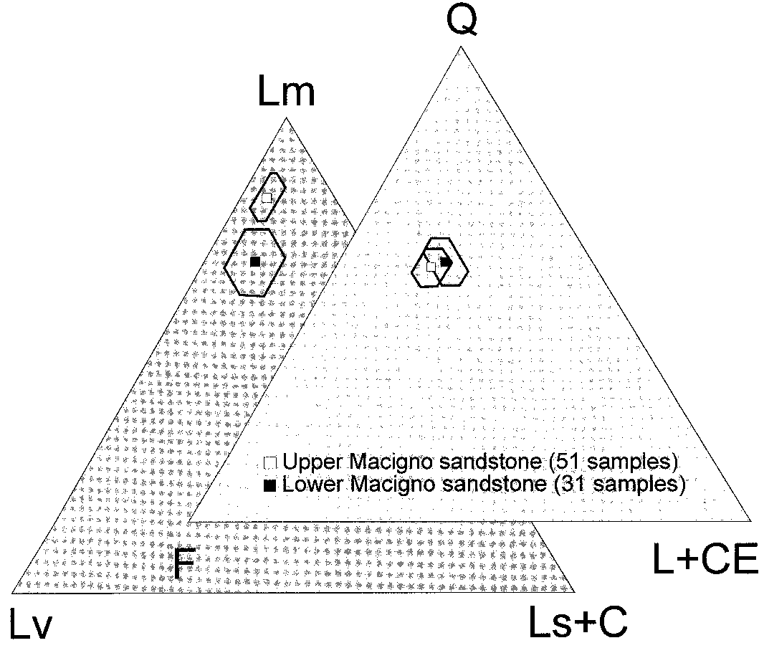

FIG. 2.—Ternary diagrams for average framework and fine-grained lithic detrital modes of the Macigno sandstone (according to the Gazzi-Dickinson method); Q 5 quartz; F 5 feldspars; L1CE 5 fine-grained and carbonate rock fragments; Lm 5 fine-grained metamorphic rock fragments; Lv 5 fine-grained volcanic rock fragments; Ls1C 5 fine-grained siliciclastic and carbonate rock fragments.

insights to understanding the provenance of clastics funneled into the Macigno Trough.

As a result of the paleocurrent directions, the basin-fill pattern records a consistent provenance of the turbidite currents from the northwest (Fig. 1). Detrital modes of the Macigno Formation record remarkably homogeneous framework compositions at the basin scale, with only a slight upward decrease in volcaniclastic content (Fig. 2). Sandstone framework mineralogy indicates predominantly crystalline source rocks with a small and decreasing contribution from an andesitic source (Fig. 3). According to Di Giulio (1999), this source was a rapidly uplifting lithospheric block roughly corresponding to that presently imaged both by the strong gravity anomaly recorded in the Ivrea area and by wide-angle reflection seismic data (Ogniben 1973; Nicolas et al. 1990).

One objective of this study was to test this interpretation using singlegrain FT chronology and the typology of zircon crystals.

# RESULTS

## Samples

The samples analyzed were collected in the Pontremoli area, north of La Spezia (Fig. 1). Despite the remarkably homogeneous petrographical composition along the belt (Di Giulio 1999), this locality was selected because it is the closest to the inferred Alpine sources, thus minimizing the potential of mixing detritus delivered from the main Alpine source with that supplied from minor, possibly transverse sources. The three samples were collected from thick and massive coarse-grained sandstone turbidite beds in the lower, middle, and uppermost part of the 2-km-thick Macigno succession (Appendix I).

## Characteristics of the Dateable Minerals

|  |
| --- |
| FIG. 3.—Histogram of the inferred contribution to the Macigno Formation from coarse-grained (roughly plutonic and orthometamorphic), finegrained (roughly metasedimentary) crystalline, volcanic, and sedimentary source rocks according to sandstone petrology (after Di Giulio 1999). |

Most apatite grains are rounded but transparent, colorless, and slightly corroded. Almost completely euhedral grains occur in each sample. These could be derived from a granitoid source with a very short transport distance, but are probably an airborne volcanic contribution because glass inclusions are common (Fig. 4), and apatites of plutonic rocks typically contain tiny zircon inclusions rather than rounded glass inclusions.

The zircon crystals are usually colorless, although a few are light brown to pinkish. Around 30% of the crystals are euhedral but most are subhedral and slightly rounded without sharp edges, sometimes with well-preserved crystal faces. Less than 10% of the crystals are well rounded.

## Fission-Track Chronology

The methodology is described in Appendix II; results are listed in Table 1. All *apatite* ages passed the chi-square test (P[x2] . 5%; Galbraith 1981) showing the homogeneity of the ages of the grain population. The apatite ages are in the range of apatite FT results published by Abbate et al. (1994) and Balestrieri et al. (1996). The apparent FT ages of 7 to 8.2 Ma are much younger than the ; 24 Ma age of sedimentation, confirming the total resetting that was expected according to the organic maturation. The distribution of the confined track lengths is rather narrow, and the unshortened tracks have a dominant role (Fig. 5). This indicates a short residence in the zone of partial annealing (Wagner 1972). Thus, apatite FT results reflect the late stage of the exhumation of the Macigno Formation in the La Spezia profile and cannot be used for provenance analysis.

Zircon ages fail the chi-square test (P[x2] , 5%, Table 1); the central ages are actually meaningless, reflecting only mixing of grains of different ages. The age spectra are basically similar for all three samples. The majority of single-grain ages form a cluster in Tertiary times at around 40– 30 Ma (Fig. 6). Beyond this very pronounced young peak, one or two diffuse, older populations are detectable. Sample ADG-1, from the base of the Macigno, contains slightly older ages than the two other samples. The oldest grains have FT ages close to 300 Ma, but in this age range dating is normally slightly biased by high spontaneous track density and because portions of grains become undateable because of the progressing metamictization (Gleadow 1978). Consequently, less accurate data are derived from ill-defined older groups with few grains than from tighter, younger age clusters.

Although nearly 2 km of sediment separates the lowermost and topmost samples, we amalgamated the single-grain data from the three samples to achieve better definition of the age clusters. The age spectra are similar, and the sandstone petrology data show that the source area did not change fundamentally during the relatively short sedimentation period (; 1.5 Ma,

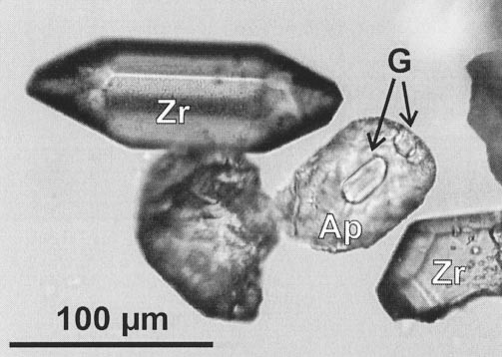

FIG. 4.—Slightly rounded, sometimes euhedral apatite crystals with glass inclusions (G) occur in all these samples. Euhedral zircons and these characteristic inclusions imply a volcanic contribution.

TABLE 1.—*Fission-track results from the Macigno Formation.*

|  |  |  |  |  |  |  |
| --- | --- | --- | --- | --- | --- | --- |
| Code | Cryst. | rs (Ns) | ri (Ni) | rd (Nd) | *P*(x2) [%] | FT age  [Ma 1 1s] |
| Zircon ages  ADG-1  ADG-12  ADG-16 | 60  60  60 | 107 (5560) 77 (4185)  74 (4385) | 57 (2977)   1. (3027) 2. (3374) | 4.85 (4899) 4.85 (4899)  4.85 (4899) | ,1  ,1  ,1 | 52.5 6 4.5 42.3 6 2.6  40.4 6 2.8 |
| Apatite ages  ADG-1  ADG-12  ADG-16 | 22  20  20 | 1.20 (209) 1.22 (173)  1.21 (218) | 16.2 (2817) 15.0 (2119)  13.9 (2508) | 5.08 (6232) 5.08 (6232)  5.08 (6232) | 57  28  26 | 1. 6 0.5   7.7 6 0.6  8.2 6 0.6 |

Cryst: number of dated apatite crystals.

Track densities (r) are as measured (3105 tr/cm2); number of tracks counted (N) shown in brackets. Central ages calculated for the zircon samples using dosimeter glass: CN 2 with zCN2 5 127.8 6 1.6. Pooled ages calculated for the apatite samples using dosimeter glass: CN 5 with zCN5 5 373.3 6 7.1. *P*(x2): probability obtaining Chi-square value for n degree of freedom (where n5 no. crystals 2 1).

see Appendix I and Costa et al. 1992). The dated crystals fall into two aliquots: (1) a group of 94 subhedral and rounded crystals; and (2) a group of 86 euhedral crystals. The chi-square test was used to select the youngest crystal populations of both aliquots (according to Brandon 1992). The crystals are ordered according to increasing age, and the pooled age and the statistical values calculated from the first 1, 2, . . . *n* data were tested. The first *n* crystals passing the test were considered as the youngest coherent population. This group was extracted and the rest were tested again. In this way we were able to select two age populations and the rest—the oldest group—also passed the chi-square test. The results are presented in Figure 7 and Table 2. The groups are rather similar in the euhedral and in the rounded mineral populations.

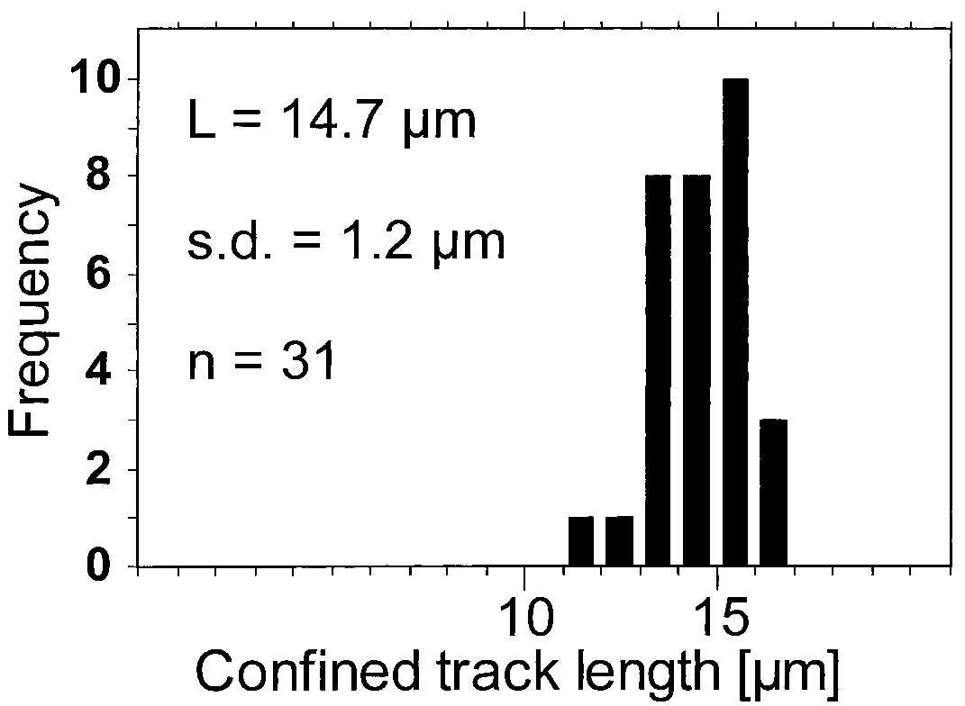

F

IG

.5

.—ConfinedtracklengthdistributionintheapatitesofsampleADG

-16.

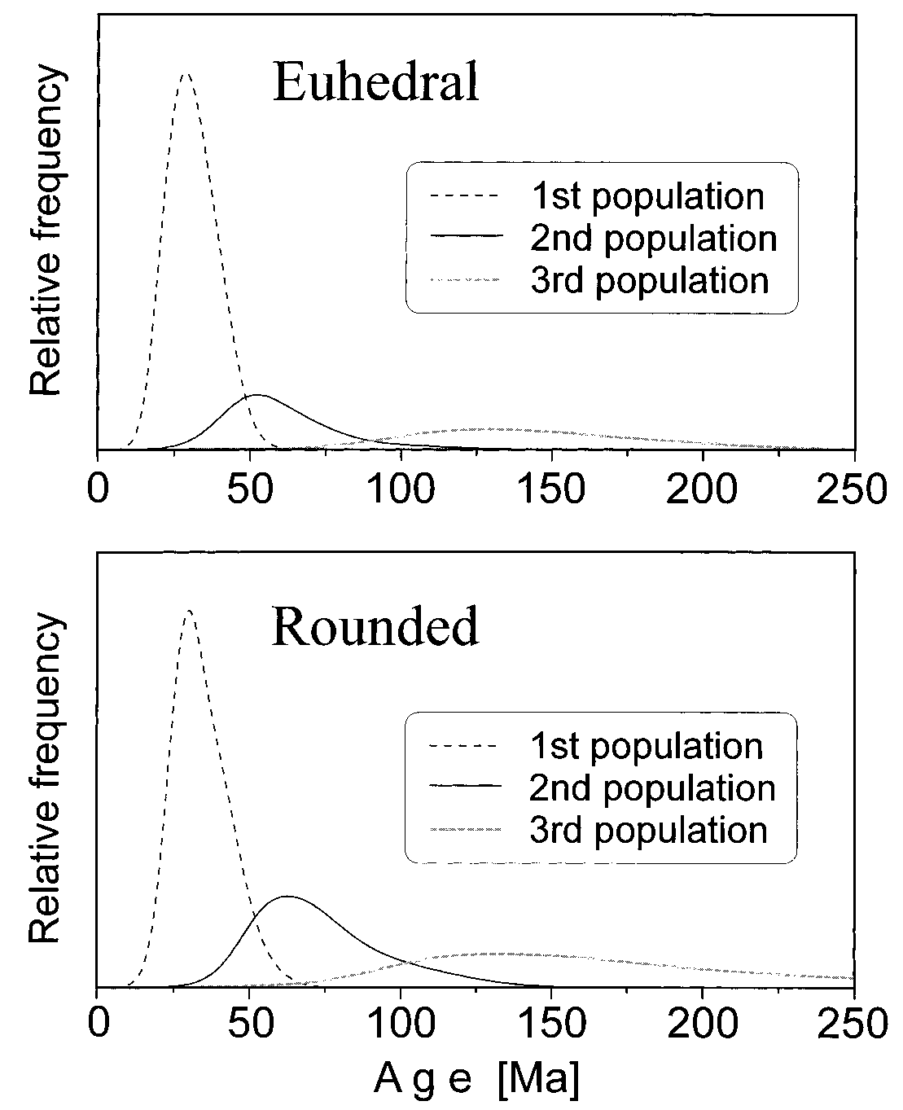

The above-described method is a rather crude approach. This technique artificially cuts the single-grain age distribution, and the overlapping parts of the tails cannot be considered. To control the reliability of this kind of subdivision, we used a basically different method which performs the binomial fitting of the subpopulations according to Galbraith and Green (1990). The results of the ‘‘Binomfit’’ process of Mark Brandon are in good agreement with the subdivision made according to chi-square age

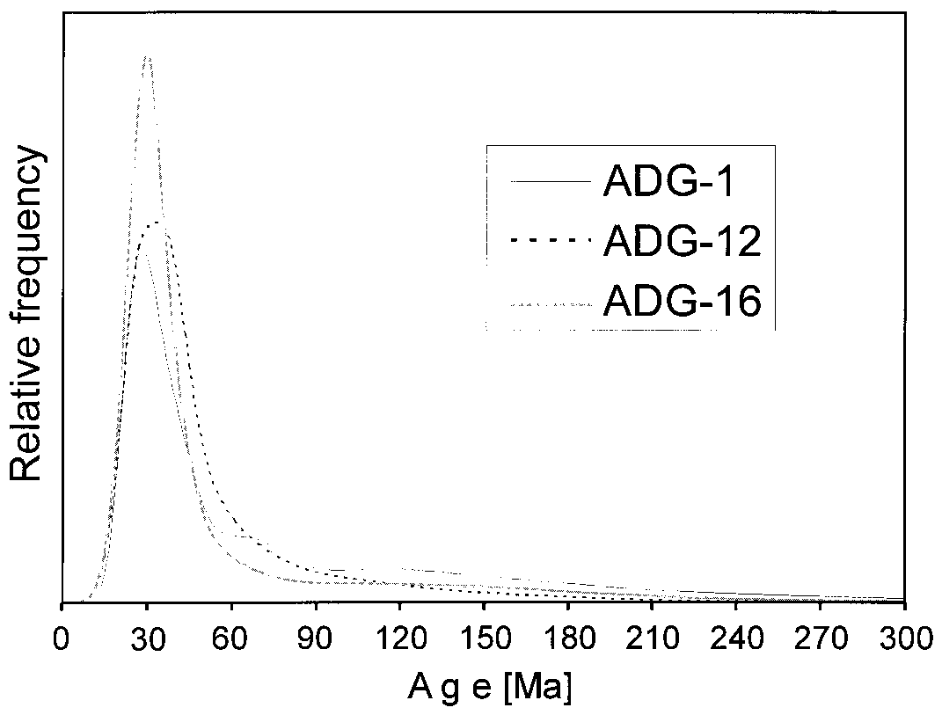

FIG. 6.—Age spectra of the zircon grains of sandstone samples (calculation made using the method of Hurford et al. 1984).

FIG. 7.—Age spectra of the subpopulations passing the chi-square test. The euhedral and rounded aliquots gave nearly identical subpopulations.

groups (Table 2). Besides the very pronounced Oligocene age cluster, a smaller Late Cretaceous and a Jurassic cluster can be detected.

## Zircon Morphology

The typological analyses of the zircon crystals (according to Pupin 1980) show a broad distribution with some clusters (Fig. 8A, B). The clusters formed in the upper part of the ‘‘S’’-fields are typical for calc-alkaline rocks, while the ‘‘P’’-crystals occur rather in alkaline magmas (Pupin 1980). The Eocene–Oligocene Periadriatic magmatic suite contains mainly ‘‘S’’-type crystals (especially the S7–S12 fields); the ‘‘P’’-type crystals are

TABLE 2.—*Ages of the crystal populations grouped according to the chi-square test. P(*x*2) is the probability of obtaining* x*2 value for n degrees of freedom*

*(where n* 5*no. of crystals* 2*1; Galbraith 1981). The ‘‘binomfit’’ populations were determined by Mark Brandon’s computer program. The two fundamentally*

*different procedures resulted in similar means and proportions. In the Oligocene populations the euhedral grains are represented by a higher proportion than the rounded ones. It is an indication of the Tertiary volcanigenic contribution.*

‘‘Chi-square’’Groups

‘‘Binomfit’’Populations

|  |  |  |  |  |  |  |
| --- | --- | --- | --- | --- | --- | --- |
|  | *P*(x2) | Cryst. | Fract. [%] | Age 6 1s | Fract. [%] | Age |
| Ectahedral crystals  1st population  2nd population  3rd population | 6  33  55 | 65  12  9 | 76  14  10 | 31 6 1  59 6 4  139 6 10 | 78  10  12 | 31  56 135 |
| Rounded crystals  1st population  2nd population  3rd population | 13  11  6 | 53  22  19 | 56  24  20 | 34 6 1  71 6 3  162 6 9 | 54  23  23 | 33  65 151 |

FIG. 8.—**A)** Morphological classification of zircon crystals according to Pupin (1980). The subclasses are determined according to the ratio of different prisms and pyramids. The light-gray coloring indicates the ‘‘S’’-fields, the gray coloring the

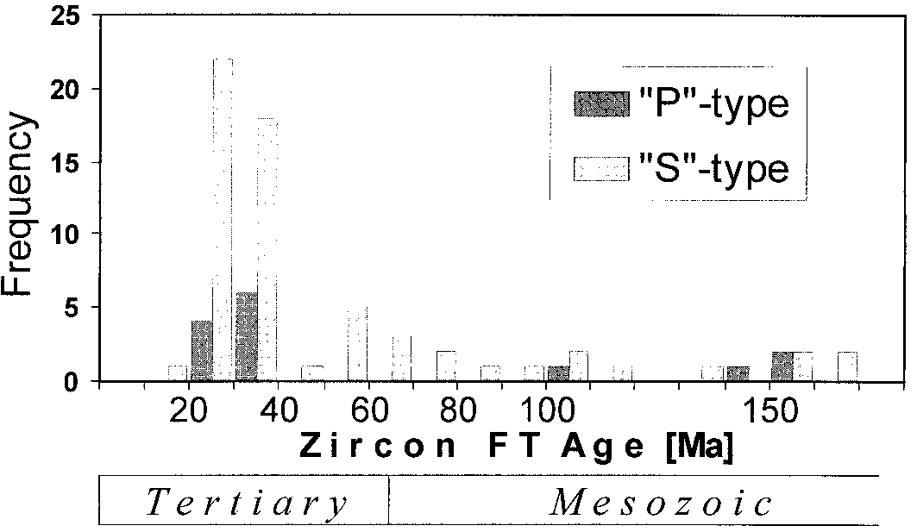

F

IG

.9

.—Agehistogramofthe‘‘S’’-typeand‘‘P’’-typecrystals.Bothtypesoccur

intheTertiaryandalsointheMesozoicagegroup.

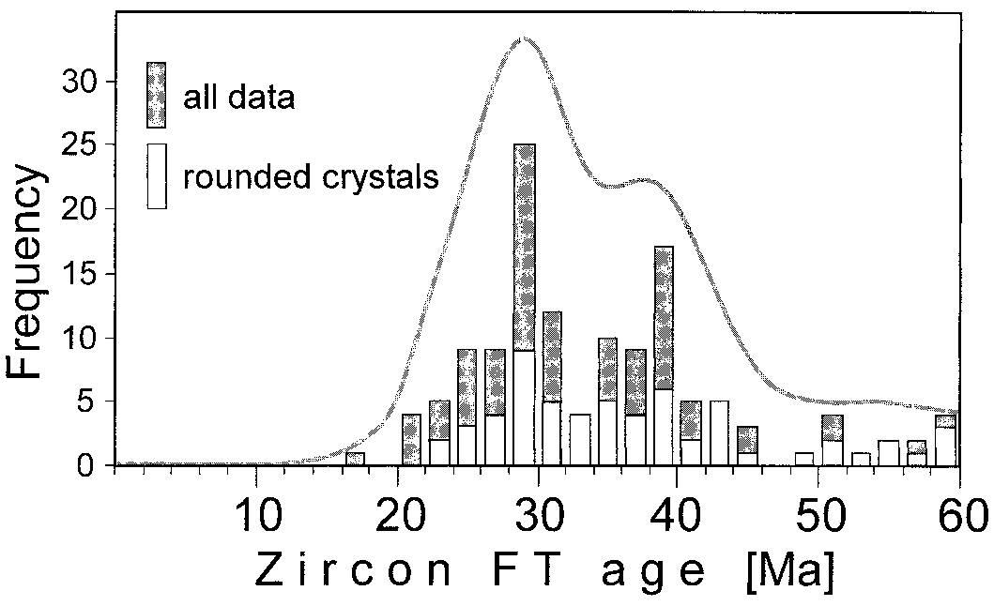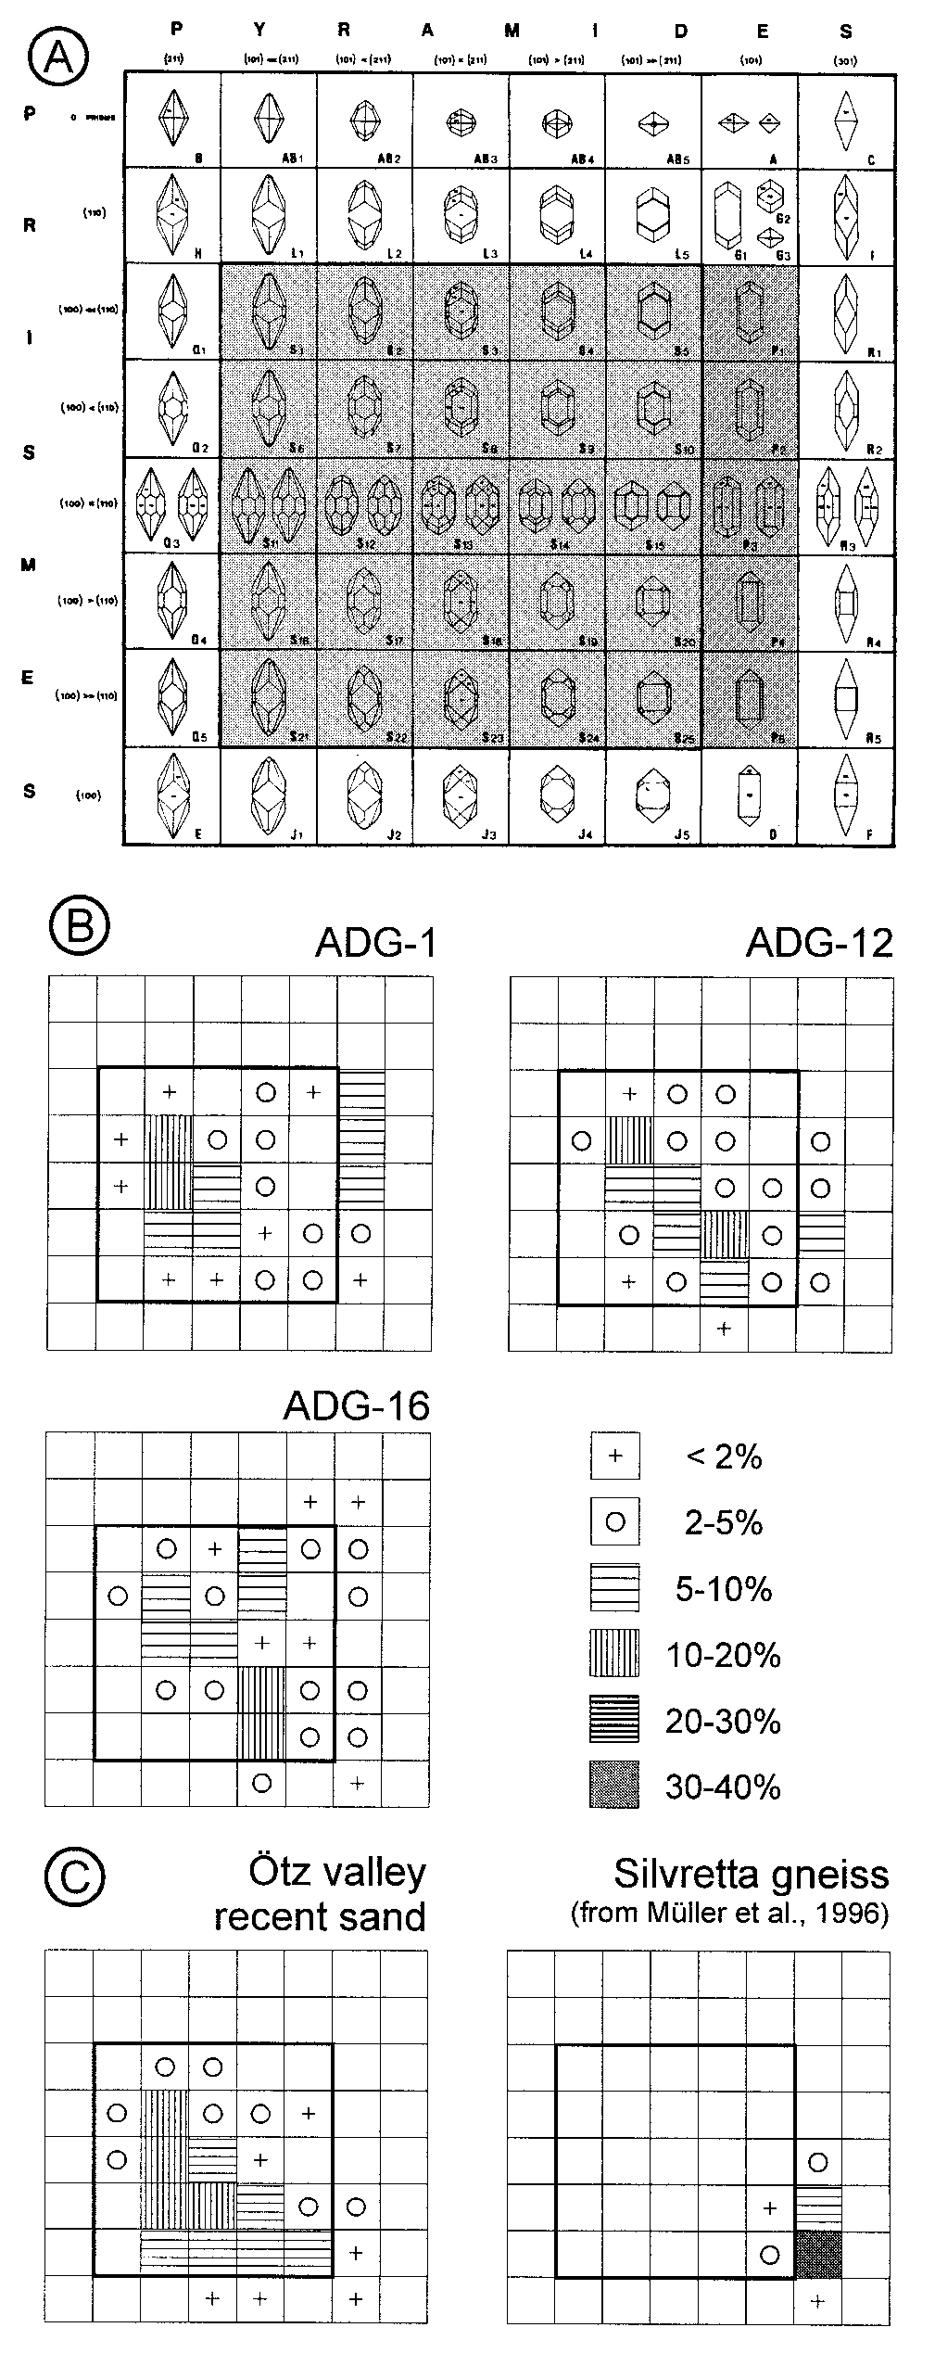

missingortheyhaveaverysubordinaterole(Pupin1988;Dunkl1990,

1992

;Elias1998;R.Pagliuca,Pavia-Tu¨bingen,personalcommunication

).

Incontrast,theVariscanbasement(andalsotheVariscancrystallinefrag-

mentsoftheAustroalpinepile)containsigneousrocksofvariouscompo-

sitions(Pupin1985),andboththe‘‘S’’andthe‘‘P’’-typezirconsarepre-

sentinthedetritalmaterialderivingfromsuchanarea.Figure8Cpresents

twoexamplesfromthewesternmostoccurrencesoftheAustroalpinenappe

pile:thetypologicaldistributionofariversandderivedexclusivelyfrom

Austroalpinebasementrocks,andatypogramofagneissfromtheSilvretta

Alps.Thefirstonehasabroaddistribution(inharmonywiththecomposite

character),whereasthesecondhasatypicalalkalinesignature,butboth

contain‘‘P’’-typecrystals.

Therelationshipbetweentheageclustersandthemorphologyofthe

datedgrainswasalsotested.Becausetheetchedanddatedcrystalsare

embeddedinteflonsoprecisedeterminationofthemorphotypeisnotpos-

sible,wedifferentiatedonlytwomorphotypegroups:‘‘S’’-typeand‘‘P’’-

typecrystalsasdiscussedabove.Figure9showsthatthereisnoseparation

inageaccordingtothecrystalmorphology.The‘‘P’’-typeand‘‘S’’-type

zirconsoccurinboththeTertiaryandtheMesozoicagegroups.

**DISCUSSION**

Inordertointerpretbetterthezirconageclustersdefinedabove,itis

necessarytoconsiderfurtherthezirconmorphology,sedimentpetrology,

andtheknownzirconFTagesofpossiblesourceareas.

‘‘P’’-fields. **B)** Zircon typograms of the Macigno sandstone samples; the bold square FIG. 10.—The younger part of the amalgamated age spectrum; 0.5 standard demarks the ‘‘S’’-fields for orientation. The broad distributions indicate the mixed viation was used for the calculation. In this way the distribution is sharper and the origin of the sediment. **C)** Typology of Austroalpine samples. Eocene and Oligocene subclusters are separated better.

## 1. Paleogene Age Cluster (; 40–30 Ma)

The younger, Tertiary age clusters of all three samples consist of two subpopulations. The amalgamated sample shows these subgroups well (see Fig. 10). The older is of Eocene age (mean ca. 39 Ma); the younger is Oligocene (calculated mean of ca. 28 Ma) if the splits are made at 33 and 48 Ma. Exact separation is not possible because of the closeness of the means and the overlapping of their tails.

**1.1. Periadriatic Magmatic Contribution.**—Sandstone petrology indicates a minor volcanic contribution to the Macigno Formation (Di Giulio 1999). The high proportion of euhedral, clear, and uniform zircons indicates an I-type magmatic origin. Some similarly shaped but glass-inclusion-bearing zircons are clearly derived from a volcanic equivalent. The intrusive or extrusive character of source rocks cannot be definitively determined solely on the basis of crystal morphotypes, but the sharp grain edges suggest aerial transport of at least some crystals.

The younger age group clusters around 30 Ma, corresponding to the mean of the very pronounced, tight cluster of the Periadriatic magmatism (Borsi et al. 1973; Prochaska 1981; Deutsch 1984). The main part of the Oligocene igneous bodies underwent rather rapid exhumation, as suggested by cooling ages (zircon FT: 28 to 25 Ma) and the appearance of the tonalite boulders in South-Alpine Oligocene sediments (Gieger and Hurford 1989). The data indicate that the Macigno Trough was also supplied from this actively exhuming belt.

South of the Periadriatic volcanic belt s.s., in the southern part of the Po Basin, boreholes penetrate Oligocene stratovolcanic complexes of dacitic and andesitic composition (Fantoni et al. 1999). These edifices and related volcaniclastic strata record the Periadriatic magmatic activity. The Ar–Ar age of 28.5 6 0.1 Ma measured on the topmost volcanic horizon indicates good agreement with the youngest zircon FT age cluster (Fig. 10). The first sediments onlapping the Mortara-Lacchiarella volcanoes are Langhian in age (; 16.4–14.7 Ma). Thus the volcanic complex probably emerged during deposition of the Macigno Formation, potentially supplying volcaniclastic material and euhedral zircons. The zircon typology of these volcanic rocks resembles the S7–S12 cluster of the zircons in the Macigno sediments (R. Pagliuca, Pavia-Tu¨bingen, personal communication). There are also volcanigenic layers of peralkaline character at the Alpine–Apennine junction (Cappodi et al. 1999) with similar Ar–Ar ages (28.4–29.6 Ma; d’Atri et al. 1999), but volcanism there produced quite different zircon subtypes (J and/or S22–25; P. Cappodi, Torino, personal communication). This indicates contemporaneous but geochemically distinct volcanism, which provided zircons of contrasting morphologies. However, the contribution of detritus from peralkaline volcanic sources was subordinate in the Macigno Basin.

**1.2. The Eocene Age Cluster.**—The older subgroup of the Tertiary zircons (Fig. 10) might also be derived from igneous rocks. Villa (1983) and Dunkl (1990) reported Eocene intrusive and tuffitic formations along the Periadriatic magmatic chain. An unannealed apatite FT age of 39 6 4 Ma is indicated in euhedral crystals of probable volcanic origin in the Eocene Gallare Marls (Lacchiarella subsurface near Milano; Fantoni et al. 1999). Nevertheless, meta-igneous rocks of the Central and Western Alps were possibly also affected by the Eocene high-temperature metamorphic phase (Rubatto et al. 1997) and provided this material to the Macigno Basin.

**1.3. Non-Periadriatic (Meta-)Igneous Rocks.**—For the P-type crystals with Tertiary ages (Fig. 9), the relationship to known Oligocene magmatic counterparts is not as obvious as for the S-type crystals. This kind of crystal is rather typical of alkaline granite. We infer a simultaneously eroding basement with Variscan magmatites, which were partly thermally affected by the Periadriatic magmatic event and had reached the surface by ; 25 Ma.

**1.4. Metasedimentary Source Rocks.**—A significant portion of the rounded and subhedral zircon grains have Tertiary ages. The splitting of the Paleogene grains into an Eocene and an Oligocene age cluster is not as evident for rounded grains as for euhedral grains (Fig. 10). Rounded zircons are derived from metasedimentary units, not from volcanic and plutonic rocks. These grains prove that the source region of the Macigno sediment contained not only igneous but also rapidly exhuming crustal domains in Oligocene times. The source region was characterized by metamorphic rocks from the zone around the Periadriatic intrusives, where extremely high geothermal gradients (von Blanckenburg and Davies 1995) reset both the mica Ar–Ar and the zircon FT thermochronometers over huge volumes of crustal material in Middle Oligocene times. The modern surface of the Western Alps contains zones where the zircon FT ages are around and slightly younger than 30 Ma: (a) the Sesia-Lanzo zone and the Gran Paradiso Massif (Hurford et al. 1989); (b) the Upper Pennine nappes (Seward and Mancktelow 1994); (c) the Monte Rosa massif; and (d) the Dent Blanche nappe system (Hurford et al. 1991; Fig. 11). These areas together with the former cover of these blocks are the most probable sources of the siliciclastic material of the Macigno Formation carrying zircons of Paleogene FT ages. The means of these Tertiary age clusters from the Macigno sandstone preceded the sedimentation by only 4–10 Ma, using an average 24 Ma depositional age (cf. Table 2 and Fig. 10).

The lid of the Lepontine dome might also have been a potential source. Deep erosion since the Oligocene (in the range of 2 km according to Kuhlemann 2000) completely removed the volume of Paleogene FT ages until recent times. Thus, the central part of the Lepontine dome now shows only Middle or even Late Miocene zircon FT ages (Hunziker et al. 1992). However, by the time of the Macigno deposition, the bottom of the Austroalpine pile, or the top of the Penninic units, supplied older zircons.

## 2. Late Cretaceous Age Cluster (; 70–60 Ma)

Some of these ages fall into the Cenozoic Era, but we refer to this age cluster as Late Cretaceous, because these cooling ages have a Late Cretaceous mean and reflect a cooling period that follow the Eo-Alpine (Cretaceous) metamorphic event. This affected the Austroalpine realm, with a climax around 110–100 Ma. Mica cooling ages form an age cluster around 95–70 Ma (see compilations of Frank et al. 1987 and Elias 1998). Zircon FT ages range between 99 and 55 Ma in the central and eastern part of the Austroalpine nappe complex (Elias 1998; Fu¨genschuh et al. 1997; Frisch et al. 1999; Dunkl, unpublished data). The Dent Blanche nappe is an exception, because the zircon FT ages in the recently exposed level show complete Oligocene reset (Fig. 11). At the sedimentation time of the Macigno Formation, however the Austroalpine pile extended much farther to the west than today (Pfiffner 1986; Frisch et al. 2000), and the higher levels of the preserved western remnants of the Austroapine nappe complex probably supplied zircon grains with Mesozoic FT ages, as also observed in the Swiss molasse foreland basin (Spiegel et al. 1999).

## 3. Jurassic Age Cluster

This is an ill-defined cluster of single-grain ages with a mean falling into the Late Jurassic (Fig. 7; Table 2). They can be related to the thermal effect of Jurassic rifting in the course of opening of the Pennine ocean (Frisch 1979). The Austroalpine crystalline basement formed a passive continental margin at that time and underwent rift-shoulder heating. The Silveretta nappe contains similar zircon FT ages (180–160 Ma; see Flisch 1986). The Silveretta nappe complex is now situated at the western termination of the coherent Austroalpine realm (Fig. 11), but we believe it continued westward before the episode of deep Neogene erosion (Frisch et al. 2000). This broader extent is also suggested by gneiss pebbles of the South German–Upper Austrian Molasse with Late Jurassic zircon FT ages (Spiegel et al. 1999; Bru¨gel 1998).

The recently exhumed basement of the Southern Alps at some distance from the Periadriatic plutons also shows Mesozoic zircon FT ages (Bertotti et al. 1999; Vance 1999). To derive siliciclastic material from this basement

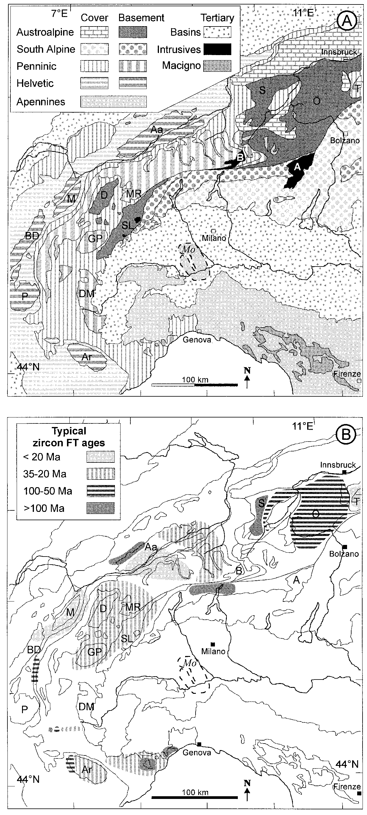

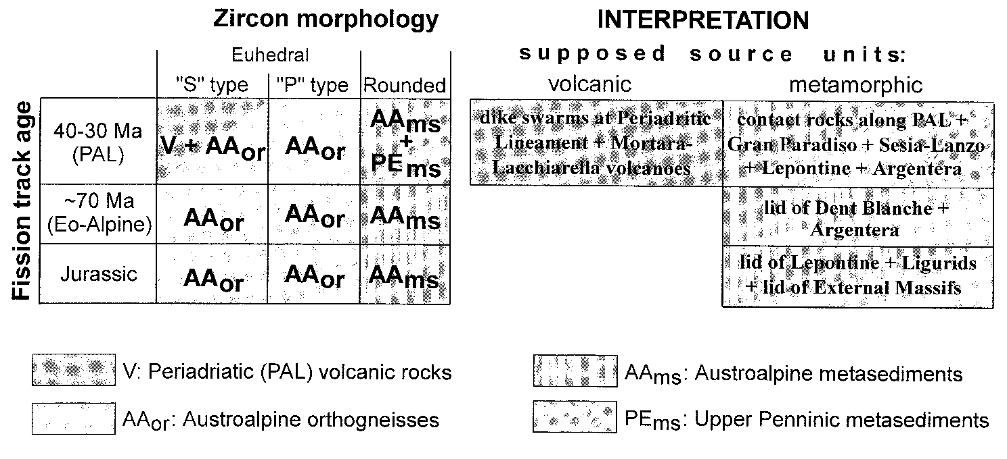FIG. 12.—Inferred units eroded in the Macigno catchment area according to zircon FT age clusters, zircon typology and published FT ages of currently exposed Western and Central Alpine units.

during the deposition of the Macigno Formation is unlikely, because deep erosion of the Southern Alps did not occur until the Miocene collision and back-thrusting (Gunzenhauser 1985; Scho¨nborn 1992). No major areas of the crystalline basement were exposed during late Oligocene times, if at all.

## 4. Combination of FT Chronology and Zircon Typology

The source units of the Macigno Formation can be identified according to the data presented above. For this purpose we have integrated:

1. the zircon single-grain FT ages of the Macigno Formation and theage clusters isolated from these distributions,
2. the known (published) age pattern of the possible source area,
3. the zircon typology of the dated sediment and,
4. the composition and characteristic zircon typology of the main unitsin the possible source area.

Figure 12 presents the integrated data; to the left there are the observations forming a ‘‘source-identification matrix,’’ and the deduced source units are named on the right.

# CONCLUSIONS

Integrating sandstone petrology data with single-grain fission tracks results, and analysis of the morphology of detrital apatite and zircon crystals of the Macigno Formation, allows the provenance, paleogeology, and paleogeography of the Northern Apennines foreland basin during late Chattian to early Aquitanian times (25 to 23 Ma) to be better understood.

1. Euhedral and slightly rounded apatite crystals with glass inclusions support airborne volcanigenic contributions and/or very short transport distances (from a nearly coeval volcanic sequence).
2. Zircon fission track chronology and zircon morphology suggest that some of the zircon crystals were derived from the Periadriatic intrusives and their volcanic products, i.e., either completely eroded volcanic edifices of the Alps or the Mortara-Lacchiarella volcanoes now in the subsurface of the Po River basin.
3. Most non volcanigenic zircon grains have Oligocene cooling ages, reflecting an actively exhuming crystalline source region with high cooling rates. This agrees nicely with the sandstone petrology.
4. Fission track data and the low degree of maturity of the siliciclastic material indicate that the source region was a rapidly exhuming region of the Western Alps formed by upper Penninic–Lower Austroalpine units.
5. The presence of a typical zircon FT age cluster composed of 70–60 Ma grains proves that the structurally higher parts of the Austroalpine nappe complex were also present in the catchment area. Moreover, Jurassic zircon FT ages indicate the presence of a specific Silvretta-type Austroalpine basement in the source area, without Eo-Alpine metamorphism and with only a mild thermal resetting in Jurassic times. The decreasing contribution of the latter source towards the top of the Macigno sedimentary section records its progressive erosion during rapid uplift of the orogenic lid.

These conclusions provide another step toward the unraveling of a paleogeological map of the catchment area supplying the Macigno Formation. It also stresses the necessity of integrating different analytical approaches in order to achieve reliable provenance pictures. In this respect, integrated fission track and typological analyses of clastic zircon crystals provide a particularly useful tool for geodynamic settings with multiple and rapidly changing clastic sources, such as collisional belts.

# ACKNOWLEDGMENTS

The German Science Foundation supported the fission track part of this study in the frame of the Collaborative Research Centre 275. Financial grants from the Italian Ministry of University and Research (MURST) and National Research Council (CNR) supported the field and sandstone petrology part of this study. Personal communications with P. Cappodi (Torino) and R. Pagliuca (Pavia-Tu¨bingen) contributed greatly to the interpretation. The final version of the manuscript benefited from the helpful comments of W. Frisch (Tu¨bingen) and the reviewers J. Murphy (Laramie), G.G. Zuffa (Bologna), and F.L. Schwab (Lexington). All support is gratefully acknowledged.

# REFERENCES

ABBATE, E., BALESTRIERI, M.L., BIGAZZI, G., NORELLI, P., AND QUERCIOLI, C., 1994, Fission track datings and recent rapid denudation in Northern Apennines, Italy: Societa` Geologica Italiana, Memorie, v. 48, p. 579–585.

ABBATE, E., AND BRUNI, P., 1987, Modino-Cervarola o Modino e Cervarola? Torbiditi oligo– mioceniche ed evoluzione del margine nord-appenninico: Societa` Geologica Italiana, Memorie, v. 39, p. 19–33.

|  |
| --- |
| FIG. 11.—**A)** Geological sketch map of the Central and Western Alps and the Northern Apennines (contours after Stampfli and Marchant 1997). Main structural units: T, Tauern Window; O¨ , O¨ tztal Alps; S, Silvretta; B, Bergel; A, Adamello; Aa, Aar; MR, Monte Rosa; SL, Sezia-Lanzo; D, Dent Blanche; M, Mont Blanc; GP, Grand Paradiso; DM, Dora-Maira; BD, Belle Donne; P, Pelvoux; Ar, Argentera; Mo, Mortara-Lacchiarella buried volcanic edifice. **B)** Recent distribution of zircon FT ages in the possible Alpine source areas of the Macigno Formation. Data were compiled from Flisch (1986), Hurford (1986), Hurford and Hunziker (1989), Michalski and Soom (1990), Hurford et al. (1991), Hunziker et al. (1992), Seward and Mancktelow (1994), Fu¨genschuch et al. (1997), Elias (1998), Bigot-Cormier et al. (1999), Schwarz et al. (1999) and Vance (1999). |

BALESTRIERI, M-L., ABBATE, E., AND BIGAZZI, G., 1996, Insights on the thermal evolution of the

Ligurian Apennines (Italy) through fission-track analysis: Geological Society of London, Journal, v. 153, p. 419–425.

BERTOTTI, G., SEWARD, D., WIJBRANS, J., TER VOORDE, M., AND HURFORD, A.J., 1999, Crustal thermal regime prior to, during, and after rifting: A geochronological and modeling study of the Mesozoic South Alpine rifted margin: Tectonics, v. 18, p. 185–200.

BIGOT-CORMIER, F., POUPEAU, G., SOSSON, M., STE´PHAN, J.-F., LABRIN, E., ZIAD, N., AND SCHWARZ, S., 1999, Fission track record and exhumation rates of the Argentera external crystalline massif (Western Alps, France–Italy): Memorie di Scienze Geologiche, v. 51/2, p. 449–451.

BONAZZI A., SALVIOLI MARIANI E., AND VERNIA, L., 1984, Diagenesi e metamorfismo dedotti dalla cristallinita` dell’illite in formazioni sedimentarie affioranti traPontremoli e Salsomaggiore (Appennino Tosco–Emiliano): Mineralogica et Petrographica Acta, v. 28, p. 123–138.

BORSI, S., DEL MORO, A., SASSI, F.P., AND ZIRPOLI, G., 1973, Metamorphic evolution of the Austridic rocks to the south of the Tauern Window (Eastern Alps): radiometric and geopetrologic data: Societa` Geologica Italiana, Memorie, v. 12, p. 549–571.

BRANDON, M.T., 1992, Decomposition of fission-track grain-age distributions: AmericanJournal of Science, v. 292, p. 535–564.

BRU¨GEL, A., 1998, Provenances of alluvial conglomerates from the Eastalpine foreland: Oligo– Miocene denudation history and drainage evolution of the Eastern Alps: Tu¨binger Geowissenschaftliche Arbeiten, Reihe A, v. 40, 168 p.

BURCHART, J., 1972, Fission track age determinations of accessory apatite from the Tatra Mountains, Poland: Earth and Planetary Science Letters, v. 15, p. 418–422.

CAPPODI, P., D’ATRI, A., RUFFINI, R., TATEO, F., AND HUNZIKER, J., 1999, Oligocene volcaniclastic layers from Alpine/Apennine Junction: evidences of peralkaline volcanism (abstract): Terra Abstracts, v. 4, p. 695.

CARTER, A., 1999, Present status and future avenues of source region discrimination and characterization using fission track analysis: Sedimentary Geology, v. 124, p. 13–45. CASTELLARIN, A., 1992, Introduzione alla progettazione del profilo CROP: Studi Geologici Camerti, spec. v. 1992/2, p. 9–15.

COSTA, E., DI GIULIO A., PLESI, G., AND VILLA, G., 1992, Caratteri biostratigrafici epetrografici del Macigno lungo la trasversale Cinque Terre-Val Gordana-M.Sillara (Appennino Settentrionale): implicazioni sull’evoluzione tettono-sedimentaria: Studi Geologici Camerti, spec. v. 1992/2, p. 229–248.

COSTA E., DI GIULIO, A., PLESI, G., VILLA, G., AND BALDINI, C., 1996, I Flysch oligo–miocenici della trasversale Toscana meridionale-Casentino: dati biostratigrafici e petrografici: Atti Ticinesi di Scienza della Terra, v. 39, p. 281–302.

D’ATRI, A., COCCIONI, R., MONTANARI, A., RUFFINI, R., TATEO, F. COSCA, M., AND HUNZIKER, J., 1999, Integrated stratigraphy of Oligocene volcaniclastic layers from the Tertiary Piemonte Basin (Italy) (abstract): Terra Abstracts, v. 4, p. 740.

DEUTSCH, A., 1984, Young Alpine dykes south of the Tauern Window (Austria): a K-Ar and Sr isotope study: Contributions to Mineralogy and Petrology, v. 85, p. 45–57.

DI GIULIO, A., 1999, Mass transfer from the Alps to the Apennines: volumetric constraints in the provenance study of the Macigno–Modino source-basin system, Chattian–Aquitanian, northwestern Italy: Sedimentary Geology, v. 124, p. 69–80.

DUMITRU, T.A., 1993, A new computer-automated microscope stage system for fission-track analysis: Nuclear Tracks and Radiation Measurements, v. 21, p. 575–580. DUNKL, I., 1990, Fission track dating of tuffaceous Eocene formations of the North Bakony Mountains (Transdanubia, Hungary): Acta Geologica Hungarica, v. 33, p. 13–30. DUNKL, I., 1992, Origin of Eocene-covered karst bauxites of the Transdanubian Central Range (Hungary): evidence for early Eocene volcanism: European Journal of Mineralogy, v. 4, p. 581–595.

ELIAS, J., 1998, The thermal history of the O¨ tztal–Stubai complex (Tyrol, Austria/Italy) in the light of the lateral extrusion model: Tu¨binger Geowissenschaftliche Arbeiten, Reihe A, v. 36, 172 p.

FANTONI, R., BERSEZIO, R., FORCELLA, F., GORLA, L., MOSCONI, A., AND PICOTTI, V., 1999, New dating of the Tertiary magmatic products of the central Southern Alps, bearing on the interpretation of the Alpine tectonic history: Memorie di Scienze Geologiche, v. 51, p. 47– 61.

FLISCH, M., 1986, Die Hebungsgeschichte der oberostalpinen Silvretta-Decke seit der mittleren Kreide: Vereinigung Schweizer Petroleum-Geologen und Ingenieure, Bulletin, v. 53, p. 23– 49.

FRANK, W., KRALIK, M., SCHARBERT, S., AND THO¨NI, M., 1987, Geochronological data from the Eastern Alps, *in* Flu¨gel, H.W., and Faupl, P., eds., Geodynamics of the Eastern Alps: Vienna, F. Deuticke, p. 272–281.

FRISCH, W., 1979, Tectonic progradation and plate tectonic evolution of the Alps: Tectonophysics, v. 60, p. 121–139.

FRISCH, W., BRU¨GEL, A., DUNKL, I., KUHLEMANN, J., AND SATIR, M., 1999, Post-collisional largescale extension and mountain uplift in the Eastern Alps: Memorie di Scienze Geologiche, v. 51, p. 3–23.

FRISCH, W., DUNKL, I., AND KUHLEMANN, J., 2000, Post-collisional large-scale extension in the Eastern Alps: Tectonophysics, v. 327, p. 239–265.

FU¨GENSCHUH, B., SEWARD, D., AND MANCKTELOW, N., 1997, Exhumation in a convergent orogen: the western Tauern window: Terra Nova, v. 9, p. 213–217.

GALBRAITH, R., 1981, On statistical models for fission track counts: Mathematical Geology, v. 13, p. 471–488.

GALBRAITH, R.F., AND GREEN, P.F., 1990, Estimating the component ages in a finite mixture: Nuclear Tracks and Radiation Measurements, v. 17, p. 197–206.

GHIBAUDO, G., 1980, Deep-sea fan deposits in the Macigno Formation (Middle–Upper Oligocene) of the Gordana Valley, Northern Apennines, Italy: Journal of Sedimentary Petrology, v. 50, p. 723–742.

GIEGER, M., AND HURFORD, A.J., 1989, Tertiary intrusives of the Central Alps: their Tertiary uplift, erosion, redeposition and burial in the south-alpine foreland: Ecologae Geologicae Helvetiae, v. 82, p. 857–866.

GLEADOW, A.J.W., 1978, Anisotropic and variable track etching characteristics in natural sphenes: Nuclear Track Detection, v. 2, p. 105–117.

GLEADOW, A.J.W., 1981, Fission-track dating methods: what are the real alternatives? Nuclear Tracks, v. 5, p. 3–14.

GREEN, P.F., 1981, A new look at statistics in fission track dating: Nuclear Tracks, v. 5, p. 77–86.

GREEN, P.F., 1985, Comparison of zeta calibration baselines for fission-track dating of apatite, zircon and sphene: Chemical Geology, v. 58, p. 1–22.

GUNZENHAUSER, B.A., 1985, Zur Sedimentologie und Pala¨ogeographie der Oligo–Mioza¨nen Gonfolite Lombarda zwischen Lago Maggiore und der Brianza: Beitra¨ge zur Geologische Karte der Schweiz, 159, 114 p.

HUNZIKER, J.C., DESMONS, J., AND HURFORD, A.J., 1992, Thirty-two years of geochronological work in the Central and Western Alps: a review on seven maps: Me´moires de Ge´ologie, v. 13, 59 p.

HURFORD, A.J., 1986, Cooling and uplift patterns in the Lepontine Alps South Central Switzerland and an age of vertical movement on the Insubric fault line: Contributions to Mineralogy and Petrology, v. 93, p. 413–427.

HURFORD, A.J., AND GREEN, P.F., 1983, The zeta age calibration of fission-track dating: Chemical Geology, v. 41, p. 285–312.

HURFORD, A.J., AND HAMMERSCHMIDT, K., 1985, 40Ar/39Ar and K/Ar dating of the Bishop and Fish Canyon Tuffs: calibration ages for fission track dating standards: Chemical Geology, v. 58 p. 23–32.

HURFORD, A.J., AND HUNZIKER, J.C., 1989, A revised thermal history for the Gran Paradiso massif: Schweizerische Mineralogische und Petrographische Mitteilungen, v. 69, p. 319– 329.

HURFORD, A.J., HUNZIKER, J.C., AND STO¨CKHERT, B., 1991, Constraints on the late thermotectonic evolution of the western Alps: evidence for episodic rapid uplift: Tectonics, v. 10, p. 758– 769.

HURFORD, A.J., FITCH, F.J., AND CLARKE, A., 1984, Resolution of the age structure of the detrital zircon populations of two Lower Cretaceous sandstones from the Weald of England by fission track dating: Geological Magazine, v. 121, p. 269–277.

HURFORD, A.J., FLISCH, M., AND JA¨GER, E., 1989, Unravelling the thermo-tectonic evolution of the Alps: a contribution from fission track analysis and mica dating, *in* Coward, M.P., Dietrich, D., and Park, R.G., eds., Alpine Tectonics: Geological Society of London, Special Publication, 45, p. 369–398.

HURFORD, A.J., AND WATKINS, R.T., 1987, Fission-track age of the tuffs of the Buluk Member, Bakate Formation, Northern Kenya: A suitable fission-track age standard: Chemical Geology, v. 66, p. 209–216.

KUHLEMANN, J., 2000, Post-collisional sediment budget of circum-Alpine basins (Central Europe): Memorie di Scienze Geologiche, **in press.**

MICHALSKI, I., AND SOOM, M., 1990, The alpine thermo-tectonic evolution of the Aar and Gotthard massif, Central Switzerland: Fission track ages on zircon and apatite and K-Ar mica ages: Schweizerische Mineralogische und Petrographische Mitteilungen, v. 70, p. 373–387.

NICOLAS, A., POLINO, R., HIRN, A., NICOLICH, R., AND ECORS-CROP WORKING GROUP, 1990, ECORS-CROP traverse and deep structure of the Western Alps: a synthesis: Societa` Geologica Italiana, Special Volume 1 p. 15–27.

OGNIBEN, L., ed., 1973, Structural Model of Italy scale 1:1000.000. Consiglio Nazionale delle Ricerche, 2 sheets.

PFIFFNER, O.A., 1986, Evolution of the north Alpine foreland basin in the central Alps: International Association of Sedimentologists, Special Publication, 8, p. 219–228.

PROCHASKA, W., 1981, Eigene Ganggesteine der Riesenfernerintrusion mit neuen radiometrischen Altersdaten: Gesellschaft der Geologie und Bergbaustudenten in O¨ sterreich,Mitteilungen, v. 27, p. 161–171.

PUPIN, J.P., 1980, Zircon and granite petrology: Contributions to Mineralogy and Petrology, v. 73, p. 207–220.

PUPIN, J.P., 1985, Magmatic zoning of Hercynian granitoids in France based on zircon typology: Schweizerische Mineralogische und Petrographische Mitteilungen, v. 65, 29–56. PUPIN, J.P., 1988, Granites as indicators in paleogeodynamics: Societa` Italiana Mineralogia e Petrologia, Rendiconti, v. 43, p. 237–262.

REUTTER, K.J., TEICHMULLER, M., TEICHMULLER, R., AND ZANZUCCNI, G., 1983, The coalification pattern in the Northern Apennines and its paleogeothermic and tectonic significance: Geologische Rundschau, v. 72, p. 861–894.

REUTTER K.J., TEICHMULLER, M., TEICHMULLER, R., AND ZANZUCCNI, G., 1980, Le ricerche sulla carbonificazione dei frustoli vegetali nelle rocce clastiche comecontributo ai problemi di paleogeotermia e tettonica ell’Appennino Settentrionale: Societa` Geologica Italiana, Memorie, v. 21, p. 111–126.

RICCI LUCCHI, F., 1986, The Oligocene to Recent foreland basins of the northern Apennines, *in* Allen, P.A., and Homewood, P., eds., Foreland Basins: International Association of Sedimentologists, Special Publication, 8, p. 105–140.

RUBATTO, D., GEBAUER, D., AND COMPAGNONI, R., 1997, Dating the UHP/ HP metamorphism in the Western Alps (Sesia-Lanzo and Zermatt-Saas-Fee): evidences for subduction events at the Cretaceous–Tertiary boundary and in the middle Eocene (abstract): Terra Abstracts, v. 9, Suppl. 1, p. 30–31.

SCHO¨NBORN, G., 1992, Alpine tectonics and kinematic models of the central Southern Alps: Memorie di Scienze Geologiche, v. 44, p. 229–393.

SCHWARZ, S., LARDEAUX, J.-M., POUPEAU, G., AND TRICART, P., 1999, Contrasted cooling ages revealed by fission track in the scist lustres of Cottian Alps: tectonic consequences: Memorie di Scienze Geologiche, v. 51/2, p. 464–466.

SEWARD, D., AND MANCKTELOW, N.S., 1994, Neogene kinematics of the central and western Alps: evidence from fission-track dating: Geology, v. 22, p. 803–806.

SPIEGEL, C., DUNKL, I., EYNATTEN, H., KUHLEMANN, J., AND FRISCH, W., 1999, Erosion history of the Swiss Alps: Evidence from zircon fission track ages: Terra Nova, v. 10, Suppl. 1, p. 68.

STAMPFLI, G.M., AND MARCHANT, R.H., 1997, Geodynamic evolution of the Tethyan margins of the Western Alps, *in* Pfiffner, O.A., Lehner, P., Heitzman, P.Z., Mueller, S., and Steck, A., eds., Deep Structure of the Swiss Alps—Results from NRP 20: Basel, Birkhau¨ser A.G., p. 223–239.

VALLONI, R., LAZZARI, D., AND CALZOLARI, M.A., 1991, Selective alteration of arkose framework in Oligo–Miocene turbidites of the Northern Apennines foreland: impact on sedimentary provenance analysis, *in* Morton, A.C., Todd, S.P., and Haughton, P.D.W., eds., Developments in Sedimentary Provenance Studies: Geological Society of London, Special Publication, v. 57, p. 125–136.

VANCE, J.A., 1999, Zircon fission track evidence for a Jurassic (Tethyan) thermal episode in the Western Alps: Memorie di Scienze Geologiche, v. 51/2, p.473–476. VILLA, I.M., 1983, 40Ar/39Ar chronology of the Adamello gabbros, southern Alps: Societa` Geologica Italiana, Memorie, v. 26, p. 309–318.

VON BLANCKENBURG, F., AND DAVIES, J.H., 1995, Slab breakoff: A model for syncollisional magmatism and tectonics in the Alps: Tectonics, v. 14, p. 120–131.

WAGNER, G.A., 1972, The geological interpretation of fission track ages: American Nuclear Society, Transactions, v. 15, p. 117.

ZAUN, P.E., AND WAGNER, G.A., 1985, Fission-track stability in zircon under geological conditions: Nuclear Tracks, v. 10, p. 303–307.

Received 5 April 2000; accepted 29 October 2000.

# APPENDIX I—SAMPLES

***Localities and Stratigraphic Ages***

All the studied samples were collected along the road from Pontremoli to Noce, along the left side of the Gordana Valley. Altitude, biostratigraphical ages, and related chronostratigraphical ages (after Costa et al. 1992) are as follows.

Sample ADG1 between *S. ciperoensis* LO and *R. bisecta* LCO; 560 m. a.s.l.; strat. age between 24.7–24.4 Ma.

Sample ADG12 between *R. bisecta* LCO and *S. delphix* FO; 675 m a.s.l.; strat. age between 24.4–23.8.

Sample ADG16 between *S. delphix* FO and *S. disbelemnos* FO; 670 m a.s.l.; strat. age between 23.8–22.9 Ma.

***Illite Crystallinity (Data after Bonazzi et al. 1984):***

Average over the whole section 4.7

Samples near ADG 1 IK 4–4.5

Samples near ADG12 IK 4.3–8.9

Samples near ADG16 IK 5.5–4.8

***Vitrinite Reflectance (Data after Reutter et al. 1980, 1983):***

Val Gordana Section Rm 1.65 Rmax 2.13 Rmin 1.52; no. observations 10

Other sections in the Pontremoli area: SW of Pontremoli Rm 2.11 Rmax 2.18 Rmin 1.81; no. observations 20. These values suggest a maximum temperature around 2008C, assuming 5 Ma effecting heating time (J. Murphy, personal communication).

# APPENDIX II—EXPERIMENTAL PROCEDURE

For the fission track dating the samples were treated by the common heavy-liquid and magnetic-separation techniques; the apatite crystals were embedded in epoxy resin, the zircon crystals in PFA-teflon. For apatite, 1% nitric acid was used with 2.5–3 min etching time (Burchart 1972). In the case of zircon crystals the eutectic melt of NaOH–KOH–LiOH was used at the temperature of 2008C (Zaun and Wagner 1985). From each zircon sample, two mounts were manufactured and etched for different times. Neutron irradiations were performed at the RISØ reactor (Denmark). The external detector method was used (Gleadow 1981), and after irradiation the induced fission tracks in the mica detectors were etched by 40% HF for 30 min. Track counts were made with an Axioskop microscope with a computer-controlled stage system (Dumitru 1993), magnification 1000. The shapes of the crystals were also recorded during the dating.

The FT ages were determined (I. Dunkl) by the zeta method (Hurford and Green 1983) using zircons from the Fish Canyon Tuff, the Buluk Member Tuff, and the Tardree Rhyolite, and apatite from Durango and the Fish Canyon Tuff. Reference ages of 27.8 6 0.2 Ma for the Fish Canyon Tuff, 31.4 6 0.5 Ma for Durango apatite, 16.2 6 0.6 Ma for the Buluk Member Tuff, and 58.7 6 1.1 Ma for the Tardree Rhyolite have been adopted according to Hurford and Hammerschmidt (1985), Green (1985), Hurford and Watkins (1987), and Hurford and Green (1983). The error was calculated by using the classical procedure, i.e., by the double Poisson dispersion (Green 1981). Calculations and plots were made using the TRACKKEY program.

The zircon typology was made under a Zeiss Axiophot microscope; the crystals were imbedded in Entellan (MERCK) resin.