Journal of the Geological Society, London, Vol. 166, 2009, pp. 517–527. doi: 10.1144/0016-76492008-093.

Crustal affinities in the Arctic Uralides, northern Russia: significance of detrital zircon ages from Neoproterozoic and Palaeozoic sediments in Novaya Zemlya and Taimyr

V. PEASE1* & R. A. SCOTT2

# 1Department of Geology and Geochemistry, Stockholm University, 104 05 Stockholm, Sweden 2CASP, University of Cambridge, West Building, 181a Huntingdon Road, Cambridge CB3 0DH, UK

*Corresponding author (e-mail: vicky.pease@geo.su.se)

Abstract: U–Pb ion microprobe detrital zircon provenance investigations of pre-Mesozoic sediment samples from southern Novaya Zemlya and northern Taimyr, Arctic Russia, provide new constraints on the tectonic evolution of northern Eurasia. Sediments from both areas previously assigned a Neoproterozoic age are shown to be Palaeozoic (<500 Ma), changing our understanding of the timing of tectonic events and their regional correlation. Samples from Novaya Zemlya provide an a priori Baltica signature, and dominant cumulative probability age peaks between 610 and 530 Ma are consistent with derivation from Timanide sources. Samples from northern Taimyr also contain the unique Timanian ‘fingerprint’ and are also inferred to be derived from the continental slope of northeastern Baltica, implying that the North Kara block was a part of Baltica in the early Palaeozoic. These data constrain the timing of deformation, metamorphism and development of an unconformity in southern Novaya Zemlya to a restricted period no earlier than late Cambrian–early Ordovician and at least 50 Ma after the peak Timanian event. The unconformity on Novaya Zemlya can be correlated in style and timing with an unconformity on Severnaya Zemlya and may record post-Timanian extensional collapse and onset of spreading in the Uralian Ocean.

Supplementary material: U–Th–Pb ion-microprobe analytical results are available at http://www.geolsoc.

org.uk/SUP18340.

The Uralian orogen can be traced from the Aral Sea to the eastern end of the Taimyr Peninsula, a distance of c. 4000 km (Fig. 1). Using the time scale of Gradstein et al. (2004), the overall cause orogenesis was the late Palaeozoic collision of Euramerica (Laurussia) with Siberia (Hamilton 1970; Zonenshain et al. 1984), one of the final stages in the construction of Pangaea. Within the broad framework of late Palaeozoic collision, there are significant differences in the timing and geometry of orogeny along this collision zone, as well as in the nature and affinity of accretionary blocks caught between the converging palaeocontinents. The complexity is particularly relevant in the northern part of the orogen, where the scarcity of data has fuelled contradictory interpretations. For example, explanations of the geometry, timing and cause of deformation in the Novaya Zemlya fold-and-thrust belt, which is offset from the remainder of the Uralian belt by c. 600 km (Fig. 1), vary widely in published tectonic models (e.g. Ziegler 1989; Otto & Bailey 1995; Torsvik & Cocks 2004). Furthermore, in both Novaya Zemlya and the Taimyr Peninsula, significant deformation events continued into the early Mesozoic, after the typical late Palaeozoic Uralian age (e.g. Korago et al. 1992; Inger et al. 1999). As the geodynamic relationship between (and relative significance of) the late Palaeozoic and early Mesozoic deformation in different parts of the Russian Arctic is not yet fully understood, we use the term Uralides in its broadest sense encompassing both late Palaeozoic and early Mesozoic deformation. One approach to help clarify these uncertainties is the study of crustal affinities, which is the main focus of this study.

The present-day topographic expression of the Uralian collision south of the Arctic Circle is the north–south-trending Ural

517

mountains (Fig. 1). This narrow mountain chain with subdued relief exposes the passive margin succession of Baltica deformed along the western boundary of the Uralian collision zone (Brown et al. 2002, and references therein). Baltica (western Eurasia in present-day coordinates) represents the eastern part of Euramerica and was a separate plate prior to Caledonian orogeny. Island arc fragments accreted to the margin of Baltica during the Palaeozoic are also exposed in the Ural mountains (see Brown et al. 2002, and references therein). East of the Urals, a substantial quantity of accretionary crust, and the northern part of the Kazakhstan plate, was caught between Baltica and Siberia as they converged (Aplonov 1995; Allen et al. 2006). Most of this accretionary crust now forms the basement to the Mesozoic West Siberian Basin (Fig. 1) and rocks deformed during Uralian collision with a demonstrable Siberian affinity are not exposed.

In contrast, rocks deformed during Uralian collision of both Baltican and Siberian affinities are exposed north of the Arctic Circle: the margin of Ediacaran to Palaeozoic Baltica is present in the Polar Urals (Puchkov 1997), which are a direct continuation of the Urals further south, whereas the late Neoproterozoic to Palaeozoic margin of Siberia is exposed in southern and central Taimyr (e.g. Inger et al. 1999; Fig. 1). However, the crustal affinities of Novaya Zemlya, northern Taimyr and Severnaya Zemlya (Fig. 1) remain controversial. Some workers (e.g. Zonenshain et al. 1990; Metelkin et al. 2005, and references therein) have suggested that the North Kara region (comprising northern Taimyr, Severnaya Zemlya and the northern Kara Sea) was an independent crustal block, named the North Kara Terrane or North Kara Massif, thus complicating the collisional history between Baltica and Siberia.

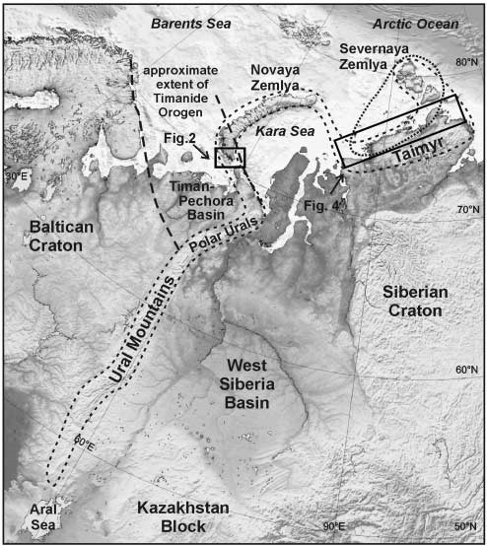

Fig. 1. Regional setting of the Uralian orogen showing the surface extent of the Uralian orogen (sensu lato), the Timanide orogen (bold dashed lines) and the hypothetical ‘North Kara block’ (dotted oval). In the subArctic Uralian mountains, the principal deformation occurred in late

Palaeozoic time; in Novaya Zemlya the main deformation is Early Mesozoic; in Taimyr both late Palaeozoic and early Mesozoic deformation is present. The study areas are indicated by boxes.

Understanding the nature, extent and amalgamation history of different basement provinces in the Russian Arctic is essential for understanding the tectonic evolution of northern Eurasia, and for constraining Arctic plate reconstructions. Furthermore, the nature of the basement plays an important role in basin initiation and development, of particular relevance in this region because the northern Uralian orogen is surrounded and, in part, overlain by some of the most important hydrocarbon basins in the Arctic (Barents Sea, Timan–Pechora, West Siberia, south Kara Sea). The palaeogeographical affinities of sedimentary units can be constrained using detrital zircon age populations, which provide precise information on the timing of tectonomagmatic events within the sediment source areas. A robust provenance determination correlates cumulative frequency profiles, which requires the analysis of a large number of grains to be confident that all major sedimentary source components are identified (Dodson et al. 1988; Vermeesch 2004). A maximum age for a sedimentary unit is provided by the youngest detrital grains contained within it, where independent corroboration of the sediment age is unavailable. Thus, investigations of detrital zircon populations from Neoproterozoic and early Palaeozoic sediments involved in the Uralian orogen can help determine basement affinity, especially when a unique age distribution (‘fingerprint’) can be identified. Detrital zircon data are presented from samples collected during expeditions to southern Novaya Zemlya and Taimyr, which provide important new constraints on crustal affinities in the Eurasian Arctic. Of particular significance in this study are zircons derived from the Timanides, an accretionary orogen along the eastern and northern margin of Baltica of late Neoproterozoic age (Gee & Pease 2004, and references therein). Timanide basement is known to underlie the Timan–Pechora Basin, southern Novaya Zemlya and parts of the southeastern Barents Shelf (Fig. 1); however, its full extent and significance in the Russian Arctic is poorly constrained.

# Geology of southern Novaya Zemlya

The Novaya Zemlya archipelago contains a predominantly westvergent fold-and-thrust belt that exposes a Precambrian to Early Triassic succession. The fold-and-thrust belt is part of the Uralian orogen but is significantly offset from its general trend (Fig. 1). The depositional setting and fauna of the Ordovician to Permian stratigraphic record imply that the archipelago was located along the eastern margin of Baltica (present-day orientation) prior to deformation in Triassic time, with platform sediments predominant on the western side of the archipelago and slope deposits on the eastern side (e.g. Bondarev 1982). This west-to-east transition from platform to slope deposits is also characteristic of the main Uralian deformation belt further south.

Precambrian to early Palaeozoic basement is exposed at a number of localities along the length of the Novaya Zemlya archipelago (Fig. 2a). In the southernmost part of the archipelago, folded, cleaved and weakly metamorphosed turbidites containing intrusive bodies of gabbro–dolerite and lamprophyre have been mapped at the base of the succession in the core of a NW–SE-trending early Mesozoic antiformal structure (Fig. 2b) named the Yuzhnonovozemel’sky, or Southern Novaya Zemlya, Anticlinorium in Russian literature (e.g. Korago et al. 1992). These strata, assigned a Neoproterozoic age on the basis of a varied assemblage of acritarchs and filamentous algae, have been described by Povysheva (1982), Smirnova et al. (1982) and Kovaleva et al. (1984). A review in English has been provided by Korago et al. (2004). The turbidites are texturally immature, and contain abundant igneous lithic fragments and varied heavy mineral suites consistent with a heterogeneous source that may have included volcanic arcs, ophiolite belts and crystalline basement (Kovaleva et al. 1984). Korago et al. (1992) recognized two deformation phases in these basement rocks, and described interference patterns in which approximately east–west-trending folds concentrated along dislocation zones are overprinted by NW–SE-trending early Mesozoic folding that affected all rocks exposed in southern Novaya Zemlya.

A prominent angular unconformity terminates the basement turbidite succession and is well exposed at a number of localities in southern Novaya Zemlya (Fig. 3a). Variegated clastic sediments of Early Ordovician age (conglomerates, sandstones, siltstones), with minor fossiliferous calcareous units, overlie the unconformity. These Ordovician units are involved in the NW– SE-trending folds, but are unmetamorphosed and do not contain the east–west structural trends recognized in strata beneath the unconformity. The base of the Ordovician succession is diachronous. Early Ordovician sediments have been interpreted to be continental, lagoonal and coastal marine deposits reflecting a diachronous transgression onto a pre-existing fold belt (e.g. Bondarev 1982).

The age constraints from existing studies suggest that the time gap represented by the angular unconformity spans at least the Cambrian Period. On this basis, it has been assumed that the unconformity is of Timanide age (Korago et al. 1992, 2004), generated in response to the orogeny that peaked during Ediacaran time (600–550 Ma) and is well documented to the SW

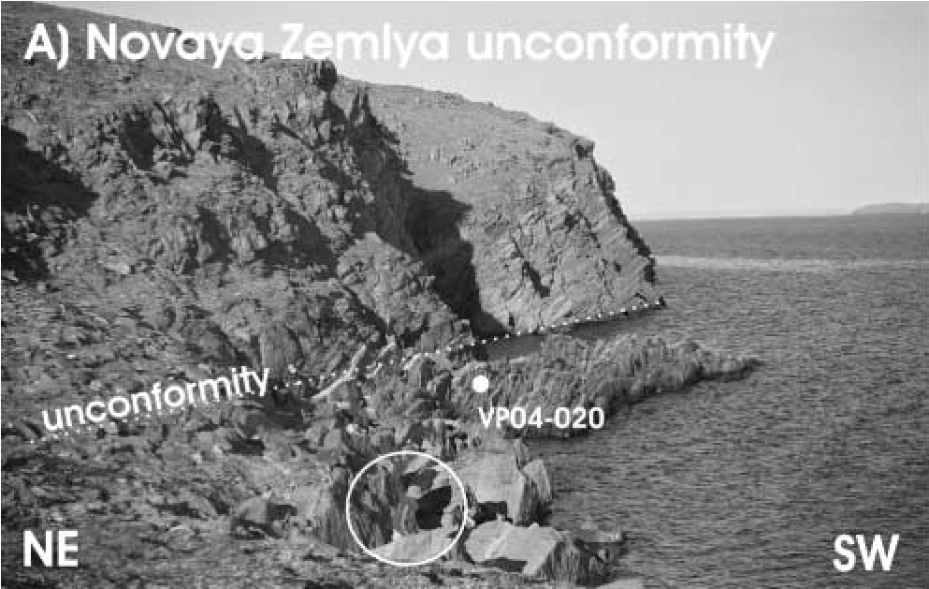

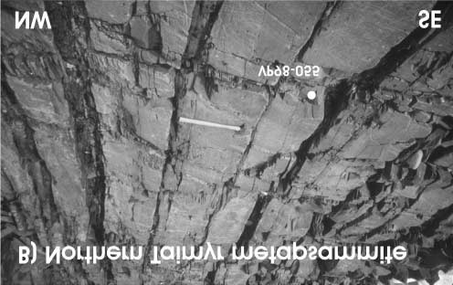

|  |
| --- |
| Fig. 2. (a) Distribution of Precambrian–  Cambrian basement units in Novaya  Zemlya (after Korago et al. 1992). (b) Distribution of Pre-Ordovician basement and overlying Palaeozoic rocks in southern Novaya Zemlya. (c) Geological sketch map of the Tikhomirova Peninsula, where Ordovician strata have a pronounced unconformable contact with pre-Ordovician strata around an antiformal hinge. The contact along the SW side is a zone of high strain and early Ordovician strata above the unconformity are near vertical (see Fig. 3a). Sample locations: 1, VP04-019; 2, VP04020; 3, VP04-021. |

Fig. 3. Field exposure. (a) Southern Novaya Zemlya unconformity. The unconformity (indicated by dotted line) is defined by NE-dipping, greenschist-facies metagreywackes of inferred Precambrian age below (in the background), in contact with vertically dipping oxidized Ordovician sandstone above, which give way to younger shelf carbonates in the foreground (person in foreground circled for scale). Location of sample VP04-020 is shown. (b) Northern Taimyr greenschist-facies, vertically dipping metapsammites (thicker beds) and metapelites (thin, highly sheared beds). Location of sample VP98-055 is shown; hammer for scale.

in the Timan–Pechora Basin and adjacent regions (for an overview see Gee & Pease 2004; Pease et al. 2008).

To understand the age and affinities of strata above and below the angular unconformity in southernmost Novaya Zemlya, a sample of sandstone below the unconformity, a sample immediately above the unconformity, and one sample about 100 m above the unconformity were collected for U–Pb isotopic dating of detrital zircons (Figs 2c and 3a).

# Geology of Taimyr

The Taimyr Peninsula is generally divided into three NE–SWtrending structural zones (Fig. 4; Vernikovsky 1996). Southern Taimyr contains a weakly to unmetamorphosed Ordovician to mid-Carboniferous shallow-marine, carbonate-dominated shelf succession that was deposited on the passive margin of Siberia (Bezzubtsev et al. 1983; Inger et al. 1999; Torsvik & Andersen 2002). Previously claimed Baltican affinities for Ordovician fossils from this succession (Cocks & Modzalevskaya 1997) have been reassessed and a Siberian affinity is now inferred (Fortey & Cocks 2003), consistent with stratigraphic and structural evidence. The passive margin succession is overlain by a package of late Carboniferous to early Triassic shallow-marine and continental siliciclastic rocks interleaved with the Permian–Triassic extrusive and intrusive rocks of the Taimyr igneous suite (Inger et al. 1999; Walderhaug et al. 2005). This siliciclastic package records the influx of detritus, possibly generated by unroofing of the northern Siberian margin in the south, but more probably caused by erosion of the developing Uralian collision belt to the north and west; however, it is not possible to demonstrate unequivocal foreland geometry (Inger et al. 1999). Rare thrust faults observed within the Palaeozoic carbonate succession are considered to be Late Palaeozoic structures of Uralian age (Inger et al. 1999). All of the Triassic and older rocks in southern Taimyr were then folded and faulted during a phase of endTriassic to earliest Jurassic dextral transpression (Inger et al. 1999; Torsvik & Andersen 2002; Walderhaug et al. 2005).

|  |
| --- |
| Fig. 4. Generalized geological map of the Taimyr Peninsula (after Bezzubtsev et al. 1983). ND, northern structural domain; CD, central structural domain. MP, Mikilova Peninsula. Sample locations: 1, VP98-055; 2, VP98-078; 3, VP98-009. |

Central Taimyr is structurally complex and lithologically diverse. It contains a weakly to unmetamorphosed latest Neoproterozoic (Vendian) to early Palaeozoic continental margin succession. Compared with units of equivalent age in southern Taimyr, central Taimyr strata document more distal, deeperwater depositional environments. This succession is interpreted to represent the continental slope of Siberia (Inger et al. 1999), and indicates that central–southern Taimyr has been a coherent part of Siberia since at least latest Neoproterozoic time.

Unconformably below the continental slope succession is a varied assemblage of Precambrian crystalline units. Greenschistfacies Neoproterozoic volcano-sedimentary successions predominate, including fragmented ophiolites, island-arc volcanic rocks and continental crust (Zonenshain & Natapov 1987; Zonenshain et al. 1990; Uflyand et al. 1991; Vernikovsky et al. 2004). Associated with them are Mesoproterozoic to early Neoproterozoic amphibolite-facies metasedimentary units intruded by c. 900 Ma granites (Pease et al. 2001). It has been demonstrated that the Neoproterozoic volcano-sedimentary successions locally lie unconformably on these higher-grade complexes (Pease et al. 2001). Previous workers (e.g. Bezzubtsev et al. 1983, 1986) inferred that these higher-grade complexes were Archaean or Palaeoproterozoic in age, and therefore related to the Siberian craton exposed 600 km to the south. However, metamorphism and granite genesis of early Neoproterozoic (Tonian) age imply that these continental fragments within central Taimyr are unrelated to the Siberian craton (Pease et al. 2001).

The youngest published igneous ages (c. 630 Ma) from central Taimyr are from metamorphosed felsic volcanic rocks (Pease & Vernikovsky 2000). However, unpublished ages (V. Pease) suggest that rhyolitic volcanism at the eastern end of central Taimyr is as young as 625–600 Ma. These ages are similar to the age of regional metamorphism in central Taimyr, which reached 600– 700 8C and 6–9 kbar (Vernikovsky 1995). As these metamorphic rocks are overlain by unmetamorphosed latest Neoproterozoic continental slope deposits of Siberian affinity, it can reasonably be assumed that the regional metamorphism records the endPrecambrian accretion of the allochthonous basement of central Taimyr to the Siberian margin.

There is no recorded evidence of tectonic activity in central Taimyr between the late Neoproterozoic and mid-Carboniferous, suggesting that, like southern Taimyr, it was part of the stable passive margin of Siberia during this time. Central Taimyr, however, was involved in the Carboniferous–Permian Uralian orogeny during which compressional tectonism was accompanied by the intrusion of syn- and post-tectonic granitoids (Vernikovsky et al. 1995; Pease 2001). Contact metamorphic aureoles associated with granitoid intrusion are locally superimposed on the regionally metamorphosed host rocks. Central Taimyr was also subjected to Early Mesozoic transpression, but the absence of Mesozoic strata in this part of Taimyr makes this deformation phase difficult to isolate from earlier deformation events.

Northern Taimyr (Fig. 4) is dominated by rhythmically interbedded clastic metasediments (sandstones, siltstones and mudstones) interpreted to represent turbidites formed on a continental slope (Bezzubtsev et al. 1986). Despite deformation and regional greenschist- to amphibolite-facies metamorphism associated with the late Palaeozoic Uralian orogeny, acritarchs and anabarites have been interpreted to suggest a late Neoproterozoic (Vendian)–Cambrian age (Bezzubtsev et al. 1986). Thermobarometry indicates that temperatures associated with Uralian garnet- to sillimanite-grade metamorphism vary from 460 to 650 8C, at pressures of 3–6.5 kbar (Vernikovsky 1995).

Older igneous rocks constitute a volumetrically minor part of northern Taimyr, but are present in the west–central region near Mikilova Peninsula (Fig. 4). These intrusive and extrusive rocks represent 700 Ma island arc volcanism (Pease & Persson 2006), presumably exposed in a tectonic window to central Taimyr basement. Local migmatization as a result of later Uralian synto post-tectonic Carboniferous–Permian granitoid plutonism complicates the structure of northern Taimyr sedimentary deposits (Vernikovsky et al. 1995; Pease 2001). These Uralian plutons have typical volcanic arc geochemical characteristics (Vernikovsky et al. 1995) and are intruded across both northern and central Taimyr. Hence, the Carboniferous–Permian granitic magmatism is interpreted as ‘stitching’ plutonism that reflects the collision of northern Taimyr with southern–central Taimyr (Zonenshain & Natapov 1987; Zonenshain et al. 1990; Uflyand et al. 1991; Sengo¨r et al. 1993; Inger et al. 1999).

There is no doubt that northern Taimyr is allochthonous with respect to central–southern Taimyr; however, the affinities of this block are uncertain and controversial. Sandstone samples were therefore collected for U–Pb detrital zircon provenance investigations from exposures representing the lowermost parts of the stratigraphic succession at several sites across northern Taimyr (Figs 3b and 4).

# Methods

Zircons were separated from about 2 kg of sample using conventional magnetic and heavy liquid mineral separation techniques. Methods for sample preparation and analytical procedures follow those described by Whitehouse et al. (1999) and Whitehouse & Kamber (2005). U–Th–Pb zircon analysis was made using a Cameca IMS1270 ion-microprobe at the NORDSIM facility in Stockholm, Sweden. Owing to the generally small grain size, a small ion-beam set-up was used (i.e. 15 m) for all samples.

U/Pb ratios were calibrated against the 1065 Ma Geostandards 91500 zircon (Wiedenbeck et al. 1995). A correction for common lead was made using the model lead composition of Stacey & Kramers (1975) when measured 204Pb counts were greater than average background by 3. Common lead probably represents surface contamination during sample preparation (e.g. Zeck & Whitehouse 1999). Even for grains where 204Pb counts were statistically significant, relatively low levels of radiogenic lead in young grains make them susceptible to over-correction and large error propagation. Consequently, ‘207-corrected ages’ (derived by projecting a line from the assumed common Pb composition through the uncorrected 238U/206Pb and 207Pb/206Pb ratios onto concordia; Ludwig 2004) are reported for ages ,1 Ga; this approach a priori assumes that the analysed grains are concordant, which is not unreasonable for low-U detrital zircon. Such an assumption is less robust for highly discordant analyses in which Pb loss cannot be discounted; consequently, analyses .10% discordant (2) on the basis of their uncorrected ratios were excluded from further data synthesis. 207Pb/206 Pb ages are reported for analyses .1 Ga. The ages obtained represent combined 207Pb-corrected and 207Pb/206Pb ages and were used to determine the cumulative frequency curves for each sample.

Data plotting was performed using Isoplot (Ludwig 2004). Weighted average ages for each peak suggest that the variation in age associated with most cumulative probability peaks is approximately 10 Ma; this was determined by iterative exclusion around the peak age until an acceptable statistical result (MSWD , 2) was achieved. Given that fewer than 125 grains per sample were analysed, it is statistically possible that the samples may contain unrecognized age populations (Vermeesch 2004).

Analytical results

# Southern Novaya Zemlya

All of the southern Novaya Zemlya samples represent typical detrital populations containing rounded and broken zircon crystals with a wide range of crystal morphology and cathodoluminescence (CL) characteristics. Most samples contain crystals that show resorption at crystal edges, such as grain 60 of VP04-019, grain 15 and adjacent crystal to the SW of VP04-020, and grains 5, 46 and 58 in VP04-021 (Fig. 5).

Sample VP04-019 is from below the unconformity (Figs 2 and 3a). In this fine-grained greenschist-facies greywacke, 53 of 65 analyses were used in the final synthesis. More than 95% of the grains analysed define the four dominant cumulative frequency age peaks of c. 530, 600, 670 and 750 Ma (Fig. 6). The youngest grains of c. 520 Ma are within 2 error limits of the youngest age peak of 530 Ma. Only two analyses yield ages older than 750 Ma.

Sample VP04-020, an oxidized medium-grained sandstone from immediately above the unconformity (Figs 2 and 3a) used 79 of 87 analyses in the final synthesis. Approximately 80% of the accepted analyses define the four main cumulative frequency age peaks of c. 500, 530, 600 and 650 Ma, with a lesser peak at c. 745 Ma (Fig. 6). The maximum age derived from the youngest grains in the sediment is c. 500 Ma. The remaining analyses yield ages of 800–900, c. 1200 and 1700–1850 Ma.

Sample VP04-021, a fine-grained, carbonate-cemented sandstone with herringbone cross-bedding, lies well above the unconformity (Figs 2 and 3a). The final synthesis used 74 of 77 analyses. About 70% of the accepted analyses define the three major cumulative frequency age peaks of c. 505, 560 and 610 Ma, with lesser peaks at c. 680 and 1440 Ma (Fig. 6). The maximum age derived from the youngest grains in the sediment is c. 490 Ma. The remaining analyses yield ages of 760, 960, 1570–1970, 2380 and 2540 Ma.

The detrital zircon age spectra from southern Novaya Zemlya reveal the following.

1. All three samples have a large proportion of zircons within the age range of 750–510 Ma (VP04-019, 100%; VP04-020, 84%; VP04-021, 50%), consistent with derivation from local sources typical of the Timanide orogen (see Gee & Pease 2004; Pease et al. 2008). Only zircons within this age range are present in the sample from below the unconformity (VP04-019). The pre-unconformity sample also contains a greater proportion of euhedral zircons compared with the two post-unconformity samples, consistent with the entirely juvenile nature of the zircon population.
2. Samples above the unconformity (VP04-020 and VP04021) contain a small population of .1000 Ma zircons, which become more significant with stratigraphic height above the unconformity (VP04-020, 6%; VP04-021, 16%). The age spectra of this older zircon population closely match the expected signal from the Baltic Shield (Cawood et al. 2007).
3. Deformed and weakly metamorphosed strata below the unconformity are mapped as Neoproterozoic (e.g. Korago et al. 2004), but the detrital zircon ages show that at least some of the succession is Cambrian or younger (<530 Ma). The existence of exposed Neoproterozoic sediments in southern Novaya Zemlya must now be open to doubt.
4. The maximum age of strata overlying the unconformity is late Cambrian–early Ordovician (<490 Ma), in good agreement with palaeontological data that indicate a Tremadoc age (Bondarev 1982).
5. The angular unconformity between early Ordovician and older rocks in southern Novaya Zemlya has previously been attributed to the Timanide orogeny (Korago et al. 1992, 2004), which peaked during Ediacaran (mid–late Vendian) time (610– 530 Ma) (Gee & Pease 2004, and references therein). However, the detrital zircon data indicate that the unconformity is of midto late Cambrian age. The potential cause of this unconformity is discussed below.

# Northern Taimyr

Sample VP98-055, the easternmost greenschist-facies sandstone sample (Fig. 3b and location 1 in Fig. 4), is medium to coarse grained. Its zircons are predominantly euhedral to subhedral (Fig. 5b), indicating a proximal source. The zircons generally lack resorption features (Fig. 5b). The final synthesis used 62 of 67 analyses. Dominant cumulative frequency age peaks occur between c. 550 and 565 Ma, with more than 50% of the grains analysed contributing to these populations (Fig. 7). The youngest grains analysed provide a maximum age of c. 500 Ma for the sample. Less dominant peaks occur at c. 625–735 Ma and c. 1.2 Ga, the latter defined by a single grain.

Sample VP98-078, also a medium- to coarse-grained greenschist-facies sandstone (location 2 in Fig. 4), contains zircons with very similar morphology and CL characteristics to VP98055 and a notable absence of irregular (resorbed) crystal edges (Fig. 5b). The final synthesis used 66 of 69 analyses. The most dominant cumulative frequency age peak occurs at c. 550 Ma, with about 80% of the total number of acceptable analyses defining this age peak (Fig. 7). A second peak occurs at 665 Ma and a single grain of 1620 Ma is also present. Multiple grains at c. 530 Ma confidently define a robust maximum age for this sample; it should be noted that a single grain as young as c. 500 Ma may be significant.

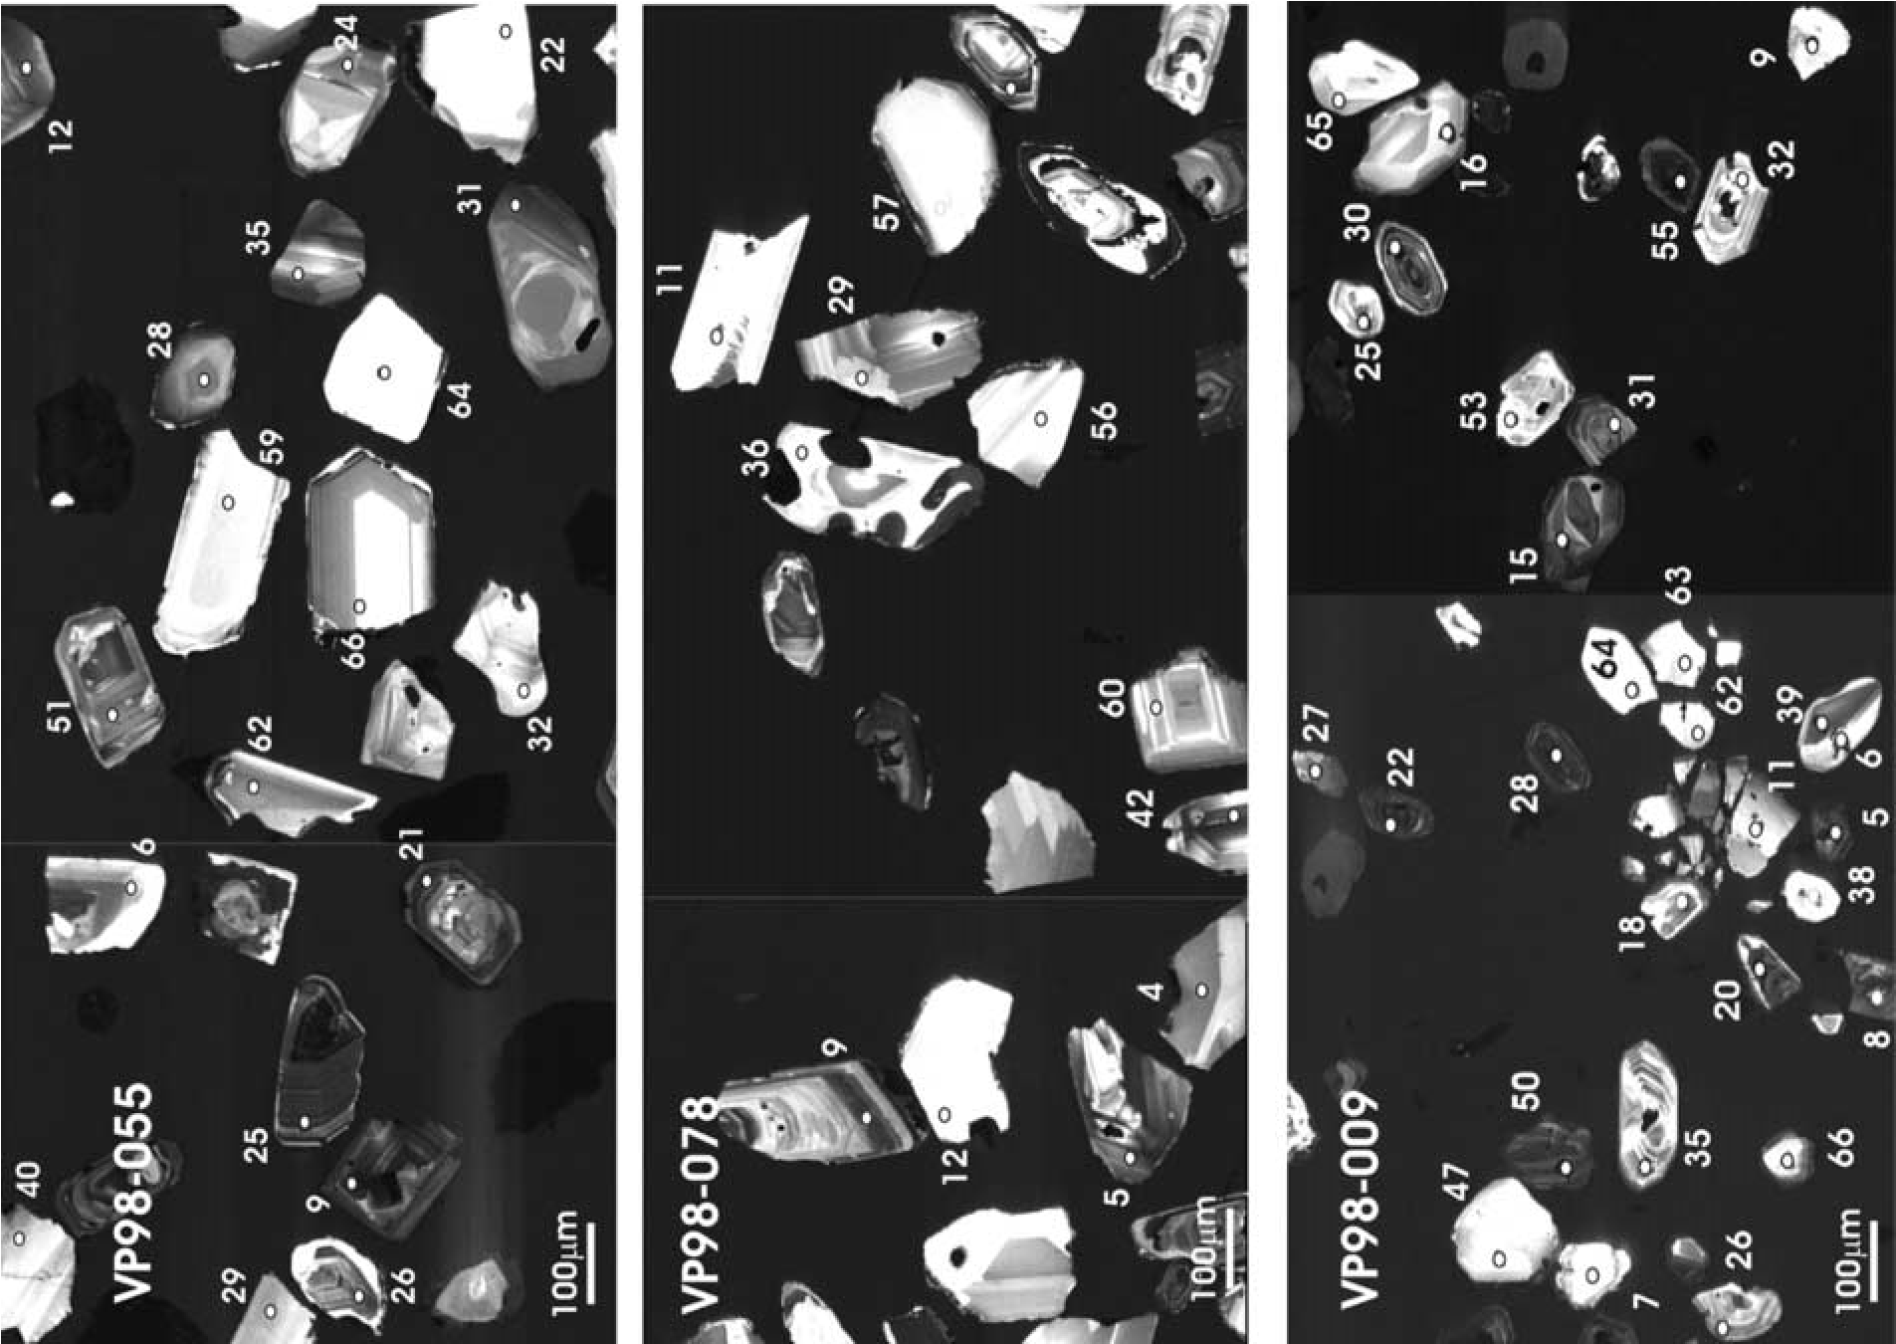

Fig.5.

(

a

)

RepresentativecathodoluminescenceimagesofzirconsfromNovayaZemla(VP04-019,VP04-020,VP04-021)andNorthernTaimyr(VP98-009,VP

98-055

,VP98-078).Analyticalnumbers

correlatetodatatable.

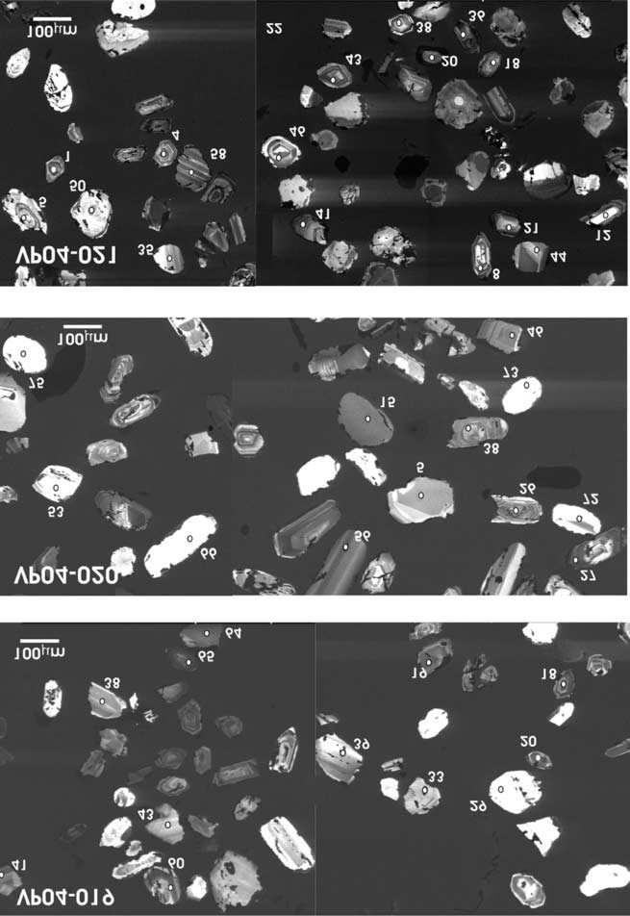

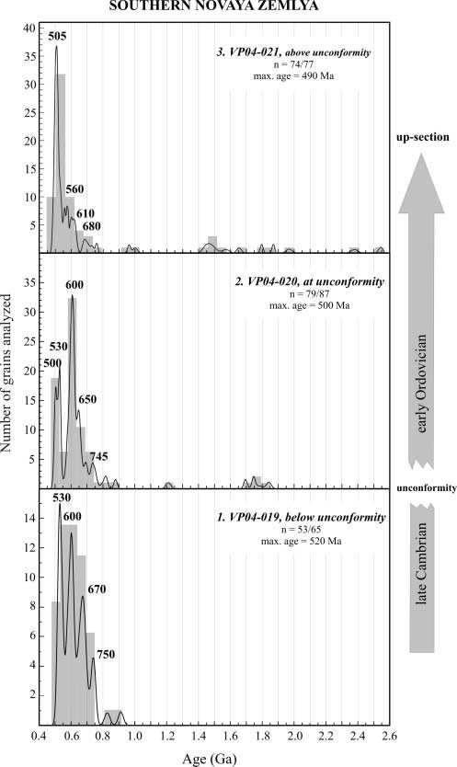

Fig. 6. Cumulative frequency diagrams (with histograms) of U–Pb detrital zircon ages from Novaya Zemlya. It should be noted that the youngest dominant peak in each sample is used to determine the maximum age.

Sample VP98-009, the westernmost sample (location 3 in Fig. 4), is finer grained than the other Taimyr samples. Its zircons vary from euhedral to subhedral and preserve a variety of CL textures including a higher proportion of CL dark crystals (e.g. grains 22, 28, 55, Fig. 5b), apparently reflecting a greater number of highly radioactive grains (2000–4000 ppm U). The final synthesis used 65 of 66 analyses. The dominant cumulative frequency peak occurs at c. 516 Ma with an inflection at c. 560 Ma; more than 50% of the grains analysed contribute to this peak (Fig. 7). The three youngest grains provide a mean age of 450 Ma. Less dominant peaks with ages of 580, 655, 690 and 750 Ma also occur. No older grains are present.

The detrital zircon age spectra from northern Taimyr reveal the following.

1. The westernmost sample (VP98-009) is not stratigraphically equivalent to the other two samples. This is consistent with its younger maximum age of c. 450 Ma and the presence of a notably distinct, U-rich, zircon population (i.e. a different

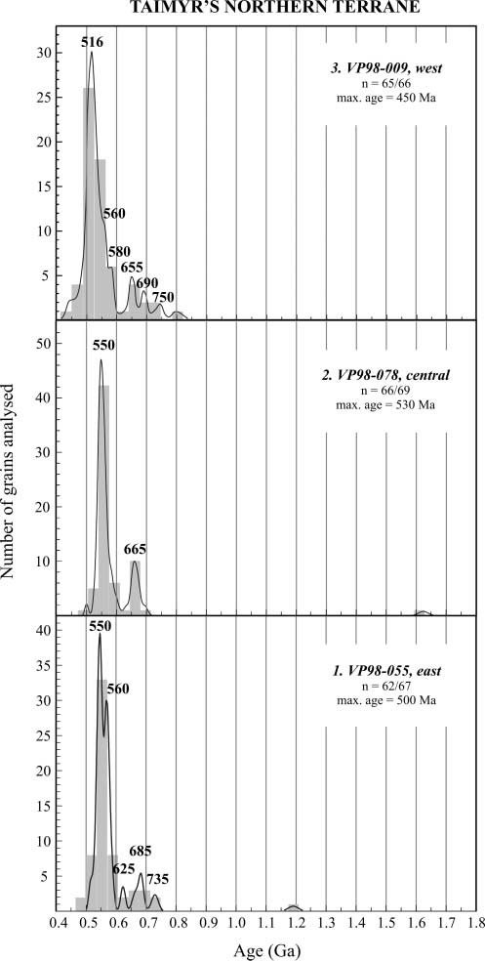

Fig. 7. Cumulative frequency diagrams (with histograms) of U–Pb detrital zircon ages from the northern domain of the Taimyr Peninsula. It should be noted that the youngest dominant peak in each sample is used to determine the maximum age.

provenance). Although all samples were collected as close to the base of the exposed stratigraphic section at each locality as possible, at 450–500 km from the other sample locations there is no reason to assume that the same stratigraphic level is exposed along the entire length of the thrust.

1. Despite being separated by over 500 km, all of the samples define peaks at 550–570 Ma (VP98-055, 70%; VP98-078, 80%; VP98-009, 35%) and older peaks from 625 to 750 Ma. Their age spectra are surprisingly similar to those from Novaya Zemlya, the implications of which are further discussed below.
2. The generally subhedral to euhedral zircon morphologies combined with a notable lack of ‘older’ ages in the northern Taimyr samples is consistent with a juvenile source of zircons close to a continental slope environment that was not receiving far-travelled material eroded from the shield.
3. All three samples are supposed to be Neoproterozoic in age (Bezzubtsev et al. 1983, 1986). Detrital zircon ages, however, consistently indicate a maximum age of less than 450–500 Ma, suggesting that this unit is actually Cambrian–Ordovician, or younger.

Discussion

# Duration of Timanide orogeny

Given the pre-Caledonian age of the southern Novaya Zemlya samples and their proximity to the Timan–Pechora region and the Baltic Shield, it was assumed that they would provide unequivocal reference data for Baltica and the Timanide orogen. The detrital zircon results corroborate this assumption, with Timanide ‘fingerprints’ present in all samples and evidence for partial input to early Ordovician sediment from the Baltic Shield. However, the detrital zircon data have significantly changed our understanding of the angular unconformity that separates early Ordovician clastic strata from older rocks in southern Novaya Zemlya.

The lithological associations, petrography and heavy mineral assemblages (Scott, unpubl. data), absence of ‘cratonic’ age zircon detritus, and proximity to the Timanide orogen on the margin of Baltica are all consistent with an arc-related continental margin setting for pre-unconformity clastic strata and associated igneous rocks in southern Novaya Zemlya. The previous dating of these strata as Neoproterozoic led to the conclusion that the deformation and weak metamorphism that they exhibit, and the unconformity that terminates the succession, were the consequence of Ediacaran Timanide orogeny (Korago et al. 1992, 2004; Bogolepova & Gee 2004; Roberts & Olovyanishnikov 2004). It is now clear, however, that the deformation, metamorphism and development of the unconformity are no older than mid-Cambrian (i.e. at least 50 Ma after the peak Timanide event), requiring a reassessment of their significance.

The late Neoproterozoic Timanide orogeny was the product of accretionary collision with the eastern and northern margin of Baltica, with the onset of convergence linked to a subduction polarity reversal in the adjacent ocean (e.g. Scarrow et al. 2001; Roberts & Olovyanishnikov 2004). As southern Novaya Zemlya is located at the outer margin of the known extent of the Timanide accretionary belt (Figs 1 and 2), it can be argued that it is likely to record the youngest collisional age. The logical conclusion of this argument is that ‘Timanide’ accretion to the margin of Baltica continued until mid- to late Cambrian time. In support of this argument, a significant proportion of the detrital zircons found in the post-unconformity early Ordovician strata of southern Novaya Zemlya yield the same age as the time span represented by the unconformity, suggesting that it represents a significant tectonomagmatic event. Our unequivocal evidence of Cambrian compressional deformation below the unconformity in southern Novaya Zemlya suggests that late Cambrian magmatism in the easternmost Timanides could still be the product of a convergent setting. For example, zircon ages of c. 490 Ma from metagranites in the Polar Urals, previously interpreted to represent incipient post-Timanian rifting (Glodny et al. 2004), may need to be reconsidered in light of longer-lived Timanian convergence.

# Correlation of the North Kara region with Baltica

In offshore areas of the Eurasian Arctic such as the eastern Barents Shelf and the northern Kara Sea Shelf, the nature and affinities of late Precambrian and early Palaeozoic basement are unknown. Consequently, there is still much to understand about late Precambrian and early Palaeozoic tectonic evolution and regional palaeogeographical relationships in the Eurasian Arctic. This investigation provides a robust link between northern Taimyr, Severnaya Zemlya and Novaya Zemlya that can be tied to the Timanian margin of Baltica.

Comparison of detrital zircon spectra from Taimyr and southern Novaya Zemlya reveals a striking similarity between the late Neoproterozoic–Cambrian continental slope deposits of northern Taimyr and the turbidites below the unconformity in southern Novaya Zemlya. The cumulative frequency peaks of 550– 565 Ma that dominate the northern Taimyr samples are consistent with Timanide ages: Granitoids with crystallization ages of 560– 565 Ma (Gee et al. 2000) occur in the basement to the Timan– Pechora Basin (Fig. 1). No other contemporaneous source for these zircons is known; consequently, northern Taimyr appears to represent a part of the continental slope of eastern Euramerica–

Baltica.

This conclusion is further supported by the integration of U– Pb magmatic zircons ages and palaeontological data from the Severnaya Zemlya archipelago. Lorenz et al. (2007) described a pronounced angular unconformity from October Revolution Island, for which isotopic ages obtained from igneous rocks below and above the unconformity surface tightly constrain its age to the vicinity of the Cambrian–Ordovician boundary, in good agreement with Tremadoc fauna obtained from associated sediments. Rocks beneath the unconformity are strongly folded, implying that a short-lived phase of deformation was responsible for generating the hiatus. Thus, the unconformity on Severnaya Zemlya is apparently similar in terms of timing and style of deformation (compressional) to the unconformity on southern Novaya Zemlya. These similarities imply that the North Kara block (of which northern Taimyr and Severnaya Zemlya are a part) was a continuation of Baltica in the Cambrian–Ordovician, rather than an independent microplate (see Metelkin et al. 2005).

# Changing tectonic regimes around the Cambrian– Ordovician boundary

The presence of a late Cambrian unconformity in southern Novaya Zemlya truncating older metasediments that have been demonstrably deformed in the Cambrian provides new insights into the Timanide orogen, suggesting that accretion to the margin of Baltica may have continued throughout the Cambrian Period. It also provides a potential explanation for the coeval Cambrian– Ordovician boundary unconformity on Severnaya Zemlya. Lorenz et al. (2007, 2008) referred to the Severnaya Zemlya unconformity as an ‘early Caledonian’ feature and suggested that it reflects far-field stresses coincident with the late Cambrian to early Ordovician (c. 500–480 Ma) Finnmarkian deformation previously described in the northern Scandinavian Caledonides (Sturt et al. 1978; Roberts 2003). The Finnmarkian deformation was interpreted to result from the collision of a magmatic arc with the Baltoscandian margin (Dallmeyer & Gee 1986; Sturt & Roberts 1991); however, recent work has cast doubt on the existence of a Finnmarkian deformation phase (e.g. Kirkland et al. 2006). Observations in southern Novaya Zemlya provide an alternative explanation for the unconformity in Severnaya Zemlya: Cambrian deformation and magmatism are related to a late Timanian accretionary event on the opposing margin of Baltica to the Caledonides. Given the lack of knowledge regarding basement beneath the Barents Shelf, it is possible that the effects of late Timanian deformation could be widespread throughout this region. Without more data, however, this possibility remains speculative.

The late Cambrian to early Ordovician event is also linked with the continental break-up that generated the Uralian Ocean. It is well established that the Uralian passive margin of Baltica to the south of Novaya Zemlya developed as a consequence of late Cambrian to early Ordovician rifting (e.g. Puchkov 2002, and references therein), which progressed to sea-floor spreading and development of the Uralian Ocean. The fact that Timanide structural trends in the Timan–Pechora region terminate against this newly formed continental margin in the Polar Urals provides compelling evidence that a continental fragment of significant size was separated from Baltica during formation of this ocean (Puchkov 2002). This late Cambrian to early Ordovician rift– drift transition is penecontemporaneous with the age of the unconformity in southern Novaya Zemlya and Severnaya Zemlya. Consequently, it can be argued that the final Cambrian accretionary event on the Baltica margin recorded in southern Novaya Zemlya was intimately related to the end of the ‘Timanide’ compressional regime, and the subsequent onset of orogenic collapse and continental break-up around the Cambrian–Ordovician boundary was regionally significant. Aspects of the post-unconformity geology of southern Novaya Zemlya are consistent with this hypothesis, as follows.

1. Early Ordovician strata above the unconformity in southern Novaya Zemlya accumulated in coastal environments and show significant thickness variations. A late Cambrian to early Ordovician extensional event is the most likely explanation of the differential subsidence, creating the accommodation space for the early Ordovician and subsequent Palaeozoic successions to be deposited and preserved. This is also consistent with late Cambrian to early Ordovician continental break-up.
2. The older zircons in the post-unconformity early Ordovician sediments indicate derivation from the Baltic Shield, suggesting that clastic detritus crossed Timan–Pechora and adjacent shelf areas to reach the coastal environments preserved in southern Novaya Zemlya. This is taken as circumstantial evidence that the late Cambrian to early Ordovician extensional event, and associated onset of early Ordovician sedimentation, may have been linked with collapse of the Timanide orogen and is consistent with the later deposition of Ordovician shallowmarine deposits across the Timan–Pechora region (e.g. Larionova et al. 2002).

It is interesting to speculate on the tectonic implications resulting from correlation of the Cambrian–Ordovician unconformities on Severnaya and Novaya Zemlya. It not only extends the duration of Timanian orogeny by c. 50 Ma, but it may also extend the supposed regional limit of Timanian deformation (see Fig. 1), and/or imply that northern Taimyr and Severnaya Zemlya were closer to southern Novaya Zemlya. Taimyr is characterized by Late Triassic dextral transpression (Inger et al. 1999), implying that Severnaya Zemlya and eastern parts of Taimyr may have been translated to some degree. Although further study of these early Palaeozoic relationships is required, a picture of complex Neoproterozoic to early Palaeozoic accretionary and rifting events around the margins of Baltica is emerging that raises important questions regarding the nature, extent and timing of amalgamation of basement elements beneath the Russian

Arctic Shelf.

# Conclusions

Deformed and weakly metamorphosed turbidites derived from a juvenile arc-related source are unconformably overlain by an unmetamorphosed Ordovician clastic–carbonate succession in southern Novaya Zemlya. Detrital zircon ages demonstrate that the turbidites beneath the unconformity are Cambrian, not Neoproterozoic as has previously been suggested, and that the age of the unconformity is Late Cambrian to Early Ordovician. Strata above and below the unconformity preserve a unique Timanide ‘fingerprint’ and thus confirm a Baltica provenance.

Detrital zircons from northern Taimyr also preserve a unique Timanide (Baltica) signature, displaying age spectra remarkably similar to those of the samples from southern Novaya Zemlya. As northern Taimyr is part of the Kara block, it follows that the Kara block was part of Baltica and not an independent microcontinent as has previously been suggested.

The deposition of early Ordovician strata unconformably upon folded and metamorphosed Cambrian strata in southern Novaya Zemlya brackets a relatively short interval for deformation and exhumation. A comparable unconformity has been reported from the Severnaya Zemlya archipelago NE of Taimyr. Severnaya Zemlya is also part of the Kara block and the similarity of the late Cambrian to early Ordovician unconformity further strengthens the argument that the Kara block was part of Baltica.

The late Cambrian to early Ordovician unconformity appears to have regional significance. It is interpreted to reflect the cessation of Timanian convergence and ultimate collapse of the orogen, which affected a greater area than previously recognized. Deformation related to Timanian convergence probably continued into late Cambrian time, extending duration of orogeny by about 50 Ma, and was followed by a transition to an extensional regime as the Uralian Ocean began to open in the Ordovician.

Without the logistical and financial assistance of the Swedish Polar Research Secretariat, fieldwork in Taimyr would not have been possible. We thank the Captain and crew of the research vessel Gorizont, operated by the Russian Hydrographic Office in Murmansk, for their logistic support in Novaya Zemlya. We also thank VNIIOkeangeologiya in St. Petersburg for their organizational role in the Novaya Zemlya expedition. Additional support from the Swedish National Science Research Council, the Royal Swedish Academy, the Swedish Museum of Natural History and EU INTAS grant (97-1139) is gratefully acknowledged. CASP acknowledges the industrial sponsors of its Arctic research with gratitude. F. Corfu and an anonymous reviewer provided constructive criticism that improved the quality of the manuscript. Thanks go to M. J. Whitehouse and the NORDSIM facility, which is funded by the research councils of Denmark, Norway and Sweden, the Geological Survey of Finland, and the Swedish Museum of Natural History. This paper is NORDSIM

Publication 224.

# References

Allen, M.B., Anderson, L., Searle, R.C. & Buslov, M.M. 2006. Oblique rift geometry of the West Siberian Basin: tectonic setting for the Siberian flood basalts. Journal of the Geological Society, London, 163, 901–904.

Aplonov, S.V. 1995. The tectonic evolution of West Siberia: An attempt at a geophysical analysis. Tectonophysics, 245, 61–84.

Bezzubtsev, V.V., Malitch, N.S., Markov, F.G. & Pogrebitsky, Yu.E. 1983. Geological map of mountainous Taimyr 1:500 000, Ministry of Geology of the USSR. Ministry of Geology of the Russian Federation (RSFSR),

Krasnoyarskgeologia, Krasnoyarsk [in Russian].

Bezzubtsev, V.V., Zalyaleyev, R. & Sakovich, A. 1986. Geological map of mountainous Taimyr 1:500 000: explanatory notes. Krasnoyarskgeologia, Krasnoyarsk [in Russian].

Bogolepova, O.K. & Gee, D.G. 2004. Early Palaeozoic unconformity across the Timanides, NW Russia. In: Gee, D.G. & Pease, V. (eds) The Neoproterozoic Timanide Orogen of Eastern Baltica. Geological Society, London, Memoirs, 30, 145–157.

Bondarev, V.I. (ed.) 1982. Geology of the South Island of Novaya Zemlya. PGO ‘Sevmorgeologiya’, Leningrad.

Brown, D., Juhlin, C. & Puchkov, V. (eds) 2002. Mountain Building in the Uralides, Pangea to the Present. American Geophysical Union, Geophysical Monographs, 132.

Cawood, P.A., Nemchin, A.A., Strachan, R., Prave, T. & Krabbendam, M. 2007. Sedimentary basin and detrital zircon record along East Laurentia and Baltica during assembly and breakup of Rodinia. Journal of the Geological Society, London, 164, 257–275.

Cocks, L. & Modzalevskaya, T. 1997. Late Ordovician brachiopods from Taimyr, Arctic Russia, and their paleogeographical significance. Paleontology, 40, 1061–1093.

Dallmeyer, R.D. & Gee, D.G. 1986. 40Ar/39Ar mineral dates from retrogressed eclogites within the Baltoscandian miogeocline: implications for a polyphase Caledonian orogenic evolution. Geological Society of America Bulletin, 97, 26–34.

Dodson, M., Compston, W., Williams, I. & Wilson, J. 1988. A search for ancient detrital zircons from Zimbabwean sediments. Journal of the Geological Society, London, 145, 977–983.

Fortey, R.A. & Cocks, L.R.M. 2003. Paleontological evidence bearing on global Ordovician–Silurian continental reconstructions. Earth-Science Reviews, 61, 245–307.

Gee, D.G. & Pease, V. (eds) 2004. The Neoproterozoic Timanide Orogen of Eastern Baltica. Geological Society, London, Memoirs, 30.

Gee, D.G., Beliakova, L., Pease, V., Larinov, A. & Dovzikova, E. 2000. New, single zircon (Pb-evaporation) ages from Vendian intrusions in the basement beneath the Pechora Basin, northeastern Baltica. Polarforschung, 68, 161–170.

Glodny, J., Pease, V., Montero, P., Austrheim, H. & Rusin, A.I. 2004. Protolith ages of eclogites, Marun-Keu Complex, Polar Urals, Russia: implications for the pre- and early Uralian evolution of the northeastern

European continental margin. In: Gee, D.G. & Pease, V. (eds) The Neoproterozoic Timanide Orogen of Eastern Baltica. Geological Society, London, Memoirs, 30, 87–105.

Gradstein, F., Ogg, J. & Smith, A. 2004. A Geologic Time Scale 2004.

Cambridge University Press, Cambridge.

Hamilton, W. 1970. The Uralides and the motion of the Russian and Siberian platforms. Geological Society of America Bulletin, 81, 2553–2576.

Inger, S., Scott, R.A. & Golionko, B. 1999. Tectonic evolution of the Taimyr Peninsula, northern Russia: Implications for Arctic continental assembly. Journal of the Geological Society, London, 156, 1069–1072.

Kirkland, C.L., Daly, J.S. & Whitehouse, M.J. 2006. Granitic magmatism of Grenvillian and late Neoproterozoic age in Finnmark, Arctic Norway— constraining pre-Scandian deformation in the Kalak Nappe Complex. Precambrian Research, 145, 24–52.

Korago, E.A., Kovaleva, G.N., Il’in, V.F. & Pavlov, L.G. 1992. The tectonics and metallogeny of the early Kimmerides of Novaya Zemlya. Nedra,

Leningrad.

Korago, E.A., Kovaleva, G.N., Lopatin, B.G. & Orgo, V.V. 2004. The Precambrian rocks of Novaya Zemlya. In: Gee, D.G. & Pease, V.L. (eds) The Neoproterozoic Timanide Orogen of Eastern Baltica. Geological Society, London, Memoirs, 30, 135–143.

Kovaleva, G.N., Korago, E.A. & Smirnova, L.N. 1984. Stratigraphy and tectonic position of the oldest deposits of the South Island of Novaya Zemlya. Byulleten’ Moskovskogo Obshchestva Ispytateley Prirody, Otdel Geologicheskiy, 59, 80–88.

Larionova, Z.V., Bogatsky, V.I., Dovzhikova, E.G., et al. 2002. The Timan– Pechora sedimentary basin (explanatory note). In: Timan–Pechora Sedimentary Basin. Atlas of Geological Maps, 2000. Ministry of Natural Resources of Komi Republic, Ukhta.

Lorenz, H., Gee, D. & Whitehouse, M. 2007. New geochronological data on Palaeozoic igneous activity and deformation in the Severnaya Zemlya Archipelago, Russia, and implications for the development of the Eurasian Arctic margin. Geological Magazine, 144, 105–125.

Lorenz, H., Ma¨nnik, P., Gee, D. & Proskurnin, V. 2008. Geology of the Severnaya Zemlya Archipelago and the North Kara Terrane in the Russian high Arctic. International Journal of Earth Sciences, 97, 519–547.

Ludwig, K. 1998. On the treatment of concordant uranium–lead ages. Geochimica et Cosmochimica Acta, 62, 665–676.

Ludwig, K. 2004. Isoplot/Ex version 3.2: a Geochronological Toolkit for Microsoft Excel. Berkeley Geochronology Center Special Publications.

Metelkin, D.V., Vernikovsky, V.A., Kazansky, A.Yu., Bogolepova, O.K. & Gubanov, A.P. 2005. Paleozoic history of the Kara microcontinent and its relation to Siberia and Baltica: paleomagnetism, paleogeography and tectonics. Tectonophysics, 398, 225–243.

Otto, S. & Bailey, V. 1995. Tectonic evolution of the northern Ural Orogen.

Journal of the Geological Society, London, 152, 903–906.

Pease, V. 2001. East European craton margin source for the allochthonous Northern Terrane of Taimyr, Arctic Siberia. EOS Transactions, American Geophysical Union, 82, F1181.

Pease, V. & Persson, S. 2006. Neoproterozoic island arc magmatism of northern Taimyr. In: Scott, R. & Thurston, D. (eds) Proceedings of the Fourth International Conference on Arctic Margins. US Department of the Interior, Minerals Management Service OCS Study, MMS 2006-003, 31–49.

Pease, V. & Vernikovsky, V. 2000. The tectono-magmatic evolution of the Taimyr Peninsula: Further constraints from new ion-microprobe data. Polarforschung, 63, 171–178.

Pease, V., Gee, D., Vernikovsky, V., Vernikovskaya, A. & Kireev, S. 2001. Geochronological evidence for late-Grenvillian magmatic and metamorphic events in central Taimyr, northern Siberia. Terra Nova, 13, 270–280.

Pease, V., Daly, J.S., Elming, S.-A˚ ., etal. 2008. Baltica in the Cryogenian, 850– 630 Ma. Precambrian Research, 160, 48–65.

Povysheva, L.G. 1982. The results of a mineralogical analysis of South Island of Novaya Zemlya. In: Bondarev, V.I. (ed.) Geologiya Yuzhnogo ostrova Novoy Zemli. PGO ‘Sevmorgeologiya’, Leningrad, 58–67 [in Russian].

Puchkov, V.N. 1997. Structure and geodynamics of the Uralian orogen. In: Burg, J.P. & Ford, M. (eds) Orogeny through Time. Geological Society, London, Special Publications, 121, 201–236.

Puchkov, V. 2002. Paleozoic evolution of the east European continental margin involved in the Uralide Orogeny. In: Brown, D., Juhlin, C. & Puchkov, V. (eds) Mountain Building in the Uralides: Pangea to Present. American Geophysical Union, Geophysical Monographs, 132, 9–31.

Roberts, D. 2003. The Scandinavian Caledonides: event chronology, palaeogeographic settings and likely modern analogues. Tectonophysics, 365, 283–299.

Roberts, D. & Olovyanishnikov, V. 2004. Structural and tectonic development of the Timanide orogen. In: Gee, D.G. & Pease, V. (eds) The Neoproterozoic Timanide Orogen of Eastern Baltica. Geological Society, London, Memoirs, 30, 47–57.

Scarrow, J.H., Pease, V.L., Fleutelot, C. & Dushin, V. 2001. The late Neoproterozoic Enganepe ophiolite, Polar Urals, Russia: an extension of the Cadomian arc? Precambrian Research, 110, 255–275.

Sengo¨r, A., Natal’in, B. & Burtman, V. 1993. Evolution of the Altaid tectonic collage and Paleozoic crustal growth in Eurasia. Nature, 364, 299–307.

Smirnova, L.N., Korago, E.A. & Kovaleva, G.N. 1982. Classification of Precambrian deposits of Yuzhnyi island on the Novaya Zemlya. In: Microfossils of the polar areas and their stratigraphic importance. NIIGA, Leningrad, 84–90.

Stacey, J. & Kramers, J. 1975. Approximation of terrestrial lead isotope evolution by a two-stage model. Earth and Planetary Science Letters, 26, 207–221.

Sturt, B.A. & Roberts, D. 1991. Tectonostratigraphic relationships and obduction histories of Scandinavian ophiolitic terranes. In: Peters, T. (ed.) Ophiolite Genesis and Evolution of the Oceanic Lithosphere. Ministry of Petroleum and Minerals, Oman, 745–769.

Sturt, B.A., Pringle, I. & Ramsay, D.M. 1978. The Finnmarkian phase of the Caledonian Orogeny. Journal of the Geological Society, London, 135, 597– 610.

Torsvik, T.H. & Andersen, T.B. 2002. The Taimyr fold belt, Arctic Siberia: timing of prefold remagnetisation and regional tectonics. Tectonophysics, 352, 335–348.

Torsvik, T.H. & Cocks, L.R.M. 2004. Earth geography from 400 to 250 Ma: a palaeomagnetic, faunal and facies review. Journal of the Geological Society, London, 161, 555–572.

Uflyand, A., Natapov, L., Lopatin, V. & Chernov, D. 1991. On the Taimyr tectonic nature. Geotectonics, 6, 76–79 [in Russian].

Vermeesch, P. 2004. How many grains are needed for a provenance study? Earth and Planetary Science Letters, 224, 441–451.

Vernikovsky, V. 1995. Riphean and Paleozoic metamorphic complexes of the Taimyr foldbelt: Condition of formation. Petrol, 3, 55–72.

Vernikovsky, V. 1996. The geodynamic evolution of the Taimyr folded area. Geology of the Pacific Ocean, 12, 691–704.

Vernikovsky, V. & Vernikovskaya, A. 2001. Central Taimyr accretionary belt (Arctic Asia): Meso-Neoproterozoic tectonic evolution and Rodinia breakup. Precambrian Research, 110, 127–141.

Vernikovsky, V., Neimark, L., Ponomarchuk, V., Vernikovskaya, A., Kireev, A. & Kuz’min, D. 1995. Geochemistry and age of collision granitoids and metamorphites of the Kara microcontinent (northern Taimyr). Russian Geology and Geophysics, 36, 46–60.

Vernikovsky, V., Vernikovskaya L., A., Pease, V. & Gee, D. 2004. Neoproterozoic orogeny along the margins of Siberia. In: Gee, D.G. & Pease, V. (eds) The Neoproterozoic Timanide Orogen of Eastern Baltica. Geological Society, London, Memoirs, 30, 233–248.

Walderhaug, H.J., Eide, E.A., Scott, R.A., Inger, S. & Golionko, B.G. 2005. Palaeomagnetism and 40Ar/39Ar geochronology from the South Taimyr igneous complex, Arctic Russia: a Middle–Late Triassic magnetic pulse after Siberian flood-basalt volcanism. Geophysical Journal International, 163, 501–517.

Whitehouse, M.J. & Kamber, B.S. 2005. Assigning dates to thin gneissic veins in high-grade metamorphic terranes: a cautionary tale from Akilia, southwest Greenland. Journal of Petrology, 46, 291–318.

Whitehouse, M., Kamber, B. & Moorbath, S. 1999. Age significance of U–Th– Pb zircon data from early Archaean rocks of west Greenland—a reassessment based on combined ion-microprobe and imaging studies. Chemical Geology, 160, 201–224.

Wiedenbeck, M., Alle´, P., Corfu, F., et al. 1995. Three natural zircon standards for U–Th–Pb, Lu–Hf, trace element and REE analysis. Geostandards Newsletter, 19, 1–23.

Zeck, H.P. & Whitehouse, M.J. 1999. Hercynian, Pan-African, Proterozoic and Archean ion-microprobe zircon ages for a Betic–Rif core complex, Alpine

belt W Mediterranean—consequences for its P–T–t path. Contributions to Mineralogy and Petrology, 134, 134–149.

Ziegler, P.A. 1989. Evolution of Laurussia: a Study in Late Palaeozoic Plate Tectonics. Kluwer, Dordrecht.

Zonenshain, L. & Natapov, L. 1987. Tectonic history of the Arctic. In: Yanshin, A.L. (ed.) Actual Problems of Continent and Ocean Tectonics. Nauka, Moscow, 31–57 [in Russian].

Zonenshain, L.P., Korinevsky, V.G., Kazmin, V.G., Pechersky, D.M., Khain, V.V. & Matveenkov, V.V. 1984. Plate tectonic model of the South Urals development. Tectonophysics, 109, 95–135.

Zonenshain, L., Kuzmin, M. & Natapov, L. 1990. Geology of the USSR: A Plate-Tectonic Synthesis. American Geophysical Union, Geodynamics Series, 21.

Received 21 July 2008; revised typescript accepted 20 December 2008. Scientific editing by Chris Clark.