Tectonics, exhumation, and drainage evolution of the eastern

Himalaya since 13 Ma from detrital geochemistry and thermochronology, Kameng River Section, Arunachal Pradesh

**François Chirouze1, Pascale Huyghe1, Peter van der Beek1, Catherine Chauvel1, Tapan Chakraborty2,**

**Guillaume Dupont-Nivet3, and Matthias Bernet1,†**

1*Institut des Sciences de la Terre, Université Joseph Fourier/CNRS, BP53, 38041 Grenoble Cedex, France*

2*Geological Studies Unit, Indian Statistical Institute, 203 B.T. Road, Kolkata 700108, India*

3*Géosciences Rennes, CNRS/Université Rennes I, CS 74205, 35042 Rennes Cedex, France*

**ABSTRACT**

**The exhumation history of the central Himalaya is well documented, but lateral variations in exhumation remain poorly constrained. In this study, we identify sediment source areas and examine the late Neogene exhumation history of the eastern Himalaya from the synorogenic sedimentary record of its foreland basin. We present Nd and Hf isotopic data as well as apatite and zircon fi ssion-track analyses from the Miocene–Pliocene Siwalik Group along the recently dated Kameng River section in Arunachal Pradesh, northeastern India. Our isotopic data show that Siwalik Group sediments deposited between 13–7 and <2.6 Ma in Arunachal Pradesh were mainly derived from Higher Himalayan source rocks. In contrast, sediments deposited between ca. 7 and 3 Ma have far less negative** ε**Nd and** ε**Hf values that require involvement of the Gangdese Batholith and Yarlung suture zone source areas via the Brahmaputra River system. Consequently, these sediments should also record incision of the Namche Barwa massif by this river. Source-area exhumation rates of Himalayanderived sediments, determined from detrital zircon fi ssion-track data, were on the order of 1.8 km/m.y. in the fastest-exhuming areas. These rates are very similar to those calculated for the central Himalaya and have been relatively constant since ca. 13 Ma. Our results do not support the hypothesis of a major change in exhumation rate linked to either local or regional climate change or to Shillong Plateau uplift during the Miocene, as reported elsewhere. The zircon fi ssion-track**

E-mail: matthias.bernet@ujf-grenoble.fr

†

**data further suggest that exhumation of the Namche Barwa massif between 7 and 3 Ma was much slower than the ~10 km/m.y. rate recorded in the recent past. Detrital apatite fi ssion-track data indicate deformation of the Siwaliks due to forward propagation of the frontal thrust since around 1 Ma.**

**INTRODUCTION**

The Himalaya region has signifi cantly infl uenced both global and regional climate (e.g., Raymo and Ruddiman, 1992; Molnar et al., 1993), as well as sediment fl ux to the Indian Ocean, since ca. 50 Ma (Métivier et al., 1999; Clift, 2006). While the evolution of this mountain belt is primarily driven by India-Asia convergence, several authors have suggested that its relief and erosion patterns have been strongly affected by the monsoon climate since the Miocene (e.g., Bookhagen and Burbank, 2006; Clift et al., 2008a, 2008b; Iaffaldano et al., 2011). Therefore, the Himalaya represents a unique natural laboratory where the interactions between tectonics, erosion, climate, and drainage evolution can be investigated. Combined geochemical provenance and detrital thermochronol ogic analyses of synorogenic sediments of different depositional ages allow the reconstruction of the tectonic and erosional history of the mountain belt by constraining source areas and exhumation rates through time.

The long-term exhumation history of the western and central Himalaya has been described using detrital mica 40Ar-39Ar, zircon fi ssion-track (ZFT), and apatite fi ssion-track (AFT) analyses (White et al., 2002; Bernet et al., 2006; Szulc et al., 2006; van der Beek et al., 2006; Najman et al., 2009; Chirouze et al., 2012a), while sediment provenance evolution has been determined from isotope geochemistry, detrital zircon U/Pb geochronology, as well as ZFT and U/Pb double dating of single grains (Robinson et al., 2001; Huyghe et al., 2001, 2005; DeCelles et al., 2004; Bernet et al., 2006). The history of the western syntaxis has similarly been constrained by detrital studies in the foreland basin (e.g., Cerveny et al., 1988; Najman et al., 2003). In contrast, very little is known about the evolution of the eastern Himal aya. Thermochronologic and geochemical data from the Bengal Fan imply relatively continuous erosion over time on the scale of the Ganges and Brahmap utra drainage system (van der Beek et al., 2006; Galy et al., 2010). Detrital AFT and ZFT data from eastern Nepal (Chirouze et al., 2012a) and in situ AFT data from Bhutan (Grujic et al., 2006) hint at slower (0.5–1 km/m.y.) long-term erosion rates in the eastern Himalaya compared to the central Himal aya (1–2 km/m.y.). Several studies have suggested that rapid (5–10 km/m.y.) focused exhumation in both the western and eastern syntaxes of the Himalaya is driven by incision of the Indus and Yarlung–Brahmaputra Rivers, respectively, following the so-called “tectonic aneurysm” hypothesis (Zeitler et al., 2001; Ding et al., 2001; Koons et al., 2002; Booth et al., 2009; Enkelmann et al., 2011). However, temporal constraints on drainage network evolution and the onset of rapid exhumation are currently not suffi ciently well known to fully constrain this model.

Here, we present detrital AFT and ZFT data as well as whole-rock Nd and Hf isotopic data from samples collected from Miocene–Quaternary foreland basin sediments along the Kameng section in Arunachal Pradesh, northeastern India (Fig. 1), which was recently dated by magnetostratigraphy (Chirouze et al., 2012b). The

*GSA Bulletin*; March/April 2013; v. 125; no. 3/4; p. 523–538; doi: 10.1130/B30697.1; 9 fi gures; 3 tables; Data Repository item 2013064.

For permission to copy, contact editing@geosociety.org

© 2013 Geological Society of America

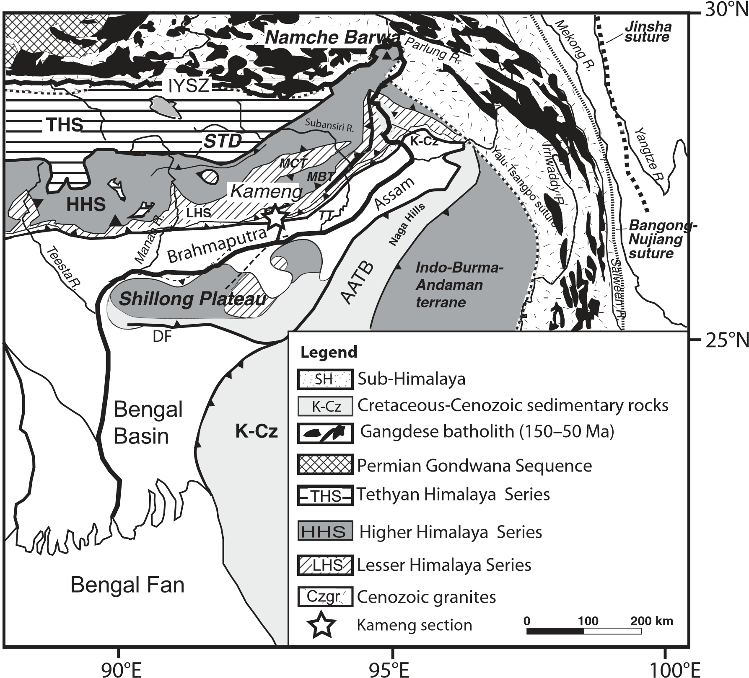

**Figure 1. Regional tectonic map showing simplifi ed geology and the locations of major rivers (after Yin et al., 2006, 2010; Guillot and Charlet, 2007). The star indicates the location of the Kameng section. Tectonic structures: I ndus-Yarlung suture zone (IYSZ), Main Frontal thrust (MFT), Main Boundary thrust (MBT), Main Central thrust (MCT), South Tibetan detachment (STD), Dauki fault (DF), Assam-Arakan thrust belt (AATB), and Tipi Thrust (TT).**

thermoc hronologic data provide constraints on exhumation rates in the eastern Himalaya and the deformation of the Sub-Himalayan foreland basin. Nd isotopes are used as provenance indicators following previous studies in the Himalaya (France-Lanord et al., 1993; Huyghe et al., 2001, 2005; Robinson et al., 2001; Clift et al., 2008a; Galy et al., 2010; Najman et al., 2012), while Hf-isotope data are reported for the fi rst time in this region. We demonstrate that the Hf-isotopic system is an excellent proxy with which to distinguish sediment source areas. In the future, it could be used combined with Nd isotopes or alone on zircon populations. At the regional scale, the data are combined to discuss different scenarios of the evolution of the Yarlung-Brahmaputra drainage system since the mid-Miocene.

**GEOLOGY OF THE EASTERN HIMALAYA**

Plate reconstructions and geologic data indicate that collision between the Indian and Asian continents began during the early Eocene (Yin and Harrison, 2000; Zhu et al., 2005; DupontNivet et al., 2010). This collision caused signifi cant crustal shortening and thickening, resulting in the formation of the Tibetan Plateau and the Himalayan mountain belt (Hodges, 2000; Yin and Harrison, 2000). The Himalaya is classically subdivided into fi ve lithotectonic zones (Fig. 1) separated by north-dipping crustal-scale faults (Le Fort, 1975; Yin and Harrison, 2000). From north to south, these are (1) the IndusYarlung suture zone, containing ophiolites of the Neotethys ocean and the Cretaceous–Tertiary Gangdese Batholith (also known as the Transhimalayan batholith) lying adjacent to the suture zone; (2) the Tethyan Himalaya Series, containing the Upper Proterozoic to Eocene sedimentary cover of the northern Indian margin; (3) the Higher (or Greater) Himalaya Series, composed of medium- to high-grade metamorphic crystalline rocks; (4) the Lesser Himalaya Series, mainly composed of low-grade Proterozoic metasedimentary rocks of the Indian plate as well as late Paleozoic–Mesozoic and Paleogene sedimentary rocks; and (5) the Sub-Himalaya, containing Neogene detrital sedimentary rocks of the Siwalik Group, derived from erosion of the orogen and incorporated into the propagating thrust wedge since the Pliocene. The Tethyan Himalaya Series domain is separated from the Higher Himalaya Series domain by the normal South Tibetan detachment system, whereas the other lithotectonic units are bounded by northdipping thrust fault systems branching off the Main Himalayan Thrust. The thrust faults include, from north to south: the Main Central thrust, the Main Boundary thrust, and the Main Frontal thrust. The major lithotectonic units and the faults bounding them can be traced along the entire length of the Himalayan range (Yin and Harrison, 2000; Yin, 2006). Minimum Cenozoic shortening of 350 km was accommodated by these main thrusts and associated duplex systems in the eastern Himalaya (Yin et al., 2010; Long et al., 2011).

**Modern Drainage System of the**

**Eastern Himalaya**

The Yarlung-Brahmaputra River system, one of the major rivers of Asia, changes names twice along its 2900 km course from SW Tibet, across the eastern Himalayan syntaxis and into the Bay of Bengal (Fig. 1). In Tibet, where it fl ows along the Indus-Yarlung suture zone and into the Namche Barwa massif, it is known as the Yarlung River (Yarlung Tsangpo). Downstream of the Namche Barwa massif, it is called the Siang River, and it becomes the Brahmaputra River in the Himalayan foreland basin (Fig. 1). It is debated when and how the Yarlung-Brahmap utra River began to incise the eastern Himalayan syntaxis. Some authors (e.g., Seeber and Gornitz, 1983; Brookfi eld, 1998; Clark et al., 2004) argue for a paleo–Yarlung River that fl owed further to the east than today, into either the present-day Red or Irrawaddy Rivers. Such a drainage network implies that the Yarlung River was captured by the Siang River after ca. 10 Ma (Brookfi eld, 1998) but before ca. 4 Ma (Zeitler et al., 2001; Clark et al., 2004). Others, however, have argued for long-term stability in the drainage patterns of the southeastern Tibetan Plateau (e.g., Burg et al., 1998; Hallet and Molnar , 2001), and sediment provenance data from the Bengal Fan suggest that the Yarlung-Brahmaputra drainage system has remained stable and fl owed into the Bengal Fan since the mid-Miocene (Galy et al., 2010).

Rapid erosion in the Namche Barwa massif currently provides between 46% and 60% of the sediment carried by the Siang River downstream of the Yarlung Gorge (Singh and FranceLanord, 2002; Stewart et al., 2008; Enkelmann et al., 2011). The isotopic signature of modern Brahmaputra sediment along the Assam Plain is dominated by the input from the Namche Barwa syntaxis, with only minor contributions from Himalayan tributaries (Singh and FranceLanord, 2002). Using heavy-mineral and detrital zircon U/Pb analyses, Garzanti et al. (2004) and Cina et al. (2009) showed that the Namche Barwa contribution still represents ~40% of the Brahmaputra sediment fl ux upstream of its confl uence with the Ganges River.

**Eastern Syntaxis**

The eastern Himalayan syntaxis is the termination of the Himalayan arc, where the structural trend gradually changes from E-W, as observed in southeastern Tibet and the Himalayan orogen, to N-S (Fig. 1). Embedded in the syntaxis, there is an active antiformal metamorphic structure called the Namche Barwa–Gyala Peri massif. Around this structure, and separated from it by a mylonitic shear zone, lies the Gangdese or Transhima layan plutonic belt of the southern Lhasa terrane. The Siang River crosses the orogen east of the Namche Barwa, exposing high-grade metamorphic rocks and very young (<10 Ma) granitic intrusions (Burg et al., 1998; Ding et al., 2001; Zeitler et al., 2001; Booth et al., 2004,

2009). The 40Ar-39Ar white mica, AFT, ZFT, and (U-Th)/He ages indicate that the Namche Barwa massif has been exhumed extremely rapidly (up to 10 km/m.y.) over at least the past 5 m.y. (Burg et al., 1998; Finnegan et al., 2008; Stewart et al., 2008). Such rapid exhumation has been attributed to intense incision by the Yarlung River, coeval with crustal-scale folding (Burg et al., 1998), and possibly facilitated by local feedbacks between tectonic and surface processes (Zeitler et al., 2001; Finnegan et al., 2008).

**Shillong Plateau**

Another important element of the eastern

Hima layan framework is the Shillong Plateau (Fig. 1), which is considered to be a basement pop-up structure uplifted along steep and seism ically active crustal-scale reverse faults (Bilham and England, 2001; Rajendran et al., 2004; Biswas and Grasemann, 2005; Kayal et al., 2006). These faults cause a 5 km offset of the Moho below the plateau (Mitra et al., 2005) and, therefore, do not seem to be connected to the Hima layan system of crustal-scale thrusts. Apatite (U-Th)/He data suggest that exhumation of the Shillong Plateau initiated 8–15 Ma, but surface uplift may only have started when the resistant basement rocks were exposed by erosion from underneath the easily erodible sedimentary cover, possibly as late as 3–4 Ma (Biswas et al., 2007; Clark and Bilham, 2008). Current convergence rates across the eastern Himalaya, estimated from global positioning system (GPS) measurements (Mukul et al., 2010), are 15–20 mm/yr, within error of the 18 ± 3 mm/yr convergence rate observed in the central Himalaya (Bilham et al., 1997; Larson et al., 1999; Jouanne et al., 2004). Approximately 1.5–3.5 mm/yr (~10%–20%) of the total present-day N-S convergence in the eastern Himalaya may be accommodated by the Shillong Plateau (Biswas et al., 2007; Mukul et al., 2010).

**STRATIGRAPHY OF THE**

**SIWALIK GROUP ALONG THE KAMENG SECTION**

The Neogene foreland basin deposits in Arunachal Pradesh are subdivided into the Dafl a, Subansiri, and Kimin Formations, based on sedimentary facies associations (Karunakaran and Rao, 1976; Kumar, 1997). These formations have been correlated with the lower, middle, and upper Siwalik Group, respectively, of the western and central parts of the Himalayan foreland basin (Yin, 2006). The ~6-km-thick Kameng section, which constitutes a complete Siwalik Group succession exposed along the Kameng River, was recently logged and magnetostratigraphically dated (Fig. 2; Chirouze et al., 2012b).

The Dafl a Formation (equivalent to the lower Siwalik Group; Fig. 2) is composed of 1–5-mthick fi ne-grained sandstone beds, alternating with up to 50-cm-thick drab-colored siltstone layers. Within mudstone/siltstone beds, wave ripples, leaf impressions, and burrows are common. Well-developed paleosol horizons are common. This type of deposit may be attributed to high-sinuosity streams, possibly in a lowgradient marine or lacustrine delta-plain setting (Chirouze et al., 2012b). The age of the exposed part of the Dafl a Formation along the Kameng section is constrained to be between ca. 10.5 and ca. 13 Ma (chrons C5n.2n to C5Ar.1n; Chirouze et al., 2012b).

The Subansiri Formation (middle Siwalik Group; Fig. 2) presents medium- to coarsegrained thick-bedded yellowish sandstone. Bed thickness ranges from 2 m in the lower part of the formation to 30 m in its upper part. Amalgamated sheet sandstone bodies and large-scale cross-bedding are common features, and the base of the beds is occasionally marked with pebbly conglomerate units. Paleocurrent directions in the Kameng section are highly variable, ranging from N120° to N270° in the lower part of the formation (Fig. 2), with a mean direction to the southwest. Such a facies may be attributed to a large sandy braided-river system. The age of the Subansiri Formation along the Kameng section is between ca. 10.5 and ca. 2.6 Ma (Chirouze et al., 2012b).

|  |
| --- |
| 459500 464500 469500 **B** Litho- Stratigraphic Magneto- Paleocurrent  **A**  Samples stratigraphy level (m) strat. age directions  KAM 14  1200  1600  KAM 381  2000 KAM 7  KAM 6 2400  KAM 15  2800  KAM 5  LHS: Lesser Himalaya Series  **Figure 2. (A) Geological map of the study area. (B–C) Schematic stratigraphic logs of the Kameng section in the hanging wall and footwall of the Tipi thrust, respectively (Chirouze et al., 2012b), and sample positions within the lower (LS), middle (MS), and upper (US) Siwalik Group, corresponding locally to the Dafl a, Subansiri, and Kimin Formations. Abbreviations: s—silt, vf—very fi ne sand, f—fi ne sand, m— medium sand, c—coarse sand, vc—very coarse sand. Paleocurrent directions are indicated where they could be measured.** |

The Kimin Formation (upper Siwalik Group; Fig. 2) is characterized by coarse sand and conglomerate deposits interlayered with welldeveloped silt layers, and can be attributed to a gravelly braided-river system. The magnetostratigraphy, together with detrital AFT data, implies that the Kimin Formation is younger than ca. 2.6 Ma (chron C2An.1n; Chirouze et al., 2012b).

To the south, the Siwalik Group is separated from the Quaternary deposits of the Brahmaputra fl oodplain by the Main Frontal thrust, while to the north, it is separated from the Lesser Himalaya Series by the Main Boundary thrust (e.g., Yin et al., 2010). Within the Kameng section, the Tipi thrust places the Dafl a Formation over the Kimin Formation (Fig. 2), such that the younger part of the section (upper Subansiri Formation and Kimin Formation) is exposed in the footwall of the thrust, while the older part (Dafl a Formation and lower part of the Subansiri Formation) crops out in its hanging wall (Fig. 2).

**METHODS**

**Geochemical Analyses**

Sixteen samples were collected along the Kameng River section (Fig. 2) for Nd and Hf isotopic analyses as well as for trace-element contents. Medium-grained sandstone with little mud matrix was carefully selected from homogeneous layers to avoid variations in trace-element contents as would be created by variable amounts of carbonates or heavy minerals. Selection of such samples does not create any bias for Nd isotopes because most minerals share similar Sm/Nd ratios (Garçon et al., 2011a, 2011b). In contrast, selection of relatively coarse-grained sediments is crucial for Hf isotopic analyses because the source-rock Hf signature is best represented by Hf contained in zircon (Garçon et al., 2011a). Part of the source-area database for Nd isotopes in the eastern Himalaya comes from modern river sands (Singh and France-Lanord, 2002) and is therefore most readily compared to sandstone samples. In addition, two sand samples were collected from the modern Kameng and Brahmap utra Rivers (upstream of the Kameng confl uence).

Whole-rock trace-element concentrations and Nd and Hf isotopic compositions were obtained using liquid aliquots of a single-acid dissolution of rock powder in Parr bombs. Trace-element determinations as well as Nd and Hf separations were performed in the geochemistry laboratory at the Institut des Sciences de la Terre, Grenoble, France. Both trace-element and isotopic compositions were measured using the technique described in Chauvel et al. (2011). Reproducibility of the rare earth elements (REEs) analyses is excellent and was controlled with complete duplicate samples (see GSA Data Repository Table DR1[1]). Isotopic compositions were measured on a Nu Plasma HR multi collector inductively coupled plasma–mass spectrometer (MC-ICP-MS) at Ecole Nationale Supérieure Lyon, France. The Ames-Rennes Nd standard gave an average 143Nd/144Nd ratio of 0.511967 ± 7 (2σ, 18 runs), and ratios provided in Table 1 were corrected to the preferred value of 0.511960 as published by Chauvel and Blichert-Toft (2001). The average 176Hf/177Hf ratio of the JMC 475 Hf standard measured during the course of this study was 0.282153 ± 40 (2σ, 8 runs), and all listed ratios were corrected for the reference value of 0.282160 as published by Vervoort and Blichert-Toft (1999). Blanks were lower than 50 pg for both Nd and Hf; their contributions were negligible relative to the amount of element analyzed. Complete dupli cate analyses were performed and the results showed that the measurements could be repro duced within analytical errors (≤0.5 εNd and εHf; see Table 1 for the defi nition of ε values).

**Fission-Track Analysis of Detrital**

**Apatite and Zircon**

Apatite and zircon grains were separated from a dozen sandstone samples from the Kameng section (Fig. 2; Tables 2 and 3) using standard heavy-liquid and magnetic separation techniques. Apatite aliquots were mounted in epoxy, polished to expose internal crystal surfaces, and etched with 5.5 *M* HNO3 for 20 s at 21 °C. Zircons were mounted in Tefl on® sheets, polished, and etched at 228 °C in a eutectic NaOH-KOH melt. Two mounts per sample were assembled and etched between 5 and 40 h. The etching progress and the quality of the etched tracks were controlled between subsequent etching steps to obtain countable fi ssion tracks for the majority of the grains (Bernet et al., 2004).

All samples were covered with muscovite sheets as external detectors and sent for neutron irradiation to the FRM II Research Reactor at the Technische Universität München, Germany. Apatite samples were irradiated together with

IRMM 540R glass standards and Durango and Fish Canyon Tuff age standards. Zircon samples were irradiated together with CN1 glass standards and Fish Canyon Tuff and Buluk Tuff age standards. After irradiation, the muscovite sheets of all samples and standards were etched for 18 min at 21 °C in 48% HF. The samples and standards were counted dry at 1250× magnifi cation, using an Olympus BH2 optical micro scope. The objective was to date up to 100 grains per sample, if possible.

Observed grain-age distributions were decomposed into major grain-age components or peaks using a binomial peak-fi tting procedure (Stewart and Brandon, 2004). To determine maximum exhumation rates, lag times (defi ned as the difference between the peak age and the depositional age; e.g., Garver et al., 1999) were calculated for the youngest ZFT age peak in each sample. First-order estimates of exhumation rate were determined using a one-dimensional steady-state thermal model (Brandon et al., 1998; Reiners and Brandon, 2006). The ZFT closure temperature was estimated following Dodson’s (1973) approach and using kinetic parameters estimated by Brandon et al. (1998). Other parameter values used in the model were: surface temperature *T*0 = 20 °C; initial geothermal gradient *G* = 20 °C/km; model thickness *L* = 25 km; and thermal diffusivity κ = 25 km2/m.y. Uncertainties in predicted exhumation rates are propagated from 2σ uncertainties in ZFT peak ages.

**RESULTS**

**Trace-Element and Isotope Geochemistry**

Trace-element concentrations are given in GSA Data Repository Table DR1 (see footnote 1), while the Nd and Hf isotopic ratios are presented in Table 1. The trace-element patterns of the samples from the Kameng section are remarkably uniform and similar to average upper continental crust (Fig. DR1 [see footnote 1]). The only signifi cant difference is the syst ematic and large negative Sr anomaly present in all samples, which is explained by the low proportion of carbonates present in these sediments (Taylor and McLennan, 1985). The two modern sediment samples collected in the Brahmap utra and Kameng Rivers are generally similar to other samples, but they are systematically richer in rare earth and high fi eld strength elements. This enrichment is most probably caused by the high proportion of heavy minerals in these modern samples, which were collected from riverbanks where heavy minerals may have been concentrated hydrodynamically.

The εNd values for samples from the Kameng section range from –12.4 to –17.4, while εHf val-

ues range from –12.1 to –26.2. Both values are correlated (Fig. 3) and fall along the “terrestrial array” in the fi eld defi ned by continental materials (Vervoort and Blichert-Toft, 1999). The εNd and εHf values of modern sands are –15.8 and –19.4, respectively, for the Kameng River and –12.4 and –12.1, respectively, for the Brahmaputra River (Fig. 3).

When plotted as a function of stratigraphic depth along the Kameng section (Fig. 4), signifi cant changes in εNd values are observed, and the variability is much larger than that reported from the central Himalaya (Huyghe et al., 2001, 2005; Robinson et al., 2001). However, the range of εNd values that we measured is in agreement with previously published values of eastern Hima layan tributaries (εNd: –21 to –12; Singh and France-Lanord, 2002) and the Brahmaputra River (εNd: –17 to –7; Singh and France-Lanord, 2002). The evolution through time of the bulkrock εNd values along the Kameng section suggests three main periods (Fig. 4). Seven samples from the Dafl a Formation, dated between 13 Ma and 8.2 Ma, have εNd values around –16.5, a value that is very similar to that of the modern Kameng River sand. Samples dated between 7.3 and 3.1 Ma have less negative εNd values around –12.5, a value similar to the modern Brahmaputra River sand; in contrast, the two youngest samples (KAM 8 and KAM 14, dated at 0.9 and 2 Ma, respectively) have more negative εNd values, which are again similar to the modern Kameng River sediment. Samples with high εNd values, similar to that of the Brahmaputra River sand, also have less negative εHf values at about –16, while samples with low εNd values, similar to that of the Kameng River sand, have much more negative εHf values around –22. The difference between the two groups is larger for Hf isotopes (~6 ε units) than for Nd isotopes (~4 ε units), as shown in Figure 3, where εNd and εHf data are plotted and compared to Himalayan source-rock data published by Chu et al. (2011). **Apatite Fission-Track Results**

Ten samples collected along the Kameng section were dated with the AFT method. All ten samples failed the χ2 test, indicating the presence of several age components in each sample. The central age and component age peaks for each sample are presented in Table 2. The overall grain-age distributions and binomial best-fi t peaks for each sample are shown in Figure DR2 (see footnote 1). Only the samples with depositional ages ≤4 Ma, collected from the footwall of the Tipi thrust, have central and peak ages older than the depositional age. Stratigraphically older samples, from the hanging wall of the Tipi thrust, have central ages and/or signifi cant age

peaks that are younger than the depositional age. The exception is sample KAM5, which has a central age and age peaks older than its depositional age of ca. 6.3 Ma (Table 2). The variation of central AFT ages versus stratigraphic depth is shown in Figure 5.

|  |  |  |  |  |  |  |  |  |  |  |  |  |  |  |  |  |  |  |  |  |  |  |  |  |  |  |  |  |  |  |  |  |  |  |  |  |  |  |  |  |  |  |  |  |  |  |  |  |  |  |  |  |  |  |  |  |  |  |  |  |  |  |  |  |  |  |  |  |  |  |  |  |  |  |  |  |  |  |  |  |  |  |  |  |  |  |  |  |  |  |  |  |  |  |  |  |  |  |  |  |  |  |  |  |  |  |  |  |  |  |  |  |  |  |  |  |  |  |  |  |  |  |  |  |  |  |  |  |  |  |  |  |  |  |  |  |  |  |  |  |  |  |  |  |  |  |  |  |  |  |  |  |  |  |  |  |  |  |  |  |  |  |  |  |  |  |  |  |  |  |  |  |  |  |  |  |  |  |  |  |  |  |  |  |  |  |  |  |  |  |  |  |  |  |  |  |  |  |  |  |  |  |  |  |  |  |  |  |  |  |  |  |  |  |  |  |  |  |  |  |  |  |  |  |  |  |  |  |  |  |  |  |  |  |  |  |  |  |  |  |  |  |  |  |  |  |  |  |  |  |  |  |  |  |  |  |
| --- | --- | --- | --- | --- | --- | --- | --- | --- | --- | --- | --- | --- | --- | --- | --- | --- | --- | --- | --- | --- | --- | --- | --- | --- | --- | --- | --- | --- | --- | --- | --- | --- | --- | --- | --- | --- | --- | --- | --- | --- | --- | --- | --- | --- | --- | --- | --- | --- | --- | --- | --- | --- | --- | --- | --- | --- | --- | --- | --- | --- | --- | --- | --- | --- | --- | --- | --- | --- | --- | --- | --- | --- | --- | --- | --- | --- | --- | --- | --- | --- | --- | --- | --- | --- | --- | --- | --- | --- | --- | --- | --- | --- | --- | --- | --- | --- | --- | --- | --- | --- | --- | --- | --- | --- | --- | --- | --- | --- | --- | --- | --- | --- | --- | --- | --- | --- | --- | --- | --- | --- | --- | --- | --- | --- | --- | --- | --- | --- | --- | --- | --- | --- | --- | --- | --- | --- | --- | --- | --- | --- | --- | --- | --- | --- | --- | --- | --- | --- | --- | --- | --- | --- | --- | --- | --- | --- | --- | --- | --- | --- | --- | --- | --- | --- | --- | --- | --- | --- | --- | --- | --- | --- | --- | --- | --- | --- | --- | --- | --- | --- | --- | --- | --- | --- | --- | --- | --- | --- | --- | --- | --- | --- | --- | --- | --- | --- | --- | --- | --- | --- | --- | --- | --- | --- | --- | --- | --- | --- | --- | --- | --- | --- | --- | --- | --- | --- | --- | --- | --- | --- | --- | --- | --- | --- | --- | --- | --- | --- | --- | --- | --- | --- | --- | --- | --- | --- | --- | --- | --- | --- | --- | --- | --- | --- | --- | --- | --- | --- | --- | --- | --- | --- | --- | --- | --- | --- |
| TABLE 1. Nd AND Hf ISOTOPIC COMPOSITIONS MEASURED AT THE KAMENG SECTION AND RIVER SEDIMENTS   |  |  |  |  |  |  |  |  | | --- | --- | --- | --- | --- | --- | --- | --- | | Sample | Age  (Ma) | 143Nd/144Nd | ±2σ | εNd | 176Hf/177Hf | ±2σ | εHf | | Brahmaputra River | 0 | 0.511996 | 0.000007 | –12.4 | 0.282442 | 0.000007 | –12.1 | | Kameng River | 0 | 0.511821 | 0.000005 | –15.8 | 0.282236 | 0.000008 | –19.4 | | KAM 8 | 0.9 | 0.511742 | 0.000008 | –17.3 | 0.282134 | 0.000005 | –23.0 | | KAM 8 dup. | 0.9 | 0.511743 | 0.000008 | –17.3 | 0.282128 | 0.000005 | –23.2 | | KAM 14 | 2 | 0.511736 | 0.000006 | –17.4 | 0.282172 | 0.000009 | –21.7 | | KAM 357 | 3.1 | 0.511921 | 0.000015 | –13.8 | 0.282302 | 0.000004 | –17.1 | | KAM 380 | 3.4 | 0.511949 | 0.000011 | –13.3 | 0.282287 | 0.000005 | –17.6 | | KAM 381 | 3.4 | 0.511996 | 0.000008 | –12.4 | 0.282333 | 0.000006 | –16.0 | | KAM 7 | 4 | 0.511978 | 0.000008 | –12.7 | 0.282349 | 0.000011 | –15.4 | | KAM 6 | 5.5 | 0.511993 | 0.000009 | –12.4 | 0.282352 | 0.000004 | –15.3 | | KAM 5 | 6.3 | 0.511987 | 0.000005 | –12.5 | – | – | – | | KAM 13 | 8.1 | 0.511821 | 0.000007 | –15.8 | 0.282097 | 0.000009 | –24.3 | | KAM 3 | 8.3 | 0.511757 | 0.000006 | –17.0 | 0.282043 | 0.000008 | –26.2 | | KAM 3 dup. | 8.3 | 0.511761 | 0.000007 | –16.9 | 0.282048 | 0.000008 | –26.1 | | KAM 12 | 8.8 | 0.511915 | 0.000010 | –13.9 | – | – | – | | KAM 191 | 9.9 | 0.511785 | 0.000010 | –16.5 | 0.282164 | 0.000005 | –22.0 | | KAM 11 | 10.7 | 0.511798 | 0.000007 | –16.2 | 0.282202 | 0.000008 | –20.6 | | KAM 10 | 11.5 | 0.511762 | 0.000019 | –16.9 | – | – | – | | KAM 213 | 12 | 0.511753 | 0.000011 | –17.1 | 0.282062 | 0.000006 | –25.6 | | KAM 16 | 13 | 0.511784 | 0.000006 | –16.5 | 0.282136 | 0.000008 | –23.0 |   *Note:* The εNd and εHf values were calculated relative to the bulk earth values published by Bouvier et al. (2008): (143Nd/144Nd)BSE = 0.512630 and (176Hf/177Hf)BSE = 0.282785 and using the following defi nitions: εNd=([143Nd/144NdSample]/[143Nd/144NdBSE] – 1) × 10,000 and εHf=([176Hf/177HfSample]/[176Hf/177HfBSE] – 1) × 10,000. No age correction was performed because the ages of sediments are sufficiently young for the correction to be negligible. Dup. stands for complete duplicate analysis.  TABLE 2. DETRITAL APATITE FISSION-TRACK RESULTS FOR THE KAMENG SECTION   |  |  |  |  |  |  |  |  | | --- | --- | --- | --- | --- | --- | --- | --- | | Sample | Depositional age (Ma) | *N* | Age range (Ma) | P1  (Ma) | P2  (Ma) | P3  (Ma) | Central age (Ma) | | KAM 20 | 0 | 53 | 0.4–44.9 | 2.9 ± 0.8  84.2% | 14.6 ± 10.3  15.8% | – | 3.8 ± 0.7 | | KAM 30 | 0 | 50 | 0.4–18.1 | 1.3 ± 1.8  35.0% | 7.3 ± 2.0  65.0% | – | 5.0 ± 1.0 | | KAM 8 | 0.9 | 71 | 0.9–48.8 | 3.5 ± 1.1  47.4% | 8.5 ± 2.0  52.6% | – | 5.9 ± 0.8 | | KAM 14 | 2 | 58 | 0.7–28.8 | 4.0 ± 0.9  85.5% | 13.6 ± 7.7  14.5% | – | 5.1 ± 0.8 | | KAM 7 | 4 | 70 | 0.9–99.0 | 3.1 ± 1.1  57.6% | 7.1 ± 2.4  38.0% | 66.9 ± 65.5  4.3% | 4.6 ± 0.7 | | KAM 15 | 5.5 | 90 | 0.9–28.7 | 3.3 ± 0.7  40.4% | 8.0 ± 4.6  33.3% | 13.8 ± 6.7  26.3% | 5.9 ± 0.6 | | KAM 5 | 6.3 | 55 | 1.7–53.7 | 7.7 ± 2.3  52.9% | 13.9 ± 4.7  40.% | 35.9 ± 19.5  6.7% | 10.9 ± 1.5 | | KAM 12 | 8.8 | 33 | 0.5–21.5 | 0.6 ± 0.8  37.1% | 2.5 ± 1.0  52.7% | 6.9 ± 2.4  10.2% | 2.8 ± 0.6 | | KAM 11 | 10.6 | 53 | 0.5–25.6 | 0.8 ± 0.6  67.0% | 5.5 ± 1.6  30.5% | 14.3 ± 10.9  2.4% | 2.7 ± 0.6 | | KAM 16 | 13.1 | 62 | 0.4–188.6 | 2.2 ± 0.6  83.0% | 14.3 ± 6.6  9.9% | 69.8 ± 54.5  7.1% | 3.7 ± 0.8 |   *Note: N* is the total number of grains counted; binomial peak-ages are given ±2 standard error (SE). The percentage of grains in a specific peak is also given. All samples were counted at 1250× dry (100× objective, 1.25 tube factor, 10× oculars) by F. Chirouze using an IRMM540R zeta of 272.00 ± 7.80 (±1 SE). Depositional ages are after Chirouze et al. (2012b). |

**Zircon Fission-Track Results**

More than 900 individual ZFT grain ages were determined for 12 samples from the Kameng River section. None of the samples passed the χ2 test, implying the presence of multiple age components. The overall grain-age distributions and binomial best-fi t peaks for each sample are shown in Figure DR3 (see footnote 1). Five out of twelve samples have three age populations and three samples have four populations, while four samples have only two age populations; all binomial-fi tted age peaks are older than the depositional age of the samples (Table 3). Overall, the peak ages of the 12 samples can be divided into three main groups. The oldest group (P3) has peak ages between 200 and 100 Ma.

The middle age group (P2) has peak ages of ca. 25–16 Ma, while the youngest age group (P1) decreases systematically in age up section, with peak ages ranging from 14 to 4 Ma (Fig. 6). Maximum source-area exhumation rates, determined from P1 lag times using a one-dimensional (1-D) steady-state thermal model, are on average 1.8 ± 0.9 km/m.y. (Fig. 7).

**DISCUSSION**

**Provenance Analysis**

Nd isotopes have been widely used for provenance studies of sediments, but this is not the case for Hf isotopes. Here we present the fi rst study evaluating their potential as a source-area indicator in continental deposits. Nd and Hf isotopic ratios of samples from the Kameng section are correlated, and the variation plots on the mantle array of Chauvel et al. (2008) within the fi eld of crustal material (Vervoort and BlichertToft, 1999) (Fig. 3), suggesting that the two isotopic compositions are characteristic of the source material and were not biased by selective heavy mineral storage upstream in the paleoriver system. If the analyzed sediments were lacking monazite and zircon present in the source granitoids, they would have trace-element patterns different from that of upper continental crust (see GSA Data Repository Table DR1 [see footnote 1]), and their Hf isotopic compositions would be displaced to ele vated Hf isotopes relative to their Nd isot opic compositions in F igure 3, as is the

TABLE 3. DETRITAL ZIRCON FISSION-TRACK RESULTS FOR THE KAMENG SECTION

|  |  |  |  |  |  |  |  |
| --- | --- | --- | --- | --- | --- | --- | --- |
| Sample | Depositional age (Ma) | *N* | Age range (Ma) | P1  (Ma) | P2  (Ma) | P3  (Ma) | Other peaks (Ma) |
| KAM 20 | 0 | 100 | 1.7–228 | 3.9 ± 0.7  15.3% | 18.9 ± 1.9  31.8% | 115.8 ± 32.5  6.0% | 9.0 ± 0.8  46.9% |
| KAM 30 | 0 | 100 | 2.6–272 | 6.4 ± 0.6  50.6% | 17.4 ± 1.8  37.5% | 138.9 ± 27.7  11.9% | — |
| KAM 14 | 2 | 101 | 2.5–393 | 5.5 ± 1.1  16.7% | 24.9 ± 4.4  15.1% | 158.9 ± 24  21.6% | 11.5 ± 1.3  46.6% |
| KAM 7 | 4 | 48 | 3.7–196 | 8.0 ± 0.9  61.4% | 22.4 ± 3.6  30% | 123.4 ± 48.5  8.6% | — |
| KAM 15 | 5.5 | 53 | 4.7–245 | 8.6 ± 1.2  25.2% | 23.9 ± 2.3  63.6% | 117.8 ± 43.4  11.2% | — |
| KAM 5 | 6.3 | 50 | 4.8–233 | 8.2 ± 0.9  59.9% | 20.1 ± 2.5  34.1% | 135.1 ± 58.2  6.0% | — |
| KAM 4 | 7.5 | 45 | 7.8–312 | 13.8 ± 1.6  73.8% | — | 129.2 ± 27.9  26.2% | — |
| KAM 3 | 8.3 | 97 | 7.8–271 | 14.1 ± 2.4  34.2% | 20.6 ± 3.8  42.1% | 108.0 ± 14.9  23.7% | — |
| KAM 12 | 8.8 | 102 | 6.8–640 | 13.5 ± 1.1  82.6% | — | 159.9 ± 30.3  17.4% | — |
| KAM 11 | 10.6 | 100 | 8.0–332 | 12.5 ± 1.4  41.9% | 20.5 ± 3.2  30.7% | 168.7 ± 33.5  14.6% | 43.0 ± 9.1  12.9% |
| KAM 9 | 13.0 | 59 | 20.7–403 |  | 20.7 ± 6.5  1.7% | 189.4 ± 20.5  98.3% | — |
| KAM1 6 | 13.1 | 87 | 8.1–400 | 16.3 ± 1.4  65.7% | — | 153.1 ± 21.5  34.3% | — |

*Note: N* is the total number of grains counted; binomial peak-ages are given ±2 standard error (SE).The percentage of grains in a specific peak is also given. All samples were counted at 1250× dry (100× objective, 1.25 tube factor, 10× oculars) by M. Bernet using a CN1 zeta of 178.55 ± 5.10 (±1 SE). Depositional ages are after Chirouze et al. (2012a).

case with oceanic clays (Vervoort et al., 1999; Carpentier et al., 2009; Garçon et al., 2011b). In that case, the measured εNd would be representative of the source areas, but the measured εHf could not be used to identify the relative contributions of different sources for each sample (Garçon et al., 2011a, 2011b). This is not the case with our data because they lie on the mantle array; their Hf isotopes are therefore representative of the source materials.

Unfortunately, hardly any Hf isotopic analyses have currently been performed on the Himalayan source rocks, and our combined Nd-Hf data can only be compared to few published compositions of the source areas. Recently, Chu et al. (2011) reported Nd and Hf isotopic data measured on material sampled along the IndusYarlung suture zone, an area that mainly consists of juvenile crust forming the Gangdese batholith. Erosion of these rocks with positive εNd and εHf values contributes to the sedimentary load of the Brahmaputra River and explains why the present Brahmaputra sand has higher εNd and εHf than the present-day Kameng River sand (Fig. 3). Most samples from the Kameng section, including the modern Kameng sample, have εHf values ranging between –26 and –19, a range that can be considered as characteristic of the sources located upstream of the modern Kameng in the Higher Himalaya Series because their εNd values coincide with the usual High Hima laya fi eld. In summary, our combined εNd-εHf study demonstrates the potential of Hf isotopes to decipher the provenance of sediment samples. This isotopic sys-

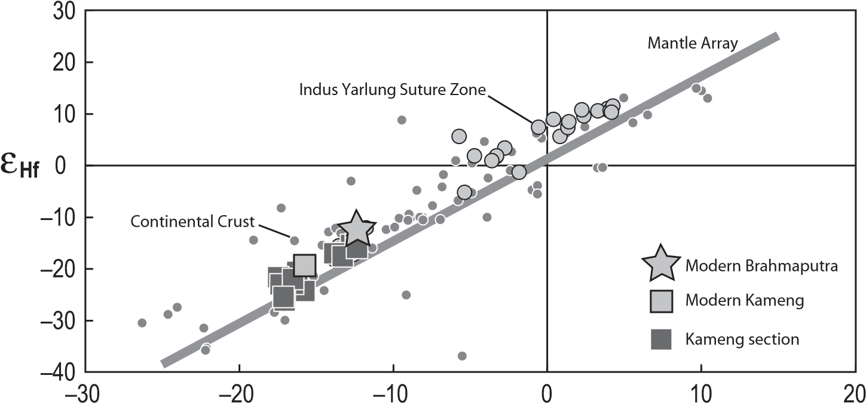

ε**Nd**

**Figure 3. Plot of** ε**Nd vs.** ε**Hf for the Kameng section samples and the two modern river-sediment samples. Small dark-gray dots correspond to crustal material as analyzed by Vervoort and Patchett (1996), Vervoort and Blichert-Toft (1999), and Vervoort et al. (2000). Mantle array is shown as defi ned by Chauvel et al. (2008). Suture zone samples (light-shaded circles) are from Chu et al. (2011). The** ε**Nd and** ε**Hf values were calculated using the Bulk Silicate Earth (BSE) values of Bouvier et al. (2008).**

|  |  |
| --- | --- |
| tem can either be used combined with the more classical Nd isotopic approach or alone using zircon grains, because Hf is almost exclusively hosted by zircons (Garçon et al., 2011a), and their Hf isotopic analysis is relatively simple to acquire using laser-ablation techniques coupled to multicollector ICP-MS.  Although the number of Nd isotopic analyses available is much larger than that of Hf analy- | ses, the Nd isotopic compositions of the various lithotectonic units exposed in the eastern Himalaya are not fully constrained. They can be summarized as follows:  (1) The Higher Himalayan Series in the Namche Barwa massif and the Kameng drainage area is characterized by εNd values ranging from –12 to –19 (Singh and France-Lanord, 2002, and references therein), while the Lesser |

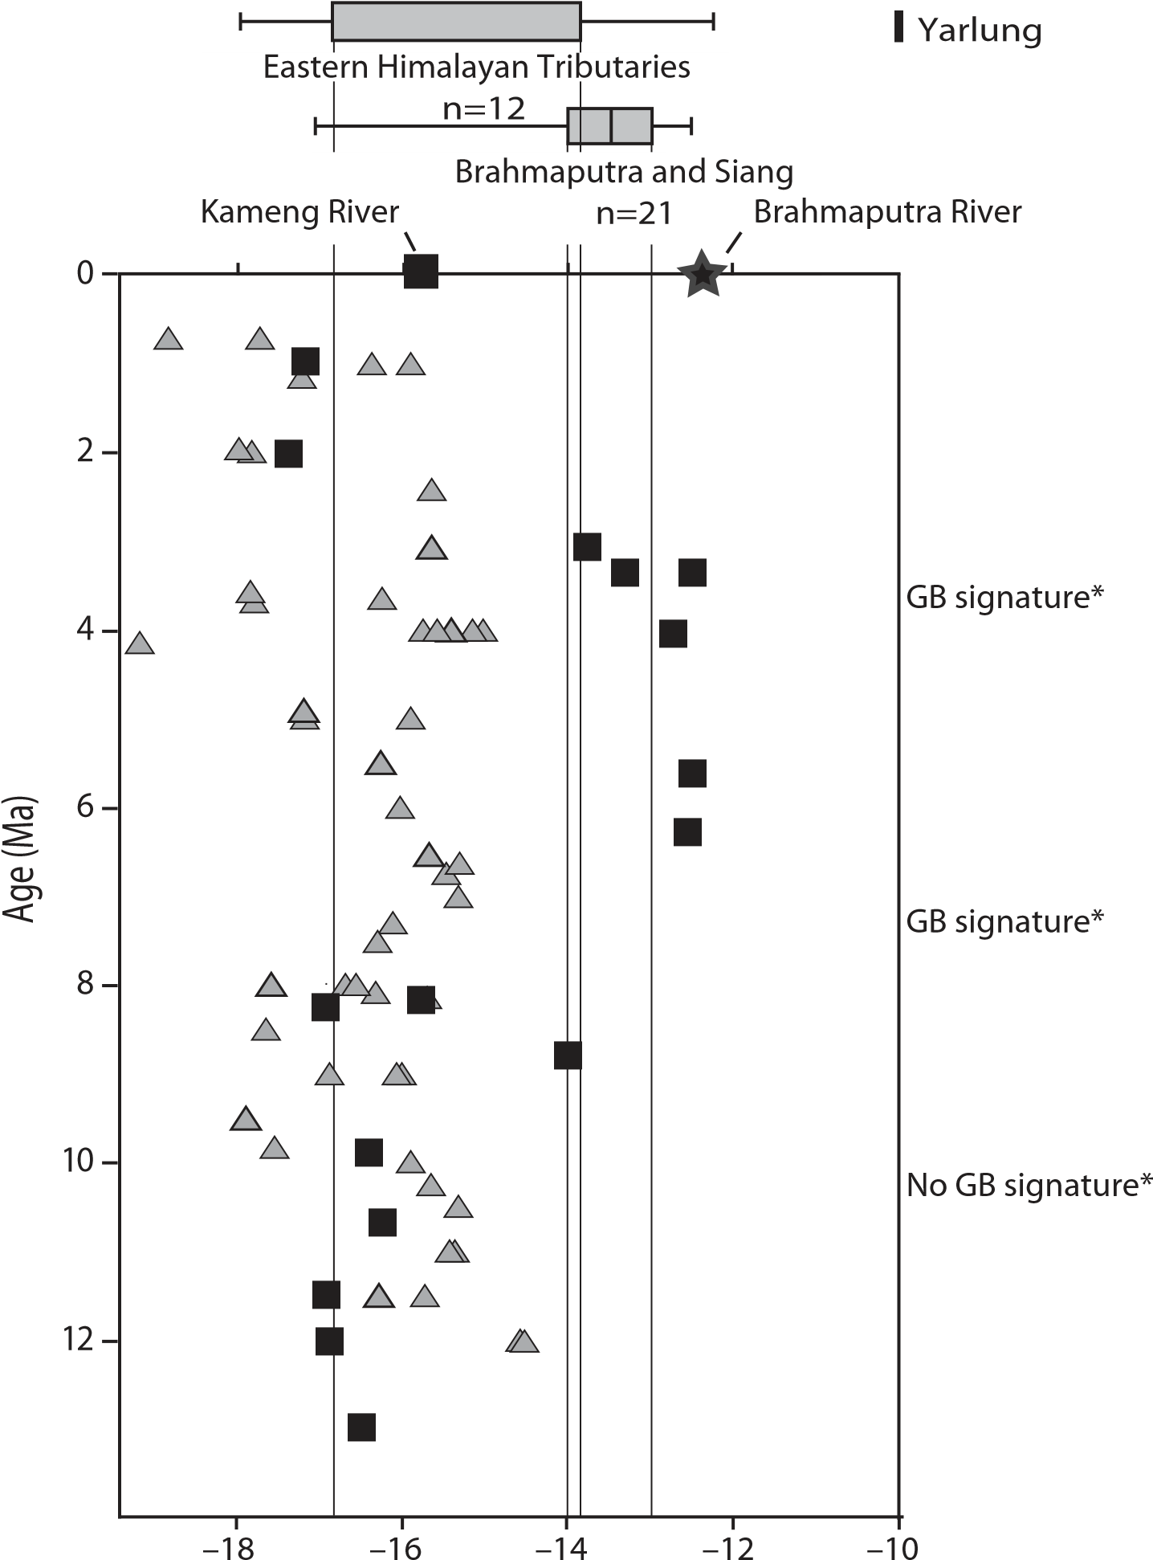n=1

# εNd

|  |
| --- |
| Kameng section (this study)  Central Himalayan Siwaliks |

*Cina et al. (2009) zircon U-Pb data

**Figure 4.** ε**Nd variation along the Kameng section compared to central Himalayan data from Huyghe et al. (2001, 2005) and Robinson et al. (2001). Modern river-sediment values for the Brahmaputra, the Siang, and the eastern Himalayan tributaries are from Singh and France Lanord (2002), and modern value for the Yarlung is from Pierson-Wickmann et al. (2000). Presence or absence of Gangdese Batholith (GB) zircon U/Pb ages (as reported by Cina et al., 2009) is also indicated. All** ε**Nd values were recalculated using the new Bulk Silicate Earth (BSE) values of Bouvier et al. (2008).**

Himalaya Series in Bhutan, to the west of Arunachal Pradesh, has εNd between –21.4 and –19.4 (McQuarrie et al., 2008). These data suggest that both the Higher and Lesser Himalaya Series in the eastern part of the belt have Nd isotopic compositions comparable to those of the western and central Himalaya (FranceLanord et al., 1993; Ahmad et al., 2000, and references therein; Robinson et al., 2001, and references therein; Richards et al., 2005). The εNd values reported for the Transhima layan plutonic rocks of the Gangdese Batholith belt are much less negative, between –6 and –8 (Singh and France-Lanord, 2002, and references therein; Chu et al., 2011).

(2) Compared to the geological units, the isotopic compositions of sands collected in modern rivers are much better documented (Pierson-Wickmann et al., 2000; Singh and France-Lanord, 2002); signifi cant differences exist between the sand carried by the eastern Himalayan tributaries, which are transverse rivers that drain only the Indian plate (50% of the εNd values range from –16.8 to –13.8) and the Brahmaputra River (50% of the εNd values range from –14 to –13). These ranges are shown by boxes in Figure 4. Our new measurements on modern sediments collected in the Kameng and Brahmaputra Rivers are entirely consistent with the existing data. The less negative εNd values observed in the Brahmaputra River sediments are attributed to the erosion of terrains with elevated εNd values, which are present only in the Indus-Yarlung suture zone and the IndoBurman Ranges (Singh and France-Lanord, 2002). Based on these constraints, the changes in εNd values through time, as measured in the Kameng section (Fig. 4), can be used to trace the evolution of the regional drainage system.

Between 13 Ma and 7 Ma, εNd values measured in the Kameng section samples (–17.1 to –15.8) are similar to values reported for sands from the modern eastern Himalayan tributaries and the Kameng River (Fig. 4). These values are also similar to values reported for Neogene sedimentary rocks produced by erosion of Higher Himalayan source rocks in the central

Himalaya (–15 to –19) (Huyghe et al., 2001, 2005; Robinson et al., 2001). While it could be argued that the Kameng sediments partly originated from the sedimentary cover of the Shillong Plateau (which is composed essentially of recycled Himal ayan material), paleocurrent measurements in the Dafl a and lower Subansiri Formations rule out northward sediment transport required by such a scenario (Fig. 2; Cina et al., 2009). Moreover, this scenario is not compatible with our ZFT results, since zircons derived from the Shillong Plateau do not show age peaks <100 Ma; the main ZFT age peaks in

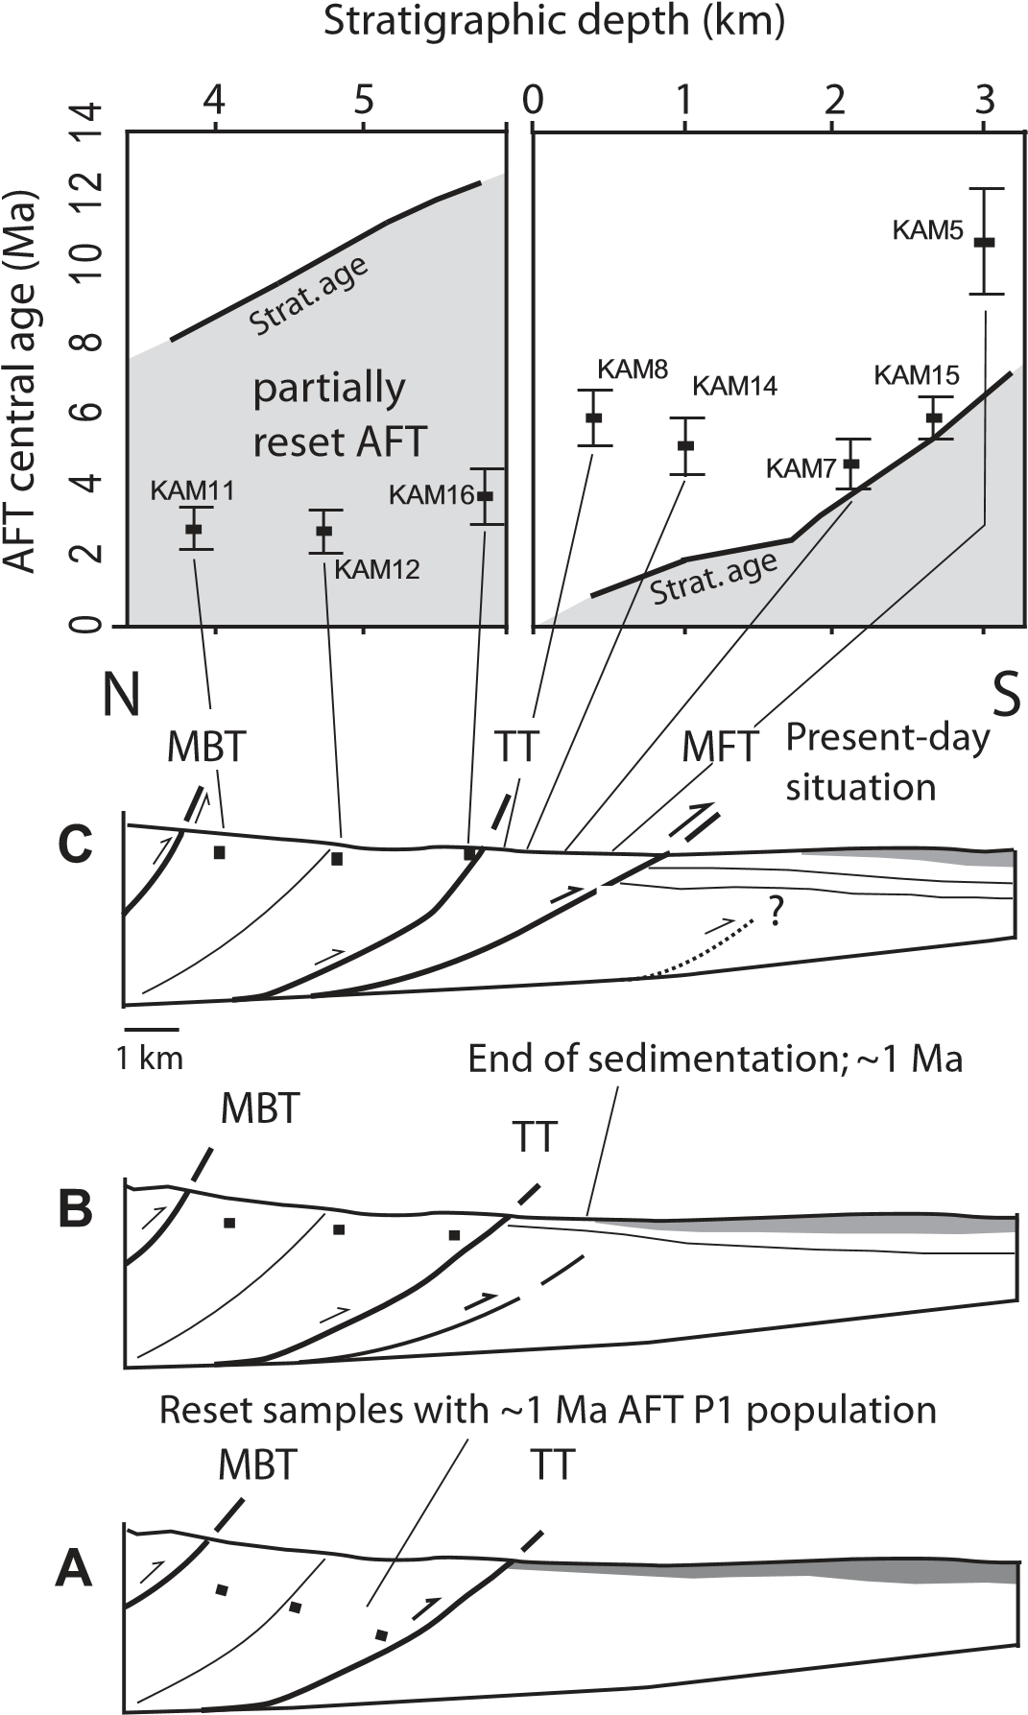

|  |  |
| --- | --- |
| these sediments are between 300 and 500 Ma (Najman et al., 2008). Sample KAM 12, dated at ca. 9 Ma, has a less negative εNd value at –14 (Fig. 4), which could be attributed to the input of sediments coming from a source with a less negative Nd isotopic signature. However, this value is still within the range observed in the eastern Himalayan tributaries (Singh and France- | Lanord, 2002). In addition, we did not observe a change in sedimentary facies and paleocurrent directions at this level of the section and therefore have no indication that a major change in the drainage system occurred at that time.  The εNd values in samples from the upper part of the Subansiri Formation, deposited between ca. 7 and 3 Ma, are less negative (–12.4 to –13.8) |

**Figure 5. Plot of apatite fi ssion-track (AFT) central age vs. stratigraphic depth for the hanging wall and footwall of the Tipi thrust, and schematic reconstruction of the thrusting sequence within the Kameng section: (A) prior to activation of the Tipi thrust at ca. 1 Ma; (B) prior to activation of the Main Frontal thrust <1 Ma; and (C) present-day situation. Partially reset samples show central ages close to or younger than the depositional age. MBT—Main Boundary thrust, TT—Tipi thrust, MFT—Main Frontal thrust. Black squares indicate the position of reset AFT samples. The present-day position of the frontal thrust is from Yin et al. (2010).**

and differ signifi cantly from values measured in the central Himalayan Siwaliks (Fig. 4). These less negative εNd values can only be explained by input of material from the Indus-Yarlung suture zone, which is currently drained by the Yarlung-Brahmaputra River. The εNd values of these sediments are similar to the average iso topic compositions reported for modern Brahmap utra and Siang River sediments (Fig. 4), which are dominated by sediment input from the Namche Barwa massif (Singh and France-Lanord, 2002). Our isotope geochemistry data are consistent with zircon U-Pb ages from the Subansiri Formation in the Kameng and Subans iri sections reported by Cina et al. (2009), which also imply input of Gangdese arc material. Therefore, the combined data strongly suggest that the river that carried sediments to be deposited in the Kameng area at that time drained the Indus-Yarlung suture zone, which implies either that these sediments were deposited by a paleo–Brahmaputra River already connected to the Indus-Yarlung suture zone, or that the Kameng (or adjacent Subansiri) catchment was much larger and connected to the Indus-Yarlung suture zone. Both scenarios are consistent with the sedimentological evidence for a large river system at this time (Fig. 2; Chirouze et al., 2012b). Although paleoc urrent directions could potentially discriminate between these scenarios, we lack a suffi cient number of paleocurrent measurements from the 7–3.5 Ma sandstones of the section because of the coarse-grained and massive nature of these sandstones and the limited accessibility of the outcrops (by raft only). We will discuss the implications for drainage development in more detail in the next section.

The εNd values from the Kimin Formation, deposited since ca. 2.6 Ma, are similar to the isotopic compositions reported for modern eastern Himalayan rivers. As the thickness of coarse sandstone layers is reduced from ~20 m to ~3 m from this time onward (Fig. 2; Chirouze et al., 2012b), we propose that the channel size of the river that deposited these sediments in the Kameng area decreased, implying a small, transverse Himalayan-type catchment.

The εHf values of our samples are in good agreement with the provenance analysis based on εNd. Lacking Hf isotope data for Himalayan source rocks (i.e., Tethyan Himalaya Series, Higher Himalaya Series, and Lesser Himalaya Series), the modern Kameng River sample, with its εHf value of –19.4, can be used as an average for the Higher Himalaya and Lesser Himal aya composition. The Kameng River only drains these sources rocks, and its εHf value is signifi cantly different from that of the modern Brahmaputra River. Future acquisition of

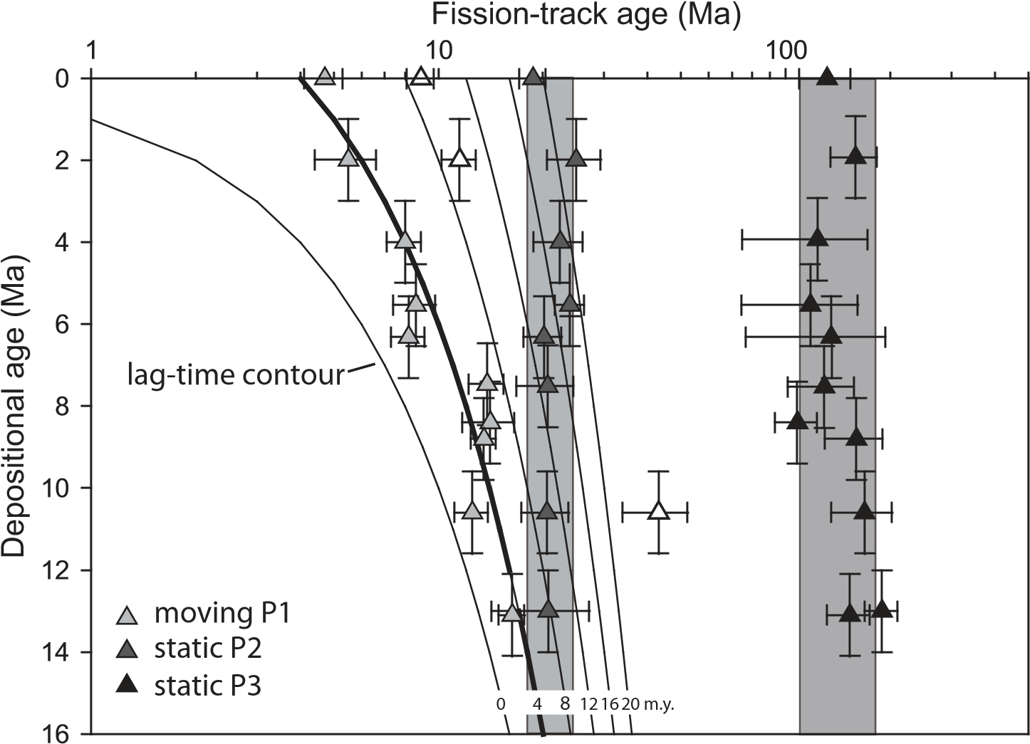

**Figure 6. Lag-time plot of zircon fi ssion-track (ZFT) age peaks of the Kameng section. Thick black line—young (P1) moving age peak; light-gray band—intermediate (P2) static age peak; darker-gray band—old (P3) static age peak. Thin continuous lines indicate constant lag times at 4 m.y. intervals.**

|  |  |
| --- | --- |
| Hf isotopic compositions of both granitoids and sediments produced by erosion of the mountain range could provide interesting additional constraints to decipher the erosional history of Himalayan rocks.  **Drainage Evolution**  The geochemical provenance information presented in this study implies reorganization of the drainage system in the eastern Himalayan during the late Miocene–Pliocene. Prior to ca. 7 Ma, the εNd signal indicates that sediments of the Kameng section were derived from eastern Himalayan sources (Tethyan Himalaya Series, Higher Himalaya Series, and Lesser Himalaya Series). Starting at ca. 7 Ma and up to ca. 3 Ma, less negative εNd values indicate the deposition of sediments with an εNd signature indicative of Indus-Yarlung suture zone source rocks, consistent with zircon U-Pb ages (Cina et al., 2009). Sediments deposited after 3 Ma in the Kameng section again originate solely from Himalayan source rocks. At present, Indus-Yarlung suture zone material is carried by the Yarlung-SiangBrahmaputra system and bypasses the eastern foreland basin.  The change from mixed Indus-Yarlung suture zone and Himalayan material to sediments originating only in the Himalaya at ca. 3 Ma can | be explained by a southward shift in the foreland basin of the Brahmaputra River because of continuous southward propagation of the Himalayan deformation front. In contrast, the input of suture-zone–derived material between 7 and 3 Ma requires establishment of a drainage connection with the Indus-Yarlung suture zone together with a shift of the Brahmaputra in the foreland basin plain. Several scenarios can be considered, two of which imply changes in the upstream drainage system (Figs. 7A and 7B), one of which implies only local drainage shifts (Fig. 7C), and a fi nal scenario that implies changes in the course of the Brahmaputra River downstream (Fig. 7D).  In the first scenario, the Yarlung and the Brahmap utra Rivers were initially two distinct drainage systems (Brookfi eld, 1998; Clark et al., 2004; Fig. 7A). The Yarlung River was captured sometime prior to 4 Ma by the steep transverse Brahmaputra-Siang River, as attested by wind gaps and capture points around the Namche Barwa massif (Clark et al., 2004), allowing sediment derived from the Indus-Yarlung suture zone to be deposited between 7 and 3 Ma in the foreland basin. Such a scenario is consistent with our provenance data, but it does not match the record of stable source areas over the past 12 m.y., as inferred from provenance data in the Bengal Fan (Galy et al., 2010). Even if the |

Yarlung connected to the Irrawaddy River rather than the Red River prior to ca. 7 Ma (cf. Clark et al., 2004), the sediment transported in this system could not have reached the part of the Bengal Fan (Deep Sea Drilling Project [DSDP] site 218) sampled by Galy et al. (2010).

A second scenario was proposed by Cina et al. (2009) and involves a sequence of captures of the Yarlung River that occurred from 7 Ma onward

(Fig. 7B), fi rst by the transverse paleo–Subansiri River and later by the Siang-Brahmaputra system. In this scenario, the Yarlung River connected with the Brahmaputra River via a p aleo–Subansiri River between ca. 7 Ma and ca. 3 Ma, permitting deposition of sediments derived from the Indus-Yarlung suture zone in the Himalayan foreland basin in what are today the Kameng and Subansiri drainages. Around 3 Ma, the Yarlung River was captured by the Siang-Brahmaputra River, establishing the modern drainage pattern. Such an evolution of the drainage system would require fi rst northwestward headward erosion of the paleo-Subansiri to capture the Yarlung River at 7 Ma, which could be possible if we consider its present-day catchment as the remnant of a larger one. An alternative scenario, in which it was the Kameng River itself that connected to the Yarlung River, appears implausible given the restricted present-day catchment of the Kameng River. Subsequent eastward propagation of deform at ion and uplift is required to disconnect the upper catchment of the transverse paleo– Suban siri River from the Indus-Yarlung suture zone and allow capture of the Yarlung River by the Siang-Brahmaputra River at ca. 3 Ma. As for the previous scenario implying drainage modifi cation upstream, this scenario is consistent with the local provenance changes in foreland sediments but does not match with the Bengal Fan record, which indicates stable source areas since ca. 12 Ma (Galy et al., 2010). Moreover, there are no geomorphic indications for headward erosion of the Siang River upstream of the Namche Barwa massif (in contrast, the Namche Barwa knickpoint appears to have been fi xed for at least the last 1 m.y.; Zeitler et al., 2001; Finnegan et al., 2008; Korup and Montgomery, 2008). Finally, there is no indication for eastward propagation of deformation and uplift in the eastern Himalaya during late Miocene– Pliocene times.

A third scenario implies large-scale stability of the Yarlung-Siang-Brahmaputra drainage system since the late Miocene (Burg et al., 1998; Galy et al., 2010), with local changes only affecting its course in the eastern Himalayan foreland basin after 7 Ma (Fig. 7C). Between 7 and 3 Ma, the Brahmaputra River may have migrated northward, close to the front of the Himalayan belt, as a consequence of surface uplift of the

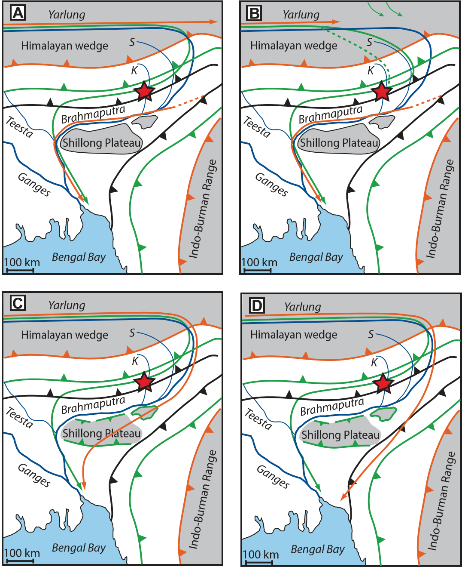

|  |  |
| --- | --- |
| Shillong Plateau. The timing of surface uplift of the Shillong Plateau is essentially unconstrained but is suggested to follow the onset of exhumation between 8 and 15 Ma (Biswas et al., 2007; Clark and Bilham, 2008). Biswas et al. (2007) suggested northward tilting of the surface of the Shillong Plateau, resulting from faster displacement along the Dauki fault bounding it to the south (Fig. 1) compared to displacement along its northern bounding fault. As a consequence, the depocenter of the foreland basin may have shifted northward, allowing sediments transported by the Brahmaputra River to be deposited in the Kameng area. Our sample locations could have been located near the confl uence of a transverse paleo–Kameng River and an E-W– | fl owing trunk of the paleo–Brahmaputra River. Such a scenario was dismissed by Cina et al. (2009) based on south-directed paleocurrents in the Subansiri area. However, we note that paleocurrent data collected in both the Kameng and Subansiri areas (Fig. 2; Cina et al., 2009) do not provide strong support for any scenario, as the measured paleocurrent directions are highly variable, ranging from N180° to N270° in sedimentary rocks with ages of 12 Ma to ca. 5 Ma. This variability appears consistent with the sedimentological evidence of meandering rivers in the Himalayan foreland basin around that time (Chirouze et al., 2012b). Finally, we note that any measured paleocurrent direction should be corrected for counterclockwise rotation that oc- |

**Figure 7. Four possible scenarios for the late Miocene–Holocene evolution of the Yarlung-Brahmaputra drainage system (see text for discussion). Blue lines—modern drainage pattern; green lines—inferred drainage between 7 and 3 Ma; red lines—inferred drainage prior to 7 Ma; S—Subansiri; K—Kameng. The red star indicates the approximate position of the sampled Siwalik section. Southward propagation of the Himalayan front with respect to India has been calculated for present-day convergence rates of 20 mm/yr (Mukul et al., 2010); they are represented in orange for the period prior to 7 Ma, in light green for the period 7–3 Ma, and in gray for the p resent-day position. The present-day coastline and Shillong Plateau are shown for reference.**

curred during thrusting in the Sub-Himalaya in the Kameng area (Chirouze et al., 2012b).

A fi nal scenario, proposed by Uddin and Lundberg (1999), suggests that the Brahmaputra River changed its course during the late Miocene, from east to north of the Shillong Plateau, between 7 and 3 Ma (Fig. 7D). This drainage shift would have resulted from surface uplift of the Shillong Plateau and/or northwestward propagation of the Indo-Burman Ranges. Such an evolution permits the deposition of the IndusYarlung suture zone material in the contemporaneous Siwalik Group sedimentary rocks and fi ts with the stable provenance in the distal Bengal Fan sediments (Galy et al., 2010). In contrast, a new chronostratigraphic framework based on biostratigraphy and seismic correlation in the Bengal Basin (Najman et al., 2012) appears to imply that diversion of the paleo–Brahmaputra River to the north of the Shillong Plateau could have taken place as recently as 1 Ma, which is incompatible with our provenance data.

**Exhumation of the Eastern Himalaya**

The constraints on provenance outlined herein allow us to evaluate the exhumation of various parts of the eastern Himalaya using detrital AFT and ZFT thermochronology applied to the Kameng section sediments. Nonreset AFT ages from the modern Kameng River (KAM 20, KAM 30) and the uppermost part of the stratigraphic section (KAM 8 and KAM 14) provide information on source-area exhumation since ca. 4 Ma. The youngest age population (P1) in these samples has lag times of 1.3–2.9 m.y., indicating relatively rapid exhumation in the range 1.5–2.0 km/m.y. in some parts of the Kameng River source area, whereas the older age component (P2) has lag times >7 m.y., implying that other parts of the catchment were exhumed more slowly, at rates not exceeding 0.6 km/m.y. These results are comparable to those observed in Siwalik Group sections from central and western Nepal, where the youngest AFT age components (P1) have lag times ranging from 0.5 to 4 m.y., and a second age peak (P2) exists with lag times between 6 and 7 m.y. (van der Beek et al., 2006). Unfortunately, no bedrock AFT ages are currently available in the Kameng River catchment for comparison with detrital AFT ages. Bedrock AFT ages from eastern Bhutan, to the west of the Kameng River catchment, range from ca. 3.5 to >8 Ma (Grujic et al., 2006) and thus appear to record slower exhumation (~0.6–0.9 km/m.y.) than our detrital data.

The detrital ZFT ages of all samples are older than the depositional age and decrease in age up section. They thus record source-area cooling and are unaffected by burial heating in the basin , consistent with our AFT data, which show incomplete annealing of the deepest buried sedimentary rocks sampled for this study. Based on the εNd provenance information discussed previously, the lag times of the youngest (P1) detrital zircon age population of sedimentary rocks deposited between 13 and 8 Ma and from <3 Ma to the present can be used to estimate exhumation rates for the eastern Himalaya. The P1 lag times are on average ~4 m.y., implying exhumation rates on the order of 1.8 km/m.y. for the most rapidly exhuming source areas (Fig. 8). Between 7 and 3 Ma, sediments were probably deposited by the Yarlung-Brahmaputra River and should thus include zircons derived from the Namche Barwa massif in the eastern syntaxis. During this time interval, the weighted-mean lag time of the youngest (P1) age population is a bit shorter (3 m.y. instead of 4 m.y.). Nonetheless, all ZFT age peaks in the Kameng section exhibit overall constant trends through time, and are comparable to data from Nepal (Fig. 9; Bernet et al., 2006; Chirouze et al., 2012a). As in the central Himalaya, the zircons generally show three age peaks: two static peaks (i.e., displaying constant peak ages through time; see Garver et al., 1999; Bernet et al., 2006), and one moving peak with a constant lag time of ~4 m.y. The average proportion of zircons belonging to each of these age populations is fairly similar in the Kameng section (P1, P2, and P3 age components are 44%, 42%, and 15%, respectively) and in central Nepal (50%, 36%, and 21%, respectively; Bernet et al., 2006).

Therefore, our ZFT and unreset AFT results suggest that the exhumation dynamics in the eastern Himalaya were similar to those of the central Himalaya (Bernet et al., 2006; van der Beek et al., 2006), at least for the sediments deposited between 13 and 7 Ma and since 3 Ma. Therefore, these results do not support the hypothesis of a deceleration in thrusting and exhumation rates in the eastern Himalaya since the mid-Miocene, linked to potential transfer of shortening to the Shillong Plateau (Clark and Bilham, 2008). Surface uplift of the Shillong Plateau does not appear to strongly affect longterm exhumation rates in the eastern Himalaya, and, therefore, the proportion of tectonic shortening accommodated by this structure may be limited, as previously suggested by Biswas et al. (2007) and observed in GPS studies (Mukul et al., 2010).

A reduction of exhumation rates at ca. 6 Ma has been suggested for the Bhutan Himalaya, inferred from in situ AFT data and the preservation of elevated paleosurfaces (Grujic et al., 2006). Slower exhumation rates compared to the central Himalaya were attributed to the decrease

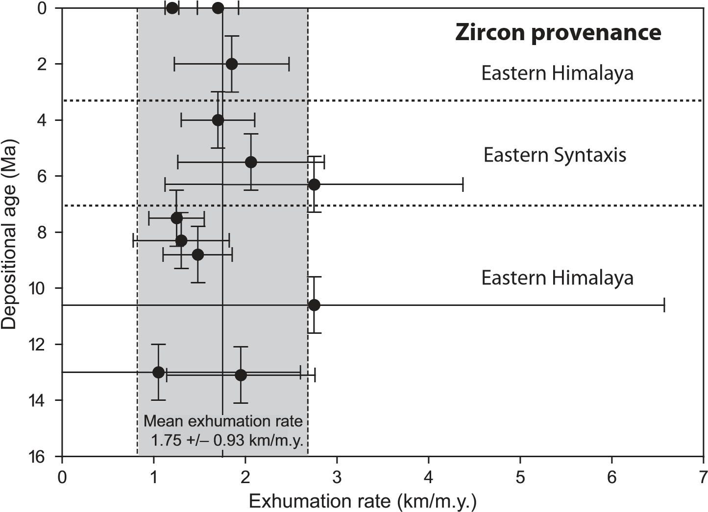

**Figure 8. First-order exhumation rate estimates for the most rapidly exhuming source areas in the eastern Himalaya based on lag times of the youngest (P1) zircon fi ssion-track (ZFT) age component in the Kameng section samples. Rates were calculated using a one-dimensional steady-state thermal advection model (Brandon et al., 1998; Reiners and Brandon, 2006). See text for model parameters.**

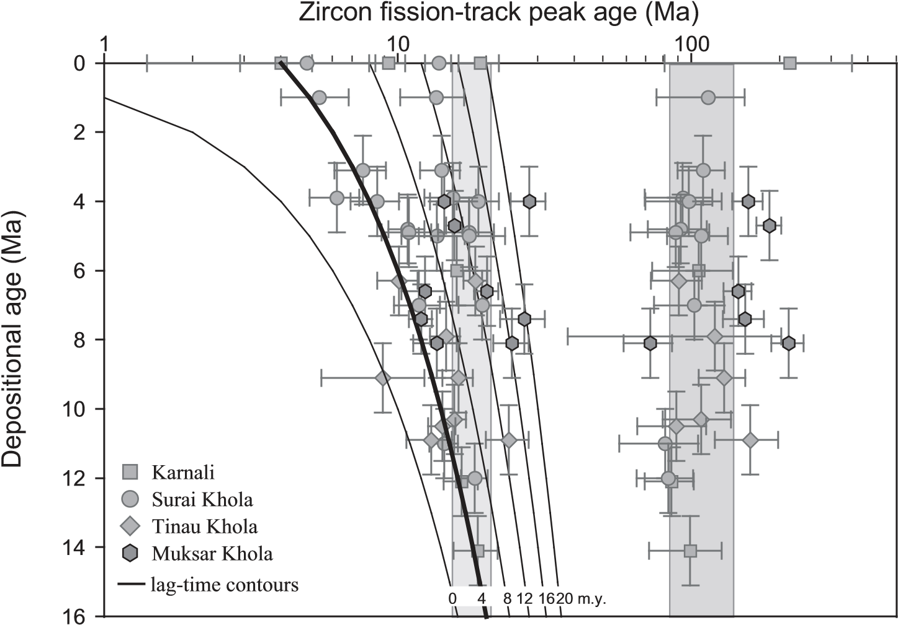

**Figure 9. Lag-time plot of detrital zircon fi ssion-track (ZFT) peak ages from the central Hima laya in Nepal (data from Bernet et al., 2006; Chirouze et al., 2012a). The peak age trends imply fairly similar exhumation histories of the central and eastern Himalaya (see Fig. 6 and text for discussion).**

of monsoon intensity caused by surface uplift of the Shillong Plateau (Grujic et al., 2006; Biswas et al., 2007). Our data, collected ~130 km east of Bhutan, do not support such an overall decrease in exhumation rates, despite similar precipitation intensities and patterns in Arunachal Pradesh and eastern Bhutan (Bookhagen and Burbank, 2006). Thus, it seems that the variation of exhumation rates between Bhutan and Arunachal Pradesh is controlled by tectonic rather than climatic variations. The geometry of the crustal detachment underlying the belt (Main Himalayan Thrust) and especially the presence or absence of a crustal ramp could control spatial variations in exhumation patterns along the Himalaya (Berger et al., 2004; Robert et al., 2011). The pattern of exhumation in Bhutan is consistent with the absence of a major ramp (e.g., McQuarrie et al., 2008; Long et al., 2011), whereas our data from Arunachal Pradesh would suggest that such a ramp reappears further east, consistent with the structural cross sections recently compiled by Yin et al. (2010).

**Exhumation of the Namche Barwa Massif**

The detrital isotopic signature described here, together with zircon U-Pb ages (Cina et al., 2009), suggests that Siwalik Group sediments in the Kameng section were deposited by a paleo–Brahmaputra River between ca. 7 Ma and 3 Ma. The εNd-εHf values of these sediments are very similar to those of the present-day Brahmaputra River sediments, and Singh and France-Lanord (2002) have shown that this signal can be explained by a mixture of sediment derived from Indus-Yarlung suture zone rocks and Himalayan rocks from the Namche Barwa massif, with very little dilution by tributaries draining the eastern Himalaya. Cina et al. (2009) showed that in their sample containing zircons from the Gangdese Batholith, the Hima layan contribution is ~70%, consistent with estimates of the present-day contribution of Namche Barwa–derived sediments in the Brahmaputra bed load (Singh and FranceLanord, 2002; Enkelmann et al., 2011).

Therefore, the majority of zircons in the ca. 7 Ma to 3 Ma sediments should be derived from the Namche Barwa syntaxis, and the young detrital ZFT age peak should record cooling of the eastern syntaxis during that time. Exhumation rates calculated for the youngest (P1) ZFT age population for this period are, however, similar to those above and below this part of the section (1.5–2.0 km/m.y.; Fig. 7). Keeping in mind the loss of resolution when estimating very rapid exhumation rates from lag times (e.g., Garver et al., 1999; Rahl et al., 2007), the recorded late Miocene exhumation rates appear to be signifi cantly slower than the Quaternary rate of up to 10 km/m.y. inferred from in situ thermochronology in the Namche Barwa massif by Burg et al. (1998) and detrital ZFT data of Stewart et al. (2008). Such extreme present-day exhumation rates are also required by the detrital ZFT age patterns of the modern Siang River sediment load downstream of the Yalung gorge, where 60%–70% of the detrital zircons belong to a ZFT age population averaging only 0.6 Ma, suggesting source-area exhumation rates of 7–9 km/m.y. (Enkelmann et al., 2011).

This contrast suggests that rapid exhumation in the Namche Barwa massif did not begin before 4 Ma. This result is consistent with estimates of the onset of exhumation inferred from in-situ analyses, which indicate that the Namche Barwa massif has been exhumed extremely rapidly (up to 10 km/m.y.) over the past 4 m.y. (Burg et al., 1998), although arguments for an earlier (ca. 6–11 Ma) onset of exhumation have also been made (Ding et al., 2001; Booth et al., 2009). Because the Yarlung-Brahmaputra River has been fl owing across the eastern syntaxis since at least 7 Ma, a minimum 3 m.y. time lag appears to separate capture of the Yarlung River by the Siang-Brahmaputra and the onset of the currently observed very rapid exhumation. This time lag may correspond to a response time required for initiation of strong feedbacks between tectonics and Siang River incision (Zeitler et al., 2001; Finnegan et al., 2008) or, alternatively, may point to an additional (climatic?) trigger required to initiate very rapid exhumation.

**Deformation and Exhumation of the Siwaliks in the Eastern Himalaya**

Samples from below ~2000 m stratigraphic depth in the section (except sample KAM 5) contain apatite with partially reset cooling ages (Fig. 5; Table 2), as they show central and/or minimum (P1) AFT ages younger than or equal to their depositional age, within error. The central age evolution with depth does not show a clearly defi ned AFT partial annealing zone (Fig. 5). Sample KAM 5 escaped partial annealing, while samples stratigraphically above and below this sample were partially annealed. The pattern of partial resetting in the section is complicated by activity of the Tipi thrust, which led to additional tectonic burial of part of the footwall, and is thus not simply controlled by burial heating during sediment deposition (Fig. 5). Despite these structural complications, the youngest (P1) population of the stratigraphically lowest and most strongly annealed samples, KAM 11, KAM 12, and KAM 16, can be used to provide a maximum age for the onset of exhumation of the hanging wall of the Tipi thrust (Fig. 5). KAM 12 and KAM 11 present P1 ages of ca. 0.7 Ma, whereas KAM 16 presents a P1 age of ca. 2 Ma. The youngest age peak could not be detected in sample KAM 16, even though this is the stratigraphically lowest sample collected; the young age peak could be mixed with an older population. We thus interpret these data to suggest onset of activity of the Tipi thrust close to 1 Ma. If we assume southward propagation of thrust activity as in Nepal (e.g., Mugnier et al., 2004), then initiation of the Main Frontal thrust must signifi cantly postdate 1 Ma in the area (Fig. 5).

The initiation age of the Main Frontal thrust can be estimated independently using the sedimentary record. Since no piggyback basins have developed along the Kameng section (Yin et al., 2010), no sedimentation occurred within the Sub-Himalaya during the activity of this thrust. The depositional age of the youngest outcrop of the Kimin Formation (upper Siwalik Group) along the section can be estimated using the sedimentation rate calculated in the top part of the section. With this hypothesis, the youngest upper Siwalik sediments would have been deposited after 1 Ma, and thus the onset of motion on the Main Frontal thrust should have occurred after this time, consistent with our AFT data.

In western Nepal, AFT results and fi eld observations indicate that the Main Frontal thrust initiated around 2 Ma, although rates of thrusting may have increased signifi cantly after ca. 0.3 Ma (Mugnier et al., 2004; van der Beek et al., 2006). Our results thus suggest that Main Frontal thrust activity initiated some 1 m.y. later in the eastern Himalaya.

**CONCLUSIONS**

Our geochemical and thermochronological analyses of foreland basin sedimentary rocks allow us to reconstruct the unroofi ng history and the evolution of the main drainage system in the eastern Himalaya. These data lead us to the following conclusions:

1. The evolution of the sedimentary provenance along the Kameng section, from one domi n ated by Himalayan tributaries to one domin ated by the Yarlung-Brahmaputra, indicates that a major reorganization of the YarlungSiang-Brahmaputra drainage system occurred in the foreland at ca. 7 Ma. The contemporaneous activity of the Indo-Burman Ranges and surface uplift of the Shillong Plateau could have diverted the paleo–Brahmaputra River to the north and forced it to fl ow along the foothills of the Himalayan Range. Southward propagation of thrusting in the Himalayan foreland after 3 Ma subsequently pushed the river south to its present course.
2. Fission-track ages from sediments deposited between 13 and 7 Ma and between ca. 3 Ma and 0 Ma record exhumation of the eastern Himal aya. Both zircon and apatite present similar lag-time trends to those in Nepal. The evolution of exhumation rates inferred from our thermochronologic results is not consistent with a postulated decrease in exhumation rates caused by either reduced shortening rates or reduced precipitation in response to surface uplift of the Shillong Plateau.
3. Zircon fi ssion-track analysis of sediments deposited between 7 and ca. 3 Ma, derived from the suture zone and the eastern syntaxis, do not present young ZFT age peaks with very short lag times, as is observed today for the very rapidly exhuming Namche Barwa massif. Therefore, exhumation in the eastern syntaxis was ~5 times slower at that time than it is today. This result suggests a lag time of at least 3 m.y. from the installation of a transverse river in the eastern syntaxis to the onset of very rapid exhumation in the Namche Barwa massif.
4. Forward propagation of deformation in the Sub-Himalaya in Arunachal Pradesh led to activation of the Tipi thrust by ca. 1 Ma. The onset of activity on the Main Frontal thrust is therefore locally younger than 1 Ma.

**ACKNOWLEDGMENTS**

We are thankful to Sarah Bureau, Francis Coeur, François Senebier, and Vincent Bouvier for their help with sample preparation. This research was funded by an Institut National des Sciences de l’Univers Reliefs de la Terre Grant (2007–2009) awarded to P. Huyghe and forms part of Chirouze’s Ph.D. project, supported by a scholarship from the French Ministry of Higher Education. Constructive and insightful comments by Deborah Robinson, Yani Najman, and an anonymous reviewer signifi cantly improved the manuscript and are gratefully acknowledged.

**REFERENCES CITED**

Ahmad, T., Harris, N., Bickle, M., Chapman, H., Bunbury, J., and Prince, C., 2000, Isotopic constraints on the structural relationships between the Lesser Himalayan Series and the High Himalayan Crystalline Series, Garhwal Himalaya: Geological Society of America Bulletin, v. 112, p. 467–477, doi:10.1130 /0016-7606(2000)112<467:ICOTSR>2.0.CO;2.

Berger, A., Jouanne, F., Hassani, R., and Mugnier, J.L., 2004, Modelling the spatial distribution of presentday deformation in Nepal: How cylindrical is the Main Himalayan thrust in Nepal?: Geophysical Journal International, v. 156, p. 94–114, doi:10.1111 /j.1365-246X.2004.02038.x.

Bernet, M., Brandon, M.T., Garver, J.I., and Molitor, B.R., 2004, Fundamentals of detrital zircon fi ssion-track analysis for provenance and exhumation studies with examples from the European Alps, *in* Bernet, M., and Spiegel, C., eds., Detrital Thermochronology—Exhumation and Landscape Evolution of Mountain Belts: Geological Society of America Special Paper 378, p. 25–36.

Bernet, M., van der Beek, P., Pik, R., Huyghe, P., Mugnier, J.-L., Labrin, E., and Szulc, A., 2006, Miocene to Recent exhumation of the central Himalaya determined from combined detrital zircon fi ssion-track and U/Pb analysis of Siwalik sediments, western Nepal: Basin Research, v. 18, p. 393–412, doi:10.1111/j.1365-2117 .2006.00303.x.

Bilham, R., and England, P., 2001, Plateau “pop-up” in the Great 1897 Assam earthquake: Nature, v. 410, p. 806– 809, doi:10.1038/35071057.

Bilham, R., Larson, K., Freymueller, J., and Project Idylhim Members, 1997, GPS measurements of presentday convergence across the Nepal Himalaya: Nature, v. 386, p. 61–64, doi:10.1038/386061a0.

Biswas, S., and Grasemann, B., 2005, Quantitative morphotectonics of the southern Shillong Plateau (Bangladesh/ India): Australian Journal of Earth Sciences, v. 97, p. 82–93.

Biswas, S., Coutand, I., Grujic, D., Hager, C., Stockli, D., and Grasemann, B., 2007, Exhumation and uplift of the Shillong Plateau and its infl uence on the eastern Himalayas: New constraints from apatite and zircon (U-Th[Sm])/He and apatite fi ssion track analyses: Tectonics, v. 26, TC6013, doi:10.1029/2007TC002125.

Bookhagen, B., and Burbank, D.W., 2006, Topography, relief, and TRMM-derived rainfall variations along the Himalaya: Geophysical Research Letters, v. 33, L08405, doi:10.1029/2006GL026037.

Booth, A.L., Zeitler, P.K., Kidd, W.S.F., Wooden, J., Lui, Y., Idleman, B., Hren, M., and Chamberlain, C.P., 2004, U-Pb zircon constraints on the tectonic evolution of southeastern Tibet, Namche Barwa area: American Journal of Science, v. 304, p. 889–929, doi:10.2475/ajs .304.10.889.

Booth, A.L., Chamberlain, C.P., Kidd, W.S.F., and Zeitler, P.K., 2009, Constraints on the metamorphic evolution of the eastern Himalayan syntaxis from geochronologic and petrologic studies of Namche Barwa: Geological Society of America Bulletin, v. 121, p. 385–407, doi:10.1130/B26041.1.

Bouvier, A., Vervoort, J.D., and Patchett, P.J., 2008, The Lu-Hf and Sm-Nd isotopic composition of CHUR: Constraints from unequilibrated chondrites and implications for the bulk composition of terrestrial planets: Earth and Planetary Science Letters, v. 273, p. 48–57, doi:10.1016/j.epsl.2008.06.010.

Brandon, M.T., Roden-Tice, M.K., and Garver, J.I., 1998, Late Cenozoic exhumation of the Cascadia accretionary wedge in the Olympic Mountains, northwest Washington State: Geological Society of America

Bulletin, v. 110, p. 985–1009, doi:10.1130/0016-7606 (1998)110<0985:LCEOTC>2.3.CO;2.

Brookfi eld, M.E., 1998, The evolution of the great river systems of southern Asia during the Cenozoic India– Asia collision: Rivers draining southwards: Geomorphology, v. 22, p. 285–312, doi:10.1016/S0169-555X (97)00082-2.

Burg, J.P., Nievergelt, P., Oberli, F., Seward, D., Davy, P., Maurin, J.-C., Diao, Z., and Meier, M., 1998, The Namche-Barwa syntaxis: Evidence for exhumation related to compressional crustal folding: Journal of Asian Earth Sciences, v. 16, p. 239–252, doi:10.1016 /S0743-9547(98)00002-6.

Carpentier, M., Chauvel, C., Maury, R.C., and Mattielli, N., 2009, The “zircon effect” as recorded by the chemical and Hf isotopic compositions of Lesser Antilles forearc sediments: Earth and Planetary Science Letters, v. 287, p. 86–99, doi:10.1016/j.epsl.2009.07.043.

Cerveny, P.F., Naeser, N.D., Zeitler, P.K., Naeser, C.W., and Johnson, N.M., 1988, History of uplift and relief of the Himalaya during the past 18 million years: Evidence from fi ssion-track ages of detrital zircons from sandstones of the Siwalik Group, *in* Kleinspehn, K., and Paola, C., eds., New Perspectives in Basin Analysis: New York, Springer-Verlag, p. 43–61.

Chauvel, C., and Blichert-Toft, J., 2001, A hafnium isotope and trace element perspective on melting of the depleted mantle: Earth and Planetary Science Letters, v. 190, p. 137–151, doi:10.1016/S0012-821X(01)00379-X.

Chauvel, C., Lewin, E., Carpentier, M., Arndt, N., and Marini, J.-C., 2008, Role of recycled oceanic basalt and sediment in generating the Hf-Nd mantle array: Nature Geoscience, v. 1, p. 64–67, doi:10.1038/ngeo.2007.51.

Chauvel, C., Bureau, S., and Poggi, C., 2011, Comprehensive chemical and isotopic analyses of basalt and sediment reference materials: Geostandards and Geoanalytical Research, v. 35, p. 125–143, doi:10.1111 /j.1751-908X.2010.00086.x.

Chirouze, F., Bernet, M., Huyghe, P., Erens, V., DupontNivet, G., and Senebier, F., 2012a, Detrital thermochronology and sediment petrology of the middle Siwaliks molasse along the Muksar Khola section in eastern Nepal: Journal of Asian Earth Sciences, v. 44, p. 94–106, doi:10.1016/j.jseaes.2011.01.009.

Chirouze, F., Dupont-Nivet, G., Huyghe, P., van der Beek, P., Chakraborti, T., Bernet, M., and Erens, V., 2012b, Magnetostratigraphy of the Neogene Siwalik Group of far eastern Himalaya, Kameng section, Arunachal Pradesh, India: Journal of Asian Earth Sciences, v. 44, p. 117–135, doi:10.1016/j.jseaes.2011.05.016.

Chu, M.-F., Chung, S.-L., O’Reilly, S.Y., Pearson, N.J., Wu,

F.-Y., Li, X.-H., Liu, D., Ji, J., Chu, C.-H., and Lee, H.-Y., 2011, India’s hidden inputs to Tibetan orogeny revealed by Hf isotopes of Transhimalayan zircons and host rocks: Earth and Planetary Science Letters, v. 307, p. 479–486, doi:10.1016/j.epsl.2011.05.020.

Cina, S.E., Yin, A., Grove, M., Dubey, C.S., Shukla, D.P., Lovera, O.M., Kelty, T.K., Gehrels, G.E., and Foster, D.A., 2009, Gangdese arc detritus within the eastern Himalayan Neogene foreland basin: Implications for the Neogene evolution of the Yalu-Brahmaputra River system: Earth and Planetary Science Letters, v. 285, p. 150–162, doi:10.1016/j.epsl.2009.06.005.

Clark, M.K., and Bilham, R., 2008, Miocene rise of the Shillong Plateau and the beginning of the end for the eastern Himalaya: Earth and Planetary Science Letters, v. 269, p. 337–351, doi:10.1016/j.epsl.2008.01.045.

Clark, M.K., Schoenbohm, L.M., Royden, L.H., Whipple,

K.X., Burchfi el, B.C., Zhang, X., Tang, W., Wang, E., and Chen, L., 2004, Surface uplift, tectonics, and erosion of eastern Tibet from large-scale drainage patterns: Tectonics, v. 23, TC1006, doi:1010.1029 /2002TC001402.

Clift, P.D., 2006, Controls on the erosion of Cenozoic Asia and the fl ux of clastic sediment to the ocean: Earth and Planetary Science Letters, v. 241, p. 571–580, doi:

10.1016/j.epsl.2005.11.028.

Clift, P.D., Giosan, L., Blusztajn, J., Campbell, I.H., Allen,

C., Pringle, M., Tabrez, A.R., Danish, M., Rabbani, M.M., Alizai, A., Carter, A., and Ackge, A., 2008a, Holocene erosion of the Lesser Himalaya triggered by intensifi ed summer monsoon: Geology, v. 36, p. 79–82, doi:10.1130/G24315A.1.

Clift, P.D., Hodges, K.V., Heslop, D., Hannigan, R., Van Long, H., and Calves, G., 2008b, Correlation of Himalayan exhumation rates and Asian monsoon intensity: Nature Geoscience, v. 1, p. 875–880, doi:10.1038/ngeo351.

DeCelles, P.G., Gehrels, G.E., Najman, Y., Martin, A.J., Carter, A., and Garzanti, E., 2004, Detrital geochronology and geochemistry of Cretaceous–early Miocene strata of Nepal: Implications for timing and diachroneity of initial Himalayan orogenesis: Earth and Planetary Science Letters, v. 227, p. 313–330, doi:10.1016 /j.epsl.2004.08.019.

Ding, L., Zhong, D., Yin, A., Kapp, P., and Harrison, T.M., 2001, Cenozoic structural and metamorphic evolution of the eastern Himalayan syntaxis (Namche Barwa): Earth and Planetary Science Letters, v. 192, p. 423– 438, doi:10.1016/S0012-821X(01)00463-0.

Dodson, M.H., 1973, Closure temperature in cooling geochronological and petrological systems: Contributions to Mineralogy and Petrology, v. 40, p. 259–274, doi:

10.1007/BF00373790.

Dupont-Nivet, G., Lippert, P.C., van Hinsbergen, D.J.J., Meijers, M.J.M., and Kapp, P., 2010, Paleolatitude and age of the Indo-Asia collision: Paleomagnetic constraints: Geophysical Journal International, v. 182, p. 1189–1198, doi:10.1111/j.1365-246X.2010.04697.x.

Enkelmann, E., Ehlers, T.A., Zeitler, P.K., and Hallet, B., 2011, Denudation of the Namche Barwa antiform, eastern Himalaya: Earth and Planetary Science Letters, v. 307, p. 323–333, doi:10.1016/j.epsl.2011.05.004.

Finnegan, N.J., Hallet, B., Montgomery, D.R., Zeitler, P.K., Stone, J.O., Anders, A.M., and Yuping, L., 2008, Coupling of rock uplift and river incision in the Namche Barwa Gyala Peri massif, Tibet: Geological Society of America Bulletin, v. 120, p. 142–155, doi:10.1130 /B26224.1.

France-Lanord, C., Derry, L., and Michard, A., 1993, Evolution of the Himalaya since Miocene time: Isotopic and sedimentological evidence from the Bengal Fan, *in* Treloar, P.J., and Searle, M.P., eds., Himalayan Tectonics: Geological Society of London Special Publication 74, p. 603–622.

Galy, V., France-Lanord, C., Peucker-Ehrenbrink, B., and Huyghe, P., 2010, Sr-Nd-Os evidence for a stable erosion regime in the Himalaya during the past 12 Myr: Earth and Planetary Science Letters, v. 290, p. 474– 480, doi:10.1016/j.epsl.2010.01.004.

Garçon, M., Chauvel, C., and Bureau, S., 2011a, Beach placer, a proxy for the average Nd and Hf isotopic composition of a continental area: Chemical Geology, v. 287, p. 182–192, doi:10.1016/j.chemgeo.2011.06.007.

Garçon, M., Chauvel, C., and France-Lanord, C., 2011b, Large Nd-Hf isotopic decoupling in Himalayan River sediments: Abstract EP41B–0610 presented at 2011 Fall Meeting, American Geophysical Union, San Francisco, Calif., 5-9 Dec.

Garver, J.I., Brandon, M.T., Roden-Tice, M.K., and Kamp, P.J.J., 1999, Exhumation history of orogenic highlands determined by detrital fi ssion track thermochronology, *in* Ring, U., Brandon, M.T., Lister, G.S., and Willet, S.D., eds., Exhumation Processes: Normal Faulting, Ductile Flow, and Erosion: Geological Society of London Special Publication 154, p. 283–304.

Garzanti, E., Vezzoli, G., Ando, S., France-Lanord, C., Singh, S.K., and Foster, G., 2004, Sand petrology and focused erosion in collision orogens: The Brahmaputra case: Earth and Planetary Science Letters, v. 220, p. 157–174, doi:10.1016/S0012-821X(04)00035-4.

Grujic, D., Coutand, I., Bookhagen, B., Bonnet, S., Blythe, A., and Duncan, C., 2006, Climatic forcing of erosion, landscape, and tectonics in the Bhutan Himalayas: Geol ogy, v. 34, p. 801–804, doi:10.1130/G22648.1.

Guillot, S., and Charlet, L., 2007, Bengal arsenic, an archive of Himalaya orogeny and paleohydrology: Journal of Environmental Science and Health, v. A42, p. 1785–1794.

Hallet, B., and Molnar, P., 2001, Distorted drainage basins as markers of crustal strain east of the Himalaya: Journal of Geophysical Research, v. 106, p. 13,697–13,709, doi:10.1029/2000JB900335.

Hodges, K.V., 2000, Tectonics of the Himalaya and southern Tibet from two perspectives: Geological Society of America Bulletin, v. 112, p. 324–350, doi:10.1130 /0016-7606(2000)112<324:TOTHAS>2.0.CO;2.

Huyghe, P., Galy, A., Mugnier, J.-L., and France-Lanord, C., 2001, Propagation of the thrust system and erosion in the Lesser Himalaya: Geochemical and sedimentological evidence: Geology, v. 29, p. 1007–1010, doi:10.1130 /0091-7613(2001)029<1007:POTTSA>2.0.CO;2.

Huyghe, P., Mugnier, J.-L., Gajurel, A.P., and Delcaillau, B., 2005, Tectonic and climatic control of the changes in the sedimentary record of the Karnali River section (Siwaliks of western Nepal): The Island Arc, v. 14, p. 311–327, doi:10.1111/j.1440-1738.2005.00500.x.

Iaffaldano, G., Husson, L., and Bunge, H.-P., 2011, Monsoon speeds up Indian plate motion: Earth and Planetary Science Letters, v. 304, p. 503–510, doi:10.1016 /j.epsl.2011.02.026.

Jouanne, F., Mugnier, J.-L., Gamond, J.F., Le Fort, P., Pandey, M.R., Bollinger, L., Flouzat, M., and Avouac, J.P., 2004, Current shortening across the Himalayas of Nepal:

Geophysical Journal International, v. 157, p. 1–14, doi:

10.1111/j.1365-246X.2004.02180.x.

Karunakaran, C., and Rao, R.A., 1976, Status of Exploration of Hydrocarbon in the Himalayan Region—Contributions to Stratigraphy and Structure: Geological Society of India Miscellaneous Publication 41, 66 p.

Kayal, J.R., Arefi ev, S.S., Barua, S., Hazarika, D., Gogoi, N., Kumar, A., Chowdhury, S.N., and Kalita, S., 2006, Shillong Plateau earthquakes in northeast India region: Complex tectonic model: Current Science, v. 91, p. 109–114.

Koons, P.O., Zeitler, P.K., Chamberlain, C.P., Craw, D., and Meltzer, A.S., 2002, Mechanical links between erosion and metamorphism in Nanga Parbat, Pakistan Himalaya: American Journal of Science, v. 302, p. 749–773, doi:10.2475/ajs.302.9.749.

Korup, O., and Montgomery, D.R., 2008, Tibetan Plateau river incision inhibited by glacial stabilization of the Tsangpo gorge: Nature, v. 455, p. 786–789, doi:10.1038 /nature07322.

Kumar, G., 1997, Geology of the Arunachal Pradesh: Bangalore, Geological Society of India, 217 p.

Larson, K.M., Bürgmann, R., Bilham, R., and Freymueller, J.T., 1999, Kinematics of the India-Eurasia collision zone from GPS measurements: Journal of Geophysical Research, v. 104, p. 1077–1093.

Le Fort, P., 1975, Himalayas: The collided range. Present knowledge of the continental arc: American Journal of Science, v. 275, p. 1–44.

Long, S., McQuarrie, N., Tobgay, T., and Grujic, D., 2011, Geometry and crustal shortening of the Himalayan fold-thrust belt, eastern and central Bhutan: Geological Society of America Bulletin, v. 123, p. 1427–1447, doi:10.1130/B30203.1.

McQuarrie, N., Robinson, D., Long, S., Tobgay, T., Grujic, D., Gehrels, G., and Ducea, M., 2008, Preliminary stratigraphic and structural architecture of Bhutan: Implic ations for the along strike architecture of the Himal ayan system: Earth and Planetary Science Letters, v. 272, p. 105–117, doi:10.1016/j.epsl.2008.04.030.

Métivier, F., Gaudemer, Y., Tapponnier, P., and Klein, M., 1999, Mass accumulation rates in Asia during the Ceno zoic: Geophysical Journal International, v. 137, p. 280–318, doi:10.1046/j.1365-246X.1999.00802.x.

Mitra, S., Priestley, K., Bhattacharyya, A.K., and Gaur, V.K., 2005, Crustal structure and earthquake focal depths beneath northeastern India and southern Tibet: Geophysical Journal International, v. 160, p. 227–248, doi:10.1111/j.1365-246X.2004.02470.x.

Molnar, P., England, P., and Martinod, J., 1993, Mantle dynamics, uplift of the Tibetan Plateau, and the Indian monsoon: Reviews of Geophysics, v. 31, p. 357–396, doi:10.1029/93RG02030.

Mugnier, J.-L., Huyghe, P., Leturmy, P., and Jouanne, F., 2004, Episodicity and rates of thrust sheet motion in Himalaya (western Nepal), *in* McClay, K.R., ed., Thrust Tectonics and Hydrocarbon Systems: American Association of Petroleum Geologists Memoir 82, p. 91–114.

Mukul, M., Jade, S., Bhattacharyya, A.K., and Bhusan, K., 2010, Crustal shortening in convergent orogens: Insights from global positioning system (GPS) measurements in northeast India: Journal of the Geological Society of India, v. 75, p. 302–312, doi:10.1007 /s12594-010-0017-9.

Najman, Y., Garzanti, E., Pringle, M., Bickle, M., Stix, J., and Khan, I., 2003, Early-Mid Miocene paleodrainage and tectonics in the Pakistan Himalaya: Geological Society of America Bulletin, v. 115, p. 1265–1277, doi:10.1130/B25165.1.

Najman, Y., and 15 others, 2008, The Paleogene record of Himalayan erosion: Bengal Basin, Bangladesh: Earth and Planetary Science Letters, v. 273, p. 1–14, doi:10.1016/j.epsl.2008.04.028.

Najman, Y., Bickle, M., Garzanti, E., Pringle, M., Barfod, D., Brozovic, N., Burbank, D., and Ando, S., 2009, Reconstructing the exhumation history of the Lesser Himalaya, NW India, from a multitechnique provenance study of the foreland basin Siwalik Group: Tectonics, v. 28, TC5018, doi:10.1029/2009TC002506.

Najman, Y., Allen, R., Willett, E.A.F., Carter, A., Barfod, D., Garzanti, E., Wijbrans, J., Bickle, M.J., Vezzoli, G., Ando, S., Oliver, G., and Uddin, M.J., 2012, The record of Himalayan erosion preserved in the sedimentary rocks of the Hatia Trough of the Bengal Basin and the Chittagong Hill Tracts, Bangladesh: Basin Research, v. 24, p. 499–519, doi:10.1111/j.1365-2117.2011 .00540.x.

Pierson-Wickmann, A.-C., Reisberg, L., and France-Lanord, C., 2000, The Os isotopic composition of Himalayan river bed loads and bedrocks: Importance of black shales: Earth and Planetary Science Letters, v. 176, p. 203–218, doi:10.1016/S0012-821X(00)00003-0.

Rahl, J.M., Ehlers, T.A., and van der Pluijm, B.A., 2007, Quantifying transient erosion of orogens with detrital thermochronology from syntectonic basin deposits: Earth and Planetary Science Letters, v. 256, p. 147– 161, doi:10.1016/j.epsl.2007.01.020.

Rajendran, C.P., Rajendran, K., Duarah, B.P., Baruah, S., and Earnest, A., 2004, Interpreting the style of fault-

ing and paleoseismicity associated with the 1897 Shillong, northeast India, earthquake: Implications for regional tectonism: Tectonics, v. 23, TC4009, doi:

10.1029/2003TC001605.

Raymo, M.W., and Ruddiman, W.F., 1992, Tectonic forcing of late Cenozoic climate: Nature, v. 359, p. 117–122, doi:10.1038/359117a0.

Reiners, P.W., and Brandon, M.T., 2006, Using thermochronolo gy to understand orogenic erosion: Annual Review of Earth and Planetary Sciences, v. 34, p. 419– 466, doi:10.1146/annurev.earth.34.031405.125202.

Richards, A., Argles, T., Harris, N., Parrish, R., Ahmad, T., Darbyshire, F., and Draganits, E., 2005, Himalayan archit ecture constrained by isotopic tracers from clastic sediments: Earth and Planetary Science Letters, v. 236, p. 773–796, doi:10.1016/j.epsl.2005.05.034.

Robert, X., van der Beek, P., Braun, J., Perry, C., and Mugnier, J.-L., 2011, Control of detachment geometry on lateral variations in exhumation rates in the Himalaya: Insights from low-temperature thermochronology and numerical modeling: Journal of Geophysical Research, v. 116, B05202, doi:10.1029/2010JB007893.

Robinson, D.M., DeCelles, P.G., Patchett, P.J., and Garzione , C.N., 2001, The kinematic history of the Nepalese Himal aya interpreted from Nd isotopes: Earth and Planetary Science Letters, v. 192, p. 507–521, doi:10.1016 /S0012-821X(01)00451-4.

Seeber, L., and Gornitz, V., 1983, River profi les along the Himalayan arc, as indicators of active tectonics: Tectono physics, v. 92, p. 335–367, doi:10.1016/0040-1951 (83)90201-9.

Singh, S., and France-Lanord, C., 2002, Tracing the distribution of erosion in the Brahmaputra watershed from isotopic compositions of stream sediments: Earth and Planetary Science Letters, v. 202, p. 645–662, doi: 10.1016/S0012-821X(02)00822-1.

Stewart, R.J., and Brandon, M., 2004, Detrital zircon fi ssiontrack ages for the “Hoh Formation”: Implications for late Cenozoic evolution of the Cascadia subduction wedge: Geological Society of America Bulletin, v. 116, p. 60–75, doi:10.1130/B22101.1.

Stewart, R.J., Hallet, B., Zeitler, P.K., Malloy, M.A., Allen, C.M., and Trippett, D., 2008, Brahmaputra sediment fl ux dominated by highly localized rapid erosion from the easternmost Himalaya: Geology, v. 36, p. 711–714, doi:10.1130/G24890A.1.

Szulc, A.G., Najman, Y., Sinclair, H., Pringle, M., Bickle, M., Chapman, H., Garzanti, E., Ando, S., Huyghe, P., Mugnier, J.-L., Ojha, T.P., and DeCelles, P.G., 2006, Tectonic evolution of the Himalaya constrained by a detrital investigation of three Siwalik foreland basin successions: SW Nepal: Basin Research, v. 18, p. 375– 391, doi:10.1111/j.1365-2117.2006.00307.x.

Taylor, S.R., and McLennan, S.M., 1985, The Continental Crust: Its Composition and Evolution: Oxford, UK, Blackwell Scientifi c Publications, 312 p.

Uddin, A., and Lundberg, N., 1999, A paleo-Brahmaputra: Subsurface lithofacies analysis of Miocene deltaic sediments in the Himalayan-Bengal system, Bangladesh: Sedimentary Geology, v. 123, p. 239–254, doi:

10.1016/S0037-0738(98)00134-1.

van der Beek, P., Robert, X., Mugnier, J.-L., Bernet, M.,

Huyghe, P., and Labrin, E., 2006, Late Miocene– Recent denudation of the central Himalaya and recycling in the foreland basin assessed by detrital apatite fi ssion-track thermochronology of Siwalik sediments, Nepal: Basin Research, v. 18, p. 413–434, doi:10.1111 /j.1365-2117.2006.00305.x.

Vervoort, J.D., and Blichert-Toft, J., 1999, Evolution of the depleted mantle: Hf isotope evidence from juvenile rocks through time: Geochimica et Cosmochimica Acta, v. 63, p. 533–556, doi:10.1016/S0016-7037(98)00274-9.

Vervoort, J.D., and Patchett, P.J., 1996, Behavior of hafnium and neodymium isotopes in the crust: Constraints from Precambrian crustally derived granites: Geochimica et Cosmochimica Acta, v. 60, p. 3717–3733, doi:10.1016 /0016-7037(96)00201-3.

Vervoort, J.D., Patchett, P.J., Blichert-Toft, J., and Albarède, F., 1999, Relationships between Lu-Hf and Sm-Nd isotopic systems in the global sedimentary system: Earth and Planetary Science Letters, v. 168, p. 79–99, doi:

10.1016/S0012-821X(99)00047-3.

Vervoort, J.D., Patchett, P.J., Albarède, F., Blichert-Toft, J., Rudnick, R., and Downes, H., 2000, Hf-Nd isotopic evolution of the lower crust: Earth and Planetary Science Letters, v. 181, p. 115–129, doi:10.1016 /S0012-821X(00)00170-9.

White, N.M., Pringle, M.S., Garzanti, E., Bickle, M.J., Najman, Y.M.R., Chapman, H., and Friend, P., 2002, Constraints on the exhumation and erosion of the High Himalayan slab, NW India, from foreland basin deposits: Earth and Planetary Science Letters, v. 195, p. 29–44, doi:10.1016/S0012-821X(01)00565-9.

Yin, A., 2006, Cenozoic tectonic evolution of the Himal ayan orogen as constrained by along-strike variation of structural geometry, exhumation history, and foreland sedimentation: Earth-Science Reviews, v. 76, p. 1–131, doi:10.1016/j.earscirev.2005.05.004.

Yin, A., and Harrison, T.M., 2000, Geologic evolution of the

Himalayan Tibetan orogen: Annual Review of Earth

and Planetary Sciences, v. 28, p. 211–280, doi:10.1146 /annurev.earth.28.1.211.

Yin, A., Dubey, C.S., Kelty, T.K., Gehrels, G.E., Chou, C.Y., Grove, M., and Lovera, O., 2006, Structural evolution of the Arunachal Himalaya and implications for asymmetric development of the Himalayan orogen: Current Science, v. 90, p. 195–206.

Yin, A., Dubey, C.S., Kelty, T.K., Webb, A.A.G., Harrison, T.M., Chou, C.Y., and Célérier, J., 2010, Geologic correlation of the Himalayan orogen and Indian craton: Part 2. Structural geology, geochronology, and tectonic evolution of the eastern Himalaya: Geological Society of America Bulletin, v. 122, p. 360–395.

Zeitler, P.K., Meltzer, A.S., Koons, P.O., Craw, D., Hallet , B., Chamberlain, C.P., Kidd, W.S.F., Park, S.K., Seeber, L., Bishop, M., and Shroder, J., 2001, Erosion, Himalayan geodynamics, and the geomorphology of metamorphism: GSA Today, v. 11, no. 1, p. 4–8, doi:10.1130/1052-5173(2001)011<0004:EHGATG >2.0.CO;2.

Zhu, B., Kidd, W.S.F., Rowley, D.B., Currie, B.S., and Shafi que, N., 2005, Age of initiation of the India-Asia collision in the east-central Himalaya: The Journal of Geology, v. 113, p. 265–285, doi:10.1086/428805.

SCIENCE EDITOR: NANCY RIGGS

ASSOCIATE EDITOR: JON PELLETIER

MANUSCRIPT RECEIVED 21 MARCH 2012

REVISED MANUSCRIPT RECEIVED 1 AUGUST 2012

MANUSCRIPT ACCEPTED 13 AUGUST 2012

Printed in the USA

1. GSA Data Repository item 2013064, Trace-element concentrations of samples from the Kameng River section (Table DR1 and Figure DR1); Apatite and zircon fi ssion-track single-grain age distributions (Figures DR2 and DR3), is available at http:// www.geosociety.org/pubs/ft2013.htm or by request to editing@geosociety.org.