**THE CASTLEGATE SANDSTONE OF THE BOOK CLIFFS, UTAH: SEQUENCE STRATIGRAPHY, PALEOGEOGRAPHY, AND TECTONIC CONTROLS**

ANDREW D. MIALL AND MOHAMUD ARUSH

*Department of Geology, University of Toronto, Toronto, Ontario M5S 3B1, Canada*

**ABSTRACT: Earlier stratigraphic work had predicted that at the type section of the Castlegate Formation, the Castle Gate, near Price, Utah, the unit consists of two sequences separated by a sequence boundary representing approximately one million years of unrecorded time. Although the type section is well exposed, it consists of a monotonous succession of braided fluvial sandstones and no obvious boundary can be identified using facies criteria—this is a good example of a ‘‘cryptic sequence boundary.’’ Petrographic data indicate, however, a significant change in detrital composition 20 m above the base of the section, at a through-going erosion surface that is therefore interpreted as the sequence boundary.**

**Revised sequence correlations, together with other petrographic data and regional paleocurrent patterns, provide the basis for a model of the paleogeographic evolution of the area. Rocks assigned to the Castlegate Sandstone comprise two or possibly three sequences formed at times of slow regional subsidence. Erosional sequence boundaries and tilts in paleoslope between each sequence record thrust loading and unloading of the basin and the growing influence of intrabasinal upwarps, movement of which was beginning to be affected by Laramide movements toward the end of Castlegate sedimentation.**

# INTRODUCTION

The Castlegate Sandstone is one of the best-known nonmarine units in North America. It forms part of the Mesaverde Group succession which is superbly exposed in the Book Cliffs of Utah (Fig. 1), and which has been the subject of numerous detailed field studies (e.g., five papers in Van Wagoner and Bertram 1995) and has been the focus of a popular A.A.P.G. field school (Van Wagoner et al. 1991).

Sequence models for the Castlegate Sandstone were developed by Van Wagoner et al. (1990), and Van Wagoner (1995), on the basis of detailed field work east of Green River, and by Olsen et al. (1995) on the basis of studies of the type section, near Price. Research on the Castlegate Sandstone by the senior author and his students led to some revisions in the regional correlation framework, the recognition that the Castlegate Sandstone consists of at least two superimposed sequences, and confirmation of the suggestion by Olsen et al. (1995) that much of the middle and upper part of the unit are the deposits of tidally influenced river systems (Yoshida et al. 1996; Yoshida 2000; Willis 2000). We demonstrated the existence of two scales of sequences in this area, long-term sequences, such as that comprising the Castlegate Sandstone, with durations of about 5 My (Figs. 2, 3), and high-frequency sequences east of Green River, each representing less than 1 My (not shown).

Recent work by Schwans (1995) has resulted in a proposed sequence framework extending from the proximal outcrop belt of the Castlegate Sandstone and its lithostratigraphic equivalents west of the Book Cliffs, into the main Book Cliffs area, based in part on correlations from the outcrop belt into the subsurface. Robinson and Slingerland (1998) developed a quantitative model for sediment transport in the Castlegate Sandstone, based on their own stratigraphic reconstruction of the unit, that differs from that developed by Yoshida et al. (1996). Earlier work by Lawton (1986a, 1986b) and Franczyk et al. (1990) on the detrital composition of the Mesaverde Group and overlying units resulted in some valuable concepts regarding provenance and transport patterns, but these ideas have not been fully integrated into modern sequence and paleogeographic interpre-

JOURNAL OF SEDIMENTARY RESEARCH, VOL. 71, NO. 4, JULY, 2001, P. 537–548

Copyright q 2001, SEPM (Society for Sedimentary Geology) 1527-1404/01/071-537/$03.00

tations. Meanwhile, controversies in interpretation of depositional environments and sequence-generating mechanisms have been aired by Yoshida et al. (1998) and Van Wagoner (1998).

A new stratigraphic synthesis by McLaurin and Steel (2000) differs significantly from that developed by the senior author and his students (Yoshida et al. 1996; Yoshida 2000; Willis 2000). One of the major differences is that McLaurin and Steel (2000) do not recognize an angular unconformity at the base of the Sego Sandstone that truncates the Buck Tongue, as shown here in Fig. 3, but correlate that shale-dominated unit to the relatively muddy middle part of the Castlegate Sandstone, as proposed in earlier work by this research group (Olsen et al. 1995). The differences between the reconstructions are elaborated and discussed by Yoshida et al.

(2001).

Some questions that arise from this earlier work include:

1. Does the Buck Tongue correlate into the middle, muddy part of the Castlegate Sandstone, as suggested by McLaurin and Steel (2000), or is it truncated by the sequence boundary at the base of the Sego Sandstone (Yoshida et al. 1996), as shown in Fig. 3. If the latter, is this sequence boundary located stratigraphically to the west, e.g., at the Castle Gate type section?
2. The Mesaverde Group was deposited in a foreland basin that is known to have been highly tectonically active (e.g., Lawton 1994). In many such basins it has been shown that sequence generation and sequence architecture are largely dependent on regional tectonism (e.g., Burbank et al. 1992; Butler and Lickorish 1997; Casas-Sainz 1997; Catuneanu et al. 1997a; Catuneanu et al. 1997b; Seager et al. 1999). Krystinik and DeJarnett (1995) could find no evidence of a eustatic imprint on Upper Cretaceous sequences of the Western Interior, yet Van Wagoner (1995) discussed possible eustatic controls on the Castlegate Sandstone, and the sequence framework of Schwans (1995) contains precise correlations to the global cycle chart of Haq et al. (1987, 1988). Can the sequence architecture of the Castlegate Sandstone be explained without resorting to eustatic mechanisms?
3. The transport model of Robinson and Slingerland (1998) is based on a regional sequence framework that implies a continuous lithostratigraphic correlation and continuous downdip sediment transport from the Sevier orogen to more distal areas east of Green River. As we show here, petrographic and paleocurrent data are not consistent with this assumption, and sequence correlations mapped by Yoshida et al. (1996) and Willis (2000) indicate that the unit classified as Lower Castlegate Sandstone by Robinson and Slingerland (1998) and others may, in fact, consist of two, or even three, superimposed sequences separated by significant regional unconformities. How does this affect the Robinson and Slingerland (1998) model?
4. Given earlier controversies regarding the fluvial style and allogenic controls of the Castlegate rivers (Yoshida et al. 1998; Van Wagoner 1998) can these problems now be resolved?

|  |
| --- |
| FIG. 1.—Location of Book Cliffs, Utah, and sections described in this paper. |

The main purpose of this paper is to present some new data that bears on the first question, above, that of the sequence architecture of the Castlegate Sandstone, and to use these new data to address questions 2 and 3. Regarding question 4, the interested reader is referred to a web document at ,www.geology.utoronto.ca/faculty/miall/reply.html.. We do not discuss here in detail the alternative sequence reconstruction for the Castlegate Sandstone proposed by McLaurin and Steel (2000). The basis for our own stratigraphic synthesis is presented in Willis (2000) and Yoshida (2000), and our comments on the McLaurin and Steel (2000) model are provided by Yoshida et al. (2001).

# SEQUENCE STRATIGRAPHY

Our correlation framework for the Castlegate Sandstone (Figs. 2, 3) is based on that of Yoshida et al. (1996), modified from that of Robinson and Slingerland (1998). We show the Lower Castlegate Sandstone subdivided into two sequences, and suggest a correlation of the Joes Valley Reservoir section different from that of Robinson and Slingerland (1998), who correlate this section to the Castlegate Sandstone. The reasons for these changes in correlation are discussed below. All these reconstructions have drawn heavily on the important early work of Fouch et al. (1983), who synthesized all available biostratigraphic data—a synthesis that has not yet been improved upon.

Robinson and Slingerland (1998) developed a regional stratigraphic framework for the Lower Castlegate Sandstone, using palynostratigraphic zonation, as a basis for the construction of a regional sediment transport model for this unit. They argued for correlation of the Lower Castlegate Sandstone of the type area—the Castle Gate, north of Price—with exposures eastward along the Book Cliffs to beyond Green River, and with the Price River and North Horn formations of the Gunnison Plateau to the west (locations in Fig. 1). Their analysis invokes a unitary, integrated, east– southeast-flowing fluvial transport system for this entire outcrop belt. Yoshida et al. (1996) argued, however, that in the type area at Castle Gate the Lower Castlegate Sandstone (what they termed the Sandstone Member of the formation) consists of at least two superimposed sequences. This is based on detailed mapping of the unit downdip to the southeast. Northwest of Trail Canyon the base of the Sego Sandstone progressively truncates the Buck Tongue of the Mancos Shale in a northwestward direction (as traced along the outcrop belt) to rest directly on the Lower Castlegate Sandstone. The upper part of the Lower Castlegate Sandstone at Horse Canyon, and localities to the west, is therefore stratigraphically equivalent to the Sego Sandstone. The section missing at the sequence boundary is estimated to represent about a million years, possibly more, on the basis of biostratigraphic data summarized in Yoshida et al. (1996). Detailed documentation for this stratigraphic reconstruction is presented by Yoshida (2000) and Willis (2000).

Although there is fragmentary evidence for sequence boundaries within

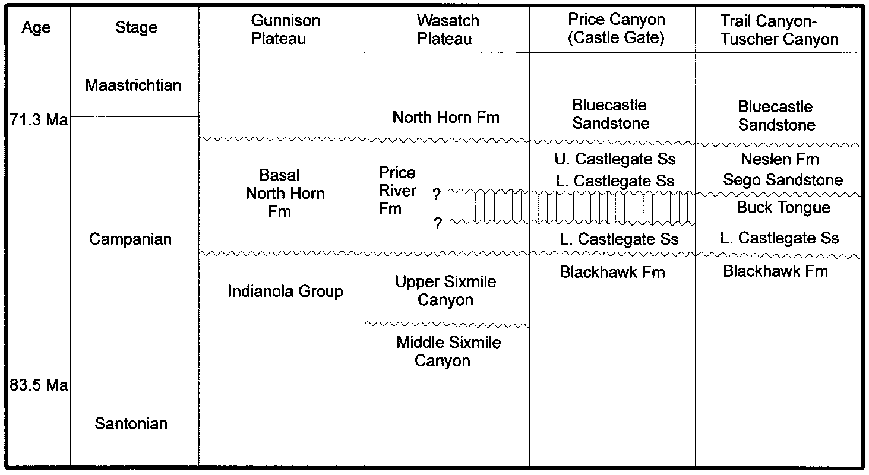FIG. 2.—Correlation table for the Castlegate Sandstone and related units, Book Cliffs, Utah. Modified from Yoshida et al. (1996) and

Robinson and Slingerland (1998). In the Price Canyon column vertical ruling emphasizes the missing section revealed by the mapping of Yoshida et al. (1996). Question marks indicate uncertainty in the updip correlation of these unconformities.

FIG. 3.—Sequence stratigraphy of the Castlegate Sandstone and correlative units, central Utah. Note the three major sequences defined by the regional sequence boundaries.

the Lower Castlegate Sandstone in the Price area, in the form of erosional relief at several major erosion surfaces within this fluvial unit, as reported by Yoshida et al. (1996), it has not hitherto been possible to identify the updip position of the base-Sego Sandstone boundary that was mapped by Willis (2000) and Yoshida (2000) in the Green River–Trail Canyon area. We have therefore sought additional clues for the location of the sequence boundary.

Sequence boundaries in continuous fluvial successions are likely to be difficult to distinguish from autogenic channel-scour surfaces, especially in successions comprising monotonous units of superimposed crossbedded sandstone of the type that commonly accumulate in braided fluvial systems. Miall (1999) termed such boundaries ‘‘cryptic sequence boundaries,’’ and suggested a range of criteria by which they might be distinguished. These include facies criteria, such as prominent, laterally extensive erosion surfaces with steep cut-and-fill relief, indicating early lithification, unusual abundance of plant fragments, bone fragments, or other lags on the erosion surface, or major changes in paleocurrent dispersal directions at the sequence boundary. ‘‘Walking out’’ of major surfaces or tracing them on outcrop photomosaics to test their lateral extent and the nature of regional correlations can provide an indication of their significance, but given the limitations of outcrop this is rarely possible.

On the basis of the criteria listed above, several surfaces in the type section at Castle Gate (Fig. 4) could qualify as sequence boundaries. These are the major surfaces indicated by the letters B to G in Figure 4. These surfaces are draped with mudstone–siltstone clasts and large plant fragments in the form of twigs, and logs. Such criteria are not, however, conclusive evidence of the presence of a sequence boundary, and offer no clues as to the correlation with the base-Sego sequence boundary to the east. Our current interpretation of the correlations in this area is shown in Figure 3, and is discussed in the following sections.

# PALEOCURRENT TRENDS

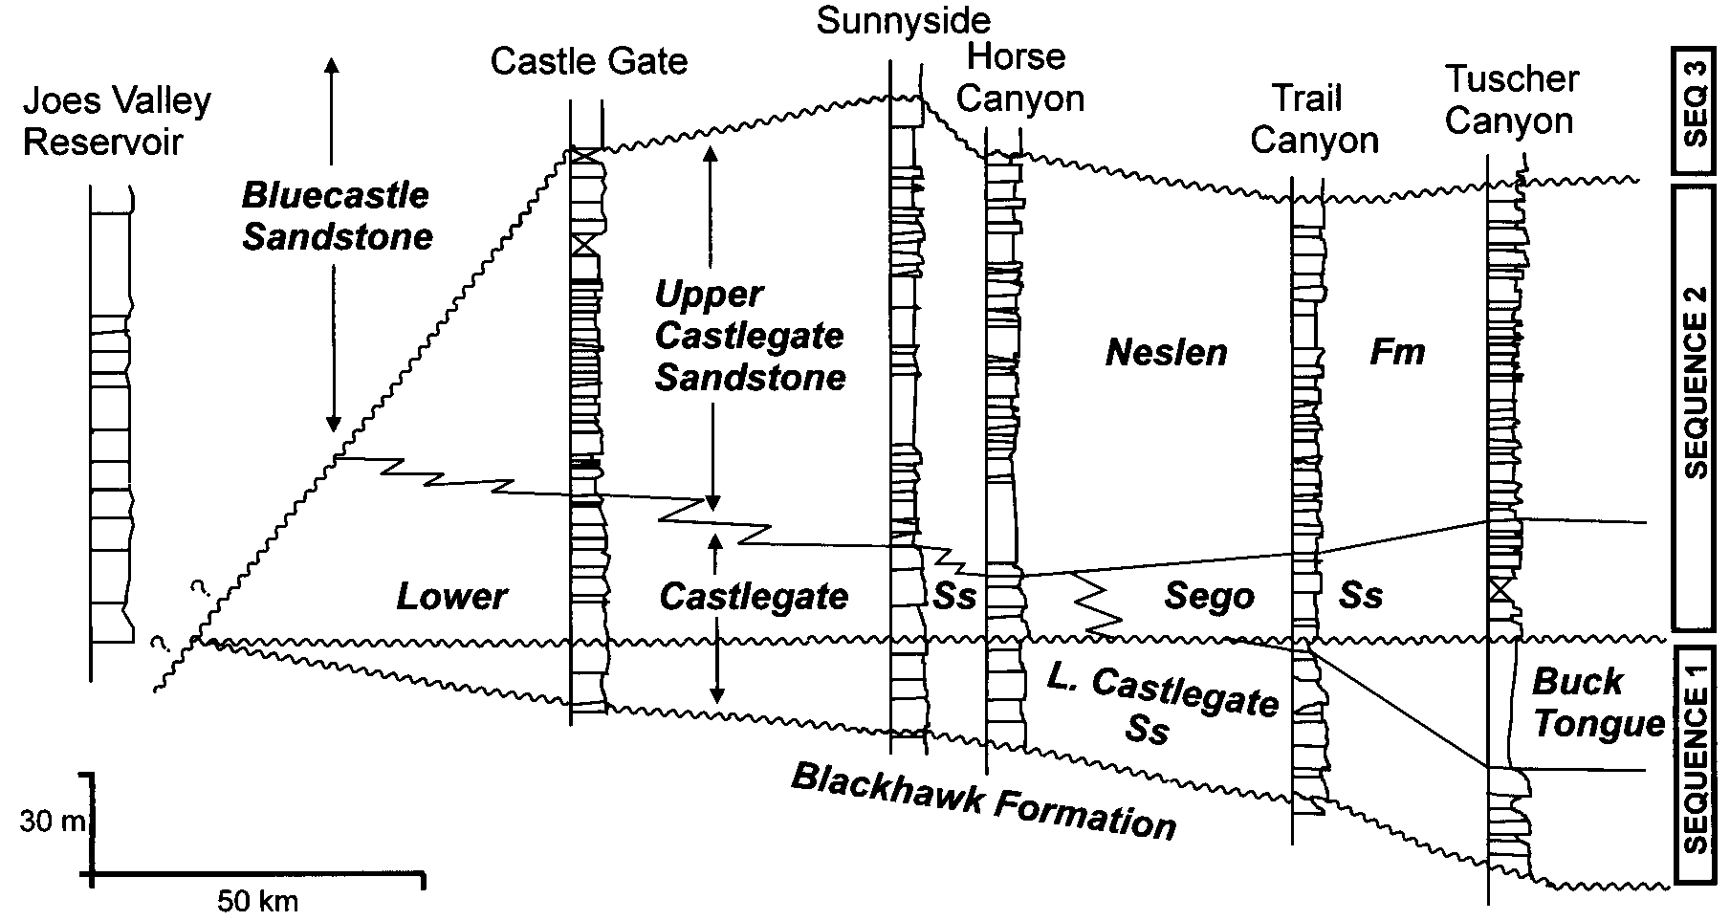We report no new paleocurrent data in this paper. Figure 5 is reproduced from the synthesis prepared by Willis (2000), based in part on earlier work by Lawton (1986b) and Miall (1993), and shows significant variations in regional transport directions during the time represented by the three sequences discussed in this study.

Transport directions in the Lower Castlegate Sandstone between the type section and Green River are consistently oriented toward the east–southeast, although these data may include some measurements at Castle Gate from beds we would now correlate with the Upper Castlegate Sandstone. This consistency in transport directions is part of the evidence incorporated by Robinson and Slingerland (1998) into their unified transport model for the Lower Castlegate Sandstone. Trends in the major incised valleys at the base of the Castlegate Sandstone are eastward in the area east of Green River, according to Van Wagoner (1995).

Transport directions in the Upper Castlegate Sandstone and Sego Sandstone equivalents show a small swing to southeastward trends. The limited data that indicate this trend are not enough to ensure statistical significance, but they are internally consistent.

Transport directions in the Bluecastle Sandstone show an almost 908 anticlockwise swing toward east to east–northeastward transport directions.

# DETRITAL COMPOSITION AS A CORRELATION TOOL

In view of the impossibility of physically tracing sequence boundaries within the predominantly sandstone succession of the Castlegate Sandstone of the western Book Cliffs, and the inadequacy of palynostratigraphic determinations for precise correlations, we have tested proposed correlations by detailed documentation of detrital composition in a few key locations. This work is based on two assumptions:

1. Units of the same facies and grain size, deposited at the same time and derived from a single source area, should display a consistent detrital composition, subject to downstream variability resulting from abrasion, selective transport, and input from tributary sources. This assumption permits stratigraphic comparison of units interpreted to be laterally equivalent. This is the principle of the ‘‘petrofacies’’ concept, as employed by Ingersoll (1978), amongst others.
2. Detrital composition changes with time as a result of erosion and unroofing of source areas. Within conformable successions such changes in composition should be continuous, resulting in an ‘‘inverted stratigraphy’’ effect (e.g., Graham et al. 1986), whereas major breaks in sedimentation may be revealed by sudden changes in composition across an erosion surface, indicating gaps in what would

|  |
| --- |
| FIG. 4.—The type section of the Castlegate Sandstone at Castle Gate, Price, showing the position of known sequence boundaries and other prominent erosion surfaces, lettered A to H. Surface A 5 base-Castlegate sequence boundary, Surface D is interpreted here as a sequence boundary correlating with the base of the Sego Sandstone. Surface H 5 base-Bluecastle Sandstone. Locations of petrographic samples are shown by the white spots. |

otherwise be expected to be a gradual change in composition, reflecting a gradual change in the units exposed to erosion in the hinterland.

# *Petrography and Correlation of the Castlegate Sandstone*

Our analysis is based on 98 samples of the Castlegate Sandstone and overlying and underlying units from Joes Valley Reservoir, the Castle Gate, Sunnyside, and Tuscher Canyon. All samples represent the fine- to medium-grained, typically cross-bedded sandstone that is characteristic of the channel-fill units of the Castlegate Sandstone. All samples were stained for feldspar identification with sodium cobaltinitrite, using the method of Allman and Lawrence (1972). A total of 400 points were counted for each thin section.

Petrographic studies of the Castlegate Sandstone and related units were carried out earlier by Lawton (1986a, 1986b) and Franczyk et al. (1990). We have attempted to relate our results to those of these earlier researchers in order to arrive at an integrated picture of petrographic variability and its causes in the Castlegate Sandstone. A general description of the detrital composition, based on samples from the Castle Gate, Joes Valley Reservoir, and Sunnyside area follows.

Detrital quartz is generally subangular to subrounded with variable grain

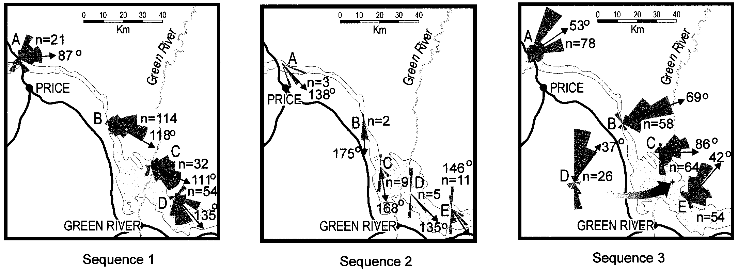

FIG. 5.—Paleocurrent data for the Mesaverde Group of the Book Cliffs area. **A)** Lower Castlegate Sandstone, data from Lawton (1986b). Localities: A, Castle Gate; B, Horse Canyon; C, Green River; D, Tuscher Canyon. **B)** Upper Castlegate Sandstone, Sego Sandstone and Neslen Sandstone. Data from Miall (1993) and Willis (2000). Localities: A, Willow Creek; B, Horse Canyon; C, Trail Canyon; D, Green River and Tuscher Canyon. **C)** Bluecastle Sandstone, data from Lawton (1986b). Localities: A, Castle Gate; B, Horse Canyon; C, Range Creek; D, Green River; E, Tuscher Canyon. Diagram from Willis (2000).

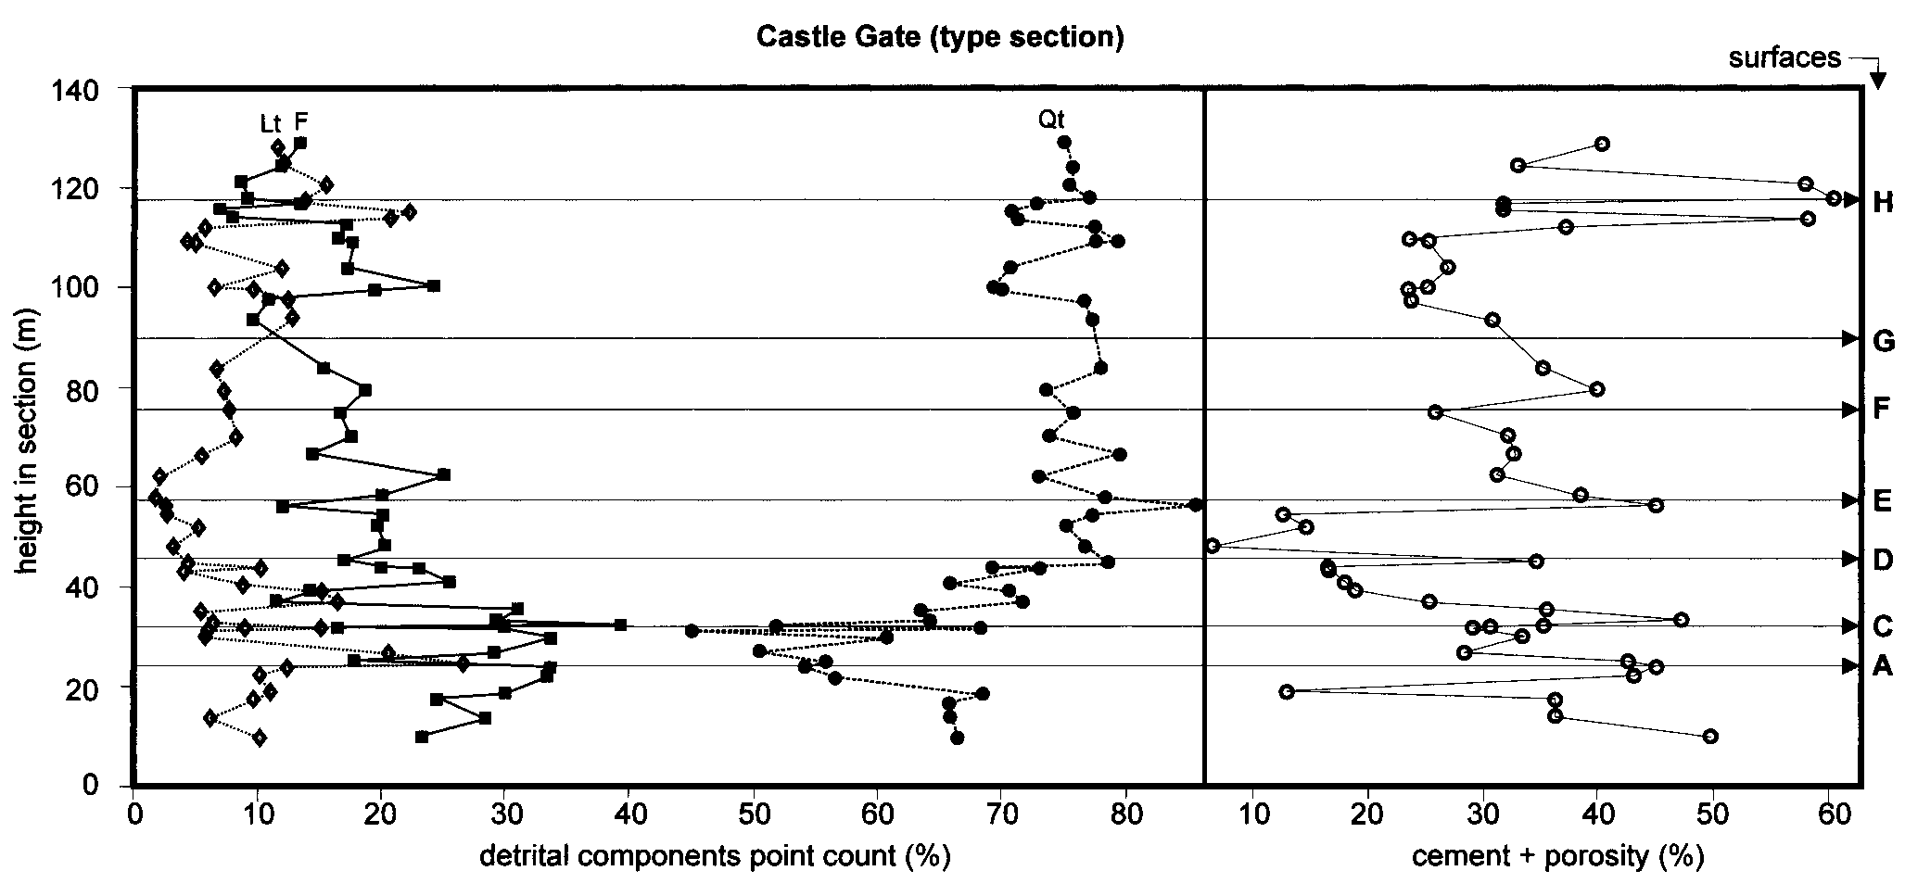

FIG. 6.—Vertical trends of detrital petrographic composition (total lithics, total feldspars and total quartz, expressed as percent of total detrital components) and total cement plus porosity (as percent of total thin-section area) in the type section of the Castlegate Sandstone at the Castle Gate, Price Canyon, Utah. Sample locations and

locations of the stratigraphic surfaces A to H are shown in Figure 4.

size: coarse- and medium- to fine-grained. Grains are predominantly monocrystalline, rarely zoned, and with vacuoles near their outer margins (volcanic origin?). Rare iron oxide coatings and quartz overgrowths have been observed. Boehm lamellae textures are rarely present, displaying thin layers of inclusions, probably muscovite and rutile. Polycrystalline quartz is rare, consisting mainly of large sutured, semicomposite crystals with preferred crystallographic fabric, probably of metamorphic origin. The compaction of the grains is variable, consisting mainly of sutured, linear concave– convex, point contacts and few samples with floating grains.

Both sodium and potassium feldspars are common, and show variable grain size. Distinctive microcline grains are present in most samples. Plagioclase is more corroded and altered but more abundant. In some samples from the type section some feldspars are corroded and partially dissolved honeycombed grains. Plagioclase may be altered and shows calcification, with selective dissolution along internal strain boundaries to completely dissolved grains.

Of the lithic fragments, chert dominates the sedimentary components. They may be corroded, with visible calcite cement in the grains. Some chert clasts display a combination of microquartz and megaquartz components; some chert grains show selective dissolution of grains. In some samples chert grains show recrystallized calcite cement and oolitic carbonates replaced by microquartz with pore space filled with chalcedony. Metamorphic rock fragments are rare; where present they are of low grade, probably phyllites. Sheared metaquartzite clasts with elongate granulite quartz crystals welded together and micacous phyllite have also been observed. Volcanic rocks are rare and hard to identify. Muscovite flakes are widespread. Zircon (common) and rutile (rare) are the main heavy minerals. Generally matrix is rare, consisting of opaque iron oxides or interstitial clay minerals. Cement is variable and consists mainly of calcite. Poikilotopic calcite cement is more abundant in coarse-grained sandstones, but limited iron oxide cement is also present. Porosity is mainly secondary, but some samples display partially preserved primary porosity. Both intergranular and intragranular secondary porosities are displayed and show oversized pores.

Figure 6 shows a plot of the vertical variation in major detrital components in 46 samples taken from the Castlegate type section north of Price. Sample locations are shown in Fig. 4. The samples span the interval from the Blackhawk Formation, below, to the Bluecastle Sandstone, above. The composition shows no significant breaks at the sequence boundary between the Blackhawk Formation and the Castlegate Sandstone or at the boundary between the Castlegate Sandstone and the overlying Bluecastle Sandstone. There is, however, a major shift in detrital composition within the Castlegate Sandstone, from a feldspathic–lithic sandstone below to a more quartzose sandstone above. This change appears to take place between samples 27 and 28, at surface D, 20 m above the base of the Castlegate Sandstone (samples are numbered from the top down). We suggest that this surface represents a major break in the section, greater than at any of the other surfaces in this section, and that it may correspond to the base-Sego sequence boundary that we had predicted would be located at about this stratigraphic level (Willis 2000). An alternative interpretation is that there is a shift in composition at surface C, but, although the compositional variance is large in the half dozen samples above and below this surface, a careful examination of the data shows that high and low values in percentage composition occur both above and below surface C, which does not, therefore, correspond to a significant shift in average detrital composition.

The compositions of all the samples at the Castle Gate type section are shown in Fig. 7. The samples above and below surface D clearly fall into different areas of this plot. Fig. 8 shows the vertical petrographic variation in the Sunnyside section of the Castlegate sandstone. No obvious breaks in composition are apparent.

In order to compare the composition of the sandstone samples at the type section with that at other key localities, we have plotted the average QtFL values for each of our suites of samples grouped by location, in Figure 9. The following observations require explanation:

1. As noted, the composition at the type section shows an increase inQt content in stratigraphically younger strata.
2. Samples from the Joes Valley Reservoir location are closer in composition to those of the Castlegate section at Tuscher Canyon than to any of the other sandstone suites in the Book Cliffs area. They are also similar to the Bluecastle Sandstone at the Castle Gate.
3. Sandstone samples from Sunnyside and from another section throughthe middle part of the Castlegate Sandstone a few hundred meters up

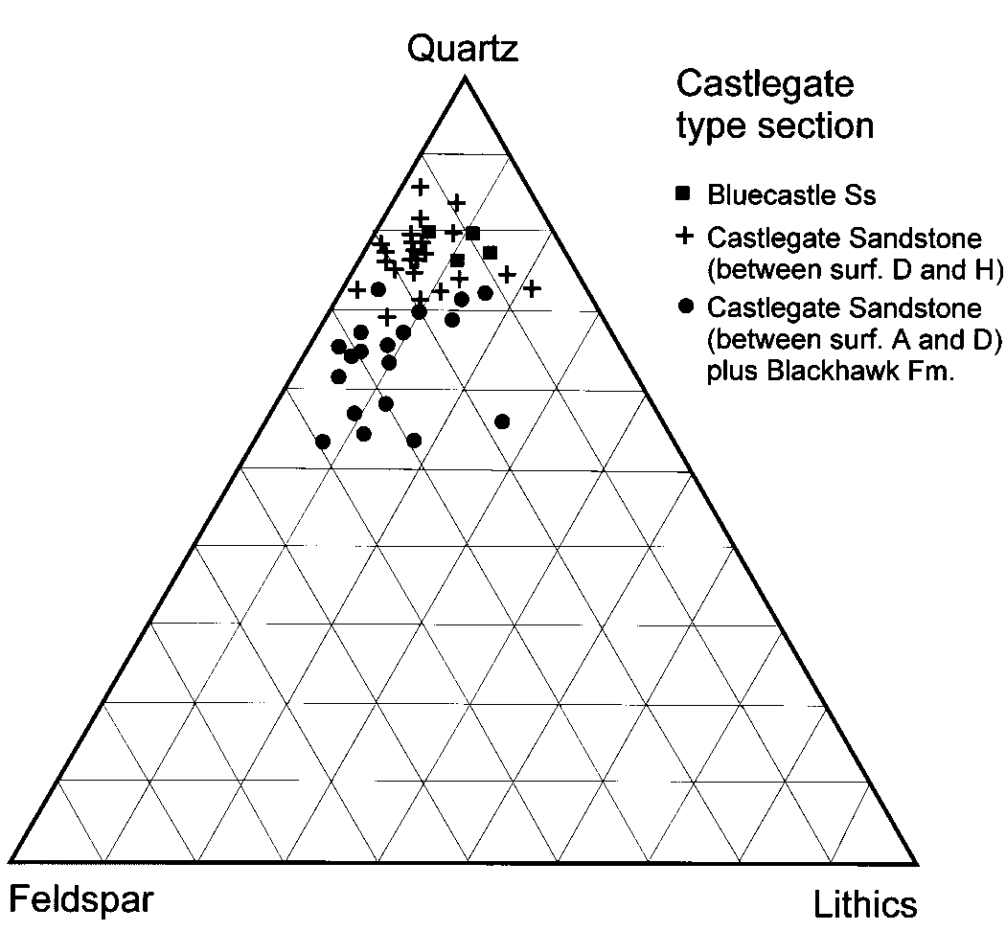

FIG. 7.—Petrographic composition of the 46 samples from the Castle Gate type section. End members are total lithics, total feldspars, and total quartz, expressed as percent of total detrital components. Samples are grouped according to their stratigraphic position relative to surface D, which is suspected to be a sequence boundary.

the canyon from the type section at the Castle Gate (Castle Gate B) compare most closely with the upper Castlegate Sandstone at the type section.

1. The vertical trend in sandstone composition at Tuscher Canyon is theopposite to that at the Castle Gate. That is, the Sego Sandstone is less quartzose and more feldspathic and lithic than the Lower Castlegate Sandstone at that locality (note the oppositely directed arrows in Fig. 9).

Contrary to the interpretation of Robinson and Slingerland (1998), whose palynostratigraphic data are not definitive on this point, we suggest that, on the basis of petrographic similarities, the section exposed adjacent to the Joes Valley Reservoir may correlate to the Bluecastle Sandstone, not the Castlegate Sandstone. It is possible that the base-Bluecastle sequence boundary cuts stratigraphically downward toward the west, as does the base-Sego sequence boundary. Strata equivalent to the Lower Castlegate Sandstone (the lowermost 20 m of the unit at the type section) may be entirely absent at Joes Valley. This is the reconstruction tentatively suggested in Fig. 3. If this is the case, then the rocks assigned to the Lower Castlegate by Robinson and Slingerland (1998) constitute parts of three sequences: the Bluecastle Sandstone (Sequence 3 in Fig. 4) at Joes Valley, the Sego Sandstone and lowermost Lower Castlegate Sandstone (Sequences 1 and 2) at the type section, and only the lowermost Lower Castlegate Sandstone (Sequence 1) downdip from Trail Canyon. Alternatively, the petrofacies similarity between the Joes Valley Reservoir samples and those from the Castlegate Sandstone at Tuscher Canyon indicates that they may correlate and have been derived from the same source terrane, a different one from that which fed the type section, as initially proposed by Robinson and Slingerland (1998). Only further sampling will resolve this point.

The lowermost Lower Castlegate Sandstone may also be virtually absent at the base of the section at Sunnyside, judging from the petrographic comparisons shown in Fig. 9 and the lack of any vertical breaks in composition shown in Fig. 8.

The westward (updip) downcutting of the base-Sego Sandstone and baseBluecastle(?) unconformities that is shown in Fig. 3 is not shown in Fig. 2, because it is not known where these unconformities tie into the stratigraphy of the Wasatch and Gunnison plateaus. The westward projection of the base-Sego sandstone unconformity is shown by a question mark in the correlation table (Fig. 2). The base Bluecastle unconformity is shown as correlating with the base of the North Horn Formation in this table. Robinson and Slingerland (1998) suggested that the Bluecastle Sandstone may correlate with either the Price River or North Horn formations west of the Castle Gate, but they do not show the base of the Bluecastle Sandstone as an unconformable sequence boundary.

Lawton (1986a, 1986b) used a different approach in point counting and in defining grain constituents in the arenites. We point-counted only the main grain constituents, following the Dickinson and Suczek (1979) and Ingersoll (1990) classification: Total quartz Qt is given by Qm 1 Qp, where Qm represents monocrystalline quartz and Qp polycrystalline quartz. Lawton included chert grains in Qp. Lawton counted muscovite as discrete grains and included them in the lithic category. This different approach causes some differences in the cluster distribution of the grains in QFL plots, although overall the vertical trend in the various sections is similar. In the proximal equivalents of the Castlegate Sandstone, Lawton (1986a, 1986b) noted an upward increase in total quartz, as do we at the type section at Castle Gate (Figs. 6, 7, 9). His plot of vertical petrographic trends in the Indianola Group at Sixmile Canyon shows an upward increase in Qm, comparable to the vertical trend we observed in the Castlegate type section. Although the Sixmile Canyon section is a considerable distance along strike from the Castlegate type section, the similarity in vertical petrographic trends suggests that the sand detritus in the two areas was derived from broadly the same evolving source area—a fold-thrust belt undergoing progressive unroofing, and this is supported by paleocurrent data that show consistent east–southeastward transport directions through this area (Fig. 5; Robinson and Slingerland 1998).

How are consistent sediment sources, vertical petrographic trends, and consistent paleocurrent trends in the Castlegate Sandstone and its correlatives to be reconciled with the possibility that these sandstones represent three separate sequences separated by major regional low-angle angular unconformities? We discuss this question below.

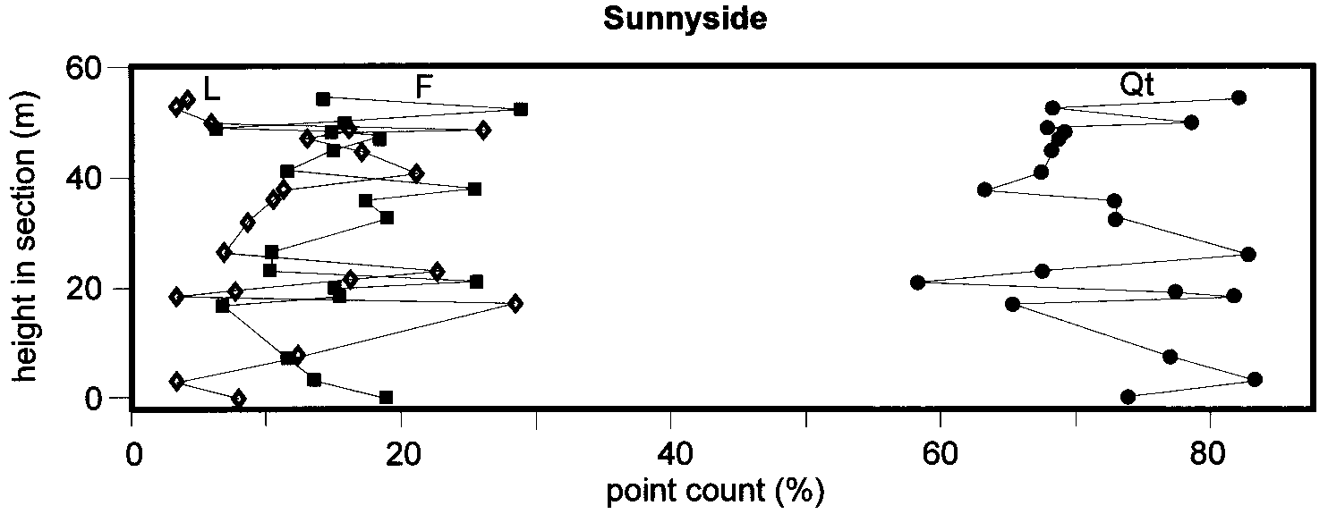FIG. 8.—Vertical trends of petrographic composition, Sunnyside section, Castlegate Sandstone. Plotted components are as in Figure 6.

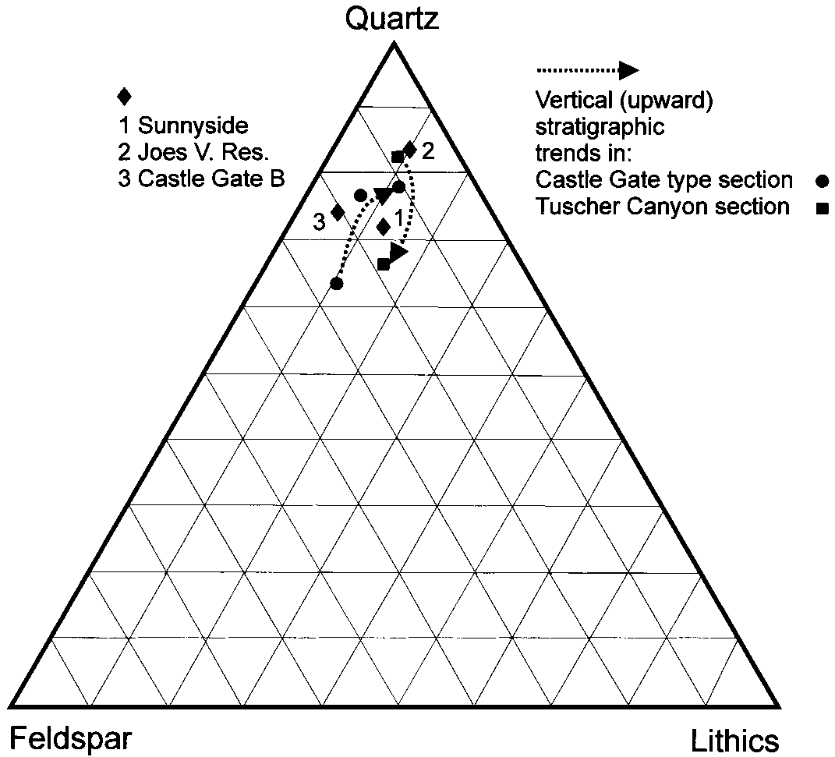

FIG. 9.—Variations in average composition of the Castlegate Sandstone and related units in the Book Cliffs area. Plotted components are as in Figure 6. Spot 1, average of 20 samples from the Sunnyside section, vertical trends of which are shown in Figure 7; spot 2, Joes Valley Reservoir section (average of 5 samples); spot 3, average of 20 samples from a Castlegate Sandstone section 200 m north of the type section in Price Canyon. Vertical stratigraphic trends are shown for the Castle Gate and Tuscher Canyon sections. At Castle Gate three spots are shown. In upward vertical order these are samples 28–46 average, from below surface D, samples 5–17, from between surfaces D and H, and samples 1–4, from the Bluecastle Sandstone above surface H. The Tuscher Canyon plots show the averages of three samples from the Lower Castlegate Sandstone (more quartzose plot at upper end of arrow) and four samples from the Sego Sandstone (at point of arrow).

Our limited sampling at Tuscher Canyon was initially planned only to permit crosschecking of the composition of the Castlegate and Sego sandstone against equivalent units updip to the west. However, the samples reveal a trend different from that observed in the Castle Gate type section, namely, evidence for a vertical upward *decrease* in quartz content from the Castlegate to the Sego Sandstone (Fig. 9), the reverse of that shown in Fig. 6. A more detailed petrographic study than ours was carried out by Franczyk et al. (1990) in this area, but these authors sampled only the upper part of the section of concern here. They did not sample the Castlegate Sandstone, but focused on the units above. Nonetheless, their data appear to show a trend similar to that noted here, namely an upward trend toward a more lithic content, from the Neslen into the Bluecastle and the overlying Farrer and Tuscher formations (Franczyk et al. 1990, their Figs. 12–14). The most logical explanation for the differences in vertical petrographic trends at Tuscher Canyon versus those at the Castle Gate and Sixmile Canyon is that rocks belonging to the same set of sequences were derived from different source terranes that underwent different unroofing histories. Paleocurrent data (Fig. 5) are consistent with this interpretation.

## CRYPTIC SEQUENCE BOUNDARIES REVEALED BY DIAGENESIS

Some additional support for the placement of a sequence boundary at surface D in the Castlegate type section (Fig. 6) is derived from observations of diagenetic alteration in the sandstones and the relationship of sandstone textures to their position relative to major bounding surfaces.

Continental sedimentary surfaces may be exposed to subaerial processes for significant lengths of time on an alluvial plain. The source of the exposure may be the shifting of an active channel to elsewhere within the alluvial valley, exposing bar-top surfaces for a period of a few years to perhaps hundreds of years. Longer-term exposure occurs if a meander belt undergoes avulsion, and even longer exposure times may be characteristic of the interfluve regions between major rivers. Uplift and exposure may also reflect changes in the balance between subsidence and sedimentation consequent upon tectonic movements of the basin or the sediment source area. Surfaces exposed for considerable periods may undergo vadose diagenesis. Paleosols also develop in such settings, but in many ancient sandy braided systems paleosols are not preserved, possibly as a result of intraformational erosion.

Bromley (1991) observed diagenetic changes at a major bounding surface, in the Kayenta Formation of Colorado, that he concluded had been exposed to subaerial weathering for a considerable period. Following this work, we suggest that the evidence of such diagenetic changes may be sought as supplementary evidence of the existence of significant surfaces of intraformational nondeposition or erosion, such as sequence boundaries. The effects include abundant cement and a loose grain framework, indicating that cementation preceded compaction due to burial. Quartz grains may show multiple overgrowths, and the grain overgrowths may be in contact with each other rather than with the grain cores, indicating that overgrowths were able to grow into precompaction pore spaces between grains. Other sandstones in the succession show tighter grain frameworks and consequently less cement and porosity, suggesting that they remained uncemented until compacted following burial. In these sandstones, quartz grain contacts commonly are sutured and intergrown, indicating compaction prior to cementation.

Figure 6 illustrates a plot showing total cement 1 porosity at the type section of the Castlegate Sandstone. The plot shows high values in the samples taken immediately (less than 20 cm) below surfaces A, D, E, and H, suggesting that these surfaces may represent episodes of significant exposure. Surfaces A, E, and H do not show major shifts in detrital composition, indicating that erosion in the source area did not significantly change the composition of the detritus shed during these periods of exposure. Surfaces A and H correspond to the bases of sequences 1 and 3 in Fig. 3. The other surfaces in the type section (surfaces C, F, and G in Fig. 4) are not associated with any significant values in the cement 1 porosity plot, although the absence of significantly higher readings in these samples could indicate that diagenetically altered material was removed by erosion immediately prior to the renewal of fluvial sedimentation.

|  |
| --- |
| FIG. 10.—River systems during deposition of the Lower Castlegate Sandstone. DCA 5 Douglas Creek Arch. Location of oolite shoal is from Van Wagoner (1995). |

In conclusion, surface D is the only one of the surfaces shown in Fig. 6 that is associated with the suggested indicators of a sequence boundary, a shift in detrital composition, and evidence of early diagenesis.

**ALLOGENIC CONTROLS OF SEQUENCE ARCHITECTURE AND PALEOGEOGRAPHY**

# *Tectonic Control of Mesaverde Fluvial Systems*

One of the major theses developed by Yoshida et al. (1996) is that an elaboration of the Posamentier and Allen (1993) model for sedimentation in foreland-ramp type basins can explain all the observed features of Castlegate sequence stratigraphy. We made much use of recent ideas relating to the tectonic effects of intraplate stress changes developed by S. Cloetingh and his co-workers (e.g., Peper et al. 1995). These show that, contrary to Van Wagoner and the Exxon ‘‘school’’ of sequence stratigraphy in general, relative changes in sea level induced by intraplate stress changes may be as rapid as any sea-level changes attributed to glacioeustasy. Our tectonic model for the development of the Mesaverde Group (Blackhawk Formation, Castlegate Sandstone and Bluecastle Sandstone) invoked two distinct tectonic processes acting over different time scales as an explanation for the generation of the two nested scales of sequences (Yoshida et al. 1996). We suggested a process of long-term flexural subsidence of varying rate, coupled with a high-frequency tectonic episodicity related to local tectonic loading and erosional unroofing events.

Variations in paleoslope, of the type discussed in the previous section, were amongst six types of observations we cited (Yoshida et al. 1998) that indicate tectonic influence on Castlegate sedimentation. They indicate regional tilts and imply a shifting of sediment sources during deposition of these units. We also suggested (Yoshida et al. 1996, p. 746) that structural grain and differential tectonic movement of the basement may have been influential in controlling dispersal trends in the Mesaverde Group.

# *The Possible Influence of Intrabasinal Tectonic Elements*

Van Wagoner (1995) reported a distal thinning of the Castlegate Sandstone and the occurrence of an oolite shoal at the base-Castlegate sequence boundary near the Utah–Colorado border (location of the oolite is shown in Fig. 10). He interpreted these observations in terms of a distal dryingup of Castlegate channels, beyond which (to the east) lay an area of ephemeral lakes, with the oolite deposited to the east of the coastline. By contrast, we noted that below the oolite the sequence boundary truncates younger strata toward the west, and suggested that Van Wagoner’s observations could be better explained as consistent with the location of the foreland basin forebulge in this area (Yoshida et al. 1998, p. 1604).

Van Wagoner (1998) rejected our model of forebulge sedimentation and provided a subsurface stratigraphic cross section through easternmost Utah and bordering Colorado to demonstrate an eastward thickening of all units from the Desert Member up to and including the Buck Tongue. We accept this argument as far as it goes, but we still suggest that a tectonic mechanism for the eastward thinning of the Castlegate Sandstone is to be preferred over a sedimentologically based terminal fan model, which we argued against earlier (Yoshida et al. 1998).

While Van Wagoner (1998, Fig. 1) is able to show eastward thickening of Mesaverde group strata over a distance of about six townships (36 miles, or ; 60 km), the larger picture clearly shows that lower subsidence rates occurred in easternmost Utah than in locations to the west during the Turonian to Campanian. Pang and Nummedal (1995), who carried out a backstripping analysis that demonstrated this pattern, attributed this to the influence of a basement element named the Douglas Creek Arch, which is a north–south element underlying the Utah–Colorado border (Van Wagoner 1995, his Fig. 3). It is not clear what, if any, is the relationship of this arch to the forebulge of the foreland basin, the position of which is not clear from Pang and Nummedal’s (1995) work. The presence of the forebulge in this area at this time is not, contrary to Van Wagoner’s (1998) claim, ruled out by other studies of foreland basin dynamics, including those by DeCelles and his coworkers. In none of that work is the position of the forebulge during the Late Cretaceous shown to be unequivocally known. DeCelles and Giles (1996, their fig. 9B) provided an isopach map of the Lower Cretaceous Cedar Mountain Formation, a reading of which suggests that the forebulge lay beneath eastern Utah at that time. For part of Jurassic–Cretaceous time DeCelles and Currie (1996) argued that the foreland basin and its forebulge were migrating eastward at a rate of about 0.5 cm/ yr, but there is no conclusive proof that this rate persisted throughout the Cretaceous, and even if it did, this would still leave eastern Utah on the inner flank of the forebulge, so the forebulge model for Castlegate sedimentation is not ruled out.

Van Wagoner (1998) claimed that forebulges constitute the boundaries of megasequences, not high-frequency sequences but recent work has demonstrated that tectonism may be rapid in foreland basins, and may be the primary generating mechanism of high-frequency sequences (e.g., the recent work on the Alberta basin by Catuneanu et al. 1997a, 1997b; see summary in Miall 1997).

|  |
| --- |
| FIG. 11.—River systems during deposition of the Bluecastle Sandstone. |

Setting aside the possible importance of regional flexure and debates about the forebulge, there remains the important influence of basement heterogeneity on the transmission of flexural stress through the foreland basin. Pang and Nummedal (1995) demonstrated the importance of local ‘‘butresses’’ and ‘‘zones of weakness’’ in affecting flexural subsidence patterns and, as Heller et al. (1993) have suggested, ‘‘changes in intraplate stresses add a small, but stratigraphically significant, component of uplift or subsidence to preexisting topography and/or zones of weakness within the lithosphere.’’ Yoshida et al. (1996) noted the possible influence of heterogeneity related to the underlying Paradox basin as a cause of differential movement, and the Douglas Creek Arch, Uncompahgre Uplift, and other pre-Cretaceous structural features are all elements that potentially could have subtly influenced sedimentation, including paleocurrent trends and thickness patterns.

Incised valleys at sequence boundaries within the Sego Sandstone of eastern Utah are oriented north–south (Day 1 in van Wagoner et al. 1991), and incised valleys on the sequence boundary at the base of the Castlegate Sandstone in the same area are oriented northwest–southeast (Day 4 in Van Wagoner et al. 1991). These features were attributed by Van Wagoner et al. (1991) and Van Wagoner (1995, his fig. 49) to structural control related to incipient Laramide deformation. Movement on structures associated with the Douglas Creek Arch might explain the orientation of the incised valleys in the Sego Sandstone. Yoshida et al. (1996) attributed downdip changes in Castlegate paleocurrent patterns to the structural influence of the underlying Paradox basin. Lawton (1986b) suggested that growth of the San Rafael Swell and Uinta Uplift in the latest Cretaceous and Cenozoic tilted the regional palesolopes and eventually imposed more variable dispersal patterns in the Cenozoic than that prevailing during the paleogeographically simple foreland-basin phase. The work of Guiseppe and Heller (1998) suggests that movement on the San Rafael Swell, a Laramide structure, began in the Campanian. Laramide influences on tilting and channeling of flow may therefore have begun during upper Castlegate-Sego sedimentation.

Recent detailed work by Donaldson et al. (1999) has provided a useful analogy for the oolite occurrences in the Castlegate Sandstone. Donaldson et al. (1999) described an economically significant ooidal ironstone deposited over intrabasinal highs in the Alberta foreland basin. Their sequencestratigraphic interpretation of these deposits indicates that they occur immediately above a regional ravinement surface and were formed at a time of sediment starvation during regional transgression. This compares closely to the tectonic setting and sequence stratigraphy of the Castlegate oolites.

The regional paleocurrent trends in Fig. 5 indicate that the Book Cliffs outcrop belt does not parallel the dispersal directions of the Castlegate or Bluecastle sandstones. This indicates that the sandstones exposed at various locations along the Book Cliffs do not represent a simple down-dip transect along one river system, and that they may have been derived from a range of different sources within the Sevier orogen to the west. This is particularly the case with the Bluecastle Sandstone and equivalents, the paleocurrent trends for which are the most markedly offset from the outcrop trend. We suggested (Yoshida et al. 1998, p. 1599) that the downdip decrease in the erosional relief of the Castlegate lowstand channel systems in eastern Utah can be explained by the fact that the outcrop belt does not parallel channel trends, and that the decrease in erosional relief actually represents an oblique transect across parallel but otherwise unrelated channels of varying size and discharge. All these features would also help to explain why vertical petrographic trends in the Castlegate–Sego succession at Tuscher Canyon are quite different from those in contemporaneous strata at Castle Gate (Fig. 9). Possibly the younger units at Tuscher Canyon were beginning to include sedimentary detritus from the San Rafael Swell, a source area that became increasingly important toward the end of the Cretaceous, according to Lawton (1986b).

Yoshida et al. (1996) suggested that the widespread, sheet-like extent of the Castlegate Sandstone indicates a temporary lull in long-term flexural subsidence, and possibly this relaxation permitted the weaker effects of local heterogeneities, such as those associated with the Douglas Creek Arch and Paradox basin–Uncompahgre Uplift, to show through in the stratigraphic response to tectonic stress. Although this is a speculative explanation of the eastward thinning of the Castlegate Sandstone, we submit that it is more soundly based in known geologic processes that the terminalfan and base-level-change sedimentological model proposed by Van Wagoner (1995). Ravinement during the beginning of the transgression that deposited the Buck Tongue is another possible mechanism for the thinning of the Castlegate Sandstone in easternmost Utah, especially where ravinement affected deposits formed over structurally positive areas, such as the Douglas Creek Arch.

## NONMARINE SEQUENCE GENERATION IN THE CAMPANIAN FORELAND BASIN

We summarize here our views regarding the paleogeographic evolution of the foreland basin during the Campanian. Our interpretations are illustrated in Figs. 10 and 11.

Along the western margins of the Western Interior Seaway a series of major thrust plates stepped progressively farther eastward into the basin between the Early Cretaceous and the Early Cenozoic, and a succession of unconformity-bounded nonmarine sequences developed in response to the episodic loading and unloading of the basement (DeCelles et al. 1995; Schwans 1995). These sequences, which now underlie the proximal part of the basin, in the area of the Gunnison Plateau and the Wasatch Plateau, average a few million years in duration and, according to the reconstruction by Schwans (1995), they developed mainly during active thrust-loading periods, when accommodation generation in the basin was presumably most rapid. In this reconstruction, the major unconformities correspond more or less to late phases of each tectonic episode, when erosion-driven isostatic uplift of the fold-thrust belt may have begun. This pattern of sedimentation and tectonics fits Heller and Paola’s (1992) ‘‘antitectonic’’ model of foreland basin development.

The units discussed in this paper correspond to the U8–U9 sequence of Schwans (1995), which developed during the mid- to late Campanian, between about 78 and 73 Ma (Robinson and Slingerland 1998). This sequence rests on an unusually widespread unconformity that extends across the entire basin, from the fold-thrust belt, where it forms the contact between the Indianola Group and the North Horn Formation (DeCelles et al. 1995; Robinson and Slingerland 1998), eastward to the Utah–Colorado border (Van Wagoner 1995). It is suggested that the unconformity represents regional isostatic rebound following a pause in thrust tectonism, although which thrust complexes were active at this time is not clear. Tectonism at this time is attributed to different tectonic elements by Schwans (1995) and by DeCelles et al. (1995). The Castlegate Sandstone, which rests on this unconformity, is one of the most laterally extensive of the clastic tongues constituting the Cretaceous foreland-basin fill in this region. In a general sense it represents the lowstand to transgressive systems tract of the longterm sequence that developed following the unconformable uplift. As shown here, however, the Castlegate Sandstone is not a single sequence, but an amalgam of at least two sequences, one of which (Lower–Upper Castlegate and Sego Sandstone; Sequence 2 in Fig. 3) truncates and overlaps the other (Lowermost Castlegate Sandstone; Sequence 1 in Fig. 3) in a westward, proximal direction. We suggest here that the upper of these two sequences is, in turn, truncated and overlapped by the Bluecastle Sandstone (Sequence 3) at Joes Valley Reservoir. This shingled, overlap pattern suggests that the Castlegate Sandstone and its downdip equivalents were formed during a period of long-term tectonic quiescence upon which shorter-term tectonic episodes were superimposed. During this long term episode, while the distal part of the basin underwent episodic, short-term mild subsidence, enough to create the accommodation space for the three successive sequences discussed here, the proximal part of the basin underwent episodic mild uplift, enough to successively strip away the proximal parts of two of those sequences. This mechanism explains why these sequences are truncated updip and do not thicken dramatically into the basin, as is typical of foreland basin deposits formed during periods of active basinal subsidence. The short-term, high-frequency episodes of subsidence and uplift are attributed to episodes of local loading and unloading that are below the resolution of the stratigraphic studies undertaken to date in the foldthrust belt. A similar mechanism was proposed by Yoshida et al. (1996) and Yoshida (2000) to explain the high-frequency sequences of the Blackhawk Formation and the Sego–Neslen succession of eastern Utah.

As shown by paleocurrent data (Fig. 5) the regional paleoslopes during deposition of each of the three successive fluvial sequences were not all tilted in the same direction. East–southeastward flow of Lower Castlegate rivers suggests simple basin-transverse fluvial dispersal (Fig. 10). The more northward flow of river systems during Bluecastle sedimentation suggests possible influence of the rising San Rafael Swell (Fig. 11). Local deviations from the regional patterns may represent the subtle influence of basement elements, including the Paradox basin and the Douglas Creek Arch.

The architecture of channel and bar deposits indicates that large, vigorous, braided channel systems were responsible for deposition of the basal parts of all three of the sequences, whereas the upper parts of at least the Lower Castlegate and Upper Castlegate–Sego sequences contain abundant evidence of tidal influence, indicating transgressive, estuarine conditions. Tidal influence has been detected in the Lower Castlegate Sandstone as far updip as Trail Canyon (Yoshida et al. 1996; Yoshida 2000), whereas tidal sedimentary structures have been recorded in the middle part of the Upper Castlegate Sandstone as far west as the type section north of Price (Olsen et al. 1995; Yoshida et al. 1996; McLaurin and Steel 2000; Willis 2000).

The demonstration that the Castlegate Sandstone consists of at least two, and possibly three sequences separated by low-angle unconformities has implications for the sediment transport model developed for this unit by Robinson and Slingerland (1998). Their numerical experiments used combinations of conditions that generated patterns of thickness and grain-size distribution similar to those actually observed in the Castlegate Sandstone. Variables in their experiments included subsidence rate, eustatic sea-level change, and sediment feed rate. Their experiments incorrectly assumed that the Castlegate Sandstone is a single, conformable sequence. How can it be that their experiments appear to ‘‘work’’? We suggest the following argument. The preserved sandstone succession records periods of maximum accommodation generation, either tectonic or eustatic in origin, and such episodes of high accommodation must also coincide with episodes of high sediment supply. These are the conditions modeled by the numerical experiments, into which were fed measured data on grain size and channel dimensions. Conditions of low or negative accommodation generation are represented by the unconformities in the succession, which leave no sedimentary record and therefore have not been modeled. The fact that the numerical models can generate simple patterns of vertical and downdip thickness and grain-size change is, of course, a reflection of the design of the experiment but is not necessarily far divorced from reality, given the possibility that three successive episodes of mild subsidence (and accommodation generation) may have reestablished similar regional transport patterns three times across a largely unchanged foreland basin. The amalgamation by erosional onlap of three segments of three originally similar sequences into one apparently conformable sequence displaying regular downdip thickness and grain-size changes is not fortuitous but reflects the repetition of similar depositional conditions three times in this basin during the Campanian. Tilting of the basin modified sediment transport directions but did not substantially alter hydraulic conditions across the basin. Robinson and Slingerland (1998, p. 124) are the first to admit that their experiments are simplistic. As they stated, ‘‘several of the known important geomorphological and crustal processes and feedbacks that influence mountain belts and foreland basin development are missing from the modeling approach. Our streams are 1-D and have constant values of water, sediment and subsidence through time.’’

## CONCLUSIONS

The Castlegate Sandstone represents an episode during which long-term regional subsidence rates on the foreland basin slowed, permitting the sheet-like dispersal of detritus eroded from the Sevier orogen. However, local, high-frequency loading episodes led to three successive episodes of subsidence and uplift that resulted in the amalgamation by updip erosional onlap of two or possibly three successive nonmarine sequences representing

(1) the Castlegate Sandstone of areas east of Green River (Sequence 1), (2) the stratigraphic equivalent of the Sego Sandstone in areas northwest of Trail Canyon (Sequence 2), and (3) possibly the Bluecastle Sandstone in areas west of Price (Sequence 3; evidence for this correlation is tentative). These correlations can be demonstrated by regional stratigraphic mapping and by petrographic comparisons.

The three successive sequences represent lowstand to transgressive deposits formed initially by vigorous braided river systems, which were then variously affected by tidal influences as base-level rise and transgression occurred.

The facies of the distal Castlegate Sandstone, including the thin, finegrained clastic facies and the oolites preserved near the Utah–Colorado border, are interpreted as low-energy interdistributary bay and shelf deposits, respectively, that formed over mildly structurally positive regions of the basin, probably during transgression. The thinness of the unit here indicates slow subsidence that may reflect the influence of basement structural elements on the transmission of intraplate stresses through the basin. Such elements include the Douglas Creek Arch, the Uncompahgre Uplift, and incipient movement on Laramide structures. The forebulge of the foreland basin may have been located in the vicinity of the Utah–Colorado border at this time.

Movement on these basement elements accounts for the changing paleocurrent patterns during Castlegate–Sego–Bluecastle sedimentation. In particular, the substantial shift toward northeastward transport directions during Bluecastle sedimentation may reflect incipient movement of the Laramide San Rafael Swell. There is no independent evidence for eustatic sealevel changes or climatic cycles during the formation of these sandstone sequences. Their facies, distribution, paleogeography, and stratigraphic history can be explained with reference to the evolving tectonic history of the foreland basin.

## ACKNOWLEDGMENTS

Thanks to Charlene Miall for field assistance and companionship, to Tobi Payenberg for teaching ADM the elements of CorelDraw, and to Andrew Willis and Shuji Yoshida for their critical comments on early drafts of the manuscript. The authors are also grateful for the critical comments of Journal reviewers Ron Steel, Ruth Robinson, and Dale Leckie and Associate Editor Greg Nadon, although not all of these reviewers agree with the ideas presented here.

The research was supported by an Operating Grant from the Natural Sciences and Engineering Research Council, Canada.

## REFERENCES

ALLMAN, M., AND LAWRENCE, D.F., 1972, Geological Laboratory Techniques: London, Blandford Press, 335 p.

BROMLEY, M. H., 1991, Architectural features of the Kayenta Formation (Lower Jurassic), Colorado Plateau, U.S.A.: relationship to salt tectonics in the Paradox Basin: Sedimentary Geology, v. 73, p. 77–99.

BURBANK, D.W., PUIGDEFA´BREGAS, C., AND MUN˜OZ, J.A., 1992, The chronology of the Eocene tectonic and stratigraphic development of the eastern Pyrenean foreland basin, northeast Spain: Geological Society of America, Bulletin, v. 104, p. 1101–1120.

BUTLER, R.W.H., AND LICKORISH, W.H., 1997, Using high-resolution stratigraphy to date fold and thrust activity: examples from the Neogene of south–central Sicily: Geological Society of London, Journal, v. 154, p. 633–644.

CASAS-SAINZ, A.M., 1997, The Rioja Trough (N. Spain): tectonosedimentary evolution of a symmetric foreland basin: Basin Research, v. 9, p. 65–85.

CATUNEANU, O., SWEET, A.R., AND MIALL, A.D., 1997a, Reciprocal architecture of Bearpaw T– R sequences, uppermost Cretaceous, Western Canada Sedimentary Basin: Bulletin of Canadian Petroleum Geology, v. 45, p. 75–94.

CATUNEANU, O., BEAUMONT, C., AND WASCHBUSCH, P., 1997b, Interplay of static loads and subduction dynamics in foreland basins: reciprocal stratigraphies and the ‘‘missing’’ peripheral bulge: Geology, v. 25, p. 1087–1090.

DECELLES, P.G., AND CURRIE, B.S., 1996, Long-term sediment accumulation in the Middle Jurassic–Early Eocene Cordilleran retroarc foreland-basin system: Geology, v. 24, p. 591– 594.

DECELLES, P.G., AND GILES, K.A., 1996, Foreland basin systems: Basin Research, v. 8, p. 105– 123.

DECELLES, P.G., LAWTON, T.F., AND MITRA, G., 1995, Thrust timing, growth of structural culminations, and synorogenic sedimentation in the type Sevier orogenic belt, western United States: Geology, v. 23, p. 699–702.

DICKINSON, W.R., AND SUCZEK, C.A., 1979, Plate tectonics and sandstone compositions: American Association of Petroleum Geologists, Bulletin, v. 63, p. 2164–2182.

DONALDSON, W.S., PLINT, A.G., AND LONGSTAFFE, F.J., 1999, Tectonic and eustatic control on deposition and preservation of Upper Cretaceous ooidal ironstone and associated facies: Peace River Arch area, NW Alberta, Canada: Sedimentology, v. 46, p. 1159–1182.

FOUCH, T.D., LAWTON, T.F., NICHOLS, D.J., CASHION, W.B., AND COBBAN, W.A., 1983, Patterns and timing of synorogenic sedimentation in Upper Cretaceous rocks of central and northeast Utah, *in* Reynolds, M.W., and Dolly, E.D., eds., Mesozoic Paleogeography of West–Central United States: SEPM, Rocky Mountain Section, p. 305–336.

FRANCZYK, K.J., PITMAN, J.K., AND NICHOLS, D.J., 1990, Sedimentology, mineralogy, palynology, and depositional history of some uppermost Cretaceous and lowermost Tertiary rocks along the Utah Book and Roan Cliffs east of Green River: U.S. Geological Survey, Bulletin 1787, p. N1–N27.

GRAHAM, S.A., TOLSON, R.B., DECELLES, P.G., INGERSOLL, R.V., BARGAR, E., CALDWELL, M., CAVAZZA, W., EDWARDS, D.P., FOLLO, M.F., HANDSCHY, J.F., LEMKE, L., MOXON, I., RICE, R., SMITH, G.A., AND WHITE, J., 1986, Provenance modeling as a technique for analyzing source terrane evolution and controls on foreland sedimentation, *in* Allen, P.A., and Homewood, P., eds., Foreland Basins: International Association of Sedimentologists, Special Publication 8, p. 425–436.

GUISEPPE, A.C., AND HELLER, P.L., 1998, Long-term river response to regional doming in the Price River Formation, central Utah: Geology, v. 26, p. 239–242.

HAQ, B.U., HARDENBOL, J., AND VAIL, P.R., 1987, Chronology of fluctuating sea levels since the Triassic (250 million years ago to present): Science, v. 235, p. 1156–1167.

HAQ, B.U., HARDENBOL, J., AND VAIL, P.R., 1988, Mesozoic and Cenozoic chronostratigraphy and cycles of sea-level change, *in* Wilgus, C.K., Hastings, B.S., Kendall, C.G.St.C., Posamentier, H.W., Ross, C.A., and Van Wagoner, J.C., eds., Sea-Level Changes: An Integrated Approach: SEPM, Special Publication 42, p. 71–108.

HELLER, P.L., BEEKMAN, F., ANGEVINE, C.L., AND CLOETINGH, S.A.P.L., 1993, Cause of tectonic reactivation and subtle uplifts in the Rocky Mountain region and its effect on the stratigraphic record: Geology, v. 21, p. 1003–1006.

HELLER, P.L., AND PAOLA, C., 1992, The large-scale dynamics of grain-size variation in alluvial basins, 2: application to syntectonic conglomerate: Basin Research, v. 4, p. 91–102.

INGERSOLL, R.V., 1978, Petrofacies and petrologic evolution of the late Cretaceous fore-arc basin, northern and central California: Journal of Geology, v. 86, p. 335–352.

INGERSOLL, R.V., 1990, Actualistic sandstone petrofacies: discriminating modern and ancient source rocks: Geology, v. 18, p. 733–736.

KRYSTINIK, L.F., AND DEJARNETT, B.B., 1995, Lateral variability of sequence stratigraphic framework in the Campanian and Lower Maastrichtian of the Western Interior Seaway, *in* Van Wagoner, J.C., and Bertram, G.T., eds., Sequence Stratigraphy of Foreland Basin Deposits: American Association of Petroleum Geologists, Memoir 64, p. 11–25.

LAWTON, T.F., 1986a, Compositional trends within a clastic wedge adjacent to a fold-thrust belt: Indianola Group, central Utah, U.S.A., *in* Allen, P.A., and Homewood, P., eds., Foreland Basins: International Association of Sedimentologists, Special Publication 8, p. 411– 423.

LAWTON, T.F., 1986b, Fluvial systems of the Upper Cretaceous Mesaverde Group and Paleocene North Horn Formation, central Utah: a record of transition from thin-skinned to thickskinned deformation in the foreland region, *in* Peterson, J.A., ed., Paleotectonics and Sedimentation in the Rocky Mountain Region, United States: American Association of Petroleum Geologists, Memoir 41, p. 423–442.

LAWTON, T.F., 1994, Tectonic setting of Mesozoic sedimentary basins, Rocky Mountain region, United States, *in* Caputo, M.V., Peterson, J.A., and Franczyk, K.J., eds., Mesozoic Systems of the Rocky Mountain Region, U.S.A.: SEPM, Rocky Mountain Section, p. 1–25.

MCLAURIN, B.T., AND STEEL, R.J., 2000, Fourth-order nonmarine to marine sequences, middle Castlegate Formation, Book Cliffs, Utah: Geology, v. 28, p. 359–362.

MIALL, A.D., 1993, The architecture of fluvial–deltaic sequences in the Upper Mesaverde Group (Upper Cretaceous), Book Cliffs, Utah, *in* Best, J.L., and Bristow, C.S., eds., Braided Rivers: Geological Society of London, Special Publication 75, p. 305–332.

MIALL, A.D., 1997, The geology of Stratigraphic Sequences: Berlin, Springer-Verlag, 433 p.

MIALL, A.D., 1999, Cryptic sequence boundaries in braided fluvial successions (abstract): American Association of Petroleum Geologists, Annual Meeting, San Antonio, Texas, p. A93.

OLSEN, T., STEEL, R.J., HøGSETH, K., SKAR, T., AND RøE, S.-L., 1995, Sequential architecture in a fluvial succession: sequence stratigraphy in the Upper Cretaceous Mesaverde Group, Price Canyon, Utah: Journal of Sedimentary Research, v. B65, p. 265–280.

PANG, M., AND NUMMEDAL, D., 1995, Flexural subsidence and basement tectonics of the Cretaceous Western Interior Basin, United States: Geology, v. 23, p. 173–176.

PEPER, T., VAN BALEN, R., AND CLOETINGH, S., 1995, Implications of orogenic wedge growth, intraplate stress variations, and eustatic sea-level change for foreland basin stratigraphy— inferences for numerical modeling, *in* Dorobek, S.L., and Ross, G.M., eds., Stratigraphic Evolution of Foreland Basins: SEPM, Special Publication 52, p. 25–35.

POSAMENTIER, H.W., AND ALLEN, G.P., 1993, Siliciclastic sequence stratigraphic patterns in foreland ramp-type basins: Geology, v. 21, p. 455–458.

ROBINSON, R.A.J., AND SLINGERLAND, R.L., 1998, Grain-size trends, basin subsidence and sediment supply in the Campanian Castlegate Sandstone and equivalent conglomerates of central Utah: Basin Research, v. 10, p. 109–127.

SCHWANS, P., 1995, Controls on sequence stacking and fluvial to shallow-marine architecture in a foreland basin, *in* Van Wagoner, J.C., and Bertram, G.T., eds., Sequence Stratigraphy of Foreland Basin Deposits: American Association of Petroleum Geologists, Memoir 64, p. 55–102.

SEAGER, W.R., MACK, G.H., AND LAWTON, T.F., 1999, Structural kinematics and depositional history of a Laramide uplift-basin pair in southern New Mexico: implications for development of intraforeland basins: Geological Society of America, Bulletin, v. 109, p. 1389– 1401.

VAN WAGONER, J.C., 1995, Sequence stratigraphy and marine to nonmarine facies architecture of foreland basin strata, Book Cliffs, Utah, U.S.A., in Van Wagoner, J.C., and Bertram, G.T., eds., Sequence Stratigraphy of Foreland Basin Deposits: American Association of Petroleum Geologists, Memoir 64, p. 137–223.

VAN WAGONER, J.C., 1998, Sequence stratigraphy and marine to nonmarine facies architecture of foreland basin strata, Book Cliffs, Utah, U.S.A.: Reply—American Association of Petroleum Geologists, Bulletin, v. 82, p. 1607–1618.

VAN WAGONER, J.C., AND BERTRAM, G.T., EDS., 1995, Sequence Stratigraphy of Foreland Basin Deposits: American Association of Petroleum Geologists, Memoir 64, 487 p.

VAN WAGONER, J.C., MITCHUM, R.M., CAMPION, K.M., AND RAHMANIAN, V.D., 1990, Siliciclastic sequence stratigraphy in well logs, cores, and outcrops: American Association of Petroleum Geologists, Methods in Exploration Series 7, 55 p.

VAN WAGONER, J.C., NUMMEDAL, D., JONES, C.R., TAYLOR, D.R., JENNETTE, D.C., AND RILEY, G.W., 1991, Sequence stratigraphy applications to shelf sandstone reservoirs: American Association of Petroleum Geologists, Field Conference Guidebook.

WILLIS, A.J., 2000, Tectonic control of nested sequence architecture in the Sego Sandstone, Neslen Formation, and Upper Castlegate Sandstone (Upper Cretaceous), Sevier Foreland Basin, Utah, U.S.A.: Sedimentary Geology, v. 136, p. 277–318.

YOSHIDA, S., 2000, Sequence stratigraphy and facies architecture of the upper Blackhawk Formation and the Lower Castlegate Sandstone (Upper Cretaceous), Book Cliffs, Utah, U.S.A.: Sedimentary Geology, v. 136, p. 239–276.

YOSHIDA, S., MIALL, A.D., AND WILLIS, A., 1998, Sequence stratigraphy and marine to nonmarine facies architecture of foreland basin strata, Book Cliffs, Utah, U.S.A.—Discussion: American Association of Petroleum Geologists, Bulletin, v. 82, p. 1596–1606.

YOSHIDA, S., WILLIS, A., AND MIALL, A.D., 1996, Tectonic control of nested sequence architecture in the Castlegate Sandstone (Upper Cretaceous), Book Cliffs, Utah: Journal of Sedimentary Research, v. 66, p. 737–748.

YOSHIDA, S., WILLIS, A., AND MIALL, A.D., 2001, Fourth-order nonmarine to marine sequences, middle Castlegate Formation, Book Cliffs, Utah—Comment and Reply—Discussion: Geology, v. 29, p. 187–188.

Received 23 February 2000; accepted 30 October 2000.