 Palaeogeography, Palaeoclimatology, Palaeoecology 234 (2006) 239–257 

www.elsevier.com/locate/palaeo

Carbonate production by rudist bivalves. The record of Late

Barremian requieniid communities from Provence (SE France)

Jean-Pierre Masse *, Mu¨kerrem Fenerci-Masse

Centre de Se´dimentologie-Pale´ontologie, associe´ au C.N.R.S., Universite´ de Provence, 13331 Marseille Cedex 03, France

Received 22 February 2005; received in revised form 7 September 2005; accepted 13 October 2005

Abstract

Rudist-bearing sediments from platform carbonates of Late Barremian age (Early Cretaceous) cropping out in the Marseille region (Provence, SE France), were investigated on a 46 km wide transect, after seven stratigraphic sections, to quantify the role of rudists in the corresponding stratigraphic system, by using various proxies. The regional stratigraphic contribution (% of total thickness) of rudist beds is relatively high (43.1%). Each rudist community type possesses a specific skeletal contribution (% of skeletal content) in the range of 19.2 to 31.5%. At a stratigraphic scale, including rudist rich and rudist free beds, the skeletal contribution drops to 13.8%: this value is derived from the standard skeletal contribution obtained for each community type, combined with the stratigraphic contribution of rudist beds in vertical successions and horizontal stratigraphic units. A closely related value (12.8%) is obtained from calculations using specific lateral dimensions of rudist bodies and their spacing (i.e. modules) depending on community types. Each community has a particular, potential, quantitative contribution to the overall regional stratigraphic system. Rudist production is deduced from the cyclostratigraphic approach of accumulation rates for each community type. Estimates of CaCO3 net production are in the range of 19 to 50 kg m2 ka1. These values are very low when compared with those obtained, at a biological scale, for modern bivalves, Late Cretaceous rudists and recent coral reefs. The geological scale used for our estimates may partly account for this difference whereas low accommodation rates linked to Cretaceous greenhouse conditions appear a potential important factor in this respect. The low net production of requieniid dominated communities, sediment dwellers not framework builders, also reflects their limited sedimentogenetic power. D 2005 Elsevier B.V. All rights reserved.

Keywords: Carbonate production; Rudists; Communities; Early Cretaceous; SE France

1. Introduction

Rudist bivalves (superfamily Hippuritoidea) were prominent components of Cretaceous Tethyan shallow water, carbonate platforms (Masse and Philip, 1981; Ross and Skelton, 1993; Gili et al., 1995; Skelton and Masse, 2000; Steuber and Lo¨ser, 2000) where they are currently claimed to have been important sedimentproducers (Ross and Skelton, 1993; Carannante et al.,

|  |
| --- |
| * Corresponding author.  E-mail address: jpmasse@up.univ-mrs.fr (J.-P. Masse).  0031-0182/$ - see front matter D 2005 Elsevier B.V. All rights reserved.  doi:10.1016/j.palaeo.2005.10.010 |

1993, 1997, 2000; Ruberti, 1997; Scott, 1995; Gili and Skelton, 2000). bSediment productionQ by rudist bivalves has been addressed by using various approaches and proxies.

Cumulative thickness of rudist-rich versus rudist-free beds within stratigraphic successions (Masse, 1976; Sto¨ssel and Bernoulli, 2000) or stratigraphic occurrences of rudist-rich bodies in a given laterally continuous bed including rudist-rich and rudist-free portions have been estimated (Fenerci-Masse et al., 2005).

Point counting analysis of thin sections was used for estimating the net contribution of rudist bioclasts to a

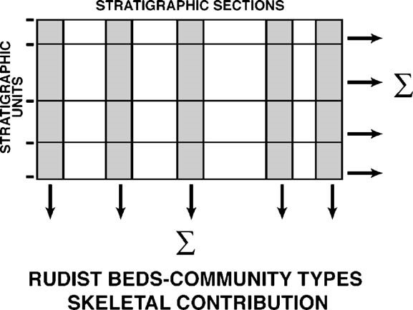

Fig. 1. Sketch diagram illustrating the method used for quantifying the stratigraphic contribution of rudist beds, community types, and their corresponding skeletal contribution.

given sediment (Masse, 1976; Amico, 1977; Petta, 1977; Scott, 1990).

Shell/matrix relationships were measured on polished slabs (Gili, 1992; Gili and Skelton, 2000; Vilardell and Gili, 2003; Go¨tz, 2003; Fenerci-Masse et al., 2004), yielding in % the packing density (number of individuals per surface unit) or coverage (horizontal surface occupied by shell material and/or shell+body cavity).

Actually the foregoing approaches did not provide estimates on carbonate production sensu stricto, i.e. the amount of bioprecipitated CaCO3 in a given time interval on a given surface, but merely reflect the proportion of rudist shell material at various scales, relatively to other skeletal or non-skeletal elements. Sclerochronological analyses of isotopic and geochemical compositions have been used successfully for interpreting growth rates and the corresponding annual carbonate production of individual rudist shells (Steuber, 1996, 1997; Steuber et al., 1998; Rauch and Steuber, 2002) including extrapolation to community production (Steuber, 2000). The method provides a rough estimate of the potential production.

In order to quantify the role of rudists in the overall inner platform sedimentation, requieniid-dominated communities from the Late Barremian of Provence (SE France) (Masse, 1976; Fenerci-Masse et al., 2004) were investigated by addressing the following aspects.

The stratigraphic contribution of rudists, i.e. the quantitative role ofrudist-rich beds invertical successions and regional stratigraphic units, was estimated for individual rudist communities, then derived for the rudist material in general. The skeletal contribution, i.e. the proportion of shelly elements produced by rudists, was quantified for each community and their adjacent (vertical and lateral) sediments, and then evaluated for stratigraphic successions and regional stratigraphic units. Fig. 1 illustrates the methods used for the foregoing quantitative approaches. Carbonate production i.e. amount of CaCO3 ka1 m2 derived from shell growth was calculated by assessing bed durations based on Milankovitch cyclicity and accumulation rates, for each community.

The corresponding results are discussed relatively to earlier investigations on skeletal production of rudists obtained after distinctive proxies, and data from modern bivalves thriving in shallow tropical environments. Special attention was paid to comparisons with modern coral reefs.

2. Regional stratigraphical and palaeogeographical framework

The Lower Cretaceous succession of Provence consists of platform carbonates the age of which range from Valanginian to Early Aptian (Masse, 1976). The Provence platform occurs on the south side of the Vocontian Basin, which represents the western extent in S.E. France of the Alpine basin (Fig. 2). Northward progradation, punctuated by southward backstepping linked to

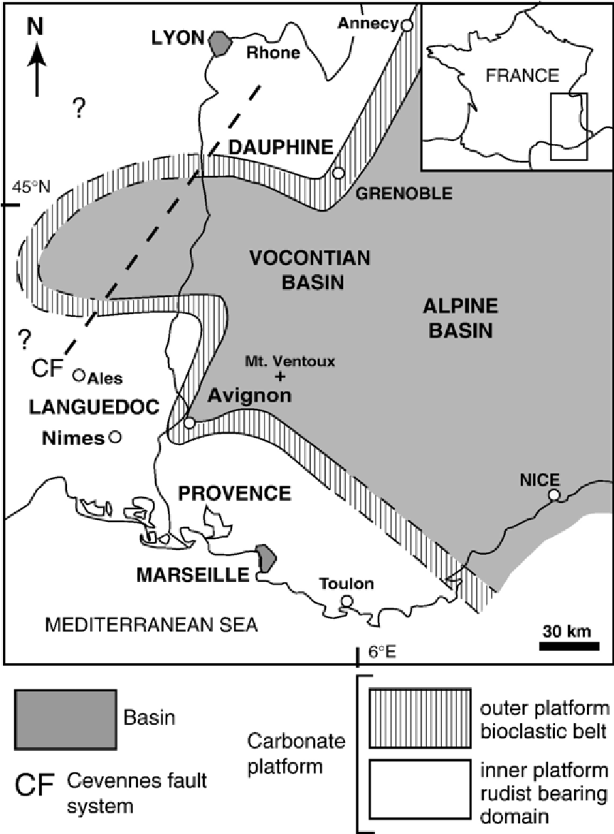

Fig. 2. Palaeogeographical configuration of SE France during the Late Barremian. West of the Ce´vennes fault system, Lower Cretaceous deposits were removed by the Mid-Cretaceous uplift. Notice the wide extent of the rudist-bearing domain compared to the narrow bioclastic belt.

drowning events, is dominant from Valanginian to Barremian. The Late Barremian is marked by the maximum northward platform spreading (Fig. 3).

The Marseille region represents at that time the inner domain of the so-called Urgonian platform. In this region, from Cassis to Martigues, the so-called bUrgonian FormationQ begins with bioclastic coral beds ascribed to the Hauterivian–Barremian transition, grading upward to rudist-dominated beds, capped by a drowning discontinuity ascribed to the Late Barremian Giraudi zone (Masse, 1976; Ropolo et al., 1998) (Fig. 4).

The studied interval, the so-called bBoumandariel sequenceQ (after the name of the Boumandariel bight, near Sausset-les-Pins) (Fenerci-Masse et al., 2005) (Fig. 5), is nearly 27 m thick, and is located in the topmost part of the Urgonian, in the Barremian (total thickness c. 350 m). The presence in this interval of Palaeodictyoconus actinostoma Arnaud Vanneau and Schroeder and Paracoskinolina maynci (Chevalier) documents a Late Barremian age (Arnaud et al., 1998). Calcareous algae Hensonella urladanasi (Conrad et al.), Apinella hispanica (Conrad and Grabner) and Falsolikanella nerae (Dragastan, Bucur and Demeter) found in the upper part of the sequence corroborate this age assignment (Masse, 1993). The Boumandariel sequence is bound by two distinctive discontinuity surfaces found throughout the Marseille region (Fig. 6) (Masse, 1976; Masse et al., 2001; Fenerci-Masse et al., 2005): the lower bounding surface (E1) (see Fig. 5) is a wellmarked, karstified exposure surface; and the upper bounding surface (E5) (see Fig. 5) is a calcrete horizon included within a microcoprolite bed (Favreina, Pethrocoprolithus), otherwise called the Pethrocoprolithus horizon (Masse, 1966).

Moreover 3 more exposure surfaces (E2, E3, E4) have been recognized within the Boumandariel sequence, so that in total 4 stratigraphic units can be defined (ascribed to parasequence sets), labelled 1 to 4. Unit 4 is characterized by the first occurrence (FO) of two calcareous green algae: F. nerae and Carpathocodium sp., with a regional biostratigraphical significance. Stratigraphic correlations in the Boumandariel sequence show the presence 14 laterally correlatable rudist bed sets labelled R1–R14 (Fig. 7), and these can be observed in wide areas or even throughout the Marseille region.

The reconstruction of the stratigraphic architecture of rudist beds was based on the study 7 sections distributed along a 46 km wide transect from Martigues to the Cassis-La Bedoule area (Fig. 7), the lateral spacing of which varies from 6.7 to 15 km. Stratigraphic correlations are based on facies types: including rudist-free and rudist-rich (i.e. community types) beds and key stratigraphic surfaces, mainly exposure surfaces (see above) (Fenerci-Masse et al., 2005).

|  |
| --- |
| Fig. 3. Stratigraphic cross section of the Early Cretaceous platform carbonates from Provence showing the Barremian maximum regional spreading (see Fig. 6 for the geographic location of the transect). |

From a stratigraphic point of view rudist beds consist of decimetre to metre thick beds having a significant lateral continuity with rudist congregations or even rudist fragments playing a prominent physiognomic role. This role refers to dominance and density, e.g. beds having less than 1 individual m2 are excluded from our definition and fossil rich beds where rudists are subordinate (e.g. coral beds) are excluded as well. Four types of rudist assemblage within these beds have been defined, based on quantitative biological and sed-

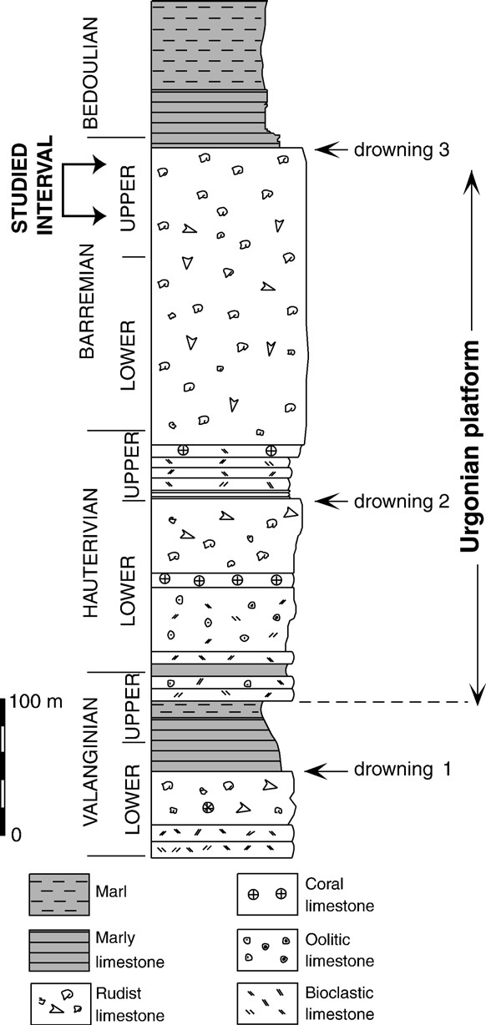

Fig. 4. Stratigraphic section of the Early Cretaceous platform carbonates from the Marseille region, showing the distribution of rudistbearing limestones.

imentological parameters (Fenerci-Masse et al., 2004) (Fig. 8):

type 1: small thin shelled rudists within wackestone, type 2: small rudists within packstone, type 3: mixed small and large rudists within packstone and grainstone, type 4: large rudists within grainstone.

Their dominant components are the Requieniidae represented by various Requienia and Toucasia species.

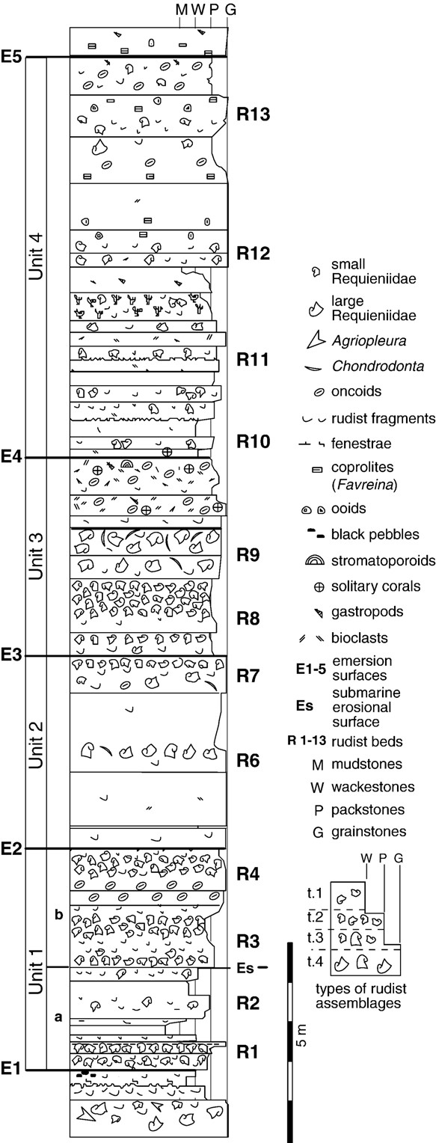

Fig. 5. Type section of the Boumandariel sequence at Sausset-les Pins showing the stratigraphic units 1 to 4 and their bounding surfaces E1 to E5.

|  |
| --- |
| Fig. 6. Study area and location of the investigated stratigraphic sections. |

Monopleuridae, Monopleura and Agriopleura, are subordinates.

Rudist-free sediments include inter-supratidal and subtidal facies. Supratidal and intertidal facies are represented by fenestrate mudstones, stromatolites, miliolid wackestones and gastropod-miliolid wackestones (Masse et al., 2003). Subtidal facies include: peloidal-bioclastic, coprolite (Favreina), oncoidal/ooidal or Bacinella-rich packstones and grainstones; digitate microbial structures are locally present.

1. Quantitative contribution of rudist beds instratigraphic entities

This section addresses the quantification of rudist beds at vertical and horizontal scales and deals with the following aspects: the stratigraphic contribution of rudists based on the cumulative thickness of rudist beds, expressed in percentage of the total thickness, evaluated for each of the 7 study stratigraphic sections, and for each of the 4 stratigraphic units of the Boumandariel sequence; and the contribution of the 4 rudist communities, expressed in %, was also estimated after their cumulative thickness in each stratigraphic unit, then for the total of rudist-bearing beds. 3.1. Total rudist stratigraphic contribution

For individual sections the stratigraphic contribution of rudist beds (Table 1) fluctuates from 22% (La Bedoule) to 71% (Jas de Laure). Low values (b25%) characterize La Bedoule and Le Merlan, whereas relatively high values (z43%) are found in the other localities.

Estimates performed for each stratigraphic unit expected to provide a more realistic picture, show the following results (Table 2): for unit 1, the stratigraphic contribution of rudists beds fluctuates from 37% (Le Merlan) to 80% (Jas de Laure), and the average is 59%; for unit 2, it ranges from 12% (La Bedoule) to 88% (Jas de Laure), compared to unit 1 the average decreases to 47%; for unit 3, its value is between 11% (La Bedoule) to 87% (Jas de Laure), compared to unit 2 the average increases to 56%; and for unit 4, it fluctuates from 10% (Cassis) to 56% (Jas de Laure), compared to unit 3 the average drops down to 32%.

3.2. Stratigraphic contribution of rudist communities

The relative proportion of community types to the overall stratigraphic contribution of rudist beds (Table 1), community 2 has the highest record (50%) then followed by community 4 (28%), and community 3 (15%), community 1 having the lowest record (7%).

Per unit distribution of community types (Table 3) relative to both rudist-free sediments and rudist beds tends to corroborate the above picture. Community 2 has the highest record 24% (16.5% to 37.8%) followed by community 4, with 13% (6.3% to 20.4%). The record of community 3 is 7% (1.4% to 12.6%). As expected the record of community 1 is low 3% (0.3 to 5.2%). Referring to stratigraphic units community 1 has its highest contribution in unit 3 and community 3

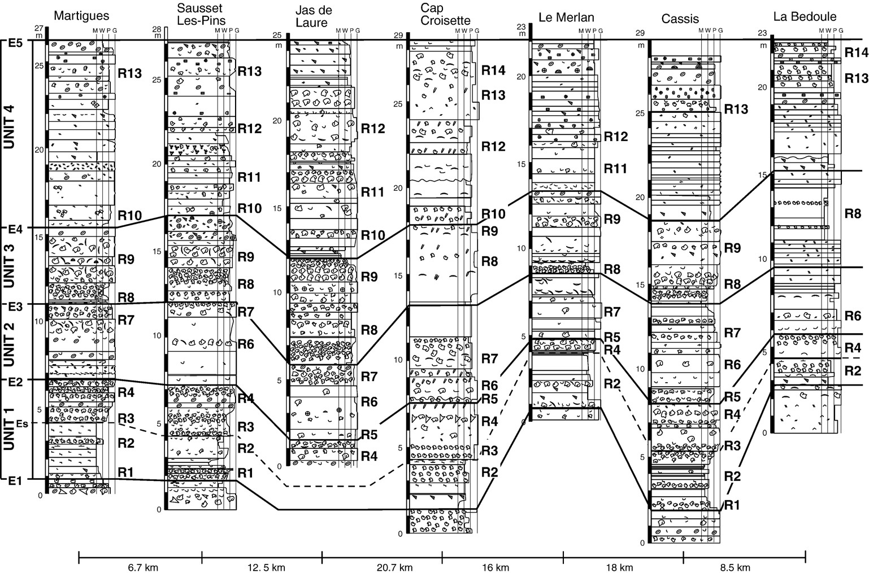

Fig.7.StratigraphiccorrelationpaneloftheBoumandarielsequenceintheMarseilleregion.

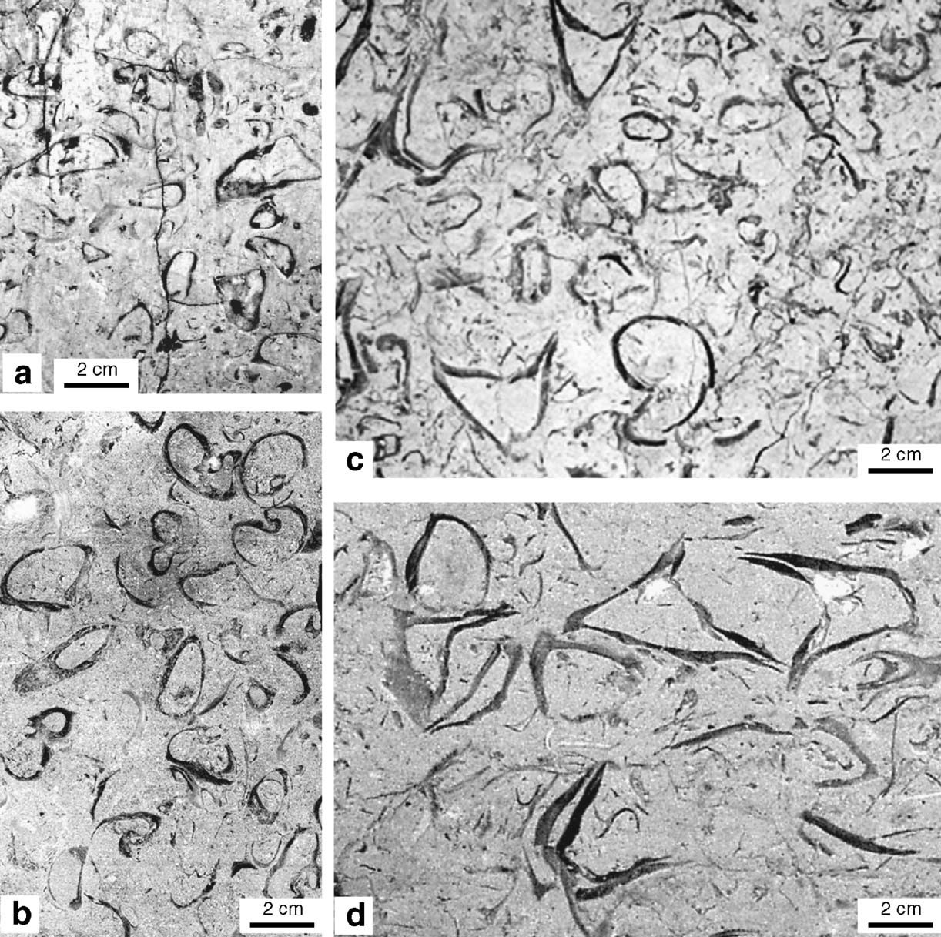

Fig. 8. Rudist community types. (a) Community type 1 with small thin-shelled forms. (b) Community type 2 with small requieniids. (c) Community type 3 with small and large forms. (d) Community type 4 with large monopleurids and requieniids. (a) natural outcrop, (b, c, d) polished slabs.

as well. Community 2 has its highest record in unit 1 whereas community 4 has its highest record in unit 2. Therefore each unit tends to have a distinctive dominant community type.

4. The skeletal contribution of rudists

In this chapter, our intent is to address the quantification of the skeletal contribution of rudists with different methods and scales. The basic data are the macro and microskeletal contribution of rudists evaluated for each community type in their associated depositional facies, by using the results of Fenerci-Masse et al. (2004). The foregoing results are used for the quantification of the skeletal contribution of rudists for vertical stratigraphic successions, then for horizontal stratigraphic units.

Table 1

For individual stratigraphic sections are given: the stratigraphic contribution of rudist community types, total rudists and their corresponding skeletal contribution

|  |  |  |  |  |  |  |  |  |  |
| --- | --- | --- | --- | --- | --- | --- | --- | --- | --- |
|  | Martigues | Sausset-les  Pins | Jas de  Laure | Cap  Croisette | Le Merlan | Cassis | La Bedoule | Average regional contribution | % relative to total rudists |
| Community 1 (%) | 4 | 2 | 2 | 2 | 1 | 6 | 3 | 3 | 7 |
| Community 2 (%) | 26 | 31 | 25 | 27 | 7 | 20 | 16 | 24 | 50 |
| Community 3 (%) | 8 | 4 | 16 | 6 | 5 | 8 | 0 | 7 | 15 |
| Community 4 (%) | 5 | 7 | 28 | 18 | 11 | 11 | 3 | 13.5 | 28 |
| Total stratigraphic contribution of rudists (%) | 43 | 44 | 71 | 53 | 24 | 45 | 22 | 43.1 |  |
| Skeletal contribution of rudists (%) | 14.4 | 14.9 | 18.7 | 16 | 8.9 | 14.2 | 9.7 | 13.8 |  |

Values of each community type are translated in % of total rudists. Stratigraphic and skeletal contributions are integrated at a regional scale.

Table 2

Stratigraphic contribution of rudist beds (% of bed thickness) per stratigraphic unit and averages

|  |  |  |  |  |  |  |  |  |
| --- | --- | --- | --- | --- | --- | --- | --- | --- |
| Martigues Sausset-les Pins Jas de Laure Cap Croisette Le Merlan Cassis | | | | | | La Bedoule | Average | |
| Unit 1 51 57 80 71 37 69 | | | | | | 49 | 59 | |
| Unit 2 39 31 88 67 37 57 | | | | | | 12 | 47 | |
| Unit 3 83 58 87 34 29 74 | | | | | | 11 | 56 | |
| Unit 4 24 38 56 46 11 10 | | | | | | 26 | 32 | |
| Table 3  Per unit stratigraphic distribution of rudist community types (% of thickness) and integration for each community type | | | | | |  |  | |
|  | Unit 1 | Unit 2 | Unit 3 | | Unit 4 | | Total | |
| Community 1 | 4.1 | 0.3 | 5.2 | | 1.7 | | 3 | |
| Community 2 | 37.8 | 18.5 | 23.2 | | 16.5 | | 24 | |
| Community 3 | 1.4 | 7.9 | 12.6 | | 5.8 | | 7 | |
| Community 4 | 15.7 | 20.4 | 11.7 | | 6.3 | | 13 | |
| Table 4  Percentage of rudist skeletal material of community types content, micro: microskeletal content refered to 100% of th |  | and their adjacent subtidal and intere sedimentary matrix) |  | | to supratidal sediments (macro: macros | | keletal | |
|  | | Total | | Macro | | | | Micro |
| Community 1 | | 24.6 | | 11.2 | | | | 15.1 |
| Community 2 | | 31.5 | | 18.3 | | | | 16.1 |
| Community 3 | | 26.8 | | 17.5 | | | | 11.2 |
| Community 4 | | 19.2 | | 11.8 | | | | 9.8 |
| Subtidal sediments | | 5 | | 0 | | | | 5 |
| Inter-supratidal sediments | | 1 | | 0 | | | | 1 |

4.1. The skeletal contribution of rudists to depositional facies

Rudist beds and their corresponding communities include both macroskeletal elements, i.e. whole shells or large fragments investigated after field photographs and quantified by image analysis (by OPTILAB software), and microskeletal rudist derived components quantified by point counting on thin sections. Aside rudist fragments the sandy fraction of the sedimentary matrix is dominated by peloids, foraminifera (mainly miliolids) being subordinate. The integration of estimates obtained from these two scales provides the total skeletal contribution for each rudist community type (Fenerci-Masse et al., 2004). The same procedure has been applied to rudist-free sediments capping or surrounding rudist-rich ones.

Community 2 has the highest record, 31.5%, due to relatively high values for both macro and microskeletal elements, then followed by community 3, 26.8%, the macroskeletal content (17.5%) being higher than the microskeletal one (11.2%) (Table 4). Communities 1 and 4 possess similar values for macroskeletal contents (11.2 versus 11.8%) whereas they differ in their microskeletal values (15.1 versus 8.4%), therefore the total skeletal contents are different (24.6 instead of 19.2%, respectively).

In the sediments adjacent to rudist communities the shell material derived from these bivalves is essentially represented by microskeletal components. In inter- to supratidal sediments this category is usually less than 1%, whereas significant amounts, 4–5%, are found in the subtidal ones.

4.2. The skeletal contribution of rudists in stratigraphic successions

For a given stratigraphic section, estimates of the skeletal contribution are based on: the cumulative thickness of rudist-rich beds referred to community types, and rudist-free beds referred to subtidal and inter- to supratidal sediments, the skeletal contribution for each facies type, and total thickness, by using

X6 ½Cumulative thickness skeletal contribution of rudist

¼ Stratigraphic skeletal contribution ð1Þ

Total thickness

i¼1

i=1; community 1, i=2; community 2, i=3; community 3, i=4; community 4, i=5; subtidal sediments, i=6; intersupratidal sediments.

The skeletal contribution fluctuates from 9.7% (La Bedoule, Le Merlan) to 18.7% (Jas de Laure), in close correspondence with the stratigraphic contribution of rudist beds (Fig. 9). The linear relationship (R2=0.959, p=0.001) between the two kinds of estimates gives a clue for predicting the skeletal contribution from the stratigraphic contribution of rudist beds and vice versa.

4.3. The skeletal contribution of rudists in stratigraphic units

Rudist beds tend to be laterally continuous over several tens of kilometres whereas rudist bodies, with a distinctive association of community types, have a more limited spatial extent (Fenerci-Masse et al., 2005). Communities 1 and 2

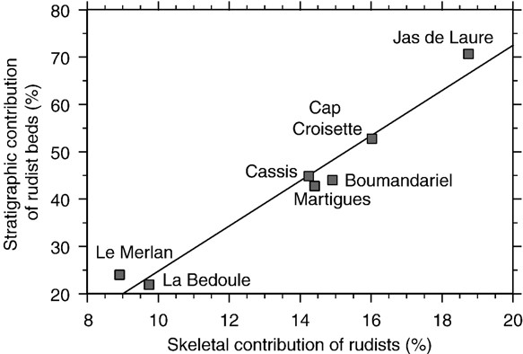

Fig. 9. Relationships between the stratigraphic contribution of rudist beds and the skeletal contribution.

Table 5

Skeletal contribution per module evaluated after: quantitative data for lateral dimensions and spacing of rudist bodies, lateral dimensions of modules, standard bed thickness and the skeletal contribution of rudist community types and adjacent rudist-free sediments

|  |  |
| --- | --- |
| Rudist bodies Module (m) Standard Skeletal  Lateral dimensions Spacing Bed thickness Skeletal contribution (m) (m) (m) contribution of rudist-free  (%) sediments (%) | Skeletal contribution  per module (%) |

Community 1 1250 (1000–1500) 1750 (1500–2000) 3000 0.17 24.6 1 10.8

Community 2 3000 0.29 31.5 1 13.7

Community 3 3000 3500 (3000–4000) 6500 0.70 26.8 5 15.1

Community 4 6500 0.70 19.2 5 11.6

Bold entries are the result expected from the data.

are usually associated within rudist beds interbedded with rudist free intervals including significant proportions of inter- to supratidal muddy sediments. Communities 3 and 4 are closely linked in rudist beds including significant portions of subtidal grainy sediments.

Average lateral dimensions of rudist bodies corresponding with communities 1 and 2 on one hand, and 3 and 4 on the other hand, and their spacing are summarized on Table 5 (Fenerci-Masse et al., 2005). Owing to the variability of values for lateral dimensions of communities 1 and 2, and the spacing of both groups of communities, we used average values for our calculations. For estimating the skeletal contribution of rudists at a stratigraphical scale, we propose a model including the following ingredients: the average lateral dimension of rudist patches, the average lateral dimension of rudist-free sediments adjacent to a rudist patch (=spacing between patches), the average lateral dimension of a module (Fig. 10) including a rudist patch and its adjacent sediment, and skeletal contribution (see above).

For each module the total skeletal contribution (%), is given by:

ðlateral dimension rudist body skeletal contributionÞþðlateral dimension rudist free skeletal contributionÞ

lateral dimension of module ¼ Skeletal contribution per module:

# ð2Þ

The maximum value is recorded for community 3 (15.1%), then followed by community 2 (13.7%), communities 4 and 1 having relatively low, nearly identical values (11.6% and 10.8% respectively), the average being 12.8%.

To estimate the total skeletal stratigraphic contribution, for a given stratigraphic succession and its corresponding regional cross section, the skeletal contribution of individual rudist communities is combined with total thickness, and thickness of a given rudist bed with a specific community type by using:

X4

ðbed thickness of a community type per module skeletal contributionÞ

total thickness

i¼1

¼ total skeletal stratigraphic contribution: ð3Þ

Applying this quantitative proxy to a sediment package including the 4 community types, each with a bed thickness corresponding with the standard values established earlier (Table 5) and therefore a total thickness of

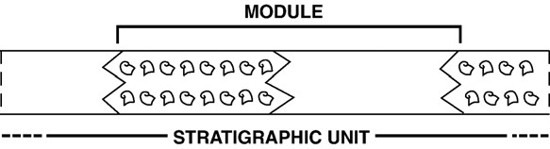

Fig. 10. Sketch diagram showing the stratigraphic significance of a bmoduleQ including laterally adjacent rudist-rich and rudist-free sediments, the relative dimensions of which depend on community types.

1.86 m, the total stratigraphic skeletal contribution is 13.2%. This value is very close to those based on averaging the estimates per module (12.8%) (see above).

|  |
| --- |
| Fig. 11. Cyclostratigraphy (Milankovitch cycles) of unit 1 of the Boumandariel sequence based on palaeobathymetric interpretation, and cycle durations (E1, E2 refer to major exposure surfaces). |

For a stratigraphic unit departing from the above model the corresponding value will be: low when the cumulative thickness of rudist-free beds is high, especially for inter-supratidal ones, relatively modest when

the cumulative thickness of communities 1 and 4 is high, with a maximum of 11.6%, and high when the cumulative thickness of communities 2 and 3 is high, with a maximum of 15.1%.

5. Carbonate production of rudists

Estimating volume or weight of carbonate produced by rudist shells on a given surface during a given time span requires the evaluation of durations of stratigraphic intervals. Cyclostratigraphic investigations, i.e. the search for bedding cyclicity and stacking hierarchies reflecting Milankovitch cycles, mainly eccentricity (100 ka) and precessionnal (20 ka) cycles (Berger and Loutre, 1994) were performed for this purpose on unit 1 of the Boumandariel sequence (thickness range 3.8 to 6.4 m).

This peritidal unit is bound by two exposure surfaces and includes a set of elementary sequences with subtidal, intertidal and supratidal deposits. Our cyclostratigraphic interpretation derives from a palaeobathymetric curve based on the Masse et al. (2003) model. The boundaries of precessionally forced sediment cycles are located at discontinuity surfaces corresponding with abrupt negative palaeobathymetric excursions, i.e. inter-supratidal sediments abruptly overlying subtidal ones. This implies for each cycle a limited depositional hiatus in the sedimentary record, by contrast with most of the cyclostratigraphic models dealing with peritidal carbonates including long lasting exposure surfaces (e.g. Drummond and Wilkinson, 1993; Anderson, 2004). Our model matches the 5/1 stacking pattern predicted for precessional cycles bundled in one eccentricity cycle (Goldhammer et al., 1987, 1990; Strasser, 1994; Anderson, 2004). Bed thickness of the interpreted precessional cycles fluctuates from 0.5 to 1.8 m and increase upward when reaching the 100 ka cycle peak (see Anderson, 2004). The corresponding eccentricity cycle fluctuates regionally from 3.8 to 6. 4 m. This thickness is in the range of those proposed from eccentricity cycles of Cretaceous platform carbonates (Strasser, 1994; D’Argenio et al., 1997; Buonocunto et al., 1999; Strasser et al., 2000; Sandulli, 2004; Anderson, 2004) or their Triassic equivalents (Haas, 1994), generated in an overall greenhouse world. These values are corroborated by duration estimates deduced from the combination of biostratigraphic dating and radiochronological data. In the Marseille area the drowning of the Barremian platform is ascribed to the Giraudi ammonite zone (Ropolo et al., 1998), therefore the Upper Barremian succession underlying this drowning discontinuity represents only the Vandenheckii–Feraudianus interval. The duration of the time span in question is 2.27 Ma for Hardenbol et al. (1998) and the corresponding sediments 140 m thick (Masse, 1976), which means 6.0 m an average by eccentricity cycle in this interval. The palaeobathymetric amplitude of each precessional unit is in the range of the eustatic fluctuations (1–2 m) predicted for a greenhouse world (Schulz and Scha¨fer-Neth, 1997), notwithstanding subsidence control cannot be overlooked (Drummond and Wilkinson, 1993) and compaction of underlying beds as well (Hunt et al., 1995; Masse et al., 2001) for additional accommodation. Fig. 11 shows that for each precessional cycle bed thickness is relatively small (b1 m) when dominated by communities 1 and 2 and relatively high (N1.5 m) when dominated by communities 3 and 4. This pattern, related to palaeobathymetry (Masse et al., 2003) also reflects distinctive accumulation rates for each group of communities, community 1 having the lowest rate and community 4 the highest.

Because compaction was not considered as a significant factor for bed thickness reduction in the studied sequence (see discussion in Masse et al., 2003) we used the present-day bed thickness for estimating accumulation rates. Moreover owing to the absence of blonglastingQ exposure surface we regarded the sedimentary record as continuous. bLong-lastingQ exposure surfaces identifying sequence boundary are bracketing the reference stratigraphic succession whereas ephemeral exposure surface (e.g. topmost part of fenestrated horizons, polygonally cracked surfaces associated with mudstones) punctuate the succession, mainly the lower half. Forward modelling investigations on the study sequence using Dionisos software (work in progress) suggest accumulation rates in the range of 0.03 m ka1 for community 1 to 0.10 m ka1 for community 4 (Table 6). It is worth noting that by using decompaction techniques (e.g. with an average 50% reduction of the original thickness) to reconstruct the original thickness (Strasser and Samankassou, 2003) may increase the corresponding accumulation rates by a factor 2. Similarly including sedimentary gaps, e.g. averaging 50% of the elapsed time, may also increase the corresponding accumulation rates by a factor 2. Whatever the scenario used for the calculation of accumulation rates, the values are

Table 6

Accumulation rates for sediments associated with communities 1 to 4, based on 3 senarios (see text for details)

|  |  |  |  |
| --- | --- | --- | --- |
|  | Scenario 1  (m ka1) | Scenario 2  (m ka1) | Scenario 3  (m ka1) |
| Community 1 | 0.03 | 0.06 | 0.12 |
| Community 2 | 0.05 | 0.10 | 0.20 |
| Community 3 | 0.07 | 0.14 | 0.28 |
| Community 4 | 0.10 | 0.20 | 0.40 |

Table 7

Production rates of CaCO3 precipitated by rudist communities (in kg m2 ka1) based on 3 senarios, scenario 1 regarded the most consistent

|  |  |  |  |
| --- | --- | --- | --- |
|  | Scenario 1 | Scenario 2 | Scenario 3 |
| Community 1 | 19 | 38 | 76 |
| Community 2 | 41 | 82 | 164 |
| Community 3 | 49 | 98 | 196 |
| Community 4 | 50 | 100 | 200 |

Bold entries in scenario 1 are considered the more relevant data.

far less than those reported for Holocene shallow water platform carbonates (e.g. Florida, Bahamas) fluctuating from 0.3 to 3 m ka1, and at the lower end of values for Kimmeridgian–Berriasian lagoonal sediments, 0.07 to 0.6 m ka1, the calculation of which involved decompaction (Strasser and Samankassou, 2003).

The production of carbonate for each rudist community is estimated by using the following parameters: the skeletal contribution of rudists to the sediment in %, which means that the production in question represents the net production, i.e. the gross production minus the material destroyed by various agents (see Discussion below), the corresponding accumulation rate, and the density of precipitated CaCO3, 2.6 g cm3 (a value retained by Steuber, 2000 for rudist shells).

The results, expressed in kg m2 a1, are calculated as follows. accumulation rate 2:6 103 ðm ka1Þ kg m3

skeletal contribution of rudists 1 m2 ð Þ%

¼ rudist production: ð4Þ

kg ka1

Table 7 documents production values obtained for each rudist community and acknowledges the 3 scenarios discussed above, referring to the mode of calculation of accumulation rates. The following will focus on values obtained for scenario 1 (implying no compaction nor sedimentation gap effects) regarded the most consistent. The highest value (50 kg m2 ka1) was obtained for community 4, by community 3, (49 kg m2 ka1) and community 2, (41 kg m2 ka1), community 1 having the lowest value (19 kg m2 ka1). 6. Comparisons

Comparisons with present day living communities require reference to production rates estimated at a biological scale (Smith, 1983) based on the metabolic activity of organisms, or biomass increase. Individual growth rates have also been evaluated for both modern and fossil bivalves. The method used herein for evaluating the CaCO3 production of rudist communities relates to a geological scale (Smith, 1983), based on the measure of accumulated carbonate divided by the estimated time increment over which that material accumulated; a proxy successfully applied for instance to the study of Holocene coral-reef accretion.

6.1. Comparisons with result obtained for rudists by using individual growth rates

Estimates of annual rates of shell accretion based on d18O and Mg cycles obtained for Requienia ammonia (a key species for community 4) from the Upper Barremian of Orgon (SE France) amount to 70 mm (Rauch and Steuber, 2002). Plasticine models of such R. ammonia were made and used to measure a volume of shell material of about 45 cm3, equivalent to 0.12 kg a1. This value is relatively high if compared to those obtained for Upper Cretaceous Hippuritidae and Torreitidae (0.012 to 0.075 kg a1) but comparable to that of the Campanian Vaccinites ultimus, (0.14–0.21 kg a1) (Steuber, 2000). Annual shell accretion of Hippuritidae has been used for modelling the production rates of rudist assemblages (Steuber, 2000). For example dense communities of Vaccinites have a potential rate of 8.9 to 35.7 kg m2 a1, whereas loose assemblages are expected to produce 2.2 to 8.9 kg m2 a1. Steuber has emphasized the need to distinguish between carbonate production by individuals, potential community production and estimated community production which is less or even far less than that of the potential one. Estimated community production fluctuates from 25 kg m2 a1 for outer bank bioconstructed bodies to 5.0 kg m2 a1 for inner bank assemblages, and drops to 2 kg m2 a1 in lagoonal settings. These values are in correspondence with taxonomic composition and average shell size.

The above estimates are higher than those obtained for the Barremian requieniid-dominated communities by a factor exceeding 100 to 250. Requieniidae with a clinger life habit (sensu Skelton and Gili, 2002) actually differ from Hippuritidae with an elevator life habit (sensu Skelton and Gili, 2002) in having a more reduced packing density and therefore a more limited standing crop. These differences cannot account for the strong dissimilarities in CaCO3 production, they are more likely the consequence of using a geological rate instead of a biological one for estimating CaCO3 production.

6.2. Comparisons with results from modern bivalves

Data provided by Richard (1982, 1985) on Tridacna maxima (Ro¨ding), Chama iostoma Conrad and Cardium fragum Linne´, thriving in atoll lagoons from French Polynesia and playing an important role in production, are summarized on Table 8 concerning average adult size, annual size increase, life span, number of individuals by m2 and annual CaCO3 production (ka m2) at community level.

These bivalves may be used as potential ecological equivalents (Odum, 1971) for requieniid rudists. The epifaunal taxa T. maxima and C. iostoma represent K demographic strategists sensu Birkeland (1977, 1988), i.e. forms with a relatively long life span and reduced shell growth rates. Large to medium size Requieniidae associated with communities 3 and 4, are somewhat similar, whereas they were sediment-dwellers instead of being attached to hard substrates as the Chama and Tridacna species in question. Assuming that the shell growth rate estimated for R. ammonia (see above) may be a valuable reference for large rudists in general found in community 3 (pars) and 4, the corresponding growth rates of T. maxima and C. iostoma are far less. Moreover the spatial densities of these two species are drastically lower than those of the requieniids. Notwithstanding these strong dissimilarities the estimated CaCO3 production is very similar. This similarity is most likely the result ofcontrasting methodologies used for approaching carbonate production rather than ecological affinities between the Barremian and modern investigated bivalves. Values obtained for living mollusc communities were based on 2 years survey excluding episodic biological breaks (diseases, trophic crisis, storm events, etc.) (Richard, 1982). By contrast estimates obtained for Barremian communities were based on reference durations in the range of 10 to 20 ka including necessarily ecological variability and therefore numerous episodic interruptions in the development of rudist communities,

Table 8

Table 9

Quantitative ecological data on Barremian Requieniidae-dominated communities and CaCO3 production

|  |  |  |  |
| --- | --- | --- | --- |
|  | Size  (cm) | Individuals  (m2) | Annual production  kg m2 |
| Community 1 | 0.8–1.0 | 1030 | 0.02 |
| Community 2 | 1.3–1.4 | 1650 | 0.04 |
| Community 3 | 3.2–3.3 | 380 | 0.09 |
| Community 4 | 3.6–4.0 | 170 | 0.05 |

which represent time averaging of equivalent even noncontemporaneous elements (Kidwell and Behrensmeyer, 1993).

Notwithstanding its endofaunal mode of life, which differs from that of the Requieniidae, Cardium fragum might be used as a possible analogue for small requieniids associated with communities 1 and 2, assumed to represent r strategists (short life span and fast growth rate). As shown in Table 8 the highest annual CaCO3 production of lagoonal bivalves is due to this species, a feature departing from that of small requieniids having the lowest production (by a factor 10). Another contrasting featureis the numberof individuals by m2 (see Tables 8 and 9), far less for modern Cardium than for Barremian forms. This may be due to the integration of several noncontemporaneous generations, at least in part. Actually several lines of evidence tend to focus on significant dissimilarities between small requieniids and modern lagoonal Cardium communities, especially in terms of demographic strategies. Communities with small Requieniidae merely represent slow growing communities in a stressing environment rather than fast growing assemblages with r strategies. As for the Tridacna– Chama reference model comparisons between the production values estimated for communities surveyed at pluri-annual scales and those investigated at the scale of 10 to 20 ka are poorly consistent.

|  |  |  |  |  |  |  |  |  |  |  |  |  |  |  |  |  |  |  |  |  |  |  |  |  |
| --- | --- | --- | --- | --- | --- | --- | --- | --- | --- | --- | --- | --- | --- | --- | --- | --- | --- | --- | --- | --- | --- | --- | --- | --- |
| Quantitative ecological data and CaCO3 production of modern living bivalves   |  |  |  |  |  |  | | --- | --- | --- | --- | --- | --- | |  | Average size  (cm) | Annual size increase (cm) | Life span  (years) | Annual CaCO3 production  kg m2 | Individuals  m2 | | Tridacna maxima | 10 | 1–1.15 | 11–12 | 0.02–0.03 | 1–5 | | Chama iostoma | 6 | 0.7 | 20 | 0.03 | 1–2 | | Cardium fragum | 3.5 | 1.4 | 3–4 | 0.20 | N200 | |

To conclude, the foregoing comparisons tentatively suggest that for short durations, equivalent to a limited number of generations (cohorts), the carbonate production of requieniid communities may have been significantly higher than those of modern lagoonal bivalves.

6.3. Comparisons with modern coral reefs

Rudists have been considered by some authors as the primary frame builders of the Cretaceous, and that, in doing so, they competed with and excluded hermatypic corals from reefal biotopes (Kauffman and Johnson, 1988). Alternative models proposed by Carannante et al. (1993) and Gili et al. (1995) emphasize their constratal (instead of superstratal) mode of life in sedimentdominated substrates without production of significant skeletal frameworks. Whatever the foregoing hypothesis, rudists have been regarded important carbonate producers by many workers (see introductory chapter) and therefore compared, in this respect, with modern coral reefs (e.g. Steuber, 2000).

Estimates for the net calcification rates referring to the metabolic activity of coral communities vary from 4 kg CaCO3 m2 a1 (Kinsey, 1983) for reef flat areas, to 1.0–1.2 kg m2 a1 for reefs in general (Smith, 1983). As pointed out by Rees et al. (2005) extrapolating the above present-day values of coral reef production (based on the alkalinity method) to the late Holocene is subject to errors. The more accurate way to estimate CaCO3 production is to measure changes in well-dated coral reef sequences. Average rates for Indian Ocean reef flats, for instance, are 2–3 m ka1 for the last 5 ka (Opdyke and Walker, 1992; Rees et al., 2005). Using the nomograph of Smith (1983) to relate vertical accretion to calcification rates, for various porosities, provides estimates in the range of 1.5 and 2 kg m2 a1. These values are 50– 65% less than the calcification rates of the living community. Actually the net production of coral communities represents about 30% of the gross production, i.e. 70% of the bioprecipitated CaCO3 is removed from the production area (Montaggioni, personal communication). The foregoing values refer to the historical phase of coral-reef accretion coeval with or immediately post-dating sea-level stabilization. Prior to this stabilization, from 18,000 to 6000 years B.P., sea-level rose at a mean rate of 10 m ka1 the corresponding carbonate production being 7–10 kg m2 a1 (Masse and Montaggioni, 2000). The geological rate of 1.5–2 kg m2 a1 for the CaCO3 production of recent coral reefs (i.e. bioconstructed bodies younger than 5 ka) compared with the rates of requieniid communities (0.02 kg m2 a1 to 0.09 kg m2 a1) show that the contrasting ecological, morphological and sedimentological behavior of rudist communities compared to the reef coral ones, underlined by Carannante et al. (1993) and Gili et al. (1995) is also obvious in terms of CaCO3 production.

7. Discussion

At a regional scale the stratigraphic contribution of rudist beds, per section, is relatively high (22% to 71%) and also relatively important for regional stratigraphic units (32% to 59%). Among rudist beds, community 2 has the highest regional record (50%), and community 1 the lowest (7%). The relative score of communities observed in vertical sections is also observed in regional stratigraphic units. The skeletal contribution of rudists to the sediment varies in correspondence with community types, from 19.2% to 31.5%. For a given vertical section the skeletal content fluctuates from 8.9% to 18.7% and possesses a linear relationship with the stratigraphic contribution of rudist beds. In strata with a significant lateral continuity (more than several kilometers) the horizontal distribution of rudist rich beds is periodical, with a wavelength depending on community types (Fenerci-Masse et al., 2005). Modules, including laterally adjacent rudist rich and rudist free strata, have specific proportions of rudist rich and rudist free material, also in correspondence with community types. The skeletal content per module fluctuates from 10.8%, corresponding to community 1, to 15.1% in the case of community 3.

The foregoing estimates show that the highest skeletal content, 31.5%, is expected to be found when the entire stratigraphic system is built by community 2, the lowest, 19.2%, when community 4 is exclusive. Actually both vertical and horizontal stratigraphic entities consist of rudist rich and rudist free facies. The encountered values are therefore lower than the above theoretically expected ones.

The foregoing findings document some contrasting, even unexpected, results on the relationships between physiognomic, mainly qualitative and visual, and quantitative aspects, regarding the role of rudists in the Barremian platform carbonates of Provence. The relatively high stratigraphic contribution of rudist (43.1% at a regional scale) corresponds with a relatively modest skeletal contribution (12.8–13.2%). This difference is not only due to the discontinuous stratal distribution of rudist beds (both vertical and horizontal) or to the lack of integration of skeletal elements found in rudist-free beds, but essentially to the internal architecture of rudist beds themselves and the composition of their associated sedimentary matrix.

|  |  |  |  |  |  |  |  |  |  |  |  |  |  |  |  |  |  |  |  |  |  |  |  |  |  |  |  |  |  |  |  |  |  |  |  |  |
| --- | --- | --- | --- | --- | --- | --- | --- | --- | --- | --- | --- | --- | --- | --- | --- | --- | --- | --- | --- | --- | --- | --- | --- | --- | --- | --- | --- | --- | --- | --- | --- | --- | --- | --- | --- | --- |
| Table 10  Framework and sedimentogenetic potential of Barremian rudist communities (see text for details)   |  |  |  |  |  |  | | --- | --- | --- | --- | --- | --- | |  | Packing density  (number individual 100 cm2) | Packing index (%) | Coverage  (%) | Macroskeletal contribution (%) | Microskeletal contribution (%) | | Community 1 | 12 | 7 | 17 | 11.2 | 15.1 | | Community 2 | 14 | 17 | 23 | 18.3 | 16.1 | | Community 3 | 3 | 9 | 23 | 17.5 | 11.2 | | Community 4 | 1 | 4 | 18 | 11.8 | 8.4 | |  | Framework |  |  |  | Sediment | |

Most of the rudist have been preserved in situ (i.e. non-transported) whereas they are not preserved in life position, a feature expected from sediment dwellers suffering toppling effects. This mode of preservation is clearly expressed by the low average values of packingindex (mutually aggregated individuals are usually less than 17%) and appears unlikely to create any rigidity by interlocked biocalcified networks (e.g. Fagerstrom, 1987; Hubbard et al., 2001). Table 10 shows that values for packing density and coverage and their corresponding macroskeletal content are equally unlikely to account for a significant framework potential. The overall layer-cake architecture of rudist beds (FenerciMasse et al., 2005) clearly reflects this absence of bioconstructional power; ascribing the corresponding bodies to brudist reefsQ sensu Johnson and Kauffman (2001) appears therefore inappropriate.

The ability of Barremian rudists to produce sand size grains also looks limited, only 11% to 17% of the sandy fraction forming the substrate of communities derives explicitly from rudists. This potential for producing sediments appears very limited when compared to corals. In modern coral reefs carbonate sands associated with coral buildups (e.g. outer reef slopes, reef flats) usually contain 30–40% of coral fragments (Ginsburg, 1956; Maiklem, 1970; Purdy, 1963; Gabrie´ and Montaggioni, 1982; Masse and Froget, 1984: Masse et al., 1989; Adjas et al., 1990) or even more when considering the gravels frequently mixed with the sandy fraction. Coral derived sandy components play also a significant role (10–20% even 45–48%) in lagoonal settings with coral patches or reticulate lagoon floors (Adjas et al., 1990).

As emphasized by Gili et al. (1995) not only the carbonate production of corals (clonal organisms with an indefinite potential longevity) is expected to be higher than that of rudist bivalves (aclonal organisms with a limited life duration), but also the historical contingencies of rudist bodies and modern coral reefs are strongly different. Modern coral reefs developed in an icehouse world, whereas rudist developed in a greenhouse world. This implies contrasting rates for accommodation, N100 m 10 ka1 for the former instead of 1–2 m 10 ka1 for the latter. The focus on the last 5 ka of coral reef growth nevertheless implies an accommodation rate (see Discussion above) of 1 m ka1 whereas the Barremian one was in the order of 0.01 to 0.1 m ka1.

We are aware that bioerosion may have been an important destructive process for rudist shells (Masse, 1976; Grosheny and Philip, 1989; Sanders, 1999) as it is for corals since the Mesozoic (Perry and Bertling, 2000), and consequently that our estimates for carbonate production s.l. represent only a fraction of the original bioprecipitated skeletal material. Two agents appear to have been important in bioerosion: microborers including: Cyanobacteria, Chlorophyta, Rhodophyta and Fungi, and macroborers, mainly clionid sponges. As shown by Peyrot-Clausade and Chazottes (2000) data on recent corals indicate that clionid sponges may account for 80–90% of the skeletal erosion to produce chips, whereas only 2–3% of the carbonate is dissolved. In situ experiments by the same workers show that on coral reef flats microborers may be responsible for the dissolution of 5–10% of the gross carbonate production. Extrapolation to rudists of the above results obtained for modern corals are speculative but support the idea of a significant carbonate loss of the living community and the taphonomic assemblage as well.

8. Conclusions

In order to quantify the role of rudists in platform sedimentation, rudist-bearing stratigraphic carbonate successions from the Late Barremian of Provence (SE France) have been investigated. A stratigraphic unit, the Boumandariel sequence, 27 m thick on average, extending on a 46-km wide transect in the Marseille area, was analysed after 7 stratigraphic sections, with a spacing between 6.7 to 15 km. Four types of rudist communities (labelled 1 to 4) were defined quantitatively by using biological and sedimentological parameters; Requieniidae are the dominant contributors, Monopleuridae being subordinate.

The stratigraphic contribution of rudists, i.e. the cumulative thickness of rudist beds (expressed in %), estimated on vertical successions and regional stratigraphic units, is relatively high (43.1%) at a regional scale but variable at a local scale. The skeletal contribution of rudists (% of skeletal material) was evaluated for each community type (standard values) then estimated for vertical successions, for which the average value (13.2%) is low. For individual sections the skeletal contribution shows a linear relationship with the stratigraphic contribution of rudist beds. At the scale of stratigraphic regional units, calculations using specific modules (including laterally adjacent rudist rich and rudist free bodies), with horizontal dimensions depending on community types, the overall skeletal contribution is nearly the same (12.8%).

The average regional stratigraphic contribution of rudist community types is low for community 1 (3%) (small thin shelled forms in a wackestone matrix) and community 3 (7%) (mixed small and large forms in a packstone matrix). The highest values were obtained for community 4 (13.5%) (large forms in a grainy matrix) and community 2 (24%) (small forms in a packstone matrix). Referring to rudist beds only, the corresponding values are: 7% for community 1, 15% for community 3, 28% for community 4 and 50% for community 2.

Community types each have a standard skeletal contribution, the lowest (19.2%) is for community 4, then followed by community 1 (24.6%). The highest values were obtained for community 3 (26.8%) and community 2 (31.5%).

Rudist net production was derived from accumulation rates deduced from bed durations, based on Milankovitch cyclicity, mainly the eccentricity (100 ka) and the precession (20 ka) cycles, in the stratigraphic duration (2.27 ma) corresponding with the Vandenheckii– Feraudianus ammonite zones. Sedimentation rates evaluated for each community type, are contrasting: 0.03 m ka1 for community 1, 0.05 m ka1 for community 2, 0.07 m ka1 for community 3 and 0.10 m ka1 for community 4. These values represent the minimum ones, obtained when assuming a continuous sedimentary record and no compaction. Combined with the standard skeletal contributions the above accumulation rates provide the amount of CaCO3 kg m2 ka1 produced at a community level. The highest production (50 kg m2 ka1) was obtained for community 4, then followed by community 3 (49 kg m2 ka1), and community 2 (41 kg m2 ka1), then production drops to 19 kg m2 ka1. Community 4 with a limited standard skeletal contribution and weak stratigraphical role possesses nevertheless the highest production rate.

Comparisons of production rates deduced from present day living communities, e.g. lagoonal bivalves, and late Cretaceous rudists, estimated at a biological scale, are poorly relevant with those obtained at a geological scale, used in the present study. Comparisons with the production of modern coral reefs, using the same geological scaling approach, show that requieniid communities were not only different from corals by their ecological, sedimentological and constructional power, but also by their low CaCO3 net production. Moreover the internal architecture of rudist bodies, with a limited aggregation of individuals, suggests that requieniids were not frame-builders and the corresponding bodies were drastically distinct from brudist reefsQ. Their ability to produce sand grains was also weak, compared to coral buildups. This modest sedimentogenetic potential may derive in part from bioerosion (microborers and clionid sponges), more prone to generate muddy fractions than sands. Nevertheless we regard the contrasting values of coral and rudist production as the result of contrasting accommodation rates, low in the Cretaceous greenhouse world and high in the Holocene icehouse world.

Acknowledgements

We are most grateful to J. Borgomano, L. Montaggioni, J. Reijmer and L. Villiers (Universite´ de Provence, Marseille) for fruitful discussions, comments and advice on the present manuscript. We thank the editors F. Surlyk, P.W. Skelton and an anonymous reviewer for their valuable constructive criticisms on our initial submission.

References

Adjas, A., Masse, J.P., Montaggioni, L., 1990. Fine-grained carbonates in nearly closed reef environments: Mataiva and Takapoto atolls. Central Pacific Ocean. Sediment. Geol. 67 (1/2), 115–132.

Amico, S., 1977. Etude de la structure du test des rudistes. Applications a` la syste´matique a` la pale´obiologie et a` la pale´oe´cologie de ce groupe. Unpublished thesis, University of Marseille-Provence. 90 pp.

Anderson, E.J., 2004. The cycle hierarchy of the bPurbeckianQ Sierra del Pozo section, Lower Cretaceous (Berriasian), southern Spain. Sedimentology 51, 455–477.

Arnaud, H., Arnaud-Vanneau, A., Blanc-Aletru, M.C., Adatte, Th., Argot, M., Delanoy, G., Thieuloy, J.P., Vermeulen, J., Virgone, A., Virlouvet, B., Wermeille, S., 1998. Re´partition stratigraphique des Orbitolinide´s de la plate-forme urgonienne subalpine et jurassienne (SE de la France). Ge´ol. Alpine 74, 3–89.

Berger, A., Loutre, M.F., 1994. Astronomical forcing through geological time. In: De Boer, P.L., Smith, D.G. (Eds.), Orbital Forcing and Cyclic Sequences, Int. Assoc. Sediment., Spec. Pub., vol. 19, pp. 15–24.

Birkeland, C., 1977. The importance of rate of biomass accumulation in early successional stages of benthic communities to the survival of coral recruits. Proc. 3th Int. Coral reef Sympos., 1, Rosenstiel School of Marine and Atmospheric Sciences, Univ. Miami, pp. 16–21.

Birkeland, C., 1988. Geographic comparison of coral-reef community processes. Proc. 6th Int. Coral reef Sympos., Townsville 1, 211–220.

Buonocunto, F.P., D’Argenio, B., Ferreri, V., Sandulli, R., 1999. Orbital cyclostratigraphy and sequence stratigraphy of Upper Cretaceous platform carbonates at Monte Sant’ Erasmo, southern Apennines, Italy. Cretac. Res. 20, 81–95.

Carannante, G., Ruberti, D., Simone, L., 1993. Rudists and related sediments in Late Cretaceous open shelf settings. A case history from Matese area (central Apennines, Italy). G. Geol. 55, 21–36.

Carannante, G., Graziano, R., Ruberti, D., Simone, L., 1997. Upper Cretaceous temperate-type open shelves from northern (Sardinia) and southern (Apennines–Apulia) Mesozoic Tethyan margins. In: James, N.P., Clarke, J.A.D. (Eds.), Cool-Water Carbonates, SEPM Spec. Pub., vol. 56, pp. 309–325.

Carannante, G., Ruberti, D., Sirna, M., 2000. Upper Cretaceous ramp limestones from the Sorrento Peninsula (southern Apennines, Italy): micro- and macrofossil associations and their significance in the depositional sequences. Sediment. Geol. 132, 89–123.

D’Argenio, B., Amodio, S., Ferreri, F., Pelosi, N., 1997. Hierarchy of high-frequency orbital cycles in Cretaceous carbonate platform strata. Sediment. Geol. 113, 169–193.

Drummond, C.N., Wilkinson, B.H., 1993. Carbonate cycle stacking patterns and hierarchies of orbitally forced eustatic sealevel change. J. Sediment. Petrol. 63 (3), 369–377. Fagerstrom, J.A., 1987. The Evolution of Reef Communities. John Wiley and Sons, New York.

Fenerci-Masse, M., Masse, J.P., Chazottes, V., 2004. Quantitative analysis of rudist assemblages: a key for palaeocommunity reconstructions. The Late Barremian record from SE France. Palaeogeogr. Palaeoclim. Palaeoecol. 206, 133–147.

Fenerci-Masse, M., Masse, J.P., Pernarcic, E., 2005. Quantitative stratigraphy of rudist limestones and its bearing on spatial organisation of rudist communities: The Late Barremian, Urgonian, sequences of Provence (S. E. France). Palaeogeogr. Palaeoclim. Palaeoecol. 215, 265–284.

Gabrie´, C., Montaggioni, L., 1982. Sedimentary facies from the modern coral reefs, Jordan Gulf of Aqaba. Red Sea. Coral Reefs 1, 115–124.

Gili, E., 1992. Palaeoecological significance of rudist constructions: a case study from Les Collades de Basturs (Upper Cretaceous, South-Central pyrenees). Geol. Rom. 28, 319–325.

Gili, E., Skelton, P.W., 2000. Factors regulating the development of elevator rudist congregations. In: Insalaco, E., Skelton, P.W., Palmer, T.J. (Eds.), Carbonate Platform Systems: Components and Interactions, Geol. Soc. London Spec. Pub.,vol. 178, pp. 109–116.

Gili, E., Masse, J.P., Skelton, P.W., 1995. Rudists as gregarious sediment dwellers, not reef-builders. Palaeogeogr. Palaeoclim. Palaeoecol. 118, 245–267.

Ginsburg, R.N., 1956. Environmental relationships of grain size and constituent particles in some south Florida carbonate sediments. Am. Assoc. Pet. Geol. bull. 40 (10), 2384–2427.

Goldhammer, R.K., Dunn, P.A., Hardie, L.A., 1987. High frequency glacio-eustatic sealevel oscillations with Milankovitch characteristics recorded in Middle Triassic platform carbonates in Northern Italy. Am. J. Sci. 287, 853–892.

Goldhammer, R.K., Dunn, P.A., Hardie, L.A., 1990. Depositional cycles, composite sealevel changes, cycle stacking patterns, and the hierarchy of stratigraphic forcing: examples from Alpine Triassic platform carbonates. Geol. Soc. Am. Bull. 102, 535–562.

Go¨tz, S., 2003. Larval settlement and ontogenetic development of Hippuritella vasseuri (Douville´) (Hippuritoidea, Bivalvia). Geol. Croat. 56/2, 123–131.

Grosheny, D., Philip, J., 1989. Dynamique biose´dimentaire de bancs a` rudistes dans un environnement pe´ridelta¨ıque : la Formation de La Cadie`re d’Azur (Santonien, SE France). Bull. Soc. Geol. Fr. 8 (6), 1253–1269.

Haas, J., 1994. Lofer cycles of the Upper Triassic Dachstein platform in the Transdanubian Mid-Mountains, Hungary. In: De Boer, P.L., Smith, D.G. (Eds.), Orbital Forcing and Cyclic Sequences, Int. Assoc. Sedimentol., Spec. Pub., vol. 19, pp. 303–322.

Hardenbol, J., Thierry, J., Farley, M.B., Jacquin, Th., de Graciansky, P.C., Vail, P.V., 1998. Mesozoic and Cenozoic sequence chronostratigraphic framework of European Basins. Charts. In: De Graciansky, P.C., Hardenbol, J., Jacquin, Th., Vail, P.V. (Eds.), Mesozoic and Cenozoic Sequence Stratigraphy of European Basins, SEPM, Spec. Pub., vol. 60, pp. 3–15.

Hubbard, D.K., Gill, J.P., Burke, R.B., 2001. The role of framework in modern reefs and its application to ancient systems. In: Stanley, G.D. (Ed.), The History and Sedimentology of Ancient Reef Systems, Topics in Geobiology, vol. 17, pp. 351–386.

Hunt, D., Allsop, T., Swarbrick, R., 1995. Compaction as a primary control on the architecture and development of depositional sequences: conceptual framework, applications and implications. In: Howell, J., Aitken, J.F. (Eds.), High Resolution Sequence Stratigraphy: Innovations and Applications, Geol. Soc. London Spec. Publ., vol. 104, pp. 321–345.

Johnson, C.C., Kauffman, E.G., 2001. Cretaceous evolution of reef ecosystems; a regional synthesis of the caribbean tropics. In: Stanley, G.D. (Ed.), The History and Sedimentology of Ancient Reef Systems, Topics in Geobiology, vol. 17, pp. 311–349.

Kauffman, E.G., Johnson, C.C., 1988. The morphological and ecological evolution of middle and Upper Cretaceous reef-building rudists. Palaios 3, 194–216.

Kidwell, S.M., Behrensmeyer, A.K., 1993. Taphonomic approaches to time resolution of fossil assemblages. Short Courses in Palaeontology vol. 6. The Palaeontological Soc., Knoxville, Tenn. 302 pp.

Kinsey, D.W., 1983. Standards of performance in coral reef primary production and carbon turnover. In: Barnes, D.J. (Ed.), Perspectives on Coral Reefs, Australian Inst. Mar. Sci., pp. 209–220.

Maiklem, W.R., 1970. Carbonate sediments in the Capricorn reef complex, Great barrier reef, Autralia. J. Sediment. Petrol. 40 (1), 55–80.

Masse, J.P., 1966. Sur la pre´sence en Basse Provence d’un niveau a`

Favreina aff. salevensis (Parejas) a` la limite Barremien–Aptien. C. R. Somm. Seances Soc. Geol. Fr., 298–300.

Masse, J.P., 1976. Les calcaires urgoniens de Provence. Stratigraphie, Pale´ontologie, les pale´oenvironnements et leur e´volution. The`se, univ. Aix Marseille II. 445 pp.

Masse, J.P., 1993. Early Cretaceous Dasycladales biostratigraphy from Provence and adjacent regions (South of France, Switzerland, Spain). A reference for Mesogean correlations. Boll. Soc. Paleontol. Ital., Spec., vol. 1, 311–324.

Masse, J.P., Philip, J., 1981. Cretaceous coral-rudist buildups of France. In: Toomey, D.F. (Ed.), European Fossil Reef Models, SEPM Spec. Pub., vol. 30, pp. 399–426.

Masse, J.P., Froget, C.H., 1984. Les environnements se´dimentaires bioclastiques du Grand-re´cif de Tule´ar (S.O. de Madagascar, Oce´an Indien). 5th European regional Meeting of Sedimentologists, 270–271.

Masse, J.P., Montaggioni, L., 2000. Growth history of shallow-water carbonates: control of accommodation on ecological and depositional processes. Int. J. Earth Sci. 90, 452–469.

Masse, J.P., Thomassin, B.A, Acquaviva, M., 1989. Bioclastic sedimentary environments of coral reefs and lagoon around Mayotte Island (Comoro Archipelago, Mozambique Channel, SW Indian Ocean). J. Coast. Res. 5 (3), 419–432.

Masse, J.P., Fenerci, M., Borgomano, J., 2001. Levelling patterns in peritidal carbonates, Late Barremian from Cassis (Marseille region, SE France), Anatomic implications. Ge´ol. Me´diterr. 28 (1– 2), 117–120.

Masse, J.P., Fenerci, M., Pernarcic, E., 2003. Palaeobathymetric reconstruction of peritidal carbonates. The Late Barremian, Urgonian sequences of Provence (SE France). Palaeogeogr. Palaeoclim. Palaeoecol. 200, 65–81.

Odum, E.P., 1971. Fundamentals of ecology. Saunders, Philadelphy and London, 3rd ed. 573 pp.

Opdyke, N.B., Walker, J.C.G., 1992. Return to the coral-reef hypothesis: basin to shelf partitioning of CaCO3 and effect on Holocene atmospheric CO2. Geology 20, 733–736.

Perry, C., Bertling, M., 2000. Spatial and temporal patterns of macroboring within Mesozoic and Cenozoic coral reef systems. In: Insalaco, E., Skelton, P.W., Palmer, T.J. (Eds.), Carbonate Platform Systems: Components and Interactions, Geol. Soc. London, Spec. Pub., vol. 178, pp. 33–50.

Petta, T.J., 1977. Diagenesis and geochemistry of a Glen Rose patch reef complex, Bandera County, Texas. Cretaceous Carbonates of Texas and Mexico, Report on Investigations, vol. 89. Bureau of Economic Geology, Austin, Texas, pp. 138–167.

Peyrot-Clausade, M., Chazottes, V., 2000. La bioe´rosion re´cifale et son roˆle dans la se´dimentogene`se a` Moore´a (Polyne´sie franc¸aise) et a` La Re´union. Oce´anis 26 (3), 275–309. Purdy, E.G., 1963. Recent calcium carbonate facies of the Great Bahama Bank: Part 2. J. Geol. 71, 472–497.

Rauch, M., Steuber, T., 2002. Stable isotope sclerochronology of early Cretaceous requieniid rudists. 6th Int. Congr. Rudists, Rovinj 2002. Abstracts and Excursion Guidebook, p. 56.

Rees, S.A., Opdyke, B.N., Wilson, P.A., Fifield, K., 2005. Coral reef sedimentation on Rodrigues and Indian Ocean and its impact on the carbon cycle. Philos. Trans. R. Soc. London 363, 101–120.

Richard, G., 1982. Mollusques lagunaires et re´cifaux de Polyne´sie franc¸aise. Inventaire faunistique, bionomie, bilan quantitatif, croissance, production. The`se, Univ. P. et M. Curie, Paris VI. 312 pp.

Richard, G., 1985. Richness of the great sessile Bivalves in Takapoto lagoon. In: Salvat, B., Richard, G. (Eds.), Atoll de Takapoto, Archipel des Tuamotu. Field Trip, 5eme Congre`s Int. Re´cifs coralliens, Tahiti, Polyne´sie Franc¸aise, vol. 1, pp. 368–371.

Ropolo, P., Conte, G., Gonnet, R., Masse, J.P., Moullade, M., 1998. Les faunes d’ammonites du Barre´mien supe´rieur/Aptien infe´rieur (Be´doulien) dans la re´gion stratotypique de Cassis-La Be´doule (S.E. France): e´tat des connaissances et propositions pour une zonation par ammonites du Be´doulien type. Ge´ol. Me´diterr. 25 (3–4), 167–175.

Ross, D.J., Skelton, P.W., 1993. Rudist formations of the Cretaceous: a palaeoecological, sedimentological and stratigraphical review. In: Wright, V.P. (Ed.), Sedimentology Review/1. Blackwell, Oxford, pp. 73–91.

Ruberti, D., 1997. Facies analysis of an Upper Cretaceous highenergy rudist dominated carbonate ramp (Matese Mountains, central-southern Italy): subtidal and peritidal cycles. Sediment. Geol. 113, 81–110.

Sanders, D., 1999. Shell disintegration and taphonomic loss in rudist biostromes. Lethaia 32, 101–112.

Sandulli, R., 2004. The Barremian carbonate platform strata of the Montenegro Dinarids near Podgorica: a cyclostratigraphic study. Cretac. Res. 25, 951–967.

Schulz, M., Scha¨fer-Neth, C., 1997. Translating Milankovitch climate forcing into eustatic fluctuations via thermal deep water expansion: a conceptual link. Terra Nova 9, 228–231.

Scott, R.W., 1990. Models and stratigraphy of Mid-Cretaceous reef communities, Gulf of Mexico. Soc. sediment. Petrol. Concepts in Sedimentology and Palaeontology 2, 1–102.

Scott, R.W., 1995. Global environmental controls on Cretaceous reefal ecosystems. In: Philip, J., Skelton, P.W. (Eds.), Palaeoenvironmental Models for the Benthic Associations of Cretaceous Carbonate Platforms in the Tethyan Realm, Palaeogeogr. Palaeoclimat. Palaeoecol., vol. 119, pp. 187–199.

Skelton, P.W., Masse, J.P., 2000. Synoptic guide to Lower Cretaceous rudist Bivalves of Arabia. Middle East Models of Jurassic/Cretaceous Carbonate systems. Soc. Econ. Palaeont. Mineral. Spec. Pub. 69, 89–99.

Skelton, P.W., Gili, E., 2002. Palaeoecological classification of rudist morphotypes. Proc. 1st Int. Conf. rudists (Beograd, 1988).bRudistsQ, UGSY, Me´m. Pub., pp. 71–86.

Smith, S.V., 1983. Coral reef calcification. In: Barnes, D.J. (Ed.), Perspectives on Coral Reefs, Australian Inst. Mar. Sci., Brian Clouston, pp. 240–247.

Steuber, T., 1996. Stable isotope sclerochronology of rudist bivalves: growth rates and late Cretaceous seasonality. Geology 24, 315–318.

Steuber, T., 1997. Hippuritid rudist bivalves in siliciclastic settings— functional adaptations, growth rates and strategies. Proc. 8th Int. Coral Reef Sympos., 1761–1766.

Steuber, T., 2000. Skeletal growth rates of Upper Cretaceous rudist bivalves: implications for carbonate production and organismenvironment fedbacks. In: Insalaco, E., Skelton, P.W., Palmer, T.J. (Eds.), Carbonate Platform Systems: Components and Interactions, Geol. Soc. London, Spec. Pub., vol. 178, pp. 21–32.

Steuber, T., Lo¨ser, H., 2000. Species richness and abundance patterns of Tethyan Cretaceous rudist bivalves (Mollusca: Hippuritacea) in the central-eastern Mediterranean and Middle East, analysed from a palaeontological data base. Palaeogeogr. Palaeoclimatol. Palaeoecol. 162, 75–104.

Steuber, T., Yilmaz, C., Lo¨ser, H., 1998. Growth rate of early Campanian rudists in a siliciclastic-calcareous setting (Pontides Mounts, North-central Turkey). Geobios, Me´m. Spec. 22, 385–401.

Sto¨ssel, I., Bernoulli, D., 2000. Rudist lithosome development on the Maiella carbonate platform margin. In: Insalaco, E., Skelton, P.W., Palmer, T.J. (Eds.), Carbonate Platform Systems: Components and Interactions, Geol. Soc. Spec. Pub., London, vol. 178, pp. 177–190.

Strasser, A., 1994. Milankovitch cyclicity and high-resolution sequence stratigraphy in lagoonal– peritidal carbonates (Upper Tithonian–Lower Berriasian, Swiss and French Jura Mountains). In: De Boer, P.L., Smith, D.G. (Eds.), Orbital Forcing and Cyclic Sequences, Int. Assoc. Sedimentol., Spec. Pub., vol. 19, pp. 285–301.

Strasser, A., Samankassou, E., 2003. Carbonate sedimentation rates today and in the past: Holocene of Florida Bay, Bahamas, and Bermuda vs. Upper Jurassic and Lower Cretaceous of the Jura Mountains (Switzerland and France). Geol. Croat. 56/1, 1–18.

Strasser, A., Hillgartner, H., Hug, W., Pittet, B., 2000. Third-order depositional sequences reflecting Milankovitch cyclicity. Terra Nova 12, 303–311.

Vilardell, O., Gili, E., 2003. Quantitative study of a hippuritid rudist lithosome in a Santonian carbonate platform in the southern Central Pyrenees. Palaeogeogr. Palaeoclimatol. Palaeoecol. 200, 31–41.