|  |  |  |  |  |  |  |
| --- | --- | --- | --- | --- | --- | --- |
| FACIES | 33 | 121-128 | Pl. 25 | 5 Figs. | 2 Tab. | ERLANGEN 1995 |

Environment and Diagenesis of an Upper Cretaceous Bioclastic Oyster Limestone Bed,

# Red Sea Coast, Egypt

Mohamed N. Shaaban, Alexandria, Hanafy M. Holail, Doha, Mohamed A. El-Askary and

Mohamed A. Rashed, Alexandria

KEYWORDS: OYSTER REEF - DIAGENESIS - RED SEA COAST (EGYPT) - CRETACEOUS

SUMMARY

An Upper Cretaceous bi(Elastic oyster limestone bed, exposed at the Red Sea coastal strip, has been investigated for its depositional environment and the early diagenctic modifications affecting its components. The deposition of this stratum body marks the end of prevailed euxinic conditions and the setting up of an oxic milieu. This dramatic change in depositional conditions is related primarily to the change in the position of oxygen minimum zone during sedimentation. The noticeable negative shift in the ö 180 —values of the studied skeletal parts (-2.7 to 6.4 %PDB) are attributed to some habitat-related controls and the dilution of marine water with a great fresh water influx. In addition, mild diagenetic alterations that have affected some of these skeletals, as indicated by their enriched manganese values and orange-colored luminescence, are also- in part- responsible for thc 5 180 negative shift. Meanwhile, the negative ö 13C signatures (-2.2 to 5.6%0 PDB) arc probably related to an upward flux of isotopically-light and reduced pore waters to the bottom watcr where the oysters are thought to havc lived and/or to the reducing conditions during which Lhc alteration of Lhcse skeletals occurred.

Moldic porosity is quite common although partly or completely occluded by clear equant low-Mg calcite of marine origin. These submarine mosaics are probably formed under oxidizing conditions in thc phreatic zone as indicated from their non-luminescence character and stable isotopic values. The wide overlap range between the oxygen and carbon stable isotopic signatures of these mosaics and lhc skeletal particles may indicaLc they both are formed under the samc conditions provided little effccL exerted by the latters.

A prom ising possibility of hydrocarbon accum ulaLions in the area east of Qusier (off shore) is expected.

## 1 INTRODUCTION

Throughout the Phanerozoic, many groups of organisms evolved and ulilizcd substantially diffcrcnt biological proccsses to form carbonaLc buildups or reefs with distinctive mineralogies and compositions. Thc Upper Cretaceous is a time where reefs and rccf mounds are abundmt in many places of thc world (JAMES, 1983). Rudists and some other bivalves arc dominant buildups at that time (e.g. ENOS, 1986, M'RABET et al., 1986). Thcsc fossil reefs offcr an exccllcnt opportunity for theoritical and economic studies but Lhcy includc some complication because of their variability among Lhc reef builders through time, their diagcncsis and in general their differencc from modem analogues (JAMES, 1983), The present papcr providcs an illustration for the depositional conditions of an example of Uppcr Cretaceous fossil reefs at Lhc Rcd Sca (Fig. l) with an emphasis on iLs early diagencsis.

## 2 GEOLOGIC SETTING

The sequcncc chosen for the present study crops out in the form of isolated basins separated and completely encircled by bascmcnt highs. The Upper Crctnccous therein comprises four successive formations: basc to Lop: Nubia Formation, Quscir Formation, Duwi Formation and the lower portions of thc Dakhla Formation. The Duwi Formation, which marks thc first marinc transgression into the study area, is composed of a widc variety of rock asscmblages (Fig. 2) that belong to two main depositional realms (GLENN & ARTHUR, 1990). Thc first is controlled by a hemipclagic deposition and is represented by organic-rich black shalcs, cherts and siliceous claystones and is confined to the basc of this formation. Thc second in contrast is characterized by reefal limcstones. Phosphorite beds arc intercalated within thc hcmipclagic and the recfal sediments.

|  |
| --- |
| Addresses: Dr. M.N. Shaaban, Dr. M.A. El-Askary, Dr. M-A. Rashcd, Alexandria University, Faculty of Science, Geology Department, Alexandria, Egypt; Fax: (203) 4836618. Dr. H.M. Holail, University of Qatar, Faculty of Science, Geology Department, P.O. Box 2713, Doha-Qatar |

The oyster buildups arc biosLromal i.e. with a great lateral extension compared to their thickness. EL-TARABILI (1969)

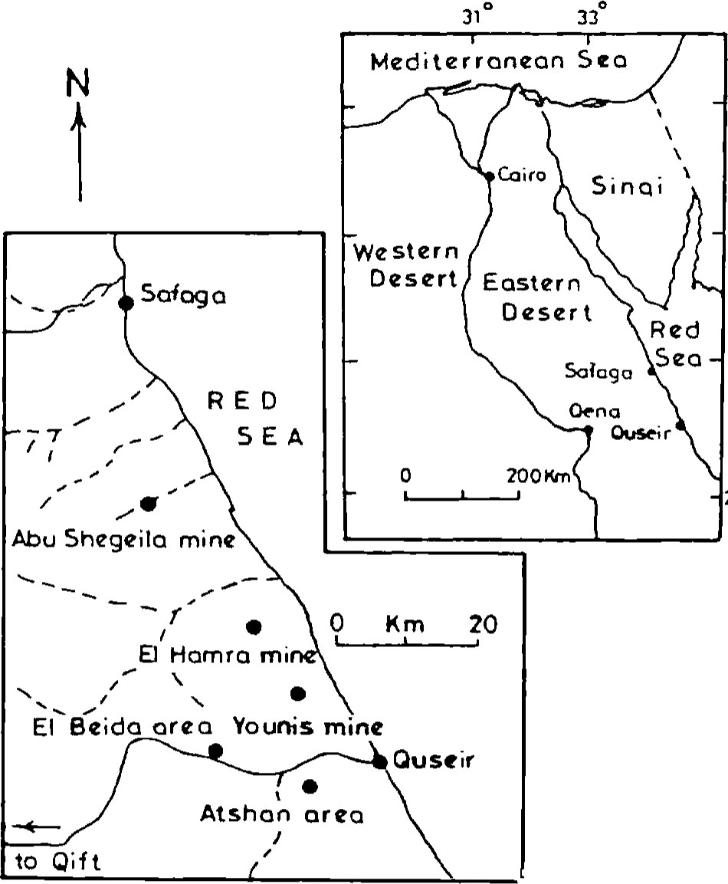31

280

Fig. l. Location map with the position of the studied areas.

noted that thesc beds exhibit a thinning towards the cast and northwest whereas they are absent at the extreme northern area near Safaga. A three dimensional block diagram (Fig. 3) revcals the variations in thickness of this biostromal unit. It corresponds to El-Tarabili's note indicating a norLhern termination for this unit of iLs maximum thickness at the southeastern parts. This northerly termination is caused by decreasing currcnt velocity and disintcgraLion of bioclastic debris by mechanical abrasion and chemical dissolution (GLENN & MANSOUR, 1979).

Thc investigated oystcr rccfs arc bedded and mostly exhibit a largc-s'cale low-angle cross bedding. This observation together with a limited presence of in- situ non-fragmentcd oyster limestones, led many authors to the conclusion Ihat these recfs are stratigraphic rather than ecologic (e.g. SOLIMAN & AMER, 1972; GLENN & MANSOUR, 1979 and GLENN & ARTHUR, 199()). Thcsc authors saw the oyster limcstoncs to bc detrital rccfal rocks resulting from thc accumulation of abraded bioclastic debris.

### 3 METHODS

Fivc sampling sites were chosen along a N-S profilc extending along the Red Sea coastal strip from Safaga to south ofQuseir (Fig. l) in order LO trace the lateral variations of thc bioclastic oyster bed.

Pctrographic examinations for lhc study samples were carried out using a polarizing microscope, Technosyn Cold Cathode Luminescope modcl 8200MK I I and an ISI DS- 130 scanning electron microscope. Specimens used for mineralogical, chemical and isotopic analyses were extracted from polished slabs using a microscopc - mounted drill assembly fitted with a diamond drill bit. The extracted powder sample, vas washed with distilled water, dried and then subjected to ) mineralogical analysis using Rigaku X-ray diffractometer miniflex CN2005, 2) chemical analysis for both major and race elements using a Perkin-Elmer rolled atomic absorption model 2380, and 3) stable isotopic inalysis for both oxygen and carbon using a Finigan MAT 251 mass spectrometer at the University of Miami, Florida, USA. The whole system is operated under computer control and the device can possess a maximum of 47 samples. During the course of the experiment samples were dropped sequentially into 3 ml 100% phosphoric acid of specific gravity of 192 placed in a pot under 900C water bath. Standards were routinely run every day of operation to ensure consistent results. Percision is 0.18%ofor oxygen and 0.120/00 for carbon. Results are reported in notation as per mil relative to the PDB standard.

### 4 PETROGRAPHY

Petrographic in vestigations reveal that the studied oyster limcstones are predominantly composed of oyster fragmcnLs embcddcd in a fine-grained matrix (i.e. oyster biomicrite) or they often occurr as coquinoid limestone. Oyster fragments appear, generally, as elongated particles rendering various degrees of original wall structure preservation and fabric retention. Partly-altered skeletals usually possess a bright orange luminescence with dark spots (Pl. 25/1-2). However, unaltered non-luminescent skeletals are frequent. Both mechanical and biological degradation are apparent wi thin these reefal limestones where the former ends up with rounded and broken skeletal fragments while the latter leads to the development of micriüzed grains and micrite rims. No diversity in taxa is observed but a notable domination for genus Ostrea Villie is documented. This genus is indicative for relatively high energy-conditions in both modern and ancient in-situ oyster tracts (MILLIMAN, 1974 and HECKLE, 1974). In addition, some gastropod fragments and planktonic foraminifers are recorded. Fully open marine rudists are not encountered. Reworked phosphatic particles are frequently observed.

Moldic porosity is quite common within these rocks. Some of the oyster shells and planktonic foraminifers are partly or completely dissolved contributing to the development of porosity within these rocks. Various stages of alteration and solution of the original shells of planktonic foraminifers have led Lo Lhe development of moldic vugs (Pl. 25/3). These vugs were mainly filled with clear calcite mosaics preserved within some oyster particles and planktonic foraminifera. These calcite crystals are non-luminescent (PI. 25/2). Some textures like shelter texture (Pl.25/4) or gcopctal fabric are recorded.

### 5 MINERALOGY

Oyster shells, in general consist of aragonite or low-Mg calcite or high-Mg calcite (BAHIURST, 1975 and MORSE & MACKENZIE, 1990). The present XRD analysis reveals that the skeletal particles and the calcite cement, filling moldic vugs within them, are composed of low magncsium calcite.

#### 6 GEOCHEMISTRY

Based on conventional and cathodoluminescence microscopy, some calcitic oyster fragments with complete and/or partial preservation of their original wall structure, were selected for geochemical analysis. Intraskeletal calcite cements were analyzed too. lhese analyses are carried out for their Ca, Mg, Fe, Mn, Sr and their stable oxygen and carbon isotopes (Tables 1 and 2). The results are comparable to values obtained from other Upper Cretaceous bivalves from different areas of the world (e.g. PIRRIE & MARSHALL, 1990). Oxygen and carbon stable isotopic signatures of skeletal fragments and abiotic calcites reveal their relative depiction in the 8 13C and 6180 (Fig. 4).

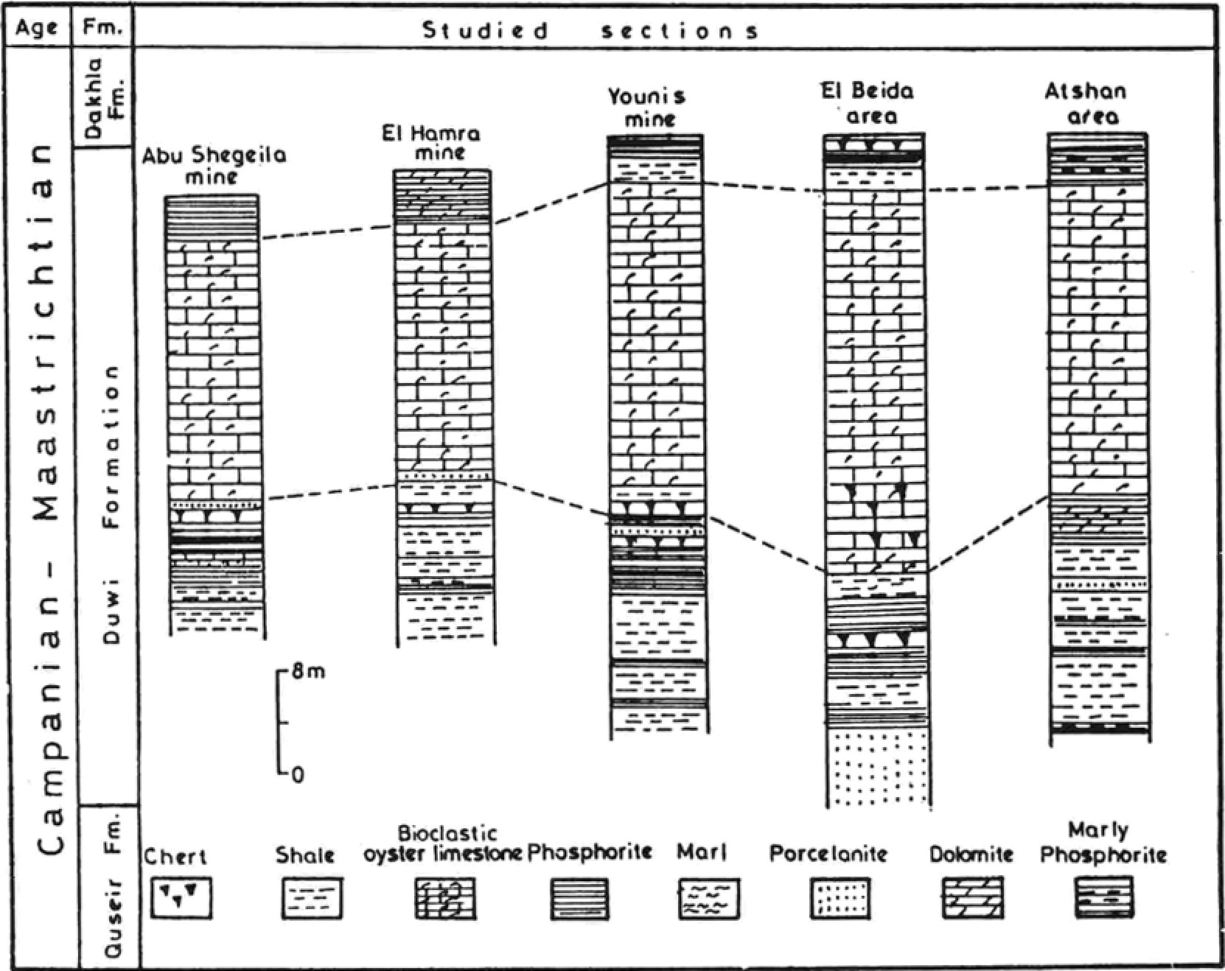

Fig.

2.

The

studied

stratigraphic

sections

at

the

investigated

ar-

eas

##### 7 DISCUSSION

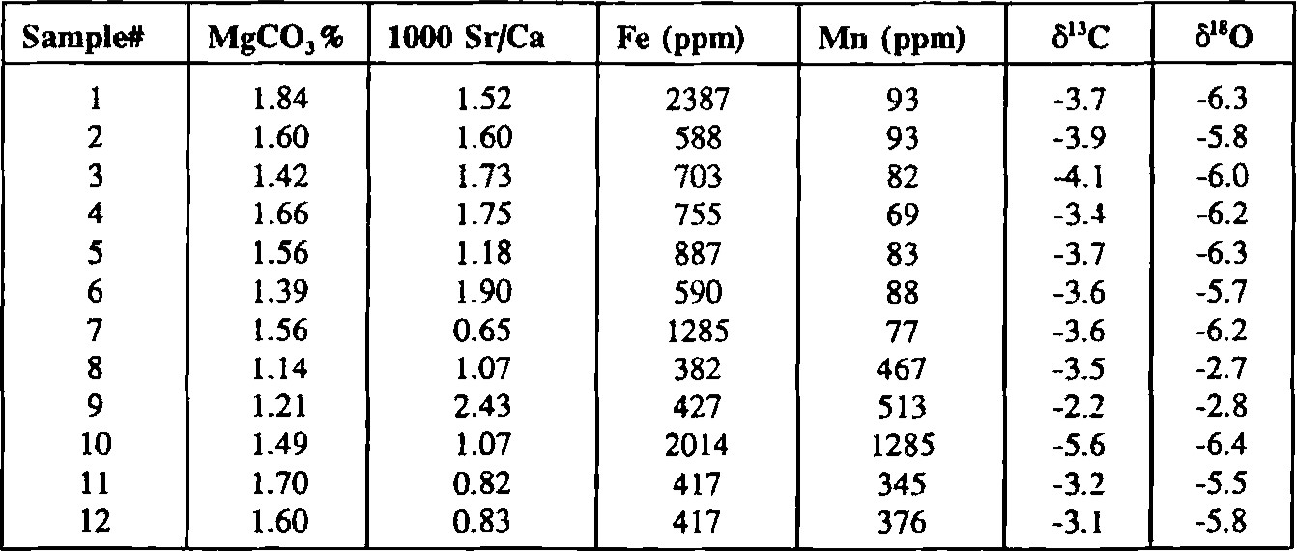Compositional changes of skeletal carbonates, in gencral, during the Phanerozoic are functions ofthrce variables; seawater carbonate saturation state, Mg/Ca ratio and temperdture (cf. MACKEFUIE & AGEGIAN, 1989). Reefal sediments, however, are more complex than other deposits and create

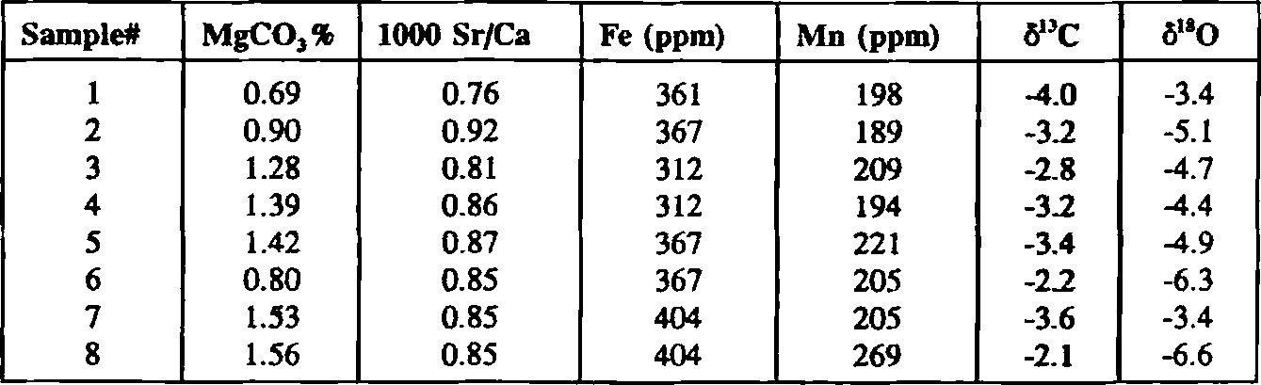Tab., 1. Chemical and isotopic composition of oyster skeletals.

Tab. 2. Chemical and isotopic composition of calcite mosaics.

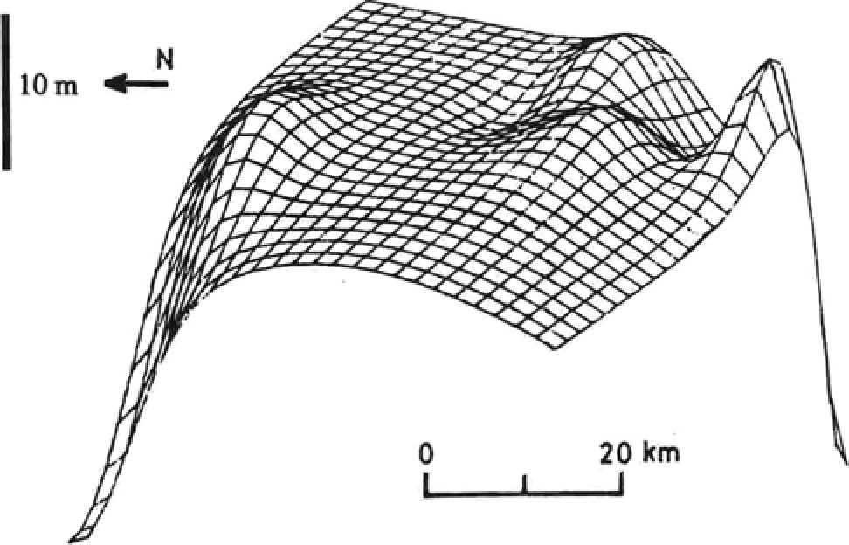

Fig. 3. Three dimensional diagrarn illustrating thickness variations in the investigated stratigraphic oyster reef beds among the study areas.

difficulties in deciphering their depositional and diagenetic histories. Unraveling the paleoenvironmental conditions of reefs on geochemical basis requires Knowledge of the diagenetic history ofthe skeletal particles. Geochemical studies ofdiagenetically-unaltered molluscan macrofossils are pow erful tools for the investigation of their paleoenvironments (e.g. BRAND, 1986; WHr1TAKER et al., 1987 and MORRISON & BRAND, 1988). The geochemistry of macrofossils, in general, is controlled by 1) the physico-chemical conditions at the environment in which the organisms lived and the biologic controls of skeletal formation and 2) subsequent diageneüc alterations (cf. DODD & STANTON, 1981 and PIRRIE & MARSHALL, 1990).

###### 7.1 Depositional environment and depositional conditions

Investigations for the depositional conditions of ancient reefs require an understanding of the sedimentological and biological processes active during their formation. Several authors (e.g. SOLIMAN & AwR, 1972 and GLENN & ARTHUR, 1990) have postulated that the Eastern Desert oyster rccfs are indicative of near-shore high-energy infralittoral or intertidal marine environments. The flourishing life within these environments lead to quick accumulation of oyster shells. Building up to sea level they formed oyster bands prograding towards deeper water while emergent portions of the reef served as traps for fine-grained lime mud.

7.1.1 Oxygen and carbon isotopic signatures

AL-AASEM & VEIÆR (1986) have argued that the Cretaceous sea was of comparable isotopic composition like that of the Holocene (i.e. 0 0/00 SMOW). The mean 5180 value of the present studied skeletals (-2.7 to -6.4% PDB) is in equilibrium with waters having a 5180 of around -3 0/00 SMOW at 250C (cf. FRIEDMAN & ONEIL, 1977 and SAVIN & YEH, 1981). This indicates that the studied skeletals were formed from warmer and/or isotopically-lighter water than thc present day seawater. Although some authors postulated a vital effect of epifaunal bivalves on their skeletal components (e.g CZERNIAKOWSKI et al., 1984 and MORRISON & BRAND, 1988) many others did not prefer this assumption for the interpretation of the depleted oxygen val ues (e.g. WRIGHT, 1987 and WHITTAKER et al., 1987). In the present work it is believed that the isotopic exchange that might have occurred across the sediment/water interface between the 6180 depleted pore waters, expelled from the—underlying sediments, and bottom seawater where these bivalves lived must have had an effect on their oxygen isotopic signatures. (cf. PIRRIE & MARSHALL, 1990). The ö 13C values of skeletal particles— (-2.2 to -5.6 0/00 PDB) that exhibit more negative values than those of normal marine signatures may support a significant role for an upward flux of the isotopically-light and reduced pore waters from the sulfate reduction zone to the bottom waters where the oysters lived.

|  |  |  |  |  |  |  |  |  |
| --- | --- | --- | --- | --- | --- | --- | --- | --- |
| 13  s c   |  |  |  |  | | --- | --- | --- | --- | |  |  |  |  | | -6 -5 -4 -3 -2    • Calc. oyster particles  Mold -filling calcite mosaics | -2  -3  -5  -6 | o | 1 |   Fig. 4. C vs. ö'80 for calcitic oyster particles and mold-filling calcite mosaics. |

A great influx of fresh waters is assumed to be supplied and delivered via rivers- that were formed prior to the deposition of the underlying Quseir Shales (cf. GERMANN et al., 1987) to the growing sites of oyster reefs. The dilution of marine waters with this fresh water influx might be another cause for the depleted 6180 signatures of the studied skeletal particles. The reduction of salinity, as a result of fresh water influx, is thought to be one of the crucial factors for the low diversity of Lhc present fossil assemblage (only oysters and some scattered echinoids, gastropods and planktonic foraminifers). The depleted 8180 values displayed by many Cretaceous skeletal specimens from various localities are to a great extent close to our present data (c.f. FORESTER et al., 1977; WHITTAKER et al., 1987 and MORRISON & BRAND, 1988). This suggests that conditions causing depleted stable isotopic values were common during the Cretaceous. However, the documented manganese values (69 to 1285 ppm)which are relatively high although comparable to other Upper Cretaceous bivalves (cf. PIRRIE & MARSHALL, 1990)coupled with the orange-colored luminescence of the analysed particles argue for some fresh water diagenetic alterations. These alterations are responsible ,in part, for the light ö180 signatures of the skeletals.

7.1.2 Trace elements content

|  |  |  |
| --- | --- | --- |
| P late | 25 | Photomicrographs illustrating the depositional and diagenetic criteria |
| Fig. 1. |  | Photomicrograph of an oyster shell (O) in contact with calcite mosaics (m). x 50 |
| Fig. 2. |  | Cathodoluminescence image of Fig. 1. |
| Fig. 3. |  | Photomicrograph of shelter texture where an oyster shell (O) shelters a pore space that is now filled by calcite mosaics (m), x 25 |
| Fig. 4. |  | SEM photomicrograph showing the development and infilling of a moldic vug via dissolution-precipitation processes in a foraminiferal shell (0= the original structure, a= partial alteration, m= calcite mosaics filling void left after complete dissolution of the original shell). x 100 |

The relative variations in trace elements of skeletal particles may be related, in part, to the inheritance of some of the chemical behavior of the aragonitic precursor. However, Upper Cretaceous was a time of global sea level rise, high atmospheric C02 and high temperatures (MACKENZw, 1990). These conditions were corresponded, in general, to relatively low Sr/Ca and Mg/Ca in seawater & AGEGIAN, 1989). This can be reflected in the composition of the skeletal carbonates provided that biomineralization processes are governed by inorganic environmental factors. Biomineralization, however, are complex processes with many biologic and inorganic constraints on the uptake of trace elements (PURSER & SCHROEDER, 1986 and MORSE & MACKENZIE, 1990). Strontium concentrations of skeletal particles, that range between a fossil's primary aragonite values and the theoretical concentrations for marine calcites (for estimated values see VEIZER, 1983), suggest that the transition from aragonite skeletals to calcite -must have occurred in a semi-closed system (cf. KINSMAN, 1969).

7.1.3 Sea level changes

The effect of sea level changes, caused either by eustatic fluctuations or regional uplift and subsidence, can form a major control on the development of buildups (MASSE & PHILIP, 1981). The oyster banks of the Eastern Desert of Egypt, in general, representa progradational stage accompanying sea level fall (highstand progradational wedge system tracts) that followed the deposition of deeper water hemipelagic sediments where the sequence of lithofacies correlates with the eustatic sea level of Haq et al., 1987 (GLENN, 1990 and GLENN & ARTHUR, 1990). The upward changes in the profiles of the study areas are related to third order rise, fall and rise of sea level accompanying an overall marine transgression. The deposi tion of the reefal sediments in the study areas might have commenced in the southern parts on top of a platform in conditions of oxygenated shoal waters below the wave base. The formation of these sediments was accompanied by major changes in the depositional conditions that had been prevailed during the deposition of their underlying hemipelagic sediments, which were relatively deeper and euxinic. These changes from euxinic to oxic conditions are primarily attributed to changes in the position of the oxygen minimum zone during sedimentation causing the vertical variation and alteration of the different facies (Fig. 5). Slight variations in the position of the oxygen minimum zone, which are goverened to great extent by sea level variations, will cause facies variations on the shelf and slope. The extension of the oyster reefs on the Upper Cretaceous platform at the Eastern Desert is limited, in general, by sea level changes, sedimen t supply and terrigenous influx and nutrient supply. These factors must have controlled the northerly termination of these recfs.

7.2 Early diagcncsis

Diagenctic modifications, starting soon after or already during the deposition of the reef growth, have a great influence on shape of the reef. Porosity development within reefs is an important process in the construction of these rocks. Moldic porosity is quite common in thc investigated rocks although some of the pores arc filled with clear calcite mosaics. Marine cementation plays an important role in the construction of buildups (e.g. GINSBURG et al., 1967, CHOQUEITE, 1983 and MARSHALL, 1986). Contemporaneous rapid and extensive marine cementation serves in binding the recf framework and protecting the smaller and more delicate rccf forms from being broken and swept away (JANffs, 1983). High-energy conditions under which the investigated oyster reefs were formed pumped large volumes of seawater through the porous system of these reefs

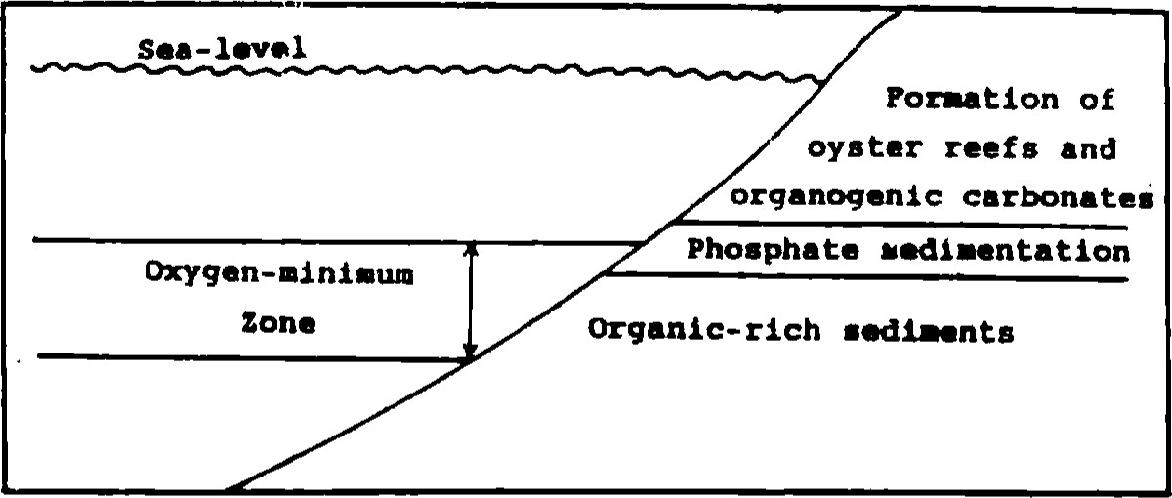Fig. 5. Sketch illustrating facies alternation with respect to oxygen-minimum zone. The curved line at the center of the diagram represents the sediment/ water interface at the shelf (not to scale).

causing the precipitation of significant amounts of calcitic cements that preserve distinctive chemical characteristics of their marine origin. The low Mg contents of these calcites can reflect the effect of temperature and a low Mg/Ca ratio of seawater during the global sea level rise of the Upper Cretaceous (cf. MACKENZIE & AGEGIAN, 1989).

If an upward flux of pore waters is a function in controlling the oxygen isotopic signature of the bottom water- as suggested before- then the isotopic reservoir for the early diageneüc cement would be either as depleted or more depleted than the bottom water (cf. PIRRIE & MARSHALL, 1990). This explains the depleted 5180 values (-3.4 to -6.6 0100 PDB) of the present early diagenetic calcite cements that coincides with the 6180 values of the skeletal parts. The reducing conditions below the sediment water interface would enhance the enrichment of pore waters with some trace elements (e.g. Mn2+ and Fe2+) and the depletion in their signatures. The upward flux of this pore water possibly resulted in the formation of an early diagenetic cement enriched in iron (312 to 404 ppm) and manganese (189 to 221 ppm) and depleted in ö 13C (-2.1 to -4.0 %oPDB).

|  |
| --- |
| 127 |

There is a consensus, among all carbonate petrographers, that manganese and iron are the most important elements that affect the luminescence of carbonate minerals. Some authors believe that it is the absolute concentration of thcsc two elements that control carbonate minerals luminescence (e.g. PIERSON, 1981) while others consider only the ratio Fe/ Mn as crucial in controlling the luminescence of these minerals (e.g. FRANK et al., 1982). MASON (1987) postulated that both values (i .c. the absolute concentrations of these two elements and the ratio Fe/Mn) are involved in controlling the luminescence of carbonate minerals. However, no simple relationship can be drawn between the presence or absence of luminescencc and the iron content or the Fe/Mn ratio. Moreover, thc presence of manganese, although essential in activating luminescence, does not guarantee that luminescence will occur (MASON, 1987). The non-luminescent character of the present calcite mosaics can be attributed to selfquenching phenomenon (cf. WALKER, 1985) rather than being the result of iron-quenching abiotic calcite cements precipitated in equilibrium with seawater would have Sr/Ca ratios between 2.4 and 4.4 x 10-4 assuming average Sr distribution coefficient values for calcite ranging between 0.027 and 0.05 (LORENS, 1981 and VEiZER, 1983) and scawater of Sr/Ca ratio like that of modern values (i.e. around 0.0089, KINSMAN, 1969). The high 1000 Sr/Ca values for the investigated early calcite mosaics (0.76 to 0.92) are in accord with the assumption that Sr is stored in reef and shelf limestones during periods of rising sea level like the Cretæeous.

7.3 A possibility for hydrocarbon accumulations!!

The presence of a large basin with prevailing euxinic conditions resulting in the formation of widespread organicrich sediments, the availability of thermal maturation for these sediments and the presence of nearby highly porous and permeable rocks are among the major factors that control the formation of hydrocarbon accumulations. According to many workers (e.g. SWARTZ & 1960 and EL-TARABILY, 1966) SE Egypt and the Red Sca regions were areas of intensive volcanic activities during the Upper Cretaceous. This provides perfect possibility for the thermal maturation of the organic-rich black shales (which are in places extremely rich in Corg). The eastern parts ofthe black shale facies are deeply buried beneath the Red Sea (around 3-5 km burial depth; GLENN & ARTHUR, 1990). Considering the high porosity and permeability of the overlying reef deposits a possible hydrocarbon accumulation in the area east of Quseir (off shore) may be

### 8 CONCLUSIONS

l) The deposition of the bioclastic oyster limestone marks the end of the prevailing euxinic conditions, that resulted in the formation of organic-rich sediments, and the set up

of oxic conditions. This change in the depositional conditions is related primarily to a change in the position of oxygen minimum zone during sedimentation. The deposition of the reefal sediments started in the southern parts near Qusier on Lop of a platform under shoal conditions. The sediments possess, in general a great lateral extension where only a northern termination is noticed near Safaga.

1. The highly depleted ö l 80 values of the analyzed skeletal particles can be related in part to habitat-controlled innuenccs and Lhe dilution of the marine water with a fresh watcrinflux. Weak fresh water diagenctic alterations have affected some of these skeletals within a reducing environment, as indicated by their depleted 813C values, are responsible for the negative 8 80 shift.
2. Moldic porosity is quite common although occluded, partly or completely, in some porLions by clear cquant low-magnesium calcites of marine origin.
3. A promising possibility of hydrocarbon accumulations in the area east of Quseir (offshore) is expected, where a suitable large basin with thermally-mature black shale facies and extremely high Corg-contenLs, is encountered below the highly porous and permeable reef deposits.

#### ACKNOWLEDGMENTS

The present work is a part of a project funded by the U .S. Agency for International Development (AID) project No. 263.0125. l. The senior author wishes to acknowledge Prof.

P.K.Swart, University of Miami, Fl., USA for providing lab facilities.

#### REFERENCES

AL-AASEM, I. & J. (1986): Diagenetic stabilization of aragonite and low-Mg calcite, Il. stable isotopes in rudists. — J. Sed. Petrol. 56, 763-770, Tulsa

Bathurst, R.C. ( 1975): sediments and their diagenesis. — 2nd ed., 658 pp.,Amsterdam (Elsevier)

BRAND U. (1986): Paleoenvironmental analysis of Middle Jurassic

(Callovian) ammonoids from Poland: Trace elements and Stable isotopes. — J. Paleont. 60, 293-301, Tulsa

CROQUETIE, P,W. (1983): Platy algal reef mounds, Paradox Basin. - In: SCHOLLE, P.A., BEBOtrr, D.C. & MOORE, C.R. (eds.): Carbonate depositional environments. — Amer. Assoc. Petrol. Geol. Mem. 33, 454-462. Tulsa

CÆRNIAKOWSKI, L.A., LOHMANN, K.C. & WILSON, LL. (1984): Closed system marine burial diagenesis: isotopic data from the

Austin Chalk and its components. — Sedimentology, 31, 863877, Oxford

DODD, J.R. & STANTON, R.J. (1981): Paleoecology, concepts and applications. — 559 pp.. Lnndon (Wiley)

EL-TARABILI, E.E. (1966): General outlines of epeirogenesis and sedimentation in region between Safage, Quseir and Southern Wadi Qena area, Eastern Desert, Egypt. — Amer. Assoc. Petrol. Geol., 50, xxx-yyy, Tulsa

(1969): Paleogeography, paleoecology and genesis of the phosphatic sediments in the Quseir$afaga area. U.A.R. — Econ. Geol., 64, 172-182, Cairo

ENOS, P, (1986): Diagenesis of Mid-Cretaceous rudistreefs, Valles platform, Mexico. —In: SCHROEDER, J.H. & PURSER. B.H. (eds.): Reef diagenesis. 160-185, New York (Springer)

FORESTER, R.w., CALDWELL, W.G.E. & (ho, F.H. (1977): Oxygen and carbon isotopic study of ammonites from the Late Creta ceous Bearpaw Formation in south western Saskatchewan. — J. Can. Earth sci., 14, 2086-2100, Calgary

FRANK, J.R., CARPENTER, A.B. & OGLESBY, T. W. (1982): Cathodoluminescence and composition of calcite cement in the Taurn Sank Limestone (Upper Cambrian), Southeast Missouri. - J. Sed. 52, 631-638, Tulsa

FRIEDMAN, I. & O'NEL, J.R. (1977): Compilation of stable isotope fractionation factors of geochemical interest. — In: FLEISCHF*, M. (ed.): Data of geochemistry. — 6th ed., U.S. Geol. Surv. Prof. Paper, No. 440-kk, Washington

GERMANN, K., BOECK, W.D. & SCHROFIYR, T. (1984): Facies developmcnt of Upper Cretaceous phosphorites in Egypt: sedimentological and geochemical aspects. Berliner geowiss. 50, 345-361, Berlin

GINSBURG, R.N., SHINN, E.A. & SCHROEDER, J.H. (1967): Submarine cementation and intemaJ sedimenLation within Bermuda reefs (Abst.). — Geol. Soc. Arner. Spec. Pap. 115, 78-79, Boulder

GLENNI C.R. (1990): Depositional sequences of the Duwi, Sibaiya and Phosphate Formation, Egypt: Phosphogenesis in a Late Cretaceous epciric sea. — In: NOTIIOLT, A. & JARVIS, L (eds.) Phosphorite research development. — Geol. Soc. I-nnd. Spec. Pub]. IGCP-156, Oxford

GLENN, C.R. & Arthur, M.A. (1988): and major elementgeochemistry of Peru margin phosphorites and associated diagenclic minerals: Authigenesis in modern organic-rich sediments. — Marine Geol., 80, 231-267, Amsterdam

- & (1990): Anatomy and origin of a Cretaceous phosphorite green sand giant, Egypt. — Sedimentology, 37, 123-154, Oxford

GLENN, C.R. & Mansour, S.E.A. (1979): Reconstruction of the depositional and diageneLic history of phosphorites and associated rocks of he Duwi Formation (Latc Cretaceous), Eastern Desert, Egypt. — Ann. Geol. Surv. Egypt, 9, 388407, Cairo

HAQ, B.U., HARDENBAL, J. & VAIL, P.R. (1987): Chronology of fluctuating sea levels since the Triassic (250 million years ago to the present). — Science, 235, 1156-1167, Washington

HECKEL, P.H. (1974): Carbonate buildups in the geologic record- a review. — In: LAP(RIE, L.F. (ed.): Reefs in time and space. — Soc. Econ. Paleon. Min. Spec. Publ., 18, 9()-154, Tulsa

JAMES, N.P. (1983): Reefenvironment. —In: SCHOLLE, P.A., BEBOUT, D.C. & MOORE, C.H. (eds.): Carbonate depositional environments . — Amer. Assoc. Petrol. Geol. Mem. 33, 345-462, Tulsa KINSMAN, D.J.J. (1969): Interpretation of Sr2+ concentrations in— carbonate minerals and rocks. — J. Sed. Petrol. 39, 486-508, Tulsa

LORENS, R.B. (1981): Sr, Cd, Mn and Co distribution coefficients in calcite as a function of calcite precipitation rate. Geochim. Cosmochim. Acta, 45, 553-561. Oxford

MACKENm, F.T. (1990): Sea level change, sediment mass and flux and chemostratigraphy. — In: GNSBURG. R.N. & BEAUIX)IN, B. (eds.): Cretaceous resources, events and rhythms-background and plans for research. — NATO ASI Series (C), 304, 289-304, Boston (Kluwer Acad. Publ.)

MACKENZE, F.T. & AGFGIAN, C. (1989): Biomineralization and tentative links to plate tectonics. — In: CRICK, R.E. (ed.): Origin. evolution and modem aspects of biomineralization in plants and animals . — 11-27, New York (Plenum Press)

MARSHALL, J.F. (1986): Regional distribution of submarine cemenis within an epicontinental reef system: Central Great Barrier reef, Australia. — In: SC}ROEDER, J.H. & PURSER, B.H. (eds.): Reef diagenesis. — 8-26, Berlin (Springer)

MASON, R.A. (1987): Ion microprobe analysis of elements in calcite with an application of the cathodoluminescence zonation of limestone cements from the Lower Carboniferous of South Wales, U.K. Chem. Geol. 64, 209-224, Amsterdam

MASSE, J. & PHILIP, J. (1981): Cretaceous coral-Rudistid buildups of France. — In: TOOMEY, D F. (ed. ) European fossil reefmodels. Soc. Econ, Paleont. Min. Spec. Publ. 30. 399426, Tulsa

MILL-MAN, JD. (1974): Recent marine carbonates. — 375 pp., New York (Springer)

MORRISON, J.O. & BRAND, U. (1988): An evaluation of diagenesis and chemostratigraphy of Upper Cretaceous molluscs from the Canadian Interior Seaway. — Chem. Geol. (Isotope Geoscience Section), 72, 235-248, Amsterdarn

MORSE, J.W. & MACKENZE, F.T. (1990): Geochemistry of sedimentary carbonates. — Developments in sedimentology 48, 707 pp., Amsterdam (Elsevier)

M'RABET, A.;.NFßRA, M.H., PURSER. B.H., SASSI, S. & BENAYED, N. (1986): Micrite diagenesis in Senonian rudist build-ups in central Tunisia, — In:  J.H. & PURSFR, B.H. (eds.): Reef diagenesis. — 210-223, New York (Springer)

PIERSON, B.L (1981 ): The control of cathodoluminescencc in dolomite by iron and manganese. — Sedimentology, 28, 601-610, Oxford

D. & MARSHALL. J.D. (1990): Diagenesis and Late Cretaceous paleoenvironmental geochemistry: A case study from James Ross Island, Antarctica. — Palaios, 5, 336345, Tulsa

PURSFR, B." & J.H. (1986): The diagenesis ofreefs: A brief revierw of our present understanding. — In: SCHROEDER, J.H.& PURSER, B.H. (eds.): Reef diagenesis. — 424-446 New York (Springer)

SAVN, S -M. & YEH, H.W. (1981 ): Stable isotopes in ocean sediments. In: EMILIAM, C. (ed.): The Sea, V. 7, the oceanic liLhosphere. — 1521-1554 (Wiley, Interscience)

Som4AN, S.M. & AMFR, K.M. (1969): Petrology of Upper Cretaceous and Danianrocks ofGebel El-Duwi, Quseir area, Eastem Desert, Egypt. Proc. Arab Sci. Cong., part 4. A, 465. Damascus SWARTZ, D.H. & ARDEN, Jr. D.D. (1960): Geologic history of Red

Sea area. — Amer. Assoc. Petrol. Geol. Bull.. 44, 1621 pp.,

J. (1983): Chemical diagenesis of carH)nates•, theory and application of the trace element technique. In: Stable isotopes in sedimentary geology. — Soc. Econ. Paleon. Min. Short course , 10, 1-100, Tulsa

WALKER, G. (1985): Mineralogical applications of luminescence techniques. —In: Berry, F.J. & Vanghen, D,J. (eds.): Chemical bonding and spectroscopy in mineral chemistry. —325 pp. Landon (Chapman & Hall)

WHITTAIGR, S.G., KYSER. T.K.& CALDWELL, W.G.E. (1987): Paleoenvironmental geochemistry of the Claggett marine cyclotherm in south-central Saskatchewan. Canad. — J. Eardl sci., 24, 967-984, Calgary

WRIGHT, E.K. (1987): Stratification and paleocirculation of the Late Cretaceous Western Interior Seaway of North America. — Geol. soc. Amer. Bull., 99, 480490, Boulder

Manuscript received June 23, 1994

Revised manuscript received January 12, 1995;

March 5, 1995