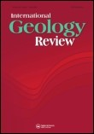

**International Geology Review**

**ISSN: 0020-6814 (Print) 1938-2839 (Online) Journal homepage:**

[**https://www.tandfonline.com/loi/tigr2**](https://www.tandfonline.com/loi/tigr20)

[**0**](https://www.tandfonline.com/loi/tigr20)



**Age and nature of the late Early Cretaceous Zhaga Formation, northern Tibet: constraints on when the Bangong–Nujiang Neo-Tethys Ocean closed**

# Jian-Jun Fan, Cai Li, Yi-Ming Liu & Jian-Xin Xu

**To cite this article:** Jian-Jun Fan, Cai Li, Yi-Ming Liu & Jian-Xin Xu (2015) Age and nature of the late Early Cretaceous Zhaga Formation, northern Tibet: constraints on when the Bangong–Nujiang Neo-Tethys Ocean closed, International Geology Review, 57:3, 342-353, DOI:

[10.1080/00206814.2015.1006695](https://www.tandfonline.com/action/showCitFormats?doi=10.1080/00206814.2015.1006695)

**To link to this article:**  <https://doi.org/10.1080/00206814.2015.1006695>



[View supplementary material](https://www.tandfonline.com/doi/suppl/10.1080/00206814.2015.1006695)



Published online: 12 Feb 2015.



[Submit your article to this journal](https://www.tandfonline.com/action/authorSubmission?journalCode=tigr20&show=instructions)



Article views: 287



[View related articles](https://www.tandfonline.com/doi/mlt/10.1080/00206814.2015.1006695)



[View Crossmark dat](http://crossmark.crossref.org/dialog/?doi=10.1080/00206814.2015.1006695&domain=pdf&date_stamp=2015-02-12)

[a](http://crossmark.crossref.org/dialog/?doi=10.1080/00206814.2015.1006695&domain=pdf&date_stamp=2015-02-12)



[Citing articles: 44 View citing articles](https://www.tandfonline.com/doi/citedby/10.1080/00206814.2015.1006695#tabModule)



Full Terms & Conditions of access and use can be found at <https://www.tandfonline.com/action/journalInformation?journalCode=tigr20>

International Geology Review, 2015

Vol. 57, No. 3, 342–353, http://dx.doi.org/10.1080/00206814.2015.1006695

Age and nature of the late Early Cretaceous Zhaga Formation, northern Tibet: constraints on when the Bangong–Nujiang Neo-Tethys Ocean closed

Jian-Jun Fan, Cai Li*, Yi-Ming Liu and Jian-Xin Xu

College of Earth Sciences, Jilin University, Changchun, PR China

(Received 8 October 2014; accepted 8 January 2015)

This article reports the depositional environment, provenance, and U–Pb zircon age constraints for the newly identified Zhaga Formation in northern Tibet and uses these to better understand the tectonic evolution of the Bangong–Nujiang suture. One transect across the Zhaga Formation was investigated. The Zhaga Formation is ~2 km thick, dominated by greywacke and conglomerate at the base, basalt and limestone in the middle, and greywacke and shale at the top. Greywacke in the Zhaga Formation typically contains 70–75% quartz, 5% feldspar, 3–5% rock debris, and >15% matrix, with normal grading and convolute bedding, basal flow structures, and distinct Bouma sequences interpreted as bathyal to abyssal turbidites. One rhyolite sample and one greywacke sample from the studied transect were collected for zircon U–Pb dating. The rhyolite yields a concordia age of 118 Ma, and the greywacke yields nine age peaks of 247, 330, 459, 541, 611, 941, 1590, 1871, and 2482 Ma, indicating that the Zhaga Formation formed during the late Early Cretaceous and the provenance of its detritus was the Qiangtang area. These data, combined with the Early Cretaceous ocean islands, indicates that the Bangong–Nujiang Neo-Tethys Ocean must have been open during the late Early Cretaceous. We conclude that the Bangong–Nujiang Neo-Tethys Ocean closed after the late Early Cretaceous and not during the Late Jurassic or the early Early Cretaceous as proposed by previous workers.

Keywords: Bangong–Nujiang suture zone; timing of ocean closure; Early Cretaceous; Zhaga Formation; Mugagangri Group

## 1. Introduction

The Tibetan Plateau is the world’s highest continental plateau. It lies ~4500 m above sea level and covers an area of approximately 2.6 million km2 between southwestern China and northern India. The Tibetan Plateau is located in the eastern section of the Alpine–Himalayan tectonic domain and has a complex geological history that includes the formation and evolution of the Palaeo- and Neo-Tethys oceans. The closure of the Tethys Ocean occurred along four main suture zones in the Tibetan Plateau, which from north to south are the Indus–Yarlung Zangbo suture zone (IYZSZ), the Bangong–Nujiang suture zone (BNSZ), the Longmuco–Shuanghu–Lancangjiang suture zone (LSLSZ), and the Jinshajiang suture zone (JSSZ) (Figure 1a). These suture zones divide the Tibetan plateau from south to north into the Himalayan, Lhasa, Southern Qiangtang–Baoshan,

Northern Qiangtang–Qamdo, and Bayan Har–Songpan

Garze terranes (Figure 1a; Pan et al. 1997, 2006; Yin and

Harrison 2000; Li et al. 2006; Hu et al. 2013; Zhai et al. 2013; Fan et al. 2014b).

The BNSZ crosses the middle Tibetan Plateau along an E–W direction, between the Lhasa block to the south and the Southern Qiangtang–Baoshan block to the north (Figure 1a). The suture provides a natural laboratory for studying features of the Neo-Tethys Ocean in China. The BNSZ starts in Kashmir and extends eastwards for 2400 km through Bangong, Gerze, Dongqiao, Dingqing, Jiayuqiao, and Burma. The BNSZ in China is subdivided into three segments, which from west to east are the Bangong–Gerze, Gerze–Dingqing, and Dingqing–Nujiang segments (Pan 1983; Pan et al. 1997; Qiu et al. 2004). Although many researchers have investigated the BNSZ since the 1980s (Pan 1983; Wang et al. 1987; Dewey et al. 1988; Bureau of Geology and Mineral Exploration of Tibet Province 1993; Pan et al. 1997, 2006; Yin and

Harrison 2000; Zhang 2007; Shi et al. 2008, 2012; Wang et al. 2008b; Fan et al. 2014b; Wu et al. 2014; Xu et al. 2014), the harsh climatic conditions and complex geological evolution of the Tibetan Plateau have meant that studies of the suture zone remain rudimentary, with many key geological problems remaining unresolved.

In recent years, the resources survey in China has suggested that the BNSZ is not only an important suture zone but also an important metallogenic belt (Feng et al. 2006; Cao et al. 2007; Liu et al. 2011; Li et al. 2011c; Zhang et al. 2011; Song et al. 2012; Qu et al. 2012). The zone contains the Duolong Cu–Au porphyry copper deposit, the Xiongmei copper deposit, the Wusula and Dacha gold deposits, and the Fuye, Caima, Nixiong, and Shesuo magnetite-rich deposits.

*Corresponding author. Email: licai010@126.com

© 2015 Taylor & Francis

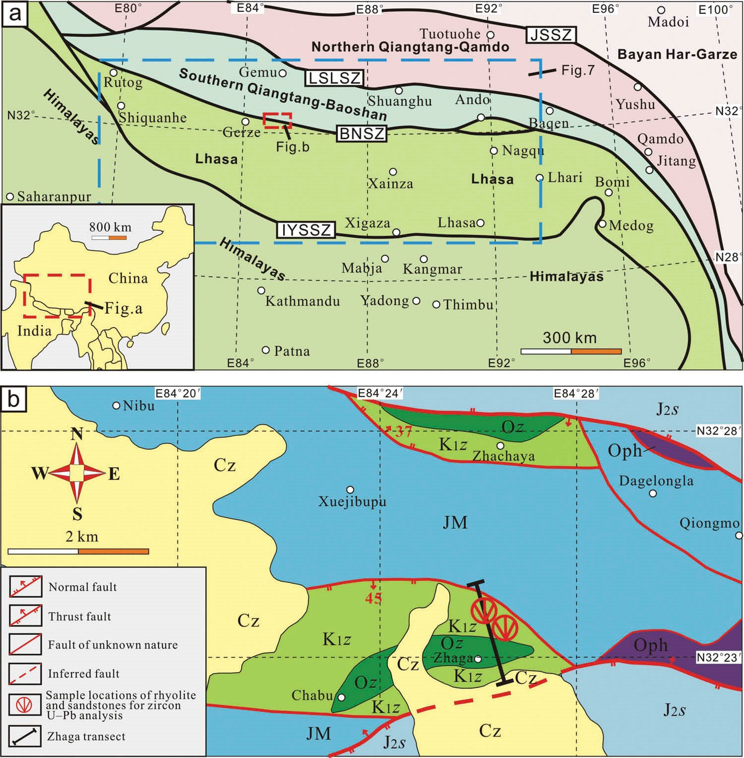

Figure 1. (a) Tectonic framework of the Tibetan Plateau. JSSZ, Jinshajiang suture zone; LSLSZ, Longmuco–Shuanghu–Lancangjiang suture zone; BNSZ, Bangong–Nujiang suture zone; IYZSZ, Indus–Yarlung Zangbo suture zone. (b) Geological map of the study area. Cz, Cenozoic, K1z, Early Cretaceous Zhaga Formation, J2s, Middle Jurassic Sewa Formation, JM, Jurassic Mugagangri Group,

Oph, ophiolite, and Oz, ocean island fragment.

The Duolong Cu–Au porphyry copper deposit, which formed during the Early Cretaceous, has estimated resources of 7 Mt fine copper and 120 t fine gold (Li et al. 2011b, 2013). The mineralization history of the deposits is highly controversial. Some scholars consider that the Bangong–Nujiang Neo-Tethys Ocean closed between the Late Jurassic and the early Early Cretaceous (Wang et al. 2002; Chen et al. 2004) and that most of the deposits were formed during the crustal uplift stage following continent–continent collision (Qu and Xin 2006; Xin et al. 2009). Other scholars argue that the Bangong–Nujiang Neo-Tethys Ocean was still subducting during the Early Cretaceous (Li et al. 2013; Fan et al. 2014a) and that most of the deposits are therefore subduction related (Li et al. 2008b, 2013). It is important to determine the timing of closure of the BNSZ in order to clarify the mineralization history of the deposits and to improve our understanding of the tectonic evolution of the Bangong–Nujiang NeoTethys Ocean.

As stated earlier, the timing of closure of the Bangong–Nujiang Neo-Tethys Ocean is highly controversial. The presence of unconformities between the Middle Jurassic Dejiguo Group, the Late Jurassic to Early Cretaceous Shamuluo Group, the Late Jurassic to Early Cretaceous Dongqiao Group, and ophiolites led previous researchers to suggest that the Bangong–Nujiang NeoTethys Ocean closed between the Late Jurassic and the early Early Cretaceous (Wang et al. 2002; Chen et al. 2004; Xin et al. 2009). However, more recent research reports the discovery of remnants of Early Cretaceous ocean islands in this area, implying that the ocean closed after the early Early Cretaceous (Zhu et al. 2006; Fan et al. 2014a).

In 2013, we identified a new formation, the Zhaga Formation from the Mugagangri Group, 30 km north of Gerze County, Tibet. We obtained a concordia age of 118 Ma from rhyolite interlayers within the unit, indicating that the Zhaga Formation formed during the late Early Cretaceous. The Early Cretaceous is a critical period in the controversy regarding the closure of the Bangong–Nujiang Neo-Tethys Ocean, and the analysis of the depositional environment and provenance of the Zhaga Formation presented in this article provides an important framework for reconstructing the tectonic evolution of the ancient ocean. Furthermore, the correlation of the Zhaga Formation with the Mugagangri Group, based upon similarities in rock assemblages and the characteristics of the flysch deposits, provides a framework for clarifying the tectonic evolution of the Mugagangri Group.

## 2. Geological background

The study area is located in the Zhaga region, approximately 30 km north of Gerze County, in the middle segment of the Bangong–Nujiang suture (Figure 1a). The study area contains a number of regional structural features oriented approximately E–W, and the rocks in the area are strongly deformed (Figure 1b). The study area contains numerous ocean island fragments and ophiolites, such as the Dongco ophiolite, and sediments of the Mugagangri Group, the Sewa Formation, and the Zhaga Formation. The Jurassic Mugagangri Group consists of bathyal to abyssal flysch deposits that formed within the Bangong–Nujiang Neo-Tethys Ocean and is dominated by greywacke and shale lithologies (Wang et al. 2002; Cao et al. 2008). The Middle Jurassic Sewa Formation consists of bathyal canyon deposits that formed in the Bangong– Nujiang Neo-Tethys Ocean and is dominated by channel conglomerates and greywacke. The Early Cretaceous Zhaga Formation is newly defined in this article and is dominated by greywacke and shale lithologies similar to those of the Mugagangri Group (Figure 2a).

The Dongco ophiolite is dominated by metamorphic peridotite, gabbro, and basalt. The ophiolite is an important remnant of the Bangong–Nujiang Neo-Tethys Ocean in this part of the suture zone and formed during the Jurassic and Early Cretaceous (Qiu et al. 2004; Bao et al. 2007). The ocean island remnant in the study area is divided into two sections. The northern section, located in the Zhachaya area, consists of limestone and basalt, whereas the southern section, located in the Zhaga region, consists of limestone, basalt, and conglomerate.

## 3. Field and petrographic observations

A transect (Figure 1b) taken across the Zhaga region provides a representative geological section through the Zhaga Formation (Figure 3).

The total thickness of the Zhaga transect exceeds 2045 m. Rocks at the base of the Zhaga transect consist of greywacke and conglomerate. The greywacke contains 70–75% quartz, 5% feldspar, 3–5% rock debris, and typically >15% matrix (Figure 2b) and has graded and convolute bedding. The conglomerate has a gravel content of ~40 wt%, and the gravel fraction is dominated by greywacke. The gravels within the conglomerate are poorly sorted and angular. The middle section of the Zhaga transect consists of basalt and limestone, with some greywacke and shale interlayers. The basalt and limestone extend westwards into the Chabu area, whereas the interlayers of greywacke and shale gradually diminish towards the west. In the Chabu area, basalts, limestones, and conglomerates occur and consist of basaltic gravel and basaltic matrix, similar to oceanic island deposits. The basalt and limestone deposits in the middle section of the Zhaga transect are therefore conceivably of oceanic island origin.

The top part of the rock sequence of the Zhaga transect is the main part of the Zhaga Formation and is dominated by thin layers (<10 cm) of greywacke interbedded with shale layers of similar thickness (Figure 2a), with interlayers of basalt and rhyolite (Figure 2c). The greywacke in this section contains typical underside moulages (Figure 2d), such as load casts and flute casts. Typical convolute bedding is observed within the Zhaga Formation (Figure 2e), where crumpled bedding occurs between two parallel beds, and distinct a–b–c–d Bouma sequence facies are also present (Figure 2f). The ‘a’ facies of the Bouma sequence is pebbly greywacke with graded bedding, ‘b’ is greywacke with parallel bedding, ‘c’ is siltstone with wavy bedding, and ‘d’ is siltstone with horizontal bedding.

The basalts of the top part of the rock sequence of the Zhaga transect are porphyritic and contain pyroxene and plagioclase phenocrysts in an intergranular matrix (Figure 2g) and have undergone greenschist-facies metamorphism. The rhyolites of the top part of the rock sequence of the Zhaga transect are also porphyritic and contain quartz crystals in a felsic matrix (Figure 2h).

Although there are no fossils in the Zhaga Formation for providing age constraints, there are many interlayers of volcanic rocks, particularly rhyolite. We collected a sample of rhyolite from the Zhaga transect for zircon U–Pb analysis to determine the age of the formation. In addition, we collected a greywacke sample for zircon U–Pb analysis to explore the provenance of the Zhaga Formation.

## 4. Analytical methods

A rhyolite sample and a greywacke sample were selected from the Zhaga transect for in situ zircon U–Pb analysis (see Figure 1b for transect location). Zircons from the samples were separated by conventional heavy liquid and magnetic techniques at the Special Laboratory of the Geological Team of Hebei Province, China. Cathodoluminescence (CL) imaging was used to examine

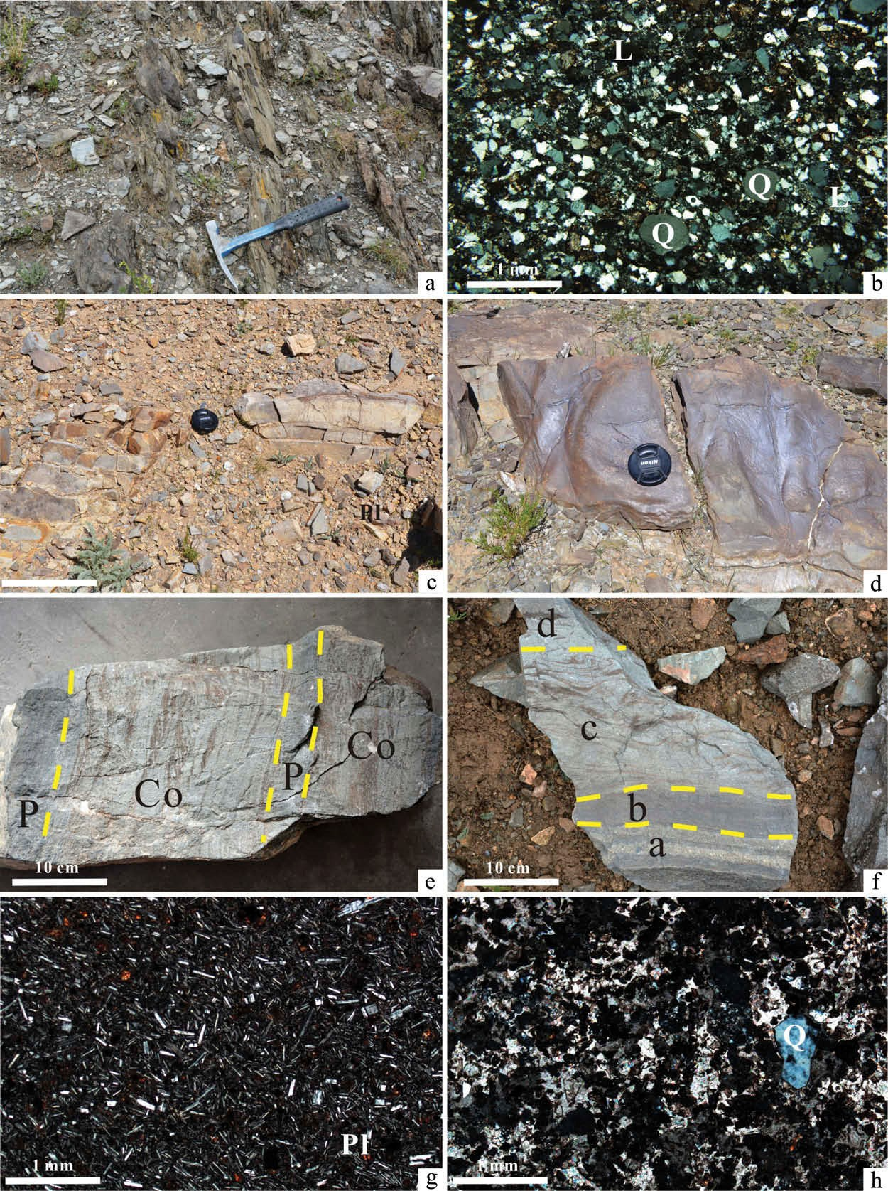

Figure 2. (a) Thin layers (<10 cm) of greywacke interbedded with shale layers of similar thickness in the Zhaga Formation. (b) Photomicrograph showing the textural immaturity of the greywacke of the Zhaga Formation. Q, quartz; L, lithic. (c) Rhyolite of the Zhaga Formation. (d) Photomicrograph showing a typical underside moulage of the greywacke of the Zhaga Formation. (e) Convolute bedding in the Zhaga Formation. Co, convolute bedding; P, parallel bedding. (f) Distinct a–b–c–d Bouma sequence in the Zhaga Formation. a, pebbly greywacke with graded bedding; b, greywacke with parallel bedding; c, siltstone with wavy bedding; d, siltstone with horizontal bedding. (g) Photomicrograph showing the intergranular structure of the basalts of the Zhaga Formation. Pl, plagioclase. (h) Photomicrograph showing the porphyritic texture of rhyolite from the Zhaga Formation. Q, quartz.

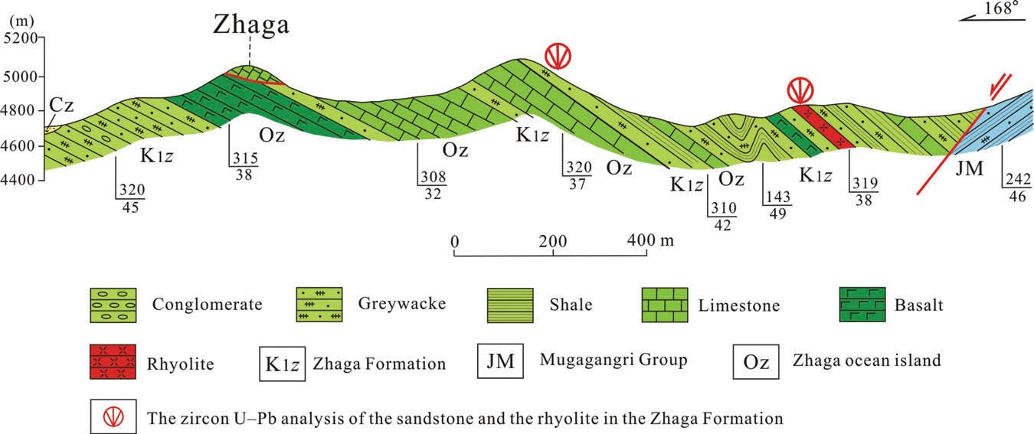

Figure 3. Geological cross-section along the Zhaga Formation transect, in the Zhaga region of Gerze County, Tibet (see Figure 1b for transect location).

the internal structures of individual zircons and to select positions for analysis, which was undertaken at the Institute of Physics, Peking University, China. Zircon LA–ICP–MS analysis was undertaken at the Geological Laboratory Centre of China, University of Geosciences, Beijing, using a 36 μm spot size and helium as a carrier gas to enhance the transport efficiency of ablated material. Determinations of the U, Th, and Pb isotopic compositions and trace element concentrations of the zircons were optimized using zircon 91500 (Wiedenbeck et al. 1995) and NIST610 (29Si) as reference and internal standards, respectively. More details of the analytical techniques and approaches used during the analyses are provided in Yuan et al. (2004). The analyses used the common Pb correction method of Andersen (2002). Uncertainties in ages are given as 1σ values, with weighted mean ages quoted at the 95% confidence level. Isotopic data were processed using the GLITTER (version 4.4) and Isoplot/ Ex (version 3.0) programs (Ludwig 2003).

## 5. Results

Zircons are abundant within the rhyolite and greywacke samples analysed during this study. LA–ICP–MS zircon U–Pb data for the rhyolite are given in Supplementary Table 1 (see [http://dx.doi.org/10.1080/00206814.2015. 1006695)](http://dx.doi.org/10.1080/00206814.2015.1006695) and for the greywacke in Supplementary Table 2. The zircons from the rhyolite are generally hypidiomorphic and short prismatic (100–200 μm), with aspect ratios of 1.5:1 to 3:1. They are typically transparent, colourless to grey, and show magmatic oscillatory zoning in CL images (Figure 4a). These zircons have Th/U ratios of 0.31–0.53, indicative of a magmatic origin (Hoskin and Black 2000), and the 19 zircons from the rhyolite analysed during this study yield a weighted mean 206Pb/238U age of 117.9 ± 0.4 Ma (mean square of weighted deviates = 0.07) (Figure 4b).

The detrital zircons from the greywacke are mostly 100–200 μm in diameter, and their shapes are commonly elliptical (Figure 5), indicating that they have experienced long-distance transport. Magma shock belts in the detrital

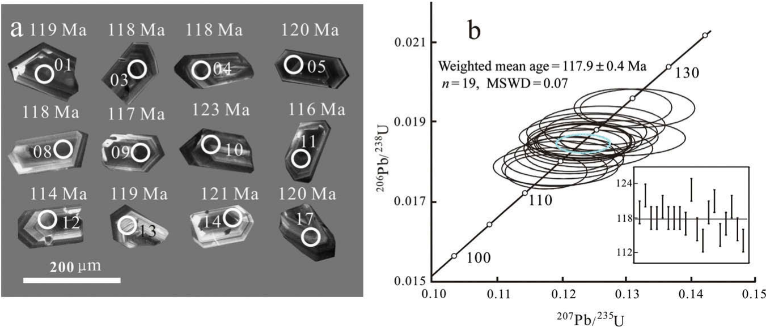

Figure 4. (a) CL images of zircons from the rhyolite. (b) Concordia plot showing the results of the rhyolite zircon LA–ICP–MS analysis.

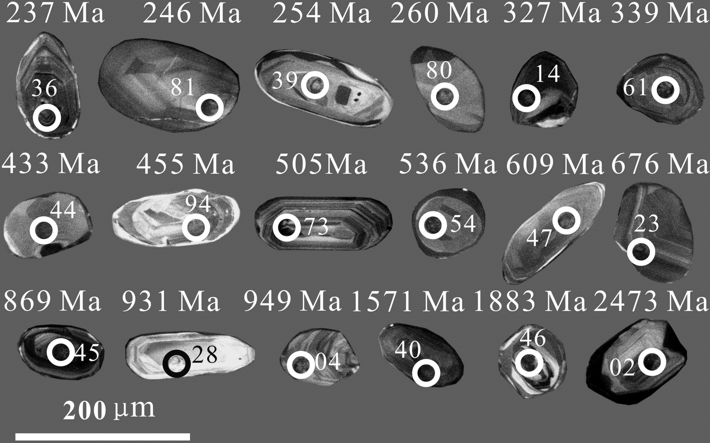

Figure 5. CL images of zircons from the greywacke of the Zhaga Formation.

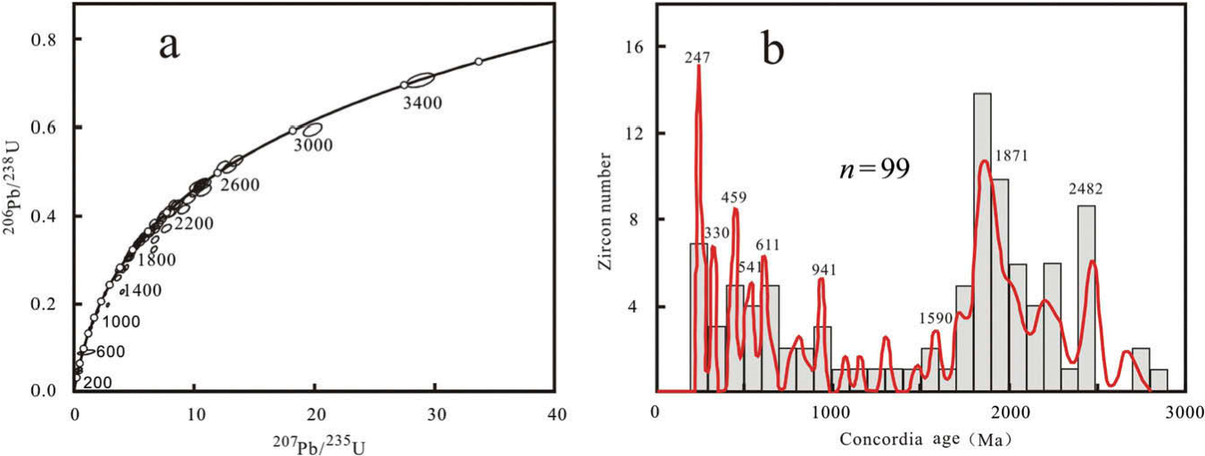

Figure 6. (a) Concordia plot of U–Pb values for the greywacke detrital zircons. (b) Histogram (grey bars) and age spectra (red line) of

concordia ages for the detrital zircons in (a).

zircons are well developed and Th/U ratios are generally greater than 0.1 (average of 0.69), indicating that most of the zircons formed from a magmatic source (Hoskin and Black 2000). Ninety-nine detrital zircons were selected for U–Pb dating. A U–Pb concordia diagram (Figure 6a) and a histogram (Figure 6b) indicate that the zircons record nine predominant ages: 247, 330, 459, 541, 611, 941, 1590, 1871, and 2482 Ma.

## 6. Discussion

6.1. The depositional environment and age of the

Zhaga Formation

As stated earlier, the base of the Zhaga Formation consists of greywacke and conglomerate. The greywacke contains a higher matrix content and a certain content of lithic, indicating low maturity (Figure 2b). The greywacke contains graded and convolute bedding, indicating that the deposit accumulated rapidly. The conglomerate gravels do not exhibit sorting or rounding, indicating that this facies also formed in a rapidly accumulating depositional environment. In addition, the conglomerate is lenticular in shape, with a flat top, indicating that it may have formed in a bathyal to abyssal canyon environment.

The main part of the Zhaga Formation consists of thin layers of greywacke interbedded with shale layers of similar thickness (Figure 2a). The greywacke contains typical underside moulages (Figure 2b), convolute bedding (Figure 2e), and a distinct a–b–c–d Bouma sequence (Figure 2f). The reported sedimentary features confirm that the Zhaga Formation records bathyal to abyssal turbidite deposition. In addition, the Zhaga Formation exposed along the studied transect contains basalt and limestone interpreted as oceanic island deposits, which typically form in deep sea basins; the contact between the turbidite facies and ocean island deposits further confirms the deepmarine origin of the Zhaga Formation.

The rhyolite of the Zhaga Formation yields a LA–ICP– MS zircon U–Pb weighted mean age of 118 Ma (Figure 4a and 4b), indicating that this formation was formed during the late Early Cretaceous. In summary, the Zhaga

Formation records late Early Cretaceous bathyal to abyssal turbidite deposition in the Bangong–Nujiang Neo-Tethys Ocean.

6.2. The provenance of the Zhaga Formation

The Zhaga Formation was deposited in the Bangong– Nujiang Neo-Tethys Ocean, which was located between the Lhasa block and the Qiangtang area (consisting of the southern Qiangtang–Baoshan block, the LSLSZ, and the northern Qiangtang–Qamdo block; see Figure 1a). It therefore seems likely that sediments of the Zhaga Formation were derived from either the Lhasa block or the Qiangtang area.

The diffusion and closure temperature of Pb in zircon is approximately 900°C (Lee et al. 1997; Cherniak and Watson 2001); zircon is therefore a reliable indicator of magmatism and high-grade metamorphism. Because of its high mineral stability, zircon is readily preserved in sedimentary rocks, and the peak ages of detrital zircons generally record high-temperature events in the sediment source region. Therefore, detrital zircons in sedimentary rocks play an important role in the identification of sediment provenance (Xu et al. 2007).

The greywacke of the Zhaga Formation yields nine peak ages of 247, 330, 459, 541, 611, 941, 1590, 1871, and 2482 Ma, indicating that the provenance region has a complex tectonic history. The peak ages of 541, 611, 941, 1590, 1871, and 2482 Ma record events widely recognized in both the Lhasa and Qiangtang terranes (Fan et al. 2012) and therefore have unclear significance for the provenance of the Zhaga Formation. In contrast, the peak ages of 459, 330, and 247 Ma have clear implications. The Lhasa block was stable at these times, with no record of magmatic or tectonic activity, whereas evidence from the Qiangtang area shows quite the contrary, as explained later.

The Qiangtang area is subdivided into the southern Qiangtang–Baoshan block and the northern Qiangtang–

Qamdo block by the LSLSZ (Li 1987; Li et al. 2006, 2007, 2009; Dong et al. 2009; Shi et al. 2009; Zhai et al. 2009; Wang et al. 2013; Wu 2013). Evidence of tectonic activity at 459 Ma exists not only in the southern Qiangtang–Baoshan block but also in the LSLSZ and the northern Qiangtang–Qamdo block. Jie et al. (2015) identified flysch deposits with interlayering of bimodal igneous rocks and obtained zircon U–Pb ages of 450 and 458 Ma from rhyolite layers. The deposits were interpreted to record an Ordovician continental rift event (Jie et al. 2015). In the LSLSZ there are many ophiolites dated at 438–467 Ma (Li et al. 2008a; Wang et al. 2008a; Zhai et al. 2010), indicating that the Longmuco– Shuanghu–Lancangjiang Ocean was undergoing rapid expansion during this period. In the northern Qiangtang– Qamdo block, the Caledonian movement is extensively developed (Lu 2004; Xia et al. 2009; Peng et al. 2014). The Ordovician continental rift event in the southern Qiangtang–Qamdo block, the expansion of the Longmuco– Shuanghu–Lancangjiang Ocean, and the Caledonian movement in the northern Qiangtang–Qamdo block could each have produced new zircons at ~459 Ma, and therefore, the 459 Ma peak age of detrital zircons from the Zhaga Formation indicates that the provenance region of the Zhaga Formation was the Qiangtang area.

The Longmuco–Shuanghu–Lancangjiang Ocean began subducting at about 350 Ma and finally closed before 214 Ma (Li 1987; Li et al. 2007, 2008a; Dong et al. 2009; Shi et al. 2009; Zhai et al. 2009; Wu 2013). This process conceivably produced many new zircons in the Qiangtang area (Li et al. 2007, 2009) and may therefore account for the peak ages at 330 and 247 Ma observed in the detrital zircons of the Zhaga Formation. This correlation is further evidenced that the provenance of the Zhaga Formation was the Qiangtang area.

In the central Lhasa block, a large-scale late Indosinian orogenic belt is recorded by widely distributed granites dated at 210–190 Ma (Li et al. 2003, 2011a). The detrital zircons of the Early Cretaceous Zhaga Formation do not yield peak ages matching this period, indicating that the provenance region of the Zhaga Formation was not the Lhasa block. In summary, the provenance of the Zhaga Formation was the Qiangtang area to the north.

6.3. The tectonic significance of the Zhaga Formation for flysch deposit formation in the Bangong–Nujiang Neo-Tethys Ocean

Flysch deposits form in predominantly deep sea basins and typically directly overlie oceanic crust. Therefore, analysis of these deposits can help reconstruct the evolution of ancient oceans. The flysch deposits of the Bangong–Nujiang Neo-Tethys Ocean are recorded in the Mugagangri Group (Bureau of Geology and Mineral Exploration of Tibet Province 1993). The Mugagangri Group is dominated by greywacke and shale and reaches huge thicknesses of up to 14,796 m in the Rongma area, Gerze County (Bureau of Geology and Mineral

Exploration of Tibet Province 1993). The group contains scarce fossils and rare sedimentary structures such as load casts, flute casts, and incomplete Bouma sequences (Xie et al. 2009).

The Mugagangri Group contains huge tectonic rock blocks within the BNSZ, with a distribution strictly limited by the suture zone. Deposits of the Mugagangri Group form the matrix of the ophiolites, ocean island fragments, and exotic limestone blocks located within the BNSZ, indicating that this group records a critical period in the evolution of the Bangong–Nujiang Neo-Tethys Ocean. However, because of the scarcity of fossils, the age of the Mugagangri Group is highly controversial.

Early to Middle Jurassic trace fossils, corals, bivalves, and gastropods are found in the western segment of the BNSZ, near Rutog County (Jiangxi Institute of Geological Survey 2005; Xie et al. 2009). In the middle segment of the BNSZ, corals, bivalves, gastropods, and bristle sponge fossils occur in Gerze, Bangor, and Nagqu counties (Wen 1979; Tibet Institute of Geological Survey 2012a, 2012b, 2012c, 2012d). These fossils are predominantly Early to Middle Jurassic in age, with a small number of Late Jurassic examples. Although occurrences are rare, the fossils indicate a Jurassic age for the Mugagangri Group. However, most of the deposits have no age constraints; although the Mugagangri Group is widely distributed, only a few sites contain fossils (Figure 7). Fan et al. (2014b) collected coral fossils of Middle Jurassic to Early Cretaceous age from the Mugagangri Group (Fan et al. 2014b). The study distinguished the Zhaga Formation from the Mugagangri Group and obtained a zircon U–Pb age of 118 Ma from its rhyolite interlayers. The Middle Jurassic to Early Cretaceous coral fossils and the 118 Ma zircon U–Pb age indicates that some parts of the Mugagangri Group may be Early Cretaceous in age. The timing of flysch deposition in the Bangong–Nujiang Neo-Tethys Ocean may therefore have extended from the Jurassic into the Early Cretaceous.

6.4. The timing of closure of the Bangong–Nujiang

Neo-Tethys Ocean

|  |
| --- |
| Figure 7. The distribution and ages of fossils of the Mugagangri Group in the BNSZ. |

The timing of closure of the Bangong–Nujiang NeoTethys Ocean is controversial. The occurrence of unconformities between the Middle Jurassic Dejiguo Group, the Late Jurassic to Early Cretaceous Shamuluo Group, the Late Jurassic to Early Cretaceous Dongqiao Group, and ophiolites led previous researchers to suggest that the Bangong–Nujiang Neo-Tethys Ocean closed between the Late Jurassic and the early Early Cretaceous (Wang et al. 2002; Chen et al. 2004; Xin et al. 2009). However, recent findings, including the discovery of the Early Cretaceous Tarenben (>100 km2) and Zhonggang (>400 km2) ocean islands, suggest that the ocean may have closed after the early Early Cretaceous (Zhu et al. 2006; Fan et al. 2014a).

If the Bangong–Nujiang Neo-Tethys Ocean had still existed during the Early Cretaceous, there should be sedimentary strata of this age recording deposition from the shallow-marine realm to the deep-sea basin. In the BNSZ, the Langshan Formation records shallow-marine deposition (Bureau of Geology and Mineral Exploration of Tibet Province 1993) but lacks evidence of deep-sea deposition. The new identification and characterisation of the Zhaga Formation reveals a crucial record of deep-sea deposition at this time.

Evidence presented here shows that during the late Early Cretaceous, shallow-marine, bathyal, and deep-sea sedimentary environments coexisted in the Bangong– Nujiang Neo-Tethys Ocean, indicating that it was still a relatively complete ocean basin at this time. The provenance of the Zhaga Formation was the Qiangtang area to the north, and the formation does not contain detritus from the Lhasa block to the south, indicating that the Bangong– Nujiang Neo-Tethys Ocean was sufficiently large to have completely separated the Qiangtang and Lhasa areas during the late Early Cretaceous (Figure 8). The Bangong– Nujiang Neo-Tethys Ocean must therefore have closed after the late Early Cretaceous, considerably later than the Late Jurassic and the early Early Cretaceous timings of closure proposed by previous scholars (Wang et al. 2002; Chen et al. 2004; Xin et al. 2009).

We propose that the unconformities between the Middle Jurassic Dejiguo Group, the Late Jurassic to

|  |
| --- |
| Figure 8. Schematic model of the late Early Cretaceous evolution of the Bangong–Nujiang Neo-Tethys Ocean. |

Early Cretaceous Shamuluo Group, the Late Jurassic to Early Cretaceous Dongqiao Group, and the ophiolites are related to the closure of a back-arc basin of the Bangong– Nujiang Neo-Tethys Ocean. Island-arc volcanic rocks older than the unconformities occur in the areas where the unconformities are observed (Fan et al. 2014a), and the ophiolites underlying the unconformities have characteristics of island-arc ophiolites (Tibet Institute of Geological Survey 2012c).

## 7. Conclusion

The results of this study can be summarized as follows.

1. The Zhaga Formation records bathyal to abyssal turbidite deposition in the Bangong–Nujiang NeoTethys Ocean during the late Early Cretaceous. Sediment provenance was the Qiangtang area to the north.
2. The late Early Cretaceous Zhaga Formation was identified from the Mugagangri Group and contains similar rock assemblages to this group. This indicates that some parts of the Mugagangri Group are Early Cretaceous in age and that the timing of flysch deposition in the Bangong–Nujiang NeoTethys Ocean may have continued from the

Jurassic into the Early Cretaceous.

1. During the late Early Cretaceous, shallow-marine, bathyal, and deep-sea depositional environments coexisted in the Bangong–Nujiang Neo-Tethys Ocean, suggesting that the ocean was a relatively complete ocean basin at this time. Provenance studies indicate that the Qiangtang area to the north was the source of sediments deposited in the Zhaga Formation. The Zhaga Formation does not contain material derived from the Lhasa block to the south, indicating that the Bangong–Nujiang Neo-Tethys Ocean was sufficiently large to have completely separated the Qiangtang and Lhasa blocks during the early Late Cretaceous. Therefore, the timing of closure of the Bangong–Nujiang Neo-Tethys Ocean must have been later than the late Early Cretaceous and did not occur during the Late Jurassic to early Early Cretaceous as proposed by previous scholars.

## Acknowledgements

We thank Ms Xu Feng for drafting the figures and Prof Dong Yongsheng, Mr Yang Hantao, Mr Zhang Xiuzheng, Mr Hu Peiyuan, and Mr Wu Hao for their help in the field.

Disclosure statement

No potential conflict of interest was reported by the authors.

## Funding

This research was supported by the National Natural Science Foundation of China [Grant No. 41272240], [Grant No. 41402190]; China Geological Survey project [Grant No. 1212011221093], [Grant No. 1212011121248], [Grant No. 12120113036700]; Graduate Innovation Fund of Jilin University [Grant No. 2014063].

## Supplemental data

Supplemental data for this article can be accessed [at http://dx.doi.](http://dx.doi.org/10.1080/00206814.2015.1006695)

[org/10.1080/00206814.2015.1006695](http://dx.doi.org/10.1080/00206814.2015.1006695)

## References

Andersen, T., 2002, Correction of common lead in U–Pb analyses that do not report 204Pb: Chemical Geology, v. 192, p. 59–79. doi:[10.1016/S0009-2541(02)00195-X](http://dx.doi.org/10.1016/S0009-2541(02)00195-X)

Bao, P.S., Xiao, X.C., Su, L., and Wang, J., 2007, Petrological, geochemical and chronological constraints for the tectonic setting of the Dongco ophiolite in Tibet: Science in China Series D: Earth Sciences, v. 50, p. 660– 671. [in Chinese with English abstract.] doi:[10.1007/ s11430-007-0045-5](http://dx.doi.org/10.1007/s11430-007-0045-5)

Bureau of Geology and Mineral Exploration of Tibet Province, 1993, Regional geology of Tibet Province: Beijing, Geological Publishing House, p. 1–707. [in Chinese with English abstract.]

Cao, S.H., Li, D.W., Yu, Z.Z., Yuan, J.Y., Wu, X.L., and Hu, W. Z., 2007, Metallogenic and geological characteristics of the Nixiong superlarge magnetite deposit in Gangdese, Tibet: Geotectonica et Metallogenica, v. 113, p. 328–334. [in Chinese with English abstract.]

Cao, S.H., Xiao, X.L., and Ouyang, K.G., 2008, Renew-establishment of the Jurassic Mugagangri Formations and its geological significance on the western side of the Bangong Co-Nujiang junction zone: Acta Sedmentologica Sinica, v. 26, p. 559–564. [in Chinese with English abstract.]

Chen, G.R., Liu, H.F., Jiang, G.W., Zeng, Q.G., Zhao, S.R., and Zhang, X.G., 2004, Discovery of the Shamuluo Fomation in the central segment of the Bangong–cuo–Nujiang suture zone, Tibet: Geological Bulletin of China, v. 23, p. 193– 194. [in Chinese with English abstract.]

Cherniak, D.J., and Watson, E.B., 2001, Pb diffusion in zircon: Chemical Geology, v. 172, p. 5–24. doi:[10.1016/](http://dx.doi.org/10.1016/S0009-2541(00)00233-3)

[S0009-2541(00)00233-3](http://dx.doi.org/10.1016/S0009-2541(00)00233-3)

Dewey, J.F., Shackleton, R.M., Chengfa, C., and Yiyin, S., 1988, The tectonic evolution of the Tibetan Plateau: Philosophical Transactions of the Royal Society A: Mathematical, Physical and Engineering Sciences, v. 327, p. 379–413. doi:[10.1098/ rsta.1988.0135](http://dx.doi.org/10.1098/rsta.1988.0135)

Dong, Y.S., Zhang, X.Z., Shi, J.R., and Wang, S.J., 2009, Petrology and metamorphism of garnet-muscovite schist from high pressure metamorphosed belt in central Qiangtang, northern Tibet, China: Geological Bulletin of China, v. 28, p. 1201–1206. [in Chinese with English abstract.]

Fan, J.J., Li, C., Wang, M., Hu, P.Y., Yang, H.T., Xie, C.M., and Wu, Y.W., 2012, The genesis and material source of Carboniferous-Late Permian ice miscellaneous conglomerate: A case study of Gangma Co area, Qiangtang, Tibetan Plateau: Geological Bulletin of China, v. 31, p. 1451–1460. [in Chinese with English abstract.]

Fan, J.-J., Li, C., Xie, C.-M., and Wang, M., 2014a, Petrology, geochemistry, and geochronology of the Zhonggang ocean island, northern Tibet: Implications for the evolution of the Banggongco–Nujiang oceanic arm of the Neo-Tethys: International Geology Review, v. 56, p. 1504–1520. doi:[10.1080/00206814.2014.947639](http://dx.doi.org/10.1080/00206814.2014.947639)

Fan, J.-J., Li, C., Xu, J.-X., and Wang, M., 2014b, Petrology, geochemistry and geological significance of the Nadong ocean island, Banggongco–Nujiang suture, Tibetan Plateau: International Geology Review, v. 56, p. 915–928. doi:[10.1080/00206814.2014.900651](http://dx.doi.org/10.1080/00206814.2014.900651)

Feng, G.S., Liao, L.G., Chen, Z.H., and Xiao, Z.J., 2006, Geological characteristics of the Caima iron-polymetallic deposit, Rutog County, western Tibet, China, and its significance for mineral prospecting: Geological Bulletin of China, v. 25, p. 267–272.

Hoskin, P.W.O., and Black, L.P., 2000, Metamorphic zircon formation by solid-state recrystallization of protolith igneous zircon: Journal of Metamorphic Geology, v. 18, p. 423–439. doi:[10.1046/j.1525-1314.2000.00266.x](http://dx.doi.org/10.1046/j.1525-1314.2000.00266.x)

Hu, P.Y., Li, C., Wang, M., Xie, C.M., and Wu, Y.W., 2013, Cambrian volcanism in the Lhasa terrane, southern Tibet: Record of an early Paleozoic Andean-type magmatic arc along the Gondwana proto-Tethyan margin: Journal of Asian Earth Sciences, v. 77, p. 91–107. doi:[10.1016/j. jseaes.2013.08.015](http://dx.doi.org/10.1016/j.jseaes.2013.08.015)

Jiangxi Institute of Geological Survey, 2005, 1:250000 Kana and Rutog sheets in Xizang: Sedimentary Geology and Tethyan Geology, v. 25, p. 39–44. [in Chinese with

English abstract.]

Jie, C.M., Li, C., Fan, J.J., Wang, M., Su, L., and Liu, Y.M., 2015, Record of Ordovician bimodal volcanism in the central QiangTang, northern Tibet: Insights into the evolution of the North Gondwana Margin. Lithos (in press).

Lee, J., Williams, I., and Ellis, D., 1997, Pb, U and Th diffusion in nature zircon: Nature, v. 390, p. 159–162. doi:[10.1038/ 36554](http://dx.doi.org/10.1038/36554)

Li, C., 1987, The Longmucuo-Shuanghu-Lancangjiang plate suture and the north boundary of distribution of Gondwana facies Carboniferous-Permian system in northern Xizang, China: Journal of Changchun College of Geology, v. 17, p. 155–166. [in Chinese with English abstract.]

Li, C., Huang, X.P., Zhai, Q.G., Zhu, T.X., Yu, Y.S., Wang, G.H., and Zeng, Q.G., 2006, The Longmu Co-Shuanghu-Jitang plate suture and the northern boundary of Gondwanaland in the Qinghai-Tibet plateau: Earth Science Frontiers, v. 13, p. 136–147. [in Chinese with English abstract.]

Li, C., Wang, T.W., Li, H.M., and Zeng, Q.G., 2003, Discovery of Indosinian megaporphyritic granodiorite in the Gangdise area: Evidence for the existence of Paleo-Gangdise: Geological Bulletin of China, v. 22, p. 364–366. [in Chinese with English abstract.]

Li, C., Zhai, G.Y., Wang, L.Q., Yin, F.G., and Mao, X.C., 2009, An important window for understanding the Qinghai-Tibet Plateau – A review on research progress in recent years of Qiangtang area, Tibet, China: Geological Bulletin of China, v. 28, p. 1169–1177. [in Chinese with English abstract.]

Li, C., Zhai, Q.G., Chen, W., Dong, Y.S., and Yu, J.J., 2007, Geochronology evidence of the closure of Longmu CoShuanghu suture, Qinghai-Tibet plateau: Ar-Ar and zircon SHRIMP geochronology from ophiolite and rhyolite in Guoganjianian: Acta Petrologica Sinca, v. 23, p. 911–918. [in Chinese with English abstract.]

Li, C., Zhai, Q.G., Dong, Y.S., Jiang, G.W., Jie, C.M., Wu, Y.W., and Wang, M., 2008a, Oceanic crust on the northern margin of Gondwana – Evidence from Early Paleozoic ophiolite in central Qiangtang, Qinghai-Tibet Plateau: Geological Bulletin of China, v. 27, p. 1605–1612. [in Chinese with

English abstract.]

Li, H.Q., Xu, Z.Q., Yang, J.S., Tang, Z.M., and Yang, M., 2011a, Syn-collisional exhumation of Sumdo eclogite in the Lhasa Terrane, Tibet: Evidences from structural deformation and

40 39

Ar- Ar geochronology: Earth Science Frontiers, v. 18, p. 66–78. [in Chinese with English abstract.]

Li, J.X., Li, G.M., Qin, K.Z., and Xiao, B., 2008b, Geochemistry of porphyries and volcanic rocks and ore-forming geochronology of Duobuza gold-rich porphyry copper deposit in Bangonghu belt, Tibet: Constraints on metallogenic tectonic settings: Acta Petrologica Sinica, v. 24, p. 531–543. [in

Chinese with English abstract.]

Li, J.-X., Qin, K.-Z., Li, G.-M., Xiao, B., Zhao, J.-X., Cao, M.-J., and Chen, L., 2013, Petrogenesis of ore-bearing porphyries from the Duolong porphyry Cu–Au deposit, central Tibet: Evidence from U–Pb geochronology, petrochemistry and Sr–Nd–Hf–O isotope characteristics: Lithos, v. 160–161, p. 216–227. doi:[10.1016/j.lithos.2012. 12.015](http://dx.doi.org/10.1016/j.lithos.2012.12.015)

Li, J.X., Qin, K.Z., Li, G.M., Xiao, B., Zhao, J.Z., and Chen, L., 2011b, Magmatic-hydrothermal evolution of the Cretaceous Duolong gold-rich porphyry copper deposit in the Bangongco metallogenic belt, Tibet: Evidence from U-Pb and 40Ar/39Ar geochronology: Journal of Asian Earth Sciences, v. 41, p. 525–536. doi:[10.1016/j. jseaes.2011.03.008](http://dx.doi.org/10.1016/j.jseaes.2011.03.008)

Li, Z.J., Tang, J.X., Yao, X.F., Duo, J., Liu, H.F., Deng, S.L., Zhang, Z., Zhang, Q.S., and Hu, Z.H., 2011c, Geological characteristics and prospecting potential of Gaerqiong copper-gold polymetallic deposit in Ali District, northern Tibet: Mineral Deposits, v. 30, p. 1149–1153. [in Chinese with

English abstract.]

Liu, Y., Zhao, Y.Y., Cui, Y.B., Lv, L.N., and Nie, F.J., 2011, Characteristics of facieology and mineragraphy of copper polymetallic ore deposit in Shesuo, Tibet: Acta Petrologica Sinica, v. 27, p. 2109–2131. [in Chinese with English abstract.]

Lu, S.N., 2004, Comparison of the Pan-Cathaysian orogeny with the Caledonian and Pan-African orogenies: Geology Bulletin of China, v. 23, p. 952–958.

Ludwig, K.J., 2003, ISOPLOT 3.0: Berkeley Geochronology Center Special Publication, v. 4, p. 70.

Pan, G.T., 1983, An evolution of Tethys in global ocean-continent transformation: Tethyan Geology, v. 18, p. 23–40. [in Chinese with English abstract.]

Pan, G.T., Chen, Z.L., Li, X.Z., Yang, Y.J., Xu, X.S., Xu, Q., Jiang, X.S., Wu, Y.L., Luo, J.N., Zhu, T.X., and Peng, Y.M., 1997, Geological-tectonic evolution in the eastern Tethys: Beijing, Geological Publishing House, p. 1–218. [in Chinese with English abstract.]

Pan, G.T., Mo, X.X., Hou, Z.Q., Zhu, D.C., Wang, L.Q., Li, G. M., Zhao, Z.D., Geng, Q.R., and Liao, Z.L., 2006, Spatialtemporal framework of the Lhasa Orogenic Belt and its evolution: Acta Petrologica Sinica, v. 22, p. 521–533. [in Chinese with English abstract.]

Peng, H., Li, C., Xie, C.M., Jiang, Q.Y., and Chen, J.W., 2014. Riwanchaka Group in central Qiangtang basin, the Tibetan plateau: Evidence from detrital zircons: Geological Bulletin of

China, v. 33, p. 1715–1727. [in Chinese with English abstract.] Qiu, R.Z., Zhou, S., Deng, J.F., Li, J.F., Xiao, Q.H., and Cai, Z. Y., 2004, Dating of gabbro in the Shemalagou ophiolite in the western segment of the Bangong Co–Nujiang ophiolite belt, Tibet-With a discussion of the age of the Bangong Co– Nujiang ophiolite belt: Geological China, v. 31, p. 262–268. [in Chinese with English abstract.]

Qu, X.M., Wang, R.J., Dai, J.J., Li, Y.G., Qi, X., Xin, H.B., Song, Y., and Du, D.D., 2012, Discovery of Xiongmei porphyry copper deposit in middle segment of BangongNujiang suture zone and its significance: Mineral Deposits, v. 31, p. 1–12. [in Chinese with English abstract.]

Qu, X.M., and Xin, H.B., 2006, Ages and tectonic environment of the Bangong Co porphyry copper belt in western Tibet, China: Geological Bulletin of China, v. 25, p. 792–799.

Shi, J.R., Dong, Y.S., and Wang, S.Y., 2009, Dating and tectonic significance of plagiogranite from Guoganjianian Mountain, central Qiangtang, northern Tibet, China: Geological Bulletin

of China, v. 28, p. 1236–1243. [in Chinese with English abstract.]

Shi, R.D., Griffin, W.L., Reilly, S.Y., Huang, Q.S., Zhang, X. R., Liu, D.L., Zhi, X.C., Xia, Q.X., and Ding, L., 2012, Melt/mantle mixing produces podiform chromite deposits in ophiolites: Implications of Re–Os systematics in the Dongqiao Neo-tethyan ophiolite, northern Tibet: Gondwana Research, v. 21, p. 194–206. doi:[10.1016/j. gr.2011.05.011](http://dx.doi.org/10.1016/j.gr.2011.05.011)

Shi, R.D., Yang, J.S., Xu, Z.Q., and Qi, X.Q., 2008, The Bangong Lake ophiolite (NW Tibet) and its bearing on the tectonic evolution of the Bangong–Nujiang suture zone: Journal of Asian Earth Sciences, v. 32, p. 438–457. doi:[10.1016/j.jseaes.2007.11.011](http://dx.doi.org/10.1016/j.jseaes.2007.11.011)

Song, J.L., Li, Z.J., Yao, X.F., Deng, S.L., Zhang, Z., Hu, Z.H., Lei, C.Y., and Wang, H.X., 2012, Characteristics and genetic significance of Skarn in the Gaerqiong Cu-Au deposit, Ge’gyai, Tibet: Acta Geoscientica Sinica, v. 33, p. 703– 712. [in Chinese with English abstract.]

Tibet Institute of Geological Survey, 2012a, 1:250000 geological survey report of Gerze county, Tibet, Wuhan: China University of Geosciences Press. [in Chinese.]

Tibet Institute of Geological Survey, 2012b, 1:250000 geological survey report of Bangor county, Tibet, Wuhan: China University of Geosciences Press. [in Chinese.]

Tibet Institute of Geological Survey, 2012c, 1:250000 geological survey report of Zigetangco county, Tibet, Wuhan: China University of Geosciences Press. [in Chinese.]

Tibet Institute of Geological Survey, 2012d, 1:250000 geological survey report of Nagqu county, Tibet, Wuhan: China University of Geosciences Press. [in Chinese.]

Wang, J.P., Liu, Y.M., Li, Q.S., Yue, G.G., and Pei, F., 2002, Stratigraphic division and geological significance of the Jurassic cover sediments in the eastern sector of the Bangong Lake–Dengqen ophiolite belt in Tibet: Geological Bulletin of China, v. 21, p. 405–410. [in Chinese with

English abstract.]

Wang, L.Q., Pan, G.T., Li, C., Dong, Y.S., Zhu, D.C., Yuan, S. H., and Zhu, T.X., 2008a, SHRIMP U-Pb zircon dating of Eopaleozoic cumulate in Guoganjianian Mt, central Qiangtang area of northern TZibet-Considering the evolvement of Proto- and Paleo- Tethys: Geological Bulletin of China, v. 27, p. 2045–2056. [in Chinese with English abstract.]

Wang, M., Li, C., Wu, Y.W., and Xie, C.M., 2013,

Geochronology, geochemistry, Hf isotopic compositions and formation mechanism of radial mafic dikes in northern Tibet: International Geology Review, v. 31, p. 187–205. [in Chinese with English abstract.]

Wang, W.-L., Aitchison, J.C., Lo, C.-H., and Zeng, Q.-G., 2008b, Geochemistry and geochronology of the amphibolite blocks in ophiolitic mélanges along Bangong-Nujiang suture, central Tibet: Journal of Asian Earth Sciences, v. 33, p. 122– 138. doi:[10.1016/j.jseaes.2007.10.022](http://dx.doi.org/10.1016/j.jseaes.2007.10.022)

Wang, X.B., Bao, P.S., and Deng, W.M., 1987, Tibetan ophiolite: Beijing, Geological Publishing House, p. 1–124. [in Chinese with English abstract.]

Wen, S.X., 1979, The new strata materials in northern Tibet: Acta Stratigraphica Sinica, v. 3, p. 150–156. [in Chinese.]

Wiedenbeck, M., Allé, P., Corfu, F., Griffin, W.L., Meier, M., Oberli, F., Quadt, A.V., Roddick, J.C., and Spiegel, W., 1995, Three natural zircon standards for U–Th–Pb, Lu–Hf, trace element and REE analyses: Geostandards and Geoanalytical Research, v. 19, p. 1–23. doi:[10.1111/ j.1751908X.1995.tb00147.x](http://dx.doi.org/10.1111/j.1751908X.1995.tb00147.x)

Wu, H., Li, C., Hu, P.Y., and Li, X.K., 2014, Early Cretaceous (100–105 Ma) adakitic magmatism in the Dachagou area, northern Lhasa terrane, Tibet: Implications for the Bangong-Nujiang ocean subduction and slab break-off: International Geology Review, p. 1–17. doi:[10.1080/ 00206814.2014.886152](http://dx.doi.org/10.1080/00206814.2014.886152)

Wu, Y.W., 2013, The evolution record of Longmuco-ShuanghuLancang ocean–Cambrian-Permian ophiolites [PHD thesis of Jilin University]: p. 1–251. [in Chinese with English abstract.]

Xia, J., Wang, L.T., Zhong, H.M., Tong, J.S., Lu, R.K., and Wang, M., 2009, Discovery of large-scale Silurian ancient delta deposition system in Longmu Co area, Qinghai-Tibet Plateau, China and its significance: Geology Bulletin of China, v. 28, p. 1267–1275.

Xie, G.G., Mo, X.X., Zhao, Z.D., and Dong, G.C., 2009, Jurassie–Cretaceous sedimentation and evolution of ancient oceanic basin in Bangong Lake Area: Earth Science Frontiers, v. 16, p. 31–39. [in Chinese with

English abstract.]

Xin, H.B., Qu, X.M., Wang, R.J., Liu, H.F., Zhao, Y.Y., and Huang, W., 2009, Geochemistry and Pb, Sr, Nd isotopic features of ore-bearing porphyries in Bangong Lake porphyry copper belt, western Tibet: Mineral Deposits, v. 28, p. 785–792. [in Chinese with English abstract.]

Xu, M.J., Li, C., Zhang, X.Z., and Wu, Y.W., 2014, Nature and evolution of the Neo-Tethys in central Tibet: Synthesis of ophiolitic petrology, geochemistry, and geochronology: International Geology Review, v. 56, p. 1072–1096. doi:[10.1080/00206814.2014.919616](http://dx.doi.org/10.1080/00206814.2014.919616)

Xu, Y.J., Du, Y.S., and Yang, J.H., 2007, Prospects of sediment provenance analysis: Geological Science and Technology

Information, v. 26, p. 26–32. [in Chinese with English abstract.]

Yin, A., and Harrison, T.M., 2000, Geologic evolution of the Himalayan–Tibetan Orogen: Annual Review of Earth and Planetary Sciences, v. 28, p. 211–280. doi:[10.1146/annurev. earth.28.1.211](http://dx.doi.org/10.1146/annurev.earth.28.1.211)

Yuan, H.L., Gao, S., Liu, X.M., Li, H.M., Günther, D., and Wu, F.Y., 2004, Accurate U–Pb age and trace element determinations of zircon by laser ablation—inductively coupled plasma mass spectrometry: Geostandards and Geoanalytical Research, v. 28, p. 353–370. doi:[10.1111/j.1751-908X.2004. tb00755.x](http://dx.doi.org/10.1111/j.1751-908X.2004.tb00755.x)

Zhai, Q.-G., Jahn, B.-M., Wang, J., Su, L., Mo, -X.-X., Wang, K.-L., Tang, S.-H., and Lee, H.-Y., 2013, The Carboniferous ophiolite in the middle of the Qiangtang terrane, Northern Tibet: SHRIMP U–Pb dating, geochemical and Sr–Nd–Hf isotopic characteristics: Lithos, v. 168-169, p. 186–199. doi:[10.1016/j.lithos.2013.02.005](http://dx.doi.org/10.1016/j.lithos.2013.02.005)

Zhai, Q.G., Li, C., Wang, J., Ji, Z.S., and Wang, Y., 2009, SHRIMP U-Pb dating and Hf isotopic analyses of zircons from the mafic dyke swarms in central Qiangtang area, Northern Tibet: Chinese Science Bulletin, v. 54, p. 2279– 2285.[in Chinese with English abstract.] doi:[10.1007/ s11434-009-0203-6](http://dx.doi.org/10.1007/s11434-009-0203-6)

Zhai, Q.G., Wang, J., Li, C., and Su, L., 2010, SHRIMP U-Pb dating and Hf isotopic analyses of Middle Ordovician meta-cumulate gabbro in central Qiangtang, northern Tibetan Plateau: Science China Earth Sciences, v. 53, p. 657–664. doi:[10.1007/s11430010-0063-6](http://dx.doi.org/10.1007/s11430-010-0063-6)

Zhang, Y.X., 2007, Tectonic evolution of the middle–western Bangong–Nujiang suture, Tibet [A thesis submitted for the degree of doctorate at the Graduate School of The Chinese Academy of Sciences]: p. 1–256. [in Chinese with English abstract.]

Zhang, Z., Geng, Q.R., Peng, Z.M., Cong, F., and Guan, J.L., 2011, Geochemistry and geochronology of the China granites in the western part of the Bangong Lake-Nujiang metallogenic zone, Xizang: Sedimentary Geology and Tethyan Geology, v. 31, p. 86–96. [in Chinese with English abstract.]

Zhu, D.C., Pan, G.T., Mo, X.X., Wang, L.Q., Zhao, Z.D., Liao, Z.L., Geng, Q.R., and Dong, G.C., 2006, Identification for the Mesozoic OIB-type basalts in central Qinghai–Tibetan plateau: Geochronology, Geochemistry and their tectonic setting: Acta Geol Sinica, v. 80, p. 1312–1328. [in Chinese with English

abstract.]