*Upper Permian as a new play model on the mid-Norwegian continental shelf: Investigated by shallow stratigraphic drilling*

T. Bugge, J. E. Ringa˚s, D. A. Leith, G. Mangerud,

H. M. Weiss, and T. L. Leith

# ABSTRACT

A 750 m–thick, fully marine succession of sandstones, coarsegrained turbidites, shales, and reworked sabkha sediments has been cored on the eastern margin of the mid-Norwegian shelf. The succession has been dated as Upper Permian–Lower Triassic and is comparable to rocks of the same age exposed onshore East Greenland. These data demonstrate that the marine depositional basin between Greenland and Norway extended much farther east than previously thought.

Reddish, shallow-marine sandstones in the lower 170 m of the cored succession probably represent reworkingofoldersedimentary rocks present to the east of the drill sites. This suggests that Upper Devonian–Lower Permian sediments were deposited on Caledonian basement east of the present-day limits of the basin.

The cored succession also contains source rocks that can be stratigraphically correlated with the oil-prone source rocks of the Upper Permian Ravnefjeld Formation onshore East Greenland. Some of the cored sandstone intervals were stained with light, nonbiodegraded oil that most likely was sourced from Upper Permian or, alternatively, Lower Triassic mudstones.

Reworked fragments of reef-building organisms in Upper Permian turbidites and Upper Permian carbonates encountered in an exploration well on the Nordland Ridge indicate that carbonate deposition and reef building occurred on structural highs on the Trøndelag Platform. The observations from the cored successions are key elements in a new Paleozoic play model on the midNorwegian continental shelf and include the first evidence for the existence of an Upper Permian source rock in the area, with Upper Permian carbonates or sandstones or Triassic–Jurassic sandstones as reservoir.

Copyright 2002. The American Association of Petroleum Geologists. All rights reserved.

Manuscript received December 15, 1999; revised manuscript received January 4, 2001; final acceptance March 13, 2001.

AAPG Bulletin, v. 86, no. 1 (January 2002), pp. 107–127 107 AUTHORS

T. Bugge *Norsk Hydro ASA, N-9480 Harstad,*

*Norway; tom.bugge@hydro.com*

Tom Bugge received his Ph.D. at the Norwegian University of Science and Technology in 1983. He studied the slope stability on the Norwegian continental margin and discovered the huge submarine Storegga Slide. After working at the Continental Shelf Division of the Norwegian

Research Council and at IKU Petroleum Research,

Tom worked for the Exploration Department of Saga Petroleum and now Norsk Hydro. His fairly comprehensive published work includes marine and shallow geology and exploration-related geology.

J. E. Ringa˚s *Statoil, P.O. Box 273, N-7501*

*Stjørdal, Norway; JERING@statoil.com*

Jan Einar Ringa˚s received his M.Sc. degree at the

Norwegian University of Science and Technology in

1982. He worked for Elf Petroleum Norge from 1983 to 1990, first as an exploration geologist and later within reservoir geology. He joined IKU/ SINTEF Petroleum Research in 1990 and participated in the seismic mapping of targets for shallow stratigraphic drilling. He continued to work within reservoir geology, and has from 1997 worked as a reservoir staff geologist for Statoil.

D. A. Leith *Statoil, P.O. Box 273, N-7501*

*Stjørdal, Norway; DEL@statoil.com*

Deborah Leith received a B.Sc. degree from the University of Glasgow, Scotland, in 1985, returning to gain an M.Sc. degree from the same university in 1989. She joined IKU/SINTEF Petroleum Research in 1991, where she worked as a sedimentologist on a variety of exploration and reservoir characterization projects. Deborah joined Den norske stats oljeselskap a.s. (Statoil) in 1996, where she currently works as sedimentologist for the Heidrun field.

1. Mangerud *Norsk Hydro Research Centre, N-5020 Bergen, Norway; gunn.mangerud@hydro.com*

Gunn Mangerud received her M.Sc. degree from the University of Trondheim, Norway, in 1988 and worked on Paleozoic and Triassic stratigraphy and geology of the Arctic region at IKU Petroleum Research until 1993. In 1993 she began work as a geologist at Norsk Hydro’s Research Centre in Bergen, with a main work area in biostratigraphy. Gunn received her Ph.D. on Permian stratigraphy of the Barents Sea from the University of Bergen in 1994. She has since worked on various research and exploration projects, mainly on the Norwegian continental shelf, including a three-year period as a project leader for the New Play Models R&D project. She now works as a section head for the Sedimentology and Stratigraphy Department.

1. M. Weiss *SINTEF Petroleum Research, N-7465 Trondheim, Norway; hermann.weiss@iku.sintef.no*

Hermann M. Weiss received a diploma in mineralogy (1979) from the University of Heidelberg, Germany. He worked at KFA Ju¨lich on petroleum-geochemical aspects of the West Canada basin and obtained a Ph.D. (1985) from the Institute of Technology (RWTH), Aachen, Germany. He joined IKU/SINTEF Petroleum Research in 1985 and was the geochemist responsible for several of the institute’s shallow drilling projects in the Barents Sea, the Norwegian Sea, and the Skagerrak.

T. L. Leith *Statoil Research Centre, Rotvoll,*

*N-7005 Trondheim, Norway; tlle@statoil.com*

Les Leith received an M.Sc. degree in organic geochemistry from the University of Newcastle upon Tyne, England, and a Ph.D. in petroleum engineering from Heriot-Watt University in Scotland. After joining IKU as a geochemist in

1984, Les moved to Statoil’s Research Centre in Trondheim in 1998. He has published work on the geochemistry of reservoir cap rocks, North Sea coals, and regional Arctic geochemistry.

# ACKNOWLEDGEMENTS

All of us worked at IKU Petroleum Research (now SINTEF Petroleum Research) during the shallow stratigraphic drilling project. The project was supported by Mobil Exploration Norway Inc., Norsk

Agip a.s., Phillips Petroleum Co. Norway, Statoil, K/S Farmand Survey and IKU Petroleum Research. Wolfgang Weitschat studied the macrofossils, Richard Bromley the ichnofacies, and Silvia Pinard the microfossils. Berit Fossum drafted the illustrations. Lars Stemmerik provided valuable comments on the core interpretation, as well as to the manuscript. Flemming G. Christiansen and Howard J. White gave constructive review comments. We acknowledge the above-mentioned persons and companies and our colleagues at IKU for their contributions. Special thanks are due to Odd Ragnar Heum, Statoil/Norsk Hydro, for his persistent belief in the project and his efforts to get it launched.

# INTRODUCTION

Hydrocarbon exploration in the Norwegian Sea since 1980 has demonstrated the existence of large oil, condensate, and gas discoveries sourced by Jurassic sedimentary rocks. These source rocks are generally thermally immature on the middle and inner shelf area. The recognition of a rich Upper Permian oil source rock (the Ravnefjeld Formation) in East Greenland (Surlyk et al., 1986; Christiansen et al., 1993) led to speculation as to whether a similar source rock could exist on the Norwegian continental shelf. If such a source rock exists, then the present Trøndelag Platform (Figure 1) is the most likely place for an Upper Permian source rock to be within the oil maturation window.

Prior to the present coring study, the only evidence for the existence of Permian sedimentary rocks in the areawas thepresence of 40 m of carbonates of supposed Late Permian age encountered in the exploration well 6609/7-1, which was drilled in 1984 on the Nordland Ridge (Figure 1). Important information was obtained by reinvestigation of seabed grab samples, which yielded palynological evidence for marine Lower Triassic rocks in the area. Additionally, the occurrence of reworked specimens of the genus *Vittatina,*which generally represents the Permian, in Quaternary clays, suggested that Permian rocks had been deposited and later eroded (Vigran and Mangerud, 1991). Seismic studies and shallow coring (Bugge et al., 1984) identified areas of Lower Triassic rocks outcropping on the seabed. Below these, strata of supposed upper Paleozoic sediments were seismically identified, but they do not outcrop on the seabed. In a localized area close to the coast, however, there seemed to be possibilities of upper Paleozoic rocks being present only a few hundred meters below the seabed. On this basis, two shallow stratigraphic boreholes were drilled by IKU Petroleum Research in 1992. The cored marine Permian–Triassic succession was more than 750 m thick and contained oil-stained sandstone and mudstone with source rock potential. In this article we present the cores and discuss the implications for geological models and hydrocarbon exploration in the area.

# GEOLOGICAL BACKGROUND

Upper Paleozoic sedimentary rocks overlie metamorphic basement on the Norwegian and the Greenland margins of the North Atlantic. With the exception of Devonian clastic rocks in intramontane basins on the Norwegian mainland, these Paleozoic sedimentary rocks only occur offshore on the Norwegian side (Sigmond, 1992) but are exposed onshore in East Greenland (Surlyk, 1990; Stemmerik et al., 1993).

In East Greenland, the entire Upper Devonian–Lower Permian succession, the Traill Ø Group (Vigran et al., 1999), is continental in nature and was deposited during the early rift phase, which followed subduction and suturing of the Baltic and Laurentian plates.

|  |
| --- |
| Figure 1. The 1992 shallow stratigraphic boreholes (6611/ 09-U-01 and 6611/09-U-02) are located on the eastern margin of the Trøndelag Platform, close to the mid-Norwegian mainland. Other relevant data points for the present article are indicated. An older shallow core (open circle) contained 20 m of Early Triassic marginal marine siltstones and sandstones. The Phillips exploration well  6609/7-1 encountered 40 m of Permian dolomites. Grab samples (asterisk immediately to the north of the older shallow core) of the sea floor contained Permian and Lower Triassic marine fossils. The base map is modified from Blystad et al. (1995). |

A major middle Permian tectonic event can be recognized in East Greenland and throughout the Arctic. It caused a shift to generally deeper marine environments in the Barents Sea (Stemmerik and Worsley, 1989; Bugge et al., 1995), which led to the establishment of a seaway from the Barents Sea area southward and to the separation of Greenland and Norway (Surlyk et al., 1984; Dore´, 1991). In East Greenland, this event caused a change from nonmarine Upper Devonian– Lower Permian deposition to dominantly marine deposition from the middle Permian onward (Figure 2) and the deposition of the Upper Permian Foldvik Creek Group (Surlyk et al., 1986; Stemmerik, 1987). In the North Sea, the middle Permian transgression led to the deposition of the evaporites and carbonates of the Zechstein Supergroup (Ziegler, 1981, 1990).

On the mid-Norwegian continental shelf, thepresence of Devonian–Early Permian sedimentary rocks is inferred from seismic data and by correlation with East Greenland (Bukovics and Ziegler, 1985; Schmidt, 1992). Schmidt (1992) correlated an extensional tectonic event observed in seismic data from offshore mid-Norway with the regional middle Permian event. The 40 m of carbonates encountered in well 6609/71 on the Nordland Ridge probably represent the Upper Permian, but they have not been dated precisely because of lack of datable fossil material.

ContinentalenvironmentsprevailedinEastGreenland throughout most of the Triassic, with the exception of marine conditions in the earliest Triassic(Griesbachian) (Surlyk et al., 1986). In the North Sea, Early Triassic deposition is represented by continental red beds, whereas marine deposition dominated in the Barents Sea. The previously existing shallow cores proved marine conditions off mid-Norway in the Early Triassic, whereas two salt layers higher in the Triassic succession (Ladinian and Carnian?) (Jacobsen and van Veen, 1984) represent later, more short-lived, marine incursions. Continental environments probably prevailed during the remaining periods of the Triassic.

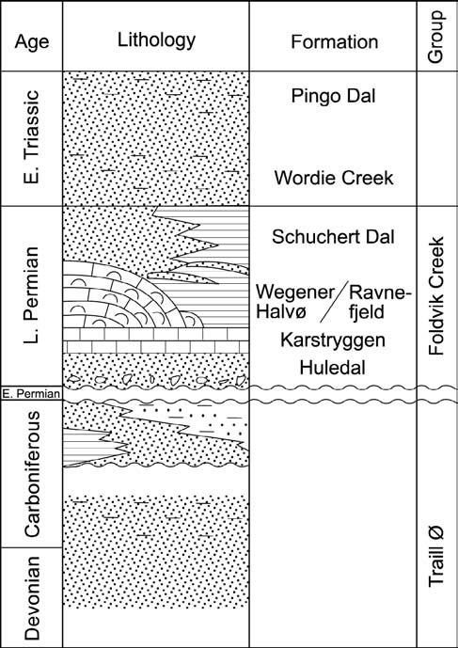

Figure 2. Simplified Devonian–Triassic stratigraphy of East Greenland. The Upper Permian–Lower Triassic succession, equivalent to the Huledal to Wordie Creek formations, was cored in the shallow stratigraphic boreholes off Norway.

# DESCRIPTION OF THE CORED SUCCESSION

The shallow cores were collected on the inner midNorwegian shelf in 1992 using the vessel M/V *Bucentaur.* The drilling locations were chosen where a strong seismic reflection, interpreted to represent the top of the Permian, was within reach of the shallow drilling equipment. Two boreholes were drilled: hole 6611/ 09-U-01 down to 560 m below seabed and hole 6611/ 09-U-02 down to 280 m below seabed (Figure 3). The boreholes were located on the northeastern margin of the Helgeland Basin (Figure 1) and were drilled 1200 m apart on the seismic line IKU-HE06-91 (Figure 3). Water depth was 350 m, and the Quaternary overburden was 10 and 8 m thick at boreholes 1 and 2, respectively. Recovery was very high (99%), and the cores, which are 54 mm in diameter, are of excellent quality. Both holes were logged using a full suite of petrophysical logging tools. Log correlation shows that the two boreholes have a stratigraphic overlap of about 60 m and represent a continuously cored succession of approximately 750 m (Figure 4).

The cored section is divided into four lithological units, from bottom to top: a lower shallow-marine sandstone unit, followed by an anhydrite unit, a lower turbidite unit, and finally an upper turbidite unit (Figure 4). The shallow-marine sandstone unit, the anhydrite unit, and the lower turbidite unit have beendated as Late Permian (Ufimian–early Tatarian?). The upper turbidite unit is Early Triassic (Griesbachian).

The low amplitude, continuous reflection occurring just below the base of borehole 6611/09-U-01 is interpreted to represent top basement (Figures 3, 5). The strong seismic reflection, which prior to drilling was interpreted to represent the top of the Permian, was later identified as the top of the anhydrite unit, an intra–Upper Permian reflector. The top Permian reflector gives a weak negative acoustic impedance contrast and corresponds to a discontinuous seismic marker (Figure 3). As such, this is probably not a good seismic marker on the Trøndelag Platform because of the similar lithologies above and below the Permian– Triassic contact, that is, distal and lateral equivalents to the upper turbidite unitand thelowerturbiditeunit. Shallow-Marine Sandstone Unit

|  |
| --- |
| Figure 3. The two boreholes 6611/09-U-01 and 6611/09-U-02, respectively 560 m and 280 m deep, were drilled 1200 m apart.  With a stratigraphic overlap of 60 m, the boreholes continuously cored 750 m of a marine Upper Permian–Lower Triassic succession. High-resolution seismic data allowed detailed seismic correlation of the cores and downhole logs. Notice that the Triassic–Permian boundary does not coincide with a seismic reflection, whereas the intra–Upper Permian anhydrite unit is a strong seismic reflector. |

The shallow-marine sandstone unit is 174.5 m thick and is composed of a series of massive, commonly calcite-cemented sandstone beds. The typical lithofacies from this unit is exemplified inFigure6a.Thebasal part of the unit commences with a 1 m–thick, poorly sorted, matrix-supported, immature, reddened conglomeratic sandstone, which abruptly fines up into massive to cross-laminated, variably bioturbated, brick red to brown-gray, fine-grained sandstones.Wherebioturbation is less intense, vague planar lamination can be observed, probably reflecting large-scale crossbedding. Elsewhere, bioturbation has destroyed all primary sedimentary structures, resulting in a homogeneous sandstone. Minor intervals (0.5 m or less in thickness) of brown laminated and partially bioturbated siltstone and mudstones coincide with marked gamma spikes (Figure 4). In contrast to the *Macaronichus segregatis*–dominated sands, the siltstones and mudstones contain a *Planolites-Taenidium* assemblage. A marked decrease in the amount of *Macaronichus segregatis* is observed above these brick red sands, which is coincident with a shift in log response toward a more clay-rich facies. Here, the sands are less reddened and are interbedded with thin silty sandstone layers. Clay drapes are common, and bioturbation consists of a *Planolites* assemblage with sparse *Taenidium*. The marked reddening of the beds continues to decrease upward through the section, and the uppermost part of the unit is represented by interlaminated very fine grained to fine-grained gray sandstones and partially reddened, weakly bioturbated, laminated sandy siltstones containing uncommon millimeter-size *Planolites.* A corresponding reduction in porosity and permeability is recognizable on the petrophysical logs.

# Anhydrite Unit

The anhydrite unit, 15.5 m thick, consists in the lower part of replacive anhydrite (after gypsum) occurring within a host pyritic, laminated siltstone. This lower part is overlain by massive, gray, carbonate-cemented sandstones that have abundant gypsum-filled fractures and small replacive anhydrite concretions or nodules, which are commonly formed along bedding lamination. These sandstones are themselves overlain by a fine-grained to coarse-grained sandstone containing large amounts of replacive anhydrite and reworked clasts of the underlying lithologies. Possibledesiccation structures are found at the top of the unit. The size of the anhydrite nodules ranges from a few millimeters, where associated with bedding lamination, to greater than 5 cm, where they have a mosaic or almost chickenwire structure (Figure 6b, c). The cumulative thickness of anhydrite throughout the unit is approximately 6.5 m. Seismically, the anhydrite unit is clearly distinguished from the overlying and underlying units as a high-velocity, high-density layer.

# Lower Turbidite Unit

The lower turbidite unit represents the youngest part of the Permian succession. It is 166 m thick and

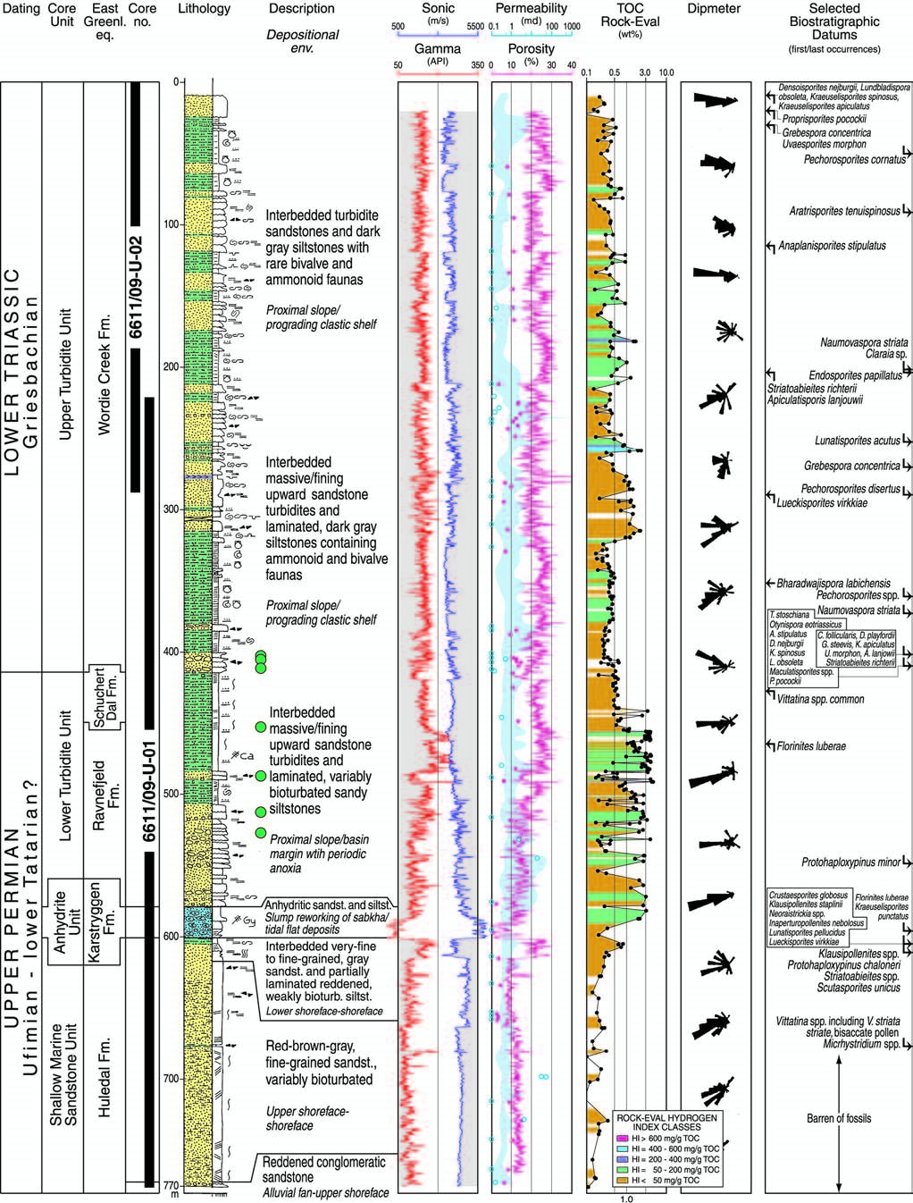

Figure 4. Composite logs of the cored succession and correlation with time equivalent units exposed onshore East Greenland. Green dots indicate oil-stained or fully oil-saturated sandstone intervals. The gamma, sonic, neutron porosity, and dipmeter logs are from downhole logging in uncased hole. Porosity and permeability measured on core plugs are shown by red dots and blue circles, respectively. The range of permeability determined by minipermeameter is indicated in light blue. Total organic carbon (TOC) content,

Rock-Eval hydrogen index (see color code), and first and last occurrences of key biostratigraphic taxa are shown. The organic-rich

Upper Permian rocks are at about 450–470 m.

consists of a series of fining-upward, 1–2 m–thick sandstone beds interbedded with variably bioturbated, dark-gray siltstone layers (Figure 7). The basal part of each fining-upward bed consists of massive, coarsegrained, locally conglomeratic sandstones, which fine upward into strongly laminated sandstones and siltstones that have soft and synsedimentary deformation structures. These deformation structures include flow, scour, and dewatering structures. The base of each fining-upward unit is commonly marked by a sharp erosional surface with tool marks and, commonly, sole and flute marks. Clast material within the sands and conglomerates is dominated by metamorphic rock fragments. Carbonate and evaporite clasts derived from the underlying Permian lithologies are also present. The metamorphic clasts are similar to lithologies found on the Norwegian mainland.

The upper part of the lower turbidite unit is dominated by sandy, locally bioturbated, laminated siltstones, interbedded with smaller, amalgamated, fining-upward sandstones, which are mostly a few centimeters thick but may locally be up to 1 m thick. Two organic-rich, nonbioturbated, dark-gray siltstone/ mudstone intervals, approximately 6 and 13 m thick, respectively, occur in the upper part of the lower turbidite unit. These are identifiable on petrophysical logs by high gamma log values ( 200 API units) and low interval velocities compared to the overlying and underlying siltstones. They have an average total organic carbon (TOC) content of 3.2 0.9 wt. % (Figure 4, 450–470 m).

Above these intervals, variably bioturbated, laminated, locally reddened, sandy siltstones interbedded with thin (1–2 cm), fine-grained sandstones comprise the upper part of the lower turbidite unit. Significant oil staining occurs in parts of this unit. Some 5–30 cm– thick sandstone intervals are fully saturated with oil.

# Upper Turbidite Unit

The upper turbidite unit comprises the upper 190 m of core 6611/09-U-01 and the entire 270 m of core 6611/09-U-02, including a stratigraphic overlap of 60 m. The boundary between the lower and upper

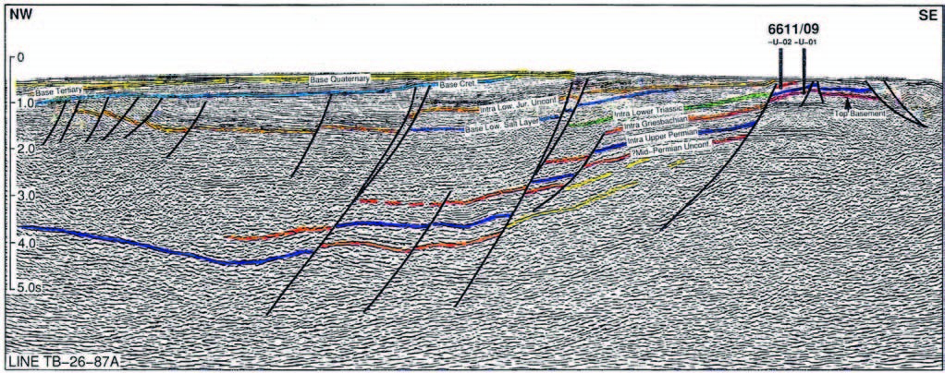

Figure 5. Seismic line from the drilling locations into the Helgeland Basin (see Figure 1). Note that the Permian–Triassic boundary is difficult to identify, whereas the top of the anhydrite unit in the Upper Permian is a good seismic reflector. A candidate for the middle Permian unconformity can be seen.

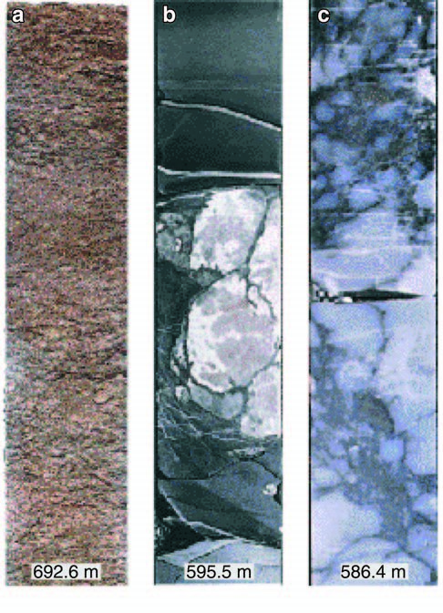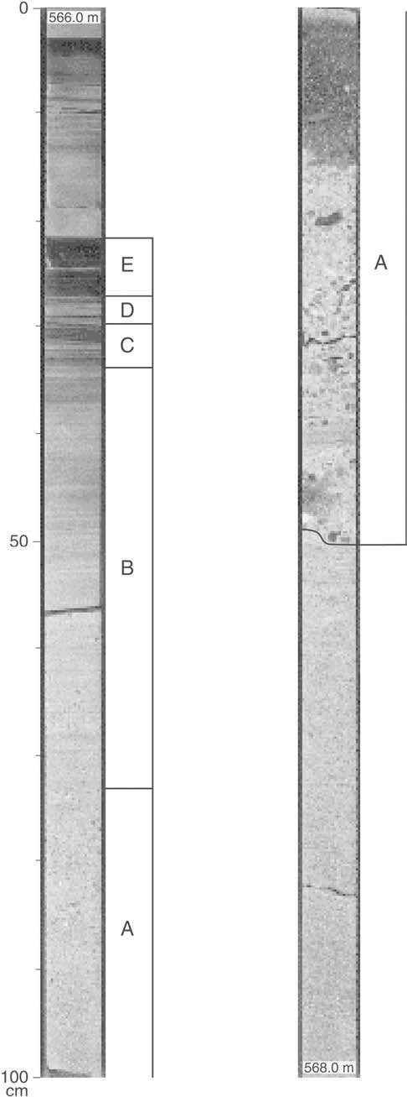upward units, between 50 and 100 m thick. Each unit consists of laminated, dark-gray, and locally pyriticsiltstones with ammonoid and bivalve faunas. The lami-

Figure 6. Core photos (core diameter is 5.4 cm). (a) The reddish shallow-marine sandstone unit comprises the lower 170 m of the cored succession. The well-sorted, fine-grained sandstone is fully bioturbated. Calcite cement has reduced the average porosity to 10% and the permeability to 7 md. The sandstone was probably derived from Late Devonian, Carboniferous, or Early Permian sandstones deposited in the present-day skerry zone east of the drill sites. (b, c) Core photos from the 15 m– thick anhydrite unit, which is interpreted to represent sediments eroded from a sabhka environment and redeposited as gravity flow deposits. Photo (b) shows siltstone with anhydrite clasts and laminae. Photo (c) shows anhydrite with chickenwire structure.

turbidite units represents the Permian–Triassic contact and is recognized in the cored succession by the development of coarsening-upward sandstones on top of the more fine grained sandy siltstones, which mark the uppermost part of the lower turbidite unit.

The upper turbidite unit represents the lower 400 m of a greater than 5000 m–thick Triassic succession. The cored succession consists of a series of coarsening-

Figure 7. A typical fining-upward turbidite sequence from the lower turbidite unit. All classical Bouma units A–E (Bouma, 1962) can be recognized. (A) Fining-upward massive sandstone. (B) Parallel laminated sandstone. (C) Current rippled/ convoluted siltstone. (D) Parallel laminated siltstone. (E) Hemipelagic siltstone/mudstone.

nated siltstones are interbedded with gradually upward-increasing amounts of massive and individually fining-upward sandstone beds. These sandstones range in thickness from 0.5 to 1.5 m. The base of each sandstone is marked by a sharp erosive boundary (Figure 8a). Soft sedimentation structures, such as convolute bedding, load balls, and rip-up clasts, are commonly observed within the siltstones (Figure 8b, c). Macrofauna identifiable in the siltstones include ammonoids, such as *Ophiceratidae* sp., *Tomopophiceras*? sp., and *Lytophiceras*? sp., and the bivalve *Claraia* sp. Minor, centimeter-thick evaporitic layers occur in a 10 m–thick interval within the stratigraphic overlap between the two boreholes and are found in both cores. Intense oil staining is observed in the lowermost 12 m of this unit.

Moderately rich palynofloras indicate a Griesbachian (Early Triassic) age for the upper turbidite unit.

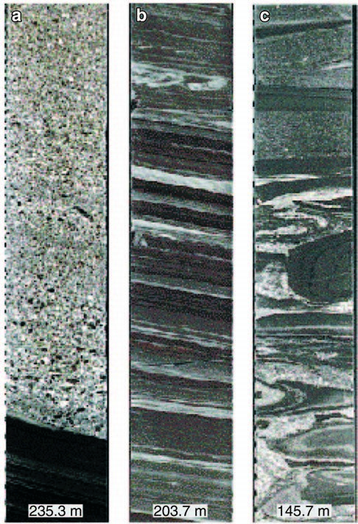

Figure 8. Core photos from the Triassic succession (core diameter is 5.4 cm). (a) Fining-upward turbidite resting on hemipelagic, laminated claystone. (b) Interbedded siltstonesandstone laminae, partly contorted. (c) Slump structures in the sandstone-siltstone beds.

The microfauna indicates a late Griesbachian age, but, as discussed in the following dating section, a 40 m– thick interval at the base ofthe unitlackingammonoids and bivalves could represent the early Griesbachian.

The fine-grained lithologies of the upper turbidite unit have generally poor organic matter contents ( 0.5 wt. % TOC). Several thin (typically 0.5–1.5 cm), more organic-rich layers (up to 2.8 wt. % TOC) of slightly brownish mudstone occur in the lower half of the upper turbidite unit (Figures 4, 9).

# INTERPRETATION

Seismic data indicate that the shallow-marine sandstone unit rests on crystalline basement, although this boundary was not cored. The basal part of the sequence as represented by the meter-thick conglomerate is enigmatic because of the paucity of the cored section. This conglomeratic interval could represent

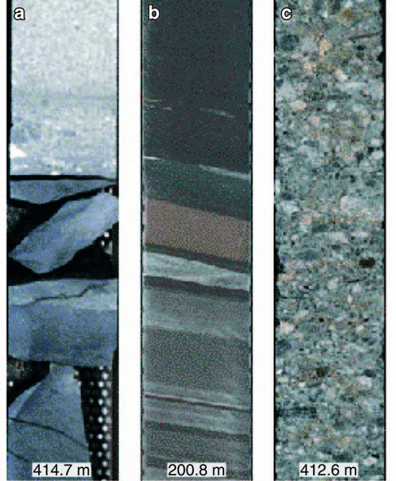

Figure 9. Core photos (diameter 5.4 cm). (a) The Permian– Triassic contact. A hiatus probably exists from the upper Tatarian to lowermost Griesbachian, that is, the uppermost Permian is missing. (b) Laminated siltstone/sandstone in the Triassic succession. Some of the thin siltstone beds are organic rich (2–3 wt. % TOC). (c) Coarse-grained, oil-stained conglomerate in the lowermost Triassic.

either a transgressive lag deposit or the reworking of a fan delta because the sediment is texturally immature, implying localized transport (Nemec and Steel, 1988). Above this basal succession, variably bioturbated, finegrained sandstones with a marine ichnofacies occur. Where bioturbation is reduced, vague cross-bedding and low-angle planar lamination is observed, which may represent large-scale trough cross-strata. These sands are variably bioturbated by *Macaronichus segregatis,* which Clifton and Thompson (1978) suggest was typically found in an intertidal or shallow subtidal environment. Subsequent researchers (Saunders and Pemberton, 1986; Pemberton and Saunders, 1990) have noted that *Macaronichus segregatis* is also common in shoreface/foreshore settings, where the higher energy levels associated with wave activity result in the absence of suspension-feeding forms. A shoreface/ foreshore interpretation for these sands would be consistent with both the development of large-scale bed forms and the ichnofauna. The higher energy intervals recorded by rip-up clasts and sandstones with erosive bases may represent minor tidal channels crossing the shoreface surface. Unfortunately, the obliteration of the primary sedimentary fabric by bioturbation has prevented a more precise interpretation of the sedimentary facies. The succession passes upward into sandstone/siltstones with a *Planolites* assemblage, which may represent lower shoreface deposits.

The characteristic red coloration of the sediments within this unit is due to hematite that occurs as both reworked grains and a primary precipitate. The latter suggests deposition in an arid climate with reasonable groundwater flow (Walker, 1967, 1976). The reworked hematite grains indicate a contribution of material eroded from a preexisting reddened source. Modal analysis shows a remarkably low content of gneiss fragments, schist, and quartzite, and a high content of quartz in the shallow-marine sandstone unit compared to the overlying units. Together with the reworked hematite and well-sorted grain size, this suggests that the sediments were reworked from an older, reddish sedimentary source. As discussed in the following provenance section, this source could be Late Devonian– Early Permian sedimentary rocks. The red coloration of this unit decreases upward and may be associated with either increasing marine influence, decreasing reworked hematite due to a shift in source area, or a combination of these two effects.

The anhydrite unit conformably overlies the shallow-marine sandstone unit and displays facies assemblages such as enterolithic layering and aphanitic anhydrite indicative of a sabkha environment. The development of this sabkha facies indicates restriction and development of hypersaline conditions, most probably in an embayment setting. A possible period of subaerial exposure is indicated by the presence of desiccation surfaces containing a solution breccia close to the top of the unit. The anhydriteis,however,rather chaotically interbedded by pyritic laminated sandstones and massive gray sandstones. This may indicate that these anhydrite deposits are the product of slumping or erosion from sabkha sediments developed upslope and now occurring as slump blocks. The interbedded, laminated siltstones probably represent an offshore transitional environment into which the slumps containing evaporitic material were periodically dumped.

The lower sandstone-rich part of the lower turbidite unit is interpreted to represent the deposition of a series of gravity flows on an unstable proximal slope or basin margin. The fining-up beds, which are typical for the lower turbidite unit, represent complete units or parts of the classical turbidite bed of Bouma (1962) (Figure 7). A proximal position is also indicated by the large amounts of terrestrially dominated palynofacies and the dominance of basement-derived clasts. The interbedded nature of these sandy turbidites with bioturbated sandy siltstones suggests that these flowswere episodic events that punctuated the normal hemipelagic background sedimentation. The ichnofaciesinthe sandy siltstones shows low diversity, consisting predominately of minor *Planolites* and uncommonisolated *Chondrites* and *Teichichnus*, suggesting that unsuitable bottom conditions for colonization were present at this time. This may have been due to the instability of the substrate.

The two nonbioturbated, organic-rich intervals reflect more stagnant, anoxic bottom conditions. The upper interval contains *Tasmanites* algae, and both intervals are interpreted to represent flooding events. Above these intervals, the presence of increasingly reddened, bioturbated, sandy siltstones could point to the subsequent development of a more oxygenated environment.

The upper turbidite unit shows similarity with the underlying lower turbidite unit in terms of both lithofacies and depositional environment. Turbidites occur, however, throughout the entire upper turbidite unit, whereas they are concentrated in the lower part of the lower turbidite unit. Another difference is that many of the turbidites found in the upper unit are finer grained and more mud-rich than in the lower unit.This could suggest that these slumps were accumulated in a slightly more distal position. Thesiltstone-dominated intervals are lithologically similar in the two units but are slightly more organic rich and have higher hydrogen indices in the upper turbidite unit.

The sandstones and siltstones in the upper turbidite unit were probably deposited as high-density sediment gravity flows on an unstable proximal slope.Soft sediment deformation structures are commonly observed (Figure 8). The bivalve-bearing and ammonitebearing siltstones most likely represent hemipelagic sedimentation that occurred between the episodic passage of successive turbidity currents. The thin evaporitic interval could suggest a period of low sea level and/or a restricted basin, but it is most likely redeposited in the form of small slump blocks. Pyritized siltstone laminae also indicate periodic anoxia and restriction of water movement. In summary, the upper turbidite unit represents deposition on the lower slope under medium deep-water, commonly restricted conditions. The turbidites were most likely the result of slope failure triggered by episodic tectonic activity.

# RESERVOIR QUALITY

Diagenetic effects have had a direct effect on the potential reservoir characteristics of the cored section, and authigenic phases include the development of kaolinite, illite, chlorite, and mixed-layer clays. Volumetrically, the precipitation of a pervasive pore-filling calcite has resulted in the destruction of considerable primary porosity. A subsequentalbitizationeventpostdates the precipitation of the early calcite cement and most likely occurred during later burial diagenesis.

Core porosities within the shallow-marine sandstone unit range from 2 to 15%, with an average of 8%; neutron-log porosity is approximately 12% in the lower part and 8–10% in the upper 60 m, which are more clay-rich. Horizontal permeability measured from core plugs is generally less than 1 md, except for three values between 6 and 60 md (Figure 4). Minipermeameter values are mostly between 0.5 and 1 md. The generally poor porosity and permeability reflect the effects of diagenetic processes and subsequent compactional effects.

In an attempt to reconstruct the original porosity/ permeability, backstripped porosities and permeabilities were calculated by removing the diageneticeffects, using image analysis techniques. These backstripped porosities and permeabilities were significantly higher after the removal of the calcite cement, indicating that this event was responsible for most of the porosity/ permeability reduction (excluding compactional effects). Throughout the entire core, mean porosity was improved from 10.5 to 16.6%. In the case of permeability, the results were even more dramatic,increasing to 335 md, as opposed to 23.2 md when calcite was in place.

The anhydrite unit is marked by uniformly lowporosities and permeabilities (Figure 4). Numerous small healed fractures were observed in the core, but no major fractures or secondary porosity is observed in this facies, and the unit would probably form an effective seal to underlying sandstones, if laterally extensive.

Core porosities are fairly constant (Figure 4) throughout the lower turbidite unit, with an average of 11%, whereas neutron-log porosity increases from about 15% in the lower part to 25% in the upper part, where the clay content is higher. Horizontal permeability is low (average 3 md). As in the case of the shallow-marine sandstone unit, backstripping of the pore cement shows that the porosity/permeability properties were primarily reduced by the previouslydiscussed early phase of pore-filling calcite cementation.

Porosity and permeability values are poor in the upper turbidite unit, with measured core porosities on the order of 8–12% and log porosities of 20–25%. Horizontal permeability measured on core plugs and using a minipermeameter is on the order of 0.2–0.4 and 0.2–1 md, respectively, for the two methods (Figure 4). The diagenetic history is nearly identical in the two turbidite units, and the poor porosity and permeability values are primarily due to calcite cementation.

# PROVENANCE

In terms of provenance, the detrital mineralogy of the cored succession shows marked differences between the basal 170 m of reddish sandstones of the shallowmarine sandstone unit and the overlying turbidite units. The red sandstones contain almost no gneiss, quartzite, or schist fragments, whereas the amount of detrital rock fragments and minerals increases markedly in the lower and upper turbidite units. This suggests that the turbidite units and the red sandstone unit were derived from different sources. Considering the detritus of the turbidite units, it may be concluded that they have their provenance in Caledonian basement rocks.

The shallow-marine sandstone unit has considerably fewer metamorphic rock fragments and contains reworked hematite, suggesting that these sediments were primarily sourced from an area of older sedimentary, possibly continental, rocks. In East Greenland, Late Devonian–Early Permian continental rocks are characterized by their reddish color. We therefore suggest that similar Devonian–Early Permian sediments were the main source for the shallow-marinesandstone unit. Dipmeter data suggest that the sediments of the shallow-marine sandstone unit were sourced from the east, thus indicating that continental sand-prone sediments of Late Devonian–Early Permian age could have been deposited in the present skerry zone east of the drill sites. These sediments were probably deposited directly on Caledonian basement. Most of these sediments were eroded between the time of the middle Permian peneplanation and that of the relative lowering of sea level, when the anhydrite sediments overlying the Upper Permian sandstone were deposited. As a result, no traces of these sediments are found in the younger part of the cored succession.

# DATING OF THE CORED SUCCESSION

The cored succession was analyzed for macrofaunaand palynomorphs, and in addition, the Permian section was analyzed for foraminifera. Ammonoids and bivalves were recorded throughout the Triassic section, except for the lowest 43 m. Foraminifera were found only in two samples in the upper 20 m of the Permian section. Palynomorphs were recorded throughout the entire succession, except for the lowermost 90 m of the basal red sandstone. Diversity and preservation are best in the Triassic section. Key fossils are shown in Figure 4.

The palynomorphs suggest a Late Permian (Ufimian–earliest Tatarian?) age for the lower 355 m of the cored succession. This comprises the shallowmarine sandstone unit, the anhydrite unit, and the lower turbidite unit. The basal 90 m are barren of fossils and cannot be dated. Because this interval is part of the same sedimentological unit, which we date as Ufimian–early Tatarian?, it is reasonable to assign the same age to the entire shallow-marine sandstone unit. A further subdivision of the cored Upper Permian succession was not possible because of remarkably insignificant palynological variations. Correlation with the East Greenland assemblages (Piasecki, 1984) suggests that there is a hiatus on top of the Permian succession and that at least the upper Tatarian is missing

(Figure 9a).

The upper turbidite unit is assigned an Early Triassic (Griesbachian) age based on palynomorphdating. The ammonoids and bivalves indicate an early late Griesbachian age, but because they do not occur in the lowermost 43 m of the unit, we believe that this part may represent the early Griesbachian. If so, no hiatus exists within the Lower Triassic succession.

The Permian palynoassemblages studied in the core material are very similar to those in the Upper Permian succession in East Greenland. They are, however, different from those recorded on Svalbard, the Barents Sea, and the Sverdrup Basin in arctic Canada (Utting and Piasecki, 1995). This similarity with East Greenland and the dissimilarity with the Arctic seem to have changed with the breakup of Pangea and an accompanying increased communication between these areas in the Early Triassic. The microflora in the Lower Triassic succession is strikingly similar to that recorded in all mentioned areas. This is also the case for the macrofauna, which appears very similar to the Early Triassic faunas recorded elsewhere in the Arctic area.

SOURCE ROCK POTENTIAL AND OIL STAINING

# Source Rock Potential of the Permian Succession

The only true potential source rock candidates in the cored succession are represented by two intervals of laminated mudstones in the upper part of the Upper Permian lower turbidite unit (450–470 m in Figure 4). The lower (13 m thick) and upper (6 m thick)mudstone intervals have average TOC contents of 3.2 and 3.5 wt. %, respectively. These two organic-rich mudstone intervals are separated by bioturbated, less organic-rich siltstones that have no source potential (1.1–2.1 wt. % TOC; HI 50 mg/g TOC).

Two intervals of laminated mudstones were recognized as having high gamma-ray values and low velocities between 450 and 470 m (Figure 4). Hydrogen index values of 44–155 mg/g TOC (average 114 mg/ g TOC) in the lower organic-rich mudstone and 143– 286 mg/g TOC (average 185 mg/g TOC) in the upper organic-rich mudstone suggest at best a moderate liquid hydrocarbon generation potential (type III to type II/III). This is consistent with the dominance of herbaceous, woody, and coaly material (60–85%) in the kerogen and, together with the generally rather aromatic nature of the pyrolysates, would tend to suggest a more proximal depositional setting. Thin tasmanitid laminae in a sample from the upper laminated mudstone coincide with a general upward improvement in source rock quality from the lower to the upper organic-rich mudstone.

An abundance of reworked organic material, generally poor vitrinite quality, and the presence of hydrocarbon staining in parts of the cored succession make determination of thermal maturity somewhat ambiguous. Rock-Eval *T*max values of 440–450C,coupled with mean vitrinite reflectance values of0.5–0.6% Ro, the generally yellow to brown kerogen color, and yellow-orange to medium orange sporinite fluorescence color would generally suggest an early oilwindow maturity for the Upper Permian section. Occasional yellow to yellow-orange sporinite in Upper Permian rocks and green-yellow sporinite in some of the overlying Lower Triassic rocks, however, suggest a lower thermal maturity for the cored interval.

Rock extracts of two samples from the upper laminated interval are relatively hydrocarbon rich, and the n-alkanes show rather smooth distributions and low wax content. This is inconsistent with the maturityand hydrogen index of these rocks and suggests that these bitumens are not indigenous. Extracts from the lower laminated mudstone interval show hydrocarbon-poor compositions, low saturated/aromatic (SAT/ARO) ratios (0.1–0.4), bimodal and slightly odd-dominated nalkane distributions (carbon preference index [CPI] 1.1–1.2), and abundant isoprenoids (Pr/n-C17  0.9– 1.5) with moderate pristane/phytane ratios (1.8–2.6). This composition is characteristic of a late immature/ early mature source with significant terrigenous input and suggests a largely indigenous origin for these extracts. The terpane composition is characterized by relatively abundant tricyclic diterpanes with carbon numbers up to 28 and a slight predominance of 27Tm over 27Ts, suggesting late immaturity (for full compound names see Figure 12). The regular C29 steranes, however, show a relatively mature composition (%29S 53–56), diasteranes are prominent, and the C29 steranes predominate only slightly over the C27 steranes. This biomarker composition is not fully consistent with the dominance of terrigenous kerogen in these rocks and thus may suggest a minor nonindigenous contribution also to the bitumens from the lower laminated unit. This complicates correlation with oils and other source rock extracts.

Stable carbon isotope composition is variable but generally heavy (28.7 to 24.8‰ Peedee belemnite [PDB] in the laminated mudstones; 29.7 to

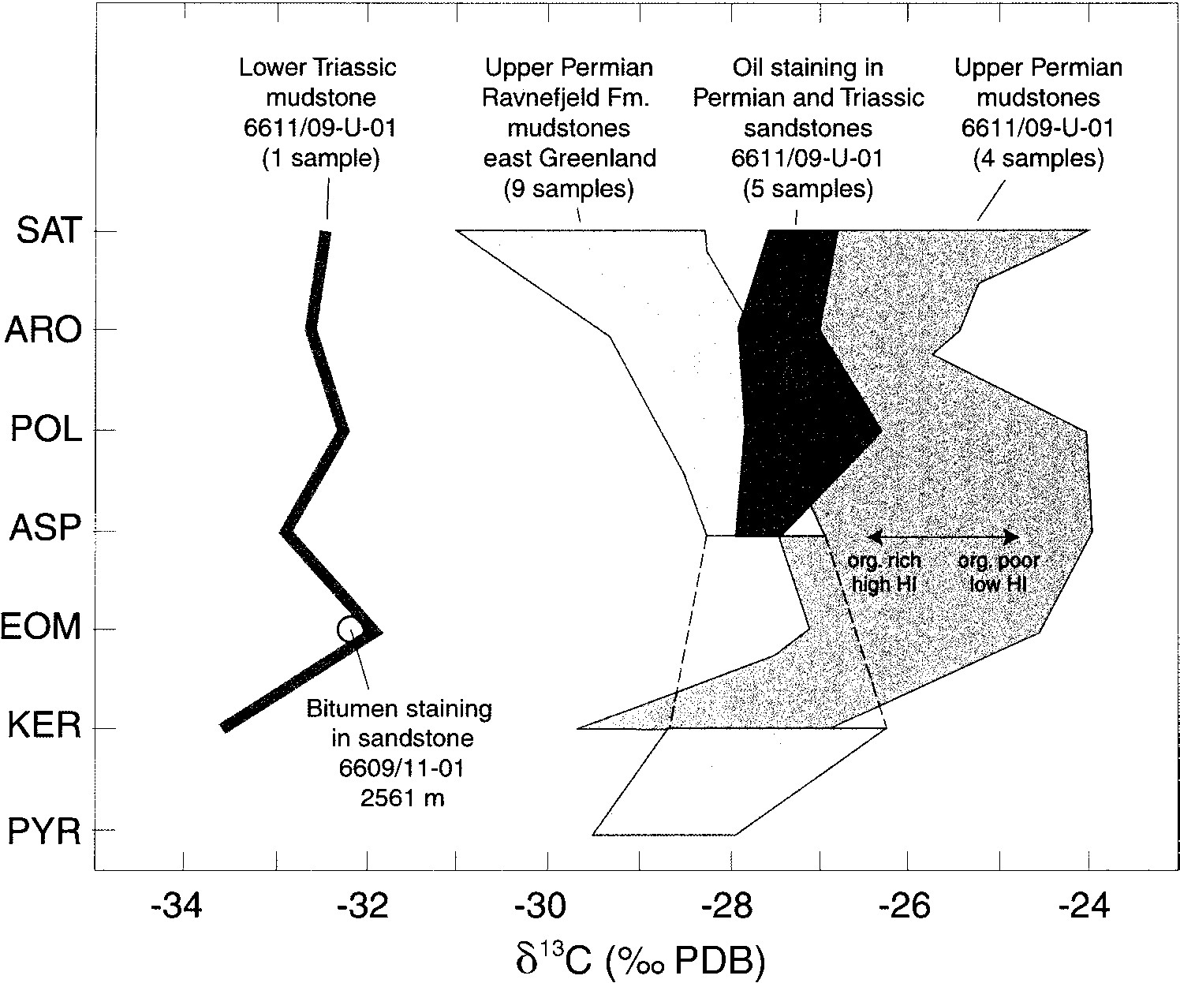24.0‰ PDB in the whole unit) (Figure 10). Samples

Figure 10. Galimov-type plot showing the variation in stable carbon isotope composition of extracted saturated (SAT), aromatic (ARO), polar (POL), and asphaltene (ASP) fractions; whole rock extract (EOM); kerogen (KER); and pyrolysate (PYR). Upper Permian siltstones (borehole 6611/09-U-01) are from the lower turbidite unit, oil staining from lower and upper turbidite units. Data for Ravnefjeld Formation, East

Greenland (Triaselv and Lille Kedelelv cores) from Christiansen et al. (1993). Data for well 6609/11-1, Helgeland Basin, is from Karlsen et al. (1995). with a low hydrogen index tend to contain the isotopically heaviest carbon, reflecting the increased input of reworked terrigenous material.

The two laminated mudstone intervals may be lithostratigraphically correlated with the Ravnefjeld Formation of East Greenland, which is also characterized by two laminated shale intervals (15–20 m total thickness). These have a good to excellent oil source potential (initial TOC content 4–5 wt. %, average 3.9 wt. %; initial hydrogen index 300–400 mg/g TOC, average 326 mg/g TOC) (Christiansen et al., 1993). They are interbedded with three organic-lean, bioturbated siltstone units, similar to the cored succession from mid-Norway, and can be traced throughout the Upper Permian depositional basin of East Greenland (Christiansen et al., 1993).

The Ravnefjeld Formation interfingers with carbonate buildups, and source rock quality varies depending on the local paleogeographic setting. The best source rock potential in the Ravnefjeld Formation is found in the deepest basinal areas where anoxic conditions could develop most easily during periods of high sea level (Christiansen et al., 1993). A similar model may reasonably be applied to the Norwegian side of the basin, such that the terrestrially dominated, laminated mudstone intervals found in the cores improve in source rock potential in more distal positions on the present Trøndelag Platform.

The generally marine-dominated character of the kerogen in the laminated shales on East Greenland is also reflected in the composition of the extractable hydrocarbons, for example, in a low wax content,smooth n-alkane distributions even at low maturities, and rather low pristane/phytane ratios (1–2.5). Abundant tricyclic diterpanes (C23–C26) and relatively high C33 and C35 homohopanes characterize the biomarkers from these rocks (Christiansen et al., 1993), similar to the mudstone extracts from mid-Norway. Carbon isotope ratios for the Ravnefjeld Formation partly overlap with those from the mid-Norwegian mudstones but are generally somewhat lower than those (29.5 to 26.2‰ PDB for most samples) (Christiansen et al., 1993, figure 15). This is probably due to the more marine character, and mostly lower maturity, of the organic matter in East Greenland.

# Source Rock Potential of the Triassic Succession

The only source rock potential in the Lower Triassic upper turbidite unit is represented by several thin (typically 0.5–1.5 cm), more organic-rich layers of slightly brownish mudstone with TOC contents of up to 2.8 wt. %. Otherwise, this unit has no appreciable source rock potential (typical TOC content 0.5 wt. % and typical hydrogen index 100 mg/g TOC). The thin organic-rich beds have hydrogen index values of less than 200 to 450 mg/g TOC. The richest of these (256 m in Figure 4) yielded a moderately aliphatic pyrolysate. The kerogen from these samples is dominated by amorphous matter exhibiting faint or no fluorescence (75%), together with minor proportions of acritarchs (5%), black and degraded wood (5–10%), bisaccate pollen (5%), and occasional *Botryococcus*type algae. The kerogen composition suggests a marine depositional environment relatively close to the coast. These beds may have thicker lateral equivalents in more basinal positions, but this remains to be proved.

# Oil Staining

Several intervals in the cored Permian and Triassic sandstones and siltstones are stained with light brown oil (Figure 8c). The visibly stained zones are typically 5–30 cm thick, and the distribution of the staining suggests that the oil followed horizontal zones that had the highest permeabilities within these otherwise poor reservoir rocks. Oil emplacement occurred after the latest phase of authigenic mineral growth.

A whole-oil gas chromatogram of this oil shows abundant, nonbiodegraded paraffins (Figure 11). This is remarkable in view of the shallow depth (200 m below seabed) and may suggest either activepetroleum migration in this area or, alternatively, sterile preservation of the oil in relatively impermeable sandstone.

Core extracts from these stained sandstones all have similar molecular and isotopic compositions and therefore probably share a common source. The saturated C15-hydrocarbon fraction is characterized by rather smooth n-alkane distributions (CPI 1.0–1.1) and shows a substantial fraction of waxy compounds and relatively abundant isoprenoids (Pr/n-C17  0.7– 1.2; Ph/n-C18  0.5–0.9) that have low pristane/ phytane ratios (1.3–1.4). These features suggest very early maturity, some input from plant waxes, and possibly a dysoxic depositional environment of the source. Homohopane isomerization ratios (%32bS 60–69) and sterane isomerization ratios (%29S 53–56), in combination with a slight predominance of 27Ts over 27Tm (%27Ts  56–60) and arelativelysmallC30 diahopane peak (Figure 12, m/z 191), are also consistent with an early mature oil.

|  |
| --- |
| Figure 11. Whole-oil gas chromatogram (GC-FID) of oil staining isolated from a frozen, canned sandstone sample from the basal part of the upper turbidite unit. |

The oil sample contains abundant tricyclic diterpanes and roughly equal quantities of steranes and diasteranes. The presence of gammacerane and a slight predominance of odd-numbered over even-numbered homohopanes probably reflects a restricted andslightly hypersaline environment. Almost equal concentrations of C27 and C29 bb-steranes (Figure 13, m/z 218) and the significant C30 R sterane peak (Figure 13, m/z 217) are typical of a marine-dominated source. Similar features (except for gammacerane) have been described from the Ravnefjeld Formation of East Greenland (Christiansen et al., 1993).

The stable carbon isotope ratios of the extracted oils and their chromatographic fractions show little variation (27.8‰ to 26.3‰ PDB; Figure 10) and are only slightly higher than those obtained from most shales of the Ravnefjeld Formation (29.4‰ to 26.8‰ PDB; kerogen up to 26.2‰ PDB) (Christiansen et al., 1993, figure 15). This may reflect differences in maturity and possibly a higher terrigenous input to the source of the Helgeland oil staining. A proper geochemical correlation between the oil staining in the sandstones and the bitumen in the cored organic-rich Upper Permian mudstonesispreventedby the partly nonindigenous origin of this bitumen. The geochemical signature of the oil staining, however, clearly contrasts with the terrestrially dominated kerogen composition in these mudstones at the coring sites.

When looking for alternative sources, a contribution from the widespread Upper Jurassic shales should not be completely ruled out on a purely geochemical basis, although oils from the Upper Jurassic on the mid-Norwegian shelf commonly show higher C30diahopane/hopane ratios than the Permian samples (Figure 14) and contain neither gammacerane nor prominent C28–C30 tricyclics. Upper Jurassic rocks are also unlikely to have been sufficiently deeply buried in areas adjacent to the coring sites. In addition, the structural setting appears to preclude migration from the known Upper Jurassic source rocks into the drilled Upper Permian sandstones. Migration from either the Upper Permian section or the thick Triassic section to the west of the drill sites is more geologically conceivable.

This narrows the alternatives for the source of the Helgeland oil staining down to either a more marine equivalent of the laminated Upper Permian mudstones or possibly a Lower Triassic source rock. Apparently indigenous extracts from some of the thin, organicrich layers in the cored upper turbidite unit contain the abundant C21–C30 tricyclic diterpanes, low concentrations of C30 diahopane, and traces of gammacerane, which are so characteristic of the oil staining. The light carbon isotope composition, however, strongly contrasts with that of the oil staining (Figure 10). Note that the isotopic composition of this Triassic rock extract is very similar to that of oil staining extracted from a sandstone core from exploration well Figure 12. Terpane (m/z 191) mass fragmentogram of oil staining (SAT fraction), extracted from a sandstone, borehole 6611/09-U-01, lower turbidite unit. Compound assignment according to the Norwegian Industry Guide to Organic Geochemical Analyses (NIGOGA) (Weiss et al., 2000): number of carbon atoms; /3

tricyclic terpanes; /4 tetracyclic terpanes; 27Ts  C27 18(H)-22,29,30-trisnorneoho-

pane; 27Tm  C27

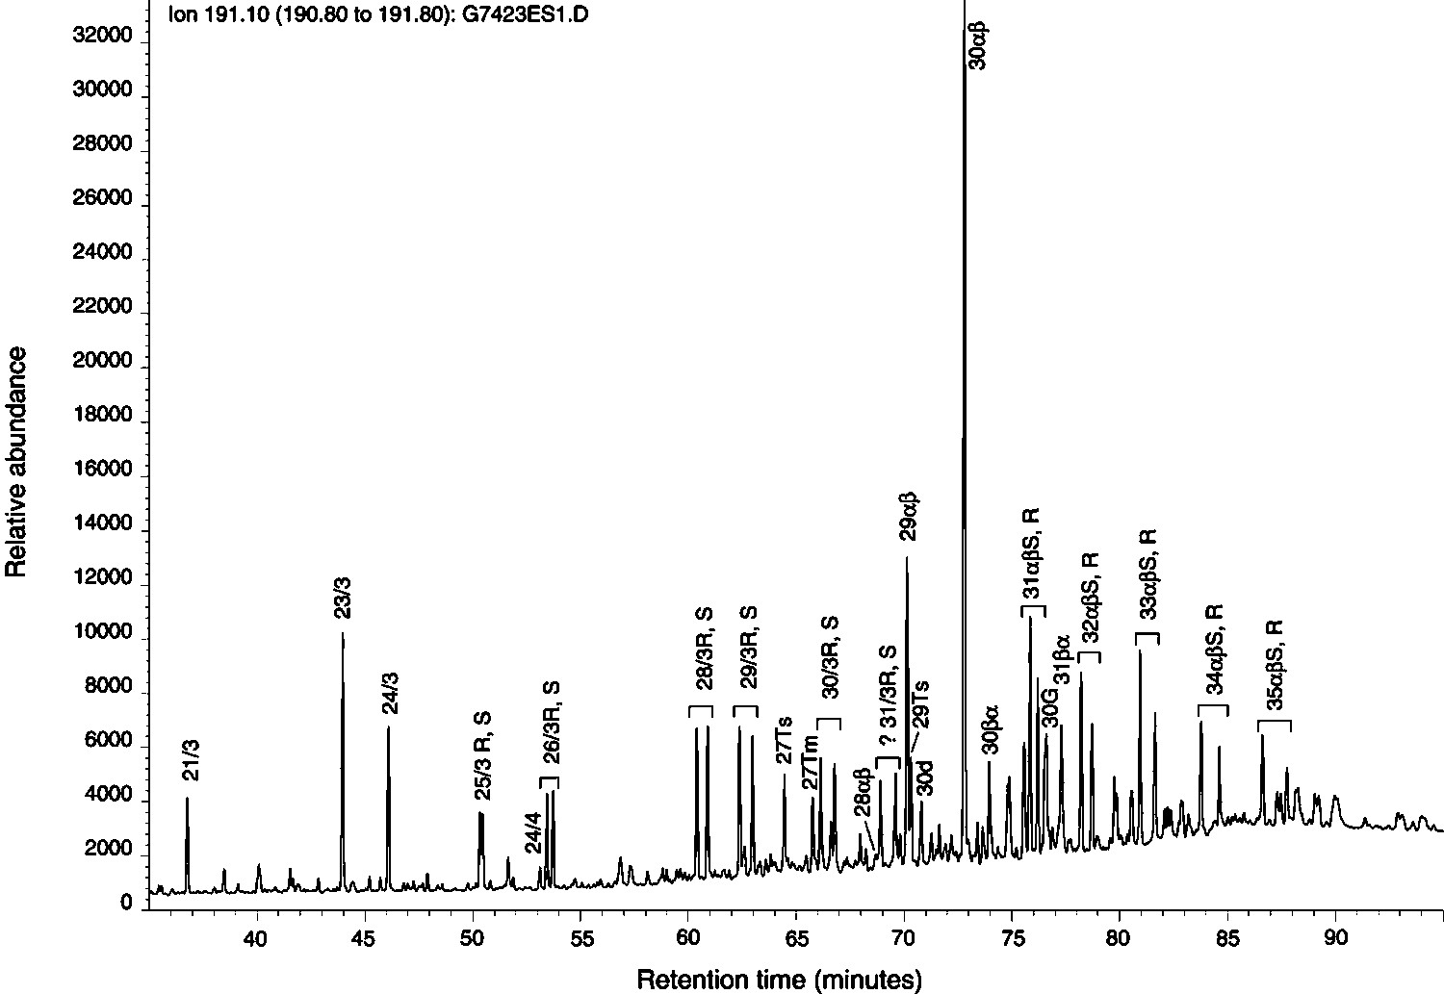17(H),21b(H)-25,28,30-trisnorhopane; 29Ts  18(H)-30norneohopane; 30d 15methyl-17(H)-27-norhopane

(C30 diahopane); 30G gammacerane; and b refer to positions 17 and 21, S and R to position 22.

6609/11-1 in the western part of the Helgeland Basin (Figure 1). Karlsen et al. (1995) suggested, on the basis of the molecular (high wax, low vanadium/nickel [V/Ni], low sulfur [S], high hopane/sterane) and isotopic composition (d13Coil 32.2‰ PDB; d2Hoil 153‰ standard mean ocean water [SMOW]), that this staining was derived from a terrestrial source rock, possibly of Triassic or Paleozoic age.

For Lower Triassic mudstones to be the source for the oil encountered in the shallow drilling would require a significant distal thickening of the thin (0.5–1.5 cm thick) layers of mudstone in the core. No obvious proof exists for such a thickening, and there are no known Lower Triassic source rocks in East Greenland.

Therefore, because the oil staining shares some features with the rock extracts from the Ravnefjeld

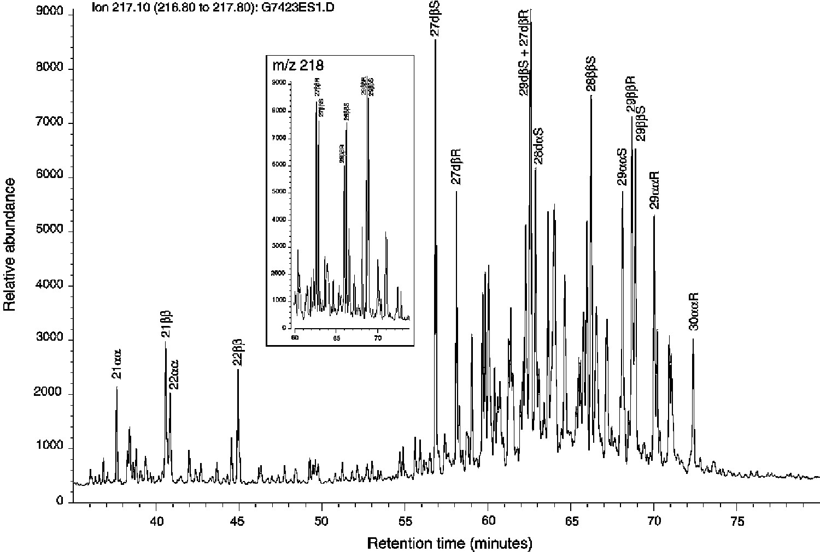Figure 13. Sterane (m/z 217 and 218) mass fragmentograms of oil staining (SAT fraction), extracted from a sandstone, borehole 6611/09-U-01, lower turbidite unit. Compound assignment according to NIGOGA: number of carbon atoms; d diasterane; and b refer to positions 13 (diasteranes), 14, and 17 (regular steranes), S and R to position 20.

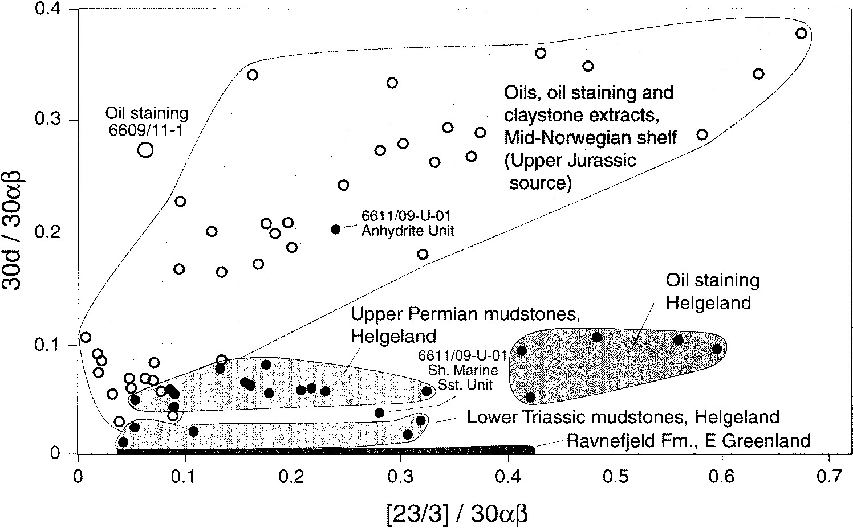Figure 14. Peak height ratios C30 diahopane/hopane vs. C23 tricyclic diterpane/hopane. Helgeland designates the coring sites 6611/09-U-01 and 6611/ 09-U-02. Data from Ravnefjeld Formation is from Christiansen et al. (1993) and F. G.

Christiansen (1993, personal communication). Data for well 6609/11-1 is from Karlsen et al. (1995).

Formation of East Greenland (e.g., high tricyclics, slight odd-dominance in homohopanes, similar carbon isotope composition), and despite the existing geochemical differences (e.g., gammacerane, C30 diahopane, diasteranes?), a more marine equivalent of the cored Upper Permian mudstones seems to be the most likely source for the oil staining.

# STRATIGRAPHIC CORRELATION AND PALEOGEOGRAPHY

|  |
| --- |
| Figure 15. Schematic reconstruction of the Late Permian–Early Triassic basin between Norway and Greenland. All the cored units on the Norwegian side can be recognized in East Greenland. In the Late Permian, the Trøndelag Platform was probably characterized by local basins that had deposition of organic-rich, oil-prone mudstones and local structural highs with carbonate deposition and reef building. |

By the middle Permian, a seaway had opened between Greenland and Norway. Marine sediments on East Greenland show that this seaway was open during the Late Permian and Early Triassic. Existing paleogeographic reconstructions suggest paleocoastlines some distance westward of the present Norwegian coastline (e.g., Ziegler, 1990; Dore´, 1991). This article shows, however, that marine sediments were deposited very close to the present coast, thus indicating that one major basin existed between Norway and Greenland and that the basin extended eastward to the present-day coastline. In following paragraphs, we discuss the many similarities between the cored succession and the sediments exposed in East Greenland. A schematic illustration of this is presented in Figure 15.

The Upper Permian Foldvik Creek Group is divided into five different formations (Figure 2) (Surlyk et al., 1986; Stemmerik, 1987) and is marine except for the lowermost part of the group. The Lower Triassic is fully marine and comprises the Wordie Creek Formation (Perch-Nielsen et al., 1974). The shallow-marine sandstone unit described in this article comprises the lower 170 m of the cored succession and probably rests directly on Caledonian basement. The basal conglomerate is overlain by a series of variably bioturbated brownish-gray sandstones with a muddy interval on top. This unit is correlated with the Huledal Formation in East Greenland, which consists of drab-colored, poorly sorted, immature fluvial conglomerates and sandstone sheet deposits. Both units are texturally immature and appear to have been deposited rapidly. Marine fossils in the uppermost meter of the Huledal Formation conglomerate complex suggest a maximum flooding event on top of the formation (Surlyk et al., 1986). The upper siltstone-mudstone part of the overall transgressive shallow-marine sandstone unit could correspond to the otherwise continental Huledal Formation.

The anhydrite unit is interpreted as redeposited and reworked sabkha deposits derived from an updip sabkha environment. The sediments show similarities with the Karstryggen Formation, which is the most widespread of the Upper Permian units in East Greenland. The Karstryggen Formation is generally represented by limestones, with gypsum deposited under hypersaline conditions, resting either on the Huledal Formation or on pre–Upper Permian rocks (Stemmerik, 1987). Stemmerik (1987) subdivided the Karstryggen Formation into four contrasting facies within a shallow-marine environment: shallow lagoonal, intertidal, high-energy setting, and a shallow subtidal high-energy setting. The anhydrite unit contains more siliciclastic material than the Karstryggen Formation, but this may be due to deposition in a more distal position of the Helgeland Basin. More optimal conditions for evaporite formation thus could have occurred in more proximal areas, that is, on the present Trøndelag Platform.

The lower turbidite unit is divided into three subunits: a lower sandy part dominated by upwardfining turbidite beds; a middle part that has organicrich siltstones/mudstones; and an upper part where laminated, dark-gray siltstones are interbedded with massive, fine-grained sandstones. The middle interval is correlated with the Ravnefjeld Formation of East Greenland, whereas the upper interval shows many similarities with the Schuchert Dal Formation.

The Ravnefjeld Formation is a lateral equivalent to the Wegener Halvø Formation in East Greenland (Figure 15), and deposition of these formations was strongly dependent on basin configuration. The Wegener Halvø Formation occurs in an areally restricted depositional environment, reflecting infill of the earlier karstic surfaces during the rapid transgression that restricted carbonate production to the basin margins (Stemmerik et al., 1990). Recent studies in East Greenland show that sand assigned to the Bredehorn Member occurs as lowstand deposits laterally to the organic-rich shales of the Ravnefjeld Formation and the carbonates of the Wegener Halvø Formation and within the siltstones of the overlying Schuchert Dal Formation (Stemmerik et al., 1997; Kreiner-Møller and Stemmerik, 2001).

An equivalent to the Wegener Halvø Formation may be absent in the study area off Norway because the transgression here could have been even more rapid because of local tectonic influence. This may have resulted in clastic deposition instead of carbonate production. The presence of carbonate clasts, specifically of skeletal grainstone clasts, and fragments of reef-building organisms in the overlying units and of algal-coated forams, tabulate coral fragments, and bryozoans in cutting samples in well 6609/7-1 on the Nordland Ridge clearly show that areas of carbonate deposition and possibly reef development did occur on the mid-Norwegian shelf area. The most likely position for a carbonate platform to develop was on structural highs, for example, on the Trøndelag Platform and on the Nordland Ridge, with clastic material being trapped in the Helgeland Basin and local subbasins. Drill breaks experienced when drilling through the carbonates in well 6609/7-1 on the Nordland Ridge could be due to karstic cavities in the carbonates. Karst development would indicate subaerial exposure and thereby support the assumption of reef development on the Nordland Ridge.

The Ravnefjeld Formation is a black, bituminous, laminated mudstone that occurs throughout the East Greenland basin (Surlyk et al., 1986). It accumulated contemporaneously with the limestones of the Wegener Halvø Formation and thus interfingers with this formation toward the basin margins. Surlyk et al. (1986) suggested that the mudstones of the Ravnefjeld Formation were deposited in anoxic conditions under a stratified water column that had fairly shallow water depths. This relates to two organic-rich, laminated mudstone units, whereas the remaining bioturbated siltstones represent periods with more oxygenated bottom-water conditions (Piasecki and Stemmerik, 1991; Christiansen et al., 1993). The two organic-rich units commonly contain *Tasmanites*, and the upper unit seems to represent a major flooding event, which also transgressed basement highs (L. Stemmerik, 1993, personal communication). The two organic-rich, high-gamma intervals in the cored succession off Norway have been correlated with these two units. The upper interval contains *Tasmanites* and may correspond with the flooding event described in the upper unit of the Ravnefjeld Formation on East Greenland. A widespread flooding and deposition of organic-rich, possibly oil-prone, mudstones could thus be suggested for most of the Trøndelag Platform. Simultaneous carbonate deposition and reef building probably occurred on structural highs. This paleogeographic setting is illustrated in Figure 15.

The siltstones and fine-grained sandstones in the upper part of the lower turbidite unit show signs of partial oxidation, indicating deposition in shallow water under more oxygenated conditions. A similar environment and similar lithologies are recorded in the Schuchert Dal Formation on East Greenland. The previously mentioned sandy lowstand deposits of the Bredehorn Member on East Greenland seem to be lithological equivalents to the sandy turbidites in the lower part of the lower turbidite unit. Considering the proximal position of the core locations, the lower turbidite facies probably represents a period of low relative sea level before a rapid sea level rise that culminated in maximum flooding and deposition of the upper organic-rich interval. A relative shallowing throughout the latest Permian is represented by the overlying siltstone/fine-grained sandstone interval.

The upper turbidite unit, which is characterized by massive and fining-upward sandy turbidites interbedded with laminated dark-gray siltstones, is correlated with the Wordie CreekFormationonEastGreenland. They are of similar age, Early Triassic

(Griesbachian), and comprise turbidites deposited in a basinal slope setting. The main difference is that the basal shaly facies present in the Wordie Creek Formation is not present in the cored section. The presence of evaporitic facies in the lower part of the upper turbidite unit suggests that the depositional basin was at least partially closed and subject to restricted water movements.

# SUMMARY AND CONCLUSIONS

1. Marine conditions prevailed on the Trøndelag Platform on the mid-Norwegian shelf during the Late Permian–Early Triassic. Shallow stratigraphic drilling close to the coast of Norway cored a 750 m– thick succession resting on Caledonian crystalline basement. The lower part of the succession is dated as Upper Permian (Ufimian–lower Tatarian?) and the upper part as Lower Triassic (Griesbachian).
2. The cored succession is similar to the succession ofthe same age outcropping onshore in East Greenland. The cored units are correlated with the Huledal, Karstryggen, Ravnefjeld, Schuchert Dal, and Wordie Creek formations. This suggests that East Greenland and the mid-Norwegian shelf formed the western and eastern margins of the same sedimentary basin during the Late Permian–Early Triassic. The eastern boundary extended much farther east than previously assumed and probably coincided with the present coastline.
3. The cored sediments were deposited in a proximalposition close to the paleocoastline and are characterized by high terrestrial input and provenance from the local bedrock, including the Caledonian basement. The lower 170 m comprise a reddish shallow-marine sandstone, which probably had its provenance in an older fine-grained sandstone that probably rested on the Caledonian basement in the present-day skerry zone, where no sedimentary rocks are known to exist today. The most likely age of the provenance sandstone is Late Devonian– Early Permian.
4. Two high-gamma, organic-rich intervals occur inthe upper part of the Permian succession. This clearly demonstrates that potential source rocks occur in the Upper Paleozoic succession on the midNorwegian shelf. They have at best a moderate liquid hydrocarbon potential at the coring site but can be correlated with the oil-prone source rocks of the Ravnefjeld Formation of East Greenland. The Ravnefjeld Formation is a basinal equivalent to the carbonates and reefs of the Wegener Halvø Formation deposited on structural highs. The cores did not penetrate any carbonates equivalenttotheWegener Halvø Formation, but carbonates and reworked reef-building organisms are found in an exploration well (6609/7-1) on the Nordland Ridge, as well as in rock fragments in the cored sandstones at the studied localities. This suggests a paleogeographic model for the Trøndelag Platform with local basins and structural highs. Source rocks equivalent to the Ravnefjeld Formation were probably deposited in local basins having periodic anoxic conditions, and carbonates were deposited on the highs,wherereefbuilding also occurred.
5. Several sandstone intervals were stained with light,nonbiodegraded oil. No possible migration route exists for hydrocarbons from the known Jurassic source rocks in the area into the Upper Permian sandstones. Geochemical correlation analyses allow no definite conclusion, but it is suggested that the oil was generated in Upper Permian mudstones or in basinal equivalents to the thin, organic-rich siltstone layers in the Lower Triassic succession.
6. The present article has proved the possibility fornew play concepts on the Trøndelag Platform that have an Upper Permian oil-prone source rock substituting for the typical Upper Jurassic source rock, which is generally immature in this area. Reservoirs could be in Permian carbonates/reefs on local structural highs or in Middle–Lower Jurassic, Triassic, or Upper Permian sandstones.

# REFERENCES CITED

Blystad, P., H. Brekke, R. B. Færseth, B. T. Larsen, J. Skogseid, and B. Tørudbakken, 1995, Structural elements of the Norwegian continental shelf, part II: the Norwegian Sea region:Norwegian Petroleum Directorate Bulletin 8, 45 p.

Bouma, A. H., 1962, Sedimentology of some flysch deposits: a graphic approach to facies interpretation:Amsterdam,Elsevier, 168 p.

Bugge, T., R. Knarud, and A. Mørk, 1984, Bedrock geology on the mid-Norwegian continental shelf, *in* A. M. Spencer et al., eds., Petroleum geology of the north European margin: Norwegian Petroleum Society and London, Graham and Trotman, p. 271– 283.

Bugge, T., G. Mangerud, A. Mørk, I. Nilsson, G. Elvebakk, S. Fanavoll, and J. O. Vigran, 1995, The upper Paleozoic succession on the Finnmark Platform, Barents Sea: Norsk Geologisk Tidsskrift, v. 75, p. 3–30.

Bukovics, C., and P. A. Ziegler, 1985, Tectonic development of the mid-Norwegian continental margin: Marine andPetroleumGeology, v. 2, p. 2–22.

Christiansen, F. G., S. Piasecki, L. Stemmerik, and N. Telnæs, 1993, Depositional environment and organic geochemistry of theUpper Permian Ravnefjeld Formation source rock in East Greenland: AAPG Bulletin, v. 77, p. 1519–1537.

Clifton, H. E., and J. K. Thompson, 1978, *Macaronichnus segregatis*—a feeding structure of shallow marine polychaetes: Journal of Sedimentary Petrology, v. 48, p. 1293–1302.

Dore´, A. G., 1991, The structural foundation and evolution of Mesozoic seaways between Europe and the Arctic: Palaeogeography, Palaeoclimatology, Palaeoecology, v. 87, p. 441–492.

Jacobsen, V. W., and P. van Veen, 1984, The Triassic offshore Norway north of 62oN, *in* A. M. Spencer et al., eds., Petroleum geology of the north European margin: Norwegian Petroleum Society and London, Graham and Trotman, p. 319–327.

Karlsen, D. A., B. Nyland, B. Flood, S. E. Ohm, T. Brekke, S. Olsen, and K. Backer-Owe, 1995, Petroleum geochemistry of theHaltenbanken, Norwegian continental shelf., *in* J. M. E. Cubittand W. A. England, eds., The geochemistryofreservoirs:Geological Society Special Publication 86, p. 203–256.

Kreiner-Møller, M., and L. Stemmerik, 2001, Upper Permian lowstand fans of the Bredehorn Member, Schuchert Dal Formation, East Greenland, *in* O. J. Martinsen and T. Dreyer, eds., Sedimentary environments offshore Norway—Palaeozoic to Recent: Norwegian Petroleum Society (NPF) Special Publication 10, p. 51–65.

Nemec, W., and R. J. Steel, eds., 1988, Fan deltas: sedimentology and tectonic settings: Glasgow and London, Blackie, 430 p.

Pemberton, S. G., and T. D. A. Saunders, 1990, On the palaeoecological significance of the trace fossil *Macaronichnus* (abs.), *in* 13th International Sedimentological Congress Program: International Association of Sedimentologists, p. 26–31.

Perch-Nielsen, K., K. Birkenmajer, T. Birkelund, and M. Aellen, 1974, RevisionofTriassic stratigraphyoftheScoresbyLandand Jameson Land region: East Greenland: Grønlands Geologiske Undersøgelse Bulletin, v. 109, 51 p.

Piasecki, S., 1984, Preliminary palynostratigraphy of the Permian– Lower Triassic sediments in Jameson Land and Scoresby Land, East Greenland: Geological Society of Denmark Bulletin, v.32, p. 139–144.

Piasecki, S., and L. Stemmerik, 1991, Late Permian anoxia incentral East Greenland, *in* R. V. Tyson and T. H. Pearson,eds.,Modern and ancient continental shelf anoxia:GeologicalSocietySpecial Publication 58, p. 275–290.

Saunders, T., and S. G. Pemberton, 1986, Trace fossils andsedimentology of the Appaloosa Sandstone: Bearpaw–Horseshoe Canyon Formation transition: Society ofPetroleumGeologistsField Trip Guide Book, Dorothy, Alberta, Canada, 117 p.

Schmidt, M., 1992, Structure of the mid-Norway Heidrun field and its regional implications, *in* R. M. Larsen, H. Brekke, B. T. Larsen, and E. Talleraas, eds., Structuralandtectonicmodelling and its implications to petroleum geology: Norwegian Petroleum Society Special Publication 1, p. 381–395.

Sigmond, E. M. O., 1992, Bedrock map of Norway and adjacent ocean areas: Geological Survey of Norway, scale 1:3 million, 1 sheet.

Stemmerik, L., 1987, Cyclic carbonate and sulphate from the Upper Permian Karstryggen Formation, East Greenland, *in* T. M. Peryt, ed., Lecture notes in Earth sciences 10: Berlin, SpringerVerlag, p. 5–22.

Stemmerik, L., and D. Worsley, 1989, Late Paleozoic sequencecorrelations, north Greenland, Svalbard and the Barents Shelf, *in* J. D. Collinson, ed., Correlations in hydrocarbon exploration: London, Graham and Trotman, p. 99–111.

Stemmerik, L., P. A. Scholle, F. H. Henk, G. D. Liegro, M. Mantovani, and D. S. Ulmer, 1990, Facies mapping and reservoir evolution of the Upper Permian Wegener Halvø Formation along the western margin of the JamesonLand,EastGreenland: Grønlands Geologiske Undersøgelse Rapport 148, p. 105–108.

Stemmerik, L., F. G. Christiansen, S. Piasecki, B. Jordt, C. Marcussen, and N. Nøhr-Hansen, 1993, Depositional history and petroleum geology of the Carboniferous to Cretaceous sediments in the northern part of East Greenland, *in* T. O. Vorren, E. Bergsager, Ø. A. Dahl-Stamnes, E. Holter, B. Johansen, E. Lie, and T. B. Lund, eds., Arctic geology and petroleum potential: Norwegian Petroleum Society Special Publication 2, p. 67–87.

Stemmerik, L., O. R. Clausen, J. Korstga˚rd, M. Larsen, S. Piasecki, L. Seidler, F. Surlyk, and J. Therkelsen, 1997, Petroleum geological investigations in East Greenland: resources of the sedimentary basins of north and East Greenland project: Geology of Greenland Survey Bulletin 176, p. 29–38.

Surlyk, F., 1990, Timing, style and sedimentary evolution of late Palaeozoic–Mesozoic extensional basins of East Greenland, *in* R. F. P. Hardman and J. Brooks, eds., Tectonic events responsible for Britain’s oilandgasreserves:GeologicalSocietySpecial Publication 55, p. 107–155.

Surlyk, F., S. Piasecki, F. Rolle, L. Stemmerik, E, Thomsen, and P. Wrang, 1984, The Permian base of East Greenland, *in* A. M. Spencer et al., eds., Petroleum geology of the north European margin: Norwegian Petroleum Society and London, Graham and Trotman, p. 303–315.

Surlyk, F., J. M. Hurst, S. Piasecki, F. Rolle, P. A. Scholle, L. Stemmerik, and E. Thomsen,1986,ThePermianofthewesternmargin of the Greenland Sea—a future exploration target, *in* M. T. Halbouty, ed., Future petroleumprovincesoftheworld:AAPG Memoir 40, p. 629–659.

Utting, J., and S. Piasecki, 1995, Palynology of the Permian ofnorthern continents: a review, *in* P. A. Scholle, T. M. Peryt, and D.S. Ulmer-Scholle, eds., The Permian of northern Pangea: Berlin, Springer-Verlag, p. 236–261.

Vigran, J. O., and G. Mangerud, 1991, Palynological evidence of Lower Triassic rocks subcropping offshore mid-Norway: Norsk Geologisk Tidsskrift, v. 71, p. 29–35.

Vigran, J. O., L. Stemmerik, and S. Piasecki, 1999, Stratigraphy and depositional evolution of the uppermost Devonian–Carboniferous (Tournaisian–Westphalian) non-marine deposits in north-east Greenland: Palynology, v. 23, p. 115–152.

Walker, T. R., 1967, Formation of red beds in modern and ancient deserts: Geological Society of America Bulletin, v. 78, p. 353– 368.

Walker, T. R., 1976, Diagenetic origin of continental red beds, *in* H. Falke, ed., The continental Permian in central, west and south Europe, NATO (North Atlantic Treaty Organization) Advanced Institute, Series C, Mathematical and PhysicalSciences: Dordrecht, Holland, Reidel, p. 240–287.

Weiss, H. M., A. Wilhelms, N. Mills, J. Scotchmer, P. B. Hall, K. Lind, and T. Brekke, 2000, NIGOGA—The Norwegian Industry Guide to Organic Geochemical Analyses, ed. 4.0: Norsk Hydro, Statoil, Geolab Nor, SINTEF Petroleum Research, and the Norwegian Petroleum Directorate, 102 p. http:// www.npd.no/engelsk/nigoga/default.htm Accessed June 1, 2000.

Ziegler, P. A., 1981, Evolution of sedimentary basins in north-west Europe, *in* L. V. Illing and G. D. Hobson, eds., Petroleum geology of the continental shelf of north-west Europe, p. 3– 42.

Ziegler, P. A., 1990, Geological atlas of western and central Europe: Shell International Petroleum Maatschappij B.V., 238 p., 56 enclosures.