LateTriassicpaleogeographicreconstructionalongtheNeo–TethyanOceanmargins,southernTibet



Fulong Cai a,b,∗, Lin Ding a,c, Andrew K. Laskowski b, Paul Kapp b, Houqi Wang a, Qiang Xu a,c, Liyun Zhang a,c

a *Key* *Laboratory* *of* *Continental* *Collision* *and* *Plateau* *Uplift,* *Institute* *of* *Tibetan* *Plateau* *Research,* *Chinese* *Academy* *of* *Sciences,* *Beijing* *100101,* *China* b *Department* *of* *Geosciences,* *University* *of* *Arizona,* *Tucson,* *AZ* *85721,* *USA*

|  |  |
| --- | --- |
| *Article* *history:*  Received 29 September 2015  Received in revised form 3 December 2015  Accepted 20 December 2015  Available online 30 December 2015 Editor: A. Yin | Sandstone petrographic and U–Pb detrital zircon analyses of Upper Triassic sedimentary rocks from the northern margin of India (Tethyan Himalaya Sequence) and southern margin of Eurasia (Lhasa terrane) provide new constraints on the Mesozoic paleogeography of Neo–Tethyan Ocean basins. The Upper Triassic Nieru Formation of the Tethyan Himalaya Sequence (THS) near Lazi city (∼29◦N, 87.5◦E) is dominated by Indian-affinity, Precambrian detrital zircons, which are typical of the majority of the THS. However, the Upper Triassic Langjiexue Formation of the THS exposed to the east (at 90–93◦E longitude) |

|  |  |
| --- | --- |
| *Keywords:* southern Tibet Triassic Greater India paleogeography Neo–Tethyan margins | includes significant populations of Permian to Early Jurassic (291–184 Ma) detrital zircons for which there is no known Indian source. In addition, the Upper Triassic Nieru Formation near Kangma town (∼28.5◦N, 90◦E), located ∼200 km to the southeast of Lazi city, yielded detrital zircon age spectra that are similar to those of Langjiexue Formation. Based on detrital zircon age spectra comparisons, we propose that both the Langjiexue and Nieru formations were derived from continental crustal fragments that were adjacent to the northwestern margin of Australia. Furthermore, we suggest that these THS units, and age-equivalent strata in Northwest Australia, West Sulawesi, Timor and West Papua, comprised a Late Triassic submarine fan along the northern Australian shelf. The Upper Triassic Mailonggang Formation in the southern Lhasa terrane (35 km northeast of Lhasa city, ∼30◦N, 91.5◦E) is dominated by Permian detrital zircons, which were likely derived from proximal Lhasa terrane sources. The Mailonggang Formation differs from all age-equivalent strata in the Tethyan Himalaya; therefore we interpret that it was separated from Greater India by the Neo–Tethyan Ocean.  © 2015 Elsevier B.V. All rights reserved. |

c *Center* *for* *Excellence* *in* *Tibetan* *Plateau* *Earth* *Sciences,* *Chinese* *Academy* *of* *Sciences,* *Beijing* *100101,* *China*

|  |  |  |
| --- | --- | --- |
| a r t i c l e | i n f o | a b s t r a c t |

# 1. Introduction

Constraining the early Mesozoic paleogeography of the Neo– Tethyan Ocean margins is crucial for understanding the opening history of the Neo–Tethyan Ocean and the paleoposition of the southern margin of Eurasia (the Lhasa terrane) and the northern margin of India (the Tethyan Himalaya). Upper Triassic strata are well exposed in the Tethyan Himalaya (Liu and Einsele, 1994; Aikman et al., 2008; Dai et al., 2008; Li et al., 2010), the Lhasa terrane (Li et al., 2014), northwest Australia (Lewis and Sircombe, 2013) and southeast Asia (Gunawan et al., 2012;

Earth and Planetary Science Letters 435 (2016) 105–11

[4](http://dx.doi.org/10.1016/j.epsl.2015.12.027)



Contents lists available at

ScienceDirec

[t](http://www.ScienceDirect.com/)

Earth

and

Planetary

Science

Letters

www.elsevier.com/locate/eps

[l](http://www.elsevier.com/locate/epsl)



|  |
| --- |
| * Corresponding author at: Key Laboratory of Continental Collision and Plateau Uplift, Institute of Tibetan Plateau Research, Chinese Academy of Sciences, Beijing 100101, China.  *E-mail* *address:* flcai@itpcas.ac.cn (F. Cai).  <http://dx.doi.org/10.1016/j.epsl.2015.12.027>0012-821X/© 2015 Elsevier B.V. All rights reserved. |

Zimmermann and Hall, 2014; Sevastjanova et al., 2015). At present, however, there is little consensus about the paleogeography of these assemblages during Late Triassic time.

Several tectonic models have been proposed to explain the provenance and paleogeographic relationships between the Upper Triassic Langjiexue Formation in the Tethyan Himalaya and age-equivalent units deposited in the Lhasa terrane (Fig. 1). One class of models argues that the Langjiexue Formation was derived from India, similar to the vast majority of previously investigated Tethyan Himalaya strata (Liu and Einsele, 1994; Searle et al., 1987). Another class of models argues that the Langjiexue Formation is allocthonous with respect to the Tethyan Himalaya and was derived from the Lhasa terrane (Dai et al., 2008; Li et al., 2010, 2015). These opposing models result in paleogeographic reconstructions that place the Langjiexue Formation on opposite sides of the Neo– Tethyan Ocean during the Late Triassic.

|  |
| --- |
| **Fig. 1.** Simplified geological map of south-central Tibet. YZMT = Yarlung–Zangpo WP = West Papua.mantle thrust, STDS = South Tibetan detachment system, RZT = Renbu–Zedang thrust,  NC = North Carnarvon basin, TL = Timor–Leste, WS = West Sulawesi, |

Models favoring an allochthonous origin were proposed to explain the presence of Permian–Triassic detrital zircons and high whole-rock εNd(*t*) values in the Langjiexue Formation (Dai et al., 2008; Li et al., 2010). These models invoke a number of explanations that fall into three broad categories (Webb et al., 2013). (1) Rift-fill: detritus was derived from the Lhasa terrane and deposited across both the southern Lhasa terrane and northern Indian margin during the initiation of Neo–Tethyan rifting (Dai et al., 2008; Li et al., 2014). This model requires that India–Lhasa terrane rifting initiated during the Late Triassic. (2) Lhasa forearc: detritus was shed from a Triassic arc that developed along the southern Lhasa terrane and was deposited in a forearc basin (Li et al., 2010). This model requires northward subduction of Neo–Tethyan oceanic lithosphere during the Triassic and an oceanic suture zone between the Langjiexue Formation and Indian-affinity Tethyan Himalya strata to the south (Li et al., 2010). (3) Intra-oceanic forearc: detritus was derived from a south-facing intra-oceanic arc within the Neo–Tethyan Ocean (Li et al., 2010). This model requires that Neo–Tethyan oceanic lithosphere was subducted northward beneath at least one Neo–Tethyan intra-oceanic arc, in addition to beneath the Lhasa terrane during Triassic time.

In an effort to discriminate among the contrasting models of early Mesozoic paleogeography, we conducted sandstone petrologic and U–Pb detrital zircon geochronologic studies on Upper Triassic strata exposed in the Tethyan Himalaya Sequence and southern Lhasa terrane of southern Tibet. Integration of our new, and previously published data indicate that the Langjiexue and Nieru formations (Fig. 1) were deposited on Greater India’s passive margin and were derived from West Papua. In contrast, the Nieru Formation exposed to the west near Lazi city exhibits an Indian affinity and the Mailonggang Formation north of the Yarlung–Tsangpo suture zone near Lhasa city exhibits a proximal Lhasa terrane affinity. We propose that the northeast Greater Indian shelf and northwest Australian shelf were contiguous during Late Triassic time and accommodated deposition of a submarine fan complexes that were deposited in the Neo–Tethyan Ocean between West Papua to the east and India–Australia to the south.

# 2. Tectonic setting

Our study area consists of three major tectonic units from north to south: the Lhasa terrane; the Yarlung–Tsangpo (India– Asia) suture zone (YZSZ); and the Tethyan Himalaya Sequence (Fig. 1). The Lhasa terrane is composed of Neoproterozoic to Lower Cambrian basement, Paleozoic to Cenozoic cover strata and igneous rocks, and Gangdese continental margin arc rocks (e.g., Gehrels et al., 2012). The Gangdese arc mainly consists of Cretaceous to early Cenozoic calc–alkaline granitoids (Chu et al., 2006) and coeval volcanic sequences (He et al., 2007). The presence of diamictites and cool-water faunas in Carboniferous–Lower Permian strata suggest that the Lhasa terrane was located along the margin of Gondwana during this time (Ji et al., 2005; Yuan et al., 2015). Warm-water faunas have been identified in Middle– Upper Permian strata (Yuan et al., 2015). This faunal change is attributed to either palaeoclimate change or northward drift of the Lhasa terrane into a warm-water regime (Yuan et al., 2015). The Cretaceous to Eocene Xigaze forearc basin is exposed along the southern margin of Lhasa terrane and was derived from the southern Lhasa terrane continental margin (Fig. 1; Dürr, 1996; Orme et al., 2015). In the eastern Himalaya, the Xigaze forearc basin is absent and the Gangdese arc was thrust southward over the Yarlung–Tsangpo suture zone (YZSZ) in the hanging wall of the Gangdese thrust during Oligocene–Miocene time (Yin et al., 1994).

The YZSZ defines the boundary between Indian- and Asianaffinity assemblages. Supra-subduction zone ophiolitic rocks exposed between the Zedang and Yungbwa areas formed during the Early Cretaceous (Fig. 1; Hébert et al., 2012 and references therein). A chert-rich mélange to the south consists of chert–pebble conglomerate, limestone, and pillow basalt blocks surrounded by a matrix of radiolarian–chert and mudstone. Radiolarian assemblages in chert sequences range from late Middle Triassic to Early Cretaceous in age (Matsuoka et al., 2002; Ziabrev et al., 2004; Zhu et al., 2005). To the south is a trench–fill basin composed of strongly-cleaved Cretaceous sandstone, shale and conglomerate in a highly sheared mudstone matrix (Cai et al., 2012). These units comprise a southward-younging accretionary complex that developed during the northward subduction of Neo–Tethyan Ocean beneath Lhasa terrane during Cretaceous time (Cai et al., 2012).

The northern Tethyan Himalaya Sequence (THS) includes Paleozoic to Eocene carbonate and clastic sedimentary rocks that were deposited on the distal passive continental margin of India (Searle et al., 1987; Liu and Einsele, 1994). Tethyan Himalaya Sequence strata were predominately derived from Gondwanan sources based on numerous stratigraphic and detrital zircon studies (e.g. Liu and Einsele, 1994; DeCelles et al., 2004; Gehrels et al., 2012). Emplacement of continental flood basalts in various areas of the Indian passive margin suggests the Neo–Tethys Ocean began to form during early Permian time (Garzanti et al., 1999).

|  |
| --- |
| **Fig. 2.** Diagram showing the stratigraphy of the Mailonggang Formation (modified after Ji et al., 2003), Langjiexue Formation, and the Nieru Formation near Lazi and Kangma. |

C = clay, S = silt, F = Fine sand, M = Middle sand, C = Coarse sand.

# 3. Stratigraphy and sampling

Several exposures of Upper Triassic strata in the southern Lhasa terrane and Tethyan Himalaya were measured and sampled for sandstone petrographic and detrital zircon provenance analysis (Figs. 1 and 2). The Mailonggang Formation in the Lhasa terrane consists of micritic limestone interbeded with mudstone and lithic sandstone. Fossils in the Mailonggang Formation include corals (*Distichophyllia,* *Margarosmillia,* *Margarophyllia*), bivalves (*Indopecten,* *Costatoria* *mansuyi,* *Pergamidia,* *Yunnanophorus,* *Unionites*), and conodonts (*Epigondololla* *bidentata,* *E.* *multidentata,* *E.* *abneptis*) (Ji et al., 2003). These fossils indicate a Carnian to Norian depositional age (Ji et al., 2003). The fossil assemblage, lithologies, and sedimentary structures in the Mailonggang Formation imply a carbonate–clastic platform depositional environment (Li et al., 2014). Three sandstones in this unit were sampled for detrital zircon analysis (Fig. 1).

The Upper Triassic Langjiexue Formation is exposed between the Renbu–Zedang Thrust to the north and an unnamed thrust fault with Jurassic–Cretaceous strata in the footwall to the south (Fig. 1; Aikman et al., 2008; Li et al., 2010). The western limit of Langjiexue Formation exposure is near Xigaze city whereas the eastern limit is the South Tibetan Detachment System which juxtaposes the Langjiexue Formation against Higher Himalaya crystalline rocks. The Langjiexue Formation is composed of a severalkm-thick, clastic-dominated sequence of slate and medium- to thick-bedded lithic sandstone and siltstone. Bivalve (*Halobia* *yunnanensis–H.* *Pluriadiata,* *Burmiesia–Unionites,* *Cassianella* *nyanangensis– Schafhaeutlis* *mengllingi*) and gastropod fossils indicate a Carnian– Norian depositional age for the Langjiexue Formation (Yu and Zhen, 1979). Flutecasts indicate southwest-directed paleocurrents (Li et al., 2003). The lithology and sedimentary structures of the Langjiexue Formation indicate a submarine-fan depositional environment (Zhang et al., 2015). Eleven sandstones from the Langjiexue Formation were sampled for detrital zircon analysis (Fig. 1).

The Nieru Formation of the Tethyan Himalaya Sequence consists of different lithologies in the Kangma and Lazi regions (Fig. 1). In Kangma, the Nieru Formation is dominantly composed of slate. In the lower part, slate is interbedded with phyllite and siltstone. Ammonite fossils indicate a Carnian–Norian depositional age (Yu and Zhen, 1979). One siltstone was sampled for detrital zircon analysis (Fig. 1). In the Lazi area, the Nieru Formation is composed of slate and sandstone. Bivalve fossils including *Halobia* indicate a Carnian– Norian depositional age (Yu and Zhen, 1979). Seven sandstones from this unit were sampled for detrital zircon analysis (Fig. 1).

# 4. Methods

The modal framework grain composition of sandstone samples was determined using the Gazzi–Dickinson point counting method (Dickinson, 1985). In this method, grains larger than 62 μm are counted as monocrystalline regardless of whether or not they are included in lithic fragments. More than three hundred grains were counted in each sample and the data are presented in Fig. 4 and in Appendix A.

U–Pb detrital zircon geochronology was conducted using Laser– Ablation Multicollector Inductively-Coupled-Plasma Mass Spectrometry (LA-MC-ICPMS) at the Arizona LaserChron Center (Gehrels et al., 2008) and an Agilent 7500a ICP-MS coupled with a New Wave Research UP193FX Excimer laser (New Wave Instruments, USA) at the Institute of Tibetan Plateau Research,

|  |
| --- |
| **Fig. 3.** Petrography of sandstones from A, Mailonggang Formation, B, Nieru Formation near Lazi, C, Langjiexue Formation (undeformed), and D, Langjiexue Formation (de- |

formed). Qm = monocrystalline quartz, F = feldspar, Lv = volcanic lithics.

Chinese Academy of Sciences, Beijing (Cai et al., 2012). In our analysis, 60 μm spot size was used. U–Th–Pb ages were calibrated for both instrumental mass bias and isotopic fractionation against zircon standard Plesovice and 91 500 (Gehrels et al., 2008; Cai et al., 2012).

Analytical data are reported in Appendix. Uncertainties shown in these tables are at the 1−σ level, and include only measurement errors. Analyses that are >20% discordant (by comparison of 206Pb/238U and 206Pb/207Pb ages) or >5% reverse discordant are excluded from interpretation. The remaining ages are shown on U–Pb concordia diagrams and relative age-probability diagrams generated using Isoplot 4 (Ludwig, 2008). Age-probability diagrams show each age and its uncertainty (for measurement error only) as a normal distribution, and sum all ages from a sample into a single probability density function. **5.** **Results**

## 5.1. Sandstone petrography

Three sandstones from the Mailonggang Formation of the southern Lhasa terrane are poorly sorted with mostly angular to subangular clast morphologies (Fig. 3A). Quartz (58–66%) includes both monocrystalline and polycrystalline grains. Feldspar constitutes 6–10% of the sand grains. Chert constitutes 4–9% of the sand grains. Lithic grains (20–24%) are composed of volcanic (15–18%) and sedimentary (5–6%) fragments. These samples plot within the recycled orogen provenance field (Fig. 4).

Two sandstones from the Nieru Formation in the Lazi region are well sorted and consist mainly of round to subangular quartz (98%) and minor feldspar (2%) (Fig. 3B). Sandstones from the Nieru Formation in the Lazi area plot within the continental block provenance field (Fig. 4).

Five coarse-grained siltstone and fine- to medium-grained sandstones from the Langjiexue Formation are poorly sorted and consist mainly of angular to subangular quartz and feldspar (Fig. 3C). Monocrystalline quartz (50–70%) displays undulose extinction. Polycrystalline quartz is composed primarily of metamorphic quartz (1–2%) with curved grain boundaries. Feldspar (14–23%) and chert (6–11%) are also major phases. No fossils were observed in

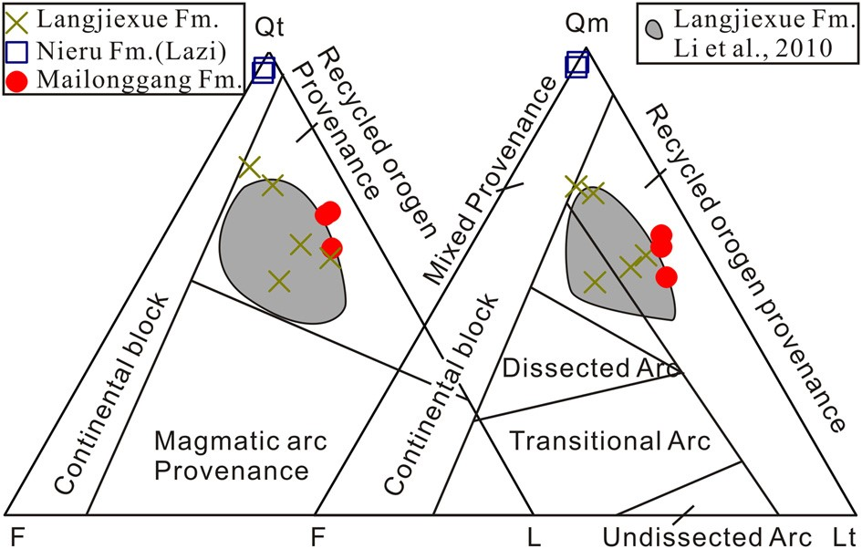

**Fig. 4.** QFL diagrams.

the chert fragments. Several sandstones are deformed and show metamorphic mica growth (Fig. 3D). Lithic fragments are mainly sedimentary fragments (1–5%) and volcanic fragments (7–10%). Sandstones from the Langjiexue Formation plot within the recycled orogen provenance field (Fig. 4).

## 5.2. Detrital zircon geochronology

Zircon crystals extracted from the Mailonggang Formation in Lhasa terrane are mostly euhedral and yield U/Th ratios ranging from 0.3 to 14.1, characteristic of igneous zircon. 300 zircon grains were analyzed, of which 241 passed the concordance filters (Fig. 5). Major age populations lie in the ranges of 600–400 Ma, 300–250 Ma, and 1300–1000 Ma. Additional ages are scattered between 3.0–1.5 Ga.

Zircon crystals extracted from the Tethyan Himalaya Nieru Formation in the Lazi region are mostly rounded or subrounded with U/Th ratios ranging from 0.3 to 18.9. 700 zircon grains were analyzed, of which 612 passed the concordance filters (Fig. 6). Major age populations were identified in the ranges of 1000–500 Ma. Additional ages are scattered between 3.5–1.0 Ga.

Zircon crystals extracted from the Nieru Formation in the Kangma region are mostly rounded or subrounded with U/Th ratios

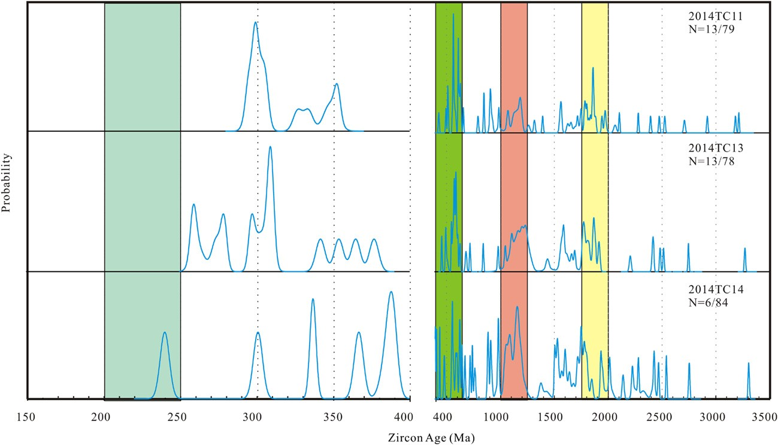**Fig. 5.** Detrital zircon age probability plots for the Mailonggang Formation. The *n* = 13/79 means the number of zircon ages in the range of 150–400 Ma (i.e., *n* = 13) and the number of zircon ages in the range of 400–3500 Ma (i.e., *n* = 79).

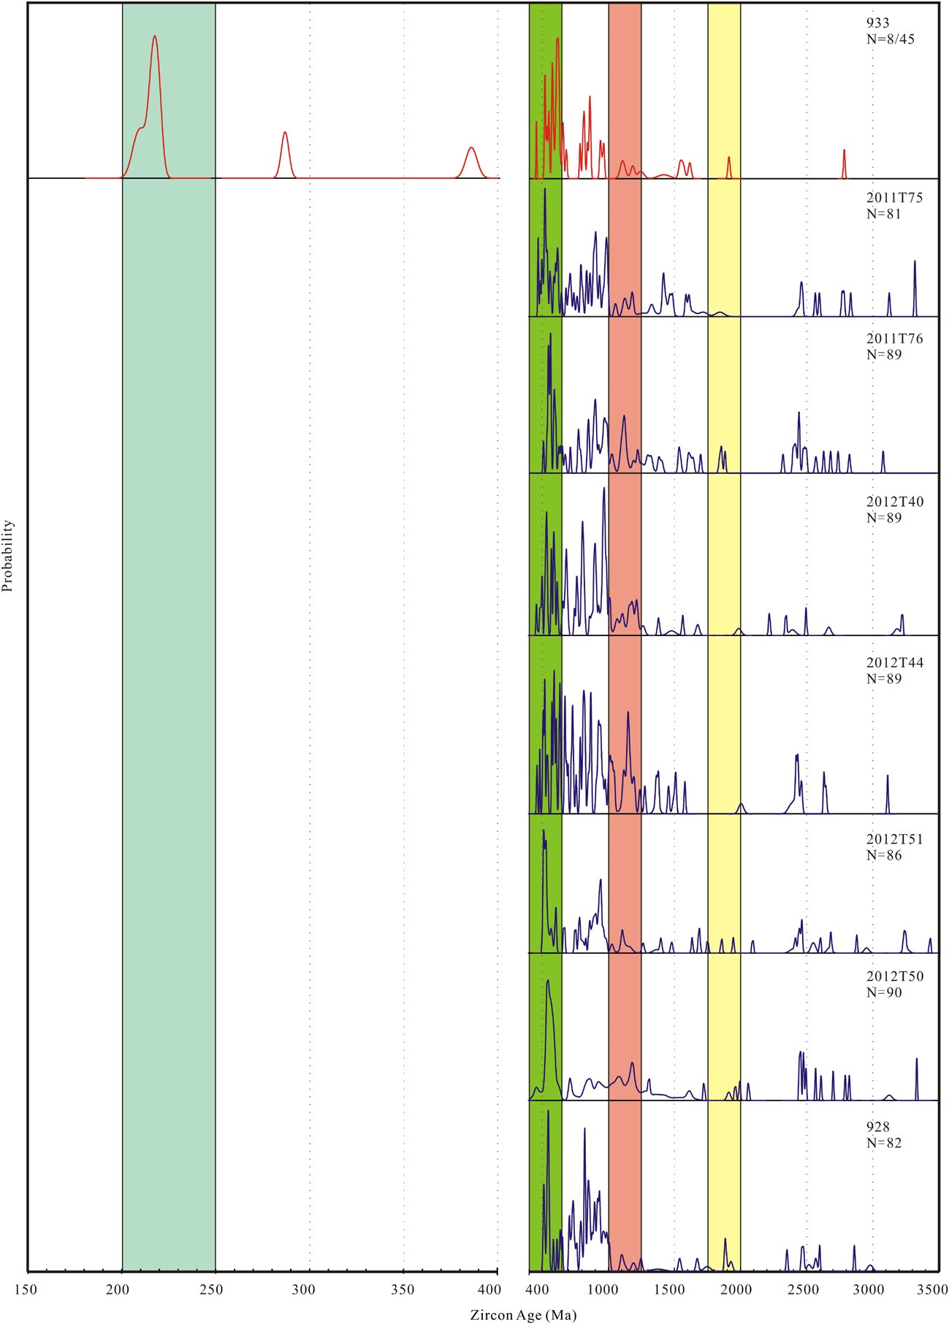

**Fig. 6.** Detrital zircon age probability plots for the Nieru Formation. The *n* = 8/45 means the number of zircon ages in the range of 150–400 Ma (i.e., *n* = 8) and the number of zircon ages in the range of 400–3500 Ma (i.e., *n* = 45).

**Fig. 7.** Detrital zircon age probability plots for the Langjiexue Formation. The *n* = 13/76 number of zircon ages in the range of 400–3500 Ma (i.e., *n* = 76).

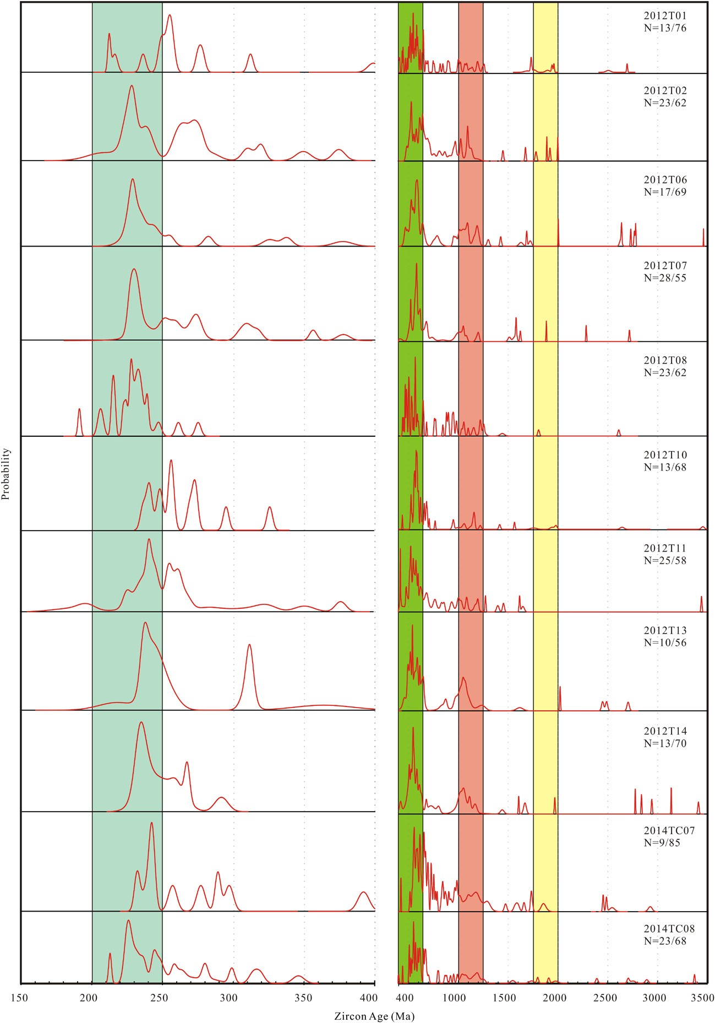means the number of zircon ages in the range of 150–400 Ma (i.e., *n* = 13) and the

ranging from 0.5 to 13.4. 68 zircon grains were analyzed, of which 53 passed the concordance filters (Fig. 6). Major age populations were identified in the ranges of 1000–500 Ma and 220–200 Ma. Additional ages are scattered between 3.5–1.0 Ga.

Zircon crystals extracted from the Tethyan Himalaya Langjiexue Formation are mostly rounded or subrounded with U/Th ratios ranging from 0.3 to 15.6. In total, 1100 zircon grains were analyzed yielding 926 interpretable ages. The eleven samples from this unit display similar detrital zircon age spectra (Fig. 7). Major age populations in these samples are between 291–184 Ma, 390–304 Ma, 800–420 Ma and 1296–800 Ma. A subordinate population is scattered between 3526–1397 Ma. **6.** **Discussion**

## 6.1. Review of published zircon data

Before interpreting our new data, we first review the published U–Pb zircon data from the Northwest Australian continent, outer Banda Arc Islands, West Papua, West Myanmar, India, Tethyan Himalaya Sequence, Lhasa terrane, and South Qiangtang terrane (Fig. 8).

The Upper Triassic Mungaroo Formation of the North Carnarvon basin in Northwest Australia contains 900–500 Ma, 1300–1000 Ma, 250–190 Ma, and 2000–1500 Ma age populations (Lewis and Sircombe, 2013). The main peak in the range of 250–190 Ma is centered at∼214 Ma (Lewis and Sircombe, 2013). The Upper Triassic strata in the outer Banda Arc Islands and West Papua are the equivalent of Mesozoic sandstones along the northern Australian margin (Bird and Cook, 1991). The Upper Triassic strata in the outer Banda Arc Islands contain a population of detrital zircon U–Pb ages between 400 Ma and 200 Ma and a few ages in the 2000–1500 Ma range, which were interpreted be derived from West Papua (Zimmermann and Hall, 2014). Upper Triassic strata in West Papua are dominated by age populations at 280–200 Ma and are accompanied by a few ages in the 1500–2000 Ma range (Gunawan et al., 2012). The Upper Triassic Pane Chaung Formation in West Myanmar is dominated by populations at 1400–700 Ma, 700–500 Ma, and 350–200 Ma, which are similar to those of the outer Banda Arc (Sevastjanova et al., 2015). Lower Triassic–Lower

|  |
| --- |
| **Fig. 8.** U–Pb age probability plots for samples from the Upper Triassic Mailonggang, Nieru and Langjiexue formations, compared to those from the South Qiangtang terrane, Lhasa terrane, Tethyan Himalaya Sequence, Indian continent, West Myanmar, Northwest Australia and West Papua (references provided in main text). |

Jurassic strata in Northeast Indian continent contain major age– probability peaks centered at ∼541 Ma, ∼952 Ma, ∼1576 Ma, and ∼2480 Ma (Veevers and Saeed, 2009). No Permian–Triassic zircons are present in these samples. Detrital zircon ages in Cambrian–

Cretaceous strata of the Tethyan Himalaya Sequence are dominated by populations at 570–480 Ma, 1200–750 Ma, and 2560–2430 Ma (Myrow et al., 2003; Gehrels et al., 2012). The Lhasa terrane records a protracted magmatic history that includes mainly Cretaceous to Paleogene and subordinate Devonian to Jurassic plutons and volcanic rocks (Chu et al., 2006; Zhang et al., 2007; Zhu et al., 2011; Ji et al., 2012). Detrital zircon ages in preCenozoic sedimentary strata of the Lhasa terrane display major age populations in the range of 160–100 Ma, 260–180 Ma, 700–500 Ma, and 1300–800 Ma with minor age populations between 2000–1800 Ma and 2500–2400 Ma (Leier et al., 2007; Pullen et al., 2008; Gehrels et al., 2012; Li et al., 2014). Upper Triassic strata of the South Qiangtang terrane are dominated by populations between 300–200 Ma and 2.0–1.8 Ga with a few ages in the 1000–500 Ma range (Gehrels et al., 2012).

## 6.2. Provenance interpretations

Sandstone compositions in the Mailonggang Formation of the southern Lhasa terrane indicate a recycled orogen provenance. The cluster of U–Pb zircon ages between 350–250 Ma suggests derivation from proximal Carboniferous–Permian igneous rocks in the Lhasa terrane. The absence of 1.8 Ga zircons in these samples and a paucity of ages between 300–200 Ma indicate that the South Qiangtang terrane is an unlikely source (Fig. 8).

The compositions of sandstones from the Nieru Formation near Lazi city indicate a continental block provenance (Dickinson, 1985). The Nieru Formation has a similar detrital zircon pattern to the well-characterized Tethyan Himalaya Sequence and source rocks of the Indian continent (Fig. 8). Pan-African (600–500 Ma) and Grenville (1000–800 Ma) grains in these samples were most likely derived from the widely exposed Neoproterozoic–Cambrian and Grenville orogenic belts in eastern Gondwana (Fitzsimons, 2000; Veevers et al., 2006). Hence, the Indian continent was the likely source of sandstones in the Upper Triassic Nieru Formation near Lazi. The Nieru Formation in the Kangma region, however, contains 300–200 Ma detrital zircons that are similar to those of the Langjiexue Formation and Upper Triassic Mungaroo Formation of the Carnarvon basin in northwest Australia (Lewis and Sircombe, 2013; Fig. 8).

Compositions of sandstones in the Upper Triassic Langjiexue Formation indicate a recycled orogen provenance (Dickinson, 1985). The most conspicuous detrital zircon age probability peak within the Langjiexue Formation is between 300 Ma and 200 Ma, with an asymmetric peak centered at∼230 Ma (Fig. 7). These grains were previously interpreted to have been derived from the Lhasa terrane (Li et al., 2010, 2014). This interpretation is supported by observations that include south-directed paleocurrent indicators (Li et al., 2003), juvenile source rocks inferred from geochemical and Nd isotopic compositions of the Langjiexue Formation (Dai et al., 2008), Paleozoic and Mesozoic arc magmatism (Chu et al., 2006; Ji et al., 2012) and 300–200 Ma detrital zircons in Jurassic strata in the Lhasa terrane (Fig. 8; Leier et al., 2007). However, there are significant differences between the Mailonggang and Langjiexue formations. The Mailonggang Formation is dominated by Carboniferous–Permian detrital zircons, which differs from the dominant Triassic age peak in the Langjiexue Formation (Fig. 8). In addition, the carbonate platform Mailonggang Formation was isolated from the submarine fan deposits of the Langjiexue Formation by a deep-marine chert belt within the Yarlung–Tsangpo suture zone (Ziabrev et al., 2004; Zhu et al., 2005; Li et al., 2014; Zhang et al., 2015). A tectonic model that can reconcile these differences involves the development of the Neo–Tethyan Ocean to accommodated the deposition of the Uppert Triassic chert that separates Upper Triassic strata along the Indian and Asian sides of the Yarlung–Tsangpo suture. In this model, provenance variations result from separation by Neo–Tethyan Ocean basins. When we compare our detrital zircon age spectra to new geochronologic data from northwest Australia (Lewis and Sircombe, 2013), Timor (Zimmermann and Hall, 2014), Sulawesi (Hennig et al., 2015) and West Papua (Gunawan et al., 2012), the presence of similar Permian–Triassic detrital zircons populations raises consideration of a tectonic model in which the Langjiexue and Nieru (Kangma) formations in Tethyan Himalaya Sequence and age-equivalent strata in the north Australia margin and outer Banda arc were derived from similar source rocks. The absence of a Permian–Triassic detrital zircon source in the Indian continent and similar detrital zircon age spectra of Permian–Triassic strata in West Papua, Timor, Sulawesi and north Australia (Fig. 8) suggest that the most likely source rocks were the volcanic arc rocks related to the subduction of Panthalassic oceanic lithosphere beneath West Papua (Gunawan et al., 2012; Zimmermann and Hall, 2014).

## 6.3. Paleogeographic reconstruction of the Neo–Tethyan Ocean margins

The Upper Triassic Langjiexue Formation provides an important provenance constraint that links Greater India and continental rocks along the northern margin of Australia during the Late Triassic. Originally, the Langjiexue Formation was interpreted to have been deposited on the distal part of the Tethyan Himalaya passive margin (Liu and Einsele, 1994; Searle et al., 1987). However, this model is inconsistent with south-directed paleocurrent indicators, which are not expected for marginal strata derived from

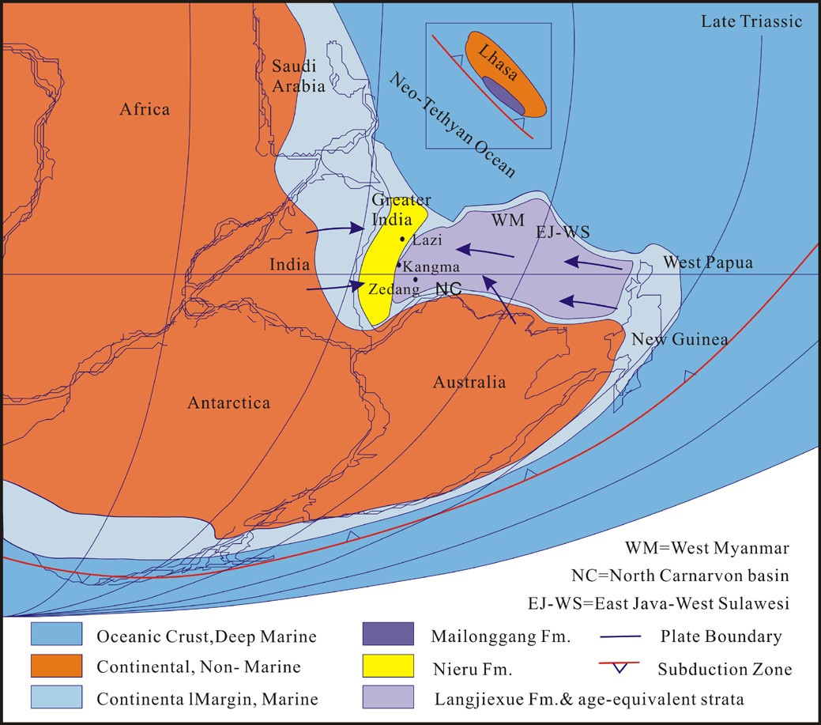

**Fig. 9.** Simplified Late Triassic paleogeographic reconstruction of the Neo–Tethyan margins.

India, which was located to the south (Li et al., 2003). The second class of models suggests that the Langjiexue Formation was deposited as an overlap assemblage atop the southern Lhasa terrane and Greater India during the initiation of continental rifting (Dai et al., 2008; Li et al., 2014). This model requires that India–Lhasa rifting occurred during the Late Triassic–Lower Jurassic. There is substantial evidence, however, that the Lhasa terrane rifted from Gondwana prior to late Triassic time (Garzanti et al., 1999; Sciunnach and Garzanti, 2012). The third class of models argues that the Langjiexue Formation was deposited in an intra-oceanic or Lhasa terrane forearc basin (Li et al., 2010, 2014). This hypothesis is also incompatible with known geological constraints, as (1) no Triassic intra-oceanic arc fragments have been documented within the YZSZ, (2) the recycled orogen provenance of the Mailonggang and Langjiexue formations is inconsistent with deposition in a forearc basin (Dickinson, 1985), and (3) the location of the Langjiexue Formation with respect to the YZSZ would require back–arc extension to rift the Langjiexue Formation from Lhasa terrane. The latter is inconsistent with recent studies indicating that the YZSZ ophiolites to the north developed in an extensional forearc rather than a back-arc setting (Maffione et al., 2015).

Our preferred interpretation is that the Langjiexue and Nieru formations were deposited on the northern margin of the Greater India. This interpretation requires that during Late Triassic time, northeast Greater India remained attached to Northwest Australia (Fig. 9; Metcalfe, 2013). Concurrently, western Myanmar, east Java– west Sulawesi, Timor and West Papua must have been located a sufficient distance from the present-day north Australia coast in order to accommodate a wide shelf (Metcalfe, 2013). Furthermore, we assert that the Lhasa terrane had already rifted from Greater India and was isolated from India-derived sedimentation by the Neo–Tethyan Ocean during Late Triassic time. We propose that a submarine fan complex developed between Papua New Guinea to the east and the North Australia shelf to the south during the Late Triassic, overlapping all terranes along the northern margin of east Gondwana (Fig. 9; Gunawan et al., 2012; Lewis and Sircombe, 2013; Zimmermann and Hall, 2014; Hennig et al., 2015). West Timor served as the north boundary of the submarine fan complex and prevented sediment transport from West Papua into the Tethyan Ocean basin to the north (Bird and Cook, 1991). This configuration facilitated long-distance transport of sediment along the north margin of Australia and onto Greater India during late Triassic. Upper Triassic strata in the outer Banda arc and west Sulawesi are dominated by Permian–Triassic detrital zircons which were derived from West Papua (Zimmermann and Hall, 2014; Hennig et al., 2015). Furthermore, west–southwestward paleocurrent indicators identified in West Timor strata suggest an overall east to west transport of sediment (Bird and Cook, 1991).

In our reconstruction, the eastern Tethyan Himalaya, which includes the Langjiexue Formation and Nieru Formation in the Kangma region were deposited as a distal part of a submarine fan complex (Fig. 9). This interpretation explains the observation that the age-equivalent strata in Tethyan Himalaya, Northwest Australia, Timor, and West Sulawesi all contain abundant Permian–Triassic detrital zircons and exhibit similar sedimentary facies (Fig. 9). In addition, Greater India experienced anticlockwise rotation during its Cretaceous northward drift (Huang et al., 2015), such that originally west-directed paleocurrent indicators would have been rotated to the modern southerly trend observed (Li et al., 2003).

The Upper Triassic Nieru Formation in the Lazi region is typical of a shallow marine depositional setting. Its present geographical position and its detrital zircon age spectra (Fig. 8) are consistent with those of the Tethyan Himalaya Sequence. Therefore, the Nieru Formation in the Lazi region was deposited on the Indian passive margin and derived from Indian continent. The Mailonggang Formation exhibits a proximal Lhasa terrane provenance and was likely separated from Greater India and Australia by the Neo– Tethyan Ocean.

# 7. Conclusions

Field observations, petrographic data, and U–Pb detrital zircon ages from the Upper Triassic strata along both sides of the Yarlung–Tsangpo suture zone in southern Tibet lead to the following major conclusions:

The Upper Triassic Mailonggang Formation in the southern Lhasa terrane is composed of shallow marine limestone and sandstone that was derived from the Lhasa terrane and deposited along the northern margin of the Neo–Tethyan Ocean.

The Upper Triassic Tethyan Himalaya Nieru Formation near Lazi is composed of quartz arenite and dominated by 1000–500 Ma detrital zircons that were likely derived from northern India. This unit was deposited along the passive northern margin of India. The Upper Triassic Nieru Formation in the Kangma region, however, consists mainly of slate and minor siltstone, and shows U–Pb age spectra similar to those of the age-equivalent Langjiexue Formation.

The Upper Triassic Langjiexue Formation of THS is composed of a several kilometer thick clastic-dominated sequence, comprising slate, shale, and sandstone. Major U–Pb detrital zircon age populations are within the age ranges 291–184 Ma, 390–304 Ma, 800–420 Ma and 1296–800 Ma. This unit may have been derived from West Papua and was deposited along the northern Gondwana margin, including Greater India, following Lhasa terrane rifting. Therefore the Langjiexue Formation is considered a part of the Tethyan Himalayan Sequence, despite not being derived from India like the majority of previously investigated Tethyan Himalaya strata.

# Acknowledgements

We thank Mark Pecha, Chelsi White, Clayton Loehn and Yahui Yue for their assistance with detrital zircon dating. We thank editor An Yin and reviewers Ian Metcalfe and Guangwei Li for their constructive comments. This study was financially supported by grants from the National Natural Science Foundation of China (41490615, 41472206) and the Chinese Academy of Sciences (XDB03010400) to Cai F. and Ding L. and the U.S. NSF Continental Dynamics Program (EAR-1008527) to Kapp P. Support for the Arizona LaserChron Center was provided by NSF-EAR 1032156.

# Appendix A. Supplementary material

Supplementary material related to this article can be found online at [http://dx.doi.org/10.1016/j.epsl.2015.12.027.](http://dx.doi.org/10.1016/j.epsl.2015.12.027)

# References

[Aikman, B.A., Harrison, T.M., Ding, L., 2008. Evidence for Early (>44](http://refhub.elsevier.com/S0012-821X(15)00790-6/bib41696B6574616C32303038s1) [Ma) Himalayan crustal thickening, Tethyan Himalaya, southeastern Tibet. Earth Planet.](http://refhub.elsevier.com/S0012-821X(15)00790-6/bib41696B6574616C32303038s1) [Sci. Lett. 274, 14–23.](http://refhub.elsevier.com/S0012-821X(15)00790-6/bib41696B6574616C32303038s1)

[Bird, P.R., Cook, S.E., 1991. Permo–Triassic successions of the Kekneno area, West](http://refhub.elsevier.com/S0012-821X(15)00790-6/bib426972436F6F31393931s1) [Timor: implications for palaeogeography and basin evolution. J. Southeast Asian](http://refhub.elsevier.com/S0012-821X(15)00790-6/bib426972436F6F31393931s1) [Earth Sci. 6, 359–372.](http://refhub.elsevier.com/S0012-821X(15)00790-6/bib426972436F6F31393931s1)

[Cai, F.L., Ding, L., Leary, R.J., Wang, H.Q., Xu, Q., Zhang, L.Y., 2012. Tectonostratigraphy and provenance of an accretionary complex within the Yarlung–Zangpo](http://refhub.elsevier.com/S0012-821X(15)00790-6/bib4361696574616C32303132s1) [suture zone, southern Tibet: insights into subduction–accretion processes in the](http://refhub.elsevier.com/S0012-821X(15)00790-6/bib4361696574616C32303132s1)

[Neo–Tethys. Tectonophysics 574–575, 181–192.](http://refhub.elsevier.com/S0012-821X(15)00790-6/bib4361696574616C32303132s1)

[Chu, M.F., Chung, S.L., Song, B., Liu, D.Y., O’Reilly, S.Y., Pearson, N.J., Ji, J.Q., Wen, D.J.,](http://refhub.elsevier.com/S0012-821X(15)00790-6/bib4368756574616C32303036s1) [2006. Zircon U–Pb and Hf isotope constraints on the Mesozoic tectonics and](http://refhub.elsevier.com/S0012-821X(15)00790-6/bib4368756574616C32303036s1) [crustal evolution of southern Tibet. Geology 34, 745–748.](http://refhub.elsevier.com/S0012-821X(15)00790-6/bib4368756574616C32303036s1)

[Dai, J.G., Yin, A., Liu, W.C., 2008. Nd isotopic compositions of the Tethyan Himalayan](http://refhub.elsevier.com/S0012-821X(15)00790-6/bib4461696574616C32303038s1) [Sequence in southeastern Tibet. Sci. China, Ser. D, Earth Sci. 51 (9), 1306–1316.](http://refhub.elsevier.com/S0012-821X(15)00790-6/bib4461696574616C32303038s1)

[DeCelles, P.G., Gehrels, G.E., Najman, Y., Martin, A.J., Carter, A., Garzanti, E., 2004.](http://refhub.elsevier.com/S0012-821X(15)00790-6/bib4465436574616C32303034s1) [Detrital geochronology and geochemistry of Cretaceous–Early Miocene strata of](http://refhub.elsevier.com/S0012-821X(15)00790-6/bib4465436574616C32303034s1) [Nepal: implications for timing and diachroneity of initial Himalayan orogensis.](http://refhub.elsevier.com/S0012-821X(15)00790-6/bib4465436574616C32303034s1) [Earth Planet. Sci. Lett. 227, 313–330.](http://refhub.elsevier.com/S0012-821X(15)00790-6/bib4465436574616C32303034s1)

[Dickinson, W.R., 1985. Interpreting provenance relations from detrital modes of](http://refhub.elsevier.com/S0012-821X(15)00790-6/bib44696331393835s1) [sandstone. In: Zuffa, G. (Ed.), Provenance of Arenites. Reidel Publishing Co., Dordrecht, pp. 333–361.](http://refhub.elsevier.com/S0012-821X(15)00790-6/bib44696331393835s1)

[Dürr, S.B., 1996. Provenance of Xigaze fore–arc basin clastic rocks (Cretaceous, south](http://refhub.elsevier.com/S0012-821X(15)00790-6/bib44757231393936s1) [Tibet). Geol. Soc. Am. Bull. 108, 669–684.](http://refhub.elsevier.com/S0012-821X(15)00790-6/bib44757231393936s1)

[Fitzsimons, I.C.W., 2000. Grenville-age basement provinces in East Antarctica: evidence for three separate collisional orogens. Geology 28, 879–882.](http://refhub.elsevier.com/S0012-821X(15)00790-6/bib46697432303030s1)

[Garzanti, E., Le Fort, P., Sciunnach, D., 1999. First report of Lower Permian basalts](http://refhub.elsevier.com/S0012-821X(15)00790-6/bib4761726574616C31393939s1) [in south Tibet: tholeiitic magmatism during break-up and incipient opening of](http://refhub.elsevier.com/S0012-821X(15)00790-6/bib4761726574616C31393939s1) [Neotethys. J. Asian Earth Sci. 17, 533–546.](http://refhub.elsevier.com/S0012-821X(15)00790-6/bib4761726574616C31393939s1)

Gehrels, G.E., Valencia, V., Ruiz, J., 2008. Enhanced precision, accuracy, efficiency, and spatial resolution of U–Pb ages by laser ablation-multicollector-inductively coupled plasma–mass spectrometry. Geochem. Geophys. Geosyst. 9. [http:// dx.doi.org/10.1029/2007GC001805.](http://dx.doi.org/10.1029/2007GC001805)

Gehrels, G.E., Kapp, P., DeCelles, P., Blakey, R., Weislogel, A., Ding, L., Guynn, J.,

Martin, A., McQuarrie, N., Yin, A., 2012. Detrital zircon geochronology of pre– Tertiary strata in the Tibetan–Himalayan orogen. Tectonics. [http://dx.doi.org/](http://dx.doi.org/10.1029/2011TC002868)

[10.1029/2011TC002868](http://dx.doi.org/10.1029/2011TC002868).

[Gunawan, I., Hall, R., Sevastjanova, I., 2012. Age, character and provenance of the](http://refhub.elsevier.com/S0012-821X(15)00790-6/bib47756E6574616C32303132s1) [Tipuma Formation, West Papua: new insights from detrital zircon dating. In:](http://refhub.elsevier.com/S0012-821X(15)00790-6/bib47756E6574616C32303132s1) [Proceedings, Indonesian Petroleum Association, Thirty-Sixth Annual Convention](http://refhub.elsevier.com/S0012-821X(15)00790-6/bib47756E6574616C32303132s1) [& Exhibition, May 2012.](http://refhub.elsevier.com/S0012-821X(15)00790-6/bib47756E6574616C32303132s1)

[He, S.D., Kapp, P., DeCelles, P.G., Gehrels, G.E., Heizler, M., 2007. Cretaceous–Tertiary](http://refhub.elsevier.com/S0012-821X(15)00790-6/bib48656574616C32303037s1) [geology of the Gangdese Arc in the Linzhou area, southern Tibet. Tectonophysics 433, 15–37.](http://refhub.elsevier.com/S0012-821X(15)00790-6/bib48656574616C32303037s1)

[Hébert, H., Bezard, R., Guilmette, C., Dostal, J., Wang, C.S., Liu, Z.F., 2012. The](http://refhub.elsevier.com/S0012-821X(15)00790-6/bib4865626574616C32303132s1) [Indus–Yarlung–Zangpo ophiolites from Nanga Parbat to Namche Barwa syntaxes, southern Tibet: first synthesis of petrology, geochemistry, and geochronology with incidences on geodynamic reconstructions of Neo–Tethys. Gondwana](http://refhub.elsevier.com/S0012-821X(15)00790-6/bib4865626574616C32303132s1)

[Res. 22, 377–397.](http://refhub.elsevier.com/S0012-821X(15)00790-6/bib4865626574616C32303132s1)

Hennig, J., Hall, R., Armsrtong, R., 2015. U–Pb zircon geochronology of rocks from west Central Sulawesi, Indonesia: extension-related metamorphism and magmatism during the early stages of mountain building. Gondwana Res. [http://dx.doi.org/10.1016/j.gr.2014.12.012.](http://dx.doi.org/10.1016/j.gr.2014.12.012)

[Huang, W.T., van Hinsbergen, D.J.J., Lippert, P.C., Guo, Z.J., Nupont-Nivet, G., 2015.](http://refhub.elsevier.com/S0012-821X(15)00790-6/bib4875616574616C32303135s1) [Paleomagnetic tests of tectonic reconstructions of the India–Asia collision zone.](http://refhub.elsevier.com/S0012-821X(15)00790-6/bib4875616574616C32303135s1)

[Geophys. Res. Lett. 42, 2642–2649.](http://refhub.elsevier.com/S0012-821X(15)00790-6/bib4875616574616C32303135s1)

[Ji, W.Q., Wu, F.Y., Chung, S.L., Liu, C.Z., 2012. Identification of early Carboniferous](http://refhub.elsevier.com/S0012-821X(15)00790-6/bib4A696574616C32303132s1) [granitoids from southern Tibet and implications for terrane assembly related to](http://refhub.elsevier.com/S0012-821X(15)00790-6/bib4A696574616C32303132s1) [the Paleo–Tethyan evolution. J. Geol. 120 (5), 531–541.](http://refhub.elsevier.com/S0012-821X(15)00790-6/bib4A696574616C32303132s1)

[Ji, Z.S., Yao, J.X., Yang, X.D., Zang, W.S., Wu, G.C., 2003. Conodont zonations of Norian](http://refhub.elsevier.com/S0012-821X(15)00790-6/bib4A696574616C32303033s1) [in Lhasa area, Xizang (Tibet) and their global correlation. Acta Palaeontol. Sin. 42](http://refhub.elsevier.com/S0012-821X(15)00790-6/bib4A696574616C32303033s1)

[(3), 382–392.](http://refhub.elsevier.com/S0012-821X(15)00790-6/bib4A696574616C32303033s1)

[Ji, Z.S., Yao, J.X., Wu, G.C., Zhan, L., Jiang, Z., Fu, Y., 2005. On the stratigraphic sequence, lithological characteristics and origin of the Lower Permian Pangduo](http://refhub.elsevier.com/S0012-821X(15)00790-6/bib4A696574616C32303035s1) [Group in Linzhou County, northern Lhasa, Tibet. Acta Geol. Sin. 79, 433–443.](http://refhub.elsevier.com/S0012-821X(15)00790-6/bib4A696574616C32303035s1)

[Leier, A.L., Kapp, P., Gehrels, G.E., DeCelles, P.G., 2007. Detrital zircon geochronology](http://refhub.elsevier.com/S0012-821X(15)00790-6/bib4C65696574616C32303037s1) [of Carboniferous–Cretaceous strata in the](http://refhub.elsevier.com/S0012-821X(15)00790-6/bib4C65696574616C32303037s1) [Lhasa terrane, southern Tibet. Basin](http://refhub.elsevier.com/S0012-821X(15)00790-6/bib4C65696574616C32303037s1) [Res. 19,](http://refhub.elsevier.com/S0012-821X(15)00790-6/bib4C65696574616C32303037s1) [361–378.](http://refhub.elsevier.com/S0012-821X(15)00790-6/bib4C65696574616C32303037s1)

[Lewis, C.H., Sircombe, K.N., 2013. Use of U–Pb](http://refhub.elsevier.com/S0012-821X(15)00790-6/bib4C657753697232303133s1) [geochronology to delineate provenance of North West Shelf sediments, Australia. In: Keep, M., Moss, S.J. (Eds.),](http://refhub.elsevier.com/S0012-821X(15)00790-6/bib4C657753697232303133s1) [The Sedimentary Basins of Western Australia IV: Proceedings of the Petroleum](http://refhub.elsevier.com/S0012-821X(15)00790-6/bib4C657753697232303133s1)

[Exploration Society of Australia Symposium. Perth, WA.](http://refhub.elsevier.com/S0012-821X(15)00790-6/bib4C657753697232303133s1)

[Li, G.W., Liu, X.H., Alex, P., Wei, L.J., Liu, X.B., Huang, F.X., Zhou, X.J., 2010. In-situ detrital zircon geochronology and Hf isotopic analyses from Upper Triassic Tethys](http://refhub.elsevier.com/S0012-821X(15)00790-6/bib4C696574616C32303130s1) [sequence strata. Earth Planet. Sci. Lett. 297, 461–470.](http://refhub.elsevier.com/S0012-821X(15)00790-6/bib4C696574616C32303130s1)

[Li, G.W., Sandiford, M., Liu, X.H., Xu, Z.Q., Wei, L.J., Li, H.Q., 2014. Provenance of late](http://refhub.elsevier.com/S0012-821X(15)00790-6/bib4C696574616C32303134s1) [Triassic sediments in central Lhasa terrane, Tibet and its implication. Gondwana](http://refhub.elsevier.com/S0012-821X(15)00790-6/bib4C696574616C32303134s1) [Res. 25, 1680–1689.](http://refhub.elsevier.com/S0012-821X(15)00790-6/bib4C696574616C32303134s1)

Li, X.H., Mattern, F., Zhang, C.K., Zeng, Q.G., Mao, G.Z., 2015. Multiple sources of the Upper Triassic flysch in eastern Himalaya orogeny, Tibet, China: implications to paleogeography and paleotectonic evolution. Tetctonophysics. [http:// dx.doi.org/10.1016/j.tecto.2015.10.005](http://dx.doi.org/10.1016/j.tecto.2015.10.005).

[Li, X.H., Zeng, Q.G., Wang, C.S., 2003. Palaeocurrent data: evidence for the source of](http://refhub.elsevier.com/S0012-821X(15)00790-6/bib4C696574616C32303033s1) [the Langjiexue Formation in the southern Tibet. Geol. Rev. 49 (2), 132–137.](http://refhub.elsevier.com/S0012-821X(15)00790-6/bib4C696574616C32303033s1)

[Liu, G.H., Einsele, G., 1994. Sedimentary history of the Tethyan basin in the Tibetan](http://refhub.elsevier.com/S0012-821X(15)00790-6/bib4C697545696E31393934s1)

[Himalayas. Geol. Rundsch. 83, 32–61.](http://refhub.elsevier.com/S0012-821X(15)00790-6/bib4C697545696E31393934s1)

[Ludwig, K.L., 2008. Isoplot 3.7. A Geochronological Toolkit for Microsoft Excel. Berkeley Geochronology Center Special Publication, vol. 4, p. 77. Rev. August 26.](http://refhub.elsevier.com/S0012-821X(15)00790-6/bib4C756432303038s1)

Maffione, M., van Hinsbergen, D.J.J., Koornneef, L.M.T., Guilmette, C., Hodges, K., Borneman, N., Huang, W.T., Ding, L., Kapp, P., 2015. Forearc hyperextension dismembered the south Tibetan ophiolites. Geology. [http://dx.doi.org/10.1130/](http://dx.doi.org/10.1130/G36472.1)

[G36472.1](http://dx.doi.org/10.1130/G36472.1).

[Matsuoka, A., Yang, Q., Kobayashi, K., Takei, M., Nagahashi, T., Zeng, Q.G., Wang, Y.J.,](http://refhub.elsevier.com/S0012-821X(15)00790-6/bib4D61746574616C32303032s1) [2002. Jurassic–Cretaceous radiolarian biostratigraphy and sedimentary environments of the Ceno–Tethys: records from the Xialu chert in the Yarlung–Zangpo](http://refhub.elsevier.com/S0012-821X(15)00790-6/bib4D61746574616C32303032s1) [suture zone, southern Tibet. J. Asian Earth Sci. 20, 277–287.](http://refhub.elsevier.com/S0012-821X(15)00790-6/bib4D61746574616C32303032s1)

[Metcalfe, I., 2013. Gondwana dispersion and Asian accretion: tectonic and palaeogeographic evolution of eastern Tethys. J. Asian Earth Sci. 66, 1–33.](http://refhub.elsevier.com/S0012-821X(15)00790-6/bib4D657432303133s1)

[Myrow, P.M., Hughes, N.C., Paulsen, T.S., Williams, I.S., Parcha, S.K., Thompson, K.P.,](http://refhub.elsevier.com/S0012-821X(15)00790-6/bib4D79726574616C32303033s1) [Bowring, S.A., Peng, S.C., Ahluwalia, A.D., 2003. Integrated tectonostratigraphic](http://refhub.elsevier.com/S0012-821X(15)00790-6/bib4D79726574616C32303033s1) [analysis of the Himalaya and implications for its tectonic reconstruction. Earth](http://refhub.elsevier.com/S0012-821X(15)00790-6/bib4D79726574616C32303033s1)

[Planet. Sci. Lett. 212, 433–441.](http://refhub.elsevier.com/S0012-821X(15)00790-6/bib4D79726574616C32303033s1)

[Orme, D.A., Carrapa, B., Kapp, P., 2015. Sedimentology, provenance and geochronlogy](http://refhub.elsevier.com/S0012-821X(15)00790-6/bib4F726D6574616C32303135s1) [of the upper Cretaceous–lower Eocene western Xigaze forearc basin, southern](http://refhub.elsevier.com/S0012-821X(15)00790-6/bib4F726D6574616C32303135s1)

[Tibet. Basin Res. 27, 387–411.](http://refhub.elsevier.com/S0012-821X(15)00790-6/bib4F726D6574616C32303135s1)

[Pullen, A., Kapp, P., Gehrels, G.E., DeCelles, P.G., Brown, E., Fabijanic, J.M., Ding, L.,](http://refhub.elsevier.com/S0012-821X(15)00790-6/bib50756C6574616C32303038s1) [2008. Gangdese retroarc thrust belt and foreland basin deposits in the Damxung](http://refhub.elsevier.com/S0012-821X(15)00790-6/bib50756C6574616C32303038s1) [area, southern Tibet. J. Asian Earth Sci. 33, 323–336.](http://refhub.elsevier.com/S0012-821X(15)00790-6/bib50756C6574616C32303038s1)

[Sciunnach, D., Garzanti, E., 2012. Subsidence history of the Tethys Himalaya. Earth-](http://refhub.elsevier.com/S0012-821X(15)00790-6/bib53636947617232303132s1)

[Sci. Rev. 111, 179–198.](http://refhub.elsevier.com/S0012-821X(15)00790-6/bib53636947617232303132s1)

[Searle, M.P., Windley, B.F., Coward, M.P., Cooper, D.J.W., Rex, A.J., Rex, D., Li, T.D.,](http://refhub.elsevier.com/S0012-821X(15)00790-6/bib5365616574616C31393837s1) [Xiao, X.C., Jan, M.Q., Thakur, V.C., 1987. The closing of Tethys and the tectonics](http://refhub.elsevier.com/S0012-821X(15)00790-6/bib5365616574616C31393837s1) [of the Himalaya. Geol. Soc. Am. Bull. 98, 678–701.](http://refhub.elsevier.com/S0012-821X(15)00790-6/bib5365616574616C31393837s1)

Sevastjanova, I., Hall, R., Rittner, M., Saw Mu Tha Lay, Paw, Tin Tin, Naing, Alderton, D.H., Comfort, G., 2015. Myanmar and Asia united, Australia left behind long ago. Gondwana Res. [http://dx.doi.org/10.1016/j.gr.2015.02.001.](http://dx.doi.org/10.1016/j.gr.2015.02.001)

[Veevers, J.J., Belousova, E.A., Saeed, A., Sircombe, K., Cooper, A.F., Read, S.E., 2006.](http://refhub.elsevier.com/S0012-821X(15)00790-6/bib5665656574616C32303036s1) [Pan–Gondwanaland detrital zircons from Australia analysed for Hf-isotopes and](http://refhub.elsevier.com/S0012-821X(15)00790-6/bib5665656574616C32303036s1) [trace elements reflect an ice covered Antarctic provenance of 700–500](http://refhub.elsevier.com/S0012-821X(15)00790-6/bib5665656574616C32303036s1) [Ma age,](http://refhub.elsevier.com/S0012-821X(15)00790-6/bib5665656574616C32303036s1) [TDM of 2.0–10](http://refhub.elsevier.com/S0012-821X(15)00790-6/bib5665656574616C32303036s1) [Ga and alkaline affinity. Earth-Sci. Rev. 76, 135–174.](http://refhub.elsevier.com/S0012-821X(15)00790-6/bib5665656574616C32303036s1)

[Veevers, J.J., Saeed, A., 2009. Permian–Jurassic Mahanadi and Pranhita–Godavari](http://refhub.elsevier.com/S0012-821X(15)00790-6/bib56656553616532303039s1) [Rifts of Gondwanan India: provenance from regional paleoslope and U–Pb/Hf](http://refhub.elsevier.com/S0012-821X(15)00790-6/bib56656553616532303039s1) [analysis of detrital zircon. Gondwana Res. 16, 633–654.](http://refhub.elsevier.com/S0012-821X(15)00790-6/bib56656553616532303039s1)

[Webb, A.A.G., Yin, A., Dubey, C.S., 2013. U–Pb zircon geochronology of major lithologic units in the eastern Himalaya: implications for the origin and assembly of](http://refhub.elsevier.com/S0012-821X(15)00790-6/bib5765626574616C32303133s1) [Himalaya rocks. Geol. Soc. Am. Bull. 125, 499–522.](http://refhub.elsevier.com/S0012-821X(15)00790-6/bib5765626574616C32303133s1)

[Yin, A., Harrison, T.M., Ryerson, F.J., Chen, W., Kidd, W.S.F., Copeland, P., 1994. Tertiary structural evolution of the Gangdese thrust system, southeastern Tibet.](http://refhub.elsevier.com/S0012-821X(15)00790-6/bib59696E6574616C31393934s1) [J. Geophys. Res. 99, 18175–18201.](http://refhub.elsevier.com/S0012-821X(15)00790-6/bib59696E6574616C31393934s1)

Yu, Z.X. Zhen, A.Z., 1979. Geologic Map of the Lhasa Region at a Scale of 1:1000000. Geologic Publishing House, Beijing.

Yuan, D.X., Zhang, Y.C., Shen, S.Z., Henderson, C.M., Zhang, Y.J., Zhu, T.X., An, X.Y., Feng, H.Z., 2015. Early Permian conodonts from the Xainza area, central Lhasa Block, Tibet, and their palaeobiogeographical and palaeoclimatic implications. J. Syst. Palaeontol.<http://dx.doi.org/10.1080/14772019.2015.1052027>.

[Zhang, C.K., Li, X.H., Mattern, F., Mao, G.Z., Zeng, Q.G., Xu, W.L., 2015. Deposystem](http://refhub.elsevier.com/S0012-821X(15)00790-6/bib5A68616574616C32303135s1) [architectures and lithofacies of a submarine fan-dominated deep sea succession](http://refhub.elsevier.com/S0012-821X(15)00790-6/bib5A68616574616C32303135s1) [in an orogeny: a case study from the Upper Triassic Langjiexue Group of southern Tibet. J. Asian Earth Sci. 111, 222–243.](http://refhub.elsevier.com/S0012-821X(15)00790-6/bib5A68616574616C32303135s1)

[Zhang, H.F., Xu, W.C., Guo, J.Q., Zong, K.Q., Cai, H.M., Yuan, H.L., 2007. Zircon U–Pb](http://refhub.elsevier.com/S0012-821X(15)00790-6/bib5A68616574616C32303037s1) [and Hf isotopic composition of deformed granite in the southern margin of the](http://refhub.elsevier.com/S0012-821X(15)00790-6/bib5A68616574616C32303037s1) [Gangdese terrane, Tibet: evidence for early Jurassic subduction of Neo–Tethyan](http://refhub.elsevier.com/S0012-821X(15)00790-6/bib5A68616574616C32303037s1) [oceanic slab. Acta Petrol. Sin. 23, 1347–1353.](http://refhub.elsevier.com/S0012-821X(15)00790-6/bib5A68616574616C32303037s1)

[Zhu, J., Du, Y.S., Liu, Z.X., Feng, Q.L., Tian, W.X., Li, J.P., Wand, C.P., 2005. Mesozoic](http://refhub.elsevier.com/S0012-821X(15)00790-6/bib5A68756574616C32303035s1) [radiolarian chert from the middle sector of the Yarlung–Zangpo suture zone,](http://refhub.elsevier.com/S0012-821X(15)00790-6/bib5A68756574616C32303035s1) [Tibet and its tectonic implications. Sci. China D 49, 348–357.](http://refhub.elsevier.com/S0012-821X(15)00790-6/bib5A68756574616C32303035s1)

[Zhu, D.C., Zhao, Z.D., Niu, Y.L., Mo, X.X., Chung, S.L., Hou, Z.Q., Wang, L.Q., Wu, F.Y.,](http://refhub.elsevier.com/S0012-821X(15)00790-6/bib5A68756574616C32303131s1) [2011. The Lhasa terrane: record of a microcontinent and its histories of drift](http://refhub.elsevier.com/S0012-821X(15)00790-6/bib5A68756574616C32303131s1) [and growth. Earth Planet. Sci. Lett. 301, 241–255.](http://refhub.elsevier.com/S0012-821X(15)00790-6/bib5A68756574616C32303131s1)

[Ziabrev, S.V., Aitchison, J.C., Abrajevitch, A.V., Zhu, B.D., Davis, A.M., Luo, H., 2004.](http://refhub.elsevier.com/S0012-821X(15)00790-6/bib5A69616574616C32303034s1) [Bainang Terrane, Yarlung–Tsangpo suture, southern Tibet (Xizang, China): a](http://refhub.elsevier.com/S0012-821X(15)00790-6/bib5A69616574616C32303034s1) [record of intra-Neotethyan subduction–accretion processes preserved on the](http://refhub.elsevier.com/S0012-821X(15)00790-6/bib5A69616574616C32303034s1) [roof of the world. J. Geol. Soc. Lond. 161, 523–538.](http://refhub.elsevier.com/S0012-821X(15)00790-6/bib5A69616574616C32303034s1)

[Zimmermann, S., Hall, R., 2014. Provenance of Mesozoic sandstones in the Banda](http://refhub.elsevier.com/S0012-821X(15)00790-6/bib5A696D48616C32303134s1) [Arc, Indonesia. In: Proceedings, Indonesian Petroleum Association, Thirty-Eighth](http://refhub.elsevier.com/S0012-821X(15)00790-6/bib5A696D48616C32303134s1) [Annual Convention and Exhibition, May.](http://refhub.elsevier.com/S0012-821X(15)00790-6/bib5A696D48616C32303134s1)