**Orogenic paleofluid flow recorded by discordant detrital zircons in the Caledonian foreland basin of northern Greenland**

**George A. Morris1,*, C.L. Kirkland2,3, and V. Pease4**

1GEOLOGICAL SURVEY OF SWEDEN, BOX 670, SE 751 28, UPPSALA, SWEDEN

2GEOLOGICAL SURVEY OF WESTERN AUSTRALIA, 100 PLAIN STREET, EAST PERTH, WA 6004, AUSTRALIA

3ARC CENTRE OF EXCELLENCE FOR CORE TO CRUST FLUID SYSTEMS, DEPARTMENT OF EARTH & PLANETARY SCIENCES, MACQUARIE UNIVERSITY, SYDNEY NSW 2109, AUSTRALIA

4GEOLOGICAL SCIENCES, STOCKHOLM UNIVERSITY, SE 106 91, STOCKHOLM, SWEDEN

# ABSTRACT

Concordant detrital zircon dates from Neoproterozoic to Paleozoic continental slope and trough deposits in northern Greenland indicate Late Archean and Paleoproterozoic sediment sources. Significant numbers of dates are, however, discordant and, together with a few apparently concordant dates, give ages younger than the depositional ages of overlying fossiliferous sediments. The discordance pattern implies partial or total radiogenic-Pb loss during the Middle Devonian, possibly facilitated by postdepositional fluid movement. Such timing of radiogenicPb loss is supported by results from a novel modeling method, which indicate that the greatest statistical similarity between concordant and discordant detrital populations occurs when Pb loss is constrained to the interval of 380–390 Ma, i.e., long after deposition. This radiogenicPb loss event is interpreted to reflect fluid flow associated with Caledonian orogenic uplift to the east.

|  |  |
| --- | --- |
| LITHOSPHERE; v. 7; no. 2; p. 138–143; GSA Data Repository Item 2015078 | Published online 22 January 2015 | doi:10.1130/L420.1 |

# INTRODUCTION

Orogeny-driven fluid flow is important in a range of geological processes, including porosity enhancement and deposition of metals (e.g., Mississippi Valley–type Pb-Zn; Nesbitt and Muehlenbachs, 1994). A key piece of information in any interpretation of such events is the time of fluid flow. The transient nature of fluidflow events, however, adds to the challenge of determining both source(s) and relative timing.

Since the advent of isotopic microanalytical techniques, such as secondary ion mass spectrometry (SIMS) and laser ablation–inductively coupled plasma–mass spectrometry (LA-ICPMS), and the resultant ability to rapidly acquire large quantities of age information from crystals, the use of detrital zircon studies has flourished. These studies typically examine the origin and correlation of sediments and/or the evolution of orogens and sedimentary basins through comparison of age spectra between samples and potential source regions (e.g., Rainbird et al., 1992; Gehrels, 2012). Studies rely on preservation of the original zircon crystallization ages, which under most circumstances reflect the timing of growth within a silicate melt. One of the strengths of zircon in such studies is that the U-Th-Pb isotopic system within a single grain typically remains

## *george.morris@sgu.se

closed through multiple high-temperature metamorphic and metasomatic events. Zircons with damaged crystal structures, or in reactive solutions, are, however, vulnerable to alteration and partial to complete resetting of their Pb-isotopic system during low-temperature metamorphic or hydrothermal events (e.g., Kramers et al., 2009). Detrital zircon studies, which seek information on the source component age, therefore typically only consider U-Th-Pb isotopic dates that lie within a few percent (usually 5%–10%) of concordia. This is rarely considered a problem because alteration processes, sedimentary transport, and indeed sample preparation techniques act together to selectively remove damaged zircon crystals, a process that could introduce a systematic bias into the data set by preferentially removing certain zircon populations present in the source region (e.g., Sircombe and Stern, 2002). The corollary of this statement is that the presence of discordant zircons can be evidence of postdepositional low-temperature alteration. In this study, we consider in some detail discordant as well as concordant age data in detrital zircons from northernmost Greenland, with implications for postdepositional fluid-rock interaction.

# Geological Background

The Neoproterozoic to Paleozoic evolution of northern Greenland (Fig. 1) records the development of a continental margin subsequent to the breakup of Rodinia. The sedimentary succession consists of six Cambrian through Early Silurian deep-water slope and trough megasequences formed by major turbidite systems, with cherts and shales deposited during periods of slower sedimentation (Higgins et al., 1991). Deposition is thought to have been concentrated in marginparallel grabens, which now form sedimentary units in Johannus Jenson Land and part of the Franklinian Basin (e.g., Trettin et al., 1991). This study examines trough sediments from three Cambrian through Silurian turbidite groups.

The Polkorridoren Group (Fig. 1) consists of a 2–3-km-thick succession of Early to midCambrian turbidite deposits outcropping across northern Greenland, the deposition of which is thought to have been strongly controlled by trough-parallel extensional faulting (Surlyk and Hurst, 1984). Zircon data from two samples are presented here: 303569, a gray quartzite from the western part of the exposure; and 255628, a purple siltstone from the eastern exposures, which directly underlies samples from the Vølvedal Group and Sydgletcher Formations (Fig. 1). The Vølvedal Group is considered Early to mid-Cambrian in age, based on comparison with graptolite-bearing outer-shelf and slope sequences to the south. The predominance of black shales and cherts indicates a period of slow hemipelagic sedimentation.

## © 2015 Geological Society of America www.gsapubs.org | For permission to copy, contact editing@geosociety.org| Volume 7 | Number 2 | LITHOSPHERE

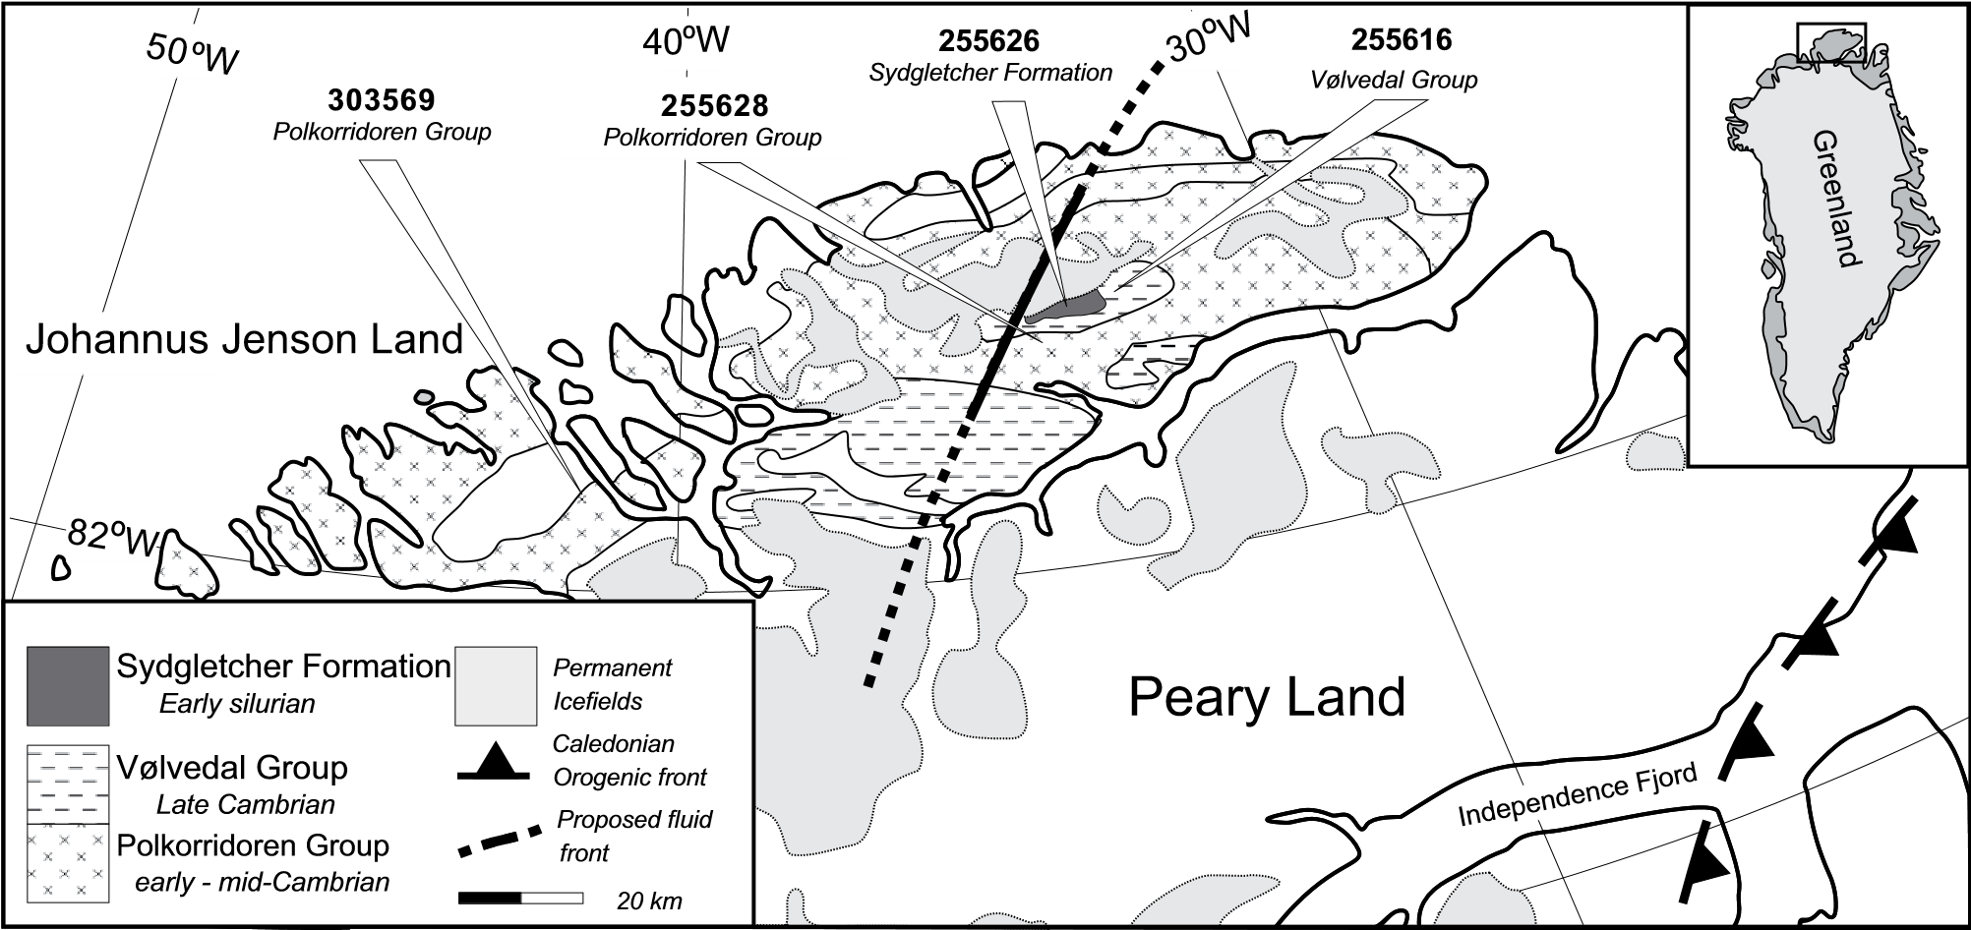

**Figure 1. Neoproterozoic to Paleozoic geology of northern Greenland with sample localities indicated, adapted from Higgins et al. (1991). The fluid front is recognized in the study area between samples 255628 and 303569; this is ~120–190 km west of the known limit for Caledonian thrusting (e.g., Gee et al., 2008). The location of the fluid front is drawn using the more conservative, minimum distance of ~130 km. The fluid front should be of regional extent and is therefore extrapolated parallel to the orogen further south (dashed line).**

Minor mudstones and conglomerates are also present (Surlyk and Hurst, 1984). Zircons from one sample, 255616, a cross-bedded psammite, are examined here. The Sydgletcher Formation of the Peary Land Group is the early part of a major (2.5 km+) sandstone turbidite sequence. The change in deposition rate has been linked to uplift and erosion to the east associated with the beginning of the Caledonian orogeny. There is no direct age determination for the Sydgletcher Formation; however, Surlyk et al. (1980) reported early Llandovery–age graptolites in underlying shales. Overlying turbidites of the Merqujôq Formation contain late Llandovery graptolites (Hurst and Surlyk, 1982), bracketing the Sydgletcher Formation within the Llandovery (443.4 Ma to 433.4 Ma). One sample 255626, a micaceous sandstone, is examined from this formation. The survival of delicate graptolite fossils and the absence of new metamorphic mineral growth attest to the unmetamorphosed nature of these sediments.

The northernmost preserved extent of the Caledonian orogen in Greenland impinges 80–160 km east-southeast of the sampled outcrops. Thrust sheets comprise far-traveled allochthons of clastic Cambrian–Silurian and Neoproterozoic sediments are overthrust onto shallow-water, predominantly carbonate, Cambrian–Silurian sediments (Fig. 1; Gee et al., 2008). Higgins et al. (2004) estimated displacement of 35–100 km along low-angle thrust faults that were subsequently reactivated in a normal sense during orogenic collapse. The youngest sediments overridden by Caledonian thrust sheets are Wenlockian (ca. 426 Ma) in age, giving a maximum age for the impingement of the orogen in this area.

# ANALYTICAL TECHNIQUES

Zircons were separated from ~1 kg of sample using conventional magnetic, heavy liquid, and panning techniques. Sample preparation and analytical procedures follow those described in Whitehouse et al. (1997). Handpicked crystals were mounted in epoxy resin blocks, along with chips of the Geostandard zircon 91500, and then imaged with a scanning electron microscope using combined backscattered electron (BSE) and cathodoluminescence (CL) mode both before and after analysis to precisely determine the location of the analyses. U-Th-Pb isotope ratios were analyzed using a Cameca IMS1270 SIMS at the Nordsim facility in Stockholm, Sweden, and results were calibrated relative to Geostandard zircon 91500. Due to a generally small grain size, an ion beam of ~15mm was used for analysis. Each isotopic age was corrected for common Pb using the presentday Pb composition of Stacey and Kramers (1975), when 204Pb count rate was significantly higher (3s) than background. This procedure avoids negative common-Pb corrections (and an increase in calculated 204Pb corrected ages), which can occur when 204Pb counts are near background level. A correlation between 204Pb and analysis time was observed; therefore, 204Pb is assumed to be related to present-day common Pb. Kirkland et al. (2008) demonstrated that the use of the present-day Stacey and Kramers (1975) common-Pb composition is valid for the Nordsim laboratory. U-Th-Pb SIMS results are presented in Table DR1.[1]

# RESULTS

Two hundred and thirty zircons from four samples were analyzed for U-Th-Pb isotopes (Fig. 2; Table DR1 [see footnote 1]). Analyses are considered discordant if they lie >10% from the concordia curve. Only 2 of 76 analyses from sample 303569 (Polkorridoren Group, west) are discordant, while 5 of 26 analyses from 255628 (Polkorridoren Group, east) are discordant (Figs. 3A and 3B). Fifteen of 65 analyses from sample 255616 (Vølvedal Group), and 39 of 63 analyses from sample 255626 (Sydgletcher Formation) are discordant and form triangleshaped arrays on 207Pb/206Pb versus 238U/206Pb Tera-Wasserburg plots (Figs. 3C and 3D). The 207Pb/206Pb ages are preferred for analyses older than 1000 Ma, and the 238U/206Pb ages are preferred for those younger than 1000 Ma. Concor-

MORRIS ET AL.

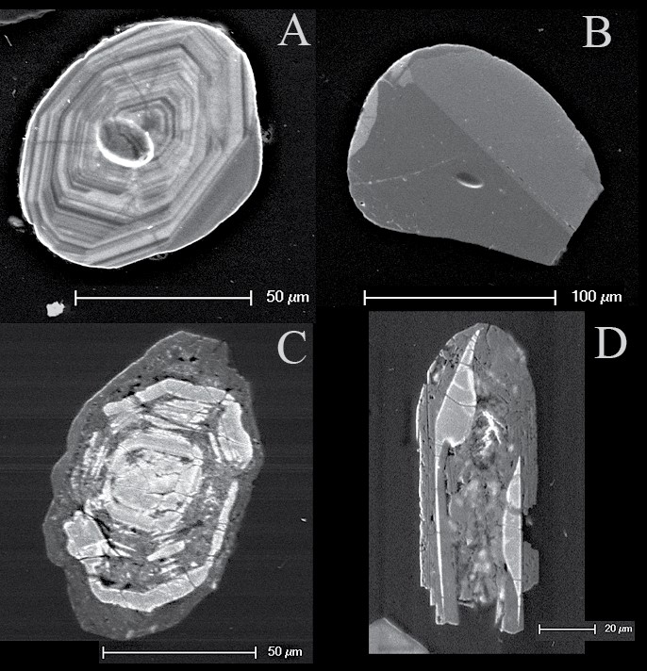

**A**

**B**

**C**

**D**

**Figure 2. Mixed cathodoluminescence (CL) and secondary emission (SE) images illustrating the range of zircons analyzed from northern Greenland. (A) Complexly zoned zircon interpreted to have grown from a silicate melt, from the Polkorridoren Formation (303569 zircon 11); although sometimes >10% discordant, this type of zircon dominates all samples. (B) Concordant twinned but unzoned zircon interpreted to reflect a metamorphic origin (255628 zircon 18); these zircons are present in the three eastern samples (255616, 255626, and 255628). (C) Altered and strongly discordant zircon from the Vølvedal Group (255626 zircon 46). (D) A concordant zircon from the Sydgletcher Formation (255626 zircon 40, 385 Ma), which returns an age significantly younger than the stratigraphic age (Llandovery: 443.4 Ma to 433.4 Ma) of the unit; the zircon is heavily fractured and altered. The apparent age is younger than the depositional age and is thought to represent complete postdepositional resetting of the U-Pb isotopic systematics.**

|  |  |
| --- | --- |
| dant age results are presented as relative probability curves in Figure DR1 (see footnote 1). Peaks are considered significant if defined by three or more analyses (Dickinson and Gehrels, 2008). Sample 303569 from the Polkorridoren Group (west) returned ages from 1145 to 2745 Ma, with significant peaks at 1800– 1870 Ma and 2290–2700 Ma, while 255628 (Polkorridoren Group, east) returned ages from 615 to 2794 Ma, with only one significant peak at 676 Ma. The lack of significant peaks in the second sample reflects the low number of analyses, but we infer 676 Ma is a significant population in the rock (cf. Andersen, 2005). Sample 255616 (Vølvedal Group) returned ages from 964 to 2972 Ma, with significant peaks | at 1810–1910 Ma and 2680–2835 Ma. Sample 255626 (Sydgletcher Formation) returned ages from 381 to 2722 Ma, with significant peaks at 833 Ma, 1800–1835 Ma, and 2520–2690 Ma. Note that the youngest apparently concordant age from the Sydgletcher Formation is younger than its Early Silurian stratigraphic age (Hurst and Surlyk, 1982).  **DISCUSSION**  Zircon exhibits excellent physical and chemical stability during high-temperature events, a factor that makes it useful in dating the oldest rocks and geological events on the planet despite subsequent long and complex metamorphic his- |

tories (Stern and Bleeker, 1998; Bowring and Williams, 1999; Wilde et al., 2001, Kramers et al., 2009). By contrast, at low temperatures associated with deep weathering, diagenesis, and very low-grade metamorphism, radiogenic Pb can be much more readily lost from damaged crystals, resulting in significant age discordance in the U-Th-Pb system (e.g., Stern et al., 1966; Larson and Tullborg, 1998; Geisler et al., 2007; Kramers et al., 2009). Kramers et al. (2009) argued that radiogenic Pb situated in a-recoil-damaged sites can be readily accessed by electrolyte solutions, making it vulnerable to reduction to Pb2+, a state in which it is soluble.

Both stratigraphically younger samples (255616 and 255626) contain significant proportions of discordant analyses (Figs. 3C and 3D). Preservation of these fragile, altered zircons indicates that the sediment has not been significantly reworked since the alteration event, as mechanical reworking would likely have destroyed such delicate grains.

Two common mechanisms of developing linear trends on concordia diagrams are radiogenic-Pb loss or sample mixing within a single grain during analysis. In the case of the latter, new zircon rim growth could be produced during metamorphism; however, in the current sample set, this is not feasible because preservation of delicate graptolite fossils shows that the host rocks are not metamorphosed. Rather, zircon grains yielding the apparently young ages are opaque under transmitted light, reveal damaged domains that follow original magmatic growth zonation, are traversed by numerous fractures, and are cavity and inclusion rich (e.g., Figs. 2C and 2D). Such features are consistent with apparently young crystals being metamict and having lost radiogenic Pb. Additionally, a linear regression through a plot of age versus the log of Th + U for all data yields a statistically significant negative correlation (*P* < 0.001; Fig. 4). The linear regression is not, however, normally distributed around the line, and a first-order polynomial better fits the data. This suggests that, after a threshold of radiation damage is reached, related to the U and Th content of a crystal, apparent ages decrease as a result of radiogenic-Pb loss. Calculated densities for grains with the highest U and Th contents are low (between 4.0 and 4.1 g/cm3; crystalline zircon = 4.7 g/cm3), suggesting strongly metamict states (Murakami et al., 1991). Such calculated densities represent maximums, as the 238U/206Pb date for young grains used in this calculation may underestimate the true crystallization age. Nonetheless, these crystal density estimates are useful as an indication of the intense degree of crystal damage and associated radiogenic-Pb loss undergone by some of the detrital population.

## www.gsapubs.org | Volume 7 | Number 2 | LITHOSPHERE

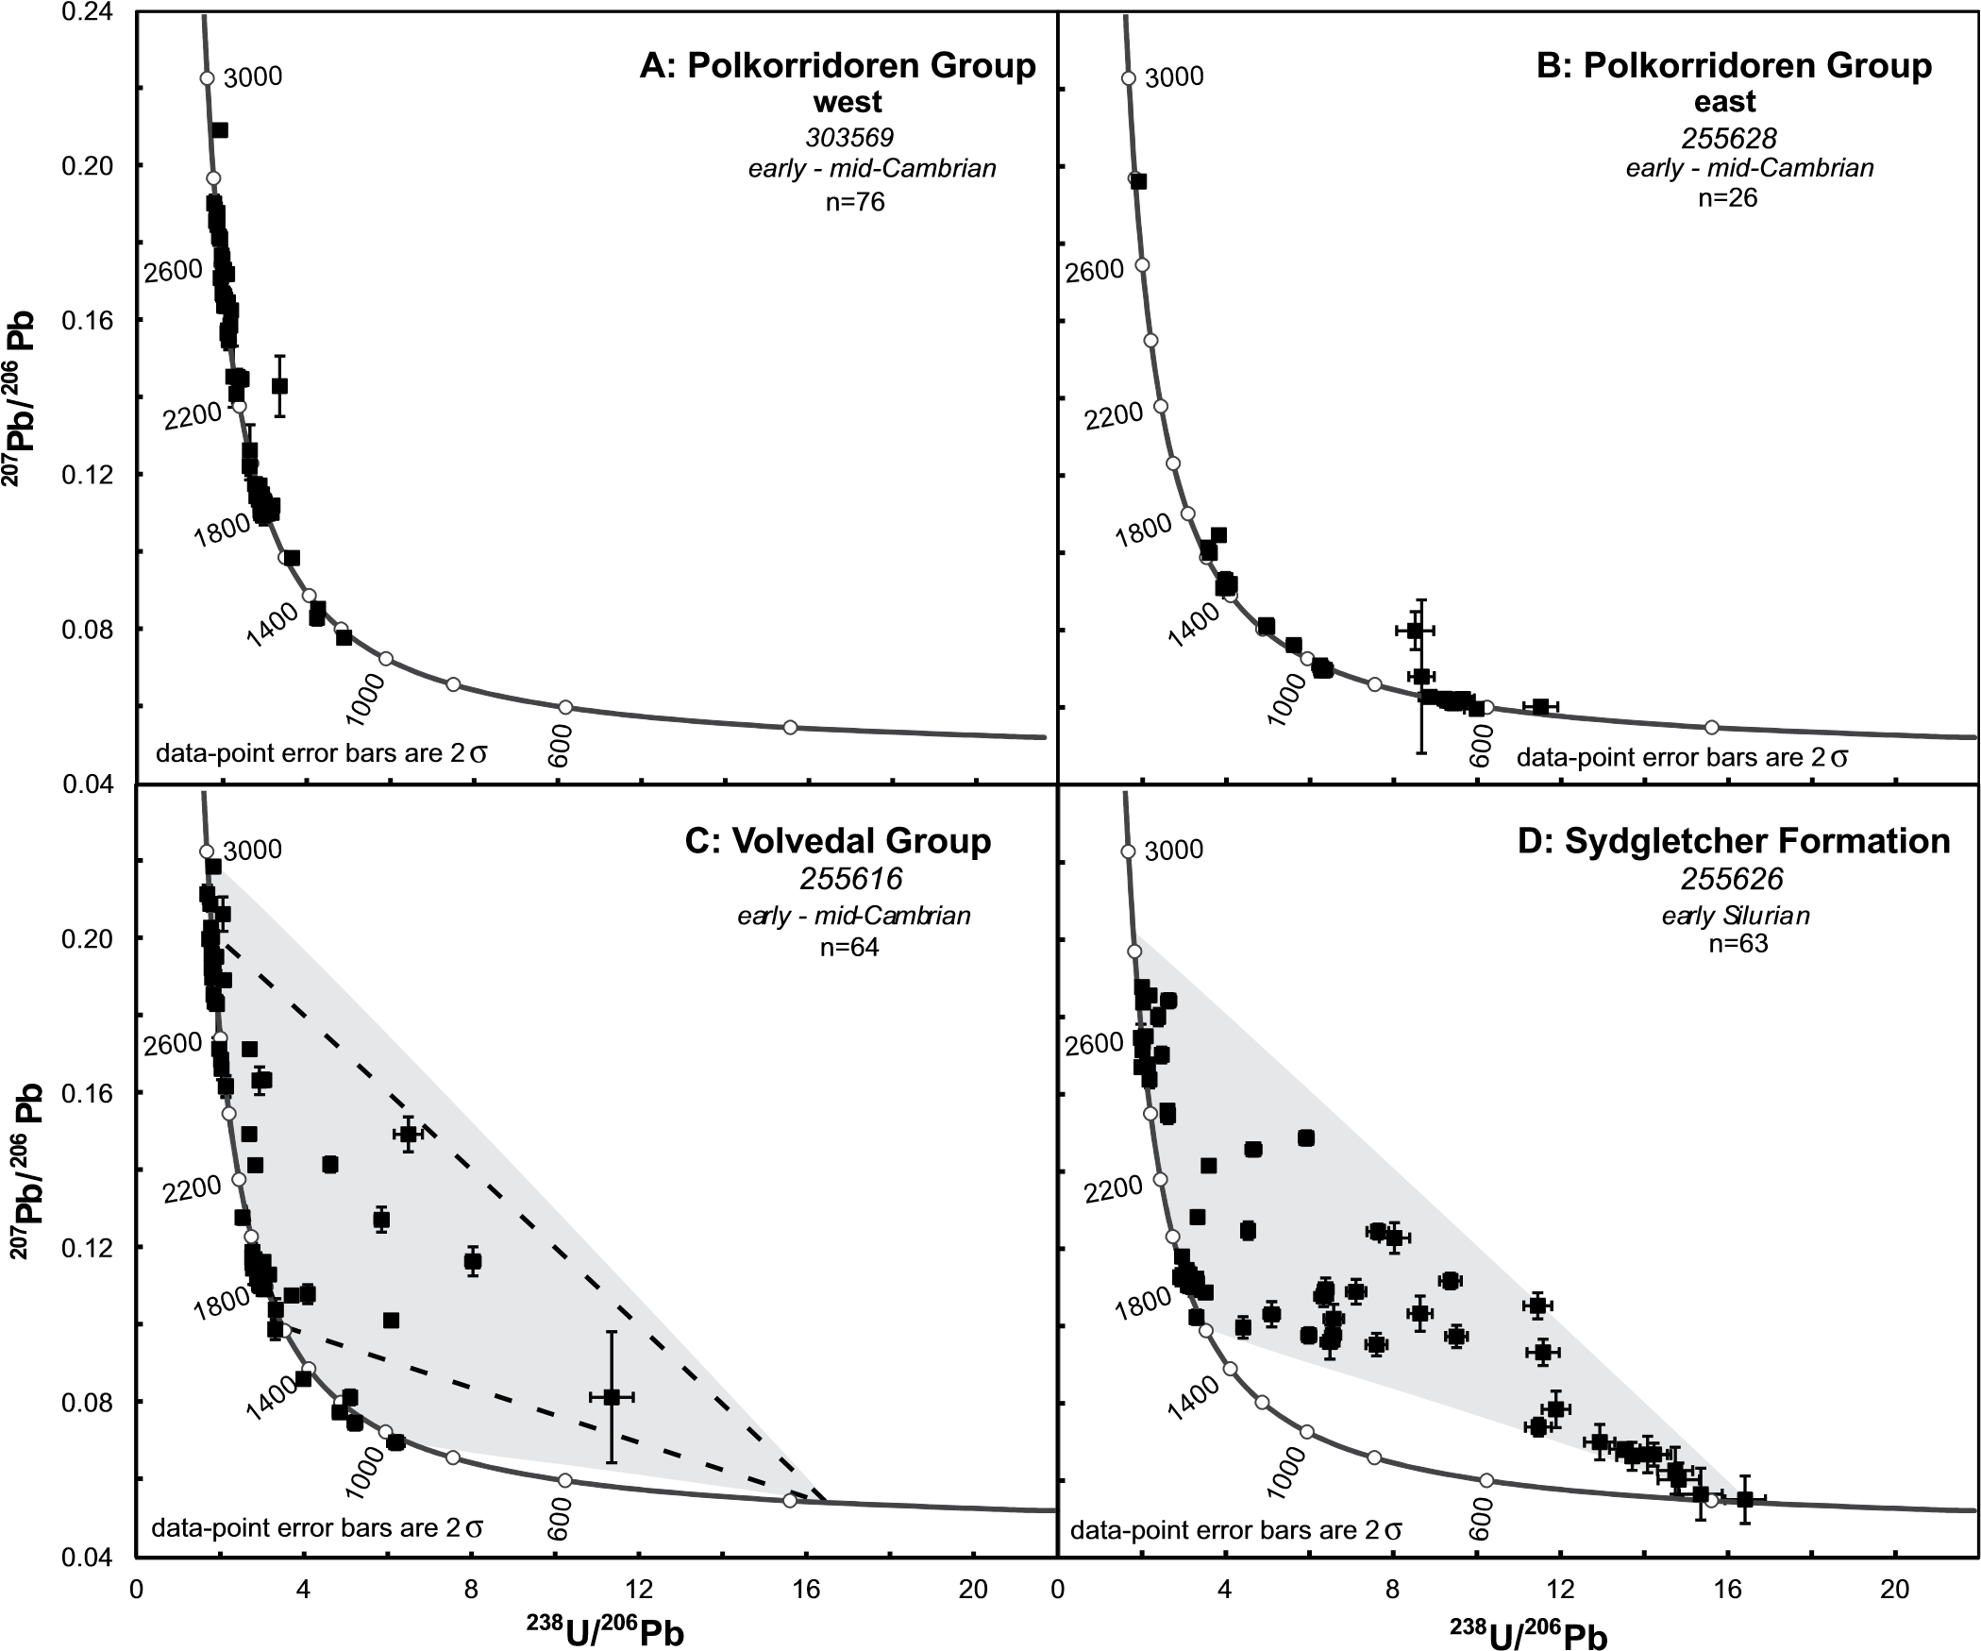

**Figure 3. 207Pb/206Pb vs. 238Pb/206Pb Tera-Wasserburg plots for northern Greenland sediments. Arrays of discordant data in C and D are shaded gray, while the area defined by discordant data in D is indicated by a dashed line in C for reference.**

The youngest 238U/206Pb concordant age in the Sydgletcher Formation is 381 Ma. We present a novel modeling method to support the timing of radiogenic-Pb loss. We model the age of the discordant population, assuming Pb loss at different times, and statistically compare the model age spectra to that of the concordant population. We know the position of the discordant data in concordia space, we assume a time of Pb loss, and then we calculate the upper intercept, which, assuming a single time of Pb loss, reflects a model age that can be used to compare with the concordant population. We repeat this process for every possible time of radiogenic-Pb loss, producing a range of upper-intercept ages for the discordant population (Fig. 5). We then compare each modeled discordant population, assuming a time of Pb loss, with the concordant population to see which modeled population is most similar to the concordant population. We consider the greatest similarity between modeled population and concordant population, for a specific time of Pb loss, to reflect the most likely time of Pb loss. This modeling assumes that the discordant population is derived from a similar geological province with similar zircon age structure to the concordant zircon population. The Kolmogorov-Smirnov (K-S) statistic is used as a means to judge the best similarity been model age (discordant data) and concordant populations over a range of radiogenic-Pb loss times for sample 255626. The K-S statistic is widely used to test the null hypothesis that two distributions come from the same population, where high *P* values reflect similar spectra (Press et al., 1992). We assume radiogenicPb loss at various times between 600 Ma and 100 Ma, covering a multitude of different possibilities, including both the depositional and inferred fluid-flow time. The statistically closest similarity between concordant and discordant populations is observed at ca. 380–390 Ma, i.e., significantly later than 450 Ma, the depositional age of the unit (Fig. 6). The probability of dissimilarity rapidly rises away from this time.

The absence of discordance in samples from the older underlying Polkorridoren Group argues for a stratigraphically confined, and therefore probably fluid-based, event rather than a regional thermal event causing the partial to total radiogenic-Pb loss. In northern Green-

MORRIS ET AL.

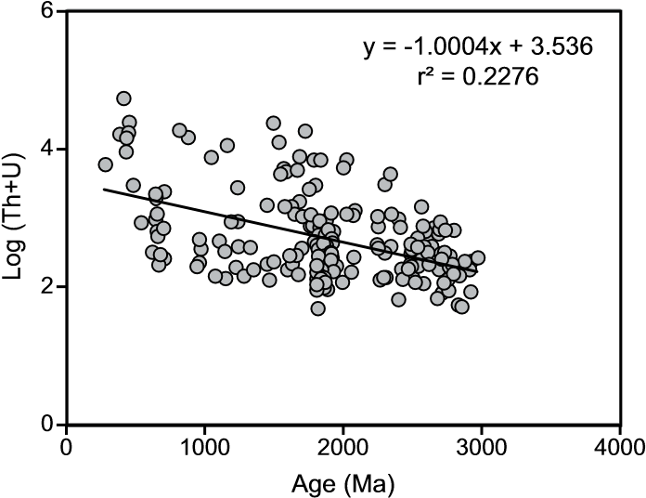

**Figure 4. Age vs. log Th + U for all age data presented in this paper. A best-fit linear regression is shown.**

land, numerous quartz-calcite–dominated vein systems cut the Neoproterozoic to Paleozoic sediments, indicating that a major fluid event(s) took place in the region. Coupled with the stratigraphically restricted nature of discordance, this suggests that lateral fluid flow caused alteration in Vølvedal Group and Sydgletcher Formation zircon crystals. While such studies are rare in the high Arctic region, evidence does exist for fluid flow at this time in the region. To the west, in the Canadian Arctic Islands, there is evidence for Early Silurian to Late Devonian fluid flow similar in age to that reported here for Greenland. Denyszyn et al. (2009) reported fluid flow as a mechanism for resetting the paleomagnetic signal in preferentially aligned Neoproterozoic Franklin dikes. Vug and Mississippi Valley–type deposit formation have been linked to long-distance shallow fluid flow (e.g., Morris and Nesbitt, 1998). On Little Cornwallis Island, a Rb-Sr sphalerite date of 366 ± 15 Ma is reported for the Polaris Mississippi Valley–type Pb-Zn deposit, along with a Re-Os bitumen date of 374 ± 9 Ma for late-stage vug-filling hydrocarbons at the same location (Selby et al., 2005). Both dates lie within uncertainty of the Devonian zircon within the Early Silurian Sydgletcher Formation.

Discordance patterns in both Vølvedal Group and Sydgletcher Formation zircons converge toward a lower concordia intercept at 381 Ma. One concordant analysis from the Sydgletcher Formation yields an age of 381 ± 5 Ma. This date is younger than its Early Silurian host, implying radiogenic-Pb loss in the Middle Devonian. We propose that the mechanism for alteration of detrital zircon grains, in the Vølvedal Group and Sydgletcher Formation, was orogenic fluid flow associated with Caledonian orogenesis as disturbance is significantly later than deposition. An alternative to fluid flow driven by the impingement of the Caledonian orogen could be a fluid

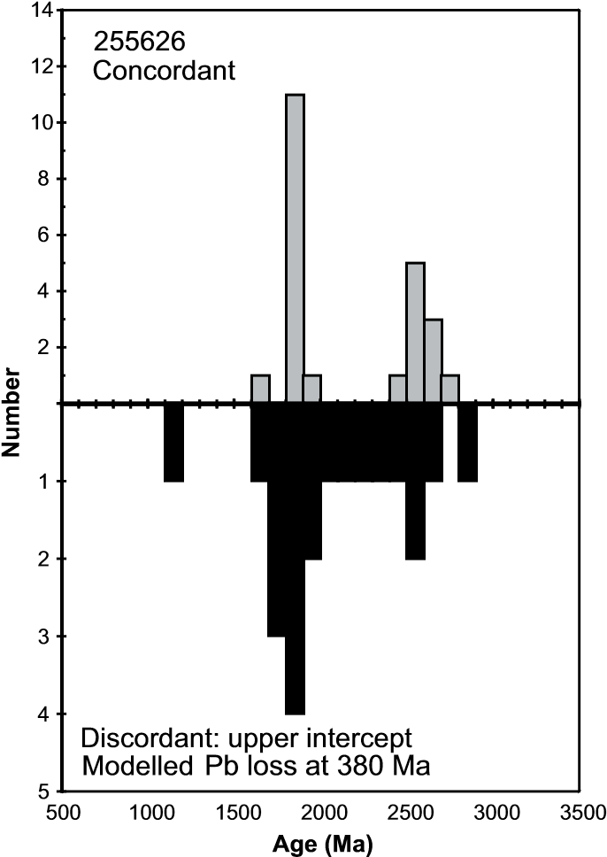

**Figure 5. Histograms showing (upper) age of concordant detrital zircon population from sample 255626 and (lower) upper-intercept age of discordant population modeled by assuming radiogenic-Pb loss at 380 Ma. The 380 Ma time of Pb loss results in the closest age spectrum similarity to the concordant population.**

event associated with uplift and exhumation due to north-south compression in the Late Devonian–early Carboniferous Ellesmerian orogeny (Soper and Higgins, 1991).

Orogenic-driven fluid flow is recognized in many foreland basins and has been invoked as a mechanism for processes including porosity enhancement by dissolution or occlusion by cementation, and concentration of metal ores and hydrocarbons (e.g., Morris and Nesbitt, 1998). Proposed fluid sources include a combination of orogenic uplift (gravity)–driven meteoric groundwater, tectonic-driven dewatering, and mineral dehydration metamorphic sources (e.g., Garven, 1985; Oliver, 1986; Nesbitt and Muehlenbachs, 1994; Craw et al., 2002; Mark et al., 2007). Sulfur isotopes indicate latestage fluid flow during the Variscan orogeny in the northern Rhenish Massif, Germany, at 200 °C (Wagner and Boyce, 2003), dropping to 100 °C in regional dolomitization events in SE Ireland, 170 km in advance of the orogenic front (Hitzman et al., 1998). Similar events are reported in foreland regions of many fold-andthrust belts, including the Rocky and MacKenzie Mountains of Canada (e.g., Morris and Nesbitt, 1998) and northern Victoria Land, Antarctica (Rossetti et al., 2006), indicating the ubiquity of major fluid events moving far in advance of orogenic fronts. Many fluid events show strong

Probability

Age of Pb loss (Ma)

0

200

400

600

800

0.0

0.1

0.2

0.3

0.4

0.5

0.6

0.7

**Figure 6. Probability (*P* value) of dissimilarity between concordant and discordant detrital zircon populations vs. radiogenicPb loss times. Larger *P* values reflect more alike detrital zircon spectra. Gray vertical bar reflects time of fluid-flow event.**

stratigraphic control, where fluid flow is concentrated in more permeable layers (or layers rheologically more susceptible to fracturing). In northern Greenland, the Caledonian orogen impinges on Peary Land, some 100 km east of the Vølvedal Group and Sydgletcher Formation sample sites (Fig. 1).

|  |
| --- |
| www.gsapubs.org | Volume 7 | Number 2 | LITHOSPHERE |

While the focus of this paper is on discordant zircons, mention should be made of the populations of concordant detrital zircons in these samples (Fig. DR1 [see footnote 1]). The Polkorridoren Group sample from eastern Johannus Jenson Land predominantly contains zircons younger than 1650 Ma, with an almost complete lack of any older zircons, consistent with the inferred lack of sediment reworking, since, for example, significant populations ≤2 Ga are present in nearby older sediments (Kirkland et al., 2009). Potential ca. 1650 Ma sources are found in the Makkovik Province in Labrador, Canada (Kerr et al., 1996). By contrast, the overlying Vølvedal Group and Sydgletcher Formation, and the sample mapped as Polkorridoren Group from western Johannus Jenson are dominated by age peaks of 1800–1910 Ma and 2500–2700 Ma. These detrital ages are ubiquitous throughout the North Atlantic region (e.g., Whitehouse et al., 1997), and many potential source regions are found in western Greenland and the northwest Canadian Shield, as well as within the Caledonian orogen to the east (Thrane, 2002; Hartlaub et al., 2005). The contrast between the eastern Polkorridoren Group sample and the stratigraphically equivalent western sample is particularly striking and suggests that detritus was either derived from different sources and/ or that these clastic rocks do not both belong to the Polkorridoren Group.

# CONCLUSION

Altered and discordant zircons are routinely ignored during detrital zircon studies, but this study shows that when sufficient data are collected, such grains can yield important information regarding their postdepositional history. Evaluation of these samples in a spatial context implies fluid-flow events far beyond the Caledonian deformation front. In a temporal context, the stratigraphically higher samples indicate a focusing of discordant data toward ca. 380 Ma and demonstrate that careful study of all components from a detrital zircon population can provide control on the timing of fluid-flow events.

## **ACKNOWLEDGMENTS**

Tony Higgins and the Geologiske Undersøgelser for Danmark og Grønland (GEUS) are thanked for the samples used in this study. Constructive reviews from Owen Anfinson and Ian Williams, as well as two anonymous reviewers on an earlier version of this manuscript, are gratefully acknowledged. Funding from the Swedish Research Council is acknowledged. NORDSIM is operated and financed under an arrangement with the Nordic Research Council (NOS-N) and the Swedish Museum of Natural History. This is NORDSIM publication number 392.

## **REFERENCES CITED**

Andersen, T., 2005, Detrital zircons as tracers of sedimentary provenance: Limiting conditions from statistics and numerical simulation: Chemical Geology, v. 216, p. 249–270, doi:10.1016/j.chemgeo.2004.11.013.

Bowring, S.A., and Williams, I.S., 1999, Priscoan (4.00–4.03 Ga) orthogneisses from northwestern Canada: Contributions to Mineralogy and Petrology, v. 134, p. 3–16, doi:10.1007 /s004100050465.

Craw, D., Koons, P.O., Horton, T., and Chamberlin, C.P., 2002, Tectonically driven fluid flow and gold mineralisation in active collisional orogenic belts: Comparison between New Zealand and western Himalaya: Tectonophysics, v. 348, p. 135–153, doi:10.1016/S0040-1951(01)00253-0.

Dickinson, W.R., and Gehrels, G.E., 2008, Sediment delivery to the Cordilleran foreland basin; insights from U-Pb ages of detrital zircons in Upper Jurassic and Cretaceous strata of the Colorado Plateau: American Journal of Science, v. 308, p. 1041–1082.

Denyszyn, S.W., Davis, D.W., and Halls, H.C., 2009, Paleomagnetism and U-Pb geochronology of the Clarence Head dykes, Arctic Canada: Orthogonal emplacement of mafic dykes in a large igneous province: Canadian Journal of Earth Sciences, v. 46, p. 155–167, doi:10.1139 /E09-011.

Garven, G., 1985, The role of regional fluid flow in the genesis of the Pine Point deposit, Western Canada sedimentary basin: Economic Geology and the Bulletin of the Society of Economic Geologists, v. 80, p. 307–324, doi: 10.2113 /gsecongeo.80.2.307.

Gee, D.G., Fossen, H., Henriksen, N., and Higgins, A.K., 2008, From the Early Proterozoic of Baltica and Laurentia to the Caledonian orogen of Scandinavia and Greenland: Episodes, v. 31, no. 1, p. 44–51.

Gehrels, G., 2012, Detrital zircon U-Pb geochronology: Current methods and new opportunities, *in* Busby, C., and Azor, A., eds., Recent Advances in Tectonics of Sedimentary Basins: Chichester, Wiley-Blackwell Publishing, p. 47–62.

Geisler, T., Schaltegger, U., and Tomaschek, F., 2007, Re-equilibration of zircon in aqueous fluids and melts: Elements, v. 3, p. 43–50, doi:10.2113/gselements.3.1.43.

Hartlaub, R.P., Chako, T., Heaman, L.M., Creaser, R.A., Ashton,

K.E., and Simonetti, A., 2005, Ancient (Meso- and Paleoarchean) crust in the Rae Province, Canada: Evidence from Sm-Nd and U-Pb constraints: Precambrian Research, v. 141, p. 137–153, doi:10.1016/j.precamres .2005 .09.001.

Higgins, A.K., Ineson, J.R., Peel, J.S., Surlyk, F., and Soderholm, M., 1991, Cambrian to Silurian basin development and sedimentation, North Greenland, *in* Trettin, H.P., ed., Geology of the Innuitian Orogen and Arctic Platform of Canada and Greenland: Geological Survey of Canada, Geology of Canada, v. 3, p. 111–161.

Higgins, A.K., Soper, N.J., Smith, M.P., and Rasmussen, J.A., 2004, The Caledonian parautochthonous fold and thrust belt of Kronprins Christian Land, eastern North Greenland: Geology of Greenland Survey Bulletin, v. 6, p. 57–66.

Hitzman, M.W., Allan, J.R., and Beaty, D.W., 1998, Regional dolomitization of the Waulsortian limestone in southeastern Ireland: Evidence of large-scale fluid flow driven by the Hercynian orogeny: Geology, v. 26, p. 547–550, doi: 10.1130 /0091 -7613(1998)026<0547:RDOTWL>2.3.CO;2.

Hurst, J.M. and Surlyk, F. 1982, Stratigraphy of the Silurian turbidite sequence of Northern Greenland: Grønlands Geologiske Undersøgelse Bulletin 145, 121 p.

Kerr, A., Ryan, A.B., Gower, C.F., and Wardle, R.J., 1996, The Makkovik Province: Extension of the Ketilidian mobile belt in mainland North America, *in* Brewer, T.S., ed., Precambrian Crustal Evolution in the North Atlantic Region: Geological Society of London Special Publication 112, p. 155–177.

Kirkland, C.L., Daly, J.S., and Whitehouse, M.J., 2008, Basement-cover relationships of the Kalak nappe complex, Arctic Norwegian Caledonides, and constraints on Neoproterozoic terrane assembly in the northern Atlantic region: Precambrian Research, v. 160, p. 245–276, doi: 10.1016 /j .precamres.2007.07.006.

Kirkland, C.L., Pease, V., Whitehouse, M.J., and Ineson, J.R., 2009, Provenance record from Mesoproterozoic–Cambrian sediments of Peary Land, northern Greenland: Implications for the ice-covered Greenland Shield and Laurentian palaeogeography: Precambrian Research, v. 170, p. 43–60, doi:10.1016/j.precamres.2008.11.006.

Kramers, J., Frei, R., Newville, M., Kober, B., and Villa, I., 2009, On the valency state of radiogenic lead in zircon and its consequences: Chemical Geology, v. 261, p. 4–11, doi:10.1016/j.chemgeo.2008.09.010.

Larson, S.Å., and Tullborg, E.L., 1998, Why Baltic Shield zircons yield late Paleozoic, lower intercept ages on U-Pb concordia: Geology, v. 26, p. 919–922, doi:10.1130/0091 -7613 (1998)026<0919:WBSZYL>2.3.CO;2.

Mark, D.F., Parnell, J., Kelley, S.P., and Sherlock, S.C., 2007, Resolution of regional fluid flow related to successive orogenic events on the Laurentian margin: Geology, v. 35, p. 547–550, doi:10.1130/G23388A.1.

Morris, G.A., and Nesbitt, B.E., 1998, Geology and timing of palaeohydrogeological events in the MacKenzie Mountains, Northwest Territories, Canada, *in* Parnell, J., ed., Dating and Duration of Fluid Flow and Fluid-Rock Interactions: Geological Society of London Special Publication 144, p. 161–172.

Murakami, T., Chakoumakos, B.C., Ewing, R.C., Lumpkin, G.R., and Weber, W.J., 1991, Alpha-decay event damage in zircon: The American Mineralogist, v. 76, p. 1510–1532.

Nesbitt, B.E., and Muehlenbachs, K., 1994, Paleohydrogeology of the Canadian Rockies and the origins of brines, Pb-Zn deposits and dolomitization in the Western Canadian sedimentary basin: Geology, v. 22, p. 243–246, doi: 10.1130 /0091 -7613 (1994)022<0243:POTCRA>2.3.CO;2.

Oliver, J., 1986, Fluids expelled tectonically from orogenic belts: Their role in hydrocarbon migration and other geologic phenomena: Geology, v. 14, p. 99–102, doi: 10.1130 /0091 -7613(1986)14<99:FETFOB>2.0.CO;2.

Press, W.H., Flannery, B.P., Teukolsky, S.A., and Vetterling, W.T., 1992, Numerical Recipes in C: The Art of Scientific Computing: Cambridge, UK, Cambridge University Press, 994 p.

Rainbird, R.H., Heaman, L.M., and Young, G., 1992, Sampling Laurentia: Detrital zircon geochronology offers evidence for an extensive Neoproterozoic river system originating from the Grenville orogen: Geology, v. 20,

p. 351–354, doi:10.1130/0091-7613(1992)020<0351 :SLDZGO >2.3.CO;2.

Rossetti, F., Tecce, F., Aldega, L., Brilli, M., and Faccenna, C., 2006, Deformation and fluid flow during orogeny at the palaeo-Pacific active margin of Gondwana: The early Palaeozoic Robertson Bay accretionary complex (north Victoria Land, Antarctica): Journal of Metamorphic Geology, v. 24, p. 33–53, doi:10.1111/j.1525- 1314.2005 .00620 .x.

Selby, D., Creaser, R.A., Dewing, K., and Fowler, M., 2005, Evaluation of bitumen as a 187Re-187Os geochronometer for hydrocarbon maturation and migration: A test case from the Polaris MVT deposit, Canada: Earth and Planetary Science Letters, v. 235, p. 1–15, doi:10.1016/j .epsl .2005.02.018.

Sircombe, K.N., and Stern, R.A., 2002, An investigation of artificial biasing in detrital zircon U-Pb geochronology due to magnetic separation in sample preparation: Geochimica et Cosmochimica Acta, v. 66, p. 2379–2397, doi: 10.1016 /S0016 -7037(02)00839-6.

Soper, N.J., and Higgins, A.K., 1991, Devonian–early Carboniferous deformation and metamorphism, northern Greenland, *in* Trettin, H.P., ed., Geology of the Innuitian Orogen and Arctic Platform of Canada and Greenland: Geological Survey of Canada, Geology of Canada, v. 3, p. 281–288.

Stacey, J.S., and Kramers, J.D., 1975, Approximation of terrestrial lead isotope evolution by a two-stage model: Earth and Planetary Science Letters, v. 26, p. 207–221, doi: 10.1016 /0012 -821X (75)90088-6.

Stern, R.A., and Bleeker, W., 1998, Age of the world’s oldest rocks refined using Canada’s SHRIMP: The Acasta gneiss complex, Northwest Territories, Canada: Geoscience Canada, v. 25, p. 27–31.

Stern, T.W., Goldich, S.S., and Newell, M.F., 1966, Effects of weathering on the U/Pb ages of zircons from the Morton Gneiss, Minnesota: Earth and Planetary Science Letters, v. 1, p. 369–371, doi:10.1016/0012-821X(66)90027-6.

Surlyk, F., and Hurst, J.M., 1984, The evolution of the early Paleozoic deep-water basin of North Greenland: Geological Society of America Bulletin, v. 95, p. 131–154, doi:10.1130/0016-7606(1984)95<131:TEOTEP>2.0.CO;2.

Surlyk, F., Hurst, J.M., and Bjerreskov, M., 1980, First agediagnostic fossils from the central part of the North Greenland foldbelt: Nature, v. 286, p. 800–803, doi:

10.1038 /286800a0.

Thrane, K., 2002, Relationships between Archaean and Palaeoproterozoic crystalline basement complexes in the southern part of the East Greenland Caledonides: An ion microprobe study: Precambrian Research, v. 113, p. 19–42, doi:10.1016/S0301-9268(01)00198-X.

Trettin, H.P., Mayer, U., Long, G.D.F., and Packard, J.J., 1991, Cambrian to Early Devonian basin development, sedimentation, and volcanism, Arctic Islands, *in* Trettin, H.P., ed., Geology of the Innuitian Orogen and Arctic Platform of Canada and Greenland: Geological Survey of Canada, Geology of Canada, v. 3, p. 165–238.

Wagner, T., and Boyce, A.J., 2003, Sulphur isotope geochemistry of black shale–hosted antimony mineralization, Arnsberg, northern Rhenish Massif, Germany: Implications for late-stage fluid flow during the Variscan orogeny: Journal of the Geological Society of London, v. 160, p. 299–308, doi:10.1144/0016-764902-010.

Whitehouse, M.J., Claesson, S., Sunde, T., and Vestin, J., 1997, Ion microprobe U-Pb zircon geochronology and correlation of Archaean gneisses from the Lewisian complex of Gruinard, north-western Scotland: Geochimica et Cosmochimica Acta, v. 61, p. 4429–4438, doi:10.1016 /S0016 -7037 (97) 00251-2.

Wilde, S.A., Valley, J.W., Peck, W.H., and Graham, C.M., 2001, Evidence from detrital zircons for the existence of continental crust and oceans on the Earth 4.4 Gyr ago: Nature, v. 409, p. 175–178, doi:10.1038/35051550.

MANUSCRIPT RECEIVED 11 SEPTEMBER 2014

REVISED MANUSCRIPT RECEIVED 15 DECEMBER 2014

MANUSCRIPT ACCEPTED 12 JANUARY 2015

Printed in the USA

1. GSA Data Repository Item 2015078, U-Th-Pb ion-micro probe analytical data, is available at www .geosociety.org/pubs/ft2015.htm, or on request from editing@geosociety.org, Documents Secretary, GSA, P.O. Box 9140, Boulder, CO 80301-9140, USA.