**THE EFFECT OF STYLOLITE SPACING ON QUARTZ CEMENTATION IN THE LOWER JURASSIC STØ FORMATION, SOUTHERN BARENTS SEA**

OLAV WALDERHAUG AND PER ARNE BJØRKUM

*Statoil ASA N-4035 Stavanger, Norway e-mail: OWALD@statoil.com*

**ABSTRACT: The shallow marine Lower Jurassic quartz arenites of the Stø Formation in the southern Barents Sea comprise (1) intervals where dispersed detrital clay is absent, and where the spacing between clay-rich laminae that evolved into stylolites upon burial is exceptionally large, up to several meters, and (2) intervals where minor detrital clay matrix occurs, clay laminae are very common, and stylolite spacing is typically less than a centimeter. Point counting of thin sections and cathodoluminescence micrographs shows that quartz cement contents are far lower in the intervals where stylolite spacing is exceptionally large, 4–11%, versus 10–20% outside these intervals. There is also a correlation between distance to nearest stylolite and volume of quartz cement. Samples located a centimeter or less from a stylolite contain 10–20% quartz overgrowths, for distances of 3–20 cm quartz cement content is 4–10%, and only 3–8% when the closest stylolite is more than 20 cm distant. Modeling of quartz cementation with the Exemplar**y **diagenetic modeling program indicates that the observed trend of decreasing quartz cement abundance outwards from stylolites is not caused by variations in grain size, degree of grain coating, or content of quartz grains, i.e., the trend is not due to more quartz surface area being available for overgrowth formation close to stylolites. On the contrary, the modeling suggests that the samples situated more than 20 cm from stylolites contain 5–8% less quartz cement than what would have been the case given a more normal stylolite abundance. This study indicates that sandstones with exceptionally few clay-rich or micaceous laminae and without clay or mica at individual grain contacts will be significantly less quartz cemented and more porous than other sandstones with similar temperature histories. However, such sandstones seem to be highly unusual on the Norwegian continental shelf. This suggests that exceptionally low abundance of stylolite precursors may be of only local importance for preserving reservoir quality at elevated temperatures, and that it is normally not necessary to include stylolite spacing and distance to the nearest stylolite as variables in quantitative models of quartz cementation.**

# INTRODUCTION

Quartz cement is the dominant diagenetic mineral and the main control on reservoir quality in deeply buried quartz-rich sandstones in many basins (Blatt 1979; Land and Fisher 1987; McBride 1989; Bloch et al. 1990; Ehrenberg 1990), but there is still not a general consensus regarding sources of quartz cement and mechanisms of quartz cementation (McBride 1989; Worden and Morad 2000). Some workers favor transport of dissolved silica into sandstones from external sources (Riches et al. 1986; Burley et al. 1989; Land and Milliken 2000), whereas others regard the extent of fluid flow required for transporting significant amounts of dissolved silica as prohibitive, and favor internal sources of quartz cement (Bjørlykke 1980; Walderhaug 1994; Bjørkum et al. 1998). Among possible internal sources, the most commonly cited are dissolution of quartz grains at stylolites (Heald 1955; Sibley and Blatt 1976; Olaussen et al. 1984; Bjørlykke et al. 1986) or individual grain contacts (Waldschmidt 1941; Lowry 1956; Sibley and Blatt 1976; Houseknecht 1988). Whether dissolution at stylolites and grain contacts is a pressure-solution process where dissolution rate is a function of the stress on the grain contacts (Weyl 1959; Dewers and Ortoleva 1990; Mullis 1991) or rather a pressure-insensitive process where

JOURNAL OF SEDIMENTARY RESEARCH, VOL. 73, NO. 2, MARCH, 2003, P. 146–156

Copyright q 2003, SEPM (Society for Sedimentary Geology) 1527-1404/03/073-146/$03.00

quartz dissolution is a result of the catalytic effect of the clay or mica at the contacts (Bjørkum 1996; Oelkers et al. 1996; Walderhaug 1996) is also a matter of continuing debate.

Several recent quantitative models of closed-system quartz cementation consider the total quartz cementation process to comprise three steps: (1) dissolution of quartz at stylolites or individual grain contacts containing clay or mica, (2) short-range diffusion (millimeters–centimeters) of silica, and (3) precipitation of dissolved silica as quartz overgrowths on quartz grain surfaces. The models either model all three steps of the process (Oelkers et al. 1996; Bjørkum et al. 1998) or assume that the precipitation step is rate-limiting and therefore model only the precipitation step (Walderhaug 1996; Lander and Walderhaug 1999). One of the simplifications resulting from assuming precipitation rate control is that the spacing between stylolites and distance to nearest stylolite are not necessary input parameters when calculating quartz cementation in a sample. In other words, the decrease of silica supersaturation and reduction of quartz precipitation rate per unit surface area outwards from stylolites are assumed to be so small that they can be ignored, and silica supersaturation is assumed not to reach significantly higher values between closely spaced stylolites compared to between stylolites with greater separation. These assumptions have been shown to be valid for typical sandstones from the Norwegian shelf (Walderhaug 2000; Walderhaug et al. 2000) and from the Gulf of Mexico and the Baltic (Lander and Walderhaug 1999). However, as stylolite spacing increases and reaches unusually large values, the simplified closed-system quartz cementation models become less accurate and overpredict quartz cementation, especially far from stylolites. This study attempts to determine the effect of stylolite spacing and distance to nearest stylolite on quartz cementation by measuring volumes of quartz cement as a function of these two parameters, and also compares the measurements with quartz cement volumes calculated on the basis of assumed precipitation rate control. The Stø Formation cores from well 7120/6-1 in the Norwegian sector of the Barents Sea are exceptionally well suited for this study because they contain intervals of unusually clean sandstone where stylolite spacings reach several meters.

# GEOLOGICAL SETTING

Well 7120/6-1 is located in the Hammerfest Basin in the southern part of the Barents Sea approximately 150 km northwest of Hammerfest in northern Norway (Fig. 1). The Lower Jurassic Stø Formation is 84 m thick in well 7120/6-1 and comprises very fine-, fine-, and medium-grained sandstones plus a few thin intervals of shale, and conglomeratic sandstone and phosphate nodule lag deposits (Fig. 2). The sandstones are shallow marine and include strongly bioturbated intervals deposited in a lower-shoreface setting, cross-bedded upper-shoreface sandstones, and a thick interval of extremely clean and largely structureless sandstones which has been considered to be a possible tidal bar complex (Bjørgen 1985), or possibly a delta mouth bar.

|  |
| --- |
| FIG. 1.—Location of wells 7120/6-1 and 7120/ 9-1 and the Snøhvit Field. |

The top of the Stø Formation is located at 2386 mRKB (meters below the rotary table) corresponding to 2049 m below the sea floor. However, as is typically the case in the Hammerfest Basin, Paleocene sediments are overlain by Pleistocene deposits in well 7120/6-1, probably reflecting largescale Tertiary erosion and uplift (Berglund et al. 1986; Nyland et al. 1992). The incomplete Upper Cretaceous stratigraphy suggests that erosional events may also have occurred during this period. The Stø Formation is presently overlain by Oxfordian shales deposited in an offshore setting, and conformably overlies the interbedded lower-delta-plain sandstones, siltstones, and shales of the Lower Jurassic Nordmela Formation.

Samples were taken from the depth range 2397.70–2468.02 mRKB or 2060.70–2131.02 m below the sea floor. Present temperature at 2398 mRKB is approximately 848C. The Stø Formation in well 7120/6-1 is gasfilled from the top down to 2425.8 mRKB and oil-filled from this level down to 2440.3 mRKB. There is no significant overpressure in the water phase today, although overpressures may have been present prior to uplift.

# METHODS

Location of stylolites was determined by visual inspection of slabbed cores. Twenty-five samples were taken from the cores, and their distances from the nearest stylolite above and below each sample recorded. When a thin section contained one of the stylolites, the distance to the nearest stylolite was set to 1 cm. All stylolites appear to have evolved from primary clay-rich, and in some cases micaceous or organic matter-rich, laminae. They are macroscopically visible with thicknesses on the order of a millimeter, and have typical amplitudes between 5 mm and less than a millimetre (Fig. 3). All clay-rich laminae within the cores have evolved into stylolites; we did not find clay-rich laminae where we could not detect evidence of quartz dissolution at their boundaries. The large stylolite spacings recorded for part of the Stø Formation are therefore not an artefact caused by disregarding, for instance, low-amplitude stylolites.

A polished thin section was made from each sample, and all thin sections were examined with a petrographic microscope and point counted twice with five hundred points per point count. Modal compositions listed in Table 1 are the average results from the two point counts. Grain size was determined by measuring the long axis of fifty quartz grains per sample and calculating the mean long-axis length for each sample. Sorting was defined as the sample standard deviation of the long axis measurements.

Percentage of quartz grain surfaces coated by clay and other substances was determined by estimating the coated percentage of the grain perimeter for the same fifty grains used for grain-size determination, and then calculating the average coating percentage for each sample. Point-counted quartz cement volumes were checked by taking three or four cathodoluminescence (5 CL) micrographs of each sample with a Technosyn MK II cold cathode CL unit mounted on a Nikon Optiphot microscope and then point counting the photographs with a transparent grid. The number of points counted per photograph varied from 240 to 300 and from 760 to 1140 per sample. A 103 objective was used, resulting in an area of 0.8 mm2 being represented on each 10 cm by 15 cm color print.

The Stø Formation was derived at least partly from older quartz-cemented sandstones, and the quartz cement volumes determined by point counting therefore have to be corrected for the presence of recycled overgrowths. The volume of recycled overgrowths can be estimated by determining the volume of quartz overgrowths present in intervals pervasively cemented by early calcite cement precipitated prior to quartz cementation. However, because calcite cemented intervals are absent in 7120/6-1, this correction was based on data from a previous study of the Stø Formation in well 7120/9-1 (Walderhaug 1985) located approximately 10 km south of 7120/6-1 (Fig. 1).

The samples 2449.70, 2451.25, and 2452.75 were also examined with an SEM for the presence of thin clay films at grain contacts, because such thin clay films may promote quartz dissolution but be practically invisible with a normal petrographic microscope (see Bjørkum 1996). The analyses included backscatter electron imaging and element mapping of Al, K, Si, and Fe at approximately ten grain contacts per sample.

Homogenization temperatures for fifty-seven aqueous fluid inclusions in quartz overgrowths were measured in samples 2449.20, 2449.70, 2451.25, and 2452.75 using the procedures and equipment described in Walderhaug (1994). Fluorescence microscopy shows that no hydrocarbon inclusions are present, and CL photography was used to check that the aqueous inclusions are really located in quartz cement.

The procedures for the quartz cementation modeling are described in following sections. The conceptual and mathematical basis for the Exemplary diagenetic modeling program is discussed in Walderhaug (1996), Lander and Walderhaug (1999), and Walderhaug et al. (2000).

# PETROGRAPHIC COMPOSITION AND DIAGENETIC HISTORY

The examined samples are all quartz arenites, and detrital grains other than quartz are limited to traces of clay clasts, muscovite, biotite, plant fragments, zircon, tourmaline, rutile, apatite, spinel, monazite, and opaque iron-titanium oxides. Detrital clay matrix is present only in the samples from bioturbated intervals, and then in amounts of a few percent or less (Table 1). Quartz cement is the only volumetrically important diagenetic mineral (Fig. 4). Other diagenetic phases are restricted to traces of authigenic kaolinite, pyrite, dolomite, and in one case siderite (Table 1). Porosities are mostly close to 20% in the intervals with very few stylolites and typically 11–16% outside these intervals (Table 1).

Quartz cementation is typically insignificant at temperatures below 70– 808C on the Norwegian continental shelf and in adjoining areas (e.g., Bjørlykke et al. 1986; Ehrenberg 1990; Giles et al. 1992), suggesting that quartz cementation started at these temperatures in the Stø Formation too.

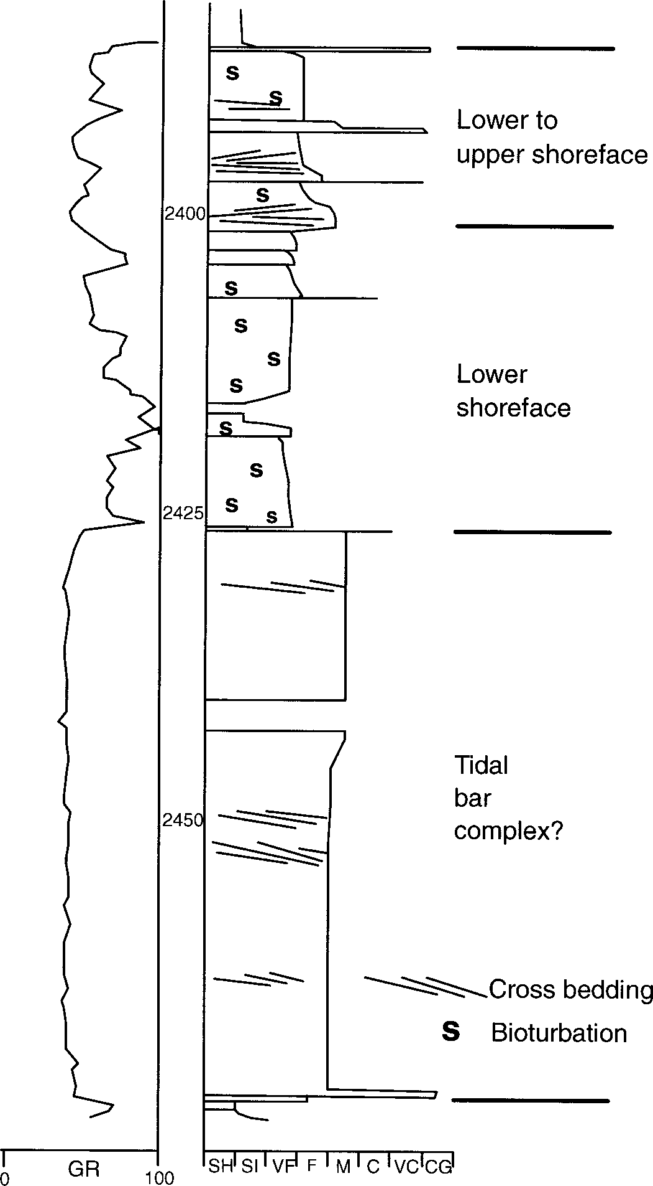

FIG. 2.—Sedimentological log and gamma ray log for the studied core interval. SH 5 shale, SI 5 siltstone, VF 5 very fine-grained sandstone, F 5 fine-grained sandstone, M 5 medium-grained sandstone, C 5 coarse-grained sandstone, VC 5 very coarse-grained sandstone, CG 5 conglomerate.

This is supported by the homogenization temperatures (5 *T*h) for the aqueous inclusions within quartz overgrowths (Fig. 5). With the exception of fifteen measurements from a single overgrowth, *T*h values are dominantly in the range 80–1068C, and the inclusions are located close to the boundaries between quartz clasts and quartz overgrowths. The somewhat rounded overgrowth containing fifteen inclusions with *T*h values between 1288C and 1588C is suspected to be recycled from an older sandstone. The *T*h values in the range 80–1068C, on the other hand, represent measurements from ten different overgrowths, suggesting that they are more representative of quartz cementation in the Stø Formation. However, it cannot be totally excluded that all *T*h measurements were performed on recycled grains, and that all *T*h values refer to temperatures of cementation in sandstones in the source area for the Stø Formation.

The only obvious internal source of quartz cement within the very clay-

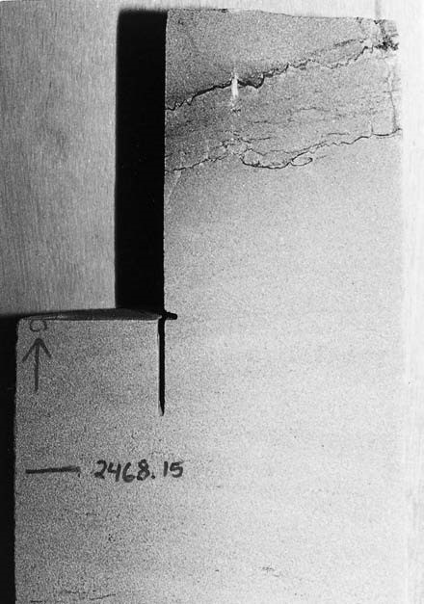

FIG. 3.—Stylolite formed from clay-rich lamina in the lower and extremely claypoor part of the Stø Formation in well 7120/6-1. Width of core is 13 cm. The upper stylolite is located at approximately 2468.00 mRKB.

poor parts of the Stø Formation is dissolution of quartz grains at stylolites evolved from clay-rich and more rarely micaceous or organic-matter-rich laminae. However, CL photographs and SEM analysis indicate that petrographically invisible clay films may have promoted minor quartz dissolution at some grain contacts within the very clean sandstones (Figs. 6, 7). Within the more clay-rich intervals, dissolution at individual grain contacts containing clay is sometimes observed without using the SEM. Other internal sources of quartz cement such as dissolution of feldspar or other non-quartz minerals are considered to be insignificant, inasmuch as no feldspar and hardly any dissolution porosity is present in these extremely quartz-rich sandstones (Table 1).

Although part of the studied interval is above the oil–water contact, the sandstones are still water-wet, and quartz cementation is therefore probably still in progress. However, the rate of quartz cementation has most likely been reduced because of uplift lowering formation temperatures.

**DISTRIBUTION OF QUARTZ CEMENT**

# Volumes of Quartz Cement

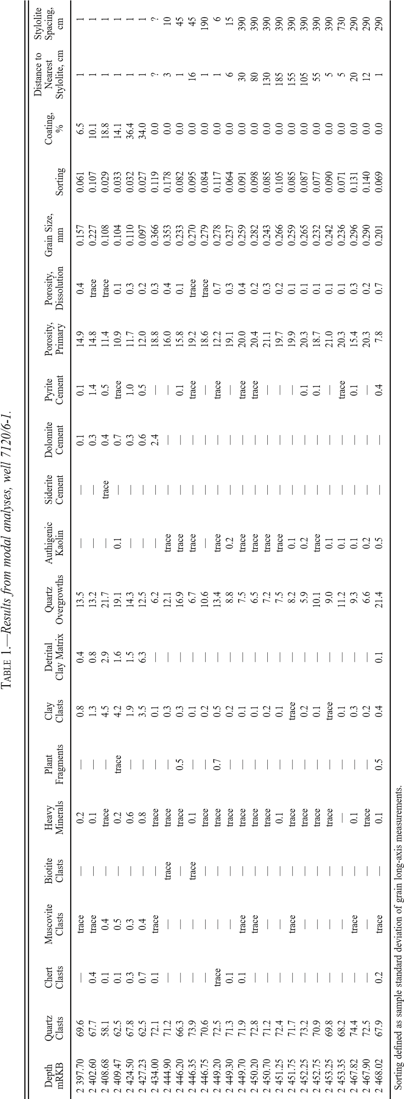The percentage of quartz cement determined by point counting thin sections and CL micrographs are quite similar (Table 2, Fig. 8), although quartz cement content varies widely from sample to sample (6–22%). These values are thought to include some inherited quartz overgrowths from older sandstones. Such inherited discontinuous and abraded overgrowths occur on some quartz grains covered by early calcite cement in the Stø Formation in the neighbouring well 7120/9-1. No such calcite cemented intervals are present in the Stø Formation in 7120/6-1, but point counting of CL micrographs from calcite cemented intervals in 7120/9-1 gave a content of inherited quartz overgrowths of 1.5% (Walderhaug 1985). It does not seem unreasonable to assume that a similar amount of inherited quartz overgrowths are present in the Stø Formation in 7120/6-1. The percentage of inherited quartz overgrowths will also be a function of the proportion of quartz clasts in a sample, and the percentage of inherited quartz overgrowths, *Pi,* in 7120/6-1 was therefore estimated as *Pi* 5 *Pi*0*F*/*F*0, where *Pi*0 is the percentage of inherited overgrowths in the calcite cemented zone in 7120/9-1 (1.5%), *F* is the percentage of quartz clasts in the sample under consideration, and *F*0 is the percentage of quartz clasts in the calcite-cemented sandstone in 7120/9-1 (43.5%). This implies that the point counted samples contain 2.3–2.6% inherited quartz overgrowths (Table 2).

# Distance from Stylolites

Immediately adjacent to stylolites (, 1 cm), contents of quartz cement corrected for inherited overgrowths are 10–20%. Volume of quartz cement then decreases to around 5% as distance from nearest stylolite increases to 25 cm, and then remains quite constant as distance to nearest stylolite increases to almost 2 m (Fig. 9).

# Stylolite Spacing

A location 10 cm distant from a stylolite when stylolite spacing is for instance 20 cm is not equivalent to a location 10 cm from the nearest stylolite when stylolite spacing is 1 m because the stylolites in the latter case have to supply a larger volume of sandstone with dissolved silica. An ideal data set should therefore include volume of quartz cement versus distance from nearest stylolite for different stylolite spacings, although this would obviously entail analyzing a very large number of samples. In the present study there does not appear to be any obvious difference in volumes of quartz cement for samples located at the same distance from the nearest stylolite, but with different spacing between the stylolites (Table 1). However, the available data make it difficult to evaluate this except for samples located very close to the nearest stylolite.

# Quartz Surface Area

Quartz cementation is strongly influenced by the quartz surface area available for formation of quartz overgrowths, and a low quartz surface area due to factors such as grain coatings, large grain size, or a small proportion of quartz clasts therefore reduces quartz cementation (Heald and Renton 1966; Heald and Larese 1974; Parnell 1987; Byrnes and Wilson 1994). The cumulative surface area *A* (cm2) of quartz grains in a sample with volume *V* (cm3), a volume fraction of quartz clasts *f,* grain size *D* (cm), and a fraction *C* of grain surfaces coated by clay or other substances can be estimated as (Walderhaug 1996):

*A* 5 (1 2 *C*)6*fV*/*D* (1)

In the present case a plot of quartz surface area as defined by Equation 1 against volume of quartz cement does show a tendency for more quartz cement to be present where quartz surface area is greatest (Fig. 10), but there is no tendency for quartz surface area within the very clean sandstone interval below 2428 mRKB to vary as a function of distance from nearest stylolite (Fig. 11). This indicates that variable quartz cement volumes within this interval are not due to more quartz surface area being available adjacent to stylolites. On the contrary, quartz surface area tends to be rather constant at around 170 cm2 per cm3 of sandstone within the clay-free interval. In the overlying finer-grained interval, where distance to nearest stylolite never exceeds 1 cm, quartz surface areas are more variable and with one exception higher, and samples from this finer-grained interval tend to contain more quartz cement (Table 1). More quartz surface area is available in the upper, finer-grained interval, which can explain the difference in quartz cement volumes between this interval and the underlying, clayfree, coarser-grained samples, even when they are located adjacent to stylolites. However, the greater quartz surface area in the upper interval does

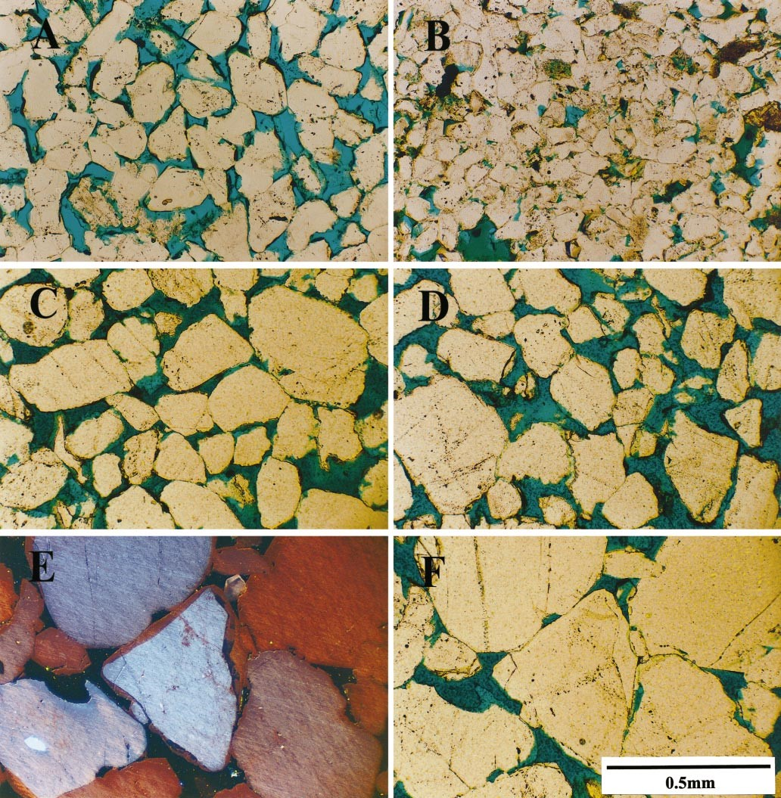

FIG. 4.—**A)** Moderately quartz cemented sandstone, 2402.60 mRKB. **B)** Strongly quartz cemented sandstone, 2408.68 mRKB. **C)** Slightly quartz cemented sandstone, 2449.70 mRKB. **D)** Slightly quartz cemented sandstone, 2451.25 mRKB. **E)** CL-micrograph of moderately quartz cemented sandstone, 2444.90 mRKB. **F)** Same field of view as E) using plane-polarized light. All micrographs taken at the same magnification.

not provide an explanation for the main problem: the trend of decreasing quartz cementation outwards from stylolites within the clay-free interval where quartz surface area remains relatively constant.

## MODELING QUARTZ CEMENTATION

|  |
| --- |
| FIG. 5.—Homogenization temperatures for aqueous inclusions in quartz overgrowths. |

Owing to factors such as grain size and grain coatings having an important effect on quartz cementation, differences in abundance of quartz cement cannot be taken directly as an effect of distance to nearest stylolite or stylolite spacing. The effect of proximity to stylolites can, however, be determined by modeling quartz cementation of each sample with the Exemplary diagenetic modeling program and comparing predictions with observed values. Because factors such as grain size and abundance of grain coatings are taken into account in the modeling, but decreasing silica supersaturation outward from stylolites is not, a systematic overprediction of quartz cement far from stylolites would be a clear indication that proximityto stylolites is a controlling factor for quartz cementation in the studied sandstones.

The concepts and mathematical formulations implemented in the Exemplary diagenetic modeling program are described in detail elsewhere (Walderhaug 1996; Lander and Walderhaug 1999; Walderhaug et al. 2000), and only a brief summary is included here.

The model of quartz cementation implemented in the Exemplary program calculates quartz cementation within a 1 cm3 reference volume located between stylolites. Only the precipitation step in the quartz cementation process is modeled, inasmuch as precipitation is considered to be the slowest and therefore rate-limiting step in the total process. The volume of quartz cement *V* (in cm3) precipitated in a cm3 of sandstone with quartz surface area *A* (cm2) during time *t* (in s) at a constant temperature can then be expressed (Walderhaug 1996) as:

*V* 5 *MrAt*/r (2)

where *M* is the molar mass of quartz (60.09 g/mole), *r* is the quartz pre-

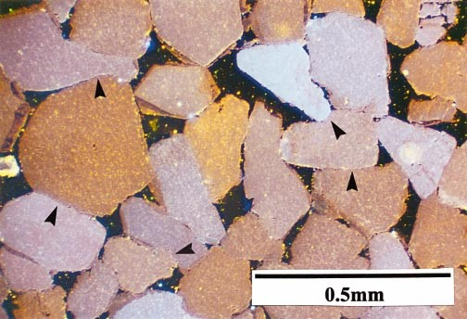

FIG. 6.—CL micrograph showing grain contacts (arrows) with possible interpenetration of quartz grains.

cipitation rate in moles/cm2s, and ris the density of quartz (2.65 g/cm3). The temperature dependence of the precipitation rate can be expressed by an Ahrrenius-type function:

*r* 5 aexp(2*E*a/*RT*) (3)

where a is a constant (moles/cm2s), *Ea* is the activation energy of the reaction (J/mole), *R* is the gas constant (8.314 J/moleK) and *T* is temperature (in Kelvins). Any temperature history can be approximated to any desired degree of accuracy by a series of segments where temperature either remains constant or changes linearly, and for a linear temperature change

Equation 3 can be transformed to

*r* 5 aexp(2*E*a/*R*(*c*n*t* 1 *d*n)) (4)

where *cn* is heating rate in K/s, *d*n is the initial temperature, and the index n refers to the relevant segment of the temperature history curve of the sandstone under consideration. Inserting the expression for precipitation rate from Equation 4 into Equation 2 enables the volume of quartz cement precipitated in a cm3 of sandstone from time *t0* to time *tm* to be calculated as the sum of a series of integrals where each integral determines the volume of quartz cement precipitated during a time step:

*M* 0 E*t*0*t*1 1 12*Ea* 1 2

*V* 5*A a* exp*dt*

r *R*(*c t* 1 *d* )

*M* 1 E*t*1*t*2 1 22*Ea* 2 2

1*A a* exp*dt* r *R*(*c t* 1 *d* )

*M m* 1 E*tmtm*21 1 *m*2*Ea m* 2

1 · · ·*A* 2 *a* exp*dt* (5) r *R*(*c t* 1 *d* )

Quartz surface area, *A,* available for quartz overgrowth formation is adjusted after each time step according to the equation

*A* 5 (1 2 *C*)6*fV*F/*D*F0 (6)

where F is present porosity and F0 is depositional porosity.

Input data for the modeling of quartz cementation includes detrital mineralogy, quartz grain size, percentage of quartz grain surfaces coated by clay or other non-quartz substances, and temperature history. Volumes of other diagenetic minerals can be entered manually at any time step in the

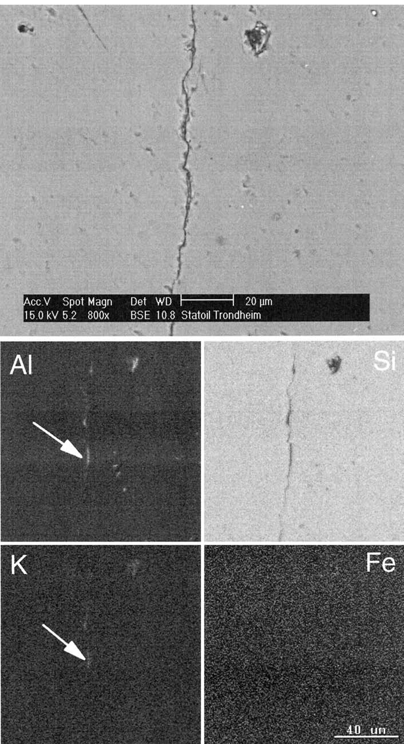FIG. 7.—Contact between two quartz grains in the backscatter mode and element mapping for Al, Si, K, and Fe. Sample 2452.75 mRKB. The images show the presence of aluminum and potassium in the contact (arrows), suggesting the presence of very thin clay films.

|  |  |  |  |  |  |
| --- | --- | --- | --- | --- | --- |
| Depth, mRKB | Quartz  Cement  Without CL  % | Quartz  Cement  Using CL  % | Estimated  Detrital  Quartz Cement  % | Corrected  Quartz Cement  Without CL  % | Corrected  Quartz Cement  Using CL  % |
| 2 397.70  2 402.60  2 408.68  2 409.47  2 424.50 | 13.5 13.2 21.7 19.1  14.3 | 12.6 12.9 18.6 19.8  16.2 | 2.4 2.3 2.0 2.2  2.3 | 11.1 10.9 19.7 16.9  12.0 | 10.2 10.6 16.6 17.6  13.9 |
| 2 427.23  2 434.00  2 444.90  2 446.20  2 446.35 | 12.5  6.2  12.1  16.9  6.7 | 12.8  8.3  12.8  14.4  5.5 | 2.2 2.5 2.5 2.3  2.6 | 10.3  3.7  9.6  14.6  4.1 | 10.6  5.8  10.3  12.1  2.9 |
| 2 446.75  2 449.20  2 449.30  2 449.70  2 450.20 | 10.6  13.4  8.8 7.5  6.5 | 7.4  16.1  6.5 8.5  7.9 | 2.4 2.5 2.5 2.5  2.5 | 8.2  10.9  6.3 5.0  4.0 | 5.0  13.6  4.0 6.0  5.4 |
| 2 450.70  2 451.25  2 451.75  2 452.25  2 452.75 | 7.2 7.5 8.2  5.9  10.1 | 5.6 7.3 7.0 6.1  8.1 | 2.5 2.5 2.5 2.5  2.4 | 4.7 5.0 5.7 3.4  7.7 | 3.1 4.8 4.5 3.6  5.7 |
| 2 453.25  2 453.35  2 467.82  2 467.90  2 468.02 | 9.0  11.2  9.3  6.6  21.4 | 6.7 6.2 9.5  7.4  22.4 | 2.4 2.4 2.6 2.5  2.3 | 6.6 8.8 6.7  4.1  19.1 | 4.3 3.8 6.9  4.9  20.2 |

TABLE 2.—*Quartz cement contents, well 7120/6-1.* 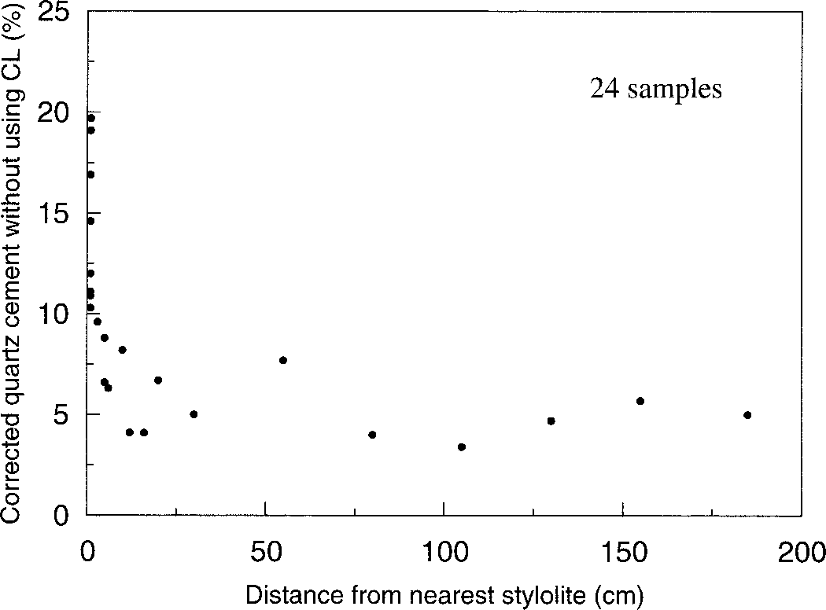

FIG. 9.—Quartz cement volume corrected for inherited overgrowths as a function of distance from the nearest stylolite. The sample 2434.00 is left out owing to disintegration of part of the core, making it impossible to be certain of distance to nearest stylolite.

|  |  |
| --- | --- |
| modeling, but because the volume of diagenetic cements other than quartz is very low (Table 1), this is of little practical significance in the present case.  Exemplary models mechanical compaction as a function of effective stress (Smith 1971; Ungerer et al. 1990) but includes options for terminating mechanical compaction when a user-specified minimum intergranular volume is reached or when a volume of quartz cement considered sufficient to stop further mechanical compaction has been precipitated. In the present case intergranular volumes are known from the point counts, and mechanical compaction was terminated when the measured intergran- | ular volumes were reached. Intergranular volume was defined as the sum of primary intergranular porosity, diagenetic cements, and detrital clay matrix. This gives a range of intergranular volumes from 28.8% to 36.9% in the upper relatively clay-rich interval and from 25.7% to 32.8% in the underlying extremely clay-poor interval. Mean intergranular volumes for the two intervals are 31.6% and 28.3%. Intergranular volume does not vary systematically as a function of distance to nearest stylolite in the almost clay-free interval.  On the basis of previous modeling experience, the activation energy for quartz precipitation was set to 60.0 kJ/mole, and the pre-exponential constant ain Equation 4 to 5.0 3 10212 moles/cm2s. Significant quartz cement is typically not present at temperatures below 70–808C on the Norwegian continental shelf (Bjørlykke et al. 1992; Ehrenberg 1990; Walderhaug |

1994), and modeling of quartz cementation was therefore initiated at 708C. The observed grain coatings appear to consist of detrital clay, possibly with some diagenetic modification, and were modeled as being in place from one million years after deposition, i.e., long before quartz cementation started. The traces of pyrite and dolomite cement present in some of the samples

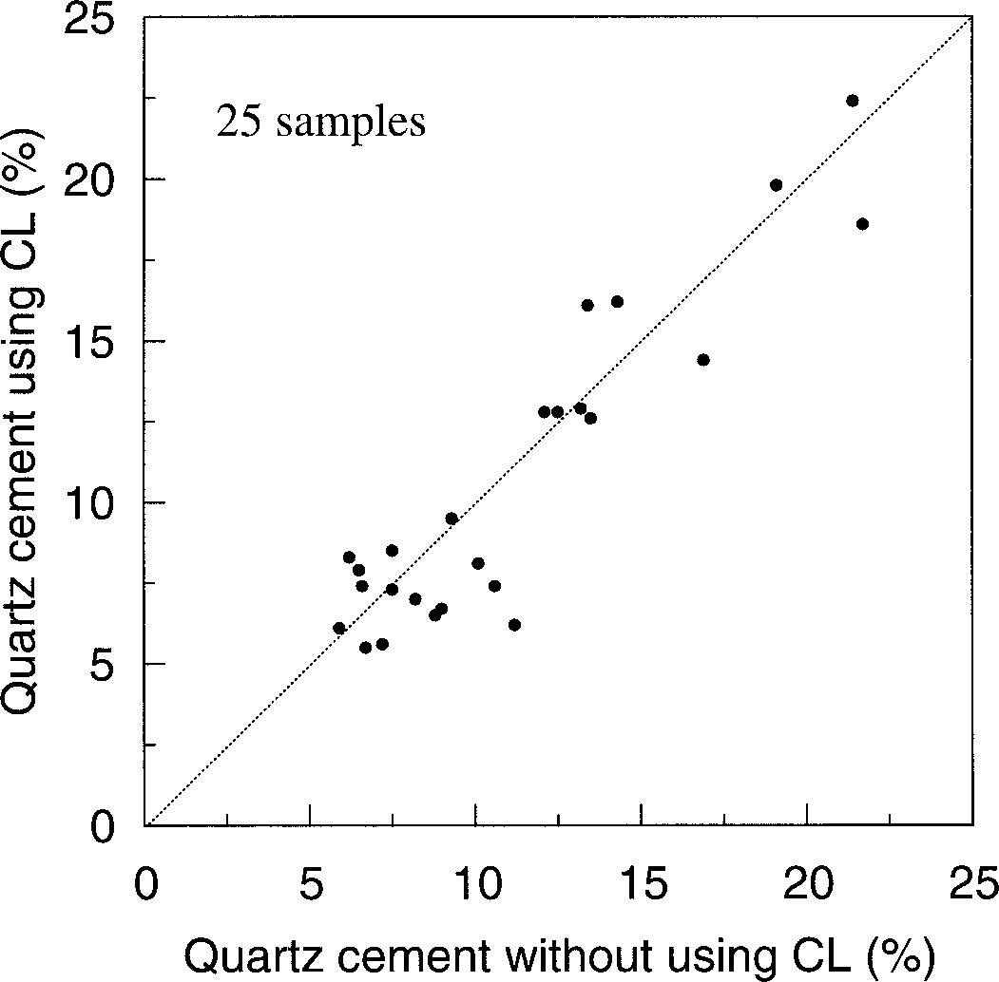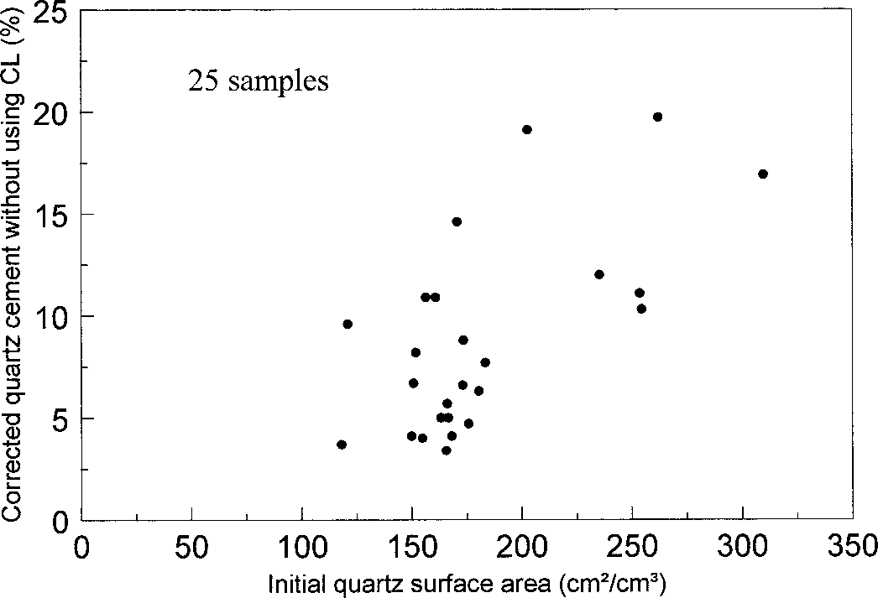

FIG. 10.—Quartz cement volume corrected for inherited overgrowths versus initial

FIG. 8.—Quartz cement determined by point counting CL micrographs versus quartz surface area. The correlation coefficient is 0.65, which is significant at the quartz cement determined by standard point counting of thin sections. 95% confidence level.

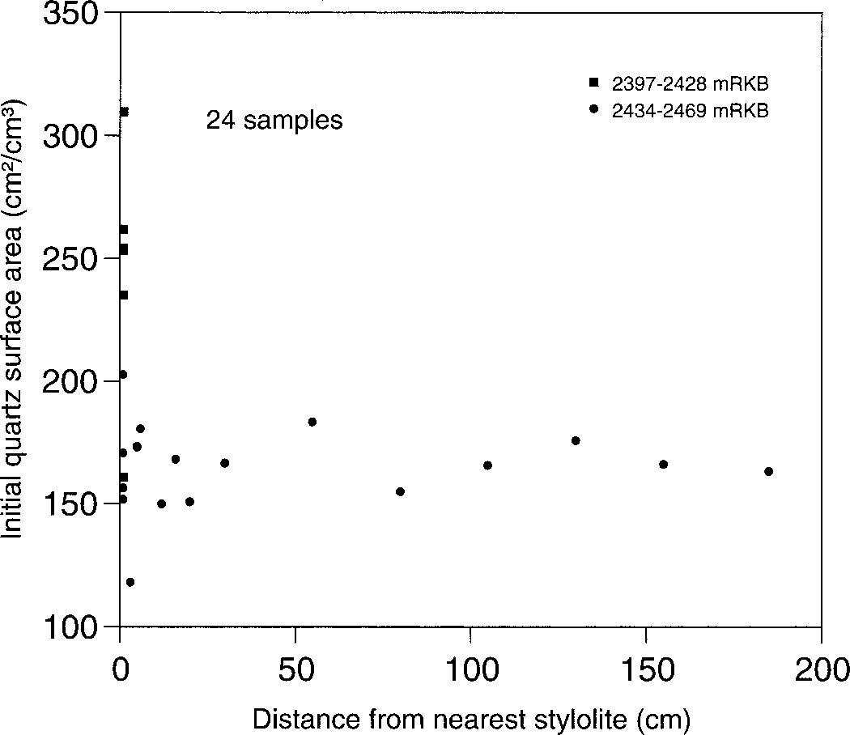

FIG. 11.—Initial quartz surface area versus distance to nearest stylolite. Owing to finer grain size, quartz surface area for samples from the stylolite-rich interval above 2428 mRKB is normally higher than in the very clay-poor interval below. This could explain why samples located only 1 cm from stylolites in the lower interval contain less quartz cement than the samples from the upper interval with abundant stylolites. However, quartz surface area is quite constant below 2434 mRKB, and variations in quartz surface area therefore cannot be the cause of the clear decrease in contents of quartz cement outwards from stylolites in this lower interval.

were modeled as having formed within the first one million years after deposition.

Owing to major uplift and erosion, constructing a reliable temperature history from the present stratigraphy is possible only from the time of deposition to the Cenomanian. Preserved sediments younger than Cenomanian are of Campanian, Paleocene, and Pleistocene age. Judging by data from other wells and previous studies of uplift indicators in the area (Berglund et al. 1986; Nyland et al. 1992), it is most likely that little sediment was deposited in the Turonian to Santonian whereas considerable deposition and uplift may have taken place in the Campanian to Maastrichtian. However, the main episode of deep burial and uplift took place in the Tertiary. The measured homogenization temperatures for fluid inclusions in quartz overgrowths are, with the exception of data from a probable

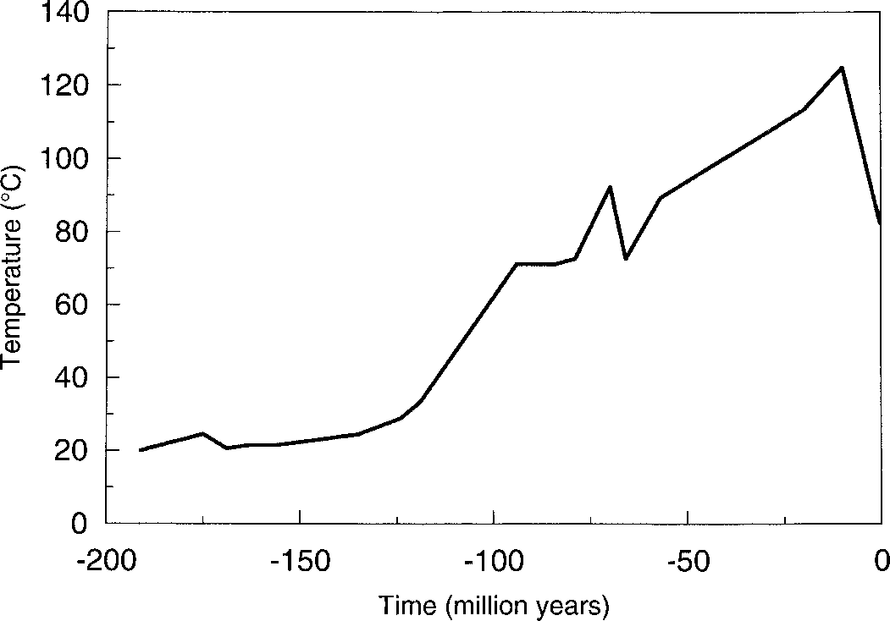

FIG. 12.—Temperature history for the Stø Formation in well 7120/6-1.

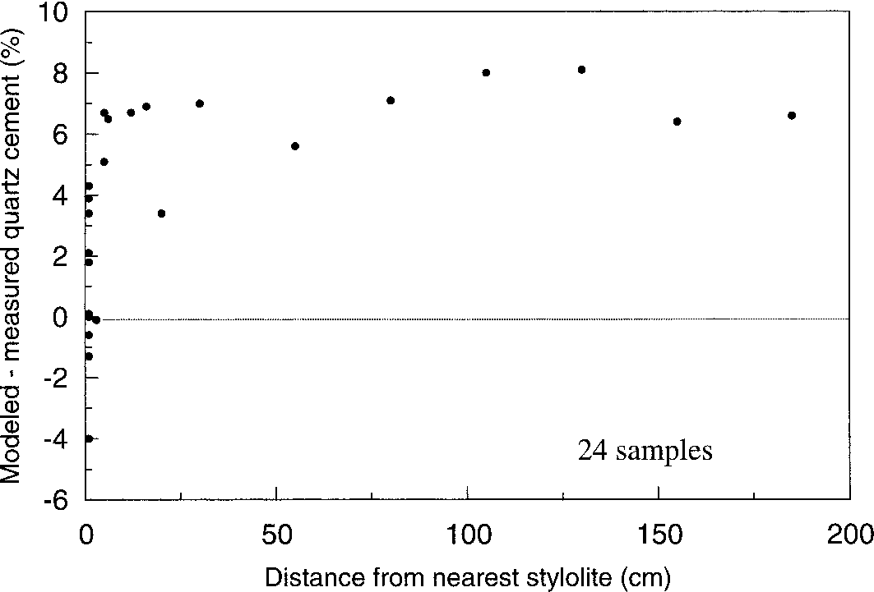

FIG. 13.—Deviation between modeled and measured quartz cement versus distance to nearest stylolite.

inherited overgrowth, dominantly between 808C and 1068C (Fig. 5), but because inclusions are located close to the boundary between detrital grains and overgrowths, considerable quartz cement has precipitated after the trapping of the inclusions. This suggests that maximum burial temperatures may have been significantly above 1068C, and measurements of homogenization temperatures for hydrocarbon fluid inclusions in calcite cement in the neighboring well 7120/9-1 indicate maximum temperatures of around 1258C for the Stø Formation (Walderhaug 1992). Maximum temperature for the Stø Formation in well 7120/6-1 is therefore considered to have been 1258C and to have occurred in the Tertiary, as has previously been suggested for this area by Nyland et al. (1992). Taking into account these constraints and at the same time requiring the temperature history to produce the observed volumes of quartz cement in the samples with normal stylolite abundance, the temperature history shown in Figure 12 is considered to be a reasonable estimate for the actual temperature history of the studied interval.

## MODELING RESULTS

For samples located 3 cm or less from stylolites, modeled quartz cement volumes are between 4% above and 4% below point-counted quartz cement volumes corrected for recycled overgrowths (Fig. 13). In contrast, quartz cement volumes are overpredicted for all samples located 5 cm or more from stylolites. Overprediction is typically 5–8% of whole rock volume and does not seem to increase systematically for distances of more than 20 cm form the closest stylolite (Fig. 13). The difference between predicted and measured quartz cement volumes does not appear to be a function of stylolite spacing, only distance to nearest stylolite, although a larger data base may be required to fully evaluate the effect of stylolite spacing.

## DISCUSSION

Variations in quartz surface area are included in the input for Exemplar modeling. The systematic overprediction of quartz cement volumes for all samples located at unusually great distances (. 20 cm) from stylolites (Fig. 13) therefore indicates that the correlation between quartz cement volume and proximity to stylolites (Fig. 9) cannot be explained as a result of more quartz surface area being available for overgrowth formation in the samples located close to stylolites. There are no significant differences in temperature history between the samples, and they all belong to the same pressure cell, so differences in temperature history or pressure history cannot be the cause of the observed variations in quartz cement volumes either.

Moreover, the variations in quartz cement volume do not conform to a pattern with more intense quartz cementation below the oil–water contact at 2440.3 mRKB, and the variable quartz cement volumes therefore cannot be explained by claiming that quartz cementation was inhibited in the oil and gas zones. On the contrary, the average quartz cement percentage above the oil–water contact is in fact 50% higher than below the contact; 12.1% versus 7.5% when using the values corrected for recycled overgrowths (Table 2) or 14.4% versus 9.9% when using the uncorrected values (Table 1). The most strongly quartz-cemented samples contain the same types of detrital grains as the less quartz-cemented samples, and there is no evidence for the former presence of biogenic silica in the Stø Formation in well 7120/6-1 or in other wells. It therefore appears reasonable to conclude that the low quartz cement volumes within the intervals with exceptionally large stylolite spacings are due to the low number of stylolites, and that the quartz cementation process tends to become more transport controlled when stylolite spacings approach half a meter. It is important to keep in mind, however, that all types of contacts between quartz and (illitic) clay or mica can generate a macrostylolite or microstylolite. This includes individual grain contacts, primary clay drapes, clay rims around burrows, matrix-supported sandstone laminae, water-escape structures and so on. Therefore, one should not expect reduced quartz cementation and better than normal porosity just because textbook examples of large amplitude macrostylolites are not visible in cores.

In the above discussion it has been assumed that all stylolites are equally efficient in generating quartz cement, whereas in practice stylolites consisting of different substances might conceivably give rise to different silica supersaturations. There is, however, no evidence for stylolites in the least quartz-cemented intervals being systematically different in composition from stylolites in more heavily quartz-cemented samples, although it is admittedly not easy to petrographically characterize material within stylolites.

Some of the CL micrographs from the least quartz-cemented samples show indications of slight interpenetration of quartz clasts (Fig. 6). No clay material is seen with a petrographic microscope at these contacts, but the element mapping performed with the SEM shows that in some cases minor amounts of aluminum and potassium are present along the contacts (Fig. 7), suggesting the presence of illitic clay. Microstylolites at individual grain contacts containing illitic clay that promoted quartz dissolution therefore probably supplied some quartz cement to zones between the macrostylolites, although it is very difficult to quantify this source of quartz cement. It cannot be excluded, however, that the quartz cement produced at these contacts may amount to a percent or two of sample volumes. A volume of quartz cement of this order should therefore perhaps be subtracted from the quartz cement volumes measured between the macrostylolites when considering the effect of distance from macrostylolites on quartz cementation in the studied sandstone. Also, the abundance of recycled overgrowths may have been underestimated, which would further reduce the volumes of precipitated quartz cement plotted in Figure 9. The trends of decreasing quartz cementation outward from stylolites, would, however, remain the same.

Modeling of quartz precipitation rate as a function of distance from nearest stylolite for different temperatures, stylolite spacings, and hydrocarbon saturations indicates that volumes of precipitated quartz cement decrease outwards from stylolites in the manner suggested by Figures 9 and 13 for large stylolite spacings whereas gradients will not be apparent for small stylolite spacings (Oelkers et al. 1996; Oelkers et al. 2000; Bjørkum et al. 1998). The definition of large stylolite spacing depends upon factors such as temperature, hydrocarbon saturation, and quartz surface area available for quartz precipitation, with gradients in the volumes of precipitated quartz cement expected to become more noticeable as these three factors increase. However, the calculations of Oelkers et al. (1996) and Oelkers et al. (2000) clearly indicate that no gradients in the volume of precipitated quartz cement are expected in the present case in the intervals with average stylolite spacings of a few centimeters or less, whereas gradients are certainly expected in the sections where stylolite spacing is on the order of meters. The results from this study are therefore in good agreement with the predictions of Oelkers et al. (1996), Oelkers et al. (2000), and Bjørkum et al. (1998).

Although lack of clay-rich or micaceous laminae that evolve into stylolites upon burial appears to have reduced quartz cementation and preserved 5–8% more porosity than normal in parts of the Stø Formation in well 7120/6-1 and in some of the neighboring wells, such extremely clean sandstone intervals seem to be very rare, at least on the Norwegian shelf. Lack of stylolite precursors has been suspected to be the cause of low quartz cement volumes and higher than normal porosities in parts of the Stø Formation since the well 7120/6-1 was drilled in 1985, but hardly any examples of this phenomenon have been found elsewhere on the Norwegian continental shelf despite several petrologists having been on the lookout for additional examples over the past fifteen years. This suggests that preserved reservoir quality due to lack of stylolite precursors is not a common phenomenon, and that models of quartz cementation based upon precipitation rate control will prove adequate in most cases.

It is also worth noting that the observed increase in quartz cement abundance close to stylolites in the Stø Formation provides supporting evidence for dissolution of quartz grains at stylolites being the main source of quartz cement in quartz-rich sandstones. There is, on the other hand, no obvious reason why quartz cement should be concentrated around stylolites if it was supplied by fluid flow or diffusion from underlying or overlying rocks. If dissolved silica originated in the overlying shales or was supplied by fluid flow from below, then a gradient in the amount of quartz cement toward the boundaries of the Stø Formation seems a more likely result than an internal small-scale variation that just happened to be correlated with distance to nearest stylolite.

## CONCLUSIONS

Sandstone samples from the Stø Formation in well 7120/6-1 located more than 20 cm from the nearest stylolite contain markedly less quartz cement than samples located closer to stylolites. Quantitative modeling of the quartz cementation process indicates clearly that the observed variations in quartz cement volumes are not due to variable abundance of grain coatings, grain-size changes, or different contents of quartz clasts. On the contrary, the modeling suggests that for all the samples located more than 20 cm from the closest stylolite, quartz cement volumes are 5–8% less than what would normally be expected even after taking these factors into account. It is therefore concluded that a very low abundance of clay-rich and micaceous laminae or other stylolite precursors can cause reduced quartz cementation and preservation of higher-than-expected porosities. However, such extremely clean sandstones appear to be rare. Scarcity of stylolite precursors may therefore be of only local importance for preservation of reservoir quality at high temperatures. This further implies that it is usually not necessary to include distance to the nearest stylolite and stylolite spacing as variables in quantitative models of quartz cementation.

## ACKNOWLEDGMENTS

This paper is based on projects performed for Statoil a.s, and their permission to publish is greatfully acknowledged. Tony Boassen is thanked for taking the SEM micrographs. The original manuscript was improved by comments from David A. Budd, Eric H. Oelkers, Stanley T. Paxton, Edward Prestholm, Knut Georg Røssland, and an anonymous referee.

## REFERENCES

BERGLUND, L.T., AUGUSTSON, J., FæRSETH, R., GJELBERG, J. AND RAMBERG-MOE, H., 1986, The evolution of the Hammerfest Basin, *in* Spencer, A.T., Holter, E., Campell, C.J., Hanslien, S.H., Nelson, P.H.H., Nysæther, E., and Ormaasen, E., eds., Habitat of Hydrocarbons on the Norwegian Continental Shelf: London, Graham & Trotman, p. 319–338.

BJøRGEN, T., 1985, A sedimentological study of the cored Lower/Middle Jurassic successions in wells: 7120/6-1, 7120/9-1 and 7120/12-2 [Unpublished Cand scient thesis]: University of Bergen.

BJøRKUM, P.A., 1996, How important is pressure in causing dissolution of quartz in sandstones?: Journal of Sedimentary Research, v. 66, p. 147–154.

BJøRKUM, P.A., OELKERS, E.H., NADEAU, P.H., WALDERHAUG, O., AND MURPHY, W.M., 1998, Porosity prediction in quartzose sandstones as a function of time, temperature, depth, stylolite frequency, and hydrocarbon saturation: American Association of PetroleumGeologists, Bulletin, v. 82, p. 637–648.

BJøRLYKKE, K., 1980, Clastic diagenesis and basin evolution: Diputacio´n Provincial, Universidad de Barcelona, Revista, Instituto de Investigaciones Geolo´gicas, v. 34, p. 21–44.

BJøRLYKKE, K., AAGAARD, P., DYPVIK, H., HASTINGS, D.S., AND HARPER, A.S., 1986, Diagenesis and reservoir properties of Jurassic sandstones from the Haltenbanken area, offshore midNorway, *in* Spencer, A.T., Holter, E., Campell, C.J., Hanslien, S.H., Nelson, P.H.H., Nysæther, E., and Ormaasen, E., eds., Habitat of Hydrocarbons on the Norwegian Continental Shelf: London, Graham & Trotman, p. 275–286.

BJøRLYKKE, K., NEDKVITNE, T., RAMM, M., AND SAIGAL, G.C., 1992, Diagenetic processes in the Brent Group (Middle Jurassic) reservoirs of the North Sea: an overview, *in* Morton, A.C., Haszeldine, R.S., Giles, M.R., and Brown, S., eds., Geology of the Brent Group: Geological Society of London, Special Publication 61, p. 263–287.

BLATT, H., 1979, Diagenetic processes in sandstones, *in* Scholle, P.A., and Schluger, P.R., eds., Aspects of Diagenesis: Society of Economic Paleontologists and Mineralogists, Special Publication 26, p. 141–157.

BLOCH, S., MCGOWEN, J.H., DUNCAN, J.R., AND BRIZZOLARA, D.W., 1990, Porosity prediction, prior to drilling, in sandstones of the Kekiktuk Formation (Mississippian), North Slope of Alaska: Association of American Petroleum Geologists, Bulletin, v. 74, p. 1371–1385.

BURLEY, S.D., MULLIS, J., AND MATTER, A., 1989, Timing of diagenesis in the Tartan reservoir (U.K. North Sea): constraints from combined cathodoluminescence microscopy and fluid inclusion studies: Marine and Petroleum Geology, v. 6, p. 98–120.

BYRNES, A.P. AND WILSON, M.D., 1994, Case history—St. Peter and Mt. Simon sandstones, Illinois basin, *in* Wilson, M.D., ed., Reservoir Quality Assessment and Prediction: SEPM, Short Course 30, p. 385–394.

DEWERS, T., AND ORTOLEVA, P., 1990, A coupled reaction/transport/mechanical model for intergranular pressure solution, stylolites and differential compaction and cementation in clean sandstones: Geochimica et Cosmochimica Acta, v. 54, p. 1609–1625.

EHRENBERG, S.N., 1990, Relationship between diagenesis and reservoir quality in sandstones of the Garn Formation, Haltenbanken, mid-Norwegian continental shelf: American Association of Petroleum Geologists, Bulletin, v. 74, p. 1538–1558.

GILES, M.R., STEVENSON, S., MARTIN, S.V., CANNON, S.J.C., HAMILTON, P.J., MARSHALL, J.D., AND SAMWAYS, G.M., 1992, The reservoir properties and diagenesis of the Brent Group: a regional perspective, *in* Morton, A.C., Haszeldine, R.S., Giles, M.R., and Brown, S., eds., Geology of the Brent Group: Geological Society of London, Special Publication 61, p. 289–327.

HEALD, M.T., 1955, Stylolites in sandstones: Journal of Geology, v. 63, p. 101–114.

HEALD, M.T., AND LARESE, R.E., 1974, Influence of coatings on quartz cementation: Journal of Sedimentary Petrology, v. 44, p. 1269–1274.

HEALD, M.T., AND RENTON, J.J., 1966, Experimental study of sandstone cementation: Journal of Sedimentary Petrology, v. 36, p. 977–991.

HOUSEKNECHT, D.W., 1988, Intergranular pressure solution in four quartzose sandstones: Journal of Sedimentary Petrology, v. 58, p. 228–246.

LAND, L.S., AND FISHER, R.S., 1987, Wilcox sandstone diagenesis, Texas Gulf Coast: a regional isotopic comparison with the Frio Formation, *in* Marshall, J.D., ed., Diagenesis of Sedimentary Sequences: Geological Society of London, Special Publication 36, p. 219–235.

LAND, L.S., AND MILLIKEN, K.L., 2000, Regional loss of SiO2 and CaCO3, and gain of K2O during burial diagenesis of Gulf Coast mudrocks, U.S.A., *in* Worden, R.H., and Morad, S., eds., Quartz Cementation in Sandstones: International Association of Sedimentologists, Special Publication 29, p. 183–197.

LANDER, R.H., AND WALDERHAUG, O., 1999, Predicting porosity through simulating sandstone compaction and quartz cementation: American Association of Petroleum Geologists, Bulletin, v. 83, p. 433–449.

LOWRY, W.D., 1956, Factors in loss of porosity by quartzose sandstones of Virginia: American Association of Petroleum Geologists, Bulletin, v. 40, p. 489–500.

MCBRIDE, E.F., 1989, Quartz cement in sandstones: a review: Earth-Science Reviews, v. 26,

p. 69–112.

MULLIS, A.M., 1991, The role of silica precipitation kinetics in determining the rate of quartz pressure solution: Journal of Geophysical Research, v. 96, p. 10,007–10,013.

NYLAND, B., JENSEN, L.N., SKAGEN, J., SKARPNES, O., AND VORREN, T., 1992, Tertiary uplift and erosion in the Barents Sea: magnitude, timing and consequences, *in* Larsen, R.M., Brekke, H., Larsen, B.T., and Talleraas, E., eds., Structural and Tectonic Modelling and its Application to Petroleum Geology: Amsterdam, Elsevier, p. 153–162.

OELKERS, E.H., BJøRKUM, P.A., AND MURPHY, W.M., 1996, A petrographic and computational investigation of quartz cementation and porosity reduction in North Sea sandstones: American Journal of Science, v. 296, p. 420–452.

OELKERS, E.H., BJøRKUM, P.A., WALDERHAUG, O., NADEAU, P.H., AND MURPHY, W.M., 2000, Making diagenesis obey thermodynamics and kinetics: the case of quartz cementation in sandstones from offshore mid-Norway: Applied Geochemistry, v. 15, p. 295–309.

OLAUSSEN, S., DALLAND, A., GLOPPEN, T.G., AND JOHANNESSEN, E., 1984, Depositional environment and diagenesis of Jurassic reservoir sandstones in the eastern part of Troms I area, *in* Spencer, A.M., Holter, E., Johnsen, S.O., Mørk, A., Nysæther, E., Sognstad, P., and Spinnangr, A˚ ., eds., Petroleum Geology of the North European Margin: London, Graham & Trotman, p. 61–79.

PARNELL, J., 1987, Secondary porosity in hydrocarbon-bearing transgressive sandstones on an unstable lower Palaeozoic continental shelf, Welsh Borderland, *in* Marshall, J.D., ed., Diagenesis of Sedimentary Sequences: Geological Society of London, Special Publication 36, p. 297–312.

RICHES, P., TRAUBB-SOBOTT, I., ZIMMERLE, W., AND ZINKERNAGEL, U., 1986, Diagenetic peculiarities of potential Lower Jurassic reservoir sandstones, Troms I area, off northern Norway, and their tectonic significance: Clay Minerals, v. 21, p. 565–584.

SIBLEY, D.F., AND BLATT, H., 1976, Intergranular pressure solution and cementation of the Tuscarora orthoquartzite: Journal of Sedimentary Petrology, v. 46, p. 881–896.

SMITH, J.E., 1971, The dynamics of shale compaction and evolution of fluid pressure: Mathematical Geology, v. 3, p. 239–269.

UNGERER, P., BURRUS, J., DOLIGEZ, B., CHE´NET, P.Y., AND BESSIS, F., 1990, Basin evaluation by integrated two-dimensional modeling of heat transfer, fluid flow, hydrocarbon generation, and migration: American Association of Petroleum Geologists, Bulletin, v. 74, p. 309–335.

WALDERHAUG, O., 1985, Et studium av tidlig jurassiske sandsteiner fra brønn 7120/9-1, Hammerfestbassenget, med hovedvekt pa˚ diagenese [Unpublished Cand. scient. thesis]: University of Bergen.

WALDERHAUG, O., 1992, Magnitude of uplift of the Stø and Nordmela Formations in the Hammerfest Basin—a diagenetic approach: Norsk Geologisk Tidsskrift, v. 72, p. 321–323.

WALDERHAUG, O., 1994, Temperatures of quartz cementation in Jurassic sandstones from the Norwegian continental shelf—evidence from fluid inclusions: Journal of Sedimentary Petrology, v. A64, p. 311–323.

WALDERHAUG, O., 1996, Kinetic modelling of quartz cementation and porosity loss in deeply buried sandstone reservoirs: American Association of Petroleum Geologists, Bulletin, v. 80, p. 731–745.

WALDERHAUG, O., 2000, Modelling quartz cementation and porosity in Middle Jurassic Brent Group sandstones of the Kvitebjørn Field, northern North Sea: American Association of Petroleum Geologists, Bulletin, v. 84, p. 1325–1339.

WALDERHAUG, O., LANDER, R.H., BJøRKUM, P.A., OELKERS, E.H., BJøRLYKKE, K. AND NADEAU, P.H., 2000, Modelling quartz cementation and porosity in reservoir sandstones: examples from the Norwegian continental shelf, *in* Worden, R.H., and Morad, S., eds., Quartz Cementation in Sandstones: International Association of Sedimentologists, Special Publication 29, p. 39–49.

WALDSCHMIDT, W.A., 1941, Cementing materials in sandstones and their probable influence on migration and accumulation of oil and gas: American Association of Petroleum Geologists, Bulletin, v. 25, p. 1839–1879.

WEYL, P.K., 1959, Pressure solution and the force of crystallization—a phenomenological theory: Journal of Geophysical Research, v. 64, p. 2001–2025.

WORDEN, R.H., AND MORAD, S., 2000, Quartz cementation in oil field sandstones: a review of the key controversies, *in* Worden, R.H., and Morad, S., eds., Quartz Cementation in Sandstones: International Association of Sedimentologists, Special Publication 29, p. 1–20.

Received 27 June 2001; accepted 5 September 2002.