Tracking Adria indentation beneath the Alps by detrital zircon U-Pb geochronology: Implications for the Oligocene–Miocene dynamics of the Adriatic microplate

Marco G. Malusà1, Owen A. Anfinson2,3, Laura N. Dafov2, and Daniel F. Stockli2

1Department of Earth and Environmental Sciences, University of Milano-Bicocca, Piazza della Scienza 4, 20126 Milan, Italy

2Department of Geological Sciences, University of Texas at Austin, 1 University Station C1100, Austin, Texas 78712, USA

3Department of Geology, Sonoma State University, 1801 East Cotati Avenue, Rohnert Park, California 94928, USA

# ABSTRACT

**The Adriatic microplate is a key player in the Western Mediterranean tectonic puzzle, but its Oligocene–Miocene dynamics are not yet fully understood. In fact, even though the timing and magnitude of Adriatic slab rollback and backarc extension in the Apennines have long been established, the timing of progressive Adria indentation beneath the Central Alps and major strike-slip motion along the Insubric fault are still poorly constrained. Here we tackle these issues by utilizing detrital zircon U-Pb geochronology on Adriatic foredeep turbidites, i.e., by comparing the geochronologic fingerprints of the exhuming tectonic domes of the Central Alps (Ticino and Toce subdomes) with those of the Oligocene–Miocene turbidites chiefly derived from their erosion. We analyzed 11 sandstone samples ranging in age from 32 to 18 Ma. The ratio between Variscan and Caledonian zircon grains (which are dominant in the Toce and Ticino subdomes, respectively) sharply increases at ca. 24–23 Ma. This major provenance change marks the westward shift of the Adriatic indenter beneath the Central Alps and the associated right-lateral activity of the Insubric fault. The coexistence of strike-slip motion at the northern boundary of the Adriatic microplate at ca. 24–23 Ma and trench retreat during scissor-type backarc opening to the west requires a near-vertical rotation axis located at the northern tip of the Ligurian-Provençal basin. We propose that the rotation axis position was controlled by the interaction between the European and the Adriatic slabs, which may have collided at depth by the end of the Oligocene, triggering the westward shift of the Adriatic indenter beneath the Central Alps.**

# INTRODUCTION

The Adriatic microplate is a key piece in the complex Western Mediterranean tectonic puzzle (Fig. 1). It represents the lower plate of the Apenninic belt to the southwest, the lower plate of the Dinaric belt to the northeast, and the upper plate of the Alpine belt to the northwest, where it is indented north of the Insubric fault beneath the metamorphic units of the Lepontine dome (X-X′ in Fig. 1) (Handy et al., 2010; Malusà et al., 2015). The motion of the Adriatic microplate relative to Europe during the Cenozoic is reasonably well constrained (e.g., Dewey et al., 1989), as are the timing and magnitude of Neogene slab rollback and trench retreat in the Apennines (Faccenna et al., 2001; Gattacceca et al., 2007). By contrast, no reliable time constraint is available in the Central Alps for the progressive westward migration of the Adriatic indenter beneath the Lepontine dome (Merle et al., 1989; Steck and Hunziker, 1994), and for the associated Oligocene–Miocene strike-slip motion along the Insubric fault (Schmid et al., 1989; Zwingmann and Mancktelow, 2004). Such a paucity of kinematic constraints along the northern boundary of the Adriatic microplate prevents reliable analysis of slab dynamics during trench retreat and backarc extension.

Here we use detrital zircon U-Pb geochronology on foredeep turbidites to track Adria indentation beneath the Central Alps, and provide first time constraints for major strike-slip motion along the Insubric fault. Results are integrated with available kinematic constraints for the Western Mediterranean area, shedding light on the Oligocene–Miocene dynamics of the

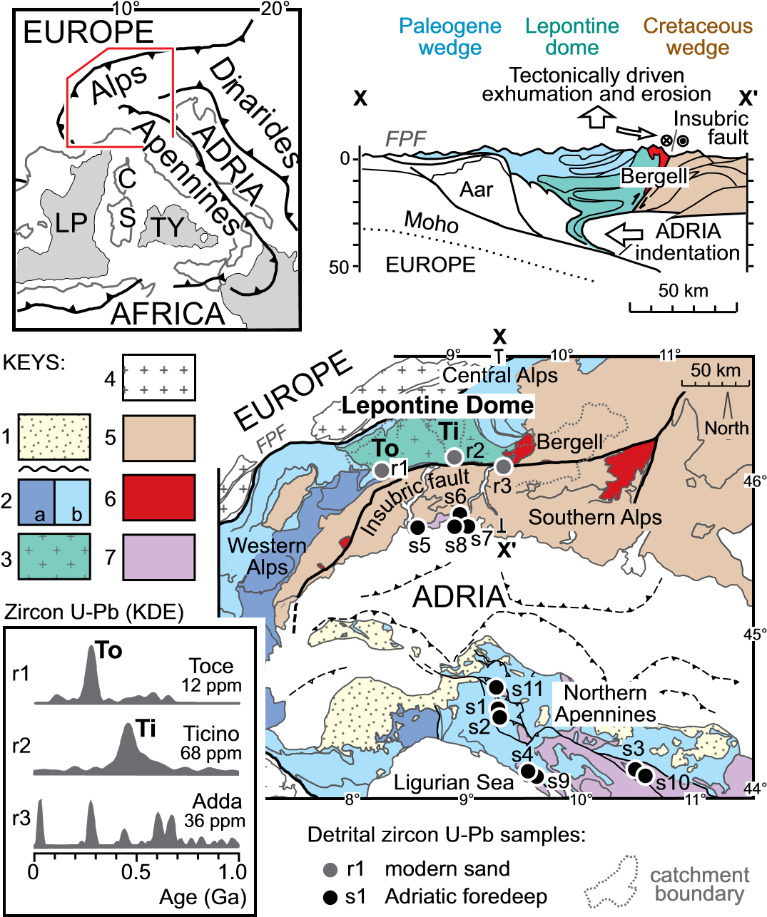

**Figure 1. Geologic map of the study area with sample locations, cross section across the Central Alps (top right), and tectonic sketch map of the Western Mediterranean (top left) (modified from Malusà et al., 2015). Keys: 1—wedge-top successions; 2—Paleogene wedge [a, (ultra)high pressure belt; b, lower grade units]; 3—Lepontine dome; 4—External Massifs; 5—Cretaceous wedge (Austroalpine and Southalpine sequences); 6—Periadriatic intrusives; 7—Adriatic foredeep turbidites, Subligurian and Tuscan units. Abbreviations: C— Corsica; FPF—frontal Pennine fault; LP—Ligurian-Provençal basin; S—Sardinia; Ti—Ticino subdome; To—Toce subdome; TY—Tyrrhenian Basin. Zircon U-Pb kernel density estimates on modern sands (KDE, bottom left) are from Malusà et al. (2013); zircon fertility values (ppm) in each drainage are from Malusà et al. (2016a).**

Adriatic microplate and its interaction with the European plate during the early stages of Adriatic trench retreat and backarc extension.

# GEOLOGIC BACKGROUND

|  |
| --- |
| GEOLOGY, February 2016; v. 44; no. 2; p. 155–158 | Data Repository item 2016040 | doi:10.1130/G37407.1 | Published online 7 January 2016  © 2016 Geological Society of America. For permission to copy, contact editing@geosociety.org.**GEOLOGY** | Volume 44 | Nu ber 2 | www.gsapubs.org **155** |

The Western Mediterranean orogenic belts record the progressive Mesozoic–Cenozoic convergence between Adria and Europe, and the consequent closure of the Tethyan Ocean between (Dewey et al., 1989; Jolivet et al., 2003; Handy et al., 2010; Malusà et al., 2015). In the AlpsApennines region, most of the Tethyan Ocean was subducted beneath the Adriatic microplate in Cretaceous time (Zanchetta et al., 2015), until Alpine subduction was choked by the arrival of thick European crust at the trench, followed by late Eocene exhumation of (ultra)high pressure [(U)HP] rocks and by the emplacement of Periadriatic magmatic rocks (Handy et al., 2010). UHP exhumation was likely triggered by the northward motion of Adria relative to Europe (Malusà et al., 2015), which is still documented for the Neogene, when the Adriatic slab started retreating eastward (Faccenna et al., 2001), leading to the scissor-type opening of the Ligurian-Provençal basin and to the counterclockwise rotation of CorsicaSardinia, with a rotation pole located in the northern Ligurian Sea (Wortel and Spakman, 2000; Gattacceca et al., 2007). Meanwhile, the progressive indentation of Adriatic lithosphere beneath the Central Alps led to the erosional unroofing of the Lepontine dome (Garzanti and Malusà, 2008). The Lepontine dome includes two distinct subdomes of Cenozoic amphibolite facies metamorphic rocks (Ticino and Toce subdomes) that formed stepwise from east to west, at a distance of ~50 km from each other, as a response to progressive Adria indentation (Merle et al., 1989). The relative displacement between the Adriatic indenter and the overlying Cenozoic metamorphic rocks was accommodated by the right-lateral Insubric fault (Merle et al., 1989; Schmid et al., 1989), while the focused erosion of the Ticino and Toce subdomes provided huge amounts of detritus to the Adriatic foredeep turbidites, which are now accreted in the Northern Apennines (~80% of total foredeep detritus, according to petrographic and fission track data; Garzanti and Malusà, 2008). Therefore, provenance changes in the Adriatic foredeep turbidites can be used to track the motion of the Adriatic indenter beneath the Central Alps, and to constrain the age of major strike-slip motion along the poorly dated Insubric fault.

# METHODS

Detrital zircon U-Pb geochronology provides an excellent means of detecting provenance changes in the Adriatic foredeep turbidites because of the markedly different age signatures characterizing the Ticino and Toce subdomes in the Central Alps (Malusà et al., 2013) (see kernel density estimates, KDEs, in Fig. 1; Vermeesch, 2012). Detritus shed from the Toce subdome (r1) is dominated by Variscan zircon U-Pb ages, whereas detritus shed from the Ticino subdome (r2) is dominated by Caledonian zircon U-Pb ages (Fig. 1). The overlying Cretaceous wedge (Zanchetta et al., 2015) shows abundant Precambrian ages and an age peak at 32–30 Ma (r3 in Fig. 1), corresponding to the climax of Periadriatic magmatism.

Resistance of zircon to diagenetic dissolution, and the high closure tem-

perature of the U-Pb geochronologic system, ensures that detrital zircon signatures remain unchanged after burial and diagenesis.

Within this framework, we collected 11 sandstone samples for detrital zircon U-Pb analysis from the proximal and distal successions of the Adriatic foredeep, exposed in the southern European Alps and Northern Apennines, respectively (s1–s11 in Fig. 1). The stratigraphic ages of these samples are independently constrained by biostratigraphic data (Catanzariti et al., 2002; Tremolada et al., 2010) ranging from 32 to 18 Ma, thus covering the entire time interval relevant for the analyzed geodynamic processes. Distal samples include those from the Aveto, Macigno, Modino, and Bobbio Formations. Proximal samples include those from the Villa Olmo and Como Formations of the Gonfolite Group, fed by local sources encompassing the Bergell volcano-plutonic complex and the Cretaceous wedge country rocks (Malusà et al., 2011).

After conventional heavy mineral separation, all grains were mounted (unpolished) on double-sided tape and depth profiled using laser ablation (LA) with a Photon Machine Analyte G2 ArF 193 nm excimer laser in a two-volume HelEx cell. The progressively ablated aerosol and He carrier gas were injected and analyzed using an Element2 magneticsector inductively coupled plasma–mass spectrometer (ICP-MS). LAICP-MS depth profiling allows for multiple ages to be obtained from a single analysis, due to ablation of the grain normal to growth zonation. A more detailed description of the analytical procedures is provided in the GSA Data Repository[1].

# RESULTS AND INTERPRETATIONS

Results are summarized in Figure 2 (see the Data Repository for U-Pb data). Only rim ages are included in this figure, to allow for an unbiased comparison with the data set published in Malusà et al. (2013), whereas both rim and core ages are included in the Data Repository. KDEs (Fig. 2) show that the analyzed samples include, in variable proportions, grain ages belonging to the Periadriatic, Variscan, Caledonian, and Precambrian populations, as observed in modern sands shed from the potential source areas (Malusà et al., 2013).

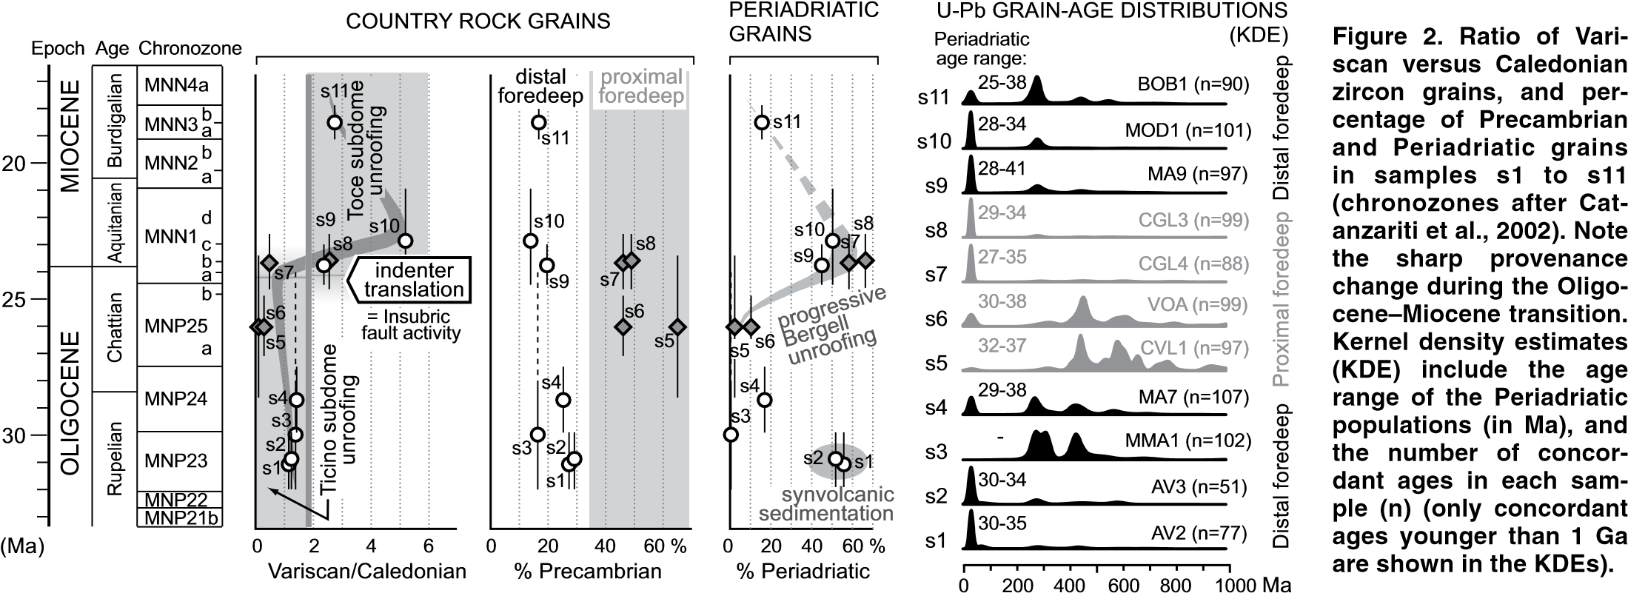Periadriatic zircon grains define a stationary peak (Malusà et al., 2011) observed in all but one sample (s3). The range of Periadriatic ages is fully consistent with published zircon U-Pb ages in Periadriatic magmatic rocks (Rosenberg, 2004). The age of the youngest Periadriatic grains in each sample decreases upsection, and is systematically older (as expected) than the stratigraphic age of the enclosing sedimentary rock.

The relative abundance of Periadriatic zircon grains exceeds 50% in samples coeval with the climax of Periadriatic magmatism (Aveto Formation, s1 and s2), samples that are dominated by volcanic zircon grains, and drops to 0% in samples deposited shortly after the cessation of magmatic activity (s3). Then the abundance of Periadriatic zircon grains progressively increases upsection because of the progressive unroofing of the Bergell volcano-plutonic complex (Figs. 1 and 2) (Malusà et al., 2011). The abundance of Periadriatic zircon grains largely exceeds 50% in proximal Aquitanian samples (s7 and s8), reaches 45%–50% in coeval distal samples also fed by Lepontine sources (s9 and s10), and decreases to 16% in the Burdigalian sample (s11).

Among the non-Periadriatic zircon grains, the relative abundance of Precambrian grains is a good marker to discriminate more local sources feeding the proximal Adriatic foredeep (47%–65% Precambrian grains in samples s5–s8) from the broader sources feeding the distal Adriatic foredeep (14%–29% Precambrian grains in samples s1–s4 and s9–s11). The former sources are dominated by Cretaceous wedge country rocks, currently drained by the River Adda and particularly rich in Precambrian zircon grains, whereas the latter also include the metamorphic subdomes currently drained by Rivers Ticino and Toce, and containing a higher proportion of Phanerozoic (i.e., Variscan and Caledonian) zircon grains.

Variations in Variscan versus Caledonian zircon grain abundance reveal major provenance shifts within the Lepontine dome during the analyzed time interval. The Variscan-Caledonian zircon grain ratio is fairly constant in distal samples during the Oligocene (1.1–1.3), but sharply increases (to >5) at ca. 24–23 Ma (Fig. 2). This indicates that detritus supplied from the Toce subdome became overwhelming at that time, i.e., since the Aquitanian. When considering that zircon fertility in bedrock is much lower in the Toce drainage (12 ppm) than in the Ticino and Adda drainages (68 and 36 ppm, respectively), this change in provenance is even more relevant because sediment contribution from the Toce subdome is prone to be underestimated in the detrital geochronology record (Malusà et al., 2016a). Insofar as westward motion of the Adriatic indenter was accommodated by strike slip along the Insubric fault, and also caused the uplift and exhumation of the Toce dome, we infer that both of these tectonic events must have occurred at ca. 24–23 Ma.

An alternative explanation for this sharp provenance change may invoke a broader paleodrainage reorganization. The drainage system was already established in the Lepontine dome at ca. 24–23 Ma (Garzanti and Malusà, 2008), but not in the Paleogene and Cretaceous wedges. However, a major impact of the Paleogene wedge into the zircon geochronology record of the Adriatic foredeep can be excluded for the following reasons: (1) the zircon fertility in the Paleogene wedge is much lower than in the Lepontine dome (Malusà et al., 2016a); (2) the Paleogene wedge lacks of Periadriatic magmatic rocks, and cannot provide the Periadriatic signal observed in the Adriatic foredeep; and (3) large areas of the Paleogene wedge were not eroded, but covered by wedge-top sediments at ca. 24–23 Ma (Malusà and Balestrieri, 2012). Most of the Cretaceous wedge also underwent negligible erosion during the Neogene, attested to by the widespread preservation of volcanic and subvolcanic rocks (Zanchetta et al., 2015).

# DISCUSSION

Detrital zircon U-Pb age data on foredeep turbidites indicate that the westward shift of the Adriatic indenter beneath the Central Alps took place at 24–23 Ma; therefore, it is broadly coeval with the onset of Apenninic trench retreat and backarc extension on top of the subducting Adriatic slab (e.g., Faccenna et al., 2001; Gattacceca et al., 2007). At the same time, Adria (and Africa) was moving northward relative to Europe, as documented by plate motion constraints (Dewey et al., 1989; purple arrows in Fig. 3A). The coexistence of right-lateral slip on the northern boundary of the Adriatic microplate and trench retreat during scissor-type opening of the backarc basin to the west requires a near-vertical rotation axis located

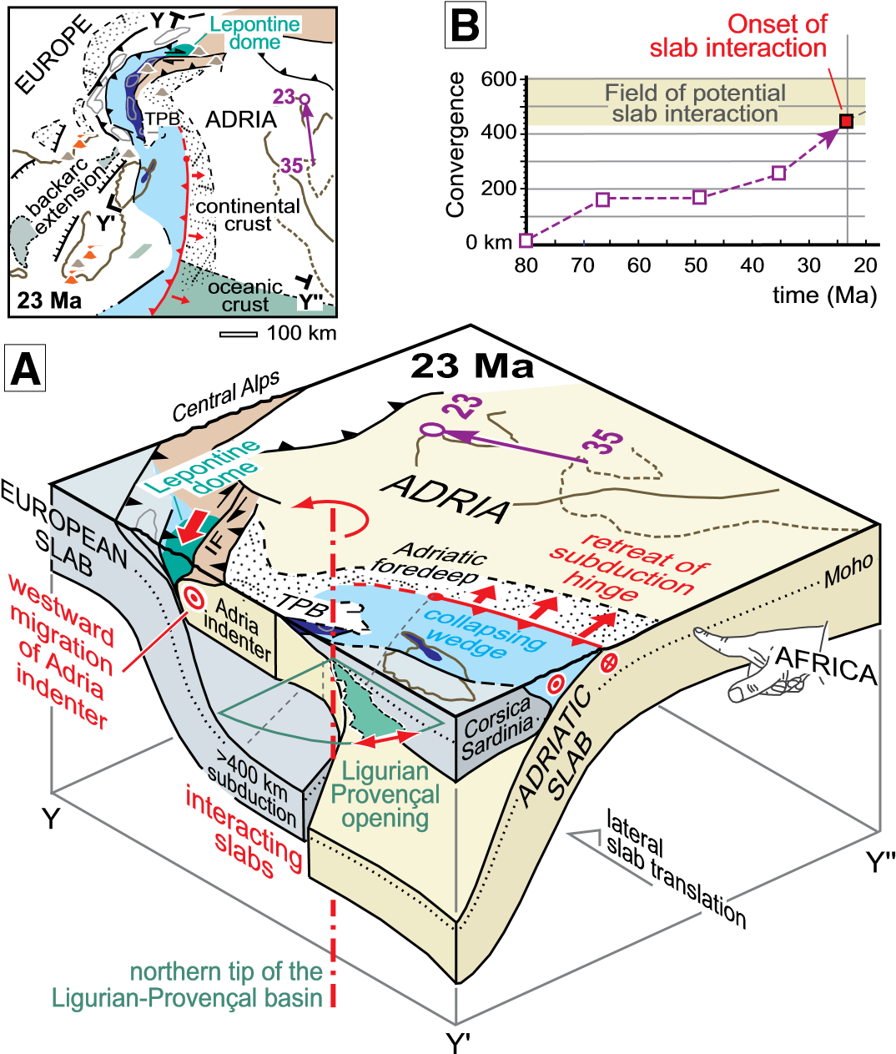

**Figure 3. A: Three-dimensional configuration of the interacting European and Adriatic slabs during the westward migration of the Adriatic indenter, the onset of slab retreat, and the scissor-type opening of the Ligurian-Provençal basin (no vertical exaggeration; see location in the palinspastic map on top left; from Malusà et al., 2015). IF— Insubric fault; TPB—Tertiary Piedmont Basin; purple arrows show trajectories of Adria motion relative to Europe (numbers are age in Ma). B: Convergence history at the Central Alps trench (based on Malusà et al., 2015) as compared with the amount of convergence required for slab interaction.**

at the northern tip of the Ligurian-Provençal basin, in agreement with paleomagnetic data (Gattacceca et al., 2007). On the basis of the new time constraints for the strike-slip motion along the Insubric fault, we propose that the position of such a rotation axis was controlled by the interaction at depth between the European slab to the north and the Adriatic slab to the south. These two slabs possibly collided at depth by the end of the Oligocene, hindering the northward propagation of the Adriatic indenter and triggering its westward shift beneath the Central Alps (Fig. 3A).

The proposed geodynamic scenario can be tested by using available plate motion constraints and recent palinspastic reconstructions (Malusà et al., 2015, 2016b). Low-temperature thermochronology data from CorsicaSardinia (Malusà et al., 2016b) indicate that the northern tip of the Adriatic slab was located offshore northern Corsica at ca. 23 Ma. Therefore, during Alpine subduction, ~300 km separated the Central Alps trench from the northern tip of the Adriatic slab to the south. This requires at least >400 km convergence at the Central Alps trench in order to account for both the vertical and horizontal components of subduction, before having a possible interaction between the south-dipping European slab and the west-dipping Adriatic slab. Figure 3B shows that the amount of convergence estimated at the Central Alps trench during the past 80 m.y. is fully consistent with this requirement.

|  |
| --- |
| **GEOLOGY** | Volume 44 | Number 2 | www.gsapubs.org **157** |

The interaction between the European and Adriatic slabs proposed herein explains not only the sudden westward shift of the Adriatic indenter, but also (1) the location of the Corsica-Sardinia rotation pole inferred on the basis of paleomagnetic data; (2) the location of the northern tip of the fan-shaped Ligurian-Provençal basin; and (3) the forelandward propagation of Alpine deformation in the Neogene, when convergence was no longer accommodated along the Alpine trench because of slab interaction at depth.

# SUMMARY AND CONCLUSIONS

Detrital zircon U-Pb geochronology on Adriatic foredeep turbidites constrains both the age of the westward shift of the Adriatic indenter beneath the Central Alps and the associated strike-slip motion along the Insubric fault to ca. 24–23 Ma. Therefore, right-lateral slip on the northern boundary of the Adriatic microplate was coeval with trench retreat in the Apennines and with scissor-type backarc opening in the LigurianProvençal basin. This requires a near-vertical rotation axis at the northern tip of the Ligurian-Provençal basin, consistent with paleomagnetic data, and possibly controlled by the interaction at depth between the European and the Adriatic slabs. Our results provide new pinpoints to the recent geodynamic reconstructions of the Western Mediterranean, and confirm that detrital zircon U-Pb geochronology can be successfully employed to investigate the link between surface and deep-seated tectonic processes in complex geodynamic settings.

## ACKNOWLEDGMENTS

We thank J.A. Spotila, P.G. DeCelles, A. Leier, and an anonymous reviewer for their insightful comments, G. Ottria for assistance during sampling, L. Stockli and S. Seaman for help with laboratory procedures, and the Jackson School of Geoscience (University of Texas at Austin) for providing financial support to the project.

## REFERENCES CITED

Catanzariti, R., Ottria, G., and Cerrina Feroni, A., 2002, Carta Geologico-Strutturale dell’Appennino Emiliano-Romagnolo: Tavole Stratigrafiche: Florence, Italy, SELCA: Pisa, Italy, Servizio Geologico, Sismico e dei Suoli, Istituto di Geoscienze e Georisorse del Consiglio Nazionale delle Ricerche, 92 p., scale 1:250,000.

Dewey, J.F., Helman, M.L., Turco, E., Hutton, D.H.W., and Knott, S.D., 1989, Kinematics of the western Mediterranean, *in* Coward, M.P., et al., eds., Alpine tectonics: Geological Society of London Special Publication 45, p. 265–283, doi: 10.1144 /GSL .SP .1989 .045 .01.15.

Faccenna, C., Becker, T.W., Lucente, F.P., Jolivet, L., and Rossetti, F., 2001, History of subduction and back arc extension in the central Mediterranean: Geophysical Journal International, v. 145, p. 809–820, doi:10.1046/j.0956 -540x .2001 .01435.x.

Garzanti, E., and Malusà, M.G., 2008, The Oligocene Alps: Domal unroofing and drainage development during early orogenic growth: Earth and Planetary Science Letters, v. 268, p. 487–500, doi:10.1016/j.epsl.2008.01.039.

Gattacceca, J., Deino, A., Rizzo, R., Jones, D.S., Henry, B., Beaudoin, B., and Vadeboin, F., 2007, Miocene rotation of Sardinia: New paleomagnetic and geochronological constraints and geodynamic implications: Earth and Planetary Science Letters, v. 258, p. 359–377, doi:10.1016/j.epsl.2007.02.003.

Handy, M.R., Schmid, S.M., Bousquet, R., Kissling, E., and Bernoulli, D., 2010, Reconciling plate-tectonic reconstructions of Alpine Tethys with the geological-geophysical record of spreading and subduction in the Alps: EarthScience Reviews, v. 102, p. 121–158, doi:10.1016/j.earscirev.2010.06.002.

Jolivet, L., Faccenna, C., Goffé, B., Burov, E., and Agard, P., 2003, Subduction tectonics and exhumation of high-pressure metamorphic rocks in the Mediterranean orogens: American Journal of Science, v. 303, p. 353–409, doi: 10.2475 /ajs .303.5.353.

Malusà, M.G., and Balestrieri, M.L., 2012, Burial and exhumation across the Alps-Apennines junction zone constrained by fission-track analysis on modern river sands: Terra Nova, v. 24, p. 221–226, doi:10.1111/j.1365 -3121 .2011 .01057.x.

Malusà, M.G., Villa, I.M., Vezzoli, G., and Garzanti, E., 2011, Detrital geochronology of unroofing magmatic complexes and the slow erosion of Oligocene volcanoes in the Alps: Earth and Planetary Science Letters, v. 301, p. 324– 336, doi:10.1016/j.epsl.2010.11.019.

Malusà, M.G., Carter, A., Limoncelli, M., Villa, I.M., and Garzanti, E., 2013, Bias in detrital zircon geochronology and thermochronometry: Chemical Geology, v. 359, p. 90–107, doi:10.1016/j.chemgeo.2013.09.016.

Malusà, M.G., Faccenna, C., Baldwin, S.L., Fitzgerald, P.G., Rossetti, F., Balestrieri, M.L., Danišík, M., Ellero, A., Ottria, G., and Piromallo, C., 2015, Contrasting styles of (U)HP rock exhumation along the Cenozoic Adria-Europe plate boundary (Western Alps, Calabria, Corsica): Geochemistry, Geophysics, Geosystems, v. 16, p. 1786–1824, doi:10.1002/2015GC005767.

Malusà, M.G., Resentini, A., and Garzanti, E., 2016a, Hydraulic sorting and mineral fertility bias in detrital geochronology: Gondwana Research, doi: 10.1016 /j .gr .2015 .09.002.

Malusà, M.G., Danišík, M., and Kuhlemann, J., 2016b, Tracking the Adriatic-slab travel beneath the Tethyan margin of Corsica-Sardinia by low-temperature thermochronometry: Gondwana Research, doi:10.1016/j.gr.2014.12.011.

Merle, O., Cobbold, P.R., and Schmid, S., 1989, Tertiary kinematics in the Lepontine dome, *in* Coward, M.P., et al., eds., Alpine tectonics: Geological Society of London Special Publication 45, p. 113–134, doi:10.1144/GSL. SP .1989

.045.01.06

Rosenberg, C.L., 2004, Shear zones and magma ascent: A model based on a review of the Tertiary magmatism in the Alps: Tectonics, v. 23, TC3002, doi:

10.1029 /2003TC001526.

Schmid, S.M., Aebli, H.R., Heller, F., and Zingg, A., 1989, The role of the Periadriatic Line in the tectonic evolution of the Alps, *in* Coward, M.P., et al., eds., Alpine tectonics: Geological Society of London Special Publication 45, p. 153–171, doi:10.1144/GSL.SP.1989.045.01.08.

Steck, A., and Hunziker, J., 1994, The Tertiary structural and thermal evolution of the Central Alps—Compressional and extensional structures in an orogenic belt: Tectonophysics, v. 238, p. 229–254, doi:10.1016/0040-1951(94)90058-2.

Tremolada, F., Guasti, E., Scardia, G., Carcano, C., Rogledi, S., and Sciunnach, D., 2010, Reassessing the biostratigraphy and the paleobathymetry of the Gonfolite Lombarda Group in the Como area (northern Italy): Rivista Italiana di Paleontologia e Stratigrafia, v. 116, p. 35–49.

Vermeesch, P., 2012, On the visualisation of detrital age distributions: Chemical Geology, v. 312, p. 190–194, doi:10.1016/j.chemgeo.2012.04.021.

Wortel, M.J.R., and Spakman, W., 2000, Subduction and slab detachment in the Mediterranean-Carpathian region: Science, v. 290, p. 1910–1917, doi: 10.1126 /science .290 .5498 .1910.

Zanchetta, S., Malusà, M.G., and Zanchi, A., 2015, Precollisional development and Cenozoic evolution of the Southalpine retrobelt (European Alps): Lithosphere, v. 7, p. 662–681, doi:10.1130/L466.1.

Zwingmann, H., and Mancktelow, N., 2004, Timing of Alpine fault gouges: Earth and Planetary Science Letters, v. 223, p. 415–425, doi:10.1016/j .epsl .2004 .04.041.

Manuscript received 3 October 2015

Revised manuscript received 11 December 2015

Manuscript accepted 14 December 2015

Printed in USA

**158** www.gsapubs.org | Volume 44 | Number 2 | **GEOLOGY**

1. GSA Data Repository item 2016040, sample locations, detailed analytical methods, and raw U-Pb data, is available online at www.geosociety.org/pubs/ ft2016 .htm, or on request from editing@geosociety.org or Documents Secretary, GSA, P.O. Box 9140, Boulder, CO 80301, USA.

   **156** www.gsapubs.org | Volume 44 | Number 2 | **GEOLOGY**