*156* S.Afr.J.Geol.,2000,103(2), 156—161

**Ages ofdetrital zircon grains from Neoproterozoic siliciclastic rocks in the Shakawe area: implications for the evolution ofProterozoic crust in northern Botswana**

R.B.M. Mapeo and A.B. Kampunzu

Department ofGeology, University ofBotswana, Private Bag 0022, Gaborone, Botswana E-mail: mapeorbm@mopipi.ub.bw; kampunzu@mopipi.ub.bw

R.A. Armstrong

Research School of Earth Sciences, Australian National University, Canberra, ACT, Australia

E-mail: prise.armstrong@anu.edu.au

*Accepted 21st June 2000*

**Abstract**— The Precambrian rocks of northern Botswana comprise poorly exposed igneous complexes, high-grade metamorphic rocks, as well as sedimentary sequences including mainly siliciclastic and carbonate rocks. New U—Pb SHRIMP data are presented for detrital zircons from siliciclastic rocks collected from the Shakawe area in northern Botswana. These data show three main age groups at *c.* 1020 Ma, 1090 Ma, and 2050 Ma which support contentions for local provenance of the sediments. They also fix the maximum age ofthe deposition of these siliciclastic rocks at 1020 Ma. The results support field evidence suggesting that the siliciclastic rocks exposed in the Shakawe zone are part of the Ghanzi—Chobe Super-

group.

# Introduction

The Neoproterozoic Ghanzi—Chobe Supergroup of Botswana

(Figure 1) is a lateral equivalent of the Damara Supergroup of Namibia and the Katangan Supergroup ofCongo and Zambia. Sedimentary sequences of the Ghanzi—Chobe Supergroup start with a major basal conglomerate, unconformably overlying older units, such as Kibaran-age bimodal volcanic rocks termed the Kgwebe volcanic sequence (Kampunzu et *al.,* 1998 and references therein). Previous U—Pb zircon dating of the Kgwebe rhyolites yielded an age of 1106 ±2 Ma (Schwartz *et at.,* 1996) which was taken as the maximum age of the Ghanzi—Chobe Supergroup. However, in Congo, the Katangan Supergroup basal units contain detrital minerals from *c.* 880 Ma granites (Armstrong *et* at., 1999). The basement rocks in the Katangan basin are well exposed and therefore have been extensively documented (Cahen *et at.,* 1984). In contrast, Precambrian rocks are poorly exposed within the Kalahari Desert and therefore the age of crustal terranes in northwest Botswana is still poorly documented. Clastic sedimentary rocks and related detrital zircons can provide powerful information on source regions *(e.g.* Compston and Pidgeon, 1986; Machado *et at.,* 1996). The aim of this paper is therefore to present new SHRIMP U—Pb ages of detrital zircon grains from siliciclastic rocks from northern Botswana and to considerthe implications for Proterozoic crustal evolu-

tion in the region.

# Geological setting and rock description

The Neoproterozoic Ghanzi—Chobe Supergroup includes three terranes from south to north (Figure 1): Ghanzi, Rooibok, and Xaudum (Carney *et* at., 1994; Key and Ayers, 1998). These terranes are tectonically bounded and their lithostratigraphic relationships are still under investigation. Older basement complexes in northern Botswana include: (1) Mesoproterozoic Kibaran-age granitoids (Kampunzu *et at.,*

1999) and a bimodal volcanic sequence termed the Kgwebe metavolcanic rocks (Kampunzu *et* at., 1998). Small bodies and dykes of Mesoproterozoic granitoids have been discovered at the southwest margin of the Zimbabwe Craton in eastem Botswana (Van de Wel *et* at., 1998), but their link with the Kibaran-age rocks reported here is not known. (2) Palaeoproterozoic rocks with U—Pb zircon ages of c. 2.05 Ga. These rocks are granitoids and rhyolites in the Okwa valley, western Botswana (Ramokate *et* at., 2000), granitoids in the Qangwa area, northern Botswana (Hanson *et al.,* 1 998a), and granulite-facies rocks including kizingitic garnet—sillimanite gneiss in the Gweta region, northeast Botswana (Mapeo, R.B.M., Armstrong, R.A. and Kampunzu, A.B., unpublished data).

The clastic sedimentary rock sample selected for U—Pb SHRIMP zircon investigation, IPP-97/1, was collected from a pit dug for water in the Shakawe area (Figure 1; GPS co-ordinates *18°23’50”*S, 21°l7’25.6”E). Rocks recovered from various pits in the area represent supracrustal siliciclastic sequences of immature sedimentary rocks (mainly conglomeratic sandstones and arkosic sandstones) associated with more mature sedimentary rocks (grey sandstones, siltstones, and shales). Cross bedding has been observed in several samples. None of the rocks show evidence of metamorphism, which suggests that these siliciclastic rocks could be part of

the Ghanzi—Chobe Supergroup. A strong tectonic fabric (mylonitic foliation and related lineation) has been observed in some samples from burrow pits and open wells, but we were not able to document the geometry and the geographic extent of this fabric due to absence of outcrops.

The sample IPP-97/1 selected for dating is an immature coarse arkosic sandstone. The rock is medium to coarse grained intexture with layering defined by graded bedding. It contains angular fragments of monocrystalline and polycrystalline quartz (lithic fragments), subhedral feldspar (mainly plagioclase), haematite, zircon, titanite, and epidote grains. Epidote is formed from the breakdown of feldspars and is localized along fractures. The rock is highly fractured with a well-defined proto-mylonitic fabric, with secondary micas developed along the shear bands. The occurrence of abundant subhedral feldspar grains along with angular quartz implies relatively short sedimentary transport distances. Therefore, we infer that the age of detrital zircons in this sample should

Downloaded from http://pubs.geoscienceworld.org/gssa/sajg/article-pdf/103/2/156/2958198/156_Mapeo_et_al.pdf by Nanjing University user

S.Afr.J.Geol.,2000,103(2) 157

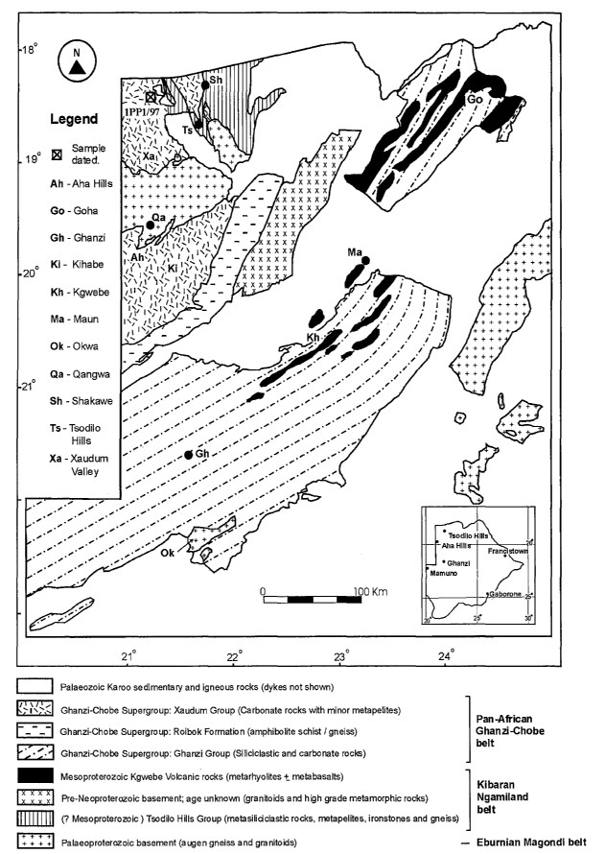

**Figure 1** Geological map of northern Botswana, modified from Camey *et al.* (1994) and Key and Ayers (1998).

mainly constrain the age of the local crustal source of these standard heavy liquid and Frantz isodynamic separation techclastic sedimentary rocks. niques in a clean laboratory. The final concentrate was hand-

picked under a binocular microscope and the zircon grains

**Analytical techniques** were mounted in epoxy together with the zircon standard AS3

The sample was crushed and the zircons separated using (Duluth Complex gabbroic anorthosite; Paces and Miller,

Downloaded from http://pubs.geoscienceworld.org/gssa/sajg/article-pdf/103/2/156/2958198/156_Mapeo_et_al.pdf by Nanjing University user

158 S.Afr.J.Geol.,2000,103(2)

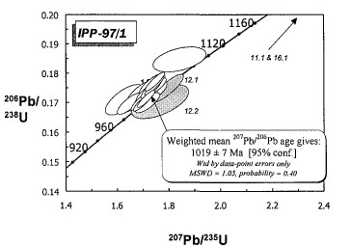1989) and the standard SL13 of the Research School of Earth Sciences, Australian National University. The grains were then sectioned approximately in half, polished and photographed. Cathodoluminescence imaging on a scanning electron microscope was carried out prior to the analyses to aid in the selection of the best target areas for the analyses. The SHRIMP data have been reduced in a manner similar to that described by Williams and Claesson (1987) and Compston *et al.* (1992). U/Pb inthe unknowns were normalized to a 2o6*pb/

238U value of 0.1859 (equivalent to an age of 1099.1 Ma) for AS3. The U and Th concentrations were determined relative to those measured in the SL 13 standard. Ages were calculated

207 206 using the radiogenic Pb/ Pb ratios, with the correction for

204 common Pb made using the measured Pb and the appropriate common Pb composition, assuming the model of Cum-

ming and Richards *(1975).* Uncertainties in the isotopic ratios and ages in the data table (and in the error boxes for the plotted data) are reported at the 1~level, but unless otherwise stated inthe text, the final weighted mean ages are reported as *95%* confidence limits, with all statistical analyses and calculations done using the Isoplot/Ex software (Ludwig, 1998).

# Results

The sample yielded abundant zircon grains which are generally light pink in colour and of variable shape and form. Few grains have sharp crystal faces preserved. More commonly, zircon grains have slightly rounded terminations but with quite well-preserved crystal forms and angular shape (Figure 2). Many of the mounted angular grains are fragments of originally larger crystals. The form and shape of the zircon grains support a short sedimentary transport distance of the grains and provenance from a source area close to the basin, as inferred above on the basis of the angular shape of quartz crystals and the preservation of a large amount of subhedral feldspar. There are no metamorphicmultifaceted grains in the population of zircons. Cathodoluminescence imaging shows that most of the zircons have very well-developed composi-

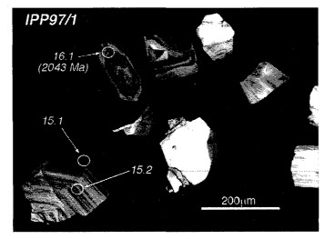

Figure 2 Cathodoluminescence images of a selection of zircons from sample IPP-97t1. The numbers refer to the analysis as recorded in Table 1. Note the typical magmatic zoning preserved in grains 15 and 16. Analysis 15.1 yields a Mesoproterozoic age whereas analysis 16.1 gives a Palaeoproterozoic age.

**Figure 3** U—Pb concordia plot of SHRIMP analyses for sample

IPP-97/I. The analyses of the Palaeoproterozoic detrital zircons plot off-scale on this diagram. These analyses, as well as the two analyses from grain 12 (12.1 and 12.2), were excluded from the age calculation. The concordia is calibrated in Ma.

tional zoning, consistent with an igneous origin. Cores of inherited zircon are also common. A second discrete popula-

tion of zircons were found during analysis (see below), these being impossible to detect petrographically as they also have good igneous zoning, similar to the zircons of the first group (Figure 2).

Twenty-five analyses were done on sixteen different grains to get a comprehensive picture of the zircon geochronology. The sample was analysed on SHRIMP II and all results are reported in Table 1 and are plotted on a standard Wetherill U— Pb concordia diagram in Figure 3.

The zircons show a large range in U and Th concentrations and isotopic compositions, but statistical analysis of the data

permits the identification of sub-populations within the sediment. The majority of the analyses plot on concordia with

207pb/206Pb

ages falling into a narrow range between 936 ±44

Ma and 1056 ±23 Ma (lty errors). These can be combined as

207 6 a group with a statistically robust weighted mean PbP° Pb age of 1019 ±7 Ma (N 21; MSWD = 1.05; Prob. = 0.40).

Whether or not there are two or more sub-populations within this group of analyses is impossible to determine from this data set, as there are no obvious physical or geochemical criteria for identifying such sub-populations. In calculating a maximum age of sedimentation for this rock, there are two possibilities, namely the maximum age of the sediment is given by the youngest zircon analysed (936 ±88 Ma; 2o), or,

if all the zircons do indeed come from a single population,

207 then the maximum age is given by the weighted mean Pb/

206

Pb age of 1019 ±7 Ma (2cs). In the discussion of the maximum age of sedimentation we use this weighted mean, rather than the age of a single analysis which is an unreliable constraint.

A number of analyses fall outside this age group. The two analyses on grain 12 represent a second source of detrital zir-

cons which are slightly older than the main group but are still

207 6 of Mesoproterozoic age. The weighted mean PbP° Pbage for repeat analyses on this grain gives 1088 ±44 Ma (2~ uncertainties). Analyses 11.1 and 16.1 clearly show that there is a third, Palaeoproterozoic population of detrital zircons



Downloaded from http://pubs.geoscienceworld.org/gssa/sajg/article-pdf/103/2/156/2958198/156_Mapeo_et_al.pdf by Nanjing University user

S,Afr.J.Geol.,2000,103(2) 159

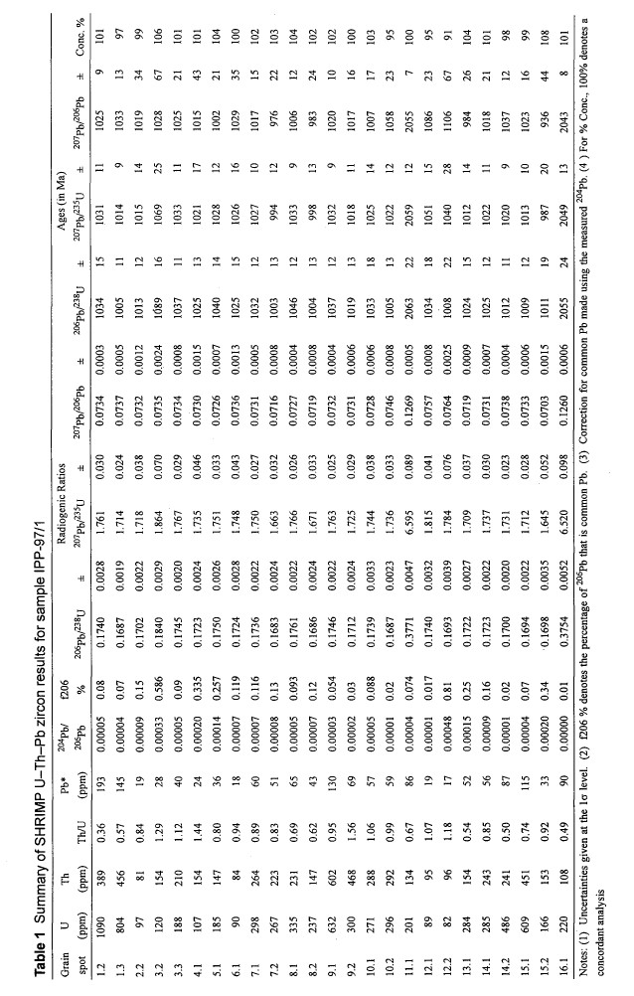

Downloaded from http://pubs.geoscienceworld.org/gssa/sajg/article-pdf/103/2/156/2958198/156_Mapeo_et_al.pdf by Nanjing University user

160 S.Afr.J.Geol.,2000,103(2)

207Pb/206Pb

giving ages of 2055 ±14 Ma and 2043 ±16 Ma respectively (2o).

# Geological implications

This study was conducted on a sample of immature, coarse arkosic sandstone composed of angular quartz and abundant subhedral feldspar grains. These features presumably indicate a short sedimentary transport distance of the grains. This is supported by the form and shape of detrital zircon grains extracted from sample IPP-97/1, and consequently provenance from a source area close to the basin is inferred for these siliciclastic rocks and the studied detrital zircons. Therefore, the U—Pb zircon ages presented in this paper could constrain the age ofthe main zircon-bearing lithologies in the local crustal source area of these clastic sedimentary rocks. The detrital zircons include three major populations, one of Palaeoproterozoic age at *c.* 2.05 Ga and two of Mesoproterozoic age at *c.* 1.09 Ga and 1.02 Ga. Assuming that these ages represent the whole spectrum of zircon-bearing lithologies in the provenance area of the sediments, these data indicate the presence of Palaeoproterozoic and Mesoproterozoicbasement complexes in that region. The basement complex exposed in northern Botswana is known to include rocks with U—Pb zircon ages fitting into these two groups and this provides support for the contention that the sediments were sourced locally. The dominant source of detrital zircons in these silici-

clastic rocks comprises rocks with ages between 1.1 and 1.0 Ga. Igneous rocks emplaced during this time range are part of the late Kibaran igneous event which represents a major crust-forming period in sub-equatorial Africa (e.g. Thomas and Eglington, 1990; Cornell *et al.,* 1996; Hanson *et al.,* l998b; Kampunzu *et al.,* 1998; 1999; Wareham *et al.,* 1998).

The absence within the zircon populations of Mesoproterozoic zircon within the age range 1.4 — 1.25 Ga (early-

Kibaran-age event) is important to stress. Granitoids with zircon ages in this range are known in central and southern

Africa, namely in the Choma—Kalomo block in southwest Zambia (Hanson et *al.,* 1988), in the Katangan province in southeast Congo (Cahen et *al.,* 1984), and in the Rehoboth area in Namibia (Hoal *et* al., 1989; Ziegler and Stoessel, 1993; Hoal and Heaman, 1995). The absence ofArchaeanzircon grains is also noteworthy. Either early Kibaran and Archaean rocks do not exist in northwest Botswana or they were not exposed to erosion during the deposition of the siliciclastic rocks located in the Shakawe area.

U—Pb detrital zircon studies around the world have shown that the youngest detrital zircon in clastic sedimentary rocks provides an older limit to deposition of the sedimentary sequence in the basin *(e.g.* Armstrong et *al.,* 1990; Krogh and Keppie, 1990). The youngest zircons analysed have an age of *c.* 1020 Ma, taken to provide the maximum age of deposition for the sedimentary sequence exposed in the Shakawe zone. Therefore, the deposition of these rocks happened after *c.*

1020 Ma and before 530 Ma, which is the age of the last deformation event within the Ghanzi—Chobe belt (Ramokate et *al,* 2000). This time range indicates that the siliciclastic rocks in the Shakawe zone are part of the Neoproterozoic Ghanzi—Chobe Supergroup sequence. This age range is broadly similar to that for deposition of sedimentary rocks in the Katangan belt. Therefore, our data support the correlation between the adjacent Neoproterozoic Ghanzi—Chobe and Katangan basins (Kampunzu and Cailteux, 1999), and provide a good basis for a regional correlation of Neoproterozoic

basins in central and southwestern Africa.

# Conclusions

This study on detrital zircon grains of an arkosic sandstone from the Shakawe zone shows that: (1) the maximum age of deposition of the sediments studied is *c.* 1020 Ma, whereas the minimum age is set by the last deformation event in the region at *c.* 530 Ma. These data imply that the siliciclastic rocks in the Shakawe zone are part of the Ghanzi—Chobe Supergroup; (2) the age spectrum of the detrital zircons enable the identification of two major crustal units as the source of the sedimentary rocks. A Palaeoproterozoic crustal component with U—Pb zircon age of *c.* 2.05 Ga and a late-Kibaran age component with U—Pb zircon age between *c.* 1.1 — 1.0 Ga. These results are consistent with a local origin for the sediments because the pre-Neoproterozoic basement exposed in northern Botswana includes Palaeoproterozoic and late Mesoproterozoic rock assemblages. The absence of both early Kibaran (1.4 — 1.25 Ga) and Archaean detrital zircons is

taken to suggest the absence of (exposed) rocks of these ages in northern Botswana during the deposition of the

Neoproterozoic siliciclastic rocks in the Shakawe zone.

# Acknowledgements

This paper is published with the permission of the Director,

Geological Survey Department (GSD) of Botswana. We are grateful to the GSD for logistical support during the fieldwork. This paper is a contribution to the Research Project ‘Kaapvaal Craton in Botswana’ and is also a contribution to the IGCP Project 418 and 419. R.B.M.M and A.B.K. acknowledge the support of the University of Botswana (Grant UB/R442). Reviews from B. Eglington and S. Master helped to improve the manuscript. Mr. O.T. Okatswa (Gabor-

one, Botswana) is thanked for the drawing of the line figures.

# References

Armstrong, R.A., Compston, W., De Wit, M.J. and Williams, IS. (1990). The stratigraphy of the 3.5 — 3.2 Ga Barberton greenstone belt revisited: a single zircon ion microprobe study. *Earth Planet. Sc Lett.,* **101, 90—106.** Armstrong, R.A., Robb, L.J., Master, S., Kruger, F.J. and Mumba, P.A.C.C.

(1999). New U—Pb age constraints on the Katangan Sequence, Central African Copperbelt. *.1. Afr Earth SeE., Spec. Abstr. Issue GSA 11,* **28, 6—7.**

Cahen, L., Snelling, N.J., Delhal, J., Vail, JR., Bonhomme, M. and Ledent, D. (1984). *The Geochronology and Evolution of Africa.* Clarendon Press, Oxford, U.K., 512 pp.

Carney, iN., Aldiss, D.T. and Lock, N.P. (1994). The geology ofBotswana. *Bull. Botswana Geol. Surv.,* **37,** 113 **pp.**

Compston, W. and Pidgeon, R.T. (1986). Jack Hills, evidence of more old detrital zircon in western Australia. *Nature,* **321, 766—769.**

Compston, W., Williams, IS., Kirschvink, J.L., Zhang, Z. and Ma, G. (1992). Zircon U—Pb ages for the Early Cambrian time-scale. *J. Geol. Soc. Land.,* **149, 171—184.**

Cornell, D.H., Thomas, Ri., Bowring, S.A., Armstrong, R.A. and Grantham, OH. (1996). Protolith interpretation in metamorphic terranes: a back arc environment with Besshi-type base metal potential for the Quha Formation, Natal Province, South Africa. *Precambrian Res., 77,* 243—271.

Cumming, G.L. and Richards, JR. (1975). Ore lead isotope ratios in a continuously changing Earth. *Earth Planet. Sci. Lett.,* **28,** *155—171.*

Hanson, RE., Wilson, Ti., Brueckner, H.K., Onstolt, T.C., Wardlaw, MS.,

Johns, CC. and Hardcastle, K.C. (1988). Reconnaissance geochronology, tectonothermal evolution and regional significance of the Middle

Downloaded from http://pubs.geoscienceworld.org/gssa/sajg/article-pdf/103/2/156/2958198/156_Mapeo_et_al.pdf by Nanjing University user

S.Afr.J.GeoI.,2000,103(2) 161

Proterozoic Choma—Kalomo block, southern Zambia. *Precambrian Res.,* 42, 39—61.

Hanson, RE., Singletary, Si., Martin, MW., Bowring, S.A., Key, R.M.,

Majaule, T., Mapeo, R.B.M., Ramokate, LV., Direng, B. and McMullan,

SR. (1998a). Geochronology of Proterozoic basement terranes in the Kalahari region of Botswana: progress report. *In:* McMullan, S., Paya, B. and Holmes, H. (Eds.), *Abstr. Vol. Int.. Conf on the role ala Natn. Geol. Surv. in Sustainable Dev., Gaborone, Botswana,* p. 137.

Hanson, RE., Martin, MW., Bowring, S.A. and Munyanyiwa, H. (l998b). U—Pb zircon age for the Umkondo dolerites, eastern Zimbabwe: 1.1 Ga large igneous province in southern Africa—East Antarctica and possible Rodinia correlations. *Geology,* 26, 1143—1146.

Hoal, B.G. and Heaman, L.M. *(1995).* The Sinclair sequence: U—Pb age constraints from Awasib Mountain area. *Comm. Geol. Surv. Namibia,* **10,** 83—9 1.

Hoal, B.G., Harmer, RE. and Eglington, B.M. (1989). Isotopic evolution of the middle to late Proterozoic Awasib mountain terrain in southern Namibia. *Precambrian Res.,* **45,** 175—189.

Kampunzu, A.B. and Cailteux, J. (1999). Tectonic evolution of the Lufilian

Arc (Central Africa Copperbelt) during Neoproterozoic Pan African Orogenesis. *Gondwana Res.,* 2,401—421.

Kampunzu, A.B., Akanyang, P., Mapeo, R.B.M., Modie, B.N. and Wendorif,

M. (1998). Geochemistry and tectonic significance ofthe Mesoproterozoic Kgwebe metavolcanic rocks in northwest Botswana: implications for the evolution ofthe Kibaran Namaqua—Natal belt. *Geol. Mag.,* 135, 669—683.

Kampunzu, A.B., Armstrong, R., Modisi, M.P. and Mapeo, RB. (1999). The Kibaran belt in southwest Africa: ion microprobe U—Pb zircon data and definition ofthe Kibaran Ngamiland belt in Botswana, Namibia and Angola. *J. Afr Earth Sci., Spec. Abstr. Issue GSA 11,* 28, 34.

Key, R.M. and Ayers, N. (1998). The 1998 edition of the National Map of

Botswana. *In:* McMuIIan, S., Paya, B. and Holmes, H. (Eds.), *Abstr. Vol.,*

*Int. Conf on the role of a Natn. Geol. Surv. in Sustainable Dev., Gaborone, Botswana, 45—46.*

Krogh,T.E. and Keppie, J.D. (1990). Age ofdetrital zircon and titanite in the Meguma Group, Southern Nova Scotia, Canada: clue to the origin of the Meguma terrain. *Tectonophysics,* 177, 307—323.

Ludwig, KR. (1998). Isoplot/Ex (version 1.00): A geochronological toolkit for Microsoft Excel. *Spec. Publ. Berkeley Geochron. Cent.,* **1, 43 pp.**

Machado, N., Schrank, A., Noce, CM. and Gauthier, G. (1996). Ages of detrital zircons from Archaean—Palaeoproterozoic sequences: implications for greenstone belt setting and evolution ofa Transamazonian foreland basin in Quadrilatero Ferrifero, south-eastern Brazil. *Earth Planet. Sci.*

Lett., 141, 259—276.

Paces, J.B. and Miller, iD. (1989). Precise U—Pb ages of Duluth Complex and related mafic intrusions, north-eastern Minnesota: geochronological insights to physical, petrogenic, paleomagnetic and tectonomagmatic

processes associated with the 1.1 Ga mid-continent rift system. J.

*Geophys. Res.,* 988, 13997—14013.

Ramokate, LV., Mapeo, R.B.M., Corfu, F. and Kampunzu, A.B. (2000). Proterozoic geology and regional correlation of the Ghanzi—Makunda area, western Botswana. *J. Afr. Earth Sci.,* **30,** 453—466.

Schwartz, MO., Kwok, Y.Y., Davis, D.W. and Akanyang, P. (1996). Geology, geochronology and regional correlation ofthe Ghanzi ridge,

Botswana. *S. Afr I Geol., 99,* 245—250.

Thomas, R.J. and Eglington, B.M. (1990). A Rb—Sr, Sm—Nd and U—Pb zircon isotope study of the Mzumbe Suite, the oldest intrusive granitoid in southern Natal, South Africa. *S. Afr I Geol.,* **93,** 76 1—765.

Van de Wel, L., Barton, J.M., Jr. and Kinny, PD. (1998). 1,02 Ga granite magmatism in the Tati Granite—Greenstone Terrane of Botswana:

implications for mineralisation and terrane evolution. *S. Afr J. Geol.,* **101,** 67—72.

Wareham, CD., Pankhurst, R.J., Thomas, Ri., Storey, B.C., Grantham, G.H., Jacobs, i. and Eglington, B.M. (1998). Pb, Nd and Sr isotope mapping ofGrenville-age crustal provinces in Rodinia. *J. Geol.,* **106,** 647— *659.*

Williams, I.S. and Claesson, S. (1987). Isotopic evidence for the Precambrian provenance and Caledonian metamorphism of high grade paragneisses

from the Seve Nappes, Scandinavian Caledonides. II. Ion microprobe zircon U—Th—Pb. *Contr. Miner Petrol., 97,* 205—2 17.

Ziegler, U.R. and Stoessel, G.F.U. (1993). Age determinations in the Rehoboth basement inlier, Namibia. *Mem. Geol. Sun’. Namibia,* **14, 106** pp.

Editorial handling: J.M. Barton, Jr.

Downloaded from http://pubs.geoscienceworld.org/gssa/sajg/article-pdf/103/2/156/2958198/156_Mapeo_et_al.pdf by Nanjing University user