Tectonophysics 57

[4](http://dx.doi.org/10.1016/j.tecto.2012.08.016)

[–](http://dx.doi.org/10.1016/j.tecto.2012.08.016)

575 (2012) 18

[1](http://dx.doi.org/10.1016/j.tecto.2012.08.016)

[–](http://dx.doi.org/10.1016/j.tecto.2012.08.016)

19

[2](http://dx.doi.org/10.1016/j.tecto.2012.08.016)

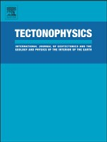

Contents lists available at

SciVerse ScienceDirec

[t](http://www.sciencedirect.com/science/journal/00401951)

Tectonophysics

journal homepage: www.elsevier.com/locate/tecto

Tectonostratigraphy and provenance of an accretionary complex within the Yarlung–Zangpo suture zone, southern Tibet: Insights into subduction–accretion processes in the Neo-Tethys

Fulong Cai a,⁎, Lin Ding a, Ryan J. Leary b, Houqi Wang a, Qiang Xu a, Liyun Zhang a, Yahui Yue a

a Key Laboratory of Continental Collision and Plateau Uplift, Institute of Tibetan Plateau Research, Chinese Academy of Sciences, Beijing 100101, China b Department of Geosciences, University of Arizona, Tucson, AZ 85721, USA

# a r t i c l e i n f o

Article history:

Received 28 March 2012

Received in revised form 7 August 2012

Accepted 12 August 2012 Available online 21 August 2012

Keywords:

Yarlung–Zangpo suture zone

Subduction

Accretion

Provenance

Tectonic evolution

1. Introduction

# a b s t r a c t

Accretionary complexes record critical information about the history of subduction and accretion along the southern margin of Asia prior to the India–Asia collision. This paper presents detailed field mapping, petrographic and detrital zircon U–Pb data from an accretionary complex within the Yalung–Zangpo suture zone, southern Tibet. From structurally higher to lower levels, the accretionary complex consists of a serpentinite mélange, the chert-matrix Tangga mélange, the mud-matrix Pomunong mélange, and the coherent Rongmawa Formation. The Tangga mélange consists of Late Triassic–Early Cretaceous abyssal chert and siliceous shale with blocks of chert and mafic to ultra-mafic rocks. The Tangga mélange was accreted beneath ophiolitic rocks during the Aptian. The Pomunong mélange consists of a Late Jurassic–Early Cretaceous hemipelagic siliceous shale and chert matrix with blocks from Early Permian seamounts and from Late Cretaceous trench-fill sandstones; it was accreted beneath the Tangga mélange after the Aptian but prior to 71 Ma. Structurally beneath these mélanges to the south, the uppermost Cretaceous Rongmawa Formation consists of turbiditic sandstone, pelagic chert, and siliceous shale and records a transition in depositional setting from lower abyssal plain to upper trench. Detrital zircons from sandstone blocks of the Pomunong mélange and the coherent Rongmawa Formation display similar U–Pb age spectra and are dominated by peaks at 71–231 Ma, 481–693 Ma, and 701–1372 Ma. These age peaks overlap with igneous crystallization ages and detrital zircon ages from sedimentary strata in the Lhasa terrane. Our data indicate that the serpentinite mélange, Tangga mélange, Pomunong mélange and Rongmawa Formation comprise a southwardyounging accretionary complex that developed during the northward subduction of Neo-Tethyan oceanic lithosphere beneath the south margin of the Lhasa terrane and that all exposed ophiolitic and accretionary complex assemblages were accreted to the Asian margin prior to the India–Asia continental collision.

© 2012 Elsevier B.V. All rights reserved.

Accretionary complexes record the processes of subduction and accretion of a consumed paleo-ocean (Chang et al., 2009; Raymond,

Prior to the India–Asia collision, Neo-Tethyan oceanic lithosphere was subducted northward beneath the southern margin of Asia (the Lhasa terrane). Early studies argued that Neo-Tethyan oceanic lithosphere was entirely consumed along this margin since Cretaceous time (Searle et al., 1987). An alternate model, however, proposes that the Neo-Tethyan oceanic lithosphere subducted along both an intra-oceanic subduction zone within the Neo-Tethys Ocean and an oceanic subduction zone beneath the southern margin of the Lhasa terrane during Cretaceous to Eocene time (Aitchison, 2000, 2007a). Better understanding of the age, provenance, and accretionary history of suture-zone rocks exposed along the Yarlung–Zangpo suture zone is required to reconcile these two conflicting models.

|  |
| --- |
| ⁎ Corresponding author. Tel.: +86 10 84097104. E-mail address: flcai@itpcas.ac.cn (F. Cai).  0040-1951/$ – see front matter © 2012 Elsevier B.V. All rights reserved.  <http://dx.doi.org/10.1016/j.tecto.2012.08.016> |

1984; Underwood and Moore, 1994). The Yarlung–Zangpo suture zone in southern Tibet contains accretionary complexes that represent relicts of the Neo-Tethys Ocean (Aitchison, 2000; Burg et al., 1987; Searle et al., 1987). Previous studies have classified this accretionary complex, from north to south, as serpentinite mélange, radiolarian intra-ophiolitic thrust sheets, and the Yamdrok mélange or wildflysh (Burg and Chen, 1984; Searle et al., 1987; Tapponnier et al., 1981). This complex is interpreted to have formed in an oceanic subduction zone beneath the southern margin of the Lhasa terrane (Searle et al., 1987); therefore these assemblages were first accreted to the Asian margin prior to being obducted onto the Indian-affinity Tethyan Himalayan margin during India–Asia collision (Burg and Chen, 1984; Ding et al., 2005; Searle et al., 1987; Tapponnier et al., 1981). More recently, the complex has been divided into the Zedong terrane, the Dazhuqu terrane, and the Bainang terrane (Aitchison, 2000), interpreted to have formed in an intra-oceanic arc and subduction zone setting, prior to being obducted onto the Tethyan Himalayan margin during the Eocene (Aitchison, 2000, 2007a). This model requires the juxtaposition of at least two individual accretionary complexes corresponding to the two postulated subduction zones (one beneath the Asian continental margin and the other within the Neo-Tethys Ocean).

In this study, we conducted field mapping, petrologic analysis, and U–Pb detrital zircon provenance studies on accretionary complex rocks exposed along the Yarlung–Zangpo suture zone in southcentral Tibet. Our goals were to define the lithostratigraphy, age, provenance and accretionary history of the units present and thereby provide insights into the subduction history of the Neo-Tethys Ocean. 2. Geological setting

The study area consists of three major tectonic elements from north to south: the Lhasa terrane of the southern Asian continental margin; Neo-Tethyan oceanic rocks exposed within the Yarlung– Zangpo suture zone, and Indian-affinity passive continental margin strata of the northern Tethyan Himalaya (Figs. 1 and 2).

The Lhasa terrane is composed primarily of the Gangdese arc in the south and sedimentary and igneous rocks in the north. The Gangdese arc consists of Cretaceous (and locally older Mesozoic) to Early Cenozoic calc-alkaline granitoids (Chu et al., 2006; Debon et al., 1986; Zhu et al., 2011a) and 43–68 Ma nonmarine volcanic sequences of the Linzizong Group (He et al., 2007). Scarce sedimentary rocks of Late Triassic to Late Cretaceous age are also exposed within the Gangdese arc. The geochemistry of the Lower Cretaceous adakite-like Sangri Group suggests that arc magmatism, and by inference northward subduction of the Neo-Tethyan oceanic lithosphere, initiated by Early Cretaceous time (Zhu et al., 2009a). The northern Lhasa terrane exposes mainly Upper Paleozoic to Cenozoic sedimentary strata with volcanic interbeds and Late Jurassic to Early Cretaceous granites (Kapp et al., 2003; Volkmer et al., 2007). The Lhasa terrane was significantly shortened by thrusting and likely achieved substantial elevation prior to the India–Asia collision (Ding and Lai, 2003; Kapp et al., 2003, 2005, 2007; Murphy et al., 1997; Volkmer et al., 2007). The Xigaze forearc basin is exposed along the southern margin of Lhasa terrane and consists of Albian– Maastrichtian marine strata (Wan et al., 1997) that are locally overlain unconformably by the Paleocene Tso-jiangding Group (Ding et al., 2005). Detrital zircon and stratigraphic studies suggest that these sediments were mainly derived from the southern Asian continental margin (Dürr, 1996; Wu et al., 2010).

The Yarlung–Zangpo suture zone exposes Late Jurassic to Early Cretaceous back arc and/or intraoceanic arc-affinity ophiolites (Bedard et al., 2009; Dubois-Côté et al., 2005; Hébert, et al., 2011; Liu et al., 2010; Malpas et al., 2003) in the north and several accretionary mélange units structurally below the ophiolites in the south. A serpentinite mélange is exposed structurally beneath the ophiolitic rocks and includes fragments of a metamorphic sole (Guilmette et al., 2009). The serpentinite melange in turn structurally overlies a mud-matrix mélange to the south, which consists of a Late Triassic to Early Cretaceous matrix that envelops weakly deformed sedimentary blocks of Permian to Cretaceous age (Wang et al., 1999). Late Jurassic to Early Cretaceous island-arc volcanic rocks are exposed in the Zedong area ~300 km to the east of Xigaze (Aitchison et al., 2007b; McDermid et al., 2002). The Eocene to Miocene (Wei et al., 2011) Liuqu Conglomerate is the youngest unit exposed in the suture zone; it is thought to be either (1) related to obduction of oceanic rocks onto the Tethyan Himalayan margin prior to the India–Asia collision (McDermid et al., 2002) or (2) post-collisional, in that it includes detritus derived from both the deformed Xigaze forearc basin to the north and the Tethyan Himalaya to the south (Wang et al., 2010).

South of the suture zone are the Paleozoic to Eocene strata of the northern Tethyan Himalaya that were deposited on the distal continental margin of India (Ding et al., 2005; Liu and Einsele, 1994; Willems et al., 1996; Yin, 2006).

## 3. Tectonostratigraphic units

Suture-zone rock units in the Ngamring area of south-central Tibet are juxtaposed by a series of regional-scale N-dipping thrust faults/ shear zones and can be divided into several tectonostratigraphic units (Figs. 3 and 4).

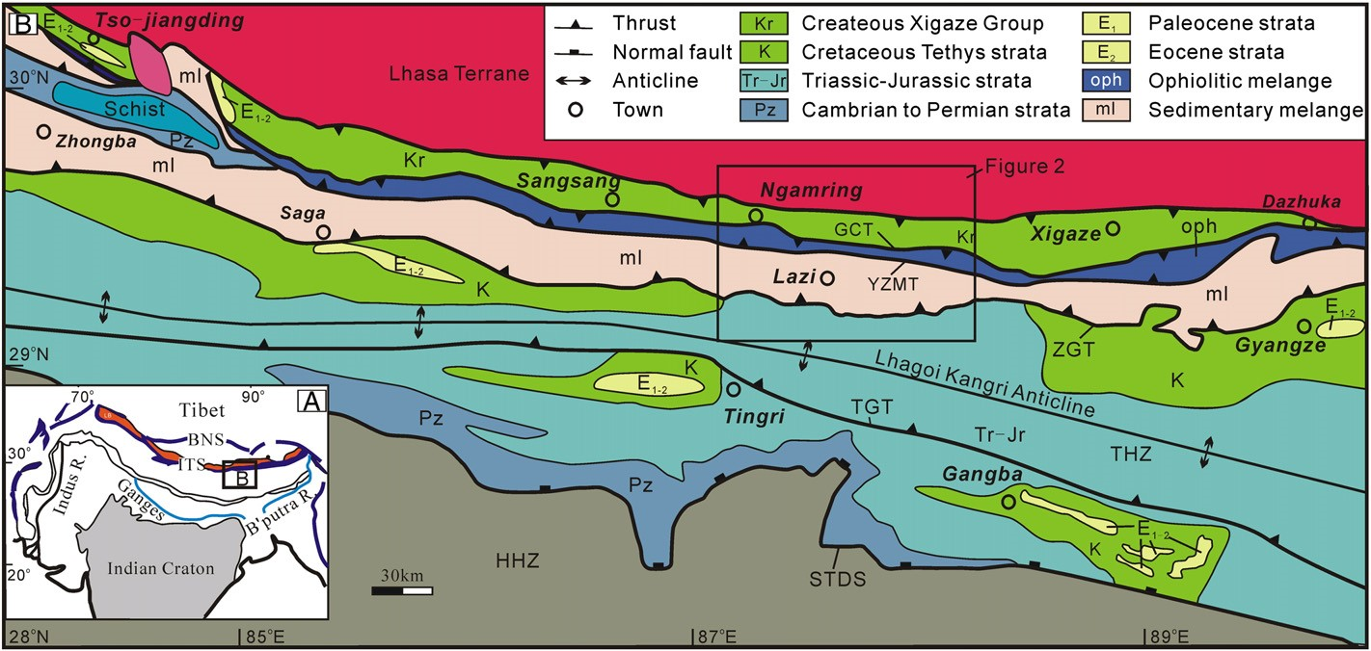

Fig. 1. Simplified geological map of south-central Tibet. GCT = Great counter thrust, YZMT = Yarlung–Zangbo mantle thrust, ZGT = Zhongba–Gyangze thrust, STDS = South Tibetan detachment system, THS = Tethys Himalaya sequence, GHS = Greater Himalaya sequence. Position of Fig. 2 is marked. After Ding et al. (2005).

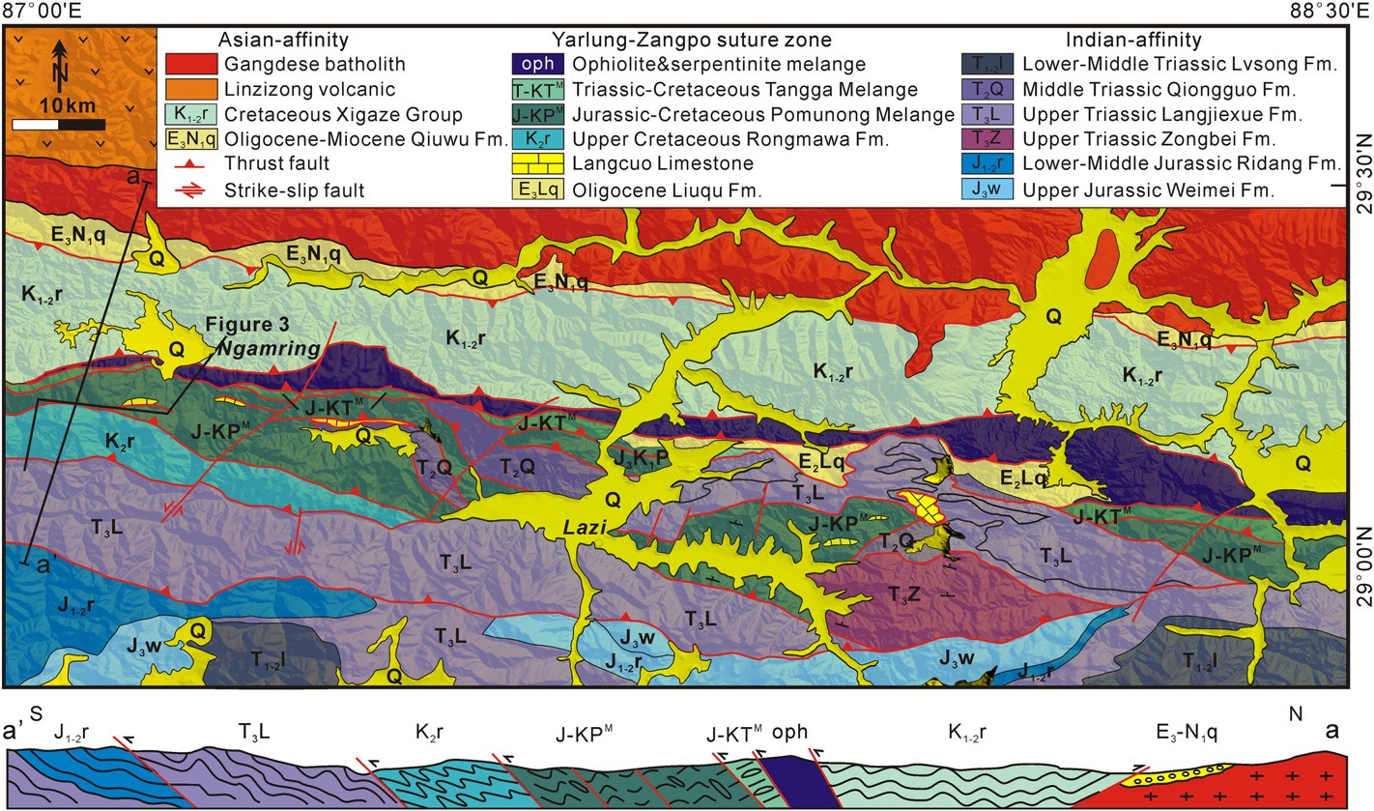

Fig. 2. Simplified geologic map of south-central Tibet in the Lazi–Ngamring area. Position of Fig. 3 is marked.

### 3.1. Lithologies of the serpentinite-matrix mélange

The Yarlung–Zangpo ophiolite is composed of chert and minor turbidites, volcanic rocks and volcaniclastic tuffs, gabbroic and diabase rocks, and harzburgites and dunites. Radiolarian biostratigraphy indicates that the pelagic chert was deposited during the Late Barremian to Late Aptian (Girardeau et al., 1984). Zircons from the gabbros yielded ages ranging from 120 Ma to 126 Ma in the Xigaze area (Malpas et al., 2003).

The serpentinite-matrix mélange is fault-bounded against the ophiolitic belt in north and the Late Triassic to Early Cretaceous red radiolarian

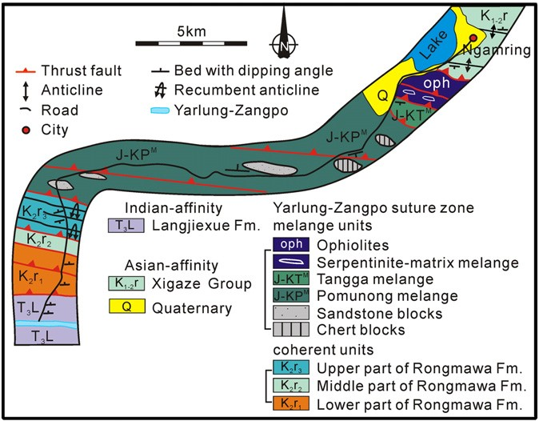

Fig. 3. Detailed structural maps of the accretionary complex in Ngamring area.

chert in south (Figs. 2 and 3). Its exposed width varies from several hundred meters to several kilometers. Strongly deformed serpentinite and peridotite make up the matrix between meter- to kilometer-scale blocks of quartzite, chert, amphibolite, mafic to ultramafic rocks.

### 3.2. Mud-matrix mélange

The mud-matrix mélange consists of limestone, sandstone, and chert blocks enclosed in mudstone, chert, and sandstone matrix. No ultramafic or ophiolitic blocks were found. The age of the matrix ranges from Late Triassic to Early Cretaceous whereas the sedimentary blocks range from Permian to Late Cretaceous in age (Li and Shen, 2005; Zhu et al., 2005). We divide this mélange on the basis of the matrix composition into the chert-rich Tangga mélange and the mud-rich Pomunong mélange (Figs. 3 and 4).

#### 3.2.1. Lithologies of the Tangga mélange

The Tangga mélange is exposed in a zone immediately south of, and in N-dipping fault contact with the serpentinite-matrix mélange. It consists of multi-colored radiolarian chert, siliceous shale, and locally alkaline basalt and tuff matrix (Fig. 5A) that surround blocks of chert, basalt, and gabbro. Radiolarian fossils indicate a Late Triassic to Early Cretaceous age (Zhu et al., 2005; Ziabrev et al., 2004). The Tangga mélange is equivalent to the Bainang terrane of Aitchison (2000) and the radiolarian intra-ophiolitic thrust sheets described by Tapponnier et al. (1981).

#### 3.2.2. Lithologies of the Pomunong mélange

The Pomunong mélange is located south of, and structurally beneath the Tangga mélange. The matrix of the Pomunong mélange is composed of highly sheared red radiolarian chert and siliceous shale with pervasive cleavage; it contains no terrigenous clastic material. Blocks are composed of massive sandstone (Fig. 5B), limestone,

|  |
| --- |
| Fig. 4. Time-space plot showing progressive assembly of lithotectonic units along the YZSZ. Gangrinboche conglomerates — DeCelles et al., 2011; Liuqu conglomerates — Wei et al., 2011; Linzizong — He et al., 2007; Tso-jiangding — Ding et al., 2005, Forearc — Wang et al., 2012; Gangdese arc — Chu et al., 2006; Ji et al., 2009; Zhu et al., 2011a, b; Ophiolite and ophiolite complex — Girardeau et al., 1984; Malpas et al., 2003; Tangga and Pomunong mélange — Zhu et al., 2005 and this paper; Trench basin — this paper; Blueschist — Ding et al., 2005; Seamount — this paper; Foreland basin — Ding et al., 2005; Indian passive continental margin — Willems et al., 1996; Yin and Harrison, 2000. |

chert, and volcanic rocks. Radiolarian fossils in the matrix suggest a Late Jurassic to Early Cretaceous age (Zhu et al., 2005).

The Langcuo limestone is found in fault-bounded blocks within the Pomunong mélange and is best exposed along the north side of the Langcuo Lake near Lazi (Fig. 5C), implying that this unit is allochthonous. The Langcuo limestone consists of purple limestone deposited directly on basalt. The presence of corals, fusulinids, and brachiopods within the limestone indicates an Early Permian age (Li and Shen, 2005).

### 3.3. Lithologies of the Rongmawa Formation

The Rongmawa Formation, first defined in this paper, is faultbounded between the Pomunong mélange to the north and the Triassic Tethyan Himalayan strata to the south. The Rongmawa Formation is roughly 2.5 km thick and is divided into three parts (Fig. 5D). The lower part of the section consists of multi-colored chert with basalt interbeds. The middle part of the section is composed of red and green siliceous mudstone deposited conformably on the top of the lower section. The upper part of the section consists predominantly of thick-bedded sandstone and black shale. Its contact with the middle part of the section was not observed in the field. Sedimentary structures in the upper part of the section such as channels (Fig. 5E), erosional surfaces, and Bouma sequences indicate a turbiditic origin for these rocks. Terriginous clastic material is much more abundant in the Rongmawa Formation than in the Tangga and Pomunong mélanges.

## 4. Structural geology

### 4.1. The serpentinite-matrix mélange

|  |
| --- |
| Fig. 5. A. Strongly sheared chert in the Tangga mélange. B. Sandstone blocks in the Pomunong mélange. C. Limestone blocks in the Pomunong mélange. D. Relationship between the upper part of the turbiditic sandstone and middle part of the siliceous shale. E. Channel in the Rongmawa Formation. F. Rootless folds in the Rongmawa Formation. |

The matrix of the ophiolitic mélange exhibits a north-dipping foliation, strong N–S trending stretching lineation, and top-to-south S–C fabrics. Blocks are exposed as lenses, boudins, and pods. The edges of most blocks are strongly foliated and display ductilely deformed bands ~1 cm thick. Fragments of the metamorphic sole were discovered in the lower part of mélange and yielded a 40Ar–39Ar amphibole age of 126 Ma (Guilmette et al., 2009). A significant strain gradient is observed within the mélange: lower structural levels are extremely deformed while the uppermost structural levels are undeformed and preserve primary magmatic textures (Huot et al., 2002 and our observations).

### 4.2. The Tangga and Pomunong mélanges

The Tangga and Pomunong mélanges are exposed as north-dipping thrust imbricates and commonly display a block-in-matrix mélange fabric. Competent layers are in many places necked or boudinaged, particularly in the gray siliceous claystone, and individual boudins are rotated relative to the original sedimentary bedding. The matrix features a north-dipping foliation, strong N–S trending stretching lineation, and top-to-south S–C fabrics (Burg and Chen, 1984 and our observations). Exotic blocks of limestone, basalt, and chert are fault-bounded within the matrix. Some large blocks consisting of bedded chert or limestone preserve their primary stratigraphy. Detailed field observations indicate that the mélange matrices experienced two stages of deformation. Early deformation is characterized by the presence of pervasive foliation and ductile kink bands that destroyed primary textures. The later episode is represented by 10-meter-scale south-vergent folding of the primary foliation and small-scale kink bands. Additionally, the matrix of these mélange units experienced regional greenschist-facies metamorphism.

### 4.3. The Rongmawa Formation

Southward inclined tight to recumbent folds at various scales were widely observed within the Rongmawa Formation. In the upper part of the section, ‘rootless folds’ in thin-bedded gray sandstone indicate strong structural disturbance and transposed bedding (Fig. 5F). Deformed beds are sandwiched between undeformed sandstones with well-preserved sedimentary beds and no significant discontinuities. The lower and middle parts of the section are strongly deformed, but are not characterized by block-in-matrix textures.

## 5. Provenance analysis

### 5.1. Sandstone petrography

Modal framework grain composition of sandstone samples was determined using the Gazzi–Dickinson point counting method (Dickinson, 1985; Ingersoll et al., 1984). In this method, crystals larger than 62 μm are counted as monocrystalline grains regardless of whether or not they are included in lithic fragments. Three hundred grains were counted in each sample, and the data are presented in

Fig. 6.

The Pomunong mélange: massive sandstone blocks were sampled in the Pomunong mélange. These sandstones are composed predominantly of quartz and lithic fragments, are generally poorly-sorted, and contain angular to subangular grains. Undulose extinction is commonly observed in monocrystalline quartz (51–59%). Polycrystalline quartz is composed of predominantly metamorphic quartz (13–14%) and minor amounts of sedimentary chert (4–5%). Many polycrystalline quartz grain boundaries display a ‘sawtooth’ pattern. Feldspar varies from 4% to 14%. Lithic fragments are mainly mudstone, volcanic fragments, and minor sandstone and make up approximately 12–19% of the total framework grains. These sandstones plot within the recycled orogen provenance field in standard QFL diagrams (Fig. 6).

The Rongmawa Formation: sandstones collected from the upper clastic part of the Rongmawa Formation are poorly sorted and consist mainly of angular to subangular quartz and lithic grains. Monocrystalline quartz (51–56%) shows strong undulose extinction; polycrystalline quartz is composed primarily of metamorphic quartz (8–14%), and small amounts of chert are also present (2–6%). Feldspar (10–14%) represents a minor phase and shows twinning. Sedimentary lithic fragments consist of sandstone (1%) and mudstone (7–10%); the abundance of volcanic grains is 2–14%. These sandstones plot in the orogenic provenance field in standard QFL diagrams (Fig. 6).

### 5.2. Detrital U–Pb geochronology

#### 5.2.1. Methods

U–Pb geochronology of zircons was conducted using an Agilent 7500a ICP-MS coupled with a New Wave Research UP193FX Excimer laser (New Wave Instruments, USA) at the Key Laboratory of

Continental Collision and Plateau Uplift, Institute of Tibetan Plateau Research, Chinese Academy of Sciences, Beijing.

The ablation system is equipped with a 193 nm ArF excimer laser and a homogenizing imaging optical system. To reduce elemental fractionation, the ablated samples are transported in a helium carrier gas through a 3 mm i.d. PVC tube and mixed with high-purity argon gas before entering the ICP-MS torch. The spot size can be varied between 10 and 125 μm by means of an aperture system, which provides a constant energy density at the ablation site for different spot sizes. In our analysis, a 35 μm spot size, 8 Hz repetition rate, and ~8–10 J/cm2 energy were used. Laser ablation pits were roughly 15–20 μm deep. Measurements were carried out using time resolved analysis operating in a fast, peak hopping sequence in DUAL detector mode.

All gas lines were purged for over 1 h prior to each analytical session in order to remove Pb from the gas line surface and achieved a 204

Pbb100 cps in the gas blank. Analyses consist of 15 s with the laser off and 40 s with the laser on. At the end of each analysis, a 45 second delay occurs during which time the previous sample is purged from the system and the peak signal intensity returns to background levels. Both standards and samples were arranged on the gas line in order to improve transfer efficiency and reduce elemental fractionation.

Raw count rates for 29Si, 204Pb, 206Pb, 207Pb, 208Pb, 232Th, and 238U were collected for age determination. The integration time for the four Pb isotopes was 30 μs; for the other isotopes (including 232Th and 238U), an integration time of 15 ms was used. The integration time for 29Si was 6 μs.

The averaged gas blank is typically b1000 cps for 29Si; b10 cps for 204 206 207 208 232 238 202

Pb, Pb, Pb, and Pb; b2 cps for Th and U. Hg is usually b10 cps in the gas blank, implying that the contribution of 204 204

Hg to Pb is negligible. U, Th, and Pb concentrations were calibrated by using 29Si as an internal standard and NIST SRM 612 as an external standard. U–Pb ages were calculated using GLITTER 4.0 and calibrated for both instrumental mass bias and isotopic fractionation against zircon standard Plesovice (337±0.37 Ma, Slama et al., 2008). Age probability plots are made from an Excel macro program (available from [http://www.laserchron.org)](http://www.laserchron.org/) that normalizes each curve based on the number of consistent analyses, such that each curve includes the same area and then stacks the probability curves (Gehrels, et al., 2011).

#### 5.2.2. U–Pb detrital zircon results

Seven samples from the blocks of massive sandstone were collected from the Pomunong mélange belt. Zircon crystals are mostly rounded or subrounded with Th/U ratios ranging from 0.5 to 20.8. 700 zircon grains were analyzed, and 558 concordant ages are considered suitable for interpretation (Fig. 7). Major age populations are within the ranges of 71–231 Ma, 481–693 Ma, and 701–1372 Ma. Two minor age populations of 1400–1865 Ma and 2320–2470 Ma are also present.

|  |
| --- |
| Fig. 6. Petrography of the sandstones from Pomunong mélange and the upper part of Rongmawa Formation plotted on standard QpLvLs, QtFL, and QmFLt diagrams (Dickinson, 1985). F = feldspar, L = lithic, Lt = Total lithics, Ls = sedimentary lithics, Lv = volcanic lithics, Qm = monocrystalline quartz, Qp = polycrystalline quartz, Qt = total quartz. |

Seven samples were collected along strike in the upper Rongmawa Formation. Detrital zircons are rounded to subrounded and yielded

Th/U ratios ranging from 0.4 to 20.7. 700 zircon grains were analyzed, and 583 concordant ages were considered suitable for interpretation (Fig. 8). Most grains fall in the age ranges of 71–234 Ma, 401–799 Ma, and 801–1291 Ma. Two minor age groups of 1301–1898 Ma and

2439–2853 Ma were also identified. The youngest detrital zircon ages (71±1 Ma; 71±1 Ma; 73±2 Ma), provide a Late Cretaceous maximum depositional age for the upper Rongmawa Formation.

### 5.3. Zircon provenance

#### 5.3.1. Review of geochronological data from different terranes

Here, we review published U–Pb zircon data from the Tethyan Himalaya, forearc basin, and Lhasa terrane to assess the provenance of the strata examined in this study (Fig. 9). The detrital zircon ages of the Cambrian–Cretaceous strata in the Tethyan Himalaya sequence are dominated by populations of 480–570 Ma, 750–1200 Ma, and 2430–2560 Ma (Amos et al., 2008; DeCelles et al., 2000; Gehrels et al., 2011; Myrow et al., 2003). A 110–140 Ma population in Nepal and southern Tibet was interpreted to be derived from northern Indian volcanic rocks (DeCelles et al., 2004) and the Wolong volcanics (Hu et al., 2010). The 200–400 Ma population from the Triassic strata near Zedong and Renbu in southern Tibet is considered to have been derived from the Lhasa terrane rather than the Tethyan Himalaya (Amos et al., 2008; Li et al., 2010). The youngest zircon age found in the Tethyan Himalaya sequence is ~110 Ma; no magmatism in the Tethyan Himalaya from 200–400 Ma has been reported to date.

The Xigaze forearc basin is dominated by age populations of 80–130 Ma and 150–190 Ma (Aitchison et al., 2011; Wu et al.,

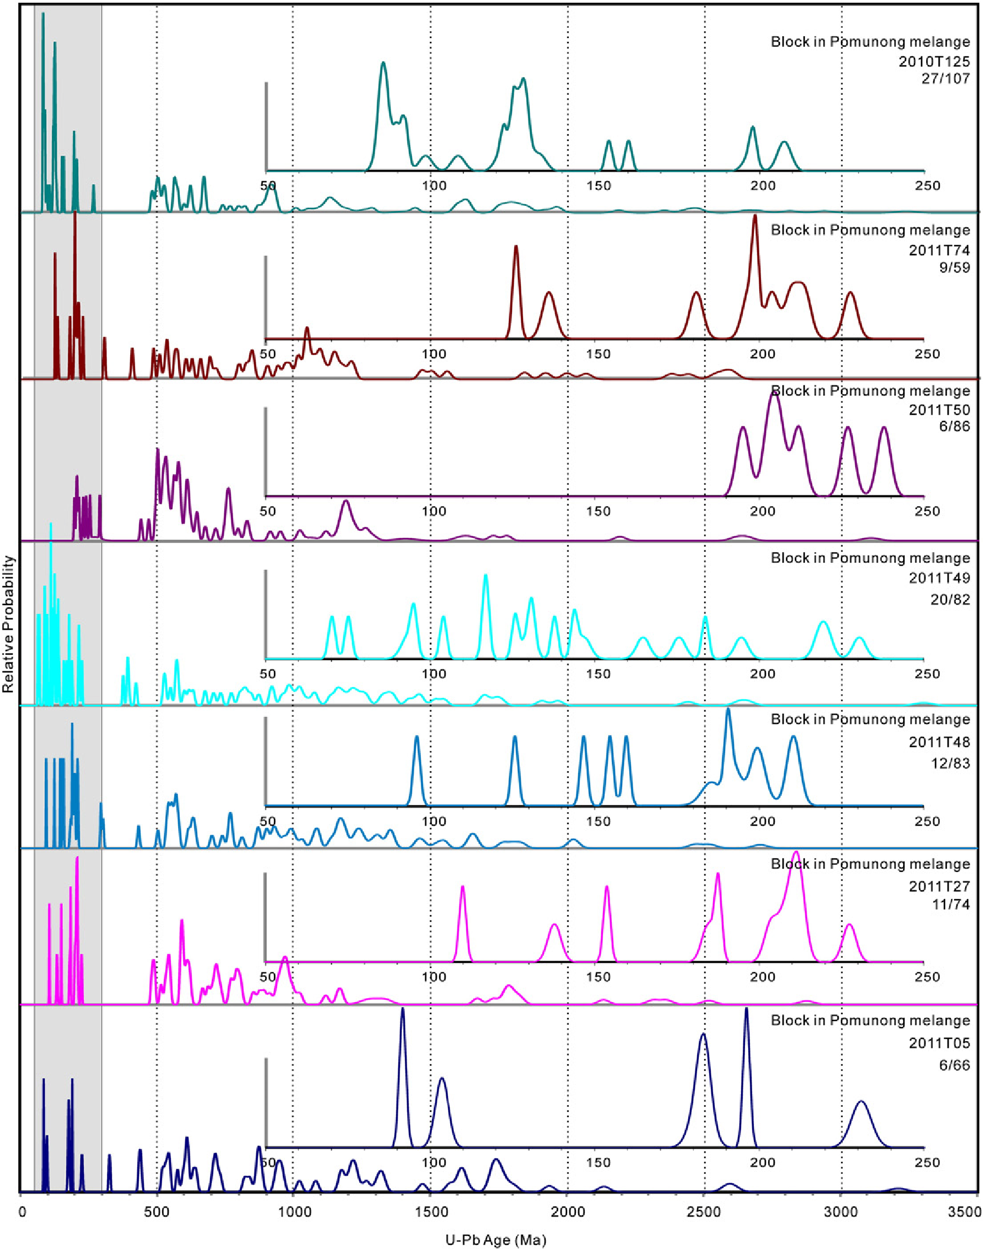

Fig. 7. Normalized probability plots for the blocks of massive sandstone in the Pomunong mélange. The 28/107 pair means the number of zircon grains in the 50–250 Ma range and the total number of zircon grains, respectively.

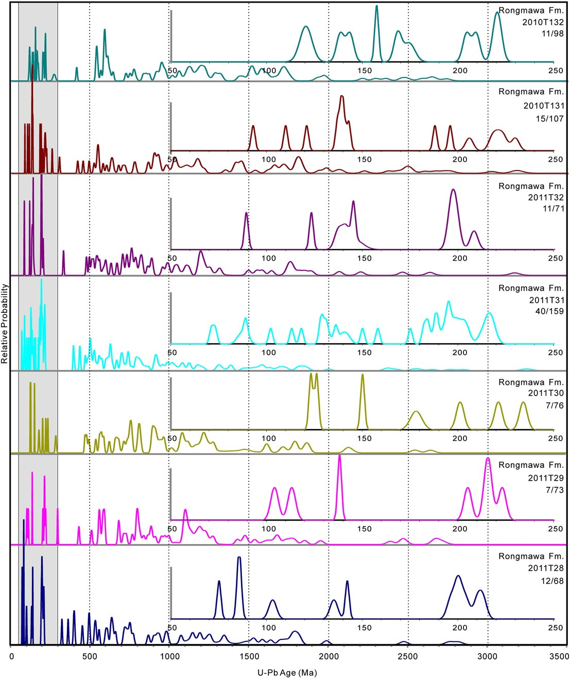

Fig. 8. Normalized probability plots for the upper part of the Rongmawa Formation. The 13/98 pair means the number of zircon grains in the 50–250 Ma range and the total number

of zircon grains, respectively.

2010). Significant pre-Mesozoic zircons are present in the Upper Cretaceous Ngamring and Padana Formations (Wu et al., 2010).

Lhasa terrane arc magmatism occurred over the following time spans: 175–237 Ma (Chu et al., 2006; Ji et al., 2009; Liu et al., 2006; Zhang et al., 2007; Zhu et al., 2008), 145–160 Ma (Ji et al., 2009; Zhu et al., 2011a, 2011b), 113–145 Ma (Murphy et al., 1997; Zhu et al., 2009b), 70–90 Ma (Wen et al., 2008), and 44–65 Ma (He et al., 2007; Ji et al., 2009; Wen et al., 2008). Detrital zircon ages from the pre-Cenozoic sedimentary strata in the Lhasa terrane display major age populations at 100–160 Ma, 200–600 Ma, and 700–1300 Ma with minor age populations of 1800–2000 Ma and 2400–2500 Ma (DeCelles et al., 2007; Gehrels et al., 2011; Leier et al., 2007a, 2007b; Zhu et al., 2011b).

#### 5.3.2. Zircon provenance interpretation

Blocks within the Pomunong mélange and the Upper Rongmawa Formation show similar petrologic features. Sandstones are rich in lithic grains and contain little quartz, typical of sediments derived from recycled orogens (Dickinson, 1985). Mesozoic zircons (71–234 Ma, 16% of the total zircon grains) found in these blocks were likely derived from the Gangdese arc and/or recycled forearc strata since except for the Early Cretaceous Wolong volcanics, no Late Cretaceous or Triassic– Jurassic magmatism has been recorded in Tethyan Himalaya.

Detrital zircon ages older than 500 Ma are broadly similar for both Lhasa terrane and Himalayan strata (Gehrels et al., 2011). We argue, however, that >500 Ma zircon grains in sandstones from the Pomunong melange and Rongmawa Formation were most likely derived from Lhasa terrane affinity rocks. This is because all samples from the Rongmawa Formation and the Pomunong mélange show a similar mix of Mesozoic and >500 Ma zircon ages as those of the Upper Ngamring and Padana Formations from the Xigaze forearc basin (Wu et al., 2010) and the Takena Formation in the Gangdese retro-arc foreland basin (Leier et al., 2007b), both derived from the Lhasa terrane.

|  |
| --- |
| Fig. 9. Normalized probability plots for all samples from the Pomunong mélange and Rongmawa Formation, compared to age probability curves from the Lhasa terrane, Tethyan |

Himalaya, the Upper Ngamring Formation of the Xigaze forearc (references in text).

## 6. Discussion

### 6.1. Tectonic and depositional settings

#### 6.1.1. Accretionary complex rocks

The central part of the Yarlung–Zangpo suture zone contains mélange assemblies (serpentinite mélange, chert-rich mélange, and mud-rich mélange), fragments of seamounts, and coherent turbidite sequences. The mélanges commonly display block-in-matrix fabric and are tectonically arranged in a south vergent imbricate structure. These associations and fabrics suggest that these rocks represent an accretionary complex (Taira et al., 1992; Zhang et al., 2011), and the asymmetric folds, crenulation and kink bands, and small-scale S–C fabrics indicate top-to-south thrusting, consistent with the development of a southward-facing accretionary complex.

#### 6.1.2. Abyssal plain rocks

The chert-matrix of the Tangga mélange is 500 to 2000 m thick and accumulated between the Late Triassic and the Early Cretaceous. Slow, long-term continuous deposition (>70 Ma) of radiolarian chert and the absence of coarse-grained terrigenous clastic material and limestone suggest that this unit formed in a pelagic setting (Isozaki, 1997). The lower and middle parts of the Rongmawa Formation are similar to the Tangga mélange; turbidities of the Upper Rongmawa Formation conformably overlie the middle section. Both mélange units were deposited in an abyssal setting below the carbonate compensation depth before being buried in the subduction trench by terrigenous clastics derived from the Lhasa terrane. The siliceous mud-matrix of Pomunong mélange, however, is hemipelagic and resembles modern sediments from oceanic swells and outer trench slope settings (Moore et al., 1982).

#### 6.1.3. Seamounts

The Langcuo limestone consists of fossiliferous purple limestone deposited directly on basalt. No terrigenous clastic material is present in this unit. Similar limestone and basalt assemblies in Oman, Cyprus, and the Zagros Mountains have been interpreted as accreted seamounts that formed during the opening of the Neo-Tethys (Searle and Graham, 1982).

#### 6.1.4. The trench wedge

The clastic sediments of the upper part of Rongmawa Formation are interpreted here as a trench wedge developed as the abyssal plain entered the Asian subduction zone (Underwood and Moore, 1994). Evidence for this includes the turbiditic nature of the clastic sediments derived from the Lhasa terrane, seaward downlap of the upper part of the Rongmawa Formation onto abyssal plain rocks, “rootless folds” sandwiched between undeformed sandstones, and accretionary complex geometry.

### 6.2. The subduction–accretion history of the Neo-Tethyan Ocean

Our studies in Lazi area, southern Tibet, indicate that the Gangdese arc, the Xigaze forearc basin, the supra-subduction zone ophiolite and serpentinite mélange, and the southward-younging accretionary complex (Tangga mélange, Pomunong mélange, and Rongmawa Formation) represent a complete arc–forearc–subduction–accretion sequence that could have been produced in a single subduction zone beneath the southern margin of the Lhasa terrane (Fig. 10). While this does not rule out the possibility of multiple Tethyan subduction zones in the Zedong area as described by Aitchison (2000), the preserved accretionary assemblage in the Lazi area is simply explained by a single Asian continental margin subduction system. Additionally, it is difficult to explain how detrital zircon grains older than 500 Ma could have been derived from an intra-oceanic arc terrane; it is more probable that these grains were derived from recycled Gangdese forearc or Lhasa terrane strata.

During Barremian–Early Aptian, the tectonics of the Neo-Tethys changed considerably. The initiation of subduction beneath the Lhasa Terrane occurred during the Barremian as constrained by studies of a Tethyan metamorphic sole (Guilmette et al., 2009). The initial northward subduction of the Neo-Tethys lithosphere beneath the southern margin of the Lhasa terrane created the Early Cretaceous adakite-like Sangri Group (Zhu et al., 2009a, 2011a,b) in the southern Lhasa terrane. The Barremian supra-subduction zone ophiolite rocks and the serpentinite mélange were formed in the overriding plate at this time (Bedard et al., 2009; Dubois-Côté et al., 2005; Liu et al., 2010). In classic accretionary assemblages such as the Franciscan complex, ophiolites constitute the structurally lowest parts of a series of imbricated thrust sheets produced by off-scraping of the downgoing plate (Snow et al., 2010). In the Xigaze ophiolite sequence, however, ophiolitic rocks are present in the structurally highest levels of the accretionary complex. This is a result of the accretion of Tethyan oceanic rocks to the Asian margin by or during Albian time. Following their accretion, the Neo-Tethyan ophiolites formed the backstop behind, or basement upon which the Xigaze forearc strata were deposited (Wang et al., 2011).

During the Late Aptian, Upper Triassic–Lower Aptian chert deposited in an abyssal setting entered the subduction zone beneath the Lhasa terrane. Here, the chert was scraped off the downgoing Neo-Tethyan plate and was accreted beneath the serpentinitematrix mélange, forming the chert-rich matrix of the Tangga mélange. Within an accretionary complex, the maximum age of accretion for a given nappe can be constrained by the transition from oceanic to terrigenous material within the sediments of that nappe. This transition indicates the arrival of the subducting oceanic plate at an ancient trench immediately prior to its accretion (Isozaki, 1997). In this manner, we determine the maximum accretion age of the Tangga mélange to be Aptian since it is buried conformably by siliceous mudstone and mudstone containing silt-sized terrigenous matterials (Matsuoka et al., 2002; Ziabrev et al., 2004). The Aptian aged chert matrix of this unit further confirms this maximum age of accretion (Matsuoka et al., 2002; Zhu et al., 2005; Ziabrev et al., 2004).

Compared to the abyssal setting of the Tangga mélange, the Pomunong mélange was deposited in a hemipelagic environment, typical of oceanic swells and/or outer trench slope settings (Moore et al., 1982). This unit would have been located close to the southern margin of Asia, and hemipelagic sediments deposited on Neo Tethyan crust would have been younger than the abyssal sediments deposited far from the Asian margin. Additionally, the Pomunong mélange is located structurally beneath the Tangga mélange. Therefore, the accretion of mud-rich Pomunong mélange would have occurred after that of the chert-rich Tangga mélange. The limestone and basalt of seamounts within the Neo-Tethys Ocean were also offscrapped and incorporated into the Pomunong mélange. The near absence of turbidite deposits in the Early Cretaceous may be the result of the Xigaze forearc basin being underfilled until the Campanian (Wan et al., 1997). In this state, sediments from the Lhasa terrane could not bypass the forearc basin and were therefore not deposited in the subduction trench. We state above that the matrix of Pomunong mélange is Early Aptian in age and encompasses latest Cretaceous trench-fill blocks of sandstone. This indicates that a major deformation event occurred after the deposition of the Rongmawa Formation which incorporated trench-fill sandstones into the Pomunong mélange.

Development of trench strata during the latest Cretaceous (b71 Ma), indicates that Pomunong mélange accretion was complete by this time. The uplifted and eroding Lhasa terrane shed sediments to the south and into the Xigaze forearc basin (Upper Ngamring Formation, Wu et al., 2010) and to the north into the Gangdese retro-arc foreland basin (Takena Formation, Leier et al., 2007a). The Xigaze forearc basin was nearly overfilled during this period (Einsele et al., 1994; Wan et al., 1997), and detrital material from the Lhasa terrane and/or recycled forearc strata would have been transported southward and deposited in the trench. The Rongmawa Formation records a transition from an abyssal plain to a trench basin. Because material accreted in a subduction zone travels only a short distance between the trench and the location of accretion, the age of the trench-fill rocks closely approximates the timing of accretion. The youngest single zircon grain ages in these strata are 71± 1 Ma, 71±1 Ma, 73±2 Ma. This provides a maximum age for the accretion of the Rongmawa Formation.

|  |
| --- |
| Fig. 10. Simplified tectonic model of the accretionary prism along the Yarlung–Zangpo suture zone during the Late Cretaceous. The Neo-Tethys Ocean subducted beneath the Lhasa terrane continually since the Early Cretaceous and created the trapped ophiolite rocks and serpentinite mélange, mud-matrix mélange, and trench basin. |

Long-term accretion of different slivers from Permian to Late Cretaceous in age along the Yarlung–Zangpo suture zone indicates that most of the Neo-Tethyan oceanic lithosphere was consumed by northward subduction beneath the southern Asian margin. The progressively southward growth and younging of this accretionary complex indicates that at least the accretionary complex exposed between Saga and Xigaze was first accreted to the southern margin of Asia prior to the India–Asia collision and was not obducted onto the Indian-affinity Tethyan Himalayan continental margin until the initiation of continental collision (Ding et al., 2005).

## 7. Conclusions

Field observations, structural–stratigraphic studies, detrital zircon U–Pb ages, and petrographic data from an accretionary complex along the Yarlung–Zangpo suture zone in southern Tibet reveal a protracted record of subduction and accretion of Neo-Tethys oceanic rocks along the southern margin of the Asian continent during the Cretaceous. The trapped ophiolitic rocks, ophiolitic mélange, offscrapped Tangga and Pomunong mélanges, and trench strata compose a Cretaceous accretionary complex that formed along the southern continental margin of Asia. The maximum depositional age of trench strata is 71±2 Ma constrained by detrital zircon ages. Detrital zircon age spectra indicate that the trench filling Rongmawa Formation was derived from Lhasa terrane affinity rocks. The Cretaceous accretionary complex, formed in single subduction zone within the Neo-Tethys Ocean during the Cretaceous, was already accreted to the southern margin of Asia at the time of the India–Asia collision.

## Acknowledgments

We thank Paul Kapp, Qing Zhang, Ji'en Zhang, Honghong Wei and Qinghai Zhang for comments on this manuscript. This study was financially supported by grants from the National Natural Science Foundation of China (41002066), the Chinese Ministry of Science and Technology (2011CB403101), the Chinese Academy of Sciences (XDB05010000, KZCX2-YW-Q09-03), the U.S. NSF Continental Dynamics Program (EAR-1008527), Key Laboratory of Continental Collision and Plateau Uplift and the China Postdoctoral Council.

## Appendix A. Supplementary data

Supplementary data to this article can be found online at [http:// dx.doi.org/10.1016/j.tecto.2012.08.016.](http://dx.doi.org/10.1016/j.tecto.2012.08.016)

## References

Aitchison, J.C., 2000. Remnants of a Cretaceous intra-oceanic subduction system within the Yarlung–Zangbo suture (south Tibet). Earth and Planetary Science Letters 183, 231–244.

Aitchison, J.C., Ali, J.R., Davis, A.M., 2007a. When and where did India and Asia collide? Journal of Geophysical Research 112, B05423 http://dx.doi.org[/10.1029/ 2006JB004706.](http://dx.doi.org/10.1029/2006JB004706)

Aitchison, J.C., McDermid, I.R.C., Ali, J.R., Davis, A.M., Zyabrev, S.V., 2007b. Shoshonites in Southern Tibet record Late Jurassic rifting of a Tethyan intraoceanic island arc. Journal of Geology 115, 197–213.

Aitchison, J.C., Xia, X.P., Baxter, A.T., Ali, J.R., 2011. Detrital zircon U–Pb ages along the Yarlung–Tsangpo suture zone, Tibet: implications for oblique convergence and collision between India and Asia. Gondwana Research 20, 691–709.

Amos, B.A., Harrison, T.M., Ding, L., 2008. Evidence for Early (>44 Ma) Himalayan crustal thickening, Tethyan Himalaya, southeastern Tibet. Earth and Planetary Science Letters 274, 14–23.

Bedard, E., Hebert, R., Guilmette, C., Lesage, G., Wang, C., Dostal, J., 2009. Petrology and geochemistry of the Saga and Sangsang ophiolitic massifs, Yarlung Zangbo Suture Zone, Southern Tibet: evidence for an arc–back‐arc origin. Lithos 113, 48–67.

Burg, J.P., Chen, G., 1984. Tectonics and structure zonation of southern Tibet, China. Nature 311, 219–223.

Burg, J.P., Leyreloup, A., Girardeau, J., Chen, G., 1987. Structure and metamorphism of a tectonically thickened continental crust: the Yalu Tsangpo suture (Tibet). Philosophical Transactions of the Royal Society of London A321, 67–86.

Chang, C.P., Angelier, J., Huang, C.Y., 2009. Evolution of subductions indicated by mélanges in Taiwan. In: Lallemand, S., Funiciello, F. (Eds.), Subduction zone Geodynamics. Springer, pp. 207–225.

Chu, M.F., Chung, S.L., Song, B., Liu, D.Y., O'Reilly, S.Y., Pearson, N.J., Ji, J.Q., Wen, D.J., 2006. Zircon U–Pb and Hf isotope constraints on the Mesozoic tectonics and crustal evolution of southern Tibet. Geology 34, 745–748.

Debon, F., LeFort, P., Sheppard, S.M., Sonet, J., 1986. The four plutonic belts of the TransHimalaya–Himalaya: a chemical, mineralogical, isotopic, and chronological synthesis along a Tibet–Nepal section. Journal of Petrology 27, 219–250.

DeCelles, P.G., Gehrels, G.E., Quade, J., LaReau, B., Spurlin, M., 2000. Tectonic implications of U–Pb zircon ages of the Himalayan orogenic belt in Nepal. Science 288 (5465), 497–499.

DeCelles, P.G., Gehrels, G.E., Najman, Y., Martin, A.J., Carter, A., Garzanti, E., 2004. Detrital geochronology and geochemistry of Cretaceous–Early Miocene strata of Nepal: implications for timing and diachroneity of initial Himalayan orogenesis. Earth and Planetary Science Letters 227, 313–330.

DeCelles, P.G., Kapp, P., Ding, L., Gehrels, G.E., 2007. Late Cretaceous to Middle Tertiary basin evolution in the central Tibetan Plateau: changing environments in response to tectonic partitioning, aridification, and regional elevation gain. Geological Society of America Bulletin 119, 654–680.

DeCelles, P.G., Kapp, P., Quade, J., Gehrels, G.E., 2011. Oligocene–Miocene Kailas basin, southwestern Tibet: record of postcollisional upper-plate extension in the Indus– Yarlung suture zone. Geological Society of America Bulletin 123, 1337–1362.

Dickinson, W.R., 1985. Interpreting provenance relations from detrital modes of sandstone. In: Zuffa, G. (Ed.), Provenance of Arenites. Reidel Publishing Co., Dordrecht, pp. 333–361.

Ding, L., Lai, Q.Z., 2003. New geological evidence of crustal thickening in the Gangdese block prior to the Indo-Asian collision. Chinese Science Bulletin 48, 1604–1610.

Ding, L., Kapp, P., Wan, X., 2005. Paleocene–Eocene record of ophilite obduction and initial India–Asian collision, south central Tibet. Tectonics 24, TC3001 http:// dx.doi.org/[10.1029/2004TC001729](http://dx.doi.org/10.1029/2004TC001729).

Dubois-Côté, V., Hébert, R., Dupuis, C., Wang, C.S., Li, Y., Dostal, J., 2005. Petrological and geochemical evidence for the origin of the Yarlung Zangbo ophiolites, southern Tibet. Chemical Geology 214, 265–286.

Dürr, S.B., 1996. Provenance of Xigaze fore-arc basin clastic rocks (Cretaceous, south Tibet). Geological Society of America Bulletin 108, 669–684.

Einsele, G., Liu, B., Durr, S., Frisch, W., Liu, G., Luterbacher, H.P., Ratschbacher, L., Richen, W., Wendt, J., Wetzel, A., Yu, G., Zheng, H., 1994. The Xigaze forearc basin: evolution and facies architecture (Cretaceous, Tibet). Sedimentary Geology 90, 1–32.

Gehrels, G.E., Kapp, P., DeCelles, P., Blakey, R., Weislogel, A., Ding, L., Guynn, J., Martin, A., McQuarrie, N., Yin, A., 2011. Detrital zircon geochronology of pre-Tertiary strata in the Tibetan–Himalayan orogen. Tectonics http://dx.doi.org[/10.1029/2011TC002868](http://dx.doi.org/10.1029/2011TC002868).

Girardeau, J., Marcoux, J., Zao, Y., 1984. Lithologic and tectonic environment of the Xigaze ophiolite (Yarlung Zangbo suture zone, southern Tibet, China), and kinematics of its emplacement. Eclogae Geologicae Helvetiae 77, 153–170.

Guilmette, C., Hebet, R., Wang, C.S., Villeneuve, M., 2009. Geochemistry and geochronology of the metamorphic sole underlying the Xigaze ophiolite, Yarlung Zangpo suture zone, south Tibet. Lithos 112, 149–162.

He, S.D., Kapp, P., DeCelles, P.G., Gehrels, G.E., Heizler, M., 2007. Cretaceous–Tertiary geology of the Gangdese Arc in the Linzhou area, southern Tibet. Tectonophysics 433, 15–37.

Hébert, H., Bezard, R., Guilmette, C., Dostal, J., Wang, C.S., Liu, Z.F., 2011. The Indus– Yarlung Zangbo ophiolites from Nanga Parbat to Namche Barwa syntaxes, southern Tibet: first synthesis of petrology, geochemistry, and geochronology with incidences on geodynamic reconstructions of Neo-Tethys. Gondwana Research http:// dx.doi.org/[10.1016/j.gr.2011.10.013](http://dx.doi.org/10.1016/j.gr.2011.10.013).

Hu, X.M., Jansa, L., Chen, L., Griffin, W.L., O'Reilly, S.Y., Wang, J.G., 2010. Provenance of Lower Cretaceous Wolong volcaniclastics in the Tibetan Tethyan Himalaya: implications for the final breakup of eastern Gondwana. Sedimentary Geology 223, 193–205.

Huot, F., Hebert, R., Varfalvy, V., Beaudoin, G., Wang, C.S., Liu, Z.F., Cotten, J., Dostal, J., 2002. The Beimarang melange (southern Tibet) brings additional constraints in assessing the origin, metamorphic evolution and obduction processes of the Yarlung Zangbo ophiolite. Journal of Asian Earth Sciences 21, 307–322.

Ingersoll, R.V., Bullard, T.F., Ford, R.L., Grimm, J.P., Pickle, J.D., Sares, S.W., 1984. The effect of grain size on detrital modes: a test of the Gazzi–Dickinson point-counting method. Journal of Sedimentary Petrology 49, 103–116.

Isozaki, Y., 1997. Jurassic accretion tectonics of Japan. The Island Arc 6, 25–51.

Ji, W.Q., Wu, F.Y., Chung, S.L., Li, J., Liu, C.Z., 2009. Zircon U–Pb geochronology and Hf isotopic constraints on petrogenesis of the Gangdese batholith, southern Tibet. Chemical Geology 262, 229–245.

Kapp, P., Murphy, M.A., Yin, A., Harrison, T.M., Ding, L., Guo, J., 2003. Mesozoic and Cenozoic tectonic evolution of the Shiquanhe area of western Tibet. Tectonics 22 http://dx.doi.org/[10.1029/2001TC001332](http://dx.doi.org/10.1029/2001TC001332).

Kapp, J.L.D., Harrison, T.M., Kapp, P., Grove, M., Lovera, O.M., Ding, L., 2005. Nyainqentanglha Shan: a window into the tectonic, thermal, and geochemical evolution of the Lhasa block, southern Tibet. Journal of Geophysical Research 110, B08413 http://dx.doi.org/[10.1029/2004JB003330](http://dx.doi.org/10.1029/2004JB003330).

Kapp, P., DeCelles, P.G., Leier, A.L., Fabijanic, J.M., He, S.D., Pullen, A., Gehrels, G.E., Ding, L., 2007. The Gangdese retroarc thrust belt revealed. GSA Today 17, 4–9.

Leier, A.L., Kapp, P., Gehrels, G.E., DeCelles, P.G., 2007a. Detrital zircon geochronology of Carboniferous–Cretaceous strata in the Lhasa terrane, Southern Tibet. Basin Research 19, 361–378.

Leier, A.L., DeCelles, P.G., Kapp, P., Gehrels, G.E., 2007b. Lower Cretaceous strata in the Lhasa terrane, Tibet, with implications for understanding the early tectonic history of the Tibetan Plateau. Journal of Sedimentary Research 77, 809–825.

Li, W.Z., Shen, S.Z., 2005. Faunas from the Permian limestone blocks at the Yarlung Zangbo suture zone in Southern Xizang (Tibet) and its paleogeographical implications. Geology Review 51, 226–233.

Li, G.W., Liu, X.H., Alex, P., Wei, L.J., Liu, X.B., Huang, F.X., Zhou, X.J., 2010. In-situ detrital zircon geochronology and Hf isotopic analyses from Upper Triassic Tethys sequence strata. Earth and Planetary Science Letters 297, 461–470.

Liu, G.H., Einsele, G., 1994. Sedimentary history of the Tethyan basin in the Tibetan Himalayas. Geologische Rundschau 83, 32–61.

Liu, Q.S., Jiang, W., Jian, P., Ye, P.S., Wu, Z.H., Hu, D.G., 2006. Zircon SHRIMP U–Pb age and petrochemical and geochemical features of Mesozoic muscovite monzonitic granite at Ningzhong Tibet. Acta Petrologica Sinica 22, 643–652.

Liu, C.Z., Wu, F.Y., Wilde, S.A., Yu, L.J., Li, J.L., 2010. Anorthitic plagioclase and pargasitic amphiobole in mantle peridotites from the Yungbwa ophiolite (Southwestern Tibetan Plateau) formed by hydrous melt metasomatism. Lithos 114, 413–422.

Malpas, J., Zhou, M.F., Robinson, P.T., Reynolds, P.H., 2003. Geochemical and geochronological constraints on the origin and emplacement of the Yarlung Zangbo ophiolites, southern Tibet. Geological Society — Special Publications 218, 191–206.

Matsuoka, A., Yang, Q., Kobayashi, K., Takei, M., Nagahashi, T., Zeng, Q.G., Wang, Y.J., 2002. Jurassic–Cretaceous radiolarian biostratigraphy and sedimentary environments of the Ceno-Tethys: records from the Xialu chert in the Yarlung–Zangpo suture zone, southern Tibet. Journal of Asian Earth Sciences 20, 277–287.

McDermid, I.R., Aitchison, J.C., Davis, A.M., Harrison, T.M., Grove, M., 2002. The Zedong terrane: a Late Jurassic intra-oceanic magmatic arc within the Yarlung–Zangbo suture zone, southeastern Tibet. Chemical Geology 187, 267–277.

Moore, J.C., Watkins, J.S., McMillen, K.J., Bachman, S.B., Leggett, J.K., Lundberg, N.,

Shipley, T.H., Stephan, J.F., Beghtel, F.W., Butt, A., Didyk, B.M., Niitsuma, N., Shephard, L.E., Stradner, H., 1982. Facies belt of the Middle America trench and forearc region, southern Mexico: results from Leg 66 DSDP. In: Leggett, J.K. (Ed.), Trench–Forearc Geology: Sedimentation and Tectonics of Modern and Ancient Active Plate Margins: Geol. Soc. Spec. Pap. , pp. 77–94.

Murphy, M.A., Yin, An, Harrison, T.M., Dürr, S.B., Chen, Z., Ryerson, F.J., Kidd, W.S.F., Wang, X., Zhou, X., 1997. Did the Indo-Asian collision alone create the Tibetan Plateau? Geology 25, 719–722.

Myrow, P.M., Hughes, N.C., Paulsen, T.S., Williams, I.S., Parcha, S.K., Thompson, K.P., Bowring, S.A., Peng, S.C., Ahluwalia, A.D., 2003. Integrated tectonostratigraphic analysis of the Himalaya and implications for its tectonic reconstruction. Earth and Planetary Science Letters 212, 433–441.

Raymond, L.A., 1984. Classification of mélange. In: Raymond, L.A. (Ed.), Mélanges: Their Nature, Origin and Significance: Geol. Soc. Spec. Pap., 198, pp. 7–20.

Searle, M.P., Graham, G.M., 1982. The “Oman Exotics” — oceanic carbonate build-ups associated with the early stages of continental rifting. Geology 10, 43–49.

Searle, M.P., Windley, B.F., Coward, M.P., Cooper, D.J.W., Rex, A.J., Rex, D., Li, T.D., Xiao, X.C., Jan, M.Q., Thakur, V.C., 1987. The closing of Tethys and the tectonics of the Himalaya. Geological Society of America Bulletin 98, 678–701.

Slama, J., Košler, J., Condon, D.J., Crowley, J.L., Gerdes, A., Hanchar, J.M., Horstwood,

M.S.A., Morris, G.A., Nasdala, L., Norberg, N., Schaltegger, U., Schoene, B., Tubrett, M.N., Whitehouse, M.J., 2008. Plešovice zircon — a new natural reference material for U–Pb and Hf isotopic microanalysis. Chemical Geology 249 (1–2), 1–35.

Snow, C.A., Wakabayashi, J., Ernest, W.G., Wooden, J., 2010. Detrital zircon evidence for progressive underthrusting in Franciscan metagraywackes, west-central California. Geological Society of America Bulletin 122, 282–291.

Taira, A., Byrne, T., Ashi, J., 1992. Photographic Atlas of an Accretionary Prism: Geological Structures of the Shimanto Belt. University of Tokyo Press, Japan.

Tapponnier, P., Mercier, J.L., Proust, F., Andrieux, J., Armijo, R., Bassoullet, J.P., Brunel, M., Burg, J.P., Colchen, M., Dupré, B., Girardeau, J., Marcoux, J., Mascle, G., Matte, P., Nicolas, A., Li, T.D., Xiao, X.C., Chang, C.F., Lin, P.Y., Li, G.C., Wang, N.W., Chen, G.M., Han, T.L., Wang, X.B., Den, W.M., Zhen, H.X., Sheng, H.B., Cao, Y.G., Zhou, J., Qiu, H.R., 1981. The Tibetan side of the India–Eurasia collision. Nature 294, 405–410.

Underwood, M.B., Moore, G.F., 1994. Trenches and trench-slope basins. In: Busby, C.J., Ingersoll, R.V. (Eds.), Tectonics of Sedimentary Basins. Blackwell Science, pp. 179–220.

Volkmer, J.E., Kapp, P., Guynn, J.H., Lai, Q., 2007. Cretaceous–Tertiary structural evolution of the north central Lhasa terrane, Tibet. Tectonics 26, TC6007 http://dx.doi.org/ [10.1029/2005TC001832.](http://dx.doi.org/10.1029/2005TC001832)

Wan, X.Q., Wang, C.S., Wang, L., 1997. Discovery of Cretaceous foraminifera in the Xigaze forearc basin, Xizang — with a chronostratigraphic discussion. Acta Geologica Sinica 71 (3), 193–201.

Wang, C.S., Liu, Z.F., Li, X.H., Wan, X.Q., 1999. Xigaze Forearc Basin and Tsangpo Suture Zone. Tibet. Geol. Publ. House, Beijing.

Wang, J.G., Hu, X.M., Wu, F.Y., Jansa, L., 2010. Provenance of the Liuqu conglomerate in southern Tibet: a paleogene erosional record of the Himalayan–Tibetan orogen.

Sedimentary Geology 231, 74–84.

Wang, C.S., Li, X.H., Liu, Z.F., Li, Y.L., Jansa, L., Dai, J.G., Wei, Y., 2011. Revision of the Cretaceous–Paleogene stratigraphic framework, facies architecture and provenance of the Xigaze forearc basin along the Yarlung Zangbo suture zone. Gondwana Research http://dx.doi.org/[10.1016/j.gr.2011.09.014](http://dx.doi.org/10.1016/j.gr.2011.09.014).

Wei, L.J., Liu, X.H., Yan, F.H., Mai, X.S., Li, G.W., Liu, X.B., Zhou, X.J., 2011. Palynological evidence sheds new light on the age of the Liuqu Conglomerates in Tibet and its geological significance. Science China Earth Sciences 54, 901–911.

Wen, D.R., Liu, D.Y., Chung, S.L., Chu, M.F., Ji, J.Q., Zhang, Q., Song, B., Lee, T.Y., Yeh, M.W., Lo, C.H., 2008. Zircon SHRIMP U–Pb ages of the Gangdese batholith and implications for Neotethyan subduction in southern Tibet. Chemical Geology 252, 191–201.

Willems, H., Zhou, Z., Zhang, B., Grafe, K.U., 1996. Stratigraphy of the Upper Cretaceous and lower tertiary strata in the tethyan Himalayas of Tibet (Tingri area, China). Geologische Rundschau 85, 723–754.

Wu, F.Y., Ji, W.Q., Liu, C.Z., Chung, S.L., 2010. Detrital zircon U–Pb and Hf isotopic constraints from the Xigaze fore-arc basin on the TransHimalaya magmatic evolution in southern Tibet. Chemical Geology 271, 13–25.

Yin, A., 2006. Cenozoic tectonic evolution of the Himalayan orogen as constrained by along-strike variation of structural geometry, exhumation history, and foreland sedimentation. Earth-Science Reviews 76, 1–131.

Yin, A., Harrison, T.M., 2000. Geologic evolution of the Himalayan–Tibetan orogen. Annual Review of Earth and Planetary Sciences 28, 211–280.

Zhang, H.F., Xu, W.C., Guo, J.Q., Zong, K.Q., Cai, H.M., Yuan, H.L., 2007. Zircon U–Pb and Hf isotopic composition of deformed granite in the southern margin of the Gangdese terrane, Tibet: evidence for Early Jurassic subduction of Neo-Tethyan oceanic slab. Acta Petrologica Sinica 23, 1347–1353.

Zhang, J.E., Xiao, W.J., Han, C.M., Ao, S.J., Yuan, C., Sun, M., Geng, H.Y., Zhao, G.C., Guo, Q.Q., Ma, C., 2011. Kinematics and age constraints of deformation in a Late Carboniferous accretionary complex in Western Junggar, NW China. Gondwana Research 19, 958–974.

Zhu, J., Du, Y.S., Liu, Z.X., Feng, Q.L., Tian, W.X., Li, J.P., Wand, C.P., 2005. Mesozoic radiolarian chert from the middle sector of the Yarlung Zangbo suture zone, Tibet and its tectonic implications. Science in China Series D: Earth Sciences 49, 348–357.

Zhu, D.C., Pan, G.T., Chung, S.L., Liao, Z.L., Wang, L.Q., Li, G.M., 2008. SHRIMP zircon age and geochemical constraints on the origin of Lower Jurassic Volcanic Rocks from the Yeba Formation, southern Gangdese, South Tibet. International Geology Review 50, 442–471.

Zhu, D.C., Zhao, Z.D., Pan, G.T., Lee, H.Y., Kang, Z.Q., Liao, Z.L., Wang, L.Q., Li, M.G., Dong, G.C., Liu, B., 2009a. Early cretaceous subduction-related adakite-like rocks of the Gangdese belt, southern Tibet: products of slab melting and subsequent meltperidotite interaction? Journal of Asian Earth Sciences 34, 298–309.

Zhu, D.C., Mo, X.X., Niu, Y.L., Zhao, Z.D., Wang, L.Q., Liu, Y.S., Wu, F.Y., 2009b. Geochemical investigation of Early Cretaceous igneous rocks along an east–west traverse throughout the central Lhasa Terrane, Tibet. Chemical Geology 268, 298–312.

Zhu, D.C., Zhao, Z.D., Niu, Y.L., Mo, X.X., Chung, S.L., Hou, Z.Q., Wang, L.Q., Wu, F.Y., 2011a. The Lhasa terrane: record of a microcontinent and its histories of drift and growth. Earth and Planetary Science Letters 301, 241–255.

Zhu, D.C., Zhao, Z.D., Niu, Y., Dilek, Y., Mo, X.X., 2011b. Lhasa terrane in southern Tibet came from Australia. Geology 39, 727–730.

Ziabrev, S.V., Aitchison, J.C., Abrajevitch, A.V., Zhu, B.D., Davis, A.M., Luo, H., 2004. Bainang Terrane, Yarlung–Tsangpo suture, southern Tibet (Xizang, China): a record of intra-Neotethyan subduction–accretion processes preserved on the roof of the world. Journal of the Geological Society of London 161, 523–538.