**Detrital zircon Hf isotopic compositions indicate a northern Caledonian connection for the Alexander terrane**

**Luke P. Beranek1,2, Cees R. van Staal1, William C. McClelland3, Steve Israel4, and Mitch G. Mihalynuk5**

1GEOLOGICAL SURVEY OF CANADA, VANCOUVER, BRITISH COLUMBIA V6B 5J3, CANADA

2DEPARTMENT OF GEOLOGICAL SCIENCES, STOCKHOLM UNIVERSITY, STOCKHOLM 106 91, SWEDEN

3DEPARTMENT OF GEOSCIENCE, UNIVERSITY OF IOWA, IOWA CITY, IOWA 52242, USA

4YUKON GEOLOGICAL SURVEY, WHITEHORSE, YUKON Y1A 2C6, CANADA

5BRITISH COLUMBIA GEOLOGICAL SURVEY, VICTORIA, BRITISH COLUMBIA V8W 9N3, CANADA

# ABSTRACT

Various plate reconstructions predict that the Alexander terrane, a Neoproterozoic–Jurassic crustal fragment now located in the North

American Cordillera, evolved in proximity to the northern Appalachian-Caledonian convergent margin during assembly of supercontinent Laurussia. To test stratigraphic connections with Laurussia that are implied by these plate reconstructions, we measured the Hf isotopic compositions of 176 detrital zircons from two relevant sedimentary sequences of the Alexander terrane. An older, Upper Silurian–Lower Devonian terrestrial to shallow-marine molasse sequence yields 405–490 Ma detrital zircons with negative εHf(t) values and Mesoproterozoic to Paleoproterozoic Hf model ages. In combination with paleomagnetic and biogeographic constraints, these Hf data argue for the molasse strata to be now-displaced equivalents of the Old Red Sandstone and primarily sourced from crustally contaminated granitoids in the Greenland, Svalbard, or British Caledonides. Late Silurian–Early Devonian orogenesis in the Alexander terrane is therefore likely related to the Scandian-Salinic phase of Appalachian-Caledonian mountain building. Younger, Middle Devonian sequences of the Alexander terrane are endowed in 390–490 Ma detrital zircons with positive εHf(t) values and Neoproterozoic Hf model ages. These isotopic signatures are consistent with the erosion of local basement rocks during the opening of the Slide Mountain–Angayucham backarc rift and tectonic separation of the Alexander terrane from northern Laurussia.

|  |  |
| --- | --- |
| LITHOSPHERE; v. 5; no. 2; p. 163–168; GSA Data Repository Item 2013074 | Published online 19 December 2012 | doi: 10.1130/L255.1 |

# INTRODUCTION

Earth’s geography and plate-tectonic history during the early Paleozoic were dominated by the complex closure of the Iapetus Ocean, which involved multiple subduction zones and culminated with the ScandianSalinic collision between greater Baltica (Baltica + Ganderia/Avalonia) and Laurentia (van Staal et al., 2009). Subduction of greater Baltica beneath Laurentia represents a major mountain-building event in the Appalachian-Caledonian orogen and led to the formation of supercontinent Laurussia (McKerrow et al., 2000). The main Scandian-Salinic phase of mountain building (400–440 Ma) was in part marked by the generation of crustally contaminated granitoids in Svalbard, Greenland, the British Isles, and Atlantic Canada (e.g., Whalen et al., 2006; Augland et al., 2012). Upper Silurian to Upper Devonian molasse strata that underlie much of the North Atlantic region partially consist of red-bed clastic successions referred to as the Old Red Sandstone (Friend and Williams, 2000).

An unresolved problem relevant to the assembly of Laurussia is where the northern continuation of the Appalachian-Caledonian orogenic system extends into the present-day Arctic Ocean region (Pease, 2011). Some global plate reconstructions argue for the northernmost extent of the Appalachian-Caledonian convergent margin to have involved crustal fragments of Laurentian, Baltican, and/or Siberian affi nity that are now located in the North American Cordillera and Canadian High Arctic (Colpron and Nelson, 2009, 2011; Cocks and Torsvik, 2011; Miller et al., 2011). The Alexander terrane (Figs. 1A and 1B) is a Neoproterozoic–Jurassic crustal fragment in the North American Cordillera that provides an opportunity to investigate these proposed northern Caledonian connections. A growing body of multidisciplinary evidence suggests that the Alexander terrane formed part of a Late Cambrian–Early Silurian arc system in proximity to the Scandinavian and Russian High Arctic regions of Baltica prior to being the site of Late Silurian–Early Devonian orogenesis and Old Red Sandstone–like red-bed sedimentation (e.g., Soja, 1994; Bazard et al., 1995; Gehrels et al., 1996; Butler et al., 1997; Soja and Krutikov, 2008; Beranek et al., 2012, 2013).

Despite the fact that published geochronological studies have shown red-bed molasse strata of the Alexander terrane to contain 420–450 Ma detrital zircons (Gehrels et al., 1996; Grove et al., 2008), these U-Pb age data by themselves are not capable of discriminating provenance from crustally contaminated granitoids of the northern Caledonides or juvenile arc rocks of the Alexander terrane. In an attempt to solve this problem and test the connections with northern Laurentia that are implied by some global plate reconstructions (e.g., Colpron and Nelson, 2009, 2011), we measured the Hf isotopic compositions of dated zircons from Silurian– Devonian sedimentary sequences of the Alexander terrane. Hf isotopes are robust geochemical tracers that identify the chemical maturity of the lithosphere from which zircons are derived and allow sediment provenance studies to distinguish juvenile (radiogenic) or evolved (unradiogenic) source components of similar age (Kinny and Maas, 2003).

# BACKGROUND GEOLOGY

|  |
| --- |
| LITHOSPHERE For permission to copy, contact editing@geosociety.org | | | | © 2012 Geological Society of America |

The Alexander terrane underlies 100,000 km2 of the North American Cordillera in southeastern Alaska, the Saint Elias Mountains of eastern Alaska, southwestern Yukon, and northwestern British Columbia, and the Coast Mountains of west-central British Columbia (Fig. 1A; Gehrels and Saleeby, 1987). The Alexander terrane is presently bounded by faults that record its mid-Mesozoic accretion to, and subsequent displacement along, the western margin of North America (e.g., McClelland et al., 1992).

# Southeastern Alaska

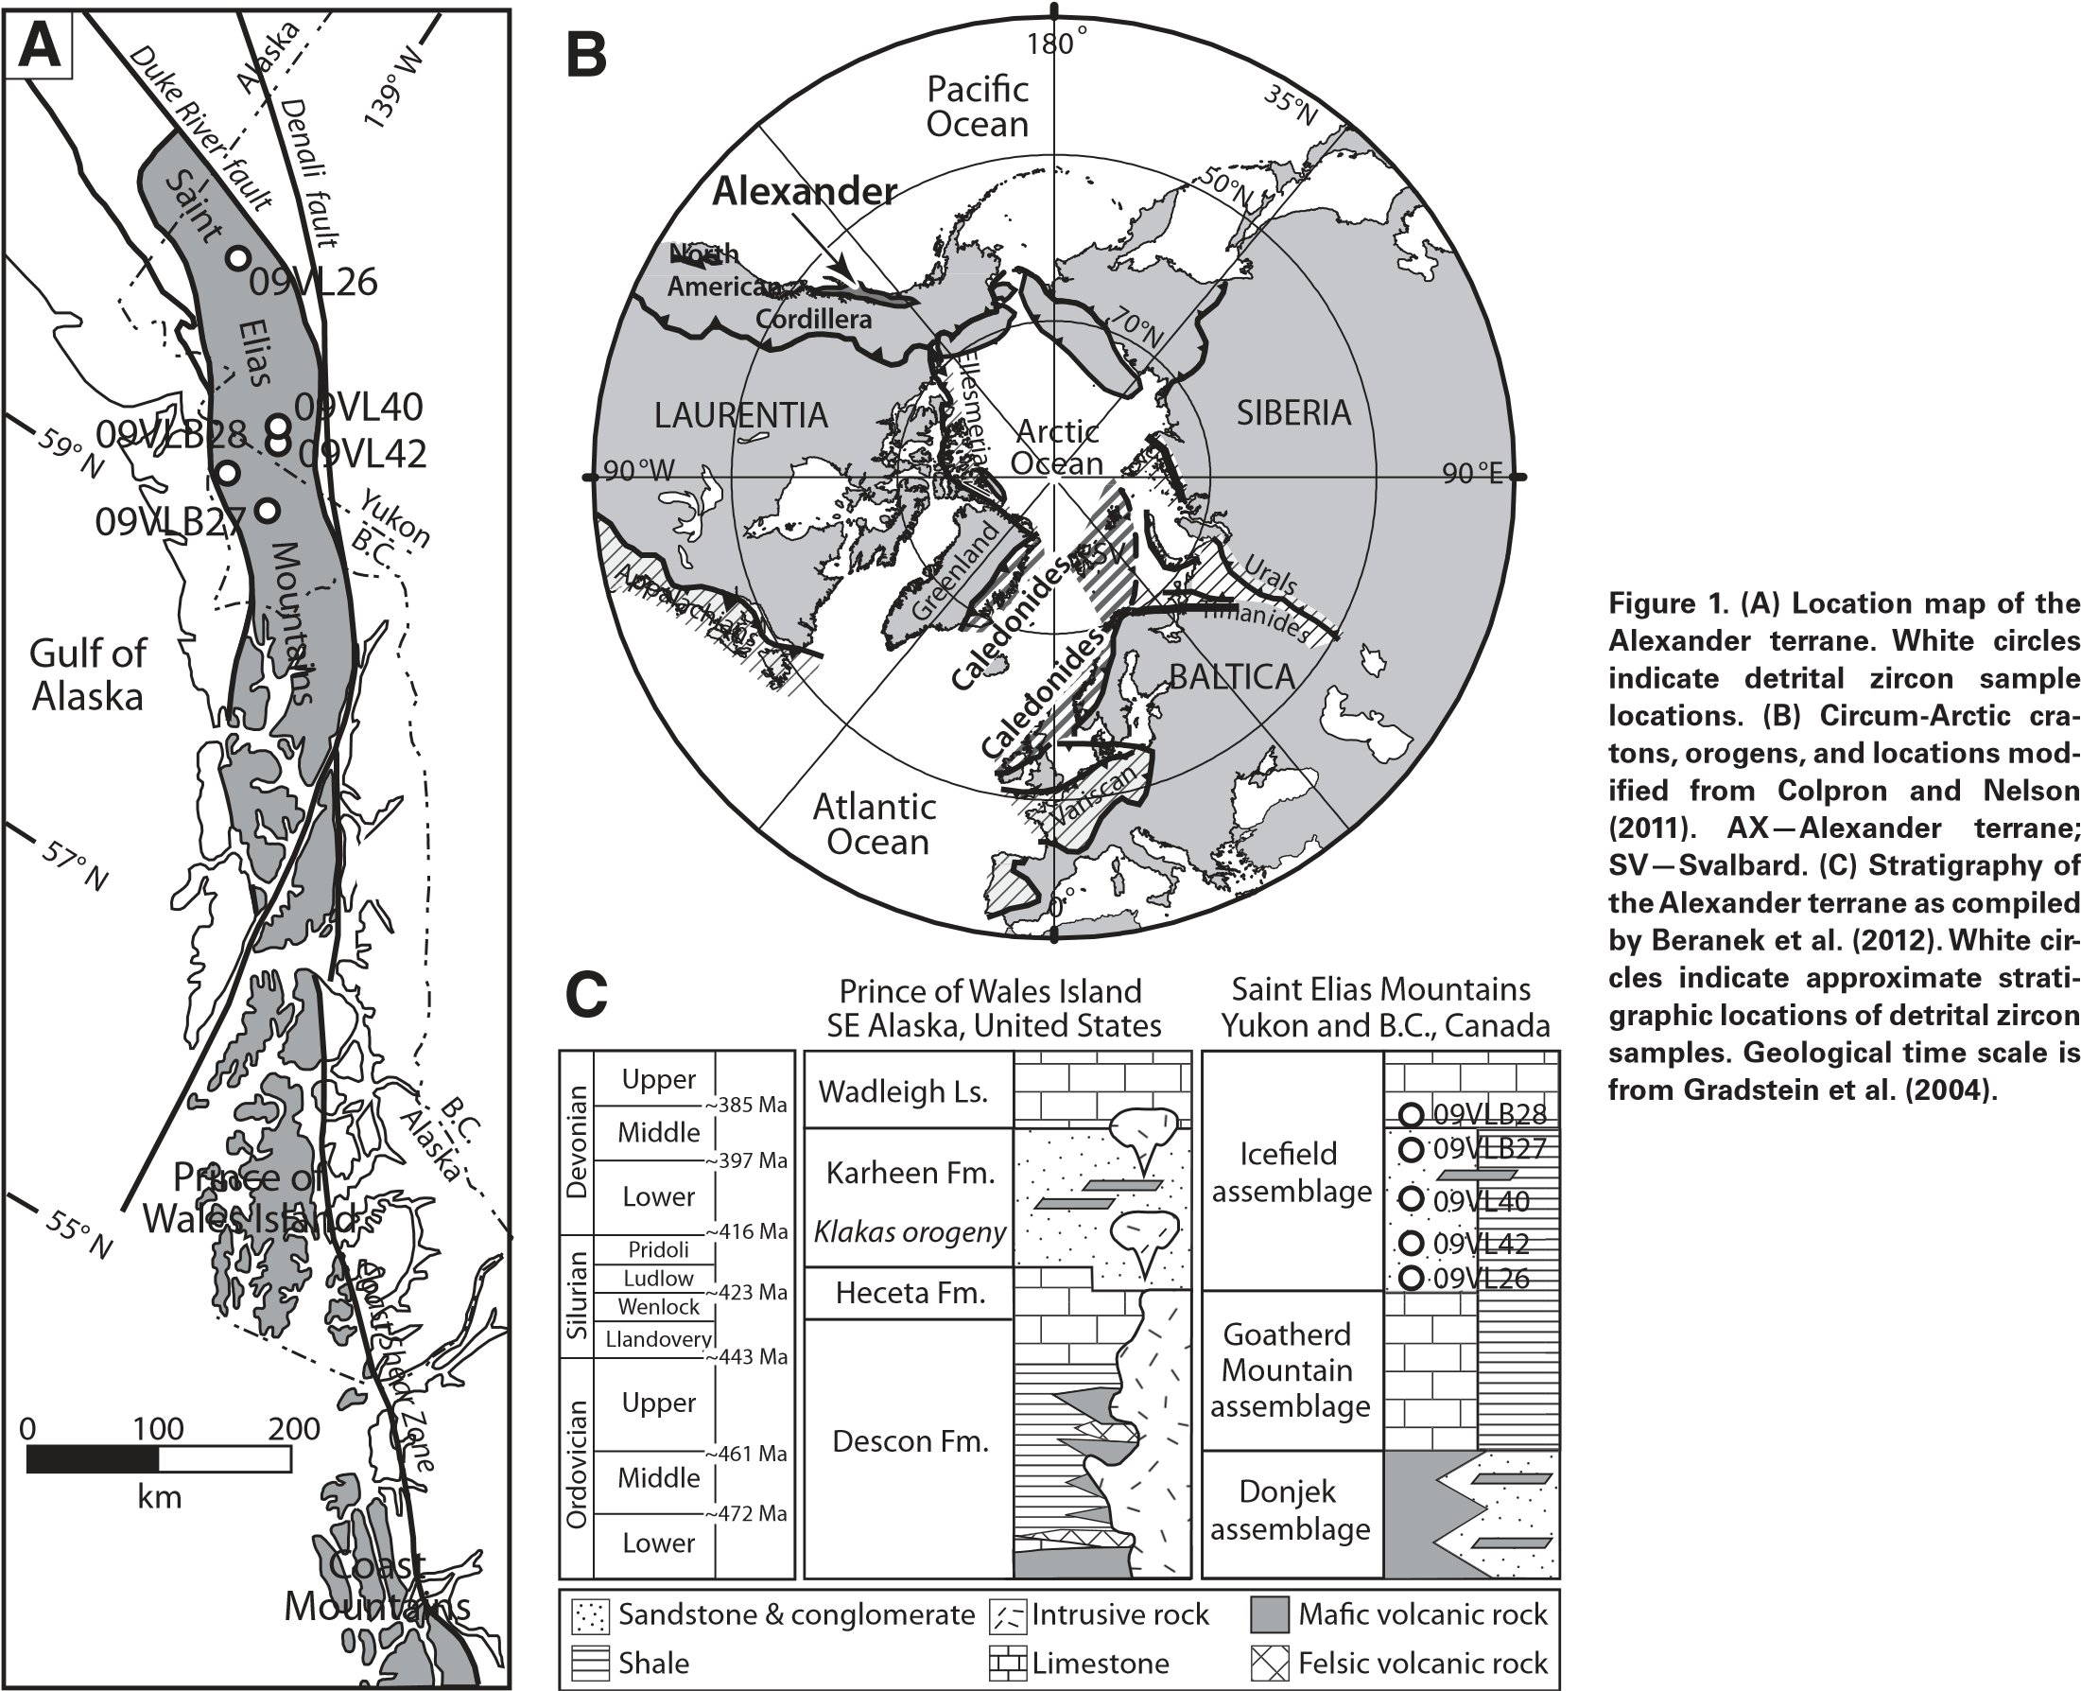The Karheen Formation in the Prince of Wales Island region of southeastern Alaska consists of Upper Silurian to Lower Devonian red-bed clastic, carbonate, and volcanic rocks that were deposited during the Klakas orogeny (Fig. 1C). This Late Silurian–Early Devonian tectonic event is broadly characterized by contractional deformation and greenschistfacies to locally amphibolite-facies metamorphism (Gehrels and Saleeby, 1987; Gehrels et al., 1987). The timing of the Klakas orogeny separates an earlier, Late Cambrian–Early Silurian convergent margin setting for the Alexander terrane from a later, Mississippian–Pennsylvanian phase of tectonic stability (Gehrels and Saleeby, 1987). Early Paleozoic (430–500 Ma) arc-type and syn- to post-Klakas (390–415 Ma) magmatic rocks in the Alexander terrane yield juvenile Nd-Sr (whole-rock) and Hf (zircon) isotopic compositions, suggesting little to no input from evolved crustal sources (Samson et al., 1989; Saleeby, 2000; Cecil et al., 2011; Beranek et al., 2012, 2013).

|  |
| --- |
| Northern Caledonian connection for the Alexander terrane | |

Paleomagnetic data require an Early Devonian magnetization for red beds of the Karheen Formation at 14° ± 4° paleolatitude in the Northern or Southern Hemisphere (Bazard et al., 1995; Butler et al., 1997). Additional paleogeographic constraints on red-bed deposition are derived from fossil assemblages in surrounding units. Upper Silurian stromatolite reefs and mud mounds of the Heceta Formation (Fig. 1C) that crop out beneath the Karheen red beds were colonized by distinctive sphinctozoan sponges and hydroids (Soja, 1994). These biotas resemble those in the Uralian (east European) margin of Baltica, Salair region of southwest Siberia, and Siberian-affi nity Farewell terrane of Alaska (Antoshkina and Soja, 2006). Early to Middle Devonian brachiopod, gastropod, and coral fauna in the Prince of Wales Island region also display statistical similarities with fossils of the Uralian margin, Siberian platform of southern Taimyr, and Kolyma-Omolon superterrane (Blodgett et al., 2002; Pedder, 2006). Larval exchange with the Baltican and Siberian realms during the Late Silurian–Middle Devonian strongly suggests a Northern Hemisphere position for the Alexander terrane within the Uralian Seaway, the marine corridor that separated Laurussia from Siberia (Soja and Antoshkina, 1997).

# Saint Elias Mountains, Northwestern Canada

Terrestrial and shallow-marine strata of the lower Icefi eld assemblage in the Saint Elias Mountains are age equivalent to the Karheen Formation (Fig. 1C). Upper Silurian and Devonian rocks of the Icefi eld assemblage consist of red-brown to orange to gray weathering sandstone, conglomerate, shale, sandy limestone, and minor basalt to andesite fl ows and tuff (Mihalynuk et al., 1993). Evidence for Late Silurian–Early Devonian metamorphism correlative with the Klakas orogeny has not yet been recognized in northwestern Canada.

Geological data from the Saint Elias Mountains are consistent with a model for the Alexander terrane to have evolved in proximity to the northern Caledonian-Appalachian convergent margin. For example, distinctive Middle Devonian trilobite fossils in southwest Yukon are elsewhere only known in Givetian strata of the Canadian Arctic Islands (Dodds et al., 1993). Underlying the Icefi eld assemblage, Cambrian–Ordovician sandstones in the Saint Elias Mountains yield Neoproterozoic to Neoarchean detrital zircons with Hf isotopic compositions that strongly favor provenance connections with the Timanide orogenic belt and Fennoscandian Shield of northeast Baltica (Beranek et al., 2013). In the model of Beranek et al. (2013), the Alexander terrane formed part of an arc system that fringed the Uralian margin during the early Paleozoic. Cambrian–Ordovician rocks of the Eurasian High Arctic have Timanide and Fennoscandian provenance signatures similar to those of the Saint Elias Mountains and are also overlain by Old Red Sandstone–like successions (Gee et al., 2006; Lorenz et al., 2008a).

# SAMPLES AND METHODOLOGY

Five rock samples of the Icefi eld assemblage in the Saint Elias Mountains were collected for detrital zircon studies. The suite includes three samples of quartzose sandstone from Yukon (09VL26, 09VL40, 09VL42) and one sample each of quartzose sandstone (09VLB27) and sandy limestone (09VLB28) from British Columbia (Fig. 1A).

Detrital zircon U-Pb geochronology was performed by laser ablation–inductively coupled plasma–mass spectrometry (LA-ICP-MS) at the Arizona Laserchron Center (ALC), University of Arizona (for analytical protocols, see Gehrels et al., 2008). Complete results and sample locations are given in the GSA Data Repository (Table DR1).[1] Detrital zircon U-Pb age results are presented in relative probability plots with stacked histograms (Fig. 2) made with the Isoplot 3.0 Excel macro of Ludwig (2003). Following data acquisition and reduction protocols at the ALC, analyses with >10% uncertainty or excessive discordance (>20% discordance or >5% reverse discordance) were rejected and not included in the probability plots.

Detrital zircon Hf isotope geochemistry was performed at the ALC using laser and ICP-MS routines similar to those used for U-Pb geochronology (for analytical protocols, see Cecil et al., 2011). In situ Hf isotope measurements were conducted on 176 dated zircons (16–47 grains analyzed from each sample; Table DR2 [see footnote 1]). Initial 176Hf/177Hf ratios are reported as εHf(t), which represents the isotopic composition at the time of crystallization relative to the chondritic uniform reservoir. The

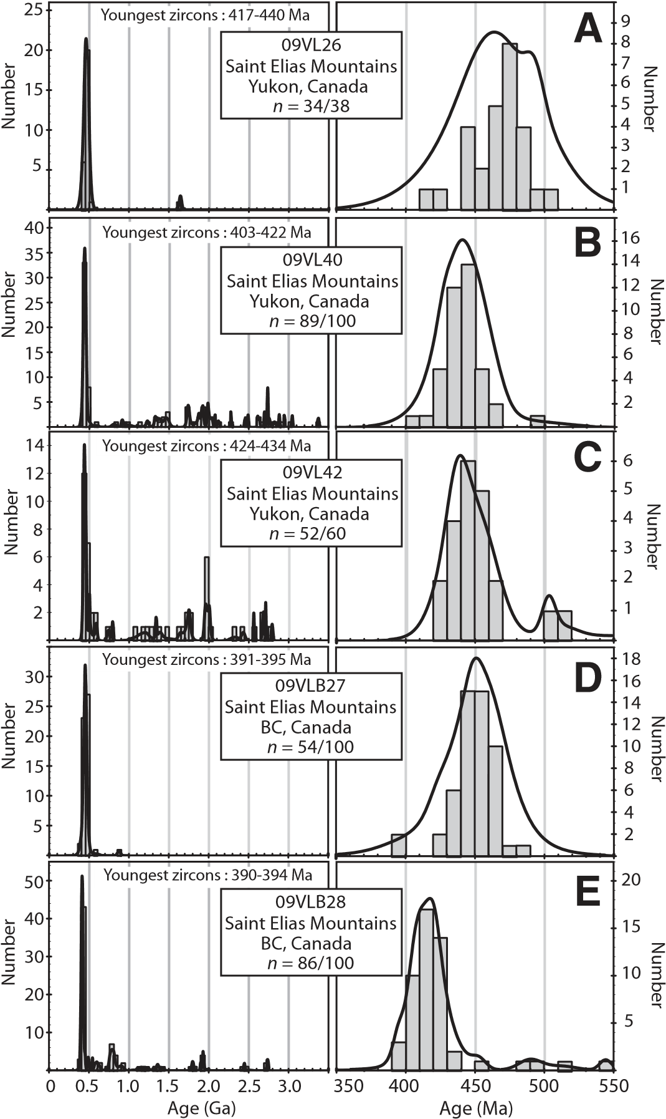

**Figure 2. Detrital zircon U-Pb probability density distribution-histogram plots of the Icefi eld assemblage. BC—British Columbia.**

εHf(t) values were calculated using the 176Lu decay constant of Scherer et al. (2001) and the chondritic values of Bouvier et al. (2008). Hf model ages were approximated to the time of crystallization using 176Lu/177Hf = 0.015 for the present-day crust (Goodge and Vervoort, 2006). Hf model ages provide an estimate for the timing of extraction of source rocks from a depleted mantle reservoir.

# DETRITAL ZIRCON SIGNATURES

Icefi eld assemblage strata yield detrital zircons that range from 390 Ma to 3372 Ma (Figs. 2A–2E), with 405–490 Ma ages forming up to 92% of each sample. The youngest age groupings (three or more grains) in the three Yukon samples occur at 403–422 Ma, 417–440 Ma, and 424–432 Ma, respectively (Figs. 2A–2C), and with available fossil data from Dodds et al. (1993) suggest Upper Silurian to Lower Devonian stratigraphic ages.

The two British Columbia samples each contain 390–395 Ma zircon age groupings (Figs. 2D–2E) and with the available fossil constraints suggest Middle Devonian stratigraphic ages.

Figure 3A shows the εHf(t) values for 176 zircons that span 390–3372 Ma. As an age group, the 405–490 Ma detrital zircons can be divided into two subpopulations based on initial Hf isotopic composition and stratigraphic age. Upper Silurian to Lower Devonian strata contain 405–490 Ma zircons with mainly negative εHf(t) values (84%) and Hf model ages that suggest Mesoproterozoic to Paleoproterozoic crust was involved in their genesis (Fig. 3B). Middle Devonian strata contain 405–490 Ma zircons with mostly positive εHf(t) values (79%) and Neoproterozoic and younger Hf model ages (Fig. 3B).

# DISCUSSION AND CONCLUSIONS

The detrital zircon Hf isotopic compositions of the Icefi eld assemblage record a major shift in the source of sediment between Late Silurian–Early Devonian and Middle Devonian time. This shift was likely the result of fi rst-order changes in tectonic setting and paleogeography of the Alexander terrane. To explain these data, we interpret the Late Silurian–Early Devonian Klakas orogeny to manifest Scandian-Salinic deformation in the region of northeast Baltica, east of the Appalachian-Caledonian convergent margin (Fig. 4A). An unresolved problem concerning the Klakas orogeny is how the Late Cambrian–Early Silurian upper-plate setting for the Alexander terrane above a subduction zone fi ts in with the overall lower-plate setting for Baltica in the Scandian-Salinic collision. Arc magmatism in the Alexander terrane ceased by ca. 430 Ma (Gehrels and Saleeby, 1987), 15–20 m.y. prior to the Klakas orogeny, and the termination of subduction probably records a change in plate dynamics related to the closure of Iapetus, such as a subduction polarity reversal.

Upper Silurian to Lower Devonian molasse strata of the Alexander terrane are herein viewed as now-displaced equivalents of the Old Red Sandstone that covered much of the northern Appalachian-Caledonian orogen (cf. Soja and Krutikov, 2008). The negative εHf(t) values and Mesoproterozoic to Paleoproterozoic Hf model ages of 405–490 Ma detrital zircons in rock samples 09VL26, 09VL40, and 09VL42 accordingly support provenance connections with crustally contaminated granites in the Greenland, Svalbard, or British Caledonides. For example, both arc-type and anatectic granite suites in Greenland (GL in Fig. 4A) incorporated material from surrounding Precambrian basement rocks and yield high initial Sr isotopic ratios (0.709–0.711), magmatic zircons with εHf(t) values of −11.9 to −5.5, and Paleoproterozoic Hf model ages (Rehnström, 2010; Augland et al., 2012). Caledonian anatectic granites in Svalbard (SV in Fig. 4A) have peraluminous geochemical signatures, negative εNd(t) values, and inherited Proterozoic zircons that together provide strong evidence for crustal melting and contamination (Johansson et al., 2005). Although detrital zircon Hf isotopic data for Old Red Sandstone units are lacking, we note that our U-Pb age populations are broadly similar to relevant Silurian–Devonian molasse strata in Svalbard (Pettersson et al., 2010), Scotland (Phillips et al., 2009), and Severnaya Zemlya (Lorenz et al., 2008b).

The Devonian period was a time of rifting in northern Laurussia and transcurrent displacement within the Caledonides (Nikishin et al., 1996; Dewey and Strachan, 2003). Devonian rifts notably formed part of the extensive Slide Mountain–Angayucham backarc system, which accompanied an arc chain situated along much of the length of northwest Laurussia (Colpron and Nelson, 2011; Miller et al., 2011). We propose that this arc chain formed by a Devonian subduction polarity reversal along the northern extension of the Caledonian convergence system, following the terminal Scandian-Salinic collision that created Laurussia (Fig. 4B). The presence of Middle to Late Devonian arc-type rocks in southeastern Alaska (Gehrels and Berg, 1992; Saleeby, 2000; Cecil et al., 2011), locally possibly as old as Early Devonian (Nelson et al., 2012), along with existing biogeographic and paleomagnetic constraints, provide evidence for the Alexander terrane to comprise part of this magmatic system (Fig. 4B).

It seems likely that the opening of the Slide Mountain–Angayucham backarc rift led to the tectonic separation of the Alexander terrane from

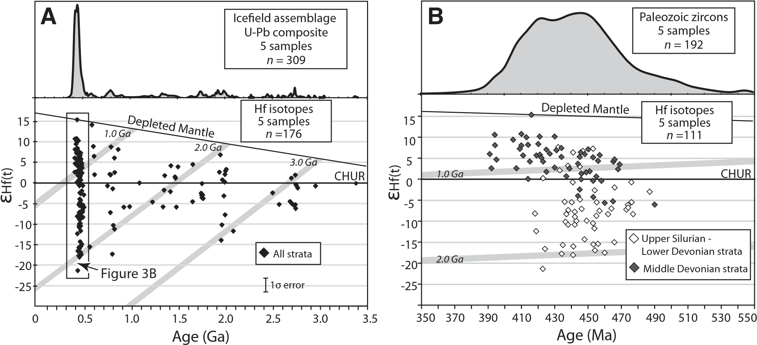

**Figure 3. (A)** ε**Hf(t) vs. U-Pb age diagram for all detrital zircons of the Icefi eld assemblage. (B)** ε**Hf(t) vs. U-Pb age diagram for Paleozoic detrital zircons of the Icefi eld assemblage. CHUR—chondritic uniform reservoir. The depleted mantle Hf evolution curves were calculated from values reported by Vervoort and Blichert-Toft (1999). Hf model ages or crustal evolution lines at 1.0, 2.0, and 3.0 Ga are plotted using 176Lu/177Hf = 0.015 (Goodge and Vervoort, 2006).**

Northern Caledonian connection for the Alexander terrane |

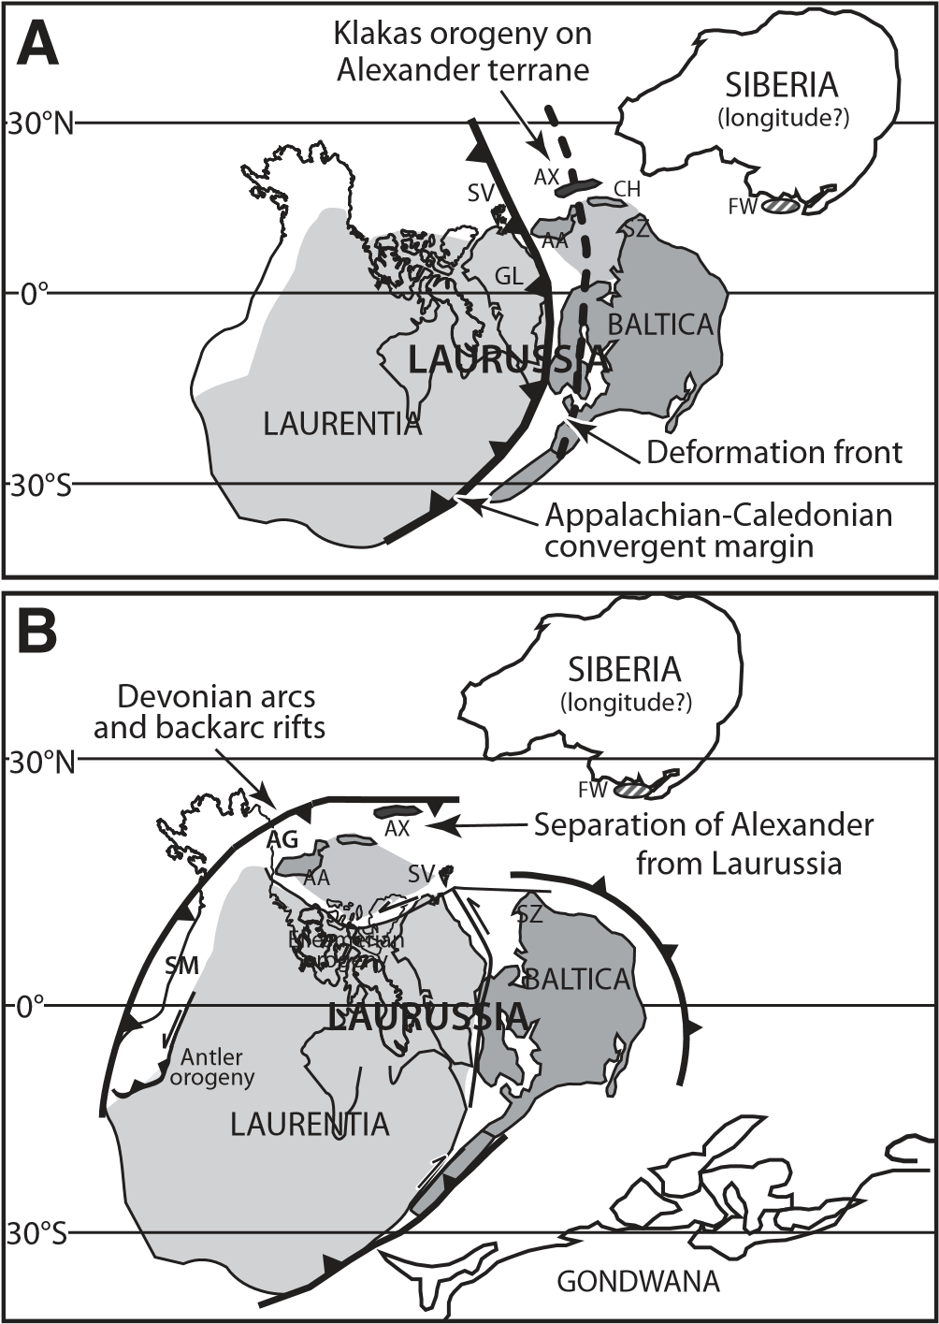

**Figure 4. (A) Late Silurian–Early Devonian paleogeographic reconstruction based on the results of this study and Beranek et al. (2013). The Alexander terrane restores to a position to the east of the Iapetan suture and within the Scandian deformation front of the Eurasian High Arctic. AA— Arctic Alaska, AX—Alexander terrane, CH—Chukotka, GL—Greenland, FW—Farewell terrane, SV—Svalbard, SZ—Severnaya Zemlya. (B) Middle to Late Devonian paleogeographic reconstruction modifi ed from Colpron and Nelson (2011) and Miller et al. (2011). AG—Angayucham Ocean, SM— Slide Mountain Ocean. The Alexander terrane is positioned on the trenchward side of the Slide Mountain–Angayucham backarc rift system.**

northern Laurussia. In addition to the generation of juvenile arc-type rocks, we predict that the timing of this separation is indicated by the relative absence of Caledonian-derived zircons in Middle Devonian sequences of the Alexander terrane (samples 09VLB27, 09VLB28). These samples instead contain 390–490 Ma detrital zircons with juvenile Hf isotopic compositions that are consistent with the erosion of local basement rocks. This hypothesis agrees with studies that consider the Alexander terrane to have evolved apart from the northern Laurussia cratons during the midPaleozoic to Mesozoic (Gehrels and Saleeby, 1987). Arc-type magmatism in southeastern Alaska ended by the Late Devonian, and the Alexander terrane evolved in a tectonically stable environment until the late Paleozoic.

# IMPLICATIONS FOR FUTURE DETRITAL ZIRCON Hf ISOTOPE STUDIES

Building upon the conclusions of this investigation, we predict that future detrital zircon Hf isotope studies will be able to more accurately

LITHOSPHERE | | |

evaluate the crustal evolution and paleogeography of Cordilleran terranes. Paleozoic detrital zircon age populations that characterize the Icefi eld assemblage are also recognized in Silurian–Devonian strata of the Arctic Alaska-Chukotka terrane of Alaska (Amato et al., 2009), eastern Klamath terrane of California and Oregon (Grove et al., 2008), Chilliwack composite terrane of Washington and southern British Columbia (Brown et al., 2010), and Quesnellia of southern British Columbia (Lemieux et al., 2007). Along with Alexander, these Cordilleran terranes contain Devonian magmatic rocks and biogeographic signatures that suggest proximity to an arc system along the trenchward side of the Slide Mountain–Angayucham backarc rift. Detrital zircon Hf isotope studies of these terranes may shed new insights into their evolved or juvenile crustal sources and the overall signifi cance of Cordilleran-Caledonian connections to global paleogeography.

## ACKNOWLEDGMENTS

This is a product of the Geo-mapping for Energy and Minerals program at Natural Resources Canada (Earth Science Sector contribution 2012270). Funding for McClelland was in part provided by National Science Foundation grants EAR-0948359 and EAR-1049368. The Arizona Laserchron Center is supported by EAR-1032156. Alex Zagorevski provided comments on an early version of this manuscript. Thoughtful reviews from J. Brendan Murphy, Maurice Colpron, and Science Editor John Goodge improved this paper.

## REFERENCES CITED

Amato, J.M., Toro, J., Miller, E.L., Gehrels, G.E., Farmer, G.L., Gottlieb, E.S., and Till, A.B., 2009, Late Proterozoic–Paleozoic evolution of the Arctic Alaska-Chukotka terrane based on U-Pb igneous and detrital zircon ages: Implications for Neoproterozoic paleogeographic reconstructions: Geological Society of America Bulletin, v. 121, p. 1219–1235, doi:10.1130 /B26510.1.

Antoshkina, A.I., and Soja, C.M., 2006, Late Silurian reconstruction indicated by migration of reef biota between Alaska, Baltica (Urals), and Siberia (Salair): GFF, v. 128, p. 75–78, doi:10.1080/11035890601282075.

Augland, L.E., Andresen, A., Corfu, F., and Daviknes, H.K., 2012, Late Ordovician to Silurian ensialic magmatism in Liverpool Land, East Greenland: New evidence extending the northeastern branch of the continental Laurentian magmatic arc: Geological Magazine, v. 149, p. 561–577, doi:10.1017/S0016756811000781.

Bazard, D.R., Butler, R.F., Gehrels, G.E., and Soja, C.M., 1995, Early Devonian paleomagnetic data from the Lower Devonian Karheen Formation suggest Laurentia-Baltica connection for the Alexander terrane: Geology, v. 23, p. 707–710, doi:10.1130/0091-7613(1995)023 <0707:EDPDFT>2.3.CO;2.

Beranek, L.P., van Staal, C.R., Gordee, S.M., McClelland, W.C., Israel, S., and Mihalynuk, M.G., 2012, Tectonic signifi cance of Upper Cambrian–Middle Ordovician mafi c volcanic rocks on the Alexander terrane, Saint Elias Mountains, northwestern Canada: The Journal of Geology, v. 120, p. 293–314, doi:10.1086/664788.

Beranek, L.P., van Staal, C.R., McClelland, W.C., Israel, S., and Mihalynuk, M.G., 2013, Baltican crustal provenance for Cambrian-Ordovician sandstones of the Alexander terrane, North American Cordillera: Evidence from detrital zircon U-Pb geochronology and Hf isotope geochemistry: Journal of the Geological Society of London, v. 170, p. 7–18, doi:10.1144 /jgs2012-028.

Blodgett, R.B., Rohr, D.M., and Boucot, A.J., 2002, Paleozoic links among some Alaskan accreted terranes and Siberia based on megafossils, *in* Miller, E.L., Grantz, A., and Klemperer, S., eds., Tectonic Evolution of the Bering Shelf–Chukchi Sea–Arctic Margin and Adjacent Landmasses: Geological Society of America Special Paper 360, p. 273–290.

Bouvier, A., Vervoort, J.D., and Patchett, P.J., 2008, The Lu-Hf and Sm-Nd isotopic composition of CHUR: Constraints from unequilibrated chondrites and implications for the bulk composition of terrestrial planets: Earth and Planetary Science Letters, v. 273, p. 48–57, doi:10.1016/j.epsl.2008.06.010.

Brown, E.H., Gehrels, G.E., and Valencia, V.A., 2010, Chilliwack composite terrane in northwest Washington: Neoproterozoic–Silurian passive margin basement, Ordovician–Silurian arc inception: Canadian Journal of Earth Sciences, v. 47, p. 1347–1366, doi:10.1139/E10-047.

Butler, R.F., Gehrels, G.E., and Bazard, D.R., 1997, Paleomagnetism of Paleozoic strata of the Alexander terrane, southern Alaska: Geological Society of America Bulletin, v. 109, p. 1372–1388, doi:10.1130/0016-7606(1997)109<1372:POPSOT>2.3.CO;2.

Cecil, M.R., Gehrels, G.E., Ducea, M.N., and Patchett, P.J., 2011, U-Pb-Hf characterization of the central Coast Mountains batholith: Implications for petrogenesis and crustal architecture: Lithosphere, v. 3, p. 247–260, doi:10.1130/L134.1.

Cocks, L.R.M., and Torsvik, T.H., 2011, The Palaeozoic geography of Laurentia and western Laurussia: A stable craton with mobile margins: Earth-Science Reviews, v. 106, p. 1–51, doi:10.1016/j.earscirev.2011.01.007.

Colpron, M., and Nelson, J.L., 2009, A Palaeozoic Northwest Passage: Incursion of Caledonian, Baltican, and Siberian terranes into eastern Panthalassa, and the early evolution of the North American Cordillera, *in* Cawood, P.A., and Kroner, A., eds., Earth Accretionary Systems in Space and Time: Geological Society of London Special Publication 318, p. 273–307.

Colpron, M., and Nelson, J.L., 2011, A Palaeozoic Northwest Passage and the Timanian, Caledonian, and Uralian connections of some exotic terranes in the North American Cordil-

lera, *in* Spencer, A.M., Embry, A.F., Gautier, D.L., Stoupakova, A.V., and Sørensen, K., eds., Arctic Petroleum Geology: Geological Society of London Memoir 35, p. 463–484.

Dewey, J.F., and Strachan, R.A., 2003, Changing Silurian–Devonian relative plate motion in the Caledonides: Sinistral transpression to sinistral transtension: Journal of the Geological Society of London, v. 160, p. 219–229, doi:10.1144/0016-764902-085.

Dodds, C.J., Campbell, R.B., Read, P.B., Orchard, M.J., Tozer, E.T., Bamber, E.W., Pedder, A.E.H., Norford, B.S., McLaren, D.J., Harker, P., McIver, E., Norris, A.W., Ross, C.A., Chatterton, B.D.E., Cooper, G.A., Flower, R.H., Haggart, J.W., Uyeno, T.T., and Irwin, S.E.B., 1993, Macrofossil and conodont data from SW Kluane Lake (115G and F[E1/2]),

Mount Saint Elias (115B and C[E1/2], SW Dezadeash (115A), NE Yakutat (114O), and Tatshenshini (114P) map areas, Yukon Territory and British Columbia: Geological Survey of Canada, Open File 2731, 137 p.

Friend, P.F., and Williams, B.P.J., eds., 2000, New Perspectives on the Old Red Sandstone: Geological Society of London Special Publication 180, p. 29–60.

Gee, D.G., Bogolepova, O.K., and Lorenz, H., 2006, The Timanide, Caledonide, and Uralide orogens in the Eurasian High Arctic, and relationships to the palaeo-continents Laurentia, Baltica, and Siberia, *in* Gee, D.G., and Stephenson, R.A., eds., European Lithosphere Dynamics: Geological Society of London Memoir 32, p. 507–520.

Gehrels, G.E., and Berg, H.C., 1992, Geologic Map of Southeastern Alaska: U.S. Geological Survey Miscellaneous Geologic Investigations Map I-1867, 24 p.

Gehrels, G.E., and Saleeby, J.B., 1987, Geologic framework, tectonic evolution, and displacement history of the Alexander terrane: Tectonics, v. 6, p. 151–174, doi:10.1029/TC006i002p00151.

Gehrels, G.E., Saleeby, J.B., and Berg, H.C., 1987, Geology of Annette, Gravina, and Duke Islands, southeastern Alaska: Canadian Journal of Earth Sciences, v. 24, p. 866–881, doi:10.1139 /e87-086.

Gehrels, G.E., Butler, R.F., and Bazard, D.R., 1996, Detrital zircon geochronology of the Alexander terrane, southeastern Alaska: Geological Society of America Bulletin, v. 108, p. 722– 734, doi:10.1130/0016-7606(1996)108<0722:DZGOTA>2.3.CO;2.

Gehrels, G.E., Valencia, V., and Ruiz, J., 2008, Enhanced precision, accuracy, effi ciency, and spatial resolution of U-Pb ages by laser ablation–multicollector–inductively coupled plasma– mass spectrometry: Geochemistry Geophysics Geosystems, v. 9, Q03017, doi:10.1029 /2007GC001805.

Goodge, J., and Vervoort, J.D., 2006, Origin of Mesoproterozoic A-type granites in Laurentia: Hf isotope evidence: Earth and Planetary Science Letters, v. 243, p. 711–731, doi:10.1016/j .epsl.2006.01.040.

Gradstein, F.M., Ogg, J.G., and Smith, A.G., eds., 2004, A Geologic Time Scale 2004: Cambridge, UK, Cambridge University Press, 589 p.

Grove, M., Gehrels, G.E., Cotkin, S.J., Wright, J.E., and Zou, H., 2008, Non-Laurentian cratonal provenance of Late Ordovician blueschists and a link to the Alexander terrane, *in* Wright, J.E., and Shervais, J.W., eds., Ophiolites, Arcs, and Batholiths: Geological Society of America Special Paper 438, p. 223–250.

Johansson, Å., Gee, D.G., Larionov, A.N., Ohta, Y., and Tebenkov, A.M., 2005, Grenvillian and Caledonian evolution of eastern Svalbard—A tale of two orogenies: Terra Nova, v. 17, p. 317–325, doi:10.1111/j.1365-3121.2005.00616.x.

Kinny, P.D., and Maas, R., 2003, Lu-Hf and Sm-Nd isotope systems in zircon: Reviews in Mineralogy and Geochemistry, v. 53, p. 327–341, doi:10.2113/0530327.

Lemieux, Y., Thompson, R.I., Erdmer, P., Simonetti, A., and Creaser, R.A., 2007, Detrital zircon geochronology and provenance of Late Proterozoic and mid-Paleozoic successions outboard of the miogeocline, southeastern Canadian Cordillera: Canadian Journal of Earth Sciences, v. 44, p. 1675–1693, doi:10.1139/E07-048.

Lorenz, H., Männik, P., Gee, D.G., and Proskurnin, V., 2008a, Geology of the Severnaya Zemlya Archipelago and the North Kara terrane in the Russian High Arctic: International Journal of Earth Sciences, v. 97, p. 519–547, doi:10.1007/s00531-007-0182-2.

Lorenz, H., Gee, D.G., and Simonetti, A., 2008b, Detrital zircon ages and provenance of the Late Neoproterozoic and Palaeozoic succession on Severnaya Zemlya, Kara Shelf: A tie to Baltica: Norwegian Journal of Geology, v. 88, p. 235–258.

Ludwig, K.R., 2003, User’s Manual for Isoplot/Ex, Version 3.00: A Geochronological Toolkit for Microsoft Excel: Berkeley Geochronology Center Special Publication 4, 77 p.

McClelland, W.C., Gehrels, G.E., and Saleeby, J.B., 1992, Upper Jurassic–Lower Cretaceous basinal strata along the Cordilleran margin: Implications for the accretionary history of the Alexander-Wrangellia-Peninsular terrane: Tectonics, v. 11, p. 823–835, doi:10.1029 /92TC00241.

McKerrow, W.S., Mac Niocaill, C., and Dewey, J.F., 2000, The Caledonian orogeny redefi ned: Journal of the Geological Society of London, v. 157, p. 1149–1154, doi:10.1144/jgs .157.6.1149.

Mihalynuk, M.G., Smith, M.T., MacIntyre, D.G., and Deschênes, M., 1993, Tatshenshini Project, Part B: Stratigraphic and Magmatic Setting of Mineral Occurrences: British Columbia Ministry of Energy, Mines, and Petroleum Resources, Geological Fieldwork 1992, v. 1993-1, p. 189–228.

Miller, E.L., Kuznetsov, N., Soboleva, A., Udoratina, O., Grove, M.J., and Gehrels, G.E., 2011, Baltica in the Cordillera?: Geology, v. 39, p. 791–794, doi:10.1130/G31910.1.

Nelson, J.L., Diakow, L.J., Mahoney, J.B., van Staal, C.R., Pecha, M., Angen, J.J., Gehrels, G.E., and Lau, T., 2012, North Coast Project: Tectonics and metallogeny of the Alexander terrane, and Cretaceous sinistral shearing of the western Coast belt: British Columbia Ministry of Energy, Mines, and Petroleum Resources, Geological Fieldwork 2011, v. 2012-1, p. 157–180.

Nikishin, A.M., Ziegler, P.A., Stephenson, R.A., Cloetingh, S.A.P.L., Fume, A.V., Fokin, P.A.,

Ershov, A.V., Bolotov, S.N., Korotaev, M.V., Alekseev, A.S., Gorbachev, V.I., Shipilov, E.V., Lankreijer, A., Bembinova, E.Y., and Shalimov, I.V., 1996, Late Precambrian to Triassic history of the East European craton: Dynamics of sedimentary basin evolution: Tectonophysics, v. 268, p. 23–63, doi:10.1016/S0040-1951(96)00228-4.

Pease, V., 2011, Eurasian orogens and Arctic tectonics: An overview, *in* Spencer, A.M., Embry, A.F., Gautier, D.L., Stoupakova, A.V., and Sørensen, K., eds., Arctic Petroleum Geology: Geological Society of London Memoir 35, p. 311–324.

Pedder, A.E.H., 2006, Zoogeographic data from studies of Paleozoic corals of the Alexander terrane, southeastern Alaska and British Columbia, *in* Haggart, J.W., Enkin, R.J., and Monger, J.W.H., eds., Paleogeography of the North American Cordillera: Evidence For and Against Large-Scale Displacements: Geological Association of Canada Special Paper 46, p. 29–57.

Pettersson, C.H., Pease, V., and Frei, D., 2010, Detrital zircon U-Pb ages of Silurian–Devonian sediments from NW Svalbard: A fragment of Avalonia and Laurentia?: Journal of the Geological Society of London, v. 167, p. 1019–1032, doi:10.1144/0016-76492010-062.

Phillips, E.R., Smith, R.A., Stone, P., Pashley, V., and Horstwood, M., 2009, Zircon age constraints on the provenance of Llandovery to Wenlock sandstones from the Midland Valley terrane of the Scottish Caledonides: Scottish Journal of Geology, v. 45, p. 131–146, doi:10.1144/0036-9276/01-383.

Rehnström, E.F., 2010, Prolonged Paleozoic magmatism in the East Greenland Caledonides: Some constraints from U-Pb ages and Hf isotopes: The Journal of Geology, v. 118, p. 447– 465, doi:10.1086/655010.

Saleeby, J.B., 2000, Geochronologic investigations along the Alexander-Taku terrane boundary, southern Revillagigedo Island to Cape Fox areas, southeast Alaska, *in* Stowell, H.H., and McClelland, W.C., eds., Tectonics of the Coast Mountains, Southeastern Alaska and British Columbia: Geological Society of America Special Paper 343, p. 107–143.

Samson, S.D., McClelland, W.C., Patchett, P.J., Gehrels, G.E., and Anderson, R.G., 1989, Evidence from neodymium isotopes for mantle contributions to Phanerozoic crustal genesis in the Canadian Cordillera: Nature, v. 337, p. 705–709, doi:10.1038/337705a0.

Scherer, E., Münker, C., and Mezger, K., 2001, Calibration of the lutetium-hafnium clock: Science, v. 293, p. 683–687, doi:10.1126/science.1061372.

Soja, C.M., 1994, Signifi cance of Silurian stromatolite-sphinctozoan reefs: Geology, v. 22,

p. 355–358, doi:10.1130/0091-7613(1994)022<0355:SOSSSR>2.3.CO;2.

Soja, C.M., and Antoshkina, A.I., 1997, Coeval development of Silurian stromatolite reefs in Alaska and the Ural Mountains: Implications for paleogeography of the Alexander terrane: Geology, v. 25, p. 539–542, doi:10.1130/0091-7613(1997)025<0539:CDOSSR>2.3 .CO;2.

Soja, C.M., and Krutikov, L., 2008, Provenance, depositional setting, and tectonic implications of Silurian polymictic conglomerate in Alaska’s Alexander terrane, *in* Blodgett, R.B., and Stanley, G.D., Jr., eds., The Terrane Puzzle: New Perspectives on Paleontology and Stratigraphy from the North American Cordillera: Geological Society of America Special Paper 442, p. 63–75.

van Staal, C.R., Whalen, J.B., Valverde-Vaquero, P., Zagorevski, A., and Rogers, N., 2009, PreCarboniferous, episodic accretion-related, orogenesis along the Laurentian margin of the northern Appalachians, *in* Murphy, J.B., Keppie, J.D., and Hynes, A.J., eds., Ancient Orogens and Modern Analogues: Geological Society of London Special Publication 327, p. 271–316.

Vervoort, J.D., and Blichert-Toft, J., 1999, Evolution of the depleted mantle: Hf isotope evidence from juvenile rocks through time: Geochimica et Cosmochimica Acta, v. 63, p. 533–556, doi:10.1016/S0016-7037(98)00274-9.

Whalen, J.B., McNicoll, V.J., van Staal, C.R., Lissenberg, C.J., Longstaffe, F.J., Jenner, G.A., and van Breeman, O., 2006, Spatial, temporal and geochemical characteristics of Silurian collision-zone magmatism, Newfoundland Appalachians: An example of a rapidly evolving magmatic system related to slab break-off: Lithos, v. 89, p. 377–404, doi:10.1016/j .lithos.2005.12.011.

MANUSCRIPT RECEIVED 16 AUGUST 2012

REVISED MANUSCRIPT RECEIVED 29 OCTOBER 2012

MANUSCRIPT ACCEPTED 31 OCTOBER 2012

Printed in the USA

1. GSA Data Repository Item 2013074, Table DR1, detrital zircon U-Pb age results; Table DR2, detrital zircon Hf isotope results, is available at www.geosociety.org /pubs/ft2013.htm,or on request from editing@geosociety.org, Documents Secretary,GSA, P.O. Box 9140, Boulder, CO 80301-9140, USA.

   LITHOSPHERE | | |