**2013-011**2015 **research-articleResearch article**10.1144/sjg2013-011First recorded occurrence of detrital baddeleyite (ZrO2) in sedimentary rock (Smith Bank Formation, Triassic, Central North Sea)A. D. Wilkins, M. J. Wilson, A. Morton, A. Hurst &, S. G. ArcherXXX10.1144/sjg2013-011A. D. Wilkins et al.Detrital baddeleyite (ZrO2) in sedimentary rock

# *Scottish Journal of Geology*

Research article

Published online August 21, 2015 doi:10.1144/sjg2013-011 | Vol. 51 | 2015 | pp. 185 –189 **First recorded occurrence of detrital baddeleyite (ZrO ) in**

**2 sedimentary rock (Smith Bank Formation, Triassic, Central North Sea)**

**A. D. Wilkins1*, M. J. Wilson2, A. Morton3, 4, A. Hurst1 & S. G. Archer1**

1. Department of Geology and Petroleum Geology, Meston Building, University of Aberdeen, Aberdeen AB24 3UE, UK
2. The James Hutton Institute, Craigiebuckler, Aberdeen AB15 8QH, UK
3. HM Research, 2 Clive Road, Balsall Common, West Midlands CV7 7DW, UK
4. CASP, University of Cambridge, 181a Huntingdon Road, Cambridge CB3 0DH, UK

* Correspondence: a.d.wilkins@abdn.ac.uk

**Abstract:** Baddeleyite (ZrO2) is a comparatively rare mineral in nature. It has been found previously only in igneous and metamorphic rocks, in soils and modern river sands derived from these rocks and, most recently, in deep sea ferro-manganese nodules in the Indian Ocean. Here we report two occurrences of baddeleyite in a siltstone from the Triassic Smith Bank Formation of the Central North Sea, which we believe to be the first record of this mineral as a detrital phase within a clastic sedimentary rock.

**Received** 22 July 2013; **accepted** 26 May 2015

Baddeleyite (monoclinic ZrO2) was first described by Fletcher (1893) and named after Joseph Baddeley, a tea tycoon, who discovered it in 1892 near the small town of Rakwana on Sri Lanka. Trace amounts of this uncommon uraniferous accessory mineral have since been reported in a variety of crystalline and hyaline rock types, including lunar basalts (Agrell *et al.* 1970; Keil *et al.* 1971), meteorites (Floran *et al.* 1978; Krot *et al.* 1993), tektites (Clarke & Wosinski 1967; Glass *et al.* 1990), carbonatites (Williams 1993; Amelin & Zaitsev 2002), kimberlites (Page *et al.* 2007), meta-carbonates (Purtscheller & Tessadri 1985), granulites (Bingen *et al.* 2001), dolerites (Wahlgren *et al.* 1996) and gabbros (French *et al.* 2002).

Globally there are less than 200 terrestrial occurrences of baddeleyite in its primary form (Fig. 1). Within the UK,

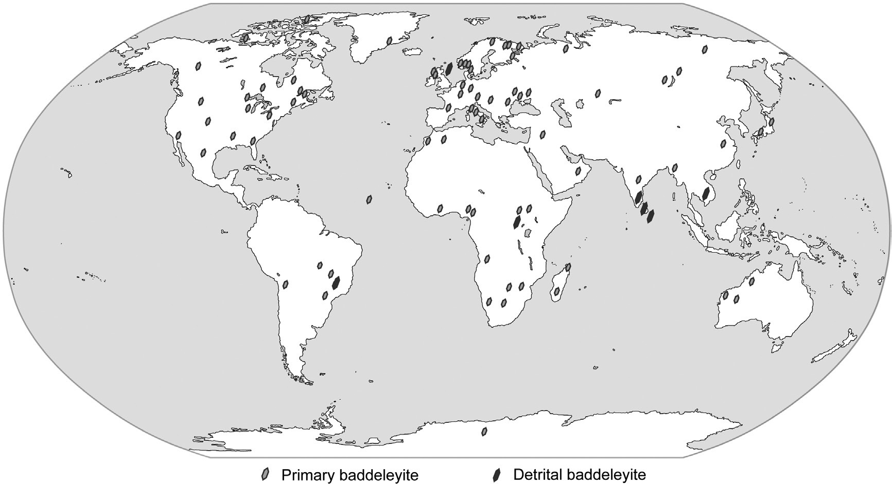

**Fig. 1.** Global occurrence of baddeleyite. *Source*: [www.mindat.org](http://www.mindat.org/), this paper and all references therein.

© 2015 The Author(s). Published by The Geological Society of London for EGS and GSG. All rights reserved. For permissions: http://www.geolsoc.org.uk/ permissions. Publishing disclaimer: www.geolsoc.org.uk/pub_ethics

186 A. D. Wilkins *et al.*

**Table 1.** *Rock types in which baddeleyite is found, and likely grain size*

|  |  |  |
| --- | --- | --- |
| Rock type | Grain size (µm) | Literature source |
| Meteorites | <1 | Lundberg *et al.* (1988) |
| Tektites | <1 | El Gorsey (1965) |
| Kimberlites | <5 | Scatena-Wachel & Jones (1984) |
| Lunar basalts | <20 | Heaman & LeCheminant (1993) |
| Meta carbonates | <30 | Purtscheller & Tessadri (1985) |
| Granulites | <30 | Bingen *et al.* (2001) |
| Gabbros | <50 | Bayanova (2006) |
| Dolerites | <100 | Wingate (1999) |

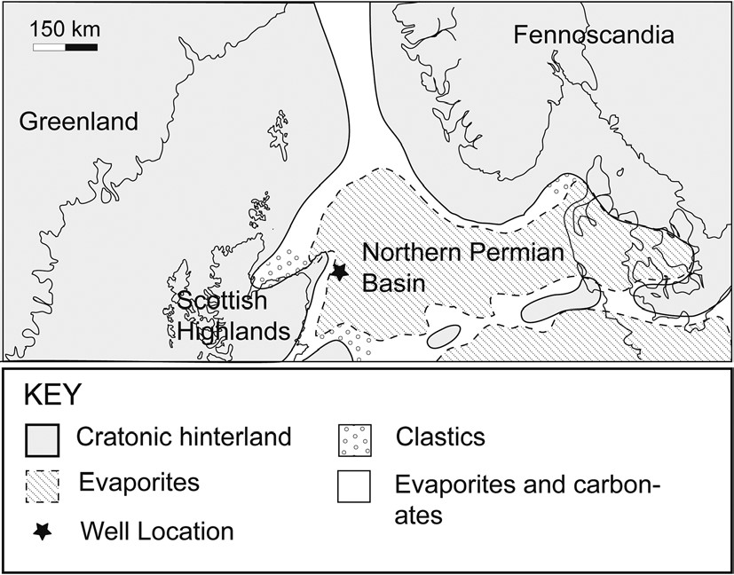

**Fig. 2.** Well location, within the context of the supercontinent Pangaea during latest Permian, earliest Triassic.

its only known occurrences are in a layered mafic–ultramafic complex on Rhum (Williams 1978); in a Scourian picrite dyke in the NW Highlands (Heaman & Tarney 1989); and in the contact metamorphic aureole associated with the Ballachulish Igneous Complex (Fraser *et al.*

2004).

Although Dunning & Hodych (1991) state that baddeleyite has never been recorded as a detrital mineral, there are previously accepted occurrences of baddeleyite in sediment and soil. For example, the mineral occurs in coarse gravels of the gem districts of Sri Lanka (Fletcher 1893; Blake & Herbert-Smith 1907), in diamond sands from Rio Verdinho, Brazil and in the gold washings at Kilo, Democratic Republic of the Congo (Palache *et al.* 1944). Baddeleyite is also reported in terra rossa soils overlying a carbonatite complex in Uganda, along with the closely related oxide calzirtite (CaTiZr3O9) (Baldock 1968). More recently, baddeleyite has been recorded within the sands of the Red River, Vietnam (Bodet & Scharer 2000) and in ferromanganese nodules from the Central Indian Ocean (Nayak *et al.* 2011). However, to date it appears that there has been no previous recording of baddeleyite as a detrital mineral contained within a sedimentary rock.

In the most chemically fractionated portions of mafic magmas, baddeleyite is a late-stage crystallization product in conjunction with apatite, ilmenite, zircon and zirconolite, and occurs as wafer-thin bladed, euhedral crystals and as blebs in association with complex Fe-Ti oxide grains (Heaman & LeCheminant 1993).

Baddeleyite is also known to occur in other far less common geological environments. During meteorite impacts it forms from the dissociation of zircon at extremely high temperatures (El Gorsey 1965). In tektites, it forms rounded and elongate blebs within glass inclusions (Glass *et al.* 1990). Within kimberlites, it is seen as a reaction rim with the baddeleyite needles perpendicular to zircon grains, the baddeleyite forming as a result of metasomatism, by desilicification of zircon mantle xenocrysts (Kresten 1974). Ferry (1996) suggested that baddeleyite forms from the breakdown of zircons during contact metamorphism of dolomites. In granulites, baddeleyite crystals are found at the margins of ilmenite grains and occasionally as rounded inclusions within them, and are believed to be an exsolution product from magmatic ilmenite (Bingen *et al.* 2001). Finally, baddeleyite mantle xenocrysts are found in carbonatite magmas (Eriksson 1984; French *et al.* 2002). A summary of the grain sizes associated with various rock types is given in Table 1 and it may be seen that in most instances the mineral occurs as silt-size grains (2–60 µm) in mafic and ultramafic rocks.

# Method

Baddeleyite was found unexpectedly while studying the mineralogy of Triassic mudstones of the Central North Sea. The samples of interest come from well 20/25-1 (Fig. 2). The well is approximately 130 km offshore of Aberdeen. The particular core sample in which the mineral occurs was taken from a depth of 5448 ft (1660.55 m) MD (measured depth) within a sequence of interbedded siltstones from the Smith Bank Formation (Fig. 3). A double polished thin section, coated with approximately 20 to 25 nm of carbon, was made in order to examine in detail the mineralogy and microtextures of the siltstone using scanning electron microscopy (SEM). SEM model ISI-ABT55 was employed, using both backscatter electron (BSE) imaging to determine and quantify the presence of heavy minerals, and energy dispersive spectra (EDS) on individual grains for elemental analysis and mineral identification (*sensu* Totten & Hanan 2007). Due to the fine-grained nature of the sample it was not possible to obtain any optical petrographic data.

# Geological setting

Baddeleyite was found in siltstones of the Smith Bank Formation which is Early Triassic in age. The Smith Bank Formation consists of fine-grained, and virtually biostratigraphically barren, mudstones that have been previously described as monotonous (Deegan & Scull 1977; Lervik *et al.* 1989; Cameron 1993). It is overlain by the Mid- to Late Triassic Skagerrak Formation, which comprises three sandstone members (Judy, Joanne and Josephine) intercalated with three mudstone members (Julius, Jonathan and Joshua).

During the Permian, the area that was later to become the Central North Sea formed a gently undulating, featureless, frequently evaporitic, basin (Fig. 2). At the onset of the Early Triassic, continental clastic sedimentation coincided with an increase in precipitation and the area became part of a southeasterly-flowing ephemeral fluvial system in which sediment was believed to be sourced from Fennoscandia,

|  |
| --- |
| Detrital baddeleyite (ZrO2) in sedimentary rock 187 |

**Fig. 3.** Sedimentary log for well 20/25-1, illustrating sample location.

Greenland and the Scottish Highlands (Steel & Ryseth 1990; McKie & Audretsch 2005; McKie & Williams 2009).

# Results

The siltstone sample mainly comprises coarse, angular, siltsized grains of detrital quartz, feldspar, muscovite and biotite, with occasional heavy minerals including zircon, Fe-Ti oxides and ilmenite. Two baddeleyite grains, *c*.4 µm in size, were detected by their high BSE luminosities at the margin of quartz grains in the siltstone sample (Fig. 4). These grains yielded EDS consisting of only a Zr signal and with no indication of an accompanying Si peak. Euhedral crystals of zircon were also observed and, as expected, here the mineral yielded a spectrum where the Si signal is clearly apparent (Fig. 5). Baddeleyite is the only possible mineral that would yield an ED spectrum comprising only Zr. Other possible Zr-bearing minerals contain other elements (Milnes & Fitzpatrick 1989), so in this instance the ED spectrum is diagnostic.

# Discussion

Keil & Fricker (1974) suggested that even in its primary crystalline form within igneous and metamorphic rocks,

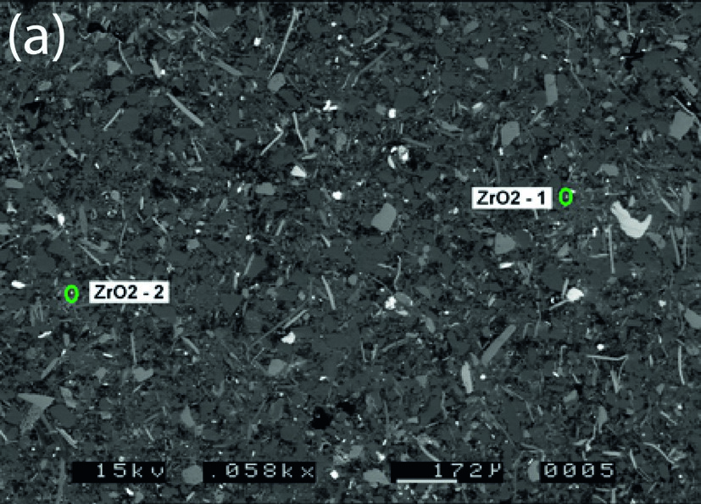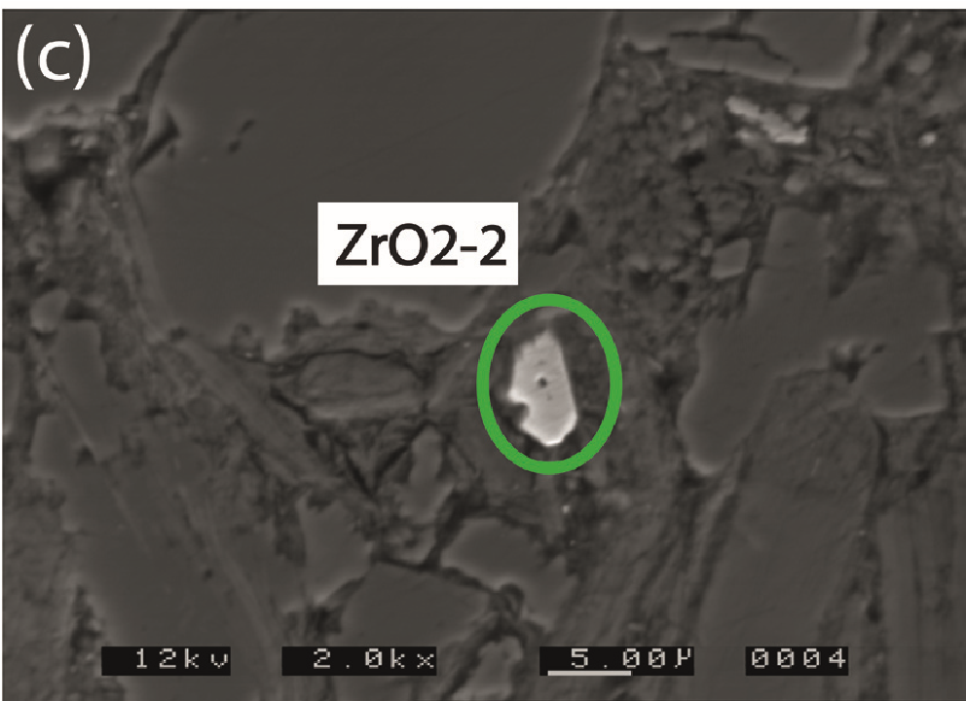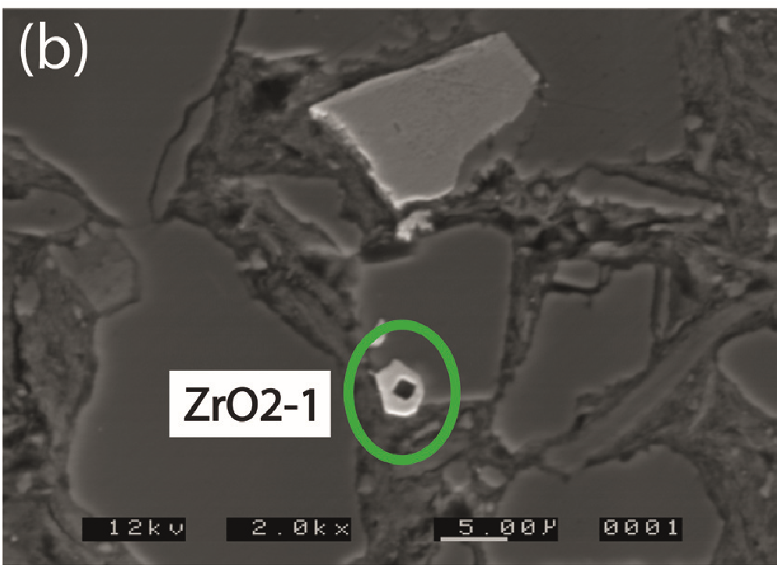

**Fig. 4.** Scanning electron micrographs of baddeleyite in Smith Bank Formation siltstone. (**a**) Low-resolution backscattered electron (BSE) image showing the location of the two baddeleyite grains ZrO2-1 and ZrO2-2 (encircled). (**b**) High-resolution BSE image of ZrO2-1 as seen in (a) showing the high atomic contrast of the baddeleyite compared with the surrounding minerals. The dark bleb in the central portion of the mineral is a carbon build up caused by the technique and machine used. (**c**) Highresolution BSE image of ZrO2-2 as seen in (a).

baddeleyite is likely to be overlooked because of its small size. Typically, baddeleyite has a crystal size of less than 30 µm (Table 1; Söderlund & Johansson 2002), so that detrital baddeleyite grains are likely to be undetected by standard heavy mineral analysis techniques that focus on sand-size particles (Mange & Maurer 1992; Morton 2012). Small

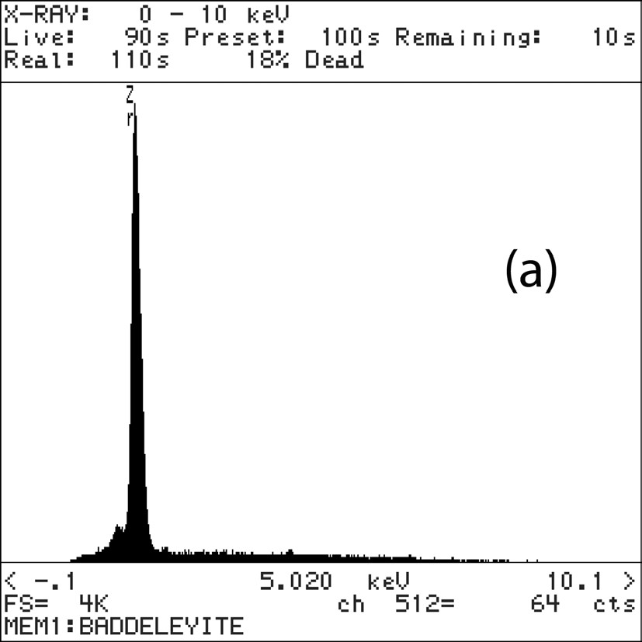

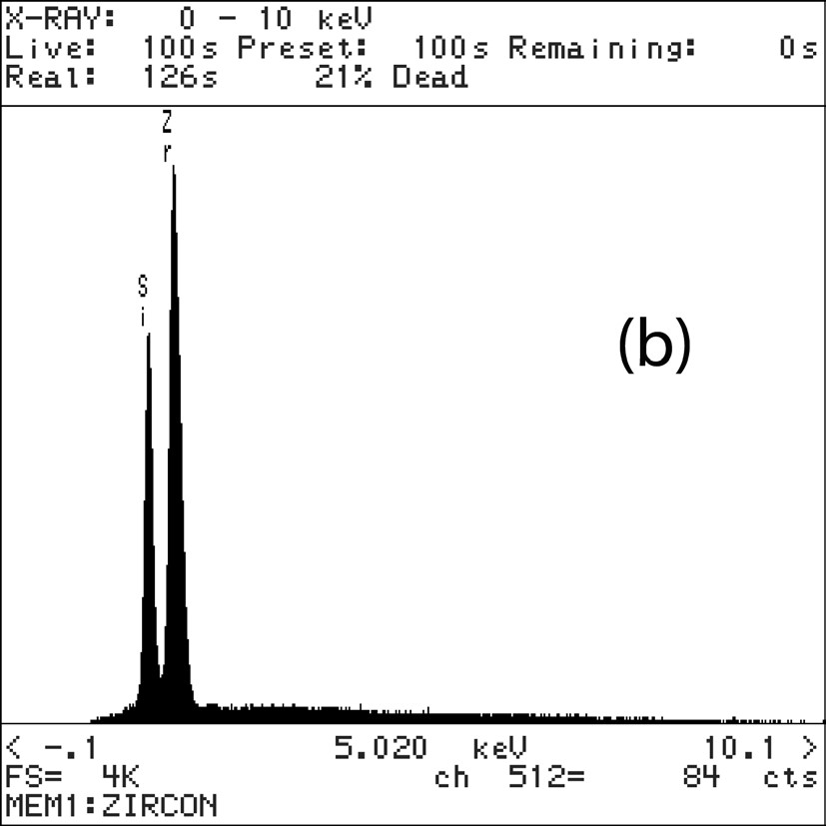

|  |
| --- |
| 188 A. D. Wilkins *et al.* |

**Fig. 5.** Energy dispersive spectra, showing (**a**) baddeleyite, diagnosed by the peak for the single detected element zirconium (Zr) and (**b**) zircon, displaying the additional silicon (Si) peak.

grains of zircon can potentially be confused with baddeleyite as both minerals are Zr-rich and have similar refractive indices (*c*. 2.19 and *c*. 1.96, respectively) and low birefringence, although baddeleyite is pleochroic (Anthony *et al.* 1985). However, because of the tiny grain-size of baddeleyite detected in this study, their optical properties were not amenable to differentiating the two minerals. The presence of baddeleyite was not noted, or expected, during thin section analysis and we believe this mineral can be overlooked easily during petrographic examination.

Paragenesis of the baddeleyite grains is unclear, partly because resolution of their morphology is limited by their very small size (Fig. 4). Given their refractory origin and the high ionic radius of Zr and its resultant low solubility and mobility in aqueous solutions (Milnes & Fitzpatrick 1989; Preston *et al.* 1998), we assume that the grains are unlikely to be authigenic, or to have been significantly modified during burial diagenesis; broadly similar to most zircon in sedimentary strata. The angular habit of the baddeleyite (Fig. 4b and c) is suggestive of minor abrasion in a sedimentary environment which, as baddeleyite is less hard (hardness = 6.5) than quartz (7) and zircon (7.5), is likely. Baddeleyite has similar hardness as plagioclase feldspar (h = 6/6.5) with which it is associated as an inclusion mineral (Siivola 1977; Scoates & Chamberlain 1995). Degradation of sand-sized plagioclase feldspar grains during transport and sedimentation and release of baddeleyite inclusions into the microgranular mix is a possible origin for the baddeleyite grains.

Given the ‘monotony’ assigned to the Smith Bank Formation (Deegan & Scull 1977; Lervik *et al.* 1989; Cameron 1993), largely a function of its fine grain size and the scarcity of fossils, the occurrence of an unusual heavy mineral such as baddeleyite may highlight the potential for applying mineral-chemical stratigraphy (Hurst & Morton 2014) to the Smith Bank Formation and other monotonous fine-grained strata. In the Central North Sea Triassic, where there is a lack of regionally-recognizable seismic markers to facilitate lithostratigraphic correlation, further investigation of the heavy mineralogy of siltstones may reveal data of lithostratigraphic significance. Further work is continuing with this end in mind.

# Conclusion

Detrital baddeleyite has been identified within an early Triassic siltstone of the Central North Sea using backscatter electron imaging and energy-dispersive x-ray analysis. This is believed to be its first recorded instance within a clastic sedimentary rock.

# Acknowledgements and Funding

The authors wish to thank John Still of the University of Aberdeen for his invaluable assistance with the SEM-EDS analyses. This work was conducted as part of the Triassic Mudstones Joint Industry Project which was sponsored by BP, ConocoPhillips, EON E&P, Esso Exploration and Production UK Limited, GDF SUEZ E&P UK Ltd, JX Nippon, Maersk Oil, Shell and Total. *Scientific editing by Rob Duck*

# References

Agrell, S.O., Scoon, J.H., Muir, I.D., Long, J.V.P., Mckonnell, J.D. & Peckett,

A. 1970. Observations on the chemistry, mineralogy and petrology of some Apollo 11 lunar samples. Proceedings of the Apollo 11 Lunar Science Conference. *Geochimica et Cosmochimica Acta*, **1**, 93–128.

Amelin, Y. & Zaitsev, A.N. 2002. Precise geochronology of phoscorites and carbonatites: The critical role of U-series disequilibrium in age interpretations. *Geochimica et Cosmochimica Acta*, **66**, 2399–2419.

Anthony, J.W., Bideaux, R.A., Bladh, K.W. & Nichols, M.C. (eds) 1985. *Zircon, Handbook of Mineralogy. II (Silica, Silicates)*. Mineralogical Society of America, Chantilly, VA.

Baldock, J.W. 1968. Calzirtite and the mineralogy of residual soils from the Bukusu carbonatite complex, south-eastern Uganda. *Mineralogical Magazine*, **36**, 770–774.

Bayanova, T.B. 2006. Baddeleyite: A promising geochronometer for alkaline and basic magmatism. *Petrology*, **14**, 187–200.

Bingen, B., Austrheim, H. & Whitehouse, M. 2001. Ilmenite as a source for zirconium during high-grade metamorphism? Textural evidence from the Caledonides of Western Norway and implications for zircon geochronology. *Journal of Petrology*, **42**, 355–375.

Blake, G.S. & Herbert-Smith, G.F. 1907. Baddeleyite from Ceylon. *Mineralogical Magazine*, **14**, 378–384.

Bodet, F. & Scharer, U. 2000. Evolution of the SE-Asian continent from U–Pb and Hf isotopes in single grains of zircon and baddeleyite from large rivers. *Geochimica et Cosmochimica Acta*, **64**, 2067–2091.

|  |
| --- |
| Detrital baddeleyite (ZrO2) in sedimentary rock 189 |

Cameron, T.D.J. 1993. 4. Triassic, Permian and Pre-Permian of the central and northern North Sea. *In*: Knox, R.W.O’B. & Cordey, W.G. (eds) *Lithostratigraphic Nomenclature of the UK North Sea*. British Geological Survey, Nottingham, 25–42.

Clarke, R.S. & Wosinski, J.F. 1967. Baddeleyite inclusion in the Martha’s Vineyard tektite. *Geochimica et Cosmochimica Acta*, **81**, 397–406.

Deegan, C.E. & Scull, B.J. 1977. *A standard lithostratigraphic nomenclature from the central and northern North Sea*. Institute of Geological Sciences Report, 77/25.

Dunning, G.R. & Hodych, J.P. 1991. Reply on ‘U/Pb zircon and baddeleyite ages for the Palisades and Gettysburg sills of the northeastern United States: Implications for the age of the Triassic/Jurassic boundary’. *Geology*, **19**, 766–767.

El Gorsey, A. 1965. Baddeleyite and its significance in impact glasses. *Journal of Geophysical Research*, **70**, 3453–3456.

Eriksson, S.C. 1984. Age of carbonatite and phoscorite magmatism of the Phalaborwa Complex (South Africa). *Isotope Geoscience*, **2**, 291–299.

Ferry, J.M. 1996. Three novel isograds in metamorphosed siliceous dolomites from the Ballachulish aureole, Scotland. *American Mineralogist*, **81**, 485– 494.

Fletcher, L. 1893. On baddeleyite (native zirconia), a new mineral from Rakwana, Ceylon. *Mineralogical Magazine*, **10**, 148–160.

Floran, R.J., Prinz, M., Hlava, P.F., Keil, K., Nehru, C.E. & Hinthorne, J.R. 1978. The Chassigny meteorite: A cumulate dunite with hydrous amphibolebearing melt inclusions’. *Geochimica et Cosmochimica Acta*, **42**, 1213–1229.

Fraser, G.L., Pattison, D.R.M. & Heaman, L.M. 2004. Age of the Ballachulish and Glencoe Igneous Complexes (Scottish Highlands), and paragenesis of zircon, monazite and baddeleyite in the Ballachulish Aureole. *Journal of the Geological*

*Society, London*, **161**, 447–462,<http://doi.org/10.1144/0016-764903-018>

French, J.E., Heaman, L.M. & Chacko, T. 2002. Feasibility of chemical U–Th– total Pb baddeleyite dating by electron microprobe. *Chemical Geology*, **188**, 85–104.

Glass, B.P., Wasson, J.T. & Futrellk, D.S. 1990. A layered moldavite containing baddeleyite. *In*: *Proceedings of the 20th Lunar Planetary Science Conference*, Houston, TX, 13–17 March, 415–420.

Heaman, L.M. & LeCheminant, A.N. 1993. Paragenesis and U–Pb systematics of baddeleyite (ZrO2). *Chemical Geology*, **110**, 95–126.

Heaman, L.M. & Tarney, J. 1989. U–Pb baddeleyite ages for the Scourie dyke swarm, Scotland: Evidence for two distinct intrusion events. *Nature*, **340**, 705–708.

Hurst, A. & Morton, A.C. 2014. Provenance models: The role of sandstone mineral-chemical stratigraphy. *In*: Scott, R.A., Smyth, H.R., Morton, A.C. & Richardson, N. (eds) *Sediment Provenance Studies in Hydrocarbon Exploration and Production*. Geological Society, London, Special Publications, **386**, 7–26, <http://doi.org/10.1144/SP386.11>

Keil, K. & Fricker, P.E. 1974. Baddeleyite (ZrO2) in gabbroic rocks from Axel Heiberg Island, Candian Arctic Archipelago. *American Mineralogist*, **59**, 249–253.

Keil, K., Prinz, M. & Bunch, T.E. 1971. Mineralogy, petrology and chemistry of some Apollo 12 samples. *Proceedings of the 2nd Lunar Science Conference*, 11–14 January 1971, Houston, Texas. MIT Press, **1**, 319–341.

Kresten, P. 1974. Uranium in kimberlites and associated rocks, with special reference to Lesotho occurrences. *Lithos*, **7**, 171–180.

Krot, A.N., Rubin, A.E. & Kononkova, N.N. 1993. First occurrence of pyrophanite (MnTiO3) and baddeleyite (ZrO2) in an ordinary chondrite. *Meteoritics*, **28**, 232–252.

Lervik, K.S., Spencer, A.M. & Warrington, G. 1989. Outline of Triassic stratigraphy and structure in the central and northern North Sea. *In*: Collinson, J.D. (ed.) *Correlation in Hydrocarbon Exploration*. Norwegian Petroleum Society, Graham and Trotman, London, 173–189.

Lundberg, L.L., Crozaz, G., McKay, G. & Zinner, E. 1988. Rare earth element carriers in the Shergotty meteorite and implications for its chronology. *Geochimica et Cosmochimica Acta*, **52**, 2147–2163.

Mange, M.A. & Maurer, H.F.W. 1992. *Heavy Minerals in Colour*. Chapman & Hall, London.

McKie, T. & Audretsch, P. 2005. Depositional and structural controls on Triassic reservoir performance in the Heron Cluster, ETAP, Central North

Sea. *In*: Doré, A.G. & Vining, B.A. (eds) *Petroleum Geology: NorthWest Europe and Global Perspectives – Proceedings of the 6th Petroleum Geology Conference*. Geological Society, London, UK, 285–298, [http://doi. org/10.1144/0060285](http://doi.org/10.1144/0060285)

McKie, T. & Williams, B. 2009. Triassic palaeogeography and fluvial dispersal across the northwest European Basins. *Geological Journal*, **44**, 711–741.

Milnes, A.R. & Fitzpatrick, R.W. 1989. Titanium and zirconium minerals. *In*: Dixon, J.B. & Weed, S.B. (eds) *Minerals in Soil Environments*. 2nd edition. Soil Science Society of America, Madison, WI, 1131–1205.

Morton, A.C. 2012. Value of heavy minerals in sediments and sedimentary rocks for provenance, transport history and stratigraphic correlation. *In*: Sylvester, P. (ed.) *Quantitative Mineralogy and Microanalysis of Sediments and Sedimentary Rocks*. Mineralogical Association of Canada Short Course Series, **42**, 133–165.

Nayak, B., Das, S.K. & Bhattacharyya, K.K. 2011. Detrital and authigenic (?) baddeleyite (ZrO2) in ferromanganese nodules of Central Indian Ocean Basin. *Geoscience Frontiers*, **2**, 571–576.

Page, F.Z., Fu, B. *et al*. 2007. Zircons from kimberlite: New insights from oxygen isotopes, trace element, and Ti in zircon thermometry. *Geochimica et Cosmochimica Acta*, **71**, 3887–3903.

Palache, C., Berman, H. & Frondel, C. 1944. *Baddeleyite. Dana’s System of Mineralogy*. 7th edn & Volume 1 (Native elements, sulphides, oxides). Wiley, New York, NY, 608–610.

Preston, J., Hartley, A., Hole, M., Buck, S., Bond, J., Mange, M. & Still, J. 1998. Integrated whole-rock trace element geochemistry and heavy mineral chemistry studies: Aids to the correlation of continental red-bed reservoirs in the Beryl Field, UK North Sea. *Petroleum Geoscience*, **4**, 7–16, [http://doi. org/10.1144/petgeo.4.1.7](http://doi.org/10.1144/petgeo.4.1.7)

Purtscheller, F.P. & Tessadri, R. 1985. Zirconolite and baddeleyite from metacarbonates of the Ötztal-Stubai complex (northern Tyrol, Austria).

*Mineralogical Magazine*, **49**, 523–529.

Scatena-Wachel, D.E. & Jones, A.P. 1984. Primary baddeleyite (ZrO2) in kimberlite from Benfontein, South Africa. *Mineralogical Magazine*, **48**, 257– 261.

Scoates, J.S. & Chamberlain, K.R. 1995. Baddeleyite (ZrO2) and zircon (ZrSiO4) from anorthositic rocks of the Laramie anorthosite complex, Wyoming: Petrologic consequences and U–Pb ages. *American Mineralogist*, **80**, 1317–1327.

Siivola, J. 1977. Baddelyite – ZrO2 – from Lovasjärvi diabase, southeastern Finland. *Bulletin of the Geological Society of Finland*, **49**, 59–64.

Söderlund, U. & Johansson, L. 2002. A simple way to extract baddeleyite (ZrO2). *Geochemistry, Geophysics, Geosystems*, **3**, [http://doi. org/10.1029/2001GC000212](http://doi.org/10.1029/2001GC000212)

Steel, R. & Ryseth, A. 1990. The Triassic–early Jurassic succession in the northern North Sea: Megasequence stratigraphy and intra-Triassic tectonics. *In*: Hardman, R.F.P. & Brooks, J. (eds) *Tectonic Events Responsible for Britain’s Oil and Gas Reserves*. Geological Society, London, Special Publications, **55**, 139–168,<http://doi.org/10.1144/GSL.SP.1990.055.01.07>

Totten, M.W. & Hanan, M.A. 2007. Heavy minerals in shales. *In*: Mange, M.A. & Wright, D.T. (eds) *Heavy Minerals In Use*. Developments in Sedimentology, **58**, 323–341.

Wahlgren, C.H., Heaman, L.M., Kamo, S. & Ingvald, E. 1996. U–Pb baddeleyite dating of dolerite dykes in the eastern part of the Sveconorwegian orogen, south-central Sweden. *Precambrian Research*, **79**, 227–237.

Williams, C.T. 1978. Uranium-enriched minerals in mesostasis areas of the Rhum layered pluton. *Contributions to Mineralogy and Petrology*, **66**, 29–39.

Williams, C.T. 1993. The occurrence of niobian zirconolite, pyrochlore and baddeleyite in the Kovdor carbonatite complex, Kola Peninsula, Russia. *Mineralogical Magazine*, **60**, 639–646.

Wingate, M.T.D. 1999. Ion microprobe baddeleyite and zircon ages for Late Archaean mafic dykes of the Pilbara Craton, Western Australia. *Australian Journal of Earth Sciences*, **46**, 493–500.

**Geological Photo Feature**

# Columnar jointing in basalt lava, Clamshell Cave, Staffa

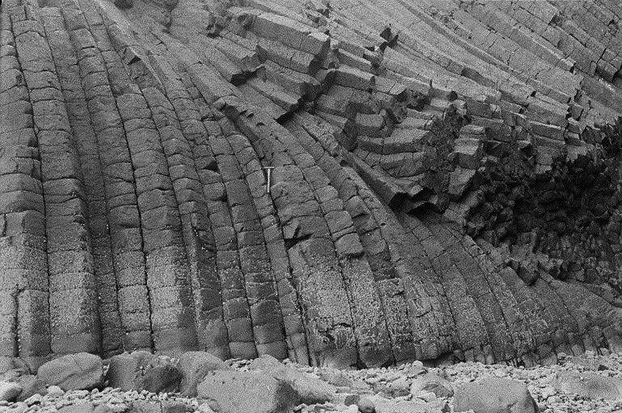Columnar jointing in basalt lava, Clamshell Cave on Staffa. Two sets of columnar joints intersect and become parallel in a Paleogene basalt lava flow. Columnar jointing is a characteristic feature of many minor intrusions. They originate by the development of a regular series of contraction joints perpendicular to the cooling surface as the rock cools from molten magma to the solid state. The columns are commonly hexagonal in pattern when viewed end-on. The beach in foreground is littered with large basalt blocks broken from the columns.

BGS photo P0002395. Copyright NERC.

***Scottish Journal of Geology***

Geological Photo Feature

# Large glacial erratic, Gart, Callander, Perthshire

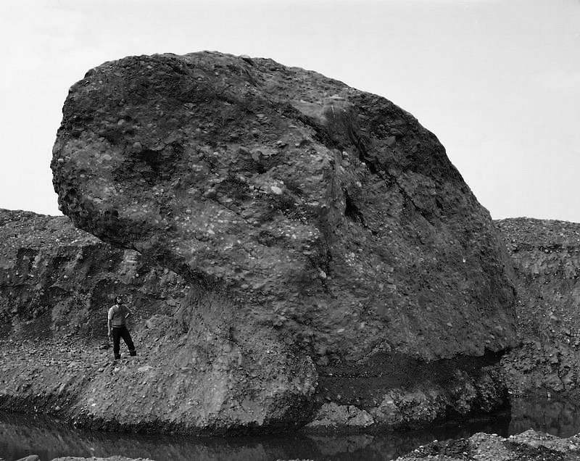This very large glacial erratic, an icescoured boulder of Old Red Sandstone conglomerate, occurs in the outwash gravels of the Loch Lomond Readvance (Younger Dryas)glacier. Due to its very large size and weight the boulder would have been deposited at the ice front of the retreating glacier and not as a meltwater deposit on the outwash plain. Gravel pit near Gart, River Teith, Callander, Perthsire.

BGS photo P002862. Copyright NERC.