Journal of the Geological Society, London, Vol. 167, 2010, pp. 217–220. doi: 10.1144/0016-76492009-023.

Correlation of Ordovician diamictites from Argentina and South Africa using detrital zircon dating

ANELDA VAN STADEN 1,2, UDO ZIMMERMANN 1,3*, FARID CHEMALE, JR4,5, JENS GUTZMER1,6 & G. J. B. GERMS1

1Paleoproterozoic Mineralisation Research Group (PPM), Department of Geology, University of Johannesburg, PO Box

524, Auckland Park 2006, South Africa

2Anglo Research, Mineralogical Research, PO 106, Crown Mines, Johannesburg 2025, South Africa

3Present address: Department of Petroleum Engineering, University of Stavanger, 4036 Stavanger, Norway

4Laborato´rio de Geologia Isoto´pica, Instituto de Geocieˆncias, Universidade Federal do Rio Grande do Sul, Porto Alegre, RS 91501-970, Brazil

5Present address: Nu´cleo de Geologia, Universidade Federal de Sergipe, Sa˜o Cristova˜o-SE, 49100-000, Brazil

6Department of Mineralogy, Technische Universita¨t Bergakademie Freiberg, Brennhausgasse 14, 09596 Freiberg, Germany

*Corresponding author (e-mail: udo.zimmermann@uis.no)

Abstract: The results of detrital zircon U–Pb geochronology suggest a maximum depositional age of 485 7.2 Ma for a glacial diamictite from the Sierra del Volca´n in eastern Argentina (Tandilia System). Earlier interpretations associated the deposit with the Neoproterozoic ‘snowball Earth’ hypothesis. The data allow direct correlation, for the first time, between Early Palaeozoic deposits in both South America and South Africa connecting the glacial deposits from southern Bolivia to central Argentina with those in South Africa (Pakhuis Formation). On the basis of these results, a new distribution map of glacial cover, corresponding to the Hirnantian stage, can be developed.

Supplementary material: Sampling and analytical techniques, data, a simplified map and BSE images are

available at http://www.geolsoc.org.uk/SUP18384.

This contribution provides the depositional age of a thin diamictite unit that occurs in the Sierra del Volca´n

(37851’23,42S, 58807’37,8’’W), situated in the Tandilia System in eastern Argentina (Fig. 1a). The sedimentology, petrography and geochemistry of the diamictite of the Sierra del Volca´n point to a glacial origin (Spalletti & Del Valle 1984; Van Staden et al. 2005). The possible association with limestones containing Cloudina sp. (Gaucher et al. 2005), dolomites and Fe-rich shales, palaeomagnetic data (Rapalini 2006) and isotope geochemical data (see compilation by Dalla Salda et al. 2006) have been used to invoke an association with Neoproterozoic glacial events of possible global extent (In˜iguez Rodr´ıguez 1999; Pazos et al. 2008). The focus of this paper is specifically the stratigraphic position of the deposit. The relevance of this glacial diamictite for palaeoclimatic and regional geological interpretation was demonstrated by Pazos et al. (2008) and is not challenged, although the deposit is c. 100 Ma younger than those workers suggested. Subsequently, the depositional age is of utmost importance for South American and South African geology and of wide international interest as it can no longer be related to the Neoproterozoic and therefore not to the ‘snowball Earth’ hypothesis.

# Geology

The Sierra del Volca´n glacial diamictite is exposed in the Tandilia System, a NW–SE-striking mountain belt located 300 km south of Buenos Aires (Fig. 1a). The basement of the

Tandilia System is composed mainly of Palaeoproterozoic rocks

217

(Buenos Aires Complex; Pankhurst et al. 2006; Rapela et al. 2007) and covered by Neoproterozoic rocks of the Sierras Bayas Group, overlain by the Neoproterozoic to Early Palaeozoic(?) Cerro Negro or Punta Mogotes Formation (Fig. 1b; Dalla Salda et al. 2006). Although the Sierra del Volca´n diamictite has been widely regarded as part of the Neoproterozoic (In˜iguez Rodr´ıguez 1999; Pazos et al. 2008), its stratigraphic position and age have remained uncertain, as it overlies the Palaeoproterozoic basement with an erosional unconformity and is, in turn, unconformably covered by siliciclastic rocks of the Ordovician to Silurian Balcarce Formation (Seilacher et al. 2003; Fig. 1b). The glacial diamictite and Neoproterozoic sedimentary rocks are only slightly folded and not metamorphosed, but have been affected by diagenetic events (Van Staden et al. 2005; Go´mez Peral et al. 2007).

|  |
| --- |
| 218 A. VAN STADEN ET AL.  Fig. 1. (a) Location of the Tandilia System in Argentina. (b) Stratigraphic table of Neoproterozoic to Palaeozoic sedimentary rocks of the Tandilia System (after Poire´ et al. 2003). Grey areas represent unconformities or sedimentary hiatus. |

Spalletti & Del Valle (1984) and Van Staden et al. (2005) have described the sedimentology, mineralogy, petrography and geochemistry of the diamictite. The unit is composed of a basal siltstone interbedded with sandy shales, followed by shales with scattered dropstones of variable sizes with faceted surfaces and capped by massive to poorly stratified white quartz arenites with clasts up to 50 cm (Spalletti & Del Valle, 1984; authors’ observation). Previous workers have interpreted a shallow marine depositional environment based on sedimentological data and SEM analyses of grain surfaces, where the upper quartz-rich bed was deposited under glacial conditions (Spalletti & Del Valle 1984; Van Staden et al. 2005). This conclusion is based on the occurrence of faceted clasts, apparent changes in viscosity of the sediment during deposition of the unit (Spalletti & Del Valle 1984) and single-grain SEM analyses (grains are mostly subrounded, faceted with conchoidal impact structures, flat pseudocleavage pattern and striated; indicating a glacial environment according to Krinsley & Doornkamp 1973). The base of the unit is weathered and geochemically similar to unrecycled Upper Continental Crust (UCC; McLennan et al. 2006) with the exception of high Fe2O3T and MnO concentrations at the very base of the package. The uppermost beds are enriched in silica (up to 90%) resulting in dilution of all other elements when compared with UCC. The sampled sedimentary dropstones (shales, quartz arenites) do not resemble the deposit or the underlying supracrustal rocks in mineralogical or chemical composition (Spalletti & Del Valle 1984; Van Staden et al. 2005), and therefore were most probably derived from other sedimentary units. Recycling, revealed by high quartz abundance in the uppermost beds, is reflected in elevated Zr/Sc ratios, with values between 32 and 100, compared with UCC. The large range indicates the poor sorting of some quartz arenite samples. Base metal concentrations, Th/U ratios and REE anomalies do not reflect anoxic depositional conditions, although a strong increase in Mo concentrations towards the top of the diamictite is notworthy, and is similar to the data from a Hirnantian glacial deposit in South Africa (Pakhuis Formation; Young et al. 2000).

# Detrital zircon ages

U–Pb isotopic data of detrital zircons (n ¼ 52) are shown in Figure 2. The youngest detrital zircon age from an acquired core is 485 7.2 Ma (Tremadoc), whereas the oldest grains show ages around 2300 Ma. The zircon assemblage is characterized by a dominant Palaeoproterozoic population (c. 2.0–2.2 Ga; roughly 50% of the dated grains), followed by Neoproterozoic as the second strongest source component. Input from Mesoproterozoic sources is less prominent. Cambrian zircons are abundant, and make up c. 15% of the population. Archaean grains are absent.

# Implications

Detrital zircons can be related to a variety of sources because of the broad age distribution. These sources include the main magmatic and crustal formation events of the R´ıo de la Plata craton in this area (Pankhurst et al. 2006; Rapela et al. 2007), thus indicating a well-mixed sedimentary deposit. This is in contrast to the relatively restricted age patterns of the underlying clastic successions of the Sierras Bayas Group (Rapela et al. 2007; Gaucher et al. 2008; Fig. 2, labelled ‘Neoproterozoic Tandil’) but comparable with that of the Balcarce Formation (Figs 1b and 2; in Fig. 2 labelled ‘Ordovician Tandil’ from Rapela et al. 2007). Because no Archaean or older Palaeoproterozoic zircon input was identified in the zircon population, it is likely that the main sources are located in the central part of the R´ıo de la Plata craton, which would also include source rocks of Mesoproterozoic ages. It is possible that the latter may also have been situated in South Africa when interpreted with regard to palaeocurrent and provenance studies (Poire´ et al. 2003; Van Staden et al., 2005; Zimmermann & Spalletti 2005). Palaeogeographical constraints are, however, poor, and the latter statement therefore remains speculative. The age of the youngest detrital zircon dated in the Sierra del Volca´n diamictite unit sets a lower age limit for sedimentation in the Ordovician.

The new stratigraphic position for the Sierra del Volca´n glacial diamictite can therefore be interpreted as age-equivalent to those in Argentina and southern South America (D´ıaz Martinez & Grahn 2007) and to the Pakhuis Formation in South Africa, where the same glacial event is recorded for Gondwana (compiled by Young et al. 2000). The Pakhuis Formation comprises subaerial, fluvioglacial, subglacial, marginal-marine and marine depositional environments, and is sandwiched between massive quartz arenites of the Peninsula and Cedarberg Formations (Fig. 1b; Gresse et al. 2006) as the Argentinean deposit with the quartz-rich Balcarce Formation. The Sierra del Volca´n glacial diamictite is therefore included as a member of the Balcarce

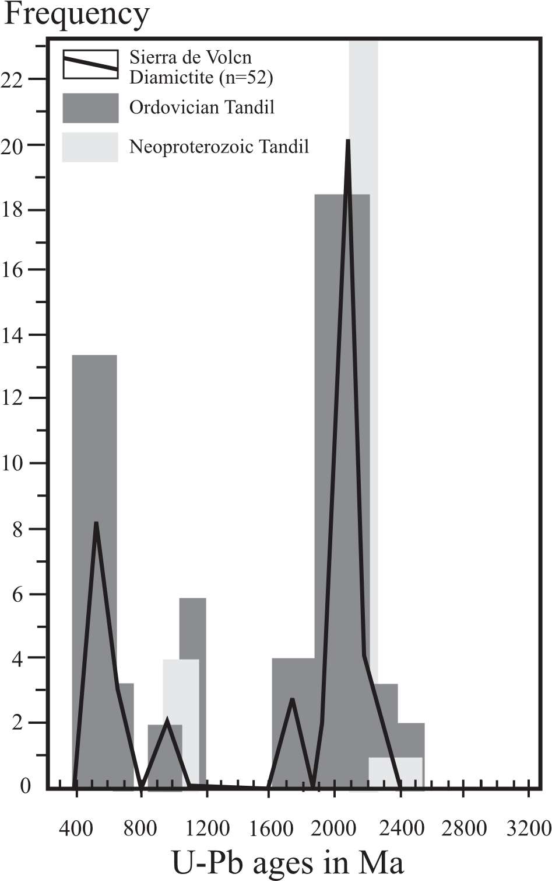

|  |
| --- |
| ORDOVICIAN DIAMICTITES, ARGENTINA 219 |

Fig. 2. Schematic zircon age distribution of the Sierra de Volca´n Diamictite (shown by the black line). For comparison, the major peaks of the zircon distribution of the Neoproterozoic Villa Mo´nica Formation (‘Neoproterozoic Tandil’; Rapela et al. 2007; Gaucher et al. 2008) and from the Ordovician to Silurian Balcarce Formation (‘Ordovician Tandil’; Rapela et al. 2007) are shown.

Formation and interpreted to be an equivalent of the Windhoek Subgroup (Fig. 1b). The age constraints allow the Sierra del Volca´n glacial diamictite to be assigned a late Ordovician age. The Ordovician sedimentary record in Argentina is exceptionally well studied, resulting in established palaeoclimatic models, whereas the only glacial environments reported are Hirnantian in age (a compilation of the vast literature has been provided by Acen˜olaza (2002) and references therein). The eastern Argentinean glacial deposit therefore bridges the distribution of the Hirnantian ice sheet between southern Bolivia and South Africa (Fig. 3).

# Concluding remarks

A combination of petrographical, sedimentological and geochemical data aided in verifying the glacial origin of the Sierra del Volca´n diamictite in eastern Argentina (Spalletti & Del Valle 1984; Van Staden et al. 2005). The detrital zircon age data in this study combined with the detailed knowledge of the palaeoclimatic conditions in Argentina for the entire Ordovician allows

Fig. 3. Outcrop localities of the glacial diamictite in eastern Argentina (black circle) and other glacial deposits of Hirnantian age (white circles) in Argentina, Bolivia, the Parana´ Basin and South Africa (ANT, Antarctica; PAT, Patagonia; map after Tankard et al. 1982; Pankhurst et al. 2006).

correlation of the deposit with the Hirnantian Gondwana-wide glacial event. It is thus not, as previously thought, of Neoproterozoic age and related to a ‘snowball Earth’ event as proposed by previous workers (e.g. Pazos et al. 2008). Detrital zircons allow for the first time reliable correlation of Early Palaeozoic rocks of eastern Argentina and South Africa. The Late Ordovician Sierra del Volca´n glacial diamictite is redefined as a member of the Ordovician to Silurian Balcarce Formation and can be interpreted as age-equivalent to the Pakhuis Formation (Table Mountain Group) in South Africa. The recognition of a glacial deposit of Late Ordovician age in eastern Argentina suggests that the Hirnantian ice sheet cover extended from SW South Africa to eastern Argentina, stretching to the central Parana´ Basin and into central and NW Argentina and southern Bolivia (Fig. 3).

The National Research Foundation of South Africa, the Geological Society of South Africa and the Faculty of Science of the University of Johannesburg and Anglo Research provided financial support for this research. Analytical work was supported by Anglo Research. We would like to thank two reviewers, and acknowledge the comments of the Advisory Editor and the quick handling of this short note. Finally, the paper is dedicated to Luis Dalla Salda and his ideas and work on this topic.

# References

Acen˜olaza, F.G. 2002. Aspects of the Ordovician System in Argentina. In: Acen˜olaza, F.G. (ed.) Aspects of the Ordovician System in Argentina.

|  |
| --- |
| 220 A. VAN STADEN ET AL. |

INSUGEO, Serie Correlacio´n Geolo´gica, 16, 7–17.

Dalla Salda, L., Spalletti, L., Poire`, D., De Barrio, R., Echeveste, H. & Benalgio, A. 2006. Tandilia. In: Acen˜olaza, F.G. (ed.) Temas de la Geologı´a Argentina I. INSUGEO, Serie Correlacio´n Geolo´gica, 21, 17–46.

Dı´az Martinez, E. & Grahn, Y. 2007. Early Silurian glaciation along the western margin of Gondwana (Peru, Bolivia and northern Argentina): Palaeogeographic and geodynamic setting. Palaeogeography, Palaeoclimatology, Palaeoecology, 245, 62–81.

Gaucher, C., Poire`, D.G., Go´mez Peral, L. & Chiglino, L. 2005. Litoestratigraf´ıa, bioestratigrafı´a y correlaciones de las sucesiones sedimentarias del Neoproterozoico-Ca´mbrico del craton R´ıo de la Plata (Uruguay and Argentina). Latin American Journal of Sedimentology and Basin Analysis, 12, 145–160.

Gaucher, C., Finney, S., Poire`, D.G., et al. 2008. Detrital zircon ages of Neoproterozoic sedimentary successions in Uruguay and Argentina: insights into the geological evolution of the Rio de la Plata Craton. Precambrian Research, 167, 150–170.

Go´mez Peral, L., Poire`, D.G., Strauss, H. & Zimmermann, U. 2007. Chemostratigraphy and diagenetic constraints on Neoproterozoic carbonate successions from the Sierras Bayas Group, Tandilia System, Argentina. Chemical Geology, 237, 109–128.

Gresse, P.G., von Veh, M.W. & Frimmel, H.E. 2006. Namibian (Neoproterozoic) to Early Cambrian successions. In: Johnson, M.R., Anhaeusser, C.R. & Thomas, R.J. (eds) The Geology of South Africa. Council of Geoscience, Johannesburg, South Africa. 395–420.

In˜iguez Rodrı´guez, A.M. 1999. La cobertura sedimentaria de Tandilia. In: Caminos, R. (ed.) Geologı´a Argentina. SEGEMAR, 29, 101–106.

Krinsley, D.H. & Doornkamp, J.C. 1973. Atlas of Quartz Sand Surface Textures. Cambridge University Press, Cambridge.

McLennan, S.M., Taylor, S.R. & Hemming, S.R. 2006. Composition, differentiation, and evolution of continental crust: constraints from sedimentary rocks and heat flow. In: Brown, M. & Rushmer, T. (eds) Evolution and Differentiation of the Continental Crust, Cambridge University Press, Cambridge, 92–134.

Pankhurst, R.J., Rapela, C.W., Fanning, C.M. & Ma´rquez, M. 2006. Gondwanide continental collision and the origin of Patagonia. Earth-Science Reviews, 76, 235–257.

Pazos, P.J., Bettucci, L.S. & Loureiro, J. 2008. The Neoproterozoic glacial record in the R´ıo de la Plata Craton: a critical reappraisal. In: Pankhurst,

R.J., Trouw, R.A.J., Brito Neves, B.B. & De Wit, M.J. (eds) West Gondwana: Pre-Cenozoic Correlations across the South Atlantic Region. Geological Society, London, Special Publications, 294, 343–364.

Poire´, D.G., Spalletti, L.A. & Del Valle, A. 2003. The Cambrian–Ordovician siliciclastic platform of the Balcarce Formation (Tandilia System, Argentina): Facies, trace fossils, paleoenvironments and succession stratigraphy. Geologica Acta, 1, 41–60.

Rapalini, A.E. 2006. New late Proterozoic paleomagnetic pole for the Rio de la

Plata craton: Implications for Gondwana. Precambrian Research, 147, 223– 233.

Rapela, C.W., Pankhurst, R.J., Casquet, C., et al. 2007. The R´ıo de la Plata craton and the assembly of SW Gondwana. Earth-Science Reviews, 83, 49–82.

Seilacher, A., Cingolani, C. & Varela, R. 2003. Ichnostratigraphic correlation of Early Palaeozoic sandstones in North Africa and Central Argentina. In:

Salem, M.J. & Oun, K.M. (eds) The Geology of Northwest Libya, Earth Science Society of Libya, Tripoli. 275–292.

Spalletti, L.A. & Del Valle, A. 1984. Las diamictitas del sector oriental de Tandilia: caracteres sedimentolo´gicos y or´ıgen. Revista de la Asociacio´n Geolo´gica Argentina, 49, 188–206.

Tankard, A.J., Jackson, M.P., Erikson, K.A., Holiday, D.K., Hunter, D.R. & Minter, W.E.L. 1982. Crustal Evolution of Southern Africa. Springer, New York.

Van Staden, A., Zimmermann, U. & Germs, G.J.B. 2005. Provenance and depositional study on tillites from El Volca´n Hill, Tandilia System in east Argentina: preliminary results. In: XVI Congreso Geolo´gico Argentina, La Plata, 20–23.9. 2005. Actas, 1, 239–246.

Young, G.M., Minter, W.E.L. & Theron, J.N. 2000. Geochemistry and palaeogeography of upper Ordovician glaciogenic sedimentary rocks in the Table Mountain Group, South Africa. Palaeogeography, Palaeoclimatology, Palaeoecology, 214, 323–345.

Zimmermann, U. & Spalletti, L.A. 2005. The provenance of the Lower Palaeozoic Balcarce Formation (Tandilia System, Buenos Aires Province, Argentina). In: XVI Congreso Geolo´gico Argentina, La Plata, 20–23.9. 2005.

Actas, 3, 203–210.

Received 17 February 2009; revised typescript accepted 14 August 2009. Scientific editing by Alan Collins.