Detrital zircon as a proxy for tracking the magmatic arc system: The

California arc example

A.P. Barth1, J.L. Wooden2, C.E. Jacobson3, and R.C. Economos4

1Department of Earth Sciences, Indiana University–Purdue University Indianapolis, 723 West Michigan Street, Indianapolis, Indiana 46202, USA

2Department of Geological and Environmental Sciences, Stanford University, 450 Serra Mall, Stanford, California 94305, USA

3Department of Geological and Atmospheric Sciences, Iowa State University, Ames, Iowa 50011, USA

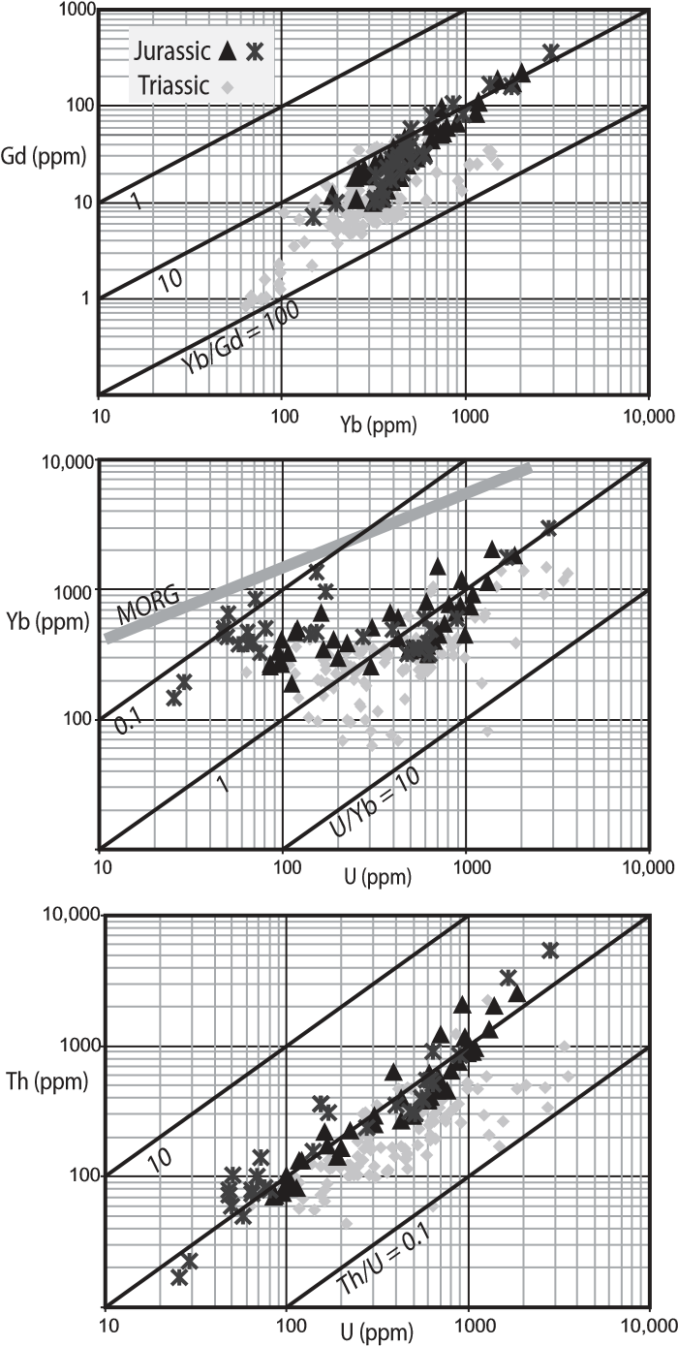4Department of Earth and Space Sciences, University of California–Los Angeles, Los Angeles, California 90095, USA

**ABSTRACT**

**Coupled age and trace element geochemical analyses of detrital zircons provide criteria that may be applied to describe average melt compositions through virtually the entire history of a long-lived magmatic arc. Detrital zircon data suggest that the California (western United States) Cordilleran arc was characterized by fi ve mean magmatic states. Three geochemically distinct pulses were characterized by high Th/U and progressively heavy rare earth element (HREE)–depleted melts. The fi rst and last pulses were also characterized by higher than average U/Yb, suggesting that progressive crustal thickening coupled with variable fl uid inputs from the subducting slab modulated pulse volumes. Lulls between pulses were states generally characterized by low magmatic volumes and low Th/U and U/Yb, suggesting fl uid-poor conditions with minimized crustal involvement in magmatism.**

**INTRODUCTION**

Zircon is an accessory mineral in a wide variety of igneous rocks, and its minor and trace element geochemistry is variable and particularly sensitive to changes in melt composition (Hoskin and Schaltegger, 2003; Ferry and Watson, 2007). Because of its resistance to recrystallization during hydrothermal alteration and sedimentation, zircon from in situ igneous rocks and detrital zircon together have the capability of recording both precise ages and variations in melt compositions from a long-lived magmatic environment. Detrital zircon can yield timeintegrated records of magmatic systems; when paired with studies of exposed bedrock, detrital records can provide a more robust understanding of vertical and secular variations in magmatic systems.

The surface expression of magmatic arcs typically provides an incomplete record of the third dimension of magmatic systems, leading to uncertainty about the connection between plutonic and volcanic processes. Long-lived, dynamic magmatic arcs may also evolve with time in response to tectonic or magmatic forcings, yet surface preservation of the early history may be poor. A coupled bedrock and detrital zircon approach that constrains temporally controlled magma volumes and melt compositions through time should be useful in expanding our understanding of the evolution of most longlived arcs. In this study, we use the geochemistry of magmatic zircons from igneous bedrock and detrital zircons from a retro-arc foreland basin to gain insight into the nature of the eroded superstructure and variations with time in the California (western United States) Cordilleran magmatic arc. This arc is incompletely exposed, and the early magmatic record has been systematically erased by younger magmatism. We suggest that detrital zircon geochemistry provides a temporally constrained average record of melt geochemistry, and the detrital record is weighted toward the eroded, presumably volcanic-dominated upper crust of the arc. We show that compatible fi rst-order melt trace element variations through time are preserved and record the longterm dynamics of arc melt generation.

**ZIRCON GEOCHEMISTRY FROM**

**EXPOSED ARC ROCKS**

There are two main controls on the trace element geochemistry of magmatic zircon. First, the extent of melt fractionation during zircon growth determines variations within a suite of cogenetic zircons. Second, differences between suites of cogenetic zircons record variable melt compositions at zircon saturation, refl ecting magma source variations. The geochemistry of zircons from exposed rocks of the California arc illustrates sensitivity to both of these controls (Anderson et al., 2008; Fohey-Breting et al., 2010; Barth and Wooden, 2010) (Fig. 1). All zircon suites yield high concentrations of U and Th and low concentrations of heavy rare earth elements (HREEs) compared to zircons from midoceanic-ridge gabbros (Grimes et al., 2007), consistent with zircon formation from enriched arc magmas. Within zircon suites, absolute concentrations of U, Th, Y, and REEs show large ranges but systematic variation in ratios of trace elements. Trace element abundances vary with Hf contents (6000–14,000 ppm), with Hf-rich, later-crystallizing zircons usually having higher Th, U, and REEs.

In addition to these variations within suites, zircon suites formed at different times show contrasting trace element ratios. In particular,

**Figure 1. Trace element abundances in zircons from Triassic intrusive (n = 109) and Jurassic intrusive and extrusive rocks (n = 74); stars are zircons from extrusive rocks. Both suites are U-enriched and Yb-depleted compared to zircons from mid-oceanic-ridge gabbros (MORG; Grimes et al., 2007), and show signifi cant fractionation-induced elemental covariation.**

zircons from Triassic intrusive rocks have characteristically lower Th/U and higher Yb/Gd than zircons from intrusive and extrusive rocks of Jurassic age (Fig. 2). Because these rocks crystallized at similar temperatures, we assume similar effective partition coeffi cients. This, in turn, implies that contrasting ratios between Triassic and Jurassic zircons refl ect a change in trace element composition of intermediate to silicic melts over this time period.

GEOLOGY, February 2013; v. 41; no. 2; p. 223–226; Data Repository item 2013054 | doi:10.1130/G33619.1 | Published online 30 November 2012

© 2012 Geological Society of America. For permission to copy, contact Copyright Permissions, GSA, or editing@geosociety.org. **GEOLOGY** | February 2013 | www.gsapubs.org **223**

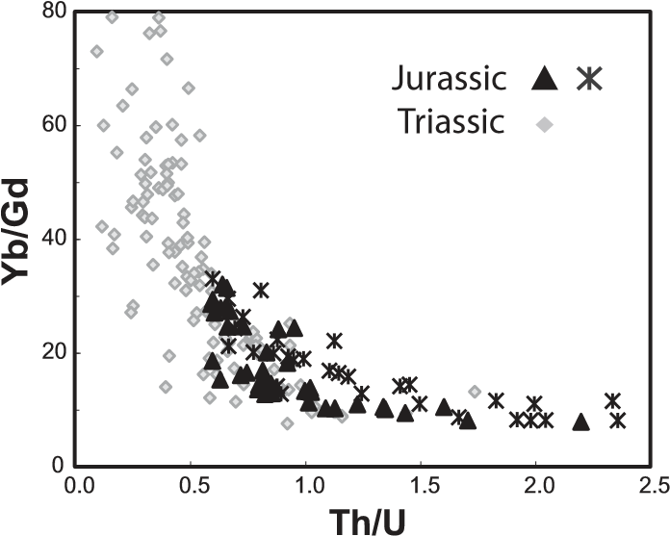

**Figure 2. Comparison of key zircon trace element ratios, illustrating higher Th/U and lower Yb/Gd characteristic of Jurassic zircons.**

**DETRITAL RECORDS OF THE TIMING**

**OF CALIFORNIA ARC MAGMATISM**

In order to gauge whether these differences in melt compositions over time are persistent and regionally signifi cant, we turn to the longerterm average arc record in detrital zircons. The California arc formed as a consequence of prolonged Mesozoic subduction beneath the former passive margin of western North America (Saleeby et al., 1992). The arc is composed of a northern, continent-fringing arc segment primarily exposed in the Sierra Nevada, and a southern, continental arc segment exposed in the Salinian Block, Mojave Desert, and Transverse Ranges. The Cretaceous intrusive history of this arc has been intensely studied, but questions remain for the arc as a whole, which can be addressed from the detrital record. Signifi cant ambiguities include the interplay between prolonged subduction and the apparent pulsed nature of magmatism, and the petrogenetic relationships between exposed plutons and volcanic rocks now largely removed by erosion.

Considering the exposed intrusive record inferred from U-Pb ages, it is evident that the arc was long-lived and periodically active (Glazner, 1991; Bateman, 1992; Ducea, 2001) (Fig. 3). Pluton ages defi ne three magmatic pulses: *p*1 in Triassic, *p*2 in Middle and Late Jurassic, and *p*3 in mid-Early to Late Cretaceous time. Between these pulses, the arc apparently transitioned to magmatic lulls, episodes of less voluminous yet continued activity, *l*1 beginning in Late Triassic and *l*2 in latest Jurassic time. Differences between the Sierra Nevada and Salinia-Mojave age distributions refl ect the migratory nature of arc magmatism and the relatively outboard position of the Sierra Nevada, where the full Cretaceous arc but only the outboard fringes of the older arcs are exposed.

Such chronologic records are incomplete, because the plutonic arc is not fully exhumed, and associated volcanic and epizonal plutonic rocks have been eroded. To amplify the record, we consider cumulative detrital zircon ages

|  |  |
| --- | --- |
| from uppermost Jurassic to Eocene sequences deposited on both the outboard (forearc basin and trench) and inboard sides of the California arc (Fig. 3). The detrital zircon age spectra serve as time-integrated proxy records of arc activity, particularly with respect to the volume of zircon-bearing rocks in the now-eroded upper arc crust. Comparison of these records confi rms that the arc was continuously active from Late Permian to Late Cretaceous time, but probably at relatively modest volumes of zircon-bearing rock for much of this time interval. Three pulses are superimposed on the background magmatic fl ux; the detrital and plutonic records are consonant, suggesting that magmas produced during pulses were stored primarily in the crust. Lack of evidence for *p*1 magmatism and the diminished *p*2 record in the trench and forearc is consistent with spatially asymmetric, migratory arc magmatism. | **GEOCHEMISTRY OF ARC-DERIVED**  **DETRITAL ZIRCONS**  The geochemistry of zircons from exposed arc rocks records consistent compositional differences between *p*1 and *p*2 magmas (Figs. 1 and 2), so we hypothesize that arc-derived detrital zircons can provide a temporally controlled record of the evolution of average melt compositions during episodic magmatism. We analyzed 265 detrital zircons from six samples of the retro-arc McCoy Mountains Formation for U-Pb age and trace element abundances (see the GSA Data Repository[1]). Mid- to Late Cretaceous sandstone and conglomerate in the upper two-thirds of this formation record basin fi lling synchronous with *p*3 magmatism and crustal loading during retro-arc shortening in the Maria fold-and-thrust belt, the expression of the Sevier orogenic belt at this latitude (Stone et al., 1987; |

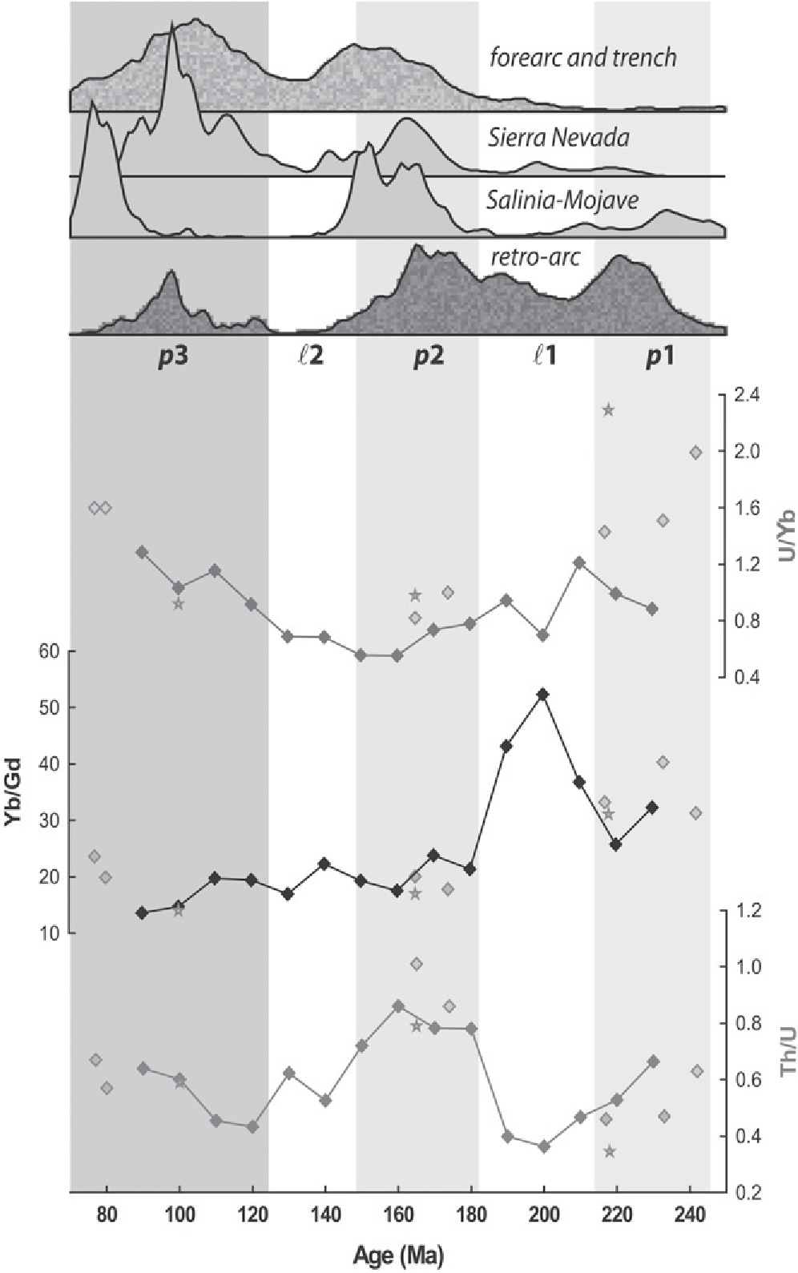**Figure 3. Proxy records for function of the California arc (western United States) through time. Upper panel: Probability plots of zircon U-Pb ages of plutonic rocks from the fringing arc (Irwin and Wooden, 2001; Saleeby et al., 2008; Barth et al., 2011) and from the continental arc (Barth and Wooden, 2006; Barth et al., 2008; Needy et al., 2009), compared to detrital zircons from uppermost Jurassic to middle Eocene sedimentary sequences on the outboard side of the arc, including the Great Valley Group (DeGraaff-Surpless et al., 2002; Wright and Wyld, 2007), analogous forearcbasin deposits of southern California (Jacobson et al., 2011), underplated trench sediments (Pelona-Orocopia-Rand schists; Grove et al., 2003), and Upper Jurassic to Upper Cretaceous retro-arc sediments (McCoy Mountains Formation; Barth et al., 2004). Lower panel: Zircon geochemistry over the same time frame as in upper panel. Diamonds with lines are average compositions of detrital zircons in 10 m.y. time windows. For comparison, gray individual diamonds are average compositions of zircons from exposed intrusive suites in the continental arc (FoheyBreting et al., 2010; Barth and Wooden, 2010; Table DR2 [see footnote 1]), and gray stars are average compositions of zircons from exposed intrusive and extrusive suites in the continent-fringing arc in the eastern Sierra Nevada (Table DR2).**

**224** www.gsapubs.org | February 2013 | **GEOLOGY**

Barth et al., 2004). About a third of the detrital zircons yield Archean to Mesoproterozoic ages, indicating that sediment was derived from the continental segment of the arc.

In order to systematically compare melt compositions through time in detrital zircons derived from variably fractionated zircon suites, we grouped arc-derived detrital zircons within 10 m.y. time windows and calculated average trace element ratios. The effect of this averaging is to yield zircon compositions at approximately constant Hf; hence, these ratios compare average intermediate melt compositions at comparable degrees of fractionation. Average detrital zircon composition at *p*1, *p*2, and *p*3 ages are, in most cases, in good agreement with average compositions of zircons from in situ igneous suites in the Salinia-Mojave continental arc segment (Fig. 3), suggesting that the detrital zircons are reliable indicators of average zircon compositions in the continental segment of the arc. In addition, we have found similar average compositions of zircons from intrusive and extrusive rocks in the Sierra Nevada continent-fringing segment of the arc, suggesting that the derived compositional patterns, at least for pulses, are common to both arc segments.

Average trace element geochemistry suggests systematic changes in melt compositions in the arc through time, and compositional contrasts between pulses and lulls. Average Yb/Gd decreases, overall and particularly from *p*1 to *p*2. For any given set of partition coeffi cients, lower zircon Yb/Gd implies melts with relative HREE depletion, suggesting that relatively HREE-depleted melts became more common in progressively younger pulses. However, data suggest contrasting behavior during *l*1 and *l*2. Increasing Yb/Gd from *p*1 into *l*1 suggests that this fi rst magmatic lull was characterized by the generation of magmas with relatively fl at melt REE patterns, whereas *l*2 magmas were not characterized by any signifi cant change in Yb/ Gd. Th/U is relatively high in zircons from *p*1 to *p*3, and particularly so for *p*2 relative to *p*1 and *p*3, and falling Th/U marks the transitions to both *l*1 and *l*2 magmatic lulls. This observation suggests that pulses were characterized by relatively high-Th/U melts, and that lulls were characterized by a decoupling of Th/U from REE behavior during melt production. U/Yb is relatively high in zircons from *p*1 and *p*3, and is low during intervening magmatic lulls and *p*2, though we caution that the detrital data set is relatively small and not in good agreement with U/Yb data for *p*1 intrusive rocks.

**DISCUSSION**

Zircons from in situ igneous bedrock and sediments of the retro-arc basin suggest that the California arc experienced 180 m.y. of continuous magmatism in fi ve distinct mean magmatic states: three geochemically discrete pulses

**GEOLOGY** | February 2013 | www.gsapubs.org

separated by lulls to a background magma fl ux. Pulses were magmatic states characterized by zircons with high average Th/U, but progressively lower Yb/Gd (HREE-depleted melts). The fi rst and last pulses were also characterized by high U/Yb, suggesting that these three trace element ratios considered together can explain the progressively greater volumes of magma generated in the younger two pulses. Lulls were magmatic states generally characterized by low average Th/U and low U/Yb, but the two recognized lulls were distinctly different in Yb/Gd.

Regional variations in modern continental and fringing arc settings provide analogs to understand this secular variability. In modern arcs, relatively highly fractionated REE patterns are associated with calc-alkalic continental arcs having more variable isotopic compositions, suggesting thicker crust and/or incorporation of an old lithospheric component, from either the overriding lithosphere or continental sediment subduction (Gill, 1981; Hildreth and Moorbath, 1988; Hawkesworth et al., 1993). The record of falling zircon Yb/Gd through time in California arc zircons suggests relative HREE depletion with time, at least for middle and heavy REEs. In the case of the continental arc, premagmatic zircons clearly indicate incorporation of an old lithospheric component but do not indicate incorporation of continental sediment. We therefore hypothesize that progressive HREE depletion was due to rapid early crustal thickening after arc initiation and continued crustal thickening beneath the arc through time, causing progressively higher-pressure fractionation of a phenocryst assemblage containing garnet and/or mixing of mantle-derived magmas with partial melts of lower crustal rocks leaving garnet-bearing residues.

In modern arcs, high Th/U is associated with high Th content and high 208Pb/204Pb, suggesting incorporation of an aged lithospheric component, as continental sediment from the subducting slab and/or from the overriding plate (Hawkesworth et al., 1993, 1997). Long-term high Th/U is a characteristic of the Proterozoic crustal framework of the continental segment of the California arc (Wooden and Miller, 1990), so the relatively high Th/U that characterizes magmatic pulses suggests enhanced involvement of fertile crustal rocks during times of high magma production (Ducea and Barton, 2007). Hughes and Mahood (2008) showed that caldera-forming eruptions indicative of voluminous magmatism in modern arc crust are associated with moderately high normal convergence rates and are favored in compressional upper plate settings, consistent with our suggestion that pulse magmas record crustal involvement above that of the background magma fl ux. Because high U/Yb is a characteristic signature of arc magmatism indicative of ingress of fl uid derived from the subducting slab (Hawkesworth et al., 1993; Pearce and Peate, 1995), we suggest that the variable U/Yb then indicates relatively enhanced fl uid involvement in generating *p*1 and *p*3, with lower fl uid fl uxes during *p*2. The trace element data imply that progressively greater volumes of magma from *p*1 through *p*2 to *p*3 were related to thicker crust, and greater involvement of Th-rich crust, coupled with a return of fl uid-rich conditions in the overriding lithosphere in *p*3 time.

**CONCLUSIONS**

Changes in melt composition suggest that the California arc was progressively dominated by high-pressure fractionation of mantle-derived magmas and/or mixing of high-pressure crustal melts, which likely records progressive thickening of arc crust following the initiation of subduction. Three pulses of high-Th/U magma production were superimposed on a secular trend to lower Yb/Gd, suggesting that pulses were related to the increased infl uence of fertile crustal sources, as episodes of crustal thickening within and beneath the arc (Dunne and Walker, 2004), and/or to higher thermal power input than was characteristic of the background magma fl ux. Low U/Yb in Jurassic time may record reduced ingress of slab-derived fl uid, which when coupled with low Th/U and high Yb/Gd indicates that minimal crustal involvement may be related to phases of large-scale extension or transtension during *l*1 compared to *l*2 (Saleeby et al., 1992). Additional detrital records of this type, particularly longitudinal transects that compare forearc to retro-arc records, are likely to provide higher-resolution records of melt variations and greater insights into the evolution of this long-lived, asymmetrical continental and continent-fringing arc system.

# ACKNOWLEDGMENTS

Funding was provided by the National Science

Foundation through grants EAR-0711115 and EAR0711119 to Barth, and by the Blaustein Fund at Stanford University. We thank G.R. Hughes, E.L. Miller, and N.R. Riggs for helpful discussions, and J. Miller and two anonymous reviewers for constructive comments.

# REFERENCES CITED

Anderson, J.L., Barth, A.P., Wooden, J.L., and Mazdab, F., 2008, Thermometers and thermobarometers in granitic systems, *in* Putirka, K.D., and Tepley, F.J., eds., Minerals, inclusions and volcanic processes: Mineralogical Society of America Reviews in Mineralogy, v. 69, p. 121–142.

Barth, A.P., and Wooden, J.L., 2006, Timing of magmatism following initial convergence at a passive margin, southwestern U.S. Cordillera, and ages of lower crustal magma sources: Journal of Geology, v. 114, p. 231–245, doi:10.1086/499573.

Barth, A.P., and Wooden, J.L., 2010, Coupled elemental and isotopic analyses of polygenetic zircons from granitic rocks by ion microprobe, with implications for melt evolution and the sources of granitic magmas: Chemical Geology, v. 277, p. 149–159, doi:10.1016/j.chemgeo.2010.07.017.

Barth, A.P., Wooden, J.L., Jacobson, C.E., and Probst,

K., 2004, U-Pb geochronology and geochemistry

## 225

of the McCoy Mountains Formation, southeastern California: A Cretaceous retroarc foreland basin: Geological Society of America Bulletin,

v. 116, p. 142–153, doi:10.1130/B25288.1.

Barth, A.P., Wooden, J.L., Howard, K.A., and Richards, J.L., 2008, Late Jurassic plutonism in the southwest U.S. Cordillera, *in* Wright, J.E., and Shervais, J.W., eds., Ophiolites, arcs, and batholiths: Geological Society of America Special Paper 438, p. 379–396.

Barth, A.P., Walker, J.D., Wooden, J.L., Riggs, N.R., and Schweickert, R.A., 2011, Birth of the Sierra Nevada magmatic arc: Early Mesozoic plutonism and volcanism in the east-central Sierra Nevada of California: Geosphere, v. 7, p. 877–897, doi:10.1130/GES00661.1.

Bateman, P.C., 1992, Plutonism in the central part of the Sierra Nevada Batholith, California: U.S. Geological Survey Professional Paper 1483, 186 p.

DeGraaff-Surpless, K., Graham, S.A., Wooden, J.L., and McWilliams, M.O., 2002, Detrital zircon provenance analysis of the Great Valley Group, California: Evolution of an arc-forearc system: Geological Society of America Bulletin, v. 114, p. 1564–1580, doi:10.1130/00167606(2002)114<1564:DZPAOT>2.0.CO;2.

Ducea, M., 2001, The California arc: Thick granitic batholiths, eclogitic residues, lithospheric-scale thrusting, and magmatic fl are-ups: GSA Today, v. 11, no. 11, p. 4–10, doi:10.1130/10525173(2001)011<0004:TCATGB>2.0.CO;2.

Ducea, M.N., and Barton, M.D., 2007, Igniting fl areup events in Cordilleran arcs: Geology, v. 35, p. 1047–1050, doi:10.1130/G23898A.1.

Dunne, G.C., and Walker, J.D., 2004, Structure and evolution of the East Sierran thrust system, east central California: Tectonics, v. 23, TC4012, 23 p.

Ferry, J.M., and Watson, E.B., 2007, New thermodynamic models and revised calibrations for the Ti-in-zircon and Zr-in-rutile thermometers: Contributions to Mineralogy and Petrology, v. 154, p. 429–437, doi:10.1007/s00410-007-0201-0.

Fohey-Breting, N.K., Barth, A.P., Wooden, J.L., Mazdab, F.K., Carter, C.A., and Schermer, E.R., 2010, Relationship of voluminous ignimbrites to continental arc plutons: Petrology of Jurassic ignimbrites and contemporaneous plutons in southern California: Journal of Volcanology and Geothermal Research, v. 189, p. 1–11, doi:10.1016/j.jvolgeores.2009.07.010.

Gill, J.B., 1981, Orogenic andesites and plate tectonics: Berlin, Springer, 390 p.

Glazner, A.F., 1991, Plutonism, oblique subduction, and continental growth: An example from the Meso zoic of California: Geology, v. 19, p. 784–

**226**

786, doi:10.1130/0091-7613(1991)019<0784: POSACG>2.3.CO;2.

Grimes, C.B., John, B.E., Kelemen, P.B., Mazdab, F.K., Wooden, J.L., Cheadle, M.J., Hanghøj, K., and Schwartz, J.J., 2007, Trace element chemistry of zircons from oceanic crust: A method for distinguishing detrital zircon provenance: Geology, v. 35, p. 643–646, doi:10.1130/G23603A.1.

Grove, M., Jacobson, C.E., Barth, A.P., and Vucic, A., 2003, Temporal and spatial trends of Late Cretaceous–early Tertiary underplating of Pelona and related schist beneath southern California and southwestern Arizona, *in* Johnson, S.E., et al., eds., Tectonic evolution of northwestern Mexico and the southwestern USA: Geological Society of America Special Paper 374, p. 381–406.

Hawkesworth, C.J., Gallagher, K., Hergt, J.M., and McDermott, F., 1993, Mantle and slab contributions in arc magmas: Annual Review of Earth and Planetary Sciences, v. 21, p. 175–204, doi:10.1146/annurev.ea.21.050193.001135.

Hawkesworth, C.J., Turner, S.P., McDermott, F., Peate, D.W., and van Calsteren, P., 1997, U-Th isotopes in arc magmas: Implications for element transfer from the subducted crust: Science, v. 276, p. 551–555, doi:10.1126/science .276.5312.551.

Hildreth, W., and Moorbath, S., 1988, Crustal contributions to arc magmatism in the Andes of central Chile: Contributions to Mineralogy and Petrology, v. 98, p. 455–489, doi:10.1007 /BF00372365.

Hoskin, P.W.O., and Schaltegger, U., 2003, The composition of zircon and igneous and metamorphic petrogenesis: Mineralogical Society of America Reviews in Mineralogy, v. 53, p. 27–62, doi:10.2113/0530027.

Hughes, G.R., and Mahood, G.A., 2008, Tectonic controls on the nature of large silicic calderas in volcanic arcs: Geology, v. 36, p. 627–630, doi:10.1130/G24796A.1.

Irwin, W.P., and Wooden, J.L., 2001, Map showing plutons and accreted terranes of the Sierra Nevada, California, with a tabulation of U/Pb isotopic ages: U.S. Geological Survey Open-File Report 01-229, scale 1:1,000,000, 1 sheet.

Jacobson, C.E., Grove, M., Pedrick, J.N., Barth, A.P., Marsaglia, K.M., Gehrels, G.E., and Nourse, J.A., 2011, Late Cretaceous–early Cenozoic tectonic evolution of the southern California margin inferred from provenance of trench and forearc sediments: Geological Society of America Bulletin, v. 123, p. 485–506, doi:10.1130/B30238.1.

Needy, S.K., Anderson, J.L., Wooden, J.L., Barth,

A.P., Paterson, S.R., Memeti, V., and Pignotta, G.S., 2009, Mesozoic magmatism in an upper- to middle-crustal section through the Cordilleran continental margin arc, eastern Transverse Ranges, California, *in* Miller, R.B., and Snoke, A.W., eds., Crustal cross sections from the western North America Cordillera and elsewhere: Implications for tectonic and petrologic processes: Geological Society of America Special Paper 456, p. 187–218.

Pearce, J.A., and Peate, D.W., 1995, Tectonic implications of the composition of volcanic arc magmas: Annual Review of Earth and Planetary Sciences, v. 23, p. 251–285, doi:10.1146/ annurev.ea.23.050195.001343.

Saleeby, J.B., Busby-Spera, C., Oldow, J.S., Dunne, G.C., Wright, J.E., Cowan, D.S., Walker, N.W., and Allmendinger, R.W., 1992, Early Mesozoic tectonic evolution of the western U.S. Cordillera, *in* Burchfi el, B.C., et al., eds., The Cordilleran orogen: Conterminous U.S.: Geological Society of America, Geology of North America, v. G-3, p. 107–168.

Saleeby, J.B., Ducea, M.N., Busby, C., Nadin, E., and Wetmore, P.H., 2008, Chronology of pluton emplacement and regional deformation in the southern Sierra Nevada batholith, California, *in* Wright, J.E., and Shervais, J.W., eds., Ophiolites, arcs, and batholiths: A tribute to Cliff Hopson: Geological Society of America Special Paper 438, p. 397–427.

Stone, P., Page, V.M., Hamilton, W., and Howard, K.A., 1987, Cretaceous age of the upper part of the McCoy Mountains Formation, southeastern California and southwestern Arizona, and its tectonic signifi cance: Reconciliation of paleobotanical and paleomagnetic evidence: Geology, v. 15, p. 561–564, doi:10.1130/00917613(1987)15<561:CAOTUP>2.0.CO;2.

Wooden, J.L., and Miller, D.M., 1990, Chronologic and isotopic framework for Early Proterozoic crustal evolution in the eastern Mojave Desert region, SE California: Journal of Geophysical Research, v. 95, p. 20,133–20,146, doi:10.1029/JB095iB12p20133.

Wright, J.E., and Wyld, S.J., 2007, Alternative tectonic model for Late Jurassic through Early Cretaceous evolution of the Great Valley Group, California, *in* Cloos, M., et al., eds., Convergent margin tectonics and associated regions: Geological Society of America Special Paper 419, p. 81–95.

Manuscript received 11 May 2012

Revised manuscript received 20 August 2012

Manuscript accepted 27 August 2012

Printed in USA

www.gsapubs.org | February 2013 | **GEOLOGY**

1. GSA Data Repository item 2013054, analytical methods, zircon ages and trace element geochemistry, is available online at www.geosociety.org/pubs/ft2013.htm, or on request from editing@geosociety.org or Documents Secretary, GSA, P.O. Box 9140, Boulder, CO 80301, USA.