**ANKERITE CEMENTATION IN DEEPLY BURIED JURASSIC SANDSTONE RESERVOIRS OF THE CENTRAL NORTH SEA**

JAMES P. HENDRY1*, MARK WILKINSON2, ANTHONY E. FALLICK3, AND R. STUART HASZELDINE2

1. *School of Geosciences, The Queen’s University, Belfast BT7 1NN, U.K. e-mail: j.hendry@qub.ac.uk*
2. *Department of Geology and Geophysics, University of Edinburgh, Grant Institute, West Mains Road, Edinburgh EH9 3JW, Scotland, U.K. 3 Isotope Geosciences Unit, Scottish Universities Research and Reactor Centre, East Kilbride, Glasgow, Scotland, G75 0QF, U.K.*

**ABSTRACT: Upper Jurassic Fulmar Formation shelf sandstones of the high-temperature, high-pressure Franklin and Elgin Fields (South Central Graben, North Sea) contain abundant disseminated and concretionary ankerite. In contrast, most Jurassic North Sea reservoirs contain only minor amounts of dispersed ankerite. Disseminated ankerite cement in the Franklin and Elgin Fields has a fairly uniform isotopic composition (**d**18O** ø2**10 to** 2**12.5‰ PDB,** d**13C** ø2**3 to** 2**5‰ PDB). Ankerite concretions have** d**18O values similar to disseminated cements but a wider range of** d**13C values (**1**1 to** 2**5.5‰ PDB). They also have highly variable intergranular volumes, which (together with the** d**13C data) are interpreted as a combination of pore-filling cementation and *in situ* replacement of comminuted bioclastic debris by ankerite.**

**Fluid-inclusion,** d**18O, and paragenetic evidence suggests that ankerite formed during deep burial (*c.* 3.5 to 4.5 km, 140–170**8**C), after the onset of overpressuring, but before hydrocarbon emplacement in the reservoirs. The regionally consistent** d**18O data suggest that ankerite formed via a temperature-influenced mechanism, and the relatively uniform** d**13C cement value indicates that organic matter and marine bioclastic carbonate contributed to the dissolved carbon reservoir in constant proportion. This can be explained by calcite dissolution in response to pH decrease during thermal breakdown of organic acids. Such acids were derived from adjacent mudrocks undergoing hydrocarbon maturation and clay-mineral transformations, and are likely to have been transported in pore fluids with Mg2**1 **and Fe2**1**. The presence of these cations in solution upon thermal decarboxylation is inferred to have stabilized ankerite at the expense of calcite. A relative paucity of ankerite in other Fulmar Formation reservoirs may reflect different sedimentological compositions (less bioclastic debris) and/or lower burial temperatures (less advanced decarboxylation).**

# INTRODUCTION

Concretionary and disseminated carbonate cements are common in shallow marine and turbidite sandstone reservoirs of the North Sea Basin (e.g., Haszeldine et al. 1992; Prosser et al. 1994). The potential impact of such cementation on reservoir performance has fuelled considerable research into the spatial controls on carbonate cementation and on the scale and timing of diagenetic mass transfer (e.g., Bjørkum and Walderhaug 1990; Wilkinson and Dampier 1990; Hendry et al. 1996). Most of these studies have been concerned with calcite cementation, and have successfully integrated micro textural and geochemical analyses within a stratigraphic and burial-history framework.

Much less attention has been paid to ferroan dolomite and ankerite cements. These are common within continental sandstone facies in the southern North Sea, where their genesis is related to the stratigraphic proximity

|  |
| --- |
| * Present Address: BG Technology, Gas Research & Technology Centre, Loughborough LE11 3GR, U.K.  JOURNAL OF SEDIMENTARY RESEARCH, VOL. 70, NO. 1, JANUARY, 2000, P. 227–239 |

of Permian carbonates and evaporites that are a source of Mg21 during burial (e.g., Purvis 1992; Sullivan et al. 1990). In the more northerly Brent Province, thick Permian evaporites are absent, and ankerite is only a minor phase except in close proximity to mudrocks (e.g., Macaulay et al. 1993; Kantorowicz 1985; Haszeldine et al. 1992). The South Central Graben (SCG) lies between these two regions, and Upper Jurassic reservoir sandstones in the Franklin and Elgin Fields (Fig. 1) contain significant quantities of authigenic ankerite, both as pervasive disseminated cements and as concretions of several decimeters to a few meters thickness. These high-temperature, high-pressure (HTHP) gas condensate reservoirs were buried to depths in excess of 5 km during the Tertiary, and are highly overpressured. We have used petrographic and isotopic tools to study the origin of the ankerite, with the aim of determining the controls on cementation and implications for mass transfer. Our principal objective was to test the hypothesis that ankerite cementation was enhanced by the deep burial and high temperatures that characterize these SCG fields.

# METHODOLOGY

Five cores were sampled from the Franklin and Elgin Fields in UK Blocks 29/ 5b, 22/30b and 22/30c (Fig. 1). The reservoir unit is the Oxfordian-age Franklin Sandstone Formation, which is broadly equivalent to the Fulmar Formation in shallower terrace regions of the SCG (Price et al. 1993; Howell et al. 1996). Samples were collected across ‘‘tight’’ carbonate-cemented intervals (#5 vol. % porosity, $25 vol. % ankerite) and from intervening sandstones (up to 26% porosity, ,25 vol. % ankerite) where only a dispersed cement is present. Two supplementary samples were collected from a dolomite–ankerite septarian concretion from the lowermost part of the Heather Formation mudrocks in 22/30c-10.

More than 140 sub samples were soxhlet treated to remove labile hydrocarbons, vacuum impregnated with blue-dyed resin, and thin sectioned. Conventional stains for K-feldspar and carbonates were applied, and about half the sections were pointcounted with 400 points per section. Grain-size data were measured on quartz grains (100 per section, maximum diameters) and mean values calculated from the Folk and Ward (1957) algorithm. Selected thin sections were subsequently polished and studied by cold-cathode luminescence (CL) and blue-light photoluminescence (PL, lexcitation ø 560 nm), before carbon-coating for examination with back-scattered scanning electron microscopy (BSEM) and energy-dispersive X-ray analysis (EDXA). A Cambridge Stereoscan 360 SEM with a Link Analytical Systems 1085S EDS was used at 20 kV and 60 s count time. Data were corrected using the ZAF4 FLS program. Several fluid-inclusion wafers were prepared, and homogenization temperatures were collected for authigenic quartz and ankerite. Inclusions in ankerite are very small and were measured only for two Elgin Field cores.

Stable O and C isotopic analyses were carried out on thin-section offcuts, and on core plugs that had been mineralogically characterized by quantitative X-ray diffraction. The sandstones contain minor but ubiquitous dolomite, syntaxially overgrown by the ankerite. Because these phases could not be physically separated, ‘‘bulk’’ isotopic data represent a contribution from both phases. Samples were manually disaggregated in a pestle and mortar, and the majority were reacted in anhydrous phosphoric acid overnight at 1008C. In an attempt to discriminate end-member compositions, several samples were treated by a ‘‘progressive leach’’ procedure. An initial aliquot of CO2 was extracted after a 3-hour reaction at 258C, and a second aliquot was extracted after complete reaction of the carbonate ($8 hours) at 1008C. Results (below) indicate that complete separation of the carbonate phases was not achieved, and the data represent variable proportions of ankerite and dolomite.

Copyright q 2000, SEPM (Society for Sedimentary Geology) 1073-130X/00/070-227/$03.00

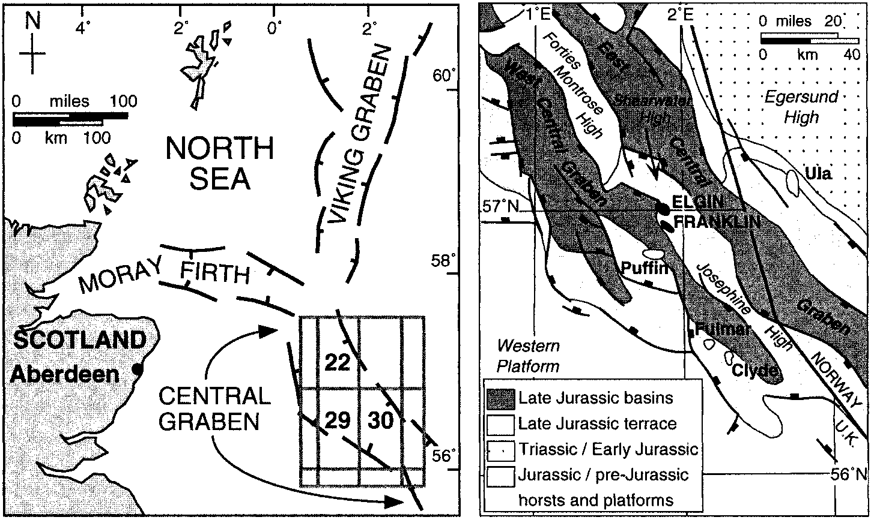FIG. 1.—Location map of the SCG showing the Franklin and Elgin Fields.

Isotopic analyses were carried out and corrected following standard procedures (Craig 1957), either at the Scottish Universities’ Research and Reactor Centre (SURRC, East Kilbride, Scotland) or in the laboratories of Elf Aquitaine Production (EAP, Pau, France). Duplicate samples run in both laboratories were used to crosscalibrate the mass spectrometers (VG SIRA 10 instruments), and results are reported relative to the PDB standard. Analytical reproducibility in each laboratory was better than 0.1‰ for d13C and d18O.

# SEDIMENTOLOGICAL AND DIAGENETIC FRAMEWORK

The Franklin Sandstone Formation is a predominantly aggradational succession of intensely bioturbated and variably argillaceous, fine-grained sandstones and siltstones, with subordinate mudstones. Most physical sedimentary structures have been obscured by bioturbation. However, the dominant *Teichicnus, Ophiomorpha,* and *Anconichnus* ichnofabrics (cf. Gowland 1996; Martin and Pollard 1996) and uniformly fine grain size (between 2.2 and 4.1 f) suggest that deposition mostly took place in the middle to lower shoreface to offshore areas of a well-oxygenated, episodically storm-influenced but predominantly low-energy, shallow marine shelf (Howell et al. 1996; Lasocki et al., in press). Facies patterns are complicated by effects of synsedimentary tectonism and halokinesis, and the limited grain-size range. Relative sea-level fluctuations typically only modified ichnofabric and clay contents of the sandstones. Reservoir subdivision (Fig. 2) is therefore based on petrophysical character, which may reflect very generalized sedimentological and/or diagenetic trends (Lasocki et al., in press).

The sandstones are mostly subarkoses and sublitharenites, with some lithic and arkosic wackes. However, discrimination of detrital and authigenic clay is difficult. Bioclasts are poorly preserved in core, with the exception of sporadic lags of thickshelled and partly silicified oysters. Compacted molds and internal casts of bivalves are present in argillaceous sandstones but are usually difficult to distinguish from burrow traces. However, partially to fully cemented molluscan biomolds are locally abundant within carbonate concretions of clay-poor sandstones in the Elgin Field (Fig. 3A).

The Franklin–Elgin Fields underwent progressive subsidence from the end of the Early Cretaceous, increasing during Oligo-Miocene time, and with maximum rates in the Quaternary (Fig. 4). Current burial depths are 5.4–5.8 km, and the fields are overpressured to about 57 MPa with reservoir temperatures of 180–1908C. Evidence of mechanical compaction includes an abundance of nested grain fabrics and the deformation of ductile grains. However, remarkably little pressure dissolution of framework grains has taken place. Average grain overlap estimated from thin section and BSEM is ,5%. In similar facies it has been suggested that, prior to overpressuring, the presence of microquartz and illitization reactions maintained high porefluid Si activities and impeded pressure dissolution (Bjørkum et al. 1993; Aase et al. 1996).

Samples from the Franklin and Elgin Fields show an identical paragenesis (Fig. 5), although present-day formation waters differ considerably in salinity and composition (Table 1). Reservoir quality was influenced principally by overpressuring, K-feldspar dissolution, microquartz cementation, and carbonate redistribution (Haszeldine et al., in press; Lasocki et al., in press). In particular, late-diagenetic feldspar dissolution caused net porosity gain in reservoir facies owing to export of reaction products (Wilkinson and Haszeldine 1996; Wilkinson et al. 1997). Peak hydrocarbon generation in the Kimmeridge Clay of the SCG was at about 40 Ma (Barnard and Bastow 1991). The Franklin Field was filled during the Miocene, but the Elgin Field was filled only within the last 5 Ma. Minor albite with hydrocarbon-filled fluid inclusions precipitated at an early stage of hydrocarbon emplacement. Subsequent de-asphalting of the crude oil produced bitumen that impregnated clays and formed droplets on surfaces of framework grains.

# ANKERITE

**Concretions.**—The Franklin Sandstone cores contain a number of pale gray, decimeter- to meter-scale ankerite-cemented intervals. They are usually sharply defined both visually and on sonic or density logs (Figs. 2, 3). Convex-outward or planar rims to some concretions suggest an elliptical to tabular morphology, but others have irregular or scalloped margins that may be related to bioturbation fabrics or merging of adjacent nodules (Fig. 3B). Other concretions have relatively diffuse margins, and patchy centimeter-scale cementation can also be seen in places (Figs. 3B, C).

**Petrography, Paragenesis, and Fabrics.**—All thin sections examined contain authigenic dolomite and ankerite, which could be discriminated only by staining, CL, or BSEM. Dolomite consists of discrete, anhedral, nonferroan crystals. These are pervasively distributed through the sandstones and rarely account for more than 5 vol. %. Our studies of this dolomite (Hendry et al., in press) suggest that it precipitated from marine-derived pore fluids in response to dissolution of labile biogenic carbonate (aragonite 6 Mg-calcite). Ankerite in porous sandstones consists of syntaxial rims on preexisting dolomite crystals, with subhedral terminations into open pore space and minor replacement of detrital silicates that are enclosed within the cement (Fig. 6A). These syntaxial rims typically account for #5 vol. % of the rock. At the margins of concretions, they are supplemented by increasing amounts of intergranular ankerite spar. Inward from the margins, most concretions are tightly cemented. They contain ,2 vol. % primary porosity and about 28–45 vol. % ankerite (Fig. 7A), both as minor rims on dolomites and abundant intergranular mosaic crystals (Fig. 8A). The latter are mostly 20 to 500 mm in size, nonplanar (Sibley and Gregg 1987), and infrequently poikilotopic. They have slightly undulose extinction, but no curved cleavage planes characteristic of saddle dolomite have been observed. Microsparry ankerite is present in a small number of atypical concretions, in association with ‘‘floating’’ detrital silt grains and ankerite-filled sponge spicule molds. These concretions are interpreted to be recrystallized calcareous hemipelagites, and small reworked clasts of similar microsparry ankerite are present in overlying sandstones.

|  |
| --- |
| FIG. 2.—Summary correlation panel across the Franklin and Elgin Fields showing gamma-ray log (left), sonic log (center), synthetic seismic trace (right), and reservoir layering. Positions of major ankerite concretions are shown by the spikes in the sonic log traces, particularly in the relatively cleaner middle division of the reservoir. |

Ankerite precipitation overlapped a more prolonged episode of macroquartz cementation (Fig. 5). Small ankerite rhombs are locally enclosed in quartz overgrowths, and embayed quartz grains in ankerite concretions have corroded remnants of thin syntaxial cements (Fig. 8A). Adjacent quartz grains that face open pore space have well-developed euhedral overgrowths (Fig. 8B). Quartz cement also fills some fractures crosscutting the ankerite concretions. Ankerite authigenesis probably also overlapped K-feldspar hydrolysis. Concretions contain more intact K-feldspar grains than in the surrounding sandstones. However, they also contain some remnants of partially dissolved grains as well as molds of grains that dissolved after encasement in the ankerite cement (e.g., Fig. 8C). In contrast, plagioclase feldspars are not appreciably corroded in any of the samples, and appear remarkably fresh (with sharply defined lamellar twinning between crossed polars) except when albitized. The relationship between ankerite and authigenic illite is frequently difficult to discern. A few examples of ankerite appearing to engulf illite fibers were observed in SEM, and ankerite was also found to be intergrown with and overlain by platy illite in several concretion fractures (Fig. 6B).

Framework grain packing within the concretions is generally less than in the surrounding porous sands, and intergranular volumes (IGV) are very high (33–56%). However, the grain packing is most striking in its *variability.* Pockets of closely juxtaposed grains are interspersed with looser, sometimes ‘‘floating’’ grain fabrics (Fig. 6C). This submillimeter-scale packing heterogeneity is not related to K-feldspar dissolution (see above) and is unlikely to be an artifact of bioturbation, which produces variability on a centimeter scale (Bourke and Mackertich 1994). It is more likely that some nonsilicate component, possibly bioclastic, has been replaced by ankerite. For example, calcitized sponge spicules contribute to high IGVs and underpacked detrital grain fabrics in Cretaceous sandstones described by Hendry et al. (1996). Ankerite-replaced bivalve shells have been observed in some concretion samples (Fig. 8C, E) but are not identifiable in many others that nevertheless feature the pronounced packing heterogeneity.

Ankerite is nonluminescent in CL, reflecting its high Fe content (Fig. 8E). EDXA on several samples produced (Fe1Mn) CO3 values of 13–26 mol % (Fig. 9). Ankerite is also nonstoichiometric, with 52–61 mol % CaCO3. In PL, it produces a variable pink-orange-yellow luminescence, which is generally more intense in the Franklin Field than the Elgin Field (Fig. 8F). Although the precise origin of the PL is unknown, it is assumed to be inorganic. Fluid inclusions in the crystals do not fluoresce in ultraviolet light, indicating an aqueous rather than hydrocarbon fluid fill.

Most of the ankerites display a mottled texture when imaged at maximum contrast in BSEM (Figs. 6C, D). EDXA shows this to represent subtle differences in the Fe: Mg ratio of the ankerite, possibly related to some form of sectoral zonation (e.g., Searl 1990). Chemical variation is less than that between the ankerite and preexisting dolomite crystals (Fig. 9), the boundary between which is very sharply defined in BSEM, PL, and CL (Figs 6A, C; 8E, F). Regular, concentric zonation is never seen in the ankerite, except in several samples from well 29/5b-6, where a late-stage, variably ferroan dolomite forms planar overgrowths on preexisting ankerite crystals (Fig. 6D). In the same samples, minor post-bitumen calcite cement partially replaces some of the ankerite.

**Spatial Distribution.**—Wireline logs do not reveal any striking pattern to concretion distribution between and within wells other than a general increase in abundance in the central parts of the formation (Fig. 2). In contrast to ankerite cement distribution described from the Magnus Formation (Macaulay et al. 1993), there appears to be no preferential development of concretions adjacent to mudrocks within or bounding the reservoir. Individual concretionary layers cannot be reliably correlated between adjacent Franklin or Elgin Field wells, which are $1.3 km apart (Figs. 1, 2).

Although ankerite nucleated on preexisting dolomite throughout the Franklin sandstones, there is no statistical difference in the amount of dolomite between ankerite concretions and ankerite-poor sandstones (Fig. 7B). Nor is there any correlation between ankerite content and detrital grain size or composition (Figs. 7C, D), other than a tendency for concretions to be located in relatively clean sandstones (#5% clay; Fig. 7D).

|  |
| --- |
| FIG. 3.—Ankerite concretion fabrics in core; centimeter scale. **A)** Two adjacent concretions with patchy cementation between. Note the biomolds (arrowed), and the irregular margins of the upper concretion, which appear to be associated with burrow traces (arrowed). **B)** Irregularly shaped concretion, possibly formed by lateral merging of two adjacent concretions. Note smaller, irregular patch of ankerite cement below. **C)** Diffuse lower margin of a large concretion, typical of the relatively muddier |

**Isotopic Composition.**—Oxygen and carbon isotope analyses define two sets of samples (Table 2; Fig. 10A). Bulk carbonate from ankerite-cemented concretions sandstones (contrast with Part B).

falls in a well-defined grouping with d18O between 29.0 and 212.5‰ PDB and d13C between 11.0 and 25.0‰ PDB. In contrast, samples of dispersed cements (which include all of the progressive leach analyses) fall on a common, positive covariant trend. The isotopically negative end of this trend intersects the 13C-depleted concretion field (d18O 5 212.8‰ PDB, d13C 5 25.5‰ PDB), and the more positive end approximates to d18O and d13C values of 23 and 0‰ PDB, respectively. The second extraction of the progressive leach procedure almost always produced a more positive d18O value (Table 2). This is because ankerite surrounding dolomite crystals was preferentially leached during the first extraction of the crushed samples, leaving a relatively more dolomite-enriched residue.

No present-day pore-water samples were available from the Elgin Field, but two drill stem test (DST) samples obtained from the Franklin Field gave formation water d18O values of 14.3 and 14.6 ‰ SMOW. Because an oil-based drilling fluid was used, the DST sample should be uncontaminated; however, it must be remembered that Elgin Field formation waters differ markedly in terms of salinity and composition (Table 1).

**Fluid Inclusions.**—Fluid-inclusion microthermometry of ankerite cement in samples from two Elgin Field cores yielded *Th* values predominantly in the range of 140–1708C, with mean values of 143 and 1538C, respectively (Fig. 11A). *Th* measurements of quartz cement have a range similar to those of the ankerite, albeit extending to higher values. Mean temperatures (Fig. 11B) range from 1438C (Franklin Field) to 1638C (Elgin Field). In contrast, three aqueous inclusions in the paragenetically late-stage albite (which also contains hydrocarbon inclusions) gave *Th* values of 155–1608C in 29/5b-6, higher than any of the quartz values. No pressure corrections were applied, on the assumption that inclusions were CH4-saturated. Small inclusion sizes precluded accurate determination of salinities in ankerite or quartz.

# DATA INTERPRETATION

Petrographic analysis of the majority of Franklin Formation sandstones demonstrates the presence of two discrete carbonate phases (discounting the few samples with post-ankerite cements or with oyster lags). Consequently, the stable-isotope data in Figure 10A should reflect binary mixtures of dolomite and ankerite, with the latter usually dominant (Fig. 7B). The linear trend of disseminated cement samples suggests that both dolomite and ankerite are isotopically invariant within and between the sampled wells. If either end member had a large range in composition such a correlation would be remarkably fortuitous, particularly given that the progressive leach analyses represent a partial separation of the two petrographically distinct phases. It could be argued that the carbonates are isotopically zoned along the trend in Figure 10A. Oxygen isotope variation could then reflect increasing temperatures of precipitation, but in this scenario a complementary mechanism for progressively decreasing the d13C values would have to be found.

|  |
| --- |
| FIG. 4.—Simplified burial and thermal and history for a representative Franklin Formation well. Modified from a 1-D geohistory model created using the GENEX package at Elf Aquitaine Production (Pau). |

Point-counted ankerite : dolomite ratios correlate poorly with isotopic compositions on the trend, reflecting errors inherent in measurement of small disseminated cement volumes. However, they generally confirm that ankerite-rich samples give the most isotopically depleted values. This agrees with paragenetic evidence and our belief that dolomite is a near-surface precipitate. The ankerite end-member composition is therefore inferred to be close to the isotopically light end of the mixing trend, with d13C and d18O values of about 23 to 25.5‰ PDB and 210 to

212.5‰ PDB, respectively.

This simple interpretation is not applicable to the concretion data. Concretion d18O values do cluster at the 18O-depleted end of the data set, as expected given that the bulk carbonate is dominated by ankerite. However, their variable d13C values cannot be explained by mixtures of isotopically invariant dolomite and ankerite, and suggest a range in ankerite composition. This discrepancy is best resolved through interpretation of the concretion petrofabric, particularly the heterogeneous grain packing. In order to account for the highest IGVs it is proposed that some of the intergranular ankerite ‘‘cement’’ represents replaced shell fragments of size similar to the framework silicate grains. These abundant shell fragments were too small for the surrounding framework grains to outline a characteristic shape, in contrast to the infrequent examples of large ankerite-replaced shells (Fig. 8C, E). Disarticulated and fragmented molluscan shell material could have been produced in abundance on the depositional shelf through the action of storms and predation, and bioturbation would readily have dispersed it through the sandstones.

Petrographic evidence suggests minor dissolution of early diagenetic dolomite prior to ankerite precipitation. However, there is no evidence for widespread replacement of dolomite by ankerite in the concretions. Dolomite crystal sizes and fabrics are identical to those in the surrounding sandstones, and the amount of dissolution was not sufficient to produce the range of concretion d13C values. The origin of the anhedral dolomite crystals is discussed by Hendry et al. (in press).

|  |
| --- |
| FIG. 5.—Paragenetic scheme and schematic overpressure history for the Franklin Formation sandstones in the SCG. Paragenetic relationships were determined in this study and by Wilkinson et al. (1997). The overpressure evolution was supplied by Elf Aquitaine Production (Pau). |

Because the Franklin sandstones have undergone minimal pressure dissolution, it is possible to calculate the porosity losses due to compaction and cementation (CoPL, CePL; Ehrenberg 1989). An original porosity estimate (OPE) was based on Beard and Weyl’s (1973) experimental data on porosity of wet sands, and the measured grain size and modal analysis data from thin section. CoPL and CePL values were then calculated from the intergranular volumes (IGV) and total cement volumes (CEM):

TABLE 1.—*Summary formation-water compositions for the Franklin and Elgin reservoirs based on two representative DST analyses.*

|  |  |  |  |  |
| --- | --- | --- | --- | --- |
|  | | Franklin Field | Elgin Field | |
| pH  TDS (mg/l) bicarbonate (mg/l) sulfate (mg/l) | | 6.5  93,200  610  0 | 5.6  265,875  180  7 | |
| chloride (mg/l)  Ca (mg/l)  Mg (mg/l)  Fe (mg/l) | | 53,500  2,300  350  9.5 | 173,700  20,000  1,100 560 | |
| (100 3 IGV) 2 (OPE 3 IGV)  CoPL 5 OPE 2  (100 2 IGV) | | | (1) |
| CePL 5 (OPE 2 CoPL) 3 (CEM 4 IGV) | | | (2) |

Results (Fig. 12) confirm that ankerite is the main cementing phase, accounting for as much as 80% and an average of 40% of the original porosity estimate (Fig. 12A). However, it is also apparent that above about 15 vol. % ankerite the sandstones are effectively undercompacted (negative CoPL) (Fig. 12B). As much as 50% of the concretion ankerite is therefore interpreted as representing replaced detrital carbonate, and up to 15 vol. % of the concretions can be surmised to have originally been shell fragments (Fig. 12C). This is probably a minimum estimate for the volume of shell material in the concretions because some shell fragments may have completely dissolved before sufficient cement was present to prevent compactional grain rearrangement.

If concretions were preferentially developed in the most bioclastic parts of the sandstones (Bjørkum and Walderhaug 1990), isotopically heavy carbon released from the shells may have been sufficient to increase the local fluid d13C value faster than it could be homogenized by diffusion (particularly if the replacement was on a fine scale such that individual shell fragments were partially closed systems with respect to carbon isotopes). Oxygen from the shells would have had negligible effect on the far greater porefluid 18O reservoir. A mixture of relatively 13C-enriched ankerite-replaced bioclastic debris and surrounding 13C-depleted ankerite cement, with similar low d18O values, readily accounts for the isotopic compositions of concretion samples, the variable framework grain packing, and presence of ‘‘oversized’’ cemented pores (Fig. 10B).

Disseminated ankerite is present mostly as a true syntaxial rim cement upon early authigenic dolomite. Replacement of some silt-grade detrital calcite may have taken place, but the bioclast content was probably less than in the concretions, and the majority of shell fragments were dissolved leaving little or no textural ‘‘fingerprint’’ (e.g., Fig. 8D). During the growth of ankerite, the local pore-fluid d13C values would not have been influenced by bioclastic carbon to the same extent as in the concretions, giving ankerite cement with a uniformly negative d13C value of about 25‰ PDB.

**ORIGIN OF ANKERITE**

# Environment of Precipitation

The strongly 18O-depleted composition and the fluid-inclusion data suggest that ankerite formed during deep burial of the Franklin sandstones. However, because

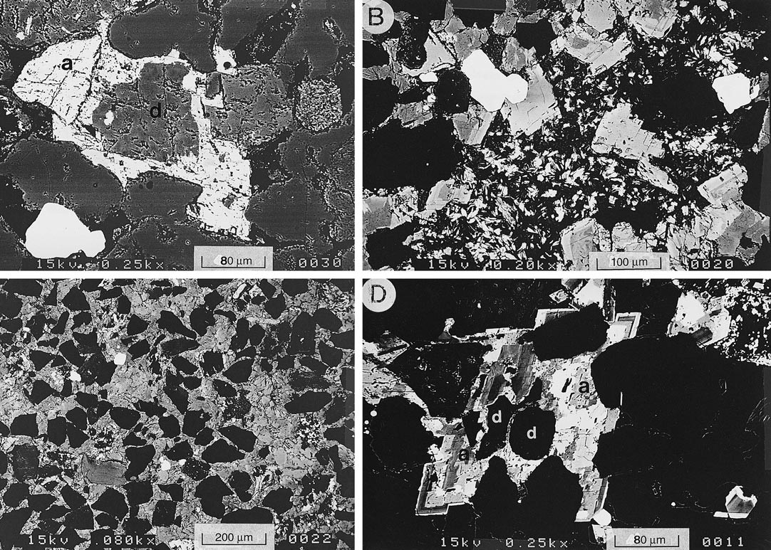

FIG. 6.—BSEM photomicrographs (maximum contrast, except A). **A)** Ankerite (**a**) syntaxially overgrows dolomite (**d**) in porous sandstone. **B)** Fracture crosscutting a concretion is partly filled by ankerite, followed by platy illite. Elsewhere, illite plates are enclosed within these ankerite crystals. Quartz grains are black; white is anatase. **C)** Typical concretion fabric, displaying the pronounced heterogeneity in packing of detrital quartz grains (black). Note the mottled zonation in the ankerite. **D)** Ankerite (**a**) in this sample has been overgrown by variably ferroan, zoned, euhedral dolomite. Some subsequent replacement by calcite (white) has taken place. Quartz grains, dolomite (**d**), and porosity are black.

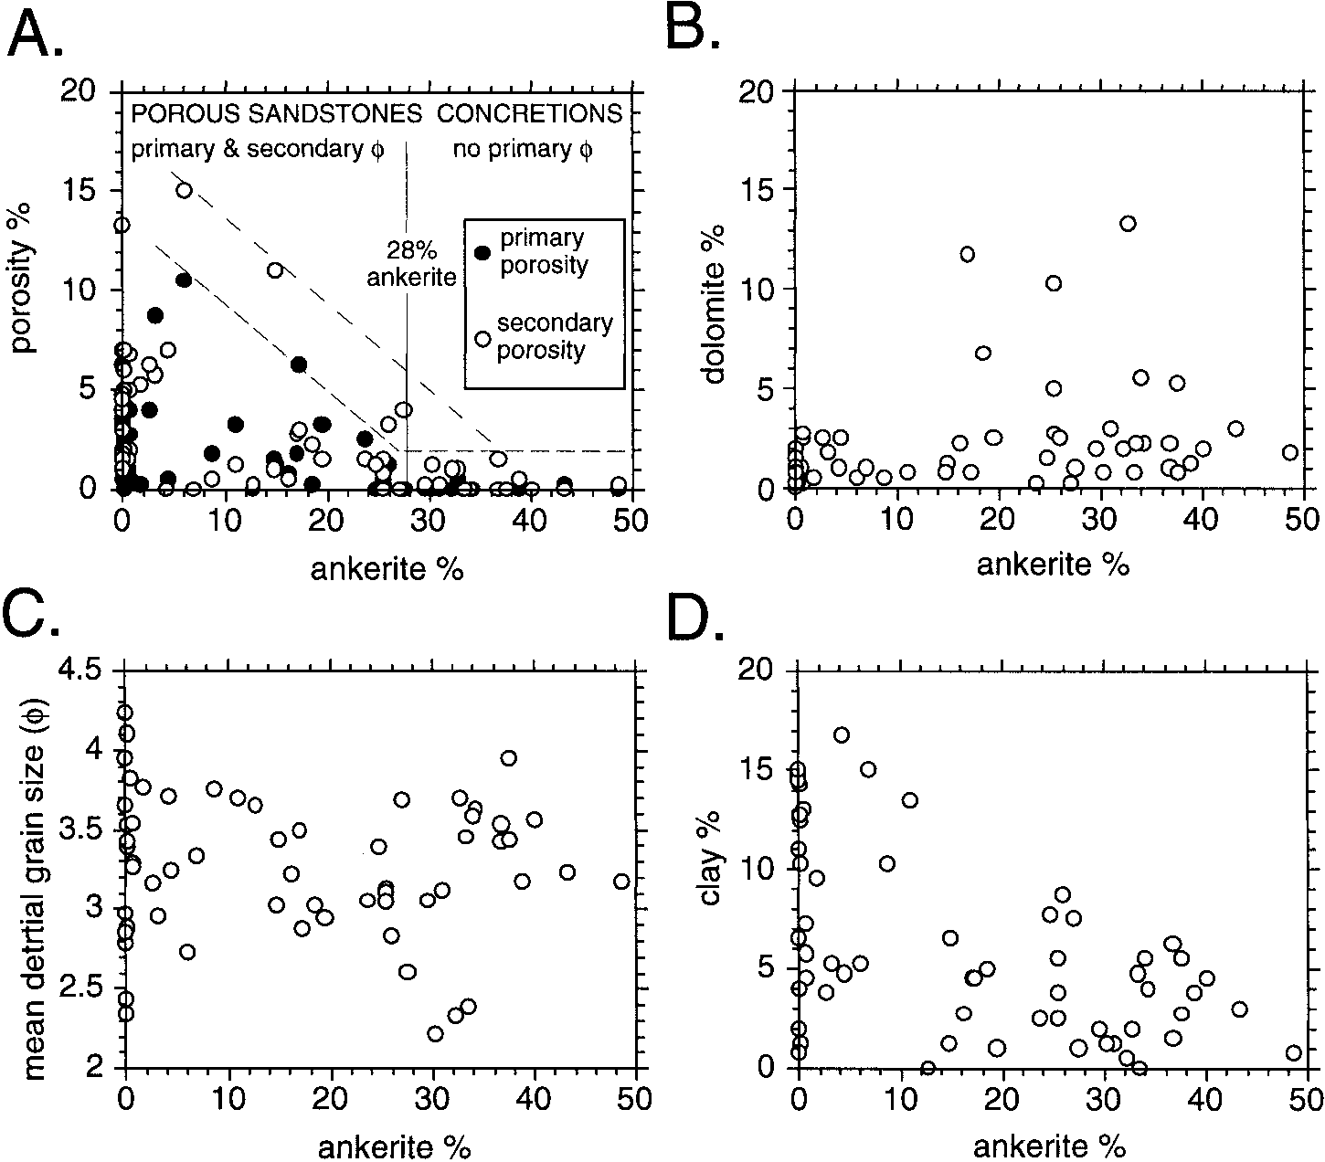FIG. 7.—Point-counted data from Franklin Formation sandstones. **A)** Ankerite versus porosity. Note that primary porosity is almost totally occluded when ankerite contents reach 28 vol.%. **B)** Ankerite versus dolomite. **C)** Ankerite versus detrital sand grain size. **D)** Ankerite versus clay content. Sampling was deliberately biased towards concretions, so the data spread is not representative of the gross sandstone composition.

the ankerite contains no hydrocarbon-filled fluid inclusions, it most probably precipitated prior to hydrocarbon emplacement in the Franklin Field in the Miocene. For reasons discussed above, IGVs and standardized compaction curves are inapplicable to establishing an absolute depth of ankerite precipitation in the concretions. An indirect estimate of precipitation depth uses the d18O value of ankerite (ø210 to 212.5‰ PDB) and fluid-inclusion *Th* values (Fig. 11A), assuming that the latter represent true precipitation temperatures. On this basis, Figures 5 and 13 suggest that ankerite was precipitated immediately preceding hydrocarbon emplacement, at about 140–1708C, from a fluid intermediate between Oxfordian seawater and the present-day formation water. Although carbonate fluid inclusions are prone to resetting (Barker and Goldstein 1990), the maximum *Th* values are less than the bottom hole temperatures in the wells (180–1908C). Similar mean *Th* values from ankerite and quartz cement are consistent with their paragenetic overlap, and quartz inclusions are less susceptible to reequilibration (Goldstein and Reynolds 1994). Quartz values extend to 1908C (Fig. 11B), probably reflecting a longer-lived cementation episode.

Precipitation at 140–1708C corresponds to burial depths in the approximate range 3.5 to 4.5 km (Fig. 4). This would have overlapped 33–30 Ma illite authigenesis in Fulmar Formation sandstones of the deep SCG (Darby et al. 1997), in accordance with the paragenetic information (Figs. 4, 5). It is unlikely that ankerite precipitated at much shallower depths. Wholesale recrystallization would have been required to reset both *Th* and isotopic data, and this is not supported by the preservation of crisp dolomite–ankerite boundaries or the discrepancy between *Th* values and current reservoir temperatures. It is equally unlikely that the ankerite precipitated over a large temperature range and is isotopically zoned. Apart from the lack of an obvious mechanism for synchronously decreasing pore-fluid d18O and d13C, our examination of samples and regional company reports pertaining to the Fulmar Formation suggest that ankerite is an insignificant phase in those fields that have never been buried to more than 3.5 km.

# Carbonate Source

From evidence discussed previously, it is apparent that some calcium and carbonate for ankerite authigenesis was supplied from dissolution of calcitic bioclasts. However, the negative d13C of the cement indicates an additional source of organic carbon. It is hence surprising that the ankerite cements have a uniform isotopic composition, which implies that the pore-fluid CO2 reservoir was regionally homogeneous. From these considerations we conclude that there must have been a proportionately consistent mixing of bioclastic and organic carbon in the ankeritecementing pore fluids, *and* that the organic component must have had an approximately fixed d13C value across both the Franklin and Elgin Fields. This is an unusual situation, given that organogenic CO2 has a typically much wider compositional range than molluscan carbonate (Anderson and Arthur 1983).

In a regional review of carbonate cement d13C values in North Sea Jurassic reservoir sandstones, Macaulay et al. (1998) documented a remarkably tight clustering of values from Upper Jurassic submarine fan reservoirs, with a mode at 29 to 212‰ PDB. The sandstones were bioclast-poor, encased in organic-rich mudrocks, and never exposed to meteoric water or pedogenic processes. Carbon isotope values of burial cements were interpreted to represent the d13C of carbon produced by *in situ* breakdown of organic acids, which were expelled into the reservoirs during kerogen maturation in the surrounding Kimmeridge Clay source rocks.

The Franklin Formation sandstones pass vertically and laterally into marine mudrocks (Heather and Kimmeridge Clay Formations) and show no evidence for synsedimentary emergence and no record of meteoric diagenesis related to the baseCretaceous unconformity. They can therefore be considered analogous to Upper Jurassic reservoirs discussed by Macaulay et al. (1998), with one important difference—the Franklin sandstones contained abundant shell fragments. It is therefore likely that the only carbon sources contributing to pore fluids during burial were intraformational bioclastic calcite (d13C about 11 to 14‰ PDB) and extraformational organic carbon with the characteristic 29 to 212‰ PDB d13C value (Fig. 10B). The estimated composition of ankerite cement (d13C 5 23 to 25‰ PDB) is approximately midway between these end members, suggesting that some interaction between organic acids and bioclasts provided the isotopically uniform dissolved CO2 reservoir.

# Organic–Inorganic Interactions

|  |
| --- |
| FIG. 8.—Transmitted light (A–D), cathodoluminescence (E), and photoluminescence (F) photomicrographs. **A)** Typically embayed quartz grains inside concretion, some with relics of syntaxial cement (arrows). Cloudy grains are K-feldspar; note slightly albitized plagioclase with overgrowth (**p**), and unstained dolomite crystal (**d**). **B)** Margin of a concretion; note well-developed quartz overgrowth in porous sandstone (arrowed). **C)** Shell fragment (**s**) in a concretion has been replaced by ankerite. Most of the replaced bioclastic debris is inferred to have been finer grained than this example, similar to the average grain size of detrital sand. Note the corroded and partly albitized K-feldspar (arrow). **D)** Elongate secondary pore in porous sandstone, inferred to be biomoldic in origin. Opaque material is bitumen. Arrow indicates corroded and illitized K-feldspar. **E)** Nonluminescent ankerite concretion; note the sharply defined, bright luminescent dolomite crystals (absent from the replaced shell fragment (**s**). **F)** Nonluminescent dolomite (**d**) syntaxially overgrown by bright luminescent ankerite (**a**). Note the sharp contact between the carbonate phases (compare with E and |

The estimated temperature of ankerite precipitation (140–1708C) is above that at which carboxylic acid anions released during thermal decomposition of kerogen become important components in oilfield pore waters (Means and Hubbard 1987; Lundegard and Kharaka 1990; Lewan and Fisher 1994). It is also above the temperature window at which these acid anions are believed to break down. Decarboxylation of acetic acid, for example, is thought to begin at about 80–1008C (Drummond and Palmer 1986; Kharaka et al. 1986; Lundegard and Kharaka 1994). On the basis of thermodynamic modeling of published formation-water chemistries, Figure 7C).

Shock (1988) also suggested that oxidation of carboxylic acids to CO2 may take place during deep-burial diagenesis.

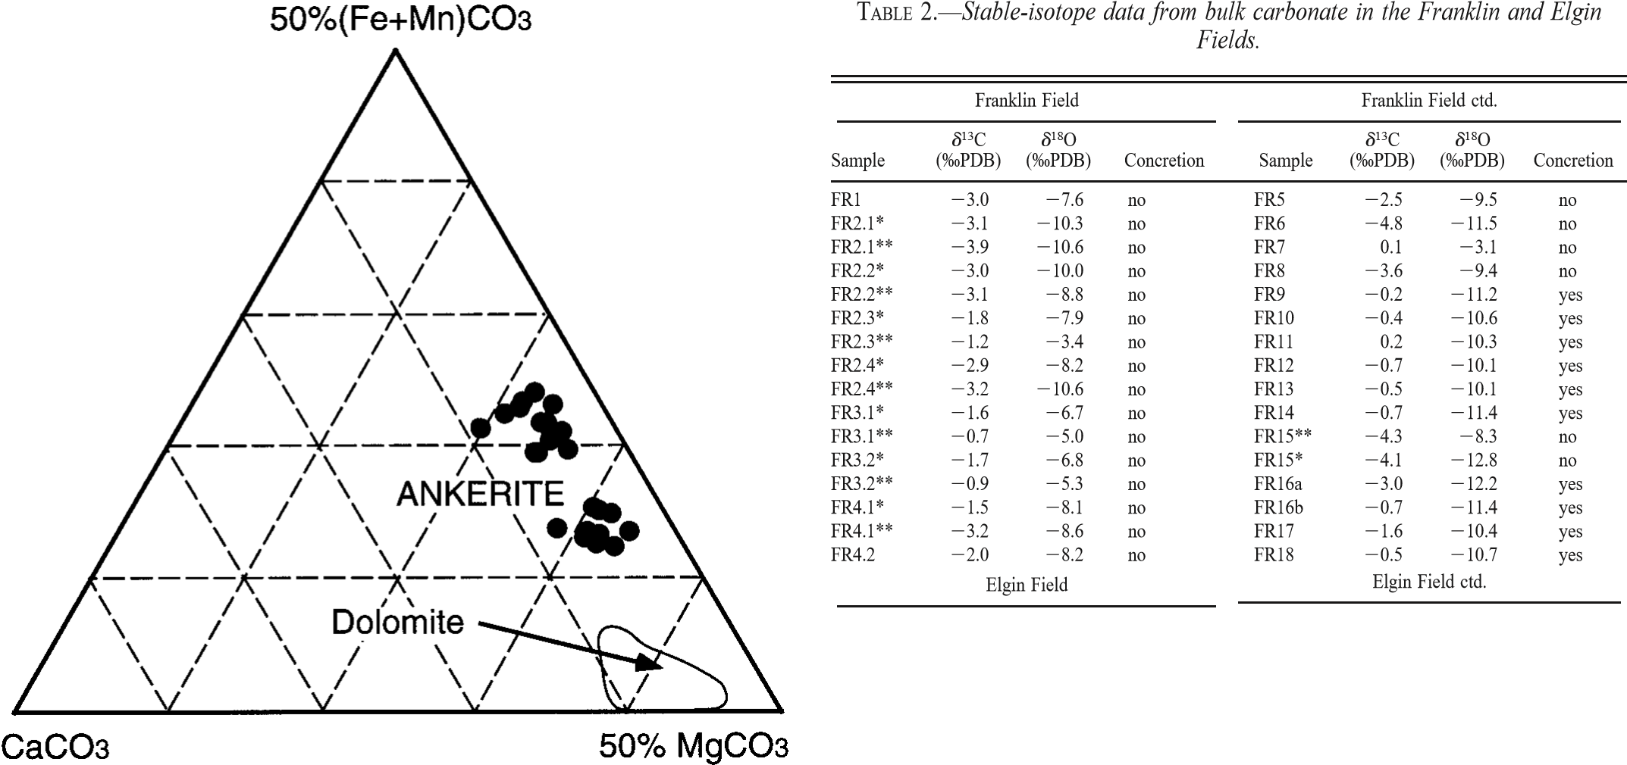Although the concentrations of carboxylic acids were not measured for Elgin– Franklin formation fluids, it is likely that significant decarboxylation took place prior to maximum burial. An attractive mechanism therefore exists for producing ankerite cement with a fixed negative d13C value of about 23 to 25‰ PDB within the appropriate temperature bracket. We propose that the decarboxylation (or oxidation) of carboxylic acids produced carbon dioxide that acted as an acid, each molecule of carbon dioxide causing the dissolution of one molecule of detrital calcite. Hence, the carbon dioxide reservoir within the pore fluids became enriched in carbon from the two sources in equal proportions. The relatively more 13C-enriched concretions show that ankerite precipitation was sufficiently rapid that the reservoir of dissolved FIG. 9.—Compositional data for Franklin Formation ankerite cement crystals obtained by EDXA. Field of early diagenetic dolomite compositions is shown for comparison.

carbon was not able to fully homogenize between bioclast-rich and bioclast-poor beds. The diagenetic scenario may be analogous to that proposed by Surdam and Yin (1994) whereby calcitic shell material in the reservoir rapidly dissolved and/or was replaced by more stable ankerite in response to increasing pCO2 and decreasing pH during decarboxylation. Both before and after the decarboxylation, slower silicate reactions (K-feldspar hydrolysis) were the predominant pH buffer (Hutcheon et al. 1993).

# Iron and Magnesium

Magnesium for early diagenetic dolomite precipitation in the Franklin sandstones is likely to have been derived from seawater, but during deep burial an additional supply of Mg21 (and Fe21) would have been required for precipitation of significant quantities of ankerite at the expense of calcite. It is unknown whether there were sufficient intraformational sources for these ions. However, it is possible that they were also derived by cross-formational mass transfer from Heather and Kimmeridge Clay Formation mudrocks undergoing clay-mineral transformation and dehydration reactions (cf. Boles 1978; Boles and Franks 1979; McHargue and Price 1982). The

|  |  |  |  |  |  |  |  |
| --- | --- | --- | --- | --- | --- | --- | --- |
| Sample | d13C  (‰PDB) | d18O  (‰PDB) | Concretion | Sample | d13C  (‰PDB) | d18O  (‰PDB) | Concretion |
| HFC1  HFC2 ELA1  ELA2  ELA3 | 24.8 24.2 23.0 21.5  24.8 | 28.7 212.2  210.5  26.9 211.3 | septarian septarian no no yes | ELC9  ELC10  ELC11  ELC12  ELC13 | 22.6 22.7 23.0 23.3  22.8 | 210.8  210.7  210.4  210.8  210.8 | yes yes yes yes yes |
| ELA4  ELA5  ELA6  ELA7  ELA8 | 23.7 24.2 22.3 23.2  22.4 | 212.2  212.2  28.6  211.7 29.2 | no yes no yes no | ELC14  ELC15  ELC16  ELC17  ELC18 | 22.9 21.8 21.4 21.4  21.5 | 211.0 28.9  29.4 210.4  210.9 | yes yes yes yes yes |
| ELA9  ELA10  ELA11  ELB1  ELB2  ELB3 | 23.9 23.4 22.5 22.8 21.8  23.6 | 211.9  211.4  212.2 28.1  25.8 211.1 | yes yes yes no no yes | ELC19  ELC20  ELC21  ELC22  ELC23  ELC24 | 21.4 21.5 21.9 23.4 21.4  20.2 | 210.9  211.1  210.2  210.5  29.7 210.0 | yes yes yes yes yes yes |
| ELB4  ELB5  ELB6  ELB7  ELC1  ELC2 | 22.4 22.8 23.4 24.8 24.1  25.5 | 28.1  28.5  210.1 29.9  29.9 211.5 | no no yes yes no no | ELC25  ELC26  ELC27  ELC28  ELC29  ELC30 | 0.8  0.2  22.7 23.1 21.9  21.5 | 210.5  210.1  210.6  211.1  210.7  210.9 | yes yes yes yes yes yes |
| ELC3  ELC4  ELC5  ELC6  ELC7  ELC8 | 23.0 23.4 23.1 22.7 22.1  22.5 | 211.1  210.8  210.5  210.6  211.6  210.5 | no yes yes yes yes yes | ELC31  ELC32  ELC33  ELC34  ELC35  ELC36 | 21.8 21.4 21.3 23.6 22.7  21.5 | 210.9  210.3 29.8 29.6 27.6  25.5 | yes yes yes no no no |

Starred samples were analyzed by a progressive leach procedure explained in the text. ‘‘*’’ indicates the first (258C) extraction and ‘‘**’’ indicates the second (1008C) extraction. FR samples are from 29/5b-6; ELA samples are from 22/30c-10, ELB samples are from 22/30c-8, and ELC samples are from 22/30c-13. HF samples are from the Heather Formation in 22/30c-10.

same fluid flux may have carried carboxylic acids into the reservoir. Illitization of smectite and generation of organic acids from kerogen are overlapping reactions during burial of organic-rich mudrocks, and take place at about 2–3 km in the North Sea Basin (Pearson and Small 1988). Ankerite cements in a Heather Formation septarian concretion of 22/30-c10 have photoluminescent and isotopic character similar to the ankerite cement in the underlying Franklin sandstones (Fig. 10), suggesting a tentative link between processes in the mudrocks and in the sandstones. It is also noteworthy that net release of Ca21 to the pore fluids through ankerite replacement of calcite helps to account for elevated Ca concentrations in the presentday formation waters (Table 1), and thus for the stabilization of plagioclase compared to K-feldspar.

# Spatial Distribution

The position of ankerite concretions bears no systematic relationship to the distribution of dolomite because dolomite crystals merely acted as nucleation sites (Fig. 7B). Instead, the foregoing interpretation predicts that ankerite is most extensive where the greatest concentration of calcitic bioclasts existed. Growth of sandstonehosted concretions indicates a dominance of transport-controlled kinetics (Wilkinson and Dampier 1990) after a short-lived period of surface reaction control and precipitation on all suitable substrates (Hendry et al. 1996). Once concretion growth was initiated in the relatively more bioclastic sandstone beds, laterally extensive cemented layers could develop by merging of concretions. Irregular concretion shapes suggest that this process took place to some extent in the Franklin sandstones, but carbonate supply was insufficient for the production of field-scale cemented beds that could impair reservoir performance.

Bioclast distribution on marine shelves is complex, and laterally extensive shell beds are likely to be produced only during episodes of prolonged condensation (Kidwell 1989; Banerjee and Kidwell 1991), for which there is no facies evidence in the sampled core. Outcrop study of shelf sandstones suggests that stratabound carbonate cementation is associated with flooding surfaces in the middle to lower shoreface, and is likely to become discontinuous both landward and basinward (Taylor et al. 1995). Intense bioturbation of the Franklin sandstones probably diluted the bioclast concentrations associated with flooding surfaces, and the location of concretions may reflect more subtle burrowing-related heterogeneities in the distribution of shell fragments.

## REGIONAL IMPLICATIONS

|  |
| --- |
| FIG. 10.—**A)** d13C–d18O cross plot of Franklin Formation carbonate samples. Franklin Field samples are subdivided according to analytical procedure; all Elgin Field samples were bulk analyses (see Table 2). Two analyses of ankerite from septarian concretions in the overlying Heather Formation are also plotted. **B)** Interpretation of petrographic and d13C data from ankerite in the Franklin sandstone. See Hendry et al. (in press) for discussion of the dolomite isotopic composition. |

Although ankerite is a common minor component of many Mesozoic North Sea sandstone reservoirs, the Franklin sandstones contain unusual amounts of it, particularly as concretions. We have interpreted the carbon in this ankerite as being derived equally from bioclasts and from organic acids (expelled from surrounding source rocks), once reservoir temperatures exceeded the threshold for decarboxylation and/or oxidation. Fulmar Formation sandstones in shallower parts of the SCG (such as the Fulmar, Puffin, Clyde, and Ula Fields) have facies and parageneses very similar to the laterally equivalent Franklin Formation, but without significantly high ankerite contents (Stewart 1986; Saigal et al. 1992; Clelland et al. 1993; Nedkvitne et al. 1993; Wilkinson et al. 1997; and our observations). Early carbonate cements (calcite, dolomite) tend to be more abundant than in the Franklin sandstones, and ankerite is reported only as thin rims on disseminated dolomite rhombs. This greater proportion of early carbonate cementation may reflect the influence of meteoric pore fluids away from the center of the SCG (note that Stewart 1986 describes near-pervasive leaching of shell material from Fulmar sandstones), or an irregular distribution of biota across the shelf.

Alternatively, the difference between the Franklin and Elgin area versus the remaining SCG may simply reflect the higher temperatures in these deeply buried areas. No other Fulmar Formation examples have been buried to the same extent as the Franklin sandstones. For example, the Fulmar Field at approximately 3.2–3.4 km burial depth and 1308C (Saigal et al. 1992) may be too shallow for significant thermal breakdown of carboxylate anions. Whilst the role of carboxylic acids in silicate diagenesis remains controversial (e.g., Crossey et al. 1986; Lundegard and Land 1986; Surdam et al. 1989), the results of this study underscore their potential importance in mediating carbonate precipitation and dissolution reactions. Any deeply buried reservoir in close spatial association with thick organic rich mudrocks is likely to be flushed with fluids rich in carboxylic acids. The potency of such fluids for carbonate diagenesis depends on: (1) the subsequent burial and thermal history; (2) the presence of metastable carbonates within the reservoir; and (3) relative kinetics of silicate and carbonate reactions that control pH buffering and which are likely to be sensitive to chemistry and the thermal evolution of the overall fluid– rock system. In high-temperature, high-pressure (HTHP) reservoirs, thermal breakdown of carboxylates is likely to be a major influence on deep-burial diagenesis.

|  |
| --- |
| FIG. 11.—Fluid-inclusion data. **A)** Histogram of *Th* values for ankerite in Elgin Field samples. **B)** Histogram of *Th* values for authigenic quartz in the Elgin and Franklin Fields. |

Because this leads to CO2 generation *in the reservoir* there is no opportunity for the acidity to be neutralized during transport and prior to interaction with the reservoir rock (cf. Giles and Marshall 1986).

Models of North Sea diagenesis have tended either to invoke an essentially isochemical system (e.g., Bjørlykke et al. 1989; Giles et al. 1992) or significant mass transfer, either from adjacent mudrocks or from Permian evaporite–carbonate successions along episodically active basin faults (e.g., Burley 1993). Recent work suggests that deep-burial diagenesis is influenced by regional flow systems related to the generation and leakage of overpressure compartments (Haszeldine et al., in press). In such a situation, cross-formational transfer of organic species and metal cations is likely to be a major control on carbonate diagenesis, and the consequences of organic–inorganic interactions should be considered in predictive diagenetic models for HPHT fields.

## CONCLUSIONS

1. Franklin Formation sandstones constituting the reservoir facies in the highpressure–high temperature Franklin and Elgin fields contain abundant diagenetic ankerite, including disseminated cements and concretions. In contrast, Middle and Upper Jurassic reservoirs in shallower parts of the Central and Northern North Sea contain minor disseminated ankerite and/or thin zones of ankerite cementation adjacent to mudrocks. The relative abundance of ankerite in the Franklin sandstones coincides with the extreme reservoir conditions (57 MPa, 1908C), suggesting a causal link.
2. Ankerite cement in the Franklin and Elgin Fields has a fairly constant isotopiccomposition (d13C ø 23 to 25‰ PDB, d18O ø 210 to 212.5‰ PDB), albeit with more variation in d13C where ankerite can be shown petrographically to have

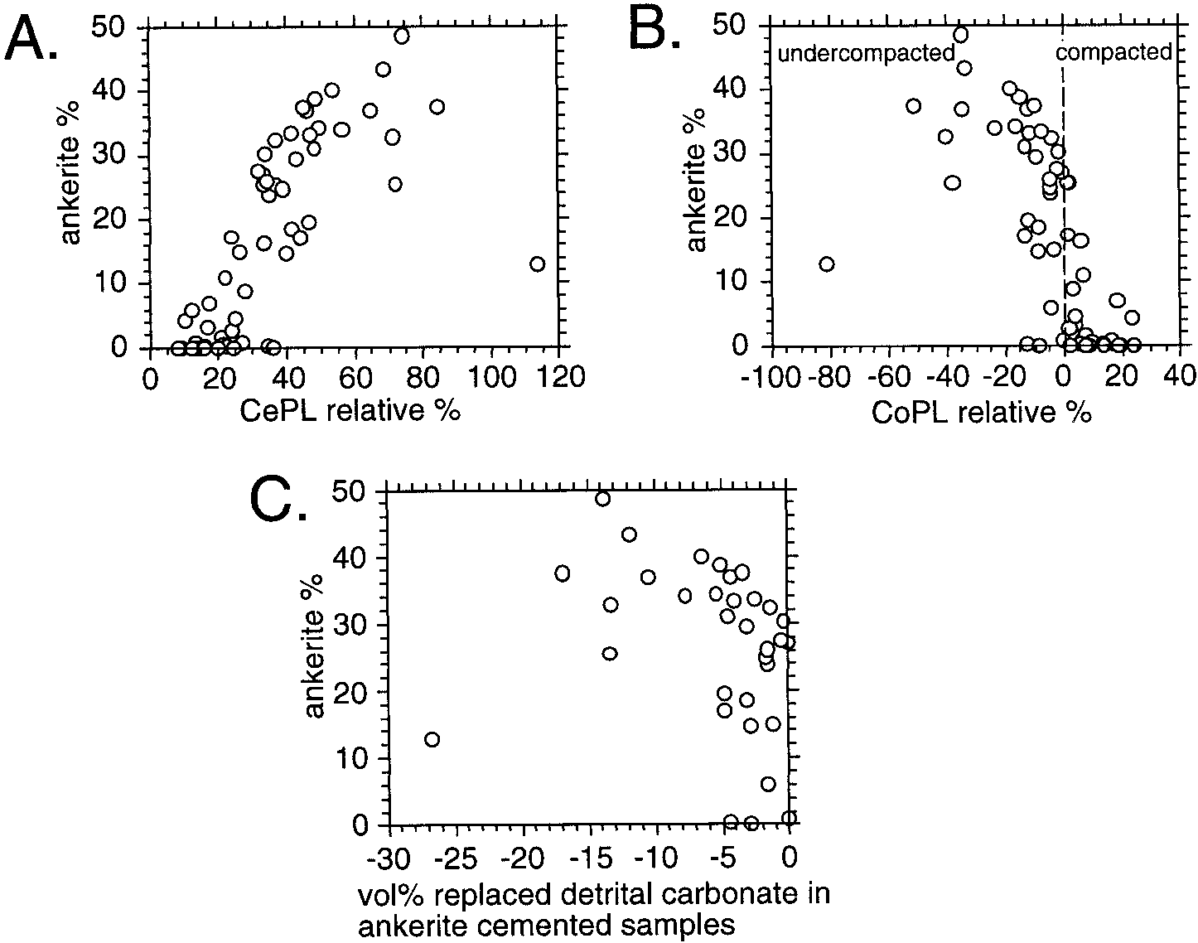FIG. 12.—**A)** Plot of porosity loss due to cementation (CePL) versus ankerite contents. **B)** Porosity loss due to compaction (CoPL) versus ankerite content; note that ankerite-poor sandstones have lost no more than 25% of their original porosity by compaction despite burial to .5 km. **C)** Plot of volume % replaced detrital carbonate (CoPL 3 OPE) 4 100, versus ankerite content.

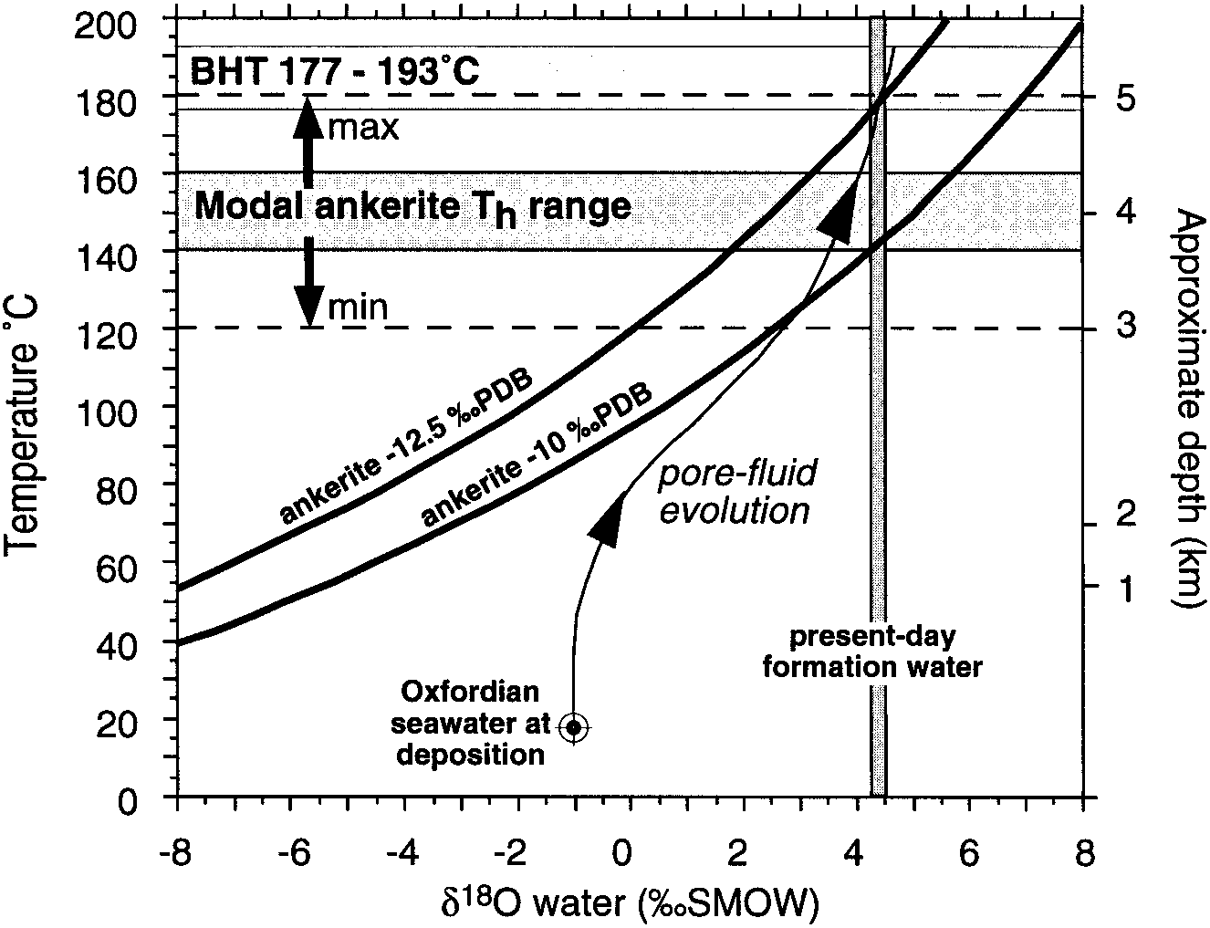FIG. 13.—Equilibrium fractionation relationships between d18O of ankerite, d18O of pore fluids, and precipitation temperature, using the ‘‘best fit’’ dolomite fractionation equation of Dutton and Land (1985). The probable pore-fluid evolution path shown is consistent with our regional studies.

replaced comminuted bioclastic material inside concretions. Paragenetic, isotopic, and fluid-inclusion evidence indicates that ankerite precipitated prior to hydrocarbon emplacement, most probably at 3.5 to 4.5 km burial depth and 140 to 1708C.

1. The consistent d13C value of ankerite cement indicates that carbon was derived in equal proportion from bioclastic carbonate and an organic source of fixed isotopic composition. The consistent d18O value of ankerite suggests that precipitation involved a temperature-controlled mechanism. Thermal breakdown of carboxylic acids provided the means both to destabilize bioclastic calcite with respect to ankerite, and to provide a reservoir of dissolved CO2 of the appropriate composition. Ankerite precipitation was concentrated in the relatively more bioclastic parts of the sandstone, forming concretions.
2. During deep burial, carboxylic acids would have been expelled from maturingsource rocks of the Kimmeridge Clay and Heather Formations into the Franklin sandstones. They may have transported Mg21 and Fe21 released during clay-mineral transformations. The subsequent thermal breakdown of carboxylate anions in the reservoir produced a potent *in situ* source of CO2.
3. Bioclastic sandstone reservoirs that have not been buried sufficiently for thermal breakdown of carboxylates may contain the ingredients for substantial ankerite formation, but will contain little if any ankerite cement. Likewise, deeply buried sandstones with little labile carbonate (either at deposition or remaining after early diagenesis) may contain some ankerite cement, but with a more negative d13C value than the Franklin example (e.g., 210‰ PDB; Macaulay et al. 1998) and probably not as concretions.
4. Organic–inorganic interactions are very likely to influence carbonate diagenesisof deep and hot sandstone reservoirs. Recent work has already shown the potential for substantial mass transfer of aluminosilicate components during deep burial (e.g., Haszeldine et al., in press) and our results strengthen the case against treating burial diagenesis of clastic reservoirs as a geochemical closed system.

## ACKNOWLEDGMENTS

We would like to thank Elf Exploration UK PLC and their operating partners for access to data and for fully funding this research via postdoctoral fellowships to JH and MW; the responsibility for interpretations presented herein rests with the authors. We are grateful to John Lasocki, Frederic Walgenwitz, and Nigel Trewin for much useful discussion and assistance during this work, and to John Still and Walter Ritchie at Aberdeen University for technical support at various stages. We particularly thank the staff at the Scottish Universities Research and Reactor Centre (East Kilbride) and Elf Aquitaine Production (Pau) for carrying out the stable-isotope analyses. SURRC is partly funded by a consortium of Scottish Universities. The paper was much improved by reviews by Kitty L. Milliken (Associate Editor, University of Texas), Peter Mozley (New Mexico Tech), and Thomas R. Taylor (Shell, Houston). Editorial handling was by Gail M. Ashley and John B. Southard.

## REFERENCES

AASE, N.E., BJøRKUM, P.A., AND NADEAU, P.H., 1996, The effect of grain-coating microquartz on preservation of reservoir porosity: American Association of Petroleum Geologists, Bulletin, v. 80, p. 1654–1673.

ANDERSON, T.F., AND ARTHUR, M.A., 1983, Stable isotopes of oxygen and carbon and their application to sedimentologic and palaeoenvironmental problems, *in* Arthur, M.A., Anderson, T.F., Kaplan, I.R., Veizer, J., and Land, L.S., eds., Stable Isotopes in Sedimentary

Geology: Society of Economic Paleontologists and Mineralogists Short Course 10, p. I.1–

I.151.

BANERJEE, I., AND KIDWELL, S.M., 1991, Significance of molluscan shell beds in sequence stratigraphy: an example from the Lower Cretaceous Mannville Group of Canada: Sedimentology, v. 38, p. 913–934.

BARKER, C.E., AND GOLDSTEIN, R.H., 1990, Fluid-inclusion technique for determining maximum temperature in calcite and its comparison to the vitrinite reflectance geothermometer: Geology, v. 18, p. 1003–1006.

BARNARD, P.C., AND BASTOW, M.A., 1991, Petroleum generation, migration, alteration, entrapment and mixing in the Central and Northern North Sea, *in* England, W., and Fleet, A., eds., Petroleum Migration: Geological Society of London, Special Publication 59, p. 167– 190.

BEARD, D.C., AND WEYL, P.K., 1973, Influence of texture on porosity and permeability of unconsolidated sands: American Association of Petroleum Geologists, Bulletin, v. 57, p. 349–369.

BJøRKUM, P.A., AND WALDERHAUG, O., 1990, Geometrical arrangement of calcite cementation within shallow marine sandstones: Earth-Science Reviews, v. 29, p. 145–161.

BJøRKUM, P.A., WALDERHAUG, O., AND AASE, N.E., 1993, A model for the effect of illitization on porosity and quartz cementation of sandstones: Journal of Sedimentary Petrology, v. 63, p. 1089–1091.

BJøRLYKKE, K., RAMM, M., AND SAIGAL, G.C., 1989, Sandstone diagenesis and porosity modification during basin evolution: Geologische Rundschau, v. 78, p. 243–268.

BOLES, J.R., 1978, Active ankerite cementation in the subsurface Eocene of Southwest Texas: Contributions to Mineralogy and Petrology, v. 68, p. 13–22.

BOLES, J.R., AND FRANKS, S.G., 1979, Clay diagenesis in Wilcox Sandstones of Southwest Texas: implications of smectite diagenesis on sandstone cementation: Journal of Sedimentary Petrology, v. 49, p. 55–70.

BOURKE, L., AND MACKERTICH, D., 1994, Permeability imaging and petrographic analysis of burrow fabrics in the Fife field: Dialog, v. 2, p. 4–5.

BURLEY, S.D., 1993, Models of burial diagenesis for deep exploration plays in Jurassic fault traps of the Central and Northern North Sea, *in* Parker, J.R., ed., Petroleum Geology of Northwest Europe: Proceedings of the 4th Conference, London, The Geological Society of London, p. 1353–1375.

CRAIG, H., 1957, Isotopic standards for carbon and oxygen correction factors for mass spectrometric analysis for carbon dioxide: Geochimica et Cosmochimica Acta, v. 12, p. 133– 149.

CLELLAND, W.D., KANTOROWICZ, J.D., AND FENS, T.W. 1993. Quantitative analysis of pore structure and its effect on reservoir behaviour: Upper Jurassic Ribble Member sandstones, Fulmar Filed, UK North Sea, *in* Ashton, M., ed., Advances in Reservoir Geology: Geological Society of London, Special Publication 69, p. 57–79.

CROSSEY, L.J., SURDAM, R.C., AND LAHANN, R., 1986, Application of organic/inorganic diagenesis to porosity prediction, *in* Gautier, D.L., ed., Roles of Organic Matter in Sediment Diagenesis, SEPM, Special Publication 38, p. 147–155.

DARBY, D., WILKINSON, M., FALLICK, A.E., AND HASZELDINE, R.S., 1997, Illite dates record deep fluid movements in petroleum basins: Petroleum Geoscience, v. 3, p. 133–140.

DRUMMOND, S.E., AND PALMER, D.A., 1986, Thermal decarboxylation of acetate. Part II. Boundary conditions for the role of acetate in the primary migration of natural gas and the transportation of metals in hydrothermal systems: Geochimica et Cosmochimica Acta, v. 50, p. 825–833.

DUTTON, S.P., AND LAND, L.S., 1985, Meteoric burial diagenesis of Pennsylvanian arkosic sandstones, Southwestern Anadarko Basin, Texas: American Association of Petroleum Geologists, Bulletin, v. 69, p. 22–38.

EHRENBERG, S.N., 1989, Assessing the relative importance of compaction processes and cementation to reduction of porosity in sandstones: discussion: American Association of Petroleum Geologists, Bulletin, v. 73, p. 1274–1276.

FOLK, R.L., AND WARD, W., 1957, Brazos River bar: a study in the significance of grain size parameters: Journal of Sedimentary Petrology, v. 27, p. 3–26.

GILES, M.R., AND MARSHALL, J.D., 1986, Constraints on the development of secondary porosity in the subsurface: re-evaluation of processes: Marine and Petroleum Geology, v. 3, p. 243– 255.

GILES, M.R., STEVENSON, S., MARTIN, S.V., CANNON, S.J.C., HAMILTON, P.J., MARSHALL, J.D., AND SAMWAYS, G.M., 1992, The reservoir properties and diagenesis of the Brent Group: a regional perspective, *in* Morton, A.C., Haszeldine, R.S., Giles, M.R., and Brown, S., eds., Geology of the Brent Group: Geological Society of London, Special Publication 61, p. 289–327.

GOLDSTEIN, R.H., AND REYNOLDS, T.J., 1994, Systematics of Fluid Inclusions in Diagenetic Minerals, SEPM, Short Course 31, 212 p.

GOWLAND, S., 1996, Facies characteristics and depositional models of highly bioturbated shallow marine siliciclastic strata: an example from the Fulmar Formation (Late Jurassic), UK Central Graben, *in* Hurst, A., ed., Geology of the Humber Group, Central Graben and Moray Firth, UKCS: Geological Society of London, Special Publication 114, p. 185–214.

HASZELDINE, R.S., BRINT, J.F., FALLICK, A.E., HAMILTON, P.J., AND BROWN, S., 1992, Open and restricted hydrologies in Brent Group diagenesis: North Sea, *in* Morton, A.C., Haszeldine, R.S., Giles, M.R., and Brown, S., eds., Geology of the Brent Group: Geological Society of London, Special Publication 61, p. 401–419.

HASZELDINE, R.S., WILKINSON, M., DARBY, D., MACAULAY, C.I., COUPLES, G.D., FALLICK, A.E., FLEMING, C.G., STEWART, R.N.T., AND MCAULAY, G., 1999, Diagenetic porosity creation in an overpressured graben, *in* Fleet, A.J., and Boldy, S.A.R., eds., Petroleum Geology of Northwest Europe: Proceedings of the 5th Conference, London, Geological Society of London, 1339–1350.

HENDRY, J.P., TREWIN, N.H., AND FALLICK, A.E., 1996, Low-Mg calcite marine cement in Cretaceous turbidites: origin, spatial distribution, and relationship to seawater chemistry: Sedimentology, v. 43, p. 877–900.

HENDRY, J.P., WILKINSON, M., FALLICK, A.E., AND TREWIN, N.H., in press, Disseminated ‘‘jigsaw piece’’ dolomite in Upper Jurassic shelf sandstones, Central North Sea: an example of cement growth during bioturbation?: Sedimentology.

HOWELL, J.A., FLINT, S.S., AND HUNT, C., 1996, Sedimentological aspects of the Humber Group (Upper Jurassic) of the South Central Graben, UK North Sea: Sedimentology, v. 43, p. 89– 114.

HUTCHEON, I., SHEVALIER, M., AND ABERCROMBIE, H.J., 1993, pH buffering by metastable mineral– fluid equilibria and the evolution of carbon dioxide fugacity during burial diagenesis: Geochimica et Cosmochimica Acta, v. 57, p. 1017–1027.

KANTOROWICZ, J.D., 1985, The origin of authigenic ankerite from the Ninian Field, UK North

Sea: Nature, v. 315, p. 214–216.

KHARAKA, Y., LAW, L.M., CAROTHERS, W.W., AND GOERLITZ, D.F., 1986, Role of organic species dissolved in formation waters from sedimentary basins in mineral diagenesis, *in* Gautier, D.L., ed., Roles of Organic Matter in Sediment Diagenesis: SEPM, Special Publication 38,

p. 111–122.

KIDWELL, S.M., 1989, Stratigraphic condensation of marine transgressive records: origin of major shell deposits in the Miocene of Maryland: Journal of Geology, v. 97, p. 1–24.

LASOCKI, J., GUEMENE, J.M., HEDAYATI, A., LEGORJUS, C., AND PAGE, W.M., 1999, The Elgin and Franklin Fields: UK Blocks 22/30c, 22/30b and 29/5b, *in* Fleet, A.J., and Boldy, S., eds., Petroleum Geology of Northwest Europe: Proceedings of the 5th Conference, London, The Geological Society of London p. 1007–1020.

LEWAN, M.D., AND FISHER, J.B., 1994, Organic acids from petroleum source rocks, *in* Pittman, E.D., and Lewan, M.D., eds., Organic Acids in Geological Processes: Berlin, SpringerVerlag, p. 70–114.

LUNDEGARD, P.D., AND LAND, L.S., 1986, Carbon dioxide and organic acids: their role in porosity enhancement and cementation, Paleogene of the Texas Gulf Coast, *in* Gautier, D.L., ed., Roles of Organic Matter in Sediment Diagenesis: SEPM, Special Publication 38, p. 129– 146.

LUNDEGARD, P.D., AND KHARAKA, Y.K., 1990, Geochemistry of organic acids in subsurface waters: field data, experimental data and models, *in* Melchior, D.C., and Basset, R.L., eds., Chemical Modeling of Aqueous Systems II: American Chemical Society, Symposium Series 416, p. 169–189.

LUNDEGARD, P.D., AND KHARAKA, Y.K., 1994, Distribution and occurrence of organic acids in subsurface waters, *in* Pittman, E.D., and Lewan, M.D., eds., Organic Acids in Geological Processes: Berlin, Springer-Verlag, p. 40–69.

MACAULAY, C.I., HASZELDINE, R.S., AND FALLICK, A.E., 1993, Distribution, chemistry, isotopic composition and origin of diagenetic carbonates: Magnus Sandstone, North Sea: Journal of Sedimentary Petrology, v. 63, p. 33–43.

MACAULAY, C.I., FALLICK, A.E., MCLAUGHLIN, O.M., HASZELDINE, R.S., AND PEARSON, M.J., 1998, The significance of d13C of carbonate cements in reservoir sandstones: a regional perspective from the Jurassic of the northern North Sea, *in* Morad, S., ed., Carbonate Cementation of Sandstones, International Association of Sedimentologists, Special Publication 26, p. 395– 408.

MARTIN, M.A., AND POLLARD, J.E., 1996, The role of trace fossils (ichnofabric) analysis in the development of depositional models for the Upper Jurassic Fulmar Formation of the Kittiwake Field (Quadrant 21 UKCS), *in* Hurst, A., ed., Geology of the Humber Group, Central Graben and Moray Firth, UKCS: Geological Society of London, Special Publication 114, p. 163–183.

MCHARGUE, T.R., AND PRICE, R.C., 1982, Dolomite from clay in argillaceous or shale-associated marine carbonates: Journal of Sedimentary Petrology, v. 52, p. 873–886.

MEANS, J.L., AND HUBBARD, N., 1987, Short-chain aliphatic acid anions in deep subsurface brines: A review of their origin, occurrence, properties, and importance and new data on their distribution and geochemical implications in the Palo Duro Basin, Texas: Organic Geochemistry, v. 11, p. 177–191.

NEDKVITNE, T., KARLSEN, D.A., BJøRLYKKE, K., AND LARTER, S.R., 1993, Relationship between reservoir diagenetic evolution and petroleum emplacement in the Ula Field, North Sea: Marine and Petroleum Geology, v. 10, p. 255–270.

PEARSON, M.J., AND SMALL, J.S., 1988, Illite–smectite diagenesis and palaeotemperatures in Northern North Sea Quaternary to Mesozoic shale sequences: Clay Minerals, v. 23, p. 109– 132.

PRICE, J., DYER, R., GOODALL, I., MCKIE, T., WATSON, P., AND WILLIAMS, G., 1993, Effective stratigraphic subdivision of the Humber Group and the Late Jurassic evolution of the UK Central Graben, *in* Parker, J.R., ed., Petroleum Geology of Northwest Europe: Proceedings of the 4th Conference, London, The Geological Society of London, p. 443–458.

PROSSER, D.J., DAWS, J.A., FALLICK, A.E., AND WILLIAMS, B.P.J., 1994, Geochemistry and diagenesis of stratabound calcite cement layers within the Rannoch Formation of the Brent Group, Murchison Field, North Viking Graben (northern North Sea): Sedimentary Geology, v. 87, p. 139–164.

PURVIS, K., 1992, Lower Permian Rotliegend sandstones, southern North Sea: a case study of sandstone diagenesis in evaporite-associated sequences: Sedimentary Geology, v. 77, p. 155– 171.

SAIGAL, G.C., BJøRLYKKE, K., AND LARTER, S., 1992, The effects of oil emplacement on diagenetic processes—examples from the Fulmar Reservoir sandstones, North Sea: American Association of Petroleum Geologists, Bulletin, v. 76, p. 1024–1033.

SEARL, A., 1990, Complex sector zonation in ankerite: geochemical controls on crystal morphology and intersector element partitioning: Mineralogical Magazine, v. 54, p. 501–507. SHOCK, E.L., 1988, Organic acid metastability in sedimentary basins: Geology, v. 16, p. 886– 890.

SIBLEY, D.F., AND GREGG, J.M., 1987, Classification of dolomite rock textures: Journal of Sedimentary Petrology, v. 57, p. 967–975.

STEWART, D.J. 1986, Diagenesis of the shallow marine Fulmar Formation in the Central North Sea: Clay Minerals, v. 21, p. 537–564.

SULLIVAN, M.D., HASZELDINE, R.S., AND FALLICK, A.E., 1990, Linear coupling of carbon and strontium isotopes in Rotliegend Sandstone, North Sea: Evidence for cross-formational fluid flow: Geology, v. 18, p. 1215–1218.

SURDAM, R.C., CROSSEY, L.J., HAGEN, E.S., AND HEASLER, H.P., 1989, Organic–inorganic interactions and sandstone diagenesis: American Association of Petroleum Geologists, Bulletin, v. 73, p. 1–23.

SURDAM, R.C., AND YIN, P., 1994, Organic acids and carbonate stability, the key to predicting positive porosity anomalies, *in* Pittman, E.D., and Lewan, M.D., eds., Organic Acids in Geological Processes: Berlin, Springer-Verlag, p. 398–448.

TAYLOR, K.G., GAWTHORPE, R.L., AND VAN WAGONER, J.C., 1995, Stratigraphic control on laterally persistent cementation, Book Cliffs, Utah: Geological Society of London, Journal, v. 152, p. 225–228.

WILKINSON, M., AND DAMPIER, M.D., 1990, The rate of growth of sandstone-hosted calcite concretions: Geochimica et Cosmochimica Acta, v. 54, p. 3391–3399.

WILKINSON, M. AND HASZELDINE, R.S. 1996. Aluminium loss during sandstone diagenesis: Geological Society of London, Journal, v. 153, p. 657–660.

WILKINSON, M., DARBY, D., HASZELDINE, R.S., AND COUPLES, G.D., 1997, Secondary porosity generation during deep burial associated with overpressure leak-off: Fulmar Formation,United Kingdom Central Graben: American Association of Petroleum Geologists, Bulletin, v. 81, p. 803–813.

Received 1 April 1998; accepted 13 March 1999.