Journal of the Geological Society, London, Vol. 160, 2003, pp. 231–246. Printed in Great Britain.

Source of the Dalradian Supergroup constrained by U–Pb dating of detrital zircon and implications for the East Laurentian margin

PETER A. CAWOOD1, ALEXANDER A. NEMCHIN1, MARTIN SMITH2 & STACI LOEWY3

1Tectonics Special Research Centre, Department of Applied Geology, Curtin University, GPO Box U1987, Perth 6845,

W.A., Australia (e-mail: p.cawood@info.curtin.edu.au)

2British Geological Survey, Murchison House, West Mains Road, Edinburgh EH9 3LA, UK

3Department of Geological Sciences, The University of Texas at Austin, Austin, TX 78712, USA

Abstract: Detrital zircons in siliciclastic units of the Dalradian Supergroup yield U–Pb ages ranging from 3.2 to 0.5 Ga. Detrital zircons from the sub-Grampian Group basement and the Grampian Group are predominantly of Palaeoproterozoic and Mesoproterozoic ages with Archaean grains absent or rare. In contrast, the overlying Appin, Argyll and Southern Highland groups contain a significant contribution of Archaean detrital zircon grains, some of which locally preserve evidence for late Palaeoproterozoic overgrowths dated at c. 1.8 Ga. In addition, on concordia plots Archaean grains are slightly discordant with a lower intercept at c. 1.8 Ga suggesting they were affected by a tectonothermal event at this time. Late Palaeoproterozoic and Mesoproterozoic grains also show evidence for overprinting by a tectonothermal event around 1.0–0.9 Ga. These tectonothermal events occurred in the source region before accumulation of the siliciclastic detritus. The analysed samples contained no definitive evidence for having been affected by a late Neoproterozoic (Knoydartian) event or of containing detritus derived from a source showing evidence for this event. The overall age range of detritus, combined with sparse palaeocurrent data, is consistent with derivation from the Laurentian foreland, especially the Labrador–Greenland region. Archaean detritus overlaps with that of Archaean cratons, notably the Superior, whereas Palaeoproterozoic detritus corresponds to the timing of suturing of Archaean cratons by a series of orogenic belts (Ketilidian–Makkovik, New Quebec, Nagssugtoqidian, Torngat belts). Mesoproterozoic detritus is consistent with derivation from the Grenville Orogen. The presence of a series of detrital age peaks in the late Palaeoproterozoic and early Mesoproterozoic (1.8–1.5 Ga), the paucity of mid-Mesoproterozoic detritus (1.4–1.2 Ga), and evidence for a tectonothermal event between 1.0 and 0.9 Ga is typical of the geological history of the Labrador–Greenland region of

Laurentia.

Keywords: Laurentia, Dalradian Supergroup, U/Pb, provenance.

Siliciclastic-dominated sequences of largely Neoproterozoic age are widespread along the eastern continental margin of Laurentia, stretching from the southern Appalachians to northern Greenland (Rankin et al. 1989, 1993; Harris & Johnson 1991; Johnson 1991; Stewart 1991; Thomas 1991; Williams et al. 1995; Strachan & Holdsworth 2000a, b; Watt & Thrane 2001; Strachan et al. 2002). These rocks are generally related to a protracted history of rifting and ocean formation associated with the breakout of Laurentia from the supercontinent Rodinia. In Scotland, these siliciclastic sequences are well preserved and include the Torridonian, Moine and Dalradian successions (Fig. 1). The timing of deposition and rifting and the tectonothermal histories of these successions are the subject of continuing controversy involving widely differing views and models.

The tectonic setting for the Dalradian, along with that of the Moine and Torridon groups, is generally envisaged as forming during an extended period of rifting associated with opening of the Iapetus Ocean (Soper 1994a, 1994b; Soper & England 1995; Dewey & Mange 1999; Dalziel & Soper 2001). However, recent evidence for a Neoproterozoic tectonothermal event in the Moine has been related to Knoydartian orogenesis (Vance et al. 1998) and is inconsistent with a protracted rifting model. This has led Prave (1999) to propose that the lower Dalradian succession may represent a foreland basin sequence derived from a Knoydartian orogenic welt. An alternative model invoking strike-slip accretion of a number of exotic terranes along the Laurentian margin

231

is favoured by other workers (e.g. Bluck et al. 1997; Bluck

2001).

This paper presents for the first time U/Pb age data for detrital zircons from the Dalradian Supergroup, and shows that their age signature is consistent with derivation from older units within Laurentia and that there are changes in the nature and content of the detritus being fed into the Dalradian basins with time.

# Regional setting and samples

The Dalradian Supergroup lies in a NE–SW-trending belt extending from the Shetland Islands, through Scotland, into northern Ireland and is bounded to the NW by the Great Glen Fault and to the SE by the Highland Boundary Fault–Fair Head– Clew Bay Line.

The Dalradian Supergroup comprises predominantly marine siliciclastic sequences intercalated with varying proportions of carbonate and volcanic rocks (Johnson 1991; Strachan & Holdsworth 2000a; Daly 2001). On the basis of variations in lithology and facies, four groups, along with subgroups and formations, are recognized (Fig. 2; Harris et al. 1994). The psammitedominated Grampian Group forms the base of the succession. It is conformably overlain by the Appin Group, comprising quartzite, laminated psammite and pelite with increasing limestone towards the top. The base of the overlying Argyll Group is marked by Port Askaig Tillite and related glacial units (e.g.

|  |
| --- |
| Fig. 1. Geological map of Scotland between the Great Glen and Highland Boundary faults, after Stephenson & Gould (1995), showing the distribution of the Dalradian Supergroup. Inset simplified map shows the distribution of late Mesoproterozoic to Cambrian siliciclastic sequences of the Torridonian, Moine and Dalradian successions. MT, Moine Thrust; GGF, Great Glen Fault, HBF, Highland Boundary Fault. |

Schiehallion Boulder Bed), which pass up into well-sorted quartzite and pelite with limestone and volcanic rock dominating at the top (Tayvallich Subgroup). The Southern Highland Group, consisting of greywacke, shale, limestone and volcanic rock, forms the top of the Dalradian succession. The entire sequence is variably deformed and metamorphosed.

The basement to the Dalradian succession in Scotland is the subject of considerable debate. The lowest, predominantly gneissic part of the Grampian Group (Central Highland Division) has yielded Neoproterozoic Rb–Sr mica ages that led Piasecki (1980) and Piasecki & van Breeman (1983) to propose that it represents a correlative of the Moine Supergroup lying south of the Great Glen Fault, and preserves an unconformable cover– basement relationship with the overlying Grampian Group modified by later shearing. Highton et al. (1999) obtained a U/Pb zircon age of 840 11 Ma from inferred syn-D1 anatectic granites in the gneisses supporting this correlation, indicating deformation and metamorphism during a Neoproterozoic Knoydartian event (see Friend et al. 1997; Rogers et al. 2001). Elsewhere in Scotland, basal conglomerates of the Colonsay Group, a probable correlative of the Dalradian, rest unconformably on Palaeoproterozoic basement of the Rhinns Complex (Fitches & Maltman 1984; Muir et al. 1994). In Ireland the Dalradian is structurally underlain by Precambrian gneisses of the Annagh Gneiss Complex and the Slishwood Division (Daly 2001).

Recent work by the British Geological Survey, summarized by Smith et al. (1999), documents stratigraphic and sedimentological evidence for a break between the Grampian Group and the basement rocks, which Smith et al. referred to as the Glen Banchor and Dava successions (Fig. 2). However, a metamorphic study by Phillips et al.(1999) found that the basement succession and lower Dalradian Supergroup (Grampian and Appin) appear to share a common history of crustal thickening and progressive metamorphism, arguing against any significant orogenic break between inferred basement and cover. To date, no rocks that can be definitely ascribed to the Grampian and younger groups of the Dalradian succession have yielded evidence for Neoproterozoic deformation, suggesting that the base of the Grampian Group (sensu Smith et al. 1999) is younger than c. 800 Ma. An upper age limit of c. 520 Ma is provided by the Leny Limestone at the top of the Southern Highland Group, which contains a late Early Cambrian fauna of Laurentian affinities (Pringle 1939; Rushton & Owen 1999; Tanner & Pringle 1999).

# Sample description and location

The majority of zircons analysed in this study were separated from samples of psammite and striped semipelite collected along a NW–SE traverse from SE of the Great Glen to the Highland Border Fault (Fig. 1). They form part of a larger provenance dataset (Smith et al.,unpub. data), and include representatives from each of the main groups and bracket the major stratigraphic and structural breaks in the succession (Fig. 2). In addition, two samples from the sandstone matrix to boulder beds in the Port Askaig Tillite at the Garvellach Islands and Islay were also analysed.

|  |
| --- |
| Fig. 2. Schematic stratigraphic column through the Dalradian Supergroup of the Central Highlands, Perthshire. Diagram shows position of analysed samples. |

Listed below in ascending stratigraphic order is description and location information for each sample.

JXX143, sub-Grampian Group basement (?Moine Supergroup). Coarse-grained, gneissose, garnet- and muscovite-bearing psammite and semipelite from the structurally upper part of the Glen Banchor succession at Blargie (NN 6014 9470). The sample lies within a series of interbedded semipelites and quartzites cut by ductile shear zones that form a basement onto which Grampian and Appin Group rocks were deposited (Piasecki 1980; Smith et al. 1999). Rb–Sr mica and U–Pb monazite ages indicate that these strata experienced tectonothermal events at 840–750 Ma (Piasecki & van Breeman 1983; Noble et al. 1996) and were therefore probably deposited before c. 850 Ma.

SMS521, Grampian Group (Garva Bridge Psammite). Medium-grained grey psammite with subordinate bands of semipelite that is representative of the basinal lithofacies of the Glenshirra Subgroup. It was collected upstream of Garva Bridge at NN 5236 9512. The Glenshirra psammites are lithologically and geochemically distinct from the rest of the Grampian Group, as they formed in shallow marine conditions subject to subaerial erosion, fluviatile deposition and red-bed environments (Haselock 1984).

SMS516, Grampian Group (Glen Buck Psammite).The Glen Buck Psammite crops out close to the Great Glen Fault and is separated from the Grampian Group strata by a major ductile shear zone (Key et al. 1997). Smith et al. (1999) correlated these coarse-grained psammites and pebbly beds with the Glenshirra Subgroup and interpreted them as a coarse, proximal lithofacies formed adjacent to a fault block. The sample was taken to confirm this correlation and is of the matrix from a wellbedded, gritty psammite unit west of Loch Tarff at NH 4298 1134.

SMS509, Grampian Group (Strath Tummel Succession). Sample from the uppermost subgroup of the Grampian Group dominated by quartzand feldspar-rich psammite with minor bands of calc-silicate. Abundant sedimentary structures indicate deposition in tidally influenced shelf conditions, interpreted by Glover et al. (1995) to represent a period of thermal subsidence post-dating the main rifting phase of the Corrieyairack Subgroup. The sample is of a blocky laminated grey psammite with micaceous laminae from the A9 roadcut south of Bruar at NN 8309 6540. SMS484, Appin Group (Strath Fionan Banded Semipelite). Striped muscovitic semipelite with thin bands of psammite typical of the Ballachulish Subgroup in Central Perthshire. It was sampled on the south side of Strath Fionan at NN 7282 5644, where it forms part of a highly attenuated succession above the Boundary Slide.

GA-99-03A, Argyll Group (Port Askaig Tillite). Brown micaceous quartz sandstone matrix from diamictite containing abundant clasts, mainly of unfoliated granite (c. 85%), up to 30 cm in diameter. The matrix sample contains c. 3% granitic clasts and alkali feldspar megacrysts up to 10 mm in diameter and a smaller proportion of carbonate clasts ,1 mm in diameter. The sample was collected along the southeastern shore of Garbh Eileach, the largest of the Garvellach Islands at NM 6715 1175.

IS-99-03A, Argyll Group (Port Askaig Tillite). Sandy pelite matrix from diamictite containing unfoliated granitic clasts up to 50 cm in diameter. The matrix is a dark grey sandy pelite with a well-developed foliation and has a phyllitic sheen. The sample incorporates c. 3% small (,2 cm in diameter) granitic clasts, alkali feldspar megacrysts and, less commonly, carbonate clasts, and was collected along the eastern coast of Islay at Port Askaig at NR 4321 6913.

SMS474, Argyll Group (Ben Lawers Schist). Sample from the Upper Easdale Subgroup located immediately beneath Ben Lawers Slide and below the first major volcanic horizon of the Argyll Group represented by the Farragon Beds (Goodman & Winchester 1993). The sample is from the basal unit known locally as the Sron Beag Schist and comprises a striped quartzose psammite and schistose semipelite with calcareous bands, taken NE of Lochan na Lairige at NN 5921 4113.

SMS490, Southern Highland Group (‘Green Beds’). Fine-grained, quartz-rich psammite typical of the Southern Highland Group in Perthshire, interleaved with chloritic volcaniclastic grits known as ‘Green Beds’. The sample was taken from the Birks of Aberfeldy by the bridge at Falls of Moness NN 8518 4724.

SMS503, Southern Highland Group (Keltie Water Grits). The uppermost unit of the Dalradian is considered to be continuous with the Southern Highland Group turbidites and contains a Laurentian trilobite fauna indicating an age of 520 Ma (Rushton & Owen 1999; Tanner & Pringle 1999). The sample of flaggy sandstone was collected from a sequence of pale variegated grits and shales interbedded with mediumgrained sandstone well exposed in the Keltie Water section 150 m north of waterfalls at NN 6456 1236.

# Analytical methods

Zircon mineral separates were prepared via standard heavy liquid and magnetic separation techniques from c. 1 kg samples. Zircons were extracted from concentrates by hand picking, mounted in epoxy, polished and gold coated. Analysed grains range in size from 70 to 200 m. U/Pb age data were determined on the sensitive high-resolution ion microprobe (SHRIMP II) at Curtin University. Analytical procedures follow those outlined by Compston et al. (1984), Nelson (1997) and Williams (1998), with operating conditions during analyses as discussed by Cawood et al. (1999) and Cawood & Nemchin (2000). Analysed grains range in age from Archaean to latest Neoproterozoic, with the bulk of the detritus Mesoproterozoic and older. Ages older than 1500 Ma were calculated from their 207Pb/206Pb ratio whereas ages of younger grains were based on their 206Pb/238U ratio, which provides a more reliable age estimate for these younger grains as a result of uncertainties in the common Pb correction. Common Pb was corrected using 204Pb and Broken Hill Pb composition for analyses with 204Pb counts that do not exceed that for the standard, whereas the Stacey and Kramers model Pb composition was used to correct unknowns with a larger number of 204Pb counts. SHRIMP analyses were based on four scans through the mass stations and we aimed to analyse at least 50–60 grains per sample because analysis of 60 grains provides a 95% probability of finding a population comprising 5% of the total (Dodson et al. 1988). Pb/Th and Pb/U ratios were determined by reference to the standard zircon CZ-3. Data were reduced using the program SQUID (Ludwig 2001) and plots generated using Isoplot/Ex (Ludwig 1999). Uncertainties reported in figures are at 2. Final mean ages for all groups are quoted with 95% confidence limits.

A large proportion of slightly discordant analyses occur in the interval between 1.8 and 0.9 Ga. This discordance leads to some uncertainty for the exact age of each peak on the cumulative probability diagram within this range. Thus some shift in the position of peaks between samples may reflect the effects of slightly discordant analyses, rather than a change in age of the source.

# Results

Concordia and frequency distribution plots for the individual samples are presented in Figures 3–7. The complete list of

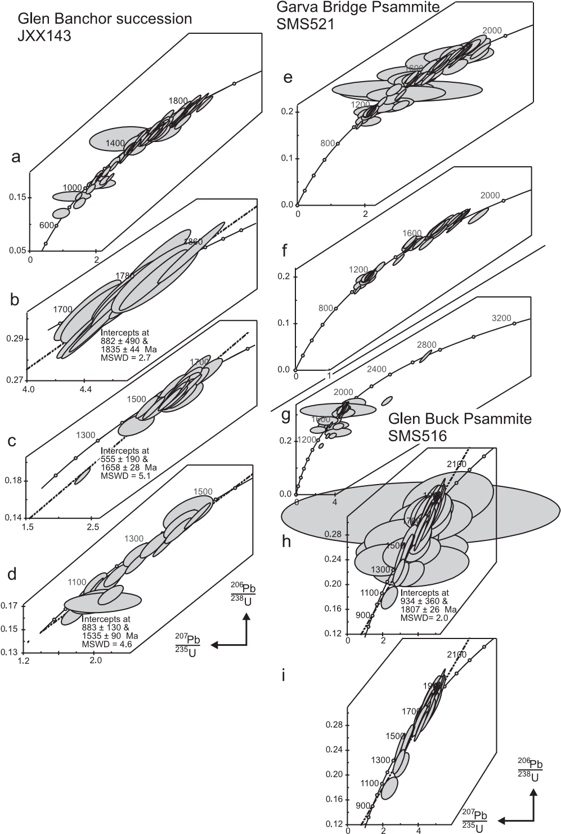

Fig. 3. Concordia diagrams based on 204Pb corrected data for samples JXX143 (Glen Banchor succession), SMS521 (Garva Bridge Psammite) and SMS 516 (Glen Buck Psammite): (a) complete dataset for sample JXX143; (b) detail for sample JXX143 of late Palaeoproterozoic analyses around 1800 Ma; (c) detail for sample JXX143 of latest

Palaeoproterozoic to earliest Mesoproterozoic analyses; (d) detail for sample JXX143 of Mesoproterozoic zircon analyses; (e) complete dataset for sample SMS521; (f) plot of most concordant analyses within dataset for sample SMS521; (g) complete dataset for sample SMS516; (h) detailed plot for sample SMS516 of late Palaeoproterozoic to Mesoproterozoic analyses; (i) detailed plot for sample SMS516 of most concordant late Palaeoproterozoic to Mesoproterozoic analyses. Error ellipses shown at 2 level. The analytical data are available as a supplementary publication (see left).

sample details and analytical data can be obtained from the Society Library or the British Library Document Supply Centre, Boston Spa, Wetherby, West Yorkshire LS23 7BQ, UK as Supplementary Publication No. SUP18181 (33 pp.). It is also available online at [http://www.geolsoc.org.uk/SUP18181.](http://www.geolsoc.org.uk/SUP18181)

# Sub-Grampian Basement (?Moine Supergroup), JXX143

Dated detrital grains are predominantly of late Palaeoproterozoic and Mesoproterozoic age ranging from 1912 10 Ma to 1132 28 Ma (Figs 3a and 4). In addition, four grains yielded Neoproterozoic 206Pb/238U ages of 978 21 Ma, 902 21 Ma, 900 17 Ma and 716 22 Ma, all but one of which are discordant or reversely discordant. The grains that yielded ages of 978 21 Ma and 716 22 Ma have extremely large errors on

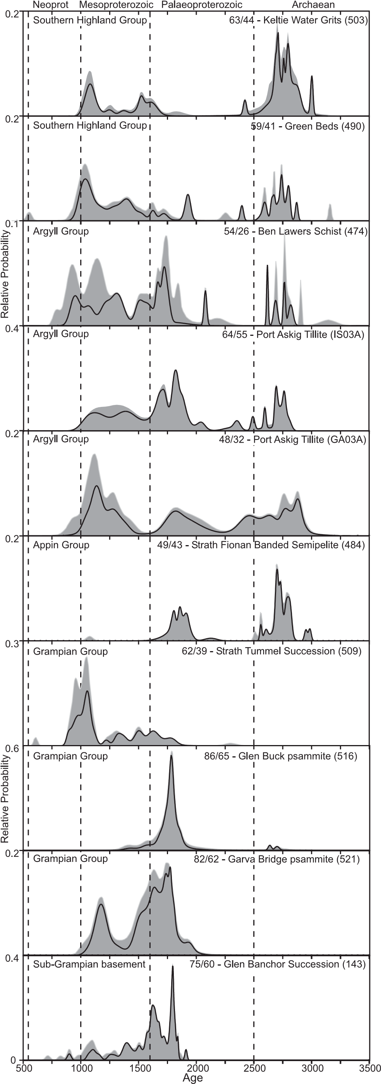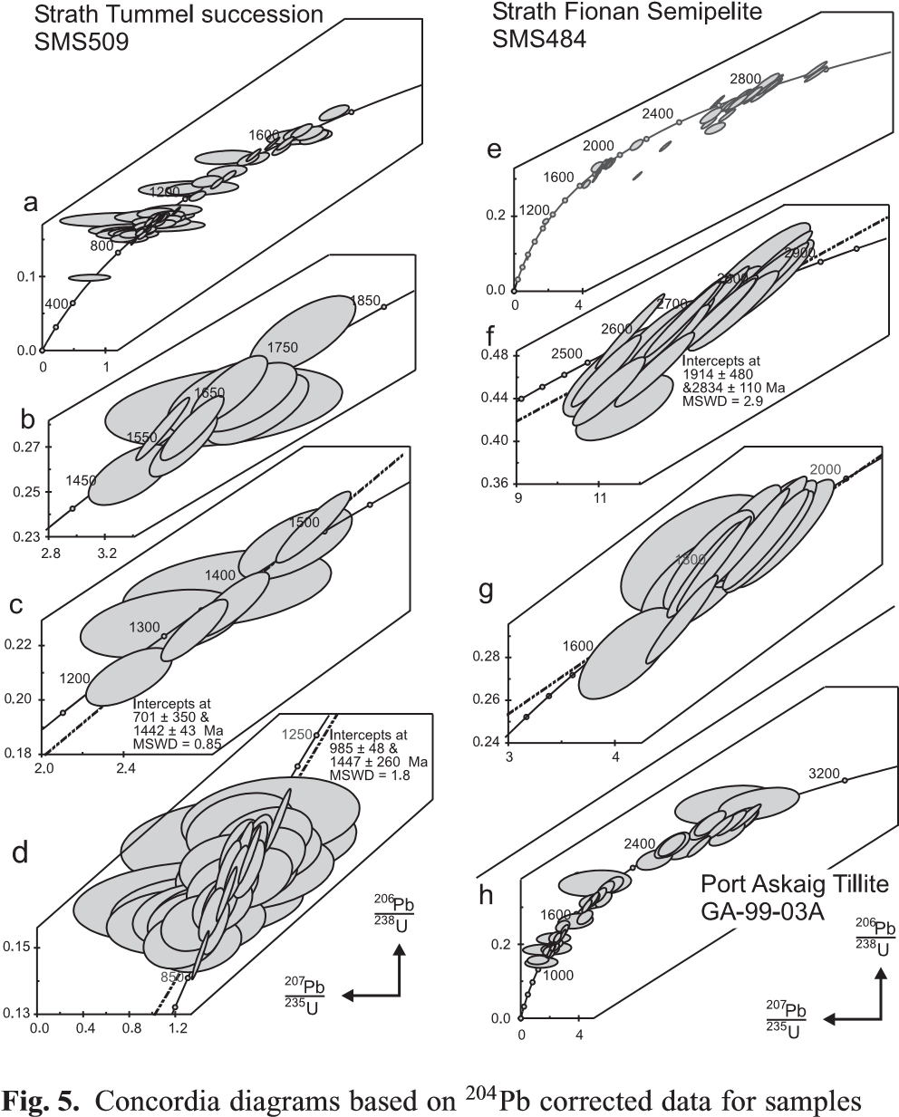SMS509 (Strath Tummel succession), SMS484 (Strath Fionan Banded Semipelite) and GA-99-03A (Port Askaig Tillite): (a) plot of complete dataset for sample SMS509; (b) detailed plot for sample SMS509 of late Palaeoproterozoic to early Mesoproterozoic analyses; (c) detailed plot for sample SMS509 of Mesoproterozoic analyses; (d) detailed plot for sample SMS509 of latest Mesoproterozoic to earliest Palaeoproterozoic zircon analyses; (e) plot of complete dataset for sample SMS484; (f) plot of late Archaean analyses for sample SMS484; (g) plot of late

Palaeoproterozoic analyses for sample SMS484; (h) plot of complete dataset for sample GA-99-03A. Error ellipses shown at 2 level. The analytical data are available as a supplementary publication (see p. 234).

their 207Pb/206Pb ages, which preclude assigning any geological significance to these ages. Palaeoproterozoic detritus constitutes over 50% of the analysed grains and includes at least two major age groups (Figs 3b, c and 4), an older one with a strong peak on the probability plot at c. 1850 Ma (16 analyses) and a second group with an age at c. 1650 Ma (25 analyses). Detritus with Mesoproterozoic ages ranges from around 1500 to 1050 Ma and this spread of data can be interpreted as lying on a discordia line with an upper intercept at c. 1550 Ma (19 analyses, Fig. 3d). However, this group also incorporates some near-concordant analyses at around 1100 Ma, suggesting an input of detritus around this age. The youngest concordant detrital grain yielded an age of 900 17 Ma.

Fig. 4. Frequency distribution diagram for analysed samples. Dashed vertical lines separate boundaries of the Proterozoic and are taken at 2500 Ma, 1600 Ma, 1000 Ma and 545 Ma. Grey filled curves incorporate all analyses, whereas the area under continuous line includes only analyses with .90% concordance. Numbers for each unit correspond to total number of analyses and number of analyses with 90% concordance.

The analytical data are available as a supplementary publication (see p.

234).

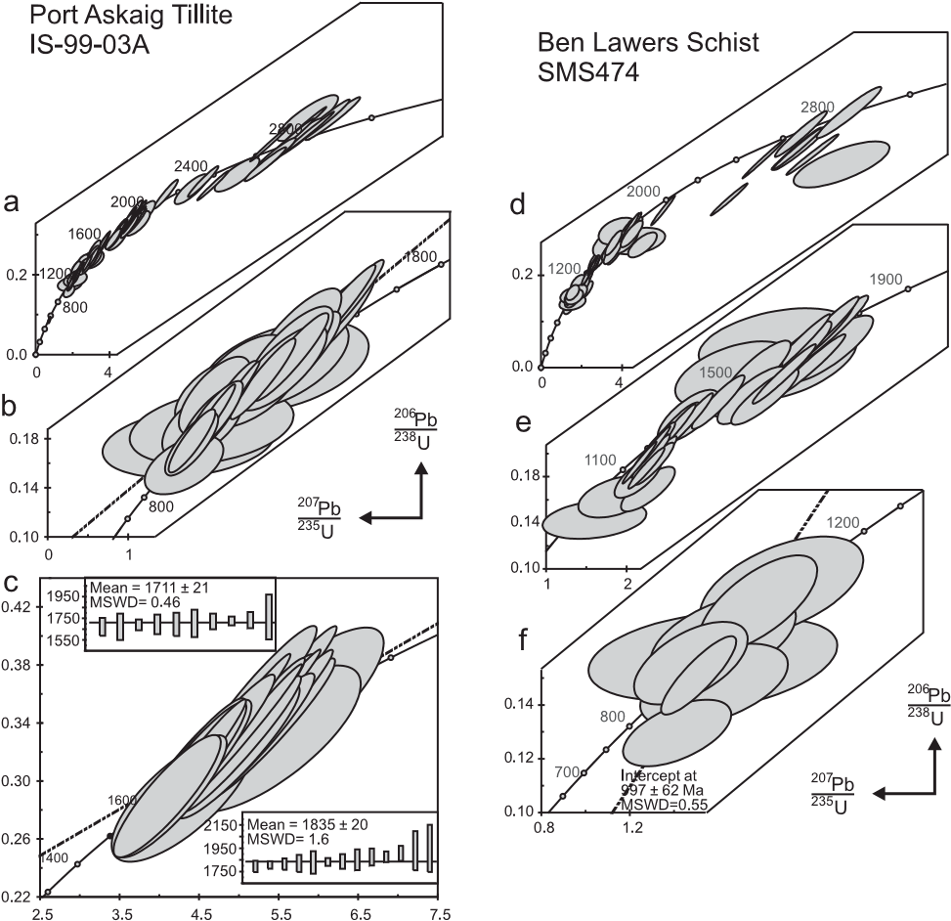

Fig. 6. Concordia diagrams based on 204Pb corrected data for samples IS-99-03A (Port Askaig Tillite) and SMS474 (Ben Lawers Schist): (a) plot of complete dataset for sample IS-99-03A; (b) plot of late Palaeoproterozoic analyses for sample IS-99-03A with insets showing

207Pb/206Pb error bars for two groups of analyses; (c) plot of Mesoproterozoic zircon analyses for sample IS-99-03A; (d) plot of complete dataset for sample SMS474; (e) plot of late Palaeoproterozoic to Mesoproterozoic analyses for sample SMS474; (f) detailed plot for sample SMS474 of latest Mesoproterozoic to early Neoproterozoic zircon analyses. Error ellipses shown at 2 level. The analytical data are available as a supplementary publication (see p. 234).

# Grampian Group, Garva Bridge Psammite, SMS521

Analysed zircon grains (82 analyses) range in age from around 1945 Ma to 1025 Ma (Figs 3e and 4) with an almost equal proportion of Palaeoproterozoic and Mesoproterozoic detritus. If all analyses with large errors are rejected (Fig. 3f), remaining points form groups on the concordia plot corresponding to peaks on the probability plot at about 1750, 1650, possibly 1550 and 1170 Ma (Fig. 4). A relatively low proportion of analysed grains fall in the age range 1300–1400 Ma (Fig. 4).

# Grampian Group, Glen Buck Psammite, SMS516

A total of 86 grains were analysed, with the vast majority being of late Palaeoproterozoic to earliest Mesoproterozoic age between around 2000 Ma and 1400 Ma, which form a pronounced unimodal peak at 1790 Ma (Figs 3g and 4). A small number of concordant points is evident at about 1550 Ma and 1400 Ma, which is also reflected in small peaks on the probability plot (Fig. 4). Four analyses, one of which is discordant, give Archaean ages of about 2700 Ma.

# Grampian Group, Strath Tummel Succession, SMS509

Analysed zircon grains within the sample range in age from 1800 Ma to 900 Ma (62 analyses) but with some 60% yielding ages between 1100 and 900 Ma (Figs 4 and 5a). The oldest concordant or nearly concordant grains are positioned near 1600 Ma (Fig. 5b). A second group is formed by analyses

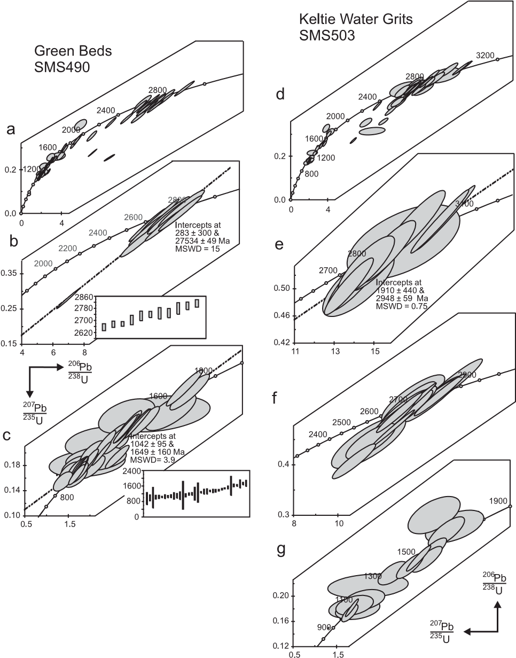

Fig. 7. Concordia diagrams based on 204Pb corrected data for samples SMS490 (Green Beds) and SMS503 (Keltie Water Grits): (a) plot of complete dataset for sample SMS490; (b) plot of late Archaean analyses for sample SMS490 with inset showing 207Pb/206Pb ages; (c) detail of latest Palaeoproterozoic to Mesoproterozoic analyses for sample SMS490 with inset showing 207Pb /206Pb ages; (d) plot of complete dataset for sample SMS503; (e) plot of 17 analyses for sample SMS503 with an upper intercept age of around 2950 Ma; (f) plot of 10 analyses for sample SMS503 with ages between 2800 and 2650 Ma; (g) plot of late

Palaeoproterozoic to Mesoproterozoic zircon analyses for sample SMS503. Error ellipses shown at 2 level. The analytical data are available as a supplementary publication (see p. 234).

distributed along the concordia line between 1400 and 1200 Ma (Fig. 5c). The last and largest group of analyses is situated near 1000 Ma (Fig. 5d).

# Appin Group, Strath Fionan Banded Semipelite, SMS484

Analysis of 50 detrital zircon grains yielded a broad age range extending from Archaean grains as old as 3000 Ma to endMesoproterozoic grains at around 1000 Ma, but with significant gaps in the age spectrum in the early Palaeoproterozoic between 2500 and 2150 Ma and in the late Palaeoproterozoic and Mesoproterozoic between 1700 and 1100 Ma (Figs 4 and 5e). The oldest grains consist of two concordant analyses with ages of 2986 12 Ma and 2952 13 Ma. Major groupings of analysed detrital ages occur in the late Archaean at 2800–2650 Ma and in the late Palaeoproterozoic at 1950–1775 Ma (Fig. 5f and g). The spread of ages of the latter along the concordia diagram suggests that this group represents a mixture of several age populations. Mesoproterozoic zircons are absent apart from a single analysis at about 1100 Ma.

# Argyll Group, Port Askaig Tillite, GA-99-03A

The 48 analysed zircon grains range in age from 2900 to 950 Ma (Figs 4 and 5h). Archaean grains have relatively large errors, accounting for the broad peak on the histogram plot between 2900 and 2400 Ma. The older peaks on the cumulative probability diagram plot at 2875 Ma and 2760 Ma, and correspond to relatively concordant analyses. Subsidiary peaks occur at 2640 Ma and 2475 Ma, but it is difficult to extract any discrete age groups from the concordia diagram and these may represent different degrees of Pb loss in the Proterozoic. Late Palaeoproterozoic ages cluster about a single peak at 1830 Ma (Fig. 4), and Mesoproterozoic to earliest Neoproterozoic grains constitute a broad-based age cluster ranging from 1450 to 950 Ma with a main peak at 1100 Ma and subsidiary peaks at 1400 Ma and 970 Ma.

# Argyll Group, Port Askaig Tillite, IS-99-03A

Analyses of 65 zircon grains range from 2800 Ma to around 1000 Ma (Fig. 6a). Archaean grains mainly range between 2800 and 2700 Ma with subsidiary peaks at 2600 and 2500 Ma (Fig. 4) possibly reflecting a shift along concordia caused by a younger tectonothermal event or mixed provenance. Two analyses yielded early Palaeoproterozoic ages at 2350–2300 Ma. Late Palaeoproterozoic zircons form the main age group within the sample, with 11 analyses defining a peak at c. 1850 Ma, whereas another 10 analyses cluster at c. 1.7 Ga (Fig. 6c). The youngest statistically defined age group, consisting of 14 analyses, has an age of c. 1.1 Ga. A number of analyses lie along the concordia line between 1600 and 1000 Ma, similar to a number of the other Dalradian samples, and it is difficult to tell if these represent a range of detrital ages or a discordia line between 1600–1500 Ma and 1000–900 Ma (Fig. 6b)

# Argyll Group, Ben Lawers Schist, SMS474

Dated grains (55 analyses) range in age from Archaean to early Neoproterozoic (Fig. 6d). Only two of the eight Archaean grains plot near concordia with dates of 2820 Ma and 2685 Ma. Discordant analyses yield 207Pb/206Pb ages between 3160 and 2615 Ma. Early Palaeoproterozoic detritus is restricted to a few discordant analyses with 207Pb/206Pb ages between 2000 and 2200 Ma. A significant number of concordant or nearly concordant analyses occur at c. 1700 Ma (Fig. 6e) and correspond to the pronounced Palaeoproterozoic age peak at 1740 Ma on the cumulative probability plot (Fig. 4). Analyses between 1600 and 900 Ma appear to fall along a discordia line. However, the five oldest analyses from this group cluster about c. 1550 Ma, whereas another 16 analyses give a peak at c. 1.3 Ga. Finally, the youngest analyses produce a peak at c. 1000 Ma (Fig. 6f).

# Southern Highland Group, SMS490

Detrital zircons range in age from 3160 to 550 Ma (Figs 4-7a). The oldest age is based on a single strongly discordant analysis that yielded a 207Pb /206Pb age of 3161 12 Ma. The bulk of the Archaean grains range between 2825 and 2600 Ma with varying degrees of concordance (Fig. 7b). Early Palaeoproterozoic ages are restricted to a few discordant zircon analyses with 207Pb/ 206Pb ages of around 2400 Ma and 2260 Ma. Two analysed zircon grains show a late Palaeoproterozoic age of c. 1930 Ma.

Analyses with ages between 1.7 and 0.9 Ga (Fig. 7c) form a continuous set of points distributed along the concordia line. On a weighted average plot of 207Pb/206Pb ages analyses form a flat plateau at c. 0.9 Ga, suggesting that this age may be a timing of a real process. The rest of the 207Pb/206Pb ages are distributed between 1650 and 900 Ma and form a slope on the diagram, confirming the suggestion of discordia.

A single late Neoproterozoic grain was dated at 553 24 Ma

# Southern Highland Group, Keltie Water Grits, SMS503

Detrital zircon grains lie largely in the age range from 3000 Ma to 1050 Ma but with a pronounced break in the age spectrum between 2400 and 1850 Ma (Figs 4 and 7d). In addition, a single strongly discordant analysis yielded a 207Pb/206Pb age of 3800 Ma. A set of 10 analyses form a reasonably tight group near the concordia with an upper intercept age of 2948 59 Ma (Fig. 7e). A further 17 analyses are distributed between about 2.8 and 2.65 Ga (Fig. 7f) and apparently fall into two groups c. 2770 Ma (seven grains) and 2700 Ma (10 grains) in terms of their 207Pb/ 206Pb ages.

Six concordant analyses with relatively large errors are distributed between about 1700 and 1500 Ma almost parallel to the concordia line (Fig. 7g). A group of analyses that appear to be concordant within the errors show a peak at c. 1075 Ma. All analyses younger than 1600 Ma can, however, be viewed as falling on a single discordia.

# Internal structure of zircon grains

Cathodoluminescence imaging reveals that the detrital zircon grains are dominated by oscillatory zoning (Fig. 8), which is commonly considered to be indicative of an igneous origin (Hanchar & Miller 1993). Crystals with radial sector zoning or fir-tree zoning (Vavra et al. 1999; Nemchin et al. 2001), which are commonly interpreted to be of high-grade metamorphic origin, are almost entirely absent from the Dalradian zircon population. This suggests that the source(s) of detrital zircon was dominated by magmatic rocks or reworked sedimentary rock derived from magmatic sources that have never been metamorphosed higher than amphibolite facies.

A striking feature of the zircon population is the presence of secondary structures in all grains (Nemchin & Pidgeon 1997; Pidgeon et al. 1998), particularly zircons younger than c. 1.8 Ga

(Fig. 8c–f and i), and probably reflects alteration under mild P– T conditions in a fluid-rich environment. At least some of these zones of alteration give earliest Neoproterozoic ages (Fig. 8c and d) and/or are associated with discordia lines that give early Neoproterozoic lower intercept ages.

# Age groups and temporal trends

Our analyses show that detrital zircon age ranges and proportions of specific age intervals vary both within and between samples. The majority of samples show multimodal age spectra (Fig. 4) indicative of a diverse provenance involving either rock units of a variety of ages and/or reworking of older sedimentary deposits. Only sample SMS516 from the base of the Grampian Group shows a pronounced unimodal age spectrum supporting the hypothesis of Smith et al. (1999) of a restricted provenance from a nearby fault block.

Archaean grains are either absent (JXX143, SMS521 and SMS509) or present only as a very minor component (e.g. SMS516) at the base of the sequence within the Grampian Group or the Dava and Glen Banchor successions. In contrast, Archaean grains are the dominant component of detritus in the Southern

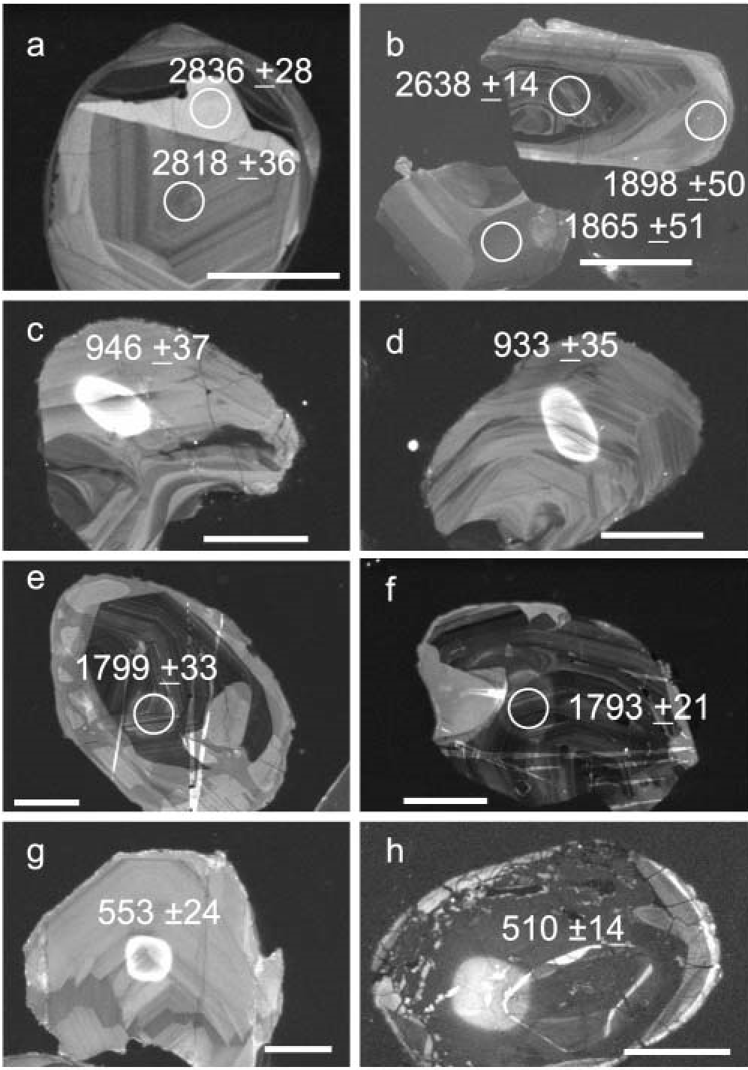

Fig. 8. Cathodoluminescence images of Dalradian detrital zircons. (a) and (b) show well-developed oscillatory zoning grain indicative of crystallization from magma whereas (c)– (i) show secondary structures in Proterozoic zircons. The fragment with the undated core in (b) shows sector or fir-tree zoning (Vavra et al. 1999), which can potentially be interpreted as formed under the granulite-facies conditions. (a) Oscillatory zoned rim of similar age to core (grain SMS503-25). (b) Two oscillatory zoned rims of Palaeoproterozoic age with one from a dated core of Archaean age (grains SMS516-3b, -c and -3a). (c) Relatively bright alteration rim is formed on one side of the grain with only remnants of linear structures, which can possibly be interpreted as residuals of original oscillatory zoning (grain SMS474-25). (d) Secondary unzoned domains are overprinting and in places totally obliterating the original oscillatory zoning (grain SMS474-31). (e)

Oscillatory zoned core disrupted by the patchy rim (grain SMS516a). (f) Brighter rim penetrating oscillatory zoned core, suggesting a recrystallization front (grain SMS516-7). (g) Oscillatory zoned grain (SMS490-59). (h) Highly altered structureless rim around remnant core (SMS484-43). Scale bar in all images represents 50 m, except that in (b), which represents 100 m.

Highland Group. The apparently abrupt incoming of Archaean detritus is recorded in mid-Appin Group (Ballachulish Subgroup) times by sample SMS474 and the overall proportion of Archaean grains thereafter increases up stratigraphic section.

A few Archaean grains have ages older than 3.0 Ga and most samples have one or two grains with ages around 2950 Ma, but only sample SMS503 has a possible group of grains with this age. The majority of Archaean grains are concentrated between 2.85 and 2.7 Ga. Although the exact ages are difficult to determine, two possible age groups are present in all samples, one in the interval 2.73–2.70 Ga and the second in the interval 2.83–2.77 Ga. The differentiation of these two groups is uncertain and may result from a single source, with slight variations in ages between samples as a result of resetting of the U-Pb system, incorporation of younger grains into the calculated groups, or input from temporally discrete sources within this age range. Archaean grains younger than 2.7 Ga are largely absent in the studied samples. Some analyses that yielded ages between 2.7 and 2.6 Ga are probably discordant grains from the older groups, which is consistent with observation of 1.8-1.9 Ga rims around the Archaean cores (Fig. 8b), although the possibility of a minor source component at around 2.6 Ga cannot be excluded (e.g. SMS490).

Proterozoic grains are distributed as a continuous array of analyses near concordia spreading from 1.9 to 0.9 Ga. They could be viewed as a single discordia line between 1.9 and 0.9 Ga components (or 1.9 Ga zircon with the U-Pb system reset at 0.9 Ga) but these lines have mean squared weighted deviations (MSWD) higher than unity, suggesting that the population is more complex. In addition, there is frequently an apparent age break in concordant analyses between 1.4 and 1.2 Ga.

On the probability plot (Fig. 4) samples JXX143, SMS521 and SMS516, and to a considerably lesser extent sample SMS509, all from the sub-Grampian Group basement and Grampian Group successions, show a pronounced age peak at c. 1.8 Ga, whereas ages between 1.9 and 2.0 Ga are rare. Samples SMS484, GA-9903A and IS-99-03A from the Appin and lower Argyll groups show significant proportions of grains with ages between 1.8 and 1.9-2.0 Ga in addition to the zircons with ages of 1.8 Ga. Sample SMS484 has no zircons younger than 1.7 Ga and it is possible that detritus in this sample was derived from a single source with an age between 1.8 and 2.0 Ga. Finally, samples SMS474, SMS490 and SMS503 from the upper Argyll and Southern Highland groups do not contain a significant number of Palaeoproterozoic zircons with ages at, or older than, 1.8 Ga.

Zircon grains with ages of c. 1.75-1.70 Ga, 1.65-1.60 Ga, 1.55-1.50 Ga and c. 1.45 Ga appear to be present in varying proportions in all samples except SMS484. The c. 50 Ma spread of these age peaks reflects intersample variations and the effect of discordant analyses. Samples SMS521, GA-99-03A and SMS490 contain concordant grains at around 1170 Ma. All samples contain grains between 1.0 and 0.9 Ga. Although the proportion of these zircons may vary they are commonly a significant part of the detrital zircon population.

The recognition of common age peaks between samples as well as broad temporal trends such as the overall absence of Archaean detritus below the Appin Group suggests that the relatively limited number of analysed samples provides a representative coverage of the Dalradian. In addition, the similarity of the provenance record of samples from glacial and non-glacial units within the Appin and Argyll groups suggests derivation of these two broad depositional regimes from similar source regions.

# Constraints on age of deposition

The depositional age of the sub-Grampian group basement is constrained by the youngest detrital grain at around 900 Ma with a lower limit for the unit provided by a U–Pb zircon age of 840 Ma for metamorphism and melt generation, and 806 Ma for ductile shearing (Highton et al. 1999). As these strata are interpreted to form a Moine-like basement to the Dalradian succession (Smith et al. 1999) then these ages constrain the time of accumulation of the Dalradian Supergroup to less than 800 Ma.

A single discordant analysis from sample SMS490 (Fig. 8g) gives an age of c. 550 Ma with a large error in the 207Pb/206Pb age. The grain is detrital and shows fine oscillatory zoning of magmatic origin and may approximate to the time of deposition of this unit and associated igneous activity. The underlying Tayvallich Volcanics, along with inferred comagmatic intrusive rocks, have yielded U–Pb zircon ages of around 600–595 Ma (Halliday et al. 1989; Dempster et al. 2002) whereas the Leny limestone at the top of the Southern Highland Group contains a late Early Cambrian fauna corresponding to an absolute age of around 520 Ma (Fig. 3; Tanner & Pringle 1999).

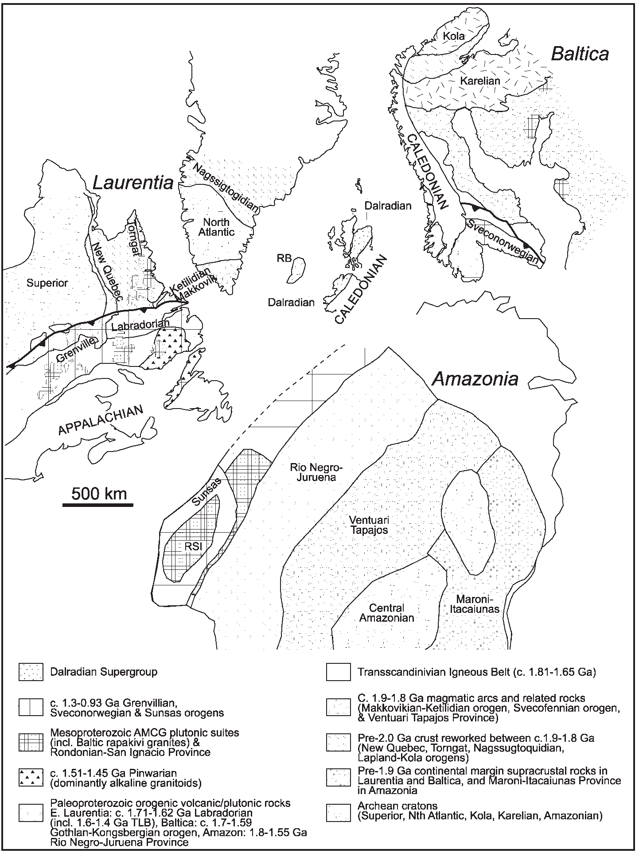A grain within sample SMS484 yielded a 206Pb/238U age of c. 510 Ma and is 10% discordant with a relatively small error on the 207Pb/206Pb age. The grain has a high U content and shows a very low luminescence with a homogeneous internal structure (apart from remnant zone in the middle), consistent with recystallization of the grain during a secondary overprint (Fig. 8i). This, combined with the stratigraphic position of the sample within the Appin Group, suggests it underwent post-deposition alteration in the early Palaeozoic possibly related to the Grampian event.

# Source regions and palaeogeography

Before opening of the Iapetus Ocean at the end of the

Neoproterozoic, the Dalradian succession accumulated within the Rodinian supercontinent and was surrounded by Laurentia, Baltica and Amazonia (Fig. 9). The late Archaean and late Palaeo- to earliest Neoproterozoic detrital zircon age groups within the Dalradian samples are in broad agreement with the age of the principal lithotectonic units recognized in Laurentia, Amazonia and Baltica.

Facies analysis indicates that although Dalradian basin evolution involved multiple periods of synsedimentary faulting alter-

Fig. 9. Source regions in Laurentia, Baltica and Amazonia. Age of crustal elements adapted from Gower et al. (1990) and Tassinari et al. (2000). Distribution of cratonic elements based on Weil et al.

(1998). RSI, Rondonia–San Ignacio Province; TLB, Trans-Labrador Batholith.

nating with periods of thermal subsidence, the basins maintained an overall palaeogeographical configuration of a SW–NE-trending shoreline lying to its NW and overall deep-water conditions further to the SE (e.g. Anderton et al. 1979; Anderton 1985; Johnson 1991; Glover et al. 1995; Strachan & Holdsworth 2000a). Palaeocurrent data are generally sparse and indicate sediment transport either orthogonal to the shoreline with derivation from the NW or parallel to the basin axis and flowing dominantly to the NE (Anderton 1985). These data support a Laurentian source for the detritus. Some workers have, however, proposed a SE source for at least some units in the Dalradian succession. Kilburn et al. (1965) proposed that the lack of Lewisian-like clasts in the Port Askaig Tillite suggests a SE source and Spencer (1971) noted that synsedimentary folds he ascribed to ice push indicate a NW motion of the glaciers. Anderton (1980) argued that the presence of granite clasts and detrital K-feldspar megacrysts in the tillite indicate a source distinct from the Grampian, Argyll and remaining Appin groups and suggests derivation from a SE source subsequently removed by rifting and ocean opening. Geochemical data from the Port Askaig Tillite collected by Panahi & Young (1997) are insufficient to accurately constrain the source area but these workers noted the similarity of the granite clasts to Rapakivi-type granites of Sweden and Norway and the scattered SE palaeocurrent data suggesting a South American source. The detrital zircon age data for the Port Askaig Tillite are similar to those of enclosing units within the Appin and Argyll groups (Fig. 4) and we see no need to invoke a discrete source for the unit. A northern Laurentian provenance for the granite clasts within the Port Askaig Tillite has been suggested by Fitches et al. (1996) and Evans et al. (1998) on the basis of the Palaeoproterozoic age and within-plate geochemical affinities of the clasts, which compares favourably with intrusive rocks in the Makkovik, Ketilidian and Svecofennian provinces of the Northern Atlantic borderlands.

The presence of abundant metamorphic detritus, granitic clasts and large, inferred grains of potassium feldspar in the Southern Highland Group (Sutton & Watson 1955; Harris & Fettes 1972; Borradaile 1973) has also led to suggestions for input from nonLaurentian affinity sediment sources, e.g. a southern continental source now preserved as basement to the Midland Valley (Phillips et al. 1976) or from an exotic block now removed by strike-slip displacement (Yardley et al. 1982). However, neither palaeocurrent data nor detrital zircon age data for the Southern Highland Group require any change in location of source and we envisage continued input from Laurentia. Combined with the Laurentian affinities of the fauna in the Leny Limestone, this suggests that the Dalradian both accumulated adjacent to, and was derived from, Laurentia.

The lack of Archaean zircon detritus in the lower Dalradian and Moine-like units rules out the Lewisian of the Caledonian foreland as a potential source. This is also supported by the absence in the Appin and younger Dalradian units of any evidence for a 2.49 Ga metamorphic overprint, which is a feature of the Lewisian gneisses in the central mainland units in the Northwest Highlands (Kinny & Friend 1997) and by the fact that the Lewisian would have been blanketed by the earliest Neoproterozoic Torridon Group (Stewart 1991).

The relatively subdued frequency of mid-Mesoproterozoic zircon detritus in the Dalradian sequence argues against input from an Amazonian source. The exposed portions of the Rondonia–San Ignacio and Sunsas belts of the Amazonia craton contain extensive units with ages in the range 1.4–1.2 Ga and hence zircons of this age should form a significant component of any Amazonian sourced detritus (Tassinari et al. 2000). The absence or rarity of early Palaeoproterozoic detritus within Dalradian samples also argues against Amazonia as a sediment source. Rock units of this age occur within the Maroni–Itaciu´nas Province adjacent to the Central Amazonian Archaean rock units (Fig. 9) and should have been part of any distribution system that sourced Archaean detritus from Amazonia (Tassinari et al. 2000). Finally, the Pb isotopic signatures of the clasts and the matrix of the Port Askaig Tillite are distinctly different from that of Amazonia and more similar to that of Laurentia (Loewy et al. 2003).

# Laurentian source

Combining the above with the overall detrital provenance record of the Dalradian succession and palaeogeographical data suggests that east Laurentia, and in particular the present-day region of Labrador and Greenland, was the likely source for the detritus. This region includes the eastern Superior and North Atlantic Archaean cratons welded by Palaeoproterozoic orogenic tracts (Torngat and New Quebec orogens, Nagssugtoqidian belt and Ketilidian–Makkovik Province), which are in turn overprinted by the Grenville Orogen (Gower 1996; Hoffman 1988).

The peak in the Dalradian age signature for Archaean detritus at 2800–2700 Ma, but with detrital ages extending back to 3.0 Ga, is typical for the Superior craton (Corfu & Davis 1992; Corfu 1993; Corfu & Stone 1998; Calvert & Ludden 1999). Late Archaean to early Palaeoproterozoic material (2.6–2.0 Ga) is rare in the analysed sample set and in the exposed rock record from Laurentia. Scattered analyses within this age range, most notably in the Argyll Group samples, may correspond to localized early Palaeoproterozoic igneous activity in the southeastern Churchill Province including 2.45–2.2 Ga dykes and calc-alkaline magmatism at 2.3 Ga (Kerr et al. 1996; Wardle & Van Kranendonk 1996). The presence of detrital Archaean grains overprinted by late Palaeoproterozoic tectonothermal events and the late Palaeoproterozoic age peak is consistent with the history of the major Laurentian Archaean cratons (e.g. Superior, North Atlantic cratons) and their suturing by Palaeoproterozoic orogenic belts (e.g. Ketilidian–Makkovik, Torngat, New Quebec Nagssugtoqidian; Hoffman 1988, 1989). Detrital zircon age peaks in the Dalradian samples at around 1.9–1.85 Ga, 1.8 Ga, 1.75–1.70 Ga, 1.65–1.60 Ga and 1.55–1.50 Ga may correspond to a series of subduction- and post-subduction-related arc accretion and collision events recorded in the Labrador and Greenland regions (New Quebec and Torngat orogens, Cape Harrison Domain and Granite Zone of the Makkovik–Ketilidian Province, Trans-Labrador Batholith, Pinware terrane; Chadwick & Garde 1996; Gower 1996; Kerr et al. 1996; Wardle & Van Kranendonk

1996).

Mesoproterozoic to earliest Neoproterozoic detrital zircons correspond in age to assembly of the Grenville Orogen (Gower 1996; Rivers 1997). The bulk of the detrital zircons within this age range are younger than 1200 Ma, with most at c. 1000 Ma, which, together with the presence of late Palaeoproterozoic detritus and the paucity of older Mesoproterozoic detritus, is consistent with the history of the NE Grenville sequence in Labrador, as opposed to the southern Grenville Province (see Gower 1996; Rivers 1997). The widespread tectonothermal event within the source at 1.0–0.9 Ga is slightly younger than the 1.0 Ga timing of final collisional suturing of the Grenville Orogen in Labrador but corresponds to the timing of terminal tectonothermal events in East Greenland (Strachan et al. 1995; Kalsbeek et al. 2000) and the Sveconorwegian belt in Baltica (Scha¨rer et al. 1996; Bingen et al. 1998; Mo¨ller 1999).

The absence of detritus in the age range 870–800 Ma in the Dalradian sediments indicates no input from units that have undergone a Knoydartian tectonothermal event of sufficient grade to generate new zircon growth, such as recognized in segments of the Moine and inferred equivalent units in the sub-Grampian basement. The inferred unconformable relationship between the Dalradian and this basement sequence (Smith et al. 1999) indicates that if the Knoydartian event represents crustal thickening (Vance et al. 1998) rather than extension (Dalziel & Soper 2001), the topographic consequences of this thickening must have been rapidly removed and followed by sustained subsidence to allow the thick Dalradian sequence to accumulate. The site of deposition of any sediments derived from this inferred Knoydartian orogenic event is unknown.

Detrital mica age data for the Dalradian are generally lacking, apart from those of Tanner & Pringle (1999), who carried out a study on the Southern Highland Group. The Ben Ledi Grit, which underlies the Keltie Water Grit, contains detrital mica ranging from 1260 to 2270 Ma with a peak between 1500 and 1700 Ma. In the Keltie Water Formation the older 1200– 1700 Ma grains are also present but are diluted by a significant influx of grains with ages between 1088 and 646 Ma. The endPalaeoproterozoic grains probably reflect orogenic events associated with Laurentian assembly whereas the Neoproterozoic detritus may relate to Rodinian breakup including Knoydartian events. The detrital mica age patterns contrast with those for the zircon detritus from the Southern Highland Group, which contains Archaean material but is poor in late Palaeoproterozoic detritus and generally lacks Neoproterozoic zircons.

# Discussion: origin and correlation of Laurentian margin siliciclastic rocks Autochthonous v. allochthonous origin

Siliciclastic sequences within or close to the Laurentian foreland of the Appalachian–Caledonian Orogen preserve a clear depositional contact with basement that constrains their site of accumulation to Laurentia. These include the Torridonian and Eriboll Group in Scotland and the Labrador Group and Fleur de Lys Supergroup of the Appalachian Humber Zone (Hibbard 1983, 1988; Stewart 1991; Walton & Oliver 1991; Cawood et al. 1996; Cawood & van Gool 1998). Depositional relations of siliciclastic sequences within more internal parts of the Laurentian margin of the orogen are either masked or not preserved, as a result of later deformational events. These units include the Moine and Dalradian supergroups in Scotland and the Krummedal and Eleonore Bay supergroups in Greenland (Johnson 1991; Strachan & Holdsworth 2000a, 2000b; Watt & Thrane 2001). Uncertainties in the nature of the basement–cover contact and in the lithotectonic affinities of the basement have led to speculation that these siliciclastic sequences may have formed outboard of Laurentia and subsequently been accreted to the margin. Bluck et al. (1997) proposed that the Dalradian and Moine successions represent exotic blocks accreted to the Hebridian foreland during early to mid-Palaeozoic assembly of the Caledonian–Appalachian Orogen (see also discussion by Tanner & Bluck (1999) and Bluck (2000)). Furthermore, Bluck & Dempster (1991) suggested a possible Gondwanan provenance for the Dalradian detritus.

The Dalradian and sub-Grampian Group detrital zircon age data outlined here along with data from the Moine Supergroup (Friend et al. 2003) support a Laurentian provenance and provide

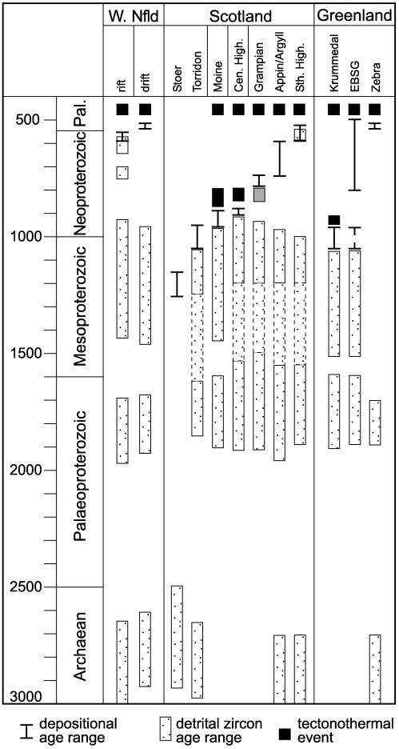

Fig. 10. Summary of detrital zircon age signatures, the depositional age ranges and timing of tectonothermal events for the late Mesoproterozoic to Cambrian Laurentian margin siliciclastic sequences in Newfoundland,

Scotland and Greenland. Source of diagram: W. Nfld, Cawood & Nemchin (2001); Torridonian, Rainbird et al. (2001); Moine, Friend et al.

(2003); Central Highlands Division, this work; Dalradian, this work;

Greenland, Tucker et al. (1993), Watt et al. (2000) and Watt & Thrane (2001). Dashed lines indicate only scattered zircon analyses in this age range or analyses within the range lie along discordia lines. Grey shading for Neoproterozoic tectonothermal event in Grampian Group column indicates uncertainty as to whether the group was affected by event at this time (see Smith et al. 1999). Pal., Palaeozoic; W. Nfld, West Newfoundland; Cen. High, Central Highland Division; Sth High., Southern Highland; EBSG, Eleonore Bay Supergroup.

no indication for, or need to invoke, an exotic origin for the detritus.

# Correlation of Neoproterozoic sequences

The relationship of the detrital zircon age signature of the Dalradian Supergroup to the other siliciclastic sequences in Scotland, the Torridonian and Moine, as well as similar sequences in the northern Appalachians and East Greenland Caledonides is summarized in Figure 10. Differences in the detail of the detrital age signatures combined with available data on the depositional age range of units define three main lithotectonic groupings. Group 1, consisting of the Mesoproterozoic Stoer Group, is dominated by Archaean detritus with no Mesoproterozoic detritus. Group 2 includes the latest Mesoproterozoic to mid-Neoproterozoic Moine, Krummedal and lower Eleonore Bay supergroups and the Torridon and Grampian groups, and is characterized by late Palaeoproterozoic and Mesoproterozoic zircon detritus with Archaean zircons generally either absent or rare, except for the Torridon Group where they form a significant component. Group 3 consists of Neoproterozoic to Cambrian siliciclastic sequences in Newfoundland, the Appin, Argyll and Southern Highland groups of the main Dalradian sequence in Scotland, and the upper Eleonore Bay Supergroup, Tillite Group and Zebra Series of East Greenland, and contains late Archaean and late Palaeoproterozoic to Mesoproterozoic detritus.

Group 1. The Stoer Group probably represents the oldest of the siliciclastic sequences preserved along the Laurentian margin and unconformably overlies Lewisian basement of the Hebridian foreland (Fig. 1). Sedimentation is inferred to have occurred in fault-controlled graben structures (Stewart 1982). The age of the unit is poorly constrained but it is generally considered to be of late Mesoproterozoic age (c. 1200 Ma) based on isotopic and palaeomagnetic constraints (Moorbath 1969; Smith et al. 1983; Cliff & Rex 1989; Turnbull et al. 1996). Thus, the inferred age of the Stoer Group predates final assembly of Rodinia during the later stages of the Grenville Orogen and it formed during a separate tectonic cycle from the other, younger siliciclastic sequences, which are related to the Appalachian–Caledonian Orogen. The detrital zircon age signature of the group is indicative of derivation from Lewisian basement, with 95% of some 110 analyses from four samples lying between 2.93 and 2.48 Ga and with scattered analyses between 1.92 and 1.74 Ga (Rainbird et al. 2001). The lack of Mesoproterozoic zircon detritus within the Stoer Group is consistent with the inferred Mesoproterozoic depositional age with sediment accumulation predating establishment of the Grenville orogenic welt as a source region.

Group 2. The Moine Supergroup, the Dava and Glen Banchor successions of the Central Highlands, the Krummedal supracrustal succession, the Nathorst Land Group of the lower Eleonore Bay Supergroup and the Grampian Group show a similar detrital zircon age signature and at least the first three have a similar depositional age range (Fig. 10). The detrital zircon age signature of all units is characterized by a dominance of late Palaeoproterozoic and Mesoproterozoic detritus. Archaean detrital grains are either absent or constitute only a few percent of the total age spectrum. Time of accumulation of the Moine, Central Highland and Krummedal sediments is constrained to between the latest Mesoproterozoic and early Neoproterozoic on the basis of the youngest detrital zircons and subsequent overprint by tectonothermal events. In detail, however, available data suggest that the Moine may be younger than the Krummedal succession. Accumulation of the Moine occurred between c. 950 Ma, the youngest detrital zircon age, and c. 870 Ma, the age of the intruding West Highland granite gneiss (Friend et al. 2003), whereas deposition of the Krummedal occurred after the youngest detrital zircon age of c. 1070 Ma (Watt et al. 2000) and before high-grade metamorphism at c. 960–950 Ma (Strachan et al. 1995).

The age of the Eleonore Bay Supergroup is less well constrained and could range throughout the Neoproterozoic. Detrital zircons as young as late Mesoproterozoic from the basal Nathorst Land Group provide an older age limit on sediment accumulation and the uppermost units of the supergroup contain late Neoproterozoic acritarchs (Vidal 1976). Watt et al. (2000) suggested that the Nathorst Land Group may represent part of the Krummedal succession rather than part of the Eleonore Bay Supergroup because of their similar detrital zircon signature, with deposition occurring in the earliest Neoproterozoic before intrusion of 960– 950 Ma Grenville granites. Such an interpretation would require a tectonic break or unconformity between the Nathorst Land Group and the remainder of the Eleonore Bay Supergroup. Smith & Robertson (1999) have recognized an angular unconformity between the Nathorst Land and Lyell Land groups but elsewhere this boundary appears to be conformable (Watt & Thrane 2001) and any breaks, if present, must be cryptic.

The Torridon Group has a similar inferred depositional age to that of the Krummedal and Eleonore Bay successions and has been considered as a possible inboard correlative of the Moine and Dalradian rocks (Geikie 1893; Kennedy 1951; see also discussion by Soper & England 1995; Soper et al. 1998). Resting unconformably on the Stoer Group or Lewisian gneiss, it is unconformably overlain by Cambrian strata of the Eriboll Group (Stewart 1991; Walton & Oliver 1991). An older limit on the time of deposition is provided by the youngest detrital zircon age of 1060 18 Ma (Rainbird et al. 2001). Rb/Sr whole-rock ages from shales of c. 1.0 Ga are interpreted to reflect diagenesis, close to the time of deposition (Turnbull et al. 1996). Archaean detrital zircon grains constitute 15–30% of the two Torridon Group samples analysed by Rainbird et al. (2001). This distinguishes the group from the Moine and argues against it representing an inboard facies equivalent (Friend et al. 2003). Differing source areas for the Moine and Torridonian have previously been noted on the basis of contrasting zircon morphologies and inferred tourmaline contents (based on boron content of stream sediments) (MacKie 1923; Plant 1984). As pointed out by Stewart (1991) and Soper et al. (1998), the Torridonian, Moine and Dalradian accumulated in spatially separated tectonically active basins allowing input from different sources even for temporally equivalent units.

The provenance record of the Grampian Group is similar to that of the Moine and the Dava and Glen Banchor successions of the Central Highlands in that all lack detrital zircons of Archaean age. This suggests derivation from a similar source and/or a similar depositional age. Noble et al. (1996) reported U/Pb monazite ages of c. 800 Ma for pegmatites and mylonites that affect ?Grampian and sub-Grampian Group rocks, confirming the earlier work of Piaseski (1980) and Piasecki & van Breeman (1983) that these rocks record a Precambrian (Knoydartian) tectonothermal event and probably correlate with the Moine Supergroup. Detrital zircon data and the monazite ages thus constrain deposition to 900–850 Ma. If Grampian Group strata are affected then this interpretation requires a stratigraphic and orogenic break within Appin Group or younger strata to separate them from rocks that record only Caledonian events. To date no such break has been detected. Instead, Smith et al.(1999) supported a cover–basement relationship at the base of the Grampian Group marked by a distinct stratigraphic and sedimentological break, implying that Grampian Group deposition is younger than 800–750 Ma.

Group 3. The Appin, Argyll and Southern Highland groups of the Dalradian, and the Labrador Group, Curling Group and Fleur de Lys Supergroup in the Appalachians have a detrital zircon age signature characterized by late Archaean and late Palaeoproterozoic to Mesoproterozoic detritus and have a depositional age that ranges from mid-Neoproterozoic to Cambrian. The upper components of the Eleonore Bay Supergroup, above the Nathorst Land Group, and the Tillite Group of the East Greenland Caledonides are included in this group on the basis of lithotectonic character (Soper & Higgins 1993) but no detrital zircon data are available for these units. A limited study of detrital zircons from the Zebra Series of NE Greenland showed that they range from 3000 to 1700 Ma and also contain detrital muscovite with cooling ages of 1700–1600 Ma (Tucker et al. 1993). Some samples of latest Neoproterozoic age, which accumulated during the final stages of rifting before breakup, also contain scattered late Neoproterozoic detrital zircons probably derived from synrift igneous activity. The Newfoundland samples differ from the Scottish samples in the larger gap in detrital zircon ages between Palaeoproterozoic and Mesoproterozoic detritus. Cawood & Nemchin (2001) argued that this reflects a southern Grenville provenance for the Newfoundland samples, as opposed to the inferred northern Grenville–Greenland location of the source of the Scottish material.

# Conclusions

Scotland contains a series of siliciclastic sequences with inferred depositional ages ranging from 1.2 to 0.53 Ga. including the Torridonian, Moine and Dalradian successions. They are inferred to have accumulated in a series of restricted fault-bounded grabens associated with lithospheric extension within and during the breakup of Rodinia and opening of the Iapetus Ocean (see Soper et al. 1998; Dalziel & Soper 2001). Comparison of the detrital zircon age signature of the Torridonian and Moine units (Rainbird et al. 2001; Friend et al. 2003) with Dalradian data indicates input from similar age source components with the most significant differences related to the absence or paucity of Archaean detritus in the Moine assemblage and the Grampian Group of the Dalradian relative to other units. Younger units of the Dalradian, above the Grampian, show an overall up-section increase in Archaean detritus consistent with unroofing of an Archaean source. However, the abrupt incoming of Archaean detritus within, or at the base of, the Appin Group requires tectonic instability to either expose Archaean material in the source or modify the distributary transport framework to capture an Archaean source. This dramatic provenance change corresponds to renewed and accelerated rifting in the Dalradian depositional basin (Glover et al. 1995).

Principal characteristics of the detrital zircon population in the Dalradian are Archaean grains (Grampian Group excepted), notably around 2.8–2.7 Ga, a paucity of early Palaeoproterozoic detritus (2.5–2.0 Ga), the presence of detrital age peaks at around 1.8 Ga, 1.75–1.7 Ga, 1.65–1.60 Ga and 1.55–1.5 Ga, a paucity of mid-Mesoproterozoic detritus (1.4–1.2 Ga), and detrital grains around 1.1 Ga and 1.0–0.9 Ga. The age signature of detrital zircons within the Dalradian as well as the Torridonian and Moine is consistent with derivation from a Laurentian hinterland. A Laurentian provenance is also consistent with the Laurentian affinities of the Cambrian fauna found within the Leny Limestone and within the Eriboll Group, which unconformably overlies the Torridon Group. These features argue against an exotic origin, with respect to Laurentia, for either the depositional setting of the units or the detritus that accumulated within these basins. The remarkably uniform age signature of the detritus within these units, which in the case of the Dalradian have depositional ages spanning up to 250 Ma, suggests extensive reworking and homogenization of detritus before deposition and/or a uniform age character of rock units within the hinterland so that changes in specific source areas with time had little effect on age range of detritus. The geology of the Laurentian hinterland is consistent with the latter point. The absence of any midNeoproterozoic detritus related to the Knoydartian event within the Dalradian sequence argues against any significant topographic expression resulting in reworking of affected units.

The preservation of the Dalradian succession within the Caledonian Orogen and the probability of sinistral strike-slip displacement within the orogen (e.g. Hutton 1987) make it difficult to accurately locate the original site of accumulation of the succession along the Laurentian margin. The overall age character of the detritus, and in particular the paucity of midMesoproterozoic detritus (1.4–1.2 Ga) and the input of detritus of 1.0–0.9 Ga age, is consistent with derivation from the Greenland–Labrador segment of the margin. Given the established large transport distances between source and depositional basin for other ancient sedimentary successions (Riggs et al. 1996; Rainbird et al. 1997) a northern Laurentian source need not limit the site of Dalradian accumulation to a similar location. However, the Dalradian is currently located on the Scottish Promontory (e.g. Dalziel & Soper 2001, Fig. 1) of the Laurentian margin. Any significant sinistral displacement of the Dalradian with respect to the craton would place the original depositional site for the succession in a major Appalachian re-entrant and it is difficult to envisage how the sequence could be transported around the promontory and emplaced in its current location.

Funding from the Tectonics Special Research Centre supported this project. The SHRIMP II is operated by a consortium consisting of Curtin University, the Geological Survey of Western Australia and the University of Western Australia. We thank G. Watt, who proposed Figure 10 and along with J. Connelly, I. Dalziel, J. Dewey, J. Evans, A. Harris, P. Kinny, J. Soper and R. Strachan provided a critical appraisal of the manuscript. Comments by journal reviewers T. Dempster, M. Flowerdew and Subject Editor M. Whitehouse helped focus our arguments and improve the manuscript. This is TSRC Publication 199, and is a contribution to IGCP projects 440 and 453. M.S. publishes with permission of the Director, British Geological Survey.

# References

Anderton, R. 1980. Distinctive pebbles as indicators of Dalradian provenance. Scottish Journal of Geology, 16, 143–152.

Anderton, R. 1985. Sedimentation and tectonics in the Scottish Dalradian. Scottish Journal of Geology, 21, 407–426.

Anderton, R., Bridges, P.H., Leeder, M.R. & Sellwood, B.W. 1979. Dynamic Stratigraphy of the British Isles. Unwin Hyman, London.

Bingen, B., Boven, A., Panzalan, L., Wijbrans, J.R. & Demaiffe, D. 1998. Hornblende 40Ar/39Ar geochronology across terrane boundaries in the Sveconorwegian Province of S. Norway. Precambrian Research, 90, 159–185.

Bluck, B.J. 2000. ‘Where ignorance is bliss ’tis a folly to be wise’ (Thomas Gray 1716–1761)—controversy in the basement blocks of Scotland. Scottish Journal of Geology, 36, 97–101.

Bluck, B.J. 2001. Caledonian and related events in Scotland. Transactions of the Royal Society of Edinburgh: Earth Sciences, 91, 375–404.

Bluck, B.J. & Dempster, T.J. 1991. Exotic metamorphic terranes in the Caledonides: tectonic history of the Dalradian block, Scotland. Geology, 19, 1133–1136.

Bluck, B.J., Dempster, T.J. & Rogers, G. 1997. Allochthonous metamorphic blocks on the Hebridean passive margin, Scotland. Journal of the Geological Society, London, 154, 921–924.

Borradaile, G.J. 1973. Dalradian structure and stratigraphy of the northern Lock Awe district, Argyllshire. Transactions of the Royal Society of Edinburgh, 69,

1–21.

Calvert, A.J. & Ludden, J.N. 1999. Archean continental assembly in the southeastern Superior Province of Canada. Tectonics, 18, 412–429.

Cawood, P.A. & Nemchin, A.A. 2000. Provenance record of a rift basin: U/Pb ages of detrital zircons from the Perth Basin, Western Australia. Sedimentary Geology, 134, 209–234.

Cawood, P.A. & Nemchin, A.A. 2001. Source regions for Laurentian margin sediments: constraints from U/Pb dating of detrital zircon in the Newfoundland Appalachians. Geological Society of America Bulletin, 113, 1234–1246.

Cawood, P.A. & van Gool, J.A.M. 1998. Geology of the Corner Brook–Glover Island Region, Ottawa. Geological Survey of Canada, Bulletin, 427.

Cawood, P.A., van Gool, J.A.M. & Dunning, G.R. 1996. Geological development of eastern Humber and western Dunnage zones: Corner Brook–Glover Island region, Newfoundland. Canadian Journal of Earth Sciences, 33, 182–198.

Cawood, P.A., Nemchin, A.A., Leverenz, A., Saeed, A. & Ballance, P.F. 1999. U/Pb dating of detrital zircons: implications for the provenance record of Gondwana margin terranes. Geological Society of America Bulletin, 111, 1107–1119.

Chadwick, B. & Garde, A.A. 1996. Palaeoproterozoic oblique plate convergence in South Greenland: a reappraisal of the Ketilidian Orogen. In: Brewer, T.S. (ed.) Precambrian Crustal Evolution in the North Atlantic Region. Geological Society, London, Special Publications, 112, 179–196.

Cliff, R.A. & Rex, D.C. 1989. Evidence for a ‘Grenville’ event in the Lewisian of the northern Outer Hebrides. Journal of the Geological Society, London, 146, 921–924.

Compston, W., Williams, I.S. & Meyer, C. 1984. U–Pb geochronology of zircons from lunar breccia 73217 using a sensitive high mass-resolution ion microprobe. Journal of Geophysical Research, 89, B525–B534.

Corfu, F. 1993. The evolution of the southern Abitibi Greenstone Belt in the light of precise U–Pb geochronology. Economic Geology, 88, 1323–1340.

Corfu, F. & Davis, D.W. 1992. A U–Pb geochronological framework for the

Western Superior Province, Ontario. In: Thurston, P. C., Williams, H. R.,

Sutcliffe, R. H. & Stott, G. M. (eds) Geology of Ontario. Ontario Geological Survey, Special Volume, 4, 1335–1346.

Corfu, F. & Stone, D. 1998. Age structure and orogenic significance of the Berens River composite batholiths, western Superior Province. Canadian Journal of Earth Sciences, 35, 1089–1109.

Daly, J.S. 2001. Precambrian. In: Holland, C.H. (ed.) The Geology of Ireland. Dunedin Academic Press, Edinburgh, 7–45.

Dalziel, I.W.D. & Soper, N.J. 2001. Neoproterozoic extension on the Scottish Promontory of Laurentia: paleogeographic and tectonic implications. Journal of Geology, 109, 299–317.

Dempster, T.J. & Rogers, G. et al.2002. Timing of deposition, orogenesis and glaciation within Dalradian rocks of Scotland: constraints from U–Pb zircon ages. Journal of the Geological Society, London, 159, 83–94.

Dewey, J.F. & Mange, M. 1999. Petrography of Ordovician and Silurian sediments in the western Irish Caledonides: tracers of short-lived Ordovician continent– arc collision orogeny and the evolution of the Laurentian Appalachian–

Caledonian margin. In: Mac Niocaill, C. & Ryan, P.D. (eds) Continental Tectonics. Geological Society, London, Special Publications, 164, 55–107.

Dodson, M.H., Compston, W., Williams, I.S. & Wilson, J.F. 1988. A search for ancient detrital zircons in Zimbabwean sediments. Journal of the Geological Society, London, 145, 977–983.

Evans, J.A., Fitches, W.R. & Muir, R.J. 1998. Laurentian clasts in a

Neoproterozoic tillite from Scotland. Journal of Geology, 106, 361–366.

Fitches, W.R. & Maltman, A.J. 1984. Tectonic development and stratigraphy at the western margin of the Caledonides: Islay and Colonsay. Transactions of the Royal Society of Edinburgh, Earth Sciences, 75, 365–382.

Fitches, W.R., Pearce, N.J.G., Evans, J.A. & Muir, R.J. 1996. Provenance of late Proterozoic Dalradian tillite clasts, Inner Hebrides, Scotland. In:

Brewer, T.S. (ed.) Precambrian Crustal Evolution in the North Atlantic Region. Geological Society, London, Special Publications, 112, 367–377.

Friend, C.R.L., Kinny, P.D., Rogers, G., Strachan, R.A. & Paterson, B.A. 1997. U–Pb zircon geochronological evidence for Neoproterozoic events in the Glenfinnan Group (Moine Supergroup): the formation of the Ardgour granite gneiss, north-west Scotland. Contributions to Mineralogy and Petrology, 128, 101–113.

Friend, C.R.L., Strachan, R.A., Kinny, P. & Watt, G.R. 2003. Provenance of the Moine Supergroup of NW Scotland: evidence from geochronology of detrital and inherited zircons from sediments, granites and migmatites. Journal of the Geological Society, London, 160, 247–258.

Geikie, A. 1893. On the pre-Cambrian rocks of the British Isles. Journal of Geology, 1, 1–14.

Glover, B.W., Key, R.M., May, F., Clark, G.C., Phillips, E.R. & Chacksfield, B.C. 1995. A Neoproterozoic multiphase rift sequence: the Grampian and Appin groups of the southwestern Monadhliath Mountains of Scotland.

Journal of the Geological Society, London, 152, 391–406.

Goodman, S. & Winchester, J.A. 1993. Geochemical variations within metavolcanic rocks of the Dalradian Farragon Beds and adjacent formations. Scottish Journal of Geology, 29, 131–141.

Gower, C.F. 1996. The evolution of the Grenville Province in eastern Labrador, Canada. In: Brewer, T.S. (ed.) Precambrian Crustal Evolution in the North Atlantic Region. Geological Society, London, Special Publications, 112, 197–218.

Gower, C.F., Rivers, T. & Ryan, A.B. 1990. Mid-Proterozoic Laurentia–Baltica: an overview of its geological evolution and a summary of the contributions made by this volume. In: Gower, C.F., Rivers, T. & Ryan, A.B. (eds) MidProterozoic Laurentia–Baltica. Geological Association of Canada, Special Paper, 38, 1–22.

Halliday, A.N., Graham, C.M., Aftalion, M. & Dymoke, P. 1989. The deposition age of the Dalradian Supergroup: U–Pb and Sm–Nd isotopic studies of the Tayvallich Volcanics, Scotland. Journal of the Geological Society, London, 146, 3–6.

Hanchar, J.M. & Miller, C.F. 1993. Zircon zonation patterns as revealed by cathodoluminescence and backscattered electron images: implications for interpretation of complex crustal histories. Chemical Geology, 110, 1–13.

Harris, A.L. & Fettes, D.J. 1972. Stratigraphy and structure of Dalradian rocks at the Highland Border. Scottish Journal of Geology, 8, 253–264.

Harris, A.L. & Johnson, M.R.W. 1991. Moine. In: Craig, G.Y. (ed.) Geology of Scotland. Geological Society, London, 87–123.

Harris, N., Haselock, P.J., Kennedy, M.J. & Mendum, J.R. 1994. The Dalradian Supergroup in Scotland, Shetland and Ireland. In: Gibbons, W. & Harris, A.L. (eds) A Revised Correlation of Precambrian Rock in the British Isles. Geological Society, London, Special Reports, 22, 33–53.

Haselock, P.J. 1984. The systematic geochemical variation between two tectonically separate successions in the Southern Monadhliaths, Inverness-shire. Scottish Journal of Geology, 20, 191–205.

Hibbard, J. 1983. Geology of the Baie Verte Peninsula, Newfoundland. Newfoundland Department of Mines and Energy, Mineral Development Division, St.

John’s.

Hibbard, J. 1988. Stratigraphy of the Fleur de Lys block, northwest Newfoundland. In: Winchester, J.A. (ed.) Later Proterozoic Stratigraphy of the Northern Atlantic Regions. Blackie, London, 200–211.

Highton, A.J., Hyslop, E.K. & Noble, S.R. 1999. U–Pb zircon geochronology of migmatization in the northern Central Highlands: evidence for pre-Caledonian (Neoproterozoic) tectonometamorphism in the Grampian block, Scotland. Journal of the Geological Society, London, 156, 1195–1204.

Hoffman, P.F. 1988. United plates of America, the birth of a craton: Early Proterozoic assembly and growth of Laurentia. Annual Review of Earth and Planetary Sciences, 16, 543–603.

Hoffman, P.F. 1989. Precambrian geology and tectonic history of North America.

In: Bally, A.W. & Palmer, A.R. (eds) Geology of North America—an Overview, The Geology of North America. Geological Society of America, Boulder, CO, A, 447–512.

Hutton, D.H.W. 1987. Strike-slip terranes and a model for the evolution of the British and Irish Caledonides. Geological Magazine, 124, 405–425.

Johnson, M.R.W. 1991. Dalradian. In: Craig, G.Y. (ed.) Geology of Scotland. Geological Society, London, 125–160.

Kalsbeek, F., Thrane, K., Nutman, A.P. & Jepsen, H.F. 2000. Late Mesoproterozoic metasedimentary and granitic rocks in the King Oscar Fjord region, east Greenland Caledonides fold belt: evidence for Grenvillian orogenesis. Journal of the Geological Society, London, 157, 1215–1225.

Kennedy, W.Q. 1951. Sedimentary differentiation as a factor in the Moine– Torridonian correlation. Geological Magazine, 88, 839–874.

Kerr, A., Ryan, A.B., Gower, C.F. & Wardle, R.J. 1996. The Makkovik

Province: extension of the Ketilidian Mobile Belt in mainland North America.

In: Brewer, T.S. (ed.) Precambrian Crustal Evolution in the North Atlantic Region. Geological Society, London, Special Publications, 112, 155–177.

Key, R.M., Clark, G.C., May, F., Phillips, E.R., Chacksfield, B.C. & Peacock, J.D. 1997. Geology of the Glen Ray District. Memoir of the British Geological Survey, Sheet 63W (Scotland).

Kilburn, C., Pitcher, W.S. & Shackleton, R.M. 1965. The stratigraphy and origin of the Port Askaig Boulder Bed Series (Dalradian). Geological Journal, 4, 343–360.

Kinny, P.D. & Friend, C.R.L. 1997. U–Pb isotopic evidence for the accretion of different crustal blocks to form the Lewisian Complex of northwest Scotland. Contributions to Mineralogy and Petrology, 129, 326–340.

Loewy, S., Connelly, J.N., Dalziel, I.W.D. & Gower, C.F. 2003. Test of a proposed Rodinia reconstruction using U–Pb geochronology and whole rock Pb isotopes. Geological Society of America Bulletin, in press.

Ludwig, K.R. 1999. Using Isoplot/ExVersion 2, a Geochronological Toolkit for Microsoft Excel. Berkeley Geochronology Centre Special Publication, 1a, 47.

Ludwig, K.R. 2001. SQUID 1.00 A User’s Manual. Berkeley Geochronology

Centre Special Publication, 2, 17.

MacKie, W. 1923. The source of purple zircons in the sedimentary rocks of Scotland. Transactions of the Geological Society of Edinburgh, 11, 200–213.

Mo¨ller, C. 1999. Sapphirine in SW Sweden: a record of Sveconorwegian (-Grenvillian) late-orogenic tectonic exhumation. Journal of Metamorphic Geology, 17, 127–141.

Moorbath, S. 1969. Evidence for the age of deposition of the Torridonian sediments of north-west Scotland. Scottish Journal of Geology, 5, 154–170.

Muir, R.J., Fitches, W.R., Maltman, A.J. & Bentley, M.R. 1994. Precambrian rocks of the southern Inner Hebrides–Malin Sea region: Colonsay, west Islay,

Inishtrahull and Iona. In: Gibbons, W. & Harris, A.L. (eds) A Revised Correlation of Precambrian Rocks in the British Isles. Geological Society, London, Special Reports, 22, 54–58.

Nelson, D.R., 1997. Compilation of SHRIMP U–Pb zircon geochronology data, 1996.

Nemchin, A.A. & Pidgeon, R.T. 1997. Evolution of the Darling Range Batholith, Yilgarn Craton, Western Australia: a SHRIMP zircon study. Journal of Petrology, 38, 625–649.

Nemchin, A.A., Giannini, L.M., Bodorkos, S. & Oliver, N.H.S. 2001. Ostwald ripening as a mechanism for zircon overgrowth formation during high-grade metamorphism: theoretical constraints, a numerical model and its application to pelitic migmatites of the Tickalara Metamorphics, northwestern Australia. Geochimica et Cosmochimica Acta, 65, 2771–2788.

Noble, S.R., Hyslop, E.K. & Highton, A.J. 1996. High-precision U–Pb monazite geochronology of the c. 806 Ma Grampian Shear Zone and the implications for the evolution of the Central Highlands of Scotland. Journal of the Geological Society, London, 153, 511–514.

Panahi, A. & Young, G.M. 1997. A geochemical investigation into the provenance of the Neoproterozoic Port Askaig Tillite, Dalradian Supergroup, western Scotland. Precambrian Research, 85, 81–96.

Phillips, E.R., Highton, A.J., Hyslop, E.K. & Smith, M. 1999. The timing and P–T conditions of regional metamorphism in the Central Highlands, Scotland. Journal of the Geological Society, London, 156, 1183–1193.

Phillips, W.E.A., Stillman, C.J. & Murphy, T. 1976. A Caledonian plate tectonic model. Journal of the Geological Society, London, 132, 579–609.

Piasecki, M.A.J. 1980. New light on the Moine rocks of the Central Highlands. Journal of the Geological Society, London, 137, 41–59.

Piasecki, M.A.J. & van Breeman, O. 1983. Field and isotope evidence for a c. 750 Ma tectonothermal event in Moine rocks in the Central Highland region of the Scottish Caledonides. Transactions of the Royal Society of Edinburgh, 73, 119–134.

Pidgeon, R.T., Nemchin, A.A. & Hitchen, G.J. 1998. Internal structures of zircons from Archaean granites from the Darling Range batholith: implications for zircon stability and the interpretation of zircon U–Pb ages. Contributions to Mineralogy and Petrology, 132, 288–299.

Plant, J.A. 1984. Regional geochemical maps of the United Kingdom. NERC News Journal, 3, 1.

Prave, A.R. 1999. The Neoproterozoic Dalradian Supergroup of Scotland: an alternative hypothesis. Geological Magazine, 136, 609–617.

Pringle, J. 1939. The discovery of Cambrian trilobites in the Highland Border rocks near Callander, Perthshire. Report of the British Association for the Advancement of Science, 1, 252.

Rainbird, R.H., Hamilton, M.A. & Young, G.M. 2001. Detrital zircon geochronology and provenance of the Torridonian, NW Scotland. Journal of the Geological Society, London, 158, 15–27.

Rainbird, R.H., McNicoll, V.J., Theriault, R.J., Heaman, L.M., Abbott, J.G., Long, D.G.F. & Thorkelson, D.J. 1997. Pan-continental river system draining Grenville Orogen recorded by U–Pb and Sm–Nd geochronology of Neoproterozoic quartz arenites and mudrocks, Northwestern Canada. Journal of Geology, 105, 1–17.

Rankin, D.W. & Drake, A.A. et al.1989. Pre-orogenic terranes. In: Hatcher,

R.D. Jr, Thomas, W.A. & Viele, G.W. (eds) The Appalachian–Ouachita Orogen in the United States, The Geology of North America. Geological Society of America, Boulder, CO, F-2, 7–100.

Rankin, D.W. & Chiarenzelli, J.R. et al.1993. Proterozoic rocks of east and southeast of the Grenville Front. In: Reed, J.C.J., Bickford, M.E., Houston,

R.S., Link, P.K., Rankin, D.W., Sims, P.K. & van Schmus, W.R. (eds) Precambrian Conterminous US, The Geology of North America. Geological Society of America, Boulder, CO, C-2, 335–461.

Riggs, N.R., Lehaman, T.M., Gehrels, G.E. & Dickinson, W.R. 1996. Detrital zircon link between headwaters and terminus of the Upper Triassic Chinle– Dockum paleoriver system. Science, 272, 97–100.

Rivers, T. 1997. Lithotectonic elements of the Grenville Province: review and tectonic implications. Precambrian Research, 86, 117–154.

Rogers, G., Kinny, P.D., Strachan, R.A., Friend, C.R.L. & Paterson, B.A. 2001. U–Pb geochronology of the Fort Augustus granite gneiss: constraints on the timing of Neoproterozoic and Palaeozoic tectonothermal events in the NW Highlands of Scotland. Journal of the Geological Society, London, 158, 7–14.

Rushton, A.W.A. & Owen, A.W. 1999. Scotland: Cambrian and Ordovician of the Grampian Terrane and Highland Border Sub-terrane. In: Rushton,

A.W.A., Owen, A.W., Owens, R.M. & Prigmore, J.K. (eds) British Cambrian to Ordovician Stratigraphy. Geological Conservation Review Series, 18, 319–322.

Scha¨rer, U., Wilmart, E. & Duchesne, J.-C. 1996. The short duration and anorogenic character of anorthosite magmatism: U–Pb dating of the Rogaland complex, Norway. Earth and Planetary Science Letters, 139, 335–350.

Smith, M., Robertson, S. & Rollin, K.E. 1999. Rift basin architecture and stratigraphic implications for basement–cover relationships in the Neoproterozoic Grampian Group of the Scottish Caledonides. Journal of the Geological Society, London, 156, 1163–1173.

Smith, M.P. & Robertson, S. 1999. The Nathorst Land Group (Neoproterozoic) of East Greenland—lithostratigraphy, basin geometry and tectonic history. Danmarks og Gronlands Geologiske Undersøgelse Rapport, 1999/19, 127–143.

Smith, R.L., Stern, J.E.F. & Piper, J.D.A. 1983. Palaeomagnetic studies of the Torridonian sediments, N.W. Scotland. Scottish Journal of Geology, 19, 29–45.

Soper, N.J. 1994a. Neoproterozoic sedimentation on the northeast margin of Laurentia and the opening of Iapetus. Geological Magazine, 131, 291–299.

Soper, N.J. 1994b. Was Scotland a Vendian RRR junction? Journal of the Geological Society, London, 151, 577–578.

Soper, N.J. & England, R.W. 1995. Vendian and Riphean rifting in NW Scotland. Journal of the Geological Society, London, 152, 11–14.

Soper, N.J. & Higgins, A.K. 1993. Basement–cover relationships in the East Greenland Caledonides: evidence from Eleonore Bay Supergroup at Ardencaple Fjord. Transactions of the Royal Society of Edinburgh, 14, 103–115.

Soper, N.J., Harris, A.L. & Strachan, R.A. 1998. Tectonostratigraphy of the Moine Supergroup: a synthesis. Journal of the Geological Society, London, 155, 13–24.

Spencer, A.M. 1971. Late Pre-Cambrian Glaciation in Scotland. Geological Society, London, Memoir, 6, 100.

Stephenson, D. & Gould, D. 1995. British Regional Geology: the Grampian Highlands, 4th. HMSO for the British Geological Survey, London.

Stewart, A.D. 1982. Late Proterozoic rifting in NW Scotland: the genesis of the ‘Torridonian’. Journal of the Geological Society, London, 139, 413–420.

Stewart, A.D. 1991. Torridonian. In: Craig, G.Y. (ed.) Geology of Scotland. Geological Society, London, 65–85.

Strachan, R.A. & Holdsworth, R.E. 2000a. Late Neoproterozoic (,750 Ma) to Early Ordovician passive margin sedimentation along the Laurentian margin of Iapetus. In: Woodcock, N.H. & Strachan, R.A. (eds) Geological History of Britain and Ireland. Blackwell Scientific, Oxford, 73–87.

Strachan, R.A. & Holdsworth, R.E. 2000b. Proterozoic sedimentation, orogenesis and magmatism on the Laurentian Craton (2500–750 Ma). In: Woodcock, N.H. & Strachan, R.A. (eds) Geological History of Britain and Ireland. Blackwell Scientific, Oxford, 52–72.

Strachan, R.A., Nutman, A.P. & Friderichsen, J.D. 1995. SHRIMP U–Pb geochronology and metamorphic history of the Smallefjord sequence, NE Greenland Caledonides. Journal of the Geological Society, London, 152, 779–784.

Strachan, R.A., Smith, M., Harris, A.L. & Fettes, D.J. 2002. The Northern Highland and Grampian Terranes. In: Trewin, N. (ed.) Geology of Scotland (4th Edition). Geological Society, London, 81–147.

Sutton, J. & Watson, J. 1955. The deposition of the Upper Dalradian rocks of the Banffshire Coast. Proceedings of the Geologists’ Association, 66, 101–133.

Tanner, P.W.G. & Bluck, B.J. 1999. Current controversies in the Caledonides. Journal of the Geological Society, London, 156, 1137–1141.

Tanner, P.W.G. & Pringle, M.S. 1999. Testing for the evidence of a terrane boundary within Neoproterozoic (Dalradian) to Cambrian siliceous turbidites at Callander, Perthshire, Scotland. Journal of the Geological Society, London, 156, 1205–1216.

Tassinari, C.C.G., Bettencourt, J.S., Geraldes, M.C., Macambira, M.J.B. & Lafon, J.M. 2000. The Amazonian Craton. In: Cordani, U.G., Milani, E.J.,

Thomaz Filha, A. & Campos, D.A. (eds) Tectonic Evolution of South America, 31st International Geological Congress, Rio de Janeiro. 19–40.

Thomas, W.A. 1991. The Appalachian–Ouachita rifted margin of southeastern North America. Geological Society of America, Bulletin, 103, 415–431.

Tucker, R.D., Dallmeyer, R.D. & Strachan, R.A. 1993. Age and tectonothermal record of Laurentian basement, Caledonides of NE Greenland. Journal of the Geological Society, London, 150, 371–379.

Turnbull, M.J.M., Whitehouse, M.J. & Moorbath, S. 1996. New isotopic age determinations for the Torridonian, NW Scotland. Journal of the Geological Society, London, 153, 955–964.

Vance, D., Strachan, R.A. & Jones, K.A. 1998. Extensional versus compressional settings for metamorphism: garnet chronometry and pressure–temperature–time histories in the Moine Supergroup, northwest Scotland. Geology, 26, 927–930.

Vavra, G., Schmid, R. & Gebauer, D. 1999. Internal morphology, habit and U– Th–Pb microanalysis of amphibolite-to-granulite facies zircons: geochronology of the Ivrea Zone (Southern Alps). Contributions to Mineralogy and Petrology, 134, 380–404.

Vidal, G. 1976. Late Precambrian acritarchs from the Eleonore Bay Group and Tillite Group in East Greenland. Rapport Grønlands Geologiske Undersøgelse, 78, 19.

Walton, E.K. & Oliver, G.J.H. 1991. Lower Palaeozoic—Stratigraphy. In:

Craig, G.Y. (ed.) Geology of Scotland. Geological Society, London, 161– 193.

Wardle, R.J. & Van Kranendonk, M.J. 1996. The Palaeoproterozoic Southeastern Churchill Province of Labrador–Quebec, Canada: orogenic development as a consequence of oblique collision and indentation. In: Brewer, T.S. (ed.) Precambrian Crustal Evolution in the North Atlantic Region. Geological Society, London, Special Publications, 112, 137–153.

Watt, G.R. & Thrane, K. 2001. Early Neoproterozoic events in East Greenland. Precambrian Research, 110, 165–184.

Watt, G.R., Kinny, P.D. & Friderichsen, J.D. 2000. U–Pb geochronological of Neoproterozoic and Caledonian tectonothermal events in the East Greenland Caledonides. Journal of the Geological Society, London, 157, 1031–1048.

Weil, A.B., Van der Voo, R., Mac Niocaill, C. & Meert, J.G. 1998. The Proterozoic supercontinent Rodinia: paleomagnetically derived reconstructions for 1100 to 800 Ma. Earth and Planetary Science Letters, 154, 13–24.

Williams, H., Kumarapeli, P.S. & Knight, I. 1995. Upper Precambrian–Lower Cambrian clastic sedimentary and volcanicrocks (Humber Zone). In: Williams, H. (ed.) Geology of the Appalachian–Caledonian Orogen in Canada and Greenland, GeologyofCanada.GeologicalSurveyof Canada,Ottawa,6,61–67.

Williams, I.S. 1998. U–Th–Pb geochronology by ion microprobe. In: McKibben,

M.A., Shanks, W.C. III & Ridley, W.I. (eds) Applications of Microanalytical Techniques to Understanding Mineralizing Processes. Society of Economic Geologists, Reviews in Economic Geology, 7, 1–35.

Yardley, B.W.D., Vine, F.C. & Baldwin, C.T. 1982. The plate tectonic setting of NW Britain and Ireland in the late Cambrian and early Ordovician times.

Journal of the Geological Society, London, 139, 455–463.

Received 2 April 2002; revised typescript accepted 23 October 2002.

Scientific editing by Martin Whitehouse