Journal of Sedimentary Research, 2006, v. 76, 244–256

Research Article

DOI: 10.2110/jsr.2006.024

# QUARTZ CEMENT IN THE FONTAINEBLEAU SANDSTONE, PARIS BASIN, FRANCE: CRYSTALLOGRAPHY AND IMPLICATIONS FOR MECHANISMS OF CEMENT GROWTH

SASHA C. HADDAD,1 RICHARD H. WORDEN,1 DAVID J. PRIOR,1 AND P. CRAIG SMALLEY2

1

Department of Earth and Ocean Sciences, University of Liverpool, 4 Brownlow Street, Liverpool, L69 3GP, U.K. e-mail: shaddad@liv.ac.uk 2

BP Exploration, Sunbury on Thames, Middlesex, TW16 7LN, U.K.

ABSTRACT: Authigenic quartz cement is the most abundant form of diagenetic cement in clastic sedimentary rocks. Despite this, there are many unknowns relating to mechanisms of growth of quartz cement and the crystallography of quartz cement. The key focus of this paper is to investigate further the issues of crystallography and quartz cement growth mechanisms, using the shallowly buried Oligo-Miocene Fontainebleau sandstone, France, as a case study. We address the following points: (1) are authigenic quartz overgrowths really in crystallographic continuity with their substrate grains? (2) What is the crystallographic inter-relationship between zones of quartz cement growth? (3) Are all quartz overgrowths entirely quartz, or do other silica polymorphs exist within overgrowths? The study combines an array of techniques to answer these questions, including transmitted-light optics, cathodoluminescence (CL), and electron backscatter diffraction (EBSD), the latter of the two being performed with the use of a scanning electron microscope (SEM). The use of EBSD to this study is crucial because it provides essential crystallographic information on the grains and their overgrowths. The data revealed: (1) quartz overgrowths comprise several zones visible in optical and CL images as parallel, isopachous, alternating bright and dark bands; (2) these bands represent areas of poorly crystalline silica and fully crystalline quartz; (3) one entire zone consists only of poorly crystalline quartz; (4) the final growth stage occurred as prismatic microcrystalline quartz into the remaining porosity; (5) the crystallographic orientation across most of the overgrowth, as far as the microcrystalline quartz layer, is the same as that of the detrital grain (i.e., it is syntaxial); and (6) the microcrystalline quartz layer has crystals with different and variable orientations relative to the detrital grain. This indicates that part of the quartz cement is not in crystallographic continuity with the substrate grain and displays an epitaxial relationship. Detailed analysis of the orientation data shows that there is a rational crystallographic rotation around a variety of axes, which indicates that the orientation of the final growth stages was not random.

## INTRODUCTION

Crystallography of Quartz Overgrowths

Quartz cement forming as syntaxial quartz overgrowths (i.e., in crystallographic continuity with their substrate) is the most common form of authigenic cement found in quartz arenites (McBride 1989), although silica cement may also form as chalcedonic, microcrystalline, or mesocrystalline quartz (Vagle et al. 1994; Aase et al. 1996). Previous work on the crystallographic orientation of quartz cement relative to detrital grains is sparse. Waugh (1970) studied the Permian Penrith Sandstone and documented the development of optically continuous quartz from detrital grains to overgrowths. In Waugh’s model to explain these data, initial crystal growth begins with numerous projections of aligned rhombohedral and prismatic quartz forming over the surface of the detrital monocrystalline grain. These projections merge and overlap to form large crystal faces; these usually follow the orientation of the parent detrital grain. However, locally isolated projections were observed that had an , 10u divergence in orientation from the dominant orientation. These were attributed to localized defects in the crystal lattice of the detrital grain. Waugh observed that quartz growth was developed most extensively along the c axis. It is known that crystals do not dissolve at equal rates in all crystallographic directions; low-index rhombohedral faces (those parallel to c axis direction) have slower dissolution rates than high-index pinacoid faces (those representing termination in the c axis direction; Cabrera and Vermilyea 1958). Hurst (1981) showed that dissolution and replacive textures formed during diagenesis of quartz are not random but seem to be governed by the crystallographic properties of the detrital quartz grains and by the surface-energy characteristics of the individual detrital grains. Cathodoluminescence (CL) studies on igneous and metamorphic quartz have shown that quartz CL colors and intensities are dependent on crystallographic orientation (Walderhaug and Rykkje 2000), but such crystallographic information has not yet been provided for sedimentary quartz.

|  |
| --- |
| Copyright E 2006, SEPM (Society for Sedimentary Geology) 1527-1404/06/076-244/$03.00 |

Despite the wealth of information about quartz cement, there are still unanswered questions about its origin. The mechanisms of formation of quartz overgrowths are not known precisely, although it is generally assumed that quartz overgrowths are in crystallographic continuity with their substrate. Specific questions relating to the crystallography of quartz cement in sandstones and details of the growth of quartz cement are addressed in this paper:

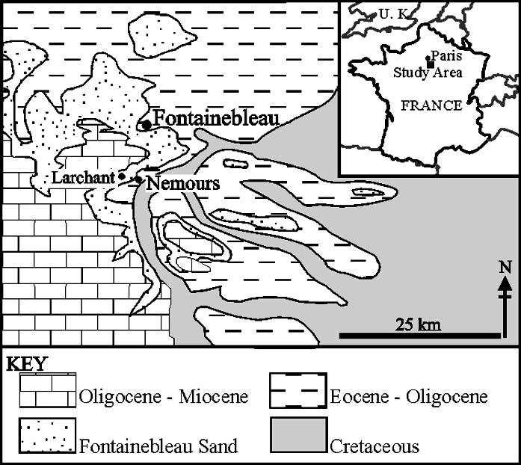

FIG. 1.— Location and geological map of the quarries at Larchant, west of Nemours, France. Geological map modified from Thiry et al. (1988) and Cooper

(1994).

1. Does optical continuity between detrital grain and quartz overgrowth, which requires that the c axes be aligned, prove that the crystal lattice is aligned? Are overgrowth and detrital grains truly in crystallographic continuity?
2. How do zones of quartz cement growth, identified using CL, relate to each other crystallographically—do they share precisely the same orientation?
3. Are all quartz overgrowths entirely quartz, or can other silica polymorphs exist within overgrowths?

## Electron Backscatter Diffraction (EBSD)

In order to address the issues laid out above and to investigate the crystallography of the quartz overgrowths in the Fontainebleau sandstone, automated electron backscatter diffraction (EBSD) was employed. The principles of EBSD have been presented previously (e.g., Venables and Harland 1973; Dingley 1984; Schmidt and Olesen 1989; Adams et al. 1993; Wilkinson and Hirsch 1997; Prior et al. 1999; Prior et al. 2002), but this study uses EBSD to address a diagenetic problem for the first time. EBSD has the capability to resolve the crystallographic orientations of points at a resolution of better than 1 mm in order to reveal microstructural information of the crystal structure and mineralogy of the material being analyzed. This can, in turn, lead to interpretations regarding mechanisms of diagenetic crystal growth.

## The Fontainebleau Sandstone

The Fontainebleau sandstone is an early Oligocene (36–27 Ma) unit, 50–80 m thick, of fine-grained, well-sorted, quartz arenite which rests on top of Eocene–Oligocene marls and is overlain by Oligo-Miocene limestones (Fig. 1; Cooper 1994; Thiry et al. 1998). It is interpreted as a marine shoreface deposit, capped by subaerial eolian dune-bedded sands (Alimen 1936) representing a prograding coastline (Cooper 1994; Thiry et al. 1988; Cooper et al. 2000; Thiry and Mare´chal 2001). Because the Fontainebleau sandstone has not been buried to a depth greater than 100 m, and in some places buried no more than a few tens of meters (Thiry 1999; Cooper et al. 2000; Thiry and Mare´chal 2001), it is an ideal location for the study of a low-temperature, shallowly buried sandstone, a situation where SiO2 cement is more likely to grow as unstable silica polymorphs because of the high silica supersaturation that is common at low temperature (Siever 1962). The diagenetic features that are seen in the Fontainebleau sandstone cannot necessarily be related to high-temperature or high-pressure effects (Thiry et al. 1988), and as such the Fontainebleau sandstone is a dramatic exception to the general temperature-related pattern of quartz cementation (Worden and Morad 2000).

In the Fontainebleau sandstone there are several laterally extensive quartz-cemented horizons that have a thickness of between 0.5 and 8.0 m. These horizons have a variable amount of quartz cement, which increases towards the center of cemented horizons (Cooper et al. 2000) and also have a variable porosity, ranging from 15% to 7% (Thiry et al. 1988). The quartz-cemented horizons are reported to have formed from silicification controlled by water-table variations in a recent (Pliocene–Quaternary) hydrogeological event, related to spring lines (Thiry et al. 1988). The stratigraphically higher quartz-cemented horizons are the oldest, and each horizon corresponds to the level of an ancient water table (Fig. 2; Thiry et al. 1988; Thiry and Mare´chal 2001). Thiry and co-workers postulated that the silica for the quartz cement was sourced internally from the Fontainebleau sandstone and cementation was enhanced where the movement of the ground water allowed a constant source of aqueous silica to reach the sands. They calculated that it would take a minimum ground-water volume of 99,375 m3 to cement just 1 m3 of sand, assuming 10 ppm of SiO2 in the groundwater. It is therefore probable that quartz cementation occurred at points of maximum ground-water flow near the paleo-spring line, with successive falls in water table.

SAMPLES AND METHODS

## Samples

Outcrop samples were collected from two quarries, Bonnevault and Les Gondonnie`res, from Larchant, west of Nemours, northern France (Fig. 3). Samples were selected from the top, middle, and bottom of the quartz-cemented horizons. Twenty-one samples were collected; these were made into 30 mm thin polished sections and were impregnated with bluestained epoxy resin to ease porosity identification. The sections were then SYTON-polished using a colloidal silica solution (Fynn and Powell 1979; Lloyd 1987; Prior et al. 1996) for several hours to remove any mechanical damage to the surface and to enable electron backscatter diffraction analysis. Samples were carbon-coated using the EMITECH K950X (, 10 nm thickness). The results of two samples are described and discussed throughout the paper and are referred to as sample 1 and sample 2 (locations seen in Fig. 3). Bonnevault quarry has two distinct quartz-cemented horizons; sample 1 comes from the top part of the lower one of these horizons. The horizon is between 1 and 3 m thick and is laterally continuous for approximately 5 m, beyond this the horizon is discontinuous. Sample 2 belongs to Les Gondonnie`res quarry, from the bottom of the only visible quartz-cemented horizon, which is 2.5 m thick and laterally continuous for at least 20 m.

## Analytical Equipment and Approach

Transmitted-light optical analysis was performed in order to locate quartz overgrowths. Their location was based on the identification of euhedral grains, with sharp, clear edges and also on the presence of dust rims (Table 1).

|  |
| --- |
| FIG. 2.—Model to illustrate the forma-  tion of the quartz-cemented horizons in the Fontainebleau sandstone, which have formed due to falling of the water table (adapted from Thiry et al. 1988). The falling water table produced successively lower quartz-cemented horizons, resulting in the stratigraphically higher ones being older. |

SEM-CL and backscattered electron (BSE) analysis combines the use of high-resolution SEM with the detail of CL (Evans et al. 1994) in order to produce high-quality, high-magnification CL images. A Philips XL30 SEM, fitted with a K.E. Developments Ltd cathodoluminescence detector (D308122), was used for cold-cathodoluminescence work. CL images were taken with an accelerating voltage of 10 kV (in contrast to 20 kV for BSE), 8 nA beam current, and 16 mm working distance. CL images were collected by accumulating the signal of 16 frames using a slow-scanning raster. Sets of high-magnification (with a spatial resolution of up to 1 mm) micrographs were collated to produce high-magnification SEM-CL montage images (approx. total area of 1.5 mm2), which encompass at least one detrital grain with its overgrowth and adjacent porosity. This approach made visible many of the internal heterogeneities of overgrowths, such as zonation patterns.

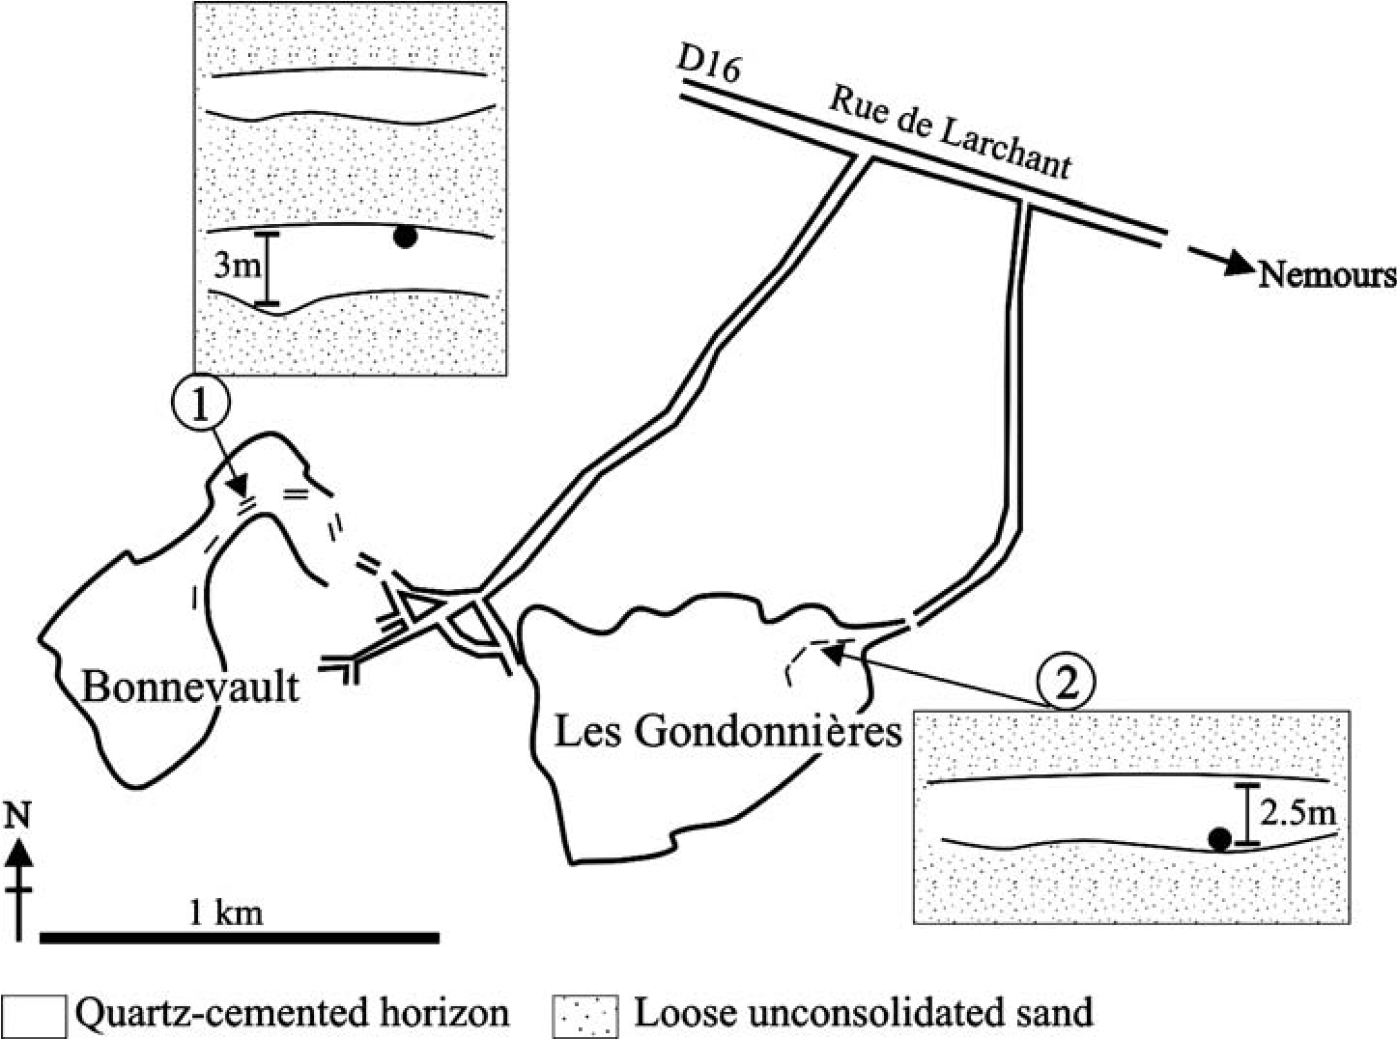Automated SEM-EBSD allows the diffraction pattern from an , 1 mm diameter area to reveal the crystallographic orientation of that area. For this work a CamScan X500 Crystal Probe SEM fitted with a thermionic field emission gun and FASTRACK stage was used (Seward et al. 2003). Working conditions were 20 kV accelerating voltage, 30 nA beam current, and 25 mm working distance.

DATA AND RESULTS

## Sample 1

Optical images of this sample (Fig. 4A, B) show subangular cemented grains, some with angular facets. The grain contact between grains 2 and 3 is sutured. Grains 1 and 3 are monocrystalline, while grain 2 is polycrystalline. The CL image (Fig. 4C) highlights a boundary between a detrital quartz grain and authigenic quartz overgrowths, particularly on grain 2, where the detrital grain luminescences brightly and the overgrowth is poorly luminescent.

The band contrast image (displaying the intensity and quality of the EBSD pattern and therefore representing the degree of crystallinity of the material; Fig. 4D) does not depict any marked gray-scale change between the detrital grain and the overgrowth, indicating consistency in the strength of the EBSD patterns across all grains and no change in quartz

FIG. 3.—Location of samples 1 and 2 from within their respective quarries. The black dots on the cross-sections represent their exact position from within the sampled horizon. Road/quarry map adapted from Cooper (1994) and Cooper et al. (2000).

|  |  |  |  |  |  |  |  |  |  |  |  |  |  |  |  |  |  |  |  |  |  |  |  |  |  |  |  |  |  |  |
| --- | --- | --- | --- | --- | --- | --- | --- | --- | --- | --- | --- | --- | --- | --- | --- | --- | --- | --- | --- | --- | --- | --- | --- | --- | --- | --- | --- | --- | --- | --- |
| TABLE 1.—Analytical techniques used in the study.   |  |  |  |  |  |  | | --- | --- | --- | --- | --- | --- | | Step | Technique | Equipment | Identifies | Area of observation | Maximum resolution | | 1 | Transmitted-light optics | Zeiss Microscope | Quartz overgrowths euhedral form and dust rims | Approx 100 mm | Approx 50 mm | | 2 | Backscatter (BSE) | Philips XL 30 scanning electron microscope (SEM) | Quartz overgrowths euhedral form and dust rims | Approx 100 mm | Approx 50 mm | | 3 | Cathodoluminescence (CL) | Philips XL 30 SEM fitted with a K.E. Developments Ltd cathodoluminescence detector (D308122) | Distinguishes detrital sand grain from quartz overgrowth. May depict zones in overgrowth | Up to 1.5 mm  (when montaged) | Up to 1 mm | | 4 | Electron backscatter diffraction (EBSD) | CamScan X500 Microprobe SEM | Hundreds of thousands of individual diffraction patterns to create a map of crystallographic orientation of grains | Map of up to 800 mm2, containing , 105,000 data points | 1 pattern of area  1 mm | |

crystallinity across the overgrowth; the entire overgrowth is fully crystalline quartz.

The crystal-orientation map (Fig. 4E) shows that detrital grains have different colors, indicating that the grains have different crystallographic orientations, as would be expected in shallowly buried sandstones that have not suffered any significant compaction, grain rotation, or deformation. The crystal-orientation images show color variations within individual grains; for example, in grain 2 (Fig. 4A) there are four different colors and hence four different crystal orientations (Fig 4E); the grain is polycrystalline quartz. The changes in crystallographic orientation in grain 2 occur at 60u and are interpreted as dauphine´ twins. Dauphine´ twins are common in quartz and form because of mechanical and/or thermal strain (Frondel 1962; Lloyd 2000). Because the Fontainebleau sandstone has been buried to less than one hundred meters in this area, it is likely that these dauphine´ twins are inherited from the sediment source terrane. (i.e., not due to diagenesis). The EBSD data reveal that the dauphine´ twin in grain 2 is also present in the overgrowth. Examination of the crystal orientation image at where the boundary between the detrital grain and the overgrowth is expected, (based on the CL image, which highlights a change in luminescence character over the boundary) reveals that there is crystallographic continuity between the detrital grain and the overgrowth.

The individual grain texture component (IGTC) image (Fig. 4G), capable of showing very small misorientations (a change in degree of crystallographic orientation from one point the next; Boyle et al. 1998; Prior 1999; Wheeler et al. 2001; Prior et al 2002) as small as 1u, cannot distinguish the grain-overgrowth boundary, confirming the interpretation of the less sensitive crystal-orientation image. In order to check that there is no significant change in crystallographic orientation over the grainovergrowth boundary, the misorientation profile (Fig. 4F) was examined. In this example, the profile distance (horizontal axis on the chart) relates to transect line 1 marked onto the crystallographic orientation map in Figure 4E. The origin represents the start point of the transect line in the detrital grain; the other end of the transect line (point 50) represents the overgrowth. The degree of misorientation along the transect line across this area is less than 1.0u. This degree of misorientation is considered to be insignificant because EBSD orientation analysis has an inherent uncertainty of approximately 6 0.5u.

To summarize the results from sample 1:

1. All silica cement in this sandstone is quartz; no other silica polymorphs occur.
2. Dauphine´ twins in monocrystalline quartz grains as well as polycrystalline quartz grains are easily defined using EBSD maps.
3. Different detrital quartz grains have different orientations that can be easily represented using crystal-orientation maps and individual grain texture component maps.
4. Quartz overgrowths have the same orientation as their respective parent detrital grains.

## Sample 2

Optical images of this sample (Fig. 5A, B) show the grains to be more heavily cemented than sample 1. The cemented quartz grains are subangular with some very strong angular facets caused by cementation. Figure 5C and D highlight the presence of concentric, isopachous (constant thickness) layers (marked by arrows I and II) which are parallel to the detrital grain or the overgrowth edge. The BSE image (Fig. 5E) shows a dark zone within the overgrowth, parallel to the edges of earlier overgrowth rims (marked by the large arrow); this zone may be rich in fluid inclusions. Just in front of this is a slightly lighter zone (marked by the smaller arrow) which follows the same pattern and direction as the aforementioned darker zone. This lighter zone may correspond to one of the concentric isopachous rims which are observed in Figure 5C. The rest of the BSE image has a uniform signal, suggesting that the overgrowth is pure silica. The CL image (Fig. 5F) usefully discriminates detrital grains that luminesce brightly, concentrically zoned overgrowths with highly variable luminescence and the nonluminescent porosity. The overgrowth belonging to the detrital grain (D) can be divided into four zones. Zone 1 resides at the detrital grain edge and varies greatly in thickness from the left to the right of the detrital grain (, 1 mm to 42 mm thickness, respectively). The thickest part of zone 1 displays three bands of alternating luminescence intensity, going from dark to bright to dark. Of these, the bright band is the thinnest and its edges are not clearly definable. Zone 2 displays smooth, intense, isopachous zonation patterns of parallel alternating fine-scale bright and dark luminescence bands that are parallel to the edges of the detrital grain. These bands are brightest on the right side of the detrital grain. Zone 3 is somewhat thicker and generally darker than zone 2 and displays only faint isopachous zonation patterns of alternating luminescence intensity. The thickness of zone 3 is constant of the right side of the detrital grain, but the grain has a changeable thickness on the left side, with a noticeable kink in the banding. In addition, it appears that the isopachous rims which are observed in optical images (arrows I in Fig. 5C) correspond to part of the CL zonation patterns found in zones 2 or 3. The final phase of cement growth (zone 4) occurs as a microcrystalline quartz zone (as defined by Vagle et al. 1994 and Lima and De Ros 2002), which has many small (, 10 mm) individual quartz crystals in a band between 15 and 26 mm thick. The microcrystalline quartz zone luminesces brightly and propagates into the pores. Optical images taken in cross-polarized light (Fig. 5G) show that the microcrystalline quartz zones go into extinction at different positions than that of their detrital grain and overgrowth substrate during rotation of the microscope stage. Accessory quartz plate images (using a first-order red tint plate in the optical microscope;

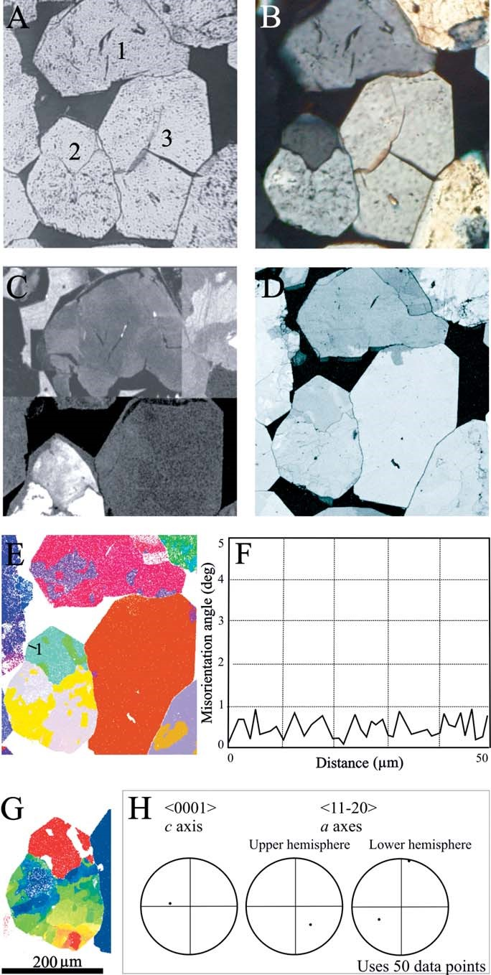FIG. 4.—Collection of images for sample 1. Optical images in A) plane-polarized light and B) crosspolarized light showing subangular, cemented grains. C) Typical cathodoluminescence (CL) image, which highlights the boundaries between detrital and authigenic quartz. D) Band contrast map and E) crystallographic-orientation map, result from a singular EBSD run, whereby every pixel has a corresponding EBSD measurement. F) Misorientation profile to display changing crystallographic orientations along a transect (e.g., line 1 marked in part E). G) Individual grain texture component map (IGTC) which is able to display very small angles of misorientations. H) Pole figures, using 50 data points (25 each from the detrital grain and overgrowth), show that there is no misorientation between detrital grain and overgrowth. The scale bar of 200 mm applies to images A–E and G.

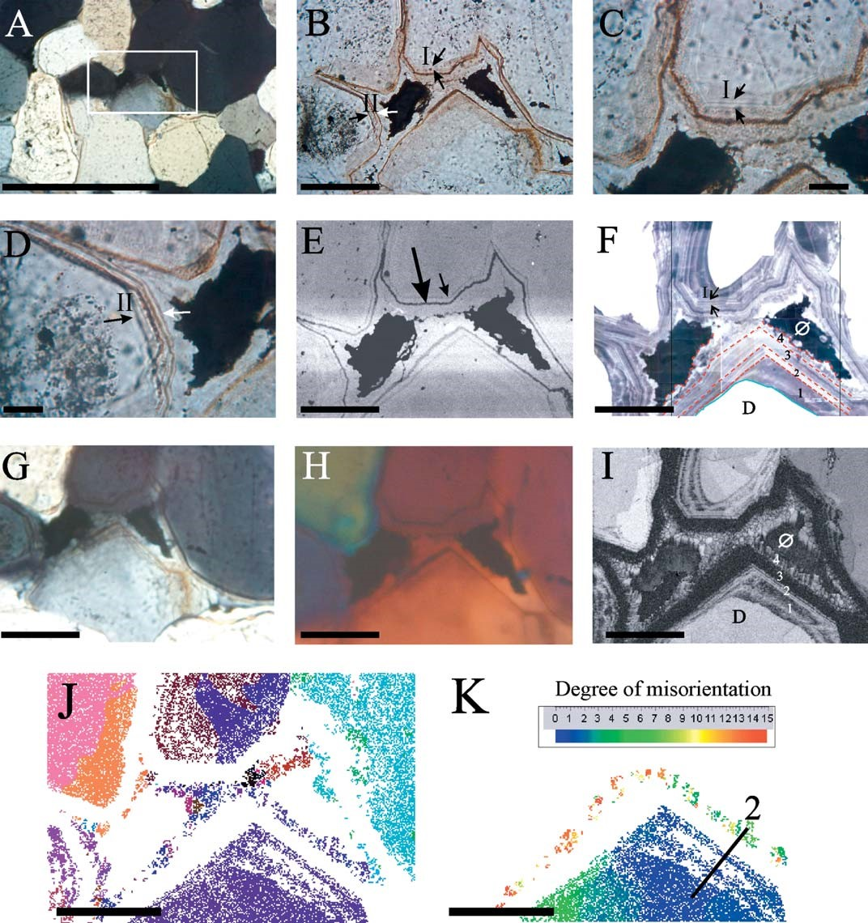

FIG. 5.—Collection of images for sample 2. Optical images in A) cross-polarized light and B–D) plane-polarized light showing that the grains are subangular and heavily cemented. The white box in part A highlights the area of focus. Arrows I and II (images B–D) highlight thin, isopachous bands around the detrital grain and overgrowth. E) Back scattered electron (BSE) image shows the presence of dark bands, marked by the large and small arrows. F) CL image displays four distinct zones within the overgrowth. G) Cross-polarized light image and H) quartz accessory first-order red tint plate image shows the microcrystalline quartz zone (zone 4) to have a slightly different crystallographic orientation to the rest of the detrital and authigenic grains. I) Band contrast image shows zones 1 and 2 have alternating high (light color) and low (dark color) band contrast response. Zone 3 has a very low response, indicating lack of crystallographic response, zone 4 has a high band contrast. J) Crystallographic orientation map shows that zones 1, 2, and 3 have orientations similar to the detrital grain. K) IGTC image shows that the microcrystalline quartz zone (zone 4) is misoriented by up to 15u from the detrital grain. Each scale bar is 200 mm.

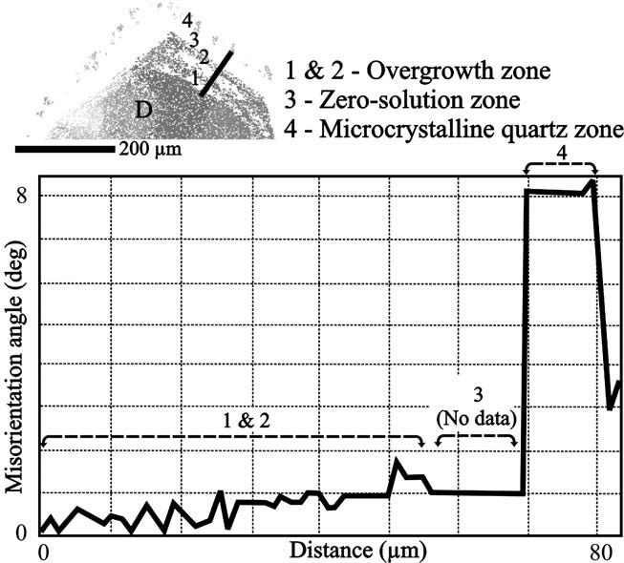FIG. 6.—Misorientation profile corresponding with transect line 2 (Fig. 5F).

Fig. 5H) shows that the microcrystalline quartz zones have color responses slightly different from the rest of the host grain, showing that the microcrystalline quartz has a crystallographic orientation different from that of the detrital grain and the rest of the overgrowth.

The crystallographic significance of the range of CL characteristics was examined through EBSD work. The EBSD band contrast image (Fig. 5I) highlights the same zones as those depicted with CL, but reveals significant internal characteristics within the cement. As expected, the detrital grain has high band contrast response. The cement regions with concentric CL layering (zones 1 and 2) have varying high and low band contrast, indicating different levels of crystallinity whereby the regions of high band contrast (which are bright in appearance) are strongly crystalline, while regions of low band contrast (which are darker in appearance) are poorly crystalline. These zones of differential band contrast correspond well with the bright and dark CL bands. Regions with low band contrast luminesce least brightly, and vice versa. Some regions of the cement within zones 1 and 2 which have concentric CL zoning have low band contrast. Either the software was unable to find a solution for the diffraction pattern that it registered, or there was a negligible diffraction pattern present. Zone 3, displaying only some faint fine-scale bands, has uniformly negligible band contrast (the zone can be termed ‘‘zero-solution’’ zone). The microcrystalline quartz zone (zone 4) has a very high band contrast response, indicating that strong lattice patterns are present.

The crystal-orientation image (Fig. 5J) shows that each detrital grain has a different color and hence a different crystallographic orientation. The minor misorientation visible within detrital grains (in Fig. 5K) is not related to the overgrowth but is caused by internal heterogeneities, e.g., pre existing strain from a previous deformation event. The crystalorientation map shows that the detrital grains, the part of the overgrowth with strong CL zoning (Fig. 5F), and the microcrystalline quartz are all the same color, indicating that they have a similar crystal orientation at the limited angular resolution (, 20u) of this type of image. The higher resolution of the individual grain texture component (IGTC) map (Fig. 5K) shows that the detrital grain and the microcrystalline quartz area in fact have different crystallographic orientations. The misorientation between the detrital grain and the microcrystalline quartz varies between 8u and 15u. Microcrystalline quartz has extended into the pores parallel to the c axes of individual microcrystalline quartz crystals.

Collated data from misorientation profiles (e.g., Fig. 6), with transects starting in the detrital grain, crossing the overgrowth, and ending in the microcrystalline quartz, confirm that there is a misorientation ranging from 6u to 28u, with a mean average misorientation of 13.3u. This degree of misorientation is significant. Figure 6 shows the misorientation profile for transect line 2 marked on the IGTC map (Fig. 5K). The transect begins at point 0 on the profile, which is within the detrital grain, and the misorientation is relative to this point. As the profile crosses the grain into overgrowth zones 1 and 2, the misorientation does not rise above 1u. Zone 3, the zero-solution zone, inevitably has no data. When the profile reaches zone 4, the microcrystalline quartz zone, the misorientation has increased to , 8u; this corresponds to the color change (IGTC map, Fig. 5K) that indicates that there is a change in crystallographic orientation.

Several pole figures of selected EBSD data are shown in Figure 7 (where pole figures employ stereographic projections to represent the orientation of major crystallographic axes). Figure 7A shows that the a axes have a dispersion of EBSD data (Boyle et al. 1998; Prior et al. 1999), i.e., the six selected EBSD data points from the detrital grain and the six from the microcrystalline quartz do not plot in the same place. This confirms that there is a misorientation between the detrital grain and the microcrystalline quartz zone and indicates that the misorientation is not random; there is, instead, a systematic rotation (Boyle et al. 1998; Wheeler et al. 2001; Prior et al. 2002). The pole figure for the c axis shows that the data fall in a tight cluster, making the data appear as one single tight point. This suggests that the rotation axis responsible for the dispersion of orientations around the a axes must lie in a direction that is parallel to the c axis. It is most likely that the rotation axis is the c axis. In contrast, the pole figures in Figure 7B and C reveal a data cluster around one of the a axes (upper hemisphere for Figure 7B and lower hemisphere for Figure 7C) and dispersion around the c axis and remaining a axes. This is indicative of rotation axes that are parallel to one or more of the a axes. Further, the pole figures in Figure 7D display dispersion around all axes bar the p axes (which has been plotted as poles to plane in order to better depict possible trends); in this instance, the rotation axis is parallel to a p axis (cf. Frondel 1962, p. 40). While this systematic rotation about specific crystallographic axes is the dominant trend, some data do not display any systematic rotation, where pole figures do not appear to cluster (Fig. 7E).

## Defining the ‘‘Zero-Solution’’ Zone

The zero-solution zones of sample 2 (parts of zone 1 and 2 and all of zone 3) are so called because the initial EBSD maps yielded no crystallographic orientation data from this area. The software was unable to index this zone because the crystallographic data recorded on the EBSP were so weak. CL and qualitative secondary X-ray analysis (EDAX) revealed that this zone is silica (SiO2), so the reasons why it has no patterns need to be investigated. There are three possibilities to explain this. The first is that this material contains quartz with an unusually high dislocation density and is sufficiently internally damaged that no patterns could be generated. This can be ruled out because it is unlikely that quartz cement in an undeformed rock would contain a dislocation density high enough to affect pattern quality. The second possibility is that the EBSP patterns suffer time-dependent damage and thus decay (due to crystal damage) too quickly for them to be recorded and indexed in this material. This theory was tested by completing short, successive automated EBSD runs and decreasing the pattern acquisition time from 500 ms to 100 ms to 50 ms to 30 ms. Although patterns are weak, there is no depreciation in pattern quality with increasing acquisition time. Much longer acquisitions do cause noticeable depreciation, suggesting that the timedependent damage is similar to quartz and occurs only for acquisition . 500 ms. The final possibility is that this material is amorphous or poorly crystalline silica and does not have enough long-range crystal structure sufficiently capable of diffracting electrons. To examine these zero-solution zones in more detail, individual electron backscatter patterns (EBSPs) from specific points were analyzed. Data from the zero-solution zone have been compared to data from the overgrowth (zones 1 and 2) and microcrystalline quartz zone (zone 4) (Fig. 8). The EBSP from within the overgrowth area (Fig. 8A) is strong and matches that of quartz. A pronounced zone axis (the intersection of all the lattice bands) is seen. The interpretation is therefore that the silica in the highband-contrast parts of the overgrowth (i.e., some of zone 1 and 2) is strongly crystalline and very likely to be quartz. The EBSP from within the microcrystalline quartz zone (Fig. 8B) is moderately strong, and the patterns appear identical to those of the overgrowth, indicating that this zone 4 is also quartz. Results are quite different from the zero-solution parts of zones 1 and 2 and all of zone 3. EBSPs were collected in traverse across zone 3 (Fig. 8C–F). In Figures 8C–E the EBSPs are very weak, although there is still a pronounced zone axis. In Figure 8F there is no EBSP but there is a blurring where one might expect the position of a zone axis to lie. The position of the zone axis in the Figure 8C–E and the patterns which are generated appear similar to those observed in Figure 8A and B. These results lead to the interpretation that the zerosolution zone is not fully crystalline quartz. The zone has caused some weak electron diffraction, and the matching of the weakly defined zone axis to a quartz zone axis in the overgrowth suggests some structural continuity. It therefore seems likely that low-band-contrast parts of zones 1 and 2 and all of zone 3 are a very poorly crystalline form of silica (e.g., cryptocrystalline quartz), such as opal C-T or chalcedony. To summarize the results from sample 2,

1. There are four distinct zones within the overgrowths.
2. Zones 1, 2, and 3 display parallel, isopachous zonation patterns of alternating fine-scale bright and dark luminescent bands that are parallel to the edges of the detrital grains.
3. Of the isopachous zones, zones 1 and 2 are identifiable with both CL and EBSD, suggesting that the processes that led to the formation and growth of these features are related.
4. Zone 3 displayed no automated EBSD response, but examination of its EBSPs found it to be a zone of poorly crystalline silica.
5. The crystallographic orientation between detrital grains and their overgrowth zones 1 and 2 is very similar, as shown by optical images and confirmed by EBSD data.
6. The microcrystalline quartz zone of zone 4, in which the individual crystals are predominantly parallel to the c axis, has a crystallographic orientation different from that of the detrital quartz grain and its former overgrowth zones, 1, 2, and 3.
7. Zone 4 quartz cements have misorientations of up to about 28u relative to the host grain; the misorientation is generally the result of a systematic rotation about one of the several dominant crystallographic axes.

DISCUSSION

## Cementation Variations in the Fontainebleau Sandstone

The two samples that have been studied yield contrasting information regarding type, style, and mechanism of cementation in the Fontainebleau sandstone. CL images from sample 1 show the overgrowths to be fairly homogeneous in internal character, i.e., zonation patterns were not observed. The uniformity of the overgrowth in terms of CL could be due to constant groundwater conditions during quartz cementation. If it is assumed that CL patterns in quartz cements are largely due to trace elements rather than defects (Kraishan et al. 2000) then the simple way to interpret the CL uniformity of cement in sample 1 is to conclude that quartz growth occurred during stable geochemical conditions when an approximately constant concentration of trace elements was present during cement growth.

The overgrowths in sample 2 are less simple than those from sample 1 and can be divided into four discernible zones (summarized above in the results summary). The optical, CL, and EBSD images show the overgrowth to be heterogeneous with, among other patterns, isopachous, parallel, alternating fine-scale bright and dark luminescent bands that are parallel to the edges of the detrital grain (zones 1, 2, and 3). These zones are inferred to be the consequence of variable trace-element concentrations within the silica (cf. Kraishan et al. 2000). The traceelement variation could be linked to quartz precipitation occurring concomitantly with a falling water table (Thiry and Mare´chal 2001) and as a result of possible changes in water chemistry. Because not all of the silica is quartz, i.e., some is poorly crystalline silica, it is rather unlikely that the variable luminescence could be the result of variable crystal defect densities.

When comparing CL and EBSD results, three major observations are made. First, the areas of the cement composed of quartz (those with highband-contrast response) generally have the brightest luminescent character. Second, the poorly crystalline silica has variable luminescence. Third, some of the poorly crystalline silica has discernible CL banding. In zone 2 (Fig. 5F, J), the concordance between the dull CL and the areas of low band contrast suggests either that (1) a trace element capable of quenching luminescence was preferentially enriched in the poorly crystalline silica material or, (2) a trace element capable of exciting luminescence was preferentially enriched in the quartz.

While the Al content of the Fontainebleau sandstones was found to be low (, 30 ppm, Pagel et al. 1996), the Fe content was found to be as high as 192 ppm (Bruhn at el. 1996; Pagel et al. 1996). Iron enrichment in

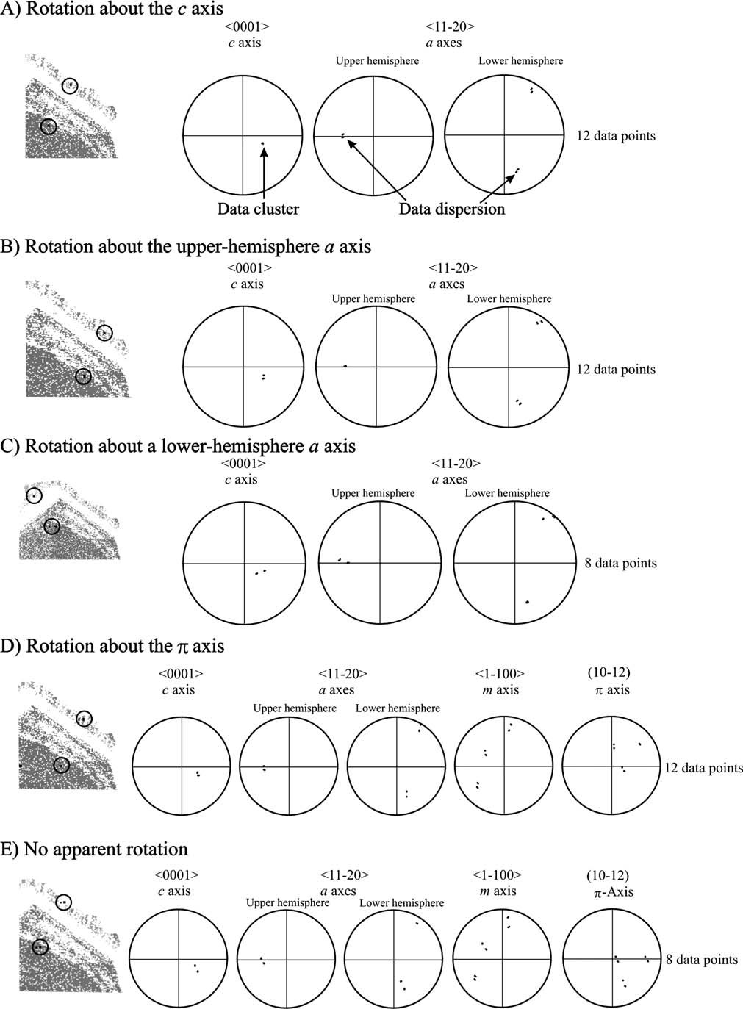

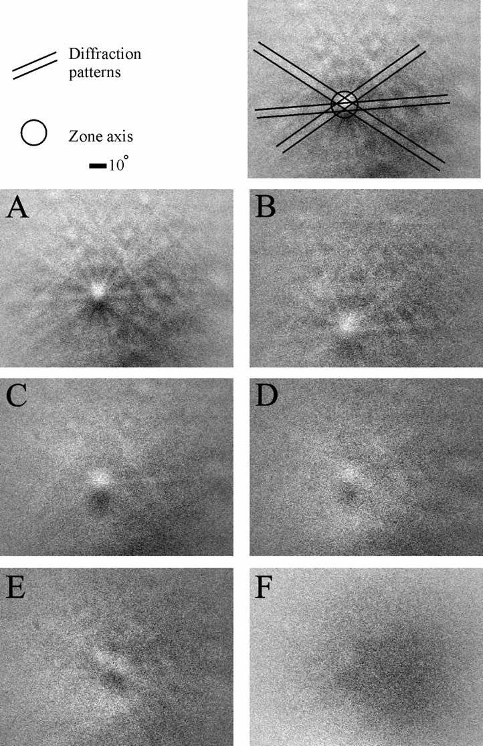FIG. 8.—Individual electron backscatter patterns (EBSPs) for the grain examined in Figure 5F. The first image depicts individual diffraction bands from lattice planes and the zone axis at their intersection. A) EBSP from overgrowth zone 1 is strong and matches that of quartz. B) EBSP from within the microcrystalline quartz zone 4 is also relatively strong. C–F) EBSPs from across zero-solution zone 3 are much weaker and the only clear feature to be seen in parts C–E is a zone axis. Despite the lack of welldefined diffraction lines, the apparent zone axis is in the same approximate position as a zone axis for quartz. In part F, There is no EBSP but there is a blurring at the position where a zone axis could lie. It is highly likely, therefore, that the zero-solution zone is a form of poorly crystalline silica.

r

FIG. 7.—Pole-figure representation of EBSD data. The extracted micrograph has circles highlighting the specific points where the crystallographic data were collected. Pole figures a, b, and d use 12 data points (6 each from both the detrital grain and the microcrystalline quartz); pole figures c and e use 8 data points (4 each from both the detrital grain and the microcrystalline quartz). The data from each point are represented on different stereographic projections of the crystallography. In all parts, data are plotted for ,0001. (c axis) and ,11–20. (a axes); in parts D and E, data is also plotted for ,1–100. (m axis) and {10–12} (p axis). A) The split of data (data dispersions) for the upper and lower ,11–20. directions show there is a misorientation between the microcrystalline quartz and detrital grain; the difference is due to rotation about the c axis (shown with the data cluster). B–C) Rotation of data is around the upper-hemisphere a axis and lower-hemisphere a axis respectively. D) Rotation of data is about the p axis. E) Shows that even though there is misorientation between the microcrystalline quartz and detrital grain, there is no apparent systematic rotation that is controlling the dispersion.

minerals is commonly associated with CL quenching (Tucker 1988). Bruhn et al. (1996) postulated that because Fe3+ is mobile only in solutions with pH , 3, the near-surface quartz cementation could have occurred in pore water which had humic acid present (giving the water a low pH) and thus allowing sufficient amounts of Fe3+ to be available for substitution. On this basis, it is possible that where the CL character is brightest, i.e., in the quartz, that there is the least iron, and that as the poorly crystalline silica has variable luminescence, it is likely to have variable iron content. Thus it is possible, but by no means certain, that option 1 above is valid, with there being preferential enrichment of iron in the poorly crystalline silica relative to the quartz cement.

The overall reasons for the fundamental differences between samples 1 and 2 beyond what has been discussed above are not within the scope of this paper but are likely to involve geographical and spatial variations between differing quartz-cemented horizons.

## Supersaturation with Respect to Silica

There has been some attention paid to the relative rates of nucleation and growth of different polymorphs of silica at different silica concentrations (e.g., Hendry and Trewin 1995). At high supersaturation, amorphous and cryptocrystalline silica grow orders of magnitude more quickly than quartz. The required high levels of supersaturation are found in the Fontainebleau because of dissolution of detrital quartz, flint, and clay-mineral grains and by the vast amount of fluid that would have percolated through the system through the paleo-spring lines (Thiry et al. 1988). A simple way to interpret the occurrence of interlayered poorly crystalline silica and quartz is that different growth rates were imposed on the system by different degrees of silica supersaturation. It seems likely that different layers in the overgrowths in sample 2 represent rather different lengths of time. Thiry and Mare´chal (2001) speculated that high levels of silica supersaturation transiently occurred due to intermittent formation of silica complexes. The layering, visible in both CL and the band contrast images, suggests that the growth of both quartz and poorly crystalline silica occurred as numerous episodes, which may reflect changes in water flow regime, i.e., changes in, or decay or input of, organic complexes or of silica supersaturation. Some images show more than 30 discernible layers suggesting at least 30 episodes.

CRYSTALLOGRAPHY OF QUARTZ CEMENT IN THE FOUNTAINEBLEAU

## Crystallographic Misorientations

Optical and EBSD data reveal that the quartz lattice of the detrital grain substrate and the authigenic quartz overgrowth are continuous in sample 1, i.e., there is no observed change in crystallographic orientation between the detrital grain and the overgrowth. The relationship between the detrital grain and the overgrowth is thus syntaxial (McBride 1989). Sample 2 is different. Optical continuity is seen between the detrital grain and overgrowth zones 1, 2, and 3, but there is optical discontinuity between the detrital grain, zones 1, 2, 3, and the microcrystalline quartz zone. These observations are confirmed by the EBSD data, which reveal that the detrital grain and the initial overgrowth (zones 1 and 2) have a very similar crystallographic orientation (6 0.5u). Hence there is no significant misorientation between the detrital grain and overgrowth zones 1 and 2. Further EBSD data reveal that the detrital grain and the microcrystalline quartz (zone 4) have different crystallographic orientations with misorientation varying between 6u and 28u. On this basis, it appears that the detrital grain and the microcrystalline quartz (zone 4) have an epitaxial relationship (Spry 1969). A traditional definition of epitaxy is ‘‘arrangement on’’ to denote oriented growth of a crystal upon another, whereby there are structural similarities of substrate and overgrowth (cf. Spry 1969, p. 164). In this instance, the majority of the previous cement phases (in zones 1 and 2) and the microcrystalline quartz have the same chemistry (silica), but they are likely to be different silica polymorphs with similar structure.

## Crystallographic Controls on Growth

The pole figures corresponding to the EBSD data reveal further significant information regarding the controls on growth of the quartz cement, particularly of the microcrystalline quartz zone (zone 4) and its relationship to the rest of the grain. The pole figures highlight the crystallographic changes between the rest of the grain and the microcrystalline quartz zone. While some pole figures show that there is a clustering of data around the c axis, with a dispersion of data around the a axes, other data show a clustering around one of the a axes and dispersion around the c axis. These crystallographic elements seem to be inherited via the poorly crystalline silica. The clustering and dispersion of data in a mainly systematic manner about specific crystallographic axes indicates that there is some simple crystallographic control over the misorientations and that the grain and microcrystalline quartz are related by this rotation around a rational crystallographic axis. It is thus likely that the final growth stages of the quartz overgrowths are systematic. The lack of response in zone 3 (Fig. 5I) shows that the silica is not quartz but it has some rudimentary crystal structure that is capable of transmitting some of the host-grain crystallography through this non-quartz zone. It seems that part of a quartz crystal structure is present even in the poorly crystalline silica but not enough to cause a full crystallographic control on the newly grown quartz. Growth of zone 4 is only weakly controlled by the host grain and zones 1 and 2, thus allowing some twisting or rotation of the quartz structure. Only part of the orientation information can be inherited through the obscuring influence of the non quartz zone.

Because different rotations are possible, different sites for nucleation of microcrystalline quartz have adopted different orientations relative to one another. The final phase of quartz growth (zone 4) in sample 2 may have been inhibited by the form of these crystals. Because zone 4 was not capable of growing on a broad common surface parallel to a substrate, growth was inhibited. This is analogous to the observation that polycrystalline detrital quartz grains have less cement than monocrystalline detrital quartz grains (fig. 7 in Worden and Morad 2000). Both cases have dominant growth occurring from multiple, misoriented, unrelated nucleation sites where extensive sideways growth is inhibited due to the presence of neighboring nucleation and growth sites. A conclusion from this is that sideways growth of quartz perpendicular to the c axis seems to be faster than outwards growth parallel to the c axis. The kinetics of quartz cementation appears to be strongly affected by the crystallographic orientation of the growth surface.

Recrystallization in the Fontainebleau Sandstone?

Some authors have proposed that quartz overgrowths in shallowly buried sands can form indirectly by transformation of a pre existing unstable silica polymorph, such as an amorphous or opaline silica, which later recrystallized: first to opal-CT, then to microcrystalline quartz, and finally to the stable alpha quartz polymorph, through a series of dissolution and reprecipitation reactions (Williams et al. 1985; Williams and Crerer 1985; Goldstein and Rossi 2002). For this series of reactions to occur, high levels of silica supersaturation are required; as previously discussed, this existed in the Fontainebleau sandstone. Optical, CL, and EBSD observations of sample 2 reveal that zone 2 has smooth, intense, isopachous zonation patterns of parallel alternating fine-scale bright and dark luminescent bands that are parallel to the edges of the detrital grains (patterns similar are displayed in zones 1 and 3). Patterns similar to these were observed by Thiry and Mare´chal (2001), and they interpret these parallel, isopachous rims as being related to amorphous or poorly ordered silica deposits which later recrystallized to stable syntaxial overgrowths, on the basis that such rims could not have formed as quartz overgrowths because they would have developed euhedral shapes. Overgrowth zones in this study appear to have variable morphologies: zone 1 of detrital grain 1 (D1) has a bright band within it that has uneven edges and has a rounded, anhedral corner; zone 1 of D2 (Fig. 5F, point I) also has rounded, smooth, anhedral edges. This is in contrast to zones 2 and 3, which have distinct straight, euhedral edges with pyramidal angular terminations. There has been some discussion among the authors and reviewers regarding the significance of this morphology contrast and the possible implications for the occurrence of recrystallization in the Fontainebleau sandstone; the two options for explaining this are as follows:

1. Zone 1 was initially deposited concentrically as an amorphous or poorly crystalline silica layer around the detrital grain and, later, parts of this recrystallized to a more stable quartz form because of dissolution–reprecipitation reactions. As subsequent amorphous or poorly crystalline silica layers formed (in zone 2), some recrystallized and others did not. Once the layer had recrystallized to form a euhedral, angular termination, further layers which were deposited took on that euhedral form. The poorly crystalline zone (zone 3) could therefore take on the euhedral form of the previous recrystallized zone but for one reason or another never managed to recrystallize itself.
2. The silica bands are not due to dissolution–reprecipitation reactions, and what is currently observed is indicative of what originally formed, i.e., some bands of zones 1 and 2 (bands with dull luminescence and low band contrast) formed as poorly crystalline silica and other bands (bands with bright luminescence and high band contrast) formed as crystalline quartz.

Although it cannot be known which of these ideas is correct, there are two flaws in the argument for recrystallization: (1) If dissolution– reprecipitation reactions had occurred, why would there be preferential recrystallization of some bands (layers) and not of others? What would cause one layer to recrystallize to stable quartz and allow another layer to remain as a low-crystallinity silica form? (2) Why would the partially recrystallized silica take on the crystallographic orientation of the detrital grain? This orientation relationship implies that recrystallization would have had to be initiated at the boundary between the detrital grain and the overgrowth and then have proceeded gradually outwards. There is no mechanistic reason why this should have occurred. Nucleation of recrystallized quartz at random locations would have led to variable crystal orientation, which we have demonstrated is not the case. On this basis, we favor the latter argument and think it most likely that the layers which are now seen are those which originally formed. Ongoing work may shed more light on this argument.

### CONCLUSIONS

The crystallography and mechanisms for quartz cement growth in the Fontainebleau sandstone have been examined using optical, CL, and EBSD to reveal the following:

1. Quartz overgrowths of the Oligo-Miocene Fontainebleau sandstone reveal contrasting overgrowth styles. Sample 1 has homogeneous overgrowth character, as defined by bland CL response; sample 2 has heterogeneous overgrowth character as defined by four discernible overgrowth zones.
2. In sample 2, zones 1, 3, and particularly zone 2 have parallel, isopachous, fine-scale bands of alternating bright and dark luminescence; these likely reflect changes in Fe3+ concentration, degrees of supersaturation, and rate of growth.
3. Crystallographic information reveals that the most part of zones 1 and 2 are fully crystalline quartz, while zone 3 is entirely a poorly crystalline silica phase and zone 4 is fully crystalline quartz. Thus the quartz overgrowths of the Fontainebleau sandstone display a range of silica types.
4. Electron backscatter diffraction revealed that the crystallographic relationship between detrital grain and overgrowth differs between samples. In sample 1, detrital grains and their overgrowths have the same crystallographic orientation; their relationship is syntaxial. In sample 2, detrital grain and their overgrowths have the same crystallographic orientation but the grain and late-stage microcrystalline quartz have different orientations; hence the relationship between the detrital grain and the microcrystalline quartz is epitaxial.
5. Misorientation profiles and pole figures revealed that there is a systematic misorientation between the detrital grain and the microcrystalline quartz, which is related to a rational crystallographic rotation about a variety of axes. This indicates that final non-syntaxial growth stages are not random and there is a crystallographic control on their growth.

### ACKNOWLEDGMENTS

This work was funded through a PhD industrial CASE award from the National Environmental Research Council (NER/S/C/2002/10624) and BP Exploration. SEM operation is funded by award NER/A/S/2001/1181. Thanks to SIFRACO, France, for allowing access to their quarries. Great thanks to: Rosalind King for help with sample collection; John Kavanagh for sample preparation; Kees Veltkamp for SEM assistance; and Gareth Seward for EBSD expertise. Further thanks to editor Kitty Milliken, associate editor Luiz Fernando De Ros, and reviewers Medard Thiry and Andrew Hurst, whose comments and suggestions have greatly improved the quality of this manuscript.

### REFERENCES

AASE, N.E., BJøRKUM, P.A., AND NADEAU, P.H., 1996, The effect of grain-coating microquartz on preservation of reservoir porosity: American Association of Petroleum Geology, Bulletin, v. 80, p. 1654–1673.

ADAMS, B.L., WRIGHT, S.I., AND KUNZE, K., 1993, Orientation imaging: The emergence of a new microscopy: Metallurgical Transactions, v. 24A, p. 819–831.

ALIMEN, H., 1936, E´tude sur le stampian du Basin de Paris: Socie´te´ Ge´ologique de France, Memoires, v. 31, p. 1–304.

BOYLE, A.P., PRIOR, D.J., BANHAM, M.H., AND TIMMS, N.E., 1998, Plastic deformation of metamorphic pyrite: new evidence from electron-backscatter diffraction and forescatter orientation-contrast imaging: Mineralium Deposita, v. 34, p. 71–81.

BRUHN, F., BRUCKSCHEN, P., MEIJER, J., STEPHAN, A., RICHTER, D.K., AND VEIZER, J., 1996, Cathodoluminescence investigations and trace-element analysis of quartz by micro-PIXE: implications for diagenetic and provenance studies in sandstones: Canadian Mineralogist, v. 34, p. 1223–1232.

CABRERA, N.A., AND VERMILYEA, D.A., 1958, The growth of crystals from solution, in Doremus, R.H., Roberts, B.W., and Turnbull, D., eds., Growth and Perfection of Crystals: New York, Wiley, p. 393–410.

COOPER, M.R., 1994, Diagenetic evolution and implications for the reservoir properties of selected shallow marine and aeolian sandstones [Ph.D. thesis]: University of Liverpool: U.K., 184 p.

COOPER, M.R., EVANS, J., FLINT, S.S., HOGG, A.J.C., AND HUNTER, R.C., 2000, Quantification of detrital, authigenic and porosity components of the Fontainebleau Sandstone: a comparison of conventional optical and combined scanning electron microscope-based methods of modal analysis, in Worden, R.H., and Morad, S., eds., Quartz cement in sandstones: International Association of Sedimentologists, Special Publication 29, p. 89–101.

DINGLEY, D.J., 1984, Diffraction from sub-micron areas suing electron backscattering in the a scanning electron microscope, Scanning Electron Microscopy, p. 569–575.

EVANS, J., HOGG, A.G.C., HOPKINS, M.S., AND HOWARTH, J.R., 1994, Quantification of quartz cements using combined SEM, CL, and image analysis: Journal of Sedimentary Research, v. 64, p. 334–338.

FRONDEL, C., 1962, Dana’s System of Mineralogy; Volume III, Silica Minerals: New York, John Wiley & Sons Inc., 334 p.

FYNN, G.W., AND POWELL, W.J.A., 1979, The cutting and polishing of electro-optic materials: London, Adams Hilger, 216 p.

GOLDSTEIN, R.H., AND ROSSI, C., 2002, Recrystallization in quartz overgrowths: Journal of Sedimentary Research, v. 72, p. 432–440.

HENDRY, J.P., AND TREWIN, N.H., 1995, Authigenic quartz microfabrics in Cretaceous turbidites: evidence for silica transformation processes in sandstones: Journal of Sedimentary Research, v. 65, p. 380–392.

HURST, A., 1981, A scale of dissolution for quartz and is implications for diagenetic processes in sandstones: Sedimentology, v. 28, p. 451–459.

KRAISHAN, G.M., REZAEE, M.R., AND WORDEN, R.H., 2000, Significance of trace element composition of quartz cement as a key to reveal the origin in sandstones: an example from the Cretaceous of the Barrow Sub-basin, Western Australia, in Worden, R.H., and Morad, S., eds., Quartz Cement in Sandstones: International Association of Sedimentologists, Special Publication 29, p. 317–331.

LIMA, R.D., AND DE ROS, L.F., 2002, The role of depositional setting and diagenesis on the reservoir quality of Devonian sandstones from the Solimo˜es Basin, Brazilian Amazonia: Marine and Petroleum Geology, v. 19, p. 1047–1071.

LLOYD, G.E., 1987, Atomic number and crystallographic contrast images with the SEM: a review of backscattered electron techniques: Mineralogical Magazine, v. 51, p. 3–19.

LLOYD, G.E., 2000, Grain boundary contact effects during faulting of quartzite: an SEM/EBSD analysis: Journal of Structural Geology, v. 22, p. 1675–1693.

MCBRIDE, E.F., 1989, Quartz cement in sandstones: a review: Journal of Sedimentary Petrology, v. 26, p. 69–112.

PAGEL, M., DEMARS, C., DELOULE, E., BLANC, P., AND BARBARAND, J., 1996, Cathodoluminescence and trace element distribution in authigenic quartz in sandstone: International Symposium of the Society of Core Analysts, Improving Reservoir Management, Proceedings: Montpellier, France, 8–10 September, SCA Conference, n. 9613, 2 p.

PRIOR, D.J., 1999, Problems in determining the misorientation axes, for small angular misorientations, using electron backscatter diffraction in the SEM: Journal of Microscopy, v. 195, p. 217–225.

PRIOR, D.J., TRIMBY, P.W., WEBER, U.D., AND DINGLEY, D.J., 1996, Orientation contrast imaging of microstructures in rocks using forescatter detectors in the scanning electron microscope: Mineralogical Magazine, v. 60, p. 859–869. PRIOR, D.J., BOYLE, A.P., BRENKER, F., CHEADLE, M.C., DAY, A., LOPEZ, L., POTTS, G.J.,

REDDY, S., SPIESS, R., TIMMS, N.E., TRIMBY, P., WHEELER, J., AND ZETTERSTRO¨M, L., 1999, Application of electron backscatter diffraction and orientation contrast imaging in the SEM to textural problems in rocks: American Mineralogist, v. 84, p. 1741–1759.

PRIOR, D.J., WHEELER, J., PERUZZO, L., SPIESS, R., AND STOREY, C., 2002, Some garnet microstructures: an illustration of the potential of orientation maps and misorientation analysis in microstructural studies: Journal of Structural Geology, v. 24, p. 999–1011.

SCHMIDT, N.-H., AND OLESEN, N.Ø., 1989, Computer-aided determination of crystallattice orientation from electron-channelling patterns in the SEM: Canadian Mineralogist, v. 27, p. 15–22.

SIEVER, R., 1962, Silica solubility, 0u–200uC, and the diagenesis of siliceous sediments:

Journal of Geology, v. 70, p. 127–150.

SEWARD, G.G.E., PRIOR, D.J., WHEELER, J., CELOTTO, S., HALLIDAY, D.J.M., PADEN, R., AND TYE, M.R., 2002, High temperature electron backscatter diffraction and scanning electron microscopy imaging techniques: In-situ investigations of dynamic processes:

Scanning Volume, v. 24, p. 232–240.

SPRY, A., 1969, Metamorphic Textures: Oxford, U.K., Pergamon Press, 350 p.

THIRY, M., 1999, Diversity of continental silicification features: example from the Cenozoic deposits in the Paris Basin and neighbouring basement; in Thiry, M., and Simon-Coinc¸on, R., eds., International Association of Sedimentologists, Special Publication 27, p. 87–127.

THIRY, M., BERTRAND-AYRAULT, M., AND GRISONI, J.C., 1988, Ground water silicification and leaching in sands: Example of the Fontainebleau Sand (Oligocene) in the Paris Basin: Geological Society of America, Bulletin, v. 100, p. 1283–1290.

THIRY, M., AND MARE´CHAL, B., 2001, Development of tightly cemented sandstone lenses in uncemented sand: example of the Fontainebleau Sand (Oligocene) in the Paris Basin: Journal of Sedimentary Research, v. 71, p. 473–483.

TUCKER, M., 1988, Techniques in Sedimentology: Oxford, U.K., Blackwell Scientific Publications, 408 p.

VAGLE, G.B., HURST, A., AND DYPVIK, H., 1994, Origin of quartz cements in some sandstones from the Jurassic of the Inner Moray Firth: Sedimentology, v. 41, p. 363–377.

VENABLES, J.A., AND HARLAND, C.J., 1973, Electron back-scattering patterns–-A new technique for obtaining crystallographic information in the scanning electron microscope: Philosophical Magazine, v. 27, p. 1193–1200.

WALDERHAUG, O., AND RYKKJE, J., 2000, Some examples of the effect of crystallographic orientation on the cathodoluminescence colors of quartz: Journal of Sedimentary Research, v. 70, p. 545–548.

WAUGH, B., 1970, Formation of quartz overgrowths in the Penrith sandstone (Lower Permian) of Northwest England as revealed by scanning electron microscopy: Sedimentology, v. 14, p. 309–320.

WHEELER, J., PRIOR, D.J., JIANG, Z., AND SPIESS, R., 2001, The petrological significance of misorientations between grains: Contributions to Mineral Petrology, v. 141, p. 109–124.

WILKINSON, A.J., AND HIRSCH, P.B., 1997, Electron diffraction based techniques in scanning electron microscopy of bulk materials: Micron, v. 28, p. 279–308.

WILLIAMS, L.A., AND CRERAR, D.A., 1985, Silica diagenesis, II. General mechanisms: Journal of Sedimentary Petrology, v. 55, p. 312–321.

WILLIAMS, L.A., PARKS, G.A., AND CRERAR, D.A., 1985, Silica diagenesis, I. Solubility controls: Journal of Sedimentary Petrology, v. 55, p. 301–311.

WORDEN, R.H., AND MORAD, S., 2000, Quartz cementation in oil field sandstones: a review of the key controversies, in Worden, R.H., and Morad, S., eds., Quartz Cement in Sandstones: International Association of Sedimentologists, Special Publication 29, p. 1–20.

Received 16 December 2004; accepted 5 June 2005.