2012**2011-054 research-articlearticle**18X10.1144/1354-079311-054B. KilhamsMey Sandstone Member

**characterizing the Paleocene turbidites of the north Sea:**

**the Mey Sandstone Member, lista Formation, uK central graben**

**Ben Kilhams1*, adrian hartley1, Mads huuse2 and chris davis3**

1*Geology and Petroleum Geology, Meston Building, University of Aberdeen, Aberdeen AB24 3UE, UK*

2*School of Earth, Atmospheric and Environmental Sciences, University of Manchester, Williamson Building, Manchester M13 9PL, UK*

3*Shell Upstream International Europe, Altens Farm Road, Aberdeen AB12 3FY, UK *Corresponding author (e-mail: b.kilhams@shell.com)*

**aBStract:** This paper presents an integrated seismic, petrophysical and core facies study of the Mey Sandstone Member of the Central North Sea Lista Formation. Seismic mapping and attribute analysis reveal that the Mey Sandstone Member is composed of distinct axial and lateral routing systems. In turn, the axial system can be divided into coeval western and eastern fairways defined by the underlying graben topography in a similar manner to the overlying Sele Formation (Forties) sandstones. These trends are confirmed by petrophysical analysis, which also reveals that the lateral systems are not as important as previously proposed and that the cycles of the Mey Sandstone Member prograded over time before a late stage of backstepping. These variations can be related directly to published sea-level curves. Core analysis reveals that mean grain size is the main control on sandstone quality and that similar proximal (channelized) to distal (sheet-like) changes in sedimentological facies occur to those described in the Sele Formation. It is argued that these deposits cannot be described as simple basin floor fans due to the impact of topography on turbidite flow routing and the existence of multiple entry points of sediment into the basin.

|  |  |
| --- | --- |
| **IntroductIon**  Since the first discovery of Paleocene hydrocarbon reservoirs in 1969 at the Arbroath Field (Ahmadi *et al*. 2003) and the Forties Field in 1970 (Stewart 1987), the Paleogene turbiditic cycles of the Central North Sea have become one of the most economically important stratigraphic intervals in Northwest Europe (e.g. Ahmadi *et al*. 2003). The mature North Sea hydrocarbon province, with its extensive exploration and production datasets, now presents an opportunity to learn more about regional-scale deepwater sedimentation in a long-lived epi-continental basin and the possible relationship of these deposits to the Central North Sea tectonic framework and sea-level variability within the Paleogene. As such, this paper presents an integrated regional seismic, well log and core analysis of the Mey Sandstone Member within the Lista Formation (~56.8–59.8 Ma) of the Central Graben, Central North Sea.  **north Sea Paleocene and**  **Paleogene lIthoStratIgraPhy**  The Paleocene stratigraphic framework of the Central North Sea, first formally proposed by Deegan & Scull (1977), has been refined and modified by a large number of authors based mainly on biostratigraphic, well and seismic correlations (Carman & Young 1981; Knox *et al*. 1981; Stewart 1987; Knox & Holloway 1992; Mudge & Copestake 1992*a*, *b*; Schröder 1992; Vining *et al*. 1993; Neal *et al*. 1994; Mudge & Bujak 1996*a*, *b*; Neal 1996).  Mudge & Copestake (1992*a*) defined the Montrose Group of the Central North Sea which, within the basinal succession, | consists predominantly of pelagic shales and coeval turbiditic sands. This group sits stratigraphically above the Cretaceous to Early Danian (~63 Ma) Chalk Group and consists of the Maureen Formation and associated Maureen Sandstone Member (~63 to ~59.8 Ma) and the Lista Formation (~59.8 Ma to ~56.8 Ma), which Mudge & Copestake (1992*a*) associated with the lower Andrew Sandstone Member, Glamis or Balmoral Tuffaceous Member and upper Balmoral Sandstone Member (Heimdal Sandstone Member in the Northern North Sea (Mudge & Copestake 1992*b*). However, the Glamis Member is not present in some areas and, therefore, Knox & Holloway (1992) redefined the three separate subdivisions as a single unit, the Mey Sandstone Member (Fig. 1). Above the Montrose Group, the Late Thanetian to Mid-Ypresian (~54 Ma) Moray Group consists of the Sele Formation (and associated Forties Sandstone Member, representing the main hydrocarbon reservoir unit across much of the Central Graben) and the tuffaceous Balder Formation.  The consensus of Central North Sea stratigraphic research suggests that the Paleogene sequences can be divided into sequence stratigraphic units with sand-rich relative regressions and lowstands alternating with shale-dominated trangressions and associated maximum flooding surfaces (Galloway 1989; Milton *et al*. 1990; Jones & Milton 1994; Mudge & Bujak 1996*a*; Neal 1996; Liu & Galloway 1997) (Fig. 1). The use of high resolution biostratigraphy allows these events to be correlated into areas of Denmark (Heilmann-Clausen 1985) and South East England (Powell *et al*. 1996; Jolley 1998). It should be noted that the main source area for clastic material to the west (East Shetland Platform and the Scottish mainland (Stewart 1987; Morton *et al*. 1993)) was uplifting during this period as |
| *Petroleum Geoscience,* Vol. **18**, 2012, pp. 337 –354 | 1354-0793/12/$15.00 © 2012 EAGE/Geological Society of London |

DOI: 10.1144/1354-079311-054.

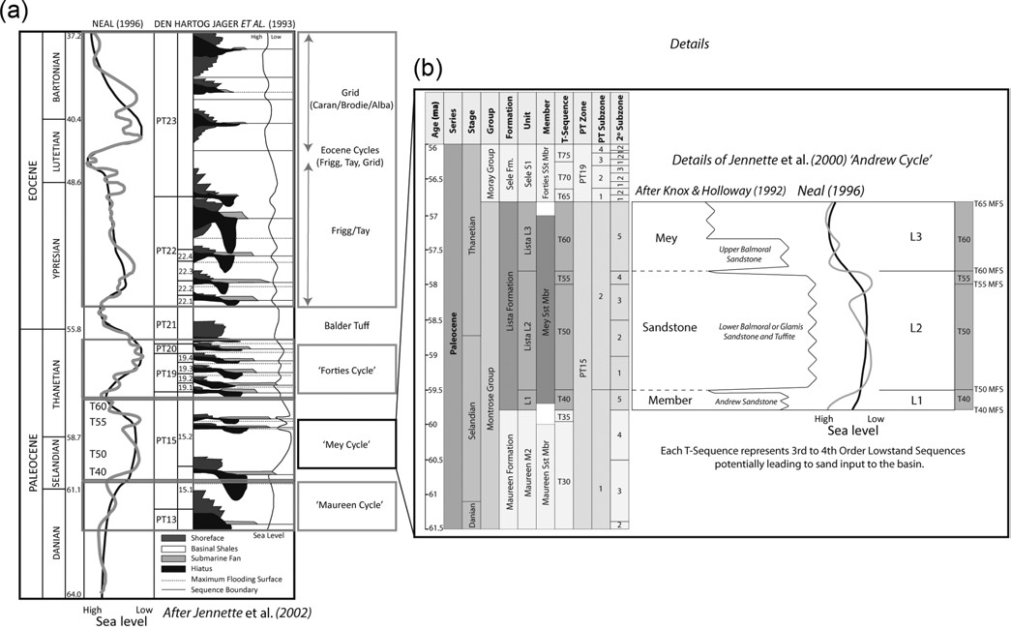

**Fig. 1.** Lithostratigraphic and sequence stratigraphic context of the Lista Formation and Mey Sandstone Member within the Paleocene of the Central North Sea. (**a**) After Jennette *et al*. (2000) illustrating the sea-level cycles and resultant lowstand deposits of each of the major Paleogene cycles postulated by Neal (1996) and Den Hartog Jager *et al*. (1993). The Lista Formation sits within Jennette *et al*. (2000)’s ‘Andrew Cycle’. (**b**) More details of this cycle, including the context provided by various lithostratigraphic and biostratigraphic studies. Note that Knox & Holloway (1992) re-defined the sequence to include the Mey Sandstone Member as an overall term for the Andrew Sandstone, the Glamis or Lower Balmoral Sandstone and Tuffite and the Upper Balmoral Sandstone. Ages (Ma), Series and Stages from Ogg *et al*. (2008), Groups from Mudge & Copestake (1992*a*), Formations, Units and Members from Knox & Holloway (1992), T (Tertiary)-Sequences after Milton *et al*. (1990) and Shell UI Europe, PT Zones, Subzones and Secondary Subzones from Schröder (1992). Sea-level curve from Neal (1996) as (a).

the North Atlantic Igneous Province and related underplating developed (Anderton 1993; Ahmadi *et al*. 2003). The pulsed nature of this magmatic activity has, by some authors, been linked directly to the generation and volumetric variation of clastic basinal input (in the Central North Sea and contemporaneously West of Shetland) although the precise details of these interactions are still under discussion (England *et al*. 1993; Nadin & Kusznir 1996; Ritchie & Hitchen 1996; White & Lovell 1997; Clift & Turner 1998; Andersen *et al*. 2002; Doré *et al*. 2002; Faleide *et al*. 2002; Hall & Bishop 2002; Jones *et al*. 2002; Bott & Bott 2004; Nielsen *et al*. 2007; Shaw Champion *et al*. 2008; Stoker *et al*. 2010) and the role of postrift subsidence variations of the Central and Northern North Sea may be underestimated (Joy 1993).

The precise number of Paleogene sequence stratigraphic cycles noted by different studies varies depending on the spatial and temporal resolution and spatial extent of the work (e.g. ten third-order cycles in Stewart (1987), 19 higher-frequency cycles in Neal *et al*. (1994)). The framework used in this paper (Fig. 1) is based around the lithostratigraphy used by Shell Upstream International (UI) Europe for the Lista Formation in the Central North Sea (Hempton *et al*. 2005), utilizing a combination of the subdivisions from Milton *et al*. (1990), Knox & Holloway (1992), Den Hartog Jager *et al*. (1993), Galloway *et al*. (1993), Mudge & Bujak (1996*a*,*b*), Neal (1996) and Jennette *et al*. (2000), with further biostratigraphic support from Schröder (1992). Knox & Holloway (1992) and Mudge & Bujak (1996*a*,*b*) defined three major subdivisions for the Lista Formation named, from oldest to youngest, L1 (~59.8–59.5 Ma), L2 (~59.5–57.8 Ma) and L3 (~57.8–56.8 Ma). Within L2, Milton *et al*. (1990) recognized two stratigraphic sequences. This framework has been utilized by Shell UI Europe to define four Tertiary (T) Sequences for the Lista Formation separated by maximum flooding surfaces (T40 within L1, T50 and T55 within L2 and T60 within L3). As such, each T-sequence represents a sustained period of sand input into the basin from the shelf (*sensu* Galloway 1989). The Neal (1996) sea-level curve is utilized in this study because it remains the most widely accepted framework for understanding the Paleogene sequences within Northwest Europe and forms the basis of many previous papers (e.g. Jennette *et al*. 2000; Davis *et al*. 2009). Note that the biostratigraphic resolution available for the intra-Lista cycles is relatively poor so that the maps presented in this study are based on the bulk Lista Formation.

# characterization of the Maureen, Mey and Forties turbiditic Sands

A number of authors have published sand presence/absence and approximate thickness maps for the Paleocene turbiditic sands of the Central North Sea based on biostratigraphic and sequence stratigraphic intervals and associated well data (Stewart 1987; Kulpecz & Van Guens 1990; Knox & Holloway 1992; Den Hartog Jager *et al*. 1993; Vining *et al*. 1993; Reynolds 1994; Mudge & Bujak 1996*a*,*b*; Liu & Galloway 1997; Kantorowicz *et al*. 1999; Ahmadi *et al*. 2003; Hempton *et al*. 2005). Although these maps differ in resolution and local details, there is general agreement throughout the Maureen, Mey (and equivalent Heimdal) and Forties sandstone members of a source area to the west/northwest, with sediments being re-deposited on to the basin floor and into the topographically lower areas of the Central Graben and South Viking Graben (Fig. 2). Note that during this period it is believed the shelf/slope break prograded into the basin, although much of this material has now been removed by subsequent erosion (Ahmadi *et al*. 2003). Attempts to understand the volume of sediment re-deposited from shelf to basin floor in each of these sequences have also been made with the Lista Formation, containing the highest volume of sands, and the Maureen Formation, having the highest net to gross according to Liu & Galloway (1997). However, Reynolds (1994) suggests these trends are oversimplified, with considerable variation within individual 0.5–1.4 Ma cycles.

The majority of published research on the Paleocene of the Central North Sea has been conducted by oil companies interested in characterizing the reservoir units of major hydrocarbon fields or placing their licences in a wider context (*sensu* Ahmadi *et al*. 2003). Although the Maureen and Mey sandstone members act as reservoirs locally, the main reservoir unit in the Central Graben (below the Balder Tuff sealing unit) is the Forties Sandstone Member and equivalents. As such, most published work has focused on this stratigraphic interval. Therefore, although field studies (O’Connor & Walker 1993; Pauley 1995; Jolley 2003; Koša 2007) and semi-regional to regional maps of the Maureen and Mey sandstone members exist, our understanding of the internal sediment distribution and emplacement processes are less detailed than for the overlying Forties Sandstone Member. Field-specific studies in this interval are more numerous (e.g. Armstrong *et al*. 1987; Kulpecz & Van Guens 1990; Wills 1991; Whyatt *et al*. 1992; Kantorowicz *et al*. 1999; Leonard *et al*. 2000; Birch & Haynes 2003; Carter & Heale 2003; Hogg 2003; Kunka *et al*. 2003; Brookes *et al*. 2008; Davis *et al*. 2009) and more detailed maps of sediment distribution within the Central Graben have been published (Kulpecz & Van Guens 1990; Kantorowicz *et al*. 1999; Hempton *et al*. 2005; Davis *et al*. 2009), which give a greater insight into the sediment routing of the Forties sands. Kulpecz and Van Guens (1990) noted that the Forties Sandstone Member showed distinct downdip (approximately NW–SE) facies changes from stacked sand-rich channels and lobes to stacked lobes with high lateral variation and finally sand-poor lobes. This work also recognized that some of the sands in the Gannet complex area seemed to be sourced from the west (eastern Scotland) rather than the NW (northern Scotland) (see also Morton 1987; Morton *et al*. 2004).

Den Hartog Jager *et al*. (1993), Richards & Bowman (1998) and Jennette *et al*. (2000) explicitly refer to the Forties system as a sand-rich to mixed sand/mud basin-floor fan. These ideas were developed by Hempton *et al*. (2005), who used modern regional 3D seismic methods and well data to define the main axial basin-floor fan system which appears to branch into western and eastern arms distally and at least three separate, and seemingly slightly younger, lateral or side fans sourced from the west (Fig. 2c). This work also provided details of downdip facies variations from channel dominated (e.g. in the Forties/Nelson field area) to sheet dominated with rare channels (e.g. in the Fram field area). Finally, this paper presented thickness, net to gross and porosity/permeability trends showing a general drop in these values down-fan (both within the main and lateral units). The major control on these trends is the relict Mesozoic graben structure with the major lineaments and intra-basinal horsts defining the sediment distribution (e.g. O’Connor & Walker 1993; Mudge & Bujak 1996*a*; Hempton *et al*. 2005; Davis *et al*. 2009; Fig. 2c, d). Further local modification is provided by salt diapirs, which were actively growing and resulting in bathymetric features during the Paleocene (Hodgson *et al*. 1992; Davison *et al*. 2000). This activity produced thickened and often complex reservoir units and associated traps encountered in fields such as Merganser, Scoter and Pierce (e.g. Davison *et al*. 2000; Payne *et al*. 2005). Sand injectites are also a well-documented phenomenon in the North Sea with the potential to remobilize large volumes of sand and produce complex stratigraphic relationships (e.g. Briedis *et al*. 2007; Huuse *et al*. 2007; Hurst *et al*. 2011).

Mudge & Bujak (1996*a*) suggest that the sands associated with the Lista Formation are more extensive than those in the Sele Formation but that they are present in similar areas, suggesting a causal link to antecedent structures (see also O’Connor & Walker 1993) (Fig. 2d). Apart from these basic maps, our understanding of how similar or dissimilar the Mey turbidite sands might be in facies and depositional trends to the overlying Sele sandstones is limited. In particular, it is unclear if the Mey system also branches into western and eastern arms, if lateral systems operate and if similar facies distributions exist in this interval. The need for a greater understanding of the Mey Sandstone Member has increased with the desire to explore for North Sea hydrocarbons in subtle stratigraphic traps and with the ongoing discussion over what these cycles can reveal concerning shelfal sorting and storage processes and timing of hinterland uplift during the Paleogene (cf. Sele cycle analysis of Den Hartog Jager *et al*. 1993 and Jennette *et al*. 2000). In order to address these issues, a much fuller understanding of each formational cycle – including sediment distribution and routing, the role of modification by structures and the internal distribution of, for example, facies associations, net to gross and porosity – is required.

# aims and locality of study

The main aim of this paper is to present an updated model for the Mey Sandstone Member within the Central Graben area (Fig. 2a, b) based on modern semi-regional 3D seismic ‘megasurvey’ data, a large well database and associated cored intervals. The spatial extent of the study is constrained by the available seismic data and concentrates on the southern limb of the Mey system (*sensu* Mudge & Bujak 1996*a*; Ahmadi *et al*. 2003), covering areas south of the Forties/Nelson fields (Quads 21, 22, 23) to the Jaeren High in the east and south to the Ardmore field (Quads 29, 30 and 31) (Fig. 2b). The available seismic dataset ends at the UK/Norway border but further well and core data were available from UK Quads 14, 15 and 28 as well as released data from the Norwegian Petroleum Directorate. The approach taken was to characterize the system from core-, well- and seismic-scale and integrate these datasets within a semi-regional model set using previous published maps as a framework.

# dataSetS

Seismic interpretation was completed utilizing a subset of the PGS Central North Sea MegaSurvey and supporting wellpicks provided by Shell UI Europe. The seismic volume was loaded into Schlumberger’s Petrel seismic-to-simulation software (version 2009.2) with further analysis using ffA’s SVI Pro (2009.1) and Shell’s 123di internal seismic interpretation package. The MegaSurvey is a regional-scale volume (50 m bin size and a vertical resolution of ~25 m (based on a dominant frequency of ~40 Hz and an internal velocity of ~4000 m s–1)) which, for some workflows, benefited from minor noise-reduction filtering. Twenty core sections, totalling ~504 m/1653 ft from across the Central North Sea (Fig. 2a, b) were provided by Shell UI Europe

|  |
| --- |
| **Fig. 2.** Spatial context of the current study and literature examples of known sand extents within the Palaeogene sequence. (**a**) Regional context after  Ahmadi *et al*. (2003), showing the seismic extent/main study area, the possible Lista-age shelf/slope break and sediment transport routes from the  Scottish and Shetland land masses (after Hall & Bishop 2002). Three cored wells are also shown which fall outside the main study area shown in  (b). (**b**) Main study data extent, including a subset of the PGS Central North Sea MegaSurvey, selected UK well data (provided by Shell UI Europe), Norwegian well data (provided by Norwegian Petroleum Directorate public access database) and core samples used (provided by Shell UI Europe and the British Geological Survey). (**c**) Regional sketch map of Sele Formation reservoirs (after Hempton *et al*. 2005). Note the two main distribution systems (axial and lateral) and the split into western and eastern arms of the axial fairway defined by the underlying topography. (**d**) Facies distribution within the ‘Lista stratigraphic sequence’ (after Mudge & Bujak 1996*a*). Although less detailed than the Sele sequence map in (c), there is a suggestion of control by the underlying rift topography and subtle areas of sand thicks and thins. |

in Aberdeen (alongside detailed well reports and biostratigraphic picks) and by the British Geological Survey in Edinburgh. Further quantitative analysis was performed in Advanced Logic Technology’s WellCAD software package. Finally, well data for

338 wells (approximate extent in Fig. 2b) was provided by Shell UI Europe for petrophysical analysis in Schlumberger’s Techlog (2010.1.3) software. A further 149 wells in the Norwegian sector of the Central North Sea were studied using released data and documents on the Norwegian Petroleum Directorate website.

# data: MethodS and analySIS

## regional 3d seismic: methods and characterization

The stratigraphic nature of the top and base Lista Formation picks (as shale-on-shale boundaries) and the merged nature of the dataset makes regional seismic mapping of these surfaces difficult. It is, however, possible to produce accurate Top Sele and Top Chalk horizons which can then be utilized as reference horizons (in combination with well data analysis) to establish an isoproportional framework for the Lista interval (*sensu* Posamentier *et al*. 2007). This method assumes that a set percentage of the interval between reference horizons can be assigned to, for example, the Sele, Lista and Maureen Formations allowing ‘pseudo-horizon’ surfaces to be generated. These surfaces are then checked against the well tops and re-picking undertaken where necessary. Further well data analysis revealed that there is some variation in these relative proportions from NW to SE across the study area and this was factored into the final set of horizons (e.g. the proportion of the Lista interval increases from ~35% to 45% from the Forties–Montrose High to the Josephine Ridge). This method is not perfect, with specific limitations being the accuracy of well picks, areas where overlying cycles may erode into older stratigraphy (or where compensational stacking or differential compaction has occurred) and structural or salt-induced highs which can break up the stratigraphy with localized slumps or debris flows. Despite these limitations, the authors believe that isoproportional slicing was the most efficient method of sufficient accuracy to achieve regional-scale interpretations within the constraints of the available data. As a quality control, the Top Sele to Top Chalk isochron (dominated by the Forties Sandstone Member) is shown to demonstrate very similar trends to those presented by Jennette *et al*. (2000) and Hempton *et al*. (2005) (Fig. 3a).

The generation of regional-scale Top Lista and Top Maureen horizons enabled the ‘Lista Interval’ to be assessed through a variety of attribute volumes, including root mean square (RMS) amplitude (Fig. 3b), variance, coherency, complex trace and instantaneous frequency (Fig. 3c). Note that these attributes cover the entire Lista Interval with the aim of defining the main Mey sand fairways and do not take into account 4th-order or localized changes in sand distribution. These datasets can vary in quality across this regional-scale survey and between attribute algorithms. For example, Figure 3b illustrates that RMS amplitude provides a detailed view of the proximal system but suffers from vertical resolution (tuning thickness) limitations south of the Gannet Complex and along the southwestern margin of the Central Graben. Meanwhile, Figure 3c shows that instantaneous frequency datasets enable more refined fairway definition in the distal areas but lack detail in the northern part of the survey. Therefore, interpretations of sediment routing are based on the integration of a wide variety of attribute-based mapping.

The analysis of these volumes supports a model of Mey sand distribution with both a graben-axial system (NW–SE), which appears to be split into western and eastern fairways, and at least two lateral (west–east) systems. The axial systems, in particular, appear to be controlled by the underlying structure, pinned to the east by the Jaeren High, to the west by the grabenbounding faults and with the Forties–Montrose High separating the western and eastern fairways in the north. Local modification by halokinetic features is also apparent (*sensu* Davison *et al*. 2000) and it is also possible that the Josephine Ridge also separates the two axial fairways distally. The timing of the development of the lateral systems relative to the axial system is not clear and the characterization of the distal extent of the lateral system is hard to determine, with a possible amalgamation with western and eastern axial fairway sands. Understanding the very distal (southeastern) areas of the axial systems is also difficult, with some structural interference and tuning thickness issues apparent.

In order to consider the internal seismic architecture of the Lista Formation, and quality check seismic attribute interpretations, seismic facies analysis was conducted across representative cross-sections of the axial and lateral systems (locations based on attribute mapping). It should be emphasized that this work was conducted over the entire Lista interval in order to define the main sand fairways. Four main seismic facies were recognized, consisting of two end-members: High Amplitude Continuous Reflections (HACR) and Low Amplitude Discontinuous Reflections (LADR) and two intermediate facies (HACR with LADR and LADR with HACR) (Fig. 4). Based on the concept that sand-rich areas (especially those with more channelized turbidite flows) are more likely to produce discontinuous seismic reflections than more mud-rich areas or background draping pelagic shales (*sensu* Weimer & Slatt 2007), it is proposed that the LADR facies represent sand-rich areas and HACR very mud-rich areas. However, it is recognized that slumping or debris flows adjacent to structures can complicate this simple framework. The intermediate facies would, therefore, consist of sandstones interbedded with mudstones in varying proportions. Therefore, seismic facies analysis acts as a qualitative control on the quantitative algorithms utilized on the same data during attribute mapping. This work revealed a number of trends. First, the main sand fairways (axial and lateral) identified from attribute work are also identifiable in the seismic facies with some suggestion that thin sands are more laterally extensive than previously thought. Secondly, the sand fairways show a distinct pattern of a central core of sand-rich facies decreasing laterally to become more mud-rich and, finally, the proportion of sand-rich facies decreases downdip, suggesting an increase in heterolithics.

These results were then integrated with the seismic attribute work to produce a final, seismically-derived interpretation of relative sand thickness (in time) and distribution (Fig. 3d). This map enables a first-pass understanding of the main Mey Sandstone Member sediment fairways. However, because of the inherent limitations in data resolution, horizon picks, lithological assumptions and characterization of the entire Lista interval, there is some local variability in results. ‘Groundtruthing’ is, therefore, required to provide greater detail and place these maps in context. This was achieved with both core facies analysis and regional petrophysical data which, in turn, enables a full understanding of sand distribution to be presented.

## core: approach and facies analysis

The aim of this analysis was to identify the main lithological facies of the Lista Formation in order to calibrate interpretations from seismic and well log analysis with particular focus on lithofacies interpretations of wireline data. A comparison with the Hempton *et al*. (2005) four-fold facies scheme for the Sele Formation (amalgamated sandstone, sand-prone heterolithics, mud-prone heterolithics and hemipelagic mudstones) was also made and this was assessed for its suitability for use in the Lista Formation. Figure 5 illustrates the main lithologies in each group and their typical well log signature, with Figure 6 providing some examples of the facies seen in core.

The Amalgamated Sandstone facies is dominated by clean, thick (typically metre-scale) sandstones (mainly quartz arenite) with subsequent flows often being erosive (amalgamated) or alternatively with thin turbiditic mudstone-rich caps or very thin pelagic shale divisions. The sandstones can be massive, laminated, graded, disrupted or rarely show signs of clastic injection. Rare calcitized or sideritic intervals also occur (usually 1 ft or less, see Fig. 6a). In the studied core intervals the average grain size is fine (0.125–0.25 mm), with a dominant distribution from very fine (0.0625–0.125 mm) to medium (0.25–0.5mm) with larger grain sizes being more common in the NW (proximal) area of the study (*n* = 2256). The average porosity is 24.1% (*n* = 240), whilst the average permeability is ~360 mD (horizontal (*k*h) (*n* = 266) and ~370 mD (vertical (*k*v) (*n* = 40).

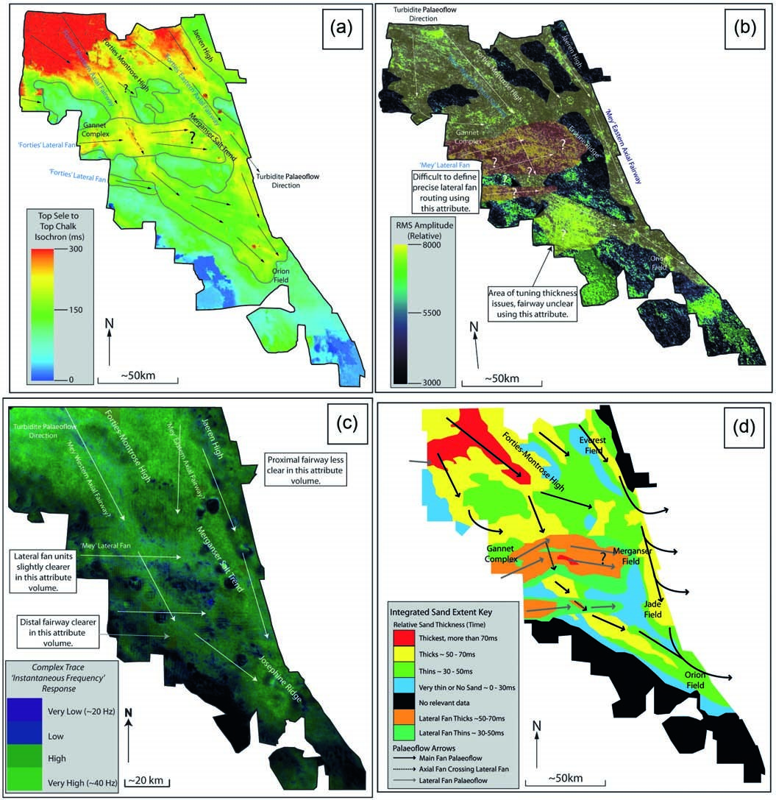

**Fig. 3.** Examples of seismic characterization and attribute volumes showing the approximate depositional patterns of the Forties and Mey sandstone members across the study area. Note that the data area is shown in Figure 1b. (**a**) Top Chalk to Top Sele isochron believed to be dominated by the Sele Formation signal. Note the similarity to the main sand routing patterns recognized by Hempton *et al*. (2005) (Fig. 1c) with distinct western and eastern axial fairways and at least two lateral systems. (**b**) Interpreted RMS amplitude map for the ‘Lista Interval’ showing main sand routing for the Mey Sandstone Member (white arrows) which appears to be similar to that in the Forties (with distinct western and eastern axial fairways (in yellow) and at least two lateral units (in orange)). Note that it is difficult to correctly define the distal axial deposits and the western edge of the lateral fans in this attribute volume due to the limited vertical resolution of the seismic data (tuning thickness). However, the proximal area is well defined. (**c**) Labelled ‘Complex Trace’ (instantaneous frequency) attribute map for the ‘Lista Interval’. This attribute measures wavelet variability/complexity in relation to the frequency (often in parallel with semblance measurements (*sensu* Taner *et al*. 1979; Robertson & Fisher 1988)) which can be a lithological proxy. Using this method it is, for example, possible to define the distal area of the axial system that was less clear in part (b) but the proximal area is less well defined. (**d**) Integrated map of Mey Sandstone Member depositional patterns and turbidite flow routing from seismic facies and attribute volume mapping. This map is the result of interpreting many attribute volumes, such as those in parts (b) and (c) and integrating this with a seismic facies framework (Fig. 4). The resulting map shows that distinct sand fairways are visible but also that more ‘groundtruthing’ with core and well data is needed to place seismic maps in context and provide greater detail in certain areas.

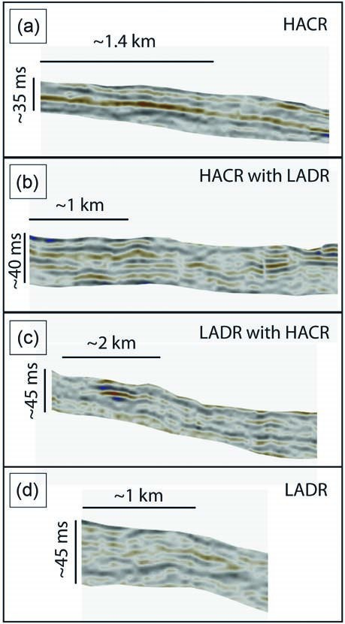

**Fig. 4.** End-member seismic facies for the Lista Formation of the

Central Graben which act as a continuum from top to bottom between

High Amplitude Continuous Reflectors (HACR) and Low Amplitude Discontinous Reflectors (LADR). As described in the main text these, and the intervening facies, enable quality checking of the attribute volume interpretations. It is also important to note that these seismic facies represent sand-dominated to shale-dominated successions and, as such, represent similar sedimentological groupings, at a different scale, to those seen in core and well logs.

This facies is interpreted as representing the main period and/ or route of sand input into the basin (as repeated high density turbidite flows) and is consistent with distributary channels (in proximal areas) or sand-rich sheets (in distal areas).

The Sand-Prone Heterolithic facies consists of a mix of sandstones and pelagic mudstones with clastic material being dominant but often in thin (typically cm- to m-scale) isolated or semi-isolated beds (Fig. 6b). As in the Amalgamated Sandstones, these deposits vary in nature from massive to laminated or graded. Quantitative analysis on the cored intervals emphasizes the two end-member lithologies inherent in this facies (claystones and siltstones (thin heterolithic sandstones) and cleaner sandstone intervals) and, as a result, the grain size and porosity/ permeability definition shows a large degree of variability. The average grain size is very fine (0.0625–0.125 mm) with sizes from clay (0.0001–0.0039 mm) to fine-grained sand (0.125–0.25 mm) being common (*n* = 1492). Porosity values vary from 10% to 25%, with the average being 17.5% (*n* = 187). Permeability values are also variable but show averages of 21.24 mD *k*h (with values ranging from 0.01 to 99 mD) (*n* = 188) and 8.99 mD *k*v (with values dominantly below 10 mD) (*n* = 49).

This facies is interpreted as being marginal to the main sand routes (channels or sheets) or being within a slightly more quiescent period of basinal input with a mix of high and low density turbidite flows.

The Mud-Prone Heterolithic facies is similar to the SandProne facies except that the dominant lithology is pelagic mudstone. Sandstone beds are nearly always thin (typically cm- to tens of cm-scale) and isolated events which again vary in nature from massive to laminated or graded (Fig. 6c). The rare sands mean that the grain size, porosity and permeability values are not as variable as for the sand-prone facies. The average grain size is silt (0.0039–0.0625 mm) with a dominant distribution from clay (0.0001–0.0039 mm) to very fine-grained (0.0625– 0.125 mm) (*n* = 1298). The average porosity value is ~14% (*n* = 46) and the average permeability is 0.14 mD (*k*h) (*n* = 43) and 0.04 mD (*k*v) (*n* = 12).

This facies is interpreted as being very marginal to the main sand-input routes or being within a very quiescent period of basinal input with low density turbidite flows being dominant.

The Hemipelagic Mudstone facies is dominated by mudstones (Fig. 6d), although some very thin (typically cm-scale) isolated sandstones can occur which are sometimes reworked, remobilized or injected. The average grain size is clay (0.0001– 0.0039mm) (*n* = 1791) and the average porosity (of the isolated sandstones) is ~9%, with a dominant distribution between 5% and 15% (*n* = 33). Permeability averages are 0.09 mD (*k*h) (*n* = 32) and 0.02 mD (*k*v) (*n* = 4), with values dominantly below 1 mD. Note that the mudstone-dominated nature of this facies means there are very few analysed core plugs available.

This facies is interpreted as being typical of undisturbed basin-floor deposition with very rare turbidite flows or as being a period without significant sand input into the basin.

|  |
| --- |
| **Fig. 5.** Facies comparison chart illustrating the relationship between core facies and their expression within petrophysical log suites (after Hempton *et al*. 2005 and Kilhams *et al*. 2011). Note the localized impact of calcitized sandstone horizons and chalk debris flow units (see text for full discussion). |

There are some limitations to this simplified four-fold facies scheme, which can often be linked to localized faults and halokinetic structures. Sand injectites make up less than 5% of the total core section and are more often found close to salt diapirs (examples of this link have also been observed by Payne *et al*. (2005) and Svendsen *et al*. (2010)) although the dataset considered here is not large enough to prove this association. The facies scheme is designed to understand the distribution of depositional sandstones and, therefore, does not take into account sand injectites, although their local implications for vertical connectivity should not be underestimated (e.g. Wild & Briedis 2010). However, these features are typically small (cm-scale) and are relatively unimportant when compared to the larger examples to the north (e.g. Duranti & Hurst 2004; Fretwell *et al*. 2007; Huuse *et al*. 2007; Lonergan *et al*. 2007; Cartwright 2010; Szarawarska *et al*. 2010). Faulted and slumped intervals are also difficult to assess, particularly as non-Lista-age sandstones can be faulted or remobilized post-depositionally so that they interfinger true Lista Formation material. Reliance has been placed on biostratigraphic picks and cross-checking against composite logs and other drilling information to identify such features. Although not as important as in the underlying Maureen Formation (Johnson 1987), chalk debris flow units regularly occur as thin bands (typically a few cm thick and consisting of sub-rounded coarse clasts within mudstones). These intervals are often associated with adjacent structural features and can be considered in petrophysical analysis by use of the sonic log (see Fig. 5). Diagenetic processes appear to have two main effects: calcitization of sandstones (development of calcite nodules) and the minor growth of siderite nodules. Stewart *et al*. (2000) suggest that calcitization can be associated with adjacent faults (and typically make up 0.6–7.2% of sandstone intervals). Siderite nodules appear to also be a localized feature (these can also be considered with use of the density log). All these features are difficult to consider using this simplified facies scheme although they are all minor effects and are likely to have minimal impact on a regional analysis of well data. It should also be noted that sedimentary logging alone does not allow a distinction to be made between sandstones within the axial and lateral systems.

It is clear that the main lithologies found within the Lista Formation are consistent with other deep-water examples from the North Sea and elsewhere (e.g. Mutti & Ricci Lucchi 1978; O’Connor & Walker 1993; Vining *et al*. 1993; Oakman *et al*. 1997; Brookes *et al*. 2008; Davis *et al*. 2009) in that there is a basic continuum from sand-rich to mud-rich intervals. Despite the limitations outlined above, the facies scheme utilized here (after Hempton *et al*. 2005) does allow the core material to be grouped into simple facies that can then act as a guide to the probable lithologies to be found within regional petrophysical analysis. Given the extensive well dataset utilized in this study this scheme acted primarily as a qualitative guide to ensure that well data analysis was as accurate as possible.

Quantitative core facies analysis also enables an evaluation of the role of grain size, diagenesis and burial compaction on reservoir quality to be made, providing more detail to previously published data (cf. O’Connor & Walker 1993). It can be demonstrated that there is a direct link between grain size and porosity

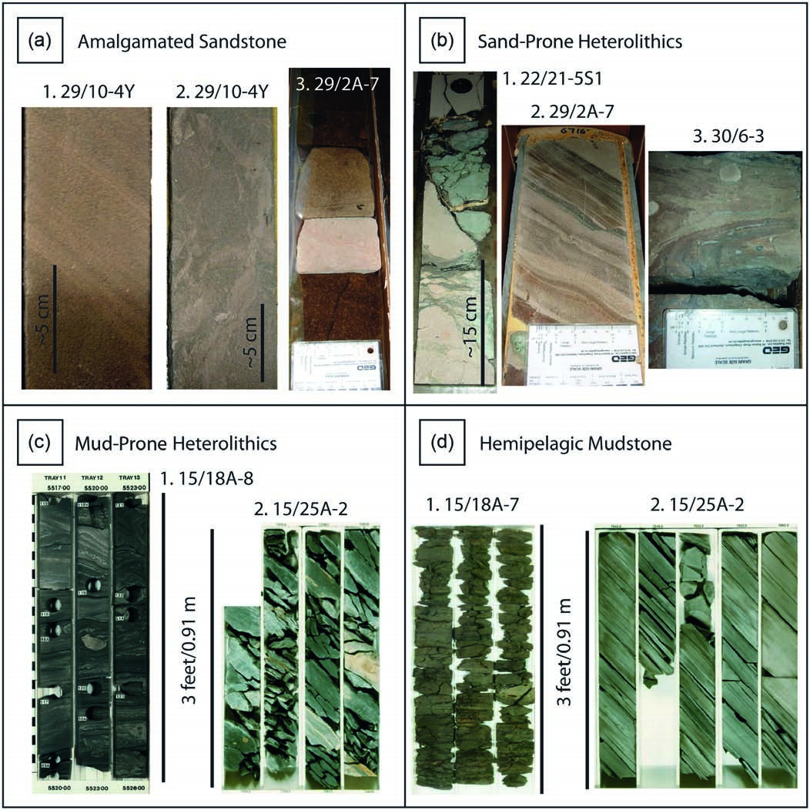

**Fig. 6.** Core photographs illustrating examples of each of the facies defined in Figure 5. Although this study has utilized a simplified facies scheme, these images, and other core-based studies (e.g. O’Connor & Walker 1993; Davis *et al*. 2009), illustrate that the lithologies are more complex. The grain-size card shown in some photographs is approximately 9 cm long. (**a**) Amalgamated Sandstone facies examples. Images 1 and 2 show examples from well 29/10-4Y. Image 1 illustrates fine-scale (mm to cm scale) cyclic turbiditic laminations of fine- (0.125–0.25 mm) and very fine- (0.0625–0.125 mm) grained sandstone (from ~13958′). Image 2 illustrates disrupted (otherwise massive) very fine-grained sandstone (from ~13962′). Image 3 is from well 29/2A-7 and shows a discrete band of calcitized sandstone within medium- (0.25–0.5 mm) grained, oil-stained sandstones. (**b**) Sand-Prone Heterolithics facies examples. Image 1 is from well 22/21-5S1 and illustrates a section of grey-green mudstone within an interval of disrupted (possible partially injected *sensu* Briedis *et al*. 2007) fine- (0.125–0.25 mm) to very fine- (0.0625–0.125 mm) grained sandstones (from ~9009′). Image 2 is from well 29/2A-7 and shows mm-scale intercalation of very fine-grained sands, silts (0.0039–0.0625 mm) and muds (from ~6718′). Image 3 is from well 30/6-3 and illustrates a slumped section dominated by very fine-grained sandstone but also including silts, muds and mm- to cm-scale chalk grains (from ~9235′). (**c**) Mud-Prone Heterolithics facies examples. Image 1 is from well 15/18a-8 and shows a section dominated by dark grey to black mudstones which are intercalated/slumped with siltstones (0.0039–0.0625 mm) and very fine- (0.0625–0.125 mm) grained sandstones (from 5517–5526′). Image 2 is from well 15/25a-2 and illustrates a section dominated by bioturbated mudstones with rare very fine-grained sands and silts (from 7353–7364′). (**d**) Hemipelagic Mudstone facies examples. Image 1 is from well 15/18a-7 and shows a section dominated by grey-green mudstones (from 5494–5503′). Image 2 is from well 15/25a-2 and illustrates a thick section of light to dark grey mudstones (from 7045–7068′).

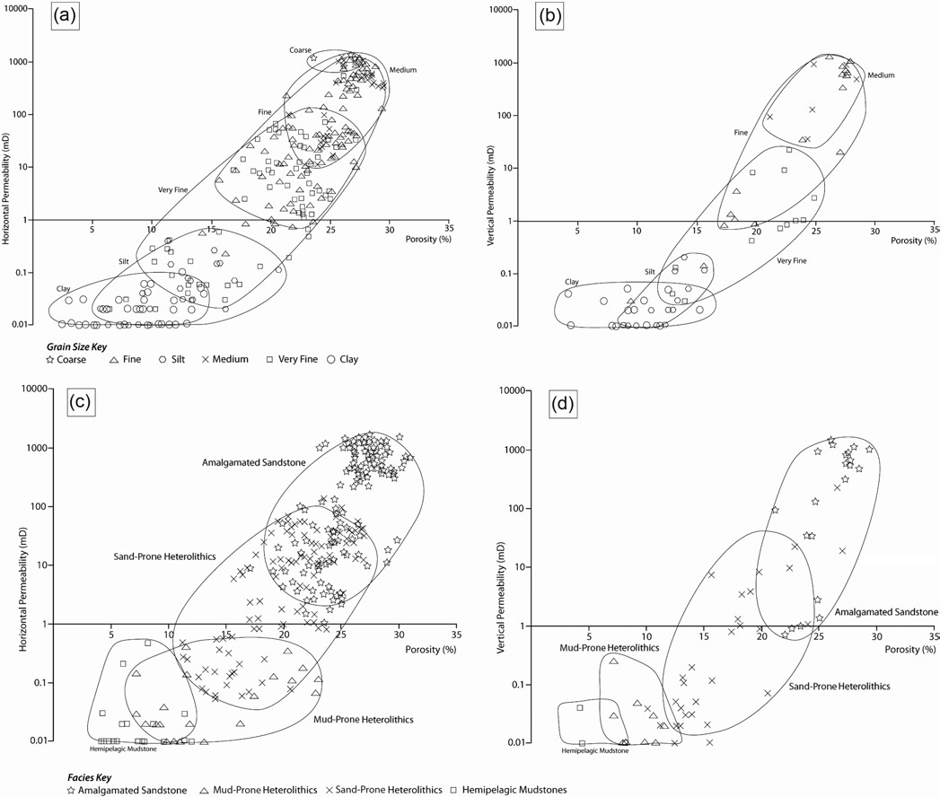

**Fig. 7.** Plots illustrating the relationship between porosity and both horizontal and vertical permeability for different grain-size divisions (**a, b**) and for the facies divisions of Hempton *et al*. (2005) (**c, d**). Note that higher porosity and permeability values are correlated to larger grain sizes and, as each facies has a distinct grain-size range (see text), it is possible to define these divisions by sandstone quality. As such, the Amalgamated Sandstone facies is associated with the highest porosity and permeability values and the mudstone-rich facies with lower values. Based on a dataset of 6837 grain-size measurements, 506 porosity values, 529 horizontal permeability values and 105 vertical permeability values.

(Fig. 7a, b) and, as each facies has a distinct grain-size distribution, an individual porosity and permeability range for each of the four divisions can be defined (Fig. 7c, d). These primary sedimentological trends appear to dominate the characterization of sandstone quality. As discussed above, although calcite and siderite cementation does occur and has a documented impact on porosity (e.g. O’Connor & Walker 1993; Stewart *et al*. 2000), the effects are localized. Burial compaction also seems to have a limited impact on porosity within the Lista Formation, with grain size and related facies more important in defining high and low quality intervals (Fig. 8). As a 1D dataset, core sections are limited when attempting to define downdip trends but, when considering the seismically defined western axial fairway, it does appear that average grain sizes decrease from fine–medium in proximal areas to very fine–fine in distal areas and that this can be linked to similar decreases in porosity and permeability values. Note that these core plug data have been used to define porosity and permeability (*k*h and *k*v) transforms so that permeability can be estimated from petrophysical data (using the Amalgamated Sandstone and Sand-Prone Heterolithics facies). Consequently, studies of relevant core sections from across the Central North Sea suggest that the Hempton *et al*. (2005) Sele Formation facies divisions are equally applicable within the Lista Formation. However, the limitations of this scheme need to be taken into account when using it as a guide to petrophysical interpretation.

## regional-scale petrophysics: methods and characterization

Petrophysical analysis firstly involved the production of derived data, including *V*Sh curves, related net-to-gross curves and porosity estimates. Because the Central Graben well database shows a hugely variable data quality (from over 40 years of drilling) every petrophysical analysis result was cross-checked against available core intervals or composite logs to ensure accuracy. Note that full petrophysical analysis was only completed on the

|  |
| --- |
| **Fig. 8.** Plots illustrating the relationship between porosity and depth. Burial compaction trends appear to be of secondary importance to primary sedimentological relationships, such as (**a**) grain size and (**b**) related facies division, with the sandstone quality patterns mirroring those seen in |

Figure 7. Based on 372 porosity data points.

UK North Sea wells such that for Norwegian sector wells no estimates of porosity and only approximations of net thickness and net to gross were determined. Each well was also given a confidence rating so that the resultant interpretations could be cross-checked against high confidence wells (this was also based on the resolution of the biostratigraphic picks used to define the Lista Formation). Using the original and derived curves, estimates of gross thickness, net thickness, net to gross and porosity were then produced for the bulk Lista Formation. Note that, as described above, the net intervals here (those used for porosity analysis) are designed to include Amalgamated Sandstone and Sand-Prone Heterolithic intervals only and, where necessary, were corrected for well deviation. Supporting datasets were also produced to help understand the possible limitations in sedimentological analysis. This included estimates of ‘carbonate’ within each well (based on gamma ray and sonic signature) to understand if chalk debris flow material or calcitic cementation was impacting the results. These well data were then contoured using kriging analysis before a final stage of manual interpretation to ensure the results were geologically sound.

Net thickness and net-to-gross maps (Fig. 9a, b) illustrate the existence of similar axial and lateral fairway trends to those interpreted from seismic data. For example, the net thickness map shows distinct areas of higher values to the west of the Forties Montrose High (corresponding to the western axial fairway) and adjacent to the Jaeren High (the eastern axial fairway). This map suggests that the western axial fairway can be seen as a thick accumulation of sands (over 250′/76 m) in the more proximal areas and that it can be followed towards the SE (following the underlying graben topography). This system thins a little (to ~125′/38 m) until meeting an area of thick sandstones to the west of the Merganser salt trend (coincident with the lateral system mapped from seismic data). The western axial fairway appears to continue to the SE, thinning to around 50 feet (15 m) before an area of slight thickening around the Josephine Ridge (up to 125′/38 m). The eastern fairway appears to follow a more complex route (compared to that seen in seismic analysis) with much of the sand south of the Jaeren High apparently routed towards the SW and the Merganser Field (with more minor amounts routed towards the SE and possibly towards the Josephine Ridge). The net to gross map appears to confirm these basic trends. These maps also show that the lateral system (~56.9°N and ~0.7°E) is relatively thin (up to 75′/23 m) but has high associated net-to-gross values (up to 0.35) and that the smaller lateral system to the south (~56.9°N and ~1.2°E) is also present. However, the extent of these systems distally may also have been overestimated by seismic analysis (due to tuning thickness issues); this is further analysed in Figure 10c. The porosity map (Fig. 9c) shows a general decrease in values from proximal (up to 35%) to distal and marginal areas (~10–20%), with the main highs being consistent with the central sand routing of the axial and lateral systems. This distal decrease is consistent with the idea that amalgamated clean sandstones with larger average grain sizes are more dominant in proximal areas and that grain size decreases distally (see ‘Core: approach and facies analysis’) as heterolithic intervals become more dominant and as average grain size in the clean sands decreases. A slight difference in porosity values between the proximal western (25–35%) and eastern (15– 25%) axial fairways can also be seen which may be an expression of the latter being slightly more distal from a source area to the NW. Further maps were also produced of permeability trends (as a transform from porosity (see above)) and of ‘carbonate’ content which confirmed that the regional impact of debris flows and calcite cementation are relatively minor in this interval.

Petrophysical analysis also enabled the production of key correlation panels designed to consider the probable extent of each of the Lista Formation T-cycles and test the validity of ideas developed from seismic and petrophysical mapping. Note that only a small subset of the wells used in this study has good biostratigraphic control sufficient to accurately distinguish the intra-Lista T-cycles. However, because the L1 (T40), L2 (T50 and T55) and L3 (T60) divisions are lithostratigraphic (sand-prone intervals with bounding shales representing maximum flooding surfaces) it should be possible to produce an interpretation of basinal cycle extent based on lithological correlations. This becomes more difficult in areas of high sandstone amalgamation (for example in more proximal settings). Note that petrophysical logs have not been included directly in Figure 10 because of the calibration issues associated with a dataset stretching over 40 years of exploration and production; Figure 5 illustrates how these facies were defined

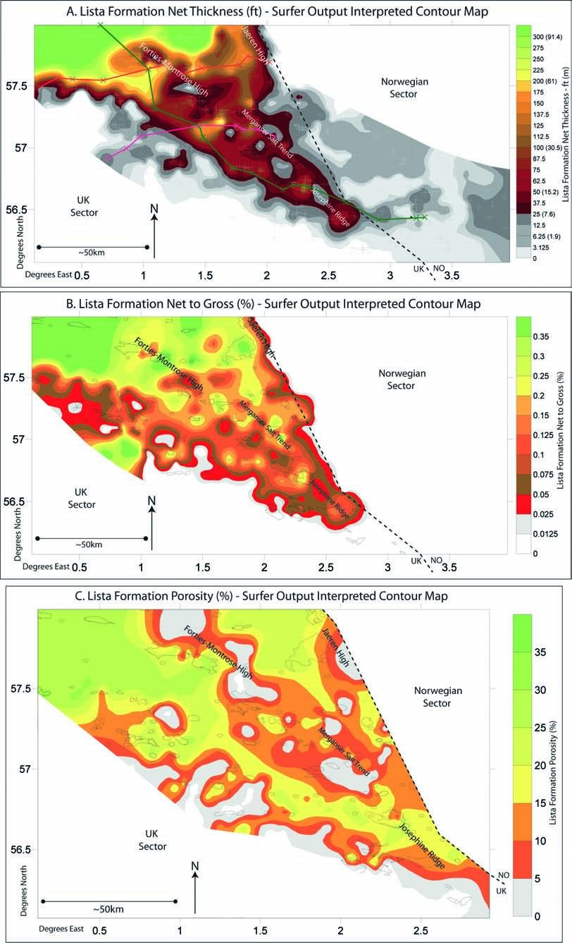

**Fig. 9.** Examples of petrophysically defined maps of (**a**) net thickness, (**b**) net to gross and (**c**) porosity. These maps allow detailed patterns within the Lista Formation to be plotted (see text for details). Selected hydrocarbon fields and structural features also shown. Note that (c) does not show any data in the Norwegian sector because full digital petrophysical analysis was limited to the UK wells. Lines shown in (a) relate to the correlation panels in Figure 10 with the dark green line being the western axial fairway correlation, the orange line the proximal strike section correlation and the pink line relating to the lateral system correlation. (a) also shows the approximate positions of all 487 wells used in the study.

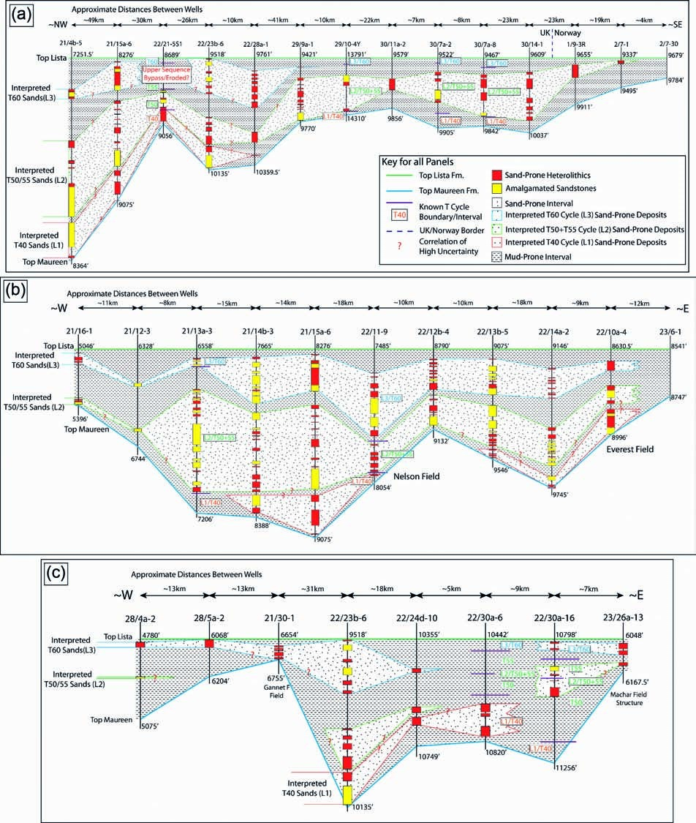

**Fig. 10.** Key correlation panels for the Lista Formation of the Central Graben. Localities of panels shown in Figure 9a and key for all panels shown in (a). The petrophysical facies illustrated here have been defined from a large range of original and derived logs of varying quality over 40 years of drilling (see Fig. 5); to retain clarity the data are simplified within the panel. Correlations are made on petrophysically derived Sand-Prone Heterolithics and Amalgamated Sandstone packages which are tied on T-cycle data where detailed picks are available and based on lithostratigraphic variability in other wells. Note that the T-cycles contain a mixture of sands and muds (so that the stippling is representative of sand-prone intervals) but that these intervals should, in theory, be separated by a mud-dominated interval representing a maximum flooding surface (with the T-cycles representing lowstands (e.g. Neal 1996)). Question marks represent areas of correlation uncertainty and this is more often the case in proximal areas where amalgamation can occur between different sand units due to erosive turbidite flows. (**a**) Section approximately down the western axial fairway of the Mey Sandstone Member illustrating the progradation of the system between the L1 and L2 intervals (biostratigraphic resolution does not allow the T50 and T55 cycles to be separated) and then a backstepping between this and the L3 interval. Note that because well 22/21-5S1 is relatively marginal to the main system there may be some local bypass or reworking of sandstones within the T55 and T60 sequences. (**b**) Approximate proximal strike section across the western and eastern axial fairways. Note that the L1 sands are only found in the basinal lows but that the L2 and L3 sequences are deposited everywhere (although they do show thickening and thinning on to the western margin, Forties–Montrose High and Jaeren High to the east). (**c**) Section across the main lateral system and eastwards to the Merganser Salt Trend (Machar Field). Note that the lateral system is relatively minor in extent and does not seem to reach the area to the east. It is also possible that these lateral deposits are dominated by relatively late (L3) sedimentation. Instead, it is difficult to correlate the sands east of well 22/24d-10. This is probably because these wells showed a mixed signal from the western and eastern axial fairways.

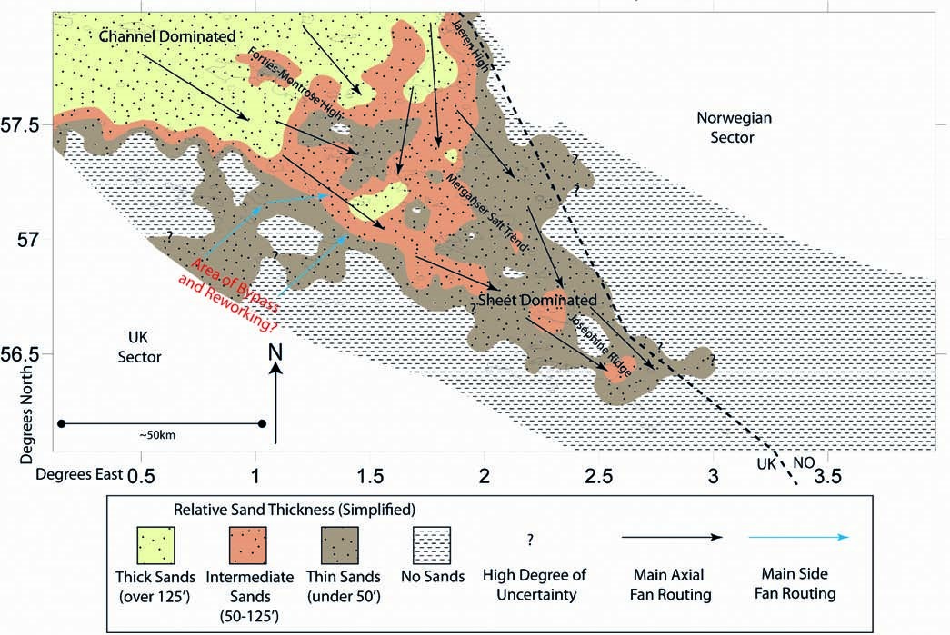

**Fig. 11.** Lista Formation simplified summary map showing the integrated interpretations of seismic, well log and core analysis. Approximate relative thicknesses are shown with the more proximal areas of thick and intermediate sands most likely to be dominated by amalgamated channels and other erosional facies (high density turbidites). The more distal or marginal intermediate and thin sands are more likely dominated by sheet- or lobe-like deposits (with Sand- or Mud-Prone Heterolithic facies). The main turbidite flow routes are also interpreted, defining the western and eastern axial fairways and also the two lateral units. The areas of highest uncertainty are marked with a question mark and include the areas of the axial system within the Norwegian sector and the possible areas of bypass or reworking associated with the lateral systems.

utilizing suites of re-calibrated logs. Figure 10a shows an example correlation panel designed to follow the western axial fairway. This demonstrates that between the L1 and L2 cycles the entire system progrades basinwards and then backsteps in L3. Figure 10b illustrates a proximal strike section across the western and eastern axial fairways in the vicinity of the Forties–Montrose High. Note that the L1 sequence sands seem to be limited to basinal lows. The L2 and L3 thin over highs (and particularly towards the western graben margin) but are more extensive than the L1 unit. Finally, Figure 10c shows a section down the main lateral system. It was suggested above that the lateral unit may not be as extensive as suggested by seismic attribute analysis and this panel seems to confirm that suspicion, with lateral sands probably not reaching further than well 22/24d-10. It is possible that the sands to the east of this represent a mixture of approximately strike-orientated sections from the western and eastern axial fairway which makes them hard to correlate. This panel also suggests that lateral sand deposition was dominated by late Lista deposition (L3 cycle).

# dIScuSSIon and IMPlIcatIonS

The results of seismic, core and petrophysical analysis were integrated into a single model to summarize the distribution of the Mey Sandstone Member within the Lista Formation of the Central Graben (Fig. 11). In particular, this study has demonstrated that there were distinct axial and lateral fairways of turbidite flow routing and subsequent sand deposition. The axial fairways can be divided into coeval western and eastern arms and, although the lateral systems show at least two entry points into the graben, their distal extent is limited. Distinct thickness trends can be seen to be associated with these axial and lateral sedimentation routes with a general fall from NW to SE consistent with a source towards the Shetlands and NE Scotland (e.g. Ahmadi *et al*. 2003). It is important to note the slight increase in thickness values around the Josephine Ridge which may relate to local remobilization (slumping and debris flows) of material from either the Joanne salt stock or tectonic movement on the ridge itself, this observation fits with the recognition of ‘megaturbidites’ and possible local re-deposition by Pauley (1995).

A number of maps have been produced for the Lista Formation and Mey Sandstone Member (e.g. Reynolds 1994; Mudge & Bujak 1996*a*; (Fig. 2d); Liu & Galloway 1997; Ahmadi *et al*. 2003). However, all of these maps are either more regional in focus (and so do not provide full descriptions of thickness variations and/or sediment routing) or are based on one set of data rather than a fully integrated multi-scale approach (particularly the use of regional 3D seismic data). Overall, the distribution of sands in Figure 11 is similar to that seen in these previous maps. In particular, Reynolds (1994) suggested that there may be a western and eastern axial routing system down the Central Graben structure and Morton *et al*. (2004) also suggested that there may be a lateral depositional system within the Lista Formation; both ideas can now be confirmed. It is also possible to compare these results with the distribution of Sele Formation sandstones provided by Hempton *et al*. (2005) (Fig. 2c). The main areas of sand deposition appear to have been very similar during these two intervals (western and eastern axial fairways and lateral fairways) which, in turn, suggests that the main control on deposition proposed by Hempton *et al*. (2005) (the relict Mesozoic graben structure) also applied during the Lista Formation. However, there are a number of subtle variations between these maps. First, within the axial system the Lista sands can be seen to prograde distally further into the basin than the axial Sele sands which is consistent with the idea that, volumetrically, the Lista-age sandstones are more extensive (e.g. Reynolds 1994; Liu & Galloway 1997). There are also a number of differences between the Sele and Lista lateral systems. For example, Hempton *et al*. (2005) suggested that these laterally-derived deposits are extensive (as far east as the Merganser Field) but the late Lista lateral fairways appear to be much less developed. It is possible that the timing of these deposits may show the impact of subtle changes in the local uplift distribution and fluvial pathway history of northern Scotland (cf. Hall & Bishop 2002). Hempton *et al*. (2005) also recognized a third, more northerly lateral entry point but this is not easily seen within the Mey Sandstone Member. Therefore, the distribution of Sele and Lista sandstones are similar, suggesting that Central Graben bathymetry was the main control on turbidite flow routing throughout this period. Subtle differences between these systems are likely to result from a combination of changes in sediment volumes and the routing of sediment in the hinterland.

It has been proposed that relative sea-level changes are the main control on sediment routing from the shelf to the basin during the Paleogene, with turbidites being deposited in the main lowstands (Den Hartog Jager *et al*. 1993; Neal 1996; White & Lovell 1997; Jennette *et al*. 2000). Using the Neal (1996) framework (Fig. 1), it is suggested that the progradation between the L1 and L2 deposits occurs because the T40 cycle is related to a fourth-order sea-level falling stage whilst the T50 and T55 units occur within major third- and fourth-order sealevel lows. The T60 unit then occurs within a minor fourth-order sea-level fall, as part of a third-order rising limb, which explains why the system backsteps between the L2 and L3 cycles. This observation is very similar to that proposed by Jennette *et al*. (2000) for the Sele Formation, which explained how turbidites could be routed to the basin in an apparent third-order transgressive systems tract. However, it is also important to recognize that autogenic processes could produce similar sedimentary patterns and fan abandonment. For example, Muto & Steel (2002) describe a situation in which sediment can retreat from a shelf edge without necessarily having variability in sediment supply or sea-level. Unfortunately, because only a small subset of wells had full biostratigraphic control it is not possible to definitively define whether the Lista Formation cycles become sandier through time, as suggested by Jennette *et al*. (2000) for the Sele Formation.

Observations from seismic, core and petrophysical analysis suggest that the sedimentological character of the Mey Sandstone Member changes from proximal to distal areas. Amalgamated sandstones and their associated channel facies are more common in proximal areas, with heterolithic intervals (more sheet-like facies) becoming dominant downdip. This change also includes an associated decrease in thickness, average grain size and, linked to this, decreasing porosity. Similar variability has been documented for the Sele Formation, the deposits of which seem to have been controlled by comparable factors to the Lista Formation. In particular, Hempton *et al*. (2005) described the hydrocarbon production challenges associated with a change from channel-dominated deposits around the Forties–Montrose High to sheet- or lobe-like deposition around the Fram and Starling fields. This work also shows a decrease in porosity values downdip, which was linked directly to changes in grain size and facies variability. Although it is difficult to map specific channel or lobe structures (at the resolution of the available seismic data) the results presented here suggest that the Lista Formation shows a similar proximal to distal variability. The Paleogene turbidite systems are typically referred to as basinfloor submarine fans (e.g. Den Hartog Jager *et al*. 1993; Reynolds 1994; Hempton *et al*. 2005). The classic definition of these systems is similar to the deposits seen within the Lista Formation, with proximal channelized deposits giving way to lobe-dominated successions on the relatively flat basin floor (e.g. Reading & Richards 1994; Richards *et al*. 1998; Weimer & Slatt 2007). Such a model is similar to those developed in the Karoo Basin of South Africa, where a basin floor with subtle growth folds allowed for relatively unconfined deposition of basin-floor fans (e.g. Grecula *et al*. 2003; Prélat *et al*. 2009; Flint *et al*. 2011). The key point is that these conceptual models of basin-floor deposition assume unconfined or weakly confined deposition, whereas in the North Sea it can be demonstrated that topography had a very important role to play in confining deposits so that the entire system is elongated down the Central Graben structure. This is not typical of standard basin-floor fan depositional models and is more reminiscent of the tectonically controlled sub-basins of the Grès D’Annot and related systems in SE France, which cause complex routing of turbidite flows (e.g. Sinclair & Tomasso 2002; Amy *et al*. 2004; Euzen *et al*. 2004; Evans *et al*. 2004). As discussed, this system is then further complicated by the development of lateral input systems so that the Lista Formation sands are derived from multiple sources and fed into the basins in different orientations. Again, this is not predicated in standard basin-floor fan models. There are also a number of other localized modifications within the Central Graben, including active halokinesis (e.g. Davison *et al*. 2000), potential fault-derived remobilization of sand-rich intervals (Pauley 1995) and differential subsidence (Koša 2007). Therefore, although the Central Graben can be characterized, by its basic sedimentology, as a basin-floor fan system it must be recognized that the distribution of these sediments is highly controlled by the underlying topography and, therefore, the system as a whole does not resemble a simple basin-floor fan model. This is an important point to understand when choosing field or prospect analogues.

This detailed analysis of the Lista Formation provides a regional-scale example of topographically controlled turbidite deposits and discusses the validity of using a standard basinfloor fan model as a descriptor. Secondly, the control of relative sea-level changes on the Paleogene sequences can be further elucidated. Although these have been recognized previously, assumptions have been made, based mainly on the Sele Formation (e.g. Den Hartog Jager *et al*. 1993; Jennette *et al*. 2000), about how all of the depositional cycles react to these changes as well as the type and volume of sediment that is input into the basin. The more detailed interpretations of the Lista Formation presented here are a significant step towards understanding these interactions. This is particularly important for the development of, and exploration for, the remaining oil and gas reserves in the Central North Sea. With many of the ‘easy’ structural features drilled, an understanding of the regional-scale stratigraphy is fundamental to finding subtle stratigraphic traps and comprehending the distribution of sediment in fields already in production.

# concluSIonS

This paper presents an integrated model of the spatial extent of the Paleocene Mey Sandstone Member within the Lista Formation of the Central North Sea. Detailed mapping from seismic data, wells and core examples allows distinct axial and lateral fairways of turbidite flows to be defined which show distinct similarities and differences with the distribution of sandstones within the overlying Sele Formation. These main depositional fairways (with thick proximal areas in the NW and thin distal areas towards the SE) appear to have been controlled predominantly by the bathymetry of the seafloor which, in turn, is defined by the relict Mesozoic graben structure. Detailed maps and correlation panels are presented, which show that the intra-Lista turbidite cycles deposited material in a prograding nature before a late episode of backstepping. These changes can be related directly to published sea-level curves and concepts of similar trends within the Sele Formation although alternative models may produce similar sedimentological patterns. From core data analysis, it is proposed that grain size is the main control on porosity in these deposits, with any impact of burial compaction overridden by sedimentological variability. This means that there is a distinct decrease in porosity from proximal to distal areas as the average grain size also decreases. Facies analysis also suggests that there is a distinct change from channel- to sheet-dominated successions downdip; again this is similar to trends seen in the Sele Formation. Finally, although the deep-water deposits of the North Sea Paleogene have often been described as basin-floor submarine fans, it should be noted that this is an atypical system with considerable modification provided by the underlying topography and with multiple sediment entry points.

This work was compiled as part of the PhD project of Ben Kilhams, which is focused on the Maureen and Lista Formations of the Central North Sea and sponsored by Shell Upstream International (UI) Europe. The author has also had access to in-house data and asset team knowledge at Shell UI Europe over a three-year period. The authors would like to thank PGS for the use of the UK part of the Central North Sea MegaSurvey 3D seismic dataset. Further Norwegian well data analysis was completed by Erika Colledge as part of her undergraduate degree at the University of Aberdeen. The work could not have been completed without the help of a large number of staff at Shell UI Europe in Aberdeen and Assen (including Steve Drake, James Eldrett, Daan den Hartog Jager, Sandra Inkster, Herald Ligtenberg, John Marshall, Tom Mckie, Michael Overstolz, Catalina Papuc, Erik Scott, Scott Thackrey, Johan Volker and Paula Watt). Thanks must also go to Stuart Archer, Doug Boyd (Integrated Sedimentology Ltd), David Healy, David Hodgson, David Jolley, Ian Kane, Ben Kneller and Alan Scott (Iron Mountain) for providing feedback, help and advice at various points in the project. Finally, the authors would like to acknowledge Lars Hamberg and one anonymous reviewer for their comments which greatly improved the manuscript.

## reFerenceS

Ahmadi, Z.M., Sawyers, M., Kenyon-Roberts, S., Stanworth, C.W., Kugler, K.A., Kristensen, J. & Fugelli, E.M. 2003. Paleocene. *In*: Evans, D., Graham, C., Armour, A. & Bathurst, P. (eds) *The Millenium Atlas: Petroleum Geology of the Central and Northern North Sea*. Geological Society, London, 548–597.

Amy, L.A., McCaffrey, W.D. & Kneller, B.C. 2004. The influence of a lateral basin-slope on the depositional patterns of natural and experimental turbidity currents. *In*: Joseph, P. & Lomas, S.A. (eds) *Deep-Water Sedimentation in the Alpine Basin of SE France: New Perspectives on the Grès d’Annot and Related Systems*. Geological Society, London, Special Publications, **221**, 311–330.

Andersen, M.S., Sørensen, A.B., Boldreel, L.O. & Nielsen, T. 2002. Cenozoic evolution of the Faroe Platform: comparing denudation and deposition. *In*: Doré, A.G., Cartwright, J.A., Stoker, M.S., Turner, J.P. & White, N. (eds) *Exhumation of the North Atlantic Margin: Timing, Mechanisms and Implications for Petroleum Exploration*. Geological Society, London, Special Publications, **196**, 291–311.

Anderton, R. 1993. Sedimentation and basin evolution in the Paleogene of the Northern North Sea and Faeroe–Shetland basins. *In*: Parker, J.R. (ed.) *Petroleum Geology of Northwest Europe: Proceedings of the 4th Conference*. *Geological Society*, London, 31.

Armstrong, L.A., Ten Have, A. & Johnson, H.D. 1987. The geology of the Gannet fields, central North Sea, UK sector. *In*: Brooks, J. & Glennie, K.W. (eds) *Petroleum Geology of Northwest Europe – Proceedings of the 3rd Petroleum Geology Conference*. *Geological Society*, London, 533–548.

Birch, P. & Haynes, J. 2003. The Pierce Field, Blocks 23/22a, 23/27, UK North Sea. *In*: Gluyas, J.G. & Hichens, H.M. (eds) *United Kingdom Oil and Gas Fields, Commemorative Millennium Volume*. Geological Society, London, Memoirs, **20**, 647–659.

Bott, M.H.P. & Bott, J.D.J. 2004. The Cenozoic uplift and earthquake belt of mainland Britain as response to an underlying hot, low-density upper mantle. *Journal of the Geological Society*, **161**, 19–29.

Briedis, N.A., Bergslien, D., Hjellbakk, A., Hill, R.E. & Moir, G.J. 2007. Recognition Criteria, Significance to Field Performance, and Reservoir Modeling of Sand Injections in the Balder Field, North Sea. *In*: Hurst, A. & Cartwright, J. (ed.) *Sand Injectites: Implications for Hydrocarbon Exploration and Production*. American Association of Petroleum Geologists Memoirs, **87**, 91–102.

Brookes, N., Konings, S., Engstron, F., Templeton, G & Melvin, A. 2008. Courageous Discovery – UK Block 30/02a shallow licence. *Devex Conference 2008 Online Presentations*, **43**.

Carman, G.J. & Young, R. 1981. Reservoir geology of the Forties oil field. *In*: Illing, L.V. & Hobson, G.D. (eds) *Petroleum Geology of the Continental Shelf of Northwest Europe*. Geological Society, London, 371–379.

Carter, A. & Heale, J. 2003. The Forties and Brimmond Fields, Blocks 21/10, 22/6a, UK North Sea. *In*: Gluyas, J.G. & Hichens, H.M. (eds) *United Kingdom Oil and Gas Fields, Commemorative Millennium Volume*.

Geological Society, London, Memoirs, **20**, 557–561.

Cartwright, J. 2010. Regionally extensive emplacement of sandstone intrusions: a brief review. *Basin Research*, **22**, 502–516.

Clift, P.D. & Turner, J. 1998. Paleogene igneous underplating and subsidence anomalies in the Rockall–Faeroe–Shetland area. *Marine and Petroleum Geology*, **15**, 223–243.

Davis, C., Haughton, P., McCaffrey, W., Scott, E., Hogg, N. & Kitching, D. 2009. Character and distribution of hybrid sedimentary gravity flow deposits from the outer Forties Fan, Palaeocene Central North Sea, UKCS. *Marine and Petroleum Geology*, **26**, 1919–1939.

Davison, I., Alsop, G.I., Evans, N.G. & Safaricz, M. 2000. Overburden deformation patterns and mechanisms of salt diapir penetration in the Central Graben, North Sea. *Marine and Petroleum Geology*, **17**, 601–618.

Deegan, C. & Scull, B.J. 1977. *A Standard Lithostratigraphic Nomenclature for the Central and Northern North Sea*. Institute of Geological Sciences Report 77/25.

Den Hartog Jager, D., Giles, M.R. & Griffiths, G.R. 1993. Evolution of Paleogene submarine fans of the North Sea in space and time. *In*: Parker, J.R. (ed.) *Petroleum Geology of Northwest Europe: Proceedings of the 4th Conference*. *Geological Society*, London, 59–71.

Doré, A.G., Cartwright, J.A., Stoker, M.S., Turner, J.P. & White, N. 2002. Exhumation of the North Atlantic margin: introduction and background. *In*: Doré, A.G., Cartwright, J.A., Stoker, M.S., Turner, J.P. & White, N. (eds) *Exhumation of the North Atlantic Margin: Timing, Mechanisms and Implications for Petroleum Exploration*. Geological Society, London, Special Publications, **196**, 1–12.

Duranti, D. & Hurst, A. 2004. Fluidization and injection in the deep-water sandstones of the Eocene Alba formation (UK North Sea). *Sedimentology*, **51**, 503–529.

England, R.W., Butler R.W.H. & Hutton, D.H.W. 1993. The role of Paleocene magmatism in the Tertiary evolution of basins on the NW seaboard. *In*: Parker, J.R. (ed.) *Petroleum Geology of Northwest Europe: Proceedings of the 4th Conference*. *Geological Society*, London, 59–71.

Euzen, T., Joseph, P., Du Fornel, E., Lesur, S. Granjeon, D. & Guillocheau, F. 2004. Three-dimensional stratigraphic modelling of the Grès d’Annot system, Eocene–Oligocene, SE France. *In*: Joseph, P. & Lomas, S.A. (eds) *Deep-Water Sedimentation in the Alpine Basin of SE France: New Perspectives on the Grès d’Annot and Related Systems*. Geological Society, London, Special Publications, **221**, 161–180.

Evans, M.J., Elliot, T., Apps, G.M. & Mange-Rajetzky, M.A. 2004. The Tertiary Grès de Ville to the Barrême Basin: feather edge equivalent to the Grès d’Annot? *In*: Joseph, P. & Lomas, S.A. (eds) *Deep-Water Sedimentation in the Alpine Basin of SE France: New Perspectives on the Grès d’Annot and Related Systems*. Geological Society, London, Special Publications, **221**, 97–110.

Faleide, J.I., Kyrkjebø, R., Kjennerud, T., Gabrielsen, R.H., Jordt, H., Fanavoll, S. & Bjerke, M.D. 2002. Tectonic impact on sedimentary processes during Cenozoic evolution of the northern North Sea and surrounding areas. *In*: Doré, A.G., Cartwright, J.A., Stoker, M.S., Turner, J.P. & White, N. (eds) *Exhumation of the North Atlantic Margin: Timing, Mechanisms and Implications for Petroleum Exploration*. Geological Society, London, Special Publications, **196**, 235–269.

Flint, S.S., Hodgson, D.M. Sprague A.R. *et al*. 2011. Depositional architecture and sequence stratigraphy of the Karoo basin floor to shelf edge succession, Laingsburg depocentre, South Africa. *Marine and Petroleum Geology*, **28**, 658–674.

Fretwell, P.N., Gordon Canning, W., Hegre, J., Labourdette, R. & Sweatman, M. 2007. A new approach to 3-D geological modeling of complex sand injectite reservoirs: the Alba Field, United Kingdon Central North Sea. *In*: Hurst, A. & Cartwright J. (eds) *Sand Injectites: Implications for Hydrocarbon Exploration and Production*. American Association of Petroleum Geologists Memoirs, **87**, 119–127.

Galloway, W.E. 1989. Genetic sequence stratigraphic sequences in basin analysis I: Architecture and genesis of flooding-surface bounded depositional units. *American Association of Petroleum Geologists Bulletin*, **73**, 125–142.

Galloway, W.E., Garber, J.L., Liu, X. & Sloan, B.J. 1993. Sequence stratigraphic and depositional framework of the Cenozoic fill, Central and Northern North Sea Basin. *In*: Parker, J.R. (ed.) *Petroleum Geology of Northwest Europe: Proceedings of the 4th Conference*. *Geological Society*, London, 33–43.

Grecula, M., Flint, S.S., Potts, G., Wickens, D. & Johnson, S. 2003. Partial ponding of turbidite systems in a basin with subtle growth-fold topography: Laingsburg-Karoo, South Africa. *Journal of Sedimentary Research*, **73**, 603–620.

Hall, A. & Bishop, P. 2002. Scotland’s denudational history: an integrated view of erosion and sedimentation at an uplifted passive margin. *In*: Doré, A.G., Cartwright, J.A., Stoker, M.S., Turner, J.P. & White, N. (eds) *Exhumation of the North Atlantic Margin: Timing, Mechanisms and Implications for Petroleum Exploration*. Geological Society, London, Special Publications, **196**, 271–290.

Heilmann-Clausen, C. 1985. Dinoflagellate stratigraphy of the Uppermost Danian to Ypresian in the Viborg 1 borehole, Central Jylland, Denmark. *Danmarks Geologiske Undersøgelse*, Series A, **7**.

Hempton, M., Marshall, J., Sadler, S., Hogg, N., Charles, R. & Harvey, C. 2005. Turbidite reservoirs of the Sele Formation, Central North Sea: geological challenges for improving production. *In*: Parker, J.R. (ed.) *Petroleum Geology of Northwest Europe and Global Perspectives – Proceedings of the 6th Petroleum Geology Conference*.

*Geological Society*, London, 449–459.

Hodgson, N.A., Farnsworth J. & Fraser, A.J. 1992. Salt-related tectonics, sedimentation and hydrocarbon plays in the Central Graben, North Sea, UKCS. *In*: Hardman, R.F.P. (ed.) *Exploration Britain: Exploration Insights for the Next Decade*. Geological Society, London, Special Publications, **67**, 31–63.

Hogg, A.J.C. 2003. The Montrose, Arbroath and Arkwright Fields, Blocks 22/17, 22/18, 22/23a. UK North Sea. *In*: Gluyas, J.G. & Hichens, H.M. (eds) *United Kingdom Oil and Gas Fields, Commemorative Millennium Volume*. Geological Society, London, Memoirs, **20**, 611–616.

Hurst, A., Scott, A. & Vigorito, M. 2011. Physical characteristics of sand injectites. *Earth-Science Reviews*, **106**, 215–246.

Huuse, M., Cartwright, J., Hurst, A. & Steinsland, N. 2007. Seismic Characterization of Large-scale Sandstone Intrusions. *In*: Hurst, A.

& Cartwright, J. (ed.) *Sand Injectites: Implications for Hydrocarbon Exploration and Production*. American Association of Petroleum Geologists Memoirs, **87**, 21–35.

Jennette, D.C., Garfield, T.R., Mohrig, D.C. & Cayley, G.T. 2000. The interaction of shelf accommodation, sediment supply and sea level in controlling the facies, architecture and sequence stacking patterns of the Tay and Forties/Sele basin-floor fans, Central North Sea. *In*: Weimer,

P., Slatt, R.M., Coleman, J. *et al*. (eds) *Deep-Water Reservoirs of the World. Proceedings of the GCSSEPM Foundation 20th Annual Research Conference*. *The Write Enterprise*, Houston, Texas, 402–421.

Johnson, H. 1987. Seismic expression of major chalk reworking events in the Palaeocene of the central North Sea. *In*: Brooks, J. & Glennie, K.W. (eds) *Petroleum Geology of Northwest Europe – Proceedings of the 3rd Petroleum Geology Conference*. *Geological Society*, London, 591–598.

Jolley, D.W. 1998. Palynostratigraphy and depositional history of the

Palaeocene Ormesby/Thanet depositional sequence set in southeast-

ern England and its correlation with continental West Europe and the Lista Formation, North Sea. *Review of Palaeobotany and Palynology*, **99**, 265–315.

Jolley, J.E. 2003. The Andrew and Cyrus Fields, Blocks 16/27a, 16/28, UK North Sea. *In*: Gluyas, J.G. & Hichens, H.M. (eds) *United Kingdom Oil and Gas Fields, Commemorative Millennium Volume*. Geological Society, London, Memoirs, **20**, 133–138.

Jones, R.W. & Milton, N.J. 1994. Sequence development during uplift: Palaeogene stratigraphy and relative sea-level history of the Outer Moray Firth, UK North Sea. *Marine and Petroleum Geology*, **11**, 157–165.

Jones, S.M., White, N., Clarke, B.J., Rowley, E. & Gallagher, K. 2002. Present and past influence of the Iceland Plume on sedimentation. *In*: Doré, A.G., Cartwright, J.A., Stoker, M.S., Turner, J.P. & White, N. (eds) *Exhumation of the North Atlantic Margin: Timing, Mechanisms and Implications for Petroleum Exploration*. Geological Society, London, Special Publications, **196**, 13–25.

Joy, A.M. 1993. Comments on the pattern of post-rift subsidence in the Central and Northern North Sea Basin. *In*: Williams, G.D. & Dobb, A. (eds) *Tectonics and Seismic Sequence Stratigraphy*. Geological Society, London, Special Publications, **71**, 123–140.

Kantorowicz, J.D., Andrews, I.J., Dhanani, S. *et al*. 1999. Innovation and risk management in a small subsea-tieback: Arkwright Field, Central North Sea. *In*: Fleet, A.J. & Boldy, S.A.R. (eds) *Petroleum Geology of Northwest Europe: Proceedings of the 5th Conference*. *Geological Society*, London, 1125–1134.

Kilhams, B.A., Godfrey, S., Hartley, A. & Huuse, M. 2011. An integrated 3D seismic, petrophysical and analogue core study of the Mid-Eocene Grid channel complex in the greater Nelson Field area, UK Central North Sea.

*Petroleum Geoscience*, **17**, 127–142.

Knox, R.W. & Holloway, S. 1992. 1. Paleogene of the central and northern North Sea. *In*: Knox, R.W. & Cordey, W.G. (eds) *Lithostratigraphic Nomenclature of the UK North Sea*. British Geological Survey, Nottingham.

Knox, R.W., Morton, A.C. & Harland, R. 1981. Stratigraphical relationships of Palaeocene Sands in the UK Sector of the Central North Sea. *In*: Illing, L.V. & Hobson, G.D. (eds) *Petroleum Geology of the Continental Shelf of Northwest Europe*. Geological Society, London, 267–281.

Koša, E. 2007 Differential subsidence driving the formation of mounded stratigraphy in deep-water sediments; Palaeocene, central North Sea. *Marine and Petroleum Geology*, **24**, 632–652.

Kulpecz, A.A. & Van Guens, L.C. 1990. Geological modeling of a turbidite reservoir, Forties Field, North Sea. *In*: Barwis, J.H., McPherson, J.G. & Studlick, J.R.J. (eds) *Sandstone Petroleum Reservoirs*. Springer-Verlag, New York, 489–508.

Kunka, J.M., Williams, G., Cullen, B. *et al*. 2003. The Nelson Field, Blocks 22/11, 22/6a, 22/7, 22/12a, UK North Sea. *In*: Gluyas, J.G. & Hichens, H.M. (eds) *United Kingdom Oil and Gas Fields, Commemorative Millennium Volume*. Geological Society, London, Memoirs, **20**, 647–659.

Leonard, A., Jolley, L., Carter, A., Mills, C., Jones, N. & Bowman, M. 2000. Lessons Learned from the Management of Submarine Fan Reservoirs in the UKCS. *In*: Weimer, P., Slatt, R.M., Coleman, J. *et al*. (eds) *DeepWater Reservoirs of the World. Proceedings of the GCSSEPM Foundation 20th Annual Research Conference*. The Write Enterprise, Houston, Texas, 478–501.

Liu, X. & Galloway, W.E. 1997. Quantitative Determination of Tertiary Sediment Supply to the North Sea Basin. *American Association of Petroleum Geologists Bulletin*, **81**, 1482–1509.

Lonergan, L., Borlandelli, C., Taylor, A., Quine, M. & Flanagan, K. 2007. The Three-dimensional Geometry of Sandstone Injection Complexes in the Gryphon Field, United Kingdom North Sea. *In*: Hurst, A. & Cartwright, J. (eds) *Sand Injectites: Implications for Hydrocarbon Exploration and Production*. American Association of Petroleum Geologists Memoirs, **87**, 103–112.

Milton, N.J., Bertram, G.T. & Vann, I.R. 1990. Early Palaeogene tectonics and sedimentation in the Central North Sea. *In*: Hardman, R.F.P. & Brooks, J. (eds) *Tectonic Events Responsible for Britain’s Oil and Gas Reserves*. Geological Society, London, Special Publications, **55**, 339–351.

Morton, A.C. 1987. Detrital garnets as provenance and correlation indicators in North Sea reservoir sandstones. *In*: Brooks, J. & Glennie, K.W. (eds) *Petroleum Geology of Northwest Europe – Proceedings of the 3rd Petroleum Geology Conference*. *Geological Society*, London, 991–995.

Morton, A.C., Hallsworth, C.R. & Wilkinson, G.C. 1993. Stratigraphic evolution of sand provenance during Paleocene deposition in the North Sea area. *In*: Parker, J.R. (ed.) *Petroleum Geology of Northwest Europe: Proceedings of the 4th Conference*. *Geological Society*, London, 73–84.

Morton, A.C., Hallsworth, C. & Chalton, B. 2004. Garnet compositions in Scottish and Norwegian basement terrains: a framework for interpretation

of North Sea sandstone provenance. *Marine and Petroleum Geology*, **21**, 393–410.

Mudge, D.C. & Bujak, J.P. 1996*a*. An integrated stratigraphy for the Paleocene and Eocene of the North Sea. *In*: Knox, R.W., Corfield, R.M. & Dunay, R.E. (eds) *Correlation of the Early Paleogene in Northwest Europe*. Geological Society, London, Special Publications, **101**, 91–113.

Mudge, D.C. & Bujak, J.P. 1996*b*. Palaeocene biostratigraphy and sequence stratigraphy of the UK central North Sea. *Marine and Petroleum Geology*, **13**, 295–312.

Mudge, D.C. & Copestake, P. 1992*a*. A revised Lower Palaeogene lithostratigraphy for the Outer Moray Firth. *Marine and Petroleum Geology*, **9**, 53–69.

Mudge, D.C. & Copestake, P. 1992*b*. Lower Palaeogene stratigraphy of the northern North Sea. *Marine and Petroleum Geology*, **13**, 287–301.

Muto, T & Steel, R.J. 2002. Role of autoretreat and A/S changes in the understanding of deltaic shoreline trajectory: a semi-quantitative approach. *Basin Research*, **14**, 303–318.

Mutti, E. & Ricci Lucchi, F. 1978. Turbidites of the Northern Apennines: introduction to facies analysis. *International Geology Review*, **20**, 125– 166 (trans. T.H. Nilsen, US Geological Survey, from Le torbiditi dell’ Appennino settentrionale: intoduzione all’ analisi di facies, *Memorie Della Societa Geologica Italiana*, **1972**, 161–199).

Nadin, P.A. & Kusznir, N.J. 1996. Forward and reverse stratigraphic modelling of Cretaceous–Tertiary post-rift subsidence and Paleogene uplift in the Outer Moray Firth Basin, central North Sea. *In*: Knox, R.W., Corfield, R.M. & Dunay, R.E. (eds) *Correlation of the Early Paleogene in Northwest Europe*. Geological Society, London, Special Publications, **101**, 43–62.

Neal, J.E. 1996. A summary of Paleogene sequence stratigraphy in northwest Europe and the North Sea. *In*: Knox, R.W., Corfield, R.M. & Dunay R.E. (ed.) *Correlation of the Early Paleogene in Northwest Europe*. Geological Society, London, Special Publications, **101**, 15–42.

Neal, J.E., Stein J.A. & Gamber, J.H. 1994. Graphic Correlation and Sequence Stratigraphy in the Paleogene of NW Europe. *Journal of Micropalaeontology*, **13**, 55–80.

Nielsen, S.B., Stephenson, R. & Thomsen, E. 2007. Dynamics of MidPalaeocene North Atlantic rifting linked with European intra-plate deformations. *Nature*, **450**, 1071–1074.

Oakman, C.D., Martin, J.H. & Corbett, P.W.M. (eds) 1997. *Cores from the Northwest European Hydrocarbon Province*. Geological Society, London.

O’Connor, S.J. & Walker, D. 1993. Paleocene reservoirs of the Everest trend. *In*: Parker, J.R. (ed.) *Petroleum Geology of Northwest Europe: Proceedings of the 4th Conference*. *Geological Society*, London, 145–160.

Ogg, J.G., Ogg, G. & Gradstein, F.M. (eds) 2008. *The Concise Geologic Time Scale*. Cambridge University Press, Cambridge.

Pauley, J.C. 1995. Sandstone megabeds from the Tertiary of the North Sea. *In*: Hartley, A.J. & Prosser, D.J. (eds) *Characterization of Deep Marine Clastic Systems*. Geological Society, London, Special Publications, **94**, 103–114.

Payne, S.N.J., Cornick, P.A., Draper, L.F., Nicholson, H., Morton, A.C., Huggins, P. & Anderton, R. 2005. Mungo Field UK North Sea 22/20, 23/16a: stratigraphy, salt diapirs and reservoir development (or ‘The Riddle of the Sands’). *In*: Powell, A.J. & Riding, J.B. (eds) *Recent Developments in Applied Biostratigraphy*. The Micropalaeontological Society, Special Publications, 23–42.

Posamentier, H.W., Davies, R.J., Cartwright, J.A. & Wood, L. 2007. Seismic geomorphology – an overview. *In*: Davies, R.J., Posamentier, H.W., Wood, L. & Cartwright, J.A. (eds) *Seismic Geomorphology: Applications to Hydrocarbon Exploration and Production*. Geological Society, London, Special Publications, **277**, 1–14.

Powell, A.J., Brinkhuis, H. & Bujak, J.P. 1996. Upper Paleocene–Lower Eocene dinoflagellate cyst sequence biostratigraphy of southeast England. *In*: Knox, R.W., Corfield, R.M. & Dunay, R.E. (eds) *Correlation of the Early Paleogene in Northwest Europe*. Geological Society, London, Special Publications, **101**, 145–183.

Prélat, A., Hodgson, D.M. & Flint, S. 2009. Evolution, architecture and hierarchy of distributary deep-water deposits: a high-resolution outcrop investigation from the Permian Karoo Basin, South Africa. *Sedimentology*, **56**, 2132–2154.

Reading, H.G. & Richards, M. 1994. Turbidite systems in deep-water basin margins classified by grain size and feeder system. *American Association of Petroleum Geologists Bulletin*, **78**, 792–822.

Reynolds, T. 1994. Quantitative analysis of submarine fans in the Tertiary of the North Sea Basin. *Marine and Petroleum Geology*, **11,** 202–207.

Richards, M. & Bowman, M. 1998. Submarine fans and related depositional systems II: variability in reservoir architecture and wireline log character. *Marine and Petroleum Geology*, **15**, 821–839.

Richards, M., Bowman, M. & Reading, H. 1998. Submarine-fan systems I: characterization and stratigraphic prediction. *Marine and Petroleum Geology*, **15**, 687–717.

Ritchie, J.D. & Hitchen, K. 1996. Early Paleogene offshore igneous activity to the northwest of the UK and its relationship to the North Atlantic Igneous Province. *In*: Knox, R.W., Corfield, R.M. & Dunay, R.E. (eds) *Correlation of the Early Paleogene in Northwest Europe*. Geological Society, London, Special Publications, **101**, 63–78.

Robertson, J.D. & Fisher, D.A. 1988. Complex seismic trace attributes. *The Leading Edge*, **7**, 22–26.

Schröder, T. 1992. A palynological zonation for the Paleocene of the North Sea Basin. *Journal of Micropalaeontology*, **11**, 113–126.

Shaw Champion, M.E., White, N.J., Jones, S.M. & Lovell, J.P.B. 2008. Quantifying transient mantle convective uplift: An example from the Faroe–Shetland basin. *Tectonics*, **27**, TC1002.

Sinclair, H.D. & Tomasso, M. 2002. Depositional evolution of confined turbidite basins. *Journal of Sedimentary Research*, **72**, 451–456.

Stewart, I.J. 1987. A revised stratigraphic interpretation of the Early Palaeogene of the central North Sea. *In*: Brooks, J. & Glennie, K.W. (eds) *Petroleum Geology of Northwest Europe – Proceedings of the 3rd Petroleum Geology Conference*. *Geological Society*, London, 557–576.

Stewart, R.N.T., Haszeldine, R.S., Fallick, A.E., Wilkinson, M. & Macauley, C. 2000. Regional distribution of diagenetic carbonate cement in Palaeocene deepwater sandstones: North Sea. *Clay Minerals*, **35**, 123–137.

Stoker, M.S., Holford, S.P., Hillis, R.R., Green, P.F. & Duddy, I.R. 2010. Cenozoic post-rift sedimentation off Northwest Britain: Recording the detritus of episodic uplift on a passive continental margin. *Geology*, **38**, 595–598.

Svendsen, J.B., Hansen, H.J., Staermose, T. & Engkilde, M.K. 2010. Sand remobilization and injection above an active salt diapir: the Tyr sand of the Nini Field, Eastern North Sea. *Basin Research*, **22**, 548–561.

Szarawarska, E., Huuse, M., Hurst, A., de Boer, W., Lu, L., Molyneux, S. & Rawlinson, P. 2010. 3D seismic characterisation of large-scale sandstone intrusions in the lower Palaeogene of the North Sea: completely injected vs in situ remobilized sandbodies. *Basin Research*, **22**, 517–532.

Taner, M.T., Koehler, F. & Sheriff, R.E. 1979. Complex seismic trace analysis. *Geophysics*, **44**, 1041–1063.

Vining, B.A., Ioannides, N.S. & Pickering, K.T. 1993. Stratigraphic relationships of some Tertiary lowstand depositional systems in the Central North Sea. *In*: Parker, J.R. (ed.) *Petroleum Geology of Northwest Europe: Proceedings of the 4th Conference*. *Geological Society*, London, 17–29.

Weimer, P. & Slatt, R.M. 2007. *Introduction to the Petroleum Geology of Deepwater Settings*. American Association of Petroleum Geologists Studies in Geology, **57**.

White, N. & Lovell, B. 1997. Measuring the pulse of a plume with the sedimentary record. *Nature*, **387**, 888–891.

Whyatt, M., Bowen, J.M. & Rhodes, D.N. 1992. The Nelson Field: a successful application of a development geoseismic model in North Sea exploration. *In*: Hardman, R.F.P. (ed.) *Exploration Britain: Geological Insights for the Next Decade*. Geological Society, London, Special Publications, **67**, 283–305.

Wild, J. & Briedis, N. 2010. Structural and stratigraphic relationships of the Palaeocene mounds of the Utsira High. *Basin Research*, **22**, 533–547.

Wills, J.M. 1991. The Forties Field, Block 21/10, 22/6a, UK North Sea. *In*: Abbots, I.L. (ed.) *United Kingdom Oil and Gas Fields: 25 Years Commemorative Volume*. Geological Society, London, Memoirs, **14**, 301–308.

Received 15 August 2011; revised typescript accepted 16 April 2012.