**Detrital zircons from Cretaceous midcontinent strata reveal an Appalachian Mountains–Cordilleran foreland basin connection**

**Emily S. Finzel\***

EARTH AND ENVIRONMENTAL SCIENCES DEPARTMENT, UNIVERSITY OF IOWA, IOWA CITY, IOWA 52242, USA

# ABSTRACT

U-Pb ages (*n* = 403) of detrital zircons from the Dakota Formation in western Iowa and eastern Nebraska provide evidence for westwardflowing fluvial systems that stretched from the Appalachian highlands to the western U.S. Cordilleran foreland basin during Albian–Cenomanian time. Approximately 78% of detrital zircon grains match the ages of Grenvillian (1.3–1.0 Ga), Pan-African (750–500 Ma), and Paleozoic (500–310 Ma) bedrock sources located within the present-day Appalachian Mountains. The presence of minor detrital zircon grains of Paleoproterozoic (2.5–1.5 Ga) or Archean age (>2.5 Ga) indicates that northern source regions in Minnesota, Wisconsin, and Canada did not contribute a significant volume of sediment, as had been previously interpreted. Based on similarities between detrital zircon signatures in the midcontinent strata and time-equivalent Cordilleran foreland basin strata, Appalachian sources may have contributed a previously unrecognized volume of sediment to the Albian–Cenomanian foreland basin system. Sediment flux from the Appalachian region to the Cordilleran foreland basin during middle Cretaceous time may have been related to increased uplift and exhumation due to passage over a mantle plume track.

|  |  |
| --- | --- |
| LITHOSPHERE; v. 6; no. 5; p. 378–382; GSA Data Repository Item 2014330 | Published online 27 August 2014 | doi: 10.1130/L400.1 |

# INTRODUCTION

During middle Cretaceous time, North American tectonics were dominated by the growth of the North American Cordillera and development of a regional north-south–trending foreland basin system. The basin was flooded by the Western Interior Seaway during Cretaceous time and separated a convergent margin fold-and-thrust belt to the west (Sevier orogeny) from low-lying craton to the east (Fig. 1; McGookey, 1972; Williams and Stelck, 1975; Kauffman and Caldwell, 1993; Robinson Roberts and Kirschbaum, 1995; DeCelles, 2004). The traditional provenance model for foreland basins suggests that most of the sediment originated from the adjacent fold-and-thrust belt, with a relatively minor contribution from the craton (Dickinson and Suczek, 1979; Schwab, 1986; DeCelles and Giles, 1996). Recent studies of the northern Andean foreland basin, however, demonstrate that craton-derived sediment may be important in the early stages of foreland basin development (Horton et al., 2010a, 2010b; Nie et al., 2012).

New detrital zircon U-Pb geochronologic data are presented here from the Albian–Cenomanian Dakota Formation, which is exposed in a relatively continuous belt from southwestern Minnesota to central Kansas (Fig. 2). It is the

*emily-finzel@uiowa.edu

oldest sedimentary unit preserved along the Cordilleran foreland basin during Mesozoic eastern margin of the Western Interior Seaway time. Compared to well-studied contemporaneand therefore provides the earliest record of ous depositional systems on the western mardepositional systems on the eastern side of the gin of the basin, middle Cretaceous strata on

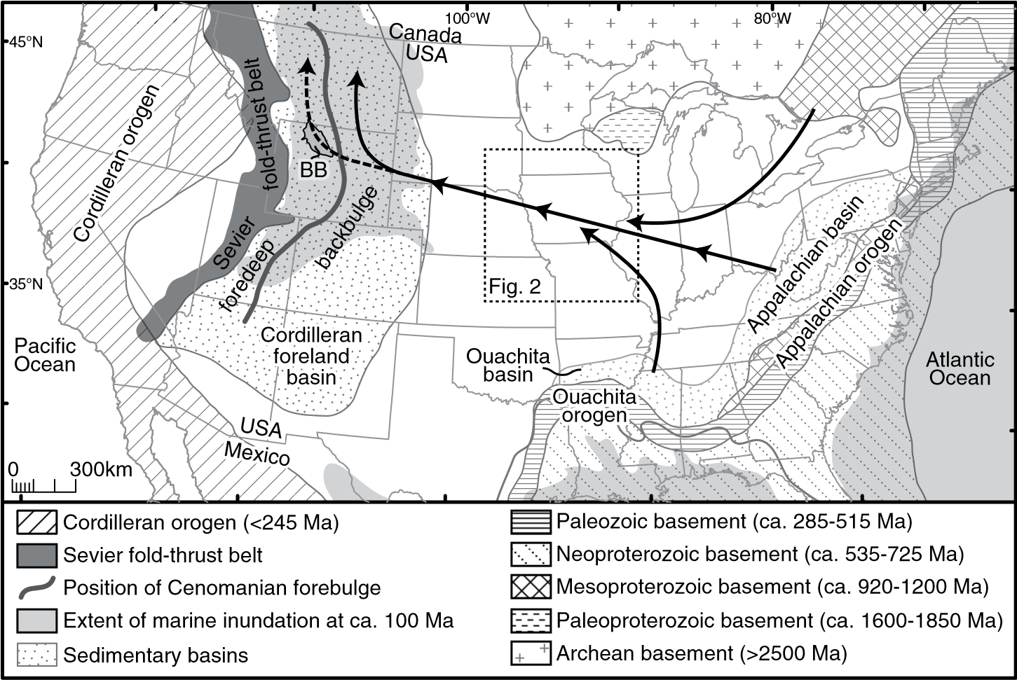

**Figure 1. Locations of major igneous sediment source terranes in middle Cretaceous time. Arrows show dominant sediment transport directions based on detrital zircon age distributions from Albian– Cenomanian midcontinent strata. Dashed and solid arrows illustrate transport of sediment into the Cordilleran foreland basin foredeep and back bulge during Albian and Cenomanian time, respectively. BB—Bighorn Basin. Figure is adapted from DeCelles (2004) and Dickinson and Gehrels (2010).**

© 2014 Geological Society of America www.gsapubs.org | For permission to copy, contact editing@geosociety.org| Volume 6 | Number 5 | LITHOSPHERE

97°W 95°W 93°W 91°W

44°N

SSP W

~~H~~omer 4242°N~~°~~

Hwy 25

Gravel pit

N

40°N Neogene nonmarine strata

Upper Cretaceous marine strata

Dakota Formation (and equivalents)

Paleozoic strata

Precambrian rocks 0 100 km

**Figure 2. Geologic map of the study area showing type localities for the Nishnabotna Member (N) and the Woodbury Member (W) of the Dakota Formation. Black dots indicate detrital zircon sample locations. SSP—Stone State Park.**

the eastern margin have only recently become a focus of investigation (Witzke and Ludvigson, 1994; Brenner et al., 2000, 2003; Joeckel et al., 2005; Ludvigson et al., 2010), and new geochronologic provenance tools have not previously been applied to these strata. As a result, the middle Cretaceous paleogeography of the midcontinent, as well as the sediment supply from the craton to the Cordilleran foreland basin, has remained poorly constrained.

# DAKOTA FORMATION

Sedimentologic and stratigraphic models for the Dakota Formation have been established from type section localities in eastern Nebraska and western Iowa (Fig. 2; Witzke and Ludvigson, 1994, 1996; Ludvigson, 1999; Brenner et al., 2000, 2003; Joeckel et al., 2005). The Albian Nishnabotna Member is characterized by conglomerate and sandstone interpreted to represent braided stream and tidally influenced incised-paleovalley deposits (Fig. 3). The paleovalleys are incised into Paleozoic bedrock, have up to 115 m of relief, and are interpreted to have developed sometime between 160 and 105 Ma (Late Jurassic–middle Cretaceous; Anderson and McKay, 1999; Ludvigson, 1999; Joeckel et al., 2005). The Cenomanian Woodbury Member is dominated by mudstone and shale with relatively minor sandstone and is interpreted to represent meandering stream and marginal marine deposits.

Previous studies that utilized sandstone petrography, conglomerate clast compositions, clay mineralogy, paleocurrent analyses, and orientations of the incised paleovalleys suggested that the sediment source terranes for the Dakota

**Bighorn Basin Iowa & Wyoming Nebraska**

Frontier Fm Woodbury

Member Mowry Sh

Muddy Ss Nishnabotna

Thermopolis/Sykes Mt Member

C GB

B

A

Morrison

Formation

**Figure 3. Stratigraphy of Upper Jurassic–Cenomanian strata in the Bighorn Basin of Wyoming and the craton in western Iowa and eastern Nebraska. A, B, and C are informal lithostratigraphic intervals in the Cloverly Formation used by previous workers. GB—Greybull Sandstone; Cen—Cenomanian; JR—Jurassic. Figure is modified from Kvale and Vondra (1993), Zaleha (2006), and May et al. (2013).**

Formation were Paleozoic carbonate bedrock and Precambrian crystalline rocks located in eastern Iowa, Minnesota, Wisconsin, and Illinois (Witzke and Ludvigson, 1994, 1996). The authors did note, however, that several lines of evidence would allow for sediment contribution from Appalachian sources. Specifically, the lack of a topographic barrier between the Western Interior Seaway and the Appalachian Mountains, the presence of isolated middle Cretaceous coarse-grained strata widespread across eastern North America, and a lack of middle Cretaceous sediments in the Mississippi Embayment strata south of the Ouachita uplands all suggest that a transcontinental fluvial system could have flowed from east to west across the continent during middle Cretaceous time.

# METHODS

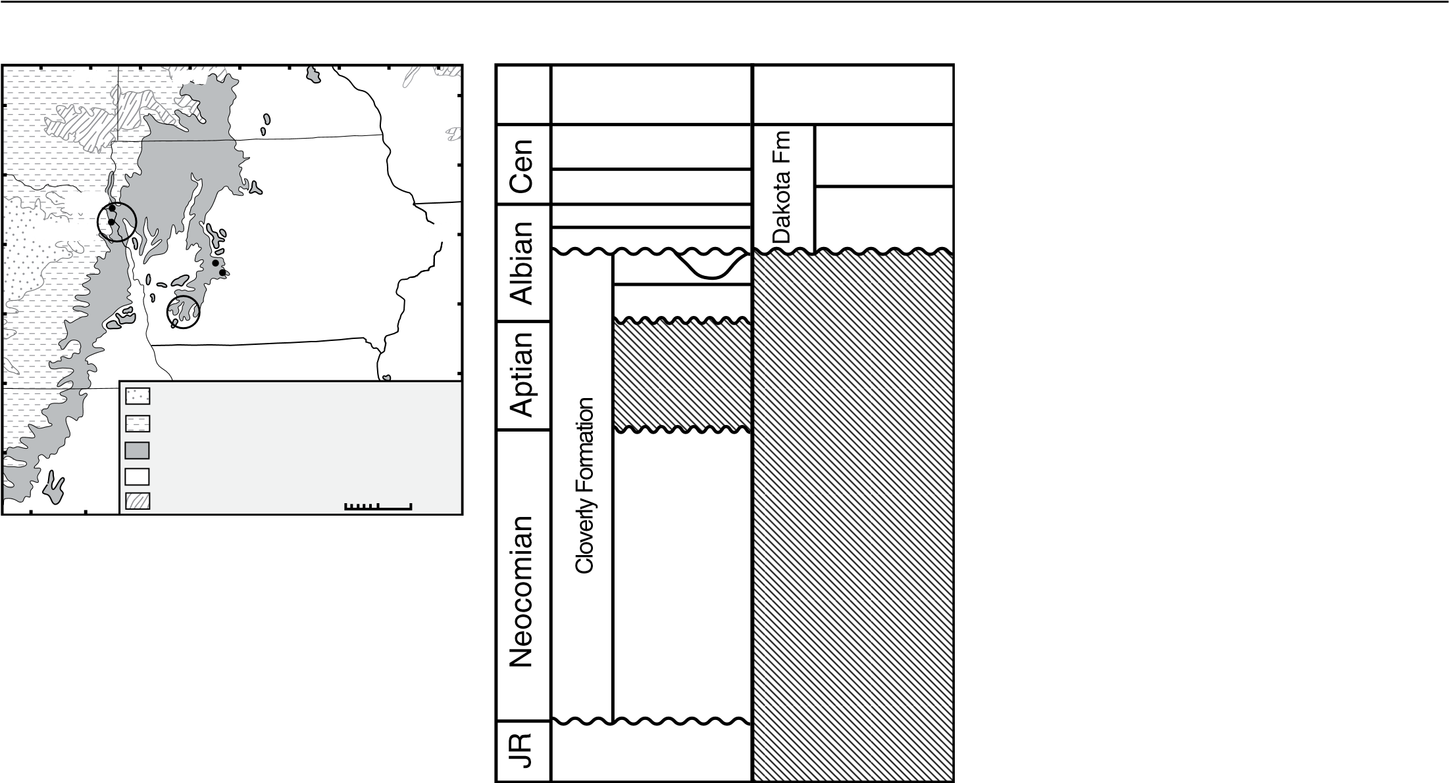Four samples were collected from Dakota Formation outcrops located in western Iowa and eastern Nebraska. Two samples each were collected from the Nishnabotna Member (Highway 25 and Gravel Pit) and Woodbury Member (Homer and Stone Park; Figs. 2 and 3). Zircons were separated using standard methods (crushing, sieving, magnetic separation, and heavy liquid separation) and mounting protocols at the University of Iowa. U-Pb analyses of detrital zircons were conducted by laser ablation–multicollector–inductively coupled plasma–mass spectrometry (LA-MC-ICP-MS) at the Arizona LaserChron Center (i.e., Gehrels, 2000, 2012; Gehrels et al., 2006). The analytical data are reported in Table DR1.[1] Interpreted ages are corrected for common Pb and are based on 206Pb/238U for younger than 900 Ma grains and on 206Pb/207Pb for older than 900 Ma grains. This division at 900 Ma results from the increasing uncertainty of 206Pb/238U ages and the decreasing uncertainty of 206Pb/207Pb ages as a function of age. Analyses that are >20% discordant (by comparison of 206Pb/238U and 206Pb/207Pb ages) or >5% reverse discordant are not included in the results and interpretation. Variations in U-Pb ages among the four samples are insignificant; therefore, individual age probability and concordia diagrams for each sample are reported in the supplementary material (see footnote 1), and a composite plot of all four samples is presented in Figure 4A.

# DETRITAL ZIRCON AGE DISTRIBUTIONS AND PROVENANCE

The new detrital zircon data from the Dakota Formation reveal primary contributions from all key plutonic assemblages of the Appalachian orogeny (Fig. 4A). Approximately 78% of detrital zircon grains are Grenvillian (1.3–1.0 Ga; Mesoproterozoic on Fig. 1), Pan-African (725– 535 Ma; Neoproterozoic on Fig. 1), or Paleozoic (515–285 Ma) in age, which closely match the ages of bedrock sources located within the Appalachian Mountains (Fig. 1). The lack of significant Paleoproterozoic- (1.85–1.6 Ga) or Archean-aged (>2.5 Ga) zircons indicates that northern source regions in Minnesota, Wisconsin, and Canada did not contribute the bulk of sediment, as was previously interpreted.

Grenvillian, Pan-African, and Paleozoic grains may also have been recycled from Appalachian or Ouachita foreland basin strata (Figs. 4B and 4C); however, a sediment source in the Appalachian or Ouachita foreland basins would still require continental-scale, westwardflowing fluvial systems. Recycling of grains from Paleozoic strata located in the midcontinent

Detrital zircons from Cretaceous midcontinent strata | SHORT RESEARCH

LITHOSPHERE | Volume 6 | Number 5 | www.gsapubs.org **379**

E.S. FINZEL

0

1000

2000

3000

500

1500

Age (Ma)

2500

2

Cenomanian-Albian

Dakota Formation

(n=403)

Ordovician-Pennsylvanian strata

Appalachian foreland basin

(n=2322)

Pennsylvanian strata

Ouachita foreland basin

(n=158)

Late Cambrian Mt. Simon Formation

Wisconsin/Illinois (n=780)

Proterozoic strata

Mid-continent rift

(n=1367)

**B**

**C**

**D**

**E**

**A**

Pz

PA

GV

PP

Archean

***Appalachians***

***Upper Midwest & Canada***

**Figure 4. Age-probability plots of detrital zircon ages from (A) the Dakota Formation, (B) Ordovician–Pennsylvanian strata in the Appalachian foreland basin (Eriksson et al., 2004; Becker et al., 2005, 2006; Park et al., 2010), (C) Pennsylvanian strata from the Ouachita foreland basin (Gleason et al., 2007), (D) the Late Cambrian Mount Simon Sandstone in Wisconsin and Illinois (Craddock et al., 2013; Lovell and Bowen, 2013), and (E) Proterozoic strata from the Midcontinent Rift area (Craddock et al., 2013). Ages of potential sediment source terranes are shown as horizontal bars at top of figure. Appalachian region: Pz—Paleozoic, PA—Pan-African, GV—Grenvillian. Upper Midwest and Canada: PP—Paleoproterozoic.**

is unlikely, since most of the strata are carbonate and shale. In addition, abundant Paleoproterozoic- and Archean-age populations in Cambrian and older strata from the upper midcontinent and Midcontinent Rift area preclude these rocks as a dominant sediment source (Figs. 4D and 4E).

**DISCUSSION AND CONCLUSIONS**

# Appalachians-Cordilleran Connection

The data set presented here represents the first analysis of detrital zircon age distributions from the Dakota Formation in the midcontinent, and is interpreted to document the presence of a westward-flowing transcontinental fluvial system that stretched from the Appalachian region to at least the midcontinent during middle Cretaceous time. In western North America, the archetypal Sevier thrust belt and foreland basin began to take shape during late Albian and Cenomanian time (Fig. 1). Foreland basin models define four depozones in foreland basin systems, including, from proximal to distal, the wedge top, foredeep, forebulge, and back bulge (DeCelles and Giles, 1996). These models suggest that only a minor amount of sediment in foreland basins is typically derived from the craton and is primarily confined to the back-bulge region (Dickinson and Suczek, 1979; Schwab, 1986; DeCelles and Giles, 1996).

During the mid-Cretaceous, Iowa and Nebraska were located on the craton east of the Cordilleran foreland basin system, whereas the modern-day Bighorn Basin in Wyoming was located in the foredeep (Fig. 1). Paleocurrent indicators and provenance studies from Albian and Cenomanian strata in the Bighorn Basin demonstrate that the development of the foldand-thrust belt created new sediment sources and increased sediment flux from the western margin of the evolving Cordilleran foreland basin (DeCelles, 2004). Existing detrital zircon data from the Bighorn Basin provide evidence that most of the sediment in the foredeep was derived from the adjacent fold-and-thrust belt (May et al., 2013).

The exception to this is the early–middle Albian Greybull Sandstone of the Cloverly Formation in the eastern Bighorn Basin (GB on Fig. 3), which exhibits west- and southwestdirected paleoflow indicators (Winslow and Heller, 1987; Kvale and Vondra, 1993; Zaleha, 2006). Similar to the Dakota Formation, the Greybull Sandstone also overlies a major regional unconformity with up to 23 m of local relief (Kvale and Vondra, 1993; Weimer, 1984). Detrital zircon age distributions from the Greybull Sandstone (Fig. 5D) contain very similar age peaks and abundances compared to Albian Dakota Formation distributions (Fig. 5C); however, a link between the Greybull Sandstone and the Appalachian region has not previously been proposed.

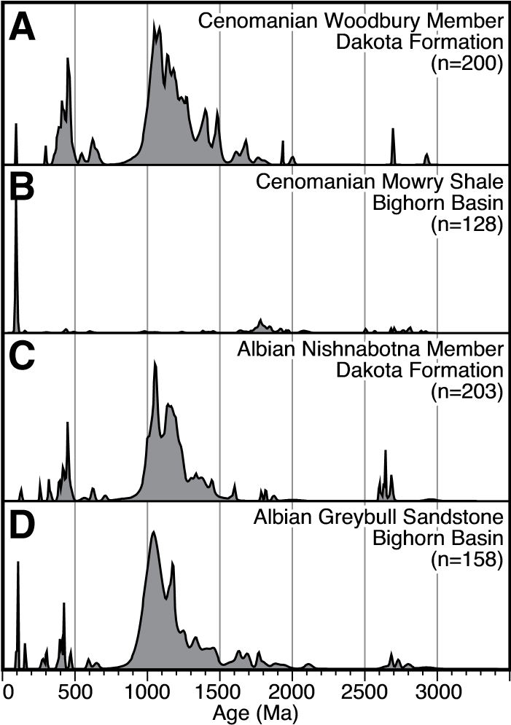

**Figure 5. Age-probability plots of detrital zircon ages from the (A) Cenomanian Dakota Formation (this study), (B) Cenomanian Mowry Shale (May et al., 2013), (C) Albian Dakota Formation (this study), and (D) Albian Greybull Sandstone (May et al., 2013).**

When taken together, the Greybull Sandstone and Dakota Formation data suggest that sediment derived from the Appalachian region during Albian time was transported >2000 km across the continent before being deposited in the distal foredeep of the Cordilleran foreland basin. Cenomanian strata in the Bighorn Basin (Fig. 5B), in contrast, have a very different detrital signature compared to the coeval Dakota Formation in the midcontinent (Fig. 5A), indicating that Appalachian-derived sediment was no longer being deposited in the foredeep of the foreland basin. The continued existence of the transcontinental fluvial systems through at least Cenomanian time, however, suggests that sediment was likely still being delivered to the back-bulge region after Albian time. These results indicate that standard foreland basin models may underestimate the amount of sediment input from the craton side of the basin, especially in the back-bulge region.

# Implications for North American Paleogeography

Transcontinental sediment transport from the Appalachian region to the North American Cordillera has previously been inferred based on detrital zircon age spectra from Upper Jurassic–Albian foreland basin deposits in Alberta,

www.gsapubs.org | Volume 6 | Number 5 | LITHOSPHERE Detrital zircons from Cretaceous midcontinent strata | SHORT RESEARCH

|  |  |
| --- | --- |
| Canada (Benyon et al., 2014; Blum and Pecha, 2014; Raines et al., 2013). These authors, however, were not able differentiate between firstcycle sediment delivered directly from the Appalachians versus sediment recycled from older strata in the southwestern United States or the fold-and-thrust belt to the west. The detrital zircon signatures from the Dakota Formation, however, also contain the same Appalachian age groups inferred to have been derived either directly from Appalachian igneous belts or recycled from Paleozoic strata of the Appalachian foreland. This new result provides the first direct evidence that a fluvial system did extend from the Appalachian region to the North America Cordilleran foreland basin during middle Cretaceous time.  Appalachian-derived sediment delivered to the western United States has also been inferred based on detrital zircon age spectra from Mississippian–Permian strata in the Grand Canyon (Gehrels et al., 2011) and Early–Middle Jurassic erg deposits on the Colorado Plateau (Dickinson and Gehrels, 2009, 2010). These depositional systems, however, existed prior to the Late Jurassic initiation of the Cordilleran foreland basin (DeCelles, 2004; Miall et al., 2008). These previously published detrital zircon age distributions in combination with the new data from the Dakota Formation reflect an evolution in source regions within the Appalachian region. In Mississippian strata of the Grand Canyon, Paleozoic ages are relatively more abundant than Pan-African ages, but the two populations become more balanced by Permian time (Gehrels et al., 2011). This pattern is interpreted to reflect the outboard location of the Pan-African terranes relative to the Paleozoic igneous units (Fig. 1), and it suggests that the late Paleozoic west-flowing transcontinental river systems eroded headward (eastward) across the Paleozoic igneous belt to tap into the more easterly Pan-African terranes.  In contrast, the Jurassic erg and Dakota Formation detrital zircon age distributions contain more abundant populations of Paleozoic grains relative to Pan-African peaks (Fig. 3). This reversal may be due to the opening of the Atlantic Ocean and the rejuvenation of east-flowing rivers that eroded headward (westward) across the upper catchment areas, which previously lay within the late Paleozoic west-flowing transcontinental river systems. Consequently, by Jurassic time, the outboard Pan-African terranes were again recaptured by the east-flowing systems and were mostly isolated from the west-flowing transcontinental rivers.  Based on the stratigraphic record in middle Atlantic offshore sedimentary basins, there have been several temporally isolated epeirogenic | increases in sediment flux from the Appalachian region since Triassic–Early Jurassic rifting of Pangea (Poag and Sevon, 1989; Poag, 1992). An increase in flux during Middle Jurassic time (ca. 170 Ma) is attributed to the existence of postrift topography (Pazzaglia and Brandon, 1996) and may be responsible for the presence of the previously inferred Middle–Late Jurassic transcontinental fluvial systems.  Widespread deposition of the Dakota Formation in the midcontinent is interpreted in this study as the sedimentary record of a second post-tectonic erosional event that is preserved to the west of the Appalachian belt. Sediment flux to the Atlantic margin basins east of the Appalachian belt were 3–7 times higher than background rates during middle Cretaceous time (Poag and Sevon, 1989; Poag, 1992; Pazzaglia and Brandon, 1996). Sediment eroded toward the west during middle Cretaceous time could not have been transported to the Gulf of Mexico because it predates opening of the Mississippi Embayment, and the Ouachita Mountains would still have been a topographic barrier to the south (Cox and Van Arsdale, 2002). Furthermore, sedimentation in the Gulf of Mexico was dominated by carbonates during Barremian– Albian time, which precludes a significant influx of siliciclastic material into that region (Galloway, 2008).  Numerical modeling indicates that a middle Cretaceous increase in sediment flux from the Appalachian region is consistent with a change in asthenospheric flow related to passage over a mantle plume (Pazzaglia and Brandon, 1996). Recent low-temperature thermochronologic data from the southern Appalachians demonstrate that beginning ca. 120 Ma and continuing for ~60 m.y., the modern river valleys draining the southern Blue Ridge Mountains experienced erosion at nearly twice the background rate (35 m/m.y. vs. 20 m/m.y.) and that presentday valley floors were exhuming at almost twice the rate of the modern ridge tops (McKeon et al., 2014). Although these erosion rates are low, inverse modeling requires nearly 1 km of relief generated during this phase of the Cretaceous (McKeon et al., 2014). Therefore, even though the Appalachian region had not experienced any major tectonic events since Triassic–Early Jurassic rifting, perturbation of the dormant orogenic system due to mantle dynamics significantly increased exhumation, erosion, and sediment flux. This mantle-driven process was significant enough to reorganize major fluvial drainages and initiate a second Mesozoic transcontinental sediment transport system that dispersed Appalachian-derived sediment across the North American continent and into the western U.S. Cordilleran foreland basin. |

LITHOSPHERE | Volume 6 | Number 5 | www.gsapubs.org

## ACKNOWLEDGMENTS

I thank George Gehrels for generous use of the Arizona LaserChron Laboratory to acquire the data presented here. Support for the Arizona LaserChron Laboratory is provided by the National Science Foundation Instrumentation and Facilities Program. Brian J. Witzke and Carl E. Jacobson provided fruitful discussions related to this project. Kenneth D. Ridgway, Ingrid Ukstins Peate, Dale Leckie, Bill Craddock, and an anonymous reviewer reviewed early versions of this manuscript. External reviewers, Andrew Leier and an anonymous reviewer handled later versions of this manuscript. Samples were processed and mounted by University of Iowa undergraduate researchers Brittany Hendrix and Jordan Gillard.

## REFERENCES CITED

Anderson, R.R., and McKay, R.M., 1999, The Geology of the Jurassic Fort Dodge Formation, Webster County, Iowa: Geological Society of Iowa Guidebook 67, 89 p.

Becker, T.P., Thomas, W.A., Samson, S.D., and Gehrels, G.E., 2005, Detrital zircon evidence of Laurentian crustal dominance in the lower Pennsylvanian deposits of the Alleghanian clastic wedge in eastern North America: Sedimentary Geology, v. 182, no. 1–4, p. 59–86, doi: 10.1016 /j .sedgeo .2005.07.014.

Becker, T.P., Thomas, W.A., and Gehrels, G.E., 2006, Linking late Paleozoic sedimentary provenance in the Appalachian basin to the history of Alleghanian deformation: American Journal of Science, v. 306, no. 10, p. 777–798, doi:10.2475/10.2006.01.

Benyon, C., Leier, A., Leckie, D.A., Webb, A., Hubbard, S.M., and Gehrels, G., 2014, Provenance of the Cretaceous Athabasca Oil Sands, Canada; implications for continental-scale sediment transport: Journal of Sedimentary Research, v. 84, p. 136–143, doi:10.2110/jsr.2014.16.

Blum, M., and Pecha, M., 2014, Mid-Cretaceous to Paleocene North American drainage reorganization from detrital zircons: Geology, v. 42, p. 607–610, doi:10.1130 /G35513.1.

Brenner, R.L., Ludvigson, G.A., Witzke, B.J., Zawistoski, A.N., Kvale, E.P., Ravn, R.L., and Joeckel, R.M., 2000, Late Albian Kiowa–Skull Creek marine transgression, lower Dakota Formation, eastern margin of Western Interior Seaway, USA: Journal of Sedimentary Research, v. 70, no. 4, p. 868–878, doi:10.1306/2DC4093E-0E47-11D7 -8643000102C1865D.

Brenner, R.L., Ludvigson, G.A., Witzke, B.L., Phillips, P.L., White, T.S., Ufnar, D.F., Gonzalez, L.A., Joeckel, R.M., Goettemoeller, A., and Shirk, B.R., 2003, Aggradation of gravels in tidally influenced fluvial systems: Upper Albian (Lower Cretaceous) on the cratonic margin of the North American Western Interior foreland basin: Cretaceous Research, v. 24, no. 4, p. 439–448, doi:10.1016 /S0195 -6671(03)00054-5.

Cox, R.T., and Van Arsdale, R.B., 2002, The Mississippi Embayment, North America: A first order continental structure generated by the Cretaceous superplume mantle event: Journal of Geodynamics, v. 34, p. 163–176, doi:10.1016 /S0264-3707(02)00019-4.

Craddock, J.P., Konstantinou, A., Vervoort, J.D., Wirth, K.R., Davidson, C., Finley-Blasi, L., Juda, N.A., and Walker, E., 2013, Detrital zircon provenance of the Mesoproterozoic Midcontinent Rift, Lake Superior region, USA: The Journal of Geology, v. 121, no. 1, p. 57–73, doi: 10.1086 /668635.

DeCelles, P.G., 2004, Late Jurassic to Eocene evolution of the Cordilleran thrust belt and foreland basin system, western USA: American Journal of Science, v. 304, no. 2, p. 105–168, doi:10.2475/ajs.304.2.105.

DeCelles, P.G., and Giles, K.A., 1996, Foreland basin systems: Basin Research, v. 8, no. 2, p. 105–123, doi:10.1046 /j .1365 -2117.1996.01491.x.

Dickinson, W.R., and Gehrels, G.E., 2009, U-Pb ages of detrital zircons in Jurassic eolian and associated sandstones of the Colorado Plateau: Evidence for transcontinental dispersal and intraregional recycling of sediment: Geological Society of America Bulletin, v. 121, no. 3–4, p. 408–433, doi:10.1130/B26406.1.

Dickinson, W.R., and Gehrels, G.E., 2010, Insights into North American paleogeography and paleotectonics from

U-Pb ages of detrital zircons in Mesozoic strata of the

# 381

E.S. FINZEL

Colorado Plateau, USA: International Journal of Earth Sciences, v. 99, no. 6, p. 1247–1265, doi:10.1007/s00531 -009-0462-0.

Dickinson, W.R., and Suczek, C.A., 1979, Plate-tectonics and sandstone compositions: The American Association of Petroleum Geologists Bulletin, v. 63, no. 12, p. 2164–2182.

Eriksson, K.A., Campbell, I.H., Palin, J.M., Allen, C.M., and Bock, B., 2004, Evidence for multiple recycling in Neoproterozoic through Pennsylvanian sedimentary rocks of the central Appalachian basin: The Journal of Geology, v. 112, no. 3, p. 261–276, doi:10.1086/382758.

Galloway, W.E., 2008, Depositional evolution of the Gulf of Mexico sedimentary basin, *in* Miall, A.D., ed., The Sedimentary Basins of the United States and Canada, Volume 5: San Francisco, California, Elsevier, p. 505–549.

Gehrels, G.E., 2000, Introduction to detrital zircon studies of Paleozoic and Triassic strata in western Nevada and northern California, *in* Soreghan, M.J., and Gehrels, G.E., eds., Paleozoic and Triassic Paleogeography and Tectonic Evolution of Western Nevada and Northern California: Geological Society of America Special Paper 347, p. 1–17.

Gehrels, G.E., 2012, Detrital zircon U-Pb geochronology: Current methods and new opportunities, *in* Busby, C., and Azor, A., eds., Tectonics of Sedimentary Basins: Recent Advances: New York, Wiley-Blackwell Publishing, p. 47–62.

Gehrels, G.E., Valencia, V., and Pulen, A., 2006, Detrital zircon geochronology by laser-ablation multicollector ICPMS at the Arizona LaserChron Center, *in* Olszewski, T., ed., Geochronology: Emerging Opportunities: Paleontology Society Papers, Volume 12, p. 67–76.

Gehrels, G.E., Blakey, R., Karlstrom, K.E., Timmons, J.M., Dickinson, B., and Pecha, M., 2011, Detrital zircon U-Pb geochronology of Paleozoic strata in the Grand Canyon, Arizona: Lithosphere, v. 3, no. 3, p. 183–200, doi:10.1130 /L121.1.

Gleason, J.D., Gehrels, G.E., Dickinson, W.R., Patchett, P.J., and Kring, D.A., 2007, Laurentian sources for detrital zircon grains in turbidite and deltaic sandstones of the Pennsylvanian Haymod Formation, Marathon assemblage, west Texas, USA: Journal of Sedimentary Research, v. 77, p. 888–900, doi:10.2110/jsr.2007.084.

Horton, B.K., Parra, M., Saylor, J.E., Nie, J., Mora, A., Torres, V., Stockli, D.F., and Strecker, M.R., 2010a, Resolving uplift of the northern Andes using detrital zircon age signatures: GSA Today, v. 20, no. 7, p. 4–9, doi:10.1130 /GSATG76A.1.

Horton, B.K., Saylor, J.E., Nie, J., Mora, A., Parra, M., ReyesHarker, A., and Stockli, D.F., 2010b, Linking sedimentation in the northern Andes to basement configuration, Mesozoic extension, and Cenozoic shortening: Evidence from detrital zircon U-Pb ages, Eastern Cordillera, Colombia: Geological Society of America Bulletin, v. 122, no. 9–10, p. 1423–1442, doi:10.1130/B30118.1.

Joeckel, R.M., Ludvigson, G.A., Witzke, B.J., Kvale, E.P., Phillips, P.L., Brenner, R.L., Thomas, S.G., and Howard, L.M., 2005, Palaeogeography and fluvial to estuarine architecture of the Dakota Formation (Cretaceous, Albian), eastern Nebraska, USA, *in* Blum, M.D., Marriott, S.B., and Leclair, S.F., eds., Fluvial Sedimentology VII: International Association of Sedimentologists Special Publication 35, p. 453–480.

Kauffman, E.G., and Caldwell, W.G.E., 1993, The Western Interior Basin in space and time, *in* Caldwell, W.G.E., and Kauffman, E.G., eds., Evolution of the Western Interior Basin: Geological Association of Canada Special Paper 39, p. 1–30.

Kvale, E.P., and Vondra, C.F., 1993, Effects of relative sea-level changes and local tectonics on a Lower Cretaceous fluvial to transitional marine sequence, Bighorn Basin, Wyoming, USA, *in* Marzo, M., and Puigdefabregas, C., eds., Alluvial Sedimentation: International Association of Sedimentologists Special Publication 17, p. 383–399.

Lovell, T.R., and Bowen, B.B., 2013, Fluctuations in sedimentary provenance of the Upper Cambrian Mount Simon Sandstone, Illinois Basin, United States: The Journal of Geology, v. 121, no. 2, p. 129–154, doi:10.1086/669230.

Ludvigson, G.A., 1999, Compositional differences between Jurassic and Cretaceous sandstones of western Iowa, with comments on the controlling factors, *in* Anderson, R.R., and McKay, R.M., eds., The Geology of the Jurassic Fort Dodge Formation, Webster County, Iowa: Geological Society of Iowa Guidebook 67, p. 45–53.

Ludvigson, G.A., Witzke, B.J., Joeckel, R.M., Ravn, R.L., Phillips, P.L., Gonzalez, L.A., and Brenner, R.L., 2010, New insights on the sequence stratigraphic architecture of the Dakota Formation in Kansas–Nebraska–Iowa from a decade of sponsored research activity: Kansas Geological Survey Bulletin 258, part 2, p. 1–35.

May, S.R., Gray, G.G., Summa, L.L., Stewart, N.R., Gehrels, G.E., and Pecha, M., 2013, Detrital zircon geochronology from the Bighorn Basin, Wyoming, USA: Implications for tectonostratigraphic evolution and paleogeography: Geological Society of America Bulletin, v. 125, no. 9–10, p. 1403–1422, doi:10.1130/B30824.1.

McGookey, D.P., 1972, Cretaceous System, *in* Mallory, W.W., ed., Geologic Atlas of the Rocky Mountain Region: Denver, Colorado, Rocky Mountain Association of Geologists, p. 190–228.

McKeon, R.E., Zeitler, P.K., Pazzaglia, F.J., Idleman, B.D., and Enkelmann, E., 2014, Decay of an old orogen: Inferences about Appalachian landscape evolution from lowtemperature thermochronology: Geological Society of America Bulletin, v. 126, p. 31–46, doi:10.1130/B30808.1.

Miall, A.D., Catuneanu, O., Vakarelov, B.K., and Post, R., 2008, The Western Interior Basin, *in* Miall, A.D., ed., The Sedimentary Basins of the United States and Canada, Volume 5: San Francisco, Elsevier, p. 329–362.

Nie, J., Horton, B.K., Saylor, J.E., Mora, A., Mange, M., Garzione, C.N., Basu, A., Moreno, C.J., Caballero, V., and Parra, M., 2012, Integrated provenance analysis of a convergent retroarc foreland system: U-Pb ages, heavy minerals, Nd isotopes, and sandstone compositions of the Middle Magdalena Valley basin, northern Andes, Colombia: Earth-Science Reviews, v. 110, no. 1–4, p. 111– 126, doi:10.1016/j.earscirev.2011.11.002.

Park, H., Barbeau, D.L., Jr., Rickenbaker, A., Bachmann-Krug, D., and Gehrels, G., 2010, Application of foreland basin detrital-zircon geochronology to the reconstruction of the Southern and Central Appalachian orogen: The Journal of Geology, v. 118, no. 1, p. 23–44, doi:1 0.1086 /648400.

Pazzaglia, F.J., and Brandon, M.T., 1996, Macrogeomorphic evolution of the post-Triassic Appalachian Mountains determined by deconvolution of the offshore basin sedimentary record: Basin Research, v. 8, p. 255–278, doi:10.1046/j.1365-2117.1996.00274.x.

Poag, C.W., 1992, U.S. middle Atlantic continental rise: Provenance, dispersal, and deposition of Jurassic to Quaternary sediments, *in* Poag, C.W., and Graciansky, P.C., eds., Geologic Evolution of Atlantic Continental Rises:

New York, Van Nostrand Reinhold, p. 100–156.

Poag, C.W., and Sevon, W.D., 1989, A record of Appalachian denudation in post-rift Mesozoic and Cenozoic sedimentary deposits of the U.S. middle Atlantic continental margin: Geomorphology, v. 2, p. 119–157, doi:10.1016/0169-555X(89)90009-3.

Raines, M.K., Hubbard, S.M., Kukulski, R.B., Leier, A.L., and Gehrels, G.E., 2013, Sediment dispersal in an evolving foreland: Detrital zircon geochronology from Upper Jurassic and lowermost Cretaceous strata, Alberta Basin, Canada: Geological Society of America Bulletin, v. 125, p. 741–755, doi:10.1130/B30671.1.

Robinson Roberts, L.N., and Kirschbaum, M.A., 1995, Paleogeography of the Late Cretaceous of the Western Interior of Middle North America—Coal Distribution and Sediment Accumulation: U.S. Geological Survey Professional Paper 1561, 115 p.

Schwab, F.L., 1986, Sedimentary “signatures” of foreland basin assemblages: real or counterfeit?, *in* Allen, P.A., and Homewood, P., eds., Foreland Basins: Special Publication of the International Association of Sedimentologists, v. 8, p. 395–410.

Weimer, R.J., 1984, Relation of unconformities, tectonics and sea-level changes, Cretaceous of Western Interior, USA, *in* Schlee, J.S., ed., Interregional Unconformities and Hydrocarbon Accumulation: American Association of Petroleum Geologists Memoir 36, p. 7–35.

Williams, G.D., and Stelck, C.R., 1975, Speculations on the Cretaceous palaeogeography of North America, *in* Caldwell, W.G.E., ed., The Cretaceous System in the Western Interior of North America: Geological Association of Canada Special Paper13, p. 1–20.

Winslow, N.S., and Heller, P.L., 1987, Evaluation of unconformities in Upper Jurassic and Lower Cretaceous nonmarine deposits, Bighorn Basin, Wyoming and Montana, USA: Sedimentary Geology, v. 53, p. 181–202, doi:10.1016/0037-0738(87)90034-0.

Witzke, B.J., and Ludvigson, G.A., 1994, The Dakota Formation in Iowa and the type area, *in* Shurr, G.W., Ludvigson, G.A., and Hammond, R.H., eds., Perspectives on the Eastern Margin of the Cretaceous Western Interior Basin: Geological Society of America Special Paper 286, p. 43–78.

Witzke, B.J., and Ludvigson, G.A., 1996, Coarse-grained eastern facies, *in* Witzke, B.J., and Ludvigson, G.A., eds., Mid-Cretaceous Fluvial Deposits of the Eastern Margin, Western Interior Basin: Nishnabotna Member, Dakota Formation: Iowa Geological Survey Bureau Guidebook 17, p. 19–30.

Zaleha, M.J., 2006, Sevier orogenesis and nonmarine basin filling: Implications of new stratigraphic correlations of Lower Cretaceous strata throughout Wyoming, USA: Geological Society of America Bulletin, v. 118, no. 7–8, p. 886–896, doi:10.1130/B25715.1.

MANUSCRIPT RECEIVED 10 JUNE 2014

REVISED MANUSCRIPT RECEIVED 3 JULY 2014

MANUSCRIPT ACCEPTED 21 JULY 2014

Printed in the USA

www.gsapubs.org | Volume 6 | Number 5 | LITHOSPHERE

1. GSA Data Repository Item 2014330, Table DR1— detrital zircon U-Pb data and Figure DR1—individual Concordia and age probability plots, is available at www.geosociety.org/pubs/ft2014.htm, or on request from editing@geosociety.org, Documents Secretary, GSA, P.O. Box 9140, Boulder, CO 80301-9140, USA.