**INTEGRATING SANDSTONE PETROLOGY AND NONMARINE SEQUENCE STRATIGRAPHY:**

**APPLICATION TO THE LATE CRETACEOUS FLUVIAL SYSTEMS OF SOUTHWESTERN UTAH, U.S.A.**

T.F. LAWTON,1 S.L. POLLOCK,2 AND R.A.J. ROBINSON3

1. *Institute of Tectonic Studies, Department of Geological Sciences, New Mexico State University, Las Cruces, New Mexico 88011, U.S.A. e-mail: tlawton@nmsu.edu*
2. *ChevronTexaco, Permian Business Unit, 15 Smith Road, Midland, Texas 79705, U.S.A.*
3. *School of Geography & Geosciences, University of St. Andrews, St. Andrews, KY16 9AL, Scotland*

**ABSTRACT: Petrographic and dispersal data are essential to correct interpretation of mechanisms that create continental sequence-stratigraphic architecture. A case study from southern Utah demonstrates that Upper Cretaceous (upper Santonian–Campanian) alluvial successions in the southernmost part of the Cordilleran foreland basin were deposited by fluvial systems of contrasting drainage directions and provenance, and suggests that different mechanisms governed their sequence architecture. Most of the rivers flowed northeast, subparallel to the basin foredeep. Less common fluvial systems flowed to the eastsoutheast. The fluvial sandstones fall naturally into four petrofacies: (1) quartzofeldspatholithic (mean Qt**61**F**19**L**20**); (2) feldspatholithic**

**(Qt**29**F**19**L**52**); (3) quartzolithic (Qt**75**F**6**L**20**); and (4) quartzose (Qt**99**F**1**L**1**). Petrofacies 1 and 2 were derived from mixed supracrustal and basement sources to the southwest and south, respectively, whereas petrofacies 3 and 4 were derived from uplifted thrust sheets of the Sevier orogenic belt to the southwest and west, respectively. Only the east-southeast-flowing rivers transported the quartzose petrofacies.**

**The fluvial strata, which include the uppermost Straight Cliffs, Wahweap, and Kaiparowits formations, form two large-scale stratigraphic successions typically interpreted as continental stratigraphic sequences hundreds of meters thick. Each succession begins with an amalgamated braided-fluvial deposit, grades to mudstone-rich strata with low sandstone-body connectivity, and culminates in highly connected sandstone bodies with multistory stacking. The basal amalgamated deposits of each succession are architecturally similar, but their compositional and dispersal characteristics are different. Quartzofeldspatholithic, quartzolithic, and quartzose sandstones above the lower base-level shift are variable, but generally similar in compositional and dispersal characteristics to both underlying and overlying strata, a phenomenon termed here *congruence.* In contrast, quartzose amalgamated fluvial sandstone above the upper base-level shift differs sharply in composition and dispersal direction from underlying and overlying lithic-rich strata. The foredeep axis controlled the progradation direction of the congruent shift, which was likely driven by climatically induced sediment influx, a eustatic fall, or both. In the case of the incongruent shift, increased sediment supply permitted the rivers to cross the foredeep. Temporal association of the upper amalgamated deposit with active structures in the thrust belt and foreland basin indicates that syntectonic thrust uplift, not isostatic uplift or climate, caused the influx of quartz.**

# INTRODUCTION

Sequence-stratigraphic research of the last decade has greatly advanced our knowledge of the geometry of foreland-basin deposits. Much research in foreland-basin sequence stratigraphy has addressed the characteristics of Upper Cretaceous continental strata in central and southern Utah (e.g., Shanley and McCabe 1991, 1995; Hettinger et al. 1993; Olsen et al. 1995; Van Wagoner 1995; Yoshida et al. 1996; McLaurin and Steel 2000). Concurrently, basin models have sought to explain foreland-basin stratigraphic successions in terms of overall basin geometry (e.g., Flemings and Jordan 1989; Heller et al. 1988; DeCelles and Giles 1996) and stratigraphic architecture (Heller et al. 1988; Posamentier and Allen 1993; Houston et al. 2000).

JOURNAL OF SEDIMENTARY RESEARCH, VOL. 73, NO. 3, MAY, 2003, P. 389–406

Copyright q 2003, SEPM (Society for Sedimentary Geology) 1527-1404/03/073-389/$03.00

Despite extensive study, mechanisms offered to explain stacking patterns in fluvial strata remain conjectural. Explanations of sequence architecture are generally couched in terms of competing sediment supply and accommodation; the primary factors, tectonic uplift and subsidence, climate, and eustatic base-level change, which drive the fundamental variables of accommodation and sediment supply, cannot be discriminated. Moreover, attempts to explain field data sets in terms of the results of tectonic basin models have met with limited success. This is partly because the extensive exposures of the Book Cliffs in central Utah, where many of the classic sequence concepts were developed, are separated from sediment source areas by a broad region of Tertiary cover. This lack of exposure has hindered correlation and understanding of linkages between tectonic processes in the thrust belt and more distal basin and caused disagreement as to the ultimate controls on sequence architecture. In the distal basin, eustatic baselevel changes are considered important to stratal architecture (Van Wagoner 1995; Shanley and McCabe 1991, 1995; McLaurin and Steel 2000), but sequences are nevertheless inferred to be influenced by tectonics through its influence on sediment supply and subsidence rate (e.g., Heller et al. 1988; Yoshida et al. 1996; Robinson and Slingerland 1998; Houston et al. 2000; Miall and Arush 2001).

We argue here that sandstone petrography and dispersal data are essential aspects of fluvial sequence analysis, and that the underlying mechanisms of fluvial sequences cannot be properly interpreted in the absence of these data. In the southernmost part of the Cordilleran foreland basin, petrology and paleocurrents of Upper Cretaceous fluvial strata reveal that architecturally similar fluvial deposits vary fundamentally in terms of their sources and dispersal directions. We consider these variations in the context of tectonic basin models to evaluate driving mechanisms of sequence architecture in this foreland basin.

Two aspects of the study area make it an ideal location to reconstruct depositional systems of the foreland basin. First, Upper Santonian–Campanian strata of southern Utah are exposed along a major west–east, thrust belt-to-basin transect (Fig. 1). Second, the fluvial systems transported petrographically distinctive detritus from separate source terranes. Sandstone petrology provides an additional tool for evaluating controls on sequence architecture by permitting recognition of different fluvial systems and projection of the systems to source areas beyond the margins of the basin.

# METHODS

To establish relationships among sequence architecture, sandstone petrology, and dispersal direction, we measured sections and utilized stratigraphic sections of other workers as cited in the text. Fluvial architecture was determined from vertical successions and inspection of nearby exposures. Correlations were established from stratigraphic position, published biostratigraphic data and correlations, and our own palynologic results. Palynomorphs were identified by Darrin Snead (Wellstrat Inc., written communication, 2002). Sandstone samples for thin sections were collected on stratigraphic sections where paleocurrent data were measured.

# GEOLOGIC SETTING

Upper Cretaceous strata of southwestern Utah were deposited in the southernmost preserved extent of the Cordilleran foreland basin. The strata

|  |
| --- |
| FIG. 1.—Geologic map of uppermost Upper Cretaceous and Paleogene rocks in High Plateaus Province of southwestern Utah. The west-northwest-trending line is the fence diagram line of Figure 3, to which numbered sections are projected parallel to structural strike. Other localities: BCA, Bryce Canyon anticline; C, Cockscomb; CCU, Circle Cliffs uplift; P, Pardner Canyon; R, Reynolds Point; S, south end of Paunsaugunt Plateau. Approximate traces of Late Cretaceous thrust faults are not restored to pre-extensional positions. Geology adapted from Bowers (1990), Goldstrand (1991), Hintze (1980), and Sargent and Hansen (1982). Wahweap and Kaiparowits formations are undifferentiated in the Markagunt and Paunsaugunt plateaus to reflect uncertainties in correlation there. |

are composed of detritus derived in part from thrust sheets of the Sevier orogenic belt and are generally interpreted as syntectonic (Peterson 1969a; Gustason 1989; Eaton 1991; Eaton and Nations 1991; Fillmore 1991; Goldstrand 1992; Schmitt et al. 1991; Goldstrand et al. 1993; Goldstrand and Mullett 1997). The strata are bounded to the west by Late Cretaceous thrust structures, and on the south by an erosional edge. To the east, Upper Cretaceous strata were eroded from Laramide uplifts in the Paleocene (Goldstrand 1990, 1991, 1992, 1994; Goldstrand et al. 1993). On the north, they are covered by Paleogene–Neogene sedimentary and volcanic rocks.

Coarse-grained Upper Cretaceous strata crop out in ranges west of the Hurricane fault, where they are extensively deformed by thrust-related faulting and folding of the Sevier orogenic belt (Fig. 1; Mackin 1947; Armstrong 1968; Hintze 1986; Maldonado and Williams 1993; Goldstrand and Mullet 1997). The westernmost Wah Wah thrust sheet contains Proterozoic–lower Paleozoic quartzite, and the Blue Mountain thrust sheet to the east is composed of Cambrian through Pennsylvanian carbonate strata (Armstrong 1968; Fillmore 1991). Clasts of Precambrian–lower Paleozoic quartzite and Paleozoic chert and limestone indicate that much of the Cretaceous section was derived from rocks in the Wah Wah and Blue Mountain thrust sheets (Fillmore 1991; Goldstrand 1991). The Iron Springs thrust sheet consists of Cambrian through Jurassic rocks thrust over the Upper Cretaceous Iron Springs Formation sometime before deposition of the Paleocene Grand Castle Formation (Fig. 2; Van Kooten 1988; Goldstrand 1991; Fillmore 1991; Maldonado and Williams 1993; Goldstrand and Mullett 1997; Nichols 1997).

A domain of thrust-related deformation is also present east of the Hurricane fault. Directly east of Cedar City, in the footwall of the Hurricane fault, the north-northeast-trending Kanarra fold involves strata as young as the Upper Cretaceous (Santonian) Straight Cliffs Formation (Averitt and Threet 1973). The Claron Formation postdates folding. East of the Kanarra fold, abundant tight, north-trending folds are present in evaporite and shale of the Upper Jurassic Carmel Formation, whereas the overlying Dakota Formation is largely unfolded, indicating structural detachment between Jurassic and Cretaceous strata during the Late Cretaceous.

Upper Cretaceous strata are exposed almost continuously from the Hurricane fault to the eastern side of the Kaiparowits Plateau. In this region, the strata are separated into three physiographic and geologic domains, the Markagunt, Paunsaugunt, and Kaiparowits plateaus, by Neogene normal faults (Fig. 1). The Upper Cretaceous section consists mostly of continental rocks, but there are marine and estuarine intervals in the section that permit its division into four major, eastward-thinning, progradational successions (Fig. 2): (1) the Dakota Formation; (2) the marine Tropic Shale and overlying Straight Cliffs Formation; (3) the Wahweap Formation; and (4) the Kaiparowits Formation. The Straight Cliffs Formation consists of 300–500 m of marine and continental strata on the Kaiparowits Plateau. The Drip Tank Member, the base of the section studied here, is a sand-rich fluvial deposit at the top of the Straight Cliffs Formation. The Wahweap Formation is an upward-coarsening fluvial succession as much as 360 m thick (Peterson 1969a; Eaton 1991; Pollock, 1999). The Kaiparowits Formation overlies the Wahweap Formation in the Kaiparowits and Table Cliffs pla-

|  |
| --- |
| FIG. 2.—Nomenclature and correlation of Upper Cretaceous and Paleogene stratigraphy of the High Plateaus region, southwestern Utah. Sources of data: Eaton (1991); Fouch et al. (1983); Goldstrand et al. (1993); Nichols (1995, 1997); Eaton et al. (2001). Time scale: Cretaceous, Gradstein et al. (1994); Cenozoic, Cande and Kent (1992). |

teaus. It is a distinctive, blue-gray weathering formation that consists of interbedded feldspathic sandstone and mudstone in roughly equal proportions. At 830 to 855 m thick directly west of Canaan Peak (Fig. 1; Eaton 1991; Little 1995), it equals the combined thickness of the Straight Cliffs and Wahweap formations.

Overlying the Kaiparowits Formation are conglomerate, sandstone, and mudstone of latest Campanian(?)–early Eocene age assigned to the Canaan Peak, Grand Castle, and Pine Hollow formations (Fig. 2; Bowers 1972; Eaton 1991; Goldstrand et al. 1993). These units are thickest in the Table Cliffs Plateau and record partitioning of the foreland basin by Laramide uplifts (Goldstrand 1991, 1992, 1994; Goldstrand et al. 1993). The Eocene Claron Formation, consisting of limestone, calcareous sandstone and mudstone, and minor conglomerate, unconformably overlies older units ranging from the Straight Cliffs through the Pine Hollow formations (Bowers 1972, 1990; Goldstrand 1991; Goldstrand and Mullet 1997).

# STRATIGRAPHY AND SEDIMENTOLOGY

Fluvial strata discussed in this paper include the Drip Tank Member of the Straight Cliffs Formation, the Wahweap Formation, the Kaiparowits Formation, and their equivalents (Fig. 2). General sedimentologic characteristics of these units are reviewed here. Specific named locations refer to measured sections of Figure 3. These strata range in age from latest Santonian to late Campanian in the Kaiparowits Plateau, but their correlation and distribution west of the Paunsaugunt fault remain incompletely understood. Difficulties in correlation arise from a variety of factors, including lateral facies changes within lithostratigraphic units, recycling of palynomorphs from older Upper Cretaceous strata, and inadequate local calibration of different biostratigraphic data sets that include palynomorphs, marine invertebrates, and mammalian fossils. Therefore, correlations reported here must be regarded as preliminary and subject to change as more biostratigraphic data become available. We employ the published time scale of Gradstein et al. (1994) for the Cretaceous time interval.

## Drip Tank Member of Straight Cliffs Formation

The Drip Tank Member is a conspicuous interval of amalgamated, multistory sandstone and pebbly sandstone with trough and planar cross-beds (Eaton 1991; Little 1995; Shanley and McCabe 1995). East of the Hurricane fault, the Drip Tank Member is present throughout the study area. In the Markagunt Plateau, it is represented by pebbly sandstone exposed near Webster Flat and the headwaters of the East Fork of the Virgin River (Fig. 3). Near Webster Flat, the Drip Tank lies 100 m stratigraphically above a biotite tuff with a late Coniacian 40Ar/39Ar age (86.72 10.58 Ma; Eaton et al. 2001). It contains abundant tree trunks, woody debris, and intraformational mudstone-clast conglomerate (Tilton 1991; Little 1995; Shanley and McCabe 1995). Pebbles as much as 2.5 cm in diameter are present in lags and dispersed on foresets, and consist of banded gray chert and dark gray chert with Paleozoic fossils. The member generally thickens northward across the Paunsaugunt and Kaiparowits plateaus (Peterson 1969b; Tilton 1991; Eaton 1991). At Henrieville Creek, it is 114 m thick and coarsens upward from medium-grained sandstone to coarse-grained pebbly sandstone (Little 1995). Dispersal directions ranged from northeast to southeast (Figs. 3, 4A; Peterson 1969a; Tilton 1991). The pebbly sandstone was deposited by southeast-flowing rivers, whereas the pebble-free sandstone was deposited by north- to northeast-flowing rivers (Figs. 3, 4A). The basal

|  |
| --- |
| FIG. 3.—North–northwest–south–southeast fence diagram aligned with paleodispersal direction of capping sandstone member of Wahweap Formation. The orientation of the diagram is depicted in Figure 1. Positions on diagram of Cenozoic normal faults (Sevier and Paunsaugunt faults) and Laramide structure (East Kaibab monocline) are indicated. Basins and uplift of top row derive from thickness trends of capping sandstone member. Quartz–feldspar–lithic modes (QtFL) of samples are indicated adjacent to sections, as are locations of paleocurrent data (resultant vectors) and number of measurements (*n*). |

contact with the underlying John Henry Member is interpreted as either interfingering (Peterson 1969b; Eaton 1991; Tilton 1991; Little 1995) or sharp and erosional (Shanley and McCabe 1995). The Drip Tank Member represents deposits of low-sinuosity braided rivers that shifted laterally to incorporate fine-grained bank material and trees (Little 1995; Shanley and

McCabe 1995). In sequence-stratigraphic terminology, it constitutes the amalgamated fluvial facies tract (Shanley and McCabe 1995), a low-accommodation depositional system.

The Drip Tank Member is latest Santonian in the Kaiparowits Plateau. In the central part of the Kaiparowits Plateau, it overlies upper Santonian

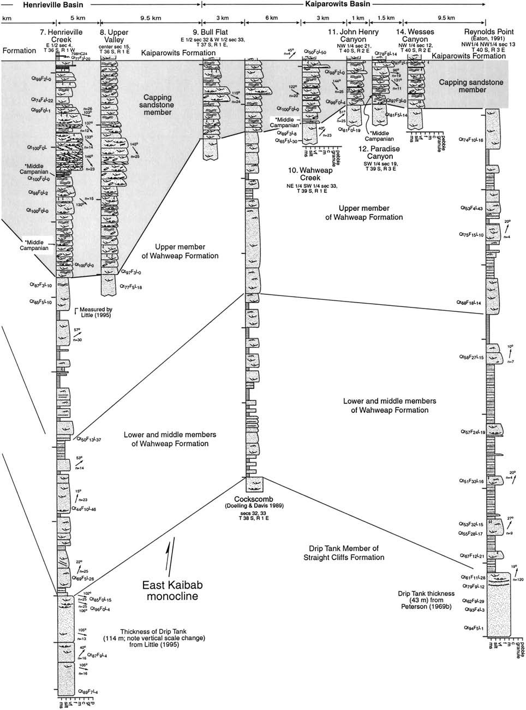

FIG. 3.—Continued.

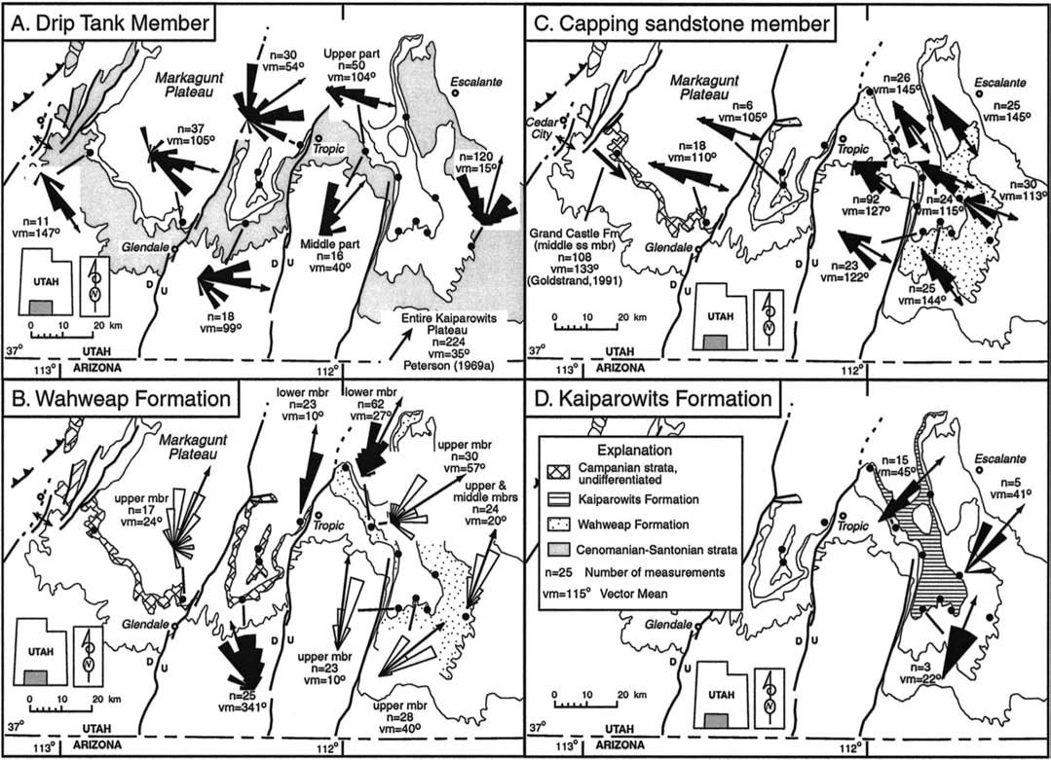

FIG. 4.—Paleocurrent maps for late Santonian–Campanian fluvial systems. **A)** Drip Tank Member of Straight Cliffs Formation. Variability of dispersal directions between sandy and pebbly facies of member can be seen in Figure 3. **B)** Lower three members of Wahweap Formation; lower and middle members indicated by black rose diagrams, upper member by uncolored rose diagrams. **C)** Capping sandstone member of Wahweap Formation. We interpret the middle sandstone member of the Grand Castle Formation at Webster Flat (Goldstrand 1991) as equivalent to the capping sandstone member. **D)** Kaiparowits Formation. Arrows are resultant vectors reported by previous

workers as indicated. Locations are identified in Figures 1 and 3.

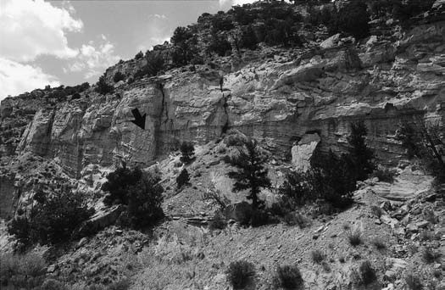

FIG. 5.—Multistory channels composed of lateral-accretion macroforms, middle member of Wahweap Formation at Henrieville Creek. Stories separated by the arrow are 8 m thick.

marine intervals in the John Henry Member (Eaton 1991; J. Kirkland, written communication 1999). At Henrieville Creek, the lower part of the Drip Tank contains palynomorphs of the middle Coniacian–latest Santonian *Proteacidites retusus* Zone (Nichols 1995, 1997). It correlates with the Emery Sandstone Member of the Mancos Shale in central Utah (Fig. 2).

## Wahweap Formation

In the Kaiparowits Plateau, the Wahweap Formation is divided into four informal members: lower, middle, upper, and capping sandstone (Eaton 1991; Little 1995). The lower and middle members constitute a mudstonedominated interval that contains isolated and multistory sandstone bodies. The combined members are 105 m thick at Henrieville Creek (Little 1995; Pollock 1999) and 177 m thick at Reynolds Point (Eaton 1991). The sharp lower contact with the Drip Tank Member is apparently conformable (Eaton 1991; Little 1995). Lateral accretion macroforms (e.g., Miall 1985, 1996), consisting of inclined beds of cross-bedded sandstone and mudstone, are present in both members (Fig. 5; Tilton 1991; Pollock 1999). Channelform, isolated sandstone bodies, as much as 8 m thick, are more abundant in the middle member. The channel bodies are interbedded with thick intervals of dark gray laminated shale, silty sandstone, and mottled sandstone

FIG. 6.—Longitudinal view of stranded tree trunk with root network, capping sandstone member of Wahweap Formation. NE 1/4 section 8, T 39 S, R 1 E, near Cockscomb locality (Fig. 3) on the flank of the East Kaibab monocline. Beds dip about 20 degrees to right. View is to north, with paleoflow to 080 (arrow).

FIG. 7.—Sandstone-rich upper part of upper member of Wahweap Formation overlain by capping sandstone member, Wahweap Creek. Contact at arrow. Cliff face is 90 m high. View is to the east, with paleoflow in upper member to left, and in capping sandstone member away from observer.

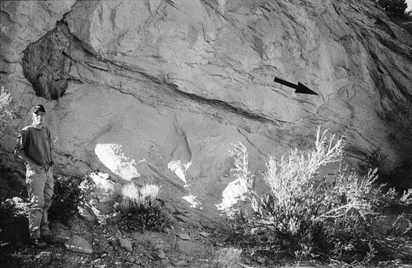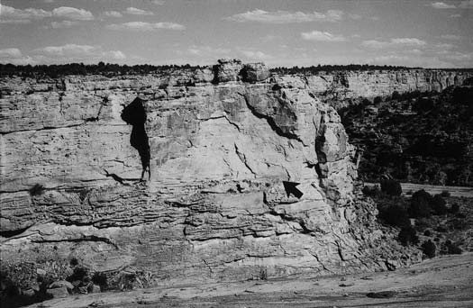

(Pollock 1999). The lower member represents deposits of meandering rivers and floodplains; the middle member was deposited by both meandering and straight, ribbon-like channels (Little 1995; Pollock 1999). The lower and middle members have northeast-directed paleocurrent indicators (Fig. 4B). They correspond to the isolated fluvial and alluvial-plain facies tracts described from the Straight Cliffs Formation of the Kaiparowits Plateau (Shanley and McCabe 1995).

The upper member of the Wahweap Formation consists of multistory channel complexes dominated by trough cross-beds. It is consistently 105– 135 m thick in the Kaiparowits Plateau but is eroded from the southern and eastern parts of the Paunsaugunt Plateau (Fig. 3). Sand-rich lateralaccretion macroforms are present in some stories and appear to increase in abundance eastward across the Kaiparowits Plateau. At Reynolds Point, thin splay sandstone sheets with ripple cross-lamination and freshwater molluscs are interbedded in siltstone intervals. Sandstone content exceeds that of underlying members and increases up section through the member. The upper member was deposited by sandy, meandering rivers. Paleocurrent data from the upper member indicate northeast dispersal (Fig. 4B). It corresponds to the isolated fluvial facies tract of Shanley and McCabe (1995).

The capping sandstone member consists of amalgamated channel complexes of sandstone and pebbly sandstone in multistory sheets (Pollock 1999). Trough cross-beds dominate the unit, and convolute cross-beds, ripple cross-lamination, and planar cross-beds are locally present. Common architectural elements (e.g., Miall 1985, 1996) include channels, gravel bedforms, downstream accretion elements, and scour hollows; fine-grained overbank and splay deposits are present but uncommon (Pollock 1999). Channel complexes and gravel bedforms contain large tree trunks with intact root networks, some still encased in siltstone (Fig. 6). Associated trough cross-beds indicate that the trunks are generally oriented parallel to paleoflow. Paleocurrent measurements indicate consistent east-southeast dispersal everywhere in the study area (Fig. 4C; Pollock 1999). This consistent dispersal direction contrasts markedly with the dominant north- to northeast-flowing river systems of the study area.

The capping sandstone member thins southeastward across the Kaiparowits Plateau, parallel to paleocurrent trends (Fig. 3). It is thickest (150 m) near Henrieville and thinnest (30 m) in the southeastern plateau, thinning abruptly at the East Kaibab monocline (Fig. 3). The member also thins to the west abruptly across the Paunsaugunt fault and is only locally present on the Paunsaugunt Plateau. Pollock (1999) interpreted these local exposures as valley-fill deposits. The basal contact, defined by color, petrology, fluvial style, and dispersal characteristics, is sharp (Fig. 7).

The capping sandstone member was deposited by low-sinuosity, braided rivers (Pollock 1999). Uncommon overbank deposits and abundant stranded trees indicate that extensive sand-body amalgamation took place by lateral channel shifting, bank erosion, and bypassing of fines. The capping sandstone member resembles deposits of the amalgamated fluvial facies tract of Shanley and McCabe (1995).

The Wahweap Formation spans the early–middle Campanian (Fig. 2). The lower three members are early to middle Campanian on the basis of mammalian vertebrate fossils (Eaton 1991; Eaton et al. 1999) and our preliminary palynomorph data (Fig. 3). At Webster Flat, a palynomorph assemblage contains *Dyadonapites reticulatus,* whose first appearance in the Western Interior is middle Campanian (Nichols 1994). At Henrieville Creek and Wahweap Canyon, the capping sandstone member contains *Aquilapollenites reductus,* which first appears in the Western Interior in the latest middle Campanian (Nichols et al. 1982; Nichols 1994). At Paradise Canyon, *Aquilapollenites clarireticulatus,* a middle Campanian palynomorph (Nichols and Sweet 1993), is present at the base of the capping sandstone member. The Wahweap therefore correlates with the Blackhawk and Castlegate formations of central Utah (Fig.2).

We regard strata above the Drip Tank Member in the Markagunt Plateau as equivalent to the Wahweap Formation. These strata have previously been assigned to the Kaiparowits(?) Formation (Sable and Hereford 1990; Nichols 1997) or the Wahweap and Kaiparowits formations (Doelling 1999). Although long-ranging, the palynomorph assemblage in the Kaiparowits(?) Formation is older than type Kaiparowits assemblages (Nichols 1997) and more closely resembles our Wahweap assemblages. On the basis of petrology and stratigraphic position above a middle Campanian palynomorph assemblage, we correlate quartzose sandstone at the top of the Cretaceous section at Webster Flat in the western Markagunt Plateau with the capping sandstone member (Fig. 3). This unit has also been assigned to the Grand Castle Formation (Goldstrand and Mullet 1997), which is Paleocene in the Table Cliffs Plateau.

In the Paunsaugunt Plateau, an unconformity beneath the Eocene Claron Formation locally truncates much of the Wahweap Formation. The entire Wahweap Formation was eroded from the crest of the Bryce Canyon anticline, which parallels the Paunsaugunt fault, prior to deposition of the Claron (Fig. 1; Bowers 1990). On the east limb of the anticline, west of Tropic, the lower and middle members and, locally, the capping sandstone member, are present. We infer that at least part of the Wahweap section is

|  |  |  |
| --- | --- | --- |
| Claron Formation (J.G. Eaton, written communication, 2002), suggesting that the Campanian strata may have been uplifted and eroded prior to resumption of deposition near the end of the Cretaceous.  ***Kaiparowits Formation***  The Kaiparowits consists of three intervals of contrasting fluvial style (Little 1995). The lower 60 m at Henrieville consists of multistory sheet sandstone bodies as much as 30 m thick separated by 5–10 m siltstone intervals. Individual stories are 3–7 m thick and locally contain lateralaccretion bodies. The middle interval northeast of Henrieville consists of 350 m of single-story to multistory ribbon channels, each 2–3 m thick and encased in mudstone-dominated overbank deposits as much as 75 m thick. The upper 55 m consists of multistory sheets as much as 10 m thick, some of which contain lateral accretion macroforms of fine-grained sandstone. The upper and lower parts of the section are interpreted as deposits of meandering rivers and the middle part as deposits of an anastamosed fluvial system (Eaton 1991; Goldstrand 1991; Goldstrand et al. 1993; Little 1995). Our limited paleocurrent data indicate Kaiparowits deposition by northflowing rivers (Fig. 4D). Compositional data described in the next section support this conclusion.  The contact of the Kaiparowits Formation is gradational with the Wahweap Formation at Henrieville Creek and Upper Valley, where both units are thickest (Fig. 3). East of the East Kaibab monocline, where the capping sandstone member is thin, the contact is sharp and the top of the Wahweap Formation is stained with hematite. The compositional shift at this contact, | Symbol | Definition |
| Qm  Qpq  Cht  K  P  Lvm  Lss  Lsc  Qt  F  L  Lt  Lsm  Qp | Monocrystalline quartz  Polycrystalline quartz  Chert  Potassium feldspar  Plagioclase feldspar  Volcanic lithic grains: felsite, vitric, hypabyssal, and microlitic grains and metamorphic grains of volcanic protolith  Sedimentary lithic grains: siltstone, argillite, phosphatic grains Detrital carbonate grains (5CE category of Zeffa, 1980)  Total quartzose grains (5Qm 1 Qpq 1 Cht)  Total feldspar (5K 1 P)  Total unstable lithic grains (5Lvm 1 Lsm)  Total lithic grains (5L 1 Qp)  Total sedimentary grains (5Lss 1 Lsc) and metamorphic grains of sedimentary protolith  Total polycrystalline quartz (5Qpq 1 Cht) |
|  | Recalculated Parameters |
|  | QtFL%Qt 5 100Qt/(Qt 1 F 1 L)  QtFL%F 5 100F/(Qt 1 F 1 L)  QtFL%L 5 100L/(Qt 1 F 1 L)  QmFLt%Qm 5 100Qm/(Qm 1 F 1 Lt)  QmFLt%F 5 100F/(Qm 1 F 1 Lt)  QmFLt%Lt 5 100Lt/(Qm 1 F 1 Lt)  QpLvmLsm%Qp 5 100Qp/(Qp 1 Lvm 1 Lsm)  QpLvmLsm%Lvm 5 100Lvm/(Qp 1 Lvm 1 Lsm)  QpLvmLsm%Lsm 5 100Ls/(Qp 1 Lvm 1 Lsm)  QmKP%Qm 5 100Qm/(Qm 1 K 1 P)  QmKP%K 5 100K/(Qm 1 K 1 P)  QmKP%P 5 100P/(Qm 1 K 1 P) |
| * Sandstone modal data are included in Appendices 1, 2, and 3. | |
| described below, is sharp and dramatic.  The Kaiparowits Formation is late Campanian. Although formerly considered Maastrichtian (Lorengel 1969), palynomorphs and mammalian fossils from the formation indicate a late Campanian age (Eaton 1991; Nichols 1997). It correlates with the Farrer and Tuscher formations of central Utah (Fig. 2).  Strata equivalent to the type Kaiparowits Formation are absent, at least locally, from the Markagunt Plateau. On the East Fork of the Virgin River, the capping sandstone member of the Wahweap is directly overlain by distinctive volcanic-clast conglomerate unique to the Maastrichtian Canaan Peak Formation (e.g., Goldstrand 1991, 1992). We infer from lithostratigraphic relations and existing biostratigraphy that the Kaiparowits is also largely absent from the Paunsaugunt Plateau, although this important inference is not universally accepted (e.g., Goldstrand 1991, 1992; Eaton 1993; Eaton et al. 1993; Eaton et al. 2001).  **SANDSTONE PETROLOGY**  Sandstone compositions of the Straight Cliffs, Wahweap, and Kaiparowits formations vary with changing paleodispersal. To document sandstone petrology, we collected 56 samples from strata exposed at various localities of the Kaiparowits Plateau and on the east flank of the Paunsaugunt Plateau. We counted 400 framework grains per thin section stained for plagioclase and potassium feldspar, using the Gazzi–Dickinson technique for counting to reduce compositional dependence on grain size (Ingersoll et al. 1984; Zuffa 1985). We counted a suite of 13 samples from the Markagunt and Paunsaugunt plateaus and compiled data of Goldstrand (1991) and Eaton et al. (1993) for samples of the Kaiparowits Formation in the Kaiparowits  Plateau and samples from the Markagunt and Paunsaugunt plateaus inter- | preted by Goldstrand as Kaiparowits Formation. In addition, we pointcounted 13 samples of the Drip Tank Member and its inferred equivalents. For comparison with our results, we include counts of 7 samples from the Iron Springs Formation (Goldstrand 1991), which was derived exclusively from the Sevier orogenic belt (Fillmore 1991; Goldstrand 1992).  All sandstone samples contain monocrystalline quartz, and most have detrital lithic grains of sedimentary origin. Feldspar and volcanic lithic grains are abundant in some samples. Grain parameters (Table 1) and modal data follow standard convention (Dickinson and Suczek 1979; Dickinson 1985) except that we include carbonate extrabasinal grains [CE of Zuffa (1985) or carbonate sedimentary aphanitic lithic grains (Lsc) of Ingersoll et al. (1987)] in the lithic category. Partly silicified carbonate grains, which consist of intergrown microcrystalline silica and finely crystalline carbonate, are included in the Lsc category. Grains consisting entirely of microcrystalline silica are classified as chert. Microcrystalline silica grains with abundant microcrystalline oxide or argillaceous material, and uncommonly containing radiolarians, are classified as argillite. Metamorphic lithic grains are rare to absent. The few metamorphic grains encountered were assigned to their inferred volcanic or sedimentary protolith for plotting purposes (e.g., Ingersoll and Suczek 1979).  Sandstones are generally matrix-free to matrix-poor, but they contain varying percentages of finely crystalline clay cement and coarse blocky calcite spar. Clay cements and pore fills are common and result in weakly indurated rocks. Local kaolinite-filled voids and uncommon skeletal feldspar grains indicate dissolution and replacement of some unstable grains and feldspar. Samples of the capping sandstone member are generally | |

also present west of the Bryce Canyon anticline. Preliminary palynomorph TABLE 1.—*Point-counting parameters\** data indicate that Maastrichtian strata may also be present beneath the

→

FIG. 8.—Detrital modes of late Santonian–Campanian sandstones, Kaiparowits Plateau. Petrofacies fields are indicated by shaded regions, which were drawn by inspection. Standard-deviation polygons and mean compositions (solid symbols) lie within their respective petrofacies fields. The Drip Tank Member, plotted with crosses, was not used to define petrofacies fields because of its compositional variability. Standard provenance fields (Dickinson and Suczek 1979; Dickinson 1985) are indicated by unshaded dotted shapes. Sandstone modal data are in Appendices 1 and 3.

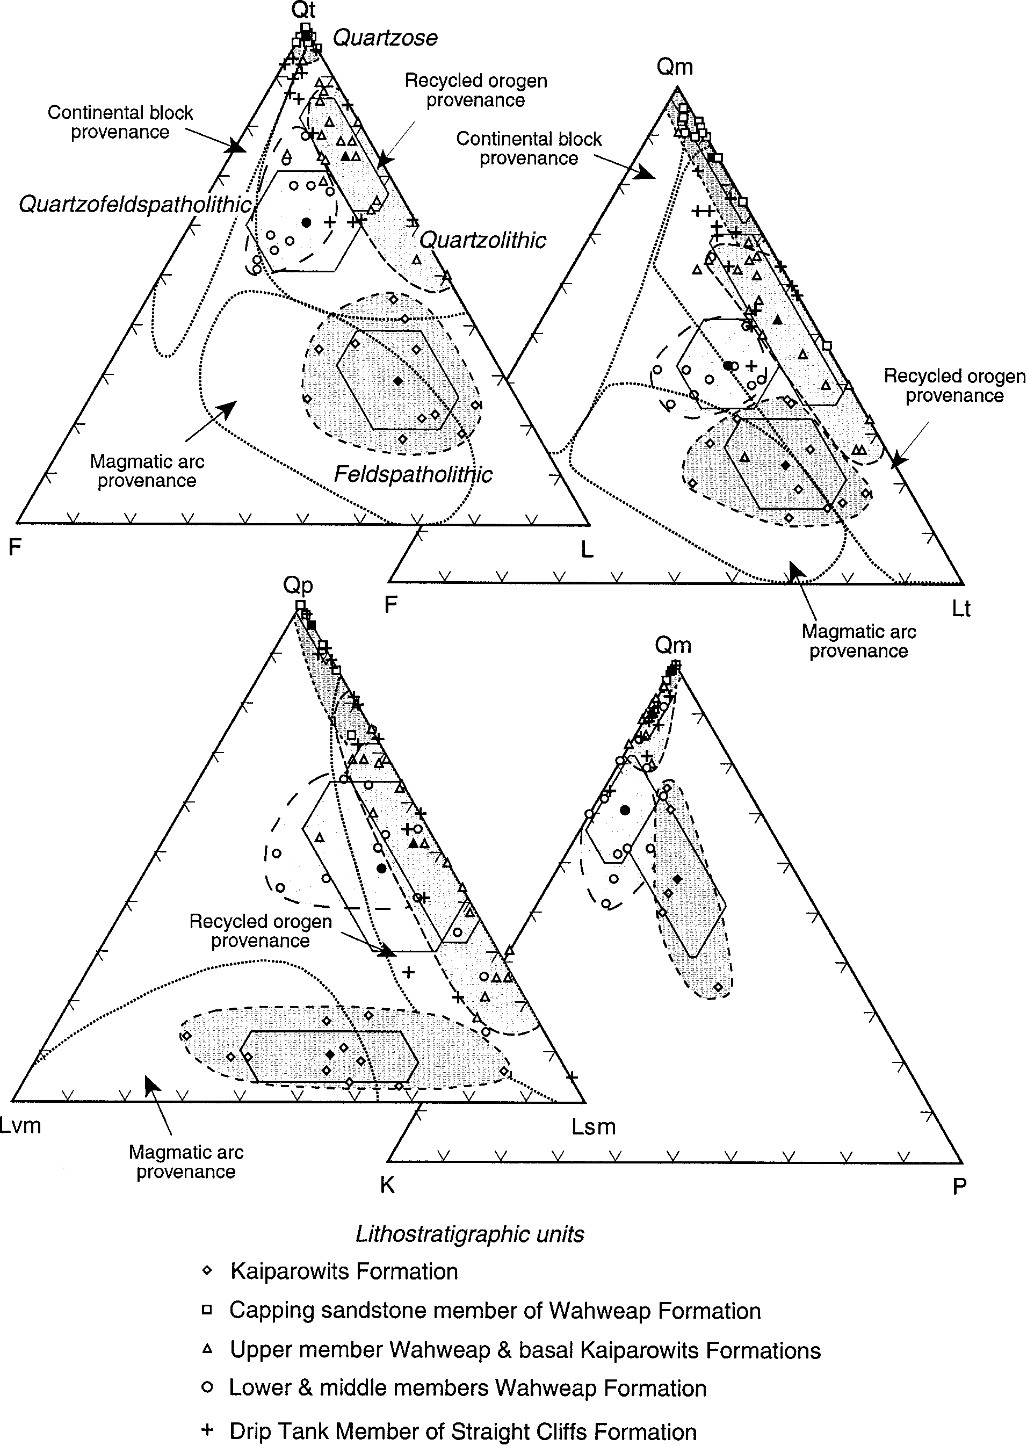

weakly cemented with illite grain coatings and local poikilotopic to patchy calcite spar (Pollock 1999). Calcite cement, where present in the Kaiparowits Formation, is coarse blocky spar and appears to have been an early phenomenon that inhibited compaction.

Campanian sandstones of the study area fall into four natural compositional categories, or petrofacies (Fig. 8; e.g., Dickinson and Rich 1972; Dickinson et al. 1986; Pollock 1999). Petrofacies were defined from stratigraphic sections throughout the Kaiparowits Plateau, where correlations are confident (Appendix 1). Petrofacies definitions were based on averages of samples over major stratigraphic intervals with consistent dispersal characteristics; we did not permit petrofacies to interfinger intricately on the basis of local compositional variability caused by single samples in a stratigraphic section. For example, all lower and middle Wahweap members were averaged to define the quartzofeldspatholithic lithofacies. This procedure resulted in broader petrofacies fields and more outliers than if individual samples had been culled into groups; nevertheless, the fields are statistically separate at the one-sigma level on the total-grain population plots (QtFL and QmFLt; Fig. 8). The Drip Tank Member was not used to define petrofacies fields because of its variability in dispersal direction and composition (Appendix 2). Because the petrofacies do not strictly conform to lithostratigraphic boundaries, they are given labels—quartzofeldspatholithic, feldspatholithic, quartzolithic, and quartzose—that describe their primary components. They can generally be recognized in hand specimen with a hand lens, with the presence of mica being an excellent guide to feldspar-bearing rocks. The samples from the Markagunt and Paunsaugunt plateaus were assigned to petrofacies where possible (Appendices 2, 3; Fig. 9) but were not used to define petrofacies because of correlation uncertainties described above. We recognize that the relative abundance of plagioclase, potassium feldspar, and clay can change with weathering rate and style (e.g., Fedo et al. 1995; Nesbitt et al. 1997). Nevertheless, the consistency of the petrofacies in major stratigraphic intervals suggests steadystate weathering conditions over the time scales represented by deposition of these intervals.

## Quartzofeldspatholithic Petrofacies

This petrofacies includes relatively quartz-rich, feldspar-bearing compositions that average Qt61F19L20 (Fig. 8; Appendix 1). Potassium feldspar is invariably more abundant than plagioclase, with microcline a common constituent. Sedimentary lithic grains, including argillite, siltstone, and phosphatic grains, are more abundant than volcanic lithic grains, which are dominantly felsite and microgranular hypabyssal grains. Carbonate extrabasinal grains are present but subordinate. Chert grains have uncommon recrystallized fossils originally composed of calcium carbonate, indicating an origin by replacement of carbonate rocks. Biotite is a relatively abundant accessory mineral, ranging from 2 to 4% of the total sandstone (Pollock 1999). This petrofacies is restricted to some samples of the Drip Tank Member and the lower and middle members of the Wahweap Formation, and was deposited by northeast-flowing rivers. It is present in the Paunsaugunt and Markagunt plateaus, although it is represented by only a single sample from the sparsely sampled Markagunt Plateau.

## Feldspatholithic Petrofacies

The feldspatholithic petrofacies is a distinctive suite of feldspar-bearing, quartz-poor litharenites and feldspathic litharenites averaging Qt29F19L52 (Fig. 8; Appendix 1). Monocrystalline quartz grains are commonly inclusion free with straight extinction and were observed in several felsite and vitric volcanic grains. Potassium feldspar and plagioclase are present in subequal proportions; microcline is present but uncommon. The two feldspars are commonly associated in granular quartzofeldspathic aggregates interpreted as granitic rock fragments. Volcanic lithic fragments are abundant, with Lvm/L ranging from 0.12 to 0.72. The volcanic lithic grains include abundant tuffaceous vitric grains, some with eutaxitic textures, flow foliation, and outlines of relict angular shards, as well as felsites and microgranular hypabyssal rock types. Black argillite and chert grains with recrystallized radiolarians are uncommon (Goldstrand 1992); a more common chert type is light brown as a result of dispersed iron oxide and contains angular detrital grains of monocrystalline quartz. We infer a late Paleozoic carbonate source, perhaps the Kaibab Limestone, for these silty chert grains. Carbonate extrabasinal grains dominate the Lsm fraction, usually constituting more than 50% of the sedimentary lithic grains. The feldspatholithic petrofacies is present in the Kaiparowits Formation, exclusive of its basal few tens of meters, and in the overlying Canaan Peak Formation (Goldstrand 1992). It was delivered to the basin by northeast-flowing rivers. Our feldspatholithic petrofacies contains less Qt and Qm than the equivalent Kaiparowits–Canaan Peak petrofacies of Goldstrand (1992), in part because we excluded samples from the basal, quartzolithic Kaiparowits. A similar petrofacies, although somewhat more enriched in quartz, is present in the correlative Farrer and Tuscher formations in east-central Utah (Lawton 1983a, 1983b, 1986; Dickinson et al. 1986; Goldstrand 1992). These strata were also deposited by northeast-flowing rivers (Dickinson et al. 1986; Lawton 1986) interpreted to represent the down-river equivalents of our feldspatholithic petrofacies.

## Quartzolithic Petrofacies

This petrofacies contains a high percentage of monocrystalline quartz and is enriched in chert and sedimentary lithic grains. Average compositions are Qt75F6L20 and Qm53F6Lt41 (Fig. 8; Appendix 1). Chert and argillite grains are abundant and contain uncommon radiolarians. Carbonate extrabasinal grains are also abundant. Volcanic lithic grains are uncommon to absent. Feldspar typically constitutes less than 10 per cent of the framework population, but it is somewhat more abundant in eastern sections, with some samples from Reynolds Point used to define this petrofacies plotting in the quartzofeldspatholithic field on the QtFL diagram. This petrofacies is present in the Drip Tank Member, the upper member of the Wahweap Formation, and the basal part of the Kaiparowits Formation. It was delivered to the study area by north- to northeast-flowing river systems. It is also characteristic of the Iron Springs Formation of the thrust belt and some strata assigned to the Kaiparowits Formation in the Paunsaugunt Plateau (Fig. 9; Goldstrand 1991, 1992). It appears to be the dominant petrofacies in western localities, including the Paunsaugunt and Markagunt plateaus and the thrust belt.

## Quartzose Petrofacies

The quartzose petrofacies contains mostly monocrystalline quartz with some chert (Qt99F1L1; Qm87F1Lt12) (Fig. 8; Appendix 1). Abraded quartz overgrowths are common, indicating derivation from a sedimentary source, and many of the grains are well rounded and spherical. Sedimentary lithic grains are locally present; felsitic volcanic lithic grains were observed in only one sample (Pollock 1999). This petrofacies is present locally in the Drip Tank Member of the Straight Cliffs Formation and encompasses the capping sandstone member of the Wahweap Formation in the Kaiparowits Plateau. Chert averages only about 10%, and even stratigraphic intervals that contain abundant chert pebbles fall into this petrofacies. It was delivered to the basin by eastsoutheast-flowing rivers (Fig. 4C). At Webster Flat, spherical Qm grains 0.5 mm in diameter are a striking and prevalent component of the petrofacies. Paleocurrent data there also indicate southeastward flow (Fig. 4C; Goldstrand 1991; Goldstrand and Mullett 1997).

# CONGLOMERATE PETROLOGY

Pebbles within late Santonian–Campanian strata were derived almost exclusively from sedimentary sources. Pebble counts in the capping sandstone

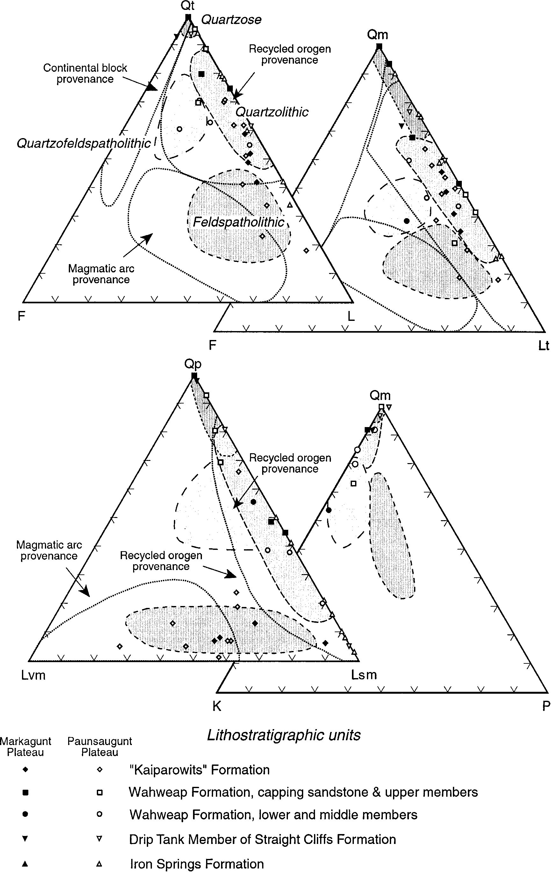

FIG. 9.—Detrital modes of Upper Cretaceous sandstones, Markagunt (solid symbols) and Paunsaugunt (open symbols) plateaus. Petrofacies and provenance fields are from Figure 8. Iron Springs samples are from thrust belt and western Markagunt Plateau (Goldstrand 1991). Sandstone modal data are in Appendices 2 and 3.

TABLE 2.—*Conglomerate clast types and possible sources, capping sandstone member*

|  |  |  |
| --- | --- | --- |
| Clast Type | Description | Possible Source Formation |
| Black chert | Black dense chert with brachiopods, bryozoans, rugose corals | Mississippian Joana Limestone |
| Gray chert | Light gray chert, commonly microporous with bleached, weathered rinds; rugose corals, fusulinids, bryozoans | Middle–Upper Paleozoic carbonate rocks |
| White chert | White and light brown chert, commonly microporous with bleached, weathered, concentric outer rinds; fusulinids, brachiopods, bryozoans | Mississippian Redwall Limestone, Pennsylvanian Callville and Ely limestones, Permian Kaibab Limestone |
| White quartzite | White or light gray quartzite | Ordovician Eureka Quartzite |
| Red quartzite | Red or pink quartzite | Precambrian–Cambrian Prospect Mountain Quartzite |
| Banded sandstone | Black and white sandstone with 1–4 mm laminae | Mesozoic clastic rocks |
| Siltstone | White or light gray siltstone | Mesozoic clastic rocks |
| Sandstone | Coarse-grained yellow sandstone | Triassic Chinle Formation |

member of the Wahweap Formation indicate a clast population of dominant chert (61–85%), red, pink, and white quartzite (6–17%), and sandstone and siltstone (3–9%)(Pollock 1999). Chert clasts contain silicified crinoid fragments, bryozoans, brachiopods, and rugose corals. White and light-gray chert clasts with bleached microporous rinds and common fusulinids, bryozoans, and brachiopods (Pollock 1999) have previously been interpreted as limestone clasts (Eaton 1991; Little 1995), but we observed no limestone in the clast population. These pebble types have been attributed to uplifted Precambrian and Paleozoic strata of the Wah Wah and Blue Mountain thrust sheets, respectively (Table 2; Fillmore 1991; Goldstrand 1991, 1992). Clast populations in the Drip Tank Member in the Paunsaugunt and Markagunt plateaus are indistinguishable from those of the capping sandstone member, except that Drip Tank pebbles have a minor, local component of volcanic clasts (0–5%; Eaton et al. 1993).

# DETRITAL SOURCES AND SEDIMENT-DELIVERY SYSTEMS

Modal compositions and pebble content indicate that the late Santonian– Campanian river systems tapped both supracrustal and basement sources to the west, southwest, and south. Long-distance transport and confluent drainage systems are inferred to have resulted in mixing of detritus from these two sources to yield the observed petrofacies types. The quartzofeldspatholithic and quartzolithic petrofacies lie in the recycled-orogen provenance field (Figs. 8, 9; Dickinson and Suczek 1979; Dickinson 1985). The feldspatholithic petrofacies is unusual in that it overlaps with the lithic-rich undissected-arc field. The quartzose petrofacies straddles the recycled-orogen and continental-block (cratonic) provenance fields. The utility of the petrofacies as indicators of tectonic setting is dependent on feldspar weathering rate as a function of rainfall, vegetation, and bulk composition of bedrock (Nesbitt et al. 1997). In spite of these caveats, a strong tie between source-rock type and petrofacies in southern Utah is confirmed by identifiable conglomerate clasts and lithic sandstone grains as well as a consistent association of petrofacies with particular dispersal systems.

The quartzofeldspatholithic facies was derived from mixed basement and uplifted sedimentary sources and carried northeastward by longitudinal river systems (Fig. 10A; Pollock 1999). Similar compositions have been attributed to thrust-belt sources to the southwest that contributed sedimentary detritus, including radiolarian chert, and to the south-southwest in southeastern California, where basement and Jurassic silicic volcanic rocks are present in thrust sheets (Goldstrand 1992). Uplifted sedimentary rocks of the thrust belt likely contributed the abundant Qm and chert that cause this petrofacies to plot outside the continental-block (uplifted-basement) provenance field of Dickinson and Suczek (1979) and Dickinson (1985). The abundance of microcline and granitic rock fragments suggests that the basement source was more extensive than limited basement exposures in the thrust sheets and additionally included widely exposed basement in southwestern Arizona. Similar feldspathic detritus in slightly older Turonian rocks of the study area has in fact been attributed to basement sources in southern Arizona (Elder and Kirkland 1994).

The feldspatholithic petrofacies, with its distinctive high volcanic-lithic content, was derived from sources to the south. Abundant vitric grains and Qm grains with straight extinction indicate that silicic ash-flow tuffs were important, if not dominant, contributors to this petrofacies. These grain types in the Kaiparowits and Canaan Peak formations were probably derived from upper Middle Jurassic ash-flow tuffs uplifted on the Maria and Mule Mountains thrust systems, active from about 80 to 65 Ma, of southwestern Arizona and southeastern California (e.g., Tosdal 1990; Miller et al. 1992; Richard et al. 1998). Radiolarian chert grains and other indicators of Paleozoic sedimentary source rocks may record a Sevier thrust belt provenance (Goldstrand 1992, 1994); however, the abundant sedimentary lithic grains and upper Paleozoic chert grains are also compatible with a sedimentary source stratigraphically beneath the Jurassic volcanic rocks in southern Arizona and southeastern California.

The chert-rich quartzolithic petrofacies was derived primarily from the Sevier thrust belt and transported by tributaries to the major longitudinal rivers (Fig. 10A). These inferences are supported by eastward and northeastward paleocurrent data, the predominantly sedimentary source indicated by the detrital composition, and a gradational petrofacies contact within the upward-coarsening Wahweap Formation (Fig. 3). Two-thirds of the Iron Springs samples reported by Goldstrand (1991, 1992) plot within this petrofacies field on the QtFL diagram (Fig. 9) and corroborate a source in the Sevier orogenic belt.

The distinctive quartzose petrofacies of the capping sandstone member was derived exclusively from the Sevier orogen and transported across structural strike into the basin. Detritus came primarily from uplifted Mesozoic strata near the tip of the thrust belt, where the Jurassic Navajo Sandstone contributed the abundant large spherical Qm grains (Pollock 1999); older foreland-basin strata, mainly the Iron Springs Formation, may have likewise contributed quartz-rich detritus. The Dakota and Iron Springs formations are the primary sources for recycled Cenomanian–Turonian palynomorphs in the capping sandstone member. We interpret the Kanarra fold and Iron Springs thrust system as important sources of sediment for the capping sandstone member. Quartzite and chert pebbles may have come directly from the Wah Wah and Blue Mountain thrust sheets (e.g., Fillmore 1991; Goldstrand 1994), or they may have been recycled from proximal foreland-basin strata uplifted on more frontal structures. Recycling of pebbly quartzolithic detritus is consistent with the somewhat reduced chert content in the quartzose petrofacies relative to the quartzolithic petrofacies.

Northeastward dispersal of detritus parallel to structural strike of the thrust orogen and foreland basin was the dominant transport mode of late Santonian–Campanian river systems in southwestern Utah. These systems are readily recognizable by their feldspar content, volcanic lithic detritus, and paleocurrent orientations. They were large-discharge, probably perennial rivers as judged from channel dimensions and facies associations, but they varied from amalgamated, sand-rich systems to mud-rich, sinuous and anastamosed ones. They conform to the model of longitudinal trunk river systems proposed for foreland basins (Miall 1981). The quartzolithic petrofacies, with a thrust-belt source and northeast- and east-directed dispersal, represents tributary systems that mixed with these trunk systems. Petrofacies distinctions are apparently blurred in the Markagunt Plateau (Fig. 9; Appendix 3) as a result of this mixing, and possibly as a result of erosion and recycling of older foreland-basin strata.

In contrast, the quartzose petrofacies was deposited by transverse streams, which flowed perpendicular to structural strike (Fig. 10B). Abrupt downstream thickness changes of the capping sandstone member suggest that it was deposited across a foreland that had begun to experience partitioning into local basins (Pollock 1999). Absence of the capping sandstone from most of the Paunsaugunt Plateau could indicate postdepositional truncation, but its presence in isolated paleovalleys (Fig. 3; Pollock 1999) sug-

|  |
| --- |
| FIG. 10.—Paleogeographic reconstructions of Campanian fluvial systems. **A)** Longitudinal trunk drainages of Drip Tank Member of Straight Cliffs Formation and lower three members of Wahweap Formation. **B)** Transverse drainages of capping sandstone member of Wahweap Formation. Dashed lines indicate positions of time-equivalent structures in foreland: KF, Kanarra fold; PD, Paunsaugunt duplex; EKN, East Kaibab normal fault. Paleogeographic elements are after the Campanian I reconstruction of Roberts and Kirschbaum (1995). |

gests that partitioning of the foreland basin began in the middle Campanian. Abrupt thinning at the East Kaibab monocline demonstrates that Campanian offset on the structure was opposite to its Laramide displacement, which was up to the west (Tindall and Davis 1999). This syndepositional displacement failed to deflect the fluvial system, which apparently cut across intrabasinal structures composed of unconsolidated material.

# GENESIS OF STRATIGRAPHIC SEQUENCES AND BASIN EVOLUTION

The succession composed of the Drip Tank, Wahweap, and Kaiparowits formations forms two third-order continental stratigraphic sequences. As most commonly interpreted (Fig. 11), the lower part of a continental sequence consists of sandstone-rich fluvial facies overlying a sharp sequence

|  |
| --- |
| FIG. 11.—Sequence-stratigraphic interpretation of upper Santonian–Campanian continental section and application to two tectonic models for foreland-basin development.  Compositional and dispersal congruence or incongruence refers to similarity or contrast, respectively, of sandstone composition and paleodispersal across inferred sequence |

boundary.

boundary (Shanley and McCabe 1991, 1995). This amalgamated fluvial facies tract is interpreted to represent deposition during lowstand (Van Wagoner 1995; Yoshida et al. 1996; McLaurin and Steel 2000) or early transgressive conditions (Shanley and McCabe 1995) following a basinward shift of facies. The subsequent transgression is recorded by isolated fluvial facies tracts and tidally influenced facies tracts, in which sandstone bodies become increasingly isolated and the section more enriched in mudstone to a level in the section that records maximum transgression (Olsen et al. 1995; Shanley and McCabe 1995). The succeeding highstand systems tract is marked by an up-section increase in multistory stacking of channel sandstone bodies and fluvial sheet sandstones (Olsen et al. 1995). Whether or not the sequence boundary is a marked unconformity or lies in a conformable succession of strata is determined by subsidence rates, which generally decrease across the foredeep with distance from the front of the thrust orogen (Posamentier and Allen 1993; Olsen et al. 1995), sediment supply rate, and locations of major channel belts.

The Drip Tank and capping sandstone members constitute the amalgamated basal parts of two depositional sequences (Fig. 11). The Drip Tank forms the basal part of a sequence that includes the lower three members of the Wahweap Formation. The capping sandstone member forms the base of a sequence that includes the Kaiparowits Formation. Petrofacies and paleocurrent analyses nevertheless indicate that the basal amalgamated sandstone units are quite different with regard to their associated sequences. Although it varies markedly in composition from story to story with location, the feldspathic Drip Tank Member is compositionally similar to the overlying strata and, like them, was deposited by rivers that flowed northeast along the basin foredeep. We term this similarity *congruence* with respect to composition and dispersal direction. The underlying John Henry

|  |
| --- |
| FIG. 12.—Conceptual model to explain basinward shift of the capping sandstone member during disruption of former foredeep. Structures of thrust belt: BM, Blue Mountain thrust; IS, Iron Springs thrust; Ka, Kanarra fold; WW, Wah Wah thrust. Structures of foreland: EKf, East Kaibab normal fault; Pd, Paunsaugunt duplex. Basins and uplift of Fig. 3: HB, Henrieville Basin; KB, Kaiparowits Basin; MB, Markagunt Basin; PU, Paunsaugunt uplift. Stratigraphic units: K, strata of foreland basin (Dakota, Iron Springs, Tropic, Straight Cliffs and Wahweap formations); Mz, Triassic–Jurassic strata; pC, Precambrian strata; Pz, Paleozoic strata. Positions of Cenozoic normal faults and Laramide East Kaibab monocline are indicated. Laramide displacement on the East Kaibab monocline was opposite to the middle Campanian displacement |

indicated in the figure.

Member is also feldspathic (Eaton et al. 1993) and similar to the lower two members of the Wahweap. The Drip Tank Member is thus compositionally and depositionally congruent with respect to both overlying and underlying strata. The capping sandstone member is incongruent with respect to both overlying and underlying strata because it differs in composition and dispersal from the underlying upper member of the Wahweap and the overlying Kaiparowits Formation.

Integration of compositional and paleocurrent data into standard sequence analysis provides insight into the potential causes of base-level shifts in these sequences. Base-level shifts that create sequence boundaries in foreland basins are generally interpreted as eustatically driven (Olsen et al. 1995; Shanley and McCabe 1995; Van Wagoner 1995) or tectonically driven (Heller et al. 1988; DeCelles and Giles 1996). In general, eustatic mechanisms are invoked by correlation of sequences with global sea-level curves (e.g., Shanley and McCabe 1995), whereas tectonic mechanisms for foredeep sequences derive from predictions of basin models. Tectonic models of foreland-basin evolution fall into two competing classes. The first, flexure-dominated class emphasizes an asymmetric foredeep in which stratal architecture is determined primarily by the balance of subsidence rate and sediment flux through time (Heller et al 1988; Flemings and Jordan 1989). In such models, dispersal of coarse detritus across the foredeep is attributed to a slowing of subsidence during thrust-belt quiescence coupled with isostatic rebound of the orogen (Heller et al. 1988; Flemings and Jordan 1989). Mudstone-rich facies accumulate and foredeep-parallel axial rivers dominate during times of active thrusting and rapid subsidence. The second class of models emphasizes foredeep disruption, whereby stratal geometries are controlled primarily by structural advance of the thrust belt into the foredeep and creation of small basins residing on the thrust sheets themselves (Ori and Friend 1984; DeCelles and Giles 1996). The migration of the structural front into the foredeep, commonly by propagation of bedding-plane thrusts beneath the foreland basin, serves to reduce the rate of subsidence in the proximal part of the basin by both local and regional uplift. Local uplift takes place on thrust-related folds; regional uplift is effected by translation of the section up the gentle stratigraphic ramp used by the propagating thrust system (Talling et al. 1995; DeCelles and Giles 1996). Foredeep disruption displaces the longitudinal trunk rivers, which are replaced by river systems developed above the propagating structural front, a part of the foreland-basin system termed the wedge-top depozone (DeCelles and Giles 1996). The impact of basin partitioning on foredeep sedimentation is not yet well understood and is dependent on the storage capacity of the wedge-top basins. Capacity is in turn dependent upon uplift rate, precipitation rate, bedrock composition and durability (Tucker and Slingerland 1996), and structural orientation (Hermanns and Strecker 1999). Increased erosion rates due to local or regional precipitation increase could also cause a basinward shift of facies.

Although the amalgamated fluvial units are architecturally similar, we interpret the capping sandstone to record a tectonic base-level shift and the Drip Tank to record a shift due to climatic change or eustatic fall. The congruent sub-Drip Tank sequence boundary represents a northeastward facies shift along the trend of a subsiding foredeep, wherein a sand-rich trunk river system of low sinuosity shifted downstream across an alluvial plain formerly traversed by sinuous trunk rivers. The compositional and paleocurrent variability of the Drip Tank records interplay of major quartzofeldspatholithic trunk rivers and confluent quartzolithic and quartzose tributaries in the compositional mixing zone of the foredeep. In support of its eustatic origin, the sequence boundary at the base of the Drip Tank Member has been correlated with a global eustatic lowstand in the early Campanian (Shanley and McCabe 1995). The foredeep-parallel shift of the lowstand river system is thus inferred to have tracked a northeastward withdrawal of the sea in central Utah, recorded there by progradation of the Emery Sandstone Member of the Mancos Shale (Fig. 2). However, if the lower Campanian of the Western Interior correlates with the global upper Santonian (e.g., Leahy and Lerbekmo 1995), the eustatic sub-Drip Tank unconformity will have to be recorrelated with a different eustatic lowstand.

We regard the incongruent capping sandstone member as the record of a basinward shift created by active structural advance of the wedge-top depozone into the former foredeep rather than post-tectonic isostatic uplift (Fig. 12). Two observations indicate that the unit is syntectonic and not the result of post-tectonic rebound of the thrust orogen. First, deposition of the capping sandstone member was roughly coeval with development of the Kanarra fold, which probably contributed easily eroded quartz sand with abundant spherical grains (Navajo Sandstone) to the foreland. Involvement of Straight Cliffs strata in the Kanarra fold and truncation of the fold beneath the Claron Formation (Averitt and Threet 1973) indicate that folding took place between the end of the Santonian and the Eocene. Second, abrupt eastward thinning of the capping sandstone member across the East Kaibab monocline records non-uniform flexural subsidence, in this case, down-to-the-west displacement on an intra-foreland basement structure, during active thrust loading. The Dakota Formation, which similarly thins eastward at the Hurricane, Markagunt, and Paunsaugunt faults, records similar domains of stepwise subsidence in the foreland basin (Gustason 1989). These down-to-the-orogen normal faults represent a brittle response to flexural lithospheric bending caused by the combined loads of the thrust belt and basin fill (e.g., Bradley and Kidd 1991). Partitioning of the quartzose petrofacies into discrete basins east and west of the Paunsaugunt Plateau thus may record disruption of the foredeep both by advance of frontal thrusts (e.g., Ori and Friend 1984) and subsidence of domains separated by flexural normal faults in the foredeep (Fig. 12). Pollock (1999) designated the small basins developed during deposition of the capping sandstone member as the Markagunt, Henrieville, and Kaiparowits basins (Figs. 3, 12). High sediment flux kept the wedge-top basins and foredeep filled and permitted consistent southeastward dispersal during deposition of the capping sandstone member.

The Santonian–Campanian fluvial systems evolved within an eastwardadvancing foreland-basin system (Eaton and Nations 1991; Little 1995; Eaton et al. 1997). In such a model, the dominant control on all fluvial systems, trunk and tributary alike, was structural. Thrust activity in the Sevier orogen to the west and simultaneous basement uplift far to the south may have enhanced sediment delivery by the longitudinal fluvial systems; however, it is more likely that sandstone architecture and geometry were modulated by climate- or uplift-driven sediment influx from the south, possibly in concert with eustatic base-level changes to the northeast in central Utah. Tectonics alone probably did not create the architecture of the lower sequence described here, which was deposited before foredeep partitioning began in the study area.

Although the lower part of the Wahweap was also deposited by longitudinal trunk rivers, petrology and dispersal evolved up section with the sequence architecture. The quartzolithic petrofacies and northeast to east dispersal of the upper member record the appearance of obliquely transverse tributary rivers in the proximal foredeep. The capping sandstone member was dispersed directly across the former foredeep as thrust faults propagated eastward, probably on a detachment in evaporite of the Carmel Formation, to at least the present Paunsaugunt fault. The capping sandstone member of the Markagunt and Paunsaugunt plateaus thus represents deposits of the wedge-top depozone. We depict the capping sandstone member as feeding a trunk system to the east (Fig. 10B); however, confirmation of our reconstruction requires more study of Upper Cretaceous strata east of the Circle Cliffs uplift.

The thick Kaiparowits Formation occupied a post-Wahweap foredeep. The sharp contact at the top of the Kaiparowits is congruent because the overlying coarse-grained Canaan Peak Formation is feldspathic in composition and was dispersed northward (Goldstrand 1991, 1992). The Kaiparowits and Canaan Peak fluvial systems connected northeastward with Farrer and Tuscher fluvial systems of central Utah (Lawton 1983a, 1983b; Dickinson et al. 1986; Goldstrand 1992) via a foredeep that ran the length of Utah. These fluvial systems probably record renewed uplift on the basement-involved thrust systems in southwestern Arizona and southeastern California (Fig. 10A).

# CONCLUSIONS

1. Late Santonian–Campanian fluvial systems of the southernmost Cordilleran foreland basin were dominantly longitudinal trunk rivers that flowed northeast along the foredeep, parallel to the strike of the Sevier thrust orogen.
2. Less common east-southeast-directed, transverse dispersal systemsdeposited amalgamated sheet sandstone units in the basin. Two amalgamated sandstone units are present in the study area. The lower one (Drip Tank Member of Straight Cliffs Formation) was deposited in the basin foredeep; the upper one (capping sandstone member of Wahweap Formation) was deposited in both the wedge-top and foredeep depozones by braided rivers that crossed the foredeep.
3. The fluvial strata contain four sandstone petrofacies. Quartzofeldspatholithic and feldspatholithic petrofacies were dispersed northeastward by the longitudinal trunk rivers from uplifted supracrustal and basement sources that lay to the south and southwest of the basin. Much of the basin fill came from these basement sources. Quartzolithic and quartzose petrofacies were derived from uplifted sedimentary rocks in the Sevier thrust orogen. The quartzolithic petrofacies was also delivered northeastward by rivers that joined the longitudinal trunk rivers in the basin foredeep. The quartzose petrofacies is unique to the east-southeast-flowing fluvial systems.
4. The two amalgamated sandstone units mark major apparent basinwardshifts of facies. The lower amalgamated sandstone is generally congruent with underlying and overlying strata with respect to its composition and dispersal azimuth. This congruent basinward shift took place parallel to the foredeep axis and was eustatically or climatically driven. The upper amalgamated sandstone represents an incongruent basinward shift that resulted from reduced subsidence rates within the wedge-top depozone as thrust deformation advanced into the former foredeep.
5. Stacking-pattern analysis without dispersal and petrographic datalacks directional and compositional information critical to the understanding of ancient fluvial successions. Integration of paleocurrent analysis and sandstone petrology with stratigraphic techniques increases the likelihood of correct interpretation of the underlying causes of facies shifts, changes in accommodation, and resultant sequence architecture.

# ACKNOWLEDGMENTS

We thank Jeff Eaton for generously sharing his knowledge of the Cretaceous of the High Plateaus, and Gus Gustason for introducing us to the fluvial systems there. We have also benefited from logistical support and/or discussions with Gayle Pollock, Ted Dyman, Jim Kirkland, Bart Kowallis, Lehi Hintze, Bill Dickinson, Wanda Taylor, and Patrick Goldstrand. Stonnie Pollock’s research was partially supported by grants from the American Association of Petroleum Geologists, Grand Staircase– Escalante National Monument, Bryce Canyon Natural History Association, and the Four Corners Geological Society. Jeff Eaton graciously read several earlier versions of the manuscript. We thank JSR reviewers Ray Ingersoll and Andrew Miall for constructive reviews and Associate Editor Greg Nadon for special attention to the manuscript. Although the reviewers greatly improved the content of the final version, they do not necessarily endorse all of our interpretations. Appendices 1, 2, and 3 are found in the SEPM data archive at http://www.ngdc.noaa.gov/mgg/sepm/archive/ index.html.

# REFERENCES

ARMSTRONG, R.L., 1968, Sevier orogenic belt in Nevada and Utah: Geological Society of America, Bulletin, p. 429–458.

Averitt, P., and Threet, R.L., 1973, Geologic map of the Cedar City quadrangle, Iron County, Utah: U.S. Geological Survey, Map GQ-1120, scale 1:24,000.

BOWERS, W.E., 1972, The Canaan Peak, Pine Hollow, and Wasatch Formations in the Table Cliff region, Garfield County, Utah: U.S. Geological Survey, Bulletin 1331-B, 39 p.

BOWERS, W.E., 1990, Geologic map of Bryce Canyon National Park and vicinity, southwestern Utah: U.S. Geological Survey, Miscellaneous Investigations Series, Map I-2108, 1:24,000, 15 p.

BRADLEY, D.C., AND KIDD, W.S.F., 1991, Flexural extension of the upper continental crust in collisional foredeeps: Geological Society of America, Bulletin, v. 103, p. 1416–1438.

CANDE, S.C., AND KENT, D.V., 1992, A new geomagnetic polarity time scale for the Late Cretaceous and Cenozoic: Journal of Geophysical Research, v. 97, p. 13,917–13,951.

DECELLES, P.G., AND GILES, K.A., 1996, Foreland basin systems: Basin Research, v. 8, p. 105– 123.

DICKINSON, W.R., 1985, Interpreting provenance relations from detrital modes of sandstones, *in* Zuffa, G.G., ed., Provenance of Arenites: Dordrecht, The Netherlands, D. Reidel Publishing Co., p. 333–361.

DICKINSON, W.R., AND RICH, E.I., 1972, Petrologic intervals and petrofacies in the Great Valley Sequence, Sacramento Valley, California: Geological Society of America, Bulletin, v. 83, p. 3007–3024.

DICKINSON, W.R., AND SUCZEK, C.A., 1979, Plate tectonics and sandstone compositions: American Association of Petroleum Geologists, Bulletin, v. 63, p. 2164–2182.

DICKINSON, W.R., LAWTON, T.F., AND INMAN, K.I., 1986, Sandstone detrital modes, central Utah foreland region: stratigraphic record of Cretaceous–Paleogene tectonic evolution: Journal of Sedimentary Petrology, v. 56, p. 276–293.

DOELLING, H.H., 1999, Interim geologic map of the Kanab 309 3 609 quadrangle, Kane and Washington Counties, Utah, and Coconino and Mohave Counties, Arizona: Utah Geological Survey, Open-File Report 366, scale 1:100.000.

DOELLING, H.H., AND DAVIS, F.D., 1989, The geology of Kane County, Utah—geology, mineral resources, geologic hazards: Utah Geological and Mineral Survey, Bulletin 124, 192 p.

EATON, J.G., 1991, Biostratigraphic framework for the Upper Cretaceous rocks of the Kaiparowits Plateau, southern Utah, *in* Eaton, J.G., and Nations, J.D., eds., Stratigraphy, Depositional Environments, and Sedimentary Tectonics of the Western Margin, Cretaceous Western Interior Seaway: Geological Society of America, Special Paper 260, p. 47–64.

EATON, J.G., 1993, Mammalian paleontology and correlation of the uppermost Cretaceous rocks of the Paunsaugunt Plateau, Utah, *in* Morales, M., ed., Aspects of Mesozoic Geology and Paleontology of the Colorado Plateau: Museum of Northern Arizona, Bulletin 59, p. 163– 180.

EATON, J.G., AND NATIONS, J.D., 1991, Introduction; tectonic setting along the margin of the Cretaceous Western Interior seaway, southwestern Utah and northern Arizona, *in* Eaton, J.G., and Nations, J.D., eds., Stratigraphy, Depositional Environments, and Sedimentary Tectonics of the Western Margin, Cretaceous Western Interior Seaway: Geological Society of America, Special Paper 260, p. 1–8.

EATON, J.G., CIFELLI, R.L., HUTCHISON, J.H., KIRKLAND, J.I., AND PARRISH, J.M., 1999, Cretaceous vertebrate faunas from the Kaiparowits Plateau, south-central Utah, *in* Gillette, D.D., ed., Vertebrate Paleontology in Utah: Utah Geological Survey, Miscellaneous Publication 99–1, p. 345–353.

EATON, J.G., GOLDSTRAND, P.M., AND MORROW, J., 1993, Composition and stratigraphic interpretation of Cretaceous strata of the Paunsaugunt Plateau, Utah, *in* Morales, M., ed., Aspects of Mesozoic Geology and Paleontology of the Colorado Plateau: Flagstaff, Arizona, Museum of Northern Arizona, Bulletin 59, p. 153–162.

EATON, J.G., LAURIN, J., KIRKLAND, J.I., TIBERT, N.E., LECKIE, R.M., SAGEMAN, B.B., GOLDSTRAND, P.M., MOORE, D.W., STRAUB, A.W., COBBAN, W.A., AND DALEBOUT, J.D., 2001, Cretaceous and early Tertiary geology of Cedar and Parowan canyons, western Markagunt Plateau, Utah: Utah Geological Association field trip road log, September, 2001, *in* Erskine, M.C., Faulds, J.E., Bartley, J.M., and Rowley, P.D., eds., The Geologic Transition, High Plateaus to Great Basin—A Symposium and Field Guide: Utah Geological Association, Publication 30, p. 337–363.

EATON, J.G., WILLSEY, S.P., YONKEE, W.A., TILTON, T.L., AND WHITE, T.S., 1997, The geometry of the Late Cretaceous Sevier foreland basin, southwestern Utah (abstract): Geological Society of America, Abstracts with Programs, v. 29, p. A278.

ELDER, W.P., AND KIRKLAND, J.I., 1994, Cretaceous paleogeography of the southern Western Interior region, *in* Caputo, M.V., Peterson, J.A., and Franczyk, K.J., eds., Mesozoic systems of the Rocky Mountain region, U.S.A.: Denver, SEPM, Rocky Mountain Section, p. 415– 440.

FEDO, C.M., NESBITT, H.W., AND YOUNG, G.M., 1995, Unraveling the effects of potassium metasomatism in sedimentary rocks and paleosols, with implications for paleoweathering conditions and provenance: Geology, v. 23, p. 921–924.

FILLMORE, R.P., 1991, Tectonic influence on sedimentation in the southern Sevier foreland, Iron Springs Formation (Upper Cretaceous), southwestern Utah, *in* Eaton, J.G., and Nations, J.D., eds., Stratigraphy, Depositional Environments, and Sedimentary Tectonics of the Western Margin, Cretaceous Western Interior Seaway: Geological Society of America, Special Paper 260, p. 9–25.

FLEMINGS, P.B., AND JORDAN, T.E., 1989, A synthetic stratigraphic model of foreland basin development: Journal of Geophysical Research, v. 94, p. 3851–3866.

FOUCH, T.D., LAWTON, T.F., NICHOLS, D.J., CASHION, W.B., AND COBBAN, W.A., 1983, Patterns and timing of synorogenic sedimentation in Upper Cretaceous rocks of central and northeast Utah, *in* Reynolds, M.W., and Dolly, E.D., eds., Mesozoic Paleogeography of West-Central United States: SEPM, Rocky Mountain Section, p. 305–336.

GOLDSTRAND, P.M., 1990, Stratigraphy and paleogeography of Late Cretaceous and Paleogene rocks of southwest Utah: Utah Geological and Mineral Survey, Miscellaneous Publication 90–2, 58 p.

GOLDSTRAND, P.M., 1991, Tectonostratigraphy, petrology, and paleogeography of Upper Cretaceous to Eocene rocks of southwest Utah [unpublished Ph.D. thesis]: University of Nevada, Reno, 205 p.

GOLDSTRAND, P.M., 1992, Evolution of Late Cretaceous and early Tertiary basins of southwest Utah based on clastic petrology: Journal of Sedimentary Petrology, v. 62, p. 495–507.

GOLDSTRAND, P.M., 1994, Tectonic development of Upper Cretaceous to Eocene strata of southwestern Utah: Geological Society of America, Bulletin, v. 106, p. 145–154.

GOLDSTRAND, P.M., AND MULLETT, D.J., 1997, The Paleocene Grand Castle Formation—a new formation on the Markagunt Plateau of southwestern Utah: U.S. Geological Survey, Bulletin 2153-D, 77 p.

GOLDSTRAND, P.M., TREXLER, J.H., JR., KOWALLIS, B.J., AND EATON, J.G., 1993, Late Cretaceous to early Tertiary tectonostratigraphy of southwestern Utah, *in* Morales, M., ed., Aspects of Mesozoic Geology and Paleontology of the Colorado Plateau: Flagstaff, Arizona, Museum of Northern Arizona, Bulletin 59, p. 181–188.

GRADSTEIN, F.M., AGTERBERG, F.P., OGG, J.G., HARDENBOL, J., VAN VEEN, P., THIERRY, J., AND

HUANG, Z., 1994, A Mesozoic time scale: Journal of Geophysical Research, v. 99, p. 24,051– 24,074.

GUSTASON, E.R., 1989, Stratigraphy and sedimentology of the middle Cretaceous (Albian– Cenomanian) Dakota Formation, southwestern Utah [unpublished Ph.D. thesis]: University of Colorado, Boulder, 376 p.

HELLER, P.L., ANGEVINE, C.L., WINSLOW, N.S., AND PAOLA, C., 1988, Two-phase stratigraphic model of foreland-basin sequences: Geology, v. 16, p. 501–504.

HERMANNS, R., AND STRECKER, M., 1999, Structural and lithological controls on large Quaternary bedrock landslides in NW Argentina: Geological Society of America, Bulletin, v. 111, p. 934–948.

HETTINGER, R.D., MCCABE, P.J., AND SHANLEY, K.W., 1993, Detailed facies anatomy of transgressive and highstand systems tracts from the Upper Cretaceous of southern Utah, U.S.A., *in* Weimer, P., and Posamentier, H.W., eds., Siliciclastic Sequence Stratigraphy: Recent Developments and Applications: American Association of Petroleum Geologists, Memoir

58, p. 235–257.

HINTZE, L.F., 1980, Geologic map of Utah: Utah Geological and Mineralogical Survey, scale 1:250,000.

HINTZE, L.F., 1986, Structure and stratigraphy of the Beaver Dam Mountains, southwestern Utah, *in* Griffin, D.T., and Phillips, W.R., eds., Thrusting and extensional structures and mineralization in the Beaver Dam Mountains, southwestern Utah: Utah Geological Association, Publication 15, p. 1–36.

HOUSTON, W.S., HUNTOON, J.E., AND KAMOLA, D.L., 2000, Modeling of Cretaceous forelandbasin parasequences, Utah, with implications for timing of Sevier thrusting: Geology, v. 28, p. 193–288.

INGERSOLL, R.V., AND SUCZEK, C.A., 1979, Petrology and provenance of Neogene sand from Nicobar and Bengal fans, DSDP sites 211 and 218: Journal of Sedimentary Petrology, v. 49, p. 1217–1228.

INGERSOLL, R.V., BULLARD, T.F., FORD, R.L., GRIMM, J.P., PICKLE, J.D., AND SARES, S.W., 1984, The effect of grain size on detrital modes: a test of the Gazzi–Dickinson point-counting method: Journal of Sedimentary Petrology, v. 54, p. 103–116.

INGERSOLL, R.V., CAVAZZA, W., GRAHAM, S.A., AND INDIANA UNIVERSITY GRADUATE FIELD SEMINAR PARTICIPANTS, 1987, Provenance of impure calclithites in the Laramide foreland of southwestern Montana: Journal of Sedimentary Petrology, v. 57, p. 995–1003.

LAWTON, T.F., 1983a, Tectonic and sedimentologic evolution of the Utah foreland basin [unpublished Ph.D. thesis]: University of Arizona, Tucson, 217 p.

LAWTON, T.F., 1983b, Late Cretaceous fluvial systems and the age of foreland uplifts in central Utah, *in* Lowell, J.D., and Gries, R., eds., Rocky Mountain foreland basins and uplifts: Denver, Rocky Mountain Association of Geologists, p. 181–199.

LAWTON, T.F., 1986, Fluvial systems of the Upper Cretaceous Mesaverde Group and Paleocene North Horn Formation, central Utah: a record of transition from thin-skinned to thickskinned deformation in the foreland region, *in* Peterson, J.A., ed., Paleotectonics and sedimentation in the Rocky Mountain region, United States: American Association of Petroleum Geologists, Memoir 41, p. 423–442.

LEAHY, G.D., AND LERBEKMO, J.F., 1995, Macrofossil magnetostratigraphy for the upper Santonian–lower Campanian interval in the Western Interior of North America—comparisons with European stage boundaries and planktonic foraminiferal zonal boundaries: Canadian Journal of Earth Sciences, v. 32, p. 247–260.

LITTLE, W.W., 1995, The influence of tectonics and eustasy on alluvial architecture, middle Coniacian through Campanian strata of the Kaiparowits basin, Utah [unpublished Ph.D.

thesis]: University of Colorado, Boulder, 328 p.

LORENGEL, C.F., II., 1969, Palynology of the Kaiparowits Formation, Garfield County, Utah: Brigham Young University, Geology Studies, v. 16, part 3, p. 61–180. MACKIN, J.H., 1947, Some structural features of the intrusions of the Iron Springs district: Utah Geological Society, Guidebook to the Geology of Utah, no. 2, 62 p.

MALDONADO, F., AND WILLIAMS, V.S., 1993, Geologic map of the Parowan Gap quadrangle, Iron County, Utah: U.S. Geological Survey, Map GQ-1712, scale 1:24,000.

MCLAURIN, B.T., AND STEEL, R.J., 2000, Fourth-order nonmarine to marine sequences, middle Castlegate Formation, Book Cliffs, Utah: Geology, v. 28, p. 359–362.

MIALL, A.D., 1981, Alluvial sedimentary basins: tectonic setting and basin architecture, *in* Miall, A.D., ed., Sedimentation and Tectonics in Alluvial Basins: Geological Association of Canada, Special Paper 23, p. 1–33.

MIALL, A.D., 1985, Architectural-element analysis: a new method of facies analysis applied to fluvial deposits: Earth-Science Reviews, v. 22, p. 261–308.

MIALL, A.D., 1996, The Geology of Fluvial Deposits: New York, Springer-Verlag, 582 p.

MIALL, A.D., AND ARUSH, M., 2001, The Castlegate Sandstone of the Book Cliffs, Utah: sequence stratigraphy, paleogeography, and tectonic controls: Journal of Sedimentary Research, v. 71, p. 537–548.

MILLER, D.M., HAXEL, G.B., AND TOSDAL, R.M., 1992, Sonoran and Mojave deserts region, *in* Burchfiel, B.C., Lipman, P.W., and Zoback, M.L., eds., The Cordilleran Orogen: Conterminous U.S.: Geological Society of America, Geology of North America, v. G-3, p. 230– 237.

NESBITT, H.W., FEDO, C.M., AND YOUNG, G.M., 1997, Quartz and feldspar stability, steady and non-steady-state weathering, and petrogenesis of siliciclastic sands and muds: Journal of Geology, v. 105, p. 173–191.

NICHOLS, D.J., 1994, A revised palynostratigraphic zonation of the nonmarine Upper Cretaceous, Rocky Mountain region, United States, *in* Caputo, M.V., Peterson, J.A., and Franczyk, K.J., eds., Mesozoic Systems of the Rocky Mountain Region, U.S.A.: SEPM, Rocky Mountain Section, p. 503–521.

NICHOLS, D.J., 1995, Palynostratigraphy in relation to sequence stratigraphy, Straight Cliffs Formation (Upper Cretaceous), Kaiparowits Plateau, Utah: U.S. Geological Survey, Bulletin 2115-B, p. B1–B21.

NICHOLS, D.J., 1997, Palynology and ages of some Upper Cretaceous formations in the Markagunt and northwestern Kaiparowits Plateaus, southwestern Utah: U.S. Geological Survey, Bulletin 2153-E, p. 81–95.

NICHOLS, D.J., AND SWEET, A.R., 1993, Biostratigraphy of Upper Cretaceous non-marine palynofloras in a north–south transect of the Western Interior basin, *in* Caldwell, W.G.E., and Kauffman, E.G., eds., Evolution of the Western Interior Basin: Geological Association of Canada, Special Paper 39, p. 539–584.

NICHOLS, D.J., JACOBSON, S.R., AND TSCHUDY, R.R., 1982, Cretaceous palynomorph biozones for the central and northern Rocky Mountain region of the United States, *in* Powers, R.B., ed., Geologic Studies of the Cordilleran Thrust Belt: Denver, Rocky Mountain Association of Geologists, p. 721–733.

OLSEN, T., STEEL, R., HOGSETH, K., SKAR, T., AND ROE, S.L., 1995, Sequential architecture in a fluvial succession: sequence stratigraphy in the Upper Cretaceous Mesaverde Group, Price Canyon, Utah: Journal of Sedimentary Research, v. B65, p. 265–280.

ORI, G.G., AND FRIEND, P.G., 1984, Sedimentary basins formed and carried piggyback on active thrust sheets: Geology, v. 12, p. 475–478.

PETERSON, F., 1969a, Cretaceous sedimentation and tectonism in the southeastern Kaiparowits region, Utah [unpublished Ph.D. thesis]: Stanford University, Stanford, California, 305 p.

PETERSON, F., 1969b, Four new members of the Upper Cretaceous Straight Cliffs Formation in the southeastern Kaiparowits region, Kane County, Utah: U.S. Geological Survey, Bulletin 1274-J, 28 p.

POLLOCK, S.L., 1999, Provenance, geometry, lithofacies, and age of the Upper Cretaceous Wahweap Formation, Cordilleran foreland basin, southern Utah [unpublished M.S. thesis]: New Mexico State University, Las Cruces, 117 p.

POSAMENTIER, H.W., AND ALLEN, G.P., 1993, Siliciclastic sequence stratigraphic patterns inramptype basins: Geology, v. 21, p. 455–458.

RICHARD, S.M., MCWILLIAMS, M.O., AND GANS, P.B., 1998, 40Ar/39Ar dates from the Harquahala and Little Harquahala Mountains, west-central Arizona: Arizona Geological Survey, OpenFile Report 98–25, 25 p.

ROBERTS, L.N.R., AND KIRSCHBAUM, M.A., 1995, Paleogeography of the Late Cretaceous of the Western Interior of middle North America—coal distribution and sediment accumulation: U.S. Geological Survey, Professional Paper 1561, 115 p.

ROBINSON, R.A.J., AND SLINGERLAND, R.L., 1998, Grain-size trends, basin subsidence and sediment supply in the Campanian Castlegate Sandstone and equivalent conglomerates of central Utah: Basin Research, v. 10, p. 109–127.

SABLE, E.G., AND HEREFORD, R., 1990, Geologic map of the Kanab 309 3 609 quadrangle, Kane and Washington Counties, Utah, and Coconino and Mohave Counties, Arizona: U.S. Geological Survey, Open-File Report 90–542, scale 100,000.

SARGENT, K.A., AND HANSEN, D.E., 1982, Bedrock geologic map of the Kaiparowits coal-basin area, Utah: U.S. Geological Survey, Map I-1033-I, scale 1:125,000.

SCHMITT, J.G., JONES, D.A., AND GOLDSTRAND, P.M., 1991, Braided stream deposition and provenance of the Upper Cretaceous–Paleocene(?) Canaan Peak Formation, Sevier foreland basin, southwestern Utah, *in* Eaton, J.G., and Nations, J.D., eds., Stratigraphy, Depositional Environments, and Sedimentary Tectonics of the Western Margin, Cretaceous Western Interior Seaway: Geological Society of America, Special Paper 260, p. 27–45.

SHANLEY, K.W., AND MCCABE, P.J., 1991, Predicting facies architecture through sequence stratigraphy—an example from the Kaiparowits Plateau, Utah: Geology, v. 19, p. 742–745.

SHANLEY, K.W., AND MCCABE, P.J., 1995, Sequence stratigraphy of Turonian–Santonian strata, Kaiparowits Plateau, southern Utah, U.S.A.: implications for regional correlation and foreland basin evolution, *in* Van Wagoner, J.C., and Bertran, G.T., eds., Sequence stratigraphy of foreland basin deposits: American Association of Petroleum Geologists, Memoir 64, p. 103–136.

TALLING, P.J., LAWTON, T.F., BURBANK, D.W., AND HOBBS, R.S., 1995, Evolution of latest Cretaceous–Eocene nonmarine deposystems in the Axhandle piggyback basin of central Utah: Geological Society of America, Bulletin, v. 107, p. 297–315.

TILTON, T.L., 1991, Upper Cretaceous stratigraphy of the southern Paunsaugunt Plateau, Kane County, Utah [unpublished Ph.D thesis]: University of Utah, Salt Lake City, 162 p.

TINDALL, S.E., AND DAVIS, G.H., 1999, Monocline development by oblique slip fault-propagation folding: the East Kaibab monocline, Colorado Plateau, Utah: Journal of Structural Geology, v. 21, p. 1303–1320.

TOSDAL, R.M., 1990, Constraints on the tectonics of the Mule Mountains thrust system, southeast California and southwest Arizona: Journal of Geophysical Research, v. 95, p. 20,025– 20,048.

TUCKER, G.E., AND SLINGERLAND, R.L., 1996, Predicting sediment flux from fold and thrust belts: Basin Research, v. 8, p. 329–349.

VAN KOOTEN, G.K., 1988, Structure and hydrocarbon potential beneath the Iron Springs laccolith, southwestern Utah: Geological Society of America, Bulletin, v. 100, p. 1533–1540.

VAN WAGONER, J.C., 1995, Sequence stratigraphy and marine to nonmarine facies architecture of foreland basin strata, Book Cliffs, Utah, U.S.A., *in* Van Wagoner, J.C., and Bertran, G.T., eds., Sequence Stratigraphy of Foreland Basin Deposits: American Association of Petroleum Geologists, Memoir 64, p. 137–223.

YOSHIDA, S., WILLIS, A., AND MIALL, A.D., 1996, Tectonic control of nested sequence architecture in the Castlegate Sandstone (Upper Cretaceous), Book Cliffs, Utah: Journal of Sedimentary Research, v. 66, p. 737–748.

ZUFFA, G.G., 1985, Optical analyses of arenites: influence of methodology on composition, *in* Zuffa, G.G., ed., Provenance of Arenites: Dordrecht, The Netherlands, D. Reidel Publishing Company, p. 165–189.

Received 11 October 2001; accepted 7 October 2002.