共享ip云桌面测试

1测试环境

1.1网络拓扑

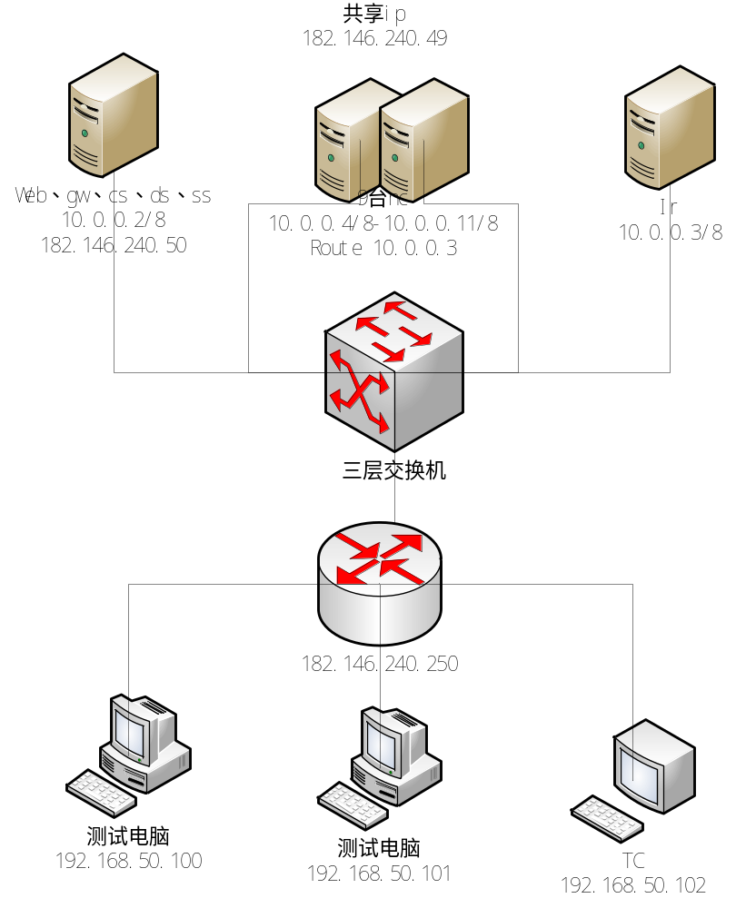1.2交换机配置
三层交换机配置规则：
telnet 用户 zhicloud / zhicloud@123

<HUAWEI>dis cur
!Software Version V200R007C00SPC500
#
sysname HUAWEI
#
vlan batch 2 10 20
#
telnet server enable
#
dhcp enable
#
diffserv domain default
#
drop-profile default
#
ip pool 182146
gateway-list 182.146.240.254
network 182.146.240.240 mask 255.255.255.240
lease unlimited
#
aaa
authentication-scheme default
authorization-scheme default
accounting-scheme default
domain default
domain default_admin
local-user admin password irreversible-cipher %#%#Wp]f7.bBu/dUb&RxJ^BL:]*#8[(hT
Lk_gG,lm4UV0}t{*X,S63y!p)';<[I*%#%#
local-user admin service-type http
local-user zhicloud password irreversible-cipher %#%#7o)<->H<gN3_fDD<rGWO=5qoNJ
!L.6N@;&Survt2IB4aWLvLM32I'O7H>b*R%#%#
local-user zhicloud privilege level 3
local-user zhicloud service-type telnet
#
interface Vlanif1
#
interface Vlanif2
ip address 182.146.240.254 255.255.255.240
#
interface Vlanif10
description for_NC_platform
ip address 10.0.0.1 255.255.255.0
#
interface Vlanif20
description for internet
ip address 182.146.240.1 255.255.255.192
#
interface MEth0/0/1
#
interface GigabitEthernet0/0/1
port default vlan 10
#
interface GigabitEthernet0/0/2
port default vlan 10
#
interface GigabitEthernet0/0/3
port default vlan 10
#
interface GigabitEthernet0/0/4
port default vlan 10
#
interface GigabitEthernet0/0/5
port default vlan 10
#
interface GigabitEthernet0/0/6
port default vlan 10
#
interface GigabitEthernet0/0/7
port default vlan 10
#
interface GigabitEthernet0/0/8
port default vlan 10
#
interface GigabitEthernet0/0/9
port default vlan 10
#
interface GigabitEthernet0/0/10
port default vlan 10
#
interface GigabitEthernet0/0/11
port default vlan 10
#
interface GigabitEthernet0/0/12
port default vlan 10
#
interface GigabitEthernet0/0/13
port default vlan 10
#
interface GigabitEthernet0/0/14
port default vlan 10
#
interface GigabitEthernet0/0/15
port default vlan 10
#
interface GigabitEthernet0/0/16
port default vlan 10
#
interface GigabitEthernet0/0/17
port default vlan 10
#
interface GigabitEthernet0/0/18
port default vlan 10
#
interface GigabitEthernet0/0/19
port default vlan 10
#
interface GigabitEthernet0/0/20
port default vlan 10
#
interface GigabitEthernet0/0/21
port default vlan 10
#
interface GigabitEthernet0/0/22
port default vlan 10
#
interface GigabitEthernet0/0/23
port default vlan 10
#
interface GigabitEthernet0/0/24
port default vlan 10
#
interface GigabitEthernet0/0/25
port default vlan 20
#
interface GigabitEthernet0/0/26
port default vlan 20
#
interface GigabitEthernet0/0/27
port default vlan 20
#
interface GigabitEthernet0/0/28
port default vlan 20
#
interface GigabitEthernet0/0/29
port default vlan 20
#
interface GigabitEthernet0/0/30
port default vlan 20
#
interface GigabitEthernet0/0/31
port default vlan 20
#
interface GigabitEthernet0/0/32
port default vlan 20
#
interface GigabitEthernet0/0/33
port default vlan 20
#
interface GigabitEthernet0/0/34
port default vlan 20
#
interface GigabitEthernet0/0/35
port default vlan 20
#
interface GigabitEthernet0/0/36
port default vlan 2
#
interface GigabitEthernet0/0/37
port default vlan 2
#
interface GigabitEthernet0/0/38
port default vlan 2
#
interface GigabitEthernet0/0/39
port default vlan 2
#
interface GigabitEthernet0/0/40
port default vlan 2
#
interface GigabitEthernet0/0/41
port default vlan 2
#
interface GigabitEthernet0/0/42
port default vlan 2
#
interface GigabitEthernet0/0/43
port default vlan 2
#
interface GigabitEthernet0/0/44
port default vlan 2
#
interface GigabitEthernet0/0/45
port default vlan 2
#
interface GigabitEthernet0/0/46
port default vlan 2
#
interface GigabitEthernet0/0/47
port default vlan 2
#
interface GigabitEthernet0/0/48
port default vlan 2
#
interface XGigabitEthernet0/0/1
#
interface XGigabitEthernet0/0/2
#
interface XGigabitEthernet0/0/3
#
interface XGigabitEthernet0/0/4
#
interface NULL0
#
ip route-static 0.0.0.0 0.0.0.0 182.146.240.250
ip route-static 182.146.240.50 255.255.255.255 10.0.0.19
ip route-static 182.146.240.51 255.255.255.255 10.0.0.20
#
user-interface con 0
user-interface vty 0 4
authentication-mode aaa
protocol inbound all
user-interface vty 16 20
#
return
<HUAWEI>

1.3网络环境描述
华为三层交换机
1到24口接入平台；网段10.0.0.1/24
25~36口接入公网测试环境；网段182.146.240.1 255.255.255.192
36~48口接入测试pc和TC客户端；网段182.146.240.254 255.255.255.240

Web公网ip：182.146.240.50 10.0.0.19
平台可用公网地址：182.146.240.49

1.4其他配置
Web端添加iptables规则做nat转换：
*nat
:PREROUTING ACCEPT [126:11977]
:POSTROUTING ACCEPT [22:1240]
:OUTPUT ACCEPT [22:1240]
-A PREROUTING -d 182.146.240.50 -j DNAT --to-destination 10.0.0.19

测试网络：
为路由器配置公网ip182.146.240.250 netmask 255.255.255.240 gw182.146.240.254
盒子和测试人员接入路由，模拟常见用户办公网络环境，通过公网ip访问云管理平台和云主机。

2测试用例

2.1开机风暴
Nc上28台云主机同时开机

批量开机脚本：
a=`virsh net-list --all |awk '{if ($2 == "inactive") print $1} '`
for i in $a
do
virsh net-start $i;
done
a=`virsh list --all |awk '{if ($3 == "shut") print $2} '`
for i in $a
do
virsh start $i;
done

关机脚本：
a=`virsh list --all |awk '{if ($3 == "running") print $2} '`
for i in $a
do
virsh shutdown $i;
done
a=`virsh net-list --all |awk '{if ($2 == "active") print $1} '`
for i in $a
do
virsh net-destroy $i;
done

测试结果

3.1开机风暴
28台云主机，在同一服务器开机性能测试
Cpu内存情况
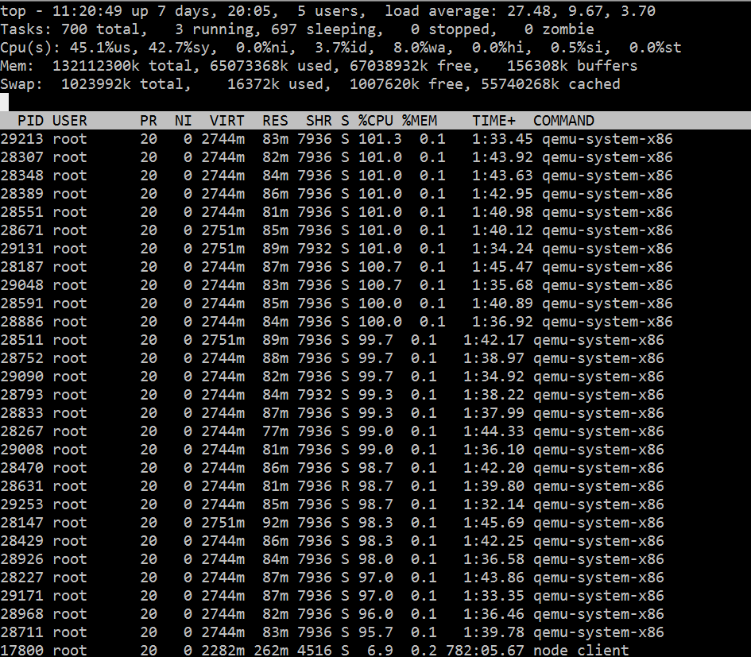
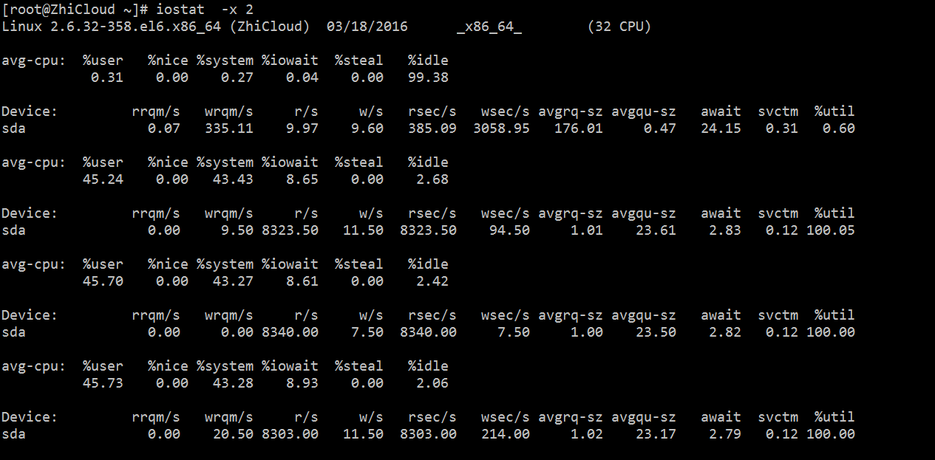

开机10分钟后
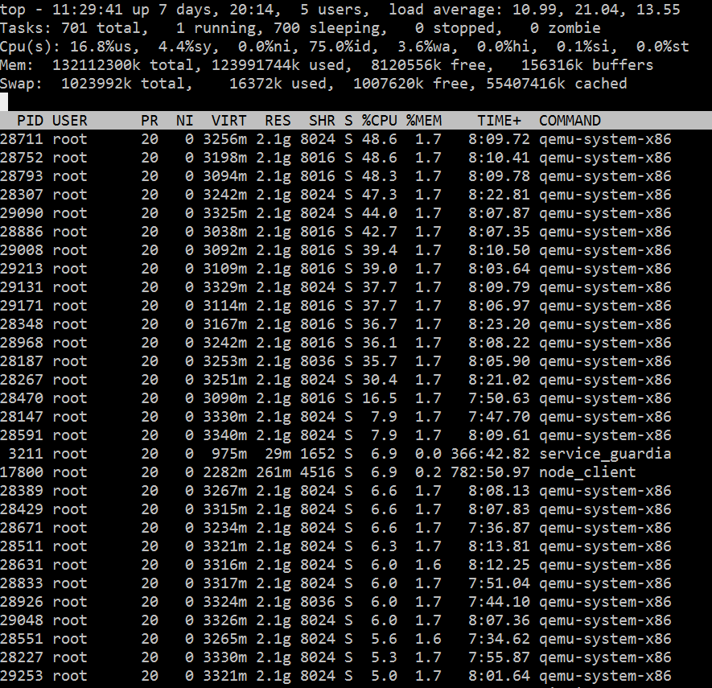
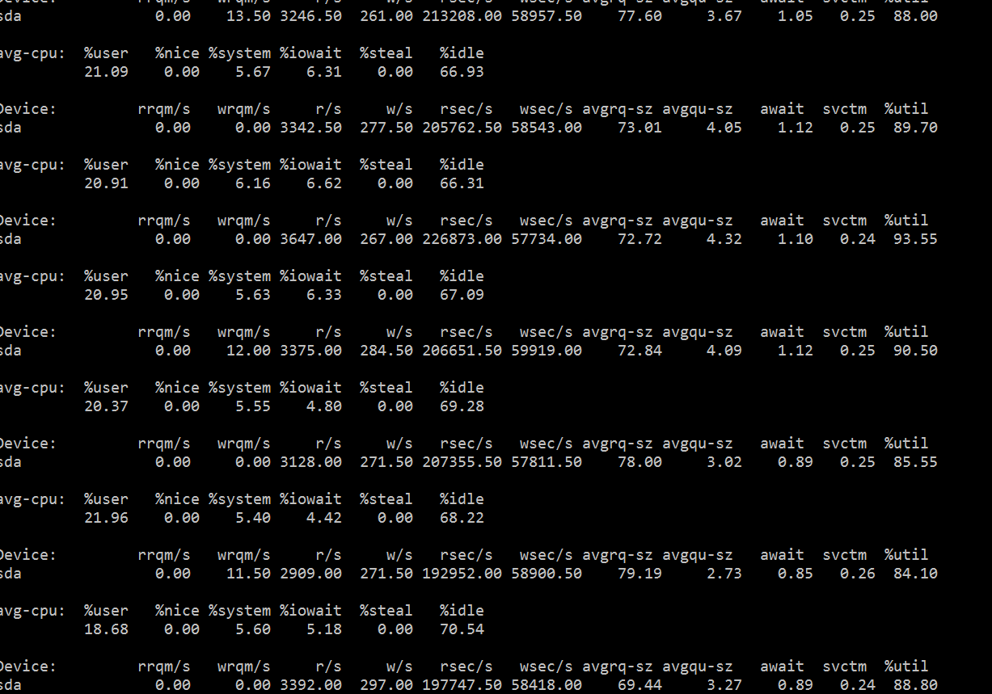
11分钟后
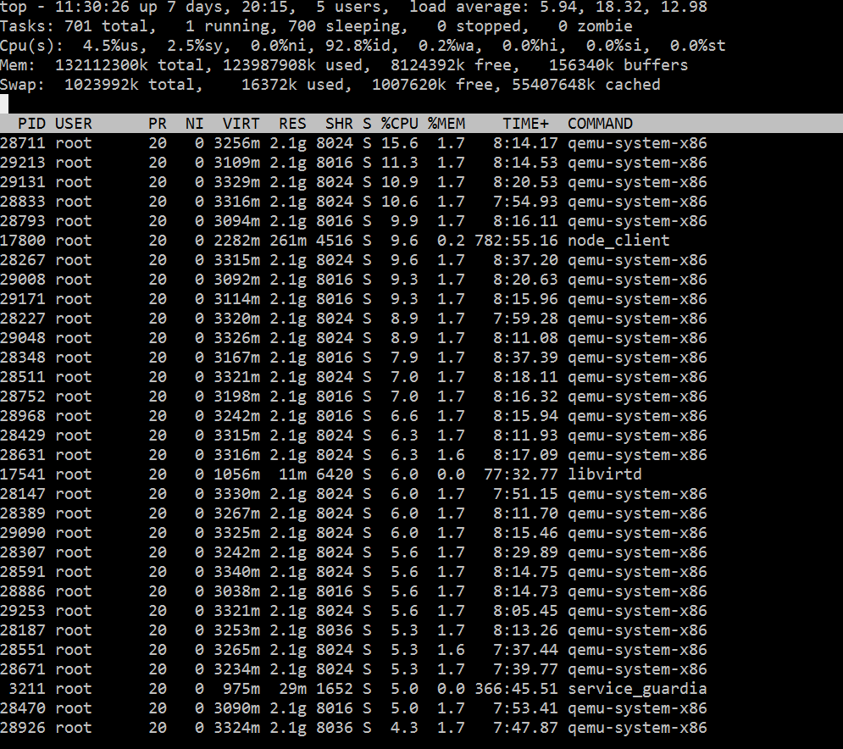
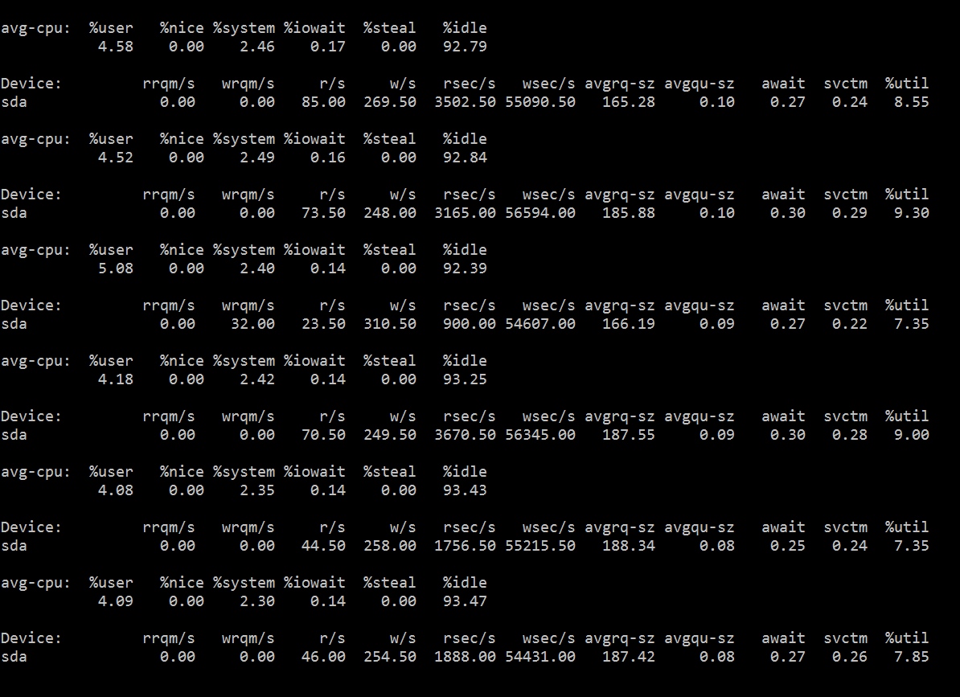
12分钟后
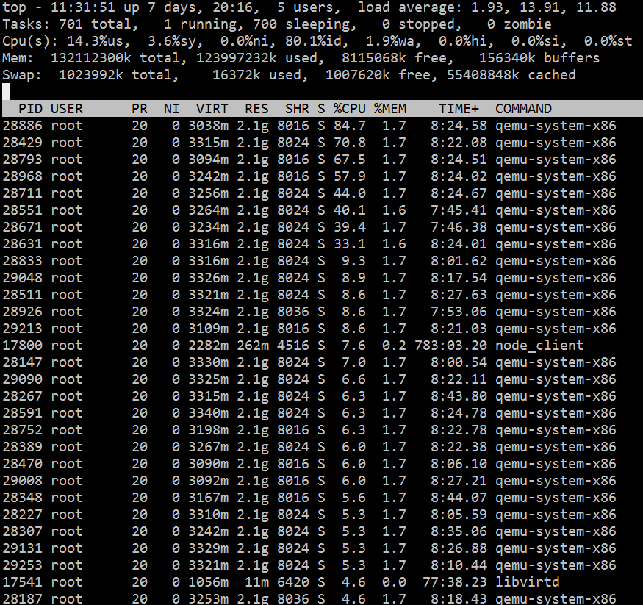
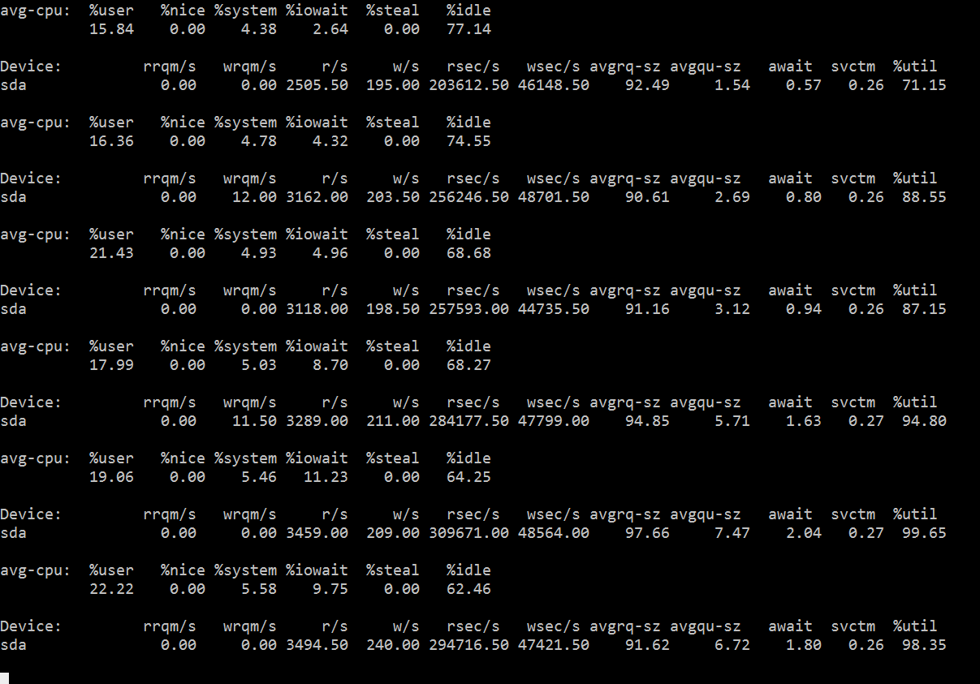
Win7虚拟机平均开机时间1分钟，在同事并发开机情况，出现io、cpu资源竞争造成阻塞，28台并行开机测试结果，阻塞10分钟因主机开机完成出现缓解。先有测试环境无法测试主机有一定工作负载下性能瓶颈。

结论：平台可以抵御开机风暴，28台云主机同时启动情况下12分钟后平台恢复正常运行。

