1. The **table wrapper box** establishes a block formatting context, and the **table box** establishes a table formatting context.
2. The computed values of properties 'position', 'float', 'margin-*', 'top', 'right', 'bottom', and 'left' on the table element are used on the **table wrapper box**.

A table with a caption above
it

1. TFOOT **must** appear before TBODY within a TABLE definition so that user agents can render the foot before receiving all of the (potentially numerous) rows of data.
2. The background set on an element in one of the layers will only be visible if the layers above it have a transparent background.

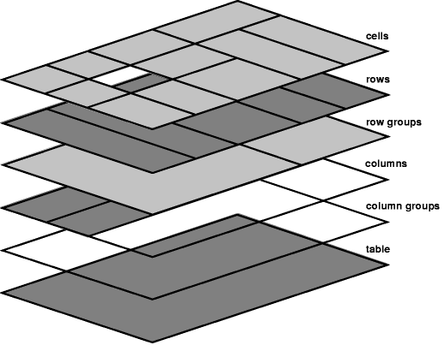

1. vertical-align

**baseline**

The baseline of the cell is put at the same height as the baseline of the first of the rows it spans (see below for the definition of baselines of cells and rows).

**top**

The top of the cell box is aligned with the top of the first row it spans.

**bottom**

The bottom of the cell box is aligned with the bottom of the last row it spans.

**middle**

The center of the cell is aligned with the center of the rows it spans.

**sub, super, text-top, text-bottom, <length>, <percentage>**

These values do not apply to cells; the cell is aligned at the baseline instead.

1. The separated borders model

A table with
  border-spacing

1. Border conflict resolution
2. Css

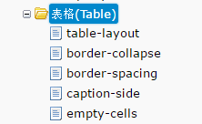

1. border-collapse影响border-style和border-spacing
2. table-layout的fixed值取第一个单元格的默认值

**参考资料：**

1. <https://www.w3.org/TR/CSS22/tables.html>
2. <https://www.w3.org/TR/html401/struct/tables.html>
3. <http://www.ruanyifeng.com/blog/2009/05/html_table_mastering.html>

**问题：**

1. 样式优先级

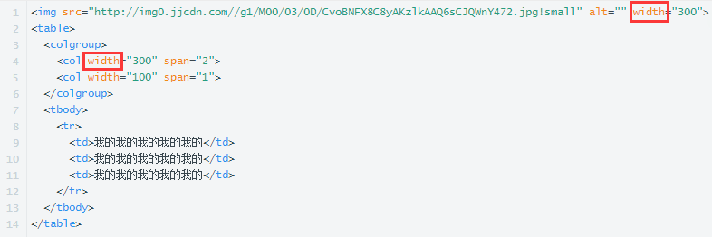

这里的样式属于**非CSS表现型提示（presentational hints）的样式优先级**，

这些属性会被翻译成相应的特殊性为0的CSS规则，并且就当它们像是被插在编写者样式表开头的一样。

也就是随便在样式表里写一个同样的属性就会重写样式，比如：

1. <col width=”300”>重写为：



1. <img width=”300”>重写为：

