VIBE CODING PROJECT MEMO
MING — A Personal Almanac Powered by Four Pillars
Name: Zhihao Feng
Project: MING — Four Pillars & Today’s Signal
Platform Used: ChatGPT / OpenAI Codex (AI-assisted vibe coding)
Date: September 1, 2026
URL / Web Link: https://temporary-instant-chestnut-6aq70wf.vercel.app/

Project Overview
MING is an English-language web experience that introduces Four Pillars (BaZi), a traditional Chinese calendar system, to a global audience. Instead of presenting astrology as a fixed prediction, MING frames it as a personal almanac: a way to understand one’s underlying pattern and read the conditions of a particular day.

Target Audience
The primary audience is English-speaking, globally minded adults who already use modern astrology, self-reflection, or wellness products such as CHANI or Co–Star, but may know little about Chinese metaphysical systems. The product is designed for curious users who want culturally distinctive guidance without needing to read Chinese or learn technical BaZi terminology first.

Problem the Project Solves
Most English-language BaZi tools feel like calculators: they produce dense charts, unexplained Chinese characters, or deterministic fortune-telling claims. MING solves the translation and experience problem. It preserves the actual Four Pillars mechanism while turning the result into clear English, transparent reasoning, and a short daily ritual.

What the Project Does
- Accepts a user’s birth date, recorded birth time, and birthplace.
- Converts the recorded time to local solar time and calculates the year, month, day, and hour pillars.
- Generates a real Four Pillars chart containing eight Chinese characters.
- Reads today’s pillar against the user’s birth chart and produces a four-part Today’s Signal: observation, theme, action, and reflection.
- Shows the calculation and reasoning so the output can be checked instead of accepted as a black box.

Outputs and Outcomes
The immediate output is a personalized chart and daily reading. The intended outcome is practical self-reflection: the user understands the conditions they are working with, sees one useful action, and keeps agency over the decision. The page also introduces Chinese astrology through English copy, calligraphy, celestial imagery, and the concepts of chart, timing, relationships, and daily practice.

Vibe Coding Process
I used a conversational, iterative workflow rather than writing a complete technical specification at the beginning. I first described the product experience, then reacted to each visual and functional version. The AI helped inspect existing repositories, combine the strongest parts into one Next.js project, generate visual assets, implement the interface, run tests, and deploy a working preview.

Representative Prompts Used
1. “Build a product-first single website where users immediately enter birth information and generate Four Pillars plus Today’s Signal. Do not keep a separate waitlist page.”
2. “Make the experience for global English-speaking users. Explain Chinese astrology through the product flow rather than through a long educational landing page.”
3. “Make the visual direction more calligraphic and mystical. Use CHANI as a high-level reference, but keep the work distinctively Chinese and original.”
4. “Create separate visual symbols for Understand Yourself, Understand Your Timing, Understand Your Relationships, and Two Minutes Every Morning.”
5. “Blend the illustrations into the background, use one consistent color system, and continue building until the full responsive website is complete.”

Overall Experience
The experience was closer to directing a small product team than using a traditional website builder. Natural-language prompts were effective for setting the product direction and visual taste, while shorter corrective prompts were better for details such as image blending, typography, mobile layout, and copy repetition. The fastest progress happened when I gave the AI a clear product behavior and a specific design critique at the same time.

Frustrations
- Generated images needed several rounds before the calligraphy felt culturally specific rather than generic or decorative.
- A mystical visual style could easily reduce trust, so the interface had to balance atmosphere with transparent calculations and careful language.
- The project began across multiple repositories, which created duplicated copy, design systems, and product directions that had to be consolidated.
- Deployment exposed dependency and build-policy issues that were not visible in the design phase.

Key Learnings
- Vibe coding still requires strong product judgment. The AI can generate options quickly, but the user must decide what the product is and what it is not.
- Prompts work best when they include audience, desired behavior, constraints, and a concrete reference point.
- Visual taste is developed through iteration. Saying that something is ‘more mystical’ is less useful than specifying calligraphy weight, background integration, palette, and section purpose.
- Functional verification matters. A polished landing page is not enough; the birth-input flow, calculation engine, mobile layout, and real output all needed testing.
- For culturally specific products, explanation and restraint are part of the design. MING should invite curiosity without presenting tradition as a novelty or claiming certainty about the future.

Validation Performed
- Tested the responsive layout at desktop and mobile breakpoints with no horizontal overflow.
- Verified solar terms, published sexagenary anchors, and 4,000 independently generated Four Pillars charts.
- Tested the birth-input flow, Today’s Signal, date controls, and expanded calculation view.
- Completed a production build and opened the deployed URL in a separate browser session.

Product Screenshots
These screens show the product journey from entry to personalized result, transparent calculation, and the visual explanation of Four Pillars.
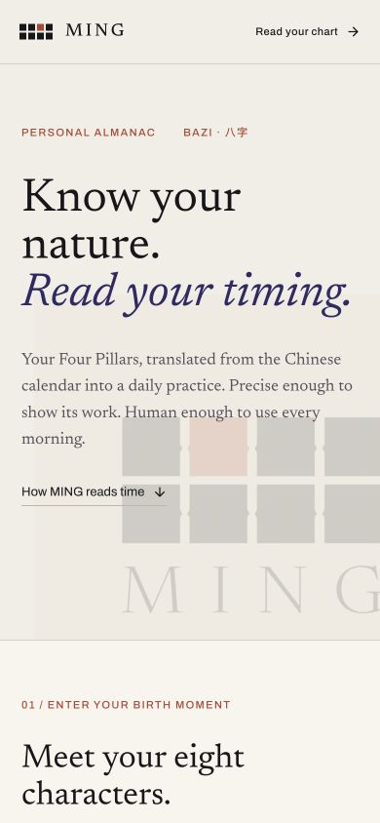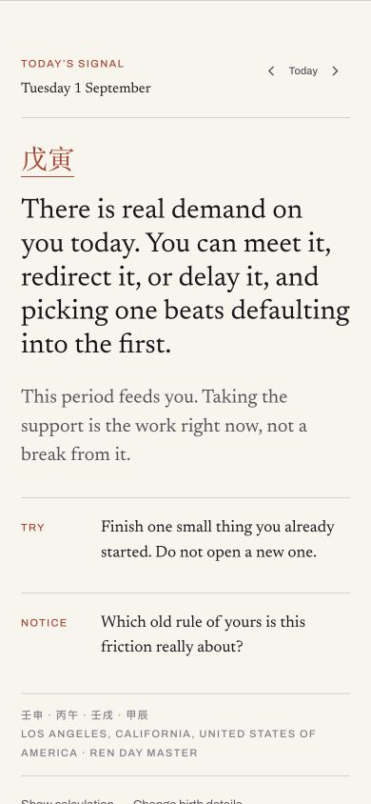
Figure 1. Entry flow Figure 2. Today’s Signal
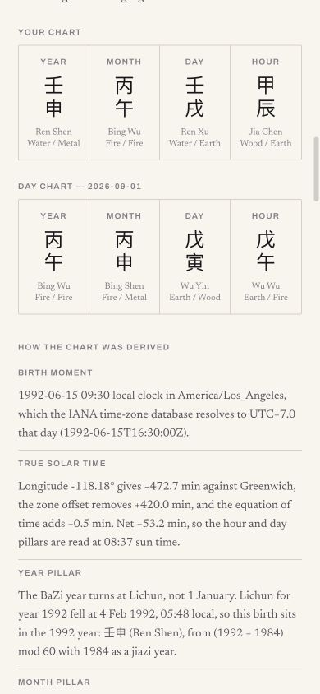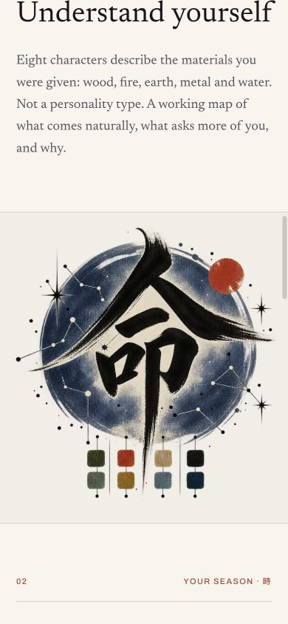
Figure 3. Four Pillars calculation Figure 4. Calligraphic feature section

Potential Next Steps
- Add a relationship comparison flow where two users can examine how their charts reinforce or challenge each other without a compatibility score.
- Create user accounts and a private history of daily notes, reflections, and recurring patterns.
- Expand the timing model to monthly and ten-year cycles while keeping the calculation visible and understandable.
- Conduct usability testing with English-speaking astrology users and revise unfamiliar terminology based on what they misunderstand.
- Work with BaZi practitioners and cultural advisors to review interpretations, translation choices, and product claims.
- Replace the temporary preview with a permanent domain and production analytics before public launch.

Closing Reflection
This assignment showed me that vibe coding is most useful when it reduces the distance between an idea and a testable product. I was able to move from a broad concept—Chinese astrology for global users—to a functioning, responsive experience with real inputs and outputs. The most important lesson was that prompting is not only asking the AI to make things; it is continuously defining quality, correcting direction, and deciding what the product should communicate.

