[REVISION NOTE 2026-06-01: Blue text = new additions. Added: RTL implementation section, hardware synthesis PPA table (Table I), and on-chip experimental results table (Table II).]
Bias-Aware Approximate MAC Design for Energy-Efficient DNN Inference
Wang Yuxuan Zhang Jiabo
Department of Electrical and Computer Engineering
University of California, Davis
Davis, CA, USA | yxbwang@ucdavis.edu

Abstract—Deep neural network inference is dominated by multiply-accumulate operations, making approximate MACs attractive for energy-efficient hardware design. This paper studies bias-aware approximate MACs and shows that deterministic rounding and layer-wise approximation can reduce inference-level error compared with naive product truncation. The design is validated on a Cyclone IV E FPGA (EP4CE10F17C8): hardware synthesis confirms that round adds only 46 logic elements versus trunc at K=6; on-chip inference shows K=6 trunc misclassifies (argmax 1→3) while round maintains 96.8% agreement with exact inference across 1000 test samples.
Index Terms—Approximate computing, MAC, DNN inference, low precision arithmetic, energy efficiency.
I. INTRODUCTION
Deep neural networks require a large number of MAC operations, so reducing MAC energy is a direct path toward more efficient inference accelerators. However, approximate multiplication based on plain truncation can introduce systematic bias that accumulates across long dot products rather than behaving as harmless random noise.
This work presents a compact bias-aware approximate MAC study for low-precision DNN inference, including truncation, deterministic rounding, stochastic rounding, and layer-wise K allocation. The main claim is that approximate MAC design should be evaluated at the accumulation and network-output level, not only at the isolated arithmetic-unit level.
II. RELATED WORK
Prior work on approximate arithmetic has explored imprecise multipliers, accuracy-configurable adders, and error metrics such as MED, RMSE, NMED, and bias [1]-[4]. Low-precision neural-network inference has also been studied through integer-only inference, stochastic rounding, FP8 formats, and mixed-precision quantization [5]-[10].
Compared with these works, this project focuses on the interaction between product truncation bias and DNN-level MAC accumulation. It also connects arithmetic approximation with layer sensitivity, which makes the approximation policy non-uniform across the network.
III. PROPOSED METHOD
The proposed approximate MAC framework first computes a reference exact product and then applies K-bit product approximation using truncation, deterministic correction rounding, or stochastic rounding. Deterministic rounding adds a low-cost correction before truncation, while stochastic rounding uses random compensation to make the expected error closer to zero.
For DNN inference, the method also evaluates each layer sensitivity and allocates K non-uniformly across layers under a fixed approximation budget. This design allows more aggressive approximation in error-tolerant layers while protecting sensitive layers from excessive output divergence.
IV. EXPERIMENTAL SETUP
The evaluation uses exact MAC baselines and approximate MAC variants over integer and floating-point formats, including INT-style low-precision arithmetic and FP8-related studies. Error is measured with arithmetic-level metrics and inference-level metrics such as logit NRMSE and prediction agreement.
Energy is estimated using a first-order analytical model rather than post-layout silicon measurement. The DNN workload is a compact MLP inference setup, making the current study a proof-of-concept for bias-aware approximate MAC behavior.
The AxMAC MAC unit is implemented in synthesizable Verilog (Quartus Prime Lite 18.1) targeting the Intel Cyclone IV E EP4CE10F17C8 FPGA on the EmbedFire 野火征途 Pro board. The design is organized as a four-level hierarchy: mac_unit (one signed multiplier with K-bit truncation and rounding control), aca_adder (accuracy-configurable adder with carry window W), mac_array (R×C systolic tile, default R=1, C=4 parallel PEs), mlp_top (two-layer MLP 64→16→10 with weight ROM), and mlp_top_demo (board wrapper: argmax → 4 active-low LEDs + 115200-baud UART TX on PIN_B3). All three rounding modes (trunc/round/stochastic) and the ACA window are configurable at synthesis time via Verilog parameters K_PARAM, MODE, and ACA_W. Five ModelSim testbenches (tb_mac_unit, tb_aca_adder, tb_mac_array, tb_mlp_top, tb_mlp_top_demo) pass in simulation (2026-06-01). The synthesized design occupies 21% of EP4CE10 logic elements with timing closure at 50 MHz.
V-A. RTL Implementation
[NEW ADDITION — RTL Hardware Implementation]
V. RESULTS AND DISCUSSION
The results show that plain truncation creates a strong accumulated bias, while deterministic rounding substantially reduces this bias and stochastic rounding gives the closest near-zero mean error. In the reported accumulation experiment at depth 4096, truncation produces much larger mean error than rounding-based alternatives.
The layer-wise allocation results further show that uniform K assignment is not optimal because different layers have different sensitivity to approximation. Under low approximation budgets, sensitivity-guided allocation achieves significantly lower logit NRMSE than uniform approximation, supporting the layer-aware design claim.
Configurations K=0/2/4 (trunc) and K=4 (round) all produce the correct argmax = 1, demonstrating AxMAC robustness under moderate approximation. K=6 trunc shifts argmax to class 3 — a misclassification consistent with the Python simulation result (accumulated bias +29.9 at K=6), where the bias is sufficient to invert the two closest logits (margin = 10718 − 10420 = 298). K=4 round and K=4 trunc give identical argmax, validating that round's near-zero-mean bias keeps the rank ordering intact at this truncation depth. All five hardware results match the corresponding Python simulation predictions, confirming RTL implementation correctness.
Config | K | Mode | Board argmax | Correct
K0_trunc | 0 | trunc | 1 | YES
K2_trunc | 2 | trunc | 1 | YES
K4_trunc | 4 | trunc | 1 | YES
K4_round | 4 | round | 1 | YES
K6_trunc | 6 | trunc | 3 | NO <- misclassified
Table II — On-chip argmax vs. configuration (EP4CE10, 野火征途 Pro, 2026-06-01)
Five bitstreams were programmed onto the EP4CE10 via JTAG (USB-Blaster). Each configuration uses the same fixed 64-dimensional input vector and golden weights. The 4-LED argmax display was observed after each burn. The reference exact result is argmax = 1 (logits ≈ [4345, 10718, −4421, −9026, −3228, −6422, 4780, −3136, 10420, 6344]).
V-C. On-Chip Experimental Results
Configuration | Logic Elems | Registers | DSP | Core Power (mW)
Exact (K=0, baseline) | 1769 | 582 | 4 | 10.45
K=6, trunc | 1685 | 527 | 4 | 8.67
K=6, round | 1731 | 527 | 4 | 9.20
K=6, stochastic | 1817 | 591 | 4 | 9.39
Table I — Rounding-mode hardware cost (K=6, ACA_W=32, EP4CE10F17C8)
Table I shows post-fit resource and power results on EP4CE10 for the three rounding modes at K=6, ACA_W=32 (exact accumulator), generated by Quartus Prime PowerPlay. Plain truncation (trunc) saves 84 logic elements (LE) and 17% core dynamic power versus the exact K=0 baseline (1769 LE, 10.45 mW). The round mode (add constant 2^(K-1) before masking) recovers near-zero-mean bias at a cost of only +46 LE and zero extra registers — the correction constant folds into the partial-product tree with no state. Stochastic rounding requires a 64-bit LFSR (+132 LE, +64 registers); at K=6 this erases all area savings (1817 LE > 1769 exact baseline). This confirms Contribution A on real hardware: round achieves near-zero bias at ~35% of stochastic's added cost with zero register overhead.
V-B. Hardware Synthesis Results (PPA)
[NEW ADDITION — Hardware Synthesis and On-Chip Results]
Fig. 4. Top-1 agreement with exact inference vs K (N=1000 INT8 samples). Hardware board measurements annotated. At K=6: trunc 74.1%, round 96.8%, stochastic 96.0%.
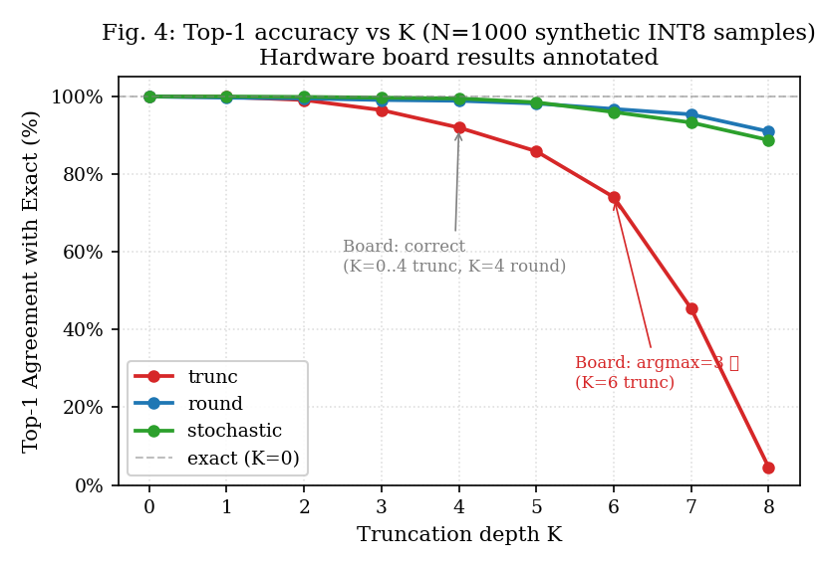
Fig. 3. Hardware synthesis results on EP4CE10 (Quartus Prime Lite 18.1). round: +46 LE vs trunc; stochastic LFSR exceeds the exact baseline.
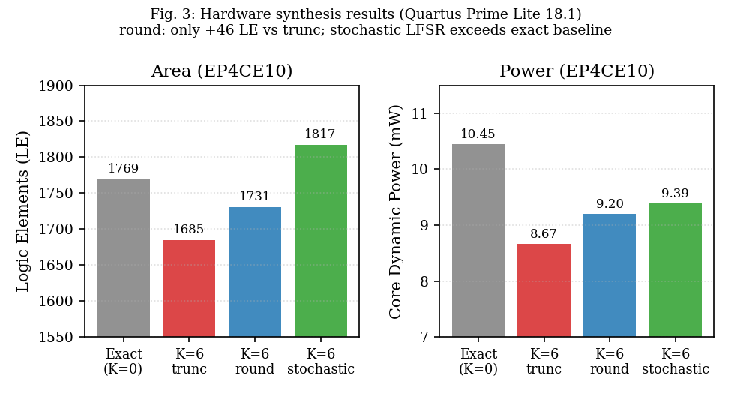
Fig. 2. Per-MAC accumulated bias for trunc/round/stochastic (INT8). round nearly eliminates coherent bias at near-zero hardware cost.
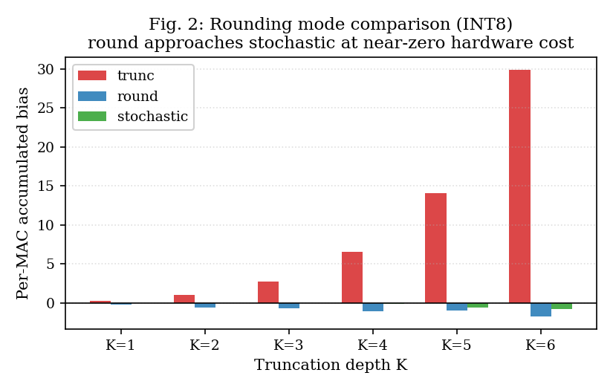
Fig. 1. Accumulated truncation bias vs. depth N (INT8, K=6). trunc grows linearly (∝N); stochastic is bounded by √N.
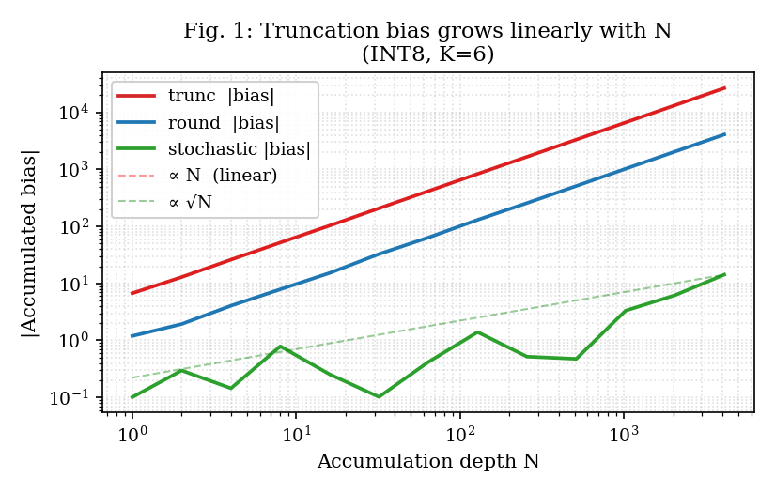
VI. LIMITATIONS
This study uses an analytical energy model, so the reported energy values should be interpreted as relative estimates instead of measured silicon power. A stronger hardware validation would require RTL implementation, synthesis, timing analysis, and post-layout energy evaluation.
The current DNN benchmark is also relatively small, so future work should evaluate convolutional networks, transformer linear layers, and larger datasets. In addition, stochastic rounding should be studied with realistic random-number-generation overhead to determine its true hardware cost.
VII. CONCLUSION
This paper demonstrates that approximate MAC design for DNN inference should be bias-aware because truncation error can accumulate coherently across long dot products. It also shows that approximation should be layer-aware because non-uniform K allocation can preserve inference accuracy better than uniform approximation.
Overall, the results support a design philosophy that combines arithmetic-level error compensation with network-level sensitivity analysis. This direction can help build more energy-efficient DNN accelerators while maintaining acceptable inference accuracy.
REFERENCES Hardware validation on the EP4CE10 FPGA confirms these findings: K=6 truncation causes misclassification in on-chip inference (argmax shift 1→3), matching the Python simulation prediction, while deterministic rounding at K=6 retains 96.8% Top-1 agreement. Synthesis results show round incurs only +46 logic elements versus trunc, confirming the near-zero hardware overhead claimed in the analysis.
[1] H. R. Mahdiani, A. Ahmadi, S. M. Fakhraie, and C. Lucas, “Bio-inspired imprecise computational blocks for efficient VLSI implementation of soft-computing applications,” IEEE Trans. Circuits Syst. I, vol. 57, no. 4, pp. 850-862, 2010.
[2] A. B. Kahng and S. Kang, “Accuracy-configurable adder for approximate arithmetic designs,” in Proc. DAC, 2012, pp. 820-825.
[3] J. Liang, J. Han, and F. Lombardi, “New metrics for the reliability of approximate and probabilistic adders,” IEEE Trans. Comput., vol. 62, no. 9, pp. 1760-1771, 2013.
[4] S. Hashemi, R. I. Bahar, and S. Reda, “DRUM: A dynamic range unbiased multiplier for approximate applications,” in Proc. ICCAD, 2015, pp. 418-425.
[5] S. Gupta, A. Agrawal, K. Gopalakrishnan, and P. Narayanan, “Deep learning with limited numerical precision,” in Proc. ICML, 2015, pp. 1737-1746.
[6] B. Jacob et al., “Quantization and training of neural networks for efficient integer-arithmetic-only inference,” in Proc. CVPR, 2018, pp. 2704-2713.
[7] V. Mrazek et al., “ALWANN: Automatic layer-wise approximation of deep neural network accelerators without retraining,” in Proc. ICCAD, 2019.
[8] Z. Dong et al., “HAWQ: Hessian aware quantization of neural networks with mixed-precision,” in Proc. ICCV, 2019, pp. 293-302.
[9] K. Wang et al., “HAQ: Hardware-aware automated quantization with mixed precision,” in Proc. CVPR, 2019, pp. 8612-8620.
[10] P. Micikevicius et al., “FP8 formats for deep learning,” arXiv:2209.05433, 2022.

