**基于格雷厄姆成长股估值公式**

**沪深300量化指数增强策略**

**策略描述、回测及Python代码v0.8**

**北京量化平台科技有限公司**

1.0 修改记录 5

2.0 免责声明 6

3.0 策略研究小组成员 6

4.0 策略说明 7

格氏成长估值公式选股策略： 7

择时空仓策略： 7

仓位管理： 8

策略持股量、调仓周期及历史回测区间： 8

择时策略假设： 8

策略后续优化方向： 9

5.0 策略表现 9

5.1.1全A股选股，价值/收盘价选股50只，现金仓位0，无择时无对冲 9

5.1.1全A股，价值收盘价选股50，现金仓位0.5，无择时有对冲，聚宽选股聚宽回测 10

5.1.2 沪深300，价值/收盘价选股50，现金仓位0，有PB（长空仓240）择时无对冲，聚宽选股聚宽回测 11

5.1.3 沪深300，价值/收盘价选股50，现金仓位0.5，有PB（长空仓240）择时无对冲，聚宽选股聚宽回测 12

5.1.8 沪深300，价值/收盘价选股50，现金仓位0，有跌停比振荡微择时以及PB（长空仓240）择时无对冲，聚宽选股聚宽回测 14

6.0 代码说明 15

聚宽代码说明： 15

同花顺-mindgo代码说明 18

PB持续择时参数选择说明 18

首先确定PB高分位阈值：（针对0.8分位） 18

然后来看PB高阈值10的空仓时间： 19

现在来确定PB低阈值：（0.8分位） 21

然后来看PB低阈值8的空仓时间： 22

跌停比---空仓期11--14以及18年实验 24

跌停比---空仓天数拟合优化后的最优效果： 24

2018-01-01----2019-01-01 回测 24

键：跌停比，值：空仓天数，设置 24

下面把它泛化到更长久的历史时期跨度： 25

2007-01-01___2019-01-01回测表现： 25

在下图三个时段还有可以改进的地方：标红 26

1 延长跌停比对应的空仓天数跨过这一小段跌幅。 26

2 剪短这一段涨幅中的跌停比对应的空仓天数 27

11到14年调优后的效果： 27

调参后的泛化效果： 28

7.0 策略代码 29

聚宽代码 29

同花顺-mindgo代码 42

# 修改记录

|  |  |
| --- | --- |
| 时间 | 修改记录 |
| 2018.01.15 | V0.1版本 |
| 2018.01.15 | V0.2 版本 |
| 2018.01.17 | V0.3 版本 |
| 2018.01.19 | V0.4 版本（加入4.2.2） |
| 2018.01.22 | V0.5 版本 （加入5.2、5.3） |
| 2018．01.23 | V0.6 版本 （加入米筐回测及代码） |
| 2019.01.10 | V0.7 版本 （加入mindgo回测及代码） |
| 2019.01.21 | V0.8 版本 （格式公式A股化，加入聚宽代码以及同花顺） |

# 免责声明

根据<<证券投资咨询管理办法>>等相关法律法规的规定，北京量化平台科技有限公司（以下简称北京量化）无偿公开的开源股票量化策略仅供学习与交流。北京量化不提供股票策略交易和股票信号交易，不提供股票投资分析、预测、建议等证券投资咨询服务，不承诺股票策略投资收益。

若您有意参照免费公开的股票量化策略进行投资，请确认您具备相应风险识别能力和风险承担能力，并且您对使用的量化策略有充分的了解。任何由于您使用公开的量化策略投资带来的资金缩水或亏损风险，北京量化不承担任何责任。

# 策略研究小组成员

策略研究指导：徐松泉

策略实现与优化：

罗林（北京大学汇丰商学院）

张陈祥（中国石油大学（北京）信息学院）

# 策略说明

现象（数据）-模型（公式）-检验（回测）-预测（外推）

本策略由选股、择时及仓位管理3个子策略组成：

格氏成长估值公式选股策略：

格氏成长策略由格雷厄姆的成长公式改进而来，策略原本核心思想是选出估值合理的高成长公司。公式如下：价值=当期（正常）利润x（8.5+2x预期年增长率）

基于对A股市场的改进，我们采用了季度的数据，更好的最终近期出现高增长的企业，本质上是一种业绩反转逻辑。公式如下：

价值=当季（正常）利润*（27+2*季度运营利润同比增长率）

然后通过估计的价值比上公司的市场价格P，得到公司目前的相对估值情况。即outvalue_ratio：价值/价格

比率越大，说明公司被低估的程度越大。

在此基础上，我们每周对比率进行排序，选取比率最大的前50名公司作为投资组合。

预期年增长率在策略中用当季/当年累计的净利润/运营利润增长率替代，也可以用分析师预期增长率替代，选择不同数据会造成选股及回测结果的不同。目前回测采用的是单季运营利润增长率，当期利润采用净利润。

择时空仓策略：正常市场状态下，按照格氏成长股估值公式计算市场所有股票估值，按市值/估值从小到大排序，买入排序靠前的股票（即按照公式计算当前最被低估的股票）；择时信号分为择时空仓信号：当择时空仓信号发出时，提示市场未来发生整体下跌的概率很高，卖出全部股票；

仓位管理：为了控制回测，有采用半仓现金控制最大回撤。

### 策略持股量、调仓周期及历史回测区间：

1 选股量：每次持仓50支，沪深300选股，平均分配仓位。

2 回测区间：

聚宽回测区间：20070101-20181231

详细说明：

聚宽数据支持2007年开始回测

公式用的都是季度净利润同比增长率

同花顺-mindgo回测区间：20090101-20181231  
 详细说明：

同花顺-mindgo数据支持2009年回测

公式用的是营运利润增长率

### 择时策略假设：

1 PB分位数择时：市场PB分位数最高分位（5%、10%、20%）估值高到一定程度并持续一定时间后，未来半年或一年市场整体下跌的概率极高（小样本的观测结果）。主要针对2008年和2015年的市场状态。金融危机、杠杆牛造成的股灾。

2 PB分位数择时：市场PB分位数最高分位（5%、10%、20%）估值高到一定程度并持续一定时间后，未来三个月或半年市场整体下跌的概率极高（小样本的观测结果）。主要针对2011年的市场状态。欧债危机。

2 跌幅择时：市场产生较强恐慌性下跌事件后（以跌停或极端跌幅占比来衡量），一段时间内市场继续下跌的概率较大（2周、4周或6周）。

### 策略后续优化方向：

1 PB分位数择时策略加入高分位数估值的持续时间，这样择时策略的置信度更高，同时会增加策略的拟合风险，降低策略的鲁棒性。

2 根据PB分位数数值及持续时间确定总体仓位配置策略，尽可能在市场整体下跌时保持空仓，市场整体上涨时保持较高仓位。

3 择时做空信号：当择时做空信号发出时，提示市场未来发生整体下跌的概率极高，买入沪深300指数期货做空合约。

4 跌停比空仓信号：通过观察跌停比与后续持续跌的天数的关系，进行在振荡行情的优化（已经完成-陈祥：容易过拟合以及造成很多年份没有交易日。）

# 策略表现

### 5.1.1全A股选股，价值/收盘价选股50只，现金仓位0，无择时无对冲

聚宽回测（使用数据：单季度净利润增长率）

|  |  |  |  |  |
| --- | --- | --- | --- | --- |
| 时间 | 策略收益 | 最大回测 | alpha | 沪深三百基准 |
| 2008- | -43.92% | 31.28% | -3% | -65.95% |
| 2009- | 135.99% | 21.20% | 58% | 96.71% |
| 2010- | 4.28% | 30.03% | 14% | -12.51% |
| 2011- | -20.41% | 34.47% | 1% | -25.01% |
| 2012- | 2.85% | 16.08% | -5% | 7.55% |
| 2013- | 2.80% | 20.57% | 7% | -7.65% |
| 2014- | 38.10% | 8.60% | 10% | 51.66% |
| 2015- | 69.18% | 9.29% | 66% | 5.58% |
| 2016- | 3.52% | 21.64% | 14% | -11.28% |
| 2017- | -0.18% | 10.28% | -17% | 21.78% |
| 2018- | -27.00% | 32.90% | -10% | -25.31% |
| 2008-2019 | 6.73% |  |  |  |

同花顺回测（使用数据：单季运营利润增长率）

### 5.1.1全A股，价值收盘价选股50，现金仓位0.5，无择时有对冲，聚宽选股聚宽回测

聚宽回测（使用数据：单季度净利润增长率）

|  |  |  |  |  |
| --- | --- | --- | --- | --- |
| 时间 | 策略收益 | 最大回测 | 超额alpha | 沪深三百基准 |
| 2009- | 61.69% | 10.97% | 14% | 96.71% |
| 2010- | 4.48% | 14.61% | 9% | -12.51% |
| 2011- | -12.76% | 20.64% | -1% | -25.01% |
| 2012- | 2.61% | 15.07% | -3% | 7.55% |
| 2013- | 1.76% | 8.17% | 3% | -7.65% |
| 2014- | 20.04% | 4.62% | 2% | 51.66% |
| 2015- | 38.01% | 24.27% | 34% | 5.58% |
| 2016- | 2.11% | 10.92% | 7% | -11.28% |
| 2017- | 0.15% | 11.08% | -12% | 21.78% |
| 2018- | -16.12% | 21.04% | -8% | -25.31% |
| 2008-2019 | 8.14% |  |  |  |

### 5.1.1.2全A股/50只股/2009-2018/满仓/mindgo

代码说明：

|  |  |  |  |  |
| --- | --- | --- | --- | --- |
| **回测策略** | **策略说明** | **组合数量** | **组合方式** | **回测区间** |
| **格氏成长策略** | 投资范围为HS300成分股 | 50只股 | 等额配置 | 2009-2018 |
| **择时策略** | PB择时，pb>10时，长期空仓240天 |  |  |  |

每年策略表现：

|  |  |  |  |  |  |
| --- | --- | --- | --- | --- | --- |
| **时间** | **基准收益（hs300）** | **策略收益** | **alpha** | **回撤** | **夏普比** |
| **2009** | 89.90% | 148.46% | 62% | 17.89% | 4.38 |
| **2010** | -11.51% | 11.54% | 25% | 29.03% | 0.34 |
| **2011** | -26.46% | -21.46% | 11% | 37.69% | -0.93 |
| **2012** | 9.75% | 28.63% | 19% | 19.5% | 1.06 |
| **2013** | -7.70% | 14.94% | 23% | 16.86% | 0.56 |
| **2014** | 52.19% | 48.44% | 9% | 9.11% | 2.27 |
| **2015** | 2.46% | 71.92% | 72% | 6.66% | 4.26 |
| **2016** | -4.58% | 28.5% | 35% | 15.64% | 0.94 |
| **2017** | 20.60% | 4.84% | -15% | 15.51% | 0.09 |
| **2018** | -26.34% | -29.24% | -3% | 36.13% | -1.27 |
| **2012-2018** | 30.97% | 101.39% | 7.00% | 18.52% | 0.6 |
| **2009-2011** | 24.58% | 28.64% | 4% | 18.98% | 0.48 |
| **年化收益：24.63%** |  | **最大回撤：** | **38.61%** | **最大回撤区间：** | **2011.7-2012.12** |

### 5.1.2 沪深300，价值/收盘价选股50，现金仓位0，有PB（长空仓240）择时无对冲，聚宽选股聚宽回测

股票池：沪深300股聚宽选股，沪深300指数回测

选股方法： 格氏公式价值/收盘价最高的50支

回测平台： 聚宽code格式成长Gscz 资金1000万

|  |  |  |  |  |  |
| --- | --- | --- | --- | --- | --- |
| 时间 | 策略收益 | 最大回测 | 夏普 | 超额alpha | 沪深300基准 |
| 2008- | 1.84% | 31.28% | -0.07 | 24% | -65.95% |
| 2009- | 114.48% | 21.20% | 3.4 | 20% | 96.71% |
| 2010- | -0.52% | 30.03% | -0.16 | 14% | -12.51% |
| 2011- | -23.79% | 34.47% | -1.28 | 3% | -25.01% |
| 2012- | 29.90% | 16.08% | 1.28 | 23% | 7.55% |
| 2013- | -1.48% | 20.57% | -0.25 | 8% | -7.65% |
| 2014- | 78.34% | 8.60% | 3.72 | 25% | 51.66% |
| 2015- | 32.85% | 9.29% | 1.75 | 29% | 5.58% |
| 2016- | 0.81% | 21.64% | -0.13 | 13% | -11.28% |
| 2017- | 21.66% | 10.28% | 1.35 | 0% | 21.78% |
| 2018- | -27.66% | 32.90% | -1.42 | -3% | -25.31% |
| 2008-2019 | 16.67% |  |  |  |  |

分析：1： 大跌后一年涨的概率大

2： 08,11,18回撤较大，考虑某些联合特征对这个最大回撤区间进行定位

### 5.1.2.2沪深300/50只股/2009-2018/满仓/mindgo

代码说明：

|  |  |  |  |  |
| --- | --- | --- | --- | --- |
| **回测策略** | **策略说明** | **组合数量** | **组合方式** | **回测区间** |
| **格氏成长策略** | 投资范围为HS300成分股 | 50只股 | 等额配置 | 2009-2018 |
| **择时策略** | PB择时，pb>10时，长期空仓240天 |  |  |  |

每年策略表现：

|  |  |  |  |  |  |
| --- | --- | --- | --- | --- | --- |
| **时间** | **基准收益（hs300）** | **策略收益** | **alpha** | **回撤** | **夏普比** |
| **2009** | 89.90% | **130.06%** | 40% | **20.78%** | 3.88 |
| **2010** | -11.51% | -1.35% | 14% | 29.05% | -0.02 |
| **2011** | -26.46% | -28.63% | -1% | 37.58% | -1.49 |
| **2012** | 9.75% | 25.53% | 16% | 16.47% | 1.12 |
| **2013** | -7.70% | -0.99% | 7% | 21.31% | -0.2 |
| **2014** | 52.19% | 81.5% | 29% | 8.19% | 3.99 |
| **2015** | 2.46% | 27.1% | 25% | 9.13% | 1.45 |
| **2016** | -4.58% | 17.52% | 22% | 14.03% | 0.68 |
| **2017** | 20.60% | 23.53% | 3% | 10.05% | 1.57 |
| **2018** | -26.34% | **-27.78%** | -1% | 33.87% | -1.37 |
| **2012-2018** | 30.97% | 218.81% | 15% | 33.87% | 0.77 |
| **2009-2011** | 24.58% | 68.81% | 0.12% | **37.88%** | 0.61 |
| **年化收益：** | **18.64%** | **最大回撤：** | **38.9%** | **最大回撤区间：** | **2010.11-2011.12** |

### 5.1.3 沪深300，价值/收盘价选股50，现金仓位0.5，有PB（长空仓240）择时无对冲，聚宽选股聚宽回测

股票池：沪深300选股，沪深300指数回测

选股方法： 格氏公式价值/收盘价最高的50支

回测平台： 聚宽code格式成长Gscz 资金1000万

|  |  |  |  |  |
| --- | --- | --- | --- | --- |
| 时间 | 策略收益 | 最大回测 | 超额alpha | 沪深三百基准 |
| 2008- | 2.15% | 16.86% | 12% | -65.95% |
| 2009- | 49.13% | 11.03% | 2% | 96.71% |
| 2010- | 0.44% | 16.85% | 6% | -12.51% |
| 2011- | -12.72% | 19.31% | 1% | -25.01% |
| 2012- | 14.25% | 8.51% | 9% | 7.55% |
| 2013- | 0.04% | 10.60% | 2% | -7.65% |
| 2014- | 35.52% | 4.70% | 6% | 51.66% |
| 2015- | 16.11% | 4.74% | 12% | 5.58% |
| 2016- | 1.19% | 11.35% | 6% | -11.28% |
| 2017- | 10.70% | 5.52% | -3% | 21.78% |
| 2018- | -15.03% | 18.18% | -4% | -25.31% |
| 2008-2019 | 7.80% |  |  |  |

### 5.1.3.2沪深300/50只股/2009-2018/半仓/mindgo

代码说明：

|  |  |  |  |  |
| --- | --- | --- | --- | --- |
| **回测策略** | **策略说明** | **组合数量** | **组合方式** | **回测区间** |
| **格氏成长策略** | 投资范围为HS300成分股 | 50只股 | 等额配置 | 2009-2018 |
| **择时策略** | PB择时，pb>10时，长期空仓240天 |  |  |  |

每年策略表现：

|  |  |  |  |  |  |
| --- | --- | --- | --- | --- | --- |
| **时间** | **基准收益（hs300）** | **策略收益** | **alpha** | **回撤** | **夏普比** |
| **2009** | 89.90% | 55.74% | 9% | 10.8% | 3.22 |
| **2010** | -11.51% | 1.1% | 7% | 16.09% | -0.05 |
| **2011** | -26.46% | -14.8% | -0.02% | 20.67% | -1.67 |
| **2012** | 9.75% | 12.89% | 7% | 8.36% | 0.99 |
| **2013** | -7.70% | -0.12% | 2% | 11.24% | -0.31 |
| **2014** | 52.19% | 36.79% | 8% | 4.37% | 3.32 |
| **2015** | 2.46% | 13.97% | 12% | 4.76% | 1.31 |
| **2016** | -4.58% | 8.7% | 1% | 7.07% | 0.57 |
| **2017** | 20.60% | 12.04% | 0% | 5.21% | 1.31 |
| **2018** | -26.34% | -15.25% | -3% | 18.93% | -1.6 |
| **2012-2018** | 30.97% | 87.09% | 6% | 18.93% | 0.65 |
| **2009-2011** | 24.58% | 35.13% | 6% | 20.67% | 0.6 |
| **年化收益：9.89%** |  | **最大回撤：** | **21.31%** | **最大回撤区间：** | **2011.4-2012.12** |

### 5.1.8 沪深300，价值/收盘价选股50，现金仓位0，有跌停比振荡微择时以及PB（长空仓240）择时无对冲，聚宽选股聚宽回测

|  |  |  |  |  |  |
| --- | --- | --- | --- | --- | --- |
|  | 收益 | 最大回撤 | alpha | Beta | Sharp |
| 2018-01-01 - 2019-01-01 | 0% | 0% | -4.00% | 0 | 0 |
| 2017-01-01 - 2018-01-01 | 3% | 3.33% | -6.01% | 0.2505 | -0.1959 |
| 2016-01-01 - 2017-01-01 | -2% | 5.77% | -5.68% | 0.0367 | -1.2679 |
| 2015-01-01 - 2016-01-01 | 9% | 4.32% | 5.24% | 0.0193 | 0.8569 |
| 2014-01-01 - 2015-01-01 | 35% | 9.62% | 4.14% | 0.5693 | 2.0534 |
| 2013-01-01 - 2014-01-01 | 0% | 9.05% | -1.53% | 0.1885 | -0.4009 |
| 2012-01-01 - 2013-01-01 | 1% | 11.43% | -4.04% | 0.3265 | -0.2371 |
| 2011-01-01 - 2012-01-01 | -1% | 4.37% | -3.64% | 0.039 | -1.1036 |
| 2010-01-01 - 2011-01-01 | 15% | 10.26% | 15.56% | 0.2564 | 0.8489 |
| 2009-01-01 - 2010-01-01 | 0% | 0% | -4.00% | 0 | 0 |
| 2008-01-01 - 2009-01-01 | 0% | 0% | -4.00% | 0 | 0 |
| 2007-01-01 - 2008-01-01 | 233% | 20.44% | 103.27% | 0.8387 | 6.5778 |
| 2007-01-01 - 2019-01-01 | 17.11% |  |  |  |  |

# 代码说明

## 聚宽代码说明：

在进行回测前，将回测时间段选取为2007年1月1日至2019年1月1日，参照沪深300股指，研究对象为全部动态A股或者沪深300，注入起始资金10，000,000元，采用日间策略使用日线回测，调仓频率为每周一进行一次。买入佣金为0.0003元，卖出佣金为0.0013元。滑点差值为0.02元/股（滑点是指下单的点位和最后成交的点位有差距）。

空仓阀值的设定：根据A股前一日的涨跌幅超过9.5%的数量占所有股数的比例，当占比达到3%时，空仓两周；当占比达到10%时，空仓六周。以上均以上海证券交易所的交易日历为准。

程序的设定：定义布尔变量来实现择时目标：

context.signal = True #择时空仓信号：True表示不空仓，False表示仓，’PB_long‘表示长期空仓

context.b = True #买入信号，初始买入

计算出空仓的结束时间：定义的cal日历中的交易日为当前日期，空仓时间段，按照交易日惯例，如果不在交易日，应选取向后一个交易日。如果当前日期小于空仓日期，执行空仓指令，当时间段结束时，b重新赋值为false。

若在正常调仓时间段，则卖出所有股票，仓位为0。

选出股票列表中的股票，仓位调整标准：将当前资金平均分配于每只股票.

接着进行选股：剔除停牌股、新股、ST股合集，将剩余的股票存在list中。

然后提取单季度财务指标中的股票代码、EPS（每股收益）、ROE（权益收益率）、 operProfitYOY（营业利润同比增长率）、结束日期、收盘价，索引设置成股票代码。

进行成长股的估值：

每股估值=EPS*(8.5+2*operProfitYOY)*(1+overflow)

注意事项：1).每股估值=EPS*(8.5+2*PEG),由于PEG（市盈率相对盈利增长比率）较难计算，故采用operProfitYOY（营业利润同比增长率）整数不是百分数。

1. .比较operProfitYOY（营业利润同比增长率）、NetAssetGrowRate（净资产增长率）、niYOY（净利润同比增长率）、niQOQ（净利润环比增长率）四个指标，选用后三者效果不佳，采用operProfitYOY（营业利润同比增长率）更为理想。
2. 吸取前任成果，聚宽上面营业利润增长率变量标签：inc_operation_profit_year_on_year

定义一个outvalue_ratio=每股估值/收盘价

根据算出的outvalue_ratio从大到小排序，提取ROE大于0的股票，再从中选取前50只股票。

最后进行择时：

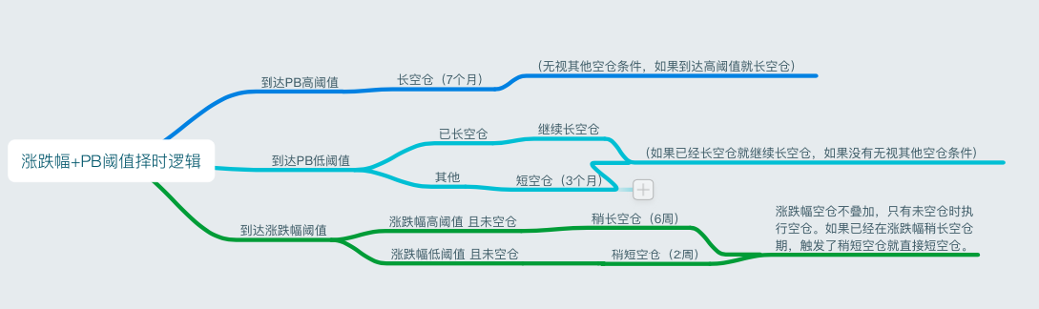

选取所有A股前一日的涨跌幅大于9.5%的股数占所有A股股数的比例，当占比达到10%时空仓六周；当占比达到3%时空仓两周。

注意事项：当选取所有A股前一日的涨跌幅大于10%或大于9%的股数占所有A股股数的比例用以择时时效果不佳，而9.5%时则较为理想。

## 同花顺-mindgo代码说明

同聚宽代码说明。平台数据已经更新，营业利润增长率在两个平台都有。

## **PB持续择时参数选择说明**

### 首先确定PB高分位阈值：（针对0.8分位）

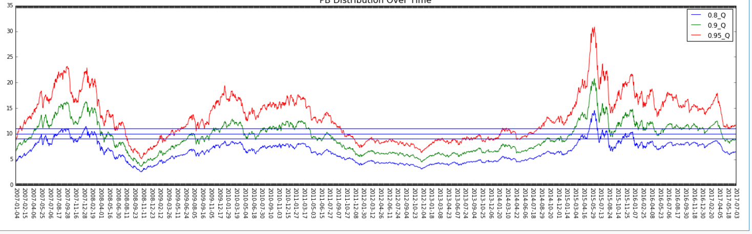

如图三条横线分别是9,10,11三个待定的长空仓阈值。首先我理解的设置高阈值的目的是：为了在牛市时提前退出，预防暴跌。所以我们要尽量保证高阈值只在两次牛市期间触发，而在平常年份不会触发。从图上来看，10作为高阈值会是一个比较合理选择。

11作为似乎更加极致，同样也满足了高阈值的基本要求，但是考虑到08年的时候0.8PB分位触及11的天数相当少，存在着过拟合的风险，所以不考虑11。（**而且聚宽和优矿的PB数据有小幅差距，在聚宽上的数据显示08年PB0.8分位其实达不到11**）

另一方面，对于9这个阈值。从图上看有些过低，会损失一部分在牛市中的收益，而且9这个阈值偏低也容易导致在未来平常年份的误触。

### A股PB分位10 + 纵线然后来看PB高阈值10的空仓时间：

如图黄线是PB0.8分位在牛市期间**最后一次触发高阈值**的时间，棕线是PB值回归到一个较低水平的时间。

08年图上的较优空仓时间为9个月，其中交易日约为200天。16年图上的较优空仓时间为4.5个月或者17个月，其中交易日分别约为96天和364天。这里空仓时间的选择比较有争议，因为两次牛市结束的方式在图形特性上并不是很相似。08年的熊市直接在11月11日左右达到了最低点，然后开始反弹。接下来的是一个高位震荡。而15年的过程相比之下进行的更为急促，牛市结束后立即开始了20多个月高位震荡。并没有出现如08年那样大的趋势走势。

这里我倾向于选择200个交易日的空仓日期。因为目前熊市的历史数据图上只有两次，所以其实这里做的选择的普适性必然不会很强，只需要满足高阈值应当发挥的作用即可。而且高阈值的本意只是在牛市估值过高时出场。200天的交易日空仓我认为满足了这样的性能。而过长时间的空仓（比如364个交易日）其实违背了高阈值空仓的本意。针对牛市后续的震荡采取的择时，不是高阈值空仓发挥作用的地方。而是后续的低阈值以及涨跌幅择时发挥作用的地方。综上所述，200交易日作为一个较为适中的选择，既能够等待市场较为冷却，又不会过长空仓带来较大的机会成本。我认为比较适合作为高阈值空仓的时长。

### A股pb分位7.5 8 8.5现在来确定PB低阈值：（0.8分位）

图中三条横线分别为8,8.5,9。因为低阈值的选择相对敏感，所以这里采用0.5作为步长。

首先对于低阈值空仓，我的理解是：用来在牛市结束，PB值中高位震荡时，进行空仓。因为从图中的图形特性来看，每当PB在中高位持续震荡结束，接下来都是一次中等幅度的下跌，进入一个低位震荡的状态（此时远低于低阈值）。

这里我选择8作为低阈值。因为当8.5作为阈值时，在10年底到11年初的震荡中并不能触及8.5这个阈值，而且其他时间区间触及9的情况也只是极短时间触碰，处于中高位震荡的波峰处。所以综合考虑9的普适性不高。另一方面，8.5作为低阈值。8.5这个低阈值基本都处于震荡的波谷处，看起来比较保险，但是必然也会造成牛市中空仓的提前，损失一部分收益。

### 然后来看PB低阈值8的空仓时间：

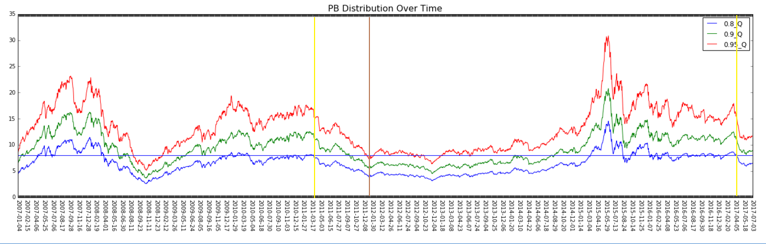

如图黄线是震荡时期最后一次触发短空仓的时间，棕线是合适的重新入场时间。仅从历史数据来看8个月（160个交易日）会是比较好的空仓持续时间。和之前高阈值空仓时间的判断相似，图上的中高位震荡只发生2次，09年末到11年初，以及16年初到17年初两段时间。所以判断的依据相当有限。

**这里我的想法是之前邮件中提到的根据触及低阈值累计天数来触发空仓的择时逻辑会表现的比较好。因为低阈值针对的是PB震荡阶段，而震荡阶段会持续一定的时间。如果按照触发即空仓的逻辑，在震荡期间内保持空仓，那么势必会造成空仓时间过长，增加机会成本。**

**而如果用累计天数方式来触发空仓，延后了空仓的触发，符合震荡的图形特性。从而达到在震荡期间，则允许触发涨跌幅择时的超短空仓来进一步扩大收益，收益最大化。**

**累计天数的空仓目前雪莹已经完成了代码，可以运行。但是还有一些小的代码验证上的疑问需要解决。后续的涨跌幅择时的参数，低阈值累计天数空仓的天数参数，都需要优化。关于后续涨跌幅择时的参数的优化，我考虑的是根据所有触发涨跌幅择时后大盘（或者当前选股）一段时间走势的样本（回撤，回撤结束时间）来进行统计判断。因为样本相比之前的阈值选择要多得多，所以也许会得出一个比较具有有普适性的结果。**

**以上就是我对高阈值，低阈值，涨跌幅择时3类择时，组合分工的理解。3类分别对应了3种PB分位比较危险的形态。高阈值负责处理股市出现极端高估值的情况，低阈值负责应PB高位震荡的情况。涨跌幅择时是一个相对精细的择时，负责在股市小幅震荡时进行短期的止损，积累收益。**

**另外还有一个想法就是目前的择时针对的都是市场高估并且空仓的情况。可不可以从另一面想，做一个市场进入低估状态则结束空仓并且买入的一个操作。**

## 跌停比---空仓期11--14以及18年实验

### 跌停比---空仓天数拟合优化后的最优效果：

### 2018-01-01----2019-01-01 回测

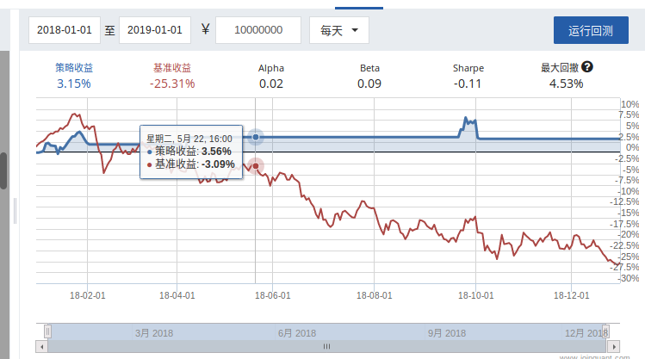

### 键：跌停比，值：空仓天数，设置

drop_count_map={1:40,2:10,3:70,4:30,5:25,6:25,7:20,8:20};

其他跌停比通过观察跌停比时间分布图，发现可能存在反转等不需要跌停，并且大的跌停已经在PB择时进行了空仓。

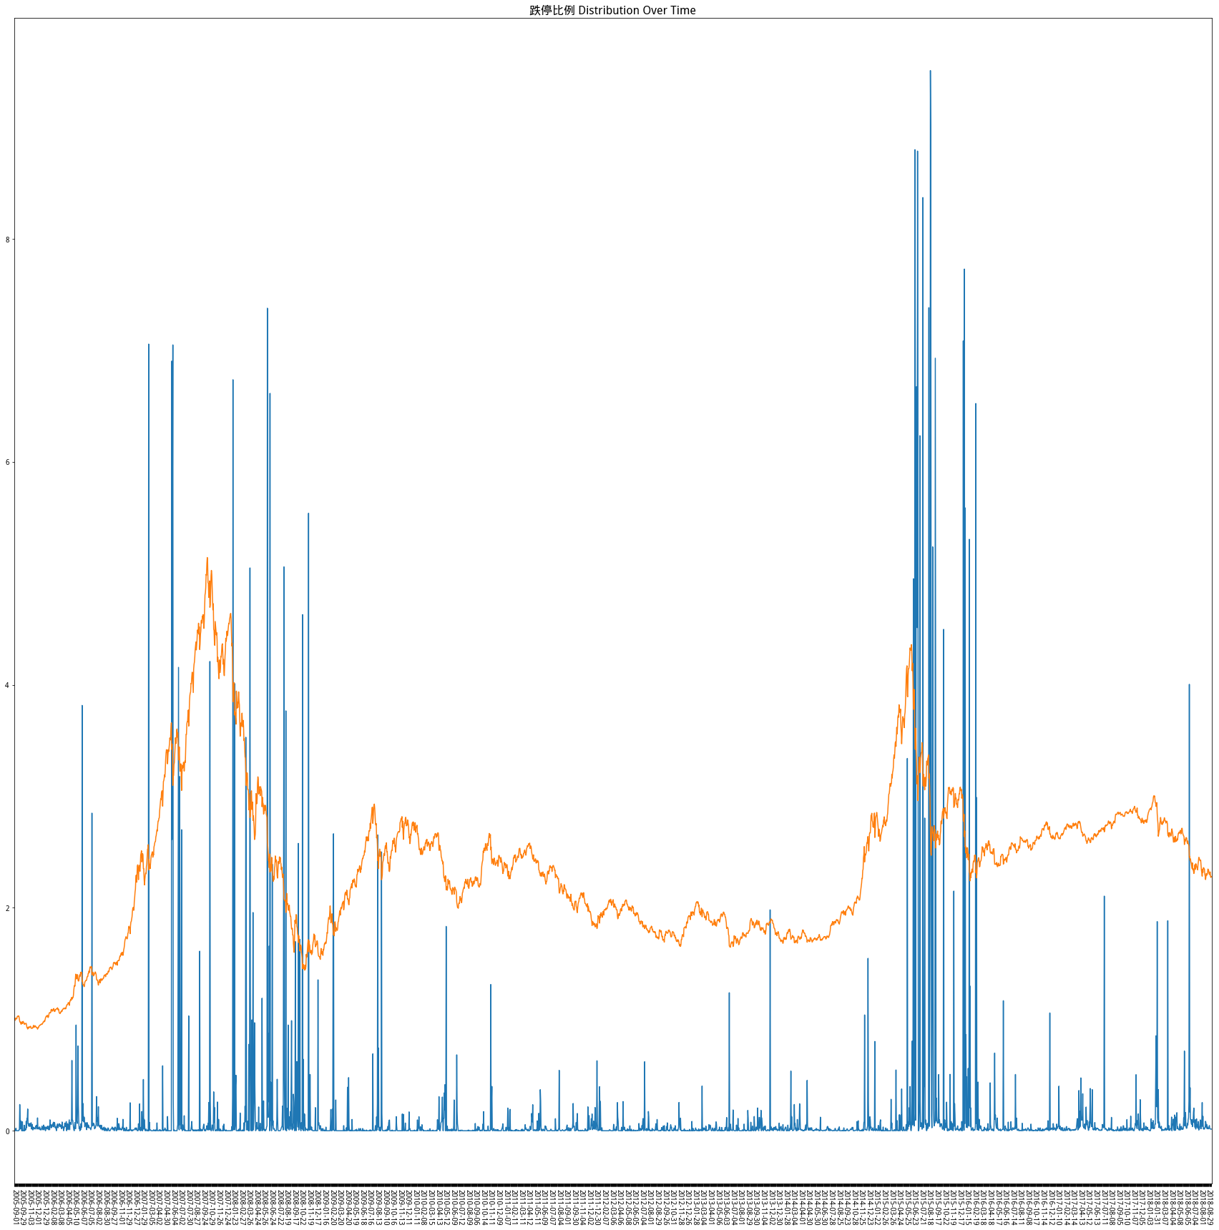

### 下面把它泛化到更长久的历史时期跨度：

### 2007-01-01___2019-01-01回测表现：

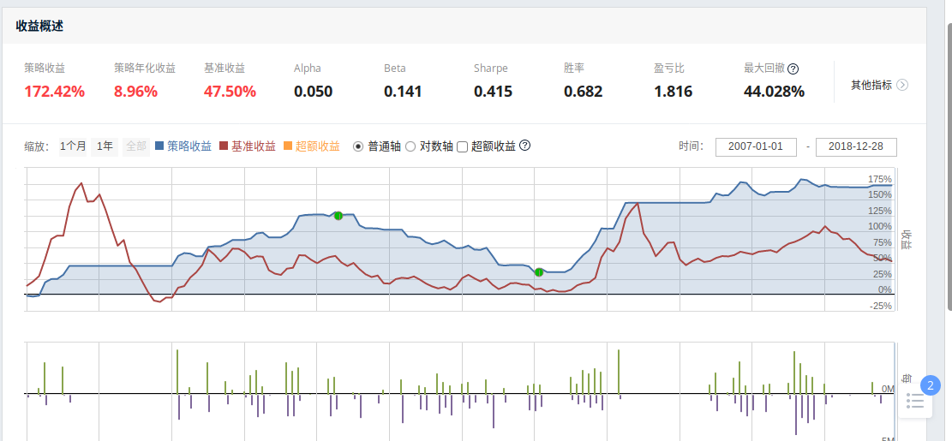

### 在下图三个时段还有可以改进的地方：标红

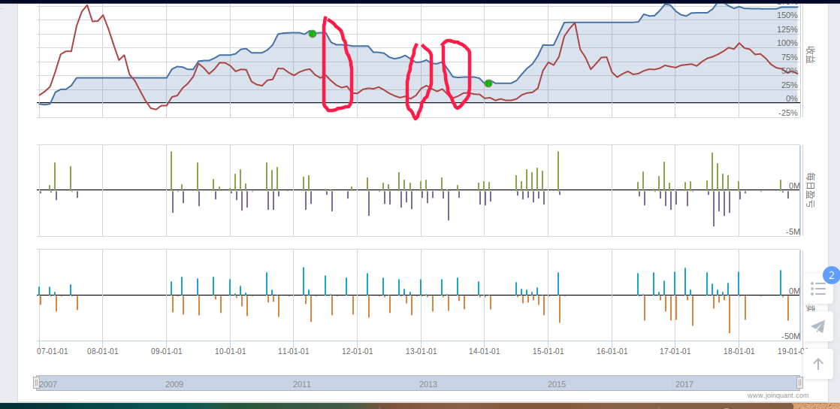

### **1 延长跌停比对应的空仓天数跨过这一小段跌幅**。

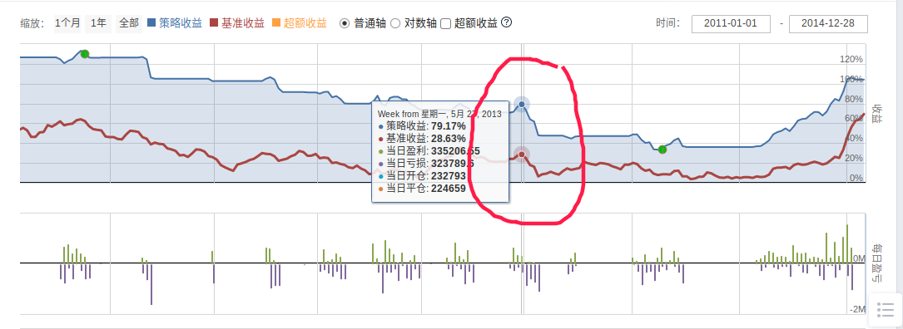

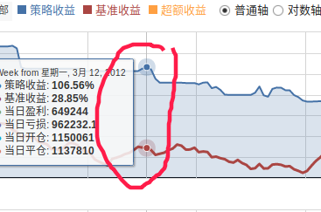

### 2 剪短这一段涨幅中的跌停比对应的空仓天数

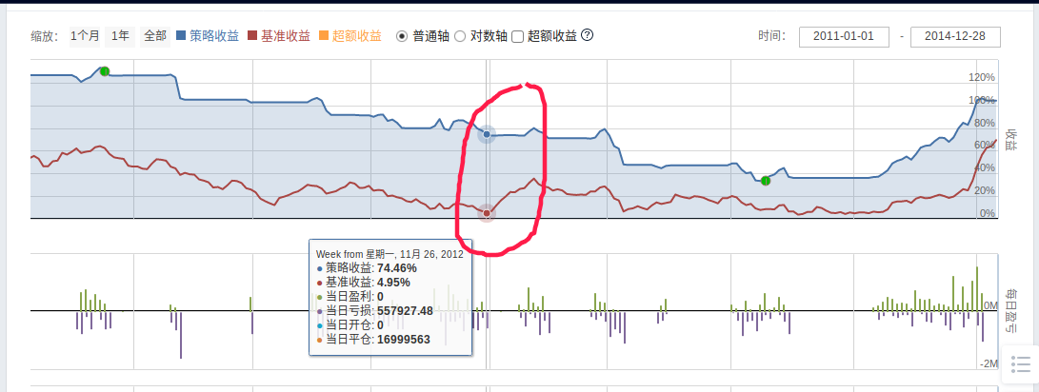

### 11到14年调优后的效果：

drop_count_map={1:40,2:10,3:70,4:30,5:25,6:25,7:20,8:20};

可以看到有些涨幅可以吃到，有些不可以，大跌都尽量躲过去了。下面再次把它泛化到07到19年看下效果。

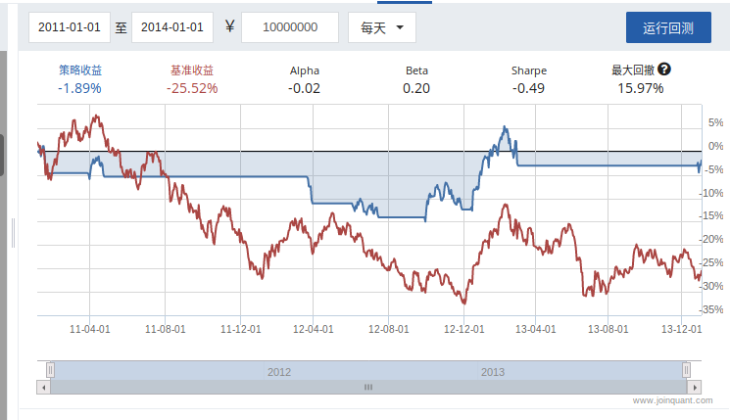

### 调参后的泛化效果：

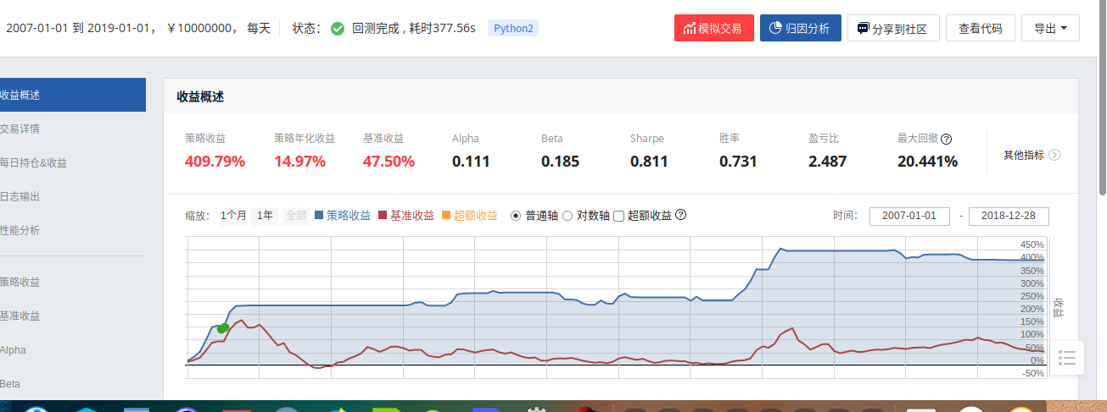

可以看到有明显的提升效果但是很多年份都没有了交易。

# 策略代码

## 聚宽代码

1. '''#!/usr/bin/env python
2. # -*- coding: UTF-8 -*-
3. #避免编辑器IDE报错
4. g,set_benchmark,set_option,log,set_order_cost,OrderCost,run_daily,send_message=0
5. query,valuation,get_fundamentals,order_target,order_target_value,get_trades,get_trade_days=0
6. run_monthly,get_iwencai,order_target_value,order_target_percent,get_datetime,get_price,history=0
7. get_last_datetime,income,income_one_season,growth_one_season,profit_one_season,balance=0;
8. get_concept_stocks,run_weekly,get_index_stocks,income_sq,profit_sq,growth_sq,get_all_securities=0
9. get_industry_stocks,indicator,attribute_history=0'''
10. from jqdata import *
11. '''
12. 格氏成长策略
13. '''
14. #策略名'格氏成长,择时'
15. name = '格氏成长,择时'
16. # 对比基准设置
17. num1 = '000300.XSHG' #指数基准
18. # 选股条件
19. #num2 = '沪深300 上市天数>200'
20. num2 = '000300.XSHG' #指数：包含多只股票
21. # 目标选股数量
22. num3 = 50
23. #市场空仓对应的PB分位数阈值
24. num4 = 0.8
25. #长期空仓天数
26. num5 = 240
27. #中期空仓天数
28. num6 = 90
29. #现金比例
30. cash_thresh = 0
31. whole_money_can_invest_thresh = 1-cash_thresh
32. def initialize(context):
33. # 设定沪深300作为基准
34. set_benchmark(num1)
35. # 开启动态复权模式(真实价格)
36. set_option('use_real_price', True)
37. log.info('初始函数开始运行且全局只运行一次')
38. # 过滤掉order系列API产生的比error级别低的log
39. log.set_level('order', 'error')
40. ### 股票相关设定 ###
41. # 股票类每笔交易时的手续费是：买入时佣金万分之三，卖出时佣金万分之三加千分之一印花税, 每笔交易佣金最低扣5块钱
42. set_order_cost(OrderCost(close_tax=0.001, open_commission=0.0003, close_commission=0.0003, min_commission=5), type='stock')
43. context.signal = True #择时空仓信号：True表示不空仓，False表示空仓，’PB_long‘表示长期空仓
44. context.b = True #买入信号，初始买入
45. #跌停比DCP择时信号，出现在里面就清仓
46. context.zeshixinhao= ['2018-03-06', '2018-03-07', '2008-11-17', '2015-11-18', '2008-11-14', '2008-11-13', '2008-11-12', '2008-11-11', '2008-11-10', '2015-11-11', '2015-11-10', '2015-11-13', '2015-11-12', '2008-11-19', '2008-11-18', '2018-10-22', '2018-10-23', '2018-10-26', '2018-10-24', '2018-10-25', '2018-10-29', '2015-11-19', '2015-12-14', '2015-12-15', '2015-12-16', '2015-12-17', '2015-12-10', '2015-12-11', '2015-12-18', '2014-03-31', '2013-04-17', '2013-04-16', '2009-02-12', '2016-09-08', '2016-09-09', '2018-03-28', '2018-03-29', '2010-05-06', '2010-05-07', '2010-05-04', '2010-05-05', '2012-03-15', '2012-03-14', '2016-09-02', '2018-03-21', '2017-04-14', '2017-04-17', '2009-02-11', '2017-04-11', '2017-04-13', '2017-04-12', '2009-02-16', '2017-04-19', '2017-04-18', '2009-02-17', '2018-01-31', '2017-08-24', '2017-08-25', '2018-01-30', '2016-05-31', '2016-05-30', '2017-08-22', '2017-08-23', '2017-08-28', '2017-08-29', '2008-04-23', '2014-08-01', '2014-08-05', '2014-08-04', '2014-08-06', '2011-05-06', '2011-05-05', '2011-05-04', '2011-05-03', '2011-05-09', '2018-12-06', '2010-10-26', '2012-04-10', '2012-04-11', '2012-04-12', '2012-04-13', '2012-04-16', '2012-04-17', '2012-04-18', '2012-04-19', '2014-12-12', '2014-12-15', '2014-12-17', '2014-12-16', '2018-08-09', '2018-08-08', '2009-10-30', '2018-08-07', '2018-08-06', '2018-08-01', '2018-08-03', '2011-06-30', '2017-11-28', '2017-11-29', '2017-11-27', '2017-11-24', '2017-11-22', '2017-11-23', '2017-11-20', '2017-11-21', '2015-06-24', '2013-10-29', '2013-10-28', '2015-06-25', '2013-10-25', '2013-10-24', '2013-10-21', '2013-10-23', '2013-10-22', '2012-07-17', '2012-07-19', '2012-07-18', '2011-03-23', '2011-03-22', '2011-08-01', '2009-06-26', '2009-06-25', '2012-12-03', '2012-12-04', '2009-06-22', '2012-12-06', '2012-12-07', '2008-06-04', '2008-06-05', '2008-06-06', '2008-06-02', '2008-06-03', '2017-12-05', '2017-12-04', '2017-12-07', '2017-12-06', '2017-12-01', '2017-06-20', '2017-06-21', '2015-05-07', '2015-05-06', '2015-05-05', '2015-05-04', '2017-06-26', '2015-05-08', '2014-04-16', '2014-04-17', '2014-04-14', '2014-04-15', '2014-04-10', '2014-04-11', '2015-01-12', '2015-01-13', '2015-01-14', '2015-01-15', '2014-04-18', '2008-05-12', '2008-05-13', '2008-05-16', '2008-05-14', '2008-05-15', '2008-05-19', '2009-11-18', '2009-11-19', '2012-11-29', '2012-11-28', '2009-11-12', '2009-11-13', '2009-11-10', '2009-11-11', '2009-11-16', '2009-11-17', '2015-11-24', '2015-11-25', '2015-11-26', '2015-11-27', '2015-11-20', '2015-11-23', '2013-05-30', '2013-05-31', '2018-10-31', '2018-10-30', '2009-04-30', '2015-12-09', '2015-12-08', '2015-12-03', '2015-12-02', '2015-12-01', '2015-12-07', '2015-12-04', '2015-08-18', '2014-03-04', '2014-03-05', '2014-03-06', '2014-03-07', '2014-03-03', '2010-01-06', '2010-01-07', '2010-01-04', '2010-01-05', '2010-01-08', '2016-09-13', '2016-09-12', '2010-05-19', '2012-03-29', '2016-09-14', '2017-04-20', '2010-05-14', '2010-05-17', '2010-05-11', '2010-05-10', '2010-05-13', '2010-05-12', '2014-07-16', '2013-11-28', '2013-11-29', '2016-05-09', '2016-05-03', '2016-05-04', '2016-05-05', '2016-05-06', '2016-06-16', '2016-06-17', '2016-06-14', '2016-06-15', '2016-06-13', '2014-07-18', '2018-04-23', '2018-04-20', '2018-04-27', '2018-04-26', '2018-04-25', '2018-04-24', '2012-04-06', '2012-04-05', '2014-12-29', '2014-12-24', '2014-12-25', '2014-12-26', '2012-04-09', '2014-12-23', '2018-08-30', '2018-08-31', '2018-08-24', '2018-08-23', '2015-09-30', '2018-08-22', '2011-10-31', '2018-09-27', '2017-11-30', '2018-06-15', '2013-10-10', '2013-10-11', '2013-10-14', '2013-10-15', '2013-10-16', '2013-10-17', '2012-07-20', '2012-07-23', '2012-07-24', '2012-07-25', '2012-07-26', '2012-07-27', '2018-08-29', '2018-08-28', '2007-11-30', '2009-12-22', '2009-12-23', '2008-06-11', '2008-06-10', '2008-06-17', '2008-06-16', '2009-12-24', '2012-12-10', '2009-12-28', '2009-12-29', '2016-01-08', '2008-01-16', '2008-01-17', '2008-01-14', '2008-01-15', '2008-01-10', '2008-01-11', '2008-01-18', '2014-04-04', '2014-04-01', '2014-04-03', '2014-04-02', '2015-01-07', '2015-01-06', '2015-01-05', '2014-04-09', '2014-04-08', '2013-06-03', '2013-06-04', '2013-06-05', '2013-06-06', '2013-06-07', '2008-05-09', '2008-05-08', '2009-11-09', '2016-02-22', '2016-02-26', '2008-09-18', '2008-09-19', '2008-09-16', '2008-09-17', '2009-11-03', '2009-11-02', '2009-11-05', '2009-11-04', '2008-09-10', '2009-11-06', '2015-11-30', '2013-05-29', '2013-05-28', '2013-05-27', '2013-05-24', '2013-05-23', '2013-05-22', '2013-05-21', '2013-05-20', '2018-10-08', '2018-10-09', '2009-04-29', '2009-04-28', '2009-04-21', '2009-04-20', '2009-04-23', '2009-04-22', '2009-04-24', '2009-04-27', '2014-03-13', '2014-03-12', '2014-03-11', '2014-03-10', '2014-03-17', '2014-03-14', '2014-03-19', '2014-03-18', '2018-03-26', '2013-10-09', '2016-09-05', '2012-07-30', '2012-03-13', '2010-01-11', '2010-01-13', '2012-03-12', '2010-01-15', '2010-01-14', '2010-01-19', '2010-01-18', '2016-09-01', '2016-10-19', '2016-10-18', '2016-10-14', '2016-10-17', '2016-10-11', '2016-10-10', '2016-10-13', '2016-10-12', '2010-05-20', '2010-05-21', '2018-03-02', '2012-03-30', '2010-05-24', '2010-05-25', '2010-05-26', '2010-05-27', '2010-05-28', '2018-03-09', '2008-10-30', '2008-10-31', '2016-05-19', '2016-05-18', '2016-05-17', '2016-05-16', '2016-05-13', '2016-05-12', '2016-05-11', '2016-05-10', '2017-06-28', '2017-06-29', '2016-06-08', '2017-06-22', '2017-06-23', '2016-06-07', '2016-06-06', '2016-06-01', '2017-06-27', '2016-06-03', '2016-06-02', '2011-04-28', '2011-04-29', '2011-04-26', '2011-04-27', '2014-12-31', '2014-12-30', '2016-01-19', '2018-08-27', '2016-01-18', '2015-09-29', '2015-09-28', '2018-08-21', '2018-08-20', '2015-09-25', '2015-09-24', '2015-09-21', '2015-09-23', '2015-09-22', '2011-08-26', '2011-08-24', '2011-08-25', '2011-08-22', '2011-08-23', '2018-01-18', '2011-08-29', '2008-02-28', '2008-02-29', '2008-02-26', '2008-02-27', '2008-02-25', '2008-02-22', '2008-02-20', '2008-02-21', '2012-07-31', '2013-10-08', '2007-11-27', '2007-11-26', '2007-11-21', '2007-11-20', '2007-11-23', '2007-11-22', '2016-01-13', '2015-03-27', '2016-01-11', '2007-11-29', '2007-11-28', '2016-01-15', '2016-01-14', '2009-12-31', '2009-12-30', '2017-12-29', '2017-12-28', '2017-12-27', '2017-12-26', '2017-12-25', '2017-12-22', '2017-12-21', '2017-12-20', '2015-06-02', '2008-01-04', '2008-01-07', '2011-10-28', '2008-01-03', '2008-01-02', '2011-10-21', '2011-10-20', '2008-01-09', '2008-01-08', '2011-10-25', '2011-10-24', '2014-04-30', '2017-05-22', '2013-06-17', '2013-06-14', '2013-06-13', '2015-02-09', '2015-02-06', '2015-02-04', '2015-02-05', '2015-02-02', '2015-02-03', '2013-06-19', '2013-06-18', '2012-09-24', '2015-06-01', '2008-09-09', '2008-09-08', '2012-09-20', '2012-09-21', '2008-09-05', '2008-09-04', '2017-05-24', '2009-11-30', '2014-07-30', '2008-09-03', '2008-09-02', '2015-06-04', '2015-06-05', '2018-02-14', '2017-06-19', '2015-06-08', '2015-06-09', '2011-10-27', '2011-10-26', '2018-06-11', '2009-04-14', '2009-04-15', '2009-04-16', '2009-04-17', '2009-04-10', '2009-04-13', '2009-12-21', '2010-01-25', '2010-01-26', '2010-01-27', '2010-01-20', '2010-01-21', '2010-01-22', '2010-01-28', '2010-01-29', '2016-10-20', '2016-10-21', '2018-10-19', '2008-08-12', '2016-10-24', '2016-10-25', '2016-10-26', '2016-10-27', '2016-10-28', '2009-05-22', '2018-10-11', '2018-10-10', '2018-10-17', '2018-10-16', '2018-10-15', '2018-03-16', '2018-03-15', '2018-03-14', '2018-03-13', '2018-03-12', '2010-05-31', '2018-03-19', '2008-10-21', '2008-10-20', '2008-10-23', '2008-10-22', '2008-10-24', '2008-10-27', '2008-10-29', '2008-10-28', '2008-05-30', '2016-06-30', '2018-09-11', '2018-09-10', '2017-06-30', '2018-09-13', '2018-09-12', '2018-09-17', '2018-09-19', '2018-09-18', '2015-09-10', '2015-09-11', '2015-09-14', '2015-09-15', '2015-09-16', '2015-09-17', '2015-09-18', '2017-04-27', '2014-12-19', '2011-08-31', '2011-08-30', '2014-12-18', '2009-08-31', '2018-02-12', '2008-09-01', '2018-02-13', '2014-12-11', '2014-12-10', '2007-11-19', '2007-11-12', '2007-11-13', '2007-11-14', '2007-11-15', '2007-11-16', '2009-12-04', '2009-12-07', '2009-12-01', '2009-12-02', '2009-12-03', '2008-01-30', '2008-01-31', '2009-12-08', '2009-12-09', '2015-06-11', '2015-06-10', '2012-05-28', '2012-05-29', '2015-06-15', '2015-06-17', '2015-06-16', '2012-05-22', '2012-05-23', '2012-05-21', '2012-05-24', '2012-05-25', '2014-04-29', '2014-04-28', '2014-04-25', '2014-04-24', '2014-04-23', '2014-04-22', '2014-04-21', '2008-05-29', '2008-05-28', '2008-05-23', '2008-05-22', '2008-05-21', '2008-05-20', '2008-05-27', '2008-05-26', '2015-02-17', '2015-02-16', '2015-02-11', '2015-02-10', '2015-02-13', '2015-02-12', '2009-11-23', '2014-07-01', '2014-07-02', '2009-11-20', '2009-11-27', '2009-11-26', '2009-11-25', '2009-11-24', '2014-07-08', '2014-07-09', '2018-08-02', '2016-02-25', '2016-02-24', '2015-04-30', '2009-04-03', '2009-04-02', '2009-04-01', '2009-04-07', '2009-04-09', '2009-04-08', '2018-06-07', '2018-06-06', '2018-06-05', '2016-02-29', '2016-04-07', '2016-04-06', '2016-04-05', '2011-03-16', '2011-03-17', '2011-03-14', '2011-03-15', '2011-03-10', '2011-03-11', '2011-03-18', '2016-10-31', '2009-10-21', '2008-10-14', '2008-10-15', '2008-10-16', '2008-10-17', '2008-10-10', '2008-10-13', '2016-06-27', '2016-06-24', '2016-06-23', '2016-06-22', '2016-06-21', '2016-06-20', '2017-06-05', '2017-06-06', '2017-06-07', '2017-06-01', '2016-06-29', '2016-06-28', '2017-06-13', '2017-06-12', '2016-12-21', '2017-06-16', '2017-05-12', '2017-05-10', '2017-05-11', '2017-05-16', '2017-05-17', '2017-05-15', '2017-05-18', '2017-05-19', '2015-09-07', '2015-09-02', '2015-09-01', '2016-11-10', '2016-12-28', '2015-09-09', '2015-09-08', '2009-08-28', '2009-08-25', '2009-08-24', '2009-08-27', '2009-08-26', '2009-08-21', '2009-08-20', '2008-02-01', '2008-02-04', '2008-02-05', '2007-11-09', '2007-11-08', '2007-11-07', '2007-11-06', '2007-11-05', '2007-11-02', '2007-11-01', '2009-12-18', '2009-12-11', '2009-12-10', '2009-12-17', '2009-12-16', '2009-12-15', '2009-12-14', '2008-01-29', '2008-01-28', '2008-01-25', '2008-01-24', '2008-01-23', '2008-01-22', '2011-08-08', '2011-08-09', '2015-06-26', '2015-06-23', '2012-05-30', '2011-08-02', '2011-08-03', '2011-08-04', '2011-08-05', '2009-07-02', '2009-07-03', '2009-07-01', '2009-07-06', '2009-07-07', '2009-07-08', '2009-07-09', '2015-02-25', '2015-02-26', '2015-02-27', '2012-09-03', '2012-09-04', '2012-09-05', '2012-09-06', '2012-09-07', '2014-07-17', '2008-09-26', '2008-09-25', '2008-09-24', '2008-09-23', '2008-09-22', '2014-07-11', '2014-07-10', '2013-11-22', '2013-11-20', '2013-11-21', '2013-11-26', '2013-11-27', '2013-11-25', '2014-06-03', '2009-06-24', '2009-06-23', '2012-12-05', '2017-08-02', '2012-08-13', '2017-08-07', '2017-08-04', '2009-06-29', '2010-07-22', '2010-07-23', '2010-07-20', '2010-07-21', '2010-07-26', '2010-07-27', '2010-07-28', '2010-07-29', '2011-03-04', '2011-03-07', '2011-03-01', '2011-03-03', '2011-03-02', '2011-03-09', '2011-03-08', '2017-12-08', '2013-07-30', '2013-07-31', '2011-07-12', '2011-07-13', '2011-07-11', '2011-07-14', '2011-07-15', '2011-07-18', '2011-07-19', '2008-10-09', '2008-10-08', '2008-10-07', '2008-10-06', '2014-07-15', '2009-01-22', '2009-01-23', '2018-11-30', '2014-07-14', '2010-02-09', '2016-12-22', '2016-12-23', '2016-12-20', '2011-05-26', '2016-12-26', '2016-12-27', '2017-04-24', '2015-01-19', '2011-09-02', '2016-12-29', '2017-01-17', '2017-01-18', '2017-01-19', '2017-04-25', '2018-08-16', '2017-05-03', '2017-05-02', '2017-05-05', '2017-05-04', '2008-12-17', '2017-05-09', '2017-05-08', '2018-08-17', '2016-11-09', '2016-11-08', '2018-10-18', '2015-01-16', '2016-11-01', '2016-11-03', '2016-11-02', '2016-11-04', '2016-11-07', '2009-08-10', '2009-08-11', '2009-08-12', '2009-08-13', '2009-08-14', '2009-08-17', '2009-08-18', '2009-08-19', '2008-02-15', '2008-02-14', '2008-02-13', '2013-08-08', '2013-08-09', '2013-08-06', '2013-08-07', '2013-08-05', '2013-08-02', '2008-02-19', '2013-08-01', '2017-07-10', '2010-11-30', '2017-07-13', '2017-07-14', '2017-07-17', '2016-04-29', '2016-04-28', '2018-06-29', '2018-06-28', '2017-07-19', '2007-12-06', '2007-12-07', '2007-12-04', '2007-12-05', '2016-04-25', '2007-12-03', '2016-04-27', '2016-04-26', '2015-06-30', '2012-05-08', '2012-05-09', '2011-08-19', '2011-08-18', '2012-05-04', '2011-08-16', '2011-08-15', '2008-02-18', '2011-08-12', '2011-08-11', '2011-08-10', '2009-07-10', '2009-07-13', '2009-07-15', '2009-07-14', '2009-07-17', '2009-07-16', '2012-09-19', '2012-09-18', '2012-09-17', '2012-09-14', '2012-09-13', '2012-09-12', '2012-09-11', '2012-09-10', '2018-06-26', '2015-10-16', '2011-11-07', '2011-11-04', '2015-10-15', '2011-11-02', '2011-11-03', '2011-11-01', '2015-10-08', '2011-11-08', '2011-11-09', '2014-07-24', '2011-12-30', '2013-04-08', '2013-04-09', '2013-04-02', '2013-04-03', '2013-04-01', '2009-03-09', '2009-03-06', '2009-03-04', '2009-03-05', '2009-03-02', '2009-03-03', '2010-07-30', '2013-04-24', '2013-04-25', '2013-07-23', '2013-07-22', '2013-07-25', '2013-07-24', '2013-07-26', '2013-07-29', '2013-04-23', '2012-02-16', '2012-02-17', '2012-02-14', '2012-02-15', '2011-07-05', '2012-02-13', '2012-02-10', '2011-07-06', '2011-07-08', '2016-01-05', '2010-04-30', '2013-03-29', '2013-03-28', '2013-03-25', '2013-03-27', '2013-03-26', '2013-03-21', '2013-03-20', '2013-03-22', '2015-11-17', '2016-04-21', '2018-11-27', '2018-11-26', '2018-11-21', '2018-11-20', '2018-11-23', '2016-04-20', '2018-11-29', '2018-06-27', '2011-11-28', '2016-04-22', '2015-11-16', '2018-06-21', '2018-06-20', '2017-01-05', '2017-01-04', '2017-01-06', '2017-01-03', '2018-06-22', '2017-01-09', '2018-01-08', '2018-01-09', '2014-07-03', '2018-01-02', '2018-01-03', '2018-01-04', '2018-01-05', '2017-05-31', '2009-08-07', '2009-08-06', '2009-08-05', '2009-08-04', '2009-08-03', '2015-08-20', '2015-08-21', '2015-08-26', '2015-08-27', '2015-08-24', '2015-08-25', '2018-09-03', '2013-08-19', '2018-09-07', '2018-09-04', '2018-09-05', '2013-08-15', '2013-08-14', '2013-08-16', '2013-08-13', '2013-08-12', '2018-02-23', '2018-02-22', '2010-11-29', '2018-02-27', '2018-02-26', '2010-11-25', '2010-11-24', '2010-11-26', '2010-11-23', '2010-11-22', '2015-04-27', '2015-04-24', '2015-04-22', '2015-04-23', '2015-04-20', '2015-04-21', '2015-04-28', '2015-04-29', '2011-08-17', '2018-06-12', '2018-06-13', '2007-12-19', '2007-12-18', '2016-04-14', '2007-12-14', '2007-12-17', '2007-12-11', '2007-12-10', '2007-12-13', '2007-12-12', '2012-05-07', '2018-10-12', '2010-12-06', '2010-12-07', '2012-05-11', '2012-05-10', '2012-05-17', '2012-05-16', '2012-05-15', '2010-12-01', '2012-05-18', '2010-12-08', '2010-12-09', '2009-07-24', '2009-07-27', '2009-07-20', '2009-07-21', '2009-07-22', '2009-07-23', '2009-07-28', '2009-07-29', '2013-11-08', '2013-11-04', '2013-11-05', '2013-11-06', '2013-11-07', '2013-11-01', '2011-11-15', '2011-11-14', '2011-11-17', '2011-11-16', '2011-11-11', '2011-11-10', '2015-10-09', '2011-11-18', '2011-12-29', '2011-12-28', '2011-12-27', '2011-12-26', '2011-12-21', '2011-12-20', '2011-12-23', '2011-12-22', '2014-06-30', '2013-04-19', '2013-04-18', '2013-04-11', '2013-04-10', '2013-04-12', '2013-04-15', '2008-07-30', '2008-07-31', '2009-03-19', '2009-03-18', '2009-03-17', '2009-03-16', '2009-03-11', '2009-03-10', '2009-03-13', '2009-03-12', '2010-07-05', '2010-07-06', '2010-07-07', '2010-07-01', '2010-07-02', '2011-03-28', '2011-03-25', '2011-03-24', '2010-07-08', '2010-07-09', '2011-03-21', '2016-04-11', '2013-07-15', '2013-07-16', '2013-07-17', '2013-07-10', '2013-07-11', '2013-07-12', '2008-06-23', '2013-07-18', '2013-07-19', '2012-02-07', '2012-02-06', '2012-02-01', '2012-02-03', '2012-02-02', '2008-06-26', '2012-02-09', '2012-02-08', '2016-08-30', '2016-08-31', '2010-04-23', '2010-04-22', '2010-04-21', '2010-04-20', '2010-04-27', '2010-04-26', '2010-04-29', '2010-04-28', '2013-03-11', '2013-03-12', '2013-03-13', '2013-03-14', '2013-03-15', '2013-03-18', '2013-03-19', '2012-01-20', '2018-11-19', '2018-11-12', '2018-11-13', '2018-11-14', '2018-11-15', '2018-11-16', '2008-06-24', '2008-06-25', '2018-01-19', '2015-05-29', '2015-05-28', '2018-01-11', '2018-01-10', '2018-01-12', '2018-01-15', '2015-10-14', '2018-01-17', '2018-01-16', '2017-05-23', '2015-10-12', '2017-05-26', '2017-05-25', '2015-10-13', '2018-05-07', '2018-05-04', '2018-05-02', '2018-05-03', '2018-05-08', '2018-05-09', '2015-08-31', '2013-08-20', '2013-08-21', '2013-08-22', '2013-08-23', '2018-09-14', '2013-08-26', '2013-08-27', '2013-08-28', '2013-08-29', '2015-10-19', '2010-11-10', '2010-11-11', '2010-11-12', '2010-11-15', '2010-11-16', '2010-11-17', '2010-11-18', '2010-11-19', '2013-12-12', '2013-12-13', '2013-12-10', '2013-12-11', '2013-12-16', '2013-12-17', '2013-12-18', '2013-12-19', '2010-08-16', '2010-08-17', '2010-08-12', '2010-08-13', '2010-08-10', '2010-08-11', '2010-08-18', '2010-08-19', '2007-12-20', '2007-12-21', '2016-04-01', '2018-06-04', '2007-12-24', '2007-12-25', '2007-12-26', '2007-12-27', '2007-12-28', '2016-04-08', '2018-06-08', '2010-12-15', '2010-12-14', '2010-12-17', '2010-12-16', '2010-12-10', '2010-12-13', '2015-03-03', '2015-03-02', '2013-11-13', '2013-11-12', '2013-11-11', '2013-11-15', '2013-11-14', '2013-11-19', '2013-11-18', '2011-09-30', '2008-03-31', '2011-12-12', '2011-12-13', '2011-12-14', '2011-12-15', '2011-12-16', '2011-12-19', '2009-07-31', '2009-07-30', '2014-06-20', '2014-06-23', '2014-07-31', '2014-06-25', '2014-06-24', '2014-06-27', '2014-06-26', '2008-07-29', '2008-07-28', '2008-07-25', '2008-07-24', '2013-04-26', '2008-07-21', '2008-07-23', '2008-07-22', '2017-04-28', '2014-05-08', '2014-05-09', '2014-05-06', '2014-05-07', '2014-05-05', '2009-03-20', '2011-11-29', '2009-03-23', '2009-03-24', '2009-03-25', '2009-03-26', '2009-03-27', '2015-10-30', '2011-11-21', '2011-11-22', '2011-11-23', '2011-11-24', '2011-11-25', '2010-05-18', '2017-04-21', '2016-09-19', '2013-07-09', '2013-07-08', '2013-07-03', '2013-07-02', '2013-07-01', '2013-07-05', '2013-07-04', '2016-04-12', '2017-04-26', '2012-08-30', '2012-08-31', '2016-08-29', '2016-08-25', '2016-08-24', '2016-08-26', '2016-08-23', '2016-08-22', '2017-02-03', '2013-03-07', '2013-03-06', '2013-03-05', '2012-01-31', '2012-01-30', '2013-03-08', '2010-07-19', '2015-11-09', '2010-07-13', '2010-07-12', '2010-07-16', '2010-07-15', '2010-07-14', '2018-11-09', '2018-11-08', '2018-11-07', '2018-11-06', '2018-11-05', '2018-11-02', '2018-11-01', '2016-12-19', '2016-12-13', '2010-12-02', '2016-12-16', '2016-12-15', '2016-12-14', '2018-06-01', '2017-01-26', '2017-01-25', '2017-01-24', '2017-01-23', '2017-01-20', '2011-07-29', '2011-07-28', '2011-07-22', '2011-07-21', '2011-07-20', '2011-07-27', '2011-07-26', '2011-07-25', '2016-07-01', '2016-07-06', '2016-07-07', '2016-07-04', '2016-07-05', '2018-01-24', '2018-01-25', '2016-07-08', '2018-01-22', '2018-01-23', '2017-06-15', '2018-05-15', '2018-05-14', '2018-05-17', '2018-05-16', '2018-05-11', '2018-05-10', '2018-05-18', '2017-06-14', '2015-08-04', '2015-08-05', '2015-08-06', '2015-08-07', '2015-08-03', '2018-09-25', '2018-02-09', '2018-02-08', '2018-09-20', '2018-09-21', '2013-08-30', '2018-02-02', '2018-02-01', '2018-02-07', '2018-02-06', '2018-02-05', '2018-01-29', '2010-11-05', '2010-11-04', '2010-11-03', '2010-11-02', '2010-11-01', '2010-11-09', '2010-11-08', '2013-12-03', '2013-12-02', '2013-12-05', '2013-12-04', '2013-12-06', '2013-12-09', '2018-01-26', '2010-08-05', '2010-08-04', '2010-08-06', '2010-08-03', '2010-08-02', '2010-08-09', '2010-12-28', '2010-12-29', '2010-12-20', '2010-12-21', '2010-12-22', '2010-12-23', '2010-12-24', '2010-12-27', '2009-09-28', '2009-09-29', '2009-09-22', '2009-09-23', '2009-09-21', '2009-09-24', '2009-09-25', '2015-03-30', '2015-03-31', '2015-04-08', '2015-04-09', '2015-06-12', '2015-04-01', '2015-04-02', '2015-04-03', '2015-04-07', '2011-09-29', '2011-09-28', '2011-09-21', '2011-09-20', '2011-09-23', '2011-09-22', '2011-09-27', '2011-09-26', '2015-06-19', '2008-08-01', '2008-08-06', '2008-08-07', '2008-08-04', '2008-08-05', '2008-08-08', '2008-03-21', '2008-03-20', '2010-10-21', '2008-03-25', '2008-03-24', '2008-03-27', '2008-03-26', '2008-03-28', '2011-12-07', '2011-12-06', '2011-12-05', '2011-12-02', '2011-12-01', '2010-10-25', '2011-12-09', '2011-12-08', '2014-06-16', '2014-06-17', '2014-06-10', '2014-06-11', '2014-06-12', '2014-06-13', '2014-06-18', '2014-06-19', '2008-07-10', '2008-07-11', '2008-07-14', '2008-07-15', '2008-07-16', '2008-07-17', '2008-07-18', '2014-05-19', '2014-05-13', '2014-05-12', '2014-05-15', '2014-05-14', '2014-05-16', '2014-07-22', '2009-03-31', '2009-03-30', '2015-10-27', '2015-10-26', '2015-10-23', '2015-10-22', '2015-10-21', '2011-11-30', '2012-08-29', '2012-08-28', '2012-08-21', '2012-08-20', '2012-08-23', '2012-08-22', '2012-08-24', '2012-08-27', '2016-08-10', '2016-08-11', '2016-08-12', '2016-08-15', '2016-08-16', '2016-08-17', '2016-08-18', '2016-08-19', '2014-07-21', '2012-01-04', '2012-01-05', '2012-01-06', '2012-01-09', '2008-03-06', '2014-02-28', '2014-02-27', '2014-02-26', '2018-06-14', '2018-12-07', '2018-12-04', '2018-12-05', '2018-12-03', '2018-09-26', '2009-02-18', '2009-02-19', '2012-02-29', '2012-02-28', '2012-02-27', '2009-02-13', '2009-02-10', '2012-02-24', '2012-02-23', '2012-02-22', '2012-02-21', '2012-02-20', '2016-07-11', '2011-07-01', '2016-07-13', '2016-07-12', '2016-07-15', '2016-07-14', '2016-07-19', '2016-07-18', '2018-05-28', '2018-05-29', '2018-05-21', '2018-05-22', '2018-05-23', '2018-05-24', '2018-05-25', '2011-07-04', '2011-07-07', '2018-09-28', '2012-05-02', '2014-07-04', '2015-08-13', '2015-08-12', '2015-08-11', '2015-08-10', '2015-08-17', '2015-08-14', '2015-08-19', '2014-07-07', '2012-05-03', '2013-09-18', '2013-09-12', '2013-09-13', '2013-09-10', '2013-09-11', '2013-09-16', '2013-09-17', '2018-06-19', '2014-12-22', '2015-07-16', '2015-07-17', '2015-07-14', '2015-07-15', '2015-07-13', '2015-07-10', '2010-12-31', '2010-12-30', '2016-03-08', '2016-03-09', '2016-03-07', '2016-03-04', '2016-03-02', '2016-03-03', '2016-03-01', '2009-09-30', '2008-04-07', '2008-04-02', '2008-04-03', '2008-04-01', '2008-04-08', '2008-04-09', '2015-04-17', '2015-04-16', '2011-09-19', '2011-09-14', '2011-09-15', '2011-09-16', '2011-09-13', '2009-05-26', '2009-05-27', '2008-08-13', '2009-05-25', '2008-08-15', '2008-08-14', '2009-05-20', '2009-05-21', '2008-08-19', '2008-08-18', '2008-03-14', '2008-03-17', '2008-03-10', '2008-03-11', '2008-03-12', '2008-03-13', '2008-03-18', '2008-03-19', '2008-07-07', '2008-07-04', '2008-07-03', '2008-07-02', '2008-07-01', '2008-07-09', '2008-07-08', '2014-05-28', '2014-05-29', '2014-05-26', '2014-05-27', '2014-05-20', '2014-05-21', '2014-05-22', '2014-05-23', '2015-06-29', '2014-06-09', '2012-08-14', '2012-08-15', '2012-08-16', '2012-08-17', '2012-08-10', '2014-06-06', '2014-06-05', '2014-06-04', '2016-08-05', '2016-08-04', '2016-08-03', '2016-08-02', '2016-08-01', '2016-08-09', '2016-08-08', '2012-01-17', '2012-01-16', '2009-01-20', '2009-01-21', '2012-01-13', '2012-01-12', '2012-01-11', '2012-01-10', '2012-01-19', '2012-01-18', '2008-12-16', '2013-10-18', '2008-12-15', '2008-12-12', '2008-12-10', '2008-12-11', '2008-12-18', '2008-12-19', '2011-01-31', '2018-11-22', '2018-12-19', '2018-12-18', '2016-09-06', '2018-12-14', '2018-12-17', '2018-12-11', '2018-12-10', '2018-12-13', '2018-12-12', '2018-11-28', '2009-02-09', '2016-09-07', '2009-02-03', '2009-02-02', '2009-02-05', '2009-02-04', '2009-02-06', '2016-07-25', '2016-07-26', '2016-07-27', '2016-07-20', '2016-07-21', '2016-07-22', '2016-12-30', '2016-07-28', '2016-07-29', '2010-06-30', '2018-05-31', '2018-05-30', '2017-08-30', '2007-10-23', '2007-10-26', '2007-10-24', '2007-10-25', '2007-10-29', '2013-09-09', '2013-09-03', '2013-09-02', '2013-09-05', '2013-09-04', '2013-09-06', '2013-12-23', '2018-07-23', '2018-07-20', '2013-12-20', '2018-07-26', '2018-07-27', '2018-07-24', '2018-07-25', '2018-06-25', '2015-07-09', '2015-07-08', '2015-07-07', '2015-07-06', '2015-07-01', '2015-07-03', '2015-07-02', '2016-03-18', '2016-03-15', '2016-03-14', '2016-03-17', '2016-03-16', '2016-03-11', '2016-03-10', '2009-09-08', '2009-09-09', '2009-09-04', '2009-09-07', '2009-09-01', '2009-09-02', '2009-09-03', '2008-04-15', '2008-04-14', '2008-04-17', '2008-04-16', '2008-04-11', '2008-04-10', '2016-01-12', '2008-04-18', '2010-10-28', '2010-10-29', '2010-10-22', '2010-10-20', '2010-08-24', '2010-08-23', '2010-10-27', '2010-08-20', '2008-06-13', '2011-09-01', '2011-09-07', '2011-09-06', '2011-09-05', '2008-06-12', '2011-09-09', '2011-09-08', '2016-01-06', '2008-08-25', '2008-08-26', '2008-08-27', '2008-08-20', '2008-08-21', '2008-08-22', '2008-03-03', '2008-03-07', '2008-08-29', '2008-03-05', '2008-03-04', '2017-08-11', '2017-08-10', '2009-12-25', '2016-05-25', '2015-06-18', '2008-06-19', '2017-08-14', '2008-06-18', '2017-08-17', '2014-05-30', '2017-06-09', '2008-11-28', '2008-11-26', '2008-11-27', '2008-11-24', '2008-11-25', '2008-11-20', '2008-11-21', '2012-08-03', '2012-08-02', '2012-08-01', '2012-08-07', '2012-08-06', '2012-08-09', '2012-08-08', '2018-03-01', '2008-12-05', '2008-12-04', '2008-12-01', '2008-12-03', '2008-12-02', '2008-12-09', '2008-12-08', '2011-01-21', '2011-01-20', '2011-01-25', '2011-01-24', '2011-01-27', '2011-01-26', '2011-01-28', '2018-12-20', '2018-12-21', '2018-12-24', '2018-12-25', '2018-12-26', '2018-12-27', '2018-12-28', '2011-02-09', '2011-02-01', '2015-01-09', '2015-01-08', '2015-08-28', '2010-06-25', '2010-06-24', '2010-06-21', '2010-06-23', '2010-06-22', '2010-06-29', '2010-06-28', '2007-10-31', '2007-10-30', '2011-06-02', '2011-06-03', '2011-06-01', '2011-06-08', '2011-06-09', '2008-05-05', '2013-09-30', '2008-05-07', '2018-07-31', '2018-07-30', '2008-05-06', '2015-06-03', '2018-09-06', '2010-02-10', '2010-02-11', '2010-02-12', '2011-05-31', '2018-03-08', '2015-07-30', '2015-07-31', '2017-07-28', '2017-07-25', '2017-07-24', '2017-07-27', '2017-07-26', '2017-07-21', '2017-07-20', '2016-02-23', '2016-03-21', '2016-03-22', '2016-03-23', '2016-03-24', '2016-03-25', '2009-10-09', '2016-03-28', '2016-03-29', '2014-07-28', '2014-07-29', '2008-04-28', '2008-04-29', '2009-09-11', '2009-09-10', '2009-09-17', '2009-09-16', '2009-09-15', '2009-09-14', '2008-04-21', '2008-04-22', '2009-09-18', '2008-04-24', '2008-04-25', '2014-07-25', '2008-09-12', '2014-07-23', '2018-04-09', '2018-02-28', '2008-09-11', '2009-05-08', '2009-05-04', '2009-05-05', '2009-05-06', '2009-05-07', '2009-10-20', '2009-06-18', '2009-06-19', '2009-06-16', '2009-06-17', '2009-06-15', '2009-06-12', '2009-06-10', '2009-06-11', '2009-10-28', '2009-10-29', '2018-08-14', '2018-08-15', '2017-08-21', '2018-03-27', '2009-01-05', '2009-01-06', '2009-01-07', '2016-01-04', '2008-12-30', '2008-12-31', '2017-07-31', '2009-01-08', '2009-01-09', '2015-12-30', '2015-12-31', '2016-04-18', '2016-04-19', '2011-01-14', '2011-01-17', '2011-01-10', '2011-01-11', '2011-01-12', '2011-01-13', '2011-01-18', '2011-01-19', '2016-04-15', '2011-02-18', '2011-02-11', '2011-02-10', '2011-02-15', '2011-02-14', '2011-02-17', '2011-02-16', '2009-02-23', '2009-02-20', '2009-02-27', '2009-02-26', '2009-02-25', '2009-02-24', '2016-04-13', '2010-06-18', '2016-01-07', '2015-10-29', '2010-06-10', '2010-06-11', '2015-10-28', '2010-06-17', '2016-09-28', '2016-09-29', '2016-09-22', '2016-09-23', '2016-09-20', '2016-09-21', '2016-09-26', '2016-09-27', '2015-10-20', '2011-06-15', '2011-06-14', '2011-06-17', '2011-06-16', '2011-06-10', '2011-06-13', '2013-09-23', '2017-08-03', '2017-08-01', '2013-09-27', '2013-09-26', '2013-09-25', '2013-09-24', '2017-08-08', '2017-08-09', '2018-07-09', '2018-07-04', '2018-07-05', '2018-07-06', '2018-07-02', '2018-07-03', '2010-02-03', '2010-02-02', '2010-02-01', '2010-02-05', '2010-02-04', '2011-05-25', '2011-05-24', '2011-05-27', '2010-02-08', '2011-05-20', '2011-05-23', '2010-12-03', '2012-05-14', '2015-07-27', '2017-07-11', '2017-07-12', '2015-07-24', '2015-07-23', '2015-07-22', '2015-07-21', '2015-07-20', '2017-07-18', '2017-06-08', '2015-07-29', '2015-07-28', '2018-04-12', '2018-04-13', '2018-04-10', '2018-04-11', '2018-04-16', '2018-04-17', '2018-04-18', '2018-04-19', '2009-10-19', '2016-03-31', '2016-03-30', '2009-10-15', '2009-10-14', '2009-10-16', '2009-10-13', '2009-10-12', '2017-06-02', '2008-04-30', '2009-05-19', '2009-05-18', '2009-05-15', '2009-05-14', '2009-05-13', '2009-05-12', '2009-05-11', '2009-06-09', '2009-06-08', '2009-06-05', '2009-06-04', '2008-06-20', '2009-06-01', '2008-06-27', '2009-06-03', '2009-06-02', '2013-05-16', '2013-05-17', '2013-05-14', '2013-05-15', '2018-03-30', '2013-05-13', '2013-05-10', '2011-06-07', '2015-05-21', '2015-05-20', '2015-05-22', '2015-05-25', '2015-05-27', '2015-05-26', '2015-01-30', '2016-02-18', '2016-02-19', '2016-02-16', '2016-02-17', '2016-02-15', '2016-01-22', '2008-11-03', '2008-11-04', '2008-11-05', '2008-11-06', '2008-11-07', '2015-11-02', '2015-11-03', '2015-11-06', '2015-11-04', '2015-11-05', '2009-01-19', '2009-01-13', '2009-01-12', '2009-01-16', '2009-01-15', '2009-01-14', '2008-12-29', '2008-12-26', '2008-12-25', '2008-12-24', '2008-12-23', '2008-12-22', '2015-12-21', '2015-12-23', '2015-12-22', '2015-12-25', '2015-12-24', '2015-12-29', '2015-12-28', '2014-03-28', '2014-03-20', '2014-03-21', '2014-03-26', '2014-03-27', '2014-03-24', '2014-03-25', '2011-02-28', '2011-02-24', '2011-02-25', '2011-02-21', '2011-02-22', '2011-02-23', '2018-03-20', '2010-06-09', '2010-06-08', '2010-06-07', '2010-06-04', '2010-06-03', '2010-06-02', '2010-06-01', '2012-03-08', '2012-03-09', '2008-08-28', '2012-03-02', '2016-09-30', '2012-03-01', '2012-03-06', '2012-03-07', '2012-03-05', '2011-01-07', '2011-01-06', '2011-01-05', '2011-01-04', '2015-05-11', '2016-05-26', '2016-05-27', '2016-05-24', '2010-01-12', '2017-08-15', '2016-05-23', '2016-05-20', '2017-08-16', '2017-08-18', '2018-07-13', '2018-07-12', '2018-07-11', '2018-07-10', '2018-07-17', '2018-07-16', '2018-07-19', '2018-07-18', '2011-05-10', '2011-05-11', '2011-05-12', '2011-05-13', '2011-05-30', '2011-05-16', '2011-05-17', '2011-05-18', '2011-05-19', '2017-07-07', '2017-07-06', '2017-07-05', '2017-07-04', '2017-07-03', '2018-04-03', '2018-04-02', '2018-04-04', '2012-04-25', '2012-04-24', '2012-04-27', '2012-04-26', '2012-04-20', '2012-04-23', '2011-06-28', '2011-06-29', '2009-10-22', '2009-10-23', '2009-10-26', '2009-10-27', '2011-06-20', '2011-06-21', '2011-06-22', '2011-06-23', '2011-06-24', '2018-08-13', '2018-08-10', '2011-06-27', '2011-10-12', '2011-10-13', '2011-10-10', '2011-10-11', '2011-10-17', '2011-10-14', '2011-10-18', '2011-10-19', '2015-01-23', '2013-10-30', '2013-10-31', '2010-10-19', '2008-08-11', '2013-04-22', '2009-06-30', '2016-01-20', '2016-01-21', '2016-01-26', '2016-01-27', '2016-01-25', '2008-06-30', '2016-01-28', '2016-01-29', '2017-12-14', '2017-12-15', '2017-12-12', '2017-12-13', '2017-12-11', '2017-12-18', '2017-12-19', '2013-05-07', '2013-05-06', '2015-05-18', '2015-05-19', '2013-05-03', '2013-05-02', '2015-05-14', '2015-05-15', '2013-05-09', '2013-05-08', '2015-05-12', '2015-05-13', '2016-02-01', '2018-03-22', '2015-01-27', '2015-01-26', '2015-01-21', '2015-01-20', '2013-06-28', '2015-01-22', '2013-06-26', '2013-06-27', '2013-06-25', '2015-01-29', '2015-01-28', '2018-03-23', '2012-11-30', '2016-02-03', '2016-02-02', '2016-02-05', '2016-02-04', '2018-03-05']
47. return buylist #返回选股列表
48. context.zeshixinhao=[]#设置为空则不进行涨跌停比例择时
49. #同花顺行业选取接口 get_iwencai(num2) 智能识别字符串,聚宽版本为get_concept_stocks
50. g.security = get_index_stocks(num2)
51. run_daily(daily_DCP_signal,time='open',reference_security = '000300.XSHG')
52. run_weekly(handle, weekday=3, time="open",reference_security = '000300.XSHG')
53. def daily_DCP_signal(context):
54. #跌停比例择时，出现择全部清仓
55. if context.current_dt.strftime('%Y-%m-%d')in context.zeshixinhao:
56. print 'DCP 择时'
57. for hold in list(context.portfolio.positions.keys()):
58. order_target_value(hold, 0)
59. return False
60. def handle(context):
61. import datetime,re
62. patt=r'择时'
63. pattern = re.compile(patt)
64. result = pattern.findall(name); #匹配name中是否存在“择时”二字，存在返回True，否则False
65. if result: #存在“择时”，即采用择时策略
66. #DCP择时--跌停比择时
67. if False==daily_DCP_signal(context):return
68. #print("entering 择时")
69. #PB择时
70. period, context.signal = time_select(context) #period：空仓天数
71. if context.signal is not True and context.b is True: #空仓并买入
72. context.b = False
73. context.date = context.current_dt + datetime.timedelta(days=period) #空仓period天再执行策略
74. for stock in list(context.portfolio.positions.keys()):
75. order_target_value(stock, 0) #下单函数，这里表示全部卖出
76. context.b = False #将空仓信号重置为不空仓
77. #log.info('空仓信号在' + context.current_dt.strftime('%Y-%m-%d') + '触发，空仓' + str(period) + '天')
78. if context.b is False and context.current_dt > context.date: #过了空仓时间买入信号若还是保持“不买入”则报错并重置买入信号为“买入”
79. log.info("error context.b is False")
80. context.b = True
82. if context.signal is True and context.b is True: #不空仓且买入
83. buylist = GrahamStockFilter(context) #执行格氏成长股选股函数，得到股票池
84. #print "buylist",buylist
85. for hold in list(context.portfolio.positions.keys()):
86. if hold not in list(buylist): #若原股票池中的股票不在策略选出的股票池中则将其全部卖出
87. order_target_value(hold, 0)
88. for stock in buylist: #若在股票池中则平均分配仓位
89. order_target_value(stock, context.portfolio.total_value*0.999/len(buylist)*whole_money_can_invest_thresh)
90. else: #不采用择时策略
91. #print("entering 不需要择时")
92. buylist = GrahamStockFilter(context) #直接用格氏成长股函数进行选股，得到股票池
93. for hold in list(context.portfolio.positions):
94. if hold not in list(buylist): #若原股票池中的股票不在现选出的股票池中则全部卖出
95. order_target_value(hold, 0)
96. for stock in buylist: #对选出的股票平均分配仓位
97. order_target_value(stock, context.portfolio.total_value*0.999/len(buylist)*whole_money_can_invest_thresh)
98. def GrahamStockFilter(context,overflow=0): #选股函数
99. df1 = Data(context) #从聚宽平台得到所需数据
100. buylist = Gscz(context,df1) #采用格氏成长策略选股
101. return buylist #返回策略选出的股票列表，即股票池
102. # 数据获取
103. def Data(context):
104. yesterday = context.previous_date.strftime('%Y-%m-%d') #格式化昨天的日期为“%Y-%m-%d"形式
105. today = context.current_dt.strftime('%Y-%m-%d') #格式化今天的日期为“%Y-%m-%d"形式
106. stock_list = g.security
107. value = get_price(security=stock_list, end_date=today, frequency='daily',fields= ['paused', 'open','high_limit','low_limit'], count=1) #从平台获取所需数据并存入value中
108. stock_list = [stock for stock in stock_list if value['paused'].ix[0,stock] == 0] #过滤掉停牌数据
109. #stock_list = [stock for stock in stock_list if value['is_st'].ix[0,stock] == 0] #同花顺平台过滤掉ST股票
110. stock_list = [stock for stock in stock_list if value['open'].ix[0,stock] != value['high_limit'].ix[0,stock] and value['open'].ix[0,stock]!= value['low_limit'].ix[0,stock]] #过滤掉涨停和跌停股票
111. #log.info('股票池数量：%d' %len(stock_list))
112. #获取财务数据
113. q = query(
114. valuation.code,
115. income.basic_eps,
116. valuation.pb_ratio,
117. valuation.pe_ratio,
118. valuation.market_cap,
119. income.operating_profit,
120. valuation.capitalization,
121. indicator.roe,
122. balance.total_liability,
123. indicator.inc_operation_profit_year_on_year).filter(valuation.code.in_(stock_list)).order_by(
124. valuation.code)
125. df1 = get_fundamentals(q,date=yesterday) #得到所需数据并存在df1中
126. df1 = df1.set_index(df1['code']) #设置股票代码为索引
127. df1 = df1[df1['roe'] > 0] #选出ROE值大于0的股票信息
128. df1['close'] = list([float("nan")] * (len(df1.index))) #加一个空的close列
129. true_list = list(df1.index)
130. close_p = history(security_list = true_list, field='close', count=1, unit='1d', skip_paused=False, fq='pre') #获取股票的收盘价
131. for stock in true_list:
132. df1.loc[stock, 'close'] = close_p[stock].values[0] #将每只股票的收盘价存到df1中
133. return df1
134. def Gscz(context,df1): # 格氏成长选股策略
135. df1['pps'] = df1['operating_profit'] / df1['capitalization'] #当季利润
136. df1['value'] = df1['pps'] * (27 + 2 * df1['inc_operation_profit_year_on_year']) #格氏成长公式
137. df1['outvalue_ratio'] = df1['value'] / df1['close'] #格氏成长公式得到的估值/股票的市场实际价格，表示市场低估程度
138. df1.dropna(inplace = True) #去掉有空值的数据
139. df1 = df1.sort('outvalue_ratio', ascending=False) #按市场低估程度由高到低进行排序
140. df1 = df1[:num3] #选出前num3只股票
141. buylist = list(df1['code'].values) #得到前num3只股票的代码
142. return buylist #返回选出的num3只股票
143. def time_select(context): #择时函数
144. yesterday = context.previous_date.strftime('%Y-%m-%d') #格式化昨天的日期为“%Y-%m-%d"形式
145. qt = query(valuation.code, valuation.pb_ratio).filter()
146. df = get_fundamentals(qt, date=yesterday) #获取昨天市场所有股票的pb值
147. # 计算昨天市场所有股票PB值的分位数
148. factor_quantiles = df.dropna().quantile([num4])
149. PB = factor_quantiles.iloc[0].values
150. # 择时空仓条件设置
151. if PB >= 10:
152. return num5, 'PB_long'
153. #elif pct > 0.1:
154. #return num6, False
155. else:
156. return 0, True
157. #跌停比计算代码
158. def get_0position_date_ruling_by_DCP(end_date='2019-01-01',count=2750,state_date=None):
159. trader_dates = get_trade_days(end_date=end_date,count=count)
160. pct_list = []#需要空仓的时间列表
161. count_drop_down=0;down_thresh=-9.8;
162. #跌停比例择时逻辑 跌停比3——空仓2周--14天 10以上---6周，中间时间用线性连续 (i-3)*4+14
163. limit_thresh=1;upper_thresh=9;
164. drop_count_map={1:40,2:10,3:70,4:30,5:25,6:25,7:20,8:20};
165. lenth=len(trader_dates);i=0
166. while i<lenth:
167. yesterday=trader_dates[i]
168. # 计算昨天市场上跌停的股票占比propotion
169. count_drop_down=0
170. stock_list = list(get_all_securities('stock', yesterday).index)
171. print yesterday
172. pct_all =get_price(security = stock_list,end_date=yesterday,fields=['pre_close','close'], count=1, frequency='daily', skip_paused=False,fq='pre')
173. percent_yesterday_df = (pct_all['close']-pct_all['pre_close'])/pct_all['pre_close']
174. percent_list = (percent_yesterday_df.iloc[0]*100).tolist()
175. for item in percent_list:
176. if item<=down_thresh: count_drop_down+=1
177. propotion = int(count_drop_down*1.0000/len(stock_list)*100)
178. print propotion
179. if propotion>=limit_thresh and propotion<upper_thresh:
180. for inc in range(1,drop_count_map[propotion]):
181. try:
182. pct_list.append(trader_dates[i+inc].strftime('%Y-%m-%d'))
183. except:
184. i=drop_count_map[propotion]+i
185. break
186. else: pass
187. i+=1
188. pct_list = list(set(pct_list))
189. print 'compute over:',drop_count_map,len(pct_list),pct_list
190. def get_DCP_distribution():
191. end_dates = ['2007-12-31','2008-12-31','2009-12-31','2010-12-31','2011-12-31',
192. '2012-12-31','2013-12-31','2014-12-31','2015-12-31','2016-12-31',
193. '2017-12-31','2018-12-31']
194. year_drop_count_map = {};
195. for end_date in end_dates:
196. trader_dates = get_trade_days(end_date=end_date,count=255)
197. pct_list = []#需要空仓的时间列表
198. count_drop_down=0;down_thresh=-9.5;drop_count_map={3:0,4:0,5:0,6:0,7:0,8:0,9:0,10:0}
199. for yesterday in trader_dates:
200. # 计算昨天市场上跌停的股票占比propotion
201. count_drop_down=0
202. stock_list = list(get_all_securities('stock', yesterday).index)
203. print yesterday,len(stock_list)
204. pct_all =get_price(security = stock_list,end_date=yesterday,fields=['pre_close','close'], count=1, frequency='daily', skip_paused=False,fq='pre')
205. percent_yesterday_df = (pct_all['close']-pct_all['pre_close'])/pct_all['pre_close']
206. percent_list = (percent_yesterday_df.iloc[0]*100).tolist()
207. for item in percent_list:
208. if item<=down_thresh: count_drop_down+=1
209. propotion = int(count_drop_down*1.0000/len(stock_list)*100)
210. if propotion>=3 and propotion<=10:drop_count_map[propotion]=drop_count_map[propotion]+1
211. elif propotion>10:
212. propotion = 10
213. drop_count_map[propotion]=drop_count_map[propotion]+1
214. print yesterday
215. else: pass
216. print 'compute over:',drop_count_map
217. import copy
218. year_drop_count_map[end_date]=copy.copy(drop_count_map);
219. print year_drop_count_map

## 同花顺-mindgo代码

1. # 使用模块导入import numpy as np
2. import pandas as pd
3. import datetime
4. import math
5. import time
6. from datetime import date
7. import re
8. '''
9. 格氏成长策略
10. '''
11. # 参数设置：
12. #策略名'格氏成长,择时'
13. name = '格氏成长,择时'
14. # 对比基准设置
15. num1 = '000300.SH'
16. # 选股条件
17. num2 = '沪深300 上市天数>200'
18. # 目标选股数量
19. num3 = 50
20. #市场空仓对应的PB分位数阈值
21. num4 = 0.8
22. #长期空仓天数
23. num5 = 240
24. #中期空仓天数
25. num6 = 90
26. def init(context):
27. set_benchmark(num1)
28. #get_iwencai(num2)
29. context.signal = True
30. context.b = True
31. run_weekly(func=handle, date_rule=2, reference_security = '000001.SZ')
33. def handle(context,bar_dict):
34. patt=r'择时'
35. pattern = re.compile(patt)
36. result = pattern.findall(name)
37. if result:
38. period, context.signal = time_select(context)
39. if context.signal == 'kongcang' and context.b is True:
40. context.b = False
41. context.date = get_datetime() + datetime.timedelta(days=period)
42. for stock in list(context.portfolio.stock_account.positions.keys()):
43. order_target_value(stock, 0)
44. log.info('空仓信号在' + get_datetime().strftime('%Y-%m-%d') + '触发，空仓' + str(period) + '天')
46. if context.b is False and get_datetime() > context.date:
47. context.b = True
49. if context.signal == 'chaodi':
50. context.b = True
51. context.signal = True

54. if context.signal is True and context.b is True:
55. buylist = GrahamStockFilter(context)
56. for hold in list(context.portfolio.stock_account.positions.keys()):
57. if hold not in list(buylist):
58. order_target_value(hold, 0)
59. for stock in buylist:
60. order_target_percent(stock, 1 / 2*len(buylist))
61. else:
62. buylist = GrahamStockFilter(context)
63. for hold in list(context.portfolio.stock_account.positions):
64. if hold not in list(buylist):
65. order_target_value(hold, 0)
66. for stock in buylist:
67. order_target_percent(stock, 1 / 2*len(buylist))

70. def GrahamStockFilter(context,overflow=0):
71. df1 = Data(context)
72. buylist = Gscz(context,df1)
73. log.info(get_datetime().strftime('%Y-%m-%d') + '选股为:' + str(buylist)[:])
74. return buylist
76. # 数据获取
77. def Data(context):
78. yesterday = get_last_datetime().strftime('%Y%m%d')
79. today = get_datetime().strftime('%Y%m%d')
80. context.iwencai_securities = get_index_stocks('000300.SH')
81. stock_list = context.iwencai_securities
82. value = get_price(stock_list, None, today, '1d', ['is_paused', 'is_st','open','high_limit','low_limit'], True, None, 1, is_panel=1)
83. stock_list = [stock for stock in stock_list if value['is_paused'].ix[0,stock] == 0]
84. stock_list = [stock for stock in stock_list if value['is_st'].ix[0,stock] == 0]
85. stock_list = [stock for stock in stock_list if value['open'].ix[0,stock] != value['high_limit'].ix[0,stock] and value['open'].ix[0,stock]!= value['low_limit'].ix[0,stock]]
86. log.info('股票池数量：%d' %len(stock_list))
87. #获取财务数据
88. q = query(
89. valuation.symbol,
90. income.basic_eps,
91. valuation.pb,
92. valuation.pe,
93. valuation.market_cap,
94. income_sq.profit_from_operations,
95. valuation.capitalization,
96. profit_sq.roe,
97. balance.total_liabilities,
98. growth_sq.opt_profit_growth_ratio).filter(valuation.symbol.in_(stock_list)).order_by(
99. valuation.symbol)
100. df1 = get_fundamentals(q,date=yesterday)
101. df1 = df1.set_index(df1['valuation_symbol'])
102. df1 = df1[df1['profit_sq_roe'] > 0]
104. df1['close'] = list([float("nan")] * (len(df1.index)))
105. true_list = list(df1.index)
106. close_p = history(true_list, ['close'], 1, '1d', skip_paused=False, fq='pre', is_panel=0)
107. for stock in true_list:
108. df1.loc[stock, 'close'] = close_p[stock].values[0]
109. return df1
111. def Gscz(context,df1):
112. df1['pps'] = df1['income_sq_profit_from_operations'] / df1['valuation_capitalization']
113. # 格氏成长公式
114. df1['value'] = df1['pps'] * (27 + 2 * df1['growth_sq_opt_profit_growth_ratio'])
115. df1['outvalue_ratio'] = df1['value'] / df1['close']
116. df1.dropna(inplace = True)
117. df1 = df1.sort_values('outvalue_ratio', ascending=False)
118. df1 = df1[:num3]
119. buylist = list(df1['valuation_symbol'].values)
120. return buylist
122. def time_select(context):
123. yesterday = get_last_datetime().strftime('%Y-%m-%d')
124. qt = query(asharevalue.symbol, asharevalue.pb_mrq).filter()
125. df = get_fundamentals(qt, date=yesterday)
126. # 计算昨天市场所有股票PB值的分位数
127. factor_quantiles = df.dropna().quantile([num4])
128. PB = factor_quantiles.iloc[0].values
129. # 计算昨天市场上跌停的股票占比
130. stock_list = list(get_all_securities('stock', yesterday).index)
131. pct_all = history(stock_list, ['quote_rate'], 5, '1d',
132. skip_paused=False, fq=None, is_panel=1)
133. pct_list = []
134. for i in range(5):
135. values = list(pct_all.iloc[0,i,])
136. pct = (len([x for x in values if x <= -9.5])) / len(stock_list)
137. pct_list.append(pct)
138. pct = max(pct_list)
139. log.info('上周最大跌停股票占比: %.2f%%' %(pct*100))
141. # 择时空仓条件设置
142. if PB >= 10:
143. return num5, 'kongcang'
144. #elif pct > 0.1:
145. #return num6, False
146. if PB <= 5:
147. return 0, 'chaodi'
148. else:
149. return 0, True